Teaching Greener: Climate Education in Worcestershire UK

An Interactive Qualifying Project submitted to the faculty of
WORCESTER POLYTECHNIC INSTITUTE
in partial fulfilment of the requirements for the
degree of Bachelor of Science

Submitted by
Caleb Powell
Logan Frandsen
Noah Mester
Ethan Knight

28 April 2022

Project Advisors:
Professor Fred J. Looft, WPI
Professor Linda Carre Looft, WPI

Project Sponsors:
Executive Director Jamie Agombar, SOS UK
Director of Education (interim) Meg Baker, SOS UK
Senior Lecturer Elena Lengthorn, University of Worcester

This report represents the work of WPI undergraduate students submitted to the faculty as evidence of a degree requirement. WPI routinely publishes these reports on its web site without editorial or peer review. For more information about the projects program at WPI, see http://www.wpi.edu/Academics/Projects.

Abstract
The goal of this project was to report on the implementation of the climate education curriculum in Worcestershire secondary schools from the perspective of faculty. First, we documented the climate education and climate change policies of England. We then worked with Students Organising for Sustainability UK to develop a teacher interview and with Senior Lecturer Elena Lengthorn at the University of Worcester to create a teacher trainee survey. The interview and survey were each used to identify successes and barriers to the implementation of climate education, and together revealed opportunities for the improvement of climate education. Our most prominent findings are that teachers do not feel prepared to teach climate change topics and have difficulty finding time to teach them.

Acknowledgments
Our research team learned a lot about sustainability practices and how little we were taught about climate change in our diverse backgrounds of education. The highlight of our project was seeing the data gathered from the teacher-trainee surveys. Their insight opened pathways to topics we never considered initially when creating this project. As a team, we would like to acknowledge to the following people:
- Executive Director Jamie Agombar, and Director of Education (interim) Meg Baker, for providing initial interview questions and data, information on school structure in the UK, and for guiding our research directions.
- Senior Lecturer Elena Lengthorn, for getting our team in contact with schools for interviews, distributing our survey to teacher trainees, and making us all feel welcomed and supported in our time at the University of Worcester.
- Professor Fred J. Looft and Professor Linda Carre Looft, for their guidance throughout our entire project. Your support for our team has been greatly appreciated, and we have learned so much from your knowledge.
Thank you all for everything you have done for this project and the research team.

Executive Summary
Climate education is a key method to prevent the global climate crisis, as a well-educated population may be more likely to make sustainable choices. Climate education is currently not at the level required to steer future generations away from the climate crisis, as climate is only mentioned 3 times in the entire English National Curriculum (Depart for Education, 2014). The two subjects where climate is mentioned are science and geography (ibid.).
Organizations across England have been working for improved climate education, while also striving towards greater integration of climate topics in the English National Curriculum. One such organization is Students Organising for Sustainability (SOS-UK), which has been researching what is currently taught in schools across England. In a previous study, 41% of teachers said that climate education is not mentioned in their school’s curriculum, while only 17% of educators said that climate change is mentioned in their school’s curriculum outside of the subjects of science or geography (Teach the Future, 2021). The primary level of schooling that teaches students about climate change is secondary school (Depart for Education, 2014). These factors created the primary focus of collecting local data from secondary schools in Worcestershire.

Goals and Objectives
The goal of this project was to report on the implementation status of the climate education curriculum in Worcestershire from the perspective of secondary school faculty. To achieve this goal, we addressed four objectives.
- Developed a database of headteachers, teachers, and curriculum heads for every secondary school in Worcestershire.
- Documented the climate education policies of England at the secondary school level and the climate change policies of the UK.
- Identified barriers and successes to the implementation of climate education in secondary schools.
- Identified opportunities for the improvement of climate education in secondary schools.
To meet these objectives, the following methods were employed:
- An excel spreadsheet cataloging information on most Worcestershire secondary schools was developed.
- Reviewed the English National Curriculum, Paris Climate Agreement, Glasgow Climate Pact, and the Department for Education’s (DfE) Sustainability and climate change strategy.
- Conducted interviews with secondary school teachers in Worcestershire.
- Surveyed Teacher trainees at the University of Worcester.
- Finally, we analyzed trends in our data and synthesized recommendations from our findings.

Results and Findings
From our interviews and surveys, we found the following:
Of the 41 schools contacted for teacher interviews, only five schools participated, with one interview per school taking place. The teacher trainee survey at the University of Worcester received 71 responses from 150 students. The survey asked teacher trainees about their time as students and their time now as they prepare to become teachers.
Teachers and teacher trainees reported several successes and challenges when implementing climate education into the curriculum. The most notable finding was that the English National Curriculum does not provide teachers with enough time or direction to properly teach climate education. The curriculum places greater emphasis on other topics, leaving climate education to be taught in the spare time available in the classroom. This timing could cause teacher trainees to feel they did not receive comprehensive climate change education as secondary students, if they received any climate education at all (Graph ES.1).
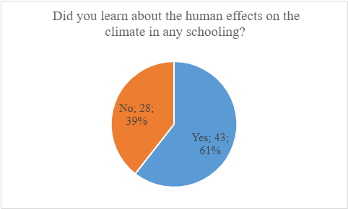
Graph ES.1: Perception of Human Effects on Climate to Coverage - Teacher Trainees Perception
The English National Curriculum’s current requirements leave most of the climate education material to be created independently. This requirement led to inconsistent climate education across schools resulting in students receiving climate education they feel is helpful, while other students feel as though they did not learn much from their climate education (Graph ES.2).
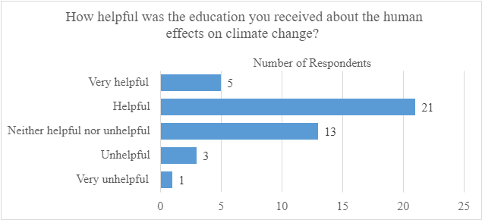
Graph ES.2: Teacher Trainee Opinions on Personal Climate Education
Climate education can extend effectively beyond the classroom. Teachers can teach about climate change while discussing current local and global events, encouraging student engagement with climate change. Some schools also have eco-clubs, which can connect students to local environments and encourage sustainable attitudes.

Recommendations
Based on our findings, we recommend the following actions:
The Department for Education (DfE) should create a climate change section within geography and chemistry, as well as add climate change ideas throughout the other disciplines of the curriculum. This should be achieved by:
- Review the National Curriculum utilizing focus groups of curriculum experts.
- Remove outdated material from the National Curriculum
- Form new climate change topics in Chemistry, and Geography, as well as implementing climate change ideas throughout the other subjects of the National Curriculum.
- Implement the new curriculum with teacher training
The DfE should improve teacher training by:
- Providing carbon literacy and climate change training to teachers, which can be accomplished by partnering with organizations such as the Carbon Literacy Project
- Providing seminars about integrating climate change into lessons
- Providing teachers with time off and support to receive these trainings
The DfE should improve access to teacher resources by:
- Creating sample lessons in all subjects for teachers to use
- Providing up-to-date resources for teachers to use during lessons, such as documentaries, videos, and class work
- Enabling teachers to share lessons and materials they developed by hosting climate change conferences, creating a forum, and establishing better communication between schools
The Department for Education should improve access to outdoor and environmental activities in schools by:
- Providing resources for them to create green spaces
- Establish eco-clubs, which allow students to form a deeper connection with the environment.

Recommendation for a Future Project
Based on our project’s experience, we recommend a future project to conduct more in-depth teacher interviews that broadens the sampling pool, includes all school levels and types, and researches the idea of a longer school day.

Authorship Page
Sec. | Author(s) | Editing Author
Abst. | Noah Mester & Caleb Powell | EK, LF
Exec. Sum. | Ethan Knight, Logan Frandsen, &  Noah Mester | CP
1 | All | All
2.1 | Ethan Knight | CP, LF
2.2 | Ethan Knight | CP, LF
2.3 | Noah Mester | CP, EK, LF
2.4 | Noah Mester & Caleb Powell | EK, LF
2.5 | Caleb Powell | EK, LF, NM
2.6 | Ethan Knight & Logan Frandsen | CP
2.7 | Ethan Knight | CP, LF
2.8 | Ethan Knight | CP, LF, NM
3.0 | All | All
3.1 | Noah Mester | CP, LF
3.2 | Noah Mester & Logan Frandsen | CP
3.3 | Caleb Powell | LF, NM
3.4 | Logan Frandsen | CP, NM
4.1 | Caleb Powell & Ethan Knight | LF
4.1.1 | Ethan Knight | LF, CP
4.2.2 | Ethan Knight | LF, CP
4.2 | Caleb Powell | LF
4.2.1 | Logan Frandsen | CP
5.1 | Ethan Knight | CP, LF
5.2 | Logan Frandsen | CP, EK
5.3 | Logan Frandsen | CP, EK, NM
5.4 | Logan Frandsen | EK, CP
6.0 | All | All
App. A | Logan Frandsen | NM
App. B | Logan Frandsen | NM
App. C | Logan Frandsen | CP
App. D | Caleb Powell | LF
App.  E | Logan Frandsen | CP

Table of Contents
Abstract 2
Acknowledgments 3
Executive Summary 4
Goals and Objectives 4
Results and Findings 5
Recommendations 6
Recommendation for a Future Project 7
1.0 Introduction 11
2.0 Background 13
2.1 Climate Change 13
2.2 Climate Change within the UK 14
2.3 UK International Cooperation and Agreements 15
2.4 Sustainability and climate change: a strategy for the education and children’s services system 16
2.5 The English Education Structure 16
2.6 Climate Change Education and Effective Ways to Teach It 18
2.7 Comparing the UK and US Approaches to Climate Education 18
2.8 A Comparison within the English National Curriculum: Physics vs Climate Change 19
3.0 Methods 21
3.1 Develop a Database of Worcestershire Secondary Schools 21
3.2 Document English Climate Education and Climate Change Policies 21
3.3 Identifying the Barriers and Successes to the Implementation of Climate Education 22
3.4 Identifying the Opportunities for the Improvement of Climate Education 22
4.0 Results 23
4.1 Semi-structured Teacher Interview Results 23
4.1.1 From Teacher Interviews: Examples of Successful Implementation of Climate Education 23
4.1.2 Teacher Interviews: Examples of Barriers to Implementing Climate Education in the Curriculum 23
4.2 Teacher Trainee Survey Results 24
5.0 Findings 28
5.1 The national curriculum’s lack of climate education puts pressure on teachers 28
5.2 The national curriculum does not allocate enough time to teach climate change 28
5.3 Schools can lead by example 29
5.4 Variability in climate education 29
6.0 Recommendations and Conclusions 30
Climate Change Topics Should be Expanded in the National Curriculum 30
The DfE Should Improve Teacher Training 30
The DfE Should Improve Access to Resources 30
The DfE Should Improve Outdoor and Environmental Activities 31
Recommendation for a Future Project 31
7.0 References 32
Appendix A – Teacher/Faculty Interview 35
Appendix B – General Consent Preamble 38
Appendix C – Secondary School Alum Interview 39
Appendix D – Semi-Structured Interview Protocol 43
Appendix E – Teacher Trainee Survey Results 44

1.0 Introduction
One significant issue for humanity is the increase of carbon dioxide (CO2) in the atmosphere, which elevates temperatures and is the primary factor of climate change. The co-director of the Grantham Institute at the Imperial College of London, Professor Joanna Haigh, authored an article on the history of CO2 in which she explains how important carbon dioxide is for the atmosphere, and how detrimental it can be when too much is introduced. As a greenhouse gas (GHG), carbon dioxide traps the heat radiating from the earth’s surface, increasing the temperature of the atmosphere. Furthermore, “a warmer atmosphere can hold more water vapour (before it condenses out in clouds or rain) and because water vapour is a GHG (greenhouse gases), this increases the temperature rise” (Haigh, 2017). One of the effects of increasing temperature is the sea level rising, placing coastal and island nations at risk. As a result, the United Kingdom (UK) endeavors to create a more sustainable future by, among many actions, ensuring that all new buildings are net carbon zero, supporting and creating green jobs, and creating a more comprehensive climate education curriculum (when compared to its current form).
At the COP26 summit in Glasgow, the UK, and other nations in the Glasgow Climate Pact (2021) pledged to make climate change and sustainability more prominent in education, “ranging from decarbonizing the school sector to providing extra training for teachers to include climate literacy across the curriculum.” (26). Teach the Future UK (2021), an organization advocating to improve climate education in the UK, has found that 92% of teachers are concerned about climate change and 90% of teachers agree climate change education should be required in schools. However, 70 % of UK teachers surveyed state that they are inadequately prepared to teach students about the climate crisis (Teach the Future, 2021). Moreover, 41% of teachers said that climate education is not mentioned in their school’s curriculum, while only 17% of educators said that climate change is mentioned in their school’s curriculum outside of the subjects of science or geography (ibid).
Climate education is a topic not well represented in the UK educational system. The English National Curriculum only explicitly mentions the human effects on climate change 3 times, stipulating that climate change must be taught in science and geography (Depart for Education, 2014). In the English curriculum, “the production of carbon dioxide by human activity and the impact on climate” is to be taught in chemistry and science, while “weather and climate, including the change in climate from the Ice Age to the present” should be taught in geography (ibid). While these topics are important, there is no mention of how everyday actions can affect climate change, nor how climate change should be integrated into other subjects like history and social studies.
Students Organising for Sustainability UK (SOS) is an organization that believes in lifelong learning about sustainability across all forms of education. Their mission statement is that “Change is urgently needed to tackle the injustices and sustainability in our world” and that “education is the answer to that change.” This organization is currently looking for local information on secondary schools in Worcestershire regarding their representation of climate education. The purpose of this project was to report on the implementation status of the English National climate education curriculum in Worcestershire from the perspective of Secondary School faculty. To achieve this goal, we addressed four objectives.
- Developed a database of headteachers, teachers, and curriculum heads for every secondary school in Worcestershire.
- Documented the climate education requirements from the English National Curriculum at each level in secondary education.
- Identified barriers limiting implementation of the climate education curriculum in secondary schools.
- Identified successes and opportunities for improvement of climate education in secondary schools.

2.0 Background
This section presents the basics of climate change and its impact on the United Kingdom and other countries around the globe. We also reviewed the English National Curriculum, specifically what the curriculum mentions for climate, briefly review the English education system, and how climate education is desired to be more meaningful to students. In addition, we examined global climate initiatives, focusing on what the UK has agreed to implement for goals in the coming years. This section concludes with a comparison between US and UK schools, as well as a comparison between climate change and physics within the English National Curriculum.

2.1 Climate Change
Climate change is a global problem facing all of humanity. One component of the climate crisis is Carbon Dioxide (CO2), a greenhouse gas (GHG) that helps trap heat within Earth’s atmosphere. As the sun’s rays pass into the atmosphere and warm the surface of the planet, CO2 and other GHGs, such as water vapor and methane, trap heat by reflecting it towards the surface instead of allowing it to escape into space.
The trapped heat radiating from the Earth’s surface has numerous effects. According to Haigh:
While the basic science of how GHGs (greenhouse gases) warm the Earth is very well understood, there are complications. The climate system responds in many ways which both enhance and ameliorate the effects of these gases. For example, a warmer atmosphere can hold more water vapor (before it condenses out in clouds or rain) and because water vapor is a GHG, this increases the temperature rise (Haigh, P. J., 2017).
CO2 traps heat in our atmosphere and without it the planet would be too cold for life to develop (Anderson et al., 2016). Conversely, if we continue to produce too much CO2 then the planet will become unbearably hot, and life will cease to exist (ibid). The same statements are applicable for the other GHGs like methane and water vapor (ibid). In figure 2.1, the increase of Carbon dioxide over the last 60 years, showing that Carbon Dioxide concentrations have increased by over 100 parts per million (ppm), increasing from 310ppm to 420 ppm.
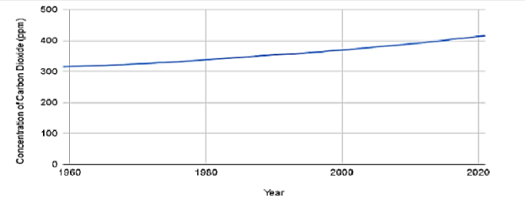
Figure 2.1: A visual representation of the increase of Carbon Dioxide in the
atmosphere since 1959. (US Department of Commerce, 2021)

2.2 Climate Change within the UK
One consequence of climate change is rising ocean levels and flooding of coastal areas (Haigh, 2017). Due to increasing temperatures, the capacity of the atmosphere to hold water vapor has increased and UK rainfall has escalated accordingly (Haigh, 2017). In 2020, some areas of the UK reported an increase of monthly rainfall by 400% while others reported having a month’s worth of rain within 24 hours (Bevan, 2022). The increased amount of rainfall is indicated by figure 2.2, which displays the increase of average yearly rainfall since 1961. The increased rainfall led to an increase in flooding and rising water levels which has resulted in nearly 1.8 million homes and over one hundred thousand commercial properties in England and Wales being at risk of flooding (Howe & White, 2004). Further, over 10,700 schools in the UK have been described as having significant flooding risk, with 4000 predicted to be at risk by the year 2050 (Department for Education, 2021).
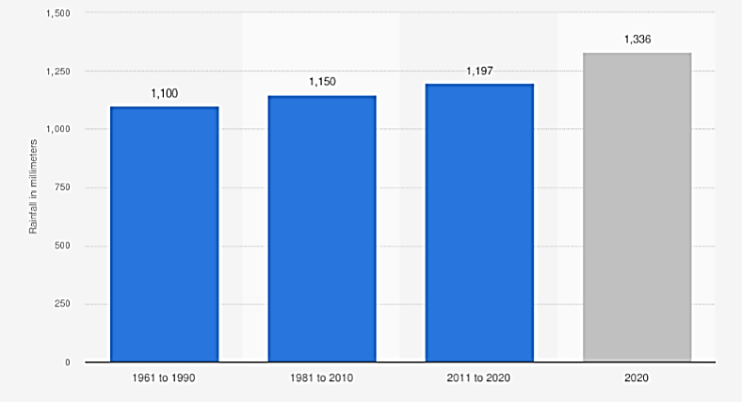
Figure 2.2: Increase in UK’s rainfall from 1961 to 2020. (Royal Meteorological Society, 2021)

2.3 UK International Cooperation and Agreements
In 2015, the United Nations ratified the 2030 Agenda for Sustainable Development, which outlines how to integrate social development with the goals for a healthy environment. The agenda announced 17 new goals for sustainable development, with goal 4 being “Ensure inclusive and equitable quality education and promote lifelong learning opportunities for all” (ibid, 14). In target 4.7 of this goal statement, sustainability is directly addressed, and reads:
By 2030, ensure that all learners acquire the knowledge and skills needed to promote sustainable development, including, among others, through education for sustainable development and sustainable lifestyles, human rights, gender equality, promotion of a culture of peace and non-violence, global citizenship, and appreciation of cultural diversity and of culture’s contribution to sustainable development (ibid, 17).
In 2015, the U.N. convened the COP21 (Conference of Parties) Climate Change Conference. This conference resulted in The Paris Climate Agreement (2015), a legally binding international treaty on climate change. It recognized the need for ambitious efforts to oppose climate change, the correlation between climate risks and poverty, food security, and biodiversity (The Paris Climate Agreement, 2015). The agreement also recognized that developing countries may not have the same economic and industrial options or resources to mitigate climate change as more developed countries (ibid). Signed and ratified by 194 countries, the Paris Climate Agreement engages almost every U.N. member state, accounting for most of the greenhouse emissions of the world (European Commission, 2021).
The restriction of greenhouse gas emissions between 1.5 and 2.0°C is a major topic addressed in the agreement (The Paris Climate Agreement, 2015). In addition, the importance of “education, training, public awareness, public participation, public access to information” (ibid) are also addressed as important topics. These ideas, coupled with the goals put forward by the 2030 Agenda for Sustainable Development (2015), became the foundation for future climate agreements. In addition, The Glasgow Climate Pact further defined the goals and steps necessary to enact meaningful climate change action (ibid). Since the conference was hosted by the UK and Mr. Alok Sharma MP served as conference president, the outcome’s ideals are especially relevant. The declaration of promises from these global agreements resulted in the UK Department for Education creating the Sustainability and climate change strategy policy paper within the DfE.

2.4 Sustainability and climate change: a strategy for the education and children’s services system
In November 2021, the UK Department for Education (DfE) produced a policy proposal draft titled Sustainability and Climate Change Strategy to address representation of environmental sustainability throughout the English school system (Addendum). For example, the draft strategy planned to become inclusive of climate education within every subject, while also providing teachers with support, training, and materials to do so (ibid). By the year 2023, every school and teacher would be promised to have access to “high-quality curriculum resources, so that teachers in all phases and subjects can confidently choose those [school subjects] that will support the teaching of sustainability and climate change” (ibid). In April 2022, the final policy paper, Sustainability and climate change: a strategy for the education and children’s services systems (DfE, 2022) was published. It made no changes to the existing English National Curriculum but did direct the DfE to “Develop a Primary Science Model Curriculum, to include an emphasis on nature to ensure all children understand the world around them” (ibid). It also proposed resources for teachers to share materials for incorporating sustainability and climate change into the current curriculum. While the report does incorporate teacher needs in one of its “action areas,” it also incorporated strategies for the promotion of “green skills and careers,” “a green, sustainable education estate” and sustainable “operations and supply chains” (ibid). Finally, the policy paper calls for international sustainability leadership in the education sector.

2.5 The English Education Structure
To understand whether climate education is being integrated into English schools, we must first understand how the education system is structured and where curriculum choices are made. Schooling is organized by three distinct levels: Primary, Secondary, and Higher Education (Department for Education, 2016). Primary level schools include students aged 5 to 11 or 12, secondary level serves students 12 to 16 years old. Lastly, higher education schools, also known as further education, are offered to students over 16 years of age.
Every level of education has something known as a Key Stage. Key Stages are used to track the progression of a student’s educational career through the system. At the Primary level, Key Stages 1 & 2 must be taught and assessed before proceeding to Secondary level, which includes Key Stages 3 and 4 (Department for Education, 2016). To pass Key Stage 4 and complete secondary education, students must take the General Certificate of Secondary Education (GCSE) exam. The GCSEs are designed to allow graduating students to demonstrate key qualifications supporting their professional development (Politics, 2021). Under the English National Curriculum, exam subjects include Math, English Literature/Language, and Science (ibid). The GCSEs are intended to assess a student’s preparation for the working world in accordance with national curriculum guidelines.
The UK has 4 classifications of school types; free schools, academies, maintained schools, and independent schools (New Schools Network, 2015). Free schools and academies are both publicly funded and bound to a legal agreement that offers more control over the curriculum (ibid). Maintained schools are state-funded, are overseen by the local authority and are required by law to follow the national curriculum (ibid). Lastly, independent schools operate by allowing the curriculum to be chosen by a board of independently elected officials (ibid). Despite variances in choosing what is taught, all topics still must come from the national curriculum instated by the Department for Education.
The current English National Curriculum was instated in 2014 by the Department for Education (2014) with a revision in 2016 for math and science. Only two subjects, science, specifically chemistry, and geography mention teaching climate change in the revised 2016 English National Curriculum. Both subjects address climate change in a more general sense, such as “how carbon in our atmosphere is making the greenhouse effect,” in chemistry or even “how the climate has changed from the Ice Age to the modern-day” in geography (ibid). The current topics stated in the curriculum do not address how someone can reduce their carbon footprint, or even how the environment can be helped. The current curriculum requires that science topics be taught throughout all secondary school levels, while geography is only taught voluntarily in Key Stage 3 (ibid.). As a result, the requirement for students to learn geography varies from school to school.
Before April 2022, the draft strategy policy paper, mentioned previously, included revisions needed for more implementation of climate change in education. The revisions attracted the attention of organizations from around the globe. Students Organising for Sustainability (SOS-UK) was one organization advocating support for the changes listed. In 2019, SOS UK conducted research of primary and secondary schools across England and investigated what learning experiences were present in terms of “sustainability at all levels” (SOS UK, 2021). Student experiences were surveyed through March of 2020, collecting over 4600 survey results. Of the British students surveyed, 39% reported they have learned “only a little, hardly anything or nothing about climate change” (ibid). The survey also found 85% of students agreed that “schools and colleges should be more encouraging … to help the environment” (ibid). Additionally, the most reported ways to help the environment were recycling, reducing litter, and reducing plastic use (ibid). With regards to increasing global temperatures, 87% of students reported being concerned about the impacts of climate change and 43% reported being worried about the future (ibid).

2.6 Climate Change Education and Effective Ways to Teach It
Climate education encompasses a multitude of topics, but at a fundamental level it informs students of the basic causes and widespread effects of human influenced climate change. As Armstrong et. al. (2018) argued, being knowledgeable about the climate crisis does not prepare a student to forestall it. Students will benefit from developing feelings of both hope and urgency about the environment (Armstrong et. al., 2018). If students are only taught the dangers of climate change, they will be fearful about the future, and fear itself will not change students' attitudes about the environment (ibid). Instead, students need to also be taught how to preserve the environment. When students are cognizant of the climate crisis and methods to prevent it, their behaviors are likely to become more sustainable (ibid).
An effective method to demonstrate to students the severity of climate change is to show the impact on their local environment (McNeal et. al., 2017). Local lessons allow students to feel more connected to global changes they may otherwise struggle to contextualize. Teachers say it is unfortunate to see how most students are not well connected to the natural world around them, so they tend not to appreciate what losing nature around them would mean (ibid). The DfE Sustainability and climate change strategy (DfE, 2022) for addressing climate change recommended schools improve student access to nature and increase lessons on local biodiversity. The inclusion of more environmental and sustainable co-curricular activities would then serve as additional ways for connecting students with their local environment (ibid).
The severity of climate change has led to a form of anxiety, known as eco-anxiety, that is prevalent amongst young adults. It has been shown that young adults typically are interested, knowledgeable, and concerned about climate change (Corner et al., 2015), and that at least in older young adults it could be causing stress due to the fact they are trying to plan their future while the future of the planet is uncertain (Clayton, 2020). Alternatively, young adults also have more time to think and reflect as compared to adults who worry about day-to-day obligations (ibid). Anxiety is not unhealthy when controlled, but according to Clayton, “climate anxiety could serve as a source of eco-paralysis: inhibiting people from taking effective action” (ibid). Therefore, teaching students about climate change in a way that reduces anxiety is paramount not just for the future, but for their short- and long-term health.

2.7 Comparing the UK and US Approaches to Climate Education
To provide a point of reference for climate change education at the secondary level in England, we compare those programs to U.S. grade 7-12 climate education programs. The US does not have a national curriculum or national standards for education, the federal government relies on state governments to specify the curriculum for K-12 schools within their authority. Curriculum requirements vary from state to state and can be influenced by political views. In the absence of federal standards or a national curriculum, the Common Core State Standards Initiative was created (About the Standards | Common Core State Standards Initiative, 2009). The common core provides English Language Arts (ELA) and math curriculum standards to the 41 states and the 4 territories that joined the initiative (ibid).
For the sake of brevity, we will focus on the state of Massachusetts as the point of reference. Massachusetts is located on the East Coast of the United States and is a progressive state. In a ranking provided by US News, Massachusetts was ranked 2nd overall for best education (Best states for education | US news best states, 2022). These rankings are based off college readiness, high school graduation rate, national math and reading scores, and preschool enrollment (ibid). In the U.S., climate change has become a political issue, and as a generalization, it can be stated that the Democratic party trusts scientific findings on climate change and the Republican Party is much less trusting of scientific reporting (Pew Research Center, 2016). Massachusetts typically votes Democrat, as reflected in the voting patterns of the state (Massachusetts presidential election voting history, 2022). In the last 9 presidential elections Massachusetts voted Democratic (ibid).
In the Massachusetts Current Curriculum Framework, climate is mentioned 14 times in the document in the context of the climate crisis and human effects of climate change. In the high school section of the curriculum, which is comparable to the English Key stage 4, climate is mentioned 13 times, with 1 mention in history and 12 in STEM-related subjects (Science and Technology / Engineering Grades Pre-Kindergarten to 12 Massachusetts Curriculum Framework, 2016). While some climate topics in the curriculum pertain to fossil fuels damaging the environment, there are other more progressive ideas present. These ideas include understanding the mechanisms and implications of climate change, the human impact on the climate, natural climate change, the history of climate change, biodiversity, and sustainable sources of energy (ibid). Meanwhile, the English national curriculum only has requirements in Key Stages 3 and 4 to teach about human-made carbon dioxide, what are carbon dioxide and methane and how they affect the atmosphere, and anthropogenic causes of climate change (Department for Education, 2016).

2.8 A Comparison within the English National Curriculum: Physics vs Climate Change
In order to show how climate change is covered, a comparison between another subject in the English National curriculum can be made to see how each are expanded. Forces is a topic of physics that is covered within the English National Curriculum during Key stages 3 and 4 (Secondary National Curriculum corrected, 2022), and within this area of study it is broken down into smaller and more specific concepts that should be covered by teachers (ibid). These ideas include the definition of a force, moment as the turning effect of a force, unit of measurement for force, work, and constant forces like gravity (ibid). To then compare forces to climate change studies, which is covered within Key Stages 3 and 4 of the English national curriculum as a set of concepts covered in the earth and atmosphere topic within chemistry, it is not given its own breakdown of specific topics (ibid). Instead, only human produced carbon dioxide, its effects, and “additional anthropogenic causes of climate change” are covered under the earth and atmosphere section of chemistry and the human and physical geography section of geography (ibid). By having climate change topics embedded in another topic, it is covered less thoroughly, resulting in less comprehension of climate topics.

3.0 Methods
The goal of this project was to report on the implementation status of the climate education curriculum in Worcestershire from the perspective of secondary school faculty. To achieve this goal, we addressed four objectives.
- Developed a database of headteachers, teachers, and curriculum heads for every secondary school in Worcestershire.
- Documented English climate change policies and climate education policies at the secondary school level.
- Identified barriers and successes to the implementation of climate education in secondary schools.
- Identified opportunities for the improvement of climate education in secondary schools.

3.1 Develop a Database of Worcestershire Secondary Schools
We developed an Excel database, organized by school type and education level. The database contained each school’s website, contact information for the main office and school administrators, and the individuals we interviewed. This database served as a reference for planning and tracking teacher interviews, as per objective 3, as well as acting as a quick guide for school information before an interview.

3.2 Document English Climate Education and Climate Change Policies
To achieve this objective, multiple documents were critically reviewed to provide a global and national context to climate education initiatives and attitudes in England, presented in Table 3.1. While the Sustainability and climate change strategy (DfE, 2022) policy paper was not read during our literature review, its draft was. However, only the official policy paper is linked in the table.
Table 3.1- Literature Review Notes
Source | Notes
English National Curriculum | This document outlines the curriculum requirements at each key stage, including the compulsory subjects and what each subject needs to cover.
Sustainability and climate change strategy (Draft in addendum) | This policy paper by the Department for Education outlines the future steps of climate education and sustainability in English schools.
COP21 – The Paris Climate Agreement | This agreement is the first of its kind in the 21st century, in which countries agreed to limit greenhouse gas emissions.
COP26 – Glasgow Climate Pact (Outcomes) | This agreement built upon the Paris Climate Agreement by further clarifying goals and objectives to climate change.

3.3 Identifying the Barriers and Successes to the Implementation of Climate Education
We conducted semi-structured interviews with headteachers, teachers, and curriculum leads which addressed how the national climate education curriculum requirements are translated into lessons by gaining their insights. Our interview questions, detailed in Appendix A, relied on questions provided by SOS UK. We conducted interviews at 4 of the 41 secondary schools contacted in Worcestershire County. We did not include schools with vulnerable student populations and non-traditional curriculums.
In addition to teacher interviews, we surveyed teacher trainees at the University of Worcester because they are all recent graduates of secondary school and could provide unique insight into their experiences of learning about climate change. With assistance from Senior Lecturer Elena Lengthorn, who forwarded our survey (Appendix C) to teacher trainees at the University. As with all participant surveys, participants' responses are anonymous and only the project team, SOS UK, and Senior Lecturer Lengthorn have access to the raw data from these surveys.

3.4 Identifying the Opportunities for the Improvement of Climate Education
We compared the teacher responses from all interviews to find common themes among the teacher’s experiences. These experiences were compared to what is required by the English National Curriculum. Using the tools built into Microsoft Forms and Excel, we analyzed the survey data to determine how climate education is viewed by students and how prepared future teachers are to address climate change. We compared the trends in responses across different subject areas and compared our survey findings to the teacher interview findings.

4.0 Results
This section will present our results.

4.1 Semi-structured Teacher Interview Results
After significant and repeated efforts to reach out to teachers in the Worcestershire schools, we only ended up with 5 interviews. With such a small sample size, we understand our data is not statistically significant, however, the data we did acquire offers interesting information which is detailed below.

4.1.1 From Teacher Interviews: Examples of Successful Implementation of Climate Education
From our interviews, we found that four of the five respondents had success integrating climate topics into subjects other than science and geography. One teacher is completing reading assignments on The Survival Game by Nicky Singer, a novel that tells the story of a climate migrant. Another teacher is using an art project to introduce climate topics to students. Both methods provide information about the climate crisis to students in years eight-ten without adding to the already full curriculum. All five respondents mentioned climate change in different areas of chemistry, biology, and other science-based classes. These topics included biodiversity, carbon emissions, and food scarcity. Three of the five teachers noted one successful approach to informally teaching sustainability outside of the classroom is creating clubs and activities that focus on sustainability and climate topics. Two schools have eco-clubs run by teachers, which improve underutilized areas of the campus by respecting local biodiversity, cleaning litter, and planting bushes and other flora. These clubs help students understand some of the hard to grasp concepts of the climate crisis. For example, some students will no longer be at these schools when the vegetation they planted reaches maturity, teaching them that sustainable decisions made now may not directly benefit them, but will impact future generations. Lastly, three of the five schools teach about local climate change to help students relate to climate topics. According to teachers, it is difficult for students to contextualize global problems like climate change, so teaching them about problems in their own community has allowed them to gain an understanding of the climate crisis. As a result, teachers reported students are more engaged in climate topics.

4.1.2 Teacher Interviews: Examples of Barriers to Implementing Climate Education in the Curriculum
From the interviews conducted, we identified a few barriers to further implementing climate education. First, lack of time prevents teachers from spending more time teaching climate change topics, as the fully scheduled school day does not allow time for new topics to be taught. One teacher suggested that outdated material should be removed from the English National Curriculum, which would provide teachers more time to cover climate change topics. Second, many school systems are still responding to COVID-19 repercussions, which exasperated pre-existing staff shortages. Teachers have more work to complete, resulting in less time to plan lessons. This finding ties into the second barrier: a lack of broad integration of climate change topics into the English National Curriculum. All respondents mentioned that, while climate change is present in the national curriculum, it should be covered in greater detail. One teacher described the national curriculum as the frame to a house, with the teachers having to figure out how to furnish it. Teachers do not have a defined lesson plan provided, requiring them to create their own without guidance. The faculty interviewed felt they were adding climate topics appropriately to the curriculum, but it would be easier for them if climate change were a full topic within either chemistry or geography. By requiring climate change to be a full topic in the National Curriculum, not just an assortment of ideas within different areas, it could be more developed and aid teachers in providing better climate education to students. Teachers also mentioned that climate change concepts could be added to non-science topics like English or history, allowing more students to be exposed to climate topics. A Level geography, the subject that primarily covers climate change, is not compulsory, meaning some students miss most of the currently taught climate change education. One teacher suggested that geography should be made compulsory to ensure every student receives proper climate crisis education.

4.2 Teacher Trainee Survey Results
We created a survey for teacher trainees which asked about their experiences with climate education as both a teacher and as a student. 71 survey responses were collected, accounting for 47% of the 150 teachers in training at the University of Worcester. Our survey, which can be seen in Appendix C, focuses on the experiences of being a student and a teacher trainee in placement. Key survey results are summarized here, while the rest of our survey results can be found in Appendix E.
Of the teacher trainees surveyed, 61% said they learned about the human effects on the climate during their schooling. Based on our observations, most teacher trainees are in their early twenties, meaning most of them attended secondary school after the current national curriculum was implemented, so age should not have added much bias to this question. As seen in table 4.1 below, most students who received climate education received it in secondary education.
Table 4.1: Academic levels where teacher trainees learned about human made climate change
School Level | Number of Responses | Percentage of Total Respondents
Primary | 10 | 23%
Secondary | 38 | 88%
Further Education (Ages 16-18) | 19 | 44%
Higher education | 16 | 37%

Additionally, graph 4.1 below presents teacher trainee responses regarding how helpful they felt their climate education was to understanding the climate crisis. Most students felt their climate education was helpful, with only four respondents indicating that their climate education was unhelpful or very unhelpful. Students who found their climate education helpful said it helped them know “the consequences of actions that I do to the environment” and “ignited interest, which I’ve explored further myself,” while students who did not find their climate education helpful felt it “didn't go into detail” and did not have “enough resources and strategies.”
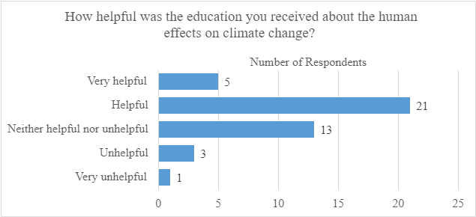
Graph 4.1: How helpful teacher trainees found their climate education
Graph 4.2 below indicates the importance respondents place on climate education for students. Almost every teacher trainee felt teaching climate change was very important or important, as “education is necessary to implement change,” especially since “the world is dying.” The one respondent who felt climate change was neither important nor unimportant reported that “the climate is variable.” The only respondent who reported climate change was unimportant appears to have accidentally selected unimportant, as they explained they felt “it is important for younger people to understand the impact [they] can have on the world.” 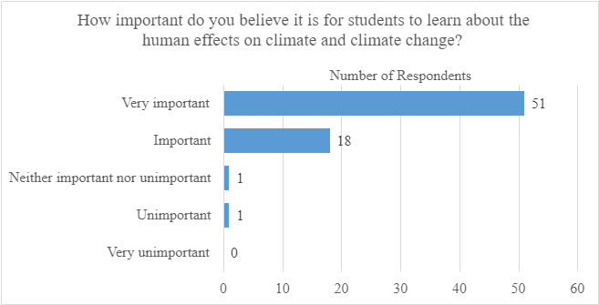
Graph 4.2: How important teacher trainees feel climate education is to students
In graph 4.3 below, most respondents do not feel prepared to teach about the climate crisis, with approximately 41% of respondents feeling unprepared to teach about the climate crisis. All four teacher trainees studying science and all seven studying geography, the subjects that currently require climate change education, feel somewhat prepared or very prepared to teach about the climate and ecological emergency.
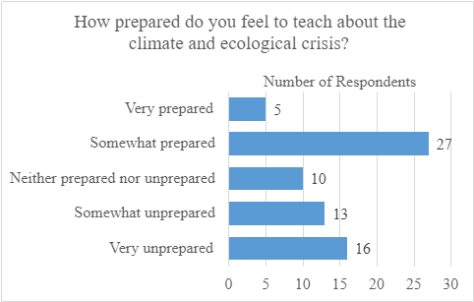
Graph 4.3: How prepared trainees feel to teach the climate crisis
Graph 4.4 presents the activities related to the climate crisis teacher trainees saw in either placement. Teaching about the climate crisis and assembly were the most common activities teacher trainees saw, reporting witnessing them 23 and 22 times, respectively.
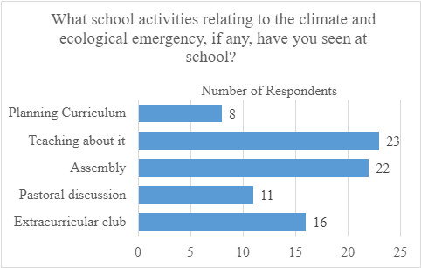
Graph 4.4: Different school activities related to the climate crisis that teacher trainees saw
When asked how they feel about their role as teachers in relation to the climate crisis, 62 respondents, approximately 87%, of teacher trainees feel responsible for helping deal with the climate crisis, as seen in graph 4.5. Teacher trainees feel responsible because “these [are] topics which will influence these children's lives” as “they can be the force of change that is needed for helping the world.” The respondents who felt it was partially their responsibility feel “it is everyone’s responsibility, not just teachers.” The only respondent who believed it was not their responsibility to teach climate change was also the only respondent who felt indifferent about their role as a teacher. Their reason for feeling not responsible and indifferent was that they “can't do everything.”
More teachers felt anxious than hopeful, which may indicate that some teacher trainees lack confidence in their ability to teach about the climate crisis. One respondent felt anxious because they “don’t know much about it [themself] so [they] would need to educate [themself] before [they] could teach others.” Some teacher trainees feel guilty about their lack of knowledge, as one respondent said they felt guilty because they “feel it is a topic [they] do not feel confident enough to discuss and debate.” Even if teachers do feel confident to teach climate education, they may feel “anxious as [to] how much change [they] can make on [their] own.”
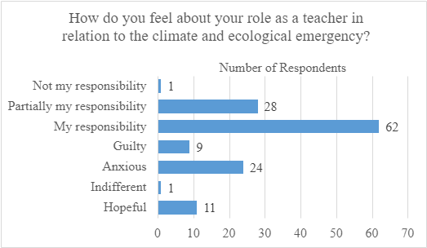
Graph 4.5: What teacher trainees feel about their role as teachers during the climate crisis

5.0 Findings
This section will cover our findings from both the interview results and the survey results.

5.1 The national curriculum’s lack of climate education puts pressure on teachers
The English National Curriculum is an integral component of climate change education. However, since it does not contain much content on climate change, pressure is applied to teachers to develop their own. This pressure could be the reason 87% of the survey respondents felt they are responsible as a future teacher to teach the climate crisis, but at the same time 34% of the total respondents also feel anxious about that idea. This perception of responsibility to teach a subject and the anxiety about teaching it shows that a fundamental problem could be present in the way the national curriculum requirements are laid out. In our literature review, we found that climate change is not a topic within a subject, instead it is a scattering of specific ideas embedded within topics of chemistry and geography, which could lead to the teacher trainees not training in those subjects feeling unprepared to teach about climate change. This lack of preparedness is further evident by 40% of teacher trainees feeling either somewhat unprepared or very unprepared to teach about the climate crisis.
Teachers have also been under pressure as the COVID-19 pandemic progresses. According to our interviews, one school reported being understaffed because of COVID-19, and as a result teachers were working much harder to help one another with lessons and cover for each other. This extra work may have put greater pressure on teachers of required topics, leaving little time to develop new lesson plans to further implement climate change.

5.2 The national curriculum does not allocate enough time to teach climate change
According to our interviews, teachers are having difficulty implementing new climate topics into their lessons because the current national curriculum is already full of content. All five teachers reported feeling there was not enough time or space in the curriculum to teach climate change in more depth than what is already covered. This time constraint could lead to students feeling unsatisfied with their climate education, as some students reported feeling their climate education was “always very brief [,] not [covered] in much detail,” and “a topic that was swept over quickly.”
An effective strategy to circumvent the lack of time allocated to teaching climate education could be covering climate change in school assemblies. One teacher reported that they used assembly time to provide additional climate education, since there is no additional class time available. This fact may also explain why approximately 31% of teacher trainees saw climate activities during assembly, since it was one way to add additional climate education without taking time away from the subjects the national curriculum requires. Another way teachers can add more climate education is through extracurricular activities, which approximately 23% of teacher trainees reported seeing in their placements. One extracurricular activity focused on climate education is eco-clubs, which happen after school and, according to teachers, help connect students with their local environment as much, and in some cases more than, in class education.

5.3 Schools can lead by example
Schools can teach students sustainable practices by modeling sustainable behavior themselves, creating a “culture of sustainability,” which students reported helped their climate education. Switching to renewable resources and recycling all demonstrate “pro-environmental attitude[s]” to students. When students see sustainable practices, they may be more likely to act sustainably in their own lives. In one school, students successfully encouraged their cafeteria to stop selling plastic water bottles, both making their school more sustainable and demonstrating that students can make a difference when confronting the climate crisis.
Another way schools can model sustainable behaviors is by engaging students directly in sustainable practices. Hosting competitions focused on sustainability and hosting eco-clubs allows students to practice the sustainable behaviors modeled by the school, and, according to teachers, makes students more likely to be environmentally conscious.
Lastly, schools can provide access to nature, which can connect students with their local environments. When students are more connected with nature, they are more likely to want to preserve their environment, according to teachers. To provide this kind of access, schools will need to maintain green spaces, which can be managed by eco-clubs or other student groups, providing students with the opportunity to care for their environment. Students who learn how to care for their school environment should also be able to care for the environment elsewhere, meaning students can take those green practices home.

5.4 Variability in climate education
As previously stated, eco-clubs are an informal way to bring additional climate education to students. However, since not every teacher interviewed reported eco-clubs at their school, some students may not have the experiences that personally connect them to the environment. One teacher reported feeling fortunate that their school had the resources to maintain an eco-club, since some schools do not have the resources required to do so. Students at schools that lack the resources to host eco-clubs may not be given the same opportunities to connect with nature as students at schools with eco-clubs.
This variation between climate education practices in schools can lead to differences in student opinions. Our student survey found that approximately 40% of students did not find their climate education helpful, which indicates that climate education at their schools was not effective for them, further supporting the idea that students do not always receive the same quality of climate education. Additionally, starting in year nine geography is not a required class. Since geography contains most of the climate education topics, students can miss crucial parts of the current climate education offerings.

6.0 Recommendations and Conclusions
The publishing of this report coincides closely with the publishing of the Department for Education’s Sustainability and climate change: a strategy for the education and children’s services systems (DfE, 2022) policy paper. While the direction of research was inspired by the draft of this policy paper, all data and findings were made independently. In addition, while some of the recommendations of this report may coincide with actions listed in the official Department for Education policy paper, all recommendations were made without the influence of the policy paper and rely solely on the facts, figures, and data collected for the purpose of this report. Because of this independence, the recommendations of this report offer a unique contrast and comparison to the contents of the coincident policy. We recommend that the Department of Education take the following actions:

Climate Change Topics Should be Expanded in the National Curriculum
The lack of discussion and the fragmented mention of climate change in the English National Curriculum needs to be solved by expanding climate change education within chemistry and geography to be its own section and by expanding it to more subjects outside of science and geography, such as history and English. The steps to complete this are as follows:
- We recommend that multiple focus groups comprised of curriculum experts from all subjects convene to review the English National Curriculum.
- The DfE should appoint a panel of teachers and other education experts who would be charged with identifying outdated material and making recommendations to the DfE about what should be updated or removed. The DfE should use those recommendations to revise the curriculum.
- The DfE should appoint a group of climate education experts, teachers, and climate curriculum experts to recommend curriculum improvements, such as climate change being made its own topic within geography and chemistry.
- Once the new National Curriculum for Climate Change Education has been finalized, the DfE can work to finalize and adopt the new curriculum. This adoption could be aided through climate education training and materials.

The DfE Should Improve Teacher Training
Teachers across subject areas need better training on climate change. Preparing teachers to teach about climate change comes about in three components; providing carbon literacy and climate change training to teachers, which can be accomplished by partnering with organizations such as the Carbon Literacy Project; providing seminars about integrating climate change into lessons; and providing teachers with time off and support to receive these trainings.

The DfE Should Improve Teachers with Access to Resources
Teachers need access to classroom materials to teach climate change lessons. The DfE can provide materials to teachers by creating sample lessons in all subjects for teachers to use; providing up-to-date resources for teachers to use during lessons, such as documentaries, videos, and class work; and helping teachers share materials they developed by hosting climate change conferences, creating a forum, and establishing better communication between schools.

The DfE Should Improve Outdoor and Environmental Activities
Extracurricular activities should be supported by the Department for Education for students to become more connected with their environment. This support can be made by improving access to outdoor spaces at school, teaching students about their local environment, and by creating Eco-Clubs at schools

Recommendation for a Future Project
We recommend more interviews should be conducted to gain more statistically significant data, by researching the current teacher resources available for climate education, and further inquiry into less traditional ideas, such as lengthening the school day. Interviews should take place at all school levels and type to create unbiased data.

7.0 References
Anderson, T. R., Hawkins, E., & Jones, P. D. (2016, July 25). CO2, the greenhouse effect and global warming: From the pioneering work of Arrhenius and Callendar to today's Earth System Models. Endeavour. Retrieved February 6, 2022, from https://www.sciencedirect.com/science/article/pii/S0160932716300308?via%3Dihub
Armstrong, A. K., Krasny, M. E., & Schuldt, J. P. (2018). Climate change education outcomes. In Communicating Climate Change: A Guide for Educators (pp. 25–31). Cornell University Press. http://www.jstor.org/stable/10.7591/j.ctv941wjn.7
Best states for education | US news best states. (n.d.). Retrieved April 19, 2022, from https://www.usnews.com/news/best-states/rankings/education
Bevan, S. J. (2022, February 3). Take back control: Two futures (or how to beat the climate emergency). GOV.UK. Retrieved February 7, 2022, from https://www.gov.uk/government/speeches/take-back-control-two-futures-or-how-to-beat-the-climate-emergency
Clayton, S. (2020). Climate anxiety: Psychological responses to climate change. Journal of Anxiety Disorders, 74, 102263. https://doi.org/10.1016/j.janxdis.2020.102263
Corner, A., Roberts, O., Chiari, S., Völler, S., Mayrhuber, E. S., Mandl, S., & Monson, K. (2015). How do young people engage with climate change? the role of knowledge, values, message framing, and trusted communicators. WIREs Climate Change, 6(5), 523–534. https://doi.org/10.1002/wcc.353
Department for Education, & Government, U. K., (2014). The national curriculum in England. London, UK; Department for Education. https://assets.publishing.service.gov.uk/government/uploads/system/uploads/attachment_data/file/840002/Secondary_national_curriculum_corrected_PDF.pdf
Department for Education, & Government, U. K., (2016). Education System In The UK. London, UK; Department for Education.
Department for Education, (2022). Sustainability & Climate Change A strategy for the education & children’s services systems. London, UK; Department for Education
Environmental Sustainability. Unesdoc.unesco.org. (2019). Retrieved February 17, 2022, from https://unesdoc.unesco.org/ark:/48223/pf0000370215
GCSEs - all you need to know. Politics.co.uk. (2022, January 23). Retrieved February 17, 2022, from https://www.politics.co.uk/reference/gcses/
Haigh, P. J. (2017, October 19). A brief history of the Earth's CO2. BBC News. Retrieved February 6, 2022, from https://www.bbc.com/news/science-environment-41671770
Howe, J., & White, I. (2004). Like a Fish Out of Water: The Relationship between Planning and Flood Risk Management in the UK. Planning Practice and Research, 19(4), 415–425. https://doi.org/10.1080/0269745052000343244
Kulakiewicz, A., Roberts, N., Long, R. (2021). Inclusion of sustainability and climate change in the national curriculum. London, UK; House of Commons Library
Massachusetts presidential election voting history - 270towin. 270toWin.com. (n.d.). Retrieved April 4, 2022, from https://www.270towin.com/states/Massachusetts
Massachusetts Department of Elementary and Secondary Education. (2022). Current frameworks. Current Curriculum Frameworks - Massachusetts Department of Elementary and Secondary Education. Retrieved April 25, 2022, from https://www.doe.mass.edu/frameworks/current.html
Muroi, S., & Bertone, E. (2019). From Thoughts to Actions: The Importance of Climate Change Education in Enhancing Students’ Self-Efficacy. Australian Journal of Environmental Education, 35(2), 123-144. doi:10.1017/aee.2019.12
My World My Home, SOS, & Friends of the Earth, (2021). My World My Home. London, UK; SOS
New Schools Network. (2015, January). Comparison of different types of school A guide to schools in England. Retrieved from New Schools Network
Peggy McNeal, Heather Petcovic & Patricia Reeves (2017) What is motivating middle-school science teachers to teach climate change?, International Journal of Science Education, 39:8, 1069-1088, https://doi.org/10.1080/09500693.2017.1315466
Pew Research Center. (2020, August 21). The politics of climate. Pew Research Center Science & Society. Retrieved April 25, 2022, from https://www.pewresearch.org/science/2016/10/04/the-politics-of-climate/
PM outlines his Ten Point Plan for a Green Industrial Revolution for 250,000 jobs. (2020). GOV.UK. Retrieved January 27, 2022, from https://www.gov.uk/government/news/pm-outlines-his-ten-point-plan-for-a-green-industrial-revolution-for-250000-jobs
Preparing America's students for success. Home | Common Core State Standards Initiative. (n.d.). Retrieved April 25, 2022, from http://www.corestandards.org/
School of Education. University of Worcester. (n.d.). Retrieved April 26, 2022, from https://www.worcester.ac.uk/about/academic-schools/school-of-education/
Secondary National Curriculum corrected PDF - GOV.UK. (2014). Retrieved April 24, 2022, from https://assets.publishing.service.gov.uk/government/uploads/system/uploads/attachment_data/file/840002/Secondary_national_curriculum_corrected_PDF.pdf
Students Organising for Sustainability, U. K., (2021). Schools Sustainability Survey. UK; SOS Education.
Sustainability and climate change: A strategy for the education and children's Services Systems. GOV.UK. (2022). Retrieved April 25, 2022, from https://www.gov.uk/government/publications/sustainability-and-climate-change-strategy/sustainability-and-climate-change-a-strategy-for-the-education-and-childrens-services-systems#action-area-4-operations-and-supply-chains
The Paris Agreement. UNFCCC. (2015). Retrieved February 17, 2022, from https://unfccc.int/process-and-meetings/the-paris-agreement/the-paris-agreement
Teach the Future, (2021). Research with UK teachers on the current state and future of climate education. London, UK; SOS UK
US Department of Commerce, N. O. A. A. (2005, October 1). Global Monitoring Laboratory - Carbon Cycle Greenhouse Gases. GML. Retrieved February 17, 2022, from http://www.esrl.noaa.gov/gmd/ccgg/trends/
United Nations. (n.d.). Transforming our world: The 2030 agenda for sustainable development | department of economic and social affairs. United Nations. Retrieved February 17, 2022, from https://sdgs.un.org/2030agenda
2016 Science and Technology Engineering Framework. (2016). Retrieved April 25, 2022, from https://www.doe.mass.edu/frameworks/scitech/2016-04.pdf

Appendix A – Teacher/Faculty Interview
The script for our semi-structured teacher interview can be seen below. When we conduct the interview, we will run through the script as it is ordered below.
- INTRODUCTION
  - Introductions and greetings
  - Consent Preamble
  - We are looking at climate change holistically, covering issues related to our climate and its relationship with the environment and society both locally and globally.
  - What is your role at your school?
- GENERAL CURRICULUM DEVELOPMENT
  - How does curriculum development work at your school?
    - Who else is involved in developing the subject curricula?
    - Are certain subjects integrated across the curriculum?
  - How, if at all, is climate change (using this definition) embedded within the curriculum (for your subject area, if applicable)?
- CLIMATE CURRICULUM – ALREADY COVERED TO ANY EXTENT
  - What about climate education, if anything, do you believe is important to teach to students?
  - (Curriculum Developer) In your school, what subjects currently cover climate education?
  - (Curriculum Developer) What subjects, if any, should climate education be expanded into?
  - What aspects of climate change are covered?
    - For example, does it cover any of the following aspects:
    - The science behind climate change and its causes
    - Individual actions
    - Large-scale, systemic action
    - Climate justice
    - Jobs and careers related to climate change
    - Politics and activism
    - Impacts of climate change
    - Local context vs global context
- How well are broader environmental problems linked to climate change covered?
What other climate topics, if any, do you believe should be taught?
- What factors would you say have enabled you to embed climate education and other environmental issues into your school’s curriculum?
  - Accessed training and resources
  - Commitment from school leadership / governance
  - Personal beliefs/values
  - Pupil demand
  - Evidence on pupil benefits of learning
  - Collaboration with other subjects
- (Teacher) What do your students think of climate change?
- (Teacher) How have your students responded to climate education?
  - Student action
  - Student attitudes
- (Teacher) What materials or methods have you found to be most helpful and/or engaging when implementing climate education into your curriculum?
- What barriers, if any, have you encountered in integrating climate education into the curriculum?
  - For example, have you had issues regarding
    - Teacher training
    - Student engagement
    - Curriculum time constraints
- (Teacher) How have you overcome any barriers you have encountered when teaching climate education?
- What changes would be useful to enable your students to learn more effectively about climate change and broader environmental issues?
  - For example, what changes would be enabling:
    - Within your school(s) – for example, creating opportunities for collaboration between subjects, or specific capacity for development
    - In relation to national policy/curriculum
    - In relation to your own skills and understanding
    - In relation to the skills and understanding of other teaching staff
- Is there anything else about climate education you would like to add?
- CLIMATE EDUCATION – NOT COVERED AT ALL
  - Do you believe climate education is important for students to learn?
  - (Teacher) What do your students think of climate change?
  - Why do you believe climate education is not currently covered in your school?
  - Does your school have plans to implement climate education?
  - What subjects, if any, do you believe should cover climate education and what topics should be covered?
  - (Teacher) Is there anywhere you feel climate education can be implemented?
  - What changes, if any, would be useful to enable your students to learn about climate change and other environmental issues?
    - For example, what changes would be enabling:
      - Within your school(s) – for example, creating opportunities for collaboration between subjects, or specific capacity for development
      - In relation to national policy/curriculum
      - In relation to your own skills and understanding]
- WRAP UP
  - Is there anything else you would like to add on your experiences of or perspectives on embedding climate change and other environmental issues into the curriculum?
  - Do you know any other teachers or faculty that would be interested in sharing their experiences with climate education? If so, how should we contact them?
  - Please feel free to reach out to us any time or share our contact information. However, we will be leaving the UK at the end of April.

Appendix B – General Consent Preamble
Below is our consent preamble we will ask teachers before we conduct our interview to ensure they understand the procedure for our project and what is required of them.
Consent:
Hello! We are a group of Worcester Polytechnic Institute Students, partnering with SOS UK and the University of Worcester, to conduct research on the current state of climate education within the UK. You are free to stop this interview at any time or not answer a question. You will not be identifiable in our final report and any recording, notes or identifying information will not be shared with anyone outside of our project group. Our research will be published on our university's website, and we will present our findings to Robin Walker, the Worcester MP, and our project advisors. We thank you for taking the time to sit down with us and chat, and if you want to ask any follow-up questions or see our final report, please feel free to reach out to us.
Our emails are ljfrandsen@wpi.edu, nymester@wpi.edu, eeknight@wpi.edu, and crpowell@wpi.edu.
Our advisors' emails are fjlooft@wpi.edu and lclooft@wpi.edu.

Appendix C – Secondary School Alum Interview
The survey questions below ask teacher trainees about their experiences as students learning about climate and as future educators preparing to teach about climate change. The survey was made using Microsoft Forms.
- Are you over 18?
- Did you learn about the human effects on the climate in any schooling?
  - Yes
  - No (go to 11)
- At what level(s) did you learn about the human effects on the climate?
  - Primary
  - Secondary
  - Further Education (16-18)
  - Higher education
- What did you learn about the human effects on the climate?
- Did the education you received about the human effects on climate and climate change impact your attitude on it?
  - Positive Impact
  - Somewhat positive impact
  - Neither a positive nor a negative impact
  - Somewhat negative impact
  - Negative impact
  - No impact
  - Unsure
- How would you rate your experience with human effects on climate and climate change education?
  - Very helpful
  - Helpful
  - Neither helpful nor unhelpful
  - Unhelpful
  - Very unhelpful
- Why do you feel this way?
- What did you find most memorable about the climate change education you received?
- What lessons or teaching methods, if any, had the greatest impact on you?
- What, if anything, did you dislike about the climate education you received?
- What would you have liked to learn about the human effects on climate change in school?
  - Flooding
  - Food
  - Weather
  - Unsure
  - I would not have liked to learn about the human effects on climate change
  - Other
- How important do you believe it is for students to learn about the human effects on climate and climate change?
  - Very important
  - Important
  - Neither important nor unimportant
  - Unimportant
  - Very unimportant
- Why do you feel this way?
- What, if anything, did you learn about the Sustainable Development Goals?

- Have you learned about the human effects on climate change outside of school?
  - Yes
  - No
- What, if anything, have you learned about the human effects on climate and climate change outside of school?
- How did this learning occur?
  - News
  - Newspapers
  - Magazines
  - Documentaries
  - Social Media
  - Other

- What subject are you training for?
  - English
  - Mathematics
  - Science
  - Design and Technology
  - History
  - Geography
  - Art and Design
  - Music
  - Physical Education
  - Computing
  - Foreign Language
  - Health Education
  - Religious Education
  - Citizenship
  - Other
- In placement 1, did you have any training on the climate and ecological emergency in your subject area?
  - Yes, a lot
  - Yes, a little
  - No
- In placement 2, did you have any training on the climate and ecological emergency in your subject area?
  - Yes, a lot
  - Yes, a little
  - No
- In either placement, have you had any training on the climate and ecological emergency in professional studies?
  - Yes, a lot
  - Yes, a little
  - No
- How prepared do you feel to teach about the climate and ecological crisis?
  - Very prepared
  - Somewhat prepared
  - Neither prepared nor unprepared
  - Somewhat unprepared
  - Very unprepared
- What did you discuss with pupils during either of your placements?
- Did you discuss the climate and ecological emergency with either of the following in placement 1?
  - Subject mentor
  - Professional mentor
  - None of the above
  - Other
- What, if anything, did you discuss about your subject curriculum or professional behaviours in relation to the climate and ecological emergency in placement 1?
- Did you discuss the climate and ecological emergency with either of the following in placement 2?
  - Subject mentor
  - Professional mentor
  - None of the above
  - Other
- What, if anything, did you discuss about your subject curriculum or professional behaviours in relation to the climate and ecological emergency in placement 2?
- How comfortable would you feel initiating a climate and ecological emergency conversation with your departmental colleagues?
  - Very comfortable
  - Comfortable
  - Neither comfortable nor uncomfortable
  - Uncomfortable
  - Very uncomfortable
- What school activities relating to the climate and ecological emergency, if any, have you seen at school?
  - Planning curriculum
  - Teaching about it
  - Assembly
  - Pastoral discussion
  - Extracurricular club
  - Other
- What placement actions on the climate and ecological emergency, if any, have you been involved with?
  - Planning curriculum
  - Teaching about it
  - Assembly
  - Pastoral discussion
  - Extracurricular club
  - Other
- How do you feel about your role as a teacher in relation to the climate and ecological emergency?
  - Not my responsibility
  - Partially my responsibility
  - My responsibility
  - Guilty
  - Anxious
  - Indifferent
  - Hopeful
  - Other
- Please explain your choice
- Is there anything else about climate education you would like to add?

- Would you like to share your email to be added to a network of teacher trainees? Your email will not be shared with anyone outside the network and will only be used for the teacher trainee network.

Appendix D – Semi-Structured Interview Protocol
Below is the procedure for our semi-structured teacher interviews, which explains how the interviews will be conducted and what the interview data is planned to be used for.
Procedure:
After we acquired the contact information of the interviewee, we sent an email explaining the purpose of our research and asked when the interviewee would be available for an interview. If they were unavailable to meet in person, we conducted our interview over an online platform, such as Microsoft Teams or Zoom, or over the phone.
Each interview had an interviewer and a scribe, who took notes and recorded the interview, if we received consent to do so. Before the interview began, we introduced ourselves and reiterated the purpose of the project. After the interview, we asked if any other teachers would be interested in an interview. This procedure will apply to over-the-phone and virtual interviews such as Microsoft Teams, Zoom, or any other equivalent software.
We asked educational professionals to be critical of their profession, so we will be keeping all participants anonymous. Only those involved with the project will have access to the raw data to protect the identity of the participants. Our team believes that interviews reveal helpful practices to integrate climate education into lessons and changes that would help integrate climate education further.

Appendix E – Teacher Trainee Survey Results
Graph E.1, present teacher trainee responses regarding whether the education they received made them concerned about the climate crisis. Most respondents indicated being more concerned or somewhat more concerned about the environment after their climate education. Only one person was somewhat less concerned after learning about manmade climate change.
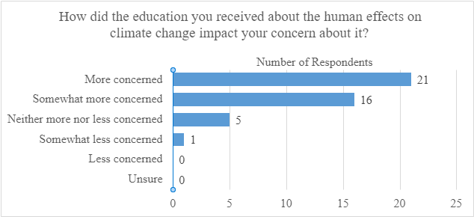
Graph E.1: How concerned teacher trainees felt after their climate education
Graph E.2 below shows that just over half of the teacher trainees surveyed learned about the human effects on climate change outside of school. The amount of climate change education students received outside of the classroom varied, with some students receiving a general “awareness of issues” while others learned “far deeper concepts.” Students learned about “more personal stories” and “the affects of climate change are apparent and devastating.” Most of the respondents learned about the human effects on climate change from either the news or documentaries, with some learning about climate change from social media sites.
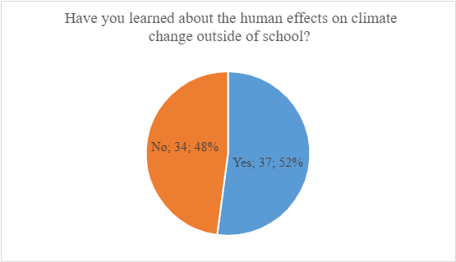
Graph E.2: Percentage of teacher trainees who learned about the human effects on climate change outside of school
Graph E.3 and graph E.4 indicate that most teacher trainees did not have training about the climate crisis in their subject areas. Most teacher trainees either received some climate education in both placements or no climate education in either of their placements. Three of the seven geography teacher trainees received some subject area training in both of their placements, accounting for three of the five “yes, a lot” responses in placement one and two of the five “yes, a lot” responses in placement two. Two of the four science teacher trainees received a little climate education training in their subject area in both placements.
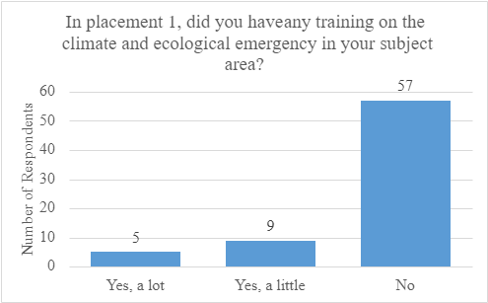
Graph E.3: Subject area training teacher trainees received in placement one
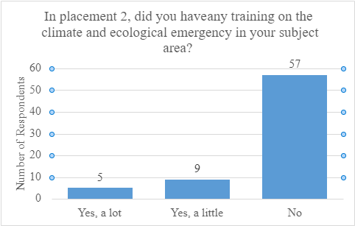
Graph E.4: Subject area training teacher trainees received in placement two
Graph E.5 shows that most teacher trainees did not receive climate education training in relation to their professional studies. None of the three respondents who answered “yes, a lot” were from the same subject, instead they were from geography, business and economics, and design and technology. Two of the seven geography respondents received any climate crisis training in professional studies, and only one of the four science trainees received any climate crisis training in professional studies, and they only received “a little” training.
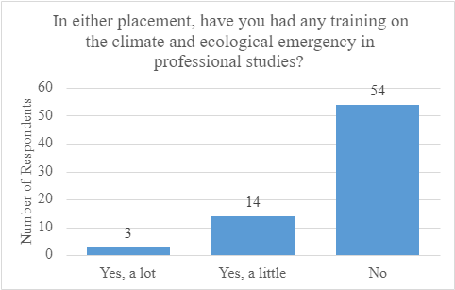
Graph E.5: Professional studies training teacher trainees received in either placement
Graphs E.6 and E.7 show whether teacher trainees discussed the climate crisis in placement one or placement two and reveal that most teacher trainees did not discuss the climate crisis. Across both placements, every geography student discussed the climate emergency with their subject mentors, and only two of them did not discuss climate change in both placements. Trainees also discussed climate change with other teachers and form tutors. Discussions about the climate crisis involved how to teach lessons, including “ways to keep the topic appropriate and factual” and the Sustainable Development Goals, as well as “sustainability in school.”
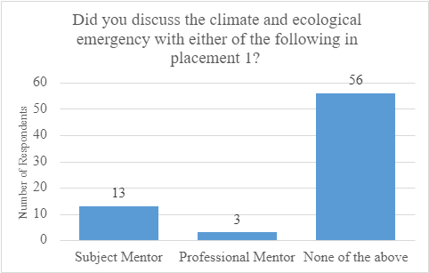
Graph E.6: Discussions teacher trainees had in placement one
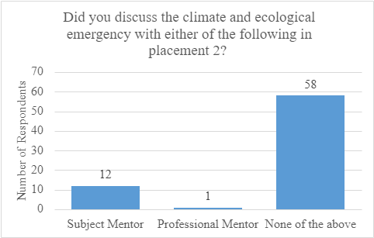
Graph E.7: Discussions teacher trainees had in placement two
Some teacher trainees also discussed the climate crisis with pupils, especially if they teach a subject the climate crisis is required to teach in. All seven of the geography trainees and three of the four science trainees reported some discussions with pupils. Many of the conversations were related to the curriculum, including “biodiversity,” “flooding,” “resource management,” and “ecosystems.” Outside of required subjects, trainees discussed “recycling,” “different energies,” and “stewardship.”
Graph E.8 reveals that most teacher trainees do not feel comfortable talking to colleagues about the climate crisis. All seven geography respondents feel comfortable or very comfortable initiating climate emergency conversations with their colleagues, while two of the four science respondents felt comfortable initiating climate discussions with colleagues, and one of them felt uncomfortable initiating climate change discussions with colleagues.
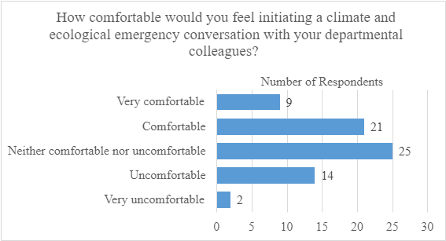
Graph E.8: How comfortable teacher trainees feel initiating conversations with colleagues about the climate crisis
Graph E.9 presents the activities related to the climate crisis teacher trainees have been involved in. Teaching about the climate crisis was the most common activity teacher trainees took part in by a large margin, with 22 trainees reporting teaching climate education in either of their placements. All seven of the geography trainees took part in climate activities in some way, with five of them teaching about the climate crisis and five of them planning climate crisis curriculum. All but one science trainee taught about the climate crisis in either of their placements.
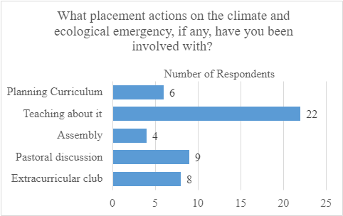
Graph E.9: School activities related to the climate crisis teacher trainees participated in

Unfortunately, this draft is no longer available online but is posted alongside this report in the Addendum. You may also contact the authors for a copy.

