Research on Option Trading Strategies

An Interactive Qualifying Project Report:
Submitted to the Faculty
of the
WORCESTER POLYTECHNIC INSTITUTE
In partial fulfillment of the requirements for the
Degree of Bachelor of Science

By

_____________________
Bogomil Tselkov

Date: April 23, 2008

Approved:

_____________________________________
Professor Oleg Pavlov, IQP Advisor

Table of Contents

Abstract 3
Acknowledgements 4
Background 5

Volatility 5

Stock Prices 6

Time Value of Money 7

Methodology 9

Trading Strategies with Options 9

Speculative Strategies 9
Simple Naked Strategies 9
Covered Writing Strategies 12
Combination 13

Valuing Options 14

Hedging Strategies 26

Hedging Simulations 28

Further Investigations 35

References 36

Abstract

Options are one of the most used financial instruments nowadays. The goal of the project is to analyze different options trading strategies. The research includes ways to price and value options and creating delta hedging simulation, based on the Black/Scholes pricing model and Monte Carlo simulations.

Acknowledgements

I would like to extend special thanks to my project advisor Professor Oleg Pavlov for his great patience and support throughout the life of this project. I would also like to thank my great friend Stefan Andreev for his constant efforts and help to build up my knowledge in finance.

- Background

Wall Street is well known place for trading stock and making money. Nowadays ones of the most useful and interesting instruments, used in the financial markets are the options.

What is option?

def: Options are financial instruments that give the owner the right, but not the obligation, to buy or sell an underlying security, or a futures contract.

There are mainly two types of options: call option and put option.

A call option gives the owner, the right to buy the underlying asset by a certain date for a certain price. (John C. Hull, Options, Futures and Other Derivatives)

A put option gives the owner the right to sell the underlying asset by a certain date for a certain price. (John C. Hull, Options, Futures and Other Derivatives)

The price in the contract is known as the exercise price or strike price. The date in the contract is known as the expiration date or maturity. There are mainly two types of options – American and European. (There are also other types of options like Bermudian options and Barrier options, but they will not be used in the paper).
American options can be exercised at any time up to the expiration date. European options can be exercised only on the expiration date itself.
(John C. Hull, Options, Futures and Other Derivatives)

The logic of the option pricing theory is based on the following important questions that produce steps to value an option:

- What are the possible values that the underlying asset might have at the end of the option’s life, and what are the probabilities that this underlying asset will have these values.

- What would the values of the option be if the underlying asset has the values identified in 1?

- What is the expected value of the option at the expiration date?

- What is the value of the option now?

  - Volatility

In order to start analyzing and exploring these questions, first we will define a very essential concept that we will use a lot in this paper:
The standard deviation of the annual percentage change in the price of the underlying when that percentage change is measured on the assumption of continues compounding.
We will call the standard deviation, measured this way – “vol”.

Note we will measure the vol on an annual basis irrespective of the life of the options. However, since we use the annual volatility, we will use a periodic vol, notated as σ_{per}, derived from the annual vol σ with the relation:

Periodic Variance = Annual Variance * Time (in years)

Therefore we have:

σ_{per}² = σ² * time,

so we have for the periodic vol:

σ_{per} = σ * SQRT(time)

  - Stock Prices

It is mostly assumed that a stock’s future price has the form of a normal distribution, since this is the type of distribution that normal people most often use in their statistics courses.

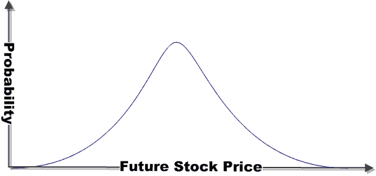
(Source: http://thismatter.com/money/options)

However, the stock’s future price is generally not normally distributed. The type of distribution that most logically describes stock prices and other underlying asset prices is a lognormal distribution. (John C. Hull, Options, Futures and Other Derivatives)

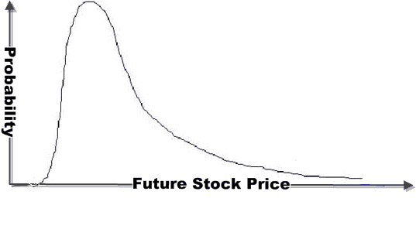
(Source: http://thismatter.com/money/options)

Unlike the normal distribution, the lognormal one is not symmetric. (Note: It has been shown that even the lognormal distribution does not provide a perfect description of stock prices, nevertheless it does provide a relatively good approximation.- Clifford J. Sherry and Jason W. Sherry, The Mathematics of Technical Analysis: Applying Statistics to Trading Stocks, Options and Futures)

  - Time Value of Money

Another this time well known principle is going to be used in our analysis – namely the time value of money and the risk-free rate of interest and discounting of cash flows.

The risk-free rate of interest plays a significant role in the pricing of options. For mathematical convenience, this rate is measured as a rate continuously compounded. It is, just like the vol, always state on an annual basis, even if the option’s life is less than or more than one year.

We will notate the effective risk-free rate as r_{e} and generally we will use the relation

r = ln(1 + r_{e}), where r denotes the continues rate.

We will also use the risk-free rate of interest to “grow” a current sum, and to “discount” a future one. Just as in the time value of money theory, we use the relationship:

FV = exp(r * N) * PV

(FV is the future value, r is the risk-free rate, N is the length of time, measured in years, and PV is the present value)

Example:
Then, for instance – the future value of a $100 with a continues rate of 5.827% after 3 months is:

FV = exp(0.05825*0.25)*100 = $101.47

From our upper equation we can derive the one for the Present Value, using discounting:

PV = FV/(exp(r*N))

- Methodology

  - Trading Strategies with Options

As formally defined, a “strategy” is a preconceived, logical plan involving position selection and follow-up action.

In a sense, all trading strategies can be divided into three basic categories. These are speculation, hedging and arbitrage. Each of these categories can be further divided into a number of subcategories.

    - Speculative Strategies

Speculation involves taking position in order to profit from a forecast with respect to the future value of some asset. This forecast is called a view. When equity options are used to ‘play a view’, the view usually involves a forecast with respect to either the direction in which the price of the underlying stock will move or whether the volatility embedded in the price of the option will change. Speculative traders based on views with respect to the direction on views about volatility are called volatility traders.

We will examine a number of speculative strategies beginning with very simple strategies and progressing to more complex strategies. Specifically, we will consider:

- Simple naked strategies

- Covered writing strategies

- Combinations

      - Simple Naked Strategies
The term ‘naked strategy’ refers to a situation in which a position is taken in an option for speculative gain and does not offset the risk associated with that position in anything else and does not hold a position in the stock on which the option is written.

Generally, there are four basic naked positions:

- Buy a call (called also a naked long call)
- Buy a put (called also a naked long put)
- Write a call (called also a naked short call)
- Write a put (called also a naked short put)

We will use the following notation:

St: price of the underlying at expiration (i.e. at time T)
X: the option’s strike price
Ct: the premium paid/received at time t for a call
Pt: the premium paid/received at time t for a put

In general, naked long strategies are quite popular with small investors who want to play a directional view. While they could play the same view by taking a position in the underlying stock or stock index, they usually don’t want to risk the full value of the underlying. Here is a representation of the naked long call.

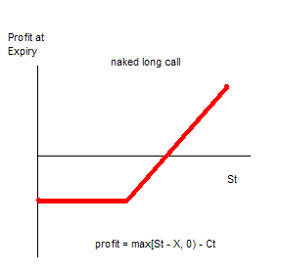

Naked short strategies are far less popular with small investors. The reason for this is because they have much greater potential downside, as we can see on the graph:

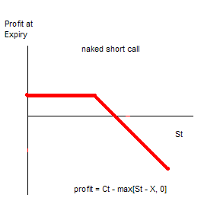

Similar is the situation with the put options:

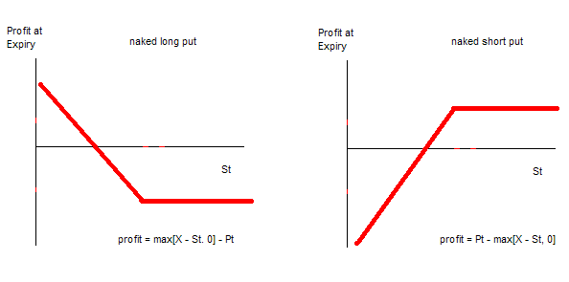

      - Covered Writing Strategies

Covered writing strategies are slightly more complex than simple naked strategies. They involve more than one position at a time. In a covered writing strategy, a party holding a position in the underlying writes options against that position. Most of the times this is represented by holding a long position in a stock and you write one or more call options on the stock. These options grant the option purchaser the right to call the stock away.

It is also possible, however more rarely, to hold a short position in a stock and to write put options against the short position. Because the first case is much more popular, we will focus on the former.

How does the process work?

Let’s assume that we first have a long position in an underlying:
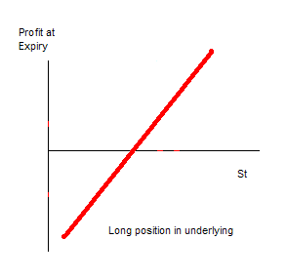
Then we add to our position a short position in call option:
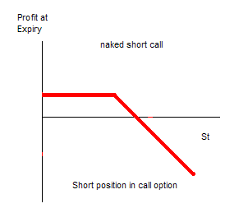
If we add those two positions together:
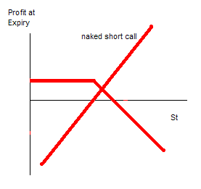
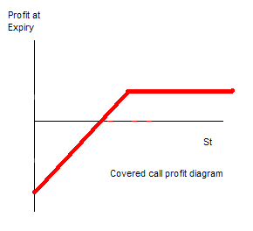

=

      - Combinations
The term “combination” refers to those strategies that involve:

- Being long both calls and puts on the same underlying and having the same expiration date (also known as long combination)

- Being short both calls and puts on the same underlying and having the same expiration date (also known as short combination)

We will look at the two most popular combinations – straddles and strangles.

The straddle involves holding a call and a put option with the same strike price and expiration date. The pattern is shown on the next figure:
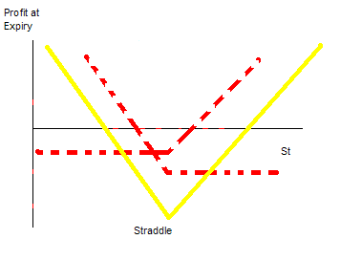
`A straddle is used when a large move is expected in the stock price, but it is unknown in which direction.

Another popular combination is the strangle. It involves having a position in put and call options with same expiration date and different strike price. The pattern of the profit is shown on the figure below:

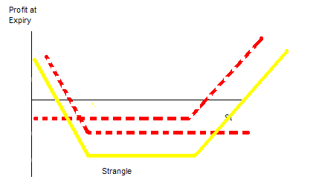

Here, we have similar strategy as in the Straddle – expectations of big movement on the stock price, but with unknown direction. The difference here is that the downside risk, if the stock price ends up in an unfavorable value, is less.

Before we continue with the more complicated hedging strategies, we should investigate how to value an option and what are the factors that we should take into consideration when trying to price the option.

  - Valuing Options

An option value is a function of time, the current spot price of the underlying, the strike price of the option, the volatility of the underlying asset’s price and the risk-free rate of interest.

Generally, most methods for valuing options can be categorized into two families of methods:

- Numeric Methods

- Analytical Methods

Numeric Methods:

Numerical Methods are a group of techniques that arrive at option valuation via a sequence of finite steps that get closer and closer to the true value.

The most widely used of the numeric methods are lattice models, and in particular – the binomial option pricing model. It was developed and published by John Cox, Stephen Ross and Mark Rubinstein (the model is also known as Cox/Ross/Rubinstein or simply CRR) in 1979.

We will build that model. However, in order to do that some assumptions need to be made:
- We’ll talk only for European-type options
- The underlying stock’s price is continuous (we have no sudden large changes)
- The underlying stock’s price is lognormally distributed
- The underlying stock does not pay any dividends
- The risk-free rate of interest is constant
- Volatility is constant
- There are no transaction costs for either the option or the stock
- Trading is continuous

We will use the following notation:

σ: The volatility of the price of the underlying stock, measured as the standard deviation of the annual percentage price change continuously compounded.

τ: The time to option expiry measured in years (or fractions of a year)

T: The number of periods into which the life of the option will be divided

t: The end of a period, (t=1 – end of the first period, etc)

r: The annual risk-free rate of interest continuously compounded

St: The underlying stock’s price at the end of period t.

X: The strike price of the option

Binomial Tree Model

The binomial pricing model uses a "discrete-time framework" to trace the evolution of the option's key underlying variable via a binomial tree, for a given number of time steps between valuation date and option expiration.

This means that we will divide the span of time, in which the underlying asset would evolve, into some number of discrete intervals.

We will divide the span of time into T discrete intervals and will denote the successive intervals as 1, 2, 3, …, T. (We will use the current time as 0). The length of each of these intervals in years is τ/T. (τ: The time to option expiry measured in years).

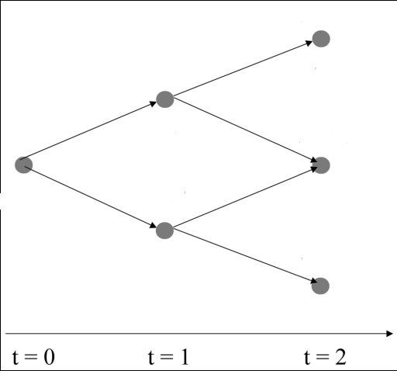
Just as we can see on the figure on the left, in a binomial framework, the price next period can rise to one and only one new higher price or fall only to one and only one new lower price.

(That’s the reason why the model is called binary model)

Now the question is by how much the stock price might go up and down each period?
The answer is obtained by using the so called “periodic vol”:

σ_{per} = σ * SQRT(τ/T)

For example, if we have an annual volatility of 20% and we have the total period of time three months. The periodic volatility would be:

σ_{per} = 0.20 * (SQRT(0.25/3)) =

= 5.77%

Therefore, the two possibilities in the time t = 1 will be:

Exp(+0.0577) * S, and
Exp(-0.0577) * S (if S is the current price of the underlying)

In the CRR binomial option pricing model, the value:

- exp(σ * SQRT(τ/T)) is called Up Multiplier and denoted U
- exp(-σ * SQRT(τ/T)) is called Down Multiplier and denoted D

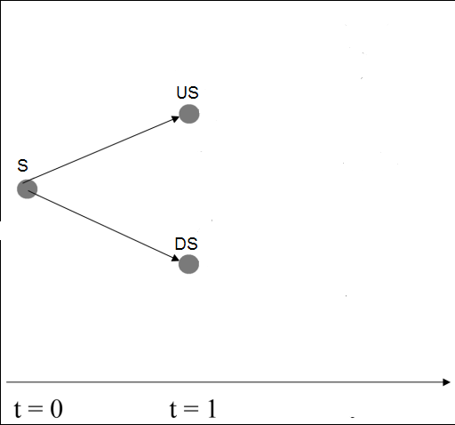
Then the two possibilities we have for the period t=1 are :
- U*S
- D*S

Then if we continue this process we will produce the following binomial tree:

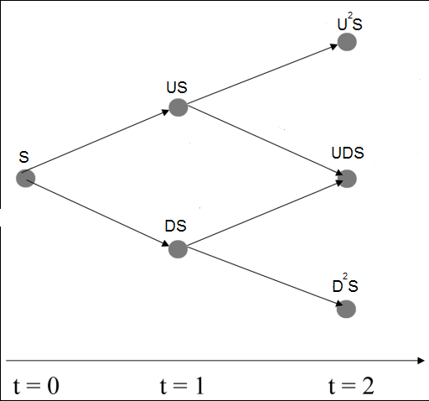

We have now described how prices evolve over time. However, we have not considered the probability of the price rising up or falling down each period.

Let’s assume that the probability of the price to rise up is p. Since we have the only alternative option of the price to fall down, the probability of the price to go down will be 1-p.

Therefore we have a situation like this:
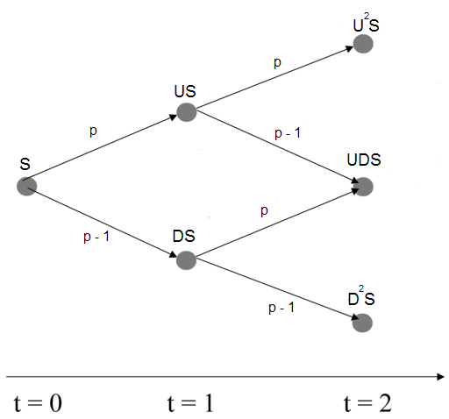

The key to deriving the probabilities is based on the risk-neutral pricing. Our expected value should basically earn the risk-free rare.

Therefore we have:

E(S) = p*U*S + (1 - p)*D*S

⬄ p = (E(S) – D)/(U-D), and since the expected value earns the risk-free rate we have:

p = (exp (r * τ/T) – D)/(U-D)

Now we are ready to complete the four steps described at the beginning of the section, namely:

- What are the possible values that the underlying asset might have at the end of the option’s life, and what are the probabilities that this underlying asset will have these values.

- What would the values of the option be if the underlying asset has the values identified in 1?

- What is the expected value of the option at the expiration date?

- What is the value of the option now?

We will show how to answer all four questions and compute the results, using the formulas already described.

Suppose we want to know the value of an ATM call option on a stock that is currently trading at $100, and the option expires in 3 months. Let’s assume we know that stock’s volatility = 30%. And the continuous risk-free rate of interest is 5%.

First, we will divide our time period from 3 months to periods of 1 month each. (i.e. T = 3).
Then we have to convert our measurements into year. Therefore we have:
Our time period = 0.25 years => the length of each interval will be 0.25/3

In general, our goal is to calculate the prices of the different possibility of the stock and their probability, so we can have an expected value for the underlying, and therefore we will be able to calculate how much a single option costs.

Our first step towards that is to calculate the up and down multipliers U and D and the probabilities p and (1 – p).

As we know:

U = exp (0.3 * SQRT (0.25/3)) = 1.09046

D = exp (- 0.3 * SQRT (0.25/3)) = 0.91704

Also,

p = (exp (r * τ/T) – D)/(U-D) = 0.5024

Therefore,

(1 – p) = 0.4976

Now we can use these values to determine all the possible future values of the stock and their probabilities:

U = 1.09045
D = 0.91704
p = 0.5024
(1-p) = 0.4976
r = 5% per year

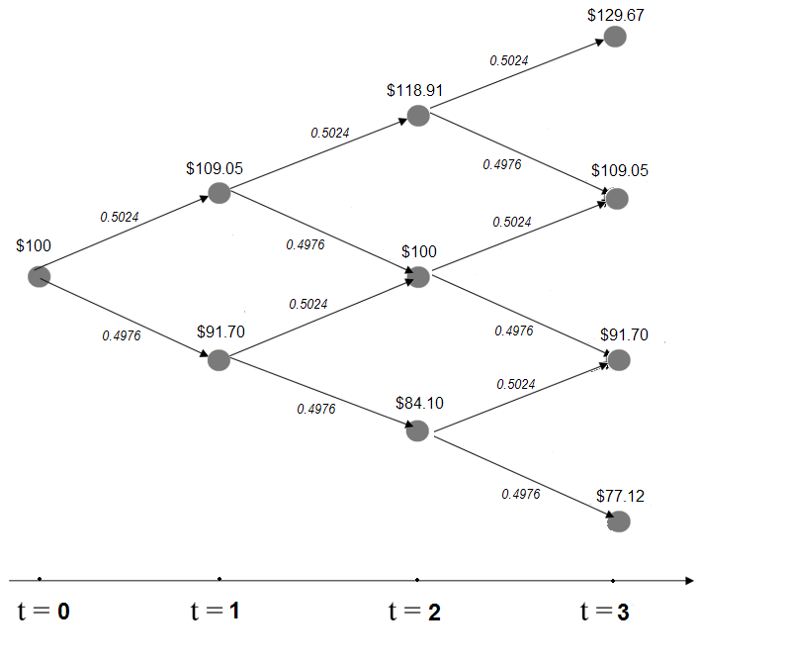

Now we obtained the terminal values of the stock and we can easily calculate the probabilities for each case, as can be seen on the figure above.

Stock Price ($) | Probability
129.67 | 12.68%
109.05 | 37.68%
91.7 | 37.32%
77.12 | 12.32%

And since we are looking for the value of ATM call option with a strike at $100, then the possible terminal values for the call option are:

Stock Price ($) | Call Option Value | Probability
129.67 | 29.67 | 12.68%
109.05 | 9.05 | 37.68%
91.7 | 0 | 37.32%
77.12 | 0 | 12.32%

Therefore we can easily compute the expected value of the option, by using its final values and their probability.

Stock Price ($) | Call Option Value | Probability |  | Probability x Value
129.67 | 29.67 | 12.68% |  | 3.762
109.05 | 9.05 | 37.68% |  | 3.410
91.7 | 0 | 37.32% |  | 0.000
77.12 | 0 | 12.32% |  | 0.000
 |  |  | Total: | 7.172

We were able to find that the option will cost $7.172 in the time t=3. Therefore, to obtain its current price (the price at time t=0), we should simply discount that value, using the risk-free rate, using the well known time value of money principle.
(Again we are assuming that there is no arbitrage in the market).

Therefore, the current value of the option is: = 7.172/(exp(0.05 * 0.25)) = 7.083

- The value of the call option is 7.083

Same approach can be followed in order to value a put option as well. For example if we want to evaluate a European-type put option on the same stock that we have looked in our previous analysis. The put has expiration in three months and struck at $100. The annual vol is again 30%, the risk-free rate is 5% and we will divide the time into 3 periods (one month per period).

Again, following the previous procedure, we construct the tree with the values:

Based on which, we compute the total value of the call option:

Stock Price ($) | Put Option Value | Probability |  | Probability x Value
129.67 | 0.00 | 12.68% |  | 0.000
109.05 | 0.00 | 37.68% |  | 0.000
91.7 | 8.30 | 37.32% |  | 3.098
77.12 | 22.88 | 12.32% |  | 2.819
 |  |  | Total: | 5.916

Again, we discount the value to obtain the present value of the option:

Current value of the put = $5.916/exp(0.05*0.25) = $5.843

- The value of the put option is $5.843

Analytical Methods

This method was first used by Fischer Black and Myron Scholes, with the assistance of Robert Merton, in 1969. It became famous as Black/Scholes model in 1973 and later on as Black/Scholes/Merton model.

Same assumptions, as in the numerical methods apply here:

- We’ll talk only for European-type options
- The underlying stock’s price is continuous (we have no sudden large changes)
- The underlying stock’s price is lognormally distributed
- The underlying stock does not pay any dividends
- The risk-free rate of interest is constant
- Volatility is constant
- There are no transaction costs for either the option or the stock
- Trading is continuous

This approach derives a complete solution that takes the form of an equation or formula. The formula requires specific inputs and produces an unambiguous solution as option value.

It is very important to note that the Black/Scholes model uses an arbitrage-free approach, which means that it is possible to create a continuously risk-free position by holding an appropriate portfolio consisting of call option on the underlying and units of underlying. As such, the portfolio should earn the risk-free rate.

Again, we will use the same notation as before:

σ: The volatility of the price of the underlying stock, measured as the standard deviation of the annual percentage price change continuously compounded.

τ: The time to option expiry measured in years (or fractions of a year)

T: The number of periods into which the life of the option will be divided

t: The end of a period, (t=1 – end of the first period, etc)

r: The annual risk-free rate of interest continuously compounded

St: The underlying stock’s price at the end of period t.

X: The strike price of the option

N(d): The area under a cumulative standard normal distribution from -∞ to the value of d. (used in the Black/Scholes formula)

Assuming there are no dividends paid, the Black-Scholes gives the following formulas for calculating the value of put(P) and call(C) options:

C = S*N(d1) –X*exp(-r* τ)*N(d2)

P = X*exp(-r* τ)*N(d2) - S*N(d1)

Where the d1 and d2 are defined as follows:

d1 = (ln(S/X) + [(r + ½ σ²) * τ])/( σ * SQRT(τ))

d2 = (ln(S/X) + [(r - ½ σ²) * τ])/( σ * SQRT(τ))

Now let’s use the Black/Scholes model to evaluate the same put and call options as before, having the same market conditions:
Stock, currently trading at $100,
ATM options,
Volatility = 30%,
Time to expiration = 0.25 years
Interest rate = 5%

After applying the Black/Scholes formula, we obtain:

Call Value = $6.583
Put Value = $6.341

Let’s compare the results with the ones from the Binomial Model:

Model: | Call Value: | Put Value:
Black/Scholes | 6.58 | 6.341
Binomial | 7.08 | 5.843

We can easily see that there is a small difference between the values obtained by the Black/Scholes and the Binomial Model. It is due to the fact that there is a tradeoff between the computational time and the accuracy of the Binomial Model.

To compute the value of the options, we separated the time interval to only 3 intervals. Let’s look at the graph, comparing the Black/Scholes value to the Binomial, based on the number of intervals that we create:

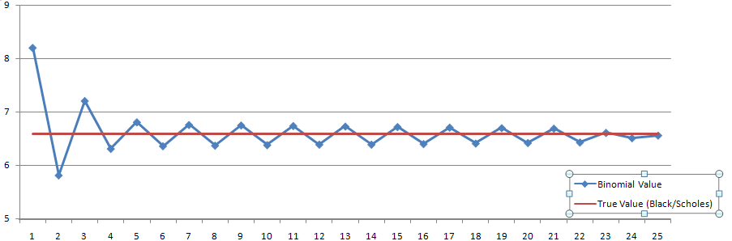

As we can see, the more time intervals we have, the closer our value is to the Black/Scholes (real) value. Therefore, using the Binomial Method, we face a tradeoff between the computational time and the accuracy of our approximation.

  - Hedging Strategies

Now as we know how to use Binomial and Black/Scholes Models to price options we can continue with more advanced trading strategies.

We will try to construct a riskless portfolio, containing stocks and options. By riskless portfolio we understand a portfolio, which will give exactly the same outcome (profit), no matter if the stock price goes up or down.

For this reason let’s consider a portfolio, that has one call option and long position in delta shares of stock. We will try to calculate what is the appropriate delta that will make our portfolio riskless.

Let’s use the binomial representation, as we used before.
We have the current stock price S, and two possibilities for it in the future – either to go up to US, or to go down to DS.
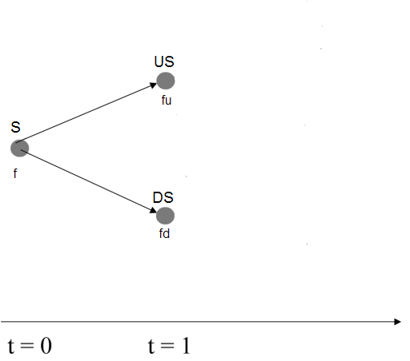

Let’s also notate the current option price (at time t=0) as f. Then let’s notate the two possibilities in time t=1 as fu and fd respectively as shown in the figure.

Since we have delta shares, and one option, and we want to create a riskless portfolio, then the value of the portfolio in both cases at time t = 1 should be the same.

One hand, if the stock price goes up, the value of our portfolio will be:

U * S * delta - fu

And on the other hand, if the stock price goes down, the value of the portfolio is:

D * S * delta – fd

Therefore we want:

U * S * delta – fu = D * S * delta – fd

<=> delta = (fu – fd)/(U*S – D*S)

In other words, our delta should represent the rate of change of the option price, in respect to the rate of change of the stock price.

What we have just calculated is the first and the most important, of the option Greek. It is known as delta. As we mentioned before, the value of an option is a function of five key value drivers:

C = f(S, X, τ, r, σ)

The “Greeks” measure exactly the sensitivity in an option’s value to each one of those drivers.

It is important to note that even though we used binomial model to show the representation of delta, we need to recognize that just as the binomial model give approximations of true option values, using such models to derive option Greeks will only produce approximations of the true values of the option Greeks.
Again, the quality of these approximations depends on how many periods we divide the life of the option. The more periods there are, the better the approximations.

Hedges that are set up at the beginning and never changes are known as static-hedging schemes. However, much more interesting are the dynamic-hedging schemes and we will look at them more closely.

- Hedging Simulations

Since changes, the investor’s position can remain delta hedged (i.e. neutral) only for a relatively short period of time, the hedge has to be adjusted periodically. This is also known as rebalancing.

Now we will create a simulation on delta hedging, using a portfolio of an option and delta shares in corresponding stock.

We will use the following market conditions for our model:

Market Conditions: |  | Value:
volatility = 20% |  | 0.2
risk-free rate = 5% |  | 0.05
600 trading days, each: |  | 0.002739726
Stock price = 50 |  | 50

Since no historical data was available for the experiment, we will begin building our model by first, following the distribution of the stock prices – namely – lognormal distribution, creating a normal distribution, using standard Excel features as shown in the figure:
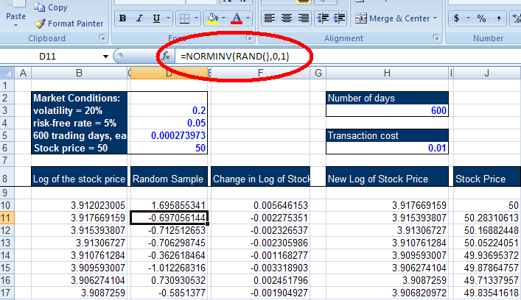

After we created a series of stock price with random movement every day, following lognormal distribution, we are ready to begin our hedging.

Considering there is no transaction cost, we used Black/Scholes model to calculate the shares of stock, delta, we have to hold each day in order to hedge our portfolio of an option and stock shares.

According to the Black/Scholes model:

Delta = N(d1)

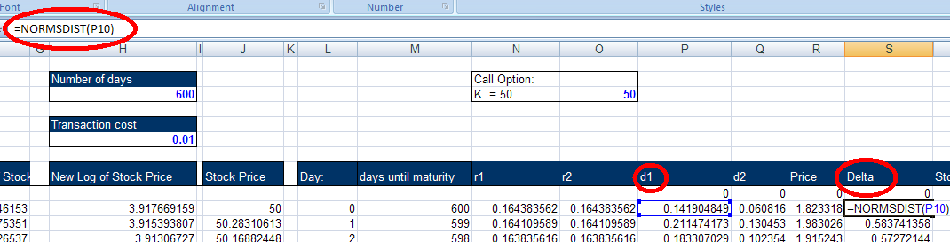

Our strategy is going to be to calculate the shares of stock needed every day in order to perfectly hedge our position and then rebalance the portfolio.
Then we will be interested to see what the outcome is at the end of the 600 day – if we lose or gain money or we stay even, compared to the interest-rate return.

In order to do this experiment, a Monte Carlo simulation approach is used. A Monte Carlo simulation of a stochastic process is a procedure for sampling random outcomes for process. In other word, we will repeat out observations 100 times and we will be interested in the distribution of our final values:

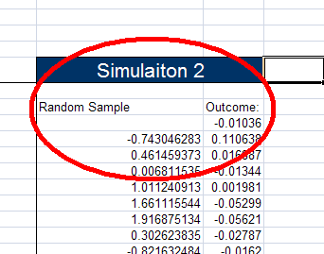

Running this experiment produced the following distribution of the total gain/loss of our portfolio:

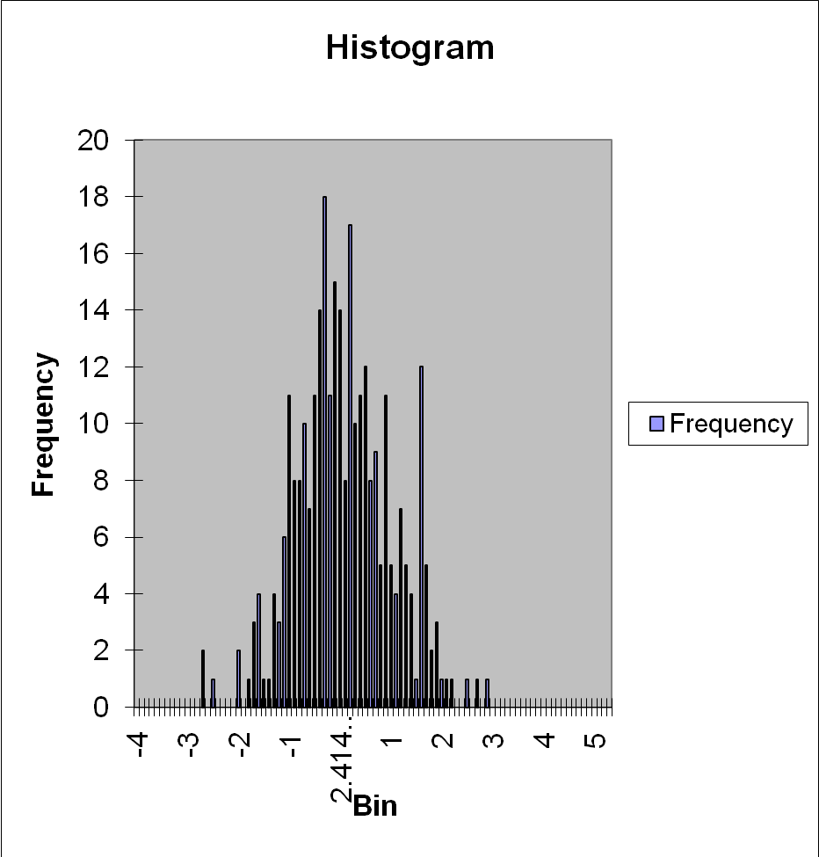

In other words, we have a normal distibution of the gain/loss of our portfolio cented at 0. Therefore we achieved almost a perfect hedging and our portfolio will have a constant outcome (equal to the risk-free rate as described in the previous section of the paper), no matter in which direction the stock price goes. (Note that we generated random process for the stock price movement).

We can conclude that if we have no transaction cost, doing daily rebalancing and delta hedging (by bying or selling the appropriate shares of stock) will well lead to a perfectly hedged portfolio in which the outcome does not depend on the movement of the stock price.

That is why it was quite interesting to continue with the hedging investigation under some different conditions – namely – what will happen if there is transaction cost?

Again we use the same market conditions, but this time we intoduce and will use another field called “transaction cost”. In our experiment we will have transaction cost = 0.01, which means that we have to lose 1% of each transaction we make.

Reproducing the experiment with Monte Carlo simulations, produced the following distribution of our final values:

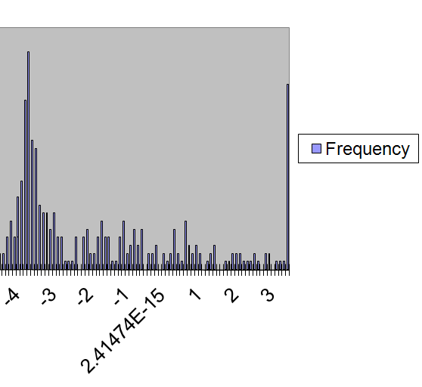

As we can see from the graph, this time the distribution is centered around -$3.5, which means that we will lose 3.5 dollars on average for reaballancing our portfolio.
Considering the fact we have a transaction cost of 1% for each buying/selling activities we do, it seems quite natural that rebalancing the portfolio each day will lose some money. However, can we still rebalance the potrfolio after a different time window and lose less?

Let’s see what happens if we try to rebalance our portfolio any other day, instead of every day.

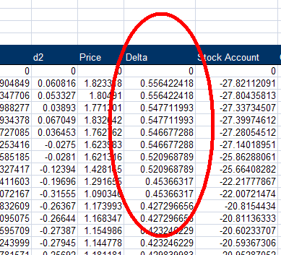

As you can see form the figure, we adjust our delta (shares in stock) every other day, which should lead to smaller overall transaction cost.

Again, after using Monte Carlo approach, we obtain the following distribution of our final gain/lose balance:

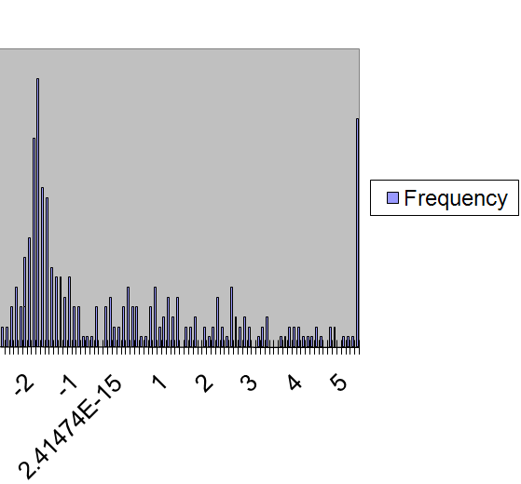

As a results, we can conclude that the average loss from the 2-day rebalancing is around $1.9, compared to the almost $3.5 lost when rebalancing every day.
However, we have a tradeoff between cost and security. During the time when we do not have a perfectly hedged portfolio we might lose money if the stock changes its price in an unfavorable direction.

- Further Investigations

How to know when to hedge and when not to? Is there any market indication that can tell us what the best strategy is? These and many other questions rose after the already made experiments.

The key for this further analysis is the connection between the delta and the other Greeks.
Even thought, the relation and calculation of delta and the other Greeks have been implemented in our model, the absence of real data made the analysis of such relationship impossible and the results were not satisfactory.

This simulation and paper can easily be continues if real market data is used. Then it will be possible to analyze the connection between the Greeks and the conditions that should be the drivers to the hedge.

- References

John C. Hull, Options, Futures and Other Derivatives, Prentice Hall; 6 edition (June 20, 2005)

Steve E. Shreve, Stochastic Calculus for Finance I, Springer

http://wikipedia.org

Martin Baxter, Financial Calculus, Cambridge University Press

Little, Jeffrey & Rhodes, Lucian. (2004), Understanding Wall Street, 4th edition, McGraw-Hill, USA

Malkiel, Burton. (2005), A Random Walk Down Wall Street. The Time-Tested Strategy for Successful Investing, 8th edition, W. W. Norton, USA

Marshall, John & Ellis, M. () Investment Banking and Brokerage, McGraw-Hill, USA.

Clifford J. Sherry and Jason W. Sherry, The Mathematics of Technical Analysis: Applying Statistics to Trading Stocks, Options and Futures

Curtis Faith, Way of the Turtle, McGraw-Hill (2007)

Solomon Kullback, Information Theory and Statistics, McGraw-Hill

Weiss, David. (1993), After the Trade is Made, New York Institute of Finance, USA.

Peter Dalgaard, Introduction to Statistics with R, Springer (2006)

