Worcester Polytechnic Institute – April 23rd, 2008

Providing a Platform for the Boston Community Learning Initiative
Alvaro Soares Jr. | Julia Zheng | David Keck | Vincent Milano | Michele Perry | Kenneth Stein

This Interactive Qualifying Project report is submitted in partial fulfillment of the degree requirements of Worcester Polytechnic Institute.

Contents
Abstract 5
Acknowledgements 6
Authorship 7
Executive Summary 8
Chapter One: Introduction 13
Chapter 2: Background 18
Out-of-School Time Initiatives 18
The Community Learning Initiative 20
Boston Public School Systems 21
Current After-School Scenario in Boston 22
Boston After School and Beyond 23
Boston Youth Sports Initiative 24
Recently Created Programs 24
Boston Youthline 25
BOSTONavigator 25
BOSTnet 26
Information Systems 27
Data Farming vs. Data Warehousing 27
Looking Ahead 28
Chapter 3: Methodology 30
Program’s Persepctive 30
Investigate Organization’s Expectations For A New System 30
Compiling A List Of Existing Systems That Could Be Implemented 33
Determining Which Software Systems Fulfill The Requirements 34
Recommending The Most Feasible Solution 35
The Youth Perspective 35
Analyze The Current System 36
Finding A Correlation Between After-School Involvement And Academic Performance 37
Mapping The Geographical Involvement Of Students In After-School Programs 38
Determining A Measurement Of After School Program Effectiveness 39
Developing A Recommendation System For Different Roles 39
Chapter 4: Findings And Analysis 41
Performance Metrics 41
The Ideal Information System 43
Implementing the New System 46
Market Research: Existing Systems 47
Cityspan’s Youthservices.net 47
KidTrax –Trax Solutions 48
Cayen Systems 49
Learning 360 49
Comparing The Systems 51
Major Aspects Contributing to Cityspan’s Top Score 59
Implementation of SYstems in Other Cities 60
Louisville, KY: KidTrax 60
Providence, RI: Cityspan 62
Boston, MA: Cayen 63
BOSTONavigator 64
The Ideal End-User Experience 67
Budgeting 69
One-Card System 70
Linking After-School Programs to Academic Performance 71
Analysis through Geographic Information Systems 74
Making Better Correlations Possible 75
Legal Issues 76
Family Educational Rights and Privacy Act (FERPA) 76
Health Insurance Portability and Accountability Act (HIPAA) 77
Uniting and Strengthening America by Providing Appropriate Tools Required to Intercept and Obstruct Terrorism (USA PATRIOT) Act 78
Policy Advising and Community Learning 79
Chapter 5: Recommendations 81
Choosing an After-School Management Software 81
Recommendation #1: Implement Cityspan’s Youthservices.net 81
Recommendation #2: Implement the new Information System during School Recess 82
Improving the end-user experience 82
Recommendation #3: Modify the User Interface of BOSTONavigator 82
Recommendation#4: Modify the Basic Search Engine 83
Recommendation #5: Introduce an Advanced Search 85
Recommendation #6: Introduce a Guided Search 85
Recommendation #7: Improving the Current Searching Algorithm 87
Recommendation #8: Include One-Time Events 87
Recommendation #9: Import Data from Youthservices.net into BOSTONavigator 88
Recommendation #10: Contingency Plans 88
Recommendation #11: Develop Incentives for Organizations to Use the new System 89
Coordinating Community Learning 90
Recommendation #12: Introduce a Community Learning Role in Boston 90
Recommendation #13: One-Card Implementation 91
Deriving Social and Behavioral Correlations 92
Recommendation #14: Multiple regression Analysis 92
Web Interaction and BOSTONavigator 93
Recommendation #15: Make BOSTONavigator an Interactive Website 93
Chapter 6: Conclusions 96
Reaching Full Potential with Boston Youthline 96
A Data Driven Government 96
Visibility 97
Impact and Social Implications 97
Appendix A: Background of Organizations 99
Appendix B: Interview Questions 107
Appendix C: Interview Summaries 112
Appendix D: Glossary of Acronyms 162
Appendix E: BOSTONavigator Wish List 165
Appendix F: Figures 170
Appendix G: Screen Shots 175
Appendix H: GIS Data Maps 187

Abstract
The Mayor of Boston, Thomas Menino, launched the Community Learning Initiative at his State of the City address in early 2008. This initiative plans to improve Boston’s after-school participation by providing a better experience to its students. The success of the initiative involves creating the necessary platform for students to attend after-school programs. To do so, there was a need to unify the after-school organizations’ information systems and a need to catalogue the offered activities. This project provides recommendations for those two issues, as well as exploring the social implications of the initiative. The project was directed by Boston’s MIS department in conjunction with Oracle Corp., and encompassed all of Boston’s public libraries, schools, and youth agencies.

Acknowledgements
We would like to express a special thank you to our professors for their support and guidance throughout the course of this project:

Professor Susan Vernon-Gerstenfeld, PhD.
Director of Academic Programs and Planning for Interdisciplinary and Global Studies

Professor Arthur Gerstenfeld, PhD.
Director of WPI Wall Street Project Center, U.S.- Africa Conference

We would also like to extend our gratefulness to our liaisons for their assistance during this project:
Nigel Jacob - Senior Advisor for Emerging Technologies, City of Boston

Chris Breining - Insight Program Director, Oracle Corporation

We would like to express our gratitude towards the following collaborators and their respective organizations:

Boston MIS Department
Bill Oates

Boston Youthline
Patty McMahon

Boston Public Libraries
Ruth Kowal
Koren Stembridge
Scot Colford
John Dorsey
Ken Peterson

BCYF
Amy Reid
Daphne Griffin

Boston’s GIS Group
Claire Lane
Jim Alberque
Carolyn Bennet

Boston Youth Services Network
Heidi Hall

Providence After-School Alliance
Elizabeth Devaney

Boston After-School and Beyond
Vickie Stringfellow
Patricia McGuiness

Oracle Corporation
Paul Laurent

Boston Public Health Commission
Michelle Urbano
Jeanne Cannata

BPS
Shamil Mohammed
Kenneth Still
Wallace Johnson
Alice Santiago
Kim Rice

Authorship
Section | Main Author | Collaborator | Partial Editing | Final Editing
Introduction | Alvaro Soares | Team | Team | Alvaro Soares
Background | Team |  | Team | David Keck,  Alvaro Soares,  Ken Stein
Methodology | Ken Stein,  Vincent Milano | Alvaro Soares, Julia Zheng | David Keck,  Vincent Milano | Michele Perry,  Vincent Milano,
Findings | Alvaro Soares | David Keck | Vincent Milano,  Michele Perry | David Keck
Analysis | Alvaro Soares | David Keck | Vincent Milano,  Michele Perry | David Keck
Recommendations | Alvaro Soares | David Keck,  Julia Zheng | David Keck | Alvaro Soares
Conclusions | Alvaro Soares | David Keck | David Keck | Alvaro Soares

Executive Summary
The Mayor of Boston, Thomas Menino, announced a new initiative in early 2008 named Community Learning. Through this initiative he plans to enhance the after-school programs in Boston by aligning them with the schools, libraries, and community centers (Menino, 2008). Menino’s opinion is that when a student is enrolled in a school, a community center and library should also be assigned to that student. To achieve this level of involvement from the students, the schools and community centers must provide proper infrastructure. At the same time, there is a need to catalog the programs offered and make this directory available to the City’s youth, parents, and after-school program staff (Jacobs, Oates, Kurland, Breining, & Carrera, 2008).
As a result, the Management Information Systems (MIS) Department of Boston has partnered with Oracle Corporation and Worcester Polytechnic Institute to realize the first phase of the Community Learning Initiative, which is expected to take five years to be at its full potential. During the initial stage, WPI’s goal is to develop recommendations for creating a platform for the Community Learning Initiative (Jacobs, Oates, Kurland, Breining, & Carrera, 2008).
To perform this task, our group was directed towards two main thrusts. The first deals with the unification of programmatic information. By doing so, the City will be able to track performance metrics related to programs and will eventually be able to base its policy decisions based on available information (Jacob, Osgood, Walat, & McMahon, 2008). The second thrust involves exploring the best manner in which programs can be relayed to those who seek them. While doing so, the group was also responsible for exploring the possibility of linking after-school participation to academic performance.
In order to understand each organization’s involvement in Boston we interviewed a total of twenty five members of Boston’s entities, including representatives from the Boston Public Libraries, Boston Center for Youth and Families, Boston Public Schools, Boston Youthline, Boston After School and Beyond, Boston Public Health Commission, Boston Youth Fund, among many other organizations. During the interviews we discovered that the level of interaction and communication between Boston’s after-school organizations is less than desirable (McMahon, 2008). We also discovered that some organizations in the City already have implemented different after-school management software (Stringfellow, 2008).
At the same time, we contacted Boston’s Graphical Information Systems (GIS) Department to collect graphical representations of Boston’s youth scenario, aiming to develop correlations with after-school programs. However, the GIS department was not able to collect any programmatic data, such as attendance and enrollment in after-school programs, due to the fact that this information is not readily available and is incomplete. The lack of data is a consequence of programs not reporting or tracking those metrics (McMahon, 2008). Also, while researching issues to resolve this scenario, we encountered some legal obstacles. The Family Education Rights and Privacy Act and other privacy statutes prevent the after-school organizations from accessing data concerning a student’s academic performance (Laurent, 2008).
In our quest to find a solution for the city’s information management problem, we interviewed representatives from companies that develop after-school management information systems around the country and requested details about their products. To better understand the impact of these systems, we also interviewed representatives from school organizations that have implemented the researched systems. We found three major vendors that could provide a possible alternative to Boston’s Community Learning Initiative: nFocus, Cityspan, and Cayen. We also considered Oracle’s education platform, known as Learning 360. However, since the system was not built for after-school programs, we felt that it was not an adequate alternative for the purposes of this project.
To compare the systems, we developed a scoring criterion for several attributes, such as report creation, tracking of performance metrics, data warehousing, cost, and system customizability. Each system was given a score from 0 to 4 for each attribute it offers. Those attributes then received a weight of relevancy, which was multiplied to the score received. Finally, the weighted scores were added to give each vendor a total score. The maximum possible score was 3060. The top score was given to Cityspan’s software, known as Youthservices.net, with 2705. The second best score was given Cayen’s Academics+ software, with a score of 2505. nFocus’ KidTrax ranked third, receiving a score of 2135. As the scores indicate, the three competitors do not differ much in their features. Therefore, we also conducted a qualitative analysis, which focused mostly on the end-user experience with each system. Once again, Cityspan proved to be the better alternative.
As our analysis clearly showed, Cityspan is the system we recommend. Its user interface is the easiest and simplest to navigate. The system is also the fastest and includes the most thorough reports. Youthservices.net received high scores in all but one category, data warehousing. There are issues when students are removed from programs, which involve generating reports on past events (Devaney, 2008). However, the company is currently working on fixing the issue. Also, this issue can be temporarily avoided by using the City’s data warehousing framework.
We studied the possibility of connecting Boston’s youth organizations with other entities through the use of an integrated, multi-purpose card that would be issued to the students. This card could potentially integrate the Massachusetts Bay Transportation Authority’s Charlie card, the Boston Public Library card, the Boston Public Schools’ identification badge, the community centers’ card, and the Boston Community Change card, which gives card owners discounts for shopping at local stores (Beadreau, Elbag, Martinez, & McAlice, 2008). We concluded that this idea is feasible, though a bit costly. However, if all partners contribute to the implementation of these cards, the City could be one of the most technologically advanced areas of the country.
Another problem we encountered was the lack of a complete listing of all offered after-school activities in Boston. Currently, BOSTONavigator attempts to offer a catalogue of programs on the internet, by allowing organizations to post programmatic information on the website and providing a search engine to users (McMahon, 2008). However, the website has some key flaws that prevent it from being used to its full potential. Problems like a poor search algorithm, lack of cooperation from organizations, and an unfriendly user interface (Stembridge, Colford, Dorsey, Peterson, & Kowal, 2008) leave much room for improvement.
Consequently, we developed recommendations for some changes that should be made to BOSTONavigator. These changes deal with tailoring the search engine to the different roles of users that would be accessing the website, such as students, parents, teacher, guidance counselors, and community center staff members. We also recommended specific changes to the user interface and structure of the search engine by implementing three levels of search: basic, advanced, and guided. The last major modification is to merge Cityspan’s list of programs with BOSTONavigator. By doing so, the issue of having the organizations post their information on the website becomes obsolete.
We believe that if the City of Boston decides to implement the recommendations made by our group, it will be able to provide a solid infrastructure to the Community Learning Initiative. The City will experience a shift in the way policy advising is made. With a unified information system in hands, the policy advisors would have programmatic information available to them at all times. As a result, policy makers would not need to base their decisions on a one-time process. The immediate impact we have experienced at the completion of this project is that we have given visibility into the Community Learning Initiative from every organization’s perspective. Therefore, although our recommendations may not be implemented immediately, Boston’s youth organizations are now aware of the current problems and have been given alternatives to solve the ongoing issues.

CHAPTER ONE: INTRODUCTION
Our nation has always been faced with the challenge of providing a well-rounded education to its students. To accomplish this, many communities have initiated after school programs throughout America. Many studies have been conducted regarding the importance of these programs. For example, M. W. McLaughlin (2000) argues that students with no available out-of-school programs miss valuable chances for growth and development. McLaughlin (2000) also notes that these activities are likely to be replaced by other activities that may impact the development of students in a negative manner. In fact, a survey conducted by Penn, Schoen & Berland Associates (2001) indicates that more than half of the country’s teenagers wish there were more community-based programs.
After the out-of-school time organizations have created these programs, which include sports competitions, art classes, and library events, they compile information regarding attendance and effectiveness of each activity. We cannot help but wonder what is happening to those data, who is handling them, and how well they are being shared within organizations? More importantly, is the information available to all of the involved organization staff in a unified way, so that there is a centralized information system?
The issue of centralization and availability of data was not only a motivation for this project, but truly its focal point. The City of Boston’s government, especially Mayor Menino and his information technology branch, have recently focused their attention heavily on creating an initiative appropriately named Community Learning. Through this initiative students are encouraged to be more engaged in after school activities than they have ever been before. However, for this initiative to achieve its desired success, each youth agency must be able to share and access each other’s resources. As some of our background research indicates, the task of making Boston’s youth organizations technologically compatible is not an easy one.
Menino presented his goal of providing an institutionalized public education as a very difficult task, sometimes referring to it as a “new miracle” for the City. He has emphasized that Community Learning is a strategy to improve the City’s out-of-school time initiatives by bringing to the students a better academic and social experience (Mayor's Office, 2008). The Community Learning initiative is based on the following tenants: It must first align the City’s youth oriented libraries, community centers, and schools. It must also smoothly bridge those organizations by creating an enriching curriculum. Finally, it ought to involve other youth-oriented organizations and museums (Jacobs, Oates, Kurland, Breining, & Carrera, 2008). To accomplish these goals, the mayor is leading a joint effort with the City’s youth organizations, the Management and Information Systems department, and the City’s policy advisors to seamlessly provide the students with the after-school experience they deserve (Mayor's Office, 2008).
To achieve the goals desired for this initiative, the city’s information systems sector needs to be in full operational compatibility. Integration points linking different City agencies must exist, such as a unified general information system, in which any member of these organizations can readily access and use the data to address their specific needs. According to the City’s Chief Financial Officer, Bill Oates, in spite of Boston’s well structured technological sector, this level of data convergence has not yet been achieved (Jacobs, Oates, Kurland, Breining, & Carrera, 2008).
As a result of the situation presented, we identified a need for correctly handling all of the gathered demographic youth-related data, which includes information about the success of each after school program, its outreach, and the students who are enrolled in the activities provided. The data correlating the students and programs not only help assess the effectiveness of each program, but also aid in targeting students who have lost interest in the activities offered. More importantly, knowing the specifics of each program’s performance allows us to target children who do not participate in any programs and need to be involved in one of the various opportunities offered by their respective cities.
The issues we discuss in the following chapters are a consequence of each of these programs’ individual data assessment. Our goal was to propose a plan to make information shared between the programs easily accessible. A great number of these programs were built independently of each other and have their own methods of collecting and storing data. This “bottom-up” approach made the interaction between these various agencies very difficult at times, because there has been no easy way to share the data that these agencies generated. As a result, there is not only a gap that makes it almost impossible to link the program’s databases, but also an unnecessary abundance of duplicate information.
Boston Youth Fund’s Patty McMahon (2008) also indicated that occasionally the information gathered by organizations is unnecessarily discarded when it can be used by other youth agencies. Such is the case with some students applying for summer employment, offered by the City of Boston. In the current situation, if a student does not get accepted into the summer employment program, the student’s application and information do not get stored in any other databases. However, those data are still important to the city, since organizers of other programs could cross-reference students who are eligible for another program and prioritize students who only qualify for the summer employment program. As a result, a better distribution of students would be made to each of the offered programs, making the most out of what the city has to offer.
The City has made some prior initiatives to provide a unified information system to its students and organizations with less than ideal success. A notable effort is BOSTONavigator. It consists of a database that links programs for various age groups and topics provided by Boston’s public libraries and centers into one publicly accessible search engine (BOSTONavigator, 2007). Although BOSTONavigator is a very innovative approach to the information dilemma, it has not yet reached its full potential because it lacks vital features, such as non-reoccurring events, which were intentionally not supported by the database.
After discovering all of the main issues surrounding the Community Learning Initiative, our group decided to tackle two distinct areas of focus: the current youth programs and the youth of Boston in relation to these programs. From the program’s perspective, the specific objectives of our project were to analyze the current after-school information systems in place, identify their deficiencies, and determine the effectiveness of each solution implementation. We identified potential links among the systems and mapped a potential solution for a feasible data model that would allow for a seamless interaction between the organizations. At the final stage of the project, the group responsible for the programs aspect of the project presented a solution containing a recommendation for a system that accommodates the current after-school organizations, schools, and libraries in Boston. The group assessed the advantages of this solution and also provided detailed information on the implementation time frame and budget.
At the same time, there is a need to look at the youth’s perspective. Therefore, the second group studied if it is possible to find a correlation between after-school involvement and academic performance by conducting interviews in an attempt to gather information from policy advisors, after-school organization leaders, library personnel, and other liaisons that may make use of the statistical data generated from the systems currently implemented in the city of Boston. We also analyzed the current system in place used to measure student performance in after school programs, such as assessing character improvement, arts proficiency, and leadership training. In addition, we attempted to use Geographic Information Systems and other tools to map the geographical involvement of students in after-school programs. Finally, our group analyzed the current systems for cataloguing and recommending after-school programs to the youth. We recommended necessary modifications and improvements that would improve the user’s experience when searching for a program.
Ultimately, we have delivered a solution that facilitates communication and interaction between after-school organizations, while making the information collected by them accessible. Our study exposes the Community Learning Initiative to the various organizations and outlines the importance of their contribution to Boston’s after-school scene.

CHAPTER 2: BACKGROUND
This chapter includes a discussion of the background information we have encountered on the subject of data warehousing as well as information concerning the public school system of Boston and its after-school initiatives. Each organization involved with the Community Learning initiative will be discussed and its organizational structure explained. We will also analyze their relevance to the project as a whole. Finally, we will introduce the concepts of data farming and data warehousing, facilitating the understanding of the technical terminology used in this report.

Out-of-School Time Initiatives
On March 3, 2005 the first ever after-school caucus was created in the Senate and House of Representatives (Afterschool Alliance, 2007). The caucus aims to create a better after-school experience for the American youth. Every state involved is pursuing an increase in after-school participation due to a recent initiative from the United States Congress. The state of Massachusetts is one of the caucus’ active members. Federal initiatives like these may have accelerated the need to create the Community Learning initiative in Boston.
Similar city and state-wide initiatives are currently occuring all across the country. States like California, New York, Rhode Island, Illinois, and Pennsylvania are home to some of the more developed programs (Grimaldi, 2008). The program in California is called the After School Support and Information System (ASSIST). Our particular project in Boston is similar to the ASSIST program in the sense that the two are providing technical services to people interested in creating and running after-school activities. ASSIST allows its users to constantly update contact information, provides budget calculation and editing tools, as well as semi-annual attendance report generation. While attempts to increase the attendance of after-school participation are occurring all across the nation, information systems are only one of several possible efforts to achieve this (After School Support & Information System (ASSIST), 2008).
An area that offers interesting alternatives is the greater Philadelphia area in Pennsylvania. The Philadelphia Recreation Program (2008) has realized that, between the hours of three and six in the evening, children that are not in any after-school programs are very likely to be participating in violent or other illegal behavior. Philadelphia has provided a solution to this problem by establishing after-school programs throughout the city. These after-school programs operate Monday through Friday between the hours of 3:00 and 6:00 PM. Through the recreation department’s effort, the program went from twelve recreation sites in 1996 to one hundred sites serving 2800 children per week (Philadelphia Recreation Program, 2008).
In Rhode Island, the city of Providence has developed a city-wide system that collects data, manages performance measurement, and provides trend tracking tools to a variety of after-school sites. The Providence After School Alliance (PASA) is an intricate educational partnership, which since 2006 has worked to align the after-school providers, schools, volunteers, youth, and parents to create AfterZones, which are areas where multiple out-of-school time opportunities are provided for the students. Through the duration of this project, Providence’s intention was to create a system that would accommodate all programs by gathering information pertaining to the various after-school organizations. With records stored electronically, tracking of trends and performance metrics can be done almost instantaneously.
A contrasting solution was implemented in the State of New York. Their attempt to solve after-school involvement revolves around a non-profit corporation called The After School Corporation. This corporation provides grants, training, and technical assistance to after-school organizations across New York.

The Community Learning Initiative
Boston’s most recent approach to this problem was sparked on the 15th of January 2008 when Mayor Menino addressed the city with his State of the City speech. The mayor’s new focus is primarily on the development of the youth of Boston. Menino refers to his vision as “Community Learning,” which strives to transform Boston into a city of “Institutions” (Menino, 2008). The institution’s purpose is to centralize Boston’s after-school programs, libraries, and schools as well as providing a better education for the students. His plan is that instead of just enrolling students into a Boston Public School, the youth will be attending programs which coordinate after-school activities with the local library and the community centers of the area. As a result, the City will be able to provide a full day of activities to the student, minimizing the youth’s potential to participate in unconstructive endeavors. The next step in this initiative is to modify the existing information system to include all government owned resources that can help create these “Institutions.”

Boston Public School Systems
Before we start analyzing the various levels of Boston’s youth involvement, we must first understand how the school system operates. The Boston Public School System has 145 schools (BPS Communications Office, 2007) which are divided up into three zones: north, east, and west (Johnson, 2008). Separating the city into zones makes the storage of data for large student groups more manageable than treating the city as one unit. These zones are important to our project as they will provide us with a way to divide the data into geographic areas of interest. Within the zones, the different schools are divided into three triads (BPS Communications Office, 2007).
An interesting process we have encountered through our research is the selection method used to place students in different schools. Boston Public Schools offer their students a school choice. This allows students the option to select from various schools depending on the zone of the city they live in (Johnson, 2008). A walking zone is a radius around the house of the person that extends for a mile for elementary school students and a mile and a half for middle school students. The walk zone for high school students is two miles. However, all high schools are city wide and a student can apply to any high school of their choice. Walk zones are important because they give the city a way to prioritize student selection (Johnson, 2008), and we believe that this system could also be applied to the out-of-school time programs. By knowing the different zones within the city, we will be able to determine if there is a need to identify specific geographic areas of focus.

Current After-School Scenario in Boston
The City of Boston has many after-school activities operating for the use of families, students, and younger children. There are a variety of programs that have contributed to helping motivate families and children to participate in the out-of-school time programs within their communities. Boston has been working to improve the activities in the libraries, museums, and community centers. To do this, Boston will bring an assortment of educational tools that can expand a student’s cultural and environmental awareness, helping them find interests that better suit their needs (BostonBeyond, 2008). The programs have been used to help keep the students off of the streets and away from vandalism, drugs, violence, and other negative activities they could be involved in between the hours of three and six o’clock in the afternoon. In Philadelphia, the time between 3 and 6 in the evening the most students find themselves idle and looking for something to do (Philadelphia Recreation Program, 2008). Although we cannot provide support, this is the same thing that we are trying to prevent from happening in Boston.
Even with all the positive aspects that these programs and initiatives are creating, they seem to be ineffective in reaching out to the people whom they hope to affect. One reason for unsuccessful attempts is miscommunication. A typical example is when one organization has information that would be vital to another organization but is unable to deliver it because it is unaware of how important their data is to others. Information that has contributed to a program’s success could be just as useful to similar programs and should be made readily available, lacking privacy concerns or legal entanglement.

Boston After School and Beyond
Boston After School and Beyond is an organization that has helped the improvement of the City of Boston’s out-of-school time programs in many ways. This organization was involved in establishing the BOSTONavigator database, along with the Mayor and BOSTnet, which will be further explained later in the paper. Bostonbeyond.com has a host of citywide networks eager to build out-of-school programs that will fit the profile of the City of Boston’s youth. Some programs they facilitate include an Arts & Culture Initiative, Boston Youth Sports initiative, School-Age & Youth Development (SAYD), and Boston Teen Environmental Network (Beyond, 2008). The programs are very important because they contribute to the city’s out-of-school profile and help us map the information network necessary to establish a developed database.
With the Arts and Culture Initiative, Boston After School and Beyond hopes to increase the quality of the arts programs, as well as providing resources to the children and youth of the city. To achieve this, Boston After School and Beyond needs to develop and manage the connection between these providers in the Boston area. One of the ideas is to make members of the out-of-school program community knowledgeable of the arts and culture community (Culture and Arts, 2008). This initiative plans to build a stronger relationship with the schools in hope of slowing the rate of reduction of the art programs in schools. Its success will be monitored and compared to the other programs to see if any progress has been made since its establishment. This initiative is important to our project because it will provide a good test case to show how effective our recommendations are. If our recommendations are effective, communication with the school system will be improved and the organization may have more positive evidence available to negotiate funding with the school system.

Boston Youth Sports Initiative
Another important organization of after-school activities is youth sports. The Boston Youth Sports Initiative (BYSI) has been building a sports network throughout the city of Boston to amplify the youth athletic experience (Boston Youth Sports, 2008). BYSI’s website serves as a portal of resources for the different facilities in Boston by having a description and website of various sports and other related programs. The major flaw with this website is that it is not a browser-friendly page – which means that there is room for improvement in terms of making this information easily accessible to the average student athlete and the various organizations that host programs for them.

Recently Created Programs
Some programs have not yet been made permanent or official, but are vital to our study, because we will be able to analyze their approach and perhaps make recommendations to help lead pilot programs in a general direction. School-Age & Youth Development Credential is a program that is currently in trial period. The program’s plan is to give important training for the organizations that are providing these after-school activities. It serves the organizations by providing them with people that are prepared to operate in a youth environment. It also includes incentives that have been created to lower the turnover rate of staff leaving the organizations (Citywide-Network, 2008)
Boston Teen Environmental Network is also helping the activities make a difference. This network is attempting to direct resources and expertise towards the community-based organizations involved in environmental education. What the network intends to do is promote opportunities for education and careers in the environmental field. Understanding how each organization contributes to the Community Learning initiative is a key issue to our project because it involves the manipulation of data in an effective manner and consequently improving the student’s after-school outreach. An institution that will aid in this process is the Urban Ecology Institute, which is helping Boston After School and Beyond with this movement of information to the public domain (Beyond, 2008).

Boston Youthline
The Boston Youthline has been working with the city to improve the out-of-school time programs in Boston. They have started a youth council, which is part of GLOCAL – an international forum that encourages students to participate in their cities’ after-school programs. The Youthline also provides a call-in service that allows youth and parents to call in to find programs in which they can participate. In the past the Youthline volunteers accessed the internal database in order to refer callers to appropriate programs, based on their interests and location within the city. Currently, the Youthline database has been discontinued because it has been replaced by BOSTONavigator. Although the Youthline database still exists, it has not been updated since BOSTONavigator was created.

BOSTONavigator
Mayor Menino has stated that the city’s youth need more entertainment and educational opportunities while they are not in school (Menino, 2008). BOSTONavigator was created to provide the many communities with a catalog of out-of-school time programs in the area. It consists of a database and a front-end website, which serves as a portal to the end users, such as students and parents. BOSTONavigator, which can be used by anyone with internet access, allows the user to query the database by zip code, age, and activity type. This search then finds possible locations and times in which activities are available for the chosen criteria (BOSTONavigator Launches, 2007). The BOSTONavigator database was organized to have each organization periodically update its information, which would in turn be made available to those accessing the website.

BOSTnet
As previously mentioned, BOSTnet collaborated in establishing BOSTONavigator. BOSTnet has a similar search engine which follows the same structure as BOSTONavigator. The difference between BOSTnet and BOSTONavigator is that BOSTnet is the only organization compiling information for its search engine, while BOSTONavigator has many sources that contribute to their database. What BOSTnet plans to accomplish is maintaining a database providing up-to-date information for a network that provides different opportunities and many resources in out-of-school time (BOSTnet, 2008). It is evident that this organization will play a key role in the implementation of any suggestions we may make in the later portions of this proposal.
All of these programs can share vast amounts of valuable information. However, they each have their own set of systems and databases. This brings us to the previously discussed situation: the possibility of bringing all of this information together to be readily accessible and useful to all of the organizations that would desire it. The shared and collected data will also allow for many statistical reports that will enable us to make analyses showing correlations between the youth and the programs. This information will lead to a more data-driven approach to improving youth development. Therefore, we must explore some methods of improving this scenario. The next section will introduce some of the techniques we have researched to resolve similar situations.

Information Systems
Information systems are an integral part of every large organization. They help to keep the organization running smoothly and efficiently, while also providing a system infrastructure that allows communication between departments. The systems of interest to us are known as organizational memory systems (OMS), which allow an organization to manage and track its performance over time (Stein & Zwass, 1995). This type of system allows executives to correct mistakes and keep their organizations thriving by generating live performance reports. A system of this kind could be implemented in a community learning setting, because it proposes a trend-oriented form of data structuring. Without organized information systems, a project can easily lose popularity with its users because it has no way to keep track of the success of various programs. Information systems give community based projects easy access to feedback from their users, both in the form of direct feedback and in the form of indirect feedback, such as attendance and exit scoring.

Data Farming vs. Data Warehousing
An emerging method for managing an organization’s long term operational memory is known as “data farming” or “data warehousing.” The use of these two expressions depends on the field in which they are being applied. Data farming is often used in business environments, management information systems, and database interfacing synonymously with the term “data warehousing” (Inmon, 1994). For the scope of this project, “data warehousing” will be used interchangeably with the term “data farming,” most specifically when referring to storing large amounts of data that are linked to chronological trend tracking.
Several of the leaders involved in data warehousing, such as William Inmon and Ralph Kimball, have pushed for different design and management approaches in creating data warehouses. These designs include the top-down and the bottom-up strategies. Top-down data farming states that the data warehouse should be carefully designed before implementing separate local information systems, in order to correctly manage all the types of corporate data that will be stored (Inmon, 1994). Bottom-up designers believe that information systems should be made unique to each entity and a data warehouse is simply the result of combining every corporate database, sometimes referred to as “data marts,” into one cluster (Kimball, 2002).
After analyzing these different classifications, we have determined that most of the organizations we will be working with are currently using a bottom-up strategy, due to the fact that each system was made indecently of the other organizations. Therefore, the data warehouse will have to be able to accommodate various data formats being imported from each after-school organization.

Looking Ahead
As previously mentioned, our background research implies that there is much room to improve the aspects of data sharing. The current efforts create a good foundation for accomplishing this task, but we feel that a careful methodical effort must be introduced in order to merge Boston’s youth information systems. The difference our project will make in these programs could be highly significant if we can explore the best possibility for the programs to not only coexist but also to thrive on each other’s stored information.

CHAPTER 3: METHODOLOGY
In this chapter we will discuss the approach taken by our group when gathering and assessing information for the project. The methods described below outline our approach to the project’s dilemmas. As we have previously noted, our group is approaching the project from two different perspectives. Therefore, we will first illustrate the strategy implemented by the programmatic side of the project, followed by the youth side’s methodology.

PROGRAM’S PERSEPCTIVE
The main goal of this thrust of the project is to determine the best after-school program management system to be implemented in the City of Boston. To do so, there were a series of objectives outlined by our group to be accomplished within our seven week preparation period previous to our seven week stay in the City. The goals that were organized during our seven week preparation consist of:
- Investigate organization’s expectations for a new system.
- Compile a list of existing systems that could be implemented.
- Determine which software systems fulfill the requirements.
- Recommend the most feasible alternative for a new system.

INVESTIGATE ORGANIZATION’S EXPECTATIONS For A New System
We conducted eighteen interviews with the organizations involved. These interviews were done many different ways, some included meeting face to face with the representative of certain organizations, but when we were not able to find a suitable meeting location or time we made conference calls. These different kinds of interviews included:
Table 1 - List of Organizations and Interviewees
Organization | Interviewee Title
Boston Youthline | Executive Director
Mayor's Youth Council | Executive Director
Cityspan, Inc. | Sales Representative
Boston Public Libraries | Applications Manager
Boston Public Libraries | Research Library Special Projects Head
Boston Public Libraries | Coordinator of Services to Libraries
Boston Public Libraries | Deputy Director
Boston Public Libraries | User Services Manager
Boston Center for Youth and Families | Director of Planning and Development
nFocus, Inc. | KidTrax Sales Representative
Boston Public Schools | OIIT Data Center Director
Boston Redevelopment Authority GIS | GIS Manager
Boston Redevelopment Authority GIS | GIS Manager
Boston Redevelopment Authority GIS | GIS Specialist
Boston Redevelopment Authority GIS | GIS Specialist
Boston Redevelopment Authority GIS | Senior Demographic Analyst
Providence After-School Alliance | Director of Quality Initiatives
Boston After School and Beyond | Director of Knowledge Management
Boston After School and Beyond | Knowledge Projects Manager
Oracle, Inc. (legal) | Senior Sales Consultant
Oracle, Inc. | Director of Oracle Insight Program
Boston Public Health Commission | Director, Division of Adolescent Health
Boston Public Health Commission | Director of Information Systems
Oracle, Inc. (Learning 360) | Product Development Director
Cayen Systems | National Account Manager
Cayen Systems | Chief Executive Officer
Cayen Systems | Implementation and Quality Control Manager
Cayen Systems | Support Staff
Louisville Public Schools | Director of Youth Services
Boston Public Schools | Athletic Director
Boston Public Schools | Assistant Athletic Coordinator
Boston Youth Services Network | Network Coordinator
Boston Public Schools Department of Extended Learning Time, Afterschool, and Services | Senior Manager

In these interviews, we gathered information about the motives for collecting data, the kinds of data being gathered, and the information that was not collected by the organizations, but may be useful if collected. We also asked questions concerning details on data collection and usage, along with questions related to the existing systems and decision making processes. Other common questions involved user privacy concerns, available data sharing or export methods, and program attendance tracking (See Appendix B).
Another step was to prompt the organizations for their expectations for a new system. We inquired our interviewees about issues they had with their current system and what features added to the new system would solve those issues. We also requested information on previous companies that have worked with Boston’s after-school organizations assisting in data collection and warehousing.
We then researched other available pre-built systems being sold, leased or rented by various vendors. To aid us in our analysis, we determined each system’s weaknesses, capabilities (see Table 3), privacy issues and privacy management capabilities, and researched the customizability of each system. Our questions were tailored to each company based on their specific organizational structure and needs. We chose the organizations to interview based on their involvement with after-school programs and the Community Learning Initiative.

COMPILING A LIST OF EXISTING SYSTEMS THAT COULD BE IMPLEMENTED
In this portion of the project we gathered specific details on each existing after-school information system alternative. We conducted four interviews with executive and sales representatives that were knowledgeable of their own system from various software companies around the world. The companies contacted were chosen based on referrals from our liaisons in Boston as well as from our background research. The interview questions prepared for the software solution providers differed greatly from those questions asked of the after-school organization executives. In the interviews with the software providers, our questions centered around the target user of their software. An example of targeted users is the staff in an out-of-school time organization. We based many of our questions on the answers provided by the organization representatives during our preliminary interviews. When talking to the companies’ representatives, we attempted to cite all of the explored after-school scenarios in Boston.
Generally, we inquired about the types of program scheduling tools that could be used with their systems, the software’s ability to track performance metrics of a program, the flexibility of the system, the documentation available, and the licensing or contracting system that would be used. We also asked about the handling of user and student information during each interview. Details on information privacy are vital to our project because the information needs to be kept on a need-to-know basis and denied to certain organizations whenever necessary.

DETERMINING WHICH SOFTWARE SYSTEMS FULFILL THE REQUIREMENTS
After collecting information from after-school programs, from solution providers, and from background research, we outlined the strengths and weaknesses of each alternative corresponding to the after-school scenario in Boston. By analyzing the effectiveness of each software package, we ranked the most feasible solutions for the City of Boston. The ranking method for the alternatives was done with a rubric (see Table 6). The rubric consisted of a list of attributes and ranking numbers 0 through 4 with a description of each requirement, and was used to ensure the most objective scoring of the systems. The list of attributes is listed below:
- Performance Metrics Recording
- Privacy
- Exporting
- Importing
- Scalable
- Customizable
- User-Friendly
- Data Warehousing
- One-Card Integration
- Cost Comparison
After ranking the potential alternatives (see Table 9), we analyzed the existing gaps within each system and addressed the issues of each system’s flaws deciding if it could meet Boston’s specific needs.

RECOMMENDING THE MOST FEASIBLE SOLUTION
Once the assessment of each system was completed, according to program necessities and possible alternatives, we addressed the issues of implementation cost and time frame. The highest ranking alternatives were contrasted in terms of a cost comparison (see Table 4). This analysis was done to forecast which programs would be feasible under Boston’s current budget constraints. After analyzing all of the aforementioned characteristics of the alternatives and their cost, we have developed a recommendation for a system that would bring a unifying solution to Boston’s out-of-school time organizations.

THE YOUTH PERSPECTIVE
The main goal of the youth side of the project was to improve the user experience for those who are reviewing the current after-school options in Boston. This goal included the analysis of data pertaining to all of the after-school programs and delivering this solution via website to every different role that might be using the system. However, to obtain a thorough understanding of the current issues and make proper recommendations, we outlined the following objectives:
- Analyze the current system in place used to measure program efficiency
- Study the possibility of finding a correlation between after-school involvement and academic performance
- Map the geographical involvement of students in after-school programs
- Determine a measurement of after-school program effectiveness
- Develop a recommendation system for different roles in the system

ANALYZE THE CURRENT SYSTEM
This step involved gathering as much information on each individual program as possible. We conducted semi-standard unstructured interviews with the same list of people mentioned above, meaning we had a list of unbiased discussion topics and questions that were asked. If it was necessary, we deviated from those questions to adapt to the interviewee’s scenario and to guide the interview in a certain direction (See Appendix B).
We met with representatives of each organization we felt could provide us with input necessary to completely understand how the current programs rate their success and performance. The organizations were chosen as a result of recommendations from our liaisons and from our background research performed by our group during our time in Worcester. The organization’s views were crucial because they gave our group a sense of what each program would consider a performance metric improvement at the end of the Community Learning Initiative implementation. For a list of the interviewees refer to Table 1 in the Program Perspective section.
During the interviews, we asked each organization what system was currently in place, if any, to determine if a program has been successful and what metrics were being used within those systems. We also asked how they stored that information and how long it was stored. At the same time we inquired as to how useful their current metrics were and what metrics they wish to implement into their systems in the future. Finally, we asked what data is requested from the state and other public departments that currently make use of their compiled information, and how much of it is available presently. The answers to these questions and other specific issues are outlined and discussed in our Findings and Analysis sections.

FINDING A CORRELATION BETWEEN AFTER-SCHOOL INVOLVEMENT AND ACADEMIC PERFORMANCE
For this portion of the project we observed the demographic academic data that is currently being compiled by Boston’s School System and the Massachusetts Department of Education (DoE). This information was provided to us at a school district level, and sometimes at an institutional level as well. The reports we analyzed include:

- Adequate Yearly Progress (AYP) Reports
- Enrollment by Grade
- Enrollment by Race/Gender
- Enrollment by Selected Populations
- Graduation Rates
- Student Indicators
- MCAS Performance Results/Participation
- MCAS Test Item Analysis
- Per Pupil Expenditures
- Plans of High School Graduates
- SAT Results

The next step was to analyze the programmatic data being reported. Based on those reports we analyzed the feasibility of being able to draw reliable conclusions correlating the students’ peformance in school versus their after-school participation. We then studied the legal issues surrounding Boston school systems, such as acts and regulations that limit the public access to the information we needed. At the same time, we researched other institutions who have made similar studies on the subject. Finally, we delivered an analysis on how to approach this type of correlative assessment if the legal issues and lack of data are an issue to the researchers. We also listed the factors that prevent such kinds of research from being performed and how the government could aid in making this process more hassle-free.

MAPPING THE GEOGRAPHICAL INVOLVEMENT OF STUDENTS IN AFTER-SCHOOL PROGRAMS
In this step of the project, we analyzed if there were any specific correlations between the attendance of the after-school programs with the demographics of the city. To do this, our group worked closely with the Geographical Information Systems (GIS) Specialist of City of Boston. In collaboration, we created a GIS map (See Appendix H) examining demographic influences on the after-school organizations in terms of attendance. Other specific maps we created included the attempts to correlate the crime-rates with high school drop-out rates, and to find a relationship between the budgets granted to an individual organization and its success in terms of attendance. We also created a map displaying all of the public libraries, schools and organization centers in Boston. The final piece was to analyze the various maps and draw possible conclusions from this spatial data representation.

DETERMINING A MEASUREMENT OF AFTER SCHOOL PROGRAM EFFECTIVENESS
After interviewing the key executives in all of the organizations involved, our group then examined the data collected from those interviews. Specifically, we categorized the wants and needs of each organization. The types of measurements of efficiency currently being used were also categorized. Based on our own analysis and research, we then created a set of program metrics (see Table 2) that may also be implemented in the after-school programs. This alternative uses data that can be generated by the proposed system to use for the new proposed BOSTONavigator.

DEVELOPING A RECOMMENDATION SYSTEM FOR DIFFERENT ROLES
Our recommendations were built on the literature and the findings in other cities worldwide as well as our own beliefs about what will work for Boston’s after-school community. This last step was the most important one, in our group’s perspective. We took into consideration all of the desired deliverables obtained from each organization. With that information, we included our own vision of what an ideal end-user interface would be. As a result, we compiled a series of attributes we felt would be optimal to include in a search-engine like system that would recommend users to specific programs offered around the city. The attributes were generated on a role basis, making each user type, such as teachers, students, and guidance counselors, unique. Finally, we created a recommendation system that would enable all user types from the City of Boston to locate programs being offered according to their criteria. The system was recommended to the representatives from each agency for the future implementation of a system.

CHAPTER 4: FINDINGS And Analysis
In this section of the project we will outline all of the discoveries we made during our stay in Boston. Most of the data we collected comes from primary sources through interviews. Please refer to Appendix C for a summary of each of the interviews. Most of the sources we have interviewed had an ample knowledge of both thrusts, namely the youth and program sides of community learning. Therefore, we have combined our findings for both thrusts of the project but will provide an analysis of each thrust.
Although after-school centers, libraries, and schools play distinct roles in a child’s education, in regards to each of the individual information systems they are all facing similar issues. The first evident issue was the ability to track performance metrics (Jacobs, Oates, Kurland, Breining, & Carrera, 2008). Each program has the goal of meeting certain predetermined objectives. The programs use the performance metrics to evaluate how successfully they have achieved certain goals.

PERFORMANCE METRICS
The metric that is most frequently used is attendance. Every organization interviewed has an interest in tracking program attendance for various purposes. For example, libraries would like to know information pertaining only to aggregate participation throughout the programs (Stembridge, Colford, Dorsey, Peterson, & Kowal, 2008). Most of the other after-school program organizers would like to have a more in-depth view of the actual involvement of the students (Reid, 2008). By tracking attendance, after-school programs would like to be able to compile information on demographics such as race, ethnicity, and age.
A similar metric to attendance is enrollment (Reid, 2008). Enrollment is the record that a student has participated at least once in a program. This is important to all organizations because they can tell how many unique visits they have to their facility. Enrollment could also aid in targeting specific demographics to increase interest in programs that are not as frequented as others (Stembridge, Colford, Dorsey, Peterson, & Kowal, 2008).
Some organizations such as Boston Centers for Youth and Families (BCYF) and libraries use pre- and post-testing surveys to assess the successfulness of individual activities. Currently this is done either by having subjects fill out a written survey or filling out the survey on a free survey website, such as surveymonkey.com (Bailey, 2008). The surveys range from basic to very extensive questions depending on what program it evaluates. For example, an arts class may consider itself successful if all students have created an original work of art by the end of the program (Stembridge, Colford, Dorsey, Peterson, & Kowal, 2008). An example of a more complex analysis is done with tutoring programs, in which various factors are evaluated such as academic improvement, reasoning skills, and the student’s appreciation for the program (Reid, 2008).
Although these metrics are very important and provide a detailed understanding of the City’s after-school involvement, we feel that there may also be other metrics that may interest the organizations that will be implementing a new information system. Those metrics, along with the expectations for that new system, will be outlined in the next section and we will cite their importance to Boston’s after-school organizations.

The Ideal Information System
Before our recommendation can be made, we first need to develop functional specifications for an ideal system. Based on the input we received from the current system users, the following requirements should be met by the adopted system:
Performance metrics must be recorded for all after-school events. In addition to the metrics mentioned by the organizations interviewed, we have also identified three additional important measures: drop-out rate, rate of return, and career tracking. The drop-out rate can inform centers about which programs have underwent a recent lack of interest. The rate will also be able to target student retention to improve the program. The rate of return signifies the amount of students who become loyal attendees of the organization: indicating that the program is valuable to the student and the student wishes to participate in the activity once again. It is important to measure this rate because it shows which programs have gained longevity and student commitment. The career tracking metric involves the ability to track the student’s activities after participating at a community center. For example, the system should be able to indicate how many students who participated in an MCAS tutoring program in middle school continued to be tutored in high school. The metrics listed and the organizations that are concerned with each metric are shown in the table below:

Table 2 - Performance Metrics
Institution | Attendance | Enrollment | Drop Out Rate | Rate of Return | Pre- and Post Testing | Career Tracking
BPS | • | • | • | • |  | •
BCYF | • | • | • | • | • | •
Libraries | • | • |  |  | •
BPHC | • | • |  |  | • | •
Youthline | • | •
YouthFund | • | • | • | • |  | •
After School and Beyond | • | • |  |  | • | •

Privacy regulations must be incorporated on a role-based level. Some organizations collect information that should not be shared with outside sources. The laws regarding information collection and sharing are very strict, as we outlined in the previous chapter. Each organization needs to have its respective security clearance level, and no user within that organization should be able to access restricted data belonging to other groups.
A complete list of current programs must be easily exported. Exporting a list of programs will make it possible to have an information system with the ability to provide a program catalog to the public. This feature also may solve a major issue within the youth side of the project. Program catalogs, such as BOSTONavigator, can be automatically updated from an exported list of programs participating in the new system. Therefore, if organizations use the appropriate system to register and track programs, they will be automatically updating BOSTONavigator.
Statistical data must be easily generated and exported from the system. The ability to make reports is a key aspect in this project – gathering information without easily being able to assess it is an inefficient use of resources. Currently, the creation of reports requires extensive amounts of time and money because they involve a one-time citywide effort to collect data. However, if the reports were generated by a unified information system, this would make them less costly and more time efficient to generate.
Miscellaneous data such as academic information must be imported easily into the system. If the school system decides to share aggregate academic information with the after-school system, the information must be easily integrated within the recommended vendor’s database.
The system must expand accordingly if new organizations are integrated. If more organizations were to arise, the system must be able to encompass these new organizations without any technical difficulty. Doing this will make additions easy and manageable.
The system must be flexible or easily customizable if new requirements were to arise in the future. The city’s policy advisors may request new reports, depending on their focus at a given time. Therefore, the system must be able to accommodate the generation of these new reports with little difficulty.
The user-interface must be easy to navigate. The after-school organizations’ staff encompasses individuals with various levels of technical experience. Therefore, the system must be able to accommodate the least experienced users.
All potential after-school organizations must be able to be incorporated into the system. Although some organizations may not initially participate in the new system, it must be able to incorporate them in the future.
Periodical and aggregate data must be stored at a data-warehouse for the purpose of tracking trends over specific time periods. While present data is important, the City will also need to analyze the history of certain metrics. Therefore, the new system needs to store information over long periods of time, in order for trends to be detected as the after-school programs are studied.

Implementing the New System
There are a few aspects to consider when implementing the proposed solution. We must address the following issues: period of installation, security and privacy, data storage, and compatibility with organizations that already use a different system.
The ideal scenario would consist of acquiring licenses for all of Boston’s after-school programs, which includes access from every community center, school, and library in the City. However, if this is not possible immediately, we believe that the community centers should be the first ones to acquire licenses, since their primary purpose is to provide the youth with after-school activities.
As Elizabeth Devaney (2008) stated, the implementation of Cityspan’s software was completed in Providence in a week. Therefore, introducing a system like this could be quickly done. We believe that the best time period to employ the new information system would be during summer vacation, since student traffic is lower. Also, community centers can have more time to adapt to the system before the school routine returns.
Storing and tracking the data compiled is also something to keep in mind. The ideal scenario would involve having the data being stored linked directly to the academic information collected by the schools. Also, it is very likely that community centers and schools that already have an after-school program management system may reject the implementation of a different system. Therefore, we must also recommend a solution to that scenario.

Market Research: Existing Systems
While exploring possible alternatives in the market, we researched the most popular after-school information systems in the country. Our list was compiled based on recommendations from representatives of community centers who had previously contacted other states for guidance. Some of the country’s most advanced after-school systems are located in Providence, Chicago (Grimaldi, 2008), and Louisville (Bailey, 2008). We also researched systems outside the country and found remarkable programs in Australia (Lynch, 2008). The systems implemented in these cities will be outlined in this section. A detailed comparison of each system will be presented in the next section.

Cityspan’s Youthservices.net
Cityspan is the company responsible for developing the systems in Providence and Chicago. They offer a web-based system that requires no software installation, known as Youthservices.net (Grimaldi, 2008). From our experience with their interface we have concluded that it is simple to use and very descriptive. Tools like attendance list creation, student tracking, and program enrollment are smoothly incorporated into the system. For example, attendance tracking may be done virtually or on paper, with the option of using a bar code scanner to input the attendance into the computer. If need be, the system is capable of creating a card with a unique tag for every student with a unique record identifier.
The reports generated by Cityspan’s application may be compiled in a spreadsheet format and can be placed into spreadsheet processing software to create visual representations of those reports. The program is also flexible in the way that it imports data, meaning it can interpret most spreadsheet data formats. Also, the system is not equipped with its own graphing tool. Cityspan does offer training through personal demonstrations as well as web conferences. They also provide the user with full-time technical assistance.
Cityspan’s major flaw lies within its data warehousing capabilities. Although the system can store past information on students, it has a few issues. Once a student drops out of an activity, he remains in the system and appears in reports, which is a positive aspect. However, while testing the system we noticed that when an activity coordinator decides to clear the current list of students to generate a new class, the old names are deleted and consequently become untraceable. Cityspan is currently on the process of creating a data-warehousing module that can store this information.

KidTrax –Trax Solutions
The system successfully implemented in Louisville, KY was developed by a company called nFocus. Their alternative, known as KidTrax, focuses on a card-based implementation (Bailey, 2008). Much like Cityspan’s implementation, the system is capable of tracking attendance and performance. In addition to the web-based application there is also a companion software that is installed locally on the machines which enables the community centers’ ability to partially operate while offline. TraxSolutions has a built-in report generator that allows the user to create graphs and charts based on the aggregate data collected by the organization, without exiting the software or application (Bailey, 2008).

Cayen Systems
Cayen Systems is a Wisconsin-based company that focuses on after-school management software. Their software has been implemented in thirty-four states, including Massachusetts, Connecticut and South Carolina (Gibson, Cayen, Stanislawski, & Husch, 2008). Similarly to the previously described systems, Cayen is also capable of tracking performance metrics. An interesting aspect of their tracking system is that they not only offer card scanning integration, but also finger scanning devices that directly interact with their software.
Cayen Systems’ major advantage is that it provides an integrated data warehousing module, which allows the student’s past information to be easily stored and retrieved from the system. Cayen’s major flaw is their system’s end-user interface, which looks outdated and is complicated to navigate.

Learning 360
The Oracle Corporation has developed its own alternative concerning the education systems, known as Learning 360. This system has been most successful in Australia, where several schools have used it. Learning 360 differs from all of the other system we have studied because it is a platform for education software, as opposed to an after-school management system. It entails building the system for school programs as well as its infrastructure (Lynch, 2008). For example, Learning 360 provides services that include managing all aspects of information, such as data warehousing, software packages, and databases for schools and teachers.
When comparing the different alternatives, we have concluded that Oracle’s Learning 360 is not a viable contender of this issue because it is not an after-school program management system. Also, it does not quantitatively record key performance metrics, such as attendance. Although Oracle offers a stable and reliable platform for data warehousing, it is important to note that our group’s purpose in this initiative is to compare information systems that are specifically geared towards after-school activities. Therefore, Oracle’s Learning 360 will not be discussed any further in this report (Lynch, 2008).

COMPARING THE SYSTEMS
In this section, we will outline the positive and negative aspects of the systems introduced above. Our process of evaluation was rather extensive. We requested guest access to each vendor’s systems that track attendance. After in depth analysis of nFocus’ KidTrax, Cityspan’s Youthservices.net, and Cayen’s Academics, we were able to distinguish the major positive and negative aspects of each system. The table we have developed which compares each system qualitatively is seen below:
Table 3 - Vendor Comparison
Vendor | Positive Aspects | Negative Aspects
nFocus’ KidTrax | Visual Report generation | Difficult to navigate system
 | Extensive set of pre-built reports | Report generation is comparatively very slow
 | Simple questionnaire to select data for each report | Internet Explorer is the only supported browser
 | Card System is a key part of the performance metrics tracking
Cayen’s Academics+ | Futuristic finger-scanning software is available to use | The user interface is difficult to manage without proper training.
 | Card integration has been a approach to acquire performance metrics | Reports were lacking in certain descriptions that would provide a more thorough analysis.
 | Can be customized extensively via the administration interface
 | Can be hosted on client’s hardware assets if desired
Cityspan’s Youthservices.net | Interface is easy to navigate | System is generally not hosted on client’s hardware assets
 | A card system is available as well as other approaches to performance metrics tracking. | Data Warehousing is still in the designing phase
 | Data can be imported from almost any format by Cityspan
 | Inexpensive software

After discussing the positive and negative aspects of each system, we contacted each company to request quotes of their software for three different scenarios. These scenarios included: only the community center sites, consisting of forty three sites; community centers and libraries, which includes seventy one sites; and all schools, community centers and libraries, containing 207 sites. These quotes were received three days after they were requested because the vendors were asked to reply promptly. This means that each vendor made approximations based on the limited information that could be provided. The quotations received were all costs designed for three years. The bottom lines from each vendor are listed below:
Table 4 - Cost Comparison
Vendor | Product | Number of Sites
 |  | Community Centers (43) | Centers + Libraries (71) | Centers + Libraries + Schools (201)
Cayen | Academics Plus (extensive use) | $132,185 | $172,505 | $368,345
 | Academics Plus  (basic) | $103,195 | $140,715 | $322,955
 | Smartracker | $99,040 | $161,605 | $430,885
nFocus | KidTrax | $284,315.50 | $461,338.50 | $1,098,309.50
Cityspan | Youthservices.net | $130,300 | $196,950 | $388,850

Cayen gave the City of Boston pricing for three different use scenarios of their system. The extensive use includes the Finger Scanning software as well as the optional web hosting by Cayen, while the latter does not include the optional equipment and services. These are only the final approximated prices for the systems and these numbers will be taken into account when we proceed with our analysis.
As previously mentioned, protection of information is a major priority to the organizations. All of the vendors we explored have implemented data encryption methods. Cityspan’s data encryption methods are similar to those used by credit card companies (Devaney, 2008). Also, each of the three systems is built with various role-based access control levels, ensuring the filtering of certain individual data (Grimaldi, 2008). Therefore, the City should have, at a minimum, the access levels outlined in the table below:
Table 5 - Access Controlled Role List
Role |  | Access Level Description
Community Center Staff | In this level, members would have access to only to students who participate in program at that specific site.
Library Staff | This level permits the taking of attendance and other performance metrics without making use of a list of members, keeping the participants’ names confidential. Also, reports can only be pulled based on aggregate information. The libraries will have no access to individual data. The system will be used to catalogue the programs at the library and to collect statistics regarding performance metrics.
School Staff | Staff would be able to see aggregate data on demographics. Individual data concerning students may only be seen for those students who attend programs at that specific school.
Other | Members of this level may only take attendance. All other functions would be blocked. May apply to substitute facilitators or any other role that should not receive full credentials.

Also, to ensure that privacy laws are not being violated, a waiver that permits the release of student information to their respective community centers has to be formulated and issued to every student participating in after-school activities upon enrollment. At the same time, a confidentially agreement must be signed by the community centers, stating that the centers’ staff will not share any individual information to others outside their respective facilities.
The City of Boston also has its own access control list that is handled by the Management and Information Systems department. An alternative to explore is to have those access levels incorporated into the chosen software. This may be a viable option, depending on how much the City is willing to customize the system.
Our next step was to outline quantitative measurements of each system, so that we could make a less subjective analysis of the competing alternatives. To perform this analysis, we developed a grading rubric that contains the attributes outlined in the “Ideal Information System” section above. A system being evaluated by the rubric can receive a score from 0 to 4, in which a zero would signify that the system does not offer that attribute. A four signifies that the system meets all of the requirements established for that specific attribute. A score of 1 through 3 would indicate that system meets some requirements, but does not fulfill all expectations. The rubric used is displayed below:

Table 6 - Rubric for Vendor Evaluation
Attributes\Score | 0 | 1 | 2 | 3 | 4
Performance  Metrics  Recording | The program gives no option for tracking performance metrics. | The lack of performance tracking is realized and is being worked out. | Modules or plug-ins for tracking performance are available, but not standard. Cannot track all metrics as well as a single way to input information. | Tracking performance metrics is a central feature of the system. Cannot track all performance metrics or having a single input method. | Tracking attendance is very successfully implemented. Can track Attendance, Enrollment, and the remainder of the performance metrics, through multiple methods.
Privacy | There are no controls on user access to private data. | Certain areas can be locked up, but the system is still insecure. | Privacy barriers are beginning to form, but are not completely secure. | User role is the only available access control method used in this system. | Access control lists, user roles, and other protections allow for comprehensive control of privileged data access.
Exports | No feasible way to export information from the system. | The current method of exporting information from the system is ineffective or incompatible with other systems. | Exportation of the information is done through an excel spreadsheet which is compatible with all the systems. | Exportation of the information is flexible, many data exportation methods are allowed. | Exportation of information is possible via a database replication system. Information can be transformed and modified to suit the needs of the system importing the data in the process.
Imports | Importing information from a separate database is not possible. | Information can only be imported if the system exports it in a specific format. | Information can be imported into the system but is difficult to organize and privatize. | Imports from separate systems are easily organized and compatible with the system. | Imports from separate systems using a variety of file and data formats can be automatically transformed to be compatible with the database. They are easily organized and functional.
Scalable | No flexibility in the future size of the system. | Growth requires discussion and work with the company’s engineering team and requires hardware expansions. | The system can change in size without help from the company, but requires hardware upgrades and software reconfiguration by the city. | The system can change in size without help from the company or reconfiguration by the city, but requires hardware upgrades. | The system can scale to meet the needs of any conceivably sized community user base in the future.
Customization | The system’s interface and underlying logic cannot be changed to fit the needs of the organizations. | The system meets some of the requirements of some of the organizations, but cannot satisfy each individual organization. | The system is customizable, but does not meet the requirements of all organizations. | The system can be customized to meet most requirements that organizations desire. | The system can be customized to meet any requirement that any organization desires without changing the system for the other organizations.
User-Friendly | The system’s user interface is very difficult to navigate. | The system’s user interface is not organized and too much information overwhelms the users. | The interface is complex, but is organized to avoid confusion. | The system is easy to operate and well organized. | The system is very user-friendly and the company is always looking to please the client. Online help is available for each menu or screen.
Data Warehousing | There is no storage for past information. | There are plans for the possible installation of a storage system. | The company has experience in successfully providing a data warehouse. | The data warehouse can be configured to store most or all of the information required and can handle a large number of records. | The data warehousing is complete and successful. It is able to handle huge volumes of data. It is upgradeable, obtainable, and easily used in statistic-based reports.
One-card Integration | No Card system available. | Card system is possible but costly, and requires extensive custom development or modification by the company. | A card system is available but is not included in the standard package, and costs a significant amount of money. | A card system is one of the core functions of the program and it is well designed and flexible. | A card system is included and has a well defined interface with privacy management controls for interaction with other systems, designed to allow for quick and easy implementation of a one-card system without invasion of privacy.
Cost Comparison | Most expensive | 2nd Most Expensive | 3rd Most Expensive | 4th Most Expensive | Least Expensive

After developing the rubric for rating the attributes, our next step was to assign a score to each vendor’s system for each attribute. The assigned scores can be found in the table below:
Table 7 - Attribute Comparison of Vendors
Attribute | KidTrax | Cayen | Cityspan
Performance Metrics Recording | • | • | •
Privacy | • | • | •
User Friendly | • | • | •
Customization | • | • | •
Imports | • | • | •
Exports | • | • | •
Data Warehousing | • | • | •
Reports | • | • | •
One Card | • | • | •
Scalability | • | • | •
Cost | • | • | •

Legend
 | • | • | • | •
0 | 1 | 2 | 3 | 4

The next step of this analysis involves assigning a weight to each attribute, in accordance with the importance of the attribute to the overall implementation of the Community Learning Initiative. We chose the weights for the system analysis by the recommendations from the future benefactors that we interviewed. Performance metrics tracking received the highest weight because it was a necessity for all the organizations involved. On the other hand, data warehousing was weighted 75. This leads us to the question of whether or not the City of Boston will be hosting their own data warehouse or it will be done by the systems company. This is the reason that we did not weight data warehousing heavily. These examples illustrate how we prioritize our weights.
The attributes and their respective weights are shown below:
Table 8 - Attributes of System and Weights
Attribute | Weight
Performance Metrics Recording | 95
Privacy | 90
User Friendly | 90
Customization | 85
Imports | 85
Exports | 80
Data Warehousing | 75
Reports | 75
One Card | 75
Scalability | 70
Cost | 70

Finally, our group combined the individual scores of the systems and the weights of each attribute. We then multiplied the systems’ score on each attribute by its respective weight. The subtotals for each attribute were then added to generate a final score for a given system. The table below visually displays this process:
Table 9 - Quantitative Comparison of Vendors
Attribute | Weight | KidTrax | KidTrax Score | Cayen | Cayen Score | Cityspan | Cityspan Score
Performance Metrics Recording | 95 | 4 | 380 | 4 | 380 | 4 | 380
Privacy | 90 | 3 | 270 | 3 | 270 | 3 | 270
User Friendly | 90 | 2 | 180 | 2 | 180 | 3 | 270
Customization | 85 | 3 | 255 | 4 | 340 | 4 | 340
Imports | 85 | 2 | 170 | 2 | 170 | 3 | 255
Exports | 80 | 3 | 240 | 3 | 240 | 3 | 240
Data Warehousing | 75 | 2 | 150 | 3 | 225 | 1 | 75
Reports | 75 | 2 | 150 | 1 | 75 | 3 | 225
One Card | 75 | 3 | 225 | 3 | 225 | 3 | 225
Scalability | 70 | 3 | 210 | 3 | 210 | 3 | 210
Cost | 70 | 2 | 140 | 4 | 280 | 3 | 210
Total |  |  | 2370 |  | 2595 |  | 2700

As the table above shows, the systems have received very similar scores. These scores are subjective to change, since some aspects in the scoring rubric are more qualitative than others. The assessment of each system’s score and our recommendation of the best alternative will be discussed in the next chapter.

Major Aspects Contributing to Cityspan’s Top Score
Cityspan’s navigation was by the far the most user-friendly – most reports and metrics recording can be accessed by three clicks. Another aspect of Youthservices.net that is worth mentioning is that Cityspan is not affiliated with any other software companies, unlike nFocus, which has a partnership with Microsoft. A partnership is an undesirable trait in this scenario because it limits some of the technology being developed to one specific standard, as opposed to being flexible towards various platforms.
Cityspan’s licensing strategy is affordable. The implementation cost is very similar to Cayen’s, which was the lowest quote we received, and much lower than KidTrax. Also, to facilitate costs, the company does give the City the option to omit certain features of the system until there is a need for them.
Aside from the attributes mentioned above, Cityspan also meets most of the criteria outlined in our scoring rubric. Attendance, enrollment, and other metrics can be easily taken, and reports may be created based on a single individual as well as the entire program’s attendants. Its interface and queries can be easily customized to fit the customer’s demands. Reports are also very thorough, well organized, and simple to generate. Cityspan can also import and export reports into their system. The company also offers the ability to merge academic and programmatic data, if requested.

Implementation of SYstems in Other Cities
During our research period, we were able to interview a few users of the alternatives mentioned above, including:
- Darrell Aniton, Director Of Youth Services at Louisville Public Schools, Kentucky – user of KidTrax software
- Elizabeth Devaney, Director of Quality Initiatives at Providence, Rhode Island – user of Cityspan’s software
- Vickie Stringfellow, Director of Knowledge Management at Boston After School and Beyond – sponsor of Cayen implementation in Boston
We will summarize the interviewees’ opinions about their respective systems in the sections below.

Louisville, KY: KidTrax
Several years ago, Jefferson County and the City of Louisville, KY wanted to connect school and after-school systems (Aniton, 2008). They researched various vendors and decided to use the KidTrax system. This decision was heavily influenced by the fact that the Boys and Girls clubs of Louisville had already been using the system. The non-profit brought a representative from KidTrax to Louisville, where a presentation was given and impressed the city’s education department.
Once KidTrax was acquired, the next step was to link the software to the data warehouse that the city already had in place. This data warehouse hosts information about the 98,000 students in the city. To accomplish the merge, the city worked with local Information Technology students at local universities to develop what is known as the Connectedness Analysis Reporting System (CARS). CARS bridges the after-school information with the in-school data that is collected (Aniton, 2008).
The city has also been progressive in the use of a card system. A student entering the school system is issued a card, which is used in the libraries, schools, and also serves as a discount card for public transportation. The community centers also issue their own cards. However, the student may use the school card in a community center without running into any conflicts because the student’s identifier is the same in both cards. The major reason for these two cards to be separately created is that the card issued by the schools is more expensive to fabricate, since it relies on other technologies, and is too costly for the community centers’ budgets (Aniton, 2008).
The legal issues that appeared during this process include mostly legal constraints. The Family Educational Rights and Privacy Act (FERPA), which will be discussed thoroughly later in this chapter, was the main obstacle. The community centers would be violating FERPA regulations if they had access to academic information of individual students. To overcome this issue, they developed a waiver that is distributed to the students’ parents before they can receive any card. The organizations also have to sign a confidentiality agreement before they can see academic data concerning the students. The organizations can only access information that relates to the students currently participation in activities hosted by that organization (Aniton, 2008).
According to Aniton, (2008), there was some resistance from parents in the beginning of this initiative. However, over time, parents started to see the benefit of the programs, and all but a few parents sign the waiver every year. Louisville’s major obstacle with KidTrax is that some organizations have difficulty in enforcing their staff to use the system. This is because some members of the staff may not be technologically inclined. To aid with the transition, KidTrax sends a training representative periodically to run help-sessions about the software and provide technical assistance.
Aniton is especially proud of KidTrax’s influence in Louisville’s “Everybody Reads” program, which targeted the 14 percent of students in the city that were not reading at grade level. They have been using KidTrax to measure program performance. Three years after its implementation, the number of students reading under grade level has dropped to 8.5 percent.

Providence, RI: Cityspan
Providence, most specifically the Providence After-School Alliance (PASA), chose Cityspan’s software because they believe it has the shortest learning curve of all of the alternatives they compared when searching for a solution (Devaney, 2008). PASA liked Cityspan’s easy–use navigation and the fact that the system allows data tracking from any computer that has internet connection, since the application is completely web-based. Another reason they chose Cityspan is that several other after-school programs in Providence were already using that system, which made the integration process less troublesome than if they had multiple systems.
Elizabeth Devaney (2008) highlights that although Cityspan does offer a card system, it is not a feature that interests Providence’s after-school organizations at the moment. Similarly to Louisville, when a student signs up for a PASA program, their parents are asked to sign a form that will allow PASA to request the student’s academic information from the child’s school. Providence’s after-school programs generate reports concerning program performance on a weekly basis for internal purposes as well as sending reports to the mayor when requested.
Although PASA is happy with the implementation of Cityspan, there are some issues that prevent the system from being ideal. One of the major problems is creating reports that are based on past records, because Cityspan is a real time system. Therefore, complications arise when trying to create a report based on past students, such as generating a report on last year’s sixth grades and their attendance at the time. Cityspan is aware of this problem and is currently looking into creating a data warehousing system that can store past data to allow these reports to be created easily (Devaney, 2008).
PASA is currently analyzing the possibility of implementing another Cityspan product that manages grants by allowing programs to apply for grants online. Devaney believes that Cityspan is an excellent system and feels that there are no major problems with the system thus far.

Boston, MA: Cayen
Unfortunately, because we discovered Cayen only at the later part of our project, we were not able to interview a school representative who uses the company’s software. However, we have interviewed a representative from Boston After School and Beyond – the organization responsible for granting ten of Boston public schools access to Cayen’s software (Stringfellow, 2008).
According to Vickie Stringfellow, Director of Knowledge Management at Boston After School and Beyond, they are considered an intermediary between organizations, the City, and funders. They are also responsible for incubating certain projects by providing financial and organizational assistance. One of the incubated projects is Partners for Student Success (PSS) initiative. This partnership involves ten schools in Boston that have acquired the Cayen software through an educational grant.
The schools use Cayen’s software exclusively for after-school programs. While all of the PSS schools have been provided with the software and a bar code scanner, some schools chose not to use the scanner and simply track attendance by entering it manually in the system. Boston After School and Beyond’s goal is to use the software to closely measure performance metrics, such as drop-out rates (Stringfellow, 2008).
Stringfellow also mentioned that the schools seem to be very happy with the system implemented by Cayen. Their major issue is that they have not been able to explore all of the features of the system, due to lack of time and staff to maintain some of the more intricate features of the system.

BOSTONavigator
As previously mentioned, BOSTONavigator was implemented to be a web-based catalogue of all the after-school programs in the City of Boston. According to Patty McMahon (2008), our main source regarding BOSTONavigator, there are several areas of concern involving the system. First, Navigator’s primary users are not taking advantage of the services that are provided by this search engine. For example, Boston’s Youthline had intended to use BOSTONavigator to recommend students and parents to organizations and programs that might interest them. However, this is not currently happening. Most assistants from the Youthline make recommendations based on their past experience and memory, because they know that BOSTONavigator is neither accurate nor thorough enough to be useful (McMahon, 2008).
At the same time, students are also not using the search engine to its full potential. The tracking reports we obtained from the website indicate that the average user spends approximately 6-9 seconds on the website (McMahon, 2008). This is due to several factors. The first being that the website is not tailored to a young adult, since its layout is not very user-friendly. The search engine is also limited because it only has three single state fields, meaning they only allow one age, one area code, and/or one activity to be input. Moreover, the query system in place does not allow for null entries (McMahon, 2008). For example, if a program does not have an age attached to its description, and the student queries the database indicating the age of 15, he would only see programs that have been assigned to age 15 and none that have no age requirements. Consequently, users do not obtain a complete list of the available programs.
In parallel, most of the organizations that are responsible for inputting programmatic information have not been keeping the database up-to-date (McMahon, 2008). In the case of BCYF, most of the community centers do not have the resources, whether it is staff or technology, to update with their information. Also, some community centers have created their own websites, overlooking the initiative to maintain a centralized information system (Reid, 2008). The libraries are updating their current information, but only through one person. They are unhappy that only recurring programs are allowed to be inserted into the database, leading to the exclusion of approximately ten thousand one-time events (Stembridge, Colford, Dorsey, Peterson, & Kowal, 2008). Determining if one-time events are considered after-school programs will be discussed in the Recommendations chapter.
Another issue with maintaining BOSTONavigator is the fact that many representatives from the organizations have found it difficult to use the interface provided to them. Koren Stembridge (2008), the User Services Manager from the library, stated that the system is complicated and fit for the more technologically advanced users. Along the with other organization’s liaisons, Koren noted that the system is not flexible. This means that every time a user needs to insert a new program, the organization, program, and opportunity fields have to be entered individually. Patty McMahon (2008) also noted that the summer programs currently in BOSTONavigator are not regularly updated. Instead they were created as a one-time process in order to meet the deadline for publicizing the summer activities.
A pattern recognized by the Youthline is that the programs that have the least difficulty updating the system are the programs whose funding depends directly on updating BOSTONavigator. The issue of generating alternative incentives has been discussed within the Mayor’s youth council, but no actions have been taken as of yet (McMahon, 2008).
Our group is not the first attempting to improve the end-user experience of BOSTONavigator. The Youthline, in conjunction with Boston After School and Beyond, has developed a wish list for future development of the system. This wish list includes functional specifications for potential changes in the future. (See Appendix E).

The Ideal End-User Experience
In the previous chapters we have seen the need for an improvement in the way programs are cataloged and displayed to the users. There is no effective program recommendation engine currently in place. Although BOSTONavigator’s objective is to provide a recommendation portal, its users are not using the website to its full potential.
Before we can start exploring new recommendations, we must first outline the different users of the City’s information systems, including the ones that deal with cataloguing programs, such as BOSTONavigator. For example, a student may approach the website with a different mentality than his parents, who in turn have a different perspective than the student’s guidance counselor. Therefore, we have created a list of possible users and their desires concerning the search engine. Those roles are shown in the table below:

Table 10 - Roles and Expectations for Each Use Case
ROLE | Description
PARENTS | Parents should be able to find specific programs in which their children may participate. They should have a user-friendly online system readily available to them. At the same time, in case internet access is not available, a similar system should be available to any city agency that can assist the parents in choosing an activity for their children. Parents should be able to walk into any of the youth centers or schools and have an agent ready to make recommendations to them. An additional feature would be if a parent could track a student’s progress in the ACES framework.
STUDENTS | Students should be able to access a website and browse through the available programs by time, location, activity type, and reviews. A recommendation system, based on the student’s preferences, should also be implemented in the website. These options should also be available to guidance counselors, school staff, and youth organization staff.
TEACHERS | Teachers should be able to access a website or software that displays statistical data about programs that need assistance or that relate to the subject they are teaching. They should also be able to use a recommendation system (similar to the parents’ system) to provide individual advice to students about which programs to join.
GUIDANCE COUNSELORS/ SCHOOL COUNSELORS | Guidance counselors should be able to see which programs have the most popularity and/or effectiveness. They also should be able to look at a student’s participation in programs, such as summer jobs and other career oriented activities. A recommendation system based on the student’s after-school profile should be made available for the counselor, so that a career planning strategy may be accurately developed for that specific student. A warning list for students that show signs of dropping out should be made available to the counselors so that they can approach the student in the appropriate time.
SOCIAL WORKERS | A case-based recommendation system should be made available to the social worker so that a student could be directed to the appropriate program, based on their current situation. For example, students with domestic problems would be recommended to the appropriate program within BCYF or BPHC.
POLICY ADVISORS | Policy advisors should be able to query the system and receive a thorough statistical evaluation of the current performance levels of demographic student groups according to the ACES framework as well as the effectiveness of each program. This information should be readily available and a tracking system, such a data warehouse trend monitoring system, should be implemented for the data to be captured and analyzed over a certain period of time. The system should be able to pull live reports, in most scenarios. This data would aid in the advisor’s decision making by creating a data-driven policy, versus an assumption-driven policy.
LIBRARY PROGRAM COORDINATORS | The library program coordinators should be able to access a user-friendly system that can provide them with attendance statistics for their programs as well as the success of each program based on the available metrics. If a card system were implemented, they can use the library card to track attendance as well as tracking other behavioral information for student demographic age groups. Also, statistical reports may be created to compare various instances of the same program to show which instances need more attention.
AFTER SCHOOL PROGRAM COORDINATORS | The centers should be equipped with a system that allows the coordinators to input attendance information, as well as other relevant youth data that is important to policy advisors and other agencies. The system should also be able to generate attendance trend reports as well as other effectiveness metrics necessary. This data will be used to assess programs that need to be scale according to their demand/success.
GOVERNMENT OFFICIALS/ BUDGETING COMMITTEES | These officials should be able to look at specific centers and their programs in a user-friendly statistical report. This data will make budget assessment and program development more efficient, since it will aid in decision making.
IT PERSONNEL | The IT Personnel should be fully trained to operate and support the system in place for all for its various levels, such as schools, centers, libraries, and web portal. They should be able to have full access to the data and schema of the information system in place. A troubleshooting line should be in place in which these personnel would be able to quickly help the community centers with their technical difficulties.
BPS EXECUTIVES/ OFFICERS | BPS executives should be able to pull reports for statistical data concerning after-school performance for various demographic age groups. This data should be stored in a data warehouse so that the executives can observe trends of student behavior versus academic performance. They should be able to readily make correlations between after-school participation and student performance as well as any other relevant information.

Understanding each user’s needs will make simple to identify the connection between the after-school management software and the end-user portal.

Budgeting
During our interview with Boston Youth Fund’s Larry Smith (2008) we discovered the funding distribution process for the city is not uniform. One public policy issue that we uncovered is that funding is done through various sponsors who choose to allocate money based on multiple reports and statistics from different groups of programs, such as program attendance, impact in the community, and success stories. The Youth Fund would like to have a centralized financial reporting system to facilitate and optimize the distribution of money.
Amy Reid (2008) from Boston’s Centers for Youth and Families commented on funding from the community centers’ perspective. Each center has its own board of trustees that raises money for the community center. As a result, community centers with more involved boards have more success in implementing fundraisers, which is another public policy issue.

One-Card System
An approach that we have investigated for a unified system is the use of a community card that may be used throughout all educational and after-school activities. Currently, several types of cards are issued in Boston. For example, the library uses a card system to track books when they are checked out and returned (Stembridge, Colford, Dorsey, Peterson, & Kowal, 2008). When consulting with the Boston Center for Youth and Families, we found that multiple organizations in the City of Boston are using the Kidtrax system. (Bailey, 2008). Alice Santiago (2008), from Boston Public Schools, has also informed us that there are plans under way to pilot a card integration program with a public school and the Massachusetts Bay Transportation Authority. For the pilot, students would be issued a card that can be used as a school identification badge as well as a pass for public transportation.
Our group also consulted with another WPI student group working on a card system implementation – the Boston Community Change Card. The Community Change card was created as a discount program for local stores (Beadreau, Elbag, Martinez, & McAlice, 2008). It works as a normal credit card and may be swiped at any store that accepts credit cards. The major advantage of the card is that it provides local business owners and local citizens with benefits. The card can only be used in local business and card owners receive a rebate on the purchased items when using the Community Change Card. Franchises and store chains cannot make use of the card. The local businesses gain from this initiative by attracting more customers, and consequently generating more revenue than they did with their previous clientele. The card also benefits non-profits as a portion of the sales also goes to an organization of the card holder’s choice. The schools could investigate co-branding with the community change card. This would allow the students who use this card to receive discounts as well as allowing the school to receive money from a portion of the sale.

Linking After-School Programs to Academic Performance
As previously mentioned, one of our objectives was to analyze the possible correlations between academic performance and participation in after-school programs. We have outlined our findings based on similar research pertaining to the subject matter.
Most of the previous attempts to make this correlation failed to prove that a relationship exists between grades and after-school participation. Thomas Kane (2004) conducted a statistical study in New York City’s after-school scene. This study hints that although the overall impression is that there is a positive impact on the academic performance of the youth involved in after-school programs, the external factors make it difficult to state that there is a direct connection between the two. Although, Kane did mention that after-school programs do promote parent involvement.
Gottfredson, Gerstenblith, & Soulé (2004) conducted a study on after-school programs and delinquency in Maryland. While a definitive correlation between program participation and grades could not be made due to external factors, the study shows that delinquency, such as drug use and violence, decreased among students who regularly participated in after-school programs. Another interesting factor is that programs that focus on a specific skill tend to achieve more success than less specific programs.
Lee Shumow (2001) offers a valuable analysis that relates to our project. He states that effective after-school programs do have a positive impact on students’ grades. In his view, an effective program is one that has regular attendance, personable staff, and multiple choices of activities available for the student. At the same time, exposure to negative experiences during after-school activities has been linked to lower test scores. Shumow also indicates that although kids study more at home then at an after-school program, they are likely to watch television, which has been associated with lower academic performance.
According to Cosden, Morrison, Guiterrez, and Brown (2004), there are positive and negative factors associated with after-school programs. They emphasize that there is a difference between programs that provide homework help and programs that offer other activities. In each scneario, they have outlined the risk factors and protective factors. Those factors are shown in the following tables:

Table 11 - Risk and Protective Factors Associated with Participation in After-School Extracurricular Activities and Homework Program
After-School Activities
Risk Factors | Protective Factors
Extracurricular activities can interfere with homework completion. | Some after-school activities provide opportunities for parent involvement.
Participation in too many extracurricular activities detracts from academic work. | After-school activities support student talents in nonacademic arenas.
 | Student is connected to positive peer group through school-sponsored activities.
 | Academic minimum requirements to participate in nonacademic activities can motivate students to achieve.
 | After-school activities provide supervision when parents are working.
After-School Activities Homework Program
Risk Factors | Protective Factors
Taking parents out of the homework "loop" may reduce parental opportunities to communicate with child about school. | Homework assistance may not be available at home.
Homework support may not be coordinated with classroom teachers. | Homework support at school relieves stress at home.
Required participation in homework activities after  school may prevent participation in other activities that would benefit student bonding to peers and school. | Students in homework programs see other students studying; norm of academic achievement is reinforced.
 | Early training in after-school homework programs may establish good study habits.
 | Student is better able to participate in class with homework support.

In summary, it is unanimous within the studies described above that after-school activities improve social skills. In most cases, there are too many socioeconomic factors that prevent the derivation of causality between program participation and academic performance. However, various correlations can be made when programs are evaluated for quality. Unfortunately, most of our analysis will be based upon the aforementioned articles rather than our own research, due to the obstacles that we have encountered.
Such a study could not be implemented by our group because we do not have the time or credentials to conduct a human subject study with the students. Furthermore, when attempting to gather aggregate and demographic information on after-school programs we were not able to find adequate data. Therefore, we have come to the conclusion that the implementation of the recommendations that will be made in the next chapter would allow the conditions for a study similar to ours, since statistical data would be readily available as a consequence of the unified information system.

Analysis through Geographic Information Systems
In our attempt to find correlations we went to the City of Boston’s Geographic Information Systems Department and asked for specific information to be placed on maps of Boston. The information that was gathered to generate these GIS maps was collected from the DoE and the Boston Police Dept. These maps can be found in Appendix H. This information was to be used to see if there were any similarities between different areas of Boston. We found it difficult to draw conclusions based on the maps that were generated. One problem we encountered was the lack of information readily available. Many correlations our group desired pertained to budgetary and attendance tracking information from after-school organizations. Unfortunately, this data was unable to be gathered which reiterates the need for an information tracking system in the City of Boston.
Even though parts of these maps were incomplete, some correlations were spotted when comparing the different information. For example, in the areas of Roxbury and Jamaica Plain there is a higher drop-out rate as well as a higher crime rate than most of the surrounding areas. As we all know, there are exceptions to the rule and the highest crime rate is located in Downtown Boston, which does not have a significant drop-out rate. This might be because there is only one school located in the downtown area of Boston, and this area of Boston contains more businesses rather than residences or schools. There are other factors that may be influencing this low drop out rate in the downtown area. Also, other factors that are beyond our scope of examination could be a cause for the higher dropout rates in the other regions of the city.
In the area of West Roxbury and Hyde Park, the attendance rates have been inversely proportional to the crime and drop-out rates, meaning that as the attendance increases the drop-out rate decreases. In the section of the map that includes Fenway, South End and Back Bay, the attendance is dropping while the crime rates increase.

Making Better Correlations Possible
As we have mentioned, attempting to find social and behavioral connections in our analysis was inconclusive. The major reason for our lack of conclusive statements is that there is no stable data set of after-school performance metrics. Therefore, even though we were able to generate GIS maps with information from the Massachusetts Department of Education and the Boston Police Department, we were missing a key piece of the puzzle – the programmatic information. Therefore, we believe that by implementing a unified information system, the City will be able to generate reports from all information sources, creating a complete data sample.

Legal Issues
After interviewing all of the organizations, there are three major legal acts that may become obstacles in the implementation of a unified information system: the Family Educational Rights and Privacy Act (FERPA), the Health Insurance Portability and Accountability Act (HIPAA), and the Uniting and Strengthening America by Providing Appropriate Tools Required to Intercept and Obstruct Terrorism (USA PATRIOT) Act.

Family Educational Rights and Privacy Act (FERPA)
The Family Educational Rights and Privacy Act, created in 1974, is a Federal law that protects the privacy of student education records. The law applies to all schools and programs that receive funds under the U.S. Department of Education. In short, FERPA gives the parents the right of allowing others to their children’s education records. These rights transfer to the student when he or she reaches the age of 18 or attends a school beyond the high school level.
According to the Family Compliance and Policy Office (2007) of the United States Department of Education, Schools may disclose, without consent, “directory” information such as a student’s name, address, telephone number, date and place of birth, honors and awards, and dates of attendance. However, schools must tell parents and eligible students about directory information and allow parents and eligible students a reasonable amount of time to request that the school not disclose directory information about them. Schools must notify parents and eligible students annually of their rights under FERPA. The actual means of notification (special letter, inclusion in a PTA bulletin, student handbook, or newspaper article) is left to the discretion of each school.
Personally identifiable information is defined as information that includes but is not limited to:
- the student’s name;
- the name of the student’s parent or other family member;
- the address of the student or the student’s family;
- a personal identifier, such as the student’s social security number or student number;
- a list of personal characteristics that would make the student’s identity easily traceable; or
- other information that would make the student’s identity easily traceable.
One important aspect of FERPA that we must note is that the use of waivers do allow for information to be shared, as long as the parents release the information through information waivers and release forms. FERPA is the most important of our researched acts, because it encompasses all school-related activities and consequently impacts all students.

Health Insurance Portability and Accountability Act (HIPAA)
The second act of importance is HIPAA. It concerns students in a similar way to FERPA, since it discusses the issue of distributing a person’s records. HIPAA applies to all citizens and aims to protect their medical records (Office for Civil Rights - HIPAA, 2008). Its privacy rule establishes regulations for the use and disclosure of Protected Health Information (PHI). PHI is any information about health status, provision of health care, or payment for health care that can be linked to an individual. This is interpreted rather broadly and includes any part of a patient’s medical record or payment history.
After consulting with Paul Laurent (2008), our legal liaison, we were informed that FERPA is a more restrictive act than HIPAA – meaning that HIPAA requirements would be met if FERPA requirements are met when regarding student information collected in schools.

Uniting and Strengthening America by Providing Appropriate Tools Required to Intercept and Obstruct Terrorism (USA PATRIOT) Act
In comparison to HIPAA and FERPA, the USA PATRIOT Act impacts this initiative in a much different manner. It was instituted after the terrorist attacks against the United States in 2001, and gives the government access to any information that may prove that a certain individual is involved in terrorist activities (ACLU of Ohio Foundation, 2002). Among its provisions, the Act increased the ability of law enforcement agencies to search telephone, e-mail communications, medical, financial and other records.
This Act plays a key role in Boston’s public libraries, because the government is granted access to all ongoing activity (Stembridge et al, 2008). However, the government is denied of any previous activity in the library. For example, federal agencies are only able to see who is currently borrowing a book, and not the previous borrowers. Currently, the library purposefully ensures that information on previous activity is not logged into their system, so that there is no risk of releasing private information. This may become an issue, since the unified system we will propose involves logging various aspects of student’s information. Overcoming this obstacle will be outlined in the Recommendations chapter of this report.

Policy Advising and Community Learning
In our process of collecting information about the impact of the Community Learning Initiative, we consulted the city’s policy advisors about the information they currently capture and the information they wish to obtain with the implementation of a new system. The following is a list of questions captured from various policy advisors in Boston (Jacob, Osgood, Walat, & McMahon, 2008) addressing those issues:
- How many students served by licensed after-school providers?
- What are the total licensed after-school program slots?
- What is the percentage of licensed after-school program slots filled?
- What aggregate data can be collected concerning participants in out-of-school time programs? Examples: gender, age, neighborhood, and school.
- Which students are not participating in a program and why? Examples of obstacles: students may run into obstacles like transportation issues, responsibility for other siblings, and an after-school job.
- What programs are available for girls?
- What programs are offered in the summer?
- Where are computer classes offered?
- Are there affordable SAT Prep courses?
- What community service opportunities available?
- What is the effectiveness of the current programs and how are we measuring that?
- Ideally, the City should know if struggling students are being referred to after-school programs. If so, do they attend the programs? And, how are their grades, attendance, and other attributes affected?
- What is the total of out-of-school children served, which is the sum of elementary school students served, high school students served, and middle school students served?
Understanding the view of policy advisors helped us to carry out a better analysis of the different alternatives that were researched. When discussing the alternatives, we took into account the different options in respect to the government official who will be creating the new regulations for Boston’s schools and community centers.

Chapter 5: Recommendations
In this chapter, we recommend a solution to the issues explored in the previous sections of the report. First, we outline the possibility of implementing a new information system by choosing one of the vendors we researched. Then, we explore the best way of cataloguing programmatic information as well as improving the current tools for users of portals, such as BOSTONavigator.

Choosing an After-School Management Software
Before unveiling our recommendations for the program thrust of the project, there are many factors we considered. A fact worth mentioning is that, as Table 9 shows, after we have scored the systems, nFocus, Cityspan, and Cayen received very similar scores. The three companies have developed very similar systems. Therefore, although we feel that the alternative we chose is the most feasible for the City of Boston, the other systems can be applicable to the City’s situation. We have made our decision by contrasting all features of each system and comparing them to our vision of an ideal system. However, the other systems would deliver similar outcomes to Community Learning.

Recommendation #1: Implement Cityspan’s Youthservices.net
After comparing all of the systems mentioned in our Findings and Analysis chapter, we have concluded that Cityspan’s Youthservices.net is the best solution for unifying the City’s after-school programs. Although Cityspan received the top score during our analysis, we did not base our decision solely on that mathematical analysis. Our experience as users also played a major role in this decision. When we were granted access to Youthservices.net, we were very impressed with the simple, yet sleek, layout of the system. The website’s sections are also very well organized. All six members of our group learned how to thoroughly enroll students, take attendance, and generate reports within five to ten minutes, without assistance from peers. Cityspan’s software was also the fastest in generating reports.

Recommendation #2: Implement the new Information System during School Recess
We believe that if Cityspan’s system is implemented, it should be done during the period of student vacations. This would allow for the implementation to happen smoothly, since student activity will be at its lowest of the year.

Improving the end-user experience
The second thrust of the project focuses on recommending improvements to the current system in place that catalogues and markets programs – BOSTONavigator. We have discovered various areas in which the portal could be improved. Those modifications will be outlined in this section.

Recommendation #3: Modify the User Interface of BOSTONavigator
Another aspect of BOSTONavigator that could be improved is the layout of the website. The page that contains the search engine has a very descriptive introduction of the portal and its origins. This description should be moved to a different section, perhaps labeled “About BOSTONavigator.” The main page could be more aesthetically pleasing by containing only the following:
- A default, basic search engine
- The option to perform an advanced search
- A link to perform a guided search
- A brief description of BOSTONavigator
- A menu with links to other sections of the website
The following picture below shows a mock-up of a possible layout of BOSTONavigator:
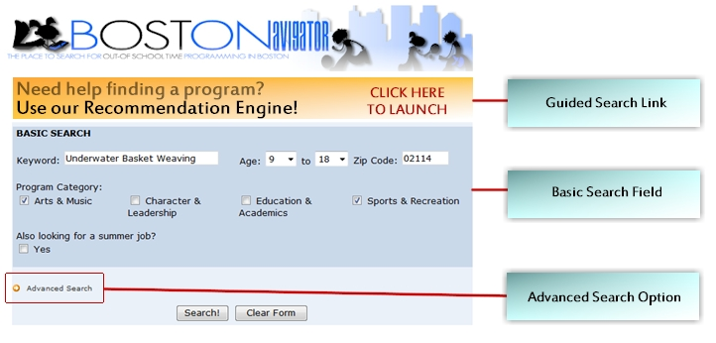
Figure 1 - Example of New BOSTONavigator Layout

Recommendation#4: Modify the Basic Search Engine
The current search engine is composed of 3 fields: Zip Code, Age, and Program Type. Only one option can be selected in each of those fields. The fields limit the user to search only within one program type or age level. As a result, we have a designed a new format for the basic search that will increase the number of results per user. The new basic search contains the following fields:
Table 12 - Basic Search Fields
Field | Description
Keyword | A text box that allows the user to query the database by keyword.
Age | Two drop-down boxes that allow the user to select an age group, as opposed to the current design that only has one age.
Zip Code | Field that allows user to enter zip code.
Program Category | Based on the ACES framework, these are the four general search categories. The boxes are checked by default, leaving all options available to the user if he chooses to ignore this field.
Are you looking for a summer job? | This field serves as a filter. It will omit employment opportunity if unchecked

An example of the proposed basic search engine fields is shown below:
Figure 2 - Graphical Example of BOSTONavigator Basic Search

Recommendation #5: Introduce an Advanced Search
The user must also have the option of performing an advanced search, which is currently non-existent. The advanced search would allow the user to get very specific, tailoring the results closely to one’s needs. The following fields would be included in the advanced search:
Table 13 - Advanced Search Fields for BOSTONavigator
Field | Sub-field | Description/Content
Location of program |  | A list of physical locations of programs would be displayed and the user may choose the location based on that list.
After school program kind | The subfields include the activities under their respective ACES framework category. | If the user has checked a program category in the basic search, that category’s subcategories would be displayed. Multiple program types may be selected.
Organization |  | The user has multiple choices of organizations.
Program Name |  | The user can select a program of interest by name of program.
Operator/Coordinator |  | User can look up a name of coordinator from a name list, containing the persons responsible for programs in the database.
Neighborhood |  | User has the choice of specifying the neighborhood(s) of preference. Useful because certain neighborhoods have multiple zip codes.
School | Query by school name, level, or school zone | User has the option of selecting his school of attendance. Useful when looking for programs that happen right after classes.
Date Span |  | Student can choose a range of dates in which he is available to work/attend a program
Gender |  | Student indicates role to filter for gender based events

Recommendation #6: Introduce a Guided Search
The last addition to the search engine is the introduction of a guided search, in which an adaptive algorithm asks questions to the user and presents the questions according to the user’s role. For example, if a user is a student seeking an educational program, the system would ask: “What subjects are you interested in?” The student would then choose an option from various subject areas, such as mathematics, English, history, and science, and move to the next question. However, if the person accessing the search is a counselor, then the system would ask: “In which subject areas does the student need improvement?” This question assumes that a guidance counselor has access to the student’s grades and would be able to make a recommendation to the student based on the student’s profile.
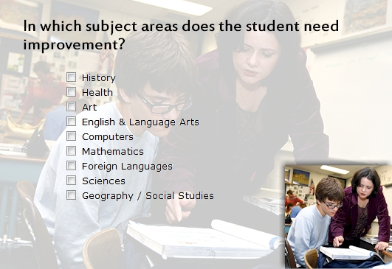
Figure 3 - Graphic Example of Different Roles
By making the structural changes outlined above, BOSTONavigator would reach its full potential as a search engine, ensuring that the user has various options when seeking a program. It also gives community centers, parents, and others the opportunity to use BOSTONavigator as a recommendation engine.

Recommendation #7: Improving the Current Searching Algorithm
BOSTONavigator would have little improvement if all aesthetic changes are made without revising its current searching algorithm. Currently, default entries, also referred to as null entries, are not correctly integrated with the query system. For example, a user that only fills the zip code field, while leaving the age field blank, would only see programs in that zip code that have no age group related to them (McMahon, 2008). Ideally, the user should be able to see all programs offered to all age groups, filtered only by zip code. This technical modification is necessary and extremely urgent because such flaws jeopardize the quality of the website, resulting in loss of user interest and reliance.

Recommendation #8: Include One-Time Events
An area in which BOSTONavigator needs much improvement is the catalogued content. To resolve this issue, a major modification needs to occur: the criteria for eligibility need to be altered. Currently, one-time events are not eligible to be catalogued (McMahon, 2008). Also, programs that are not supervised by the City’s staff are not logged, such as sports programs hosted by Boston Youth Sports Initiative (Stringfellow, 2008). We believe that those kinds of events and programs must be catalogued. Removing them from BOSTONavigator would decrease popularity of the website and would also fail in providing a thorough picture of all after-school activities in Boston.

Recommendation #9: Import Data from Youthservices.net into BOSTONavigator
In this section, the merging of our project’s two thrusts becomes very evident. BOSTONavigator can benefit greatly from the implementation of Cityspan’s system. As previously stated, a major issue with BOSTONavigator is the collection of data from program representatives (McMahon, 2008).
If a unified after-school system is implemented, such as Cityspan’s Youthservices.net, entering data into BOSTONavigator would be much simpler. Instead of requesting each organization to enter its own information, an export from the after-school program managing software can be simply imported into BOSTONavigator. That export would contain a list of all programs in the database, as well as information relevant to them, such as location, age group, date and time of occurrence, targeted audience, and any other fields that may be important to the user. Ensuring those fields are filled would be trivial, since they could simply be fields presented to program organizers when registering the program in Youthservices.net.

Recommendation #10: Contingency Plans
Unifying a system of such large scale, such as Boston’s after-school programs’ system, and its companion portal is a very difficult task in the City’s scenario. The reason is that both technologies are currently in their initial stages. Therefore, implementing changes to BOSTONavigator must be done in conjunction with the implementation of an after-school management system. If that is not the case, the logical scenario would be to implement the after-school management first, setting a basis for BOSTONavigator to merge the two systems. However, if BOSTONavigator is the first area tackled by the City, the module which integrates Youthservices.net and the recommendation portal should not be written until the after-school management software is first implemented.

Recommendation #11: Develop Incentives for Organizations to Use the new System
Another obstacle that may still be present after integrating all of the technologies recommended is ensuring that organizations may still choose not to use the after-school management system. Therefore, Boston must first ensure that organizations participating in the new information system are receiving attention by marketing after-school program performance after implementing Youthservices.net.
There must also be an incentive system in place to ensure that the organizations are contributing. Although this strategy is not flawless, it will aid in increasing the cooperation of different organizations. An example of an incentive tactic is to ensure that programs receiving grants from the City may have their grant revoked if the after-school management software is not being used. Community Learning awards may also be created. For example, certain smaller grants may only be eligible to programs that use Cityspan’s software.

Coordinating Community Learning
Since this initiative is headed by the mayor and encompasses all of Boston’s youth agencies and schools, it must be coordinated closely to ensure that progress is made.

Recommendation #12: Introduce a Community Learning Role in Boston
Another recommendation is to introduce a Community Learning role in the city of Boston. The Community Learning Director will have several obligations, including:
- Ensuring that programs are tracking their performance metrics
- Coordinating incentive programs for organizations participating in the Community Learning Initiative
- Ensuring provider interaction between Cityspan and the City of Boston
- Monitoring the success of BOSTONavigator
- Generating city wide reports that show progress in the Community Learning Initiative
- Developing specifications for modifications to the after-school management software
This person would gather information from all of the youth organizations. It is also the person’s responsibility to target programs that are not correctly using Cityspan’s software, and to ensure that they are fully aware of how to use the system. The following chart this director’s placement in Boston’s public service hierarchy:

Figure 4 - Organizational Chart for Community Learning Administrator

Recommendation #13: One-Card Implementation
In the future, we recommend that Boston make use of information integration by merging all of the current card systems in place. The best scenario would be one in which a single student would have a card that serves as a transportation pass, a school identification badge, a library card, a community center badge, and a discount card for local businesses. These technologies could be merged in various ways.
We believe that the best approach is to have a card that operates in three different technologies: a magnetic strip, a bar code, and a radio-frequency chip. These technologies are currently in use by different organizations and would allow for maximum interaction between the different entities while avoiding privacy issues. The table below outlines the different entities and their card systems:
Table 14 - Table of Card Technologies Used in Boston
Entity | Technology Used
 | Magnetic Strip | Bar Code | RF Chip
Massachusetts Bay Transportation Authority |  |  | •
Boston Public Schools | • | •
Community Centers |  | •
Boston Public Libraries |  | •
Boston Community Change | •

Deriving Social and Behavioral Correlations
As stated in the previous chapter, it is not possible to develop causality between after-school participation and academic performance. Unfortunately, due to the brief time limit of this study, we were not able to conduct a thorough analysis of this aspect.

Recommendation #14: Multiple regression Analysis
We recommend that, after implementing the systems, the City should conduct a multiple regression analysis to draw correlations between the academic achievement and the after-school attendance of the students. This type of analysis involves evaluating the impact of several variables on a specific attribute. Through this analysis, the level of impact that each variable has on the attribute can be viewed. For example, this type of regression analysis would analyze standardized test scores by observing the influences of all factors that may contribute to those scores, such as: social class, school choice, parent involvement, classroom performance, cultural background, and other variables.

Web Interaction and BOSTONavigator
It is eminent that new technologies are making their way into many aspects of American society, including government. Therefore, there are some aspects of City management that may soon follow the latest technological trends. BOSTONavigator is currently a catalog that enables users to search for after-school programs in the Boston area. However, it could be much more than that. Today, some of the most popular websites on the internet have its content managed by the users, not the webmaster.

Recommendation #15: Make BOSTONavigator an Interactive Website
This concept of web interaction and BOSTONavigator would be very innovative. We have developed a list of interesting features that may be worth considering in the future. This list is displayed in Table 15, found on the next page.

Table 15 - Future Implementations for BOSTONavigator
Feature | Description
Most Searched Programs | Upon entering the website, short a list of most popular programs would be displayed
Recently Searched Programs | A different list from the one above. It displays the latest programs searched, generating pseudo-random suggestions to new users.
Rating System | Users would have the ability to rate the quality of programs they have participated.
Community Learning Impact Note | This feature would let each role (parent, student, counselor, etc…) know how important they are to Community Learning and how important the initiative is to the children.
Targeted Counseling | Certain parents may go to Navigator to search for programs that may target weak aspects of a child, such as poor school performance, drug use, violence, health issues, etc… This feature would include a section of how to approach kids when talking about difficult subjects, like the ones mentioned above. These sections would only appear when programs of that kind are sought.
Targeted Advertisement | Applicable when the City is trying to market a citywide event that may involve a targeted group. Events that related to the results of a query would be advertised on the sides or bottom of the results page.
Random Content Generator | To market programs, a banner that alters itself every time the page is refreshed may be placed on the main page.
Account System for Students | This would allow the student to create an account and save his previous information. Other features include:  - Immediate enrollment into programs  - Ability to see which friends are in the program you have chosen  - Receive newsletters and updates (if desired)  - Post projects, pictures, and reports  - Automatic recommendation system based on programs you have attended  - Program availability  - Calendar manager to avoid time conflicts of enrolled programs  - E-mail reminders of one time events
Account System for Guidance Counselors/Teachers | Similar to the previous feature, it would enable these roles to:  - Access the student's academic information, as well as after-school programs on the same screen  - Recommend after-school programs automatically, based on student profile  - Observe which programs have been associated with the improvement a student’s performance metric

Today’s technologies allow for the features listed above to exist. However, they are very costly and intricate. Therefore, we do not feel it would be feasible to implement them now for those reasons.
We feel that the recommendations made in this chapter will transform Boston’s after-school scenario and ensure that the Community Learning Initiative is successful. The next chapter will outline the impact of our group’s involvement in Boston.

Chapter 6: ConclusionS
In the final chapter of our report, we will explore the possible additions to our current recommendations that are not feasible or urgent at this stage of the Community Learning Initiative. We will also analyze the influence our project has in the Community Learning Initiative and it how it plays a key introductory role to this five-year plan.

Reaching Full Potential with Boston Youthline
One of the organizations that would benefit directly from improving BOSTONavigator would be the Boston Youthline. Once BOSTONavigator is working at the desired level, this organization will be able to use it on a daily basis to recommend programs to students who call the hotline. Also, BOSTONavigator will play a key role in helping students that are looking for employment.

A Data Driven Government
It is important to notice that the recommendations we have made from both sides of the project interact symbiotically – the program side creates the framework for the youth side to provide users with a catalog of after-school programs offered around Boston. Also, if our recommendations are implemented, we believe that Boston will be one of the pioneers of data-driven policy making. Currently, a process-based policy-making strategy is being used in Boston’s government. Process-based policy involves creating one-time studies concerning a specific issue or topic. As a result, the data gathered is stagnant and future reports of the same kind cannot be retrieved instantaneously. The ability to create reports easily and quickly will provide the policy makers with the capability to make decisions based on the current scenario, instead of forecasting a situation.

Visibility
Perhaps the most important aspect of WPI’s involvement in this project is an element that does not require deliverable outcomes. The mere fact that we have managed to interview most of the City’s organizations has sparked interaction, interest, and awareness about the Community Learning Initiative. Therefore, even if our exact recommendations are declined, the organizations responsible for youth involvement in after-school programs see the need to integrate technologies in a uniform manner. We have seen that the issue of communication between these organizations is a primary factor of poor decision-making. Therefore, by gathering the information on this report and introducing an analysis of the current scenario in Boston, we believe that our group has contributed immensely in advancing the Mayor’s proposition to improve after-school programs in Boston.

Impact and Social Implications
The City of Boston is Massachusetts’ largest urban center. Implementing an initiative like Community Learning is a task of enormous grandeur. Thus, our group’s recommendations have an impact in various levels of the City. Primarily, we have affected all of Boston’s youth organizations, libraries, and schools, which make up a total of over two hundred entities. Consequently, the implementation of our recommendations will affect Boston’s 56,000 public school students, and over five thousand other students in charter and private schools who may participate in after-school activities within the City (District Profiles, 2008). As a result, the student’s parents will also be affected. At the same time, Boston’s Management Information Systems department has also been involved. Finally, the initiative was instituted by the Mayor, which connects our project to senior-level government officials and policy advisors who may also benefit from the recommendations we have made. It is clear to notice the depth and impact of this project. We feel that our involvement has been very beneficial to the Community Learning Initiative, and believe that it has provided the foundation for implementing this new citywide strategy.

Appendix A: Background of Organizations
The purpose of this section is to provide the reader with supplemental information about the major organizations that are listed within the project’s proposal.

City of Boston
The City of Boston’s government was first incorporated as a town administration group in 1630. It later became a city government in the year of 1822. In the present, Boston has become one of the country’s most well-known urban centers (City Government, 2008). Though its development is largely a result of its government, Boston is also noted for its diversity and culture. Boston’s current leader is Mayor Thomas M. Menino. He has served four terms in his current position since his election in 1993 (Biography of Mayor Menino).
Mayor Menino has coordinated many changes around the city, such as the completion of a major reconstruction of Boston’s traffic system, known as “The Big Dig.” Menino has also succeeded in lowering crime rates and violence in Boston, Massachusetts’ capital. An event Menino assisted in bringing to Boston was the Democratic National Convention of 2004 (Biography of Mayor Menino). He has also announced a series of initiatives to enhance the quality of life in the Boston community, including the Community Learning Initiative for children and youth in the Boston area – which our project is geared toward (Jacobs, Oates, Kurland, Breining, & Carrera, 2008).
One of the city government departments that will play a main role in accomplishing our mission is the Management and Information Systems Department (MIS). The MIS department provides and manages hardware and software information systems and technologies that enable City agencies to accomplish their respective technological missions.
See figure A-2 for organizational structure of the City of Boston

Boston Public Schools
The Boston Public Schools (BPS) was the first public school system in the country (Boston Public Schools, 2008). The BPS has improved greatly in recent history, having previously been listed as one of the less acclaimed systems in the country (The Boston Public Schools at a Glance, 2007). Currently, the BPS is one of the most commended public school systems, having won the 2006 Broad Prize for Urban Education (Boston Public Schools, 2008). Since 1647 when the BPS was founded, their goal has been to help the children of the city. Their main mission is to prepare all the students to perform well in school by having exceptional teachers and engaging the community to support the children. However, even with their improved performance, the BPS still struggles with low average standardized test scores (The Boston Public Schools at a Glance, 2007).
The BPS attempts to provide the children with many different opportunities. Within the system there are almost one hundred and fifty schools, and there is an application and priority process which allows students to number their school choices within their district (Boston Public Schools, 2008). Although they may not receive their first choice, the various options allow for potential optimal education. The BPS also attempts to provide students with many after-school programs including the BPS DELTAS (Department of Extended Learning Time, After-school, and Services) About BPS Deltas This service allows students access to programs that will permit them to develop their education outside of the classroom. BPS works with several different agencies to keep the children active and attempt to enrich their education (The Boston Public Schools at a Glance, 2007).
See figure A-3 for hierarchical structure of the Boston Public Schools.

Boston Public Libraries
The Boston Public Library (BPL) was the first publicly funded library in the United States. On April 3rd 1848, John Quincy, mayor at the time, signed an act for the City of Boston which created the BPL (The Boston Public Library, 2008). The library has significantly grown since its creation in 1848 and currently has twenty eight branches (Boston Public Library Branches, 2008). The headquarters of the BPL is located at Copley Square and is a combination of two buildings. The Johnson Building, which is the headquarters of the two, contains the circulation collection of the general library holding 6.1 million books. The other building is the Mikim building which holds Boston’s research collection and 1.2 million rare books and manuscripts (The Boston Public Library, 2008).
Besides books and research material, the BPL also hosts many events and book review groups. Typical events at the library encompass topics from history to literature. The twenty eight surrounding branches are located around Boston, as seen in figure A-3. Each branch has its own distinct features, from the resources available at the library to the building’s design (Boston Public Library Branches, 2008).
See figure A-1 for a map of the Boston Public Libraries.

Boston Centers for Youth and Families
The Boston Centers for Youth and Families’ (BCYF) maxim is to enhance the quality of life for the residents of Boston through a variety of programs and services (Key Initiatives, 2008). To accomplish this goal, they have many initiatives that help to serve the public. The initiatives that they have been working on include ACES (Arts, Character, Education, and Sports), GIRLS (Growth, Intervention, Respect, Leadership, and Support for girls), and the Streetworker Program (Key Initiatives, 2008).
ACES has been designed to provide a City-wide program that is structured more competently than the previous programs were, as well as meeting the needs of the single communities through the Art, Education, and Sports programs. The GIRLS initiative was created to provide programs for the young women in the City of Boston, emphasizing the girls with the most needs. The goal of the Streetworker Program is to reach out and connect troubled youth with much needed resources and services. This program was established in 1990 and since then has been acknowledged with national and international praise for its effectiveness (Key Initiatives, 2008).

BOSTON YOUTH FUND
The Boston Youth Fund (BYF) has made it their goal to provide a quality work experience, as well as some monetary compensation for the work of the individuals that they hire. They are responsible for providing job opportunities in the communities and local businesses to teenagers. These opportunities make it possible for the youth of Boston to find and explore different work environments and their talents, while simultaneously providing services for the community (Boston Youth Fund, 2008).
The Boston Youth Fund offers jobs to youth, hoping that they will discover skills that were previously hidden before getting experience in an environment that may become their future workplace. Hopeline is an application service that helps youth in Boston acquire summer employment. Boston Youth Fund’s main priority is to hire as many Hopeline applicants as they can. To be eligible for Hopeline, an applicant must be between the ages of 15 and 17and a resident of the City of Boston (Boston Youth Fund, 2008).

BOSTONavigator
BOSTONavigator is a database that is filled with information concerning Out-of-School Time programs that are available for the residents of Boston. The information is readily accessible through a search engine located on the home page. A search may be performed given one or more of the following criteria: the age of the child participating, an activity of interest, and a ZIP Code (BOSTONavigator, 2007). The database is constantly updated using data from BOSTnet and Boston After School and Beyond, with some support from the City of Boston website. BOSTONavigator is a new initiative that was recently released in October 2007 and is currently in its early stages (BOSTONavigator, 2007).
For a screen shot of the BOSTONavigator website, see figure A-4

BOSTON POLICE DEPARTMENT
The Boston Police department is the oldest official police department in the country, having been created in 1824 and formally initiated in 1838. It initially served the City in a very different manner by performing sewer repair and maintenance, street repair, and burial vault maintenance, in addition to police duties, resembling a unified Boston Department of Public Works and Boston Police Department (Boston Police Department, 2008). It now has the central mission of keeping the peace and security of the city.
The headquarters of the Boston Police Department has had four different locations thus far, starting at City Hall, then moving to 37 Pemberton Square where it remained until 1925. Its next headquarters was located at 154 Berkeley Street, where it remained until the most recent move to the new station at 1 Schroeder Plaza in 1997 (Boston Police Department, 2008).
The department has full in-house DNA testing capabilities as well as extensive technically advanced facilities, as a result of its relatively new headquarters building. It also has an advanced computer-based officer dispatch system allowing efficient distribution of officers to 911 calls and other emergencies (Boston Police Department, 2008). These are all common features of a well-funded, recently modernized municipal police department.

BOSTON PUBLIC HEALTH COMMISSION
The Boston Public Health Commission (BPHC) was created as a consequence of the Boston Public Health act of 1995. BPHC’s main concern is to promote and protect the health of the residents of Boston. In an attempt to accomplish this mission, the Boston Public Health Commission hosts a wide range of events. These are intended to protect the most vulnerable in the city as well as sparking knowledge regarding preventable injuries and disease. Typical events of this organization include lobby days for HIV and AIDS (The Boston Public Health Commission, 2008).
See figure A-5 for organizational structure of the Boston’s Public Health Commission

ORACLE
Oracle Corporation was founded in 1997 by Larry Ellison, Bob Miner, and Ed Oates based on the principle of creating and improving relational databases. Today, they are one of the leading companies in the market of database systems (Oracle's History: Innovation, Leadership, Results, 2008). Also, Oracle was the first software company to develop and deploy 100 percent internet-enabled enterprise software across its entire product line: database, business applications, and application development and decision support tools. According to the company’s statistics, Oracle is one of the world's leading suppliers of software for information management, and the world's second largest independent software company. For the scope of this project, the division of Oracle that plays the biggest role in our research is the Oracle Insight Program (Oracle's History: Innovation, Leadership, Results, 2008).

Oracle Insight Program
According to the company, the Oracle Insight Program strives to help organizations that are undergoing critical challenges. The program is designed to identify problems their clients are facing and subsequently help them develop feasible, practical and affordable solutions (The Oracle Insight Program, 2008). Based on customer’s need and objectives, the Insight Program conducts time-to-benefit analysis and high-level implementation plans, in order to work out the best practices and solutions. This program allows the customers to work closely with the Oracle Insight Program team, which helps the customers fully understand the technology side of the solution. According to Oracle, the Insight Program is most useful for organizations who wish to transform and move ahead of their competition. The Oracle Insight program can be applied to various industries from areas such as high technology, life sciences, industrial manufacturing, professional services, financial services, and retail. The insight program will be the division of Oracle involved with this project alongside Worcester Polytechnic Institute and the City of Boston (The Oracle Insight Program, 2008).

Appendix B: Interview Questions

Overview
This portion of the Appendix contains the questions that we asked during our interviews. The first list of questions is what our group asked City Span, one of the possible solution providers. The Interview questions for all other service providers were extremely similar to this list and may have varied only slightly. The next list of questions is typical for an interview we had with one of the various organizations of Boston. These particular questions are from the interview we had with Amy Reid and the BCYF.

Interview Questions- Possible Database Solution
- Please describe your system from a youth’s perspective. A teacher/guidance counselor’s perspective.
- What type of data base do you have? Who collects the data? How they collect the data?
- How user friendly is your system? Can the database be updated easily?
- How flexible is your system?
  - Can your package/solution be combined with custom software or software from other vendors?
  - If so, how does the interface work? Is there documentation on this available?
  - Do you export information that can be shared with other systems?
- Up scaling the system to include other organizations – how is it done?
- Does every organization need to have your software in place, or is it something accessible through a website? A front end website that uses the database.
- Are there any methods commonly used to keep program signup synched in an online program database?
- Is there a case management system in place?
- Is your system used in budgeting committees?
- What statistical and/or behavioral capabilities does your system offer?
  - What kind of programs can be processed by this software? Periodic? Non periodic? What kinds of periodic schedules are available (yearly, weekly, x day of month, nth Friday of month, etc)
  - Comparing test scores/academic performance with after-school organization attendance
  - Are there other metrics for performance in after-school programs in place?
- What kind of reports can we derive from it?
- How is data related to participation and other attributes integrated into the system? How is it updated and who updates it?
- How do kids use your system? Is it used to store after-school information for parents and students?
- Do students need to create their own profile? Do they need to log in?
- If there is a website, how does the searching system work? Is there any advanced search options available?
- Is there a technical liaison available at all times for support?
- Is a one-card system part of your technologies?
  - How integrated is it? Who is involved?
  - What are the legal issues? How were they overcome?
- What were some of the legal issues you encountered in these cities?
- How did you get around some legality issues? What issues can’t you get around?
- Which cities have the most customized system? How does their system work?
- What are the low-budget scenarios you have worked with?
- If the systems are different between schools and after-school departments, how do you integrate them without changing their current data system?
These particular questions are from the interview we had with Amy Reid and the BCYF.

Interview Questions- Youth Organizations
- What kinds of activities are provided to the youth? How many do you offer?
- What are your most popular programs? Have any been discontinued and why?
- What kinds of reports are being used to determine success of programs at BCYF? Are there any reports for youth performance?
- How are people usually referred to come to the BCYF? What are those first timers usually looking for when they come?
- How does a new program usually get created and how do they market their new program?
- Is there any referral system in place that advises certain kids to take certain programs to improve their weaker attributes?
- What information would you like from the library, schools and other organizations to make correlations? Are you currently receiving any data from other organizations? Are there any studies for current correlation?
- What information do you typically collect from new attendees of some of these programs?
- How do your programs typically track attendance?
- What information from your system is significant to a policy advisor who is trying to measure how effective the library’s programs are?
- What information from your programs do you believe would be useful to the other organizations?
- Do you advise your entire program heads to post information pertaining to the programs on BOSTONavigator?
- In a broad sense what do you want the outcome of this project to be?
- Does the BCYF participate in updating BOSTONavigator?
- Are you concerned with any legal information of sharing of data relating to the BCYF?

Appendix C: Interview Summaries

Overview
This portion of the Appendix contains summaries of the various interviews conducted. These interviews provided our group with valuable data allowing us to suggest the best solution for the unification of Boston’s Youth Organization’s. The interviews are in chronological.
Interview Summary with Patty McMahon 113
Interview Summary with Clareann from CitySpan 117
Interview Summary with Koren from Boston Public Libraries 122
Interview Summary with Boston Centers for Youth and Families 125
Interview Summary with KidTrax 128
Interview Summary with the Boston Public Schools 134
Interview Summary with Boston’s GIS Group 136
Interview Summary with Paul (Oracle) Concerning Legal Issues 140
Interview Summary with Providence After-School Alliance 142
Interview Summary with Boston After School and Beyond 146
Interview Summary with Boston Public Health Commission 148
Interview Summary with L-360 136
Interview Summary with Cayen 150
Interview Summary With Louisville Representative 155
Interview Summary with Athletics Director for BPS 158
Interview Summary with Boston Youth Services Network 160

Interview Summary with Patty McMahon

Members of Our Group Present:
Vinny, Alvaro, Ken, Julia, Michele, Dave

Interviewees Present:
Patty McMahon- Boston’s Youthline and Mayor’s Youth Council Coordinator
Patty.McMahon@cityofboston.gov

Date of Interview:
March 14, 2008 at 2:00PM

Meeting Overview:
On Friday March 14, 2008 at 2:00Pm we met with Patty McMahon we outlined many different topics. The topics that were discussed ranged from the Mayor’s youth council, BOSTONavigator, and Youthline. Patty is very knowledgeable of the programs and initiatives that are occurring around her job, even though she is not directly involved with all of them.

Mayor’s Youth Council
The Mayor’s youth council is currently encouraging youth involvement throughout the city. They are part of GLOCAL an international organization that encourages students to participate. The Mayor also developed the Youthline to allow children to call in to find programs that they can attend.

Boston’s Youthline
This Youthline database has over 4,000 programs in it. The problem with it is it has not been updated in over a year. This is mostly because the BOSTONavigator database took precedence over it. The Youthline also provides a call in service, offering information on after-school programs and activities available to children of specific age. The Youthline is currently being told to use the database known as BOSTONavigator, but the Youthline volunteers know that the information on BOSTONavigator is incomplete. Instead, the volunteers give recommendations using their own experience with certain programs.

BOSTONavigator
BOSTONavigator has several of its own flaws including the absence of clubs, workshops, and other short-term or one-time only events in the database. Other problems are the website is not user friendly and organizations lack incentive to input the information into the database that is regarded as vital to the success of BOSTONavigator. Also, the search engine is difficult to use and discourages users, as the average time spent on the website is less than 10 seconds. BOSTONavigator was put together in a short period of time, which may contribute towards many of the flaws. Although the City of Boston receives information every month about BOSTONavigator, but the team that created the database is no longer in direct contact with the City of Boston.

Incentives for Updating
What Patty recommended was possibly offering incentives for the programs to enter data. Some ideas for incentives included: restricting funding, not giving out permits (for parks etc.), an ad on the website for timely updating, etc. She also mentioned a problem with health forms. A majority of the programs offered for the youth require health forms for the programs, but because the youth cannot always get to the doctor, or cannot afford to go to the doctor as often they do not have the opportunity to experience the after-school activities. Patty thought it would be a good idea if the city could hold onto the forms and tell the programs they have an updated form and they could be accessed at a time of emergency or when needed.

Program measurements
She also mentioned ideas for the programs, such as if all of the available spots are taken in the program, the over flow of students who are rejected should be referred to a similar program in a close vicinity to the original one. This should encourage participation throughout the after-school programs. Also, measuring the effectiveness of programs, we have to look at a variety of factors. Some of the ideas we had were like the restaurant rating systems and pre/ post evaluations for the programs.

Smart Card
The idea of a smart card system was also introduced. She believes this is a good idea and recommended incentives for the students to utilize this card. Ideas for these incentives included MBTA discounts, tracking community service hours for the students, other discounts, and or having a point system. She recommended looking into other cities to see how they got around the legality issues as well as what they did concerning a smart card system.

New System
She brought up many points when it came to the possibility of a new system. One was that tutors and other program facilitators should have access to the homework websites. They cannot help the children if they don’t know what they are supposed to help them with. Transportation was also very troublesome for the youth, if bussing could be provided; more students would have the option to attend.

Private Organizations
Patty also stated, that the YMCA’s and Boys and Girls Club and other privately owned organizations should be included to help reduce the problem of integration later on. If they are invested from the beginning they will feel more of a part of it.

Correlations
When correlations were brought up one of the ideas she thought we should explore was the link between the attendance in after-school programs and the attendance at school. She also suggested looking into what combination of programs, have a positive or negative effect on the students’ grades. If there was a steady correlation between these ideas there could be some analysis made from that. She recommended to us that talking to Vicky Stringfellow at Boston After School and Beyond would be a very good idea and she would be able to help us tremendously in our findings.
See Appendix E for Patty’s Boston Navigator Wish list

Interview Summary with Clareann from CitySpan

Members of Our Group Present:
Vinny, Alvaro, Ken, Julia

Interviewees Present:
Clareann Grimadi- Sales Representative
clarann@cityspan.com

Date of Interview:
Tuesday March 18, 2008 at 2:00PM

Meeting Overview:
During the interview with Cityspan we found that they have a complex database that is set up so all organizations involved in the city’s after-school programs can type in their information into their own particular organization’s database. Then the organization as a whole decides what data collected from their individual programs will be shared with other programs.
The Cityspan system is very user-friendly, and all the information relevant to specific programs can be accessed and updated through the system. Also, the system has the ability to easily collect performance metrics such as attendance, and possibly enrollment.
In San Francisco they wanted a front end online site that marketed the programs to the students. Cityspan does not run the user side but rather they have the ability to export the data from the system to various contracting companies that have experience doing the marketing site.
San Francisco had contacted Cityspan for a quote on the time and money it would take to implement this system, but Cityspan was not picked as the primary candidate to build their system
In terms of a case management system there is a system that records Medical records of students. HIPAA (Health Insurance Portability and Accountability Act) is the act that controls the sharing of medical information, the people working with this act need to be contacted to discus legalities in sharing medical records. This is the only way to get the information concerning the health of the youth to be able to be shared on the system.
Cityspan is also used in budgeting and funding of various programs. They are also available to do many statistical and behavioral comparisons with the information that they collect. In some complicated legal cases Cityspan will aggregate the collected figures for specific organizations and then send it to the organizations requesting the information.
A variety of reports can be created from the database, but no graphical reports. To make graphics the information needs to be exported to an excel spreadsheet and graphed through excel. Caralann stated that they are the type of company that anything is possible. The system is very flexible and can be customized to whatever fits Boston’s ideal system. This might not be worth it seeing that without customizations making a graph with the data Cityspan sends out, takes minimal time.
There system is capable of tracking attendance in a two different ways:
  - Smart cards/ barcode scanner
    - Using a smart card to identify the youth is quick and generates responsibility
  - Easily accessible attendance forms that the program assists in creating.
    - The attendance is updated by the program leaders or officials taking attendance.
Their system is more of a back end data gathering program as opposed to the front end Student-user. Each student involved has there own profile in the program, it varies on who enters this data. The profile is entered when the student enrolls in the program. The City of Boston would have to contract out the manufacturing of a website to a different company in order to create a similar site to BOSTONavigator.
Some keys of this company’s system and software are there is readily accessible support available. Their system is capable of a one-card barcode system to help track attendance.
There have been some legal issues Cityspan has experienced in the past revolving around data sharing systems. They have built systems that opt in and opt out of data sharing systems that have legal problems. This allows for organizations to share only the data they want everyone else to see. For example, in the City of Oakland Fender Program allows the police department to enter information about a student into the system once they have been arrested. This data is then referred to a variety of community bases after-school programs, telling them that this student should be focused on.
Other Acts permitting the sharing of information have been dealt with by allowing the information to be withheld. For example, FERPA- parents allow data to be shared amongst community based organizations. Philadelphia (PASA) shares grade and service. As well as, HIPPA- which deals with agreements in terms of medical information shared. Also, Organizations are the only people allowed to see individual data, but in terms of the state looking at the data, the information is aggregated.
Providence after school alliance (myprovidence) has been very successful in implementing the system that Cityspan provides. Elizabeth Devaney, who works in policy, sees kids go across all the different entities of life. It was suggested to contact her in hopes to avoid any pitfalls involved in integrating this system.
City of Chicago’s database includes 170 sites and new agencies have been added to the database since its creating. The school systems have provided resistance when it comes to their information. In response to this, Chicago gave the data to youthservices.net and they provide the figures back to Chicago, aggregated (data export.) Data was exported in massive excel files or cf’s or ttp’s. Youthservices.net is capable of server to server xml transfers.
Providence has developed a slot system showing how attendance in each program is compared to the capacity of the program’s facilities. The most similar cities to our case include Chicago and Providence and they are both using the Cityspan software. The cities gather data from each of the organizations involved and compile it into the Cityspan software.
Clareann referred to the users in terms of three different thirds. This is in a sense of why the organizations leaders are entering their information into the database. First third thrives off database. Second Third does it just to gather funding “kick in pants group”. Last third needs more hand holding and technological background. All these thirds come together to make the groups that are updating the information system.
Some of the questions that were asked include the length and total cost to implement this system in the City of Boston. This project would be implemented in a short few months and would cost each site about $500 every year, without any customizations. The information servers are located on a server farm, and all the data gets backed up there immediately.
City of Chicago and Providence will be a model to us. The key in setting up a database like this is getting each agency into the room to develop their agency one by one, instead of having the all organizations involved in the room discussing all organizations at the same time.
What was also mentioned was Wallace Foundation initiative in Providence, DC, NYC, Boston, and Chicago. We have explored this initiative in order to view its relevance to our project.
See appendix A-14 for Cityspan’s screen shots

Interview Summary with Koren

from Boston Public Libraries

Members of Our Group Present
Alvaro, Ken, Dave, and Michele

Interviewees Present:
Scot Colford - Applications Manager
scolford@bpl.org - Scot handles our automated library system. He can provide aggregate statistics about patrons and the materials they borrow.
John Dorsey - Research Library Special Projects
jdorsey@bpl.org – John captures all of the library’s program statistics. He can tell you number of programs, program attendance, etc. He is also the person who provides our monthly stats to the city.
Ken Peterson - Coordinator of Services to Libraries
kpeterson@bpl.org – Works with all the members of our automated library system network. He also is the liaison to the statewide summer reading program.
Ruth Kowal - Deputy Director
rkowal@bpl.org
Koren Stembridge – Programs, Partnerships, and Youth Services
kstembridge@bpl.org – I oversee all of our youth programs

Date of Interview:
Wednesday March 18, 2008 at 2:00PM

Meeting Overview:
From the collective comments from Koren and her team, we gathered the following facts:
The library is not focused on obtaining specifics from an individual. Instead, it wants to be able to look at demographic information. Their system currently collects data on location and type of item, collection retrieved, borrower type (mostly age related), and zip code of borrower. Anyone in the commonwealth can get a library card.
In addition to their current reports, the library would like to look at graphics on aggregate data including: traffic times, racial and demographic data. They would like “the who” to be disconnected from the information for privacy and legal reasons. The library needs to be as private as possible. Book borrowing data is removed as soon as the book is returned for privacy reasons. The library would want all data to be anonymous for their own databases to avoid privacy issues.
Attendance is the only performance metric they use to track their students. To them, it is a fairly solid metric to measure program success. Attendance is usually taken as a head count and then entered into the computers. However, data on attendance must be hand transcribed, as the module that exports reports is not properly working currently. Gate counts are also taken everyday in respect to each library. They don’t collect information on individual programs for the reports. But they might be scared of that information because it might be used to kill programs that might not be used as well.
The state asks a list of questions to the library regarding their programs. Those are listed in the BAR (Boston About Results). It develops performance targets and displays your performance to the rest of the City’s organizations. Its purpose is let you know if you are on track to reach a goal. However, results are not usually entered for some events until they end. So BAR negatively portrays that initiative as not meeting the target for most of the year, until it is finally updated. Therefore the report would better be divided if there was a way to divide events monthly, quarterly, etc…
When it comes to BOSTONavigator, Koren is the only one updating to the database. However, all of the reoccurring activities are already in Navigator. The big gap is with the non-reoccurring events. Estimated 10,000 – 11,000 programs are not recorded in the Navigator database. The interface to upload the information is very complicated.
There is an interesting distinction between libraries and after-school centers: it is not listed as a place where unattended children can stay, though it is not a problem as long as no one causes trouble.
The following are the most popular programs and their respective age groups:
Table 16 - Most Popular Library Programs
Age Group | Program
Younger Children | Performers
Older Children | Media and Technology Related Events  Arts and Music
Teenagers | Homework Help

Interview Summary with

Boston Centers for Youth and Families

Members of Our Group Present:
Vinny, Michele, Dave, Julia

Interviewees Present:
Amy Reid- Director of Planning and Development
Amy.Reid@cityofboston.gov

Date of Interview:
Thursday March, 29 2008 at 2:00PM

Meeting Overview:
On Thursday March 29, 2008 at 2:00PM our group met with Amy Reid of the Boston Centers for Youth and Family. These centers budget is roughly twenty-two million dollars for program planning and development from the city of Boston. Each individual center also has its own developed fundraising program which varies greatly from center to center. The total of all the extra fundraising amongst all centers amounts to 10 million dollars a year.
In terms of the development of the community centers, majority of the centers do not use computers to track attendance. The program participants sign in and sign out on paper which is then documented by one person onto a computer. Out of all the community centers, five sites still do not have internet access, while other centers have active websites. This means that there is not an equal distribution of IT personnel. The only data available is attendance, which is also the only data they require. BCYF publicize their programs and opportunities via city website, brochures, papers and posters. BCYF has started to use Dashboard to track participation this year. They have not found a way to evaluate all of the programs on the same level.
There are many areas the BCYF wants to develop as a result of this initiative. One key focus is improving the attending tracking method currently in place. Presently, the BCYF staff needs to manually input information from the massive and unorganized paperwork that they collect. The way BCYF processes information is also extremely slow. For example, for some programs once the information on the program is put into BOSTONavigator the program is already complete. Many programs that are being run at the different community centers are not getting onto BOSTONavigator. Moreover, according to Amy, many community centers’ staffs are not technologically savvy.
BCYF’s aim is to work on changing youth’s attitudes during the programs that they are providing. Amy does not think that BCYF could take credits if students’ grades go up because they participate in their out of school programs. BCFY also provides a wide selection of programs serving from age zero to seniors.
There are several challenges BCYF is facing. They want a way to track enrollment, participation and measure performance easily and effectively through documentation of pre and post tests, and they want to see all different BCYF’s projects can be coordinated into one consolidated database. Amy mentioned Kidtrax as one example of a good system that could help BCYF to process information more effectively. According to Amy, BFYF would like more information regarding to demographical statistics.

Interview Summary with KidTrax

Members of our Group Present:
Vinny, Alvaro, Dave, Julia

Interviewees Present:
Liatt Bailey- KidTrax Sales Representative
LBailey@nFocus.com

Date of Interview:
Tuesday March 25, 2008 at 2:00PM

Meeting Overview:
On Tuesday March 25, 2008 at 2:00 PM our group had a conference call with Liatt a representative of the company nFocus. Liatt had much valuable information that proved itself extremely important in our final analysis of this company’s product, KidTrax. Liatt claimed that Kidtrax, part of the TraxSolution’s, has been the only service provider to capture attendance with barcode and scanners. This system connects and combines all after-school records with in-school information. This allows for the adults who are working with the youth to have a complete overview of what aspects the youth is excelling in and struggling. Programs, communities, and parents are brought together as a result leading to a better experience for the youth.
KidTrax’s approach has always been operational and strategic. Children between the ages of 5-18 spend only 35 percent of their time awake in the classroom. This application helps the groups and parents find out what the youth does with the rest of the time and to build after-school organizations around it. Also it will let you know if a youth should be involved in more activities to help broaden his experience. Liatt claimed that KidTrax is “Only one in the market who has a successful model that has been implemented” but we are skeptical of this statement seeing that have talked with representatives of Cityspan and Oracle Learning 360.

Key features offered by KidTrax alternative:

Surveys:
The KidTrax software is the only application with a built in survey model. This allows for an attribute categorization to be applied to the programs. Some surveys and evaluations are currently being utilized by some of Boston’s after-school activities. These are currently using a service called Survey Monkey which is an online blog type survey. This makes utilizing the data gathered extremely difficult and the survey almost useless. The Survey manager makes it easy to create and manage various surveys for all organizations.

Statistical correlations:
This application offers a large quantity of different reports measuring the progress of the organizations. The various reports are designed to handle the numerous wants and needs of different programs. The tests vary, by reporting different statistical correlations for the specific goals of the organization. An example includes that it can compare after-school participation with grades. nFocus, who created TraxSolution’s, reports this data in a variety of forms including tables, pie graphs, and bar graphs. Reports allow government heads to track a programs success. To do this the application uses a drop down method allowing multiple methods of tracking student’s attendance. If you know a child’s demographic, age, participation and grades, this allows for small changes to occur to improve the system of education and youth development. Most organizations use about 10 of the immense amount of reports to relay the data. There are filters that can be applied to generate specific reports if you do not want certain information involved because of privacy issues. Reports can show aggregated data as well.

Security Issues:
We all know nothing is ever 100% safe, similar to the internet, but TraxSolution’s have implemented everything they can to protect all information on the system. The United States Army uses the same program to protect the information of 2 million soldiers.
Security levels in the system are like a funnel, the people higher up get more privileges on the application. Certain people are allowed to view the usability roles of all others, pending on what position the person is.

Family Tracking:
Before you put any new person into the system a search is performed to make sure no duplication is done inside the system. In terms of what is tracked on a family. The system includes not only information pertaining to brothers and sisters, but also parents and even grandparents.

Usability Resources:
This support system is unlike any other. KidTrax offers an online user manual database, call in service, live online chat resource, and 12 free online training sessions per week. In terms of their support employees, they are paid in terms of the survey results relating to their performance. This proves that their resources act knowledgably and perform at their highest ability.

One Time Events:
One time events can go in the system there are a few ways they can do it. He would like to start capturing more from one time events in terms of attendance and participation.

General note system:
There is a general note section which allows for notes pertaining to individual student to be gathered. These notes are not confidential. An example of a general note includes a note of a bruise on a student’s body this will help make sure the bruises do not become a regular occurrence. A positive example includes a girl who sells the most boxes of Girl Scout cookies. This would allow all the staff involved in the students’ programs and school to compliment the girl on her achievements.

KidTrax tracking system includes the following:
- User define code:
- Zip code, UDC, (pick up notes, picture, identification, size)
- Contact status, school family, emergency, UDC enrollment

Miscellaneous Features:
Tracking ID capabilities follows all ID’s such as licenses, library cards. This tracking ID ties all of them together. There is the ability to track size and such in terms of clothing needs. There are mailing options directly threw the system. The reports are capable of being manipulated. This allows for the data to be exported into different files just for whatever the preference is of who’s using the data. The database can be utilized online; however the organizations that need to take and input attendance require having the software at their program. There is the ability to customize ID cards on the application.

Examples of past work:

Past work with libraries:
They have worked with libraries before in California, but they do not have compatibilities for an asset tracking section. They are capable to integrate with other databases such as the current library system in place.

Example in Louisville:
Three years ago the city’s school identified a group of teenage girls who were ready to fail out of school for English (16% of the girls). City said regardless of what traditionally happened they were going to implement more English tutoring sessions. The city was able to recommend the girls to the program because they could view their grades in the database. This cut the number of possible failing students from 16 percent down to 8.
In terms of getting over legal issues that come with the database, Louisville used FERPA forms. In the past five years there were only two parents who said the City couldn’t share their kids’ data in Louisville. Parents traditionally sign because they want anything that can help the positive progress of their kids. They had a lawyer involved when putting this system in place to make sure all the T’s were crossed.

Possibility in Boston:
Boston’s probably the only city in the country ready to replicate the database currently in Louisville. This is because 22 BCYF centers already use KidTrax software, 16 of the current high schools use it. Ultimately the City currently has everything in place; a funding source, the mayor’s support, and collaboration from all the organizations. Liatt has been in contact with Christine Ivension from Boston Public Schools. In terms of price round about, nFocus are expensive and said they will be the most expensive in the market.

Steps to implement it in Boston:
Step One-Set up the database to mirror terminology amongst all organizations
Step Two- Walking threw what data Boston is going to collect. How can Boston use it?
Step Three- Use this data to provide appropriate funding and organizational decisions.
See Appendix G for screen shots of KidTrax Alternative

Interview Summary with the Boston Public Schools

Members of Our Group Present:
Alvaro, Michele, Ken, Julia

Interviewees Present:
Shamil Mohammed- OIIT Data Center Director
smohhamed@boston.k12.ma.us

Date of Interview:
Tuesday April 1, 2008

Meeting Overview:
On Tuesday April 1, 2008 at 3:00PM our group held a conference call with Shamil Mohammed with the Boston Public Schools system.
The Boston Public School System is looking into a universal card system with the MBTA (Massachusetts Bay Transit Authority) and the Boston Public Library. The MBTA and the schools are going to pilot a card that acts as a student identification card and a pass for the MBTA. This card will avoid legal issues based on the way it is being created. The MBTA will preprint the cards and give them to the schools. The schools will then print their IDs on the other side. When the card is used, the MBTA will recognize the card as a student pass but will not know which student it is. This anonymous use of the card is important in keeping the confidentiality of the students. The school department believes that a one card system is the future of the public school systems.
Ideally, the school would like one system that supports all of their needs. This includes attendance tracking and storing other data. The school would like to be able to view aggregate reports of data based on MCAS scores and other grades. They also would like to create an early warning system that will allow the school to see which students are at risk for dropping out. This system includes a decrease in attendance, suspensions, and other signs that a child may be in trouble.
The BPS recommended that we talk to the After-School Programs Coordinator as well as the Sports Coordinator for the school system. These people are in charge of organizing the after-school programs and could give us the best insight as to what the after hours programs need. BPS also recommended we research the company Cayen, as that is software that the school system currently uses. They also stated that Miami-Dade, Philadelphia, Fresno, and New York City are model cities for the development of a unified system.

Interview Summary with Learning 360

Members of Our Group Present:
Vinny, Alvaro, Ken, Julia, Michele, Dave

Interviewees Present:
Greg Lynch- Produce Development Director L-360
Carl Swinson

Date of Interview:
Thursday April 3, 2008 at 8:00PM

Meeting Overview:
During the interview with Learning 360, we learned that the system is intended as a platform, and is not specifically targeted at the after-school sector. It is designed as a single “point of truth” which can be handled by everyone involved in the school system, including parents, children, administrators, policy makers, teachers, and counselors, and has a high level of security configuration to allow for compliance with laws such as FERPA. Its intention is to put information back into the hands of the right people, when they need it. For policy makers, it allows information to be used as evidence for changes to be made, or evidence for the success of changes already made.
The system was designed with policy advising and auditing in mind, and has at its core an advanced data warehouse. The warehouse was designed so that it could be personalized for each student, allowing both individual and aggregate trends to be tracked. Its implementation was started in response to a global trend in the K12 market that Oracle saw, namely, the individualization of education. It was designed with a hope that it would increase parental involvement in the educational system, and keep children busy with something during the after-school hours, whether it has academic value or not. The system was built with the knowledge that assembly-line teaching styles do not work well for the gifted and lagging students, leaving them either bored or struggling constantly to keep up. It allows teachers to give qualitative feedback about individual students so that other teachers (and the students and parents) can see what their perceived strengths and weaknesses are, and individualize education to help improve the learning process.
The system does not allow for attendance tracking or enrollment, but does have a partner application that handles recommendations. The user interface is quite user friendly, though the hub is the only portion that has been used in NYC. The general method of adoption is to find the early adopters and those actively looking for a system similar to L-360 and configure it for them first, then gradually add other groups of users as the system installation matures. The system was designed to allow different capabilities to different classes of users.

Interview Summary with Boston’s GIS Group

Members of Our Group Present:
Vinny, Michele, Dave, Ken

Interviewees Present:
Claire Lane- GIS Manager for the City of Boston
Claire.lane@cityofboston.com
Carolyn Bennet- GIS Group for City of Boston
Jim Alberque- GIS Group for City of Boston
Swaran- Census Data Specialist for City of Boston
Allah-GIS Group for City of Boston

Date of Interview:
Wednesday April 2, 2008

Meeting Overview:
On Wednesday April 2, 2008 at 1:30 our group met with the City of Boston’s GIS Group. A few weeks prior to this meeting our group had emailed them a list of various GIS maps our group was interested in creating. This meeting was to follow up and figure out what data is needed to create these maps. Swaran was the man who was in charge of census information, and he said he could get us data pertaining to family income, race, and employment information. One issue that arose was what time frame our data should focus on, specifically pertaining to crime rates. We came to an agreement that the best data would be the most recent, but all the data on the specific maps needs to correlate with each other and be from the same time period. Crime rates also stirred up another question, asking what type of crime are we looking for, and do we want it by location. We asked for all data pertaining to crime, so our group could then figure out the different correlations on our own and use it for our data. For example, this data will aid in the comparison of crime rates during the time period out of school for an area with high drop out rates, with the crime rates of an area with low drop out rates. One room for concern is dealing with the various schools where the attendees do not live in that particular area for example Roxbury Latin. When we get these maps they will be .pdf files so we can use them on our report and presentation. These maps will be completed by the 15th of April because Allah went on vacation.
See Appendix H for the final GIS Maps

Interview Summary with Paul Laurent (Oracle) Concerning Legal Issues

Members of Our Group Present:
Alvaro, Michele, Ken, Julia, Vinny, Dave

Interviewees Present:
Paul Laurent- Legal Specialist at Oracle
Paul.laurent@oracle.com
Chris Breining- Director Oracles Insight program
Chris.breining@oracle.com

Date of Interview:
Monday April 7, 2008 at 2:00PM

Meeting Overview:
On Monday April 7, 2008 at 2:00PM our group had a conference call with Paul Laurent from Oracle concerning the legal issues in this project. Paul went on to say that certain people involved in the professional development of the youth have access to student’s records. This is stated in the form 34CFR99.31 which Paul came across in his research. In terms of people such as guidance counselors having access to data pertaining to after-school participation of the youth, Paul wasn’t sure if this data was considered legal information and was going to look into it more in the next few weeks. Paul went on to say that FERPA only applies to stuff BPS touches. In terms of organizations that meet in the public school, usually the BPS gives a stamp of approval and claims liability when doing so. Some SAT tests and tutoring may take designation, pending on who gets “fire walled” off in the process. From Paul’s research of the current situation in Boston he has discovered that there is already some sort of waiver applied in Boston, but he wasn’t sure about the technicalities of it. Our group then asked Paul about legalities concerning health issues. Currently, there is usually volunteered health information that is provided by the parents to the school concerning diabetes and allergies. This information if volunteered can be entered into a database. Rooms for concern in the creating of this database, revolver around statements of security vs. the reality of security, we probably want an idea of the defining roles and how they will use the data. Chris said we should look into the ideal various levels of granularity. Overall this meeting was successful in gathering legal information and we decided that we should talk again after we speak with a representative of Louisville.

Interview Summary with

Providence After-School Alliance

Members of our Group Present:
Vinny, Michele, Dave, Julia

Interviewees Present:
Elizabeth Devaney- Director of Quality Initiatives
edevaney@mypasa.org

Date of Interview:
Tuesday April 8, 2008

Meeting Overview:
On Tuesday April 8, 2008, we interviewed Elizabeth Devaney from the Providence After-School Alliance (PASA). This organization has implemented the Cityspan system. In this interview we gathered a lot of information of on how they chose Cityspan as opposed to other systems and the benefits and disadvantages to this system.
Providence chose Cityspan because it is an easy to use system that requires little technical knowledge to implicate. This user friendly system allows people to track data easily and it can be accessed from almost anywhere, as it is tracked online. Another reason they chose Cityspan is because several other after-school programs in Providence already were using the Cityspan system and the integration process would be easier. Cityspan also easily integrates, with other systems and can easily export data. PASA also chose this system because it liked the layout. It allows programs to be viewed individually, as well as all programs city wide. PASA also was not interested in using a one card system. Although Cityspan does offer a card system, it is not a necessary feature of the system. All of these options combined, are the reasons Providence chose this system.
There are thirty licensed sites currently in Providence. All of the programs enter in their students and they can view what programs they are enrolled in within their organization as well as their contact information. There are many different levels from administrators to volunteers. The different access levels ensure the privacy of the students’ information. Volunteers can only view attendance sheets while administrators have access to all of the information. Another method that is used to ensure security includes making all employees to sign a memorandum of use. This outlines the confidentiality of the users and informs the employees of how they can use the information they have. Every employee has their own password. The website portion of the Cityspan system uses security similar to that of major credit card companies and is highly secure. Another way to ensure security is the students’ academic information is not stored in the after-school database; they are kept in the school system’s database. When a student signs up for PASA their parents are asked to sign a form that will allow PASA to be able to request academic information from the school for that child.
Providence uses this system for multiple reasons. They use it as a tool to track attendance, enrollment, dates, medical permission forms, and transportation permission forms among others. All of these different functions can be easily maintained and are stored in a central database that can be accessed by personnel with the appropriate administration level.
Reports can easily be made from the Cityspan system. The data can easily be exported and put into an excel sheet to create customized reports. Cityspan does offer the option of creating reports but it costs more money. All of the reports that can be generated can be broken down many ways including school, gender, and grade. The PASA program finds this is an easy way to generate reports and uses it frequently. They generate reports on a weekly basis for internal purposes as well as sending reports to the mayor, when requested. This system is useful because it reduces data duplication. All the students are enrolled in one database and are not counted multiple times if they are enrolled in several organizations. PASA also uses a different product that measures the effectiveness of programs. All of these features are used to rate the programs and to see how they should be funded.
Providence does not currently have a referral system for their programs. They provide all students with a catalog of their after-school events. A student can go through the brochure and discover what after-school opportunities are open to them. They have discussed putting this catalog online but feel that a hard copy is the best method, since not everyone has the internet. Also, permission slips need to be signed for various programs and it is easier for the parents to do this with the catalog compared to online.
Although PASA is happy with the implementation of Cityspan, there are some issues. One of the major problems is creating reports based in the past. Cityspan is a real time system and complications occur when trying to create a report on the past based on students transferring schools or students advancing a grade. Cityspan is aware of this problem and is currently looking into creating a data warehousing system that can store past data to allow these reports to be created easily. Another problem is having the program facilitators enter the data. To solve this problem, PASA has their staff track the attendance and other statistics personally.
One caution that they had with the system was do not over-customize in the beginning. Devaney stated that although some of the features are intriguing, it is probably best to wait and see what features are actually needed and add them later. One example was the behavior tool they added. Although the tool may be used in the future, currently it is not being utilized. She said to keep human capacity in mind because even attendance tracking is a lot of work.
PASA is currently looking into implementing another Cityspan product that manages grants. It allows programs to apply for grants online. Providence believes that Cityspan is an excellent system and have had no major problems with this system thus far. PASA also said that the implementation period was quick. It took less than a week to have all of the sites running with the Cityspan system. Although, they have taken several years to perfect the customization to tailor it to their needs, they believe that Cityspan was the best choice for them.

Interview Summary with

Boston After School and Beyond

Members of Our Group Present:
Vinny, Alvaro, Ken, Julia

Interviewees Present:
Vickie Stringfellow- Director of Knowledge Management
vstringfellow@bostonbeyond.com
Patricia McGuiness- Knowledge Projects Manager

Date of Interview:
Tuesday April 8, 2008

Meeting Overview:
On Tuesday April 8, 2008 our group met with representatives from Boston After School and Beyond (BASB). This interview was held with Vickie Stringfellow and Tricia McGuiness. Vickie claimed that this organization has a lot of turnover in employment; and she had only been working there for six months. The BASB does not actually provide the programs for the youth, but provides PSS (Partners for Student Success). What her particular position does is tries to formulate correlations from what data they have and provide new programs to areas that need them. They have set up a database for 10 different organizations focusing on involvement in after-school programs. The program they used to implement this database was created by a company called Cayen. Before they set up this database they examined a few other solutions but were convinced to use Cayen from external factors. Originally Boston After School and Beyond was working with the various other youth organizations in Boston such as the Boston Public Library and BCYF who all stated they would implement the same database. Unfortunately, after BASB put this database in the other organizations did follow through on there end. The ten programs that have the database in place said its working well, and the key function is attendance tracking. One complaint that they have seen is that there software offers too much. The people running the programs are either not technically savvy enough to work it, or do not have enough time. Vickie had suggested that our group met with representatives of Boston Youth Services Network (BYSN) and Boston Youth Sports (BYS). These two organizations have already developed a unified database between profit and non-profit organizations.

Interview Summary with

Boston Public Health Commission

Members of Our Group Present:
Vinny, Michele, Ken, Dave

Interviewees Present:
Michelle Urbano- Director Division of Adolescent Health Boston
Michelle_Urbano@BPHC.org
Jeanne Cannata
Jeanne_Cannata@BPHC.org

Date of Interview:
Tuesday April 15, 2008 at 10:00PM

Meeting Overview:
On Tuesday April 15, 2008 our group met with the Boston Public Health Commission (BPHC). The two representatives from the BPHC that our group met with was, Michelle and Jeanne. The BPHC currently offers a variety of programs aimed towards the youth and their development in health knowledge. The BPHC refers to these programs as out-of-school programs because they occur all school year as well as during the summer. The Boston Public Health Commission layout which is in Appendix A under BPHC shows the outline of this organization as a whole. There are six key focus points and divisions of the BPHC. The division that is most influential in our research and study is the Child, Adolescent and Family Health Division. This division of the BPHC hosts 7 key programs focused on developing health education which is outlined in Appendix A under BPHC. Peter Holtgrave, the director of Boston Area Health Education, also has the position designated to enter all information pertaining to these out-of-school programs in the current BOSTONavigator database. They also claimed that the current Navigator system needs to be revised to improve usability allowing for better visibility of these programs to the public.
Recently this health commission just put in a new database to track attendance and outcomes. This database is called Efforts to Outcome (ETO) produced by socialsolutions.com.
One of the programs offered within the BPHC had actually tried to compare grades with performance and attendance within the program. This program is called BAHEC/ Youth to Health Careers. This program educates and develops all youth interested in entering a career in health care. The leaders of this program have visibility to all the youth’s grades that are enrolled. In order to obtain these grades the BPHC just went to the Boston Public Library and asked for these grades.
See Figure A5 for layout of the BPHC

Interview Summary with Cayen

Members of Our Group Present
Vinny, Dave, Ken, Julia

Interviewees Present:
Jim Gibson
jgibson@cayen.net
Joe Cayen – CEO
jcayen@cayen.net
Steve Stanislawski
sstanislawski@cayen.net
Craig Husch
chusch@cayen.net

Date of Interview:
Wednesday April 9, 2008 at 2:00PM

Meeting Overview:
When talking to Cayen Systems representatives they showed up many aspects of the web-based software that they offer to cities such as Boston. We discussed some of the locations where Cayen Systems has been implemented and these locations included 34 states which include Kentucky, Connecticut, Nevada, and South Carolina. They have also been looking into expanding internationally to Australia and Puerto Rico in which initial discussions have occurred.
The system is excellent at observing what happens before and after the school day. It has primarily been designed for monitoring and managing the after-school scene in a simpler fashion. Cayen is a real-time system allowing all the users to report through the same system. The design of the system would allow the district officers in charge of the system to have the option of viewing all of the information for the city, also having the site officers capable of viewing the information pertaining to the site or location.
Cayen also has a registration function that collects all demographic information that is reported to the system. They also can show information such as a miscommunication about the room assignments.
Attendance can be taken many different ways including the usual way, sign-in sheet. Another way that attendance can be collected is through a card system, using a bar code which is attached to a user identification number. There is a third, new way to collect attendance with this system, which involves a finger-scanner. Your fingerprint is given an alpha-numeric code and every time you scan in the print and code is matched. There is a lot of interest in using the finger scanner as an attendance tracker, because it is very safe and very difficult to lose.
As with all the other systems they can provide a myriad of reports that can be used to make decisions regarding programs in the after-school scene. Correlations can also be made more readily regarding the exposure to after-school programs. Cayen also views participation pre and post testing and can compare this knowledge to grades in the classroom.
The Cayen system is very flexible when it comes to how you would like to design it. As for measuring metrics it observes the usual metrics but also has the option of having qualitative data, such as comments. The system also has the ability to produce mailing labels, rosters for field trips, and make surveys for the users to take.
When it comes to technical team and services that need to be provided for the users, they have some alternatives. They have a technical team supporting the system. This team has plenty of experience with the system, and they have a call in service by either email or phone, help can be provided. They also come to the site where they are implementing the system and train all of the staff in the use of the system as well as online videos to train new users.
They have a detailed search of the system for specific activities very similar to the BOSTONavigator site. The different types of sites can be customized for the libraries, and community centers. Depending on what the specific sites want and can handle specific options can be selected and deselected.
Boston After School and Beyond is currently employing some of this software at 10 different sites in Boston. There were a number of things that could have been used at these sites but are not because the specific sites felt that they would not be used and would be an unnecessary expense.
When discussing privacy of the system there are different levels of security throughout the system. The highest level is the District-level, which can see all of the information about the sites regarding the programs. There is also a site-level, which can look at the information about the specific site. Other levels can be generated, like a login for the guidance counselor so the counselor can make suggestions to the student for after-school activities. This is a very secure system and has an agreement that needs to be signed with FERPA for you to access this information. The site managers can subjectively enter information along with academics.
They also have a referral system that had caught our attention. This could benefit our project because part of our project is to help create a recommendation system to encourage participation in after-school activities.
Importing and exporting information can be done. For importing, the data can be put into an excel format the fields can be looked at and added to the database. Exporting is different, Cayen wants the users to be able to maintain and manage their own reports. So the reports that can be used are already in the web-based system.
One thing that was thoroughly explained during our interview was that this system is not one size fits all. Cayen is willing to do a lot of customizations for each organization. Customizations can also be done after Cayen Systems is done with the initial customizations. All these options available to the organizations can be added or discarded with no regard to time periods.
When it comes to data warehousing capabilities Cayen has a system that makes it easy. None of the information is deleted from the system when the student moves or is taken out of a program. So whether the students are active or inactive in system, they are never completely dropped form system.
Their attendance tracking system is very flexible. As was said before they can track attendance using Finger scanning, bar code, and many other options. If the city decides to go with one-card integrating the card with other community objectives such as transit or community change.
Cayen Systems has the ability to export a list of programs to update the external search engine on a daily basis. This is very important because this could cut out the mess of updating the search engine manually every time a program changes.
Cayen also gives us the opportunity to have any kind of event set up as an activity, whether it is a one-time, many week-long, or regular weekly events. Online Enrollment is possible with this system and is a supplemental capability similar to finger scanning ability.
See Appendix G for Cayen’s interface

Interview Summary With Louisville Representative

Interviewer:
Alvaro Soares

Interviewees Present:
Darrell Aniton – Director of Youth Services, Louisville Public Schools
Darrell.aniton@louisvilleky.gov

Date of Interview
Tuesday April 15, 2008

Meeting Overview:
Several years ago Jefferson county and the city of Louisville, KY wanted to connect school and after-school systems. They researched a few vendors and decided to use the KidTrax system. This decision was heavily influenced by the fact that the Boys and Girls clubs of Louisville had already been using the system. The non-profit brought a representative from KidTrax to Louisville, where a presentation was given and impressed the city’s education department.
Once KidTrax was acquired, the next step was to link the software to the data warehouse that the city had. This data warehouse hosts information about the 98,000 students in the city. To accomplish the merge, the city worked with local Information Technology students at local universities to develop what is known as the Connectedness Analysis Reporting System (CARS). CARS bridges the after-school information with the in-school data that is collected.
The city has also been progressive in the use of a card system. When a student enters the school system, he is issued a card which is used in the libraries, schools, and also serves as a discount card for public transportation. The community centers also offer their own card. The major reason for these two cards to be issued separately is because the card issued by the schools is more expensive, since it relies on other technologies. However, the student may use the school card in a community center without running into any conflicts. In other words, the student’s identifier is the same in both cards.
Cards are only issued when the parents have signed a waiver that addresses FERPA issues. This gives the organizations access to information regarding student test scores. However, an organization can only see the profile of a student who attends that organization. The organization in turn needs to sign a confidentiality agreement to be granted access to the information.
The academic information visible to the organizations includes mostly standardized test scores. They have chosen not to include student grades because they feel that teachers grade more subjectively and therefore may not give a fair assessment of the student’s potential.
Louisville’s major obstacle with KidTrax is that some organizations, especially the smaller ones, have difficulty in training their staff to use the system. This is because the staff may not be used to utilizing technology for managing programs. To help with this, KidTrax sends a training representative periodically to run help-sessions about the software and provide technical assistance. The KidTrax licensing in Louisville is done per organization.
The City of Louisville also issues grants every year to non-profits. The organizations that receive the grants must use KidTrax or they get their grants revoked. The group that has achieved the most success in Louisville is the “Everyone Reads” program. This program aims to bring all kids who do not read at grade level up to standard reading level within four years. Their goal is to recruit ten thousand citizens to help with the program. They are very close to reaching the ten thousand volunteer mark. They have used KidTrax to contrast student reading levels and report the results every year. They have been able to see a significant increase in the program’s performance after implementing KidTrax.

Interview Summary with Athletics Director for BPS

Members of Our Group Present:
Michele, Ken, Julia, Vinny

Interviewees Present:
Kenneth Still- Athletic Director for Boston Public Schools
kstill@boston.k12.ma.us
Wallace Johnson- Assistant Athletic Coordinator for Boston Public Schools

Date of Interview:
Wednesday April 16, 2008 at 10:00AM

Meeting Overview:
On Wednesday April 16, 2008 at 10:00AM our group had an interview with Kenneth Still and Wallace Johnson who are the Athletic Directors of the Boston Public Schools. They are in charge of coordinating all of the sports and records. They work closely with the permits department to make sure that the fields are reserved for the students in the after-school hours. They also are in charge of making sure that the students have a team to play on. They sometimes set up coops between schools to ensure that as many teams as possible can be made.
The athletics department of the school still uses paperwork for the most part as a way to communicate and store information. They have forms for everything from accident reports to sign up sheets. The reason they have not yet put most of this information on computers is that most of the forms require a signature. If there was a system in place that would allow for an electronic signature, this would be ideal for them.
Ken stated that they also work closely with the Boston Centers for Youth and Families. They coordinate a lot of the gym and field usage. They also collaborate on times so that students can participate in athletics that are offered by both.
Wheelock College is trying to work out a work study with the athletics department. They will be help the department immensely and they can even be put to use to enter the data into the computer. They can help the athletics department become up to date in terms of having less paper work and more information on the computers.
An interesting fact that Ken brought to our attention is that approximately 7,000 children have been lost from the public school system over the past five years. He believes this is mostly do to the fact private schools offer a better sports programs. Not only do they have better sports but they offer a wider variety. Also, the METCO program, which allows students to go to schools in surrounding areas, takes a significant portion of the people. Overall, the sports are a key part of the out of school time programs. And we believe they are one of the major ways children participate in after-school activities.

Interview Summary with Boston Youth Services Network

Members of Our Group Present
Michele, Ken, Julia, Vinny

Interviewees Present:
Heidi Hall- Network Coordinator of Boston Youth Services Network
Heidi@bysn.org

Date of Interview:
Thursday April 17, 2008

Meeting Overview:
On Thursday April 17, 2008 our group met with Heidi Hall of Boston Youth Services Network (BYSN). Heidi was recently employed as the Network Coordinator in 2006. This is the first time this network has had actual staff in this position ever. The Boston Youth Service Network entails 14 youth based service organizations who focus on the outlier students. This network has been around for ten years and strives to assist; people who are struggling, out of school youth, dropouts, pregnant teens and students that can be seen as “at risk.”’ These fourteen organizations provide opportunities for the youth to help them recover from their struggle. There are a few key areas of focus at these centers even though each location varies slightly pending. All centers strive to get dropouts there GED/diploma. One leader from each of the organizations meets all together for a conference once a month. This allows for everyone to know the status of programs and what is working or not. Heidi had told us that she had mentioned to all of the organizations that they should put there information on to BOSTONavigator.
The BYSN has a similar problem to all ht other organizations that we have interviewed. A few of their centers have a well developed, while many do not. When we ran by our idea for a unified database she seemed vary skeptical in many aspects. She was afraid that the system would not be as customized to the BYSN’s needs as they should be. Heidi went on to say that they have been on the search for some databases to unify there centers, two that she had looked at include ETO and Cityspan.
The BYSN has been in constant communication with the BPS to decide if they could share academic information pertaining to students on the verge of fielding.

Appendix D: Glossary of Acronyms
ACES- Art Character Education and Sports
ASSIST- After School Support and Information System
AYP- Adequate Yearly Progress
BAM- Business Activity Monitor - provides business executives the ability to monitor their business services and processes in the enterprise, to correlate key performance indicators down to the actual business process themselves, and most important, to change business processes quickly or to take corrective action if the business environment changes through the use of interactive, real-time dashboards and proactive alerts.
BASAB- Boston After School and Beyond
BCYF- Boston Centers for Youth and Family
BOSTnet- Boston Out of School Time
BOSTONavigator- Boston Out of School Time Navigator
BPL- Boston Public Libraries
BPS- Boston Police Department
BYF- Boston Youth Fund
BYS- Boston Youth Sports
BYSI- Boston Youth Sports Initiative
BYSN- Boston Youth Services Network
CARS- Connectedness Analysis Reporting

CoB- City of Boston
DoE- Department of Education
EDW- Enterprise Data Warehouse
ESB- Enterprise Service Bus -a mechanism that manages access to applications and services to present a single, simple, and consistent interface to end-users’
ETO - Efforts to Outcome Software
FERPA- Family Educational Rights and Privacy Act
PASA- Providence After School Alliance
GIS- Geographical Information Systems
HIPPA- Health Insurance Portability and Accountability Act
MCAS- Massachusetts Comprehensive Assessment System
MDM- Master Data Management- comprehensive method of enabling an enterprise to link all of its critical data to one file, called a master file that provides a common point of reference. MDM streamlines data sharing among personnel and departments.
OBIEE- Oracle Business Intelligence Enterprise Edition - portfolio of technology and applications that provides integrated, end-to-end Enterprise Performance Management System, including performance management applications, BI applications, BI foundation and tools, and data warehousing.
ODI- Oracle Data Integrator- Oracle Data Integrator is a comprehensive data integration platform that covers all data integration requirements — from high-volume, high-performance batches, to event-driven, trickle-feed integration processes, to separate operating -enabled data services.
OMS- Organizational Memory Systems
PASA- Providence After-School Alliance
PSS- Partners for Student Success
SAYD- School-Age & Youth Development
UCM-Universal Customer Master is a Data Hub technology that lets organizations source each data element from each data source to build the composite master record. This single-source-of-truth record is further supported by a metadata framework that allows organizations to personalize the data models by adding unique attributes to them without programming. After the record is uniquely identified, a robust rules-based matching engine determines whether the record is a duplicate. If it is, then the hub doesn't create a new record in the data registry. Instead, it adds a record in a cross-reference table. Data models structure and store the data, UCM also ensures the information itself is accurate, up-to-date, and complete and can use a Change Data

Appendix E: BOSTONavigator Wish List
This portion of the appendix displays the wish list for the next version of BOSTONavigator. Patty McMahon from Youthline and various organization leaders compiled this list hoping that the next update of navigator can fix many of these problems.
Table 17 - BOSTONavigator Wish List
# | Item | Description | Changes to | Comments | Suggested  by
1 | Track Resources also | Add the ability to track and search for Resources for youth, families and youth workers (e.g. information hotlines, web-based information resources, etc). | Programs Tracked | Changes and additions to data tracked & functionality unclear | Youthline
2 | Track Unsupervised also | Add the ability to track and search for Unstructured or unsupervised activities in which youth or their families can participate (e.g. swan boats in Boston Common). | Programs Tracked | Changes and additions to data tracked & functionality unclear | Youthline
3 | Track Facilities also | Add the ability to track and search for Facilities that are available to children and youth (e.g. playing fields, pools, etc.). | Programs Tracked | Changes and additions to data tracked & functionality unclear | Youthline
4 | Track Volunteer Opportunities also | Add the ability to track and search for Volunteer Opportunities for youth. | Programs Tracked | Changes and additions to data tracked & functionality unclear | Big Brothers/Sisters
5 | Track OST Support Orgs also | Add the ability to track and search for OST Support Organizations or service providers who service OST Providers and the out-of-school time community. | Programs Tracked | Changes and additions to data tracked & functionality unclear | Youthline
6 | Track 1-time events also | Add the ability to track and search for One-time Events (e.g. workshops, concerts, speeches, celebrations, movies, etc) | Programs Tracked | Changes and additions to data tracked & functionality unclear | Multiple
7 | eMail Reminders for Stale Data | Create an email reminder system that sends emails to remind organizations to update their data when it hasn’t been modified and/or validated in x months. | Data Quality / Standard | Depends on degree of automation | DQ&C
8 | Inactivate Stale Data | AND/OR Inactivate opportunities that haven’t been modified or validated in x months (presumably with email warnings). | Data Quality / Standard | If we commit to a business rule, should be possible as a batch process of some sort | BOSTnet
9 | Verify/Standardize Addresses | Implement Address Verification using City Standards to compare all addresses against city databases and require valid addresses for data entry (ensures better quality for google mapping, BRA map analysis, etc) | Data Quality / Standard |  | City MIS
10 | Encourage Validation | When Saving a record, automatically prompt to remind them to “validate” their record and give them the option of going back to check the data and do so. | Data Quality / Standard | Unclear whether this would cause significantly more validation than changes to screentext under way, and would slow data entry | BOSTnet
11 | Improve quality of street data entry | Add Help Hint or, better yet, validation check street address so first line has only a street number and name to ensure proper mapping by Google | Data Quality / Standard |  | Provider
12 | Even out SubActivities across Activities | “Even out” subactivities, adding the ability to track subactivitiesfor some of the categories without this functionality (e.g. Mental Health and/or Counseling, Community Service/Civic Engagement, etc), and making the level of detail between existing activities’ subactivities more even (e.g. Environmental Activities’ subcategories are very detailed). | Data Format | Will require addition of subactivity tables for those activities w/o, and resultants changes to fcnlity & search | Multiple
13 | Allow decimals in Ratio | Change staff/student ratio field to accept decimals (e.g. 7.5 staff:students) | Data Format |  | Consultant
14 | Simplify Start/End Times | Change Start/End Time to drop downs in 15 minute increments (rather than requiring :00 - :59 dropdown). | Data Format |  | Consultant
15 | Record Date Created | Add a Date Created field for analysis purposes (knowing which records originated when) | Data Tracked | Org ID #s after 400 (Zumix).  ProgID #s after 576 (ZooTeen..)  ProgOppID #'s after 753 (ZooTeen Program ...)  populate it with 6/20 for the original imports, and then use the "modified" date initially for the others (correct for any records not modified two or more times).  Also add "Source" for original import? | Consultant
16 | Track # volunteers also | Collect and report on the number of volunteers a program uses. The current database reports on staff, but volunteers effect "staff":participant ratios for example. | Data Tracked |  | Big Brothers/Sisters
17 | Track Availability of Slots | Track whether a program is full or has open slots (or "Open/Closed"?). | Data Tracked | Would require very regular program data entry for information to be functional/useful | Youthline
18 | Track weekend hours | Allow the ability to enter specific hours for weekend programming (as we do for after-school) [Presumably separate Sat. and Sun. times.] | Data Tracked |  | Provider
19 | Track specific vacations of operation | Provide the ability to specify which vacations a program is open for those that offer School Vacations. (e.g. some program operate during February and April vacation, but not December.) | Data Tracked |  | Provider
20 | "Calendarize" Opportunities | Track a “start” and “end” date for each opportunity. [Currently ask for and report season (Fall/Winter/Spring/Summer) Enrollment Period.] | Data Tracked | Depends on the degree of functionality with data; Could get into calendaring/searches; Also would require more frequent data entry
21 | Make program registration/documents available | Provide the ability for programs to upload information/application/registration forms and make available to parents online for download. (AND Provide scanning/file conversion services to programs so they can submit information/application/registration forms in paper or in, e.g., Word Format with conversion to pdf.) | Data Tracked | Dependent on extent of functionality desired | Health Center
22 | Show bus lines/metro stations nearby | Collect data on bus lines or metro stations that serve the program OR Include nearest T Stop and Bus Routes from address (is their any MBTA interface/API/data exchange capability?) | Data Tracked | Perhaps addresses could be run against MBTA data. If not, addition of data points requiring collection/reporting. | Health Center
23 | Track Funders | Collect information on who funds programs. | Data Tracked | Not clear whether this data would be reported and shared readily. | Oversight
24 | Ages as ranges | In “Opportunity Profile” (1-page detail) show ages as a range (e.g. 9-12) rather than listing individual ages (e.g. 9,10,11,12) | Opportunity Profile |  | DQ&C
25 | Allow Volunteer-Supervised events also | Broaden definition of programs in BOSTONavigator to include those for which volunteers (e.g. mentors, as in Big Brothers and Big Sisters) provide services. | Programs Tracked | Assumes adding tracking # of volunteers; Other Changes and additions to data tracked & functionality unclear | Big Brothers/Sisters
26 | Simplify Validation | Provide the ability to validate their entire record rather than asking them to validate each individual org/program/opportunity screen. | Provider User Friendliness | Seems to shortcut review of data onscreen before validating | BOSTnet
27 | Lookup Zips for Schools | Add the ability to pull back a zip code when looking up schools on front end, or to search by public school. | Search
28 | Add "Free Programs" Search | Add ability to search for only FREE programs (i.e. those w/o fees). OR Include Fee (yes/no) on search results screen (perhaps instead of summer after adding a “summer programs” search capability). | Search | Value dependent on accurate, consistent entry of data | Health Center
29 | Add Summer Program Search | Create a “Summer Search” for summer programs. [?Move to front search at right times of year or market/push address & links for it (e.g. www.BOSTONavigator.org/Summer)?] | Search | Value dependent on accurate, consistent approach to entering summer opportunities | Multiple
30 | Search by Neighborhood | Change search to also (or instead of zip) pull by neighborhood (using Neighborhood field and/or a a “fuzzy zip” that pulls in zip codes commonly associated with a neighborhood). | Search | Requires fuller population of the neighborhood field and, preferably, a city-endorsed standardized way to assign neighborhoods and relate them to zip codes. | Multiple
31 | Search by Address / Radius | Provide capability to search from a specific address, ideally with a selectable radius (1/3/5/7/10 miles, etc). [If this is to be done, we should also make available the same functionality for school addresses or make school addresses available in a lookup to pull back into this search.] | Search
32 | Increase search flexibility | Somehow allow the search to be more flexible so that it ignores punctuation marks (e.g. “/” or “-“) or is “fuzzier”, more forgiving. Perhaps utilize Google or some existing full text search technology. | Search |  | Multiple
33 | Advanced, flexible search | Create an “Advanced Search” that allows a searcher to use other, or a combination of other, fields to search for programs. Example might include services to those with disabilities, selecting multiple activities/subactivities, neighborhood, Program Goal, Transportation, etc. | Search |  | Multiple
34 | Track/Search on School Name | For Opportunities with Location Type “Public School” (“Private School”? ), create a new field to allow user to select the specific school from a dropdown. Create the ability to search for programs sited at a specific school using this list”. Also include school (in addition to Opportunity/Program/Organization) field for the Alternate Searches. | Search |  | Multiple
35 | Allow multi-organization administrators | Revise administrative interface to allow for “system admins” who have control over a defined universe of organizations, but not all of them. | Security |  | Consultant
36 | Make Alternate Search link clearer | Make the link to Alternate Search more visible. | User Friendliness |  | Multiple
37 | Enhance "Landing Page" & Enhance for Youth, other users | Create a landing page at BOSTONavigator.org (e.g. with a compass motif suggested by City MIS) that provides paths for parents, youth, “surrogates” (e.g. counselors, youth workers, …), sector servers (foundations, intermediaries), (media?). Provide more appropriate language, layouts, colors, etc for each of these audiences using, essentially, the existing search capabilities. | User Friendliness | Depends on the degree to which we go in re-formating and changing search functionality | Youthline
38 | Encourage Data Entry at all levels | OR Change the look of the screen a program sees when it first logs on so that it lists all their programs and opportunities in a relational chart of some sort. Then, from that screen they could review/edit/add the individual pieces as necessary. | Workflow / Functionality |  | BOSTnet
39 | Encourage Data Entry at all levels | In order to encourage/enforce more complete data entry at all levels (i.e. Org/Prog/Opp), use pop-up screens that force users to actively click "yes" or "no" when asked if they need to update other levels of their data. | Workflow / Functionality |  | BOSTnet
40 | Copy down contact info | Add the ability to copy contact info from a previous entry so it doesn't need to be re-typed (presumably from ED to Program Coordinator, Program Coordinator to Opportunity Contact, or from other Programs or Opportunities within the same Organization). Presently, only the Opportunity Address information can be filled in (if it is the same as the Organization info). | Workflow / Functionality | Given that opportunities can be cloned, it is unclear how useful this would be. | Youthline
41 | Org Tree View for OA/Pas | A new landing page for login and logout that provides a complete organizational view, with all programs and opportunities shown in an organized, hierarchical fashion. For each, provide a hyperlink to the View/Edit screen and a checkbox for the validation box along with the last validated (by/on) and modified (by/on) data. This provides a central place to navigate to/from an org's records and from which to validate those records to which the user has access. If the user does not have access to a given record, show it in the hierarchy, but make distinct (grey out?), and inactivate link to record and validation checkbox for that record. | Workflow / Functionality | A high priority for making validation scheme more usable and simplifying navigation/understanding of 3 tier structure | DQ&C

Appendix F: Figures
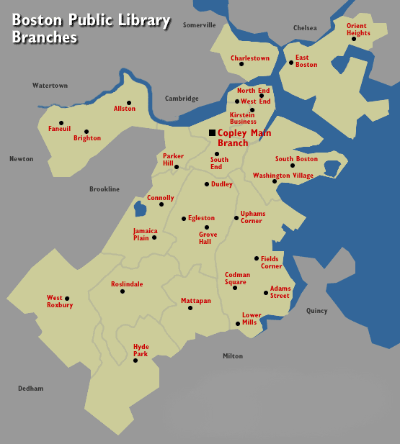
Figure A5 - Boston Public Library Branches

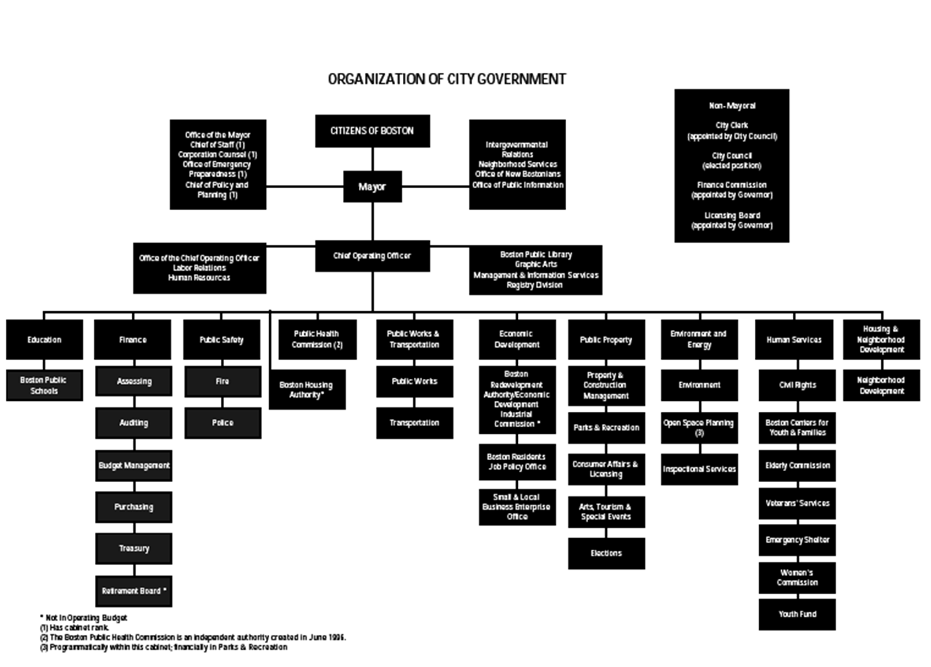
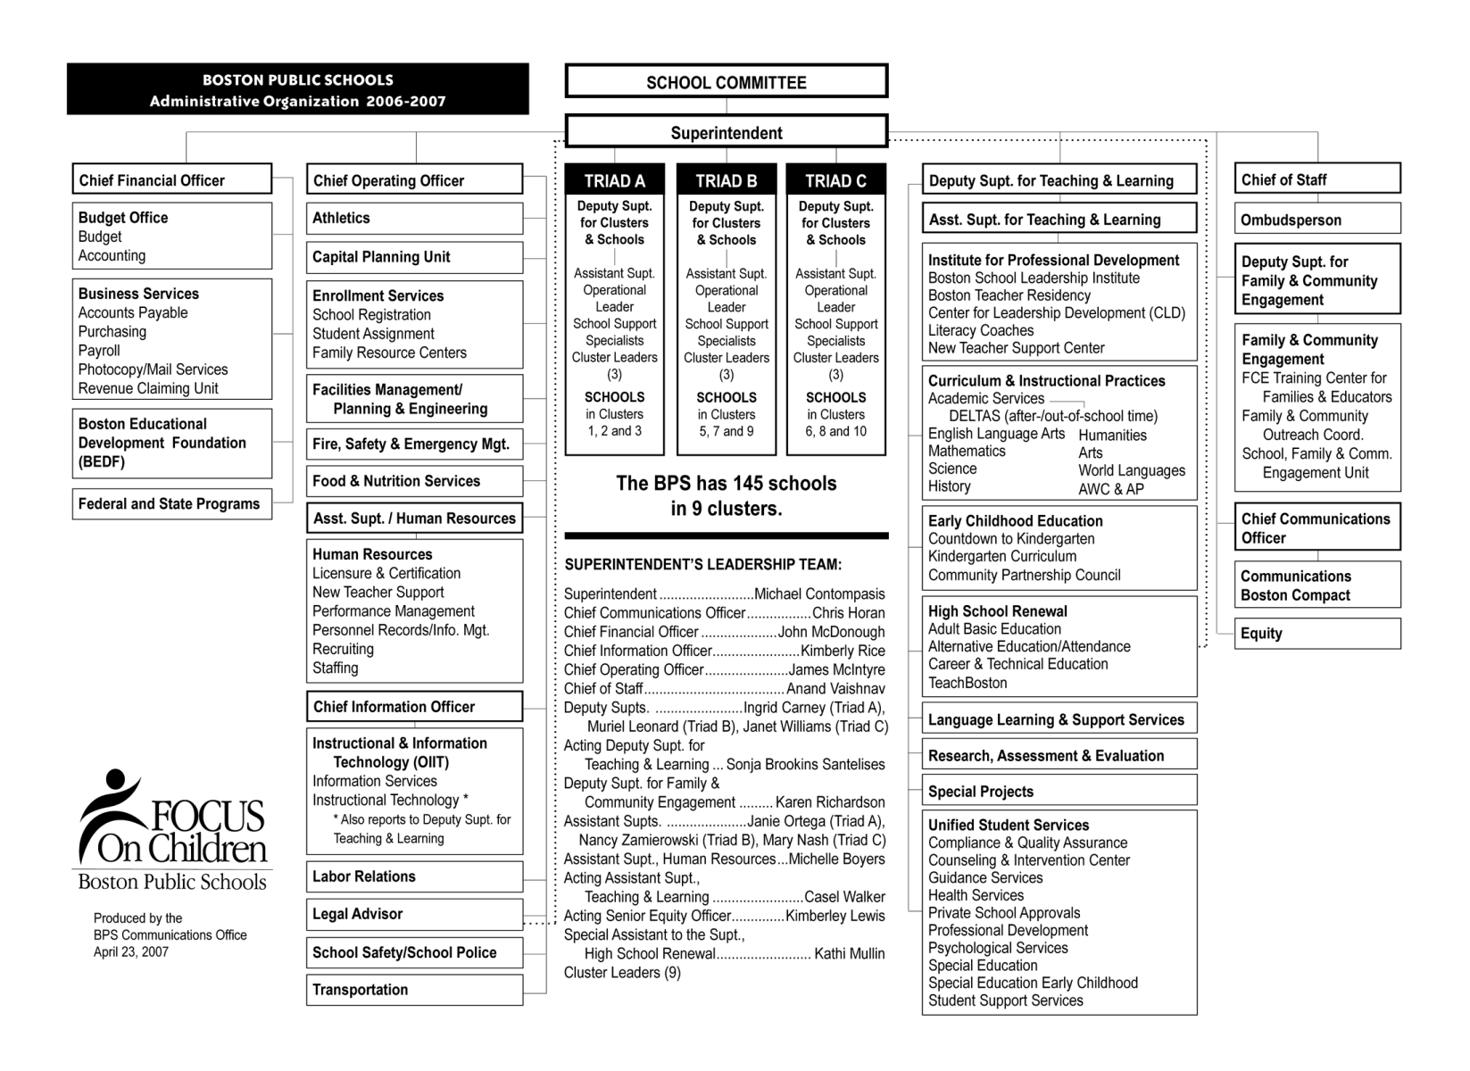
Figure A6 - Organization of City Government
Figure A7 - School Committee Chart
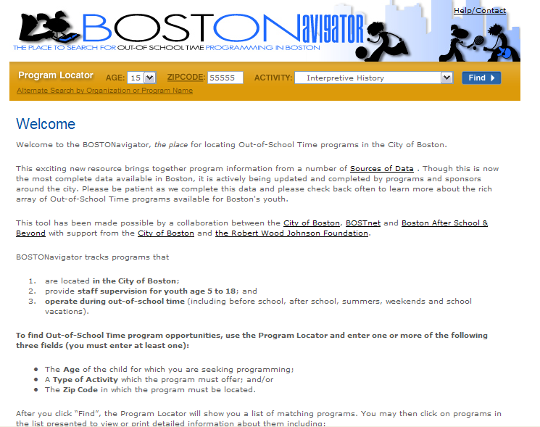Figure A8 - Screen shot of BOSTONavigator
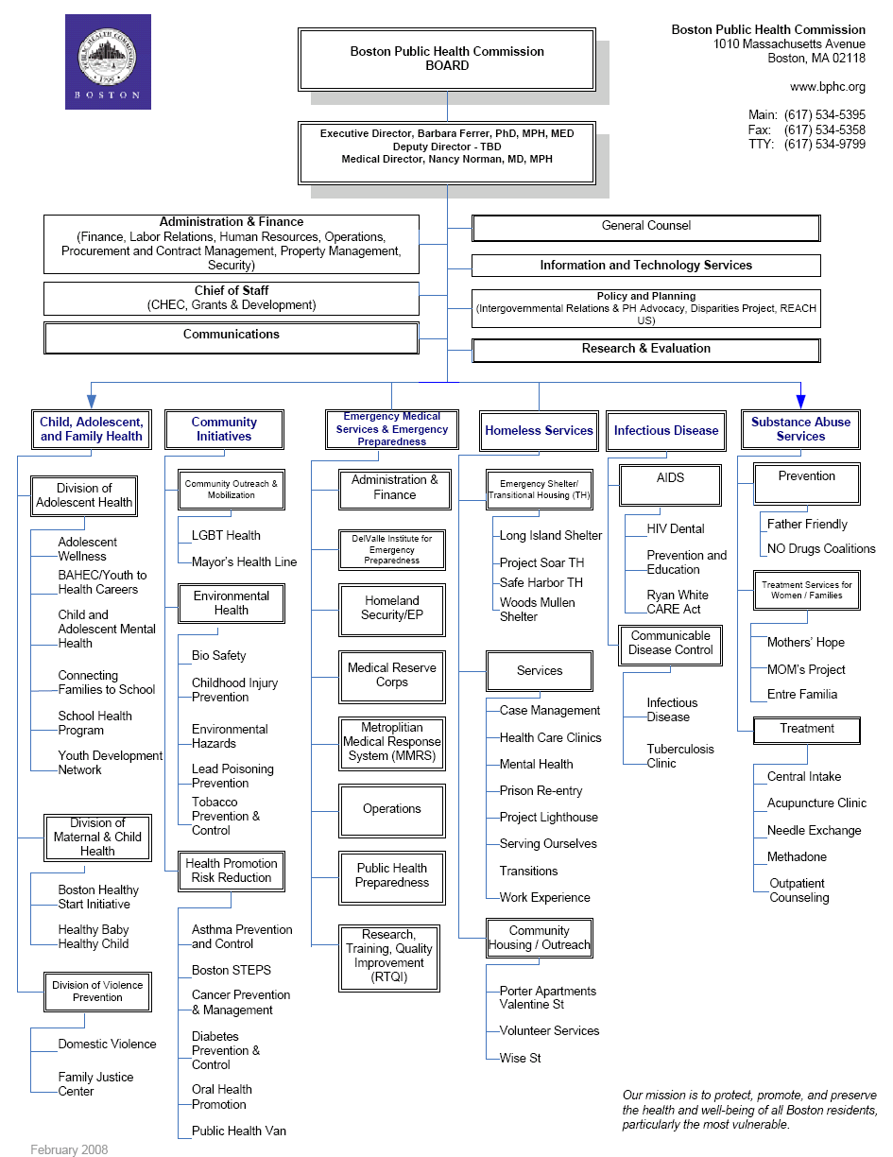
Figure A9 - BPHC Organization Chart

Appendix G: Screen Shots

Cayen Systems
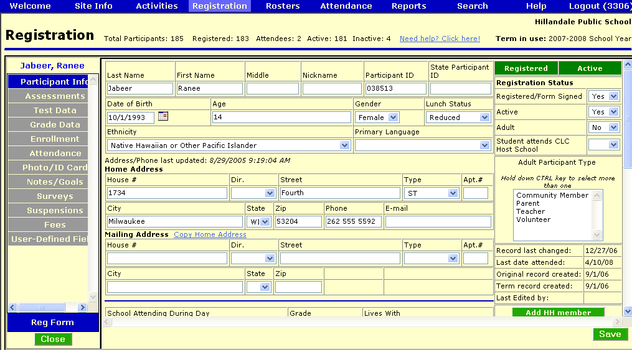
Figure A10 - Cayen Systems Screen Shot
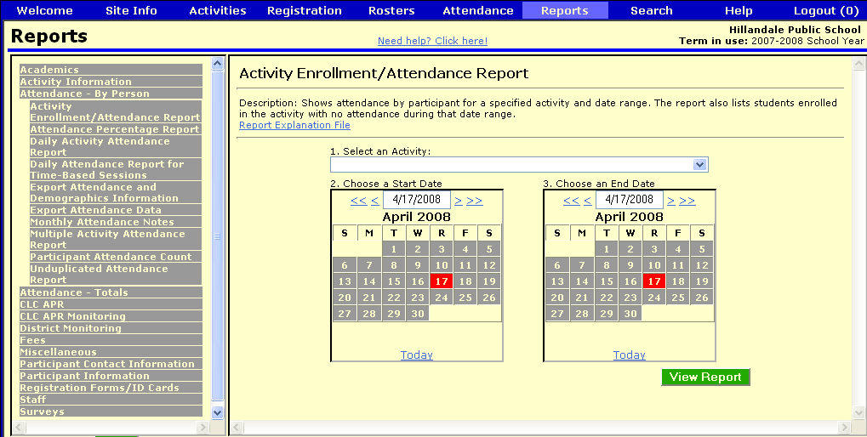
Figure A11 - Cayen Systems Screen Shot
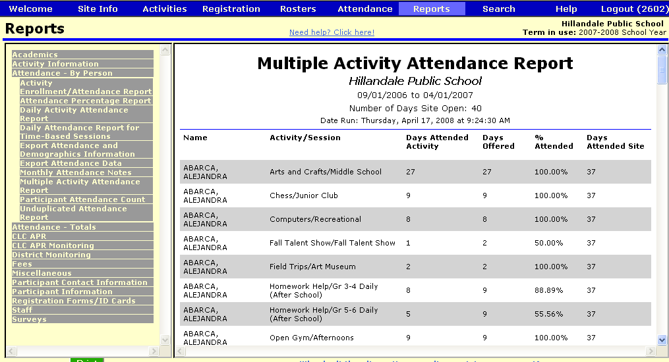
Figure A12 - Cayen Systems Screen Shot
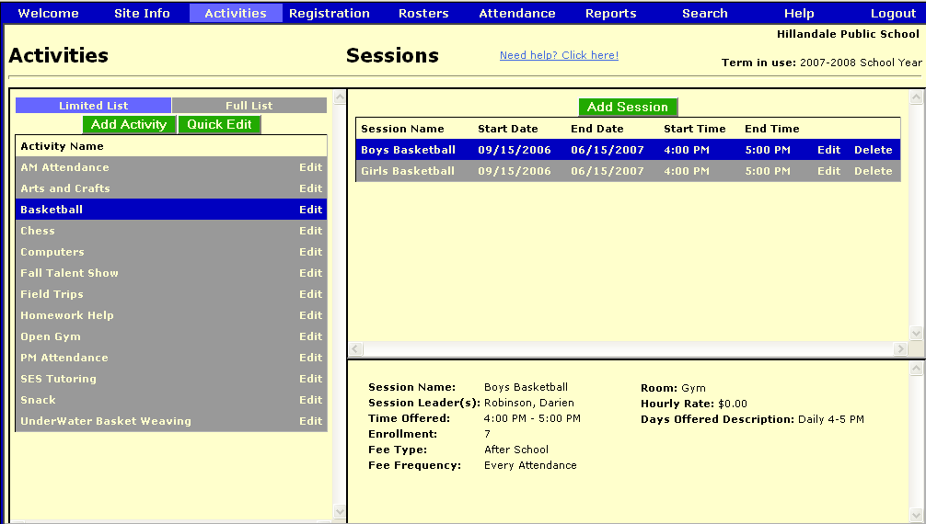
Figure A13 - Cayen Systems Screen Shot

KidTrax
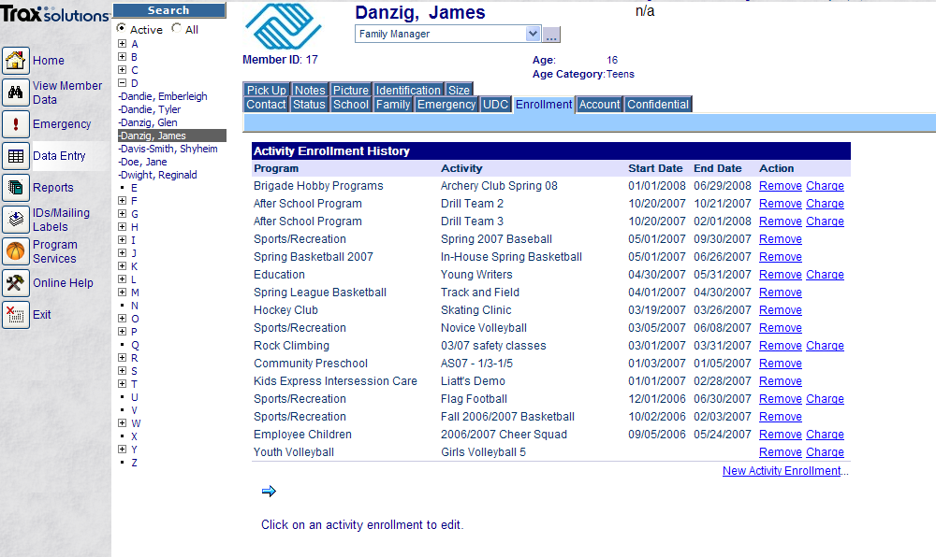
Figure A14 - nFocus' KidTrax Screen Shot
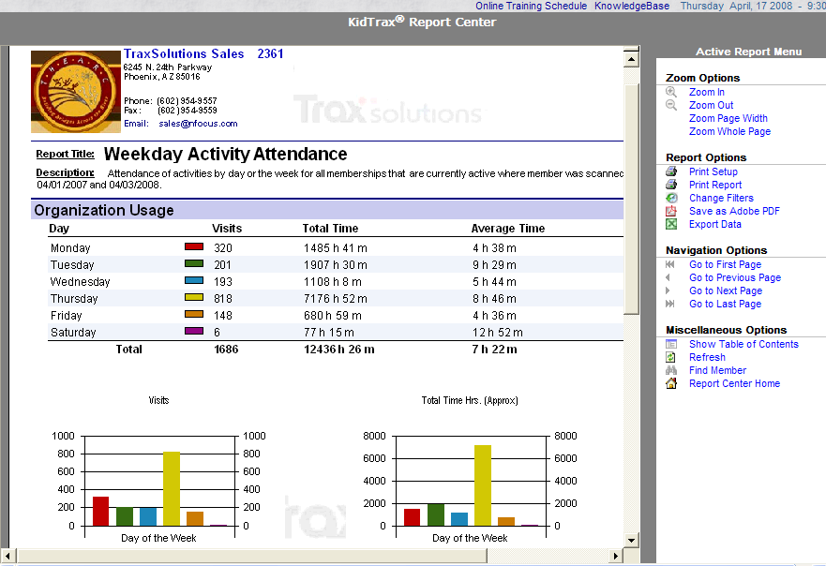
Figure A15 - nFocus' KidTrax Screen Shot
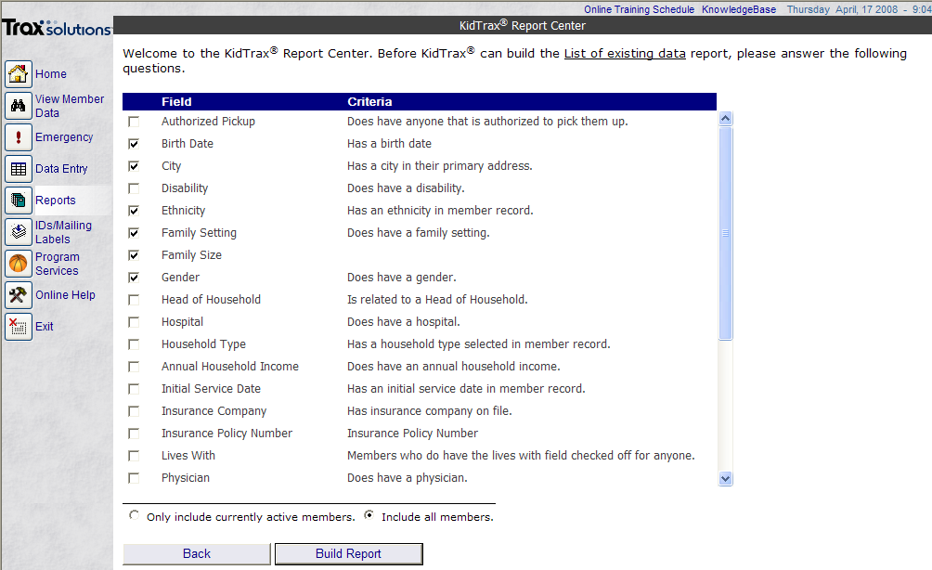
Figure A16 - nFocus' KidTrax Screen Shot
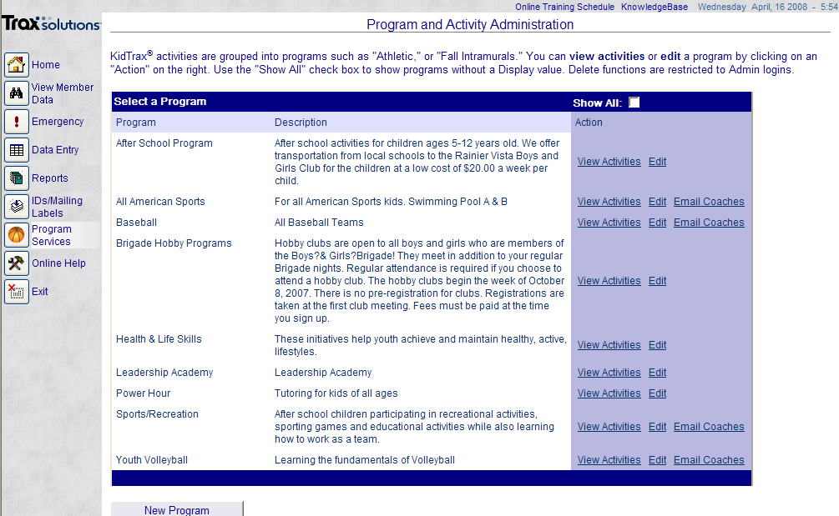
Figure A17 - nFocus' KidTrax Screen Shot

CitySpan
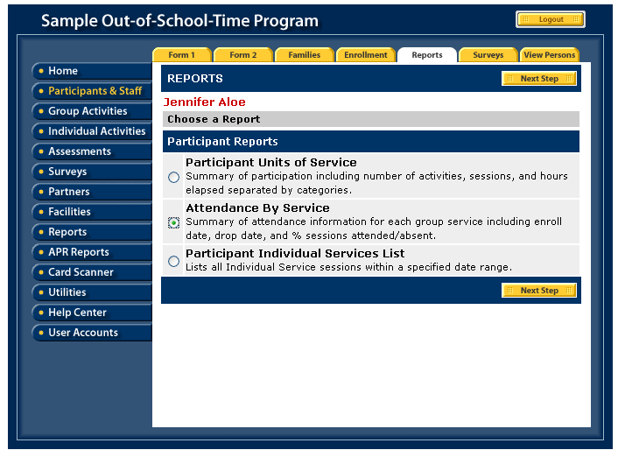
Figure A18 - Cityspan's Youthservices.net Screen Shot
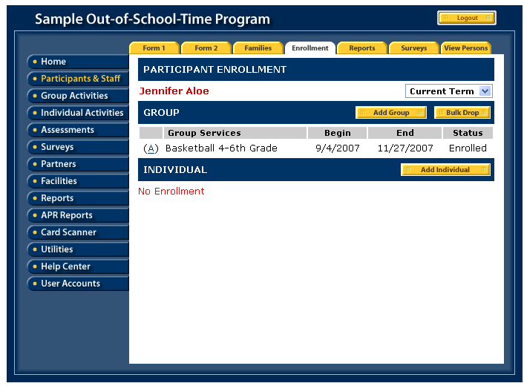
Figure A19- Cityspan's Youthservices.net Screen Shot
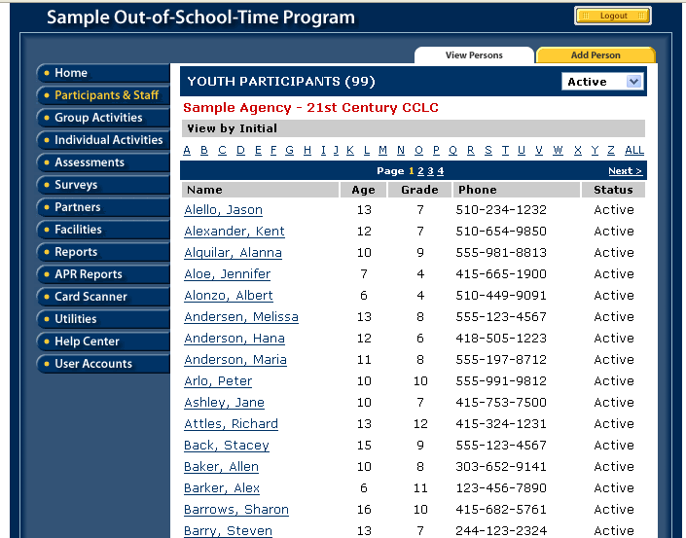
Figure A20- Cityspan's Youthservices.net Screen Shot
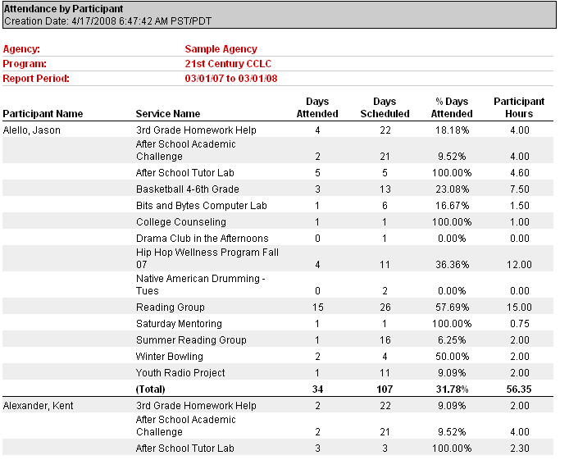
Figure A21- Cityspan's Youthservices.net Screen Shot

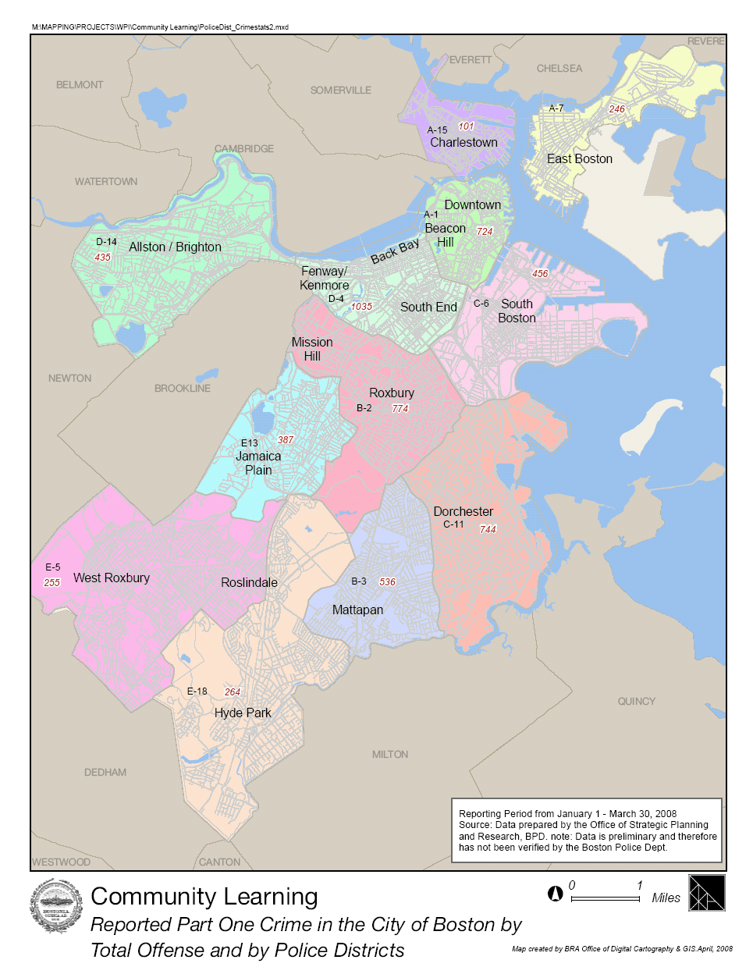
Appendix H: GIS Data Maps
Figure A22 - GIS: Reported Crime by Police Districs
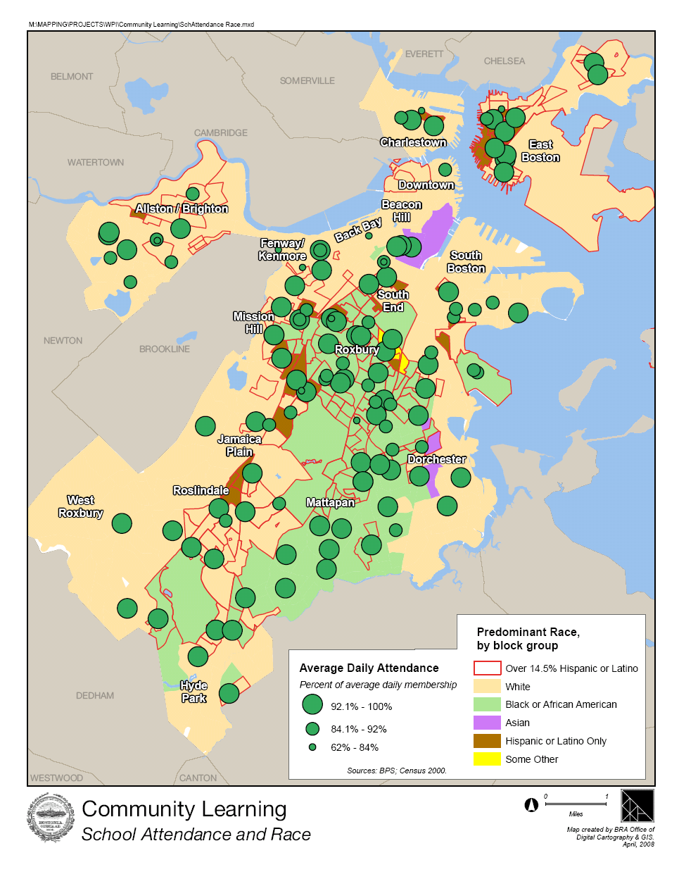
Figure A23 - GIS: School Attendance and Race
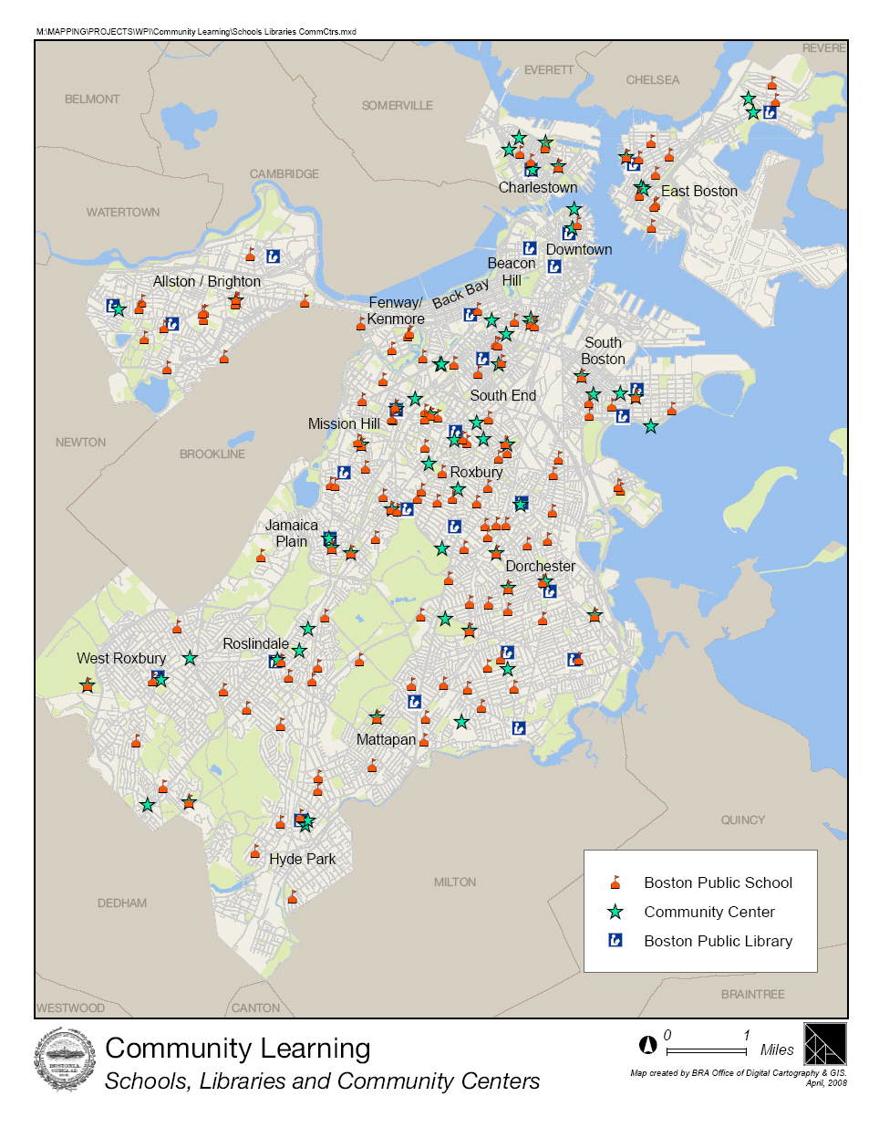
Figure A24 - GIS: Schools, Libraries, and Community Centers

Table of Figures
Figure 1 - Example of New BOSTONavigator Layout 83
Figure 2 - Graphical Example of BOSTONavigator Basic Search 84
Figure 3 - Graphic Example of Different Roles 86
Figure 4 - Organizational Chart for Community Learning Administrator 91
Figure A5 - Boston Public Library Branches 170
Figure A6 - Organization of City Government 171
Figure A7 - School Committee Chart 172
Figure A8 - Screen shot of BOSTONavigator 173
Figure A9 - BPHC Organization Chart 174
Figure A10 - Cayen Systems Screen Shot 175
Figure A11 - Cayen Systems Screen Shot 176
Figure A12 - Cayen Systems Screen Shot 177
Figure A13 - Cayen Systems Screen Shot 178
Figure A14 - nFocus' KidTrax Screen Shot 179
Figure A15 - nFocus' KidTrax Screen Shot 180
Figure A16 - nFocus' KidTrax Screen Shot 181
Figure A17 - nFocus' KidTrax Screen Shot 182
Figure A18 - Cityspan's Youthservices.net Screen Shot 183
Figure A19- Cityspan's Youthservices.net Screen Shot 184
Figure A20- Cityspan's Youthservices.net Screen Shot 185
Figure A21- Cityspan's Youthservices.net Screen Shot 186
Figure A22 - GIS: Reported Crime by Police Districs 187
Figure A23 - GIS: School Attendance and Race 188
Figure A24 - GIS: Schools, Libraries, and Community Centers 188

Index of Tables
Table 1 - List of Organizations and Interviewees 31
Table 2 - Performance Metrics 44
Table 3 - Vendor Comparison 51
Table 4 - Cost Comparison 52
Table 5 - Access Controlled Role List 53
Table 6 - Rubric for Vendor Evaluation 55
Table 7 - Attribute Comparison of Vendors 57
Table 8 - Attributes of System and Weights 58
Table 9 - Quantitative Comparison of Vendors 58
Table 10 - Roles and Expectations for Each Use Case 68
Table 11 - Risk and Protective Factors Associated with Participation in After-School Extracurricular Activities and Homework Program 73
Table 12 - Basic Search Fields 84
Table 13 - Advanced Search Fields for BOSTONavigator 85
Table 14 - Table of Card Technologies Used in Boston 92
Table 15 - Future Implementations for BOSTONavigator 94
Table 16 - Most Popular Library Programs 124
Table 17 - BOSTONavigator Wish List 165

Bibliography
(2007). Retrieved January 20, 2008, from BOSTONavigator: http://www.bostonavigator.org/search.aspx
About BPS Deltas. (n.d.). Retrieved February 1, 2008, from BPS Deltas: http://www.bpsdeltas.org/about/index.htm
ACLU of Ohio Foundation. (2002, August). Impact of the USA PATRIOT Act on FERPA. Retrieved March 31, 2008, from ACLU of Ohio Foundation: http://www.acluohio.org/publications/ferpa.pdf
Afterschool Alliance. (2007, May 31). Afterschool Alliance. Retrieved January 27, 2008, from Launch of the Congressional Afterschool Caucases: http://www.afterschoolalliance.org/caucuses.cfm
Aniton, D. (2008, April 15). Director of Youth Services, Lousiville Public Schools. (W. C. Team, Interviewer)
Bailey, L. (2008, March 25). KidTrax Interview. (W. C. Group, Interviewer)
Beadreau, M., Elbag, M., Martinez, K., & McAlice, K. (2008, April 7). Merging Community Learning with Coomunity Change. (W. C. Team, Interviewer)
Beyond, B. (2008, January 1). Boston Beyond. Retrieved January 27, 2008, from Citywide-Network: http://bostonbeyond.org/strategic-initiatives/citywide-networks1.html
Biography of Mayor Menino. (n.d.). Retrieved February 3, 2008, from City of Boston: http://www.cityofboston.gov/mayor/bio.asp
BOSTnet. (2008, January 1). Retrieved January 27, 2008, from BOSTnet.org: http://www.bostnet.org/matriarch/MultiPiecePage.asp_Q_PageID_E_5_A_PageName_E_WhatTheNetwork
BOSTnet. (2008, January 1). Retrieved January 27, 2008, from BOSTnet hosting: http://www.bostnet.org/matriarch/MultiPiecePage.asp_Q_PageID_E_5_A_PageName_E_WhatTheNetwork
BOSTnet. (2008, January 1). Retrieved from BOSTnet.org.
Boston Beyond. (2007, October). Retrieved January 27, 2008, from BOSTONavigator Launches: http://bostonbeyond.org/_assets/pdf/BOSTONNavigatorPR10_07.pdf
Boston Police Department. (2008). Retrieved February 6, 2008, from City of Boston: http://www.cityofboston.gov/police/
Boston Public Library Branches. (2008). Retrieved February 3, 2008, from Boston Public Library: http://www.bpl.org/guides/branch.htm
Boston Public Schools. (2008). Retrieved January 29, 2008, from BPS: http://boston.k12.ma.us/
Boston Youth Fund. (2008). Retrieved February 12, 2008, from Boston Youth Fund: http://www.bostonyouthzone.com/teenzone/employment/byf/
Boston Youth Sports. (2008, January 1). Retrieved January 27, 2008, from BYSI: http://www.bostonyouthsports.org/
BPS Communications Office. (2007, April 23). Boston Public Schools. Retrieved January 19, 2008, from Administrative Organization 2006-2007: http://boston.k12.ma.us/dept/orgchart07.pdf
Center for Research on Women, Wellesley College. (2003, January). Making the Case: A Fact Sheet on Children and Youth in Out-of-School Time. Retrieved January 20, 2008, from National Institute on Out-of-School Time: http://www.niost.org/publications/Factsheet_2003.PDF
City Government. (2008). Retrieved February 05, 2008, from City of Boston: http://www.cityofboston.gov/government/
City of Boston. (n.d.). FOCUS on Children. Retrieved January 24, 2008, from Superintendent Profile: http://boston.k12.ma.us/supt/profile.asp
Cosden, M., Morrison, G., Guiterrez, L., & Brown, M. (2004). The effects of homework programs and after-school activities on school success. Theory Into Practice .
Culture and Arts. (2008, January 1). Retrieved January 27, 2008, from Arts.Bostonbeyond: http://arts.bostonbeyond.org/
Devaney, E. (2008, April 8). Director of Quality Initiatives at Providence, Rhode Island . (W. C. Team, Interviewer)
District Profiles. (2008). Retrieved April 13, 2008, from Massachusetts Department of Education: http://profiles.doe.mass.edu/
Family Policy Compliance Office. (2007, April 27). General, FERPA. Retrieved April 16, 2008, from US Department of Education: http://www.ed.gov/policy/gen/guid/fpco/ferpa/index.html
Gibson, J., Cayen, J., Stanislawski, S., & Husch, C. (2008, April 10). Understanding the Functionality of Cayen Systems. (W. C., Interviewer)
Grimaldi, C. (2008, March 18). Interview with CitySpan. (W. C. Group, Interviewer)
Horne, G. E. (2004). DATA FARMING: DISCOVERING SURPRISE. Winter Simulation Conference, (pp. 807-813). Woodbridge, VA.
Inmon, W. H. (1994). Using the Data Warehouse. John Wiley & Sons.
Jacob, N., Osgood, C., Walat, E., & McMahon, P. (2008, April). Policy Advising Questions. (W. C. Team, Interviewer)
Jacobs, N., Oates, W., Kurland, J., Breining, C., & Carrera, F. (2008, January 18). Presentation: The Oracle/WPI Project and The Community Learning Initiative. Boston, MA, United States of America.
Johnson, C. R. (2008, January). Introducing the Boston Public Schools 2008. Retrieved January 19, 2008, from A Guide for Parents and Students: http://boston.k12.ma.us/Schools/IntroBPSEng.pdf
Key Initiatives. (2008). Retrieved February 12, 2008, from City of Boston: http://www.cityofboston.gov/bcyf/initiatives.asp
Kimball, R. (2002). The Data Warehouse Toolkit: The Complete Guide to Dimensional Modeling (Second Edition). John Wiley & Sons.
Kintera. (2007). After School All Stars. Retrieved January 27, 2008, from After School Programs & Youth Summer Camps for At Risk Youth: http://www.afterschoolallstars.org/site/pp.asp?c=enJJKMNpFmG&b=854559
Laurent, P. (2008, April 7). (W. C. Team, Interviewer)
Line, B. Y. (2008, March 10). Interview with Boston Youth Line. (W. C. Group, Interviewer)
Lynch, G. (2008, April 3). Product Development Director, Learning 360. (W. C. Group, Interviewer)
Mayor's Office. (2007, November 16). City of Boston - News & Press Releases. Retrieved January 20, 2008, from Mayor Menino Announces the VIP Program: http://www.cityofboston.gov/news/default.aspx?id=3696
Mayor's Office. (2008, January 16). City of Boston - News & Press Releases. Retrieved January 20, 2008, from Mayor Menino Delivers State of the City Address at Strand Theatre: http://www.cityofboston.gov/news/default.aspx?id=3755
McMahon, P. (2008, March 14). YouthLine. (W. C. Group, Interviewer)
Meeting, V. -O. (2008, March 10). Community Learning Kickoff Meeting. (W. C. Group, Interviewer)
Menino, T. M. (2008, January 15). City of Boston. Retrieved January 25, 2008, from News & Press Releases: http://www.cityofboston.gov/mayor/pdfs/2008_State_of_the_City.pdf
Office for Civil Rights - HIPAA. (2008, January 30). HIPAA. Retrieved April 16, 2008, from United State Department of Health and Human Services: http://www.hhs.gov/ocr/hipaa/
Oracle's History: Innovation, Leadership, Results. (2008). Retrieved February 4, 2008, from Oracle: http://www.oracle.com/corporate/story.html
Philadelphia Recreation Program. (2008, January 1). Retrieved January 27, 2008, from Recreation Program: http://www.phila.gov/recreation_old/special/afterschool.html
Santiago, A., & Mohammed, S. (2008, April 1). BPS Involvement in Community Learning. (W. C. Group, Interviewer)
Stembridge, K., Colford, S., Dorsey, J., Peterson, K., & Kowal, R. (2008, March 20). Boston Public Library Community Learning Interview. (W. C. Group, Interviewer)
Stringfellow, V. (2008, April 8). Boston After School and Beyond and Community Learning. (W. C., Interviewer)
The Boston Public Health Commission. (2008). Retrieved February 12, 2008, from Public Health Comission: http://www.bphc.org/
The Boston Public Library. (2008). Retrieved February 15, 2008, from Boston Public Library: http://www.bpl.org/guides/history.htm%20(1)
The Boston Public Schools at a Glance. (2007). Retrieved February 11, 2008, from Boston Public Schools: http://boston.k12.ma.us/bps/bpsglance.asp#history
The City of Boston. (2007). Retrieved January 20, 2008, from The Violence Intervention & Prevention (VIP) Initiative: http://www.cityofboston.gov/vip/
The Oracle Insight Program. (2008). Retrieved January 23, 2008, from Oracle: http://www.oracle.com/services/insight/index.html

