Biofuels IQP
Algae Experiment
David J. Liston
4/22/2013

This project focused on the feasibility of utilizing algae as a feasible source for energy production. An Experiment was performed to test the overall concept.

Contents
Introduction 2
Background 4
Current Algae Production 5
Algenol Biofuels 6
Solix Biofuels 7
Sapphire Energy 8
Background of algae: 10
Algae for Bio-diesel 10
Algae for Food production and or Fermentation Feed Stock 18
Methodology 22
Results 32
Discussion 38
Appendix 39
Images Biofuel Companies 39
Oil Content of Microalgal Species Data 40
Images Algael Strains 41
42
Images Plant Process Design 42
Images experiment 43
References 47

Introduction

The Energy debate has been going on for some time, and Algae as a fuel source for its oil and starches seems to be an excellent candidate. I am seeking to conduct a simple experiment to establish how hard it would be to convert starches and sugars into not only ethanol but using the carbon dioxide given off by fermentation to stimulate the production of algae in a makeshift photo bioreactor. Ethanol E85 (85% ethanol gasoline)is already emerging on the market, and algae is an incredibly versatile plant not only producing oil which could be used in Bio-diesel, it has a high starch content as well. This means that after the oil has been extracted it the left over starches in the algae could be fermented again. Algae is also an excellent feed to livestock. With the potential of using ABE fermentation instead of ethanol fermentation we could produce Acetone, butanol, and Ethanol giving us a very versatile group of chemicals off which many different bio-fuels could be based from. Furthermore butanol is a direct drop in replacement for the internal combustion engine. Even more promising is extracting oil from certain algae strains to produce Bio-diesel, acetone, butanol, and Ethanol from a single rapid growing crop and production facility.
To demonstrate the seemingly simple process of produce Ethanol alcohol and algae using readily available resources and inexpensively, with minimal background experience. I also hope to get more information on the possible problems with using fermentation as a CO₂source for stimulating algae production.
The Vision
My research on algae and the companies in operation tries to find a solution to feeding and powering the world could potentially be benefited with the miracle plant duckweed. It seems more than feasible that we could utilize ABE or Ethanol formation to produce liquid fuels and CO₂. Using a facility setup similar to the one used in my experiment we could use the CO₂to aerate an open pond, stimulating Duckweed growth. The Duckweed can then be feed back into the fermenter to produce more liquid fuels and CO₂, so the cycle would continue. Should the economic climate of where ever one of these facilities is built favors the fuel, animal feed, or any one of the useful byproducts the facility wouldn’t have to be altered. The equipment for fermentation and the open ponds are cheap, making this concept a potential winner, particularly in the developing world. With higher yields on less land than industrial corn, perhaps someday Lemnoideae will be instrumental in fueling and feeding the ever demanding world. By analyzing my experiment and the companies currently producing algae biofuels, I propose a facility is based on a research paper entitled “production of high-starch duckweed and its conversion to bioethanol.

Background
There has been consistent debate that the earth is running out of oil, space and oxygen. As the earth’s population increases and the demands for energy continues its inevitable clime. Humanity is using limited resources an astounding rate. As we grow more, we eat more, and consume more; one’s political orientation doesn’t change the inevitable trend. Scientist, engineers, businesspeople and politicians alike have been searching for new and cheaper forms of cleaner energy to power an ever changing and often volatile world. The escalating food and energy costs smaller nations are struggling to eat and survive. This IQP suggests a solution, however the proses to get there was a lengthy one, so let’s begin from the start.
This IQP Began where another left off, the entitled biofuels IQP made a strong case for Butonal as the next replacement for Gasoline in the USA. It suggested that using lignocellulosi as a feed stock , the plant material could be broken down into simple sugar’s that could be fermented using ethanol fermentation or even ABE fermentation. Ethanol fermentation would not surprisingly produce ethanol and ABE fermentation would produce Acetone, Butonal and Ethanol, three great raw materials. The problem they faced was what to use as a feedstock. The answer was Algae, because of its incredibly fast production possibility, and the huge variety of possible species that could be used. However there are a few key issues with using algae. For instance some of the highest yielding strains are temperamental to environmental changes and many of the high yielding strains are micro-algae that are difficult to harvest, as I found out. Furthermore the Algea needs high levels of CO₂ to achieve a fast production rates, it would seem pointless to create a green fuel if you have to create a lot of CO₂ to produce it. As a result of all of this my first step was to see what companies today using to create algae derived fuels.

Current Algae Production
Each of the algae fuel companies below utilize CO₂ sequestering to grow blue green algae. Algenol Biofuels and Solix Biofuels both use closed systems to produce their products. Algenol is the only facility focused on ethanol production ware as Solix and Sapphire are focused to gain entry into the biodiesel and jet fuel industry. All these companies have been able to successfully demonstrate reasonably high levels of production, however they have not been able to meet the high production necessary to be cost effective yet. The concept of utilizing waste CO₂ to produce a usable fuel is truly novel. Each company are high tech corporations which use expensive operations to produce algae resources.
Algenol Biofuels, Solix Biofuels and Sapphire Energy are currently building and operating large scale algae farms. They all differ in there the products they seek to produce as well as not surprisingly the way in which they produce them.

Algenol Biofuels
With Headquarter in Bonita Springs Florida Algenol is focused of “Direct to Ethanol” technology. This technology employs Blue Green Algae specifically Cyanobactial which is capable of converting the sugars in the algae directly to ethanol. The process and closed system grows the algae in seawater and allows it produce ethanol which then uses passive evaporation where the ethanol condenses on the sides of the container and flows down the walls where it can be collected (figure 1). This technology is very promising because of it employs a no harvest and no kill procedure, this allows it be in a state of near constant production. Algenol’s technique utilized CO₂ from on industrial plants such as power plants, cement plants, and ethanol factories. This technology is expensive however as it is a closed system. The company broke ground on a 36 acre facility in Florida on 2011. The company hoped to complete the project by the end of 2012 which it hopes will produce 100,000 gal/year of ethanol, this equates to 2777 gallons of ethanol per acre per year. Algenol has the goal of producing 8,000 gallons of ethanol per acre per year.
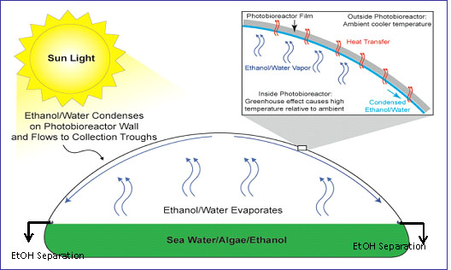
Figure 1

Solix Biofuels
Based out of Fort Collins CO, Solix Biofuels is focused on the using algae to produce Biodiesel and A-Jet fuel. The company has developed the Lumian AGS400, a high productivity algae growth system. The system employees floating photo bioreactor panels to create the optimal environment to grow the algae. The company’s demonstration plant utilizes on nearby oil refinery to supply CO₂ (figure 2), they claim acciving production of 3000 gallons of algae oil per acre per year. The Lumian system is a turnkey operation the company would sell to those interested in algae oil production.
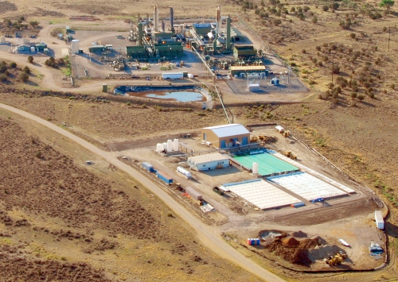
Figure 2

Sapphire Energy
Sapphire Energy is based out of San Diego California however has facilities in Las Cruce NM, and Columbus NM. The company is focused on producing drop in transportable replacements to 91 octain gasoline, diesel and jet fuel. The company currently has a 300 acre facility with 100 acres of open pond systems in operation (figure 3) . The capacity of the finished 300 acre facility is estimated at 1million gallons of finished product a year, averaging 3333 gallons per acre per year. A unique feature of this company is to use the waste product biomass to be recycled as nutrient to support the algae ponds. In doing so Sapphire will lower the overall fertilizer requirements and carbon foot print.
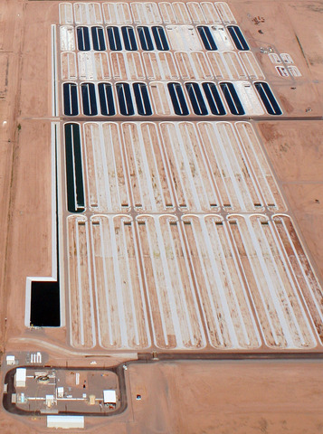
Figure 3

Background of algae:
Algae is the fasting growing plant in the world, many strains are capable of doubling there mass over 24 hours. This makes them an awesome contender to be a feed crop for many different application, bio-fuels in particular. Sperilina and other Blue-Green algae have a oil content over 40% of the dry mass (a drop in replacement to Diesel). Furthermore using Lignocellulosi as a feedstock for ethanol or ABE production could create a nearly symbiotic cycle of energy production, yielding butanol, ethanol and bio-diesel in a carbon neutral fuel.

Algae Strains
There are thousands of various algae strains each has different uses, making the selection proses very complicated. Some algae strains have large lipid contents, perfect for oil production, where others have high levels of proteins and or starch, a great source of food and feedstock for animals or as a feedstock for ethanol production. I want to make the distinction between these two options. While one strain in particular spiralina could be used for both, most strains however will be more effective for one over the other.

Algae for Bio-diesel
For algae grown for Bio-diesel production the most important factor in finding a suitable strain is that the strain needs to have an uncommonly high lipid production as a percentage of dry weight. The higher the dry weight the more percentage of oil there is in the plant material, the result is higher yields, a crucial aspect in mass production of oil derived from algae. It should be noted that there are only micro-algae in this list, the reason behind this is that microalgae produce significantly more oil by weight than there macro counterparts. There are a few promising candidate however, the table below lists just a few (Ayhan Demirbas 2010, p.150).
Oil content of few microalgal species:
Microalgal species | Oil content(% dw)
Ankistrodesmus TR-87 | 28-40
Botryococcus braunii | 29-75
Chlorella sp. | 29
Chlorella protothecoides(autotrophic/ heterothrophic) | 15-55
Cyclotella DI- 35 | 42
Dunaliella tertiolecta | 36-42
Hantzschia DI-160 | 66
Nannochloris | 31(6-63)
Nannochloropsis | 46(31-68)
Nitzschia TR-114 | 28-50
Phaeodactylum tricornutum | 31
Scenedesmus TR-84 | 45
Stichococcus | 33(9-59)
Tetraselmis suecica | 15-32
Thalassiosira pseudonana | (21-31)
Crpthecodinium cohnii | 20
Neochloris oleoabundans | 35-54
Schiochytrium | 50-77
By looking for algae strains that demonstrate great promise for domestic cultivation intended for oil production the selections can be narrowed. The four strains that this section will be focusing on are Ankistrodesmus, Botryococcus braunii, Scenedesmus, and Nannochloropsis oculata. The draw to these strains are there high oil content ( >= 40%), steady growth, and demonstrated use.

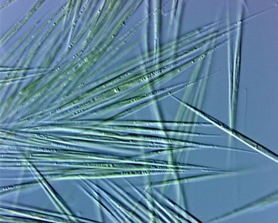
Ankistrodesmus
Figure 4
Ankistrodesmus cells rarely solitary, mostly in few to many celled colonies with 4-16 (-128) cells. Ankistrodesmus cells are long and needle- or spindle-shaped, or sometimes curved or slightly crescent-shaped, 15-105 x 1-6 µm. the cells are mostly in parallel bundles, in some species individual cells or bundles rotating to give spiked or stellate appearance to colony. Cell walls smooth. Chloroplast parietal and band shaped, single, but becoming multiple prior to autospore formation(P.S. Peter A. Siver). This algae strain is very common throughout North America. The genus is usually found within the plankton of freshwater ponds and lakes, and sometimes inhabits artificial ponds, temporary pools, and even waterfalls. Ankistrodesmus reproduces trough asexual reproduction (M.D Guiry 2012). While the table from Ayhan Demibras subjects this strain is capable of achieving between 28%- 40% of its dry weight, a study from the American Association for the Advancement of Science subjects this strain is capable of achieving 18-73% of its dry weight as Oil. To achieve the highest percentages of oil production the article speculated was a result of the vacuum drying proses while the algae was still living (V.W. Virginia R. Williams & R.M. Rosamond Mcmillan 1961, p.459-460).

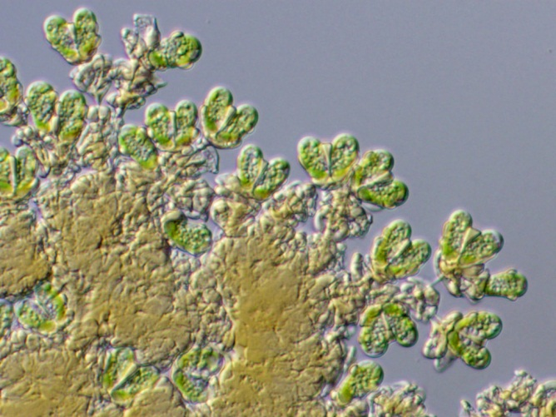
Botryococcus braunii
Figure 5
Botryococcus braunii is a green colonial microalgae found worldwide in freshwater and brackish lakes, reservoirs and ponds. The potential of this algae to be grown in brackish water means production of it will have a smaller effect of dwindling freshwater resvior. This algae gained a great interest in scientific and commercial world because if its ability to synthesize and accumulate huge amount of various lipids. It has been evidenced by the analysis of crude petroleum and earth sediments that Botryococcus is the major biological partner to form the crude petroleum million years ago. These algae produce various types of hydrocarbons out of which botryococcnes are the most important as it produced in highest quantity and have many properties similar to the various contents of crude oil. (D.B. Dinesh Kumar Barupal 2008). B.braunii is furthermore regarded as a potential renewable fuels source because of its incredible ability to produce large amounts of hydrocarbons. Depending on growth conditions and the strain, up to 75% of dry mass can be hydrocarbons (A. Anirban anerjeeb, R. Rohit sharms, Y. Yusuf chisti 2002, 446). Intensive research is being undergone to maximize the hydrocarbon contents in these algae by altering the genetic and environmental conditions. Because of its widespread research and great performance potential B.bruanii has and distinct chance of becoming the fuel of tomorrow.

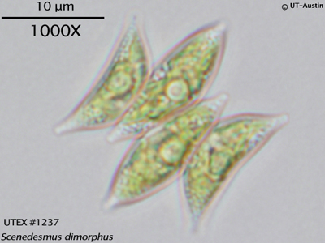
Scenedesmus dimophus
Figure 6
Scenedesmus dimorphus is a green microalgae, bean shaped of approximately 10μm in size. This nonmotile colonial green alga consists of cells aligned in a flat plate. The colonies most often have between 2-4 cells, but may have 8, 16, or are occasionally unicellular. The cells are usually cylindrical but may be more lunate, ovoid, or fusiform. Typically the end cells each have two long spines up to 200 µm in length protruding from their outer corners, and other cells may have additional spines or chitonous bristles (P.S. Peter A. Siver). Scenedesmus is commonly found throughout North America from tropical to arctic climates. These algae can have dense growth in nutrient rich water, giving it added potential for bio-diesel production. These algae like B.bruanii can be grown in brackish water, giving it added viability. Categorized as a heavy bacterium, Scenedesmus has a lipid content of 16-40%. The result of this high lipid content Scendedesmus is one of the preferred species for oil yield in the production of Biodiesel. There is a problem with this microalga, it is heavy, the result of which is that it forms thick sediments if not kept in constant agitation. This can be overcome with most paddle wheel algae ponds (C.R. Carlos A. Ramos Encarnación 2010 p.9).
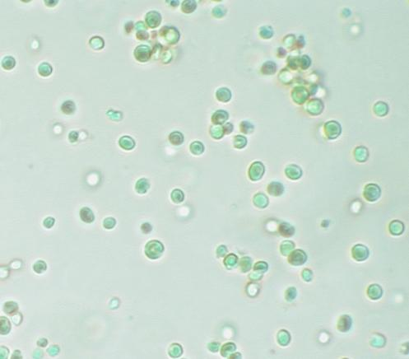
Nannochloropsis salina
Figure 7
Nannochloropsis salina is a green microalgae, this unicellular strain is spherical in shape. Uniquely lacking chlorophyll pigments this is one of the smallest microalgae’s with a lengths between 1-2 µm. N.salina are planktonic but can grow attached to various substrates (Fisher et al. 1998). This promising strain is already demonstrating its potential with the Colorado Company Solix. Currently operating two demonstration plants Solix has shown the potential of this algae for biofuels and as a CO₂ absorber. There first plant is a small setup with 6,000 liters flowing through a helical-tubular photo bioreactor, producing proximately 1.5 kg/day by dry weight algae biomass with CO₂ enrichment. There second plant located at Coyote Gulch is substantially larger at 120,000 liter in three helical-tubular photo bioreactor basins, the supplied CO₂ come from an amine plant which would normally release the CO₂ into the air as a byproduct (P.L. Peter Lammers, p.21).

Algae for Food production and or Fermentation Feed Stock
While algae has been cultivated as a food source for centuries large scale mass production has only recently come to fruition. A key idea behind growing algae as a food source is that it has a high protein and starch content. As a raw material vegetable protein can be easily broken down for formation, as a result it could be used in a fermenter to produce Ethanol, Butonal and Acetone (R. Bowen Feb 2010). A producer of the high protein algae could potentially skip the fermentation proses and use the algae as inexpensive animal feed, or even human consumption. While researching I found two algae strains in particular that have demonstrated strong potential for food production, Spirulina and Lemnoideae.

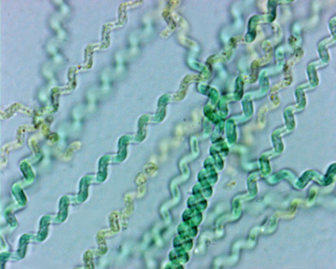
Spirulina
Figure 8
Spirulina filaments have a tendency to form mats in both marine and fresh waters or are found tangled amongst other algae or detritus. The genus is commonly found in lakes rich with sodium carbonate, such as bogs and moist mud. Over 50 species of spirulina have been discovered using various techniques. By dry weight between 50-70% of the biomass is protein, as much as is in soybeans, grains, and nuts. The cell walls are made of mucopolysaccarides making spirulina easier to digest than other forms of microalgae. Touted as a super food Spirulina contains high levels of vitamin B, essential unsaturated fatty acids, and betacarotene (P.S. Peter A. Siver). This alga has rightfully earned its title as a super food, as the work of Dr. Ripley D. Fox suggests. Dr. Fox set up an integrated Spirulina plant for a Farende, Togo using human and animal waste as a feedstock for the spirulina production. The dried algae were then feed to malnourished children daily with remarkable benefits. Wide spread cultivation of spirulina has existed throughout much of Africa and Asia, making it a known viable source of food

Lemnoideae minor
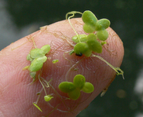
Commonly referred to as Duckweed, this aquatic plant is the smallest angiosperm plant in the world (flowering). This small free floating macro algae can have extremely rapid multiplication rates, in proper conditions it can double its mass in 24hours. Sometime growing to easily this plant is a menace for ponds, and is a nuisance to pond management. Resistant to bacteria and able to flourish in brackish water duckweed is very resilient. Already used as an inexpensive water treatment option, duckweed can remove minerals, heavy metals, and organic nutrients from waste water. As a feedstock the biomass yield of 7-20 tons dry weight per hector of water surface per year is remarkable (S. N. Xiu p.1293). In comparison one hector of corn at the nation average of 151 bushels / acre produces just north of 10 tons of shelled corn per hector. Depending on strain, grown under ideal conditions and harvested regularly duckweed has a fiber content of 5-15%, a protein percentage of 35-45%, and starch content from 3-75%. To feed the world Lemnoideae has incredible potential; additionally the protein has higher concentration of essential amino acids, lysine, methionine, trace mineral, beta carotene, and xanthophyll than most plant proteins (P. Paul skillicorn p.4). For use as animal feed, or human consumption, the high nutrient content characteristics make it ideal. One study from North Carolina state University shows the promise of using high starch duckweed to produce ethanol, “Compared with maize-toethanol conversion, a 50% higher ethanol yield can be achieved using the technology developed in this research, making duckweed-to-ethanol conversion a promising technology to supplement maize-based ethanol production.”( J. Jiele xu p.71)
Figure 9
Bibliography
R.B. R. Bowen, "Basic Fermentation Chemistry," Colorado State University, p. 1, Feb 2010. [Online]. Available: http://www.vivo.colostate.edu/hbooks/pathphys/digestion/herbivores/ferment.html
P.S. Peter A. Siver, "The SilicaSecchiDisk," Connecticut College, Na. [Online]. Available: http://silicasecchidisk.conncoll.edu/Algal-ED_finished.html.
S. N. Xiu, A. Shahbazi, J. Croonenberghs & L. J. Wang (2010): Oil Production
from Duckweed by Thermochemical Liquefaction, Energy Sources, Part A: Recovery, Utilization, andEnvironmental Effects, 32:14, 1293-1300

P. Paul skillicorn, W. Willian spira, W. William journey, Duckweed Aquaculture, Edition of book, Washington DC: The international Bank for Reconstruction and Development, 1993, p. 3-92.
J. Jiele xu, W. Weihua cui, A. Anne-m. Stomp, " Production of high-starch duckweed and its conversion to bioethanol," Biosystems Engineering, Vol. 110, no. , pp. 67-72, Aug 2011

Methodology

Strain Selection
As a feedstock for ABE and ethanol fermentation the clear candidate seems to be Lemnoideae (duckweed). This macro-strain has all the characteristics necessary for a large scale production. Fast growing, even comparable to micro-strains, means large regular harvest and high yield. A result of its inherent buoyancy Duckweed floats would float on the surface of any open pond, making harvesting it very simple (and cheap). The potential for incredibly high starch content means it can be fermented similar to corn. The added benefit of a large protein and nutrient content makes it’s a fantastic animal feed. Duckweed is also incredibly resilient and can be grown in brackish water. The potential for this simple aquatic plant could be a higher yielding replacement for corn. While other species such as Nannochloropsis salina and Spirulina could potentially be used to produce bio-diesel they are difficult to harvest, easy to kill, and demonstration plants aren’t producing as high of yields as speculated.
Plant Process Design
The facility is designed to produce inexpensive ethanol, butonal, acetone, methane, electricity, and high value fertilizer. The wide range of products the operation can produce will be instrumental in meeting the demands of an ever-changing marketplace. To do this there are two important cycles in this process the first surrounding fermentation, the second surrounding anaerobic digestion. A diagram illustrates both cycles and the overall process below.

Figure 10

Inputs
Sun: Provides energy for photosynthesis
Water: Necessary for duckweed growth, fermentation, Bio-Digester
Animal Waste: Provides nutrients for Bio-digester.
Duckweed Cycle:
Duckweed growth: duckweed to be grown in open ponds. The nutrient rich fertilizer as a result of the bio digester will be the primary source of fertilizer. Siphoning of the nutrient liquid will be diluted into the open pond so as to maintain a ammonium (NH4-N) of 20 mg l⁻¹ . (XU J section 2.2)
Saline shock: Harvested duckweed will then be placed in a separate tank willed with a NaCl concentration of no more than 37.4mmol l⁻¹. Any salt concentration higher than this will be detrimental to the duckweed. Once starch contact stabilizes, the duck weed is died and milled.
Starch to sugar conversion: The process of Hydrolysis has been used extensively for ethanol from corn production. A similar method will then be used to convert the starch in the duckweed to Maltose which can be fermented. This process uses heat and the enzyme amylase for the conversion.
Fermentation: After the Hydrolysis has finished and been allowed to cool, the mash will be transferred to a fermentation vessel and allowed to convert the Maltose to ethanol. ABE fermentation could also be used during this step to produce Acetone, Butonal and Ethanol.
Bio-digester cycle:
Distillation: The fermented mash is distilled to concentrate the ethanol. The same process could be used to separate the byproducts from ABE formation as well.
Bio digester: the Bio-digester uses anaerobic digestion to convert the pig effluent into methane (g), CO₂ (g), and fertilizer as waste. The gasses, together known as bio-gas, are then fed to the power generator and the fertilizer is used to provide nutrients for the duckweed. Excess fertilizer can be sold or used for crops.
Power generation: The biogas is used to operate the power generator using any form of combustion. This allows for many different power generation options including gas turbines, steam turbines or reciprocating engines. The waste heat from combustion can be used to heat the anaerobic digest or heat the distiller. The waste CO₂ can be used to feed the duckweed and stimulate growth; this completes the carbon cycle allowing for sequestering some of the carbon dioxide and preventing leakage to the environment.
Output:
High value Fertilizer: The facility will use much of this for duckweed nutrients; however excess can be sold as an source of income.
Green Grid Electricity: Electricity produced form the power generation can be sold to grid resulting in stable source of income.
Fuel: Ethanol, Acetone, Butonal are sold to be used in car or wherever demand is needed. The price of ethanol usually is comparable to that of gasoline.

1. Xu J, Cui W, Cheng JJ, Stomp A. Production of high-starch duckweed and its conversion to bioethanol. Biosystems Engineering 2011 10;110(2):67-72.

Materials: Most of the materials where acquired though materials laying around the FIJI (fraternity of Phi Gamma Delta) house, however some materials had to be bought (*)
2 five gallon fermenting jug. ( I will be using a 5 gallon water jug)
10 clear 2 liter soda bottles with caps
(*)20ft clear pvc tubing
(*)Stopper X2
(*)Silicon sealant
10 gallons of water
(*)5 lbs of white sugar
(*)1 lb corn meal
(*)Yeast and starter
Algae samples: a strain obtained from a Lab in Gateway Park (strain1), Salisbury pond (strain2), and from a neglected kiddy pool at FIJI (strain3)
Bleach
Stove
Large pot
Funnel
(*)Hydrometer
(*)Airlock X2
Concentrated plant fertilizer
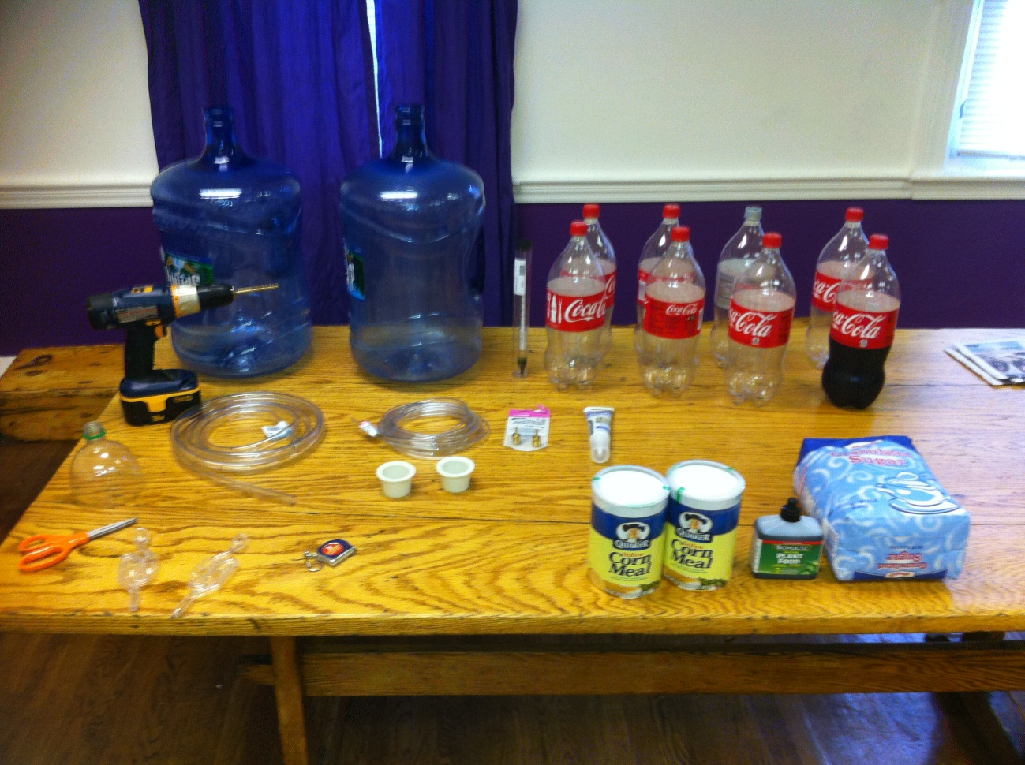
Figure 11

Finding the right Algae strain and fertilizer concentration
The experiment was started using strain1 however it was not successful, the algae refused to propagate. So we did a simple experiment to find one that would grow successfully. To do this I used the strain2 and strain3, we injected 10cc strain2 into 3 separate 1 pint mason jars will with filtered water. I then did the same with strain3. Then I added varying levels of the plant fertilizer (by drops) in each jar, 1 drops, 2 drops, and 5 drops. The six jars where then sealed to minimize cross contamination, and to attempt to replicate the sealed environment of our photo bio reactors. The jars were then placed outside in direct sunlight in the same place the photo bio reactor would be set. Observations were taken throughout a week at 12:30pm to monitor the algae’s progress. Strain3 with 5 drops was the most prolific by far, I was able to notice that minor propagation began after just 2 days, and was completed after 5 days. Strain2, 5 drops, took longer to begin propagation and stopped after a full week. The conclusion was to use 5 drops/pint with strain3.
Construction of fermenter as a photo bioreactor:
- Construction of fermenter, airlock and stopper placed on the 5 gallon water jugs.
- Drill 2 holes in each top of the 2 liter soda bottles.
- Connecting tubing to each 2 liter soda bottle.
- Use the silicone sealant to seal all areas where gas transfer was happening.
- Final apparatus construction.
- Check seals.
Sterilization: Sterilization is a fundamental in ensuring successful fermentation. In an attempt to create as sterile environment I used a private bathroom in FIJI, the space was small and I could control who when in and out. The serializing agent was a strong mixture of warm water and bleach. To maintain safety during the sterilizing proses I used a respirator and gloves in an attempt to keep from over containing myself of bleach. Everything was cleaned, the toilet was clean inside and out. The ceiling was sprayed with the water bleach mixture, the vents where covered and the windows where sealed. The shower was sterilized and the drain was covered. Not spot was left un-scrubbed.

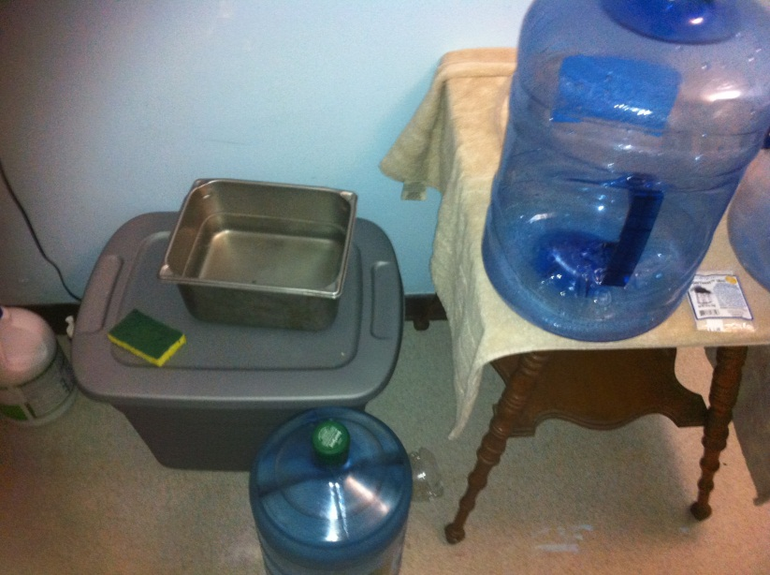
Figure 12
Making the mash and fermenter setup
- Bring 2.5 gallons of water to boil over stove
- Reduce heat and add 1lb of corn meal, let boil for 4 minutes staring continuously
- Remove from heat and add 5lbs of sugar stir till dissolved
- Cover and let cool (while waiting Continue to step 4)
- Sanitize all fermenting equipment with bleach, (fermenter, stopper, airlock, hydrometer and funnel) rinse to ensure no residual bleach in on equipment.
- Add remaining 2.5 gallons of water to now sanitized fermenter
- Place yeast in warm water with small amount of sugar activate it.
- Once mash is cool, yet still worm pour yeast into mash stir.
- Pour mash into fermenter using funnel so as not to spill.
- Take Hydrometer reading 1.101
- Place on air lock and connect hose of photo bioreactor to fermenters airlock.
Bioreactor Prep
- Combine solution of fertilizer and algae strain.
- Using funnel pour equal amount of solution in each soda bottle

Final setup
- Ensure photo bioreactor is in direct sunlight
- Ensure Fermenter is out of direct sunlight.

Results
Data:
Hydrometer reading start: 1.101 , End 1.021
Growing process and observations:
The plastic bottles where named PB1-4 from left to right.
Day 1: (figure 13) The entire apparatus is set up. Fermentation has not noticeably begun. No signs of algae growth. I checked on the fermenter 4 hours later and there was definite fermentation beginning.

Day 2: (figure 14) Fermentation has begun with full vigor. When we acquired the strain of yeast from a local brewery shop the owner told us that this strain should be in its full state of fermentation after 48 hours. PB 3 and PB4 have already begun to show signs of propagation. PB3 is also demonstrating a faster growth rate than PB4. This result is good because it demonstrates that the addition of CO₂ is stimulating algae growth as we assumed. PB4 was a similar result to what we had experienced during the Mason jar experiment. Some condensation of the top of the reactors. PB1 is currently bubbling vigorously (5-8 bubbles per burst) about 36 times a minute. PB2 is bubbling individual bubbles at the rate of 80 per/minute. PB3 is bubbling individual bubbles at the rate of 20 bubbles per minute. And PB4 is showing a rate of only 5 per/minute. This demonstrates obvious leaks in the apparatus. Regardless all four PB are receiving C02 bubbles. We were not surprised by the leaks they are to be expected giving the equipment used. Notice not growth in PB 1 and PB2, we can only speculate as to why; however we assume it’s because there is too much CO₂ in the PB. Another potential reason is that the gas coming from the fermenter is a mixture of not just CO₂ but also some alcohol in vapor; this would likely kill the algae.

Day 3: (figure 15) Vigorous growth in BP3, notice the stark difference between PB3 and PB4. PB4 shows signs of continued growth however the color is noticeably darker. Significantly more condensation of the top of the reactors. Still no growth in PB1 or PB2. Bubble rates seem to have stayed relatively constant. PB1 about bubbling vigorously (5-7 bubble per burst) about 36 bubbles/ minute. PB2 bubbling individual bubbles at the approximate rate of 68 bubbles / minute. PB3 showing a rate of approximately 20 bubbles / minute. While PB4, demonstrating a rate of 4 per /minute.

Day 4: (figure 16) Little change in the growth of the algae. Even more condensation on the inside of the reactors. Bubble rates have sharply diminished. PB1 is no longer bubbling in large burst, but now in individual bubbles at the rate of 100 per/minute. PB2 is bubbling at the rate of 30 per minute. PB3 is at the rate of 7 per minute. While the bubble rate of PB4 is negligible.

Day 5: (figure 17) Bubbling as ceased signaling fermentation has as well. Furthermore there is no sign of more buildup of condensation. Perhaps some sign of algae growth in PB2 however this could just be wishful thinking on our part. No noticeable change in PB1, PB3, or PB4

Day 6: (figure 18) Thankfully still no sign of fermentation. But PB2 is now definitely showing signs of Algae growth. This seems to back up the hypothis we made on day 2 concerning there being two much CO₂ for there to be any Algae propagation. With the leaks in the system it is possible that some of the excess CO₂ was able to escape from PB2. Still no growth in PB1. Algae has begun to settle in the bottom of PB3 and PB4.

Day 7: (figure 19) last day of our experiment. Distinctly more growth in PB2 however none what so ever in PB1. Notice the similar color in PB 2 and PB4. While difficult to see in the photo, there is a large amount of algae that has settled in PB3. Some settled algae in PB4.

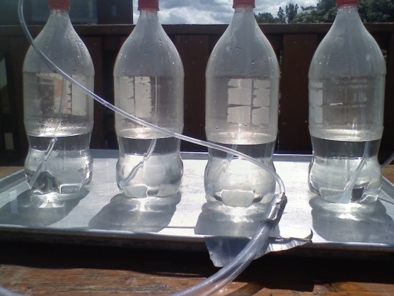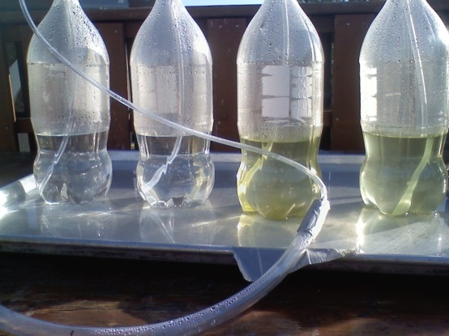
Figure 13 Figure 14
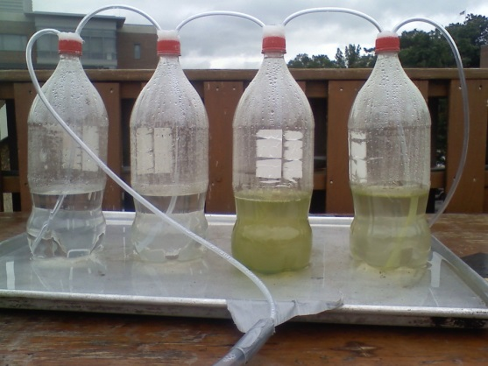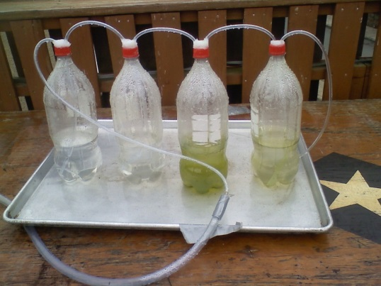
Figure 15 Figure 16
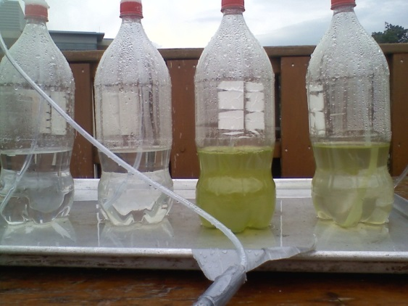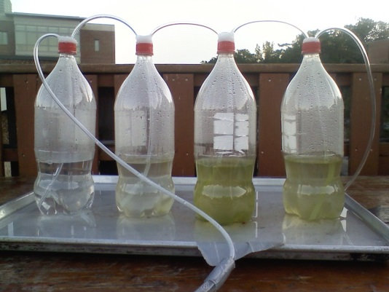
Figure 17 Figure 18

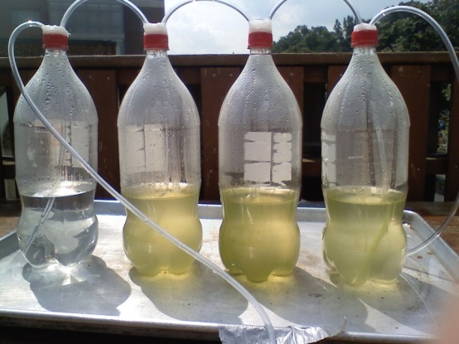
Figure 19

Experiment conclusion: we began taking a Hydrometer reading from the fermented mash, which read 1.021. As such we were able to calculate an approximate alcohol percentage of 13.39% . With a total alcohol yield of .669 gal. In a vain attempt to filter out the algae from the water we tried passing it through a coffee filter, however most of the algae ended up passing through. As such we were unsuccessful in calculating a yield of algae. We were however able to smell a noticeable aroma of alcohol from PB1. This would suggest that there was some alcohol vapor that was caught in the fertilized water making it impossible for the selected Algae to propagate. The overall experiment was a success; we were able to show that it’s not all that difficult to grow algae. Additionally we were able to demonstrate increased growth rate and yield from algae grown with added CO₂, but not too much CO₂. Furthermore we demonstrated that you could successfully grow algae and feed it CO₂ produced from fermentation. I did attempt to extract the algae through a coffee filter however most of the algae passed through it, bringing another issue to light, how to efficiently harvest massive amounts of algae. This effect has the potential to be minimized by using duckweed because it is a much larger algae and floats on the water’s surface.

Discussion
Through this experiment I found that algae is not difficult to produce, and using the formation process as a CO₂ source was feasible. I can’t help feel however that the proses of harvesting large quantities of micro algae and then the necessary process of removing the water form it so that the algae can be processed would be labor intensive, expensive, and inefficient. The true conclusion from here would be that the production plant theorized is conceivably possible. By using Duckweed as the selected strain would alleviate much of the issues I found with harvesting because the aquatic plan is not in suspension and is much larger. Additionally there would not be a need to dry the algae before processing, only to mechanically pulp it. I would love to attempt this same experiment at a larger scale using duckweed.

Appendix

Images Biofuel Companies

Oil Content of Microalgal Species Data
Microalgal species | Oil content(% dw)
Ankistrodesmus TR-87 | 28-40
Botryococcus braunii | 29-75
Chlorella sp. | 29
Chlorella protothecoides(autotrophic/ heterothrophic) | 15-55
Cyclotella DI- 35 | 42
Dunaliella tertiolecta | 36-42
Hantzschia DI-160 | 66
Nannochloris | 31(6-63)
Nannochloropsis | 46(31-68)
Nitzschia TR-114 | 28-50
Phaeodactylum tricornutum | 31
Scenedesmus TR-84 | 45
Stichococcus | 33(9-59)
Tetraselmis suecica | 15-32
Thalassiosira pseudonana | (21-31)
Crpthecodinium cohnii | 20
Neochloris oleoabundans | 35-54
Schiochytrium | 50-77

Images Algael Strains
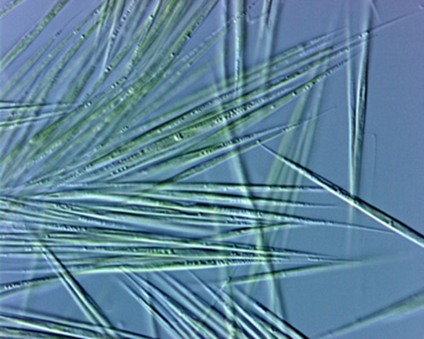

Images Plant Process Design

Images experiment

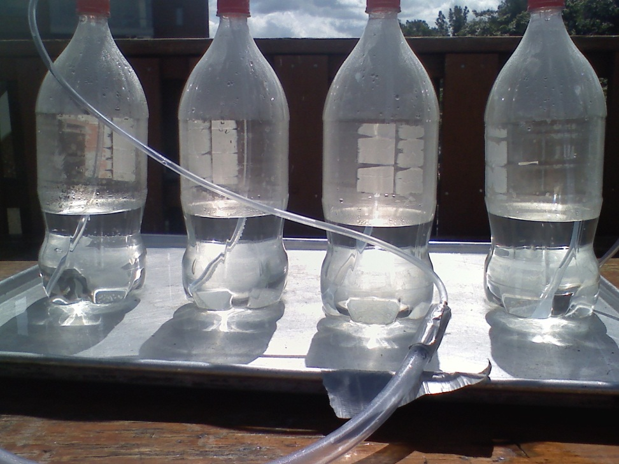

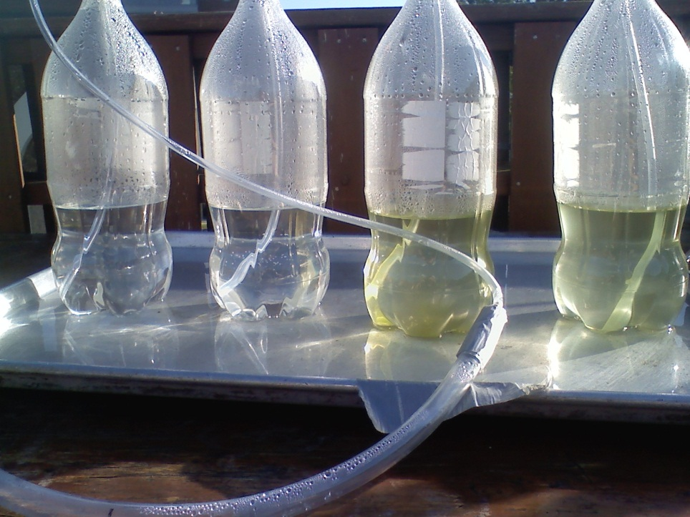
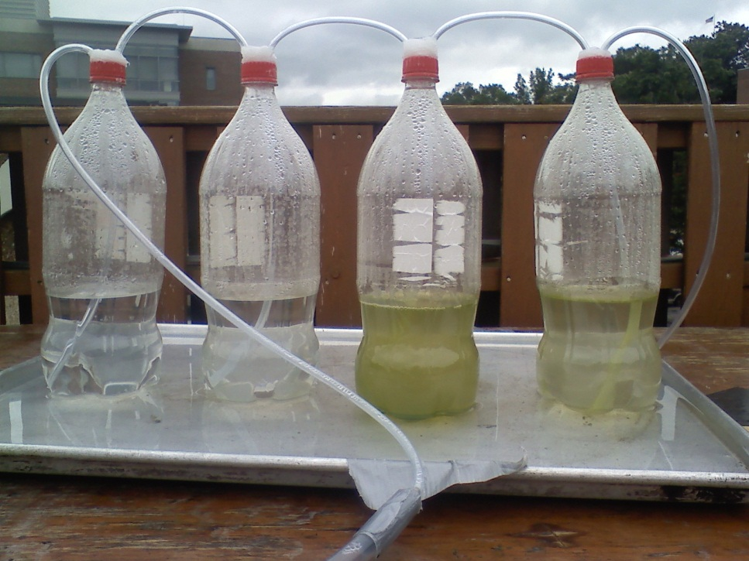
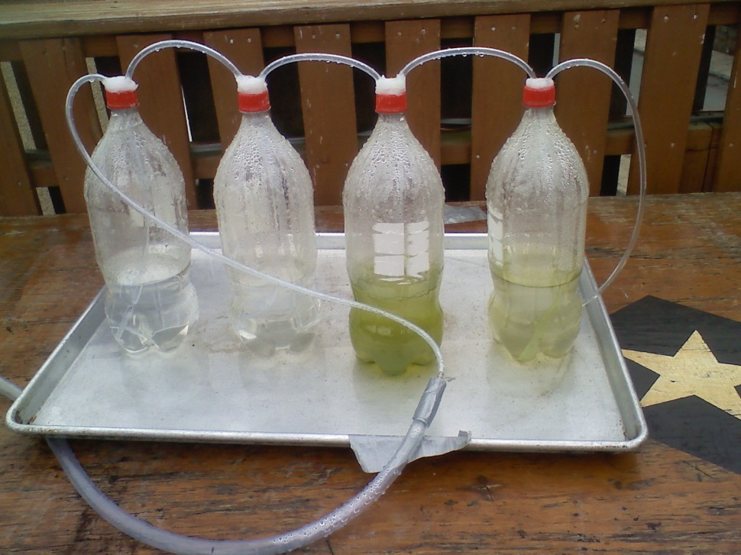
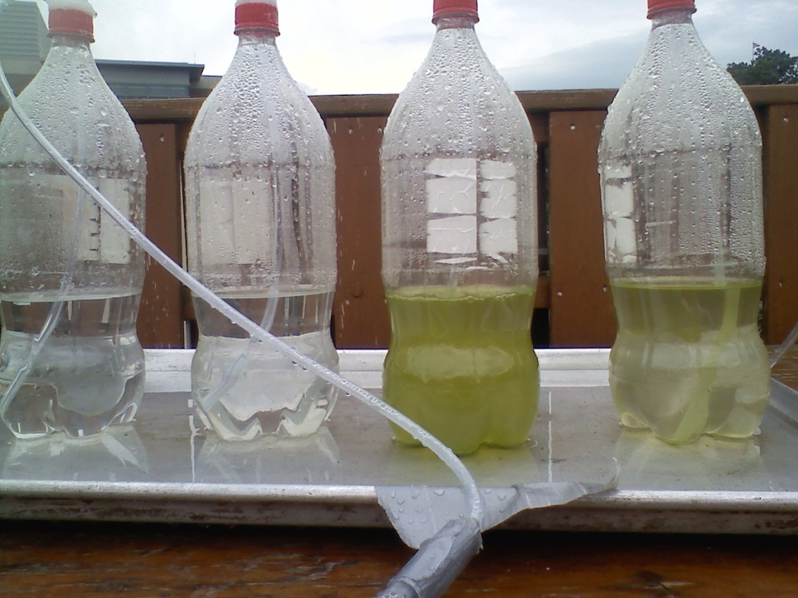
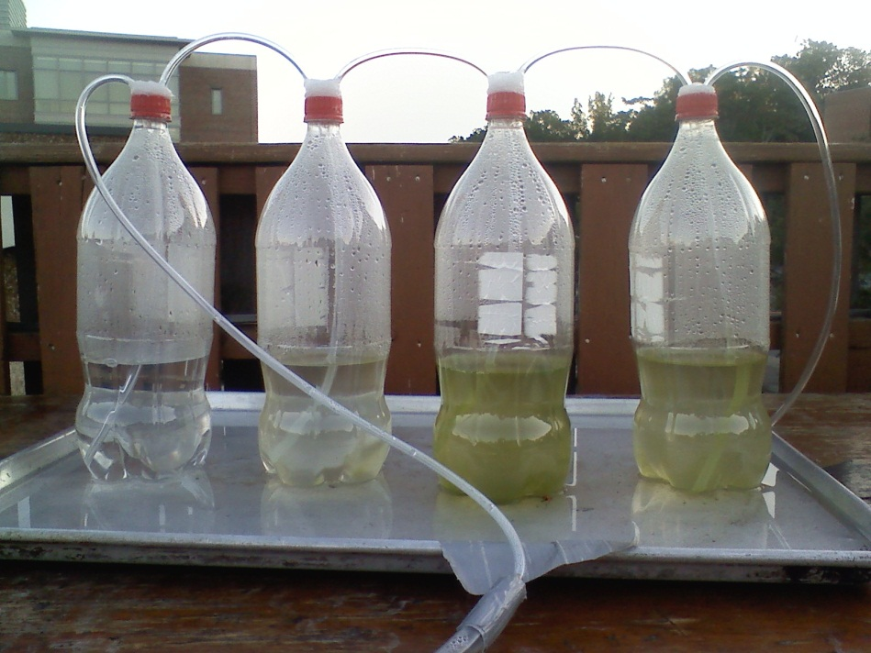
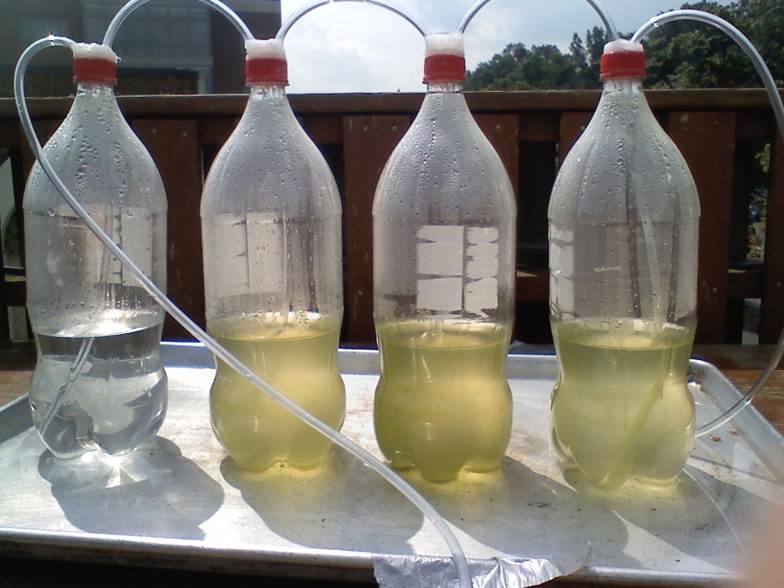

References
"About Algenol | Algenol Biofuels." About Algenol | Algenol Biofuels. N.p., n.d. Web. 24 Apr. 2013.
"Direct to Ethanol | Algenol Biofuels." Direct to Ethanol | Algenol Biofuels. N.p., n.d. Web. 24 Apr. 2013.
"Coyote Gulch Demonstration Facility | Solix Biofuels - Algae to Energy - The Production Technology Company." Coyote Gulch Demonstration Facility | Solix Biofuels - Algae to Energy - The Production Technology Company. N.p., n.d. Web. 24 Apr. 2013.
"Lumian AGS4000 | Solix Biofuels - Algae to Energy - The Production Technology Company." Lumian AGS4000 | Solix Biofuels - Algae to Energy - The Production Technology Company. N.p., n.d. Web. 24 Apr. 2013.
"The Sapphire Energy Story." Company. N.p., n.d. Web. 24 Apr. 2013.
A.D. Ayhan Demirbas & M.D. M Fatih Demirbas, "Chapter 6 Biodiesel from Algae," in Algae energy : algae as a new source of biodiesel ,, New York : Springer: Dordrecht, p. 150, 2010.
M.D. Guiry in Guiry, M.D. & Guiry, G.M. 2012. AlgaeBase. World-wide electronic publication, National University of Ireland, Galway. http://www.algaebase.org; searched on 12 February 2012.
V.W. Virginia R. Williams & R.M. Rosamond Mcmillan, "Lipids of Ankistrodesmus braunii," vol. 133, no. 3451, pp. 459–460, Feb 17th, 1961
D.B. Dinesh Kumar Barupal, "Botryococcus braunii Document Actions Fuel, Biofuel and the Microalgae," Metabolimics Fiehn Lab, Ucdavis, p. 1, Mar., 2008. [Online]. Available: http://fiehnlab.ucdavis.edu/staff/kumar/Botryococcus/. [Accessed Oct. 21, 2011].
A. Anirban anerjeeb, R. Rohit sharms, Y. Yusuf chisti, " Botryococcus braunii: A Renewable Source of Hydrocarbons and Other Chemicals," Critical Reviews in Biotechnology, Vol. 22:3, no. , pp. 245-279, 2002.
C.R. Carlos A. Ramos Encarnación, G.B. Germano Salazar Benítez & G.S. Gustavo Méndez Santos, "MAXIMIZATION OF SCENEDESMUS DIMORPHUS LIPID YIELD FOR THE PRODUCTION OF BIODIESEL," Polytechnic University of Puerto Rico, pp. 1–44, 2010. [Online].
P.S. Peter A. Siver, "The SilicaSecchiDisk," Connecticut College, Na. [Online]. Available: http://silicasecchidisk.conncoll.edu/Algal-ED_finished.html.
Fisher, T., T. Berner, D. Iluz and Z. Dubinsky (1998). The kinetics of photoacclimation response of Nannochloropsis sp (Eustigmatophyceae): A study of changes in ultrastructure and PSU density. J. Phycol. 34: 818-824.
P.L. Peter Lammers, "Biomass and Bioproducts from Nannochloropsis," New Mexico State University, pp. 1–22, Na. [Online]. Available: http://gcep.stanford.edu/pdfs/NjaBZp8qVXt6XGURnPlAWQ/Pete_Lammers_WorkshopSep2009.pdf.

