Project ID: DRA 1701

Improving Microinjection into Hydrogel- Encapsulated Organisms via Induced Vibration
A Major Qualifying Project Report submitted to the faculty of
WORCESTER POLYTECHNIC INSTITUTE
in partial fulfillment of the requirements for the degree of Bachelor of Science
Submitted by:

________________________
Christopher Rockwell

________________________
Noah Rockwell
April 25, 2018

_________________________________
Professor Dirk Albrecht, Ph.D., Advisor
Department of Biomedical Engineering

_________________________________
Professor Pradeep Radhakrishnan, Co - Advisor
Department of Mechanical Engineering

Table of Contents
Table of Contents ii
Authorship iv
Acknowledgments vi
Abstract vii
Table of Figures viii
Table of Tables x
Chapter 1: Introduction 1
Chapter 2: Literature Review 5
2.1: Transgenic Organisms 5
2.2: Importance of C. elegans 6
2.3: Transformation Through Microinjection 8
Chapter 3: Project Strategy 16
3.2: Project Approach 17
3.3: Initial Client Statement 17
3.4: Technical Design Requirements 18
3.5: Requirements for Attachment 18
3.5.1: Objectives 19
3.5.2: Specifications 19
3.5.3: Constraints 20
3.5.4: Functions 21
3.6.1: Objectives 22
3.6.2: Specifications 23
3.6.3: Constraints 23
3.6.4: Functions 24
3.7.1: Standards for Attachment 25
3.7.2: Standards for Containment 25
3.8: Revised Client Statement 26
3.9: Project Approach 26
Chapter 4: Design Process 29
4.1: Needs Analysis 29
4.2: Functions and Specifications 30
4.4: Evolution of Major Components 31
4.5.2: Scotch Yoke 33
4.5.3: Mechanical Vibration 34
4.6: Alternate Designs for Attachment 35
4.7: Final Design for Attachment 36
4.8: Details of Control System 37
4.9: Final Design for Control System 40
4.10: Details of the Containment 42
4.10.1: Agarose as a Major Component 44
4.10.2: Polydimethylsiloxane (PDMS) as a Mold 45
4.10.3: Improved Hydrogel Model 46
4.10.4: Treated Slides for Improved Removal 49
4.10.5: Using Spacers to Control Thickness 50
4.10.6: Pure Hydrogel Solution 55
4.11: Alternate Designs for Containment 55
4.12: Final Design for Containment 57
5.1 Quantification of Vibration 60
5.2: Deformation Results 66
Chapter 6: Final Design and Validation 70
6.1: System usage and validation 70
6.2: Economics 71
6.3: Environmental Impact 72
6.4: Societal Influence 73

Authorship
Chapter 1: Introduction – Chris Rockwell

Chapter 2: Literature Review
2.1: Transgenic Organisms – Chris Rockwell
2.2: Importance of C. elegans – Chris Rockwell
2.3: Transformation Through Microinjection – Chris Rockwell
2.4: Current Methods of Injection – Noah Rockwell
2.5: Standard Process in Local Lab – Noah Rockwell
2.6: Updated Method of Containment – Chris Rockwell
2.7: Vibration for Improved Injection – Chris and Noah Rockwell

Chapter 3: Project Strategy
3.1: Project Goals – Chris Rockwell
3.2: Project Approach – Noah Rockwell
3.3: Initial Client Statement – Chris Rockwell
3.4: Technical Design Requirements – Chris Rockwell
3.5: Requirements for Attachment – Chris Rockwell
3.5.1: Objectives – Chris and Noah Rockwell
3.5.2: Specifications – Chris and Noah Rockwell
3.5.3: Constraints – Chris and Noah Rockwell
3.5.4: Functions – Chris and Noah Rockwell
3.6: Requirements for Containment – Chris and Noah Rockwell
3.6.1: Objectives – Chris and Noah Rockwell
3.6.2: Specifications – Chris and Noah Rockwell
3.6.3: Constraints – Chris and Noah Rockwell
3.6.4: Functions – Chris and Noah Rockwell
3.7: Design Requirements Standards
3.7.1: Standards for Attachment – Chris Rockwell
3.7.2: Standards for Containment – Chris Rockwell
3.8: Revised Client Statement – Chris and Noah Rockwell
3.9: Project Approach – Chris Rockwell
3.10: Financial Consideration – Chris Rockwell

Chapter 4: Design Process
4.1: Needs Analysis – Chris Rockwell
4.2: Functions and Specifications – Chris Rockwell
4.3: Modeling and Feasibility – Noah Rockwell
4.4: Evolution of Major Components
4.5: Details of the Attachment – Noah Rockwell
4.5.1: Piezo Vibration – Noah Rockwell
4.5.2: Scotch Yoke – Noah Rockwell
4.5.3: Mechanical Vibration – Noah Rockwell
4.6: Alternate Designs for Attachment – Noah Rockwell
4.7: Final Design for Attachment – Noah Rockwell
4.8: Details of Control System – Chris and Noah Rockwell
4.9: Final Design for Control System – Chris and Noah Rockwell
4.10: Details of the Containment
4.10.1: Agarose as a Major Component – Chris Rockwell
4.10.2: Polydimethylsiloxane (PDMS) as a Mold – Chris Rockwell
4.10.3: Improved Hydrogel Model – Chris Rockwell
4.10.4: Treated Slides for Improved Removal – Chris Rockwell
4.10.5: Using Spacers to Control Thickness – Chris Rockwell
4.10.6: Pure Hydrogel Solution – Chris Rockwell
4.11: Alternate Designs for Containment – Chris Rockwell
4.12: Final Design for Containment – Chris Rockwell

Chapter 5: Design Verification
5.1 Quantification of Vibration – Chris Rockwell
5.2: Deformation Results – Chris Rockwell

Chapter 6: Final Design and Validation
6.1: System usage and validation – Noah Rockwell
6.2: Economics – Noah Rockwell
6.3: Environmental Impact – Chris Rockwell
6.4: Societal Influence – Noah Rockwell
6.5: Political Ramifications – Noah Rockwell
6.6: Ethical Concerns – Noah Rockwell
6.7: Health and Safety Issues – Noah Rockwell
6.8: Manufacturability – Noah Rockwell
6.7: Sustainability – Chris Rockwell

Chapter 7: Discussion – Noah Rockwell

Chapter 8: Conclusions and Recommendations – Noah Rockwell

All members contributed equally to the editing of this paper.

Acknowledgments
Our team would like to thank Prof. Albrecht for the inspiration for the project, advice during the design, and his help throughout, and our co advisor from the Mechanical Engineering department, Pradeep Radhakrishnan for his continued support and help with the mechanical aspects of the design. We would also like to thank our lab manager Eric Larsen for his guidance and knowledge in the lab and Prof. Page for his help with our early designs. Special thanks to Lisa Wall for helping us find materials and equipment.

Abstract
The creation of transgenic C. elegans is commonly done via microinjection of plasmid DNA, a process that has a short time frame of ten minutes in its current state. An alternate approach developed in Prof. Albrecht’s lab utilizes a poly(ethylene glycol) hydrogel to encapsulate the worms, increasing longevity to 24 hours or more, with a new observed issue of the hydrated outer shell becoming more durable, leading to difficulty puncturing. Our team developed an attachment to solve this problem. Initial designs were narrowed down to a 3D-printed attachment that utilized vibration to provide the desired 5 to 15 µm of movement in the needle. This motion was quantified by microscopy as 4.24 µm transverse, and 12.7 µm axially. Our device succeeded in reducing the depression of the C. elegans cuticle from an average of 67.2 µm to an average of 27.2 µm, which is between 2 to 5 µm off the current standard. Our design was also successful in injecting tracer dye into the gonad of the C. elegans, confirming its ability to complete this process.

Table of Figures
Figure 1: Example of C. elegans 1
Figure 2: Example of C. elegans Injection 3
Figure 3: Examples of transgenic organism 6
Figure 4: Fluoresced C. elegans Muscle shown in two different states above, with the scale bar showing 50 micrometers 7
Figure 5: Micropipette Puller 10
Figure 6: Example of hydrogel containment 12
Figure 7: A example of the different stages of a mosquito bite, ranging from a to d 13
Figure 8: Image of Single Cell Injection 14
Figure 9: The PiezoDrill, and example of the piezo impact drive 15
Figure 10: PatchmanTM NP 2 micromanipulator and FemtoJet that was used for testing 20
Figure 11: Initial Gantt chart of process 28
Figure 12: Gannt chart for D term progress 29
Figure 13: 3D printer used to create the majority of the attachment 31
Figure 14: Example of a scotch yoke 34
Figure 15: Completed Attachment 36
Figure 16: System attached to micromanipulator 37
Figure 17: Diagram of the attached motor with potentiometer to vary the power 38
Figure 18: Diagram of the connection with the stronger motor, using an attached power source 39
Figure 19: The different attempted motors, starting from the left, a geared motor, a linear vibration motor, and a rotation vibration motor 39
Figure 20: Control system without box, with the white arrow pointing to the connected motor 41
Figure 21: Example of single pole double throw switch 42
Figure 22: Schematic of the final design for the induced vibration, the motor representing the vibration motor and the switch representing the foot pedal 42
Figure 23: Liquid agarose on a slide 45
Figure 24: Example of simple two element containment, with the dark grey in this case representing agarose and the light grey representing hydrogel 45
Figure 25: Agarose stamp created with microstructure 46
Figure 26: Example cross section, with the dark grey representing agarose and the light grey representing hydrogel 47
Figure 27: Cross-linked microstructure with encapsulated C. elegans, with broken needle tip shown by the white arrow 48
Figure 28: Example of a C. elegans without enough material to cover it, that has pushed free from the channel to the surface of the hydrogel 49
Figure 29: Scotch tape 51
Figure 30: Example of spacers from previous process 52
Figure 31: Silhouette Cameo Electronic Cutting Tool used to cut PDMS spacers 53
Figure 32: Basic representation of improved spacers 53
Figure 33: Hydrogel containment created using square PDMS spacer 54
Figure 34: Agarose heating for use to create stamps 55
Figure 35: Cross section of final mold used, dimensions in μm 56
Figure 36: Mold created with microstructure 56
Figure 37: Single hair brush used to align C. elegans 57
Figure 38: Cross section of hydrogel system, with the arrow representing direction of the needle and the units in um 58
Figure 39: Contained C. elegans in hydrogel system 59
Figure 40: Attached Camera for Analysis (acA1300-60gm - basler ace.) 60
Figure 41: Still from the video used to track the needle 60
Figure 42: Vibration in open air tracked for two hundred points, with the needle coming from the left side of the image 61
Figure 43: Two hundred points tracked and then put through a moving average filter 62
Figure 44: Vibration tracked for two hundred points while the needle is embedded in hydrogel 63
Figure 45: Motion of the needle while embedded in hydrogel tracked for two hundred points 64
Figure 46: Heat map of the motion of the needle in open air, using two hundred tracked points and darker colors representing higher number of occurrences 65
Figure 47: Heat map of vibration in gel tracked for two hundred points 65
Figure 48: Injection without Vibration, with the blue line representing the deformation measurement 66
Figure 49: Injection with vibration, with the blue line representing the deformation measurement 67
Figure 50: Deformation difference, between with and without vibration 68
Figure 51: Successful injection into C. elegans 71
Figure 52: Example of current injection 77
Figure 53: One side of the needle clamp 98
Figure 54: Outer side of the needle clamp 98
Figure 55: Vibration dampening pad, two in the final design 99
Figure 56: End cap for the case 99
Figure 57: Main component and attachment to micromanipulator 99

Table of Tables
Table 1: Design function to means table 21
Table 2: Comparison of deformation in micrometers, with average and standard deviation 65
Table 3: Total cost of the attached system 68

Chapter 1: Introduction
The term transgenic organisms refer to organisms that have had a foreign gene intentionally inserted into their genome. This is done to develop researchers’ understanding of many core aspects of biology, such as the immune system, the impact of oncogenes (genes that could potentially transform a cell into a cancer cell), and more. Rodents such as rats or mice are the most commonly used transgenic organisms, utilized in many labs across the world.
A more recent example is the nematode C. elegans., the research of which is the major focus of over fifteen hundred labs across the world. This research has led to many advances in the scientific community’s understanding of human development, cell death, and a wide range of similar topics.
The major method through which research with C. elegans is done is to inject plasmid deoxyribonucleic acid (DNA) into the organism. This plasmid DNA then expresses itself in the next generation that is developed from the injected C. elegans. This method takes a significant amount of practice to achieve, and is also slow due to the process’s current constraints.
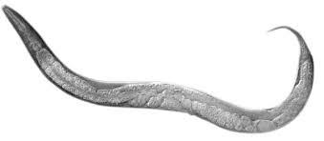
Figure 1: Example of C. elegans [1]
The goal of this project was to improve the ease and efficiency of this micro-injection into C. elegans nematode, the results of which could possibly be utilized in the microinjection of other similar transgenic organisms. C. elegans, shown in Figure 1, are on average 1 mm in length, and are commonly found in soil around the world. C. elegans has a worm-like structure, a tough outer layer known as a cuticle, and four main bands of muscle used for movement that run the length of the body. They are also non-hazardous, non-infectious, non-pathogenic, and non-parasitic organisms, making handling of C. elegans a safe process.
C. elegans are important due their status as the first organism to have its genome completely mapped out. This allowed for a series of more targeted studies in the field of biology, leading to a deeper understanding of topics such as gene regulation during development, cell death, RNAi, GFP, microRNA, and behavioral genetics. This has led to multiple Nobel Prizes and Breakthrough in Life Science awards, the use of C. elegans has been a powerful tool for research.
Other factors of the importance of C. elegans is, the similarity of their neural pathways to that of humans, the much smaller scale of these pathways, and that C. elegans was the first organism to have their pathways completely mapped out. These factors allow us to understand more about the neurons in our own brains by mapping the way neurons in C. elegans react using genetically encoded fluorescent markers, genetic removal of function, and a range of other methods. It’s much easier to study C. elegans than the human brain since they have only three hundred and two neurons versus the eighty-six billion of a human, which allows research to much more easily map their neural pathways. C. elegans are also very similar to the neurochemical homology of humans, sharing over sixty to eighty percent of the genes in human disorders. This has contributed to an increased understanding of neurodegenerative disease, lifespan, and aging, as well as neural regeneration.
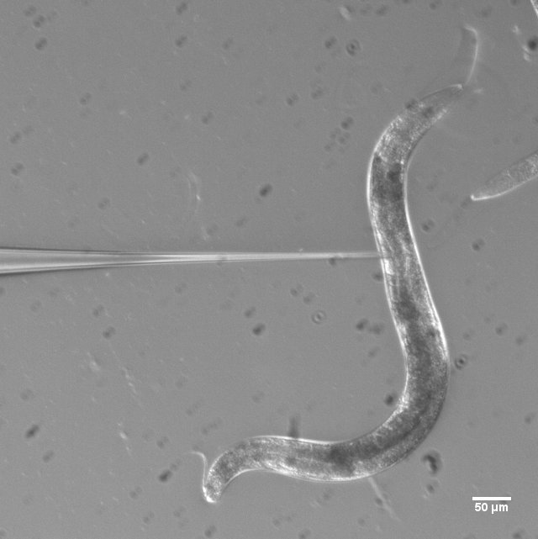
Figure 2: Example of C. elegans Injection
The major method of genetic modification that we focused on with our project is microinjection, shown in Figure 2. Plasmid DNA is injected into the gonad of the C. elegans, each injected animal is isolated, and the next generation is analyzed. All successful worms are then isolated and used for research.
This injection process is done using a pulled microinjection needle which is attached to a micromanipulator, a device that allows for movement on a small scale, with a large degree of precision. The C. elegans are stuck to an agarose pad, and a drop of oil is placed on top to slow dehydration. This is the standard method, but it has shortcomings. Once placed on the agarose, the C. elegans perish within fifteen minutes due to dehydration. This makes the overall process very slow, since only a small number of animals can be injected at a time, especially when the time required to retrieve the animals is considered. The process also relies on the inconsistent adhesive properties of the agarose to keep the animals in place, which often leads to them becoming pushed free during injection, causing a loss to what is already a small time frame for this process. We worked with Prof. Dirk Albrecht’s lab, which is trying to counteract these issues by using hydrogel to contain the C. elegans during injection. The hydrogel keeps the animals healthy for over twenty-four hours as long as a buffer is continuously added to the hydrogel’s surface. This solves both the problem of a small time frame for the process, as well as holding the animals in place. However, it has led to a new problem. It was observed that while the animals are healthy inside the hydrogel, it becomes difficult to puncture their outer cuticle. This causes the cuticle to depress a significant distance, often more than halfway through the animal, before the needle punctures. This causes issues such as injecting into the incorrect area, pushing the animals out of the hydrogel, and damaging the animal beyond recovery. Our project aims to solve this problem.
The other component of our project was updating the hydrogel containment system that was being used by Prof. Albrecht’s lab. While our major goal was to solve the issue of deformation, our team aimed to design a more streamlined process. The hydrogel was put through a range of iterations to find the best way to align and inject C. elegans. Using the expertise of Prof. Albrecht’s lab, we expanded on our knowledge of C. elegans microinjection and hope that it serves as a strong model for future work.

Chapter 2: Literature Review
Transgenic organisms refer to organisms which have had their genes intentionally modified genes. These modifications have contributed greatly to the scientific community by expanding our understanding of genetics and a range of other topics. Currently the most common method of generating transgenic organisms is through microinjection, which is a technically difficult and time consuming process. An update to this method was developed here at the Worcester Polytechnic Institute, in the context of a nematode C. elegans, but this updated process comes with its own issues. Our project addresses these issues to create an improved method to generate transgenic organisms.
Work with the C. elegans nematode has advanced our understanding in multiple fields of science, including biology, chemistry, medicine, and psychology, and it has allowed for major progression in our understanding of genetics and neuronal function. Research with C. elegans has won three Nobel prizes, two in physiology or medicine and one in chemistry, with the research focusing on genetics of organ development, programmed cell death, ribonucleic acid (RNA) interference, and work with green fluorescent protein. C. elegans research also looks to expand researchers understanding of the effects of aging on neuronal function [2], the function of neuronal pathways associated with muscle activity [3], and a range of other areas of research.

2.1: Transgenic Organisms
There is a large range of transgenic organisms being studied. C. elegans has been a very powerful example of a transgenic organism, but other examples include mice, zebrafish, and fruit flies, shown in Figure 3. Each of these organisms has been extensively researched due to the ease of their genetic modification, when compared to other organisms.
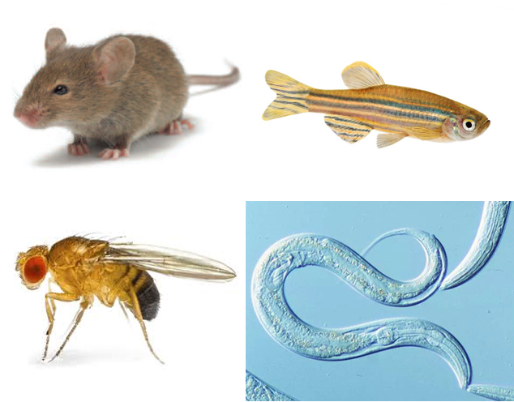
Figure 3: Examples of transgenic organisms in order left to right top to bottom [4][5][6][7]
The research that has been developed from these modifications have had far reaching implications, and have expanded the understanding of developmental gene regulation, the action of oncogenes, the immune system, and mammalian development. Gene modifications that researchers have developed allow them to create more accurate genetic models for human conditions and to better understand the human genome [8].
One example of this is the development of a model for oncogenesis and diseases. Transgenic organisms have been crucial in this research, allowing for more representative study of the reactions of different tissues to oncogene activity when compared to standard cell culture. These transgenic models have also allowed for the understanding of how oncogenes cooperate and their effect on growth and differentiation [8].

2.2: Importance of C. elegans
One of the factor of C. elegans success in neuroscience is their neural similarities to humans and their simple and well-understood nervous system. According to recent estimates, C. elegans has over sixty percent of the genes present in human genetic disorders. Many human biochemical pathways, such as insulin signaling, are also present in C. elegans [9]. C. elegans was also the first multicellular organism to have its entire genome sequenced, and the entire series of connections between its neurons mapped out. It was also determined that eighty-three percent of the C. elegans proteome has homologous human genes [10].
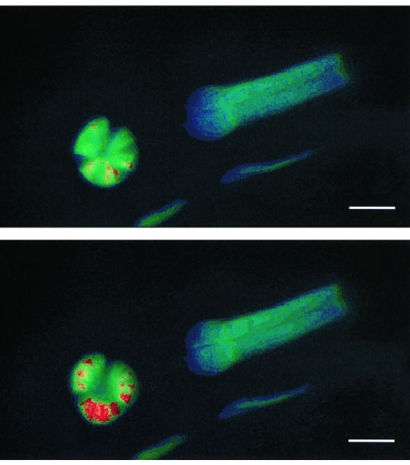
Figure 4: Fluoresced C. elegans Muscle [1] shown in two different states above, with the scale bar showing 50 micrometers
Furthermore, C. elegans has a less complex nervous system than a human. In comparison, a single worm has 302 neurons to a human's ~86 billion and ~8000 neuronal connections compared to a human’s ~100 trillion. These factors allowed for the success of C. elegans as a much faster and direct tool for research of the human brain and genetics [11].
Mutation between generations or direct genetic modification of C. elegans is the core of their research and is done through a range of methods. Both mutation and genetic modification work well in C. elegans due to their generation time of around 3.5 days, short lifespan of 2-3 weeks, and their genetic malleability between generations [12].
Direct genetic modification of C. elegans has the added benefit of being able to add or remove specific genetic functions. An example of this is adding fluorescence to neuronal or muscle activity, shown in Figure 4. This addition allows a direct visualization of neural activity of C. elegans, and their response to stimulus such as food, or to the effects of aging on their neural function. An example of removing function is the loss of function modification of a known gene in C. elegans development. The loss of this gene allows researchers to more directly quantify its importance in C. elegans development and its interaction with other genes [13].

2.3: Transformation Through Microinjection
The transformation of C. elegans is a constantly evolving process, but is most commonly done by microinjection of transgenic or foreign DNA into C. elegans. This foreign DNA is injected into the gonad of the host animal, which is then expressed in the following generation. Microinjection also allows for RNA interference, or the ability to use RNA molecules to inhibit gene expression or translation by blocking mRNA molecules. There is a large range of different methods that have been developed for a variety of modifications to C. elegans, but in almost all cases a large part of the process is microinjection into individual C. elegans, with the intended expression showing in the next generation [14].
There are a large number of factors contributing to both the success or failure of this technique, and how the results are classified. Transformation usually requires some form of co-transformation with a marker gene that allows for selection or scoring of the desired gene. After each injection, the C. elegans that express these marker genes are saved, and the next generation from these successful examples are used as the basis for research.
A more recent method that has been developed for the microinjection of C. elegans and other transgenic organism is Crispr/Cas9. It is done by direct injection of the Crispr/Cas9 and replacement deoxyribonucleic acid (DNA) into the gonad of C. elegans. After multiple injections the new strain is reproduced and express the inputted modification. In Crispr/Cas9 the enzymatic cleavage of DNA is guided by guide ribonucleic acid (gRNA) and is specific to the DNA sequence [14]. This powerful targeting is also helped by the fact that C. elegans has had its entire genome mapped.
Some examples of the impact of Crispr in work with C. elegans are targeted indels (insertion or deletion of genes). Crispr without a donor sequence usually renders a gene nonfunctional and is called a deletion, and is done to study the effect of the loss of that gene. Green florescent protein (GFP) tags by adding GFP to the gene product to visualize its movement via fluorescence microscopy; and Gene editing. This includes a donor sequence and selects for homologous recombinants that then have a specific targeted mutation, which can be used to make disease models or replications of human disease mutations in an animal model.

2.4: Current Methods of Injection
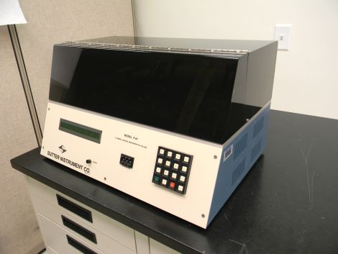
The current process of C. elegans genetic modification is done using pulled microinjection needles made of borosilicate glass with a fine internal glass filament, pulled in our lab with the micropipette puller shown in Figure 5. Injection needles are filled with 1 μl of DNA injection mix using a needle-loading pipette, and then placed into a needle holder with a pressurized injection system which is then attached to a micromanipulator.
Figure 5: Micropipette Puller
To prepare the C. elegans, agarose injection pads are baked to make the material adhesive, to immobilize the worms. C. elegans are then picked onto the injection pads and then a drop of injection oil, typically a Halocarbon oil or heavy paraffin oil, is added on top. This oil is used to increase the time before the worm perishes due to dehydration while on the agarose. Once on the pad, a worm pick is used to press the C. elegans down onto the pad to ensure adherence. The C. elegans are then injected with less than one microliter of the DNA solution at 15° to 45° degrees directly into the gonad. The gonad, due to the hermaphroditic nature of C. elegans, accounts for sperm production and the uterus of the animal. Once the injection process is completed, a recovery buffer is added to the agarose pad to keep the animals alive [13].
The current issue with method is that the C. elegans perish after ten minutes due to dehydration. This leads to a small process time considering that an operator needs time to align the needle, set up the pad, and to carry out the injection, which is a technically difficult process. This results in a bottleneck to the amount of research that comes out of C. elegans, genetic modification, as it takes numerous attempts to produce a successful strain.

2.5: Standard Process in Local Lab
Our work was done entirely in Prof. Albrecht’s lab. Injection work was done with a PatchMan TM NP 2 micromanipulator and connected FemtoJet pressure system. Both of these came with their own strengths and limitations. While the PatchMan TM NP 2 allowed for very fine control of motion, it can only move on a single axis at a time, and does not allow for the diagonal direction that is optimal for injection.
The FemtoJet pressure system allowed for a range of injection pressures and control. Using standard procedure, our team wss able to set up a baseline for injection into C. elegans. As this updated process is very new, there isn't a fully defined procedure to follow, this meant that the process had to be determined through trial and error and large amounts of testing.

2.6: Updated Method of Containment
A newer method developed in Prof. Albrecht’s lab was given to us at the start of this project. In this procedure Poly(ethylene glycol) (PEG) hydrogel is used in conjunction with Lithium phenyl-2,4,6-trimethylbenzoylphosphinate (LAP) photoinitiator, which allows for the crosslinking of the hydrogel to encapsulate the worms. A photoinitiator reacts to radiation (in our case ultraviolet light), creating free radicals which then connect the surrounding PEG chains and create a solid hydrogel structure shown below in Figure 6.
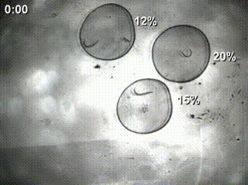
Figure 6: Example of hydrogel containment [15]
This process is aided by spacers that allow for the optimal amount of material on top of the worms. It is possible to vary this level when PDMS spacers are used. Spacers made of PDMS can be made and ranged in thickness with accuracy.
The issue with this process is primarily the deformation of the outer cuticle of the animals. In healthy C. elegans the cuticle tends to be difficult to puncture, due to its elasticity and thickness. This causes the needle to greatly depress the cuticle of the animals during injection. Due to this depression, problems arise, such as damaging the animals, injection into the wrong area, and freeing the animal from the gel. More detail about this process is reproduced in Appendix A.

2.7: Vibration for Improved Injection
A commonly used method to improve the process of microinjection is by inducing a vibration. Examples of this can be found in nature, with a compelling example consisting of the mosquito. It was recently discovered in 2010 that the mosquito does not directly pierce the skin, but uses its two maxillas, or upper and lower parts of its jawbone, to create a variable frequency. This is combined with nano sharp teeth is used to advance the mosquitoes’ feeding fascicle into human skin [16]. Shown below in Figure 7 is a visualization of this.
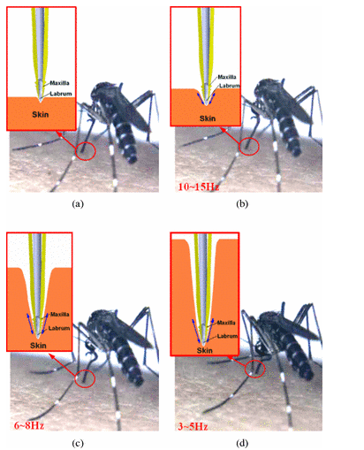
Figure 7: A example of the different stages of a mosquito bite, ranging from a to d [16]

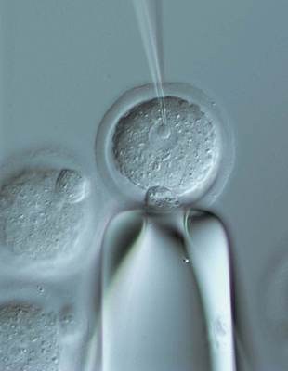
Another example of this vibration increasing the ease of penetration is the piezo impact drive, shown in Figure 8, which is a microinjection device that was created for the same with the same goal of reducing deformation. This drive is used to do microinjection for single cell microinjection [17], shown in Figure 9, which ten times smaller than our application. The drive was developed to reduce cell membrane deformation during single cell microinjection. To achieve this the piezo impact drive uses vibration induced through oscillating piezo crystal. In both cases cell membrane deformation and C. elegans cuticle deformation, the issue being added damage and inaccuracy to the process.
Figure 8: Image of Single Cell Injection [17]
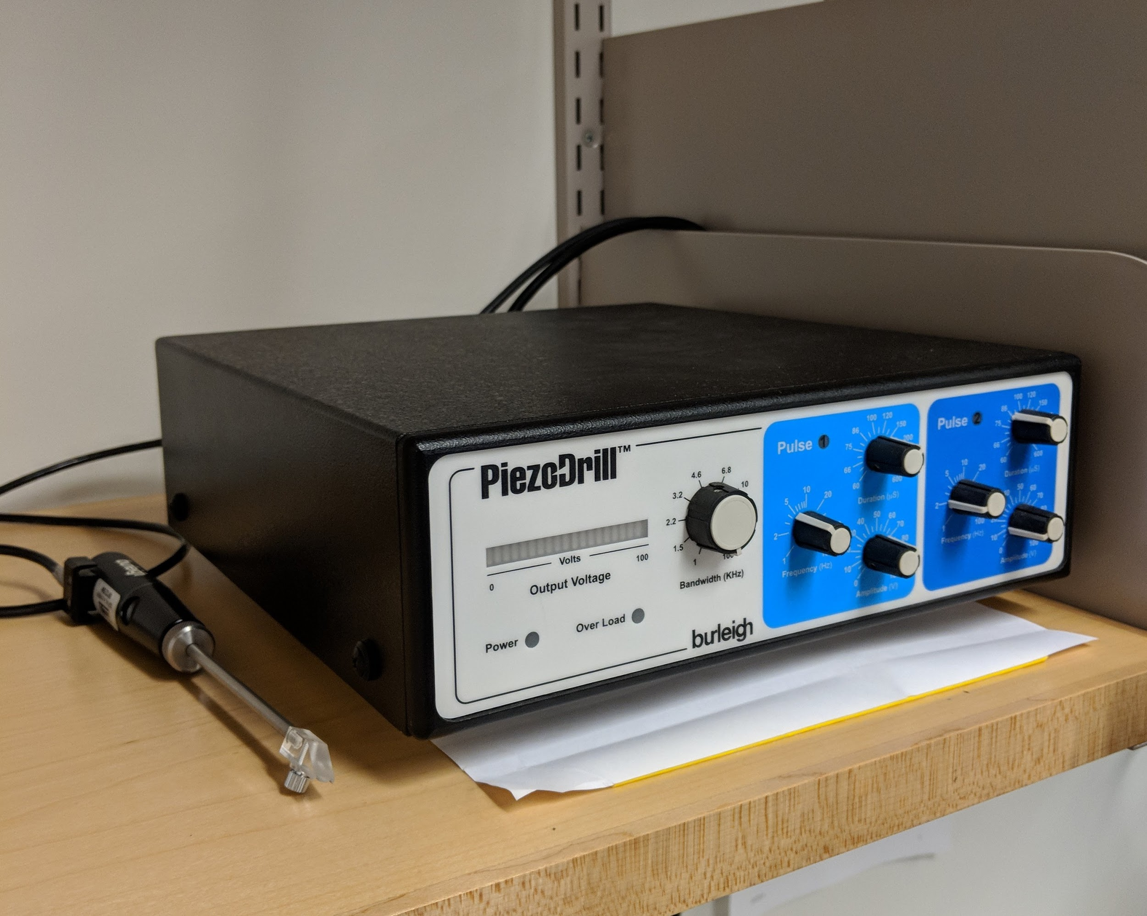
Figure 9: The PiezoDrill, and example of the piezo impact drive

The last device our team looked into as an example of utilizing vibration for improved penetration was a tattoo gun. Tattoo guns have been used for years to repeatedly and effectively puncture the outer layer of an animal, in this case humans skin. There are several types of tattoo guns, each with a different method of vibration, but each with the same design goal. The tattoo guns’ needles puncture the outer dermis to a depth of 1 to 2 mm repeatedly to deposit the ink at the desired depth. This vibration is on a much larger and rougher scale than our design aims for, but it acted as a positive indication that mechanical vibration would be effective for application.

Chapter 3: Project Strategy
At the beginning of this project we developed an initial project statement from which we started work and narrowed down our team’s focus. With continued contact with our sponsor and research, we expanded on this project statement. We did this through the development of a series of objectives/constraints and requirements for our design. Using these objectives and a new and more comprehensive client statement our team developed a project approach with which to tackle the design of an improvement to the current system of microinjection in C. elegans.

3.1: Project Goals
The major goal of our project is to improve the speed of C. elegans genetic modification. As shown above current methods are time consuming and difficult. Improving the ease and efficiency of routine genetic modification would allow for faster research and larger batches of modified C. elegans, going from 2 to 5 at a time to 20 to 50 or more.
The primary method through which we intended to increase efficiency is through designing a method to induce vibration to aid in the puncturing of the hydrated C. elegan in conjunction with updating the new method of containment that was developed through Prof. Albrecht’s lab. This vibration was theorized to be the solution to the new issues that had stemmed from this improved method of encapsulation.
From initial measurements of C. elegans it was determined that a representative range of motion to penetrate through the cuticle or outer casing of the C. elegans was a distance between 5 and 15 micrometers. This allowed us to create a baseline to move forward.
Two minor goals that stemmed from this were to make the process easier for an operator and to not add a major cost. Part of the difficulty with the previous process was that it takes some skill for an operator to do with any efficiency, and even then this efficiency is gated by the nature of the approach.
The major goals that stemmed from this were as follows, ranked in order of importance to our project:
- Induce a vibration in the range of 5 to 15 micrometers
- Decrease the deformation to the cuticle of the C. elegans
- Improve the efficiency of C. elegans injection
- Add no new cost, over our teams $500 budget

3.2: Project Approach
Due to the lack of complexity of any design the major method through which we went about developing this project was rapid prototyping. There was a wide variety of methods to induce a vibration and very limited costs and time associated with these different methods. This meant that it was possible for our team to quickly develop and test a range of methods.

3.3: Initial Client Statement
Our initial client statement was developed from very limited initial discussion with our client and early research. Our initial client statement was as follows:

Design a method to more easily penetrate the hydrated cuticle of C. elegans to improve the process of microinjection and generation of transgenic organisms.

This client statement gave our team a focus for this project to move into the next phase of development, setting our goals, objectives, requirements, and determining our constraints.

3.4: Technical Design Requirements
To meet this initial client statement, we wanted to make an easier to use, faster, more accurate, and more consistent system for C. elegans genetic modification. Another aspect that stemmed from future research was cost. Our team wanted to make this system as cheap as possible, as it will be used primarily in smaller labs and initially for this single application.
The gold standard process currently has a maximum deformation 20 to 25 μm, which our team attempted to replicate. Direct measurements of the C. elegans lead us to aim for a needle movement in the 5 to 15 μm range, which would theoretically allow for an improved injection. Our team also needed to constrain the motion perpendicular to the needle as much as possible, optimally 5 micrometers or less.
This system also needed to be directly compatible with the setup in the local lab at WPI. It had to be incorporated as an attachment to the current micromanipulator and hold the current microinjection needle. The micromanipulator that our team used came with a maximum weight limit of 100 grams for any attachment.

3.5: Requirements for Attachment
The attached system was meant to replace the end component of a micromanipulator, with the added benefit of introducing a controlled vibration or a piston motion to the pulled microinjection needed. What follows are our team’s objectives, constraints, and functions of our design.

3.5.1: Objectives
- A controlled vibration: Early measurements of the C. elegans showed this range would be 5 to 15 μm. This allowed for us to develop initial results and determine the impact of this induced vibration.
- A stable system: Our team needed to make sure that any attached device did not damage the current system. We wanted to integrate our attachment as cleanly as possible with the current micromanipulation system. If our attachment damaged or even reduced the lifespan of the current system, then we could assume that it had failed due to any repair or replacement costs.
- Minimal cost: A major aspect of this design as given by the client was the attached system cannot introduce any large added cost. We intended to design this system within 500 dollars.
- Accurate injection: Accuracy is important to our team and our client so we needed to make sure that the introduced motion was controlled, such that it only acts along the needle. We also needed to determine the correct rate, frequency, and accuracy of the motion of vibration, to avoid unnecessary damage.

3.5.2: Specifications
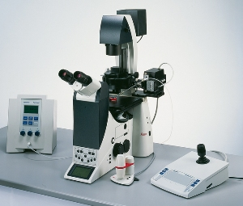
We were working with a PatchmanTM NP 2 micromanipulator and FemtoJet from Eppendorf as shown in Figure 10. From these instruments came a set of specifications which are as follows:
Figure 10: PatchmanTM NP 2 micromanipulator and FemtoJet that was used for testing [19]

- The resolution of the micromanipulator is ~40 nm: This was a factor for injection, but did not affect our design, as this system has already been successfully used for the standard procedure of microinjection. It is also standard procedure to move the tip of the needle into contact with the C. elegans before starting injection. This means that resolution should not be a major factor for our design.
- The max speed of the micromanipulator is 7,500 μm/s: This gives us an upper limit but does not constrain our design, as during injection it is common practice to use higher speeds to get into position and then a finer, controlled motion to perform the injection.
- The injection pressure ranges between ~5 and 6,000 hPa and can be incremented in steps of 1 hPa: While both aspects of the injection pressure are set, they were previously used to inject so were not expected to be an issue for this design.
- The max weight of an attached system is 100 grams: This specification was predicted to not constrain our design as all parts were 3D printed, not machined. Initial measurements determined the weight of the needle was 12.9 grams, leaving our team 87.1 grams to work with.

3.5.3: Constraints
Some constraints that we developed from using this micromanipulator and injection system were:
- The resolution of the micromanipulator motion. This resolution worked well for our application considering that the diameter of C. elegans is 50 μm, providing a very controlled motion for our scale.
- The maximum speed of the micromanipulator. Considering that we were using vibration to penetrate the cuticle this speed was not predicted to be an issue but was taken into account.
- The injection pressure. The device gave our team a large range of possible pressures, but the FemtoJet had already been proven to work in C. elegans microinjection, so our team did not expect any issues.
- The weight. We did not expect any major issues with the weight as 100 grams gave us a reasonable working space.

3.5.4: Functions
Past our objectives there were also direct technical functions required. Listed below these functions were developed based on the set up at Prof. Albrecht’s lab.
- A controlled start and stop: Our system needed to be able to start and stop motion just before and just after injection. This would allow the operator to position the needle before inducing a vibration.
- A constant vibration at a set rate: The set rate was determined from testing to provide a consistent injection.
- Vibration dampening to the system: The extent of damping required varied between designs, but was required if vibration would cause wear to the system. This was done through proper material selection and design.

Design Function | Possible Means of Accomplishing Function
Vibration | Piston | Mechanical | Pressurized | Magnetic | Piezo
Power | Standard | Battery pack
Housing | Metal | Plastic | 3D Printed

Table 1: Design function to means table
Above Table 1 coves some of the functions and their possible means. For the vibration we had multiple possible methods including using a scaled down piston, mechanical methods such as a small rotational vibration, pressurized vibration, magnetic vibration, and piezo electric vibration. In terms of power the attachment could be plugged into a socket or have its own battery. For the housing or damping it could be machined out of metal or plastic or 3D printed directly.

3.6: Requirements for Containment
The containment was meant to surround the C. elegans and prevent them from moving, while keeping them hydrated. The added benefit of this system was that with current practices the worms dry out and quickly perished. A sturdier system would allow for a sample to be maintained during injection to avoid this drying, as well as potentially complement the vibration by reducing its power.

3.6.1: Objectives
- Increased lifespan: Encapsulated C. elegans must be able to survive longer than the current time of 10 to 15 minutes.
- Ease of Recovery: In the previous process the recovery of C. elegans was a relatively simple process. We did not want to increase this time.
- Improved stability: C. elegans microinjection requires some level of effort. It takes effort to find the worm and the needle.

3.6.2: Specifications
Our team was working exclusively with C. elegans in the L4 stage loaded on to standard slides and fitted under a microscope.
- Size of a slide: We used standard glass slides for this application so any system had to fit on a standard glass slide or 75 by 26 mm.
- Pressure: There was a limit to the amount of pressure that our system can output. This limit should not push the C. elegans out of the system.
- Force: The maximum force that could be put on the needle will determined how strong our system had to be.
- Age of the C. elegans: C. elegans that were injected needed to be in the young adult age, as this was the standard age for injection. This was because researchers wanted to inject into the organism while it is healthiest, and young enough to produce a line that can express the gene of choice without issue.

3.6.3: Constraints
Some of the constraints for our containment system were as follows:
- C. elegans lifespan: The C. elegans that have been encapsulated must survive long enough to inject and be removed. The amount of time that this requires was not long, or within a 30-minute range.
- The max force: The maximum force of the micromanipulator that we were using is one of the more integral constraints for the gel, and comes from the maximum speed of 7,500 μm/s. The acceleration was not given, but from this we can estimate that the maximum force was between 1 and 2 Newton. We needed the gel to be pliant enough to be able to be penetrated by the needle easily, or it would significantly increase the amount of time for each injection and render injection impossible.
- The size of a slide: As stated above the size of the slides we are using constrained the dimensions of any containment system. We wanted this system to be something that could be readily incorporated by another lab.
- The size of the worms: This was a constraint to the amount of detail that we needed to put into the system. Due to their smaller size C. elegans limit the amount of complexity that we could put in any system that we developed.

3.6.4: Functions
There were also functions required for the containment system. These included:
- Contain the worms without movement: This was to allow a user to align the needle with the C. elegans. The microinjection has to be done into a specific area, and is done with precision, which would be difficult or impossible without containing the movement of the C. elegans.
- Allow for the application of moisture: Any system we developed had to maintain the same benefit from the design implemented in Prof. Albrecht’s lab, or allow for the C. elegans to be maintained for 24 hours or more.
- Allow for penetration of the needle without much effort: As reviewed above the major goal of this project is to the reduce the deformation of the worm’s cuticle.
- Align the worms in the gel: This allowed for an increase in efficiency, as microinjection needs to be done from one side of the worms. Having to rotate the whole containment every time means that the needle must be fully removed and pulled out of focus. This drastically increases the amount of time this process takes an operator.

3.7: Design Requirements Standards
Any attached design or microfluidic design will comply with all standards including those from the International Organization for Standardization (ISO). We will be using ISO 9001 for quality management of the design and manufacture of the attachment, and we will also be using ISO 14001 during the manufacture of the attachment to manage any possible environmental impact. These both pertain to the standard method through which the parts should be machined or printed to achieve the required quality and prevent any negative environmental impact, and were chosen because we want to meet current standards with the manufacture of our design.
As our design is dealing with a fairly novel application of microinjection into C. elegans, there is limited other information on standards. Any other standards will come from us, and the manufacturer of the micromanipulator.

3.7.1: Standards for Attachment
The major standard for the attachment is that it is safe for the operator. In terms of design we wanted to make sure that it is a stable system, and that it is designed in a simple controlled fashion. Other standards were dependent on the selection of the final design.

3.7.2: Standards for Containment
The containment system must be a stable and not significantly impact the health of the C. elegans while also containing them. This was already achieved by Prof. Albrecht’s lab but since we were attempting to update this process for our attachment, and also attempting to improve the efficacy and accuracy of this process, we had to be careful that this remains the case.

3.8: Revised Client Statement
From the above requirements/objectives our revised client statement was as follows:

Design a method to more easily penetrate the hydrated cuticle of C. elegans to improve the process of microinjection and generation of transgenic organisms, through inducing a vibration down the axis of the microinjection needle, in the range of 5 to 15 micrometers.

This new client statement directly focuses on the major challenge of our project, allowing our team to focus our design. From this client statement, we developed an impact statement as follows:

This technique would reduce the bottleneck of microinjection and increase the amount of research coming out of C. elegans modification for over fifteen hundred labs.

3.9: Project Approach
Our design relied heavily on testing and modification so it was important to start work on testing early as possible. Following this we wanted to complete the initial design as well as any needed iterations of the attachment as well as updating and designing the microfluidic system by the end of B term. This would allow us to do a range of testing and minor updates to both throughout C term.
The initial organization that we developed is shown in Figure 11.
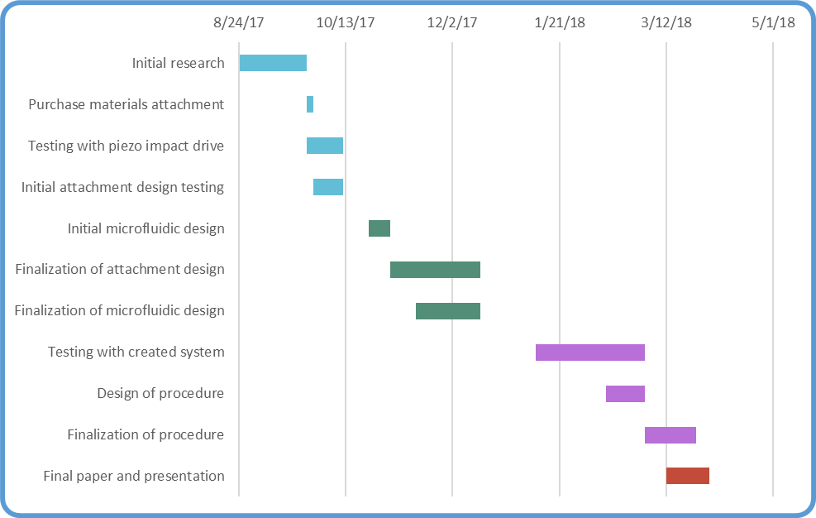
Figure 11: Initial Gantt chart of process
This was updated in the final term to be more accurate to the final time constraints, shown in Figure 12. Wherein it was hoped that a test strain could be developed.
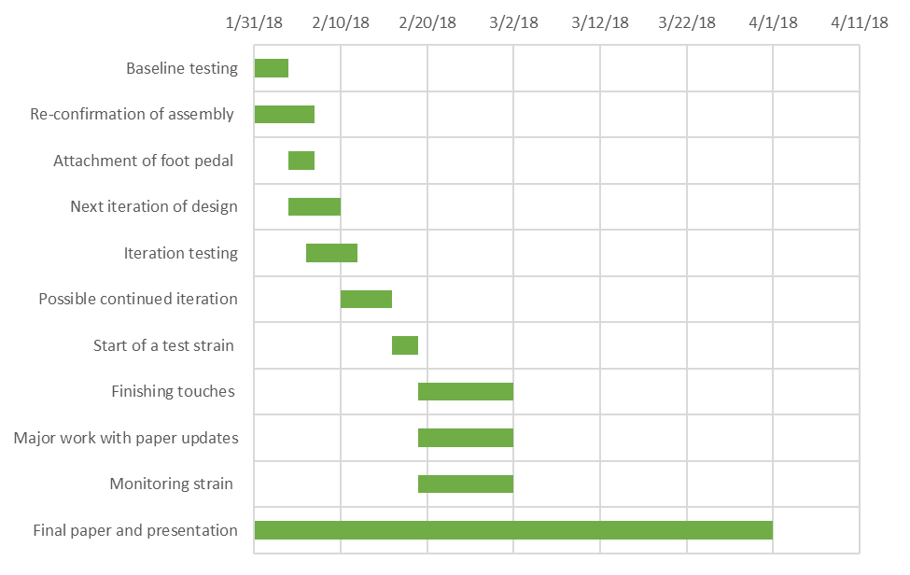
Figure 12: Gannt chart for D term progress

3.10: Financial Consideration
One of our main objective was to minimize the cost of this attachment. Design, testing, and production of the attachment were all done within our $500 budget. There's a large number of methods to induce vibration, with the majority being small mechanical motors priced between $5 to $30. The initial design was expected to cost no more than 20$, with the final design matching the same price. Design of a control board was required, but did not add much to the cost. Valuing all these aspects together we still had large amounts of room for future development and testing.

Chapter 4: Design Process
This chapter will go into the process through which our device and containment system was developed. It will include analysis of the need for this attachment, an overview of the many iterations that were done in an attempt to fulfill this need, some of the different designs that our team developed during this process, the final design that was selected, and our reasons for selecting it.

4.1: Needs Analysis
There are two major components to the need for this product, the first of which is current issues with the routine genetic modification of C. elegans. Current methods of modification are time consuming, include potential loss of C. elegans, put strain on C. elegans, and are dependent on an operator's skill to maintain consistency. These modifications are required for large volumes of the research done with C. elegans, such as research concerning neural or genetic function. The time consuming nature of such genetic modification increases the total time required to complete research and decreases batch sizes and accuracy. Improvement to this process could be used in over 1,500 labs.
The second component is the importance of research with C. elegans. C. elegans is a model system used to develop a deeper understanding of a range of mental health issues, and the human nervous system in general. Mental health problems affect hundreds of millions worldwide and ~18% of Americans, 4% of which would be classified as “severe.” When compared to other ill-nesses, mental health issues are ranked the highest in terms of the total number of years of life affected. An increase to the efficiency and accuracy of research to try and better understand these issues could decrease the amount of time it takes address them.

4.2: Functions and Specifications
The major goal of this project is to improve on the current method of microinjection, without introducing excessive cost. As such our design needed to outperform current practice in terms of speed, without decreasing accuracy or while keeping costs reasonable. The current system can inject 2 to 5 C. elegans in a time frame of 10 minutes at most. We needed to improve on this rate to be considered our project success. This increase has two parts: the microfluidic system that will allow for much larger batches, and the vibration that will allow for easier injection. The microfluidic system needed to align the C. elegans and keep them safe from dehydration for a minimum of an hour to be considered a success. The vibrating attachment needed to stop the C. elegans outer cuticle from being significantly deformed to be considered a success. We are also developing this within a budget of $500.

4.3: Modeling and Feasibility
Figure 13: 3D printer used to create the majority of the attachment
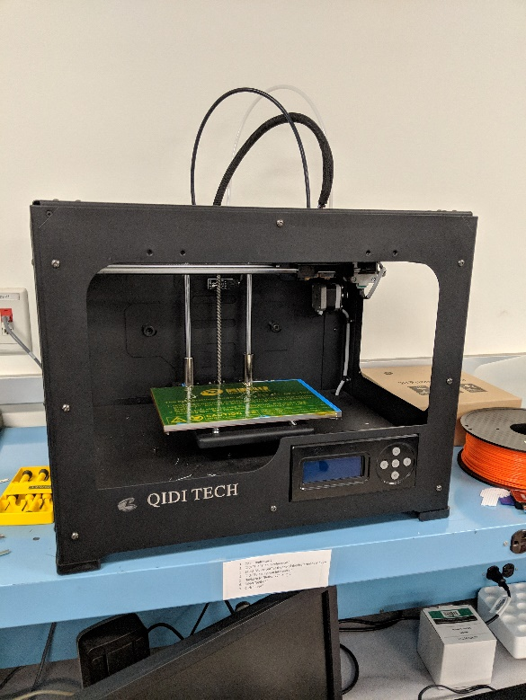
The majority of modeling for this project was done through rapid prototyping using a QIDI TECHNOLOGY 3DP-QDA16-01 Dual Extruder Desktop 3D Printer as shown in Figure 13. A number of CAD models were printed and tested due our access to 3D printing and the speed at which we could make changes. The range of models that we tried for the containment were all tested with an initial baseline given to us by Prof. Dirk Albrecht's lab, with consideration towards the initial research outlined above.
Figure 13: The 3D printer used
In terms of the attachment, the initial CAD models that were created required modification to deal with the tolerances of the available 3D printers for our design.
Before acquiring the ridged film that was the standard at Prof. Albrecht’s lab, a PDMS stamp was tested. An existing design with worm-scale parallel lines was chosen. The PDMS replica was Oxygen Plasma Bonded to a glass slide, pattern-up. When the 3% agarose was dropped onto a glass slide, it was then stamped with the PDMS replica, patterning the pad with ridges. Hydrogel (12% W/V PEG in 0.7% LAP) was applied to the pad and worms were introduced.
Figure 13: 3D printer used to create the majority of the attachment

4.4: Evolution of Major Components
The following sections discuss three design components: the attachment, the control system, and the containment for the C. elegans. Each part discusses the major details and design path, followed by some alternate designs that we developed, and concludes with the final design that we developed.

4.5: Details of the Attachment
The aim of out attachment was to utilize vibration, or a similar mechanical motion, to puncture the outer cuticle of the C. elegans. Through initial research we determined three different methods for achieving our goal. Each method was experimented with and weighed to determine which would be the most effective.

4.5.1: Piezo Vibration
The piezo impact drive is used for a very similar application on a much smaller scale. The Piezo Drill reduces the deformation of cell membranes in single cell injection. This is the exact goal our team was aiming to achieve, although on a much smaller scale. The vibration is accomplished through the use of a piezoelectric crystal that rapidly contracts and expands. The processes of the motion are described as follows:
- The cycle starts with the actuator in extended state.
- The actuator makes slow contraction so that the inertial force caused by the contraction should not exceed the static friction. The main body keeps the position.
- At the end of contraction process, a sudden stop of the motion is made to move the main body.
- Then, a rapid expansion of the actuator causes impulsive inertial force, which results in the step-like motion of the main body [18].

While it was determined early on that this was a similar technology, there are major issues with using the piezo impact drive for work with C. elegans. As was mentioned above, the scale is different by a factor of ten, so the amount of force and vibration required is at a much different magnitude, with the translation of the needle being 1 µm or less. While the piezo impact drive helped confirm our theory that added vibration would improve this process, it wasn’t viable for our project. Current piezo impact drives are also much more expensive than what many labs using C. elegans for research can afford. There is a large price range with these machines, varying from sixteen thousand dollars to sixty, due to the large amount of accuracy and control provided by the device. Working on a larger scale with C. elegans, this precision isn't necessary. Part of the hope for this project is that we would be able to develop a simple, inexpensive and straightforward solution to these problems that could be implemented by other labs.

4.5.2: Scotch Yoke
Our team looked into other methods of achieving the 5 to 15 µm motion along the needle that we theorized would be required for injection. A scotch yoke is a system developed to convert rotational motion to linear motion, which we theorized could then be applied directly in the axis of injection. An example of a scotch yoke system can be seen in Figure 14. The advantages of this system would’ve been very consistent and controlled motion, and a large range of testing speeds and frequencies due to the adjustability of the motor.
After initial brainstorming, our team determined that the scotch yoke would not be feasible. As can be seen from Figure 14, the linear translation provided by the motor is equal to twice the radius, or radial arm. Developing a radial arm between 2.5 um and 7.5 um would require more time than any other alternative, as well as significant material analysis to determine if such an arm could withstand the forces provided by the motor. Considering this, our team determined the negatives of this method significantly outweigh the theoretical benefits.
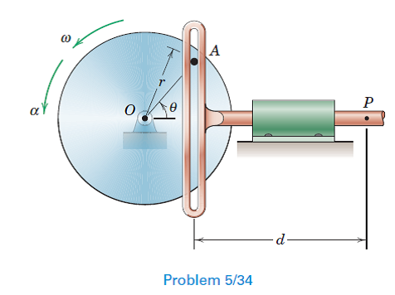
Figure 14: Example of a scotch yoke [20]

4.5.3: Mechanical Vibration
The final method we looked into was mechanical vibration. Tattoo guns are an effective model for mechanical vibration, as they achieve the same goal as our project but on a much larger scale. The needle movement is between 1-2mm, and the vibration amplitude is significantly rougher. However, it still acted as a model for our design. There is a large range of cheap vibrating components available, which would allow for a similarly large range of testing to sufficiently optimize our device. The major advantages of this method were the simplicity, the price, and the low weight. One of the drawbacks that our team considered was that the vibration would be very randomized, leading to movements in the axis that were unwanted. Furthermore, the vibration would be of a higher level, causing wear on the device.
Our team chose to focus on mechanical vibration for our design, as the benefits significantly outweighed the theorized issues.

4.6: Alternate Designs for Attachment
After developing our design, it was put through a series of iterations to achieve our desired specifications.
The first issue our team observed concerned the interface between the micromanipulator and our device’s main body. Our initial design was developed with a thick connecting area, to provide a sturdier connection during the vibration. We failed to account for the length of the connecting screws of the micromanipulator. During our first attempt to attach our device, this error was observed, and the back of the main body was reduced in thickness from 12.7 mm to 7 mm to correctly attach the device.
The next issue that our team addressed was the tolerances of the 3D printer we were using causing the interface between the needle and the centerpiece to be too loose. The needle diameter was 4.4 mm, and the SolidWorks model was set to a diameter of 4.5 mm. Due to the tolerances of the printer, there was not enough friction, causing the needle to freely slide back and forth. This would have resulted in large discrepancies in the needle movement. The diameter was reduced to 4.2 mm, and the needle was observed to be solidly held in place, requiring a large amount of force to slide within the centerpiece.
Our initial design had no motor housing on the centerpiece, as we wanted to be able to test multiple motors with different geometries using a rudimentary attachment method. After initial testing was completed, and the three-volt rotational motor was selected as the optimal choice, a housing was added to the centerpiece (as can be seen in Appendix D) to provide more direct translation of force.
After adding the housing, our team observed that the 5 mm diameter of the rods on the main body were causing too much friction to the centerpiece, causing the movement of the needle tip to be negligible. The diameter was decreased to 4.5 mm, and the needle movement was again quantified. The needle movement was again observed to be far beneath the set goal of 5 to 15 µm. The diameter was again reduced to 4.1 mm, and the movement again tested. At this diameter, after the rods were sanded to remove ringing from the 3D printing process, the needle movement was observed to be within the desired range.

4.7: Final Design for Attachment
The final design for our vibrating attachment can be seen below in Figure 15.
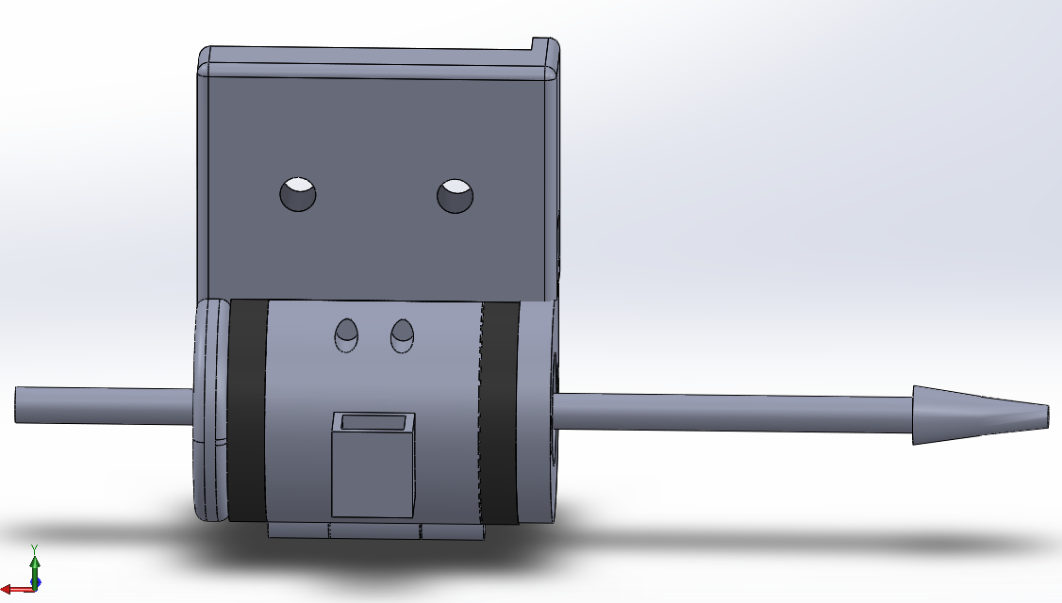
Figure 15: Completed Attachment
The attachment is made up of seven 3D printed parts connected around the needle. These parts include the main body, buffer pads, end cap, and the two sides of the centerpiece, which are the only components that are able to move. These parts can be seen individually in Appendix D.
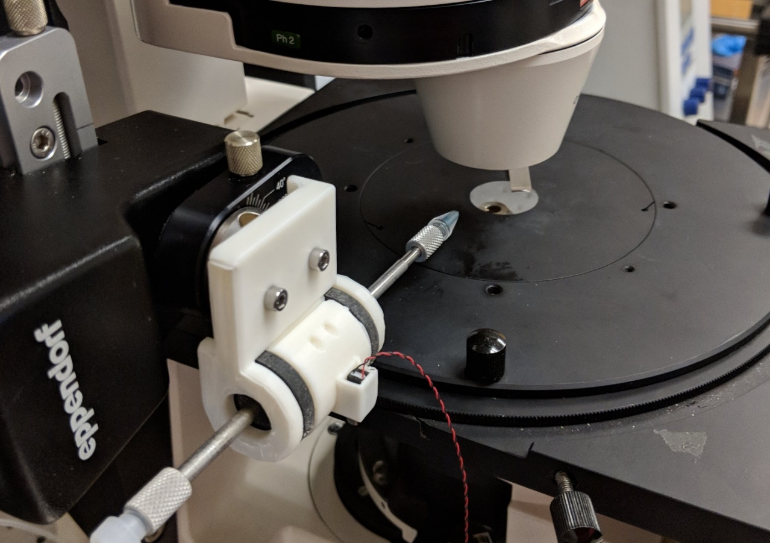
Figure 16: System attached to micromanipulator
The device is put together around the needle, and then screwed onto the micromanipulator. The needle is fed through the first hole in the main body, and the first buffer pad is slid on next. The centerpieces clamp onto the needle, and then are slid onto the two rods of the main body. Finally, the last buffer pad and the end cap are attached, leaving the needle immobile except for the slight movement caused by the depression of the buffer pads on either side from the force of vibration. The completed system is shown in Figure 16. This design provided the desired 5 to 15 μm movement in the needle when switched on, while staying inexpensive and lightweight.

4.8: Details of Control System
Control of the attached vibration was also an important part of this design, in conjunction with the attachment. Our team initially started this project with multiple motors that took varying levels of power. To solve this, we used an Arduino UNO microcontroller board with an attached Arduino motor shield. This allowed us to range power between the Arduino’s native 5 volt range up to 12 volts, which was required for some of our initial motors. It also allowed us to vary the power to levels lower than 5 volts via the Arduino code reviewed in Appendix C. Paired with a potentiometer, or a variable resistor, shown in Figure 17 and Figure 18, we were able to vary the power to a given motor, allowing for our team to test a range of vibrations.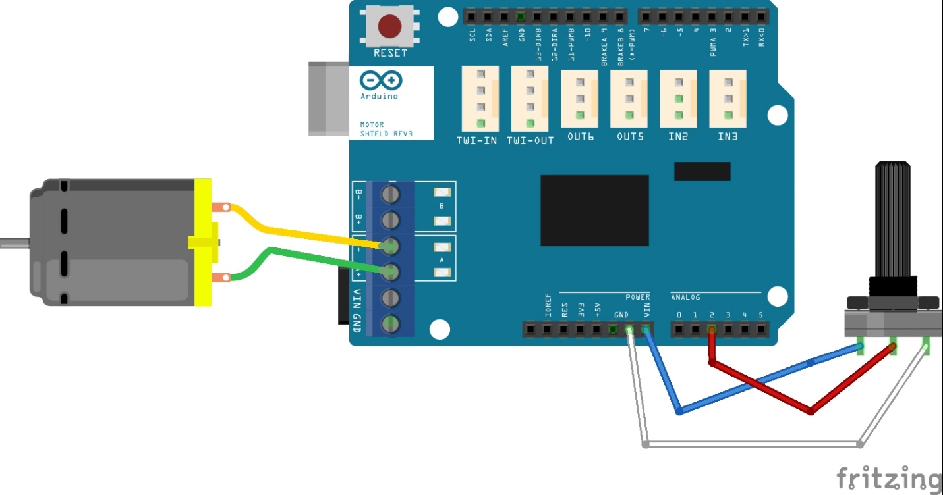

Figure 17: Diagram of the attached motor with potentiometer to vary the power
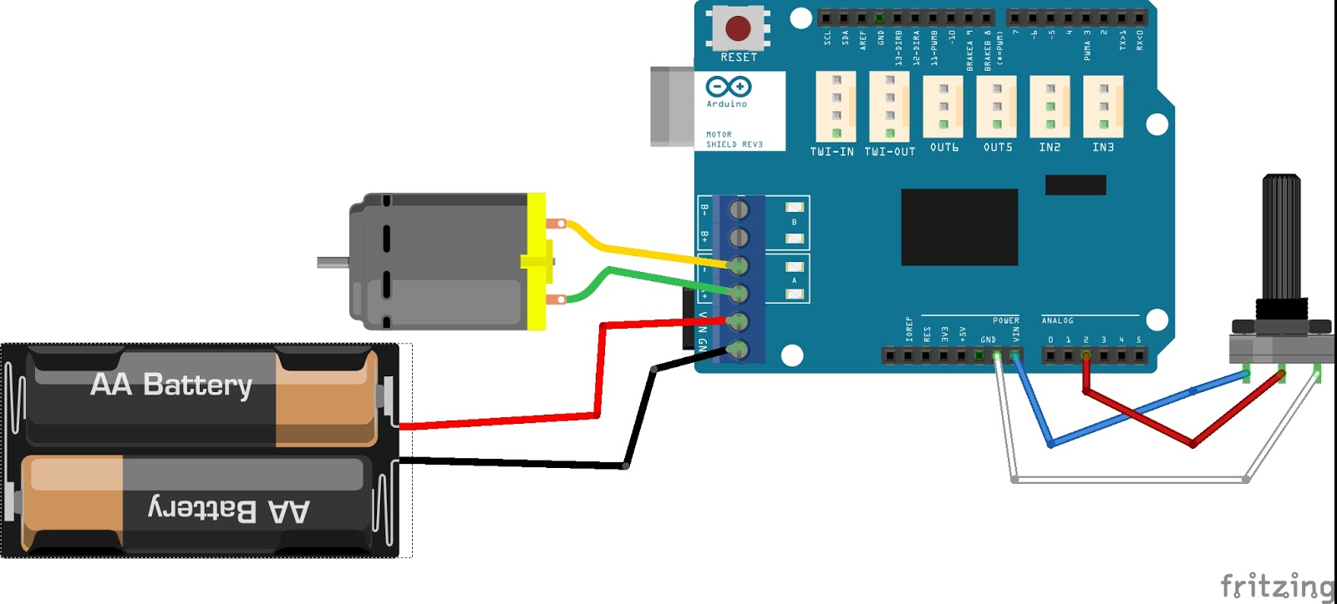

Figure 18: Diagram of the connection with the stronger motor, using an attached power source
Both Figure 17 and Figure 18 show different configurations that were tested with this design. The first showing the connection to the basic vibration and the second showing the connection to the geared motor. Both the geared motor and basic vibration motor are shown below in Figure 19.
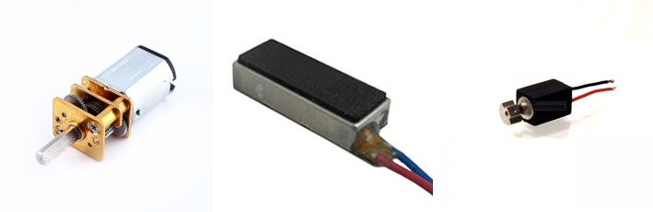
Figure 19: The different attempted motors, starting from the left, a geared motor, a linear vibration motor, and a rotation vibration motor

We were able to run the geared motor, but it was determined early on that it was not a feasible component, as the size constraints for this application limited its usability. The second motor was reviewed and it was observed that it required A/C power using a specific range. This was due to the only version of this motor being used as a haptic feedback engine, or as the tactile feedback when a button is pressed on a touchscreen in a phone or similar device, for example. The implementation of this motor would have required the development of an entire attached circuit, which was determined to be time inefficient after testing was conducted with the third motor.
The third motor tested was a common rotational vibration motor. As can be seen in Figure 19 on the right, this motor utilizes a weight imbalance to create a rotational vibration. Our team conducted repeated vibration quantification tests to determine if the rotational nature of the motor would work for our design. It was theorized that the rotational nature of the vibration would lead to a circular motion pattern in the injection needle, potentially leading to the damage of C. elegans specimens. After repeated testing, it was observed that the design of the attachment constrained the vibration to the desired axial motion. After determining the motion of the needle fit our need, our team used the Arduino and attached potentiometer to vary the amplitude of vibration to determine the most optimal power level. It was observed that to achieve the desired 5 to 15 um of motion, the full power of the motor was required. As was mentioned above, after testing the rotational motor, and finding it fitting for both our amplitude requirement and movement profile, it was determined that the added requirements of the A/C motor weren’t worthwhile.
After completing optimization testing with the attachment, the system was updated to output optimal power, via an attached foot pedal. This foot pedal allowed for a user to apply vibration without removing their hands from the micromanipulator controls.

4.9: Final Design for Control System
The control system went through very minimal iterations through this process, as it was not the main focus of the design. As was reviewed above, the initial design is the same as the final design in this case, with the only major alteration being the removal of the potentiometer and the attachment of the foot pedal.
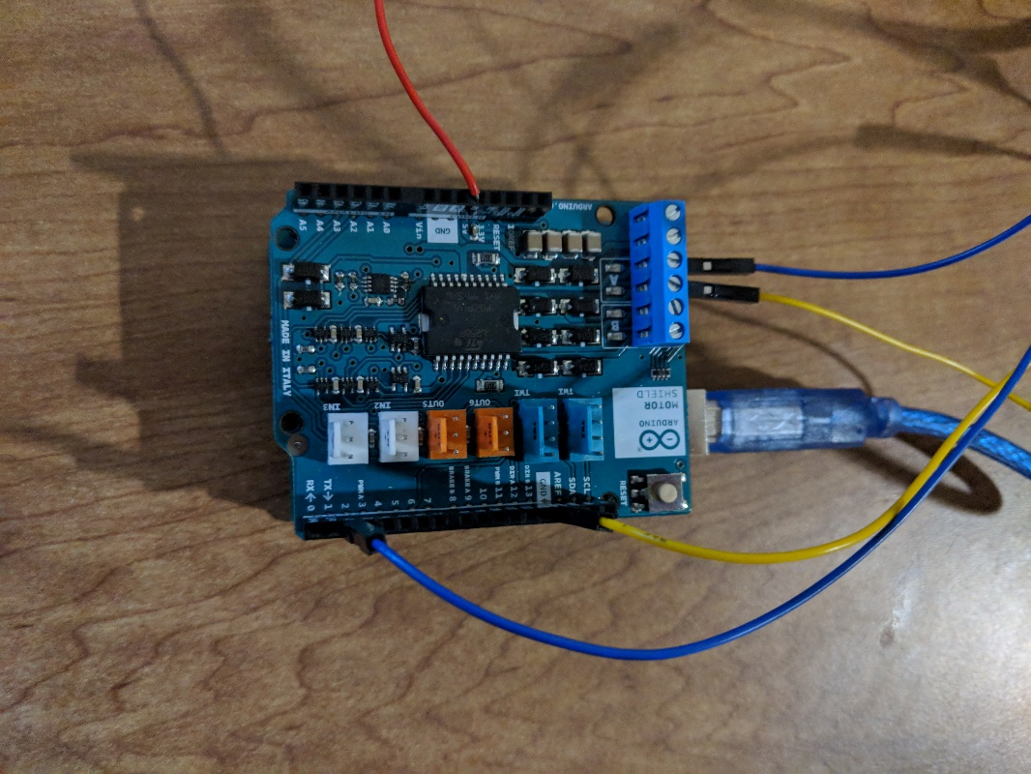
Figure 20: Control system without box, with the white arrow pointing to the connected motor
In Figure 20 above the control system can be seen, as well as the attached leads to the foot pedal and the power. The two leads indicated by the white arrow are the output power for the vibration motor. The other three leads are for the foot pedal, which comes in the form of a single pole double throw switch shown in Figure 21.
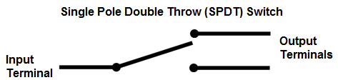
Figure 21: Example of single pole double throw switch [21]
The code for this second iteration is also in Appendix C, and the diagram for the final control system is shown below in Figure 22.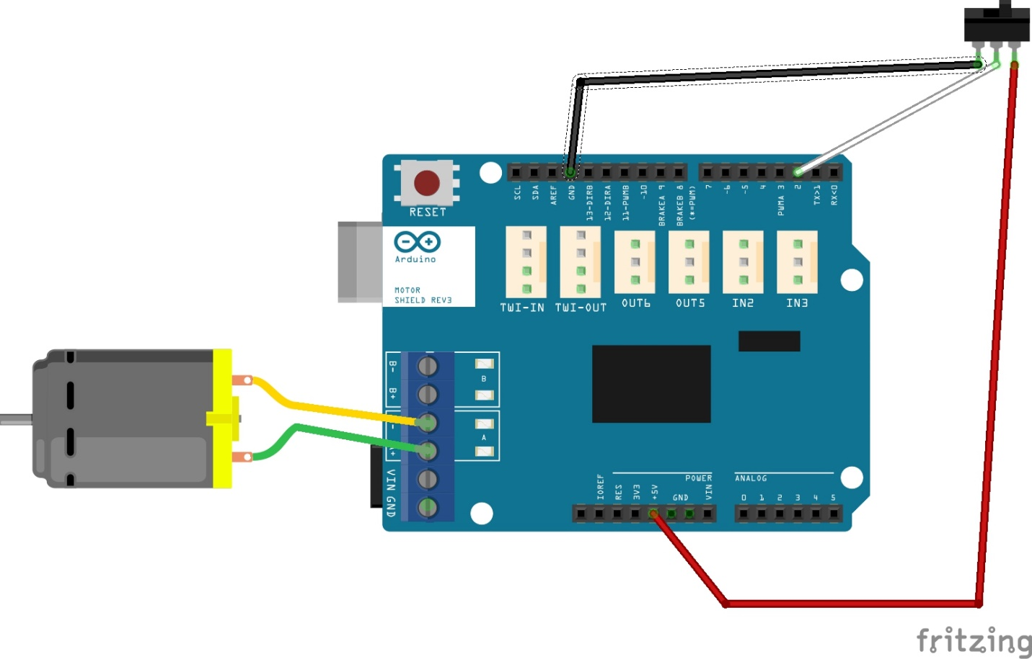

Figure 22: Schematic of the final design for the induced vibration, the motor representing the vibration motor and the switch representing the foot pedal
This figure shows the foot pedal as its more basic representation of a single throw double pole switch, as well as the connected motor.

4.10: Details of the Containment
Work on a new containment for the C. elegans originated from a previous process developed in Prof. Dirk Albrecht's lab. To review, in this process C. elegans were contained using Poly(ethylene glycol) (PEG) hydrogel encapsulation. A PEG hydrogel solution is mixed, with a hydrogel photoinitiaor in water or a buffer. This solution is then attached to a glass slide that has been salinized by coating with 3-(trimethoxysilyl)propyl methacrylate. Another set of slides is prepared by making them hydrophobic either through fluorination, or the simpler solution of using Rain-X Glass Water Repellent and letting sit for an hour. Worms are pipetted into the hydrogel solution and the hydrophobic slides created are placed on top. Crosslinking is achieved through a photoinitiator and UV light.
The major updates that we were looking for in this process were to attempt to align the worms for ease of injection, to allow for enough material to prevent the C. elegans from breaking out of their containment, and for there to be enough material to allow for the application of some form of hydration to keep the C. elegans alive.
Initial brainstorming lead to numerous designs, the majority of which were ruled out based on their deviation from the original design. We intended our modification to be an update of the previous process that was already in place, not a complete replacement. From this we narrowed our design down to a series of different modifications. This section discusses the major modifications to this hydrogel process that were attempted.
Initially our team wanted to verify the results that were given to us. This was done by simply pipetting 20% (w/v) PEGDA from Alfa Aesar in 0.1% Irgacure onto a standard glass slide, picking worms into the droplet formed, and covering with an untreated coverslip. Crosslinking was done via the same UV light process as above and it was determined that we were able to easily encapsulate the worms, even given that we were using untreated slides, which lead to varying levels of success on removal. While the hydrogel frequently broke on removal of the coverslip, this served as an initial proof of concept to allow us to move forward with a series of new iterations.

4.10.1: Agarose as a Major Component
Agarose is a polysaccharide and a linear polymer. It is commonly used in molecular biology for the separation of large molecules and as such was readily available in the lab. Agarose had also previously been used as a base for this hydrogel design, but had been removed as there was no significant benefit observed when compared to hydrogel. We wanted to revisit agarose as it would allow us to easily and repeatedly create a pattern for the hydrogel. Thus agarose was used in a large number of our original iterations.
Initially we started out by simply re-affirming that agarose could be used in this process. Agarose was heated to a liquid, and then a large drop of agar was pipetted onto a glass slide as shown in Figure 23. Following this a cover slip was placed on top, and this was let to sit for two to three minutes. Once solidified, the excess agar was trimmed and 20% (w/v) PEGDA from Alfa Aesar in 0.1% Irgacure was pipetted on top.
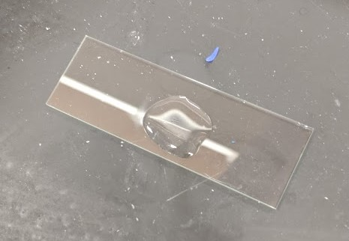
Figure 23: Liquid agarose on a slide
Worms were then picked into this hydrogel surface, and it was cross-linked via the same method. This resulted in the structure shown below in Figure 24.
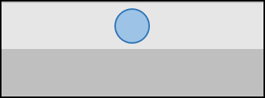
Figure 24: Example of simple two element containment, with the dark grey in this case representing agarose and the light grey representing hydrogel
This method seemed to have several issues. While we were occasionally able to stop the worms from moving initially, upon removal of the cover slip the hydrogel would break, freeing the C. elegans. This was found on repeated attempts, even when the concentration of agarose was varied from the standard 3% that we had been using. Attempts were made with 2.5%, 2.0%, and 3.5% but all iterations seemed to have the same issue.

4.10.2: Polydimethylsiloxane (PDMS) as a Mold
Following our initial work with agarose, we theorized that part of the issue we were having was that the depth of hydrogel that lacked any form of microstructure or spacers was creating some of our issues with stability. From this we attempted using PDMS pads, with representative microstructures originating from Prof. Albrecht’s lab. DraftSight software was used to develop structures which could then subsequently be imprinted into PDMS slides that were attached to a glass slide.
An existing design with worm-scale parallel lines was chosen. A PDMS replica was Oxygen Plasma Bonded to a glass slide, pattern-up. When the 3% agarose was dropped onto a glass slide it was then stamped with the PDMS replica – patterning the pad with ridges. This was then used in the same process as above, but in this case the mold was imprinted into the agarose, allowing for the microstructure to be moved onto the slide. An example of this design is shown below in Figure 25.

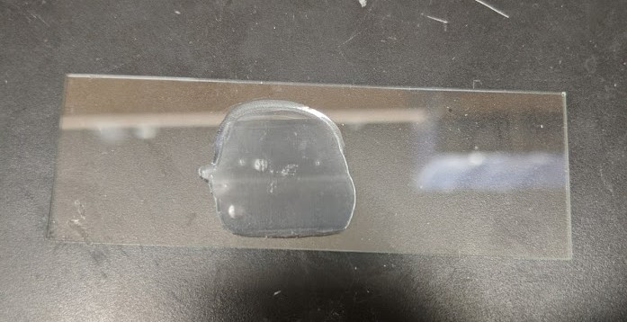
Figure 25: Agarose stamp created with microstructure

This resulted in a structure such as below in Figure 26, wherein the C. elegans were pushed into the groves.
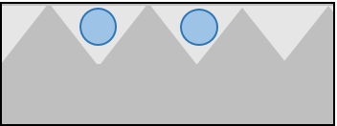
Figure 26: Example cross section, with the dark grey representing agarose and the light grey representing hydrogel
This was again met with mixed results, repeating the same issues as previous attempts, wherein the structure would break when removed or have difficulty crosslinking.

4.10.3: Improved Hydrogel Model
Following these tests, we went back to the precious work and realized they included a different hydrogel. 12% (w/v) PEGDA from ESI-Bio in 0.7% LAP (Lithium Phenyl(2,4,6-tirmethyl-benzoyl)phosphinate) was commonly used. With the use of this new hydrogel, both previous methods significantly improved in the encapsulation of the worms and the retention of the worms upon removal of the cover slip.
To expand on our results, crosslinking and encapsulation was also attempted using 0.07% LAP (Lithium Phenyl(2,4,6-tirmethyl-benzoyl)phosphinate) concentration. This resulted in limited crosslinking and almost immediate breakage of the hydrogel.
We were consistently able to remove the gel without breakage if we removed it on the agarose side, wherein the agarose would be the top layer, and the hydrogel containing the C. elegans was beneath it. This was initially not seen as an issue until actual injection was attempted. As shown in Figure 27 this consistently lead to significant difficulty in penetration of the needle to the C. elegans, commonly breaking the needle before it could be aligned or taking excessive amounts of time to align in the range of ten to fifteen minutes. As part of our goal we wanted to efficiently align the needle next to the individual C. elegans for the ease of the user.
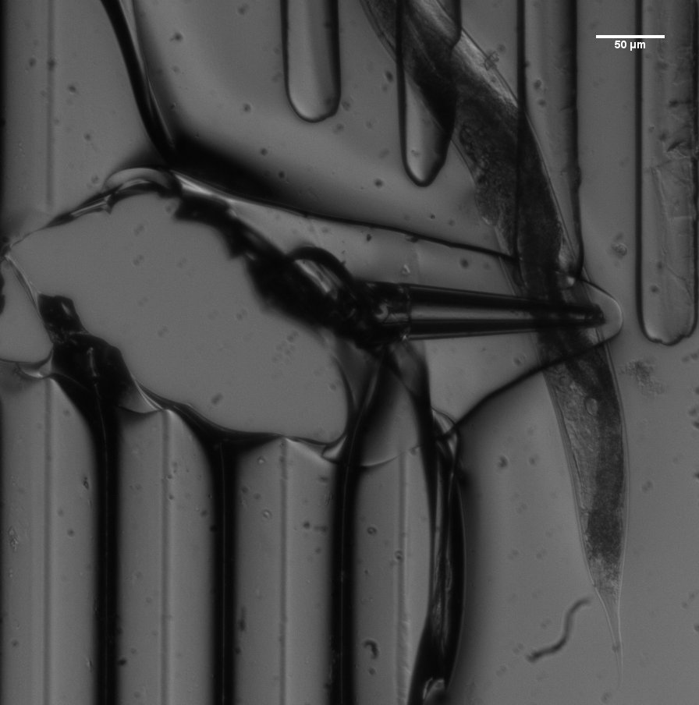
Figure 27: Cross-linked microstructure with encapsulated C. elegans, with broken needle tip shown by the white arrow
The concentration of the hydrogel was also modified to allow for easier penetration, as well as to better contain the C. elegans. Our team tried iterations using the concentrations from the previous study as a baseline, or 12%, 15% and 20% concentrated hydrogel. During these trials it was attempted to use less material in the upper layer to make the C. elegans easier to access. In our trials this was met with limited success, as reducing the amount of material often resulted in the lack of enough material to completely cover encapsulated C. elegans as shown in Figure 28.
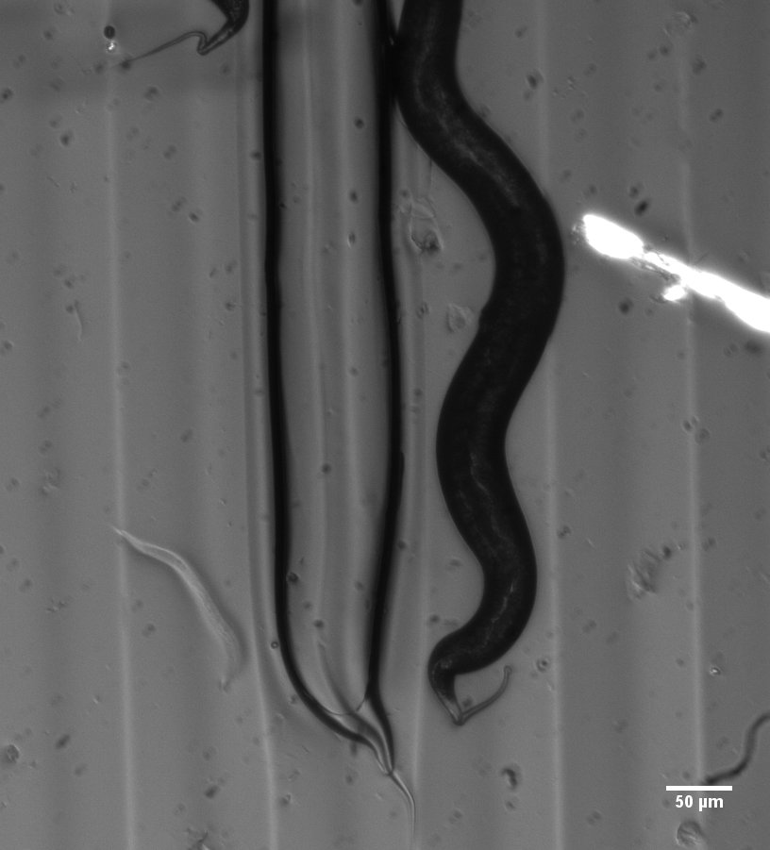
Figure 28: Example of a C. elegans without enough material to cover it, that has pushed free from the channel to the surface of the hydrogel
When trying to minimize the amount of hydrogel on top of the C. elegans it was determined that the impact of higher concentrations was minimal. A set distance of 20 to 30 micrometers was required, as going lower than this allowed the C. elegans to break free regardless of the hydrogel concentration.

4.10.4: Treated Slides for Improved Removal
Another part of the process that had been previously tested was using two different types of treatment in conjunction with the injection. This came in two major forms: treatment to increase the attachment to the slides and to reduce the attachment. To increase attachment, the standard procedure of salinization reviewed in Appendix B was used to improve the connection between the slide and the hydrogel. This consistently improved our results, reducing the breakage and making it substantially easier to remove the correct slide.
To reduce the connection to the slides two different methods were attempted. One was to use fluorinated slides, and the other was a simpler approach of applying RainX, or a basic water repellant used to treat car windshields, to laboratory slides.
Fluorination of slides was done by evaporating fluorine in a vacuum, and allowing it to naturally deposit on the slides. These slides could then be used for multiple iterations of testing. These slides again consistently improved results, allowing for a significant reduction in the difficulty of removing the covering slide without breaking the containment.
RainX application was done via the method prescribed by the makers, wherein RainX was applied and the slides were used after sitting for a period of time. This method had more mixed results, wherein there was less significant difference between using the RainX slides and the fluorinated slides.

4.10.5: Using Spacers to Control Thickness
` Another method that was attempted from previous work was to use spacers, or material placed on the slide to control the distance between the upper and lower slides. The most basic example of this that was attempted was by using commonly available Scotch tape. Scotch tape is a standard of 0.0625 mm or 62.5 μm thick. Considering that the average C. elegans is on average 50 μm thick, this allows for Scotch tape to be used as a basic spacer, shown in Figure 29.
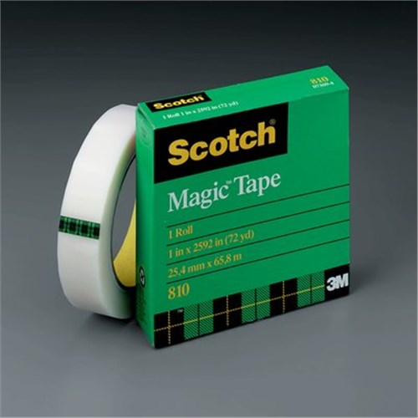
Figure 29: Scotch tape [22]
This allowed us to control the thickness of the total system to either ~62.5 μm or ~125.0 μm, both within a feasible range for this application. It was quickly determined that due to the bottom layer of material taking up space, more than 62.5 μm of material was required, as it would have little to no impact on the results. Using two layers of Scotch tape, or a thickness in the range of ~125.0 μm, improved these results, but it was difficult to achieve a standard distance as air was commonly trapped under the tape, changing the distance by an unknown amount.
Following iterations using tape with and without patterning and achieving the same results, we attempted more precise methods, in the form of PDMS spacers. Spacers were prepared by casting polydimethylsiloxane (PDMS, Sylgard 184, Ellsworth Adhesives) in a 1:10 ratio to thicknesses of 100 μm. Rectangles were then manually cut out of this material and placed on both sides of the base as shown in Figure 30 below.
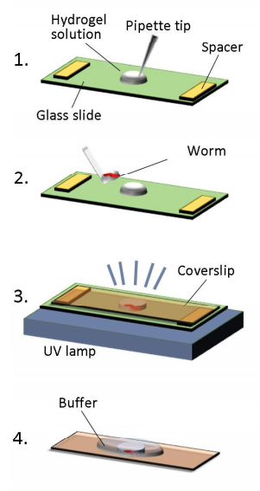
Figure 30: Example of spacers from previous process [15]

This again improved the outcome allowing for much more consistent results.
One final round of testing with spacers came in the form of using spacers cut using a Silhouette Cameo Electronic Cutting Tool, shown in Figure 31 below. It is generally used for craft and for cutting up to 12-inch wide and 10-feet long sections of a variety of materials. The cutting tool allowed us to directly control the shape of the spacers that we applied.
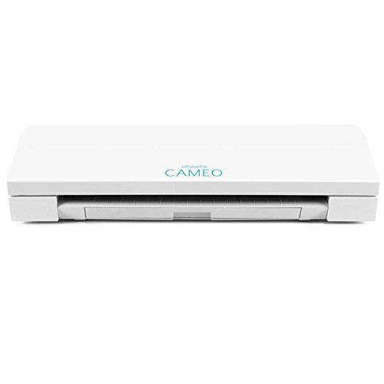
Figure 31: Silhouette Cameo Electronic Cutting Tool used to cut PDMS spacers [23]
This was a process that had been used by our collaboration lab manager Eric Larson, wherein a PDMS pad of the same 100 μm thickness is run through the cutting tool. This was used to make square and rectangular spacers in which hydrogel could be pipetted. A basic representative is shown to the right in Figure 32. This resulted in examples such as is shown in Figure 33. This method was used for both patterned and un-patterned applications
Figure 32: Basic representation of improved spacers
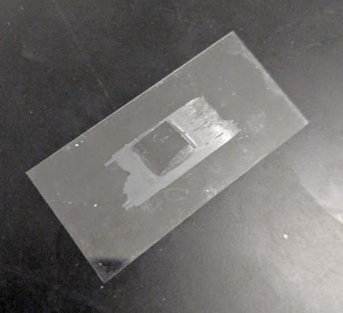
Figure 33: Hydrogel containment created using square PDMS spacer
Hydrogel would be pipetted into the mold, and then trimmed to the size of the spacer using a scalpel. This allowed for a much higher degree of control in the amount of hydrogel and the distance between the two slides.
It was also possible to directly pipette hydrogel into the center of these spacers and to pick C. elegans directly into the resulting area. This allowed for a much higher level of control due to the variance between different trimmed microstructures. This method was also the main process through which future testing was done, as it was by far the most consistent for our team, allowing for quick and stable encapsulation.

4.10.6: Pure Hydrogel Solution
Finally, it was determined very late in the experimental process that it was possible to use hydrogel for both the base and upper layer of the containment, as similar to the previous design in Figure 26. In conjunction with the fluorination and salination treatments that were reviewed above, this allowed for much more consistent removal of the hydrogel on the correct side, and a much thinner and easier to penetrate layer for the user. Agarose was observed to have some potential as well, but we were unable to solve the issue of its propensity to come off the slide much easier than the hydrogel. Penetration through agarose was deemed highly difficult but hydrogel solved this issue, allowing for much more consistent results.
Using a fully hydrogel system was the most consistent method, allowing for application of a buffer, maintaining the ability to align the worms, and allowing for greater control of removal. Agarose served as a stable base, but created the issues discussed previously, so our team went with a pure hydrogel solution as the final design.

4.11: Alternate Designs for Containment
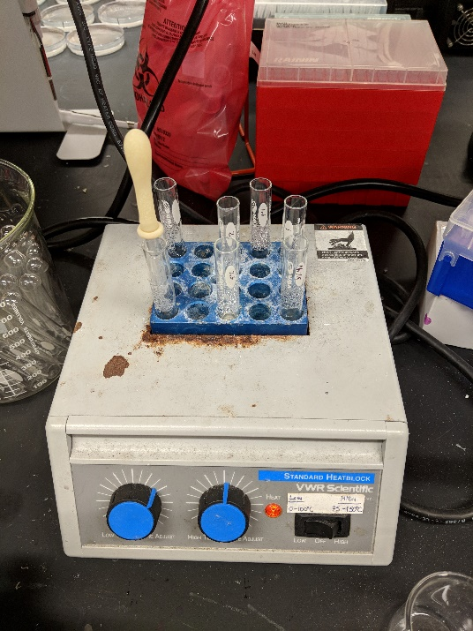
Our team was given the PEG hydrogel encapsulation method at the start of this project as the major method that we were trying to improve. The majority of this work came in the form of the attached system, but numerous iterations of the hydrogel design were theorized and attempted to try to improve the ease and efficiency of the process. The majority of testing was with using liquid agarose, shown in Figure 34, as a component of the design.
Figure 34: Agarose heating for use to create stamps
A review of the different methods that we tried are as follows:
- Agarose with hydrogel: This had the issue of incorrect spacing, the difficulties with agarose, and no alignment.
- Agarose, with hydrogel, and spacers: This allowed for the correct distance but did not solve any of the issues with agarose.
- Agarose, with hydrogel, PDMS spacers, and patterning: This aligned the C. elegans but maintained the issues with agarose.
- Agarose, with hydrogel, tape spacers, and patterning: Same as previous, but tape gave less control on the distance, limiting the design.
- Hydrogel as both layers: This solved our issues with agarose but had the same issues as previous.
- Hydrogel as both layers, with PDMS spacers: This was the most consistent by far, with the limitation that it did not align the C. elegans.
- Hydrogel as both layers, with tape spacers: Same issues with tape spacers as with 4.
- Hydrogel as both layers, with PDMS spacers, and patterning: This gave us the greatest amount of control, but was difficult to reproduce consistently with square spacers.
- Hydrogel as both layers, with patterning: Without controlling the distance it was difficult to apply the correct amounts, as the hydrogel would leak.

In all cases using salinization and fluorination improved the outcome of this process.

4.12: Final Design for Containment
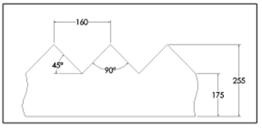
The final design of the hydrogel system has large similarities to the process originally given with a few significant changes. Shown in Figure 35, we used the same microstructure that was created by Prof. Albrecht’s lab as the base to use as a mold. This microstructure was then attached to a slide to be used as a mold for hydrogel as shown in Figure 36. The exact details of the film are shown in Appendix E, but the dimensional details are of major importance for our application.
Figure 35: Cross section of final mold used, dimensions in μm
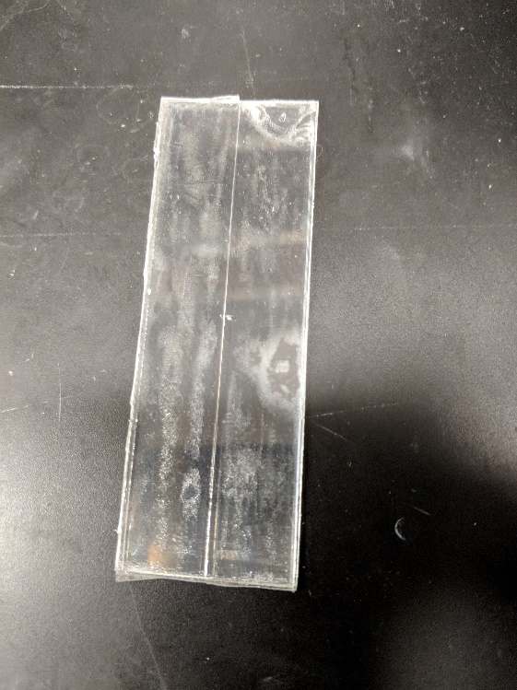
Figure 36: Mold created with microstructure
Hydrogel is pipetted into the mold and a salinized slide is placed on top (Appendix B). This is then cross-linked to create the lower base of the structure. Liquid hydrogel is pipetted on top of this mold and worms are picked in. Using a method taught to us by the lab manager Eric Larson, a single hair either from an eyebrow, eyelash, beard, or wherever is preferred is removed. Then this hair is super glued into the end of a pipette tip. The resulting brush, shown in Figure 37, can be used to align the worms better in the channels so when the top layer is placed they are more evenly spaced out.
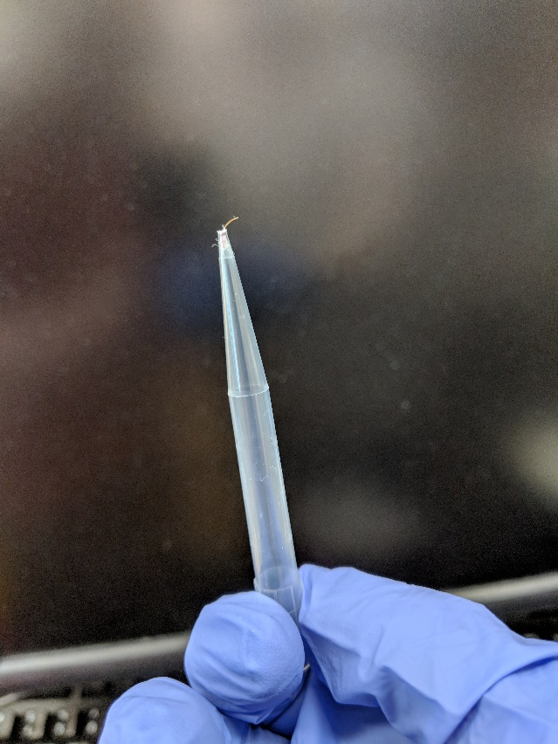
Figure 37: Single hair brush used to align C. elegans

Following alignment, the second layer is cross-linked to form the resultant structure in Figure 38.
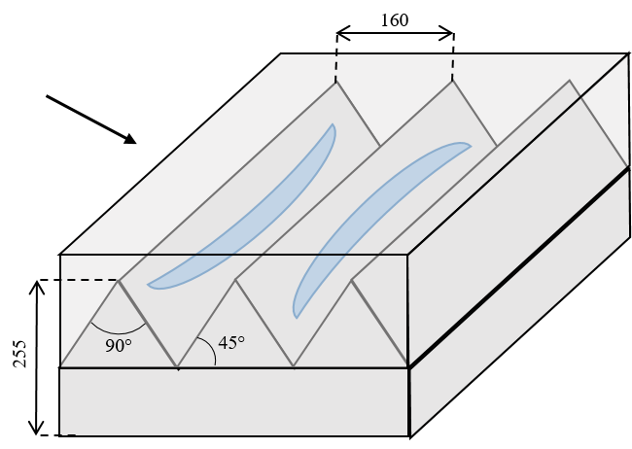
Figure 38: Cross section of hydrogel system, with the arrow representing direction of the needle and the units in um
This allows for numerous C. elegans to be encapsulated at a time and used for injection, as shown in Figure 39.
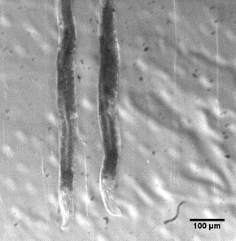
Figure 39: Contained C. elegans in a patterned hydrogel system, with PDMS spacers

Chapter 5: Design Verification
This chapter will go into the various methods through which our team verified our designs success at the application given. It is broken up to multiple series of tests to quantify each aspect of the design that was required.

5.1 Quantification of Vibration
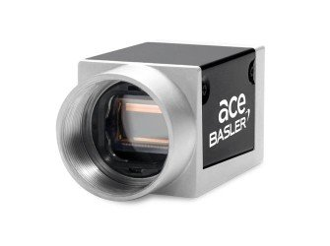
A major part of our team’s design was controlling the vibration to an axial motion as best as possible, and this was achieved through the dampening properties of the containment. To verify this, we used microscopy and an attached acA1300-60gm - Basler ace camera, shown in Figure 40. This camera allowed the needle tip to be tracked when viewed at five times focus, with a max speed of roughly one hundred and fifty frames per second.
Figure 40: Attached Camera for Analysis (acA1300-60gm - basler ace.) [24]
Once videos were acquired of the tip in open air versus the tip in hydrogel, ImageJ was used paired with a tracking plug-in [23] to allow for the tip of the needle to be tracked manually and exported, an example of this video is shown in Figure 41. This data was used to create the plots shown in the figures below.
Figure 41: Still from the video used to track the needle
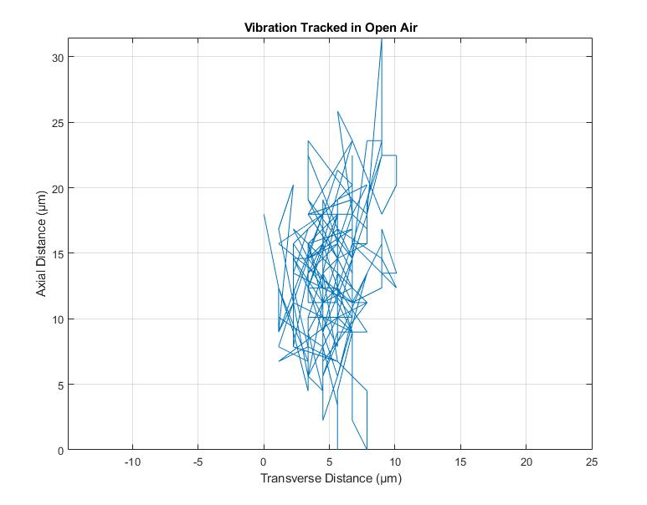
Figure 42: Vibration in open air tracked for two hundred points, with the needle coming from the left side of the image
In Figure 42 we see the motion of the needle in the air, tracked for 200 points, and outputted directly. While we maximized frames per second as much as possible we can still see that there was some difficulty in fully tracking the motion, as such the needle seems to skip or move in a more linear fashion. This can be attributed to the limitations of the camera.
As can be seen the motion is unconstrained and hard to follow with this representation. In terms of the actual range we do seem to get the desired motion that we were aiming for with this iteration, the vibration ranging from 0 to 10.1 μm, but with the downside of a 31.5 μm motion away from the axis of the needle.
The issue with this representation is it is difficult to tell the exact path of the needle. To better visualize the motion the same points were put through a moving average filter, shown in Figure 43.

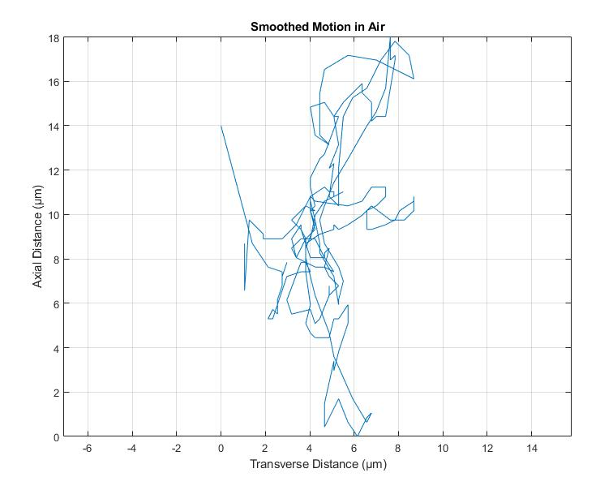
Figure 43: Two hundred points tracked and then put through a moving average filter
In this example we can more clearly see the motion of the needle, while losing some of the dimensional accuracy of the Figure 42, as a moving average filter was used. Two vectors were extracted, the x location and the y location. The moving average was then used on each of these vectors separately, wherein a number of elements, in this case five, are averaged around each element.
While Figure 43 is not representative in terms of distance it does give our team a much clearer understanding of the motion of the needle. The motion, while still erratic seems to cycle between its upper and lower bounds, in an approximately cyclic fashion.
It was our hope with these designs that the containment would constrain this motion of the needle. To validate this our team used the same method to track two hundred points while the tip of the needle was embedded in a hydrogel system. This is shown in Figure 44.
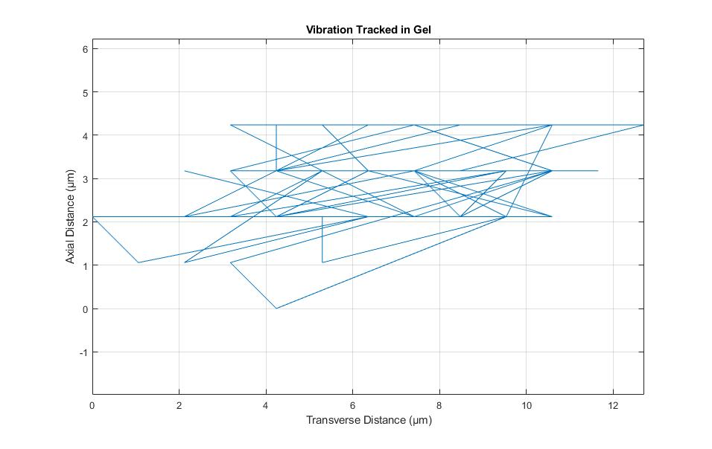
Figure 44: Vibration tracked for two hundred points while the needle is embedded in hydrogel
While this figure has the same issues as above, it shows a decreased motion out of the axis of the needle, reduced to 4.24 μm. We are also in the right range of motion along the needle, maxing at a 12.7 μm motion. To further understand this motion, the same filters were again applied to create a new figure.
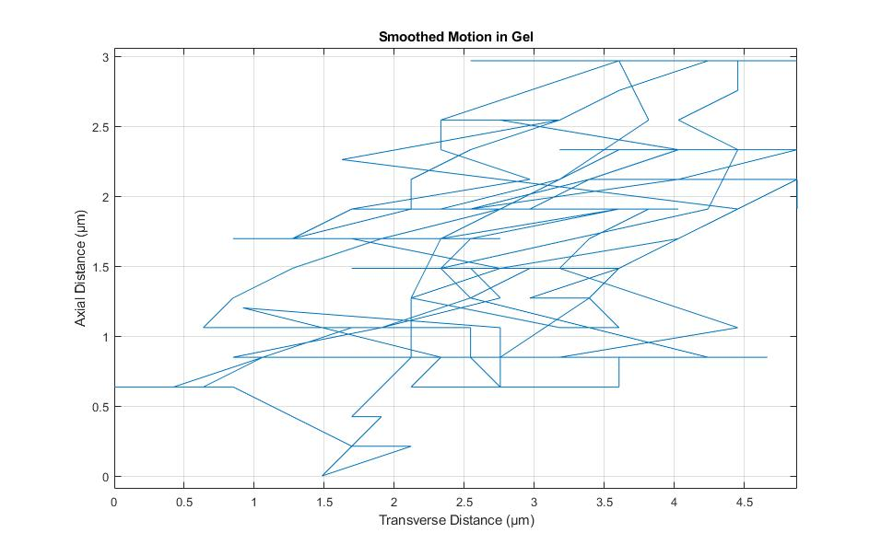
Figure 45: Motion of the needle while embedded in hydrogel tracked for two hundred points
Figure 45 shows similar issues of scaling but shows that the motion is much more constrained to a vibration along the axis of the needle. A large part of the variation in the y axis could also be due to user error. As tracking was done manually on images that were to scale in terms of pixel to μm there was difficulty in being exact when the motion was more constrained. To help expand on our understanding, one last representation of both data sets was made, show in Figure 46 and 47.
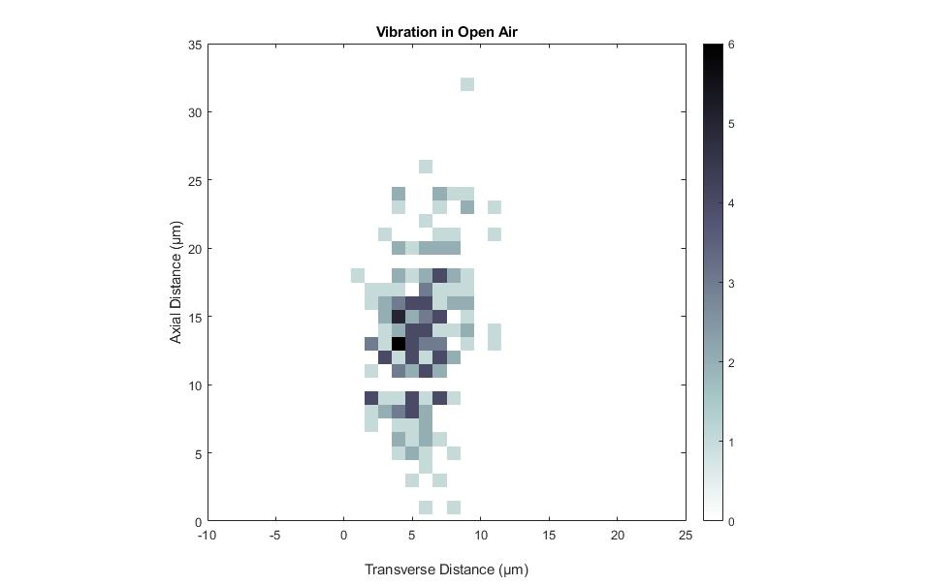
Figure 46: Heat map of the motion of the needle in open air, using two hundred tracked points and darker colors representing higher number of occurrences
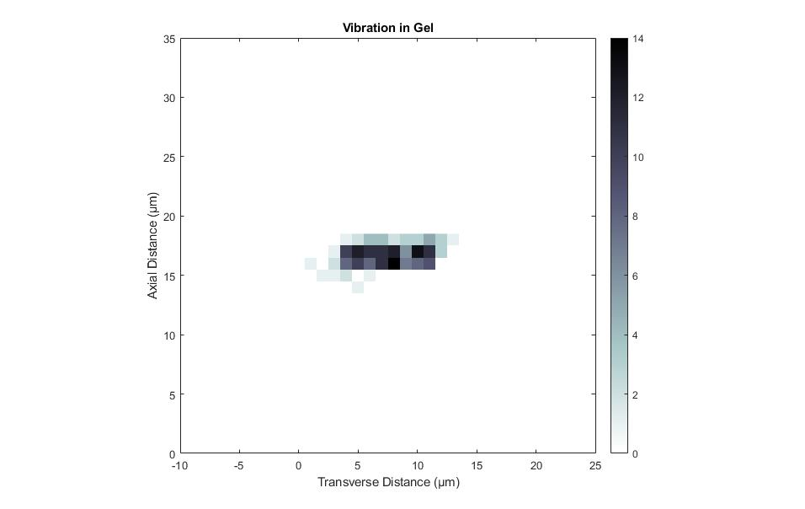
Figure 47: Heat map of vibration in gel tracked for two hundred points
In both figures we can see a much clearer view of the motion, with Figure 47 showing a higher concentration of points or a more controlled motion.

5.2: Deformation Results
To confirm the design, it was necessary to develop a form of repeatable tests to show the reduction in deformation. Our team did this via microscopy and numerous recordings. Pads were made containing multiple worms, and penetration was attempted. Each trial comparing the results with and without vibration using the same pad and pulled needle via direct measurement using ImageJ. An example of deformation can be seen in Figure 48 and 49.
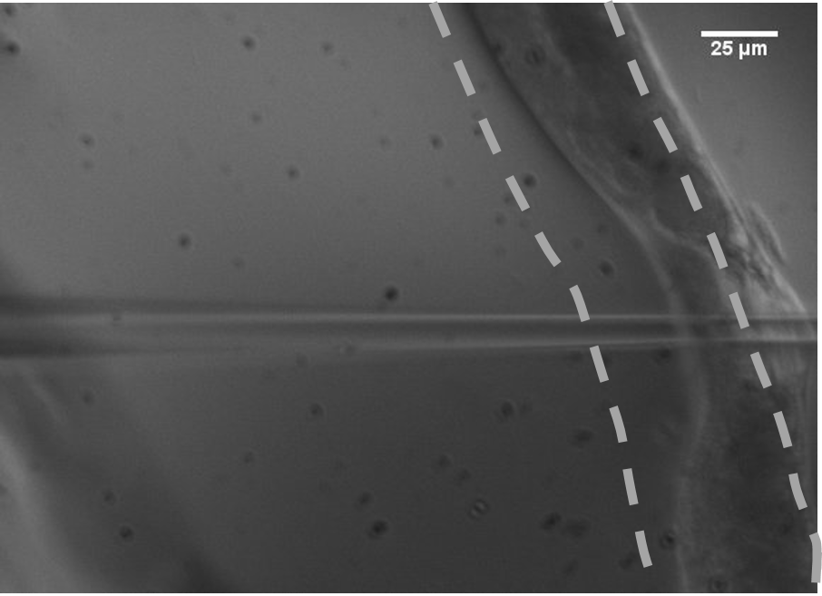
Figure 48: Injection without Vibration, with the blue line representing the deformation measurement
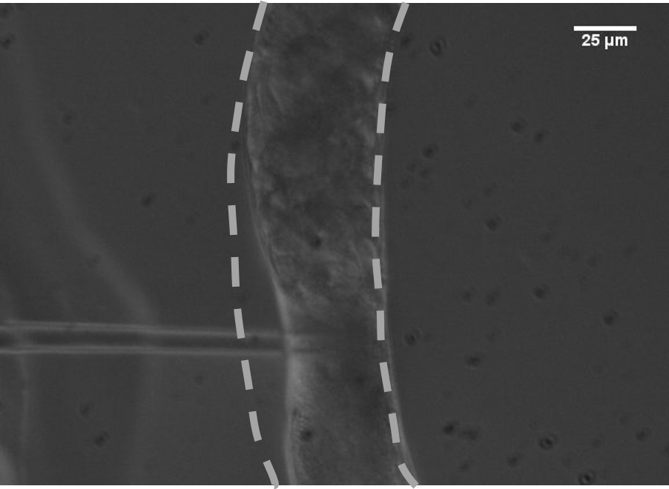
Figure 49: Injection with vibration, with the blue line representing the deformation measurement
These two figures show a direct example of the impact of vibration on deformation. Figure 48 shows an example of the deformation when there is no vibration to the system. While a somewhat extreme case it shows the relative impact when the animal is hydrated, there is large difficulty in penetrating without causing damage. Figure 49 shows the decreased deformation when using vibration, the needle penetrates with much less difficulty and causes less damage to the organism. Both figures show the line of measurement that was used to create Figure 50.

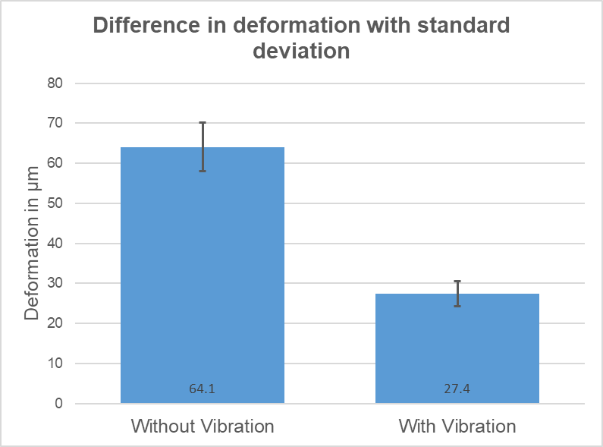
Figure 50: Deformation difference, between with and without vibration
As can be seen there is a significant difference between tests with vibration and those without, with an average of 57% reduction in vibration between samples. The full results can be seen in Table 2.

Without Vibration | With Vibration | Difference
44.4 | 27.4 | 17.0
64.1 | 22.1 | 42.0
56.4 | 19.2 | 37.2
59.9 | 17.8 | 42.1
55.6 | 25.1 | 30.6
47.7 | 19.5 | 28.2
49.5 | 22.6 | 26.8
48.3 | 23.1 | 25.2
45.7 | 18.9 | 26.8
60.4 | 26.5 | 33.9
50.0 | 24.8 | 25.2
52.9 | 25.0 | 27.9
52.7 | 26.0 | 26.7
44.5 | 26.8 | 17.6
49.2 | 25.3 | 23.9
Average
64.1 | 27.4 | 28.7
Standard Deviation
6.1 | 3.2 | 7.5

Table 2: Comparison of deformation in micrometers, with average and standard deviation
Comparing the two samples with a simple paired t-test resulted in a rejection of the null hypothesis that the two samples were the same. With a default alpha value of 0.05 the resulting p value was 9.0754*10⁻¹⁶ meaning a substantially significant difference between the values.

Chapter 6: Final Design and Validation
In this chapter our team looked into the larger scale effects of our project. Our project was used for a very specific area of research, which is relatively small in scale. As such our team didn’t predict any major effects from our project, other than a potential increase in the overall amount of research coming out of genetic modification of C. elegans.

6.1: System usage and validation
The final design of our project utilizes a 3D printed attachment, a three volt rotating vibrating motor, and an Arduino control system actuated with a single switch foot pedal. It interfaces around the needle as described in 4.4.1. After the centerpiece is connected around the needle, main body attached to the micromanipulator, and the motor inserted into is housing, the device is ready for use. The Arduino motor shield connects into a USB for power, at which point the vibration is initiated with the foot pedal.
For final verification of our teams design it was necessary to perform an actual injection. It was possible that the induced vibration would negatively impact the injection process, in terms of accuracy or damage to the C. elegans. To perform the injection, our team used a combination of xylene cyanol blue dye and an injection buffer consisting of 20 mM Potassium Phosphate (K2HPO4), 3 mM Potassium Citrate, 2% Volume Polyethylene Glycol (PEG), and the final solution had its pH equilibrated to around 7.5.
To test injection, C. elegans were encapsulated in a hydrogel disk. The disk was then cut using a razor to position the C. elegans at the edge. The needle was inserted into the hydrogel at an angle of 15 degrees, and positioned at the edge of the cuticle. The needle was slowly moved further into the hydrogel until a small amount of cuticle depression was observed, at which point the vibration was actuated, and the needle moved forward until cuticle puncturing was observed. As can be seen in Figure 51 we were able to inject into the C. elegans without damage or leakage to the outside structure, while encapsulated in un-patterned hydrogel.
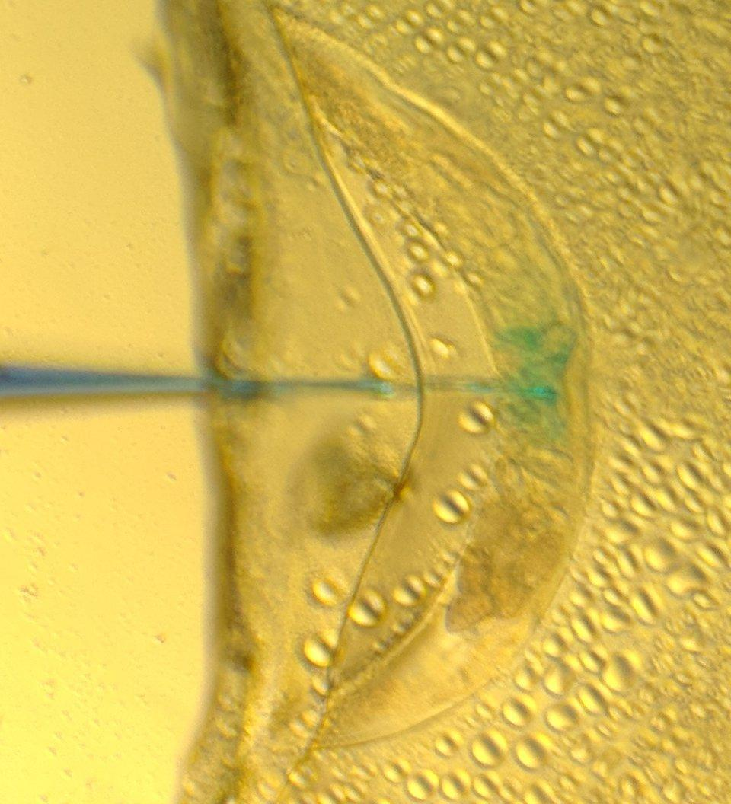
Figure 51: Successful injection into C. elegans, in a hydrogel system, which used square PDMS spacers
This was consistent over five samples using the same methods, in which there was no observed loss of dye during the vibration before puncturing the cuticle of the C. elegans. This provided our team with conclusive proof that our project not only reduced the depression of the cuticle while injecting, but also wouldn’t interfere with or impact the process of injection.

6.2: Economics
Our attached device and its control system were both designed to be a cheap way to improve the microinjection process.
total expense
ABS | 20 to 30 dollars per spool
Arduino Uno | 20 dollars
Arduino Motor Sheild | 22 dollars
Foot pedal | 7.5 dollars
Vibration Motor | 1.75 dollars per
TangoblackPlus | Less than 20 dollars, would be possible to replace

Table 3: Total cost of the attached system
From Table 3 the total cost of this device was in the range of fifty to eighty dollars. While this is dependent on the producers of this attachment having a 3D printer, it still is a minimal cost in comparison. Assuming that a 3D printer was not available the printer would cost around 650 dollars, which still a relatively low cost for this application.
It is also not required to include an Arduino in this design. The Arduino Uno and combined motor shield allowed for our team to quickly iterate through different designs, and allowed for quick modification of this process, but in the final design the power being outputted was a set value. It would be straightforward to develop an attachment that was a simple power switch.

6.3: Environmental Impact
Our project should have minimal environmental impact. This is in large part due to the fact that our design is mostly constrained to work done in the lab, and would not expand far out of this. Any attachment or system would be using already available materials in the lab and most fabrication required would be done via 3D printing, and would in most cases be done once for each lab. As reviewed above the attached Arduino is not necessarily required for this application, a simpler circuit could be developed for the same application.
3D printing is also considered a much more energy efficient process than standard manufacturing as well [26]. As it requires minimal user input, has limited waste products, reduced energy requirements, and reduced CO2 emissions. Larger scale manufacturing of this attachment was not in the scope of this project, but the main method of manufacture was intended to be 3D printing.
C. elegans is also considered a safe organism to work with. It is found all around the world, and it has no real safety concerns in terms of handling and reproduction. Any safety concerns would come in the form of any materials that were being used in conjunction with C. elegans, which would be on a case by case basis and not on the scope of this project as we were more focused on an improved standard procedure.

6.4: Societal Influence
Our project could have large societal impact if is implemented in the over fifteen hundred labs working with C. elegans. The slow and arduous nature of this process has led to a bottleneck in the amount of research coming out of genetic modification of C. elegans. Increasing the efficiency of this process would lead to a large increase in the amount of basic biological research coming out of C. elegans genetic modification.
Work with C. elegans has also already had substantial impact in the scientific community. In 2002 three Nobel prizes were achieved through research with C. elegans. Including, Sydney Brenner for his work on genetics, John Sulston for his work on development, and H. Robert Horvitz for his work on understanding cell death. Since then work with C. elegans has won even more prizes, including the Nobel Prize and Breakthrough Prizes in Life Science. The impact of C. elegans has already been seen, it remains to be seen how much faster an improvement to the current methods would move research forward. All of these accolades were achieved with the previous method which is less efficient. With our updated design, the understanding of neurodegenerative disease, lifespan, and aging, as well as neural regeneration could be seriously improved in the coming years.

6.5: Political Ramifications
There are limited to no political ramifications to this design as it allows for an increase in research that is already being done. Our design does not allow for new research but allows for a large increase in the speed at which research with C. elegans can be done. Any political impact of this research would be due to the research itself, and not a modification to the process

6.6: Ethical Concerns
C. elegans are not regulated or classified as an organism with a large ethical concern. Their lifespan’s are naturally short, only a few days, and microinjection typically does not decrease this time. Our design does not increase damage to the C. elegans and provides a cleaner injection aimed at reducing overall damage. Our team determined there were no other ethical concerns to be addressed.

6.7: Health and Safety Issues
There were three health and safety concerns to consider with our design:
The first was determining if the vibration would cause the microinjection needles used to break or snap, potentially sending shards at the operator. Our team observed no breakage while in open air, and any breakage observed while injecting was completely contained by the hydrogel.
The second was determine if any materials or chemicals used in updating the containment system would be detrimental to the health of the operator. Hydrogel is considered pH-neutral, non-toxic, and environmentally friendly, so they were not a concern. The major concern came in the form of the treatment of the slides. Both the salinization and fluorination procedure require contact with toxic chemicals. As such they required safe handling and proper lab procedure. A secondary concern was in the form of the photoinitiators. As mentioned previously photoinitiators generate free radicals, which are considered harmful if not handled properly.
The third was exposure to UV light during crosslinking. While there is less negative impact to UV light than the chemicals used, the generation of UV light was still handled with care. As it could be harmful if directly exposed to the skin or eyes.

6.8: Manufacturability
Our device is full manufactural with the requirement of a 3D printer. The overall size and weight of the part puts the material requirement very low, and all other parts are outsourced. The Arduino can be replaced with a simple resistor after our team finalized the vibration amplitude required.

6.7: Sustainability
The major method through which this device was developed was using 3D printing, which as reviewed above is considered a very energy efficient process. This means that there would be very minimal energy requirements to develop each attachment, when compared to standard manufacture. As this design is meant to be used on a much smaller scale the impact of this energy consumption is minimal and would be incorporated into already existing manufacturing process. As in, it is not expected that the manufacture of this device would cause any larger scale development.
The device itself is powered through a USB connection, and takes minimal amounts of power, the motor only requiring three volts when running, and the foot pedal relies on a loop of five volts. The impact of this device is not expected to be large as well considering that the major electrical components is the motor which will be off ninety percent of the time.

Chapter 7: Discussion
Our project was to improve microinjection of C. elegans through improving the ease of puncturing the hydrated cuticle. We aimed to do this through induced vibration to reduce the depression of the outer cuticle of the C. elegans. The way we planned to determine the success of our project was through a set of goals established early on. First, our device had to puncture the outer cuticle of the C. elegans with less depression than the current method. Second, our attachment must not negatively impact the injection process. Our team was concerned about the interaction between the induced vibration and the filled needle. Third, our process needed to increase the overall efficiency of the process.
As was discussed above, our team was successful in our first goal of reducing the depression of the outer cuticle by an average 57.2% over a series of fifteen tests. This result is especially significant when related to the depression of the cuticle during injection using the standard process. The old process, which utilizes agarose and injects the animals while in a dehydrated state shows a cuticle depression of between 20 to 25 µm shown in Figure 52. This puts our devices average depression of 27.2 µm right at the current gold standard for injection.
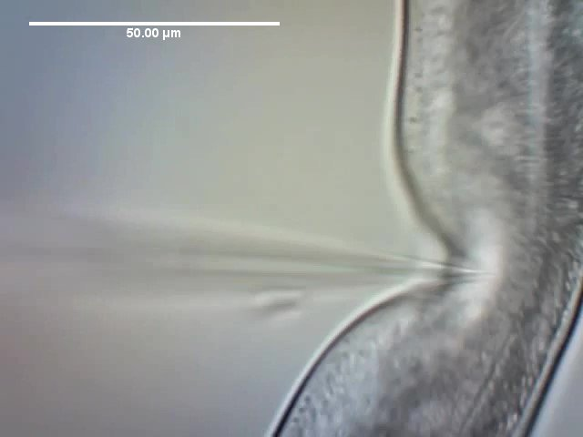
After completing a series of successful tests, proving the attachment reduced cuticle depression to the desired level, our team aimed to verify that the device wouldn’t negatively impact the injection process. Over a series of five injections, using a different needle and C. elegans each time, our team observed no leakage of dye, or any other negative effect caused by the use of vibration. This led out team to conclude that we were successful in this goal.
Figure 52: Example of current injection [27]
Our team set out to update the containment system of the C. elegans, with the goal of aligning the C. elegans. During initial testing our team found the process even in its updated form to be slow, due to the fact that the injection stage needed to be repeatedly repositioned. The alignment of the C. elegans would completely remove this added inefficiency and reduce the overall process time. During the development of this final design, our team ran into several issues. We observed that when using untreated slides, the cross-linked hydrogel tended to stick more than the agarose it was overlaid on. This resulted in difficulty getting the desired top layer of hydrogel, and instead having a top layer of agarose that consistently led to needle breakage. Our team solved this through the use of treated slides, one to help with adhesion and one to prevent it, resulting in a higher success rate.
This problem of adhesion became much less important once our team moved to a fully hydrogel design, at which point a new issue was observed. The new design had a variable thickness to the layer of hydrogel covering the align C. elegans which would lead to the surface layer tearing on slide removal, or being thin enough that the worms could wriggle free themselves. Our team first looked to solve this issue by introducing a paralytic to the animals during encapsulation, but the tearing during slide removal still left the animals in open air, resulting in quick dehydration. This issue was addressed through the use of spacers mentioned earlier, giving a desired surface layer thickness.
Something our team observed was that the setup time of our new design was much longer than the previous standard on a single pad to single pad basis. The process of selecting an agarose pad, picking on worms, and adding oil is much faster than our team’s updated process. Our team weighed this against the time reduced through eradicating the need to reposition the injection stage, as well as the number of C. elegans that could be done in a single sitting. Our updated system could theoretically hold over forty worms in each pad, conversely the agarose pad design can only inject three or four worms at a time due to the ten-minute dehydration limitation. After weighing these improvements, our team determined that despite the increased setup time, our design achieved our overall goal of increasing the efficiency of the process over the current standard.
An additional variable that had to be accounted for throughout testing was the angel of needle injection, along both the y and x axis. Early on it was theorized that having the injection angle perpendicular to the C. elegans by 45 degrees would reduce the deformation. After repeated testing our team observed that this angle of injection increased the deformation of the hydrated cuticle to a greater level than the original 90-degree angle. In the y axis, there was difficulty determining the correct angle setting for the needle. As was mentioned before, the micromanipulator our team used could only move in one axis at a time. The solution to this was to set the needle at the correct angle to puncture the cuticle while only moving in the x axis. When the angle was too great, the stress from the hydrogel would lead to needle breakage. When the angle was too small, the needle would deflect before puncturing the hydrogel, leading to difficulty in testing. The finalized method was setting the y axis angle to 15 degrees, and slicing the hydrogel to position the worms directly at the edge. This allowed for a much easier injection path for testing.
The limitations of our system are the similar to the old process. The limitation of a ten-minute time frame was removed, but the designs true efficiencies still relies on the skill of the operator, as lining up the needle to the gonad of the animal is challenging, and requires significant practice. In the hands of a skilled operator, our team predicts no added limitations due to the system.

Chapter 8: Conclusions and Recommendations
Our teams’ recommendations for the future are split into tests that should be carried out, and updates to the physical designs. Our team theorized that adding a form of stabilization to the device to further reduce the y axis vibration, as well as increasing the power of the motor slightly would further reduce the cuticle depression. Additionally, our team observed issues with the consistency of the updated containment design. The top layer of hydrogel was variable in its success in containing the C. elegans. Our team suggests specific spacers, designed to apply the correct layer of gel on the top surface. The thickness of the layer would have to be further refined through repeated testing.
The hydrogel process also needs to be streamlined for the larger scale it is intended for. The process of scaling up the hydrogel design to encapsulate a larger number of C. elegans, thirty or forty for example, is a straight forward process. For the purpose of this project, pads were created with between four and six worms since the goal was to test and iterate as many methods as possible, but to scale up it would simply require more material. The final containment design was created using a maximum of 9.5um of hydrogel. This covered a relatively small section of the glass slide. To achieve the desired thirty or forty animals, more hydrogel would be added, and stamped, in the same process as described earlier. This would create a much larger grooved area to align the C. elegans.
Our team also did injection using single pads, the process wherein numerous pads would be used still needs to be refined to allow for larger batches. This would be in conjunction with a protocol for transfer to the injection stage and a standardized procedure during the injection.
Future tests should be carried out to determine if the vibration effects the DNA plasmid that is injected into the C. elegans. Our team predicted that there would be no effect, due to the preparation process requiring centrifuging for ten to twenty minutes at 16,000 RPM, but direct testing is required to confirm this assumption.
Testing should also be done to determine if there is a specific frequency of vibration that would prove more effective. Our team tested with a range of amplitudes, but frequency should also be considered.
The final test our team recommends is a direct test of the efficiency of this new process. Have a proficient operator determine how many C. elegans injections can be achieved in a time frame, around two hours to start, using the old process and the updated version. Directly comparing the two would give a direct qualitative increase of efficiency from the updated process.
In conclusion, our team believes that our project serves as an improved model for microinjection of C. elegans. We achieved all goals our team originally set, while staying in our 100 g weight constraint, and confirming that our device not only reduces deformation, but also can be used for injection with no negative effects. Our team believes this project can also be expanded for use in microinjection of other small scale organisms.

Appendix A: Hydrogel Microinjection Procedure
This is the procedure that was given to use part way through the year as a baseline. The majority of modifications were made based on this procedure, and our final design used the same light film as the basis for the mold.

Protocol for the Microinjection of Aligned C. elegans Embedded in Hydrogel
Albrecht Lab
Directed Research 2016-2017
Connor Haley

Procedure

- Prepare an agarose padded cover slide
- Materials:
  - 3% Agarose Solution
  - 2 Glass Cover Slides
- Prepare a boiling 3% agarose solution in diH₂0, keep this warm on a heating surface
- Add a couple of drops of the warm 3% agarose solution to the middle of the first slide and then immediately cover this section with the second slide at a 90˚ angle
- Let the two slides with for 1-3 minutes and then gently pull apart the sandwiched slides
- Set aside the blank slide and use the slide with the agarose pad for injection procedure
- Make fresh slides each time, use immediately
- Pulling a Needle
  - Materials:
    - World Precision Instruments Borosilicate Glass Capillaries
    - Sutter Instruments Co. Needle Puller
  - Turn the needle puller on with the black switch on its left side
  - When prompted what program to use, press the number 0. On this setting, the parameters should read “Heat = 800, Pull = 100, Vel. = 23, Time = 250” as these are most ideal for worm injections. If these are not the parameters displayed you may edit them.
  - Open the tube of capillaries and after opening the bag shake on out into your gloved hand. Do not touch the other capillaries in the bag, one you have one close the bag and replace it in the tube.
  - Feed the capillary into the grove of the Needle Puller on the left side until there is half an inch of clearance between the capillary and end of the notch to the left of the clamp. (Shown below in picture) Screw the clamp down at this point but not too tightly, only until you need some resistance.
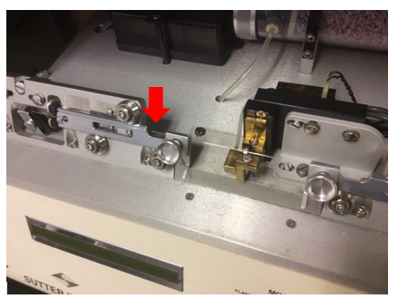
Clamped Capillary Highlighting Clearance Distance
  - Depress the metal hinge that is holding the pulling mechanism apart and pull both sides together until the capillary is within the clamps of the right side of the pulling mechanism. Tighten the other clamp to the same tightness as the initial clamp. (Shown below)
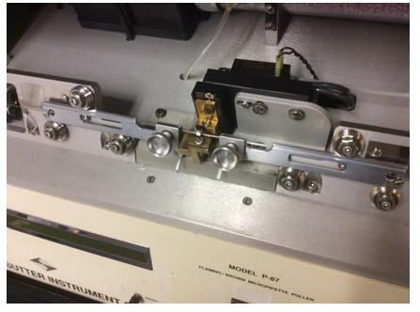
Fully Loaded Capillary into Needle Puller
  - Close the hood of the needle puller and press the green button next to the display. A portion of the puller will glow and after the allotted amount of time the mechanism will pull the heated glass apart.
  - Open the hood of the needle puller and loosen the clamps to retrieve the pulled needles. Examine them to see if they were pulled to an appropriate length.
- Needle Loading
- Materials:
  - Pulled needle
  - 10μL Pipettor
  - Injection sample
- Use 10μL pipettor to place 1.5μL drop of the injection material onto the bottom opening of the needle. Make sure droplet envelops the entire bottom opening as much as possible. The injection material will travel up the needle by capillarity action due to a groove inside the tube.
- Hold needle tip side up for approximately 5 minutes while liquid fills needle.
- Place the needle horizontally onto a glass slide for ease of retrieval.
- Microscope and Injection System Set-Up
- Materials
      - Zeiss Light Microscope Aziovert S 100
      - Eppendorf Femotojet
        - Needle Holder and Tube
      - Eppendorf Patchman NP2
- Turn on Femtojet in back, keep the tube in the front disconnected and let it cycle through to build up pressure
- Turn on the green switch on the side of the Zeiss scope for power.
- On the injector where the needle is inserted, screw on the correct size injector tip (either size 0 for 1mm needles or size 1 for 1.2mm needles)
- Press standby on the Patchman NP2 so that it is on.
- Once Femtojet has finished cycling, you can connect the tube to the front of the machine. You will know that the cycling is done because the sound of pressure building will stop.
- Insert filled needle into needle holder. Place the needle holder into the metal holder on the needle arm. Verify the angle on the needle arm approximately -5˚(5˚ descended)
- The following are the movement controls on the Patchman NP2.
  - Push knob right= needle goes right (x plane)
  - Push knob left= needle goes left (x plane)
  - Push knob down= needle goes down (y plane)
  - Push knob up= needle goes up (y plane)
  - Rotate knob clockwise= needle moves down (z plane)
  - Rotate knob counter clockwise= needle moves up (z plane)
- Place needle in highest position (z plane)
- Breaking the Needle
  - Materials:
    - An un-pulled needle mounted permanently on a glass slide
  - Place the glass slide with the mounted need onto the stage to it can be viewed though the microscope.
  - Adjust the focus on the microscope so the middle of the mounted needle is visualized. You can tell if the middle of the needle is in focus if you focus up or down and the needle structure gets smaller.
  - Use the Patchman to maneuver the needle tip into view so it is in focus along with the middle of the mounted needle.
  - Bring the tip of your needle to the edge of the mounted needle and lightly tap the needles against each other until the tip breaks.
  - Test the injection liquid by pressing Inject on the Femtojet and adjust the injection levels if needed.
- Worm Preparation
  - Materials:
    - C. elegans Roundworm
    - Agarose Padded Slide
    - 20% Hydrogel 0.1% PEGDA
    - 10μL Pipettor
    - 312nm UV Source
    - -10˚ C Fridge
    - Light Control Film 175μm PC
    - Stereoscopic microscope
    - 2 Pairs of Tweezers
  - Prepare the Light Control Film by cutting a 1mm x 1mm square out of the sheet. Peel off its protective coatings and, using a pair of tweezers, verify which side has the jagged edges by dragging the tweezers over either side of the film on one of the corners. You’ll be able to feel the bumps.
  - Using the pipettor place a 5μL drop of the hydrogel onto the agarose padded slide.
  - Pick as many C. elegans as desired onto the center of the drop of hydrogel
  - Immediately take the slide and place it into a -10˚ C Freezer for no more than 2 minutes. This will slow down the activity of the worms.
  - After the freezer, immediately bring the slide back and place the light control film over the droplet of hydrogel. Verify the worms align into the groove of the film, and if not you can move the film around slightly with the tweezers until adequate alignment is achieved.
  - Place the slide with the control film onto the UV Source, cover the entire source with tin foil, and switch the source on for 15 seconds. Then turn the source off and remove the tin foil.
  - Observe the control film under a stereoscopic microscope. See the worms aligned in the gel under the film. If he worms have made a pocket for themselves in the gel, you were not fast enough in UV crosslinking the gel between the freezer and the UV source.
  - With two sets of tweezers, hold one corner of the film down with a point of one set of tweezers and on the other side of the film gently lift the film from the agarose layer. Once removed, what remains is C. elegans encapsulated in a hydrogel and aligned in triangular rows. (Example shown below) The graphic below illustrates the geometry from another plane of reference.
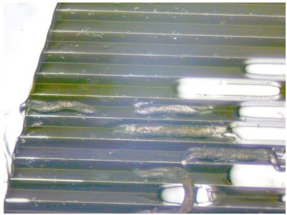
Alignment of C. elegans in Hydrogel
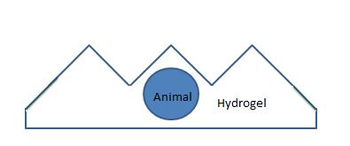
Graphic of Animal Aligned in Hydrogel
- Worm Injection
  - Place the slide containing the encapsulated worms onto the stage so it is viewable through the microscope. Focus on a particular worm you wish to inject.
  - Use the Patchman to move the needle holder as high in the Z plane as the motor will go. Change the angle of the needle holder to -20˚ (20˚ descended). This is the ideal angle for injection of the worms in the triangular shaped hydrogel.
  - Move the needle in focus just to the left of the worm you wish to inject. Locate the vulva of the worm. You are going to inject the opposite side of the worm where the gonadal arms are. If the gonads are more easily accessible from the other direction, rotate the slide 180˚.
  - Use the Patchman to move the needle to the right. This should pierce the triangular hydrogel and touch against the worm, not piercing the animal. If you pierce through the other portions of the hydrogel this is fine. Tap on the side of the injection microscope platform and the needle will go into the worm. (Shown below) This ensures that you don’t push the needle in too far with the knob on the Patchman. The graphic below illustrates this action from another plane of reference.
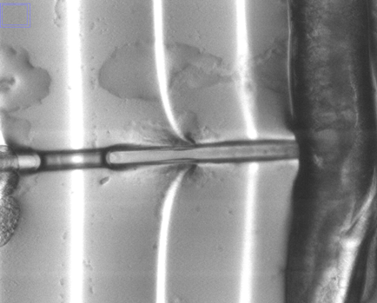
Piercing Worm with Needle
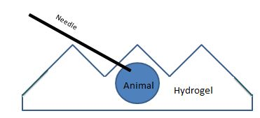
Graphic of C. elegans Injection
  - Once the needle has pierced the worm, press the inject button to start the flow of the injection material into the worm. Fill up the gonadal arm until it looks full.
  - Using the Patchman move the needle to the left to pull out of the worm.
  - Move the stage in any desired direction to repeat the injection process for as many worms as you intend on injecting.

- Worm Recovery
  - Materials:
    - Two Pairs of Metal Tweezers
    - One seeded plate
    - Ethanol Lamp
  - Sterilize the pair of tweezers by flaming them with the Ethanol Lamp
  - Once injection is complete, remove the slide from the stage. With a set of tweezers carefully remove the hydrogel layer from the agarose layer on the slide and transfer the hydrogel to a seeded plate.
  - With the two tweezers gently clasp the hydrogel and begin to tear it apart enough for the C. elegans to crawl out.
  - If some prove difficult to remove or are only halfway out, leave the hydrogel in the plate and the worms will be able to crawl out.
  - Repeat worm preparation, injection, and worm recovery for however many worms you are planning on injecting.

Appendix B: Procedure used for Salinizing Glass
This appendix reviews the procedure that was used to salinize the glass slides for all of the containment applications. This was done to increase the attachment of hydrogel in most cases but also was attempted in the agarose models.

3-(Trimethoxysilyl)propyl methacrylate

Catalog Number M6514
Storage Temperature 2–8 °C

CAS RN 2530-85-0
Synonyms: γ-Methacryloxypropyltrimethoxysilane; [3-(Methacryloyloxy)propyl]trimethoxysilane

Product Description
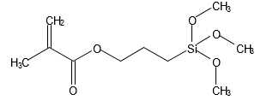
Molecular formula: C10H20O5Si
Molecular weight: 248.35
Appearance: Clear, colorless to faint yellow liquid
Density: 1.045 g/mL

3-(Trimethoxysilyl)propyl methacrylate has been used to covalently link polyacrylamide gels to glass plates. Gels cast in this way do not lift from the glass plate as a result of shrinking or swelling due to pH gradient formation during isoelectric focusing. Also the gel will remain attached to the glass plate during staining procedures.1

This product can also be used to attach cells, microscopic sections, and total organs to slides and other glass surfaces for in situ hybridization purposes. The attachment was faster and considerably more durable than using poly-L-lysine or other protein systems.2

Precautions and Disclaimer
This product is for R&D use only, not for drug, household, or other uses. Please consult the Material Safety Data Sheet for information regarding hazards and safe handling practices.

Storage/Stability
Store the product at 2–8 °C, protected from moisture. Any cloudiness in the liquid indicates some exposure to water. The product remains active for at least 2 years.
The product will react with water, since alkylsilanes react with hydroxyl groups. An ethanol solution remains active for one day.

Procedure
A procedure for treating glassware.¹
- First, glass plates should be cleaned in strong soap, rinsed thoroughly with water, and dried
(preferably in a drying oven.)
- Place spacers around glass plates to allow full contact with the silane solution.
- Dilute 1 mL of 3-(trimethoxysilyl)propyl methacrylate in 200 mL of ethanol and just before use, add 6 mL of dilute acetic acid (1:10 glacial acetic acid:water).
- Pour solution (step 3) onto plates and allow to react for ∼3 minutes. Pour off excess, and then rinse plates with ethanol to remove the residual reagent. Allow to dry thoroughly.
A similar procedure without using ethanol:
- Adjust 1 L of water to pH 3.5 with acetic acid. Add 4 mL of 3-(trimethoxysilyl)propyl methacrylate and stir until clear.
- Treat plates for an hour at room temperature, then rinse and dry.
The coated film may be removed from the glass surface by soaking in a 10% sodium hydroxide solution.
References
- Garoff and Ansorge, Anal. Biochem., 115, 450-457 (1981).
- Dyanov, H.M., and Dzitoeva, S.G., BioTechniques, 18, 822-826 (1995).

Sigma brand products are sold through Sigma-Aldrich, Inc.
Sigma-Aldrich, Inc. warrants that its products conform to the information contained in this and other Sigma-Aldrich publications. Purchaser must determine the suitability of the product(s) for their particular use. Additional terms and conditions may apply. Please see reverse side of the invoice or packing slip.

Appendix C: Arduino Code Used
Initially the code was used to connect the potentiometer to the Arduino so our team could vary the amount of vibration that we were outputting. Once an output was determined the code was modified to work with an attached foot pedal.
The initial code is as follows:
/* Motor Control Code – Chris Rockwell */

void setup() {
// Setting up the output pin to get a reading
pinMode(12,OUTPUT);
}

void loop() {
// Writing a value to the output, analogRead goes between 0 and 1023
// analogWrite writes to a pin, followed by a value from 0 to 255
// to output the max of 3 volts we want the max integer received to be 153
analogWrite(3, analogRead(A2) - 870);
}

This is a review of the code used to run the motor and connect to the foot pedal. This was modified from code found in [28]
/* Foot pedal control code – Chris Rockwell */

void setup() {
// Setting up the input pin
pinMode(2, INPUT);
// Setting up the output pins to send a signal to the foot pedal
pinMode(12, OUTPUT);
pinMode(5, OUTPUT);
}

void loop() {
// getting a reading from the input pin, either HIGH or LOW
int reading = digitalRead(2);

// If the reading is HIGH or the footpedal is down and sending a signal
if (reading == HIGH) {
// Set the speed of the motor to the max value of 153
analogWrite(3, 153);
} else {
// Otherwise keep the speed at 0
analogWrite(3, 0);
}
}

Appendix D: CAD Models
This appendix reviews the different parts that were 3D printed for this design. Giving explanation for each part that made up the design.
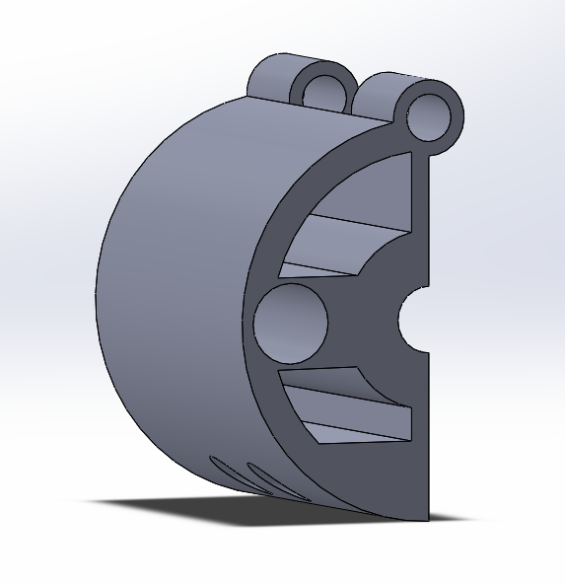
Figure 53: One side of the needle clamp
Shown above in Figure 50 is the first half of the needle clamp, which holds the needle in place and slides along the two rods of the main body to provide the vibration.
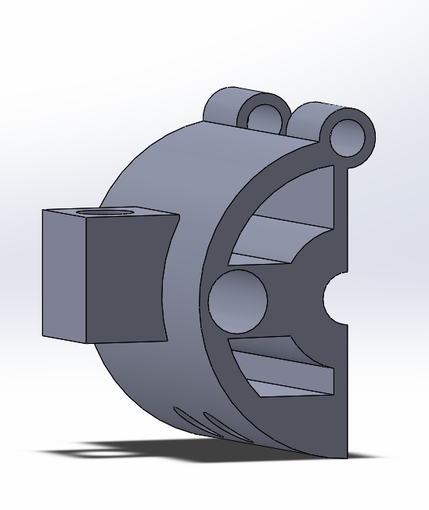
Figure 54: Outer side of the needle clamp
Shown above in Figure 51 is the second half the clamp, which houses the vibrating motor.
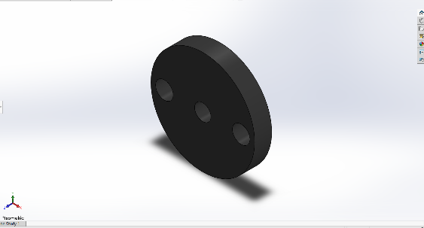
Figure 55: Vibration dampening pad, two in the final design
In Figure 52 you can see the force absorbing pad, which reduces the force of vibration to the desired level.
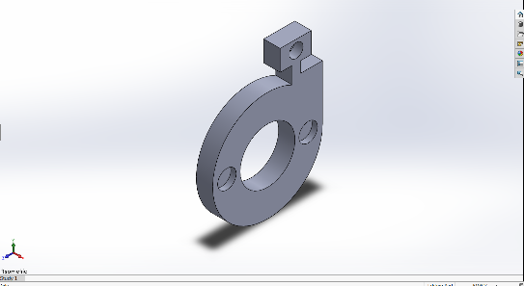
Figure 56: End cap for the case
The end cap of the device, shown in Figure 53, fits into the slot seen in the main body, holding the centerpieces and force absorbing pads onto the two sliding rods.
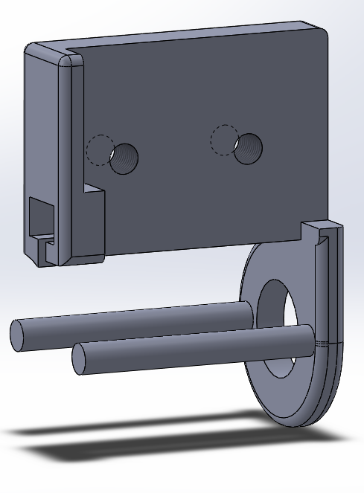
Figure 57: Main component and attachment to micromanipulator
In Figure 54 you can see the main body which attaches directly to the micromanipulator, and holds each other piece along the two rods

Appendix E: Light Control Film Datasheet
This is an expert from the datasheet that we were given in conjunction with the light control film that was used as the major mold. It gives more detail of the material properties and technical details of the design.
Film Optics Ltd | Film Optics Ltd  39/40 Shrivenham Hundred Business Park  Watchfield, Oxfordshire, SN6 8TZ  United Kingdom  Tel: +44 (0)1793 847593 or 847594  Email: info@film-optics.co.uk

90/160 Light Control Film
SPF90/160/175PET
Technical Specification
Date: 3/10/13, Issue Number 1
Description
90/160 Light Control Film is a symmetrical prism structure with 90-degree top angle. The film is produced on the surface of a 175-micron PET base film using a UV casting process and an acrylic based, high refractive index lacquer.
Applications
The film exhibits unique properties in that it will either reflect or transmit light depending on the incident angle at which the light strikes the film. The film can be used to propagate light along a tube at high efficiency. By altering the angle at which the light hits the tube it is also possible to cause the light to exit the tube at any given point. The film finds applications in light transmission devices (e.g. daylighting systems) and in lighting luminaire construction.

Structure
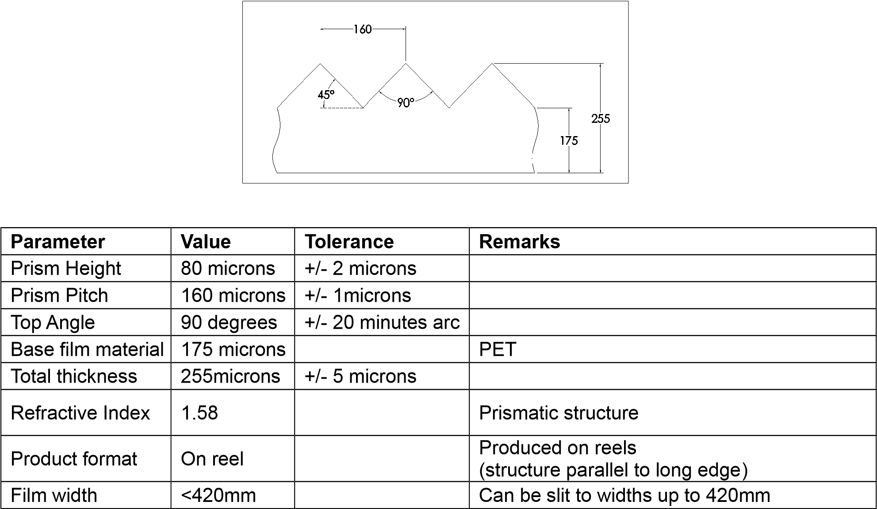

Handling
As with all precision optical films care should be taken when handling. Surgical gloves should be worn to avoid fingerprinting. Care should be taken to avoid scratching the film surface. Films should be handled in a clean, dust free environment with a liner used on surfaces to protect the structure. The film can be easily cut using a guillotine, sharp bladed knife or scissors.

Sales contact details
E-mail: info@film-optics.co.uk
Tel: +44 (0) 1793 847593 or 847594
Web www.film-optics.co.uk

Registered in England No. 8449240 . VAT No GB162208533
Registered Office: 147, Ryefield Avenue, Uxbridge, Middlesex, UB10 9DA, U.K.

References
[1] (). Caenorhabditis elegans as a Model Organism. Available: http://devbio201415.tumblr.com/post/100430112589/caenorhabditis-elegans-as-a-model-organism.
[2] D. S. Wilkinson, R. C. Taylor and A. Dillin, "Chapter 12 - analysis of aging in caenorhabditis elegans," in Methods in Cell Biology, J. H. Rothman and A. Singson, Eds. Academic Press, 2012, pp. 353-381.
[3] R. Kerr et al, "Optical Imaging of Calcium Transients in Neurons and Pharyngeal Muscle of C. elegans," Neuron, vol. 26, (3), pp. 583-594, 2000. Available: http://www.sciencedirect.com/science/article/pii/S0896627300811964. DOI: 10.1016/S0896-6273(00)81196-4.
[4] EpiVax, HLA Transgenic Mice, Retrieved from http://epivax.com/lab-services/hla-transgenic-mice
[5] Emily Matchar, Could the Tiny Zebrafish Teach Us to Cure Blindness?, Retrieved from https://www.smithsonianmag.com/innovation/could-tiny-zebrafish-teach-us-cure-blindness-180962626/
[6] Your Genome, Fruit flies in the laboratory, Retrieved from https://www.yourgenome.org/stories/fruit-flies-in-the-laboratory
[7] Katya Simpson, The Story of C. Elegans, Retrieved from http://blog.eyewire.org/the-story-of-c-elegans/
[8] R. Jaenisch, "Transgenic animals," Science, vol. 240, (4858), pp. 1468, 1988. Available: http://science.sciencemag.org/content/240/4858/1468.abstract.
[9] K. Schmeisser and J. A. Parker, "Worms on the spectrum - C. elegans models in autism research," Exp. Neurol., 2017. . DOI: 10.1016/j.expneurol.2017.04.007.
[10] C. Lai et al, "Identification of novel human genes evolutionarily conserved in Caenorhabditis elegans by comparative proteomics," Genome Res., vol. 10, (5), pp. 703-713, 2000.
[11] L. M. Kutscher and S. Shaham, "Forward and reverse mutagenesis in C. elegans," WormBook : The Online Review of C. elegans Biology, pp. 1, 2014. Available: http://www.ncbi.nlm.nih.gov/pubmed/24449699.
[12] R. C. Lee, R. L. Feinbaum and V. Ambros, "The C. elegans heterochronic gene lin-4 encodes small RNAs with antisense complementarity to lin-14," Cell, vol. 75, (5), pp. 843-854, 1993.
[13] T. C. Evans, "Transformation and microinjection," .
[14] A. E. Friedland et al, "Heritable genome editing in C. elegans via a CRISPR-Cas9 system," Nat. Methods, vol. 10, (8), pp. 741-743, 2013. . DOI: 10.1038/nmeth.2532.
[15] K. Burnett, E. Edsinger and D. R. Albrecht, "Hydrogel encapsulation of living organisms for long-term microscopy," bioRxiv, 2017. Available: http://biorxiv.org/content/early/2017/09/27/194282.abstract. DOI: 10.1101/194282.
[16] X. Q. Kong and C. W. Wu, "Mosquito proboscis: An elegant biomicroelectromechanical system," Phys Rev E., vol. 82, (1), pp. 011910, 2010. Available: https://link.aps.org/doi/10.1103/PhysRevE.82.011910.
[17] Anonymous (). Red Hot. Available: https://www.the-scientist.com/?articles.view/articleNo/42260/title/Red-Hot/.
[18] (). Piezo Impact Drive Mechanism. Available: http://www.aml.t.u-tokyo.ac.jp/research/pidm/pidm_e.html.
[19] News Medical Life Sciences, PatchManTM NP 2 Micromanipulator from Eppendorf, Retrieved from https://www.news-medical.net/PatchManTM-NP-2-Micromanipulator-from-Eppendorf
[20] J. L. Meriam, L. G. Kraige and J. N. Bolton, Engineering Mechanics: Statics, 8th Edition: 2014Available: https://books.google.com/books?id=JKWqBAAAQBAJ.
[21] (). What is a Single Pole Double Throw (SPDT) Switch?. Available: http://www.learningaboutelectronics.com/Articles/What-is-a-single-pole-double-throw-switch-SPDT.

[22] TapeCase, 3M 810 TAPE Scotch® Magic™ Tape, Retrieved from https://www.tapecase.com/pd/cn/tapes-die-cuts/1002/14002842/3m-810-tape-scotch-magic-tape.aspx
[23] Silhouette, Silhouette Cameo Electronic Cutting Tool, Retrieved from https://www.amazon.com/Silhouette-Cameo-Electronic-Cutting-Tool/dp/B005Y1CPSU
[24] Basler, acA1300-60gm - Basler ace, Retrieved from https://www.baslerweb.com/en/products/cameras/area-scan-cameras/ace/aca1300-60gm/
[25] (). Manual Tracking. Available: https://imagej.nih.gov/ij/plugins/track/track.html.
[26] M. Gebler, Schoot Uiterkamp, Anton J M and C. Visser, "A global sustainability perspective on 3D printing technologies," Energy Policy, vol. 74, pp. 158-167, 2014. Available: http://www.sciencedirect.com/science/article/pii/S0301421514004868. DOI: 10.1016/j.enpol.2014.08.033.
[27] Amy F, C. elegans Injection, Retrieved from: https://www.youtube.com/watch?v=DLMvbJqlz4c
[28] TechMartian. (). Reading an SPDT Switch. Available: http://www.instructables.com/id/Reading-an-SPDT-Switch/.

