New Nucleoside Analogs for Visualizing DNA Replication with a Culture of Safety Analysis in New York Hospitals

A Major Qualifying Project submitted to the faculty of Worcester Polytechnic Institute in partial fulfillment of the requirements for the Degree of Bachelor of Science.
This report represents the work of one or more WPI undergraduate students submitted to the faculty as evidence of completion of a degree requirement. WPI routinely publishes these reports on the web without editorial or peer review

Submitted by:

Silvana M. Reid, Biochemistry and Professional Writing

Advised By:

Professor Destin Heilman, Ph.D., Department of Chemistry and Biochemistry
Professor Nicholas Rhind, Ph.D., Department of Biochemistry and Molecular Biotechnology
Professor Brenton Faber, Ph.D., Department of Humanities and Arts
Professor Yunus Telliel, Ph.D., Department of Humanities and Arts

Table of Contents
Acknowledgments 8
Forward 9
Part 1: New Nucleoside Labeling for DNA Visualization 10
Abstract 11
Introduction 12
DNA Replication Models: 13
Stochastic vs Deterministic 13
Stochastic Increased Efficiency Model 13
Relative Efficiency Model 14
Methods of Analyzing 14
Bulk vs Single Molecule 14
DNA Combing 16
Thymidine Analogs 17
ORM - Optical Replication Mapping 18
Fluorescent Labels 19
Compatible Nucleosides 20
Abasic Sites and Glycosylase 21
Applications of Origin Site Tracking 22
Materials and Methods 23
Testing Toxicity of Potential Nucleosides 23
Acute Growth Curves 23
Long-Term Growth Curves 23
Testing Incorporation of VdU 23
Cell Preparation 23
Incorporating VdU and dI into HeLa Cells 24
Purification of Conjugated DNA 24
Measuring Incorporation 24
Conjugating Dyes onto VdU 25
Ideal Conditions for Fluorophore 25
Ideal Conditions for Dye Conjugation in DNA 25
Results 26
Incorporation of VdU and dI into Human Cells 27
Conjugation of Dyes 28
Treated dI DNA with Glycosylase 29
Discussion 30
Figures 33
References 48
Part 2: Analysis of New York Hospitals 50
Culture of Safety at WPI Biomedical Laboratories 51
Abstract 51
Chapter 1: Introduction 52
Chapter 2: Literature Review 53
Section 2.1: What is an Occupational Hazard? 53
Section 2.1.1: DuPont-Making a Toxic Product 53
Section 2.1.2: Hazards in the Hospital Environment: Hospital Personnel at Risk 54
Section 2.1.3: Preventative Measures 55
Section 2.2: Culture of Safety in Health Care Systems 55
Section 2.2.1: Patient Impact 55
Section 2.3: Culture of Safety Process Improvement 56
Section 4.3.1: Barriers to Process Improvement 56
Chapter 3: Research Design 57
Section 3.1: Analysis of Patient Outcomes 57
Section 3.1.1: Rating Hospitals-Safety Grade and Data Robustness 57
Section 3.2: Determining Culture of Safety Through Occupational Hazards 59
Section 3.3: Correlation Factors Between Occupational and Patient Safety 60
Section 3.3.1: Zip codes 60
Section 3.3.2: Population 60
Section 3.3.3: Number of Beds 60
Section 3.3.4: Statistical Analysis 61
Section 3.4: Limitations 61
Chapter 4: Results 62
Chapter 5: Discussion 64
References 66
Appendix A: Summary of terms and definitions utilized 68
Appendix B: The common procedures defined in the Medicare website (Medicare.gov, 2022) 68

Acknowledgments
The success of my Major Qualifying Project: New Nucleosides for DNA Visualization would not have been possible without the supervision of my advisor, Professor Nicholas Rhind (Professor at University of Massachusetts Medical School) and Professor Destin Heilman (WPI). In addition, I would like to thank the entirety of the Rhind Group, specifically Wendy Kam, for aiding me in the lab and PhD candidate Adam Hedger from the Watts Labs for training and assisting me with HPLC. For my Major Qualifying Project: Assessing Culture of Safety in New York Hospitals, I would like to thank Professor Yunus Telliel and Professor Brenton Faber for co-advising my project, as well as my partner Liza Hote for collaborating with me on the project.

Forward
This joint Major Qualifying Project consisted of two parts: a biochemistry research project focused on investigating novel nucleoside analogs for DNA visualization and a professional writing study which created and analyzed a quantitative study of the culture of the safety of New York Hospitals. My biochemistry project was performed at the University of Massachusetts Medical School with Professor Nick Rhind, while I worked in tandem with my professional writing partner, Liza Hote to access the culture of safeties relationship with patient safety. These projects were joined through an analysis of the impact culture of safety can have on laboratory research and overall safety in the lab environment.

Part 1: New Nucleoside Labeling for DNA Visualization

Author:

Silvana Reid, Chemistry and Biochemistry

Supervisors:

Professor Nicholas Rhind, PhD, University of Massachusetts Medical School: Biochemistry and Molecular Biotechnology

Professor Destin Heilman, PhD, Worcester Polytechnic Institute: Chemistry and Biochemistry

Abstract

DNA replication is temporally regulated with some origins firing early in the S phase and others firing later. Probabilistic models for DNA replication suggest that early origins are more likely to fire, and late origins are less likely. For this project, we wanted to develop tools that allow current models to be tested to answer why some origin fires early or later. Currently, such replication models are based on laborious, time-consuming single-molecule DNA visualization techniques. Optical replication mapping (ORM) has been determined to be an efficient tool in visualizing DNA, as it is neither labor-intensive nor time intensive as other approaches. The issue with ORM is that it’s not compatible with EdU, IdU, BrdU, or CldU, which are used to visualize origin sites.The primary goal of this project is to analyze their ability to be incorporated into DNA and their compatibility to be fluorescently tagged. In doing such, we wanted to determine which workflow would be optimal for further preparation for optical replication mapping (ORM).

Introduction
The term origin refers to the sequences in a genome that indicate to the cell where to initiate replication in preparation for cellular division. As seen in Figure 1, replication occurs in a stepwise process. The cell cycle is split into two parts; the longer portion is referred to as interphase and the end portion is referred to as mitosis. During interphase, both stepwise and continuous processes occur to allow the cell to grow and replicate its DNA (Stockdale et al, 1961). This allows S-phase to occur, in which the genetic material is doubled, and which is initiated at the origins. Understanding origins during this phase are important because it provides insight into replication timing. Replication timing has been shown to be largely dependent on the time of the initiation of origins. The replication of eukaryotic chromosomes has been shown to have a predictable order, which is largely mediated by the time of the initiation of origins (Rhind, 2006). It has been confirmed that this order, although not the origins themselves, are conserved between species, which leads to the idea that the timing of replication is independently regulated by the mechanism specifying origins (Rhind et al, 2009). Coming to understand the regulation of this timing allows for a clearer picture of the effects of origin replication timing on the genome, allowing a better understanding of how replication works and the kinetics that are involved (Rhind, 2006). This project is aimed at creating new analytical procedures which will allow for specific location determination of origins during replication. By providing specific locations, we can more deeply investigate the biological phenomenon of origin firing, which will allow for further investigation of their kinetics and other properties.
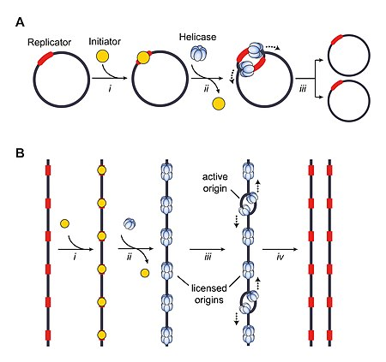

Figure 1: Represents DNA replication in the S-Phase-Specific locations of origins are identified to demonstrate the role these sites play in initiating replication (Wikimedia, 2022)

DNA Replication Models:
The organization of eukaryotic DNA replication has two proposed mechanisms: stochastic and deterministic. These proposed mechanisms differ based on their definitions of origins firing either earlier or later than others.

Stochastic vs Deterministic
The two different models define the term “early origin firing’ differently. The first model that was introduced was the deterministic model. The deterministic model determines origin firing by the parameter’s values and initial conditions (Rhind et al, 2009). This model follows a stepwise protocol, where origins that are “early” are the ones that fire first, while the origins that are “late” fire afterward. The stochastic model proposes inherent randomness, insisting that origin firing wasn’t a stepwise procedure but rather a random phenomenon. In this model, origins fire on probability rather than stepwise. The “earlier” are the ones that are considered most likely to fire, while those that fire “later” are less likely to fire. This model is more widely accepted, since it aligns with the eukaryotic replication is heterogenous, with each cell using a different combination of origins and demonstrating different patterns of replication (Huberman,2006).

Stochastic Increased Efficiency Model
The stochastic increased efficiency model looks to use polymerase recycling to increase the efficiency of late firing in the S-phase in response to the random gap problem. The random gap problem is a large gap between origin firing that take a long time to replicate, causing a decrease in replication efficiency (Patel et al,2005)). It has been proposed that origin firing is limited by the ability to recruit essential replication-fork proteins (Rhind et.al,2006) (Huberman, 2006). In this case, it refers primarily to polymerase, which is required for origin firing but limited in number. When forks merge, polymerases would be released and could be reenlisted to allow further origins to fire (MacAlpine, 2021).

In doing such, one can have a roughly constant number of active replication forks throughout the S phase, as polymerases are recycled from old replication forks to new ones, allowing maintenance of origin firing. Maintenance and increasing the percentage of potential origins would allow an increase in efficiency (MacAlpine, 2021). Increasing origin efficiency would, in turn, ensure that random gaps in replication would be efficiently closed by new origin firing.

Consistent numbers of replication forks and the increasing density of origin firing predicted by this model have been observed in budding yeast and frog embryonic cells. Through the increased efficiency model, the problem of the random gap problem is rectified by identifying the mechanisms by which some cells rectify this gap problem (Huberman, 2006).

Relative Efficiency Model
Although the previous model provides a solution for the random gap problem seen in frog and yeast cells, it is not consistent with the definitive patterns seen in other models and studies. To resolve this, the relative efficiency model incorporates the idea of late efficient origins and stochastic origin firing. Early and late firing are not mapped, instead, they are associated with broader regions of replicating DNA segments. In this model, origins fire stochastically, but the regions with efficient origins replicate early due to onset early firing. The model does not require the identification of individual mechanisms of S-phase timing and firing in defined time sets (Huberman, 2006).

Although these methods allow insight into the functionality and timing of origins, they lack the evidence that comes because of high-resolution kinetic studies. It provides a plausible explanation for the organization of timing and stochastic firing, however, cannot identify specific origins or measure the efficiency of different points in the S-phase. Overall, this model adds replication timing to the stochastic model, making it more realistic of what occurs during DNA replication (Rhind et.al 2009) (Huberman, 2006).

Methods of Analyzing

Bulk vs Single Molecule
Approaches to looking at cellular events can be separated into two separate methodologies: bulk and single cell. The difference between the two is that single-cell analysis can represent a single cell behavior, while the bulk methodology represents a population of cells. Bulk methods (Figure 2b) look to measure the average behavior of a population to identify differences between the sample conditions. In contrast, single-cell methods (Figure 2a) measure the behavior of individual cells, or in this case single origins, in a sample to be able to identify differences between cell types and states. In comparison, bulk analysis is analogous to knowing the average height of everyone on the basketball team; it only gives you a big picture and provides little detail as to the actual heights of the team. Single-cell molecule analysis would allow for every height of the basketball players, which would allow for a more accurate estimation as to what the heights were on the team

Single-cell analysis is seen to have benefits over the bulk methodology, as it allows for a better understanding of distribution, cell stress, nutrition, and development of the cells. This approach can provide more accurate analytical procedures, such as in the fields of developmental biology and evolution.
This specific study chose single-cell analysis based on its ability to study correlation. In contrast to the bulk methodology, a single-cell approach allows for the tracking of specific origins and the ability to draw correlations from these data sets (Oshige et al, 2010). By working from specific locations instead of an average, we can study the fine details to create a better visual of what's occurring and study the kinetics of cellular development.

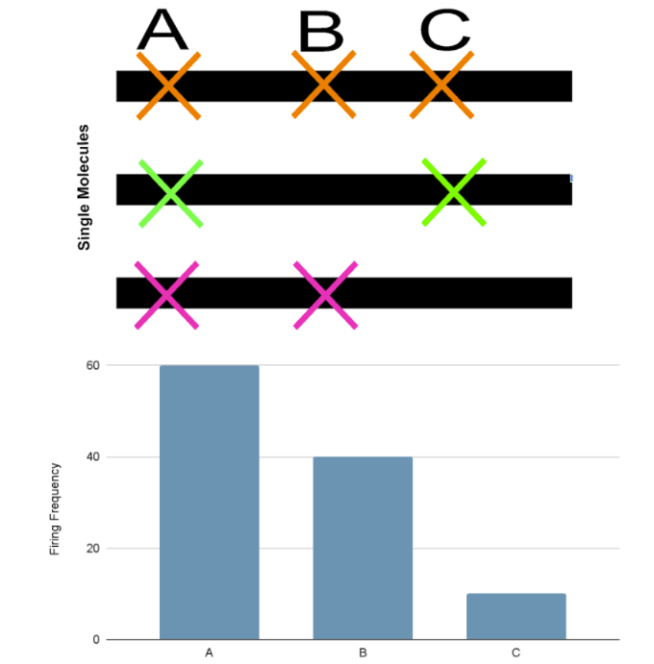

Figure 2: A. Single-Cell Analysis-This model demonstrates the method of single-cell analysis. The specific location of DNA can be identified and compared. B. Bulk Cell Analysis- This model demonstrates the method of bulk analysis, where the average can be taken. When compared with other methodologies, less information is available. Identifying the difference between single and bulk cells is important, as single cell allows for specific location and kinetic tracking of origins, while bulk cannot.

DNA Combing
A popular methodology that is used for single-cell analysis to study specific replication-initiation locations is DNA combing. DNA combing is the method of analyzing DNA by aligning single-molecule strands on the Mb (mega-base-pair) range on a salinized glass coverslip as seen in Figure 3. These DNA strands are labeled in vivo with pulses of halogenated nucleotides, which allows the determination of the density and position of origins. In optimal conditions, the DNA is deposited in a linear fashion, enabling accurate measurements and optimal resolution (Schowb, 2009). Origins can be detected using synthetic nucleoside analogs of thymidine IdU, BrdU, CldU, and EdU which are abbreviated names for 5-Iodo-2′-deoxyuridine, 5-Bromo-2'-deoxyuridine, 5-chloro-2′-deoxyuridine and 5-Ethynyl-2′-deoxyuridine (Oshige et al, 2010) ( Czajkowsky et al, 2008).
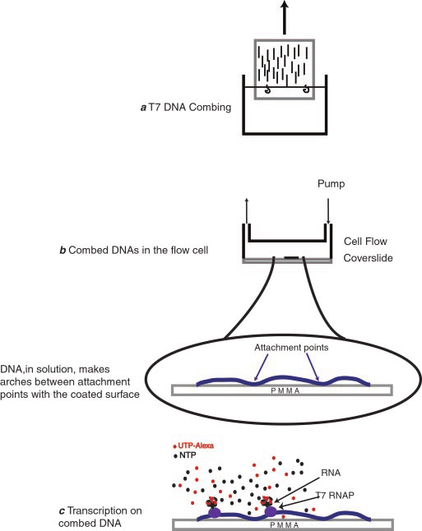

Figure 3: Methodology of DNA combing- DNA combing works by resuspending DNA in solvent and allowing it to adhere to a glass coverslip. The DNA, which is in single strand form and is pulse labeled with nucleosides, is then stretched underneath a microscope, allowing individual origins to be visible under specific UV (Gueroui, 2022).

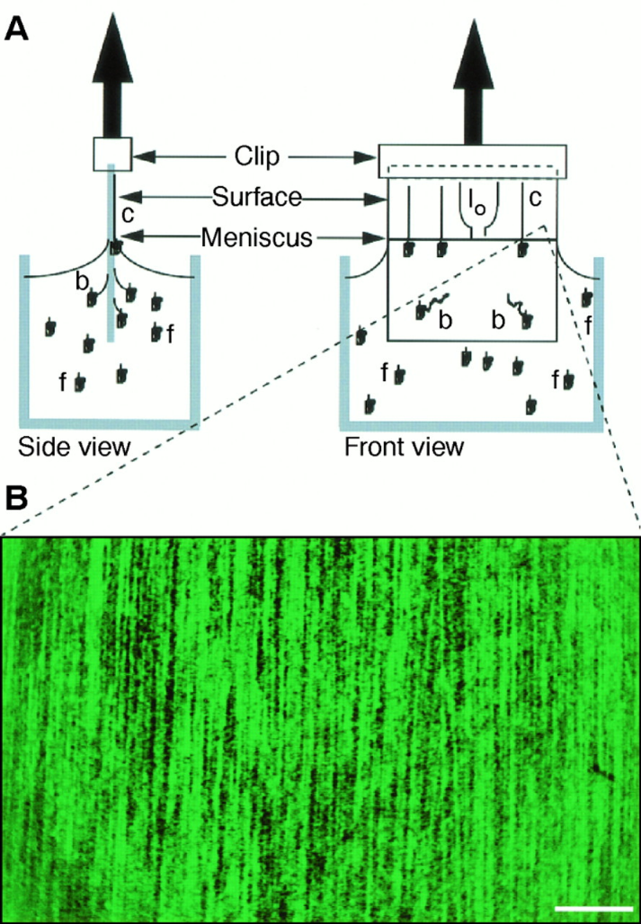

Figure 4: DNA combing Analysis- Demonstrates the analysis of DNA combing samples when stretched under a microscope, allowing single cell molecules analysis to occur (Gerbi, 2015).

Thymidine Analogs
These analogs are commonly used to study cell proliferation in living tissues, with application to diagnosing cancer or developmental biology. These analogs are incorporated during the S-phase into the newly synthesized DNA molecules, replacing thymidine. Cells can then be visualized using immunofluorescence to detect the sites where BrdU is present, as this indicates recent DNA replication or repair. EdU, the abbreviated version of 5-Ethynyl-2′-deoxyuridine, performs in a similar way. A distinction from the other nucleoside analogs is that EdU is detected with fluorescent azide, which is covalently bonded using click-chemistry. Click-chemistry in this case refers to the copper-catalyzed bioconjugation, which can make this assay slightly toxic. While effective, DNA combing is technically demanding due to the complex surface preparation and necessity for large amounts of starting material in order to achieve genomic-scaling mapping (Oshige et al, 2010) (Czajkowsky et al, 2008).
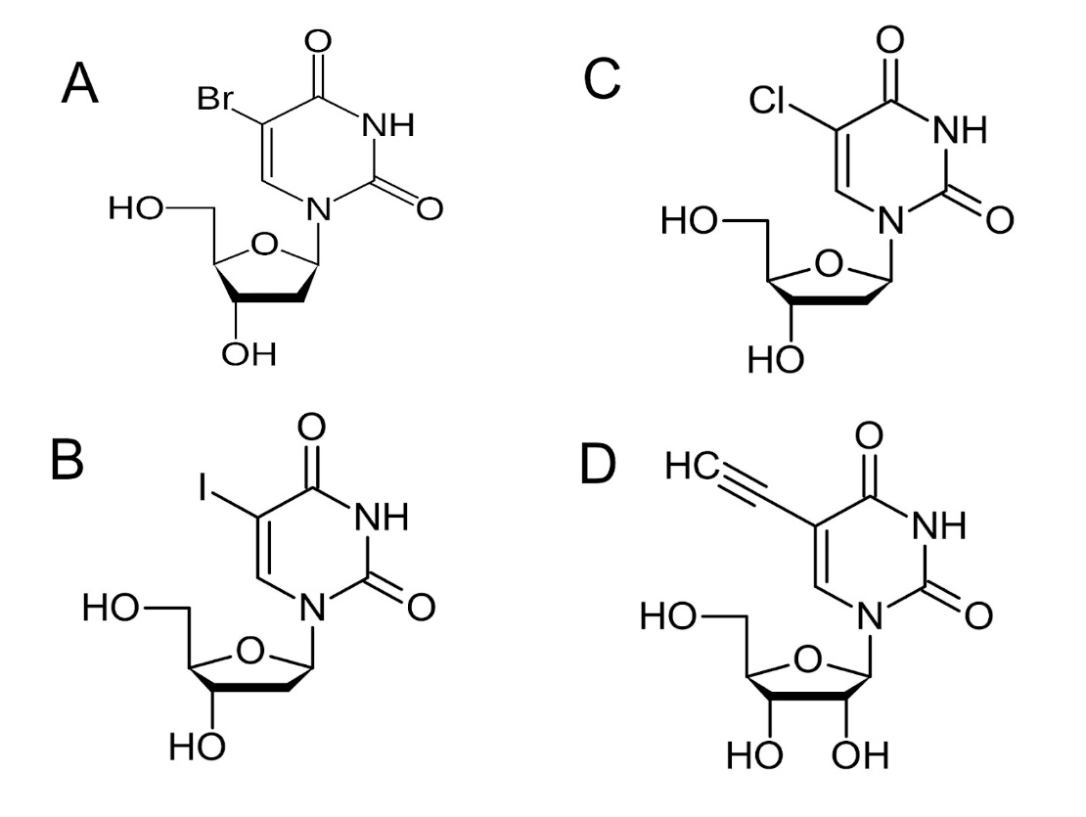

Figure 5: Previously Known Nucleotides-Previously used nucleotides that are functional in DNA combing but are not compatible with the new method. This is due to their resonance structures being incompatible with double stranded DNA, which is required for ORM.

ORM - Optical Replication Mapping
Due to the technical demand of DNA combing and the necessity for large amounts of starting material Optical Replication Mapping (ORM) was created. Instead of stretching the DNA on a coverslip, ORM is a high-throughput single-molecule approach that combines the Bionano Genomics approach with in vivo fluorescent nucleotide pulse labeling (Jeffet et.al 2021). This approach involves taking long-labeled strands of double-stranded DNA labeled with nucleoside analogs and pulling them through linearized nanochannel arrays on a Saphyr chip. The Saphyr chip allows for automated high-resolution imaging, allowing the nucleoside labels to identify origins. It covers 2000-fold coverage of the human genome in approximately 300kb, which allow identification of both origin sites and the probability of them firing with high confidence (Jeffet et al 2021) (Wang et al 2021).

This single-molecule approach can be used to map the early initiation sites and their firing probabilities. It allows for robust fiber mapping and significantly higher throughput, which has been used to allow single fiber analysis on mammalian genomes. Essentially, it performs a similar task that DNA combing does, however, ORM is more flexible than the previous methodology (Wang et al 2020). Whereas DNA combing is a tedious and time-sensitive task, ORM provides a more user-friendly technology that is easier and faster to perform (Jeffet et al, 2021). Through this, we can avoid the technical shortcomings of DNA combing and combat the heterogeneous nature of eukaryotic cells’ replication kinetics and the low efficiency of initiation sites.
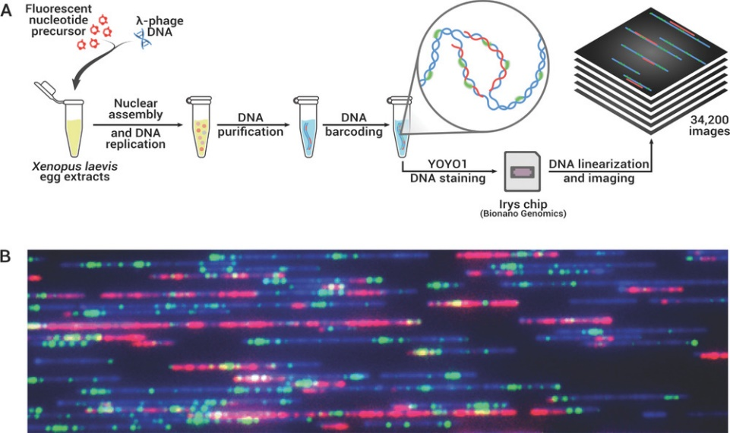

Figure 6: ORM Analysis Workflow Walkthrough- Double Stranded DNA which has been pulse labeled is resuspended and stretched through nanotubes for visualization (de Carli et al, 2015)

The shortcoming of ORM is that nucleoside labels that were previously used are not compatible with this methodology. Antibody identification of BrdU, IdU, and CldU requires denaturation of the DNA into single-stranded DNA which is incompatible with ORM. EdU is also incompatible because copper catalysis causes DNA damage, breaking up the DNA into small fibers. Currently, ORM is labeled by transfecting in fluorescence labels, however, this methodology isn’t generally applicable because it can only be used in cell lines that are easily transfect able (Bianco et al, 2012).

Fluorescent Labels
In this study, Tamra-Tetrazine, and FAM-Maleimide were utilized to label incorporated VdU to indicate origin locations. Tetrazine-activated TAMRA dye reacts with TCO-containing compounds via an Inverse-Electron-Demand Diels-Alder reaction to form a stable covalent bond and does not require a Cu-catalyst or elevated temperatures. Maleimide is labeled with FAM. FAM (fluorescein) is a bright fluorophore that is compatible with various fluorescence detection instruments. FAM is a universal dye that is useful for microscopy, qPCR, and many other methods as well as for FRET-based and fluorescence polarization-based binding assays.

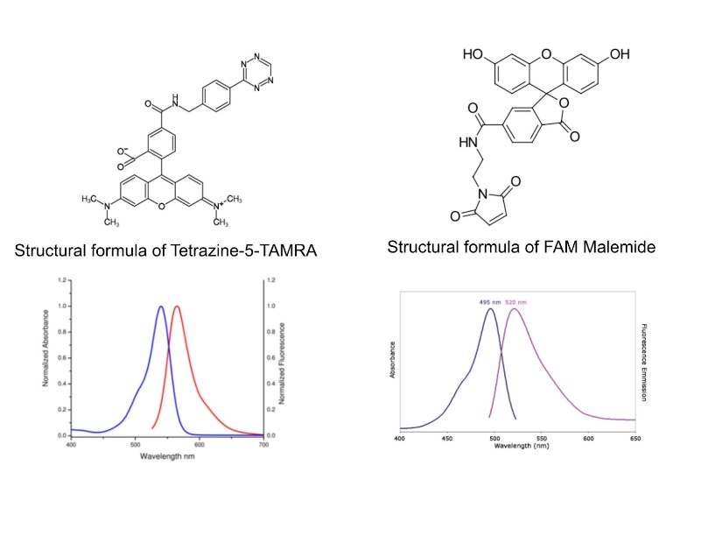

Figure 7: Structure of fluorescent dyes used during this study- Peaks of fluorescence are essential to identify, as it can indicate successful conjugation and solvent conditions

Compatible Nucleosides
Compatible nucleoside analogs may include VdU and AmdU, which may be able to be labeled without denaturation or copper catalyzation. VdU is the abbreviated term for 5-VdU (5-Vinyl-2'-deoxyuridine) and AmdU is the abbreviated term for 5-AmdU (5-Azidomethyl-2'-deoxyuridine). Both can be used as a replacement for BrdU (5-Bromo-2'-deoxyuridine) or the copper-catalyst requiring 5-EdU (5-Ethynyl-2'-deoxyuridine) to measure de novo DNA synthesis during the S-phase of the cell cycle (Bianco et al, 2012). The analogs are cell-permeable and incorporated into replicating DNA instead of its natural analog thymidine. The resulting vinyl-functionalized DNA can subsequently be detected via Cu(I)-free Alkene-Tetrazine Ligation that offers the choice to introduce a Biotin group (via Tetrazines of Biotin) for subsequent purification tasks or a fluorescent group (via Tetrazines of fluorescent dyes) for subsequent microscopic imaging (Wang et al, 2020 )(Sivakumar, 2021).

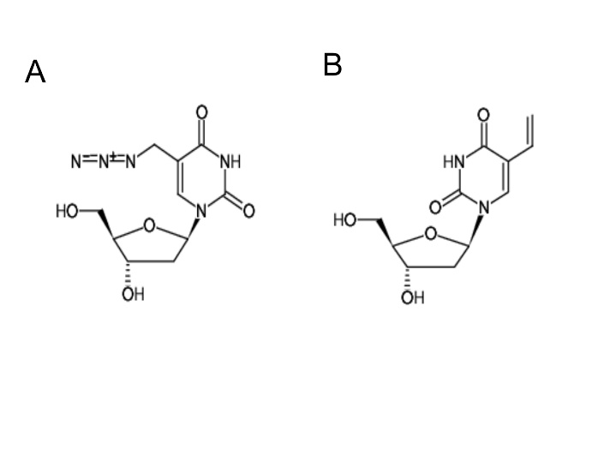

Figure 8: Tested Nucleotide Analogs During this revision of the experimental procedure- Panel A is the structure of AmdU and Panel B is the structure of VdU

Abasic Sites and Glycosylase
Apurinic/apyrimidinic (AP) sites, also known as a basic site, are frequent lesions found in DNA that contain neither purine or pyrimidine bases caused by spontaneous depurination (Figure 9). AP sites can also be created through a process called base excision repair, which is the process of removing small non-helix distorted base lesions from the genome. During this process, an enzyme called DNA glycosylase recognizes the damaged base and cleaves the nitrogenous base bond to release the base. This breaks the glycosidic linkage between the two and leaves an AP site. Apyrimidinic sites form at a rate roughly 20 times slower, with estimates at around 500 formation events per day, per cell. At rates this high, it is critical for cells to have a robust repair apparatus in place to prevent mutation (Wilson, 2022).

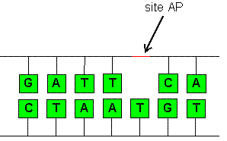

Figure 9: Simple representation of an AP site within DNA- Once the glycosylase recognizes a non-natural nucleoside, it will cut it out causing the creating of an a-basic site (Wikimedia, 2022).

The glycosylase used in this methodology recognizes non-natural nucleotides; since dI is not supposed to be there, the glycosylase will cut out the inosine base, making a basic site. The a basic site created is a good binding pocket for a hydrophobic small molecule. There is a lab that has developed a small fluorescent molecule that can attach to the sugar at a basic site, which can be used as a fluorescent tag to track origin firing (Wilson, 2022).

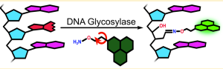

Figure 10: Glycosylase Mechanism- Using base-excision repair, glycosylase creates a high specificity AP site. From here a fluorescent probe can be attached for identification through multiple assays (Wilson, 2022).

Applications of Origin Site Tracking
Understanding how and when the origins of fire can allow insight into the DNA replication kinetics of cells. Patterns of replication in genome-scale mapping have given insight into differential cell types and growth conditions, with applications in the field of gene expression, chromatin structure, and genome evolution. Using ORM allows research into and experimentation in cell lines that don’t have effective transformation. This approach can further support modeling, as currently, we have stochastic modeling, however, not in high resolution. Higher-resolution modeling can provide more accurate timing of replication and origin firing. In doing so, there can be further developed into the insight of DNA replication kinetics and allow demonstration in a greater range of systems (Rhind et al, 2013).

This study looks to optimize the process of optical replication mapping to target and monitor origin firing sites more accurately. The first step of this process is to identify nucleoside labels that are compatible with ORM. This approach led us to test the toxicity of VdU and AmdU in yeast to determine what morphological and toxic effect these nucleotides would have on the cells. The next step after this was to test the incorporation of the nucleoside and whether they can be conjugated to fluorescent dyes in He La cells and optimize these procedures. With successful conjugation of both dyes, the labeled DNA would be pulled through the ORM system to locate the origin sites and study the regulation of replication kinetics during cell differentiation.

Materials and Methods

Testing Toxicity of Potential Nucleosides

Acute Growth Curves
Yeast cells were grown in 5 mL culture tubes and then transferred to 4 50 mL flasks at a concentration of 0.5 OD. Flasks were treated with VdU, AmdU, BrdU, CldU, IdU, and EdU at concentrations (insert concentrations). After 4hrs, the OD was measured, and samples were taken from each flask to determine morphological changes in the yeast cells. From microscope pictures, the percent septation of the cultures was also calculated. The flasks were then allowed to grow overnight, with a similar procedure occurring at the end of this time frame.

Long-Term Growth Curves
Yeast cells were plated into a 96 well plate at a concentration of 0.05 OD and treated with 1uM 10uM, 33uM, and 100uM of the analogs used in the acute growth curves. The 96-well plates were placed on the optical spectrometer to measure the OD over a time frame of 32 hrs. Growth curves were determined from the OD data and inferred doubling times were compared to determine the long-term toxicity of analogs.

Testing Incorporation of VdU

Cell Preparation
HeLa, human epithelial cells, were thawed from a stock solution by gentle agitation in a 37°C water bath for approximately 2 minutes. Transfer of vial conditions was done in aseptic conditions to a centrifuge tube containing 9.0 mL complete culture medium and spinning at approximately 125 xg for 5 to7 minutes. To make the complete growth medium, add the following components to the base medium: fetal bovine serum to a final concentration of 10%. Resuspend the cell pellets were then placed into a 25 cm2, then moved to a 75 cm2 culture flask. Cells were subculture until reaching 75-90% density for VdU incorporation in Corning® T-75 flasks (ATCC).

Incorporating VdU and dI into HeLa Cells
HeLa cells were subculture from the stock solution in Corning® T-75 flasks. The culture medium was removed and discarded. Cells were briefly rinsed with PBS solution to remove all traces of serum that contains trypsin inhibitor. Approximately 1ml of Trypsin-EDTA solution was added to the flask until the cell layer is dispersed. After cells are properly dispersed, 9 ml of complete growth medium was added by gentle pipetting 5-6 times to remove clumping (ATCC). Cells were separated into 2ml aliquots into four 15 cm dishes, with the remaining cells added back to the stock solution before dilution. Dishes were then brought up to 20ml in a culture medium and grown overnight at 37°C. After 16hrs and once cells properly adhere to the dish surface concentrations of 10 uM, 33 uM, and 80 uM of either VdU and dI were added and incubated for 24 hrs.

Purification of Conjugated DNA
Media was aspirated and cells were washed 2x PBS on ice before lysing for 10 min at 35 C. Cell scrapers were used to detach excess cells, which were then separated by 1ml into separate tubes. For every 1ml of lysate, cells were treated with 50 ul of proteinase K. Samples were then incubated at 65 C for 24 hrs. Samples were equilibrated to RT and 50 ul was removed for assessment of nucleic acid content via polymerase gels. Samples were then phenol/chloroform extracted and were then precipitated with ethanol. Samples were resuspended in water before being treated with RNase.

Measuring Incorporation
The incorporation of VdU was measured through high-performance liquid chromatography (HPLC). HeLa cells treated with 33uM VdU were filtered through Amicon filters in order to remove ribonucleotides and other contaminants from DNA samples. Approximately 30 ug of
purified DNA samples were digested with snake venom enzyme and incubated overnight at 37 C. Samples were then filtered again through Amicon filters and speed vac'd to concentrate samples. After determining sample DNA concentration, 15 ug of purified DNA samples were prepared to be analyzed on HPLC. VdU incorporation was identified via time of elution at 23.5 minutes and dI was identified via time elution of 18 minutes. Calculation of incorporated nucleoside was determined through comparison to other naturally occurring nucleosides.

Conjugating Dyes onto VdU

Ideal Conditions for Fluorophore
Dyes used in this experimentation have proven to be condition-dependent, with factors such as solvent conditions and pH impacting whether fluorescence can occur. Particularly, the FAM fluorophore was determined to be Ph-dependent. To ensure optimal fluorophore labeling capacity, different pH and solvent conditions were tested for impact on the fluorescent dyes when conjugated to VdU nucleosides.

Dye | pH Condition | Temperature
Maleimide | 4 | RT
Maleimide | 7 | RT
Maleimide | 12 | RT
Maleimide (20uM) | 1:1 Water to DMSO | 37°C
Maleimide (50uM) | Water | 37°C
Tamara-Tetrazine (20uM) | 1:1 Water to DMSO | 37°C
Tamara-Tetrazine (50uM) | Water | 37°C

Ideal Conditions for Dye Conjugation in DNA
A stock solution of VdU-labeled DNA was prepared (as seen above) and labeled with 33 uM of VdU. Purified DNA was treated with the following conditions overnight based on the results found in the table above.

Dye | Condition | Temperature
Tamara-Tetrazine (20uM) | DNA in water | 35°C
Tamara-Tetrazine (20uM) | DNA in 1:1 Water to DMF | 35°C
Tamara-Tetrazine (20uM) | DNA in water | 75°C
Tamara-Tetrazine (20uM) | DNA in 1:1 Water to DMF | 75°C
Tamara-Tetrazine (20uM) | DNA in water | RT
Tamara-Tetrazine (20uM) | DNA in 1:1 Water to DMF | RT
Maleimide (20 uM) | DNA in water | 35°C
Maleimide (20 uM) | DNA in 1:1 Water to DMF | 35°C
Maleimide (20 uM) | DNA in water | 75°C
Maleimide (20 uM) | DNA in 1:1 Water to DMF | 75°C
Maleimide (20 uM) | DNA in water | RT
Maleimide (20 uM) | DNA in 1:1 Water to DMF | RT
Maleimide (50uM) | DNA in 1:1 Water to DMSO | 37°C
Tetrazine (50uM) | DNA in 1:1 Water to DMSO | 37°C

Results
The main objective of this research was to determine compatible nucleoside analogs for double-stranded DNA so that it can be compatible with double-stranded DNA. In the initial yeast assays, it was determined that VdU was an acceptable candidate to move forward for nucleoside testing for labeling origins in DNA replication (Figure 4). This conclusion is drawn because when compared to past analogs used, VdU was determined to have a similar morphological impact and displayed equivalent or improved toxicity of cells both in acute and long-term time frames. The issue with past analogs is that they halogenated, which would cause the breakage of double-stranded DNA, however, they can be easily taken up by the cell due to their resemblance to thymidine, making them excellent reference tools. Through acute testing (Figure 1) ranging from 0.01 uM to 3.1 uM, VdU demonstrated the same or less morphological impact on the yeast cells with increased septation when compared to other nucleosides tested at the same concentrations. When looking at the average OD to concentration, one can notice that the VdU (in orange) remains somewhat linear when compared to the other analogs, which experience lowered ODs at the higher concentrations. Since VdU does not experience such a dramatic drop-off when it reaches higher concentrations, around 0.31 uM, it indicates that the analog is not demonstrating a substantial effect on the overall growth of the yeast. This indicated that during short-term exposure, VdU could be incorporated into the cells DNA without causing long-lasting damage to the cell's overall growth pattern.

This was further seen in the long-term exposure testing (Figure 2), whereas VdU demonstrated similar behavior as seen in the acute testing. Here, one can see VdU (in orange) compared to analogs on a scale of OD over time. Initially cells are at a low density of 0.05 OD and treated with various concentrations of analogs. A concentration with a comparable growth rate was determined to be 33 uM, whereas one could look at linear growth rates with a plateau at the end indicating cells had become too dense. When averaged, cells treated with VdU demonstrated to have the highest OD. Such as the acute growth curve, VdU demonstrated to have incorporation without causing serious issues to the cell’s growth patterns. Conclusions from both acute and long-term growth curves was further supported by the septation index. After being treated with concentrations of analogs ranging from 0.01 uM to 3.1 uM, VdU exhibited the least amount of effect on the morphology of the yeast cells. This was demonstrated by cells exhibiting normal septation, but also not demonstrating extreme scarring on split cells. Based on the data demonstrated in the yeast studies, the best growth rate seen in VdU was determined to be 33 uM, since in this concentration some morphology change was noticed, indicating incorporation, however, did not produce the toxic effect seen in the 100 uM samples (Figure 3).

It should be noted that AmdU was also tested in tandem with the VdU. In both long term and acute growth rates AmdU did not demonstrate any morphological change or toxicity, therefore, it was determined that AmdU was not being uptaken by the cells. The exact study was then replicated in the long-term study, whereas VdU at 33uM was demonstrated to have the least impact on cellular growth rate and AmdU showed no sign of being uptaken by the cells. Further literature studies demonstrated that AmdU was not compatible with this workflow, eliminating it as a potential analog. The elimination of AmdU from the study caused us to look at other forms of nucleoside analogs which could be incorporated into cells. Previous studies had suggested that dI, when treated with glycosylase specific for non-natural nucleotides, could be cut-out to form a-basic sites that could be labeled with sugar tagged with fluorescent dyes. Since these studies were done in human cells, this methodology was tested in tandem with VdU in human cells.

Incorporation of VdU and dI into Human Cells
Yeast cells demonstrated to be incompatible with HPLC, which is the primary methodology of quantifying VdU incorporation, due to extensive RNA contamination. Purification of DNA had to be optimized to get rid of excess RNA contamination, which skewed the results of HPLC. Optimization was attempted in both yeast cells and human HeLa cells; however, only HeLa demonstrated decrease RNA contamination when treated with 2x standard amount of RNAse and left overnight at both the proteinase K and RNASE stage. Given that yeast and human models are extremely similar, we proceeded to optimize incorporation of VdU into HeLa cells. Such as in the yeast studies, VdU was determined to have an optimal concentration of 33uM, whereas there was both incorporation and minimum toxic effect. HeLa cells treated with 80 uM showed morphological changes and signs of toxicity when incubated overnight. Conditions below 33uM, such as 10uM, demonstrated some forms of conjugation, however, it was approximately 2-3% incorporation when incubated for 24hrs which was too low for the study.

Optimal VdU incorporation was seen in HeLa cells treated with 33uM of VdU incubated for 24hrs with incorporation of VdU calculated to be 9.31%. (Figure 5). The time of incubation proved to be an important factor, whereas VdU incorporation doubled in cells treated for 24hrs rather than 16hrs in the same media and temperature. If cells were allowed incubate over approximately 28-30hrs, cells would become overgrown and begin to show morphological changes from possible toxic effects.

Conjugation of Dyes
Once optimal conditions for conjugation were determined, a stock solution of cells treated with 33uM of VdU were grown and purified via the optimized DNA purification protocol determined earlier. Once the stock solution was verified to have greater than 5% incorporation of VdU, assays were performed to determine optimal conditions to conjugate a fluorescent tag. Additionally, conditions were tested on un-incorporated VdU nucleoside, to determine what conditions may be DNA dependent or not.
Based on previous research studies, we determined that signs of conjugation would be indicated by the development of a new peak near either the original VdU or dye peak, with additional signs of fluorescence at these peaks. Based on previous literature which indicate that FAM was pH dependent at 4.5, whereas if the solution was too acidic it would deprotonate the fluorophore causing lack of fluorescence, conditions were tested for optimal conditions at pH conditions of 4.5, 7, and 12 in water as seen in Table 1. FAM absorbance is characterized as occurring at 495nm, therefore its expected that conjugated peaks would appear at this absorbance and demonstrate fluorescent capacity. In both conditions, incorporated and un-incorporated VdU, there was no sign of conjugation or fluorophore spectra detected. Since the dye itself was not fluorescing, it was determined that other conditions may affect fluorescence of the fluorophore.
During this study, we were unable to successfully conjugate a fluorophore onto VdU that was DNA incorporated. Based on the chemistry of the VdU and the Fam-Maleimide fluorophore as seen in Figure 13, we were able to determine possible chemical structure and exact mass of the conjugate. Both FAM-Maleimide and Tamara-Tetrazine have proven to be soluble in DMF, therefore the conditions seen in Table 2, which were tested for optimal solvent conditions and temperature. Neither Maleimide nor Tetrazine demonstrated conjugation at room temperature when incubated overnight. After overnight incubation and digestion, there were no signs of dye conjugations with either Maleimide or Tetrazine in any conditions at 75C when compared to dye standards and untreated control (Figure 8 & Figure 9). Tamara-Tetrazine did not exhibit any signs of conjugation at 35C, however, Maleimide exhibited a new peak between VdU and excess dye at approximately 33 minutes in water as seen in Figure 10. This peak did not exhibit signs of fluorescence at 450nm; therefore, other solvent conditions were explored in both incorporated and unincorporated form.

Since VdU was not demonstrating fluorescence in DMF, DMSO was also applied for both incorporated and unincorporated DNA. In DMSO, optimal solubility of the dyes was estimated to be at 37C overnight based on previous literature. When non-incorporated nucleoside VdU and dye in 1:1 DMSO to water at 37C, there was conjugation detected with Maleimide (Figure 11). As seen in Figure 11, there were additional peaks formed near the end of the HPLC run at approximately 35 minutes that are not seen the Maleimide standard. Conjugation is additionally thought to occur due to the fluorescence which occurs at the Maleimide peak and the additional peaks. Fluorescence is indicated by the spectra seen in Figure 11, which demonstrates a slight peak at approximately 450 nm. Given the success of this Maleimide, non-incorporated VdU nucleoside was also treated with Tamara-Tetrazine in 1:1 DMSO to water at 37C as seen in figure 12. Due to signs of conjugation being at the end of HPLC run, the run was extended to 40min to determine a more accurate elution time. Signs of conjugation were detected at 30 minutes; however, fluorescence was not as intense as that seen in the Maleimide sample at 450nm. The condition of 1:1 DMSO to water was also applied to VdU incorporated DNA, as seen in Figure 14. Despite the success seen in the non-incorporated nucleoside form, there was no sign of an additional peak or fluorescence under these conditions.

Treated dI DNA with Glycosylase
Due to varied success with the VdU, the alternative method of incorporating dI into DNA was done in tandem with the VdU assays. Following the success of the 24hr incubation with VdU, dI was put into similar incubation conditions of temperature, time, and solution. In these conditions, dI was also optimally conjugated when cells were treated with 33uM of IdU and incubated overnight. From the HPLC seen in Figure 6, 33uM, dI DNA had approximately 4.63%, while dI DNA treated with 100 uM showed toxic effect and only had 2.1%. Once a stock solution had been created, the 33uM of dI was treated with both standard and excess glycosylase. The glycosylase used for this experiment was supposed to recognize non-natural nucleotides such as dI, removing the inosine to create an a-basic site. In both standard conditions and doubled glycosylase with increased incubation time, there was no distinct sign of the creation of an a-basic site as seen in figure 15. While a-basic sites were indicated to occur with an additional peak around the 20min marker, as seen in the standard, no additional peaks were seen in glycosylase treated samples. Due to lack of peaks, there is no viable way to determine whether or not the glycosylase was successful Therefore, it’s assumed that the glycosylase was unsuccessful in recognizing the dI and removing it to form an a-basic site (Figure 15).

Discussion
The applicability of a workflow is both dependent on its effectiveness and its usability. While DNA combing is an effective and accurate way to provide single-cell analysis, it’s negated by a high workload which makes it difficult to use as a consistent method. Creating a more streamlined procedure eases workload of researchers, but also allows for expedited timelines of data. By creating a usable methodology for ORM, the studying of origins and the kinetics of DNA replication will be more readily studied and applied. Understanding the phenomenon of origins allows insight into the process of DNA replication, which can be applicable to multiple fields of molecular biology. Creating a usable workflow will allow easier determination and tracking of kinetic properties during different phases; therefore, identifying VdU as a possible candidate opens the pathway for studying origins in double-stranded DNA via ORM.

When compared to the literature, VdU demonstrated to act as it was expected to when incorporated into double-stranded DNA. In the study, VdU performed similarly to BrdU, which is within logical reasoning since VdU is commonly used as a replacement for BrdU in measuring de novo DNA synthesis. The consistency of VdU, in addition to it easily being easily uptaken by the cells without exhibiting excess toxic or negative morphological effects to yeast cells lines identified it as candidate for ongoing experimentation. Easy uptake is due to the analogs' natural resemblance to thymidine, which is recognized by the cell and incorporated in cellular synthesis through replication. This differentiates from other potentially used analogs such as AmdU which was likely not naturally uptaken by the cells due to its need for cellular polymerases, such as spAAC Click Chemistry with strained cycloalkenes to react and be uptake. While this does allow for AmdU to react in copper-free conditions, it does limit its utilization in this study, which is why it was eliminated earlier on.

The ideal concentration from the yeast studies was demonstrated to be 33uM, which was similarly replicated when switching to HeLa cells. The ideal incubation time and conditions were selected based on the cell's overall ability to uptake cells and have a high survival rating. The timing of incubation was determined to have the highest impact factor over solvent conditions, where cells tripled VdU incorporation when incubated at 24hrs in standard temperature. To perform analysis of VdU incorporation, samples were run on HPLC after being treated with snake venom enzyme to break this down to single-nucleotide form. This was essential because HPLC is unable to read entire double-stranded DNA, so the enzyme was needed to break it down to a readable form. Also, the enzyme also allowed for decreased RNA contamination which was problematic during this study. To eliminate RNA contamination to workable amount, factors such as RNASE/proteinase K during purification, Amicon washes before digestion, and digestion time proved to have impact. The methodology as described is the optimal workflow found that allows for accurate VdU incorporation calculation with decrease RNA contamination.

During this study, signs of conjugation of VdU to a fluorescent dye was only detected in non-incorporated VdU nucleoside. Stand-alone nucleoside VdU was demonstrated to have potential conjugation with FAM-Maleimide labels in 1:1 DMSO to water, indicated by overall decrease of 93% of VdU from the control. This was similarly seen with TAMRA-Tetrazine when treated in the same condition of 1:1 DMSO to water, however, incorporation was not as significant. Solvent conditions were extremely important when attaching fluorophores since the fluorophores proved to be both pH and solvent dependent. The condition of 1:1 DMSO to water proved to be the only condition where there were signs of conjugation, with additional fluorescence of the fluorophore in the nucleoside form. It should be noted that assumption of conjugation is assumed by creation of a peak and fluorescence only; further identification of the conjugate should be assessed via mass spec before sending samples for ORM

Other conditions did not show significant signs of conjugation but also suppressed the fluorescent capacities of the dyes. This is likely due to un-ideal pH conditions, which could cause deprotonation of the fluorophore. When these conditions were applied to VdU incorporated DNA and stand-alone nucleotide, there was no significant sign of conjugation or signs of fluorescence. This was seen in all conditions, including 1:1 DMSO which had previously proven to be compatible outside of DNA form. This indicates that there were additional factors in DNA that cause a lack of conjugation and fluorescence not seen in nucleotide form even with ideal pH conditions determined. Possible explanations are that intramolecular forces in DNA affecting the fluorophore's ability to conjugate effectively to VdU as previously proposed. Further assessment of solvent conditions should identify what these factors are and how they are preventing the conjugation of VdU to dye in DNA form. This can be applied, not only to labeling origins, but also overall DNA labeling with these dyes.

The workflow designed for incorporation of dI was extremely like that of the VdU incorporation workflow. This is likely due to both analogs being thymidine mimic, which the cell recognizes as the same, therefore, identical conditions can be applied. The usage of dI was compatible for this study because it was acting as a target for the glycosylase, instead of a marker like VdU. Since one of the first steps is to cut-out the dI, it does not exhibit the incompatibility with double-stranded DNA that had been previously identified due to halogenation. When treated with glycosylase, there was no sign of the creation of an A-basic site in dI-treated DNA. This was unexpected because the glycosylase which was used is specific for non-naturally occurring nucleotides such as dI, which should remove the inosine to create an a-basic site. In both standard conditions and doubled glycosylase with increased incubation time, there was no distinct sign of the creation of an a-basic site. This indicates that ideal conditions for dI treated DNA were not created from the kit solutions and with the current incubation times

Through both yeast and HeLa cell trials, VdU has proven to be successfully incorporated into DNA. In 1:1 DMSO and water, nucleoside VdU has been demonstrated to optically conjugate with excess maleimide when incubated overnight and has demonstrated some conjugation with excess Tamra-Tetrazine. Further experimentation can explore whether this can occur in incorporated DNA, which would allow it to be a possible candidate for labeling origins for Optical Replication Mapping (ORM). A key component of this will be to identify factors present in DNA form that would prevent either the conjugation of the dye or prevent the fluorescence of the fluorophore. Additionally, certifying that the peaks found in non-nucleoside form are conjugates via mass spec comparison to predicted mass is essential before moving on. In tandem, incorporation of dI has also been proven to be successfully incorporated into DNA, however, was not converted to an A-basic with standard conditions or excess glycosylate. Future directions for this candidate will be to optimize conditions and continue future conjugation of a fluorescent tag. Once a viable workflow is identified and ORM can be completed, future studies can be aimed at improving the kinetic studies of DNA replication and applying them to the appropriate fields. If proper labeling can occur, labeled DNA can be sent to Bio-Nano for ORM to determine if origins can be accurately located on a single-molecule approach. From there, origins can be studied and categorized by their kinetic properties for more accurate categorization and studying the phases of cellular division

Figures

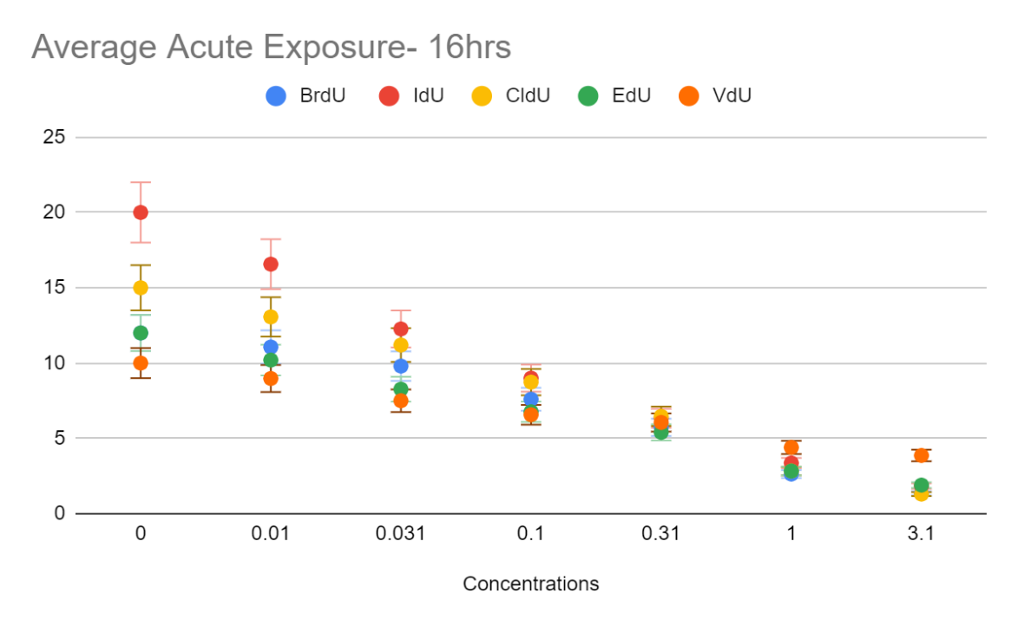
Figure 1: Acute Exposure of Nucleoside Analogs- After being treated with concentrations ranging from 0.01 uM to 3.1 uM it, the density of the cells was measured via their OD to indicate the effect of the analogs on growth rate.

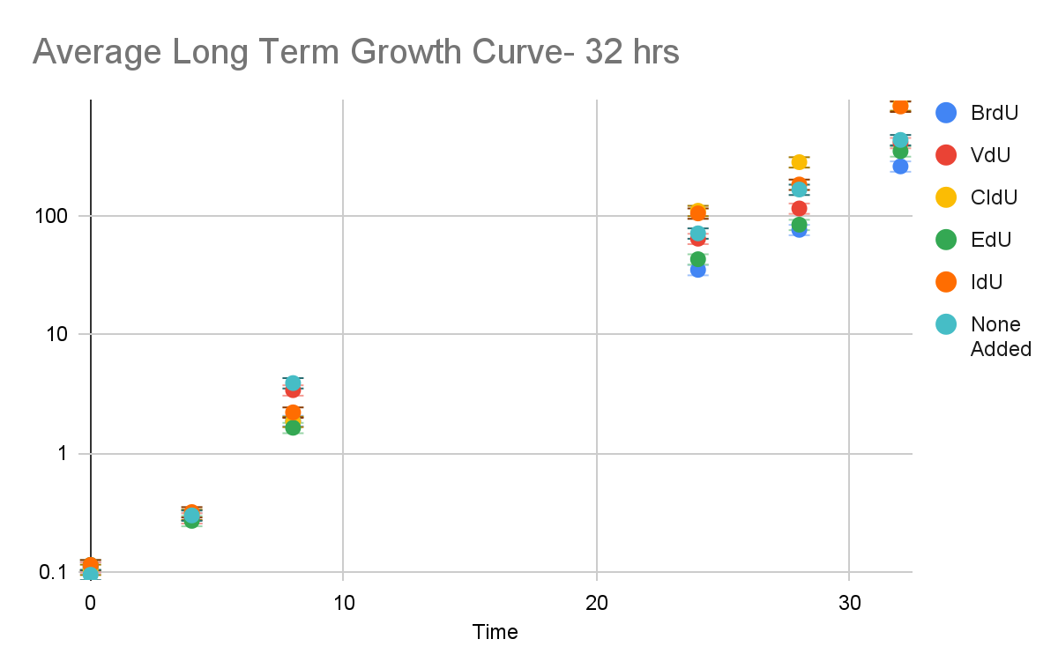

Figure 2: Long Term Exposure of Nucleoside Analogs: Over an extended period of time of 32 hrs, VdU was shown to have no negative effect on cell growth when compared to other analogs

Figure 3: Septation after Exposure of Nucleoside Analogs: After being treated with concentrations ranging from 0.01 uM to 3.1 uM, the morphology of the cells was accessed via their septation in order to determine toxic effect of the analog

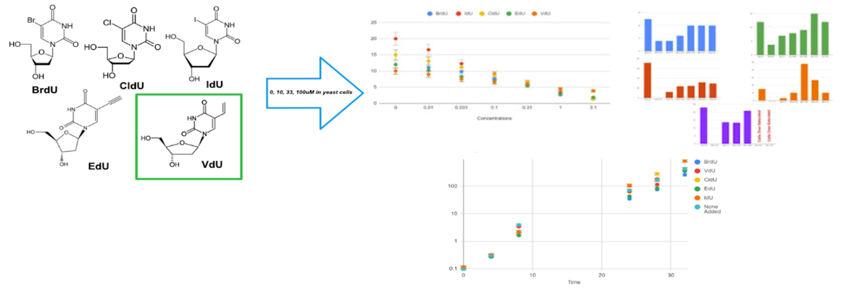

Figure 4: Yeast Toxicity Workflow- Panel A- Acute Exposure, Panel B- Septation, Panel C- Long Term Exposure. Yeast studies were first carried out to compare the compatibility of the nucleotide analog VdU, which had been previously indicated to be compatible, to other known analogs. Through acute testing, VdU demonstrated the same or less morphological impact on the yeast cells with increased septation. Through long-term testing, the same results were demonstrated. This indicated VdU was an acceptable candidate, as it was causing little to no toxic effect, but still showing signs of incorporation

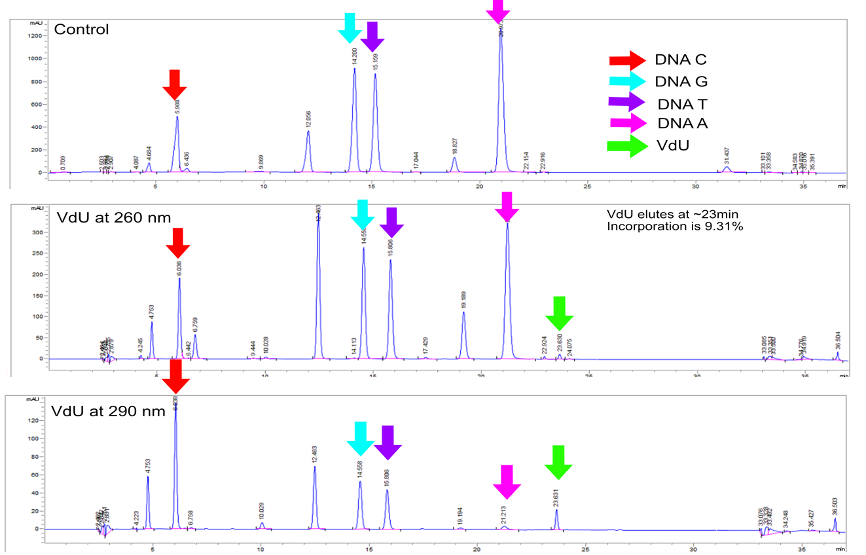

Figure 5: Incorporation of VdU Top to Bottom- Control, Vdu incorporated DNA at 260 nm, and VdU incorporated DNA at 290 nm. Through VdU standard, we have accessed that VdU elutes at approximately 23min during HPLC. When compared to unlabeled DNA, VdU clearly has become incorporated at this time point; as seen by the peak measured at 260 nm which increases in height at 292 nm (VdU optimal absorbance). Optimal VdU incorporation is found at 33uM after a 24hr incubation as seen in the figure.

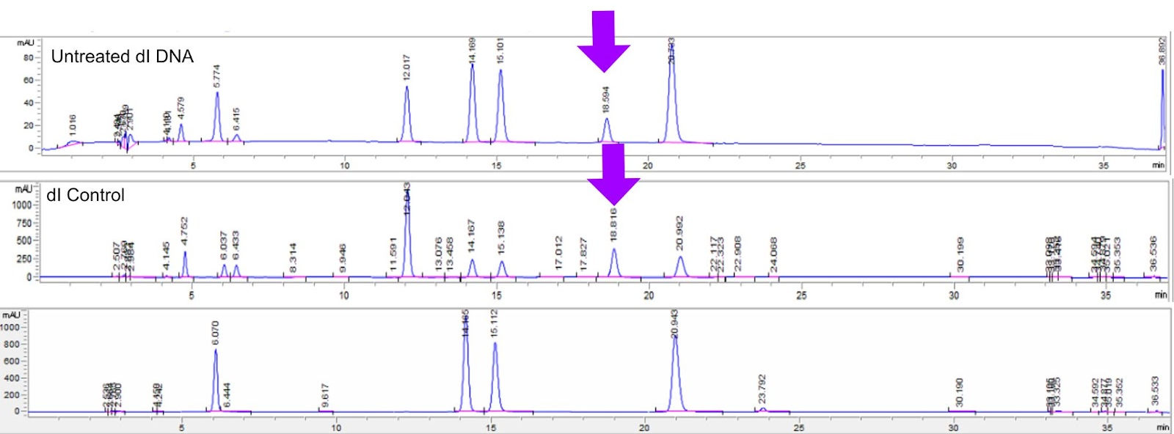

Figure 6: Incorporation of dI Top to Bottom- dI Incorporated DNA, dI Control, HeLa DNA Control. dI was shown to elute at around 18 minutes. Through comparisons with the controls, there was successful incorporation of dI in HeLa cells DNA, when treated with 33uM

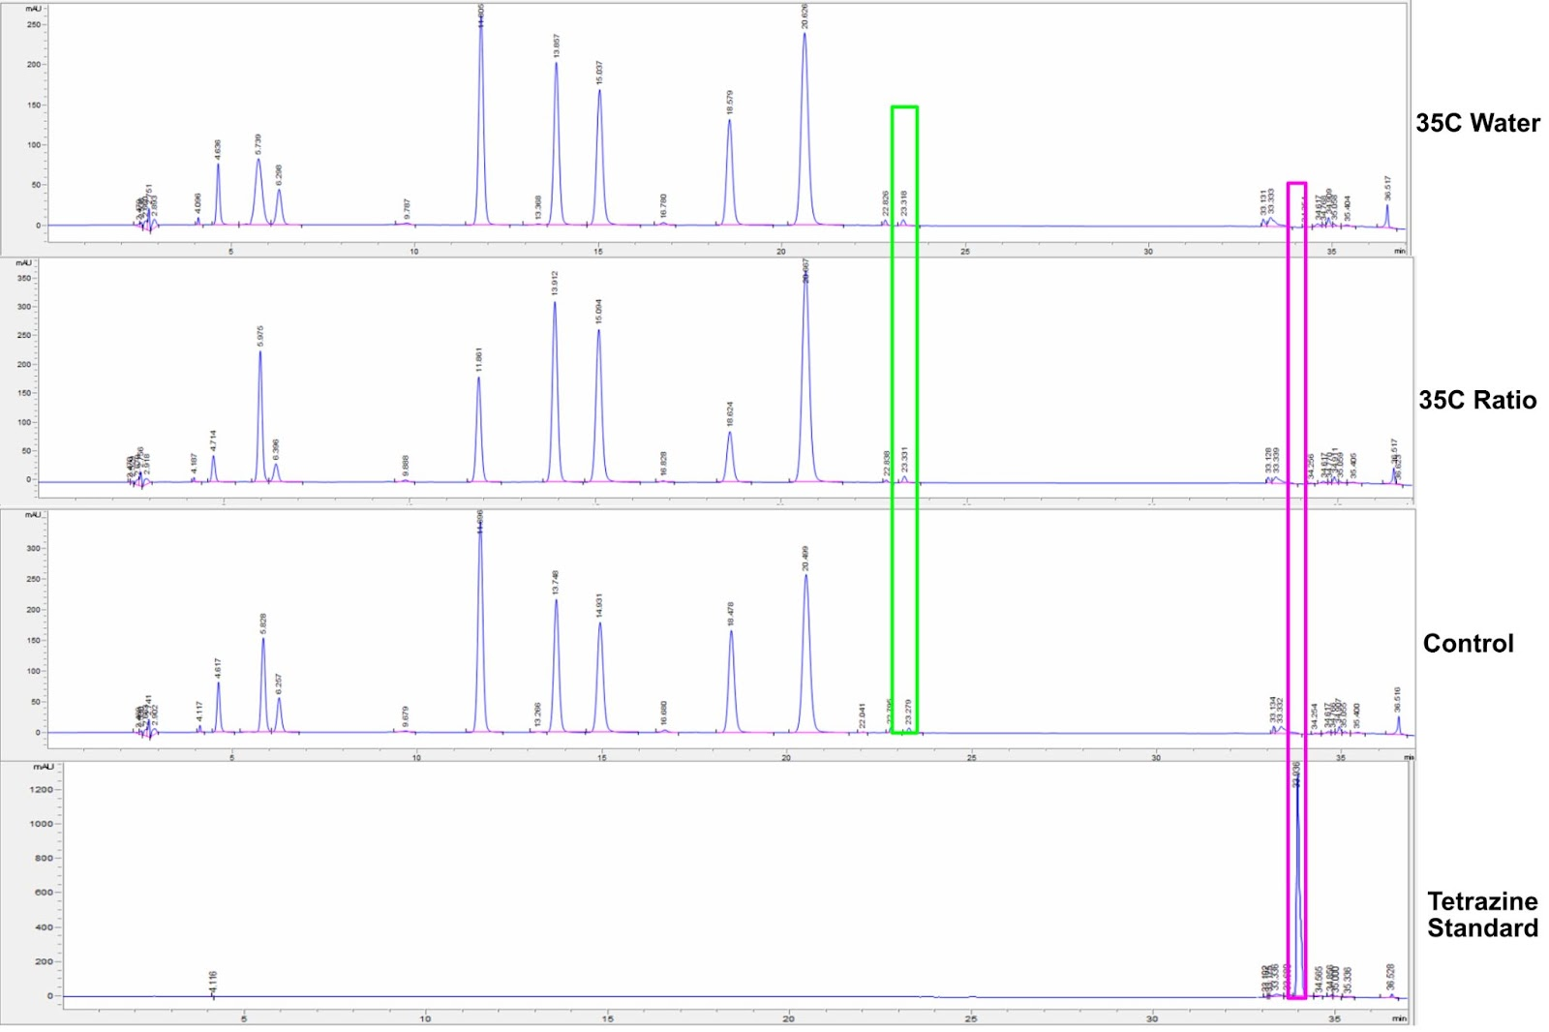

Figure 7: Tetrazine Samples Treated at 35- Measured on HPLC, Tetrazine indicated no signs of conjugation in the water samples and samples in 1:1 water to DMF

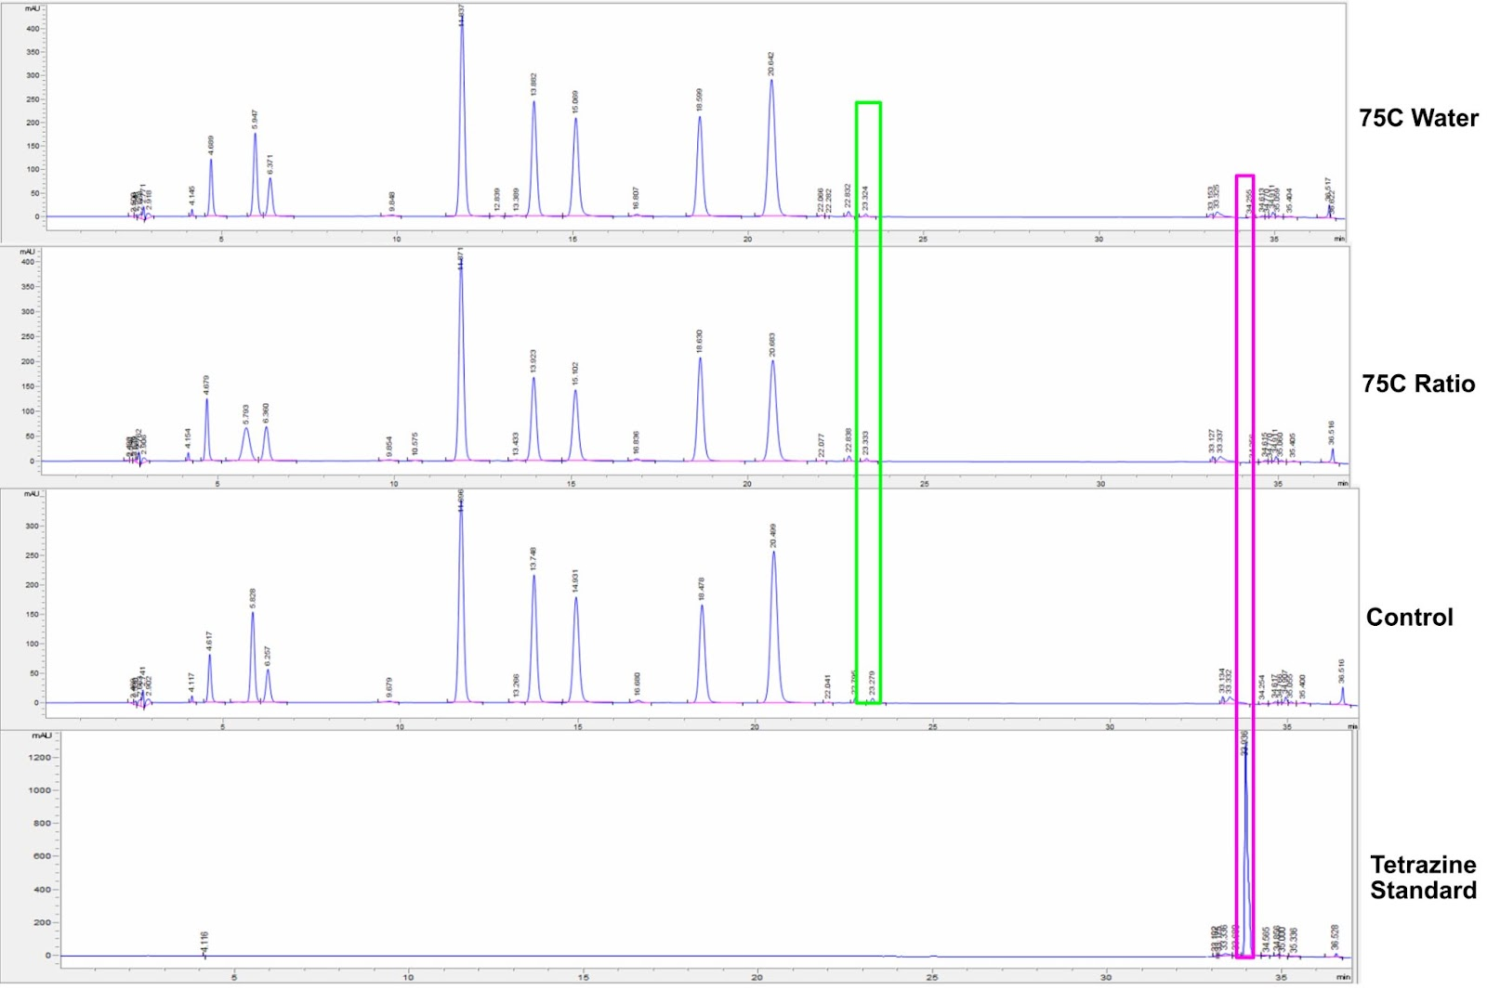

Figure 8: Tetrazine Samples Treated at 75- Measured on HPLC, Tetrazine indicated no signs of conjugation in the water samples and samples in 1:1 water to DMF

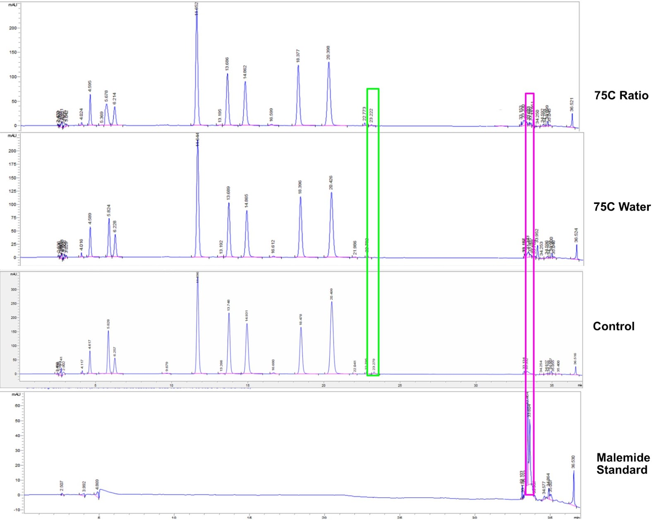

Figure 9: Maleimide Samples Treated at 75- Measured on HPLC, Maleimide indicated no signs of conjugation in the water samples and samples in 1:1 water to DMF

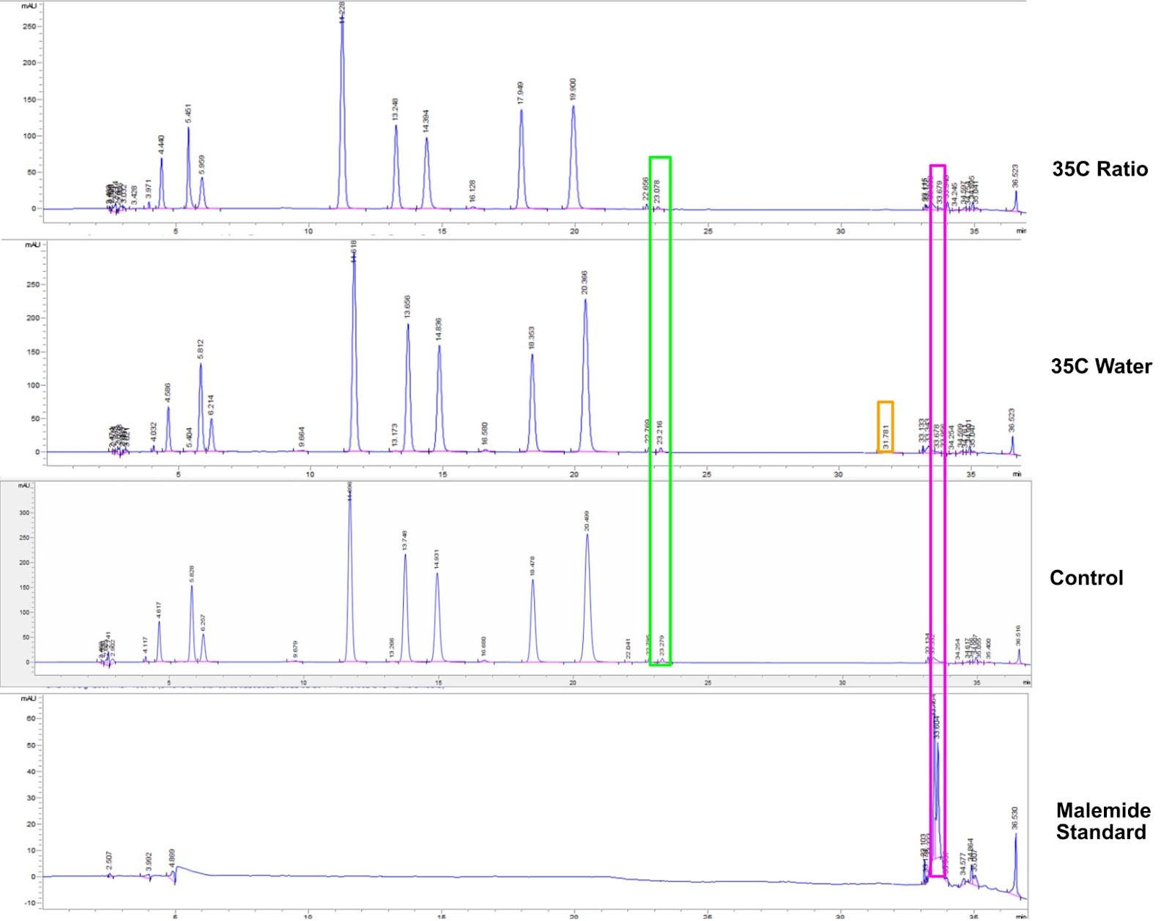

Figure 10: Maleimide Samples Treated at 35- Measured on HPLC, Maleimide indicated no signs of conjugation in the water samples and samples in 1:1 water to DMF

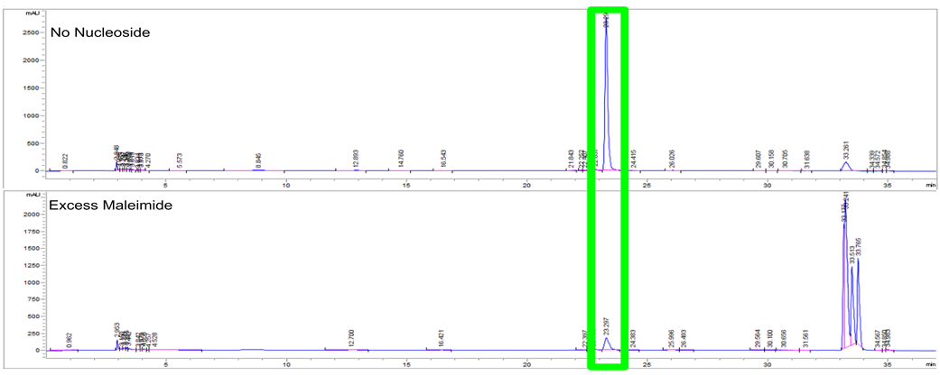

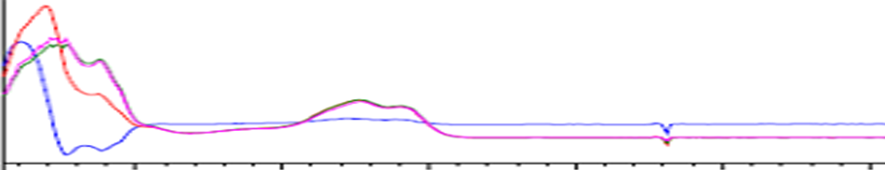

Figure 11: VdU Nucleoside Treated with Maleimide Top to Bottom- Control, Increased Maleimide in 1:1 DMSO. Stand-alone nucleotide VdU was demonstrated to have potential conjugation with FAM-Maleimide labels in 1:1 DMSO to water. FAM-Maleimide is demonstrated to elute at approximately 33 min and fluoresces at 450 nm (see spectra). Conjugation is indicated through a decreased height of peaks between controls, low concentration, and high concentration of FAM-Maleimide with the same concentration of VdU. Panel A: VdU with no maleimide added had a height of 2766.4 mAU. Panel B: VdU with 50 ul of Maleimide had a height of 354.7 mAU. Panel C: VdU with 75 ul of Maleimide had a height of 180.6 mAU. Overall Incorporation showed a maximum of a 93% decrease.

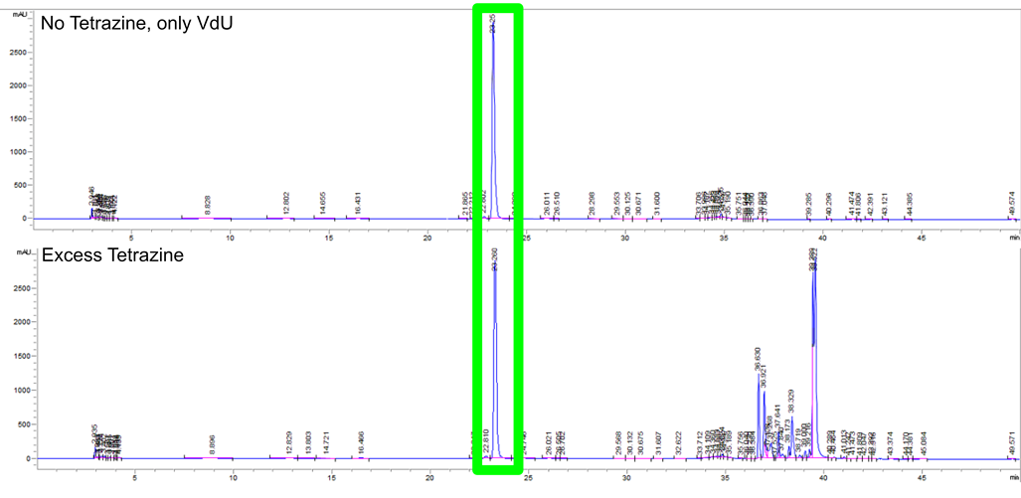
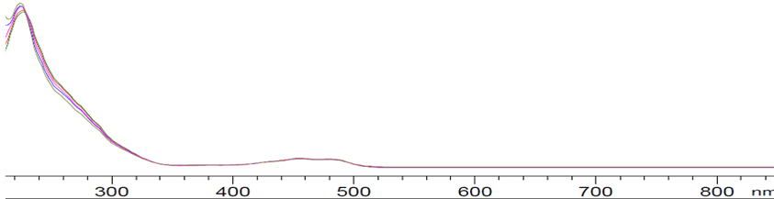

Figure 12: VdU Nucleoside Treated with Tetrazine Top to Bottom- Control, Increased Tetrazine in 1:1 DMSO. Stand-alone nucleotide VdU was demonstrated to have potential conjugation with excess Tamra-Tetrazine in 1:1 DMSO to water for approximately 36 min and fluoresces at 450 nm (see spectra). This conjugation was not as excessive as seen in maleimide due to less-intense fluorescence

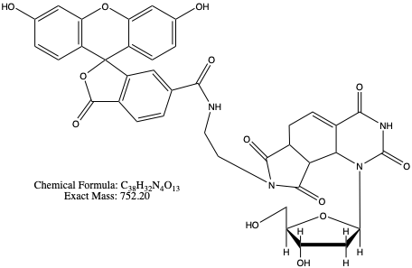

Figure 13: Proposed Maleimide DNA Conjugate Based on the equivalent maleimide reactivity towards RNA here, the proposed mechanism for how conjugates, DNA, and Fluorescent dye will look for mass spec analysis

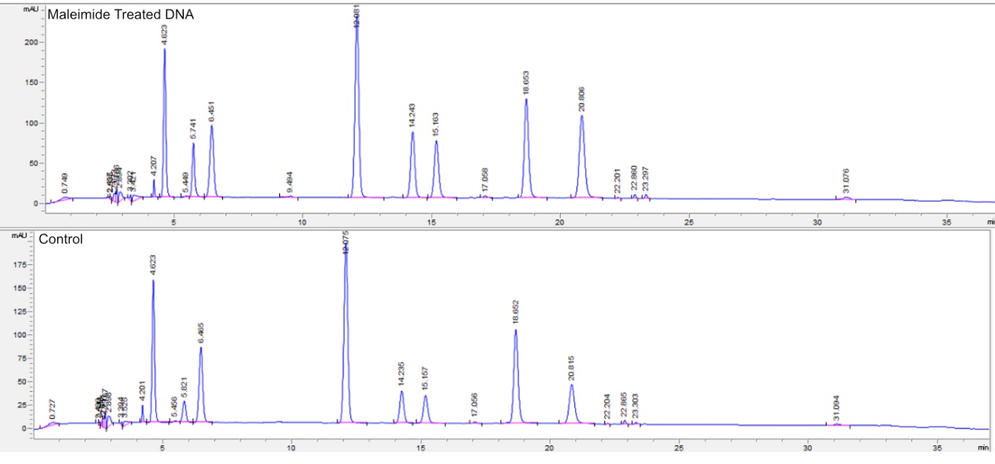

Figure 14: Maleimide Treated DNA in 1:1 Water to DMSO. DNA was treated with excess Maleimide 1:1 DMSO to water at 37C. No signs of fluorescence or conjugation as indicated with non-incorporated VdU nucleoside

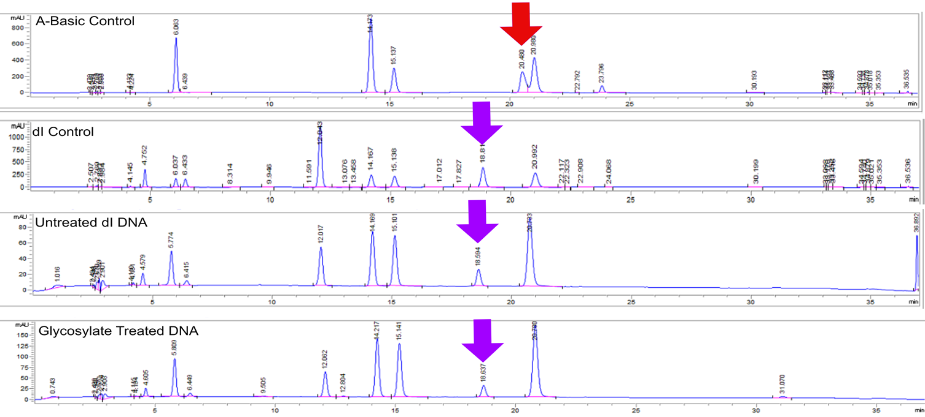

Figure 15: dI Glycosylase Treatment Top to Bottom- Abasic Control, dI Control, Un-Treated dI DNA, Glycosylase Treated DI DNA at Standard Conditions. The glycosylase used for this experiment is supposed to recognize non-natural nucleotides such as dI, removing the inosine to create an a-basic site. In both standard conditions and doubled glycosylase with increased incubation time, there was no distinct sign of the creation of an a-basic site.

References
Bianco, J. N., Poli, J., Saksouk, J., Bacal, J., Silva, M. J., Yoshida, K., Lin, Y.-L., Tourrière, H., Lengronne, A., & Pasero, P. (2012). Analysis of DNA replication profiles in budding yeast and mammalian cells using DNA combing. Methods, 57(2), 149–157. https://doi.org/10.1016/j.ymeth.2012.04.007
Czajkowsky, D. M., Liu, J., Hamlin, J. L., & Shao, Z. (2008). DNA combing reveals intrinsic temporal disorder in the replication of yeast chromosome vi. Journal of Molecular Biology, 375(1), 12-19. doi:10.1016/j.jmb.2007.10.046
De Carli, F., Menezes, N., Berrabah, W., Barbe, V., Genovesio, A., & Hyrien, O. (2018). High-throughput optical mapping of replicating DNA. Small Methods, 2(9), 1800146. https://doi.org/10.1002/smtd.201800146
Gerbi, S. (2015). Faculty opinions recommendation of dynamic molecular combing: Stretching the whole human genome for high-resolution studies. Faculty Opinions – Post-Publication Peer Review of the Biomedical Literature. https://doi.org/10.3410/f.723294149.793503167
Gueroui, Z., Place, C., Freyssingeas, E., & Berge, B. (2002). Observation by fluorescence microscopy of transcription on single combed DNA. Proceedings of the National Academy of Sciences, 99(9), 6005–6010. https://doi.org/10.1073/pnas.092561399
Hela. ATCC. (n.d.). Retrieved April 28, 2022, from https://www.atcc.org/products/ccl-2
Huberman, J. (2006). Faculty opinions recommendation of DNA replication origins fire stochastically in fission yeast. Faculty Opinions – Post-Publication Peer Review of the Biomedical Literature. doi:10.3410/f.1032463.374720
Jeffet, J., Margalit, S., Michaeli, Y., & Ebenstein, Y. (2021). Single-Molecule Optical Genome Mapping in nanochannels: Multidisciplinarity at the nanoscale. Essays in Biochemistry, 65(1), 51–66. https://doi.org/10.1042/ebc20200021
MacAlpine, D. M. (2021). Stochastic initiation of DNA replication across the human genome. Molecular Cell, 81(14), 2873-2874. doi:10.1016/j.molcel.2021.06.022
Oshige, M., Yamaguchi, K., Matsuura, S., Kurita, H., Mizuno, A., & Katsura, S. (2010). A new DNA combing method for biochemical analysis. Analytical Biochemistry, 400(1), 145-147. doi:10.1016/j.ab.2010.01.021
Patel, P. K., Department of Biochemistry and Molecular Pharmacology, Arcangioli, B., Unit, G. D., Baker, S. P., Services, D. of I., Bensimon, A., Unit, G. S., Rhind, N., Hua, H., & Froget, B. (2005, October 26). DNA replication origins fire stochastically in fission yeast. Molecular Biology of the Cell. Retrieved April 27, 2022, from https://www.molbiolcell.org/doi/10.1091/mbc.E05-07-0657
Rhind, N. (2006). DNA replication timing: Random thoughts about origin firing. Nature Cell Biology, 8(12), 1313-1316. doi:10.1038/ncb1206-1313
Rhind, N., & Gilbert, D. M. (2013). DNA replication timing. Cold Spring Harbor perspectives in biology, 5(8), a010132. https://doi.org/10.1101/cshperspect.a010132
Rhind, N., Yang, S., & Bechhoefer, J. (2009, November 19). Reconciling stochastic origin firing with defined replication timing. https://link.springer.com/article/10.1007%2Fs10577-009-9093-3
Schwob, E., Renty, C. de, Coulon, V., Gostan, T., Boyer, C., Camet-Gabut, L., & Amato, C. (2009). Use of DNA combing for studying DNA replication in vivo in yeast and mammalian cells. Methods in Molecular Biology, 673–687. https://doi.org/10.1007/978-1-60327-815-7_36
Sivakumar, S. (2004). In vivo labeling of fission yeast DNA with thymidine and thymidine analogs. Methods, 33(3), 213-219. doi:10.1016/j.ymeth.2003.11.01
Stockdale, F., & Holtzer, H. (1961). DNA synthesis and myogenesis. Experimental Cell Research, 24(3), 508-520. doi:10.1016/0014-4827(61)90450-5
Wang, W., Klein, K., Proesmans, K., Yang, H., Marchal, C., Zhu, X., . . . Rhind, N. (2020). Genome-wide mapping of human DNA replication by optical replication mapping supports a stochastic model of eukaryotic replication. doi:10.1101/2020.08.24.263459
Weitao Wang, Kyle Klein, Karel Proesmans, Hongbo Yang, ProfileClaire Marchal, D., Xiaopeng Zhu, Tyler Borrman, Alex Hastie, ProfileZhiping Weng,., ProfileJohn Bechhoefer,.Chun-Long Chen,., M. Gilbert,., & Nicholas Rhind,. (2021, June 21). Genome-wide mapping of human DNA replication by optical replication mapping supports a stochastic model of eukaryotic replication timing. Bionano Genomics. Retrieved April 28, 2022, from https://bionanogenomics.com/publications/genome-wide-mapping-of-human-dna-replication-by-optical-replication-mapping-supports-a-stochastic-model-of-eukaryotic-replication-timing/
Wikimedia Foundation. (2022, February 25). Origin of replication. Wikipedia. Retrieved April 27, 2022, from https://en.wikipedia.org/wiki/Origin_of_replication
Wilson, D. L., & Kool, E. T. (n.d.). Ultrafast oxime formation enables efficient fluorescence light-up measurement of DNA base excision. Journal of American Chemical Soceity. https://doi.org/10.1021/jacs.9b09812.s001

Part 2: Analysis of New York Hospitals

Author:

Silvana Reid, Chemistry and Biochemistry

Liza Hote, Chemistry and Biochemistry

Supervisors:

Professor Brenton Faber, PhD, Department of Humanities and Arts

Professor Yunus Telliel, PhD, Department of Humanities and Arts

Culture of Safety at WPI Biomedical Laboratories
At Worcester Polytechnic Institute, we are constantly being educated on the hazards associated with being a lab member and reminded to uphold these safety precautions. This involves lab members adhering to safety protocols including wearing protective personal equipment (PPE) both in academic and research laboratories. Considering the COVID-19 pandemic, we became markedly aware how important PPE, namely wearing face masks, is to protect yourself and those around you. The procedures we had to follow mimicked those often seen in hospitals. Such as doctors must care for their patients, we had to take on a new level of responsibilities for the people around us. Reflecting on our own experiences, we wanted to further explore how to create a culture of safety to instill this in our own lives.
The next piece of this research is focused on analyzing the culture of safety in rural New York hospitals. No previous works have been done to quantify and measure the culture of safety in these areas. In doing this, we hoped to gain further insight into the culture of safety which exists in other medical environments, so we can take away factors they use to apply this in daily life. Our project started with the hypothesis that if hospitals had a poor culture of safety among their staff and employees, then they would also have poor patient outcomes. Through this, we hoped to gain further insight into the patient doctor relationships and how hospitals maintain a culture of safety.

Abstract
Research laboratories are places where hypotheses get tested and ideas become reality. While labs are the center of cutting-edge science, they contain more hazards and risks than the regular workplace. No matter what research is being conducted, it is vital for any lab member to understand the hazards existing in the environment around them so that they don't put themselves, other lab members, and the research at risk. When completing our separate biochemistry Major Qualifying Projects at Worcester Polytechnic Institute and the University of Massachusetts Medical School were required to obtain training to protect ourselves from chemical, physical, and biological hazards. In relation to this, we explored the outcomes of weak and strong cultures of safety in individual institutions. We hypothesized that if there is a poor culture of safety in any institution, indicated by the number of occupational hazards, there would also be poor work results. Due to access to information, we analyzed New York hospital data in relation to compensation claims and patient outcomes, which were indicative of occupational and patient safety culture respectively. We then quantitatively correlated the hospital's patient safety grade with occupational hazards in the hospitals. By examining trends and using statistical analysis, we demonstrate that hospitals with better note-taking abilities or ‘measurement robustness,’ tend to have better patient outcomes. The results elucidate ‘you are what you measure,’ and organizations that put the effort into recording their practices, tend to have better work outcomes.

Chapter 1: Introduction
As biochemistry students, we are ingrained with extensive and repetitive training of how important laboratory safety is for both our protection and the overall success of our research. These training sessions cover biological, chemical, and physical hazards which include proper waste disposal and what proper protection equipment is required. However, other institutions may not have the same access or priorities to these kinds of training, and thus have less developed cultures of safety.

The impact that a poor culture of safety can have on employee lives can be seen in the Dupont Teflon crisis. Here, we see an extreme example of how massive corporations allow breaches of safety for their employees in a trade creating monetary gain and sustaining credibility. Every day employees went to their jobs unaware they were being exposed to toxic chemicals without the proper protective equipment. Hundreds of people's lives were immensely negatively impacted, while Dupont's upper management was acutely aware of the issues but did nothing to prevent it. Similar incidents are found in medical environments, where there are constant reports of a lack of personal protective equipment for medical staff. This was exceptionally seen during the COVID-19 pandemic when many hospital staff went on strike to protest budget reductions that hospital management made which directly affected the well-being of their lives. Other incidents were reported before the pandemic, such as nurses having increased spontaneous abortions through unknowingly being exposed to certain toxic chemicals.

In our research on culture of safety, we were unable to find studies that quantitatively assessed culture of safety in any capacity in hospital settings. As life science students, we found this troubling, as we felt that assigning numerical values to certain culture of safety factors would allow comparison and identification of gaps in safety standards, especially in a clinical environment. Through our examination of New York Hospitals, we quantitatively assessed whether a poor culture of safety is linked to poor patient outcomes. We hypothesized that increased occupational hazards would lead to a worse patient outcome.

To quantify the culture of safety, we created a data set in two steps. The number of occupational hazards was determined from the NYS Assembled Workers compensation claims dataset. Hospitals don’t often publicly publish any information informing occupational hazards at their institutions. Therefore, we summed the number of occupational hazards by zip code that was self-reported. In tandem with this, we assessed patient outcomes, used the Medicare website, and independently developed a criterion to rank the New York hospitals. The grading criteria were designed to encompass multiple patient outcomes to common procedures to be able to compare hospitals with ease. Using these two datasets in conjunction with other standardization metrics, we proceeded to analyze the numerical values assigned. We determined if there was a correlation between the quality of patient care and the culture of safety for healthcare workers. Based on the results, we identified indicators and causation factors of a poor culture of safety.

Chapter 2: Literature Review

Section 2.1: What is an Occupational Hazard?
Occupational Safety and Health Administration (OSHA) defines an occupational hazard as a risk associated with working in a specific occupation (Department of Labor, 2022). These risks are classified as either long-term, where they directly cause stressors to the body, or short-term, where they cause emotional stress. Both short-term and long-term occupational hazards can directly affect the workplace environment through a decrease in physical and emotional safety. Hazards can be separated into four separate categories: physical, chemical, biological, and ergonomic risk factors. Each of these categories causes varying degrees of long- and short-term impacts, with a large influence stemming from human factors. (Department of Labor, 2022). Human factors are defined by the World Health Organization as “individual characteristics which influence behavior at work in a way which can affect health and safety” such as daily tasks, working environment, policies, and attitudes. Workplace environments that do not properly monitor occupational hazards and allow for an unsafe work environment have proven to have significant negative impacts on the culture of safety and cause detriments to the lives of workers both in and out of the workplace (Department of Labor, 2022). The focus of our project was to assess these culture of safety violations and determine how occupational hazards were interconnected.

Section 2.1.1: DuPont-Making a Toxic Product
Investigating case-studies regarding violations of safety culture helps build an understanding of how and why they occur. Violations of culture of safety due to occupational hazards can notably be seen in the DuPont lawsuit. In 2017, DuPont agreed to pay approximately 617$ million to settle thousands of lawsuits brought against them in relation to their product, Teflon, which was responsible for the widespread intoxication of C8 (Rich 2016). C8 is the common term for Perfluorooctanoic which is per fluorinated carboxylic acid produced and used worldwide as an industrial surfactant in chemical processes and as a material feedstock. Widespread intoxication is a concern because in 2012, after seven years of study, a panel of public health experts released a report documenting a probable link between C8 and six conditions: testicular cancer, kidney cancer, thyroid disease, ulcerative colitis, pregnancy-induced hypertension, and high cholesterol (Sisk 2021). According to a 2007 study, C8 is in the blood of 99.7% Americans, earning the name the ‘forever chemical’ since it never degrades. Further studies have identified that a majority of the C8 found in the systems of Americans is from Teflon products, such as their non-stick pans (Sisk, 2021).

On record, previous female Dupont employees reported being moved to different departments unexpectedly when they became pregnant. From this group, a percentage of the children born to these employees had physical deformities and demonstrated elevated C8 in their systems. In addition, many of the workers who were exposed to C8 for extended periods of time developed rare forms of cancer directly linked to C8 intoxication. It was discovered that DuPont had been aware since at least the 1960s that C8 was toxic in animals and since the 1970s that there were high concentrations of it in the blood of its factory workers. DuPont scientists were aware in the early 1990s of links to cancerous tumors from C8 exposure, however, company executives failed to inform the Environmental Protection Agency [EPA] or the public (Sisk, 2021) (Rich, 2016).
Due to failed management and lack of transparency, Dupont created an unsafe workplace environment which affected not only their employees' lives, but also their families and the surrounding town area. Lack of proper chemical management led to the development of increased cancer risk as well as birth defects; casualties could have been avoided if management had investigated and created proper safety protocols to decrease exposure to their employees. Dupont exemplifies what a poor culture of safety can cause: an increase in both long- and short-term occupational hazards. This, in turn, has resounding impacts on their employees' lives.

Section 2.1.2: Hazards in the Hospital Environment: Hospital Personnel at Risk
Our study looked directly at the culture of safety in a hospital environment. To do this, we must understand the work environment that exists for clinicians and other hospital personnel. Hospital personnel and staff are exposed daily to various types of occupational hazards such as physical and chemical dangers, radiation, infectious risks, and psychosocial problems prevalent in hospitals (Jachuck et al, 1989) (CEB, 1985). Exposure to toxic chemicals encompasses a wide distribution of hazards since they can range from minor skin irritation to possible carcinogenic (CEB, 1985).

As mentioned previously, nurses face a wide range of workplace hazards including dangerous chemicals and drugs. They also face sharp injuries, back injuries, violence, and stress. Despite consistently being exposed to hazards, nurses and related medical personnel consistently face the lack of personal protection equipment (PPE). During the COVID-19 pandemic, nurses reported a deficiency in face shields and masks. Lack of available PPE puts nurses in direct danger, both from viral infections such as COVID-19 and other hazards found in the workplace (Cohen et al, 2020). Failure to provide this PPE not only puts nurses, but the entirety of the healthcare system at risk as it decreases the effectiveness of caregivers.

Both viral and chemical exposures have been demonstrated to have an impact on the personal lives of nurses. Usage of chemicals such as anesthetic gas is an extremely common procedure, however, without proper PPE can cause harm to the nurses administering it. Female nurses have participated in studies to determine the effects of an antineoplastic drug exposure on birthing rates (Lawson 2013). Out of the 6707 live births included in the study, 775 reported spontaneous abortions 20 weeks before the due date. When factors such as age, parity, shift work, and hours worked were included, it was determined that excessive exposure with antineoplastic drug was associated with a 2-fold increased risk of spontaneous abortion, particularly with early spontaneous abortion before the 12th week, and 3.5-fold increased risk among nulliparous women (Triolo 1989). In addition, nurses who were exposed to sterilizing agents, such as steam autoclaves, demonstrated a 2-fold increase in late spontaneous abortion (12-20 weeks). Irregular births in nurses due to exposure causes concerns for the occupational safety of them, but also for the safety of the patients they attend to. Decreased occupational safety may be correlated to worse patient care outcomes which may be reflective of the deficient culture of safety within the facility (Fleisher 2022).

Section 2.1.3: Preventative Measures
Most hospitals have an employee health service available to their employees to prevent hazards such as chemical exposure. However, many lack professional training to handle job-related risks and assessing appropriate preventive measures (CEB 1985). To combat this, some states have also passed “right-to-know" laws which require worker education about hazards in their work environment to increase knowledge and decrease accidents. The COVID-19 pandemic actively highlighted declining factors of US health care safety and the lack of resilience in safety culture infrastructure. Consistently, health care workers lacked sufficient materials to safely work in medical settings. Occurrences such as this call into question the maintenance of worker safety and the overall cultural safety of medical environments today (ECRI 2019).

Section 2.2: Culture of Safety in Health Care Systems
A culture of safety is defined as the attitudes and behaviors of the group and individuals toward patient safety within a healthcare facility. A culture of safety can most readily be observed through policy and leadership (ECRI, 2019, 10). Most of the time, a culture of safety is a reference to the relationship between the patient and the medical community made up of doctors, nurses, and other staff. When a patient is taken into care, an entire healthcare team is responsible for patient safety and must work together to ensure patients' well-being during treatment. A key component of ensuring patient safety is to document patient safety outcomes, including adverse events (Han Y et al., 2020). This touches upon another aspect of culture of safety: the ability of an organization to measure, recognize, and correct misidentifications, misspecifications, and misunderstandings that pose threats to safety (Vogus et al 2010). When conducting our research on the notion of ‘culture of safety', we focused on the quantitative portion of the definition: the ability of an organization to measure its patients' outcomes.

Section 2.2.1: Patient Impact
It has previously been shown that an established culture of safety leads to a reduction of adverse events as it pertains to patient safety (Han Y et al., 2020). This has been measured in a variety of dimensions including reduced infection rates, fewer readmissions, better surgical outcomes, reduced adverse events, and decreased mortality (ECRI, 2019, 10). In a 2020 study, researchers Han Yonghee, Kim Ji-Su, and Seo YeJi found and published in the Western Journal of Nursing Research that higher mean scores for “communication openness” in patient safety culture were significantly correlated with lower rates for pressure ulcers and falls. Additionally, higher mean scores for “working in teams with other health professionals” in patient safety competency were significantly correlated with reductions in ventilator-associated pneumonia (Han et al., 2020).

While we assume there may be multiple factors involved, we have come to assume that fewer poor patient outcomes demonstrate a greater culture of safety. The quality health care would not be able to be delivered if there is a poor culture of safety, because the employees themselves would not be safe. Several strategies (Weaver et al, 2013) have been used to try to create an improved culture of safety, such as bundling multiple interventions or tools that employees can use as a resource to improve the safety culture. Accreditation bodies identify leadership standards for safety culture measurement and improvement (Guldenmund, 2000).

Section 2.3: Culture of Safety Process Improvement
Cultures of safety are directly impacted by strong leadership committed to ensuring safety practices within the organization. This can look a variety of ways: leaders should encourage employees to “learn about errors and near misses, investigate errors and near misses, investigate errors to understand their causes, develop strategies to prevent error recurrence, and share the lessons learned with staff so they recognize the value of reporting their concerns''(ECRI, 2019, 10). One specific aspect of these action recommendations is “reporting their concerns.” Creating an environment where employees can report allows mistakes to be caught earlier and thus improved at the facility level.

Section 4.3.1: Barriers to Process Improvement
To improve incident reporting, especially among doctors, clarification is needed of which incidents should be reported to increase simplification and feedback given to reports. An example of this can be seen in a qualitative study of OHS risks and preventative measures which was conducted with a sample of Australian small business to better understand the occupational health and safety of the construction industry. Thou They selected both immediate consequences (such as fall risks) and long-term consequences/health effects (such as skin disease) as analytical factors. Through this, they found that most employees see occupational injury as an unavoidable aspect of their careers (Lingard 2022). In work settings, workers often feel barriers extend to the individual, whereas a lot of the failures are the result of poor management and access to resources. Additionally, the dualism of physical barriers occupational hazards, but also social barriers, such as group mindset and ostracization. Such barriers can be products of strategic organizational rhetoric and cultural discourse such as coalition formation (Lingard, 2022) (Zoller, 2009) (da Silva, 2019).

Chapter 3: Research Design
Our research was aimed at determining if there was a positive correlation between a culture of safety in the workplace and patient outcomes. This hypothesis can be examined two-fold: occupational hazards and patient outcomes. Patient outcomes were determined using the Medicare website and an independently developed quantitative measurement called “safety grade.” This encompasses the ratings each hospital received in common patient procedures. The common patient procedures included the rate of complications of knee/hip replacement patients, serious complications, and death among patients with serious treatable complications after surgery. This data set ultimately served to measure the patient outcomes in selected hospitals in New York. The second part of the research was to examine the culture of safety through the lens of occupational hazards. The number of occupational hazards was calculated from the New York compensation claims to determine how many injuries occurred in these hospitals. Once this was done, the hospital and occupational hazard data sets were combined via zip codes to determine which hospitals had the most or least occupational hazard claims. At the end, we combined both research paths to assess overall relationships between a culture of safety and patient outcomes.

Section 3.1: Analysis of Patient Outcomes

Section 3.1.1: Rating Hospitals-Safety Grade and Data Robustness
We used the Medicare website to collect data about the patient outcomes in New York hospitals (Medicare.gov, 2022). As seen in Figure 1, the Medicare website offers several resources with the goal of informing patients and health care providers about different health and drug plans. We narrowed down the number of hospitals by only looking at emergency services (hospitals that provide emergency services like acute medical or trauma care) and hospital type (acute care) (ECRI, 2019, 10). Once we found this list of hospitals, we devised a rating criterion based on the national rating system the website provided (Table 1) This was done by clicking the hospitals, then clicking the “complications and deaths,” tab and rating them based on pre-decided ratings that are based on the national averages seen in Table 1. The specific definitions of the items in the rating column can be found in Appendix B.

Once we developed the safety grade criterion, we developed our process of grading the NY hospitals. Figure 1 demonstrates the interface once the hospitals were filtered by both “Emergency Services,” and “Acute Care.”
Figure 1: Excerpt from the Medicare website already filtered by hospitals that provide emergency services and acute care.

After filtering the Medicare website, we found 135 hospitals to grade. The hospitals were rated as being above average, or below average. There were also fields: “no reported data,” or “not enough data available”; Examples of these fields are shown in Figure 2. When the field “number of cases too small,” appeared we first rated the hospital negatively. Upon further investigation, this grade was excluded from analysis because we did not want to bias and exclude smaller hospitals that may have less resources to record but could still have good patient outcomes.

Figure 2: Website interface process to access the common patient rating

The next step was to create a comprehensive Microsoft Excel sheet with the hospitals, zip codes, and grades. The Microsoft Excel sheets were color-coded to stay organized and have a firm understanding of which hospitals were graded higher versus lower to identify outliers or any missing fields. To analyze the quality of the hospitals recorded data, we developed a metric termed data robustness. This was a qualitative measurement of the hospital’s capacity to report their data. It was identified by the number of Medicare categories for which the hospital reports complete data. As mentioned, this field became “data robustness” and was scored 0-6. Hospitals with fully reported data (positive or negative) were scored 4-6 while hospitals with missing and incomplete data were scored lower 0-2. This enabled us to compare quality scores against the robustness of each hospital’s reporting system. Although studies have been done to examine patient safety practices, none have attempted to quantitively assess patient outcomes and occupational hazards to inform culture of safety. As a result, we independently developed the data sets based off what was directly available for the public online.

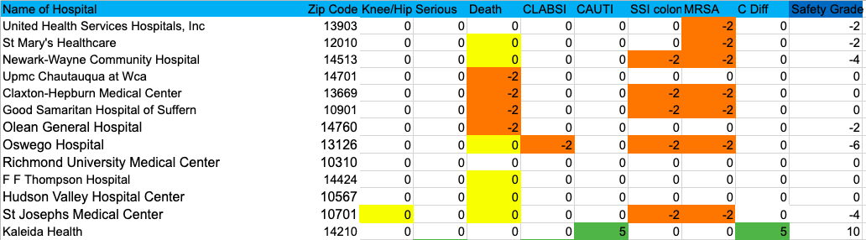
Figure 3: An excerpt from Microsoft Excel recording the New York hospitals, their respective zip codes, and grades from the common procedures.

Section 3.2: Determining Culture of Safety Through Occupational Hazards
We used the NYS Assembled Workers Compensation claims data set to determine the number of occupational hazards in NY hospitals (York, 2021). The NYS assembled workers' compensation claims developed by the Workers’ Compensation board (WCB) provides data on worker’s compensation, disability, volunteer firefighters’, volunteer ambulance workers’, and volunteer civil defense worker’s benefits. The WCB uses this data to ensure employer compliance and regulates different stakeholders involved including self-insured employers, medical providers, and third-party administrators. The WCB determines claims of workplace injury by injuries that cause a worker to lose more than one week of work, or permanent disability. WCB also includes injuries disputed by the employer, or when they receive a C-3 Form (claim from the injured worker). Although this data set included many fields not related to healthcare providers, we filtered it to only investigate claims recorded under the healthcare field. The process of connecting hospitals to occupational injury count can be seen in Figure 4. By the end of this process, there were 25 hospitals studied.

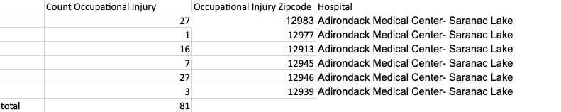Figure 4: Excerpt from the process of counting the occupational zip code count in a 10-mile radius of Adirondack Medical Center-Saranac Lake

Section 3.3: Correlation Factors Between Occupational and Patient Safety

Section 3.3.1: Zip codes
To combine the hospital and the occupational injury data sets, we found the zip codes within a ten-mile radius for the hospitals and matched them with the occupational hazards that occurred at those specific zip codes. We used a zip code query to find these zip codes (Qi, 2019). We counted the number of occupational claims in those zip codes within a 10-mile radius of the hospitals. It should be noted that during this portion of our research, we had excluded hospitals in major cities, New York City, Buffalo, Rochester, and Albany due inability to accurately determine which occupational injury corresponded to which hospital due to zip code overlap.

Section 3.3.2: Population
Hospital size depends on the number of beds but is also impacted by the geographical location. To address this issue and enable accurate hospital comparison, we standardized their size based on the population where the hospitals are respectively located. This was done from a simple Google search to determine population size in each zip code.

Section 3.3.3: Number of Beds
The American Hospital Directory was the source utilized to identify the number of beds in the hospitals. The American Hospital Directory provides “data, statistics, and analytics about more than 7,000 hospitals nationwide” (American Hospital Directory, 2022). The number of beds, as seen in the “staffed beds” field in Figure 5, was employed to standardize injury counts, given that it allowed us to determine the size of hospitals.

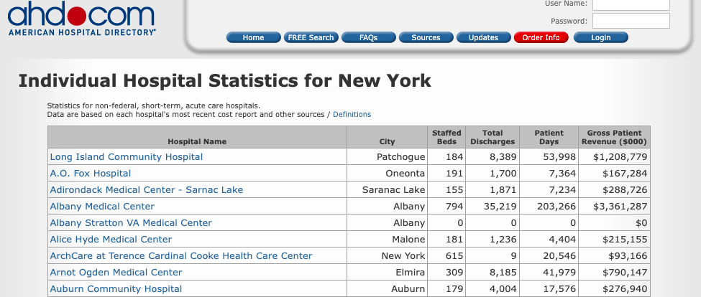Figure 5: Excerpt from the American Hospital Directory

Section 3.3.4: Statistical Analysis
Before beginning our statistical analysis, we first standardized our data set to decrease data errors or variance. This was largely through eliminating hospitals in high-metropolitan areas, since we could not accurately determine which occupational injuries correlated to which hospital accurately due to the proximity of the hospitals. We then used python to create a code which looked for correlation between our data sets.

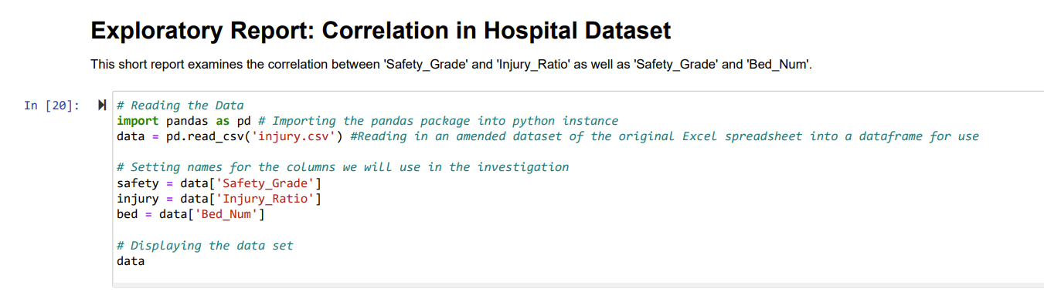
Figure 6: Code used for statistical analysis to indicate correlation

Section 3.4: Limitations
There are a few limitations to our approach to studying the culture of safety at New York Hospitals. To begin with, the culture of safety as a concept is an extremely complex and dynamic one that is difficult to measure. We decided to use patient outcomes to decipher it, but this excluded many aspects like policies or leadership that these hospitals may have but are not seen within the provided Medicare website metrics. Furthermore, all our data is online information with little context provided. We assumed the definitions of the columns in the NY workers compensation claims website. Next, we assumed that people who live in a 10-mile radius of the hospital would go to those specific hospitals.

Chapter 4: Results
We were unable to confirm our hypothesis that patient safety and occupational hazards were positively correlated. Figure 6 demonstrates bed/injury/population versus safety grade. The y-axis demonstrates the injury count standardized by the number of beds and the population in the given zip codes of the hospitals. This is a standardized metric enabling direct comparison between all the hospitals. If these standardizations did not occur, then larger hospitals would be compared with smaller hospitals, and conclusions would not be able to be made. The x-axis demonstrates the patient safety grade. The metric reflects the patient safety practices among the 25 hospitals studied using the grading described in Table 1. The graph demonstrates that their relationship is horizontal, meaning that there is no change or no correlation.

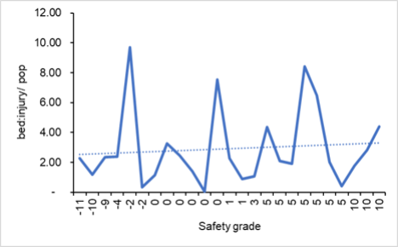
Figure 6: Comparison of safety grade to occupational injuries- Due to lack of positive slope we can determine there is no correlation between safety grade and injury count, our hypothesis was not proven.

While we were unable to find a positive correlation between patient safety and occupational hazard count, we identified a positive correlation between patient safety and the hospital size. Figure 7 has the safety grade on the y-axis while the number of beds is on the x-axis to demonstrate their correlation. The positive relation between these two variables was found to be statistically significant. These values, through the code demonstrated in Figure 8, had a strong correlation.

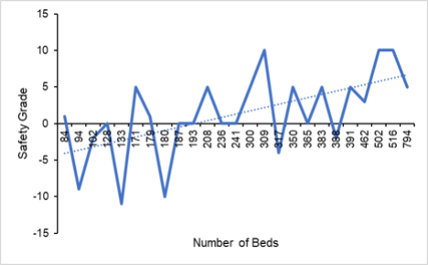

Figure 7: Safety grade is positively correlated with the sizes of the NY hospitals. As the number of beds in the NY hospitals increases, the safety grade increases as well. In other words, the larger the hospitals are, the better patient outcomes they tend to have. This was a statistically significant finding.

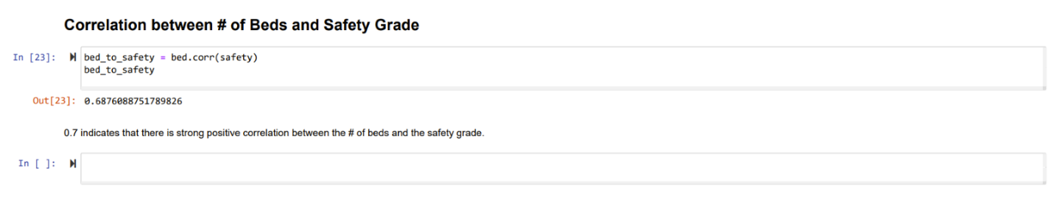Figure 8: Code used to determine correlation of initial factors. A strong correlation was indicated between the number of beds and the safety grade determined from the Medicare website

In comparison, Figure 9 demonstrates safety grade versus robustness, a variable that is indicative of the hospital's quality of reporting data. This illustrates a positive correlation between the two suggesting that the better safety practices a hospital has, note-taking, policy, or strong leadership as examples, then the better patient outcomes they will have. More specifically, based on data robustness, hospitals which reported their patient outcomes were more likely to have less occupational accidents. Together, this suggests that larger hospitals were more likely to report data, indicating a developed culture of safety.

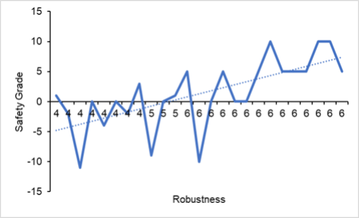
Figure 9: Patient outcomes become better with improved safety practices. Safety grade versus robustness elucidates a positive correlation. This means that as robustness, or the ability of hospitals to report their data, improves, then their safety grade improves as well.

Chapter 5: Discussion
The focus of this project was to establish whether there was a relationship between the culture of safety within the workplace and overall patient safety. Through a two-step approach, we created a dataset that represents both the occupational safety, as well as patient safety of hospitals located in New York state. From there, we were able to paint a picture of the safety culture of each hospital, allowing a comparison between their occupational and patient safety.
Overall, we found that our hypothesis was unable to be proven based on the data we collected. Based on the data sets, there was no direct correlation between patient and occupational safety, however, we found a correlation between the culture of safety and hospital size. There was a positive correlation between the hospital size and patient safety.

When standardized, we found that hospitals that reported their data were more likely to have been more likely increased safety grades. In the Medicare data that the patient outcomes were based on, some of the values did not contain records of patient outcomes indicating hospitals were not reporting on common procedures. This was indicative that increased quality of safety in hospital work environments is directly correlated to the hospital's quality of reporting their quality of patient care. Essentially, if hospitals put more emphasis on reporting their data, they are more likely to have an increased culture of safety. Plausible explanations as to why this could be occurring in some hospitals and not others could be access to monetary resources, effective management, and increased worker interactions. These factors were not included in our data set, as they are qualitative factors, and our study focused mainly on quantitatively accessing a culture of safety. Despite not being included in our studies, these qualitative factors are very likely to be impacting safety scores as they also make a significant impact. Overall, our data was indicative that larger hospitals were more likely to report data on patient care, which was ultimately correlated to a higher level of safety in these institutions.

Further research can be focused on understanding why this occurrence occurs. Previous studies, such as ones done by the ECRI, have indicated how to create an effective culture of safety, as well as policies that can be put in place to improve it. To determine what factors are decreasing the culture of safety in smaller hospitals and increasing it in larger hospitals, further research can compare qualitative factors, such as policies or access to resources, to determine correlation. From there, further recommendations can be created to help increase culture of safety, with a focus increasing a culture of safety in small hospitals and maintaining them in larger hospitals. In terms of our own research, the lessons learned from assessing the culture of safety in hospital environments can also be applied to laboratory environments. As biochemistry students who work consistently in research laboratories, understanding how to create an effective culture of safety is important for maintaining both our safety, the safety of others, and success in our research endeavors. Maintaining a culture of safety in a laboratory environment is like that of a medical environment. It’s important to provide a quantitative assessment of accidents that occur and identify sources of occupational hazards. In doing so, one can maintain a culture of safety, ensuring the quality of life for researchers and overall research. Taken together, “you are what you measure,” is the main takeaway and one to bring in all future workplace environments.

References

American Hospital Directory - Individual Hospital statistics for New York. (n.d.). Retrieved April 26, 2022, from https://www.ahd.com/states/hospital_NY.html
C E B. (1985). Occupational hazards to hospital personnel. Journal of Occupational and Environmental Medicine, 27(11), 850. https://doi.org/10.1097/00043764-198511000-00021
da Silva, S. L., & Amaral, F. G. (2019). Critical factors of success and barriers to the implementation of occupational health and Safety Management Systems: A systematic review of literature. Safety Science, 117, 123–132. https://doi.org/10.1016/j.ssci.2019.03.026
Department of Labor Logo United States department of Labor. Safety Management - Hazard Identification and Assessment | Occupational Safety and Health Administration. (n.d.). Retrieved April 20, 2022, from https://www.osha.gov/safety-management/hazard-Identification
ECRI. Culture of safety: an overview. Health Syst Risk Manage 2019 Jun 14.
Fleisher, L. A., Schreiber, M., Cardo, D., & Srinivasan, A. (2022). Health Care Safety during the pandemic and beyond — building a system that ensures resilience. New England Journal of Medicine, 386(7), 609–611. https://doi.org/10.1056/nejmp2118285
Guldenmund, F. W. (2000). The nature of safety culture: A review of theory and research. Safety Science, 34(1-3), 215–257. https://doi.org/10.1016/s0925-7535(00)00014-x
Han, Y., Kim, J.-S., & Seo, Y. (2020). Cross-Sectional Study on Patient Safety Culture, Patient Safetyb Competency, and Adverse Events. Western Journal of Nursing Research, 42(1), 32–40. https://doi.org/10.1177/0193945919838990
Jachuck, S. J., Bound, C. L., Steel, J., & Blain, P. G. (1989, July 1). Occupational hazard in hospital staff exposed to 2 per cent glutaraldehyde in an Endoscopy Unit. OUP Academic. Retrieved April 20, 2022, from https://academic.oup.com/occmed/article-abstract/39/2/69/1355873

Lawson, C. C., Rocheleau, C. M., Whelan, E. A., Lividoti Hibert, E. N., Grajewski, B., Spiegelman, D., & Rich-Edwards, J. W. (2013). Occupational exposures among nurses and risk of spontaneous abortion. Obstetric Anesthesia Digest, 33(1), 36–37. https://doi.org/10.1097/01.aoa.0000426099.31929.92
Lingard, H., & Holmes, N. (n.d.). Understandings of occupational health and safety risk control in small business construction firms: Barriers to implementing technological controls. Taylor & Francis. Retrieved April 20, 2022, from https://www.tandfonline.com/doi/abs/10.1080/01446190010002570
Medicare.gov. (22 January,2022 ). Retrieved April 26, 2022, from https://www.medicare.gov/care-compare/all-results?searchType=Hospital&page=1&state=NY&emergencyServices=true&hospitalType=Acute+Care+Hospitals&sort=alpha&returnAllResults=true
Qi, J. (2019, January 19). U.S. ZIP code query: United States ZIP code 5 plus 4. U.S. ZIP Code 5 Plus 4. Retrieved April 26, 2022, from https://zip.postcodebase.com/
Rich, N. (2016, January 6). The lawyer who became Dupont's worst nightmare. The New York Times. Retrieved April 20, 2022, from https://www.nytimes.com/2016/01/10/magazine/the-lawyer-who-became-duponts-worst-nightmare.html
Sisk, T. (2021, June 22). A lasting legacy: Dupont, C8 contamination and the community of Parkersburg left to grapple with the consequences. EHN. Retrieved April 20, 2022, from https://www.ehn.org/dupont-c8-parkersburg-2644262065/particle-7
Trinkoff, A. (2008). New resource for patient safety and quality. Advances in Neonatal Care, 8(4), 193. https://doi.org/10.1097/01.anc.0000333700.86195.e5
Triolo, P. K. (1989). Occupational Health Hazards of Hospital Staff Nurses Part II. AAOHN Journal, 37(7), 274–279. https://doi.org/10.1177/216507998903700704
Vogus, T., Weick, K. E., & Sutcliffe, K. M. (2010). Doing no harm: Enabling, enacting, and elaborating a culture of Safety in Health Care. SSRN Electronic Journal. https://doi.org/10.2139/ssrn.1904620
Weaver, S. J., Lubomksi, L. H., Wilson, R. F., Pfoh, E. R., Martinez, K. A., & Dy, S. M. (2013). Promoting a culture of safety as a patient safety strategy. Annals of Internal Medicine, 158(5_Part_2), 369. https://doi.org/10.7326/0003-4819-158-5-201303051-00002
York, S. of N. (2021, July 1). NYS Assembled Workers' Compensation claims. Kaggle. Retrieved April 26, 2022, from https://www.kaggle.com/new-york-state/nys-assembled-workers’-compensation-claims https://www.ncbi.nlm.nih.gov/pmc/articles/PMC7531934/
Zoller, H. M. (2009). The social construction of occupational health and safety: Barriers to environmental-labor health coalitions. NEW SOLUTIONS: A Journal of Environmental and Occupational Health Policy, 19(3), 289–314. https://doi.org/10.2190/ns.19.3.b

Appendix

Appendix A: Summary of terms and definitions utilized
Term | Definition
Safety grade | A numerical value which represents hospital’s ability to meet national standards (in reference to the Medicare data)
Injury count | The number of occupational injuries recorded within a 10-mile radius of the hospitals examined
Population | The number that appeared from a Google search “zip code,” and “population.”
Number of beds | The number of staffed beds according to the American Hospital Directory
Zip codes | These were used to combine the injury count and safety grades. The zip codes within a 10-mile radius of the hospitals were determined. Subsequently, the number of injuries were counted in each zip code and overlayed with the safety grades.
Measurement robustness | Measure of the hospital’s capacity to report their data. It is identified by the number of Medicare categories for which the hospital reports complete data.

Appendix B: The common procedures defined in the Medicare website (Medicare.gov, 2022)
Criteria | Definition
Rate of complications for hip/knee replacement patients | Complications included in this measure are: infection, heart attack, pneumonia, wounds that split open or bleed after surgery, serious blood clots, replacement hip/knee joints that don’t work, and death (Medicare.gov, 2022).
Serious complications | Complications may be a sign of poorer quality hospital care (Medicare.gov, 2022).
Deaths among patients with serious treatable complications after surgery | Refers to surgical patients who died after developing serious complications that could have been treated (Medicare.gov, 2022).
Central line-associated blood stream infections (CLABSI) in ICUs and select wards | A central line is a narrow tube inserted into a large blood vessel. When inserted incorrectly or not kept clean, central lines can become an easy way for germs to enter the body and cause serious infections, CLABSIs, in the blood.  Include intensive care units (ICUs), neonatal intensive care units (NICUs), and adult and pediatric medical, surgical and medical/surgical wards (Medicare.gov, 2022).
Catheter-associated urinary tract infections (CAUTI) in ICU’s and select wards | A catheter is a drainage tube inserted into a patient’s bladder through the urethra and left in place to collect urine. When put incorrectly, kept clean, or when left in place for long periods of time, catheters can become an easy way for germs to enter the body and cause serious infections in the urinary  Include ICUs and adult and pediatric medical, surgical, and medical/surgical wards (Medicare.gov, 2022).
Surgical site infections (SSI) from colon surgery or from abnormal hysterectomy | Compares the number of surgical site infections from specific types of operative procedures conducted at a hospital to a national benchmark (Medicare.gov, 2022)
Methicillin-resistant Staphylococcus Aureus (MRSA) blood infections | MRSA is a type of bacteria that is resistant to certain antibiotics. Hospital staff can prevent MRSA from being transmitted to patients by taking certain precautions, like washing hands; using protecting gloves and gowns; sterilizing equipment between patients etc… (Medicare.gov, 2022).
Clostridium difficile (C. diff) intestinal infections | C. diff is a type of bacteria that causes inflammation of the colon. Hospital staff can prevent C. diff in the same way they can prevent MRSA (Medicare.gov, 2022).

