Caring for the Young Lesson Plan
Authors: Taylor McGinty, Michael Nason, Rebecca Whittier
Worcester Polytechnic Institute
Recommended Citation for our work:
McGinty, T; Nason, M; Whittier, R. (2022). Caring for Young. Worcester Polytechnic Institute.

Below is a complete lesson plan with an interactive activity, instructor script, lecture presentation, vocabulary words, science spotlights, and review questions.

Levels: 6-8 grade

Introduction Activity: Before presenting the lecture slides and beginning the lesson, have students complete this activity as an introduction!
Before the activity, cut out the images of animals caring for their young (See photos below). Split students into small groups of 2-4 students. Give each group all of the photos and have them sort them into groups based on what kind of care they think is being provided. Do not provide students with the 4 ways of caring, see if they can identify them before the lesson!

Shelter
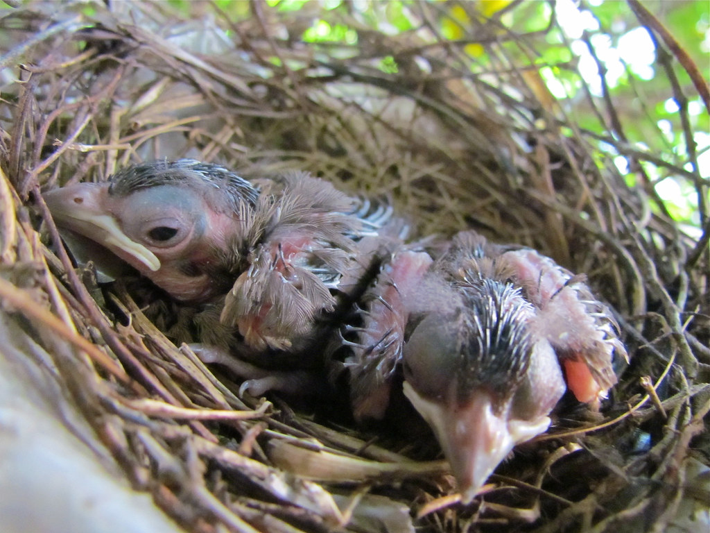
"Day 6 Baby Cardinals" by audreyjm529 is marked with CC BY 2.0.
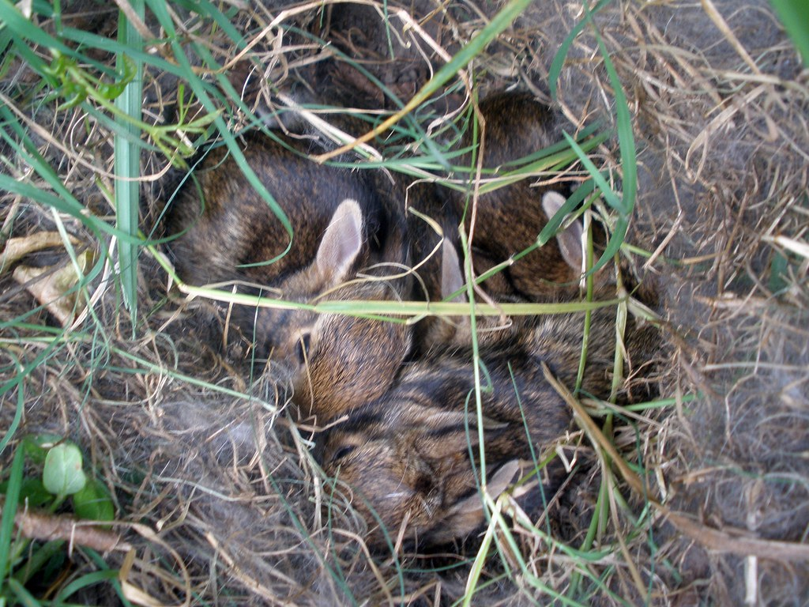
"Baby Rabbits: 12 Days Old" by Tobyotter is marked with CC BY 2.0.

Protection
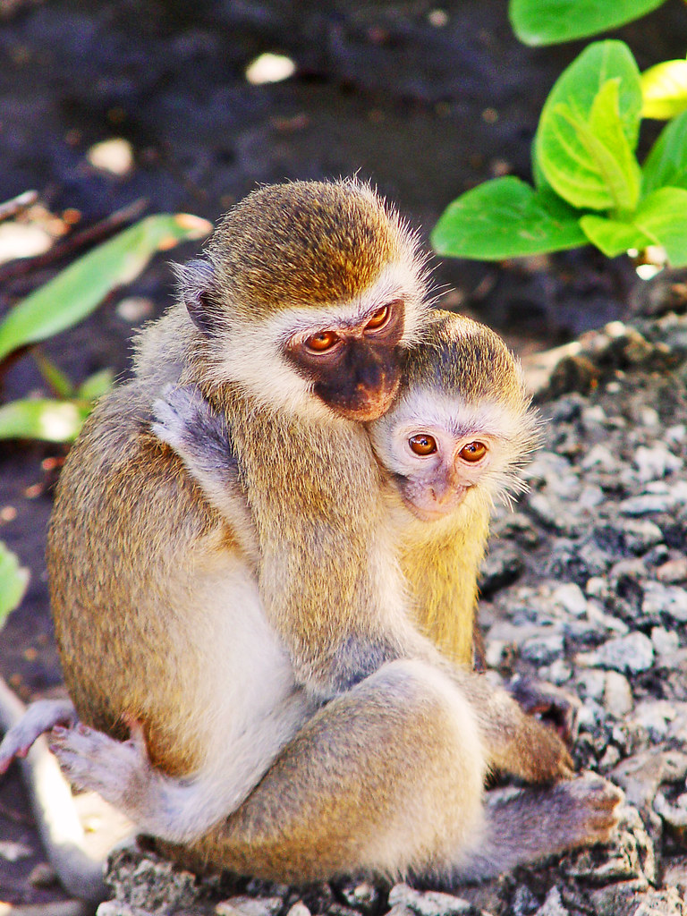
"Maternal instinct" by Tambako the Jaguar is marked with CC BY-ND 2.0.
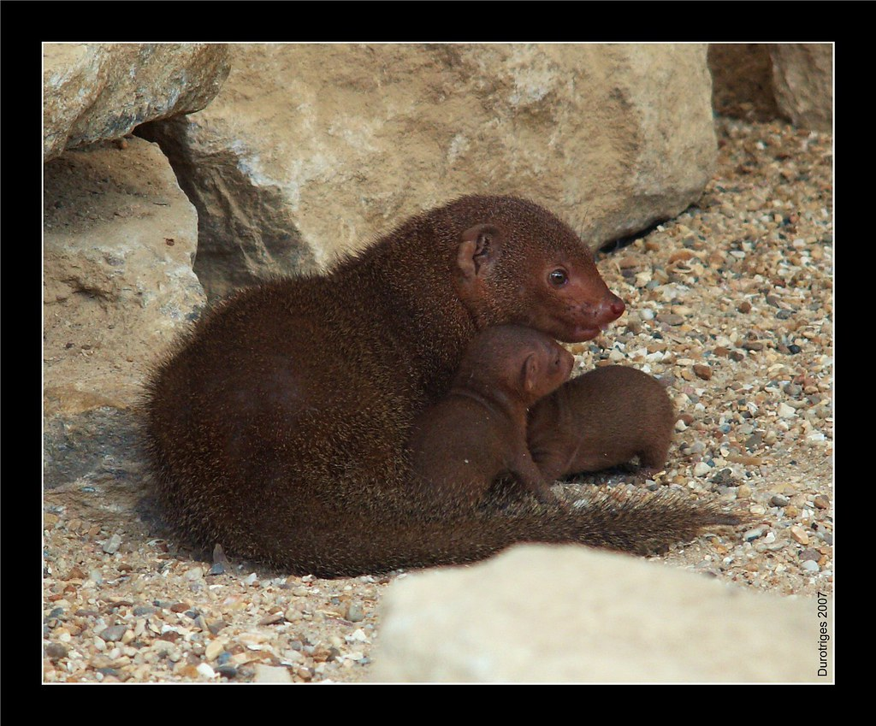
"Mother and Child" by Durotriges is marked with CC BY-NC 2.0.

Feeding
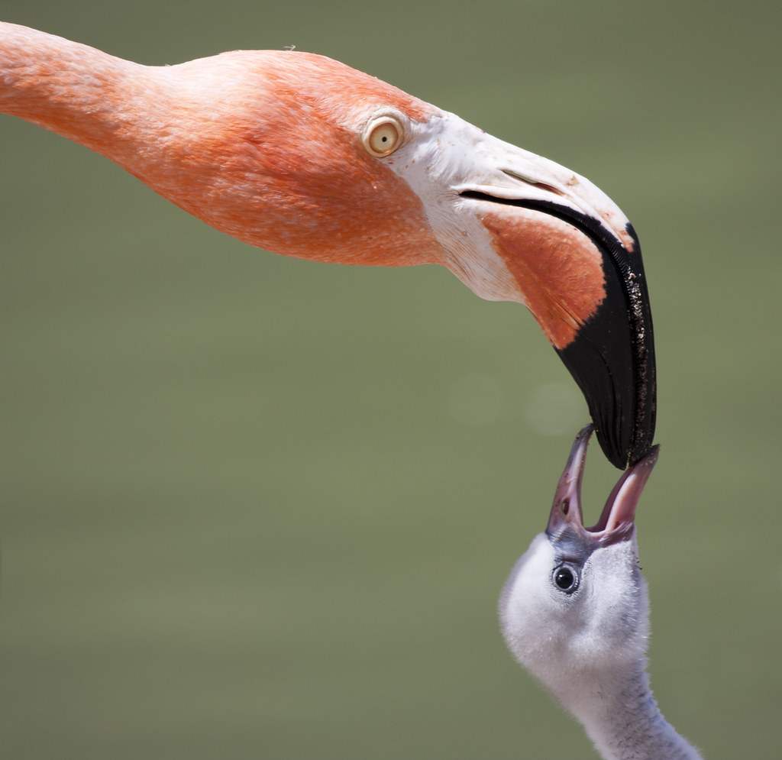
"Mom and baby flamingo" by San Diego Shooter is marked with CC BY-NC-ND 2.0.
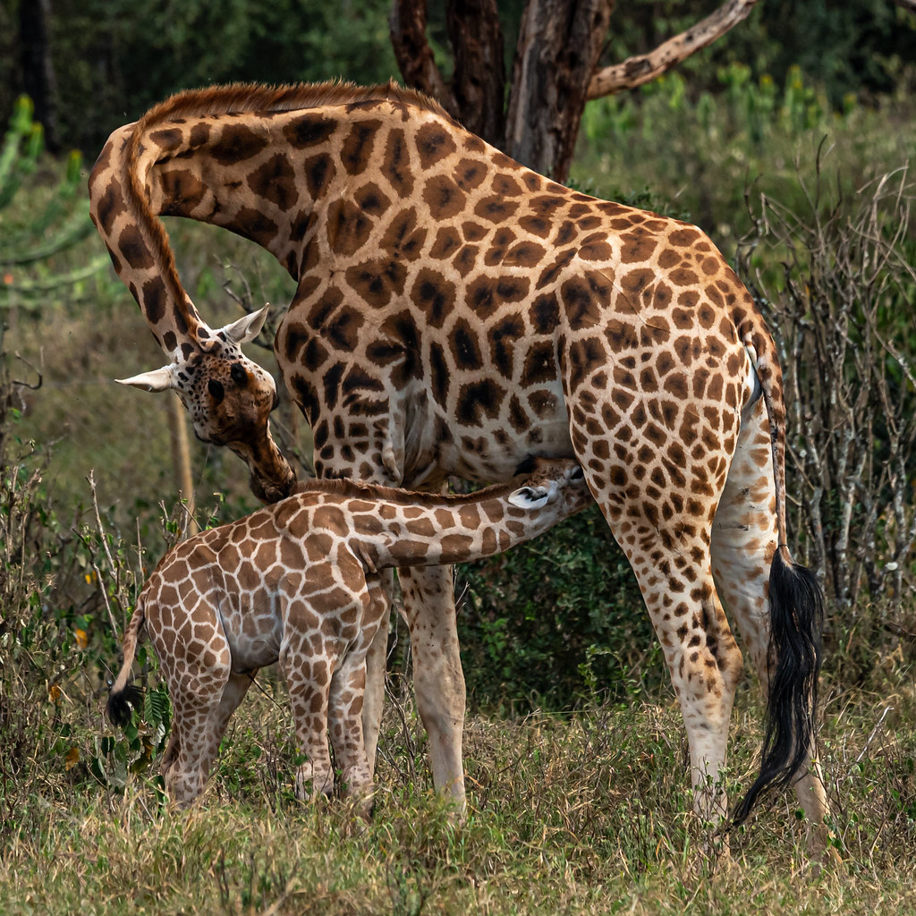
"Nursing baby giraffe" by RayMuzyka is marked with CC BY-NC-SA 2.0.

Teaching
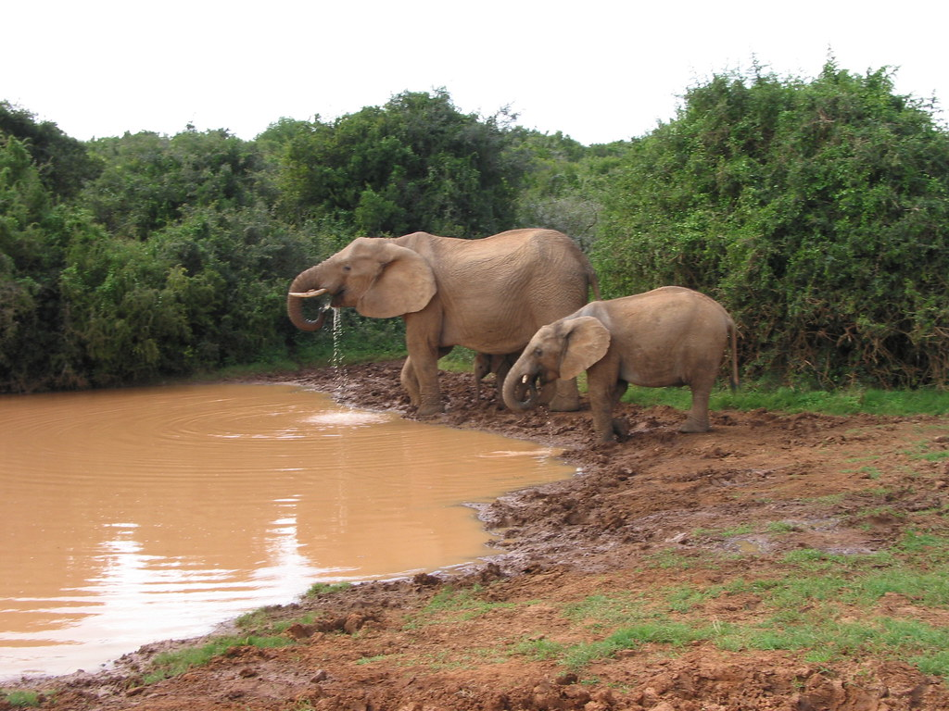
"Elephant Herd at the Watering Hole" by Matthew Bietz is marked with CC BY-NC-SA 2.0.

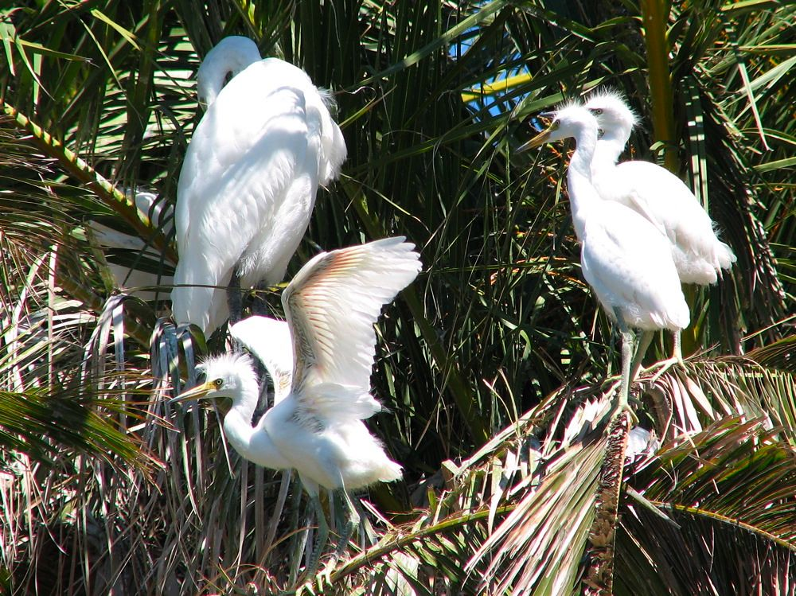
"Baby egrets!" by oskay is marked with CC BY 2.0.
Presentation Instructor Script:

Slide 1: Title Slide 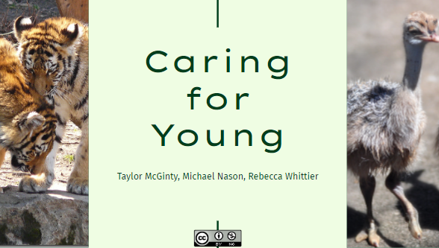
Ostrich Image:"Baby Ostrich" by Len Radin is marked with CC BY-NC-SA 2.0.
Tiger Image: "~Amur Tiger Cubs @ Buffalo Zoo~" by ~Sage~ is marked with CC BY-NC-ND 2.0.

Slide 2: Objectives
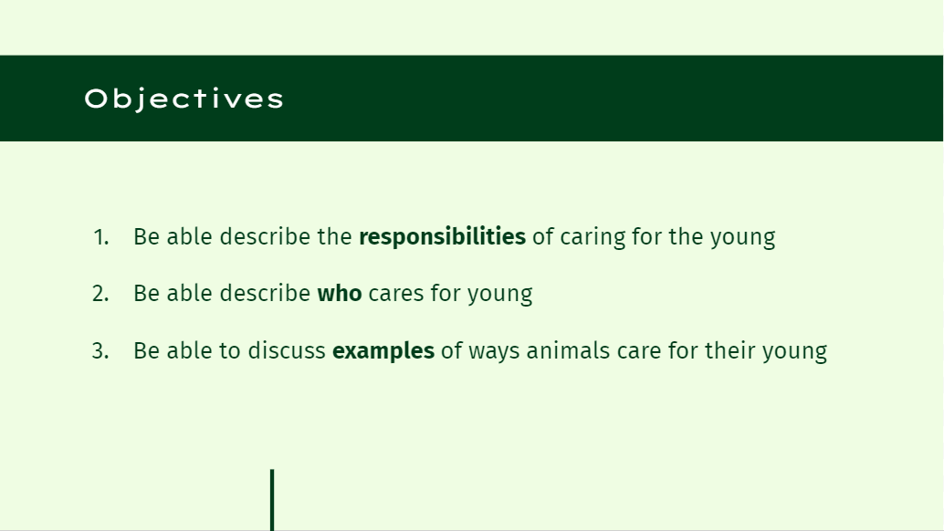
The objective of our OER is to present information to a wide range of students in terms of age on how different species care for their young. The goal is to provide background information on the different types of care, who does the caring, as well as comparing and contrasting examples of these things from different animal species. The goal is to provide a holistic learning experience that will be simple enough for younger learners to understand, but also enough detail to engage older students with more knowledge.

Slide 3: Vocabulary
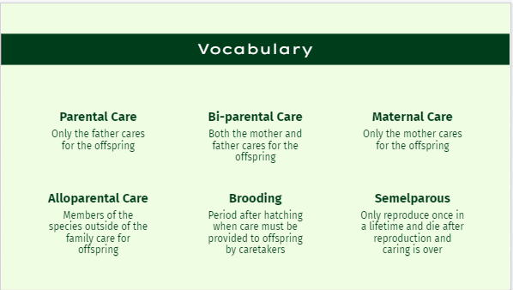
Vocabulary Words:
- Parental Care: Only the father cares for the offspring
- Maternal Care: Only the mother cares for the offspring
- Bi-Parental Care: Both the mother and father cares for the offspring
- Alloparental Care: Members of the species outside of the family care for the offspring
- Brooding Period: Period after hatching when care must be provided to offspring by caretakers
- Semelparous: only reproduce once in a lifetime and die after reproduction and caring period is over

Slide 4: Importance of Caring for the Young
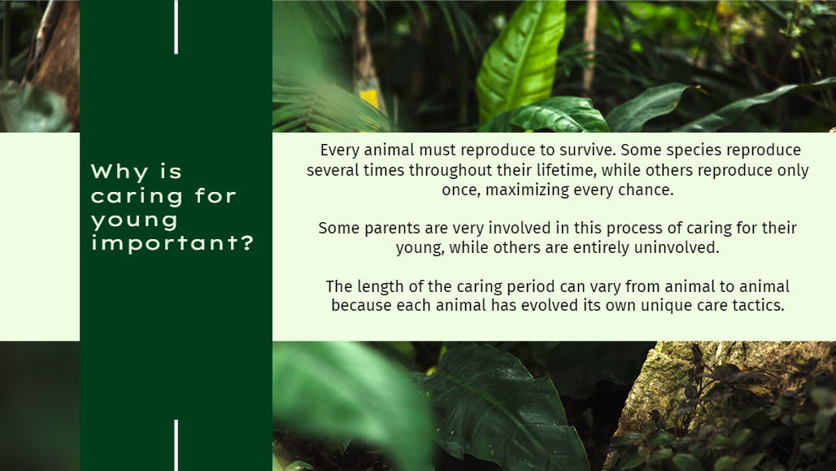
Every animal must reproduce to survive. Some species reproduce several times throughout their lifetime, while others reproduce only once and must maximize every chance. There are various care tactics and parental roles involved in caring for offspring. The parents in some species are very involved in this process when caring for their young, while others are entirely uninvolved. The length of care can vary from animal to animal and even species to species. For some animals, the caring period begins at the time of fertilization and continues until the offspring leave the shelter. For others, it begins at time of birth and ends shortly after the offspring are strong enough to hunt for themselves. Each species has evolved its own unique care tactics which will be discussed in this article.

Slide 5:Intro Slide
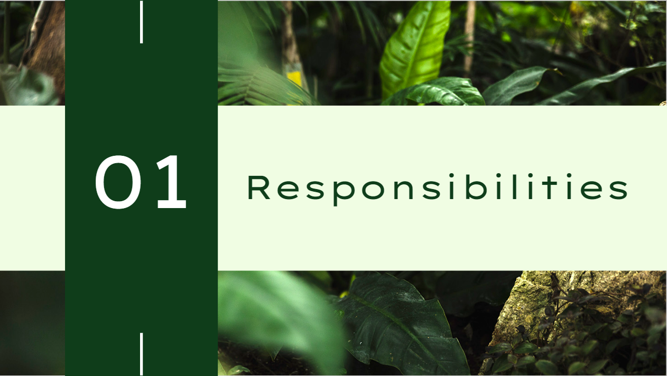

This next section will focus on the responsibilities of parent animals in caring for the young.

Slide 6: Four Main Responsibilities
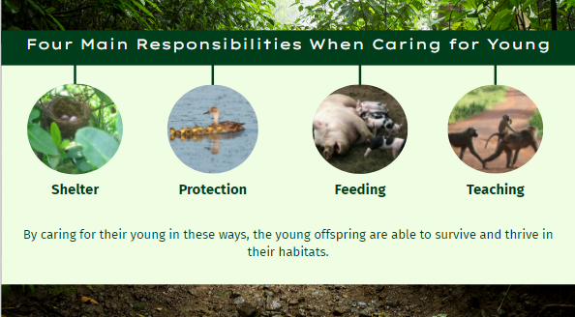
Shelter Image:"Bird Nest" by Sikachu! is marked with CC BY-NC-ND 2.0.
Protection Image: "A Readhead Hen Swimming with her Babies" by USFWS Mountain Prairie is marked with CC BY 2.0
Feeding Image: "grateful" by woodleywonderworks is marked with CC BY 2.0.
Teaching Image: "Ghana Teaching Project" by Frontierofficial is marked with CC BY 2.0.

There are four main ways that animals care for and help raise their young: shelter, protection, feeding, and teaching. By caring for their young in these ways, the young offspring are able to survive and thrive in their habitats.

Slide 7: Shelter
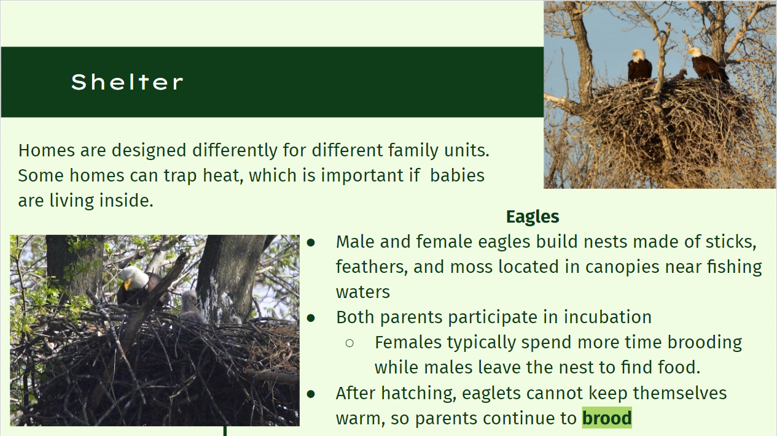
Top image: "Bald eagle nest on Seedskadee National Wildlife Refuge" by USFWS Mountain Prairie is marked with CC BY 2.0.
Bottom image: "Bald eagle with young at John Heinz National Wildlife Refuge" by U. S. Fish and Wildlife Service - Northeast Region is marked with CC PDM 1.0.

Shelter provides a variety of benefits for animals. Homes of different kinds can trap heat which is especially important when babies are in the home. Some homes are specially designed for a mother and babies or just for a single animal while others provide shelter for the entire family.

Eagles
Eagles serve as a great example of animals that provide unique shelter for their families.
Male and female eagles build an impressive shelter for their families high up in a canopied area nearby water for fishing. The 4-5 foot wide nest is built out of interwoven sticks and the 1-2 foot deep inside is lined with moss and feathers. Both parents participate in incubation after eggs are laid but the females typically spend the most time on the nest because males leave the nest often to find food for the family. After hatching, parents must continue to brood because eaglets cannot keep themselves warm for a few weeks. For up to one month, eaglets are rarely left at the nest alone, to prevent predation. (Wabasha, Minnesota: National Eagle Center 2019)

Slide 8: Protection
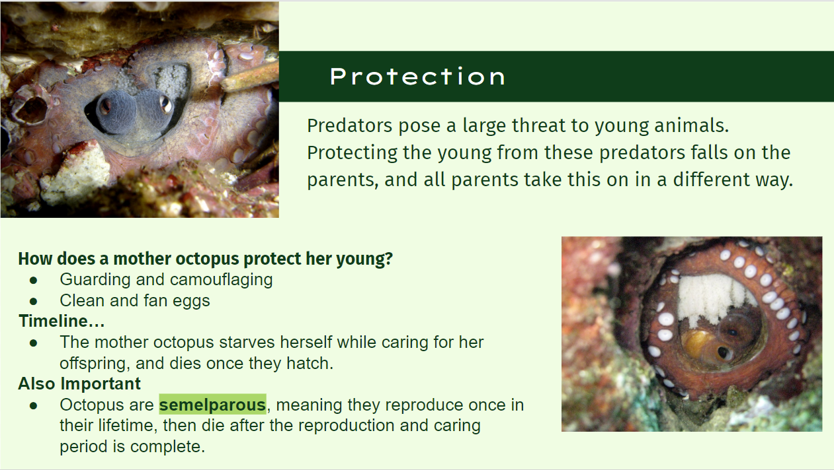
Top image: "Gloomy Octopus with eggs" by Saspotato is marked with CC BY-NC-SA 2.0.
Bottom image: "Octopus with eggs" by Simone Carletti is marked with CC BY-NC-ND 2.0.

Some animals take extreme care to protect their young offspring from danger. Predators pose one of the biggest threats to animals. Young animals are an easy target of attack for predators and oftentimes, parents must fend off predators or use other protection factors to prevent their young from being attacked. For most animals, protecting their young comes as an instinct to ensure the young have a chance to grow up, mature, and to have offspring of their own.
Protection comes in many forms. Some parents attack predators, while others use hiding techniques to avoid being noticed.

Octopus:
Young octopus are cared for entirely by their mother. The father octopus simply fertilizes the eggs once they are laid and the mother takes over care. Octopus are semelparous, meaning they reproduce once in their lifetime, then die after the reproduction and caring period is complete. Octopus care for their young offspring in a unique way. During the brooding period, the mother begins to starve herself while caring for her offspring. As development progresses, the mother octopus begins to waste away and once all offspring have hatched, the mother dies. Mother octopuses protect the eggs by guarding and camouflaging to hide from predators. They also clean the eggs and fan them to ensure adequate oxygenation for the eggs. Shallow water octopus have a 1-3 month brooding period on average while deep sea octopus have longer brooding periods, with one of the longest brooding periods being recorded at 53 months total (Robinson et al. 2014).Once the offspring hatch, they enter the ocean and are no longer under the care of the mother. This means the mother octopus does not teach them or provide specialized shelter for development. (Starr 2018)
Slide 9: Feeding
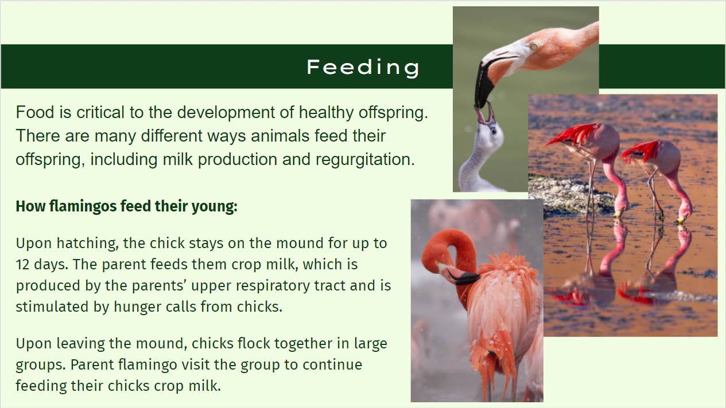
Flamingo image: "Mom and baby flamingo" by San Diego Shooter is marked with CC BY-NC-ND 2.0.
Image:"Flamingo" by szeke is marked with CC BY-NC-SA 2.0.
Image : "Flamingo at National Zoo" by Smithsonian's National Zoo is marked with CC BY-NC-ND 2.0.

Feeding is another important way animals care for their young. There are many different methods of feeding and many types of food animals feed their offspring. Many animals, including mammals, produce milk that provides all nutrients the animals need to grow until they are mature enough to find their own food. Baby birds depend on their parents to regurgitate food for nutrition.

Flamingos:
Flamingos are a noticeable bird, having long legs, hooked bills, and an unmistakable pink color. Unlike a typical bird nest, flamingos have a mound of mud to protect eggs from flooding and ground heat. Both the male and female parent flamingos work to build the nest, developing neighborhoods of nests. Upon hatching, the chick stays on the mound for up to 12 days and the parent feeds them milk, called crop milk. The crop milk comes from the parents’ upper digestive tract and both male and female parents feed the chick crop milk. In some cases, foster feeders can feed the chicks crop milk as well. Although not well understood, it is believed hunger begging calls from the chick stimulate the crop milk secretion. Upon leaving the mound, chicks flock together in large groups. Parent flamingo visit the group to continue feeding their chick crop milk. Flamingo parents and chicks have a distinctive call to allow for recognition of each other. (San Diego Zoo Wildlife Alliance Animals and Plants 2022)

Slide 10: Teaching
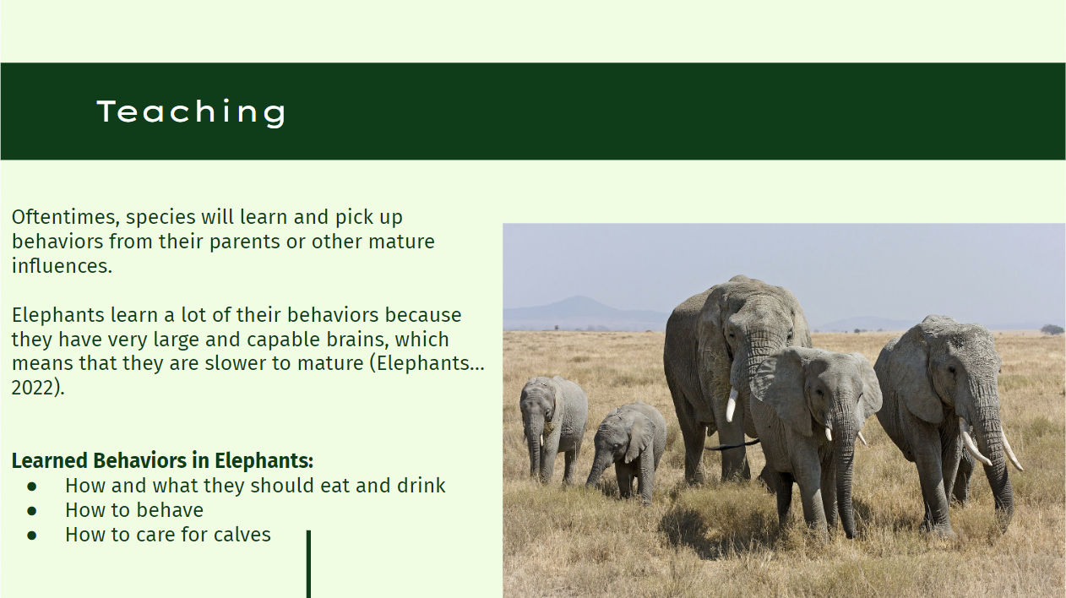
"Elephant " by Ikiwaner is licensed under CC BY-SA 4.0

Not every behavior in a species is genetically inherited. Oftentimes, species will learn and pick up behaviors from their parents or other mature influences. A beautiful example of teaching their young are elephants. It is believed that elephants exhibit teaching because their brains are very large, and therefore, slow to mature. For this reason, the “matriarchs” or social leaders are known to have enormous amounts of knowledge that they pass on to the young over time (Lahdenperä et al. 2016).
Elephant calves look to their caregivers to learn how and what they should eat and drink. In the Kruger National Park, elephant mothers have been observed taking up a quantity of water in her trunk, winding it around that of her calf so that the tip of hers was directly below her child’s, and then allowing the water to fall into the tip of the calf’s trunk (Garstang 2015). By doing this repeatedly, the mother is teaching her calf how it can control and manipulate its trunk for drinking.
They also look to their elders to learn how they should behave. Elephants that have been orphaned due to tusking of their mothers, have been observed killing other animals (Elephants… 2022). This is not a behavior that has been seen in young males that are a part of a herd.
Finally, young female elephants learn how to raise calves from more mature mothers (Elephants… 2022). They help to raise the calves, as allomothers, so that they are better prepared to raise their own when they are of the age to have their own offspring.

Slide 11: Who cares for young?
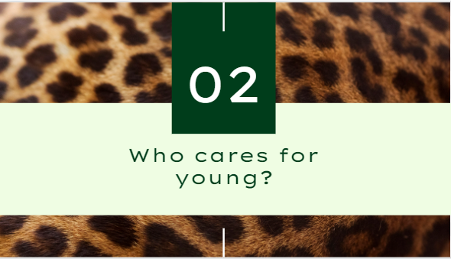
This next section explains which parent(s) is caring for the offspring.

Slide 12: Who is caring for young?
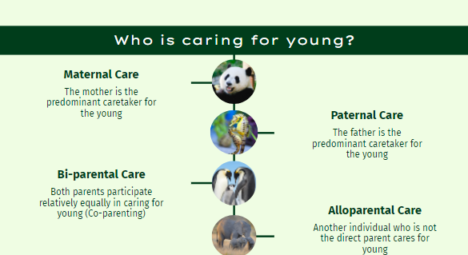
Panda image: "Giant Panda Bear Eating Apples" by Digital Story is marked with CC BY-NC 2.0.
Seahorse image: "Seahorse Couple" by San Diego Shooter is marked with CC BY-NC-ND 2.0.
Penguin image: "Emperor Penguins" by Christopher.Michel is marked with CC BY 2.0.
Elephant image: "Mother elephant with twins in Amboseli National Park, Kenya, East Africa" by diana_robinson is marked with CC BY-NC-ND 2.0.

Some offspring are cared for by one parent while others are cared for by both parents. Some animals also participate in alloparental care. Like the names suggest, maternal care is when the mother is the primary caregiver and parental care is when the father is the primary caregiver. In bi-parental care, both parents care for the offspring together. Alloparental care is unique because it does not involve the parents, but rather animals outside the family, like a foster parent.

Slide 13: Maternal Care
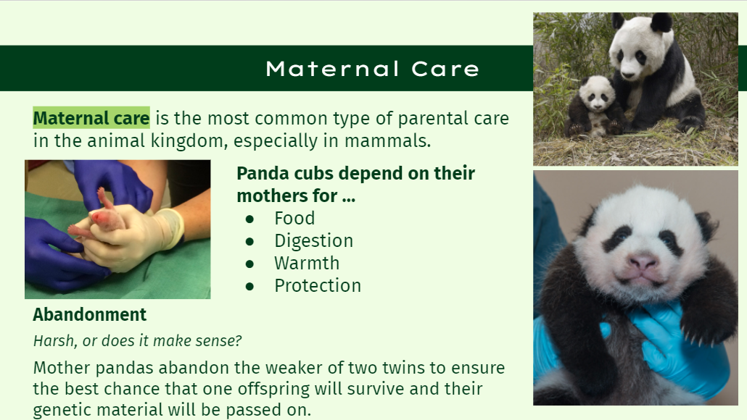Top Panda image: "giant-panda-mother-and-cub-molong-nature-reserve-china-pictures" by mrs.gsoell is marked with CC BY-ND 2.0.
Left panda image: "Twin Giant Pandas Born at the Smithsonian's National Zoo" by Smithsonian's National Zoo is marked with CC BY-NC-ND 2.0.
Bottom panda image: "Giant Panda Cub Oct. 23, 2013" by Smithsonian's National Zoo is marked with CC BY-NC-ND 2.0.

Maternal care is the most common type of parental care in the animal kingdom. For this type of care the mothers are better equipped to help ensure that the young survive. This is common in mammals as they produce milk.

An example of maternal care is the giant panda. Baby giant pandas are born pink, blind, and deaf. They have no ability to crawl, see, hear, digest food, or regulate body temperature. They are entirely dependent upon their mother for warmth, food, and protection for the first few months of their lives. The mother panda barely even sets their baby down for the first few months of their lives. The panda is eventually weaned off of the mother's milk and instead eats bamboo. By age 1 they are supplementing their mothers milk with bamboo, and by age 2 they are typically not dependent on their mothers milk for nutrients. During this time, they also start to leave the shelter on their own, and they learn to climb. In this instance care starts during the mothers pregnancy and continues for 2-3 years until the baby is ready to live its life independent of its mother.

Female pandas only have one fertile window per year. It is critical that they pass their genetic material on to continue to survive. Wild mother pandas often have two cubs at a time. Due to the demanding effort of being a mother panda they typically abandon the weaker cub to give the stronger one the best chance at survival. While this may seem harsh, it is the best way to ensure their genetic material is passed on, and not expend effort nurturing a baby that will not survive, or split the effort and having both cubs not survive.

Slide 14: Paternal Care
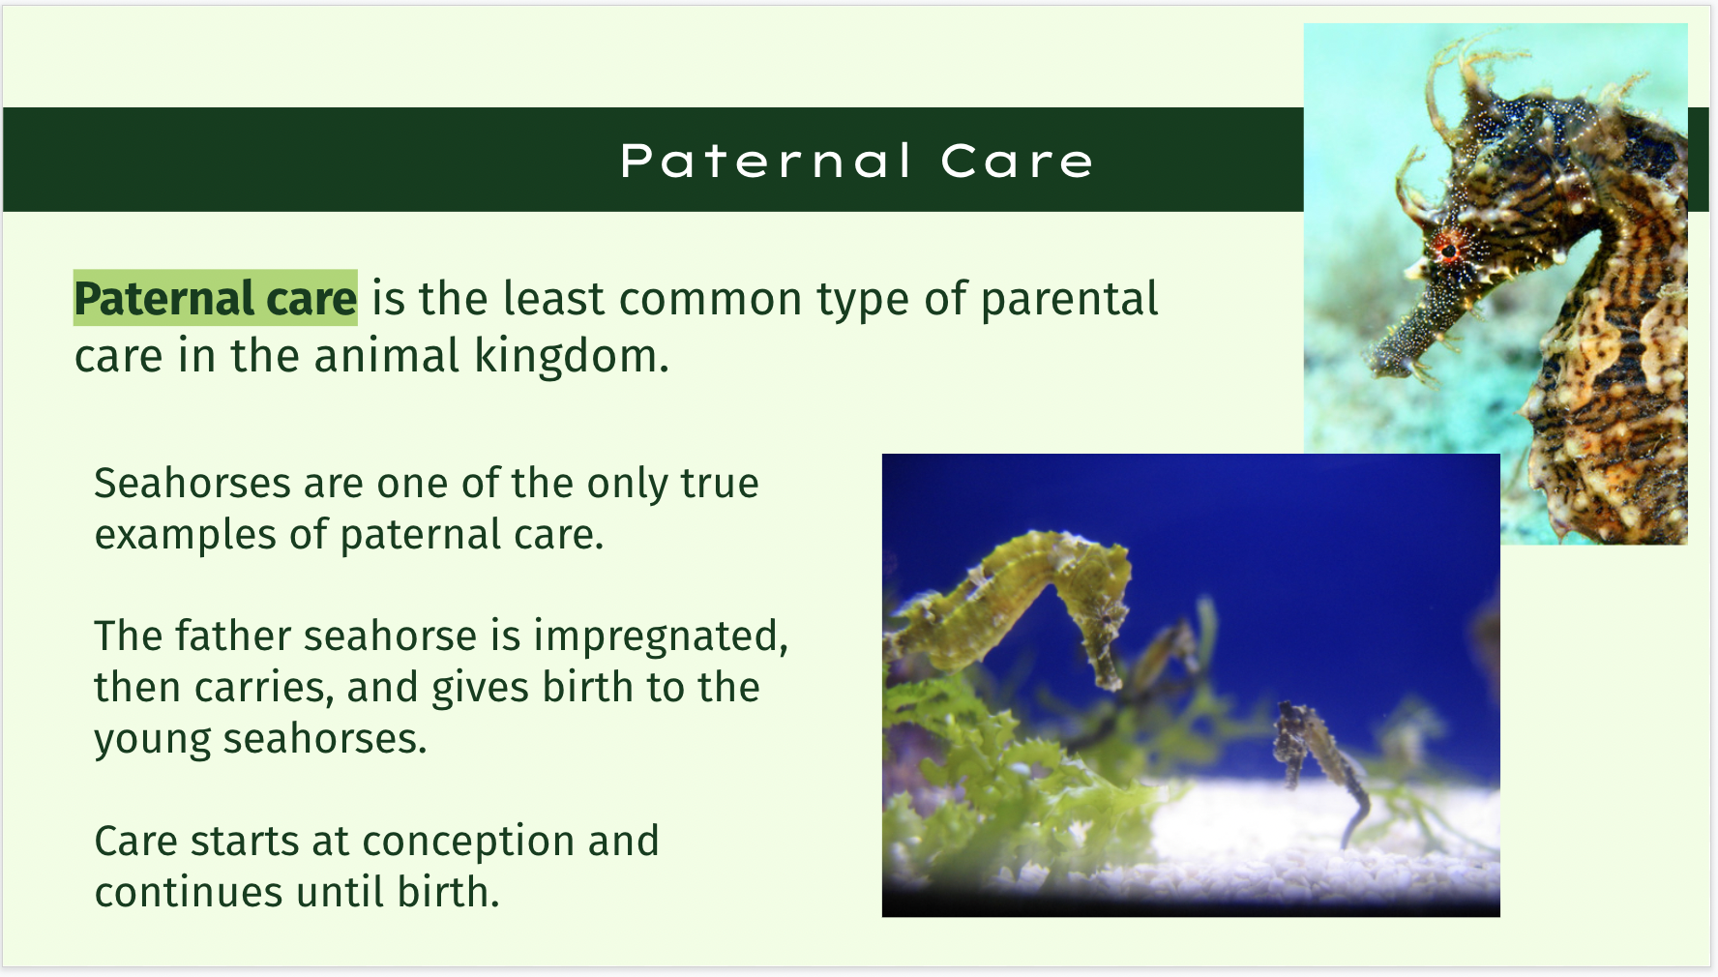
Image 1: "Lined Seahorse- Hippocampus erectus" by MattSullivan is marked with CC BY 2.0.
Image 2: "Seahorse & Baby" by Pumpkin Pundit is marked with CC BY-NC-ND 2.0.

Paternal care is the most rare type of parental care in the animal kingdom.

An example of paternal care is the seahorse. The male seahorse is actually impregnated and then carries the young in a pouch for the first 10 to 25 days. This pouch regulates the salinity around the eggs. This increases their likelihood of survival in comparison to other fish. This process is quite costly for the father seahorse. In this instance care is considered to start at conception and continue until the father gives birth and the babies are alone.

Slide 15: Bi-parental care
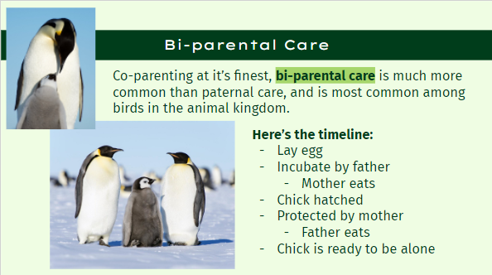
Image 1: "Emperor Penguins" by Christopher.Michel is marked with CC BY 2.0.
Image 2: “Emperor Penguins" by Christopher.Michel is marked with CC BY 2.0.

Bi-parental care is much more common than paternal care. This is most commonly found amongst birds in the animal kingdom. 90 percent of bird species practice bi-parental care.

An example of bi-parental care is the emperor penguin. These penguins mate, and the female penguin lays an egg. The male penguin then keeps the egg warm by balancing the egg on top of its feet under a flap of thick feathery skin known as the brood pouch. They then hold the egg for 2-3 months while the mother penguin returns to the ocean to stalk up on food. They huddle with the other father penguins rotating for warmth and they do not eat during this period. They survive on the fat they put on during the summer months. The mother penguin returns around the time the baby penguin is hatching, and then the mother penguin takes responsibility. They keep the baby penguin warm in their own brood pouch, and feed them with the food they collected while they were gone. The father penguin then returns to the ocean to eat. Around the time the baby penguin is ready to get its own food is around the time arctic summer begins to melt the ice closer to the breeding ground. At this point the baby penguin is just about ready to go off on its own. In this example care starts at the beginning of this timeline when the egg is laid, and it ends when the chick is left to care for itself.

Slide 16: Alloparent Care
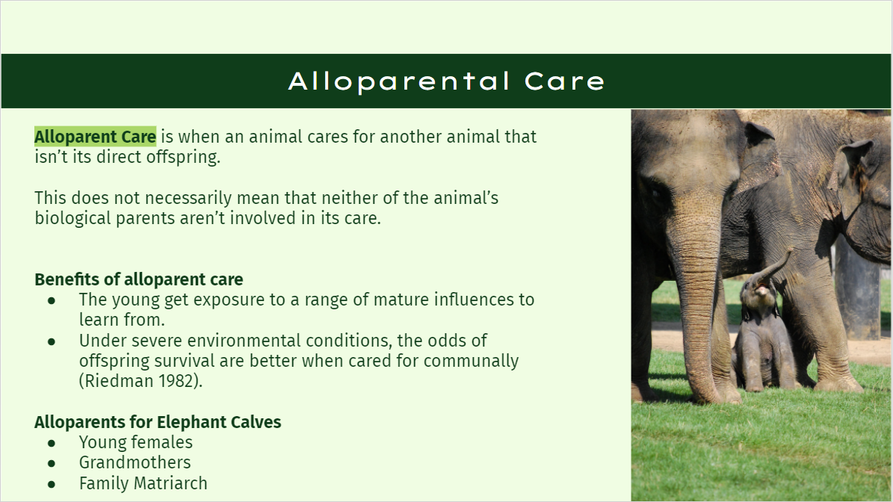

"Elephant Baby 1" by carolineCCB is marked with CC BY 2.0.

Alloparent care is a form of care for the young by an animal that is not its direct parent. This can be done by other family members as well as animals that are not related at all. (Wikimedia Foundation 2022). That being said, young animals that are cared for by alloparents can also receive care from their biological parents. Though it is very common for humans to have alloparents during the time they are raised, it is less common to be seen in other animal species.
There are numerous benefits to alloparent care. The first of which is that the young get exposed to a range of mature influences. For animal species that exhibit learned behaviors, this is beneficial because they can pick up different habits from different elder figures. In addition, the odds of offspring survival are greatly increased under severe environmental conditions when cared for communally (Riedman 1982).
A great example of a species that is raised between efforts from a biological parent, the mother, and alloparents are elephants. The task of raising an elephant calf is very much a communal effort.
Proof of this idea was found in a study on the “grandmother-hypothesis” conducted on semi-captive elephants in Myanmar (Lahdenperä et al. 2016). This hypothesis is the idea that grandmothers will act as allomothers to their daughter’s young to better the fitness - or chances of survival - of their family, and therefore the species. The scientists that specialize in animal behaviors, called ecologists, wanted to determine if this hypothesis did truly improve the elephant calves’ odds of survival. “…we found that having a grandmother residing in the same location as the grandcalf significantly decreased calf mortality…Grandmother’s presence in the same location had beneficial effects also on shortening the daughter’s inter-birth intervals.” Therefore, they concluded that when elephants specifically have alloparents, they are more likely to survive, and it gives their mother more freedom to continue reproducing at a faster rate. All of this is with the goal of species survival and longevity.
Grandmothers aren’t the only forms of an alloparent for elephant calves. Young females who are still with the herd but not ready to reproduce themselves will act as an allomother to calves. They will learn from mature mothers how to care for calves so that they will be better prepared to do so when they reach the age (Elephants… 2022). In addition, the matriarch of a family herd will also help to guide the family and therefore calves with their vast knowledge base.

Slide 17: Spotlight
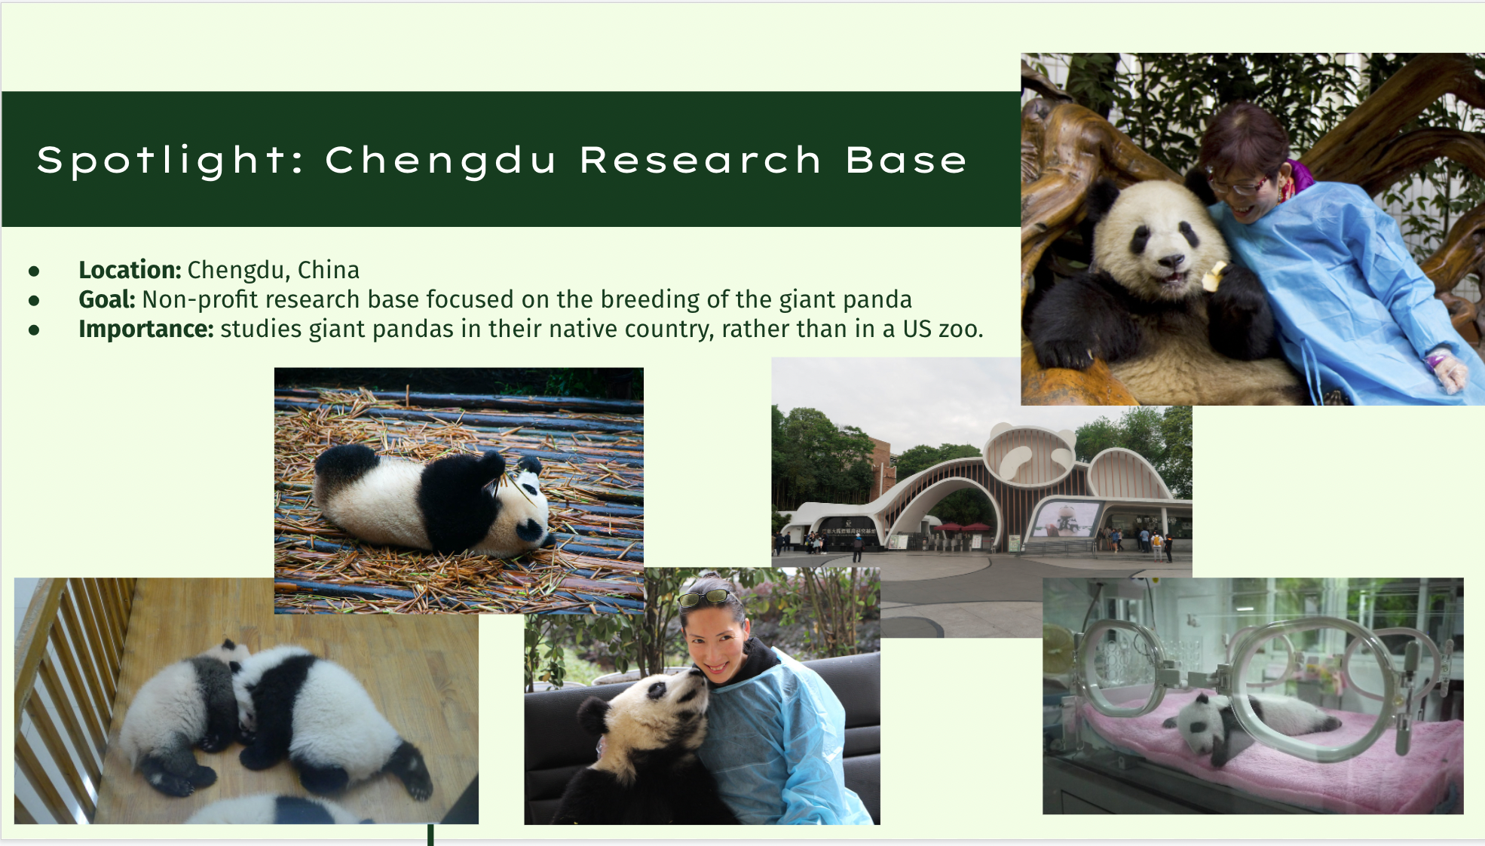
Image: "Visiting the Chengdu Panda Sanctuary" by BC Gov Photos is marked with CC BY-NC-SA 2.0.
Image: "Chengdu Research Base of Giant Panda Breeding" by rwoan is marked with CC BY-NC 2.0.
Image: "Baby Panda" by randomwire is marked with CC BY-NC-SA 2.0.
Image: "baby panda encounter at bifengxia panda base" by *lingling* is marked with CC BY-NC-ND 2.0.
Image: "Baby pandas" by little_ram is marked with CC BY-NC-SA 2.0.
Image: "Panda Baby" by lukas.b0 is marked with CC BY-NC-SA 2.0.

The Chengdu research base is a non profit research center located in Chengdu, China that focuses on the breeding of giant pandas, which are native to china. This center's main goal is to conserve giant pandas as their numbers in the wild were dropping dangerously low. The base does scientific research, breeding, public education, and education through tourism.
This center is relatively new. This center started in 1987 with 6 sick, starving pandas, and has now expanded to 215 pandas without capturing additional pandas from the wild.
The base has produced over 400 published papers, and has been granted 30 national patents. Additionally, the base has received numerous different awards spanning all levels and areas in this field. This is important because a lot of panda research that is easy to locate comes out of US zoos even though these animals are native to China, so here these animals are being studied in their home country in a more natural way. Additionally the base cooperates with other countries–Spain, France, Japan, the US, Germany, Canada–to loan them pandas, so they can raise awareness among their own people. Additionally, they work with many international animal organizations to raise money and awareness for the giant panda.

Slide 18: Spotlight
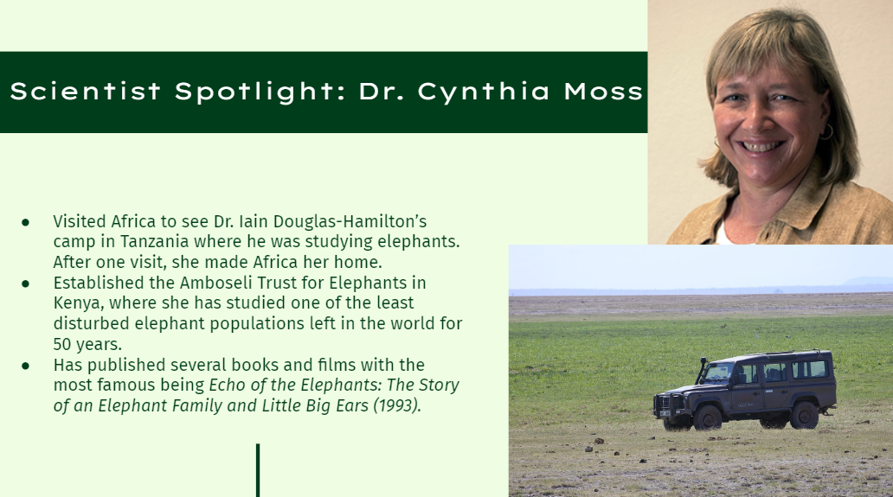
Image: "Cynthia Moss" by MacArthur Foundation is licensed under CC BY-NC 4.0
Image: "Elephant Trust Land Rover" by Hedwig in Washington is licensed under CC BY 4.0

Dr. Cynthia Moss is a major contributor in the field of animal behavior and has dedicated her career as an etheologist to studying elephant populations. She originally had a career in journalism, however, she once took a trip to visit Africa and made it her home after witnessing the work of Dr. Iain Douglas-Hamilton studying the elephants of Tanzania.
She established the Amboseli Trust for Elephants in Kenya in 1972 and has been studying the local elephant population since then. It is one of the least disturbed elephant populations left in the world. Her efforts to protect these elephants and educate the local populations on conservation have been wildly successful as “Moss and her assistants at the Amboseli Elephant Research Project have built up a database on every elephant in the park--some 700 when Moss arrived 28 years ago, and close to 1,100 now” (Robinson 2000). A major part of this effort has been holding 10-day courses on elephant observation techniques for the local people. Dr. Moss is passing on enormous amounts of knowledge onto those who likely wouldn’t have access to that level of education, while simultaneously protecting the elephant species of Africa.
Dr. Moss has made groundbreaking discoveries surrounding the identification of elephants using the wrinkle patterns on their ears. She has also published numerous books and films, with her most famous book being Echo of the Elephants: The Story of an Elephant Family and Little Big Ears (1993).

Slide 19: Let’s Review
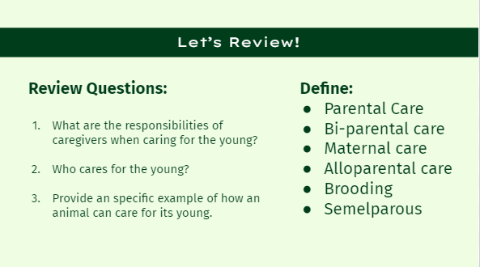
Teachers: Use these review questions and definitions prompts to help students prepare for quizzes, or just to review the material covered in this lesson.

Slide 20: Acknowledgement Slide

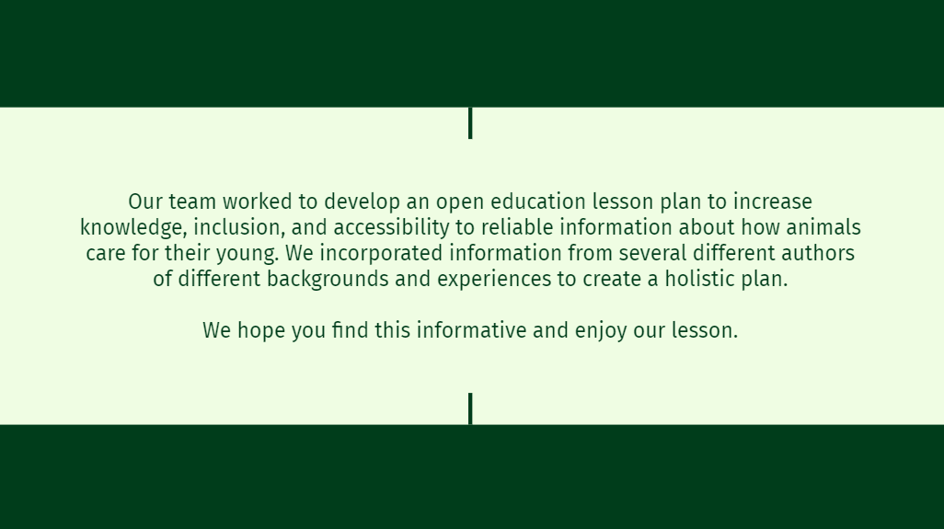
Our team worked to develop an open education lesson plan to increase knowledge, inclusion, and accessibility to reliable information about how animals care for their young. We incorporated information from several different authors of different backgrounds and experiences to create a holistic plan. We worked to use authors and research from different locations globally as well as different social backgrounds. We chose to do a cultural spotlight on a research location in China, and a female scientist to exemplify the diversity in the field and show readers that there are individuals in this field that they identify with. We tried to make a resource that was diverse not just in author but in content. We included an interactive activity and many visuals to involve individuals with different learning styles and abilities. This was important to us as far as inclusivity, since not everyone learns in the same way, and we wanted this to be an accessible and helpful resource for a wide range of individuals.

We hope you enjoyed our lesson plan and even learned something new!

Slide 21 & 22: Citations