Analysis of Course Evaluations at Worcester Polytechnic Institute
by
Dominic Chang

An Interactive Qualifying Project
Submitted to the Faculty
of the
WORCESTER POLYTECHNIC INSTITUTE
In partial fulfilment of the requirements for the
Degree of Bachelor of Science
By

___________________________________
March 2015

___________________________________
Professor George D. J. Phillies, Advisor
Abstract
Course evaluations were used in order to gather information about the general performance of courses at WPI, and to compare the performance of physics courses at WPI to courses at WPI in general. From the data collected it is clear that there is some faulty design in the course evaluations, though some usable data was still gathered from it. There is also evidence to support that over enrolment in fall semesters may be causing stress on the physics department resources.

Table of Contents
Definition of Terminology 1
Background 2
Introduction 3
Executive Summary 4
Histogram Data 5
Analysis of Courses from All Departments at WPI 6
Table of histogram information for All Departments distributions 11
Analysis of Physics Courses at WPI 16
Table of histogram information for Physics distributions 17
Comparison of Physics Courses to Courses from All Departments 24
Table of correlation coefficients 25
Improvements 44
Appendix A 46
Appendix B 48
All Departments 48
Section1 48
Section2 64
Section3 80
Section4 94

Physics 102
Secion1 102
Section2 118
Section3 134
Section4 148

Definition of Terminology
Correlation :-The interdependence of statistical quantities. Correlation here is measured with the Pearson product-moment correlation coefficient. Correlation coefficients of magnitude 0-0.3 are said to have none or almost no correlation, 0.3-0.5 are said to be weakly correlated, 0.5-0.7 are said to be moderately correlated, and 0.7-1 are strongly correlated.

Interquartile Range :- The size of the interval between the 75th and 25th percentile of a distribution

P-Value :- The probability that the scatter plot does not fit a linear model. The significance level here is chosen to be 0.05 which is traditional.

Significance Level :-The minimum cut off point in which the scatter plot is said to not fit a linear model. P-value’s less than the significance level are said to have strong evidence of linear fit.

Background
The physics department of any school which offers engineering degrees plays an integral role in its accreditation. It was once required for every Accreditation Board for Engineering and Technology (ABET) accredited major to take one year of calculus based physics as a part of a degree requirement. This requirement was changed to instead require one year of mathematics and basic science. Despite the change, many engineering societies still require students to take physics in an engineering curriculum, Architectural engineering for example required demonstration of mathematical proficiency through calculus based physics. Other engineering major societies may not formally require physics, but many departments still implement physics requirements on the WPI. WPI’s Aerospace Engineering program requires students to take PH2201 for example, despite the society not requiring physics as the only means to attain this knowledge. As a result, it is of the utmost pertinence that the WPI physics department lives up to a good standard as it is the foundation for many other majors at WPI.

Introduction
Course evaluations have become one of the main methods of course quality review at WPI. Course evaluations usually take the form of a questionnaire which comprises 32 multiple choice questions and 4 open ended questions, with additional response boxes are also provided to allow instructors to ask their own questions. As such, the data gathered from course evaluations could possibly be a good representation of how different factors affect course quality. This could be especially useful in analysing a department’s performance in comparison to the performance of other departments. For this reason, course evaluations are the main method of data used in this study to evaluate the performance of WPI’s physics department with respect to the rest of the university.
Data for this study was acquired through course evaluations that were provided by Carla Mararian of academic affairs. The data acquired contained information from the spring semester of academic years 2012-2013 to the fall semester of 2014-2015, since these were the dates that the most recent iteration of course evaluations were used for. These evaluations are freely available on bannerweb.wpi.edu, for WPI students and faculty to access. Due to the large amount of data present in the file, processing was primarily done through the use of visual basic in Microsoft Office, with graphing and analysis done in Mathematica. Frequency distributions of each question, in the form of histograms, were plotted separately for physics and for all departments, which were then separated by semester for further analysis. At this point, questions of interest were chosen for scatter plots to examine correlations between different factors of a course. These were done separately for courses in all departments, physics, STEM, and all other courses available at WPI.
Of all the questions, only questions 1 to 26B of the course evaluations were chosen, since questions 27 and onward pertain to lab courses, and were of no interest to the project since only data provided from lecture sections were used. The use of only data provided from lectures was to avoid possible redundancy in the responses since not all courses have conference or lab sections. A copy of a blank course evaluation is given in Appendix A.
Executive Summary
All Departments:
- The structure of questions 9 to 16 have clearly failed to accomplish their goal of comparing courses to other courses the students have taken.
- Some questions may be more important in evaluating course quality than others, and these questions vary amongst departments.
- The amount learned in a course was the most influential factor for students in determining course quality.
- Most students generally responded to the course evaluation questions positively, indicating that students generally consider WPI courses to be of good quality.

Physics:
- Students reviewed physics courses at WPI to have a slightly lower quality than courses generally available at WPI in fall semesters. Spring semester are however comparable to that of all courses available at WPI.
- Stress on the physics department resources from the large number of enrolments in physics courses in fall semesters may be resulting in lower quality scores for physics in fall semesters, also putting more stress on students and causing lower student performance.
- Most students generally responded to the course evaluation questions positively, indicating that students generally consider WPI courses to be of good quality.
- The quality of the instructor’s teaching was the most influential factor for students in determining physics course quality.
- The instructor’s ability to give an understandable explanation to the student had the highest correlation with the instructor’s teaching quality, and was also highly correlated with course quality.

Histogram Data
Due to the discrete nature of the data, all the responses for a courses of a given question were first averaged before plotting. The result was a more continuous frequency distribution of each question. The median and interquartile range was then found as a possible measure of the general student’s response for a question in the course. Plots were then separated into sections, whose descriptions are given below the figure. Frequency distributions of all responses for questions 24 to 26B were used instead of the averaged values since this proved to be more useful.
Binning in the figures was done such that values which fell on a border were put into the bin to the left of the border. Bin sizes were chosen based the number of data points available for plotting.
The questions were divided into sections based on the types of responses available for the questions. A summary of the response criteria for each section is as follows: section 1 (questions 1-8) asks students to rank on a scale from very poor(1) to excellent(5), section 2 (questions 9-16) asks students to compare the course to other courses they have taken on a scale of much less(1) to much more(5), section 3 (questions 17-23) asks the students to give the frequency which the attributes occurred in the questions asked on a scale from never(1) to always (5), and section 4 (questions 24-26B) has response criteria defined by each question in the section. It was found that the data was a good representation of student’s answers to the questions of the course evaluations since the response rate was a high 99% in general for all departments, and a 98% in physics.

Analysis of Courses from All Departments at WPI
In this section, analysis was done on the data on all course evaluations in order to discover trends and patterns in courses at WPI. This was done in order to set a basis of comparison between physics courses at WPI and all courses in general.
It was noteworthy that many of the distributions were very similar in appearance with very few or no points below 3.0, and most of the median valued falling near 4.0 for questions 1 to 23(See Appendix B). Despite the similarity, the distributions however resulted in different scatter plots when the data was divided into different categories (‘All Departments’ STEM, physics, other), implying that the correlation between questions depended on the department (See scatterplots in comparison to of physics course to courses from all departments). Thus one can be conclude that there is some criteria which are taken into consideration by students when answering questions, and this criteria may vary between departments. This is evident through quick analysis of the correlation matrices on page.
The similarities in the distributions could possibly be a result of students using the response criteria from the first section of question for all the questions. This possibility can be inferred from the fact that section 2 asks students to compare the course they are taking to other courses they have taken. One would expect questions based on this criteria to be centred near 3.0 instead of near 4.0.
Further evidence of the possibility of the response criteria from section 1 being used for questions 1 through 23 are seen through observations of the distributions of questions 24 to 26B, since these do not appear anything similar to other plots above. The differences occurred most likely because the structure of these questions prevent the response criteria of the first section from being a logical choice. It can therefore be concluded that though the similarity in the graphs may suggest lack of considerations on part of the student when answering the questions of the course evaluations, there is strong evidence that the information is still relevant for analysis.
A majority of the ‘All departments’ histograms feature a spike in the bins which contain integer values, and then a dip immediately after (see Appendix B). The spikes in these bins were possibly due to responses from courses which had a very small student population. Since the values plotted were the averaged values of all responses in a course, the courses which had a small student populations would have been more likely to have integer values as averages, resulting in spikes as seen in the distributions. Courses which have larger student populations are able to have a larger range of possible averages, possibly explaining why spikes and dips are not as noticeable at other points of the distributions. The large frequency of points with values of 4, was most likely indicative that most students found the content of the courses at WPI to be good or above average. The reason for these peaks not appearing in the physics distributions is possibly because of the larger bin size and/or lower frequency of smaller class populations amongst physics courses, since many of the courses with small class populations appeared to be humanities courses. More data points would be necessary to confirm this.
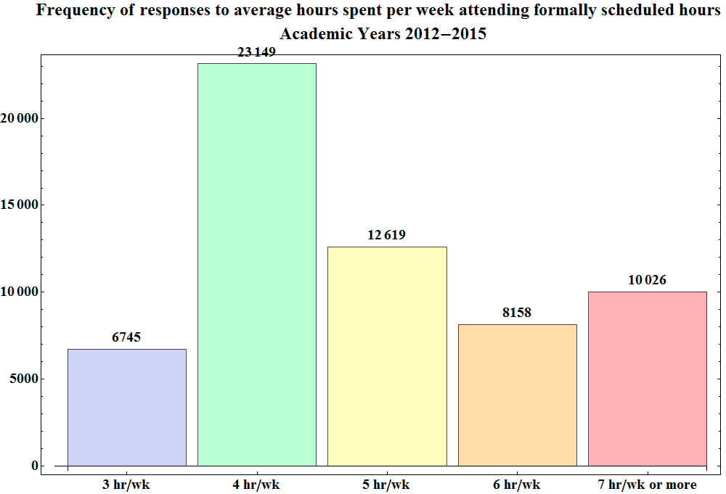
Figure 1 Showing the total ratings distribution of how many formally scheduled hours of course time the students attended, for all departments for Academic years 2012-13 to 2014-15
In general most students seem to attend about 4 hr/wk of course hours, with 38% of students general responding this way. Examination of figure 46.2 also shows that only 16.5% of students attend 7 or more hours a week of formally scheduled course hours.

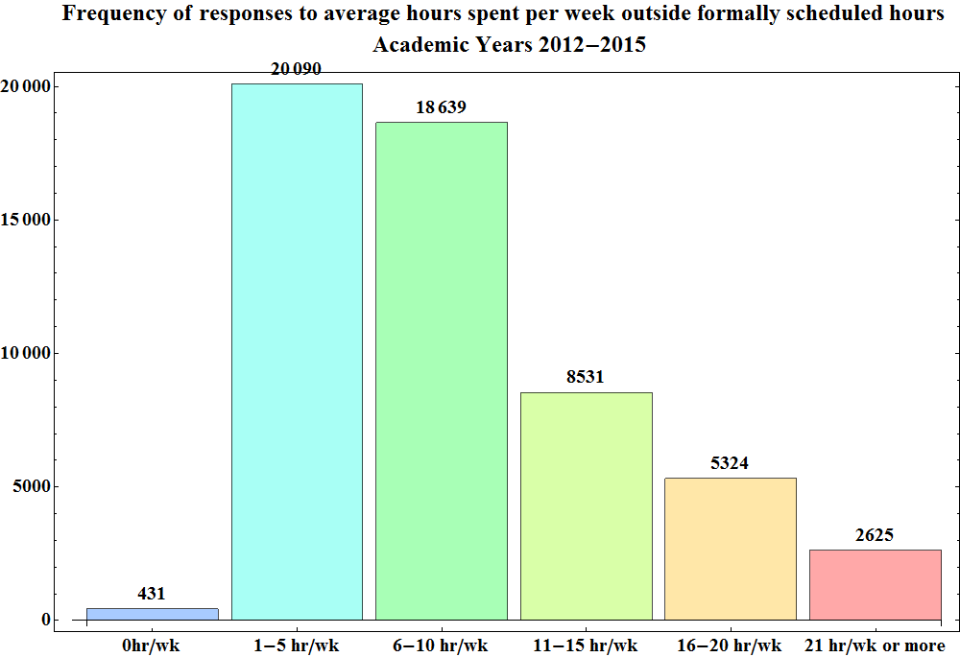
Figure 2 Showing the total ratings distribution of how hours outside of formally scheduled class time the students spent on their courses, for the physics department for Academic years 2012-13 to 2014-15
The most important question worth consideration in section 4 was that of the number of hours spent on a course outside of formally scheduled hours. It is commonly believed that at WPI, students are expected to spend 2-3 hours of additional work outside of formally scheduled course hours for every hour of scheduled course work. From the distribution, it can be seen that majority of students attend 4 hours of formally scheduled course hours per week (see figure1), but only put in 1-5 hours of work per week (see figure 2). The distribution also shows that 50.7% of the student population attends more than 5 hours of formally scheduled course time per week, with 72.9% of students putting in less than 10 hours of work outside of these formally scheduled course hours, which is much less than what is expected. Even more so, there appears to be no correlation between the number of formally scheduled course hours attended, and the number of hours spent on work outside formally scheduled course hours as seen through inspection of the table of correlation coefficients.
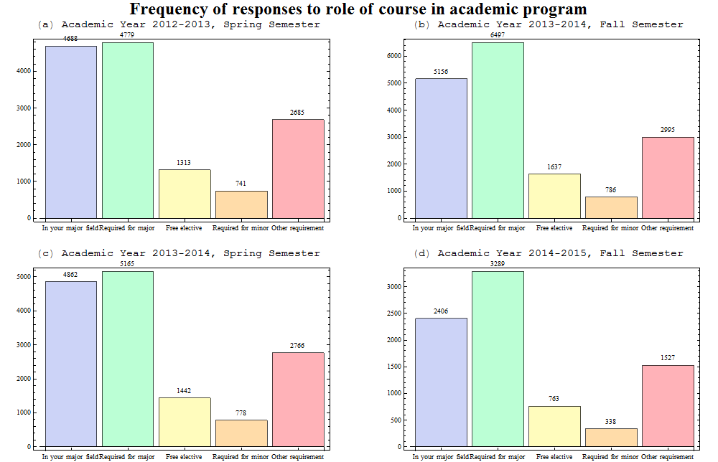
Figure 3 Showing the semester breakdown of the distribution of how the course was related to their academic program, for all departments for Academic years 2012-13 to 2014-15

Figure 3 above shows that a larger proportion of students take courses as a major requirement than as a field in their major during fall semesters rather than spring semesters. The larger proportion of students taking courses as a major requirement may be evidence that more students attempt to take major requirements during fall semesters than during spring semesters, possibly from how classes are chosen by incoming freshmen. Figure 3 shoes the only distribution with a noteworthy difference between fall and spring semesters when course evaluation data from all the departments were plotted. The difference was however small, with about 29% of students enrolling in courses within their major field in fall semesters, as compared to about 33% in spring semesters, a difference of only 4%.
A summary of the information from the histogram plots of the data from all departments is given in the following tables.
 | All Departments | Academic Years 2012-2015
Question | Question Description | Median | 25th Percentile | 75th Percentile | Interquartile Range
1 | My overall rating of the quality of this course is | 4.27 | 3.85 | 4.56 | 0.71
2 | My overall rating of the instructor's teaching is | 4.30 | 3.82 | 4.62 | 0.80
3 | The educational value of the textbook and/or assigned reading was | 3.87 | 3.47 | 4.19 | 0.72
4 | The educational value of the assigned work was | 4.23 | 3.92 | 4.50 | 0.58
5 | The instructor's organization of the course was | 4.29 | 3.88 | 4.56 | 0.68
6 | The instructor's clarity in communicating course objectives was | 4.29 | 3.88 | 4.58 | 0.69
7 | The instructor's skill in providing understandable explanations was | 4.33 | 3.86 | 4.64 | 0.78
8 | The instructor's skill in speaking clearly and audibly was | 4.61 | 4.27 | 4.81 | 0.54
9 | The amount I learned from the course was | 4.00 | 3.63 | 4.30 | 0.68
10 | The intellectual challenge presented by the course was | 3.94 | 3.56 | 4.25 | 0.69
11 | The instructor's personal interest in helping students learn was | 4.25 | 3.89 | 4.53 | 0.64
12 | The instructor stimulated my interest in the subject matter | 4.00 | 3.56 | 4.36 | 0.80
13 | The instructor encouraged communication outside of regular contact hours | 3.97 | 3.58 | 4.30 | 0.72
14 | The amount of reading, homework, and other assigned work was | 3.79 | 3.44 | 4.13 | 0.69
15 | My attendance and participation for this course was | 4.10 | 3.85 | 4.33 | 0.49
16 | The amount of effort I put into this course was | 4.05 | 3.74 | 4.33 | 0.60
17 | The instructor was well prepared to teach class. | 4.68 | 4.42 | 4.85 | 0.43
18 | My instructor used course time effectively. | 4.50 | 4.14 | 4.72 | 0.58
19 | The instructor encouraged students to ask questions. | 4.59 | 4.30 | 4.80 | 0.50
20 | The instructor treated students with respect. | 4.75 | 4.52 | 4.88 | 0.37
21 | Instructor feedback on exams/assignments was timely and helpful. | 4.29 | 3.89 | 4.58 | 0.69
22 | The exams and/or evaluations were good measures of the material covered. | 4.33 | 4.00 | 4.59 | 0.59
23 | My grades were determined in a fair and impartial manner. | 4.55 | 4.29 | 4.75 | 0.46
24 | What grade do you think you will receive in this course? | 1.91 | 1.57 | 2.25 | 0.68
25 | Which of the following best describes the role of this course in your academic program? | 2.13 | 1.63 | 3.25 | 1.62
26A | On average, how many hours of the formally scheduled hours for lecture, conference, and labs did you ATTEND each week? | 2.48 | 2.07 | 3.50 | 1.43
26B | On average, what were the total hours spent in each 7-day week OUTSIDE of formally scheduled class time in work related to this course (including studying, reading, writing, homework, rehearsal, etc)? | 3.00 | 2.62 | 3.47 | 0.85
Table1 Showing the median, 25th percentile, 75th percentile, and interquartile range for the frequency distribution of all departments for each question for Academic years 2012-15

 | All Departments | Academic Year 2012-2013 Spring Semester
Question | Question Description | Median | 25th Percentile | 75th Percentile | Interquartile Range
1 | My overall rating of the quality of this course is | 4.27 | 3.85 | 4.57 | 0.73
2 | My overall rating of the instructor's teaching is | 4.30 | 3.81 | 4.64 | 0.82
3 | The educational value of the textbook and/or assigned reading was | 3.89 | 3.45 | 4.23 | 0.78
4 | The educational value of the assigned work was | 4.25 | 3.91 | 4.51 | 0.60
5 | The instructor's organization of the course was | 4.29 | 3.88 | 4.57 | 0.70
6 | The instructor's clarity in communicating course objectives was | 4.30 | 3.88 | 4.59 | 0.71
7 | The instructor's skill in providing understandable explanations was | 4.33 | 3.86 | 4.67 | 0.81
8 | The instructor's skill in speaking clearly and audibly was | 4.62 | 4.31 | 4.81 | 0.50
9 | The amount I learned from the course was | 4.00 | 3.67 | 4.33 | 0.67
10 | The intellectual challenge presented by the course was | 3.94 | 3.56 | 4.25 | 0.69
11 | The instructor's personal interest in helping students learn was | 4.23 | 3.83 | 4.50 | 0.67
12 | The instructor stimulated my interest in the subject matter | 4.02 | 3.56 | 4.37 | 0.81
13 | The instructor encouraged communication outside of regular contact hours | 3.94 | 3.55 | 4.27 | 0.72
14 | The amount of reading, homework, and other assigned work was | 3.78 | 3.43 | 4.12 | 0.69
15 | My attendance and participation for this course was | 4.09 | 3.82 | 4.38 | 0.56
16 | The amount of effort I put into this course was | 4.03 | 3.72 | 4.33 | 0.62
17 | The instructor was well prepared to teach class. | 4.67 | 4.40 | 4.84 | 0.44
18 | My instructor used course time effectively. | 4.46 | 4.14 | 4.73 | 0.59
19 | The instructor encouraged students to ask questions. | 4.59 | 4.27 | 4.80 | 0.53
20 | The instructor treated students with respect. | 4.73 | 4.50 | 4.88 | 0.38
21 | Instructor feedback on exams/assignments was timely and helpful. | 4.28 | 3.88 | 4.58 | 0.71
22 | The exams and/or evaluations were good measures of the material covered. | 4.33 | 3.95 | 4.58 | 0.63
23 | My grades were determined in a fair and impartial manner. | 4.56 | 4.28 | 4.75 | 0.47
24 | What grade do you think you will receive in this course? | 1.89 | 1.56 | 2.25 | 0.69
25 | Which of the following best describes the role of this course in your academic program? | 2.13 | 1.60 | 3.07 | 1.47
26A | On average, how many hours of the formally scheduled hours for lecture, conference, and labs did you ATTEND each week? | 2.50 | 2.13 | 3.50 | 1.38
26B | On average, what were the total hours spent in each 7-day week OUTSIDE of formally scheduled class time in work related to this course (including studying, reading, writing, homework, rehearsal, etc)? | 3.00 | 2.65 | 3.44 | 0.79
Table2 Showing the median, 25th percentile, 75th percentile, and interquartile range for the frequency distribution of all departments for each question for Academic Year 2012-2013 Spring Semester
 | All Departments | Academic Year 2013-2014 Fall Semester
Question | Question Description | Median | 25th Percentile | 75th Percentile | Interquartile Range
1 | My overall rating of the quality of this course is | 4.30 | 3.85 | 4.57 | 0.73
2 | My overall rating of the instructor's teaching is | 4.36 | 3.83 | 4.64 | 0.81
3 | The educational value of the textbook and/or assigned reading was | 3.89 | 3.50 | 4.21 | 0.71
4 | The educational value of the assigned work was | 4.23 | 3.90 | 4.50 | 0.60
5 | The instructor's organization of the course was | 4.33 | 3.95 | 4.59 | 0.64
6 | The instructor's clarity in communicating course objectives was | 4.33 | 3.92 | 4.60 | 0.68
7 | The instructor's skill in providing understandable explanations was | 4.38 | 3.90 | 4.64 | 0.75
8 | The instructor's skill in speaking clearly and audibly was | 4.59 | 4.27 | 4.81 | 0.54
9 | The amount I learned from the course was | 4.00 | 3.63 | 4.33 | 0.70
10 | The intellectual challenge presented by the course was | 3.96 | 3.61 | 4.29 | 0.68
11 | The instructor's personal interest in helping students learn was | 4.30 | 3.94 | 4.57 | 0.63
12 | The instructor stimulated my interest in the subject matter | 4.00 | 3.58 | 4.38 | 0.80
13 | The instructor encouraged communication outside of regular contact hours | 4.00 | 3.63 | 4.33 | 0.70
14 | The amount of reading, homework, and other assigned work was | 3.79 | 3.44 | 4.13 | 0.68
15 | My attendance and participation for this course was | 4.14 | 3.87 | 4.38 | 0.51
16 | The amount of effort I put into this course was | 4.06 | 3.78 | 4.36 | 0.58
17 | The instructor was well prepared to teach class. | 4.72 | 4.48 | 4.86 | 0.39
18 | My instructor used course time effectively. | 4.53 | 4.17 | 4.75 | 0.58
19 | The instructor encouraged students to ask questions. | 4.60 | 4.33 | 4.80 | 0.47
20 | The instructor treated students with respect. | 4.76 | 4.57 | 4.90 | 0.33
21 | Instructor feedback on exams/assignments was timely and helpful. | 4.32 | 3.96 | 4.61 | 0.65
22 | The exams and/or evaluations were good measures of the material covered. | 4.37 | 4.00 | 4.62 | 0.62
23 | My grades were determined in a fair and impartial manner. | 4.57 | 4.32 | 4.78 | 0.46
24 | What grade do you think you will receive in this course? | 1.92 | 1.57 | 2.26 | 0.69
25 | Which of the following best describes the role of this course in your academic program? | 2.11 | 1.67 | 3.42 | 1.75
26A | On average, how many hours of the formally scheduled hours for lecture, conference, and labs did you ATTEND each week? | 2.50 | 2.06 | 3.36 | 1.30
26B | On average, what were the total hours spent in each 7-day week OUTSIDE of formally scheduled class time in work related to this course (including studying, reading, writing, homework, rehearsal, etc)? | 3.00 | 2.67 | 3.50 | 0.83
Table3 Showing the median, 25th percentile, 75th percentile, and interquartile range for the frequency distribution of all departments for each question for Academic Year 2013-2014 Fall Semester

 | All Departments | Academic Year 2013-2014 Semester 2
Question | Question Description | Median | 25th Percentile | 75th Percentile | Interquartile Range
1 | My overall rating of the quality of this course is | 4.25 | 3.88 | 4.55 | 0.68
2 | My overall rating of the instructor's teaching is | 4.25 | 3.81 | 4.62 | 0.81
3 | The educational value of the textbook and/or assigned reading was | 3.88 | 3.50 | 4.18 | 0.68
4 | The educational value of the assigned work was | 4.24 | 3.93 | 4.50 | 0.57
5 | The instructor's organization of the course was | 4.25 | 3.88 | 4.55 | 0.67
6 | The instructor's clarity in communicating course objectives was | 4.27 | 3.88 | 4.58 | 0.70
7 | The instructor's skill in providing understandable explanations was | 4.31 | 3.87 | 4.64 | 0.77
8 | The instructor's skill in speaking clearly and audibly was | 4.63 | 4.25 | 4.82 | 0.57
9 | The amount I learned from the course was | 4.00 | 3.63 | 4.27 | 0.64
10 | The intellectual challenge presented by the course was | 3.90 | 3.52 | 4.23 | 0.71
11 | The instructor's personal interest in helping students learn was | 4.24 | 3.89 | 4.52 | 0.63
12 | The instructor stimulated my interest in the subject matter | 4.00 | 3.55 | 4.37 | 0.82
13 | The instructor encouraged communication outside of regular contact hours | 4.00 | 3.57 | 4.33 | 0.76
14 | The amount of reading, homework, and other assigned work was | 3.81 | 3.44 | 4.13 | 0.70
15 | My attendance and participation for this course was | 4.08 | 3.82 | 4.33 | 0.51
16 | The amount of effort I put into this course was | 4.00 | 3.70 | 4.30 | 0.60
17 | The instructor was well prepared to teach class. | 4.65 | 4.40 | 4.85 | 0.45
18 | My instructor used course time effectively. | 4.46 | 4.13 | 4.70 | 0.57
19 | The instructor encouraged students to ask questions. | 4.58 | 4.30 | 4.79 | 0.49
20 | The instructor treated students with respect. | 4.73 | 4.50 | 4.88 | 0.38
21 | Instructor feedback on exams/assignments was timely and helpful. | 4.28 | 3.86 | 4.59 | 0.73
22 | The exams and/or evaluations were good measures of the material covered. | 4.33 | 4.00 | 4.62 | 0.62
23 | My grades were determined in a fair and impartial manner. | 4.55 | 4.29 | 4.76 | 0.46
24 | What grade do you think you will receive in this course? | 1.90 | 1.60 | 2.25 | 0.65
25 | Which of the following best describes the role of this course in your academic program? | 2.20 | 1.64 | 3.15 | 1.51
26A | On average, how many hours of the formally scheduled hours for lecture, conference, and labs did you ATTEND each week? | 2.40 | 2.04 | 3.46 | 1.42
26B | On average, what were the total hours spent in each 7-day week OUTSIDE of formally scheduled class time in work related to this course (including studying, reading, writing, homework, rehearsal, etc)? | 2.92 | 2.56 | 3.42 | 0.86
Table4 Showing the median, 25th percentile, 75th percentile, and interquartile range for the frequency distribution of all departments for each question for Academic Year 2013-2014 Spring Semester

 | All Departments | Academic Year 2014-2015 Fall Semester
Question | Question Description | Median | 25th Percentile | 75th Percentile | Interquartile Range
1 | My overall rating of the quality of this course is | 4.21 | 3.82 | 4.50 | 0.68
2 | My overall rating of the instructor's teaching is | 4.24 | 3.81 | 4.55 | 0.74
3 | The educational value of the textbook and/or assigned reading was | 3.78 | 3.40 | 4.06 | 0.66
4 | The educational value of the assigned work was | 4.20 | 3.92 | 4.44 | 0.52
5 | The instructor's organization of the course was | 4.23 | 3.81 | 4.50 | 0.69
6 | The instructor's clarity in communicating course objectives was | 4.22 | 3.86 | 4.50 | 0.64
7 | The instructor's skill in providing understandable explanations was | 4.25 | 3.82 | 4.53 | 0.71
8 | The instructor's skill in speaking clearly and audibly was | 4.58 | 4.25 | 4.79 | 0.54
9 | The amount I learned from the course was | 4.00 | 3.57 | 4.26 | 0.69
10 | The intellectual challenge presented by the course was | 3.96 | 3.57 | 4.27 | 0.70
11 | The instructor's personal interest in helping students learn was | 4.25 | 3.84 | 4.46 | 0.62
12 | The instructor stimulated my interest in the subject matter | 4.00 | 3.57 | 4.29 | 0.72
13 | The instructor encouraged communication outside of regular contact hours | 3.92 | 3.58 | 4.20 | 0.62
14 | The amount of reading, homework, and other assigned work was | 3.79 | 3.44 | 4.16 | 0.72
15 | My attendance and participation for this course was | 4.10 | 3.86 | 4.28 | 0.42
16 | The amount of effort I put into this course was | 4.05 | 3.75 | 4.33 | 0.58
17 | The instructor was well prepared to teach class. | 4.69 | 4.40 | 4.83 | 0.43
18 | My instructor used course time effectively. | 4.48 | 4.13 | 4.70 | 0.57
19 | The instructor encouraged students to ask questions. | 4.57 | 4.28 | 4.76 | 0.48
20 | The instructor treated students with respect. | 4.76 | 4.50 | 4.88 | 0.38
21 | Instructor feedback on exams/assignments was timely and helpful. | 4.25 | 3.85 | 4.53 | 0.68
22 | The exams and/or evaluations were good measures of the material covered. | 4.26 | 3.94 | 4.51 | 0.57
23 | My grades were determined in a fair and impartial manner. | 4.50 | 4.25 | 4.74 | 0.49
24 | What grade do you think you will receive in this course? | 2.00 | 1.61 | 2.29 | 0.68
25 | Which of the following best describes the role of this course in your academic program? | 2.10 | 1.65 | 3.50 | 1.85
26A | On average, how many hours of the formally scheduled hours for lecture, conference, and labs did you ATTEND each week? | 2.59 | 2.10 | 3.70 | 1.60
26B | On average, what were the total hours spent in each 7-day week OUTSIDE of formally scheduled class time in work related to this course (including studying, reading, writing, homework, rehearsal, etc)? | 3.00 | 2.64 | 3.60 | 0.97
Table5 Showing the median, 25th percentile, 75th percentile, and interquartile range for the frequency distribution of all departments for each question for Academic Year 2014-2015 Fall Semester

Analysis of Physics Courses at WPI
Information from the physics courses at WPI were used for analysis in this section of the document. The analysis done for all the departments was used as a basis for analysis of physics courses at WPI.
Much like the distributions of the data from all the departments, many of the distributions of the physics courses appeared similar. Many of the distributions however differed from one another depending on whether the courses were taken in the spring or fall semester, with the fall semester medians lower in all the questions of sections 1-3 which showed this difference. The difference between the spring and fall semesters was most likely due to the increased frequency of course enrolments in the fall semester than in the spring semester. Fall semester medians were lower for questions 1, 2, 4 through 9, 11, 13 and 17 to 21 as can be seen in tables 6 through 9. Since there was a 98% response rate to course evaluations, it is fair to make the assumption that the number of responses closely represents the number of enrolments in a course.
With this assumption, it can be said that strain on faculty resources may have resulted in lower course quality, since there were almost twice the number of students enrolling in physics courses in fall semesters than in spring semesters, with an average of 569.5 responses occurred in spring semesters vs an average of 936 in the fall semesters. Strain on faculty resources may also explain why questions pertaining to instructor ratings would be lower in the fall semester than in the spring semester since the student to instructor ratio would double in this period. One can freely assume that majority of the increased fall enrolments are in 1000 level courses, since there is a noticeably greater number of sections in the fall semester of these courses than spring semester.

 | Physics | Academic Years 2012-2015
Question | Question  Description | Median | 25th  Percentile | 75th  Percentile | Interquartile Range
1 | My overall rating of the quality of this course is | 4.00 | 3.57 | 4.36 | 0.79
2 | My overall rating of the instructor's teaching is | 4.00 | 3.50 | 4.50 | 1.00
3 | The educational value of the textbook and/or assigned reading was | 3.62 | 3.20 | 4.00 | 0.80
4 | The educational value of the assigned work was | 3.99 | 3.71 | 4.34 | 0.64
5 | The instructor's organization of the course was | 4.11 | 3.70 | 4.47 | 0.77
6 | The instructor's clarity in communicating course objectives was | 4.00 | 3.60 | 4.50 | 0.90
7 | The instructor's skill in providing understandable explanations was | 3.90 | 3.46 | 4.40 | 0.95
8 | The instructor's skill in speaking clearly and audibly was | 4.39 | 3.86 | 4.71 | 0.86
9 | The amount I learned from the course was | 3.72 | 3.39 | 4.17 | 0.77
10 | The intellectual challenge presented by the course was | 4.14 | 3.92 | 4.43 | 0.51
11 | The instructor's personal interest in helping students learn was | 4.03 | 3.72 | 4.36 | 0.64
12 | The instructor stimulated my interest in the subject matter | 3.62 | 3.27 | 4.20 | 0.93
13 | The instructor encouraged communication outside of regular contact hours | 3.82 | 3.48 | 4.20 | 0.72
14 | The amount of reading, homework, and other assigned work was | 3.77 | 3.50 | 4.01 | 0.51
15 | My attendance and participation for this course was | 4.01 | 3.76 | 4.20 | 0.45
16 | The amount of effort I put into this course was | 4.00 | 3.83 | 4.31 | 0.48
17 | The instructor was well prepared to teach class. | 4.56 | 4.21 | 4.81 | 0.60
18 | My instructor used course time effectively. | 4.34 | 3.91 | 4.64 | 0.73
19 | The instructor encouraged students to ask questions. | 4.40 | 4.00 | 4.67 | 0.67
20 | The instructor treated students with respect. | 4.66 | 4.40 | 4.85 | 0.45
21 | Instructor feedback on exams/assignments was timely and helpful. | 4.06 | 3.71 | 4.44 | 0.73
22 | The exams and/or evaluations were good measures of the material covered. | 4.11 | 3.60 | 4.50 | 0.90
23 | My grades were determined in a fair and impartial manner. | 4.44 | 4.08 | 4.75 | 0.67
24 | What grade do you think you will receive in this course? | 2.33 | 1.95 | 2.63 | 0.68
25 | Which of the following best describes the role of this course in your  academic program? | 2.20 | 1.96 | 2.49 | 0.53
26A | On average, how many hours of the formally scheduled hours for  lecture, conference, and labs did you ATTEND each week? | 4.26 | 2.20 | 4.58 | 2.38
26B | On average, what were the total hours spent in each 7-day week OUTSIDE of formally scheduled class time in work related to this course (including studying, reading, writing, homework, rehearsal, etc)? | 3.13 | 2.83 | 3.49 | 0.66
Table6 Showing the median, 25th percentile, 75th percentile, and interquartile range for the frequency distribution of physics for each question for Academic years 2012-15

 | Physics | Academic Year 2012-2013 Spring Semester
Question | Question  Description | Median | 25th  Percentile | 75th  Percentile | Interquartile Range
1 | My overall rating of the quality of this course is | 4.35 | 3.80 | 4.60 | 0.80
2 | My overall rating of the instructor's teaching is | 4.46 | 3.78 | 4.74 | 0.96
3 | The educational value of the textbook and/or assigned reading was | 3.63 | 3.13 | 4.36 | 1.23
4 | The educational value of the assigned work was | 4.25 | 3.78 | 4.58 | 0.80
5 | The instructor's organization of the course was | 4.31 | 3.90 | 4.50 | 0.60
6 | The instructor's clarity in communicating course objectives was | 4.30 | 3.89 | 4.60 | 0.71
7 | The instructor's skill in providing understandable explanations was | 4.39 | 3.77 | 4.71 | 0.95
8 | The instructor's skill in speaking clearly and audibly was | 4.59 | 4.41 | 4.80 | 0.39
9 | The amount I learned from the course was | 4.03 | 3.43 | 4.20 | 0.77
10 | The intellectual challenge presented by the course was | 4.18 | 3.92 | 4.56 | 0.64
11 | The instructor's personal interest in helping students learn was | 4.21 | 3.78 | 4.40 | 0.62
12 | The instructor stimulated my interest in the subject matter | 4.11 | 3.31 | 4.39 | 1.09
13 | The instructor encouraged communication outside of regular contact hours | 3.94 | 3.67 | 4.17 | 0.51
14 | The amount of reading, homework, and other assigned work was | 3.74 | 3.35 | 4.18 | 0.83
15 | My attendance and participation for this course was | 4.00 | 3.69 | 4.14 | 0.45
16 | The amount of effort I put into this course was | 4.00 | 3.70 | 4.24 | 0.54
17 | The instructor was well prepared to teach class. | 4.74 | 4.49 | 4.86 | 0.37
18 | My instructor used course time effectively. | 4.36 | 4.18 | 4.71 | 0.53
19 | The instructor encouraged students to ask questions. | 4.61 | 4.39 | 4.90 | 0.50
20 | The instructor treated students with respect. | 4.77 | 4.51 | 4.96 | 0.45
21 | Instructor feedback on exams/assignments was timely and helpful. | 4.37 | 3.93 | 4.65 | 0.73
22 | The exams and/or evaluations were good measures of the material covered. | 4.45 | 4.06 | 4.59 | 0.53
23 | My grades were determined in a fair and impartial manner. | 4.63 | 4.35 | 4.85 | 0.50
24 | What grade do you think you will receive in this course? | 2.13 | 1.60 | 2.54 | 0.94
25 | Which of the following best describes the role of this course in your  academic program? | 2.26 | 1.84 | 2.50 | 0.66
26A | On average, how many hours of the formally scheduled hours for  lecture, conference, and labs did you ATTEND each week? | 2.93 | 2.03 | 4.41 | 2.38
26B | On average, what were the total hours spent in each 7-day week OUTSIDE of formally scheduled class time in work related to this course (including studying, reading, writing, homework, rehearsal, etc)? | 3.15 | 2.83 | 3.58 | 0.75
Table7 Showing the median, 25th percentile, 75th percentile, and interquartile range for the frequency distribution of physics for each question for Academic Year 2012-2013 Spring Semester

 | Physics | Academic Year 2013-2014 Fall Semester
Question | Question  Description | Median | 25th  Percentile | 75th  Percentile | Interquartile Range
1 | My overall rating of the quality of this course is | 3.83 | 3.50 | 4.09 | 0.59
2 | My overall rating of the instructor's teaching is | 3.70 | 3.25 | 4.25 | 1.00
3 | The educational value of the textbook and/or assigned reading was | 3.62 | 3.29 | 3.89 | 0.60
4 | The educational value of the assigned work was | 3.92 | 3.67 | 4.08 | 0.42
5 | The instructor's organization of the course was | 3.93 | 3.64 | 4.36 | 0.72
6 | The instructor's clarity in communicating course objectives was | 3.83 | 3.56 | 4.26 | 0.70
7 | The instructor's skill in providing understandable explanations was | 3.77 | 3.35 | 4.25 | 0.90
8 | The instructor's skill in speaking clearly and audibly was | 4.27 | 3.73 | 4.66 | 0.93
9 | The amount I learned from the course was | 3.63 | 3.36 | 3.91 | 0.55
10 | The intellectual challenge presented by the course was | 4.08 | 3.87 | 4.38 | 0.51
11 | The instructor's personal interest in helping students learn was | 3.92 | 3.75 | 4.27 | 0.52
12 | The instructor stimulated my interest in the subject matter | 3.50 | 3.18 | 3.74 | 0.56
13 | The instructor encouraged communication outside of regular contact hours | 3.77 | 3.46 | 4.14 | 0.68
14 | The amount of reading, homework, and other assigned work was | 3.71 | 3.52 | 4.01 | 0.49
15 | My attendance and participation for this course was | 4.02 | 3.65 | 4.23 | 0.57
16 | The amount of effort I put into this course was | 4.00 | 3.82 | 4.27 | 0.45
17 | The instructor was well prepared to teach class. | 4.43 | 3.96 | 4.73 | 0.77
18 | My instructor used course time effectively. | 4.21 | 3.62 | 4.51 | 0.89
19 | The instructor encouraged students to ask questions. | 4.31 | 4.00 | 4.50 | 0.50
20 | The instructor treated students with respect. | 4.63 | 4.39 | 4.72 | 0.33
21 | Instructor feedback on exams/assignments was timely and helpful. | 4.00 | 3.73 | 4.29 | 0.56
22 | The exams and/or evaluations were good measures of the material covered. | 3.87 | 3.50 | 4.23 | 0.72
23 | My grades were determined in a fair and impartial manner. | 4.31 | 4.01 | 4.58 | 0.57
24 | What grade do you think you will receive in this course? | 2.32 | 2.00 | 2.52 | 0.52
25 | Which of the following best describes the role of this course in your  academic program? | 2.17 | 2.00 | 2.30 | 0.30
26A | On average, how many hours of the formally scheduled hours for  lecture, conference, and labs did you ATTEND each week? | 4.43 | 2.60 | 4.70 | 2.10
26B | On average, what were the total hours spent in each 7-day week OUTSIDE of formally scheduled class time in work related to this course (including studying, reading, writing, homework, rehearsal, etc)? | 3.07 | 2.83 | 3.41 | 0.58
Table8 Showing the median, 25th percentile, 75th percentile, and interquartile range for the frequency distribution of physics for each question for Academic Year 2013-2014 Fall Semester
 | Physics | Academic Year 2013-2014 Semester 2
Figure | Question  Description | Median | 25th  Percentile | 75th  Percentile | Interquartile Range
1 | My overall rating of the quality of this course is | 4.15 | 3.91 | 4.59 | 0.67
2 | My overall rating of the instructor's teaching is | 4.19 | 3.88 | 4.65 | 0.78
3 | The educational value of the textbook and/or assigned reading was | 3.72 | 3.36 | 4.07 | 0.71
4 | The educational value of the assigned work was | 4.17 | 3.86 | 4.54 | 0.68
5 | The instructor's organization of the course was | 4.25 | 3.84 | 4.59 | 0.75
6 | The instructor's clarity in communicating course objectives was | 4.21 | 3.89 | 4.59 | 0.70
7 | The instructor's skill in providing understandable explanations was | 4.06 | 3.76 | 4.51 | 0.76
8 | The instructor's skill in speaking clearly and audibly was | 4.54 | 4.00 | 4.77 | 0.77
9 | The amount I learned from the course was | 3.92 | 3.65 | 4.33 | 0.69
10 | The intellectual challenge presented by the course was | 4.14 | 3.91 | 4.48 | 0.56
11 | The instructor's personal interest in helping students learn was | 4.31 | 4.00 | 4.50 | 0.50
12 | The instructor stimulated my interest in the subject matter | 3.85 | 3.45 | 4.37 | 0.92
13 | The instructor encouraged communication outside of regular contact hours | 4.16 | 3.78 | 4.37 | 0.59
14 | The amount of reading, homework, and other assigned work was | 3.83 | 3.53 | 4.01 | 0.49
15 | My attendance and participation for this course was | 4.09 | 3.75 | 4.28 | 0.53
16 | The amount of effort I put into this course was | 4.13 | 3.85 | 4.35 | 0.50
17 | The instructor was well prepared to teach class. | 4.74 | 4.33 | 4.85 | 0.52
18 | My instructor used course time effectively. | 4.58 | 4.23 | 4.73 | 0.50
19 | The instructor encouraged students to ask questions. | 4.64 | 4.39 | 4.77 | 0.38
20 | The instructor treated students with respect. | 4.79 | 4.66 | 4.93 | 0.27
21 | Instructor feedback on exams/assignments was timely and helpful. | 4.36 | 3.85 | 4.62 | 0.77
22 | The exams and/or evaluations were good measures of the material covered. | 4.29 | 3.95 | 4.63 | 0.69
23 | My grades were determined in a fair and impartial manner. | 4.69 | 4.36 | 4.81 | 0.45
24 | What grade do you think you will receive in this course? | 2.19 | 1.80 | 2.76 | 0.96
25 | Which of the following best describes the role of this course in your  academic program? | 2.40 | 2.00 | 2.90 | 0.90
26 | On average, how many hours of the formally scheduled hours for  lecture, conference, and labs did you ATTEND each week? | 3.29 | 1.96 | 4.45 | 2.49
27 | On average, what were the total hours spent in each 7-day week OUTSIDE of formally scheduled class time in work related to this course (including studying, reading, writing, homework, rehearsal, etc)? | 3.00 | 2.75 | 3.34 | 0.59
Table9 Showing the median, 25th percentile, 75th percentile, and interquartile range for the frequency distribution of physics for each question for Academic Year 2013-2014 Spring Semester

 | Physics | Academic Year 2014-2015 Semester 1
Figure | Question  Description | Median | 25th  Percentile | 75th  Percentile | Interquartile Range
1 | My overall rating of the quality of this course is | 3.72 | 3.21 | 3.96 | 0.76
2 | My overall rating of the instructor's teaching is | 3.66 | 2.96 | 4.00 | 1.04
3 | The educational value of the textbook and/or assigned reading was | 3.36 | 2.89 | 3.63 | 0.73
4 | The educational value of the assigned work was | 3.77 | 3.68 | 4.17 | 0.49
5 | The instructor's organization of the course was | 3.84 | 3.65 | 4.05 | 0.39
6 | The instructor's clarity in communicating course objectives was | 3.73 | 3.25 | 3.93 | 0.69
7 | The instructor's skill in providing understandable explanations was | 3.63 | 2.93 | 4.01 | 1.08
8 | The instructor's skill in speaking clearly and audibly was | 4.05 | 3.61 | 4.37 | 0.76
9 | The amount I learned from the course was | 3.48 | 3.33 | 3.73 | 0.40
10 | The intellectual challenge presented by the course was | 4.17 | 3.95 | 4.43 | 0.48
11 | The instructor's personal interest in helping students learn was | 3.71 | 3.14 | 3.94 | 0.80
12 | The instructor stimulated my interest in the subject matter | 3.36 | 2.91 | 3.75 | 0.84
13 | The instructor encouraged communication outside of regular contact hours | 3.39 | 3.17 | 3.66 | 0.50
14 | The amount of reading, homework, and other assigned work was | 3.83 | 3.51 | 4.00 | 0.49
15 | My attendance and participation for this course was | 4.04 | 3.94 | 4.18 | 0.25
16 | The amount of effort I put into this course was | 4.09 | 3.86 | 4.33 | 0.47
17 | The instructor was well prepared to teach class. | 4.38 | 4.19 | 4.58 | 0.38
18 | My instructor used course time effectively. | 4.08 | 3.82 | 4.60 | 0.77
19 | The instructor encouraged students to ask questions. | 3.95 | 3.28 | 4.23 | 0.95
20 | The instructor treated students with respect. | 4.43 | 3.70 | 4.70 | 1.00
21 | Instructor feedback on exams/assignments was timely and helpful. | 3.83 | 3.36 | 4.04 | 0.67
22 | The exams and/or evaluations were good measures of the material covered. | 3.79 | 3.44 | 4.21 | 0.76
23 | My grades were determined in a fair and impartial manner. | 4.00 | 3.71 | 4.47 | 0.76
24 | What grade do you think you will receive in this course? | 2.46 | 2.33 | 2.68 | 0.35
25 | Which of the following best describes the role of this course in your  academic program? | 2.13 | 1.96 | 2.25 | 0.29
26 | On average, how many hours of the formally scheduled hours for  lecture, conference, and labs did you ATTEND each week? | 4.48 | 4.21 | 4.64 | 0.43
27 | On average, what were the total hours spent in each 7-day week OUTSIDE of formally scheduled class time in work related to this course (including studying, reading, writing, homework, rehearsal, etc)? | 3.34 | 3.02 | 3.72 | 0.70
Table10 Showing the median, 25th percentile, 75th percentile, and interquartile range for the frequency distribution of physics for each question for Academic Year 2014-2015 Fall Semester
Further evidence that the most of the increased enrolments in the fall semesters are in 1000 level physics courses can be seen through closer inspection of the table of correlation coefficients . The table of correlation coefficients shows that a majority the questions are weakly and moderately correlated with the number of formally scheduled course hours attended (Question 26A) in physics, but show none or almost no correlation with question 26A in general for all departments. Adding to the fact that all the 1000 level courses in the physics department have 7 hours a week of scheduled course time, where PH 2651 is the only physics course above the 1000 level having more than 4 hours of scheduled course time per week, It is obvious that that the lower performance of physics courses in the fall semester is correlated with greater enrolments in the fall semester.

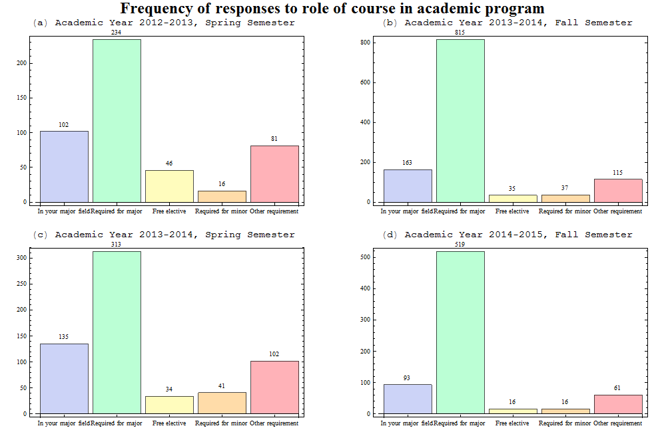
Figure 4 Showing the semester breakdown of the distribution of how the course was related to their academic program, for the physics department for Academic years 2012-13 to 2014-15
Figure 4 shows that much like the distribution of the data from all departments for the role that the course played in the student’s academic program (figure 3), the fall semester showed a greater enrolment proportion of students who took courses as a major requirement than during the spring semesters. Further comparison between figure 4 and figure 3 showed that there was however a much larger percentage in physics than in general for all departments, with 22% difference in enrolment of students taking courses as a major requirement between the two semesters, compared to only a 4% difference in general for all departments. The resulting difference in enrolment between semesters in physics courses is possibly due to a larger number of freshmen students attempting to complete their physics or basic science requirement during their first semester of WPI, since this is commonly recommended for many majors on the WPI designs page. One may thus argue that there exist the possibility that incoming freshmen rank courses lower because of the greater intellectual challenge, or greater the amount of they are given in college courses, but the table of correlation coefficients show that students opinions of these factors have little or no correlation between the their opinion of the course quality.

Comparison of Physics to Courses from All Departments
The information gathered for physics courses and courses in general at WPI were used to compare and contrasts similarities and differences between the two in this section. The data from all courses was subdivided into two other groups of STEM and other in order to allow for further comparison.* Scatterplots and correlation data was found in order to examine the difference in the importance of factors in course evaluations between the groups.

* The category STEM includes all engineering courses, along with Interactive Media and Art Design (IMGD), Computer Science (CS), and the basic and natural sciences. The ‘Other’ section contain the business, finance, social science arts, R.O.T.C. and all other courses available at WPI.
Table of Correlation Coefficients:
The following are tables of correlation coefficients for the questions plotted in the scatterplots. Question combinations with p-values less than the significance level are shaded. Combinations with strong correlations are shaded darker.
 | Physics
All Departments | Question | 1 | 2 | 3 | 4 | 5 | 6 | 7 | 8 | 9 | 10 | 11 | 12 | 13
 | 1 |  | 0.93 | 0.62 | 0.81 | 0.84 | 0.90 | 0.90 | 0.65 | 0.85 | 0.11 | 0.75 | 0.85 | 0.60
 | 2 | 0.45 |  | 0.54 | 0.74 | 0.87 | 0.91 | 0.95 | 0.72 | 0.79 | 0.17 | 0.79 | 0.82 | 0.63
 | 3 | 0.20 | 0.19 |  | 0.65 | 0.49 | 0.62 | 0.58 | 0.43 | 0.62 | 0.15 | 0.52 | 0.67 | 0.47
 | 4 | 0.27 | 0.21 | 0.39 |  | 0.74 | 0.73 | 0.72 | 0.52 | 0.77 | 0.16 | 0.59 | 0.73 | 0.50
 | 5 | 0.47 | 0.79 | 0.17 | 0.21 |  | 0.87 | 0.84 | 0.62 | 0.75 | 0.21 | 0.66 | 0.69 | 0.56
 | 6 | 0.42 | 0.90 | 0.18 | 0.21 | 0.80 |  | 0.93 | 0.75 | 0.79 | 0.21 | 0.78 | 0.82 | 0.65
 | 7 | 0.75 | 0.31 | 0.28 | 0.37 | 0.32 | 0.29 |  | 0.77 | 0.76 | 0.19 | 0.76 | 0.83 | 0.64
 | 8 | 0.37 | 0.74 | 0.15 | 0.18 | 0.55 | 0.73 | 0.29 |  | 0.62 | 0.36 | 0.59 | 0.64 | 0.48
 | 9 | 0.82 | 0.37 | 0.17 | 0.24 | 0.38 | 0.35 | 0.61 | 0.31 |  | 0.36 | 0.70 | 0.83 | 0.55
 | 10 | 0.18 | 0.15 | 0.12 | 0.35 | 0.16 | 0.14 | 0.09 | 0.10 | 0.29 |  | 0.11 | 0.19 | 0.17
 | 11 | 0.38 | 0.80 | 0.16 | 0.18 | 0.63 | 0.74 | 0.26 | 0.62 | 0.34 | 0.17 |  | 0.79 | 0.82
 | 12 | 0.42 | 0.85 | 0.17 | 0.18 | 0.65 | 0.78 | 0.28 | 0.69 | 0.38 | 0.17 | 0.84 |  | 0.68
 | 13 | 0.32 | 0.65 | 0.14 | 0.17 | 0.53 | 0.63 | 0.22 | 0.51 | 0.30 | 0.18 | 0.82 | 0.71
 | 14 | 0.16 | 0.11 | 0.15 | 0.31 | 0.12 | 0.11 | 0.14 | 0.10 | 0.22 | 0.59 | 0.13 | 0.15 | 0.14
 | 15 | 0.53 | 0.24 | 0.12 | 0.16 | 0.25 | 0.24 | 0.44 | 0.22 | 0.65 | 0.24 | 0.25 | 0.27 | 0.24
 | 16 | 0.18 | 0.13 | 0.15 | 0.43 | 0.13 | 0.11 | 0.16 | 0.12 | 0.25 | 0.68 | 0.14 | 0.16 | 0.16
 | 17 | 0.36 | 0.80 | 0.15 | 0.17 | 0.78 | 0.79 | 0.22 | 0.60 | 0.30 | 0.12 | 0.64 | 0.65 | 0.53
 | 18 | 0.37 | 0.81 | 0.15 | 0.16 | 0.77 | 0.79 | 0.23 | 0.57 | 0.31 | 0.11 | 0.63 | 0.66 | 0.53
 | 19 | 0.38 | 0.75 | 0.15 | 0.18 | 0.61 | 0.70 | 0.26 | 0.61 | 0.31 | 0.13 | 0.77 | 0.71 | 0.67
 | 20 | 0.61 | 0.30 | 0.18 | 0.25 | 0.33 | 0.28 | 0.61 | 0.24 | 0.47 | 0.10 | 0.29 | 0.26 | 0.22
 | 21 | 0.21 | 0.17 | 0.48 | 0.39 | 0.17 | 0.16 | 0.33 | 0.13 | 0.16 | 0.10 | 0.16 | 0.14 | 0.14
 | 22 | 0.25 | 0.21 | 0.47 | 0.57 | 0.21 | 0.21 | 0.36 | 0.16 | 0.18 | 0.15 | 0.18 | 0.18 | 0.15
 | 23 | 0.24 | 0.20 | 0.43 | 0.52 | 0.19 | 0.20 | 0.35 | 0.15 | 0.17 | 0.14 | 0.17 | 0.16 | 0.13
 | 24 | -0.14 | -0.25 | -0.06 | -0.11 | -0.20 | -0.26 | -0.11 | -0.18 | -0.08 | 0.05 | -0.21 | -0.25 | -0.18
 | 25 | 0.12 | 0.13 | 0.09 | 0.06 | 0.11 | 0.11 | 0.13 | 0.11 | -0.01 | -0.16 | 0.09 | 0.09 | 0.05
 | 26A | -0.08 | -0.07 | -0.10 | -0.06 | -0.03 | -0.07 | -0.12 | -0.08 | -0.06 | 0.01 | -0.08 | -0.10 | -0.07
 | 26B | 0.00 | -0.02 | 0.02 | 0.07 | -0.02 | -0.02 | 0.00 | 0.03 | 0.12 | 0.47 | 0.02 | 0.03 | 0.07
Table10 Showing the correlation coefficients of Physics and All Departments Scatter Plots

 |  | Physics
All Departments | Question | 14 | 15 | 16 | 17 | 18 | 19 | 20 | 21 | 22 | 23 | 24 | 25 | 26A | 26B
 | 1 | 0.14 | 0.42 | 0.24 | 0.79 | 0.76 | 0.77 | 0.69 | 0.76 | 0.78 | 0.73 | -0.31 | -0.19 | -0.50 | -0.12
 | 2 | 0.14 | 0.40 | 0.22 | 0.82 | 0.78 | 0.81 | 0.73 | 0.72 | 0.70 | 0.67 | -0.25 | -0.13 | -0.46 | -0.10
 | 3 | 0.14 | 0.35 | 0.24 | 0.41 | 0.36 | 0.50 | 0.45 | 0.45 | 0.55 | 0.60 | -0.31 | -0.21 | -0.58 | -0.07
 | 4 | 0.21 | 0.41 | 0.30 | 0.66 | 0.63 | 0.59 | 0.50 | 0.62 | 0.71 | 0.66 | -0.32 | -0.24 | -0.51 | -0.01
 | 5 | 0.19 | 0.42 | 0.29 | 0.87 | 0.82 | 0.61 | 0.57 | 0.66 | 0.69 | 0.65 | -0.25 | -0.15 | -0.40 | -0.07
 | 6 | 0.19 | 0.38 | 0.28 | 0.81 | 0.74 | 0.77 | 0.68 | 0.74 | 0.74 | 0.72 | -0.31 | -0.15 | -0.46 | -0.09
 | 7 | 0.17 | 0.38 | 0.22 | 0.81 | 0.74 | 0.79 | 0.69 | 0.70 | 0.67 | 0.65 | -0.28 | -0.15 | -0.45 | -0.09
 | 8 | 0.25 | 0.33 | 0.33 | 0.66 | 0.53 | 0.64 | 0.42 | 0.43 | 0.42 | 0.41 | -0.17 | -0.14 | -0.43 | 0.01
 | 9 | 0.35 | 0.54 | 0.44 | 0.72 | 0.68 | 0.63 | 0.52 | 0.65 | 0.70 | 0.65 | -0.23 | -0.23 | -0.53 | 0.11
 | 10 | 0.59 | 0.41 | 0.67 | 0.25 | 0.19 | 0.10 | -0.07 | 0.07 | -0.01 | -0.03 | 0.17 | -0.14 | -0.11 | 0.44
 | 11 | 0.18 | 0.38 | 0.22 | 0.56 | 0.53 | 0.81 | 0.80 | 0.67 | 0.61 | 0.61 | -0.26 | -0.12 | -0.42 | -0.07
 | 12 | 0.22 | 0.43 | 0.29 | 0.64 | 0.61 | 0.73 | 0.68 | 0.68 | 0.73 | 0.72 | -0.40 | -0.14 | -0.57 | -0.03
 | 13 | 0.25 | 0.34 | 0.19 | 0.48 | 0.42 | 0.66 | 0.68 | 0.57 | 0.54 | 0.58 | -0.29 | -0.06 | -0.33 | -0.08
 | 14 |  | 0.42 | 0.68 | 0.22 | 0.17 | 0.09 | -0.01 | 0.17 | 0.15 | 0.11 | 0.06 | -0.12 | -0.09 | 0.60
 | 15 | 0.22 |  | 0.66 | 0.40 | 0.40 | 0.27 | 0.17 | 0.29 | 0.30 | 0.23 | -0.10 | -0.28 | -0.30 | 0.21
 | 16 | 0.75 | 0.28 |  | 0.28 | 0.26 | 0.14 | 0.00 | 0.15 | 0.13 | 0.06 | 0.15 | -0.28 | -0.19 | 0.53
 | 17 | 0.08 | 0.16 | 0.09 |  | 0.89 | 0.59 | 0.48 | 0.66 | 0.64 | 0.59 | -0.16 | -0.12 | -0.31 | -0.01
 | 18 | 0.07 | 0.17 | 0.08 | 0.88 |  | 0.58 | 0.47 | 0.68 | 0.63 | 0.54 | -0.16 | -0.07 | -0.23 | -0.05
 | 19 | 0.09 | 0.21 | 0.10 | 0.68 | 0.67 |  | 0.79 | 0.71 | 0.62 | 0.62 | -0.19 | -0.08 | -0.37 | -0.15
 | 20 | 0.12 | 0.36 | 0.13 | 0.26 | 0.26 | 0.31 |  | 0.65 | 0.59 | 0.63 | -0.22 | -0.01 | -0.29 | -0.24
 | 21 | 0.10 | 0.11 | 0.12 | 0.13 | 0.12 | 0.15 | 0.24 |  | 0.77 | 0.70 | -0.24 | -0.03 | -0.27 | -0.13
 | 22 | 0.16 | 0.11 | 0.20 | 0.19 | 0.17 | 0.18 | 0.26 | 0.68 |  | 0.85 | -0.41 | -0.12 | -0.47 | -0.10
 | 23 | 0.12 | 0.11 | 0.17 | 0.17 | 0.16 | 0.19 | 0.29 | 0.63 | 0.82 |  | -0.43 | -0.07 | -0.50 | -0.15
 | 24 | 0.01 | -0.07 | 0.00 | -0.16 | -0.16 | -0.19 | -0.11 | -0.08 | -0.12 | -0.11 |  | -0.12 | 0.32 | 0.19
 | 25 | -0.03 | 0.05 | -0.06 | 0.12 | 0.09 | 0.09 | 0.08 | 0.11 | 0.10 | 0.09 | -0.06 |  | 0.25 | -0.24
 | 26A | -0.05 | -0.03 | 0.00 | -0.02 | -0.02 | -0.06 | -0.06 | -0.04 | -0.05 | -0.06 | 0.01 | -0.02 |  | 0.06
 | 26B | 0.55 | 0.16 | 0.51 | -0.04 | -0.07 | 0.00 | 0.00 | -0.03 | -0.01 | -0.03 | 0.07 | -0.15 | 0.00
(Continued) Table10 Showing the correlation coefficients of Physics and All Departments Scatter Plots

 | Other
STEM | Question | 1 | 2 | 3 | 4 | 5 | 6 | 7 | 8 | 9 | 10 | 11 | 12 | 13
 | 1 |  | 0.38 | 0.09 | 0.16 | 0.30 | 0.33 | 0.63 | 0.27 | 0.75 | 0.37 | 0.30 | 0.37 | 0.18
 | 2 | 0.94 |  | 0.10 | 0.14 | 0.83 | 0.85 | 0.15 | 0.72 | 0.26 | 0.14 | 0.75 | 0.80 | 0.53
 | 3 | 0.60 | 0.56 |  | 0.30 | 0.10 | 0.11 | 0.23 | 0.04 | 0.06 | 0.03 | 0.04 | 0.10 | 0.02
 | 4 | 0.84 | 0.80 | 0.62 |  | 0.13 | 0.12 | 0.29 | 0.12 | 0.16 | 0.06 | 0.07 | 0.11 | 0.06
 | 5 | 0.79 | 0.81 | 0.58 | 0.74 |  | 0.87 | 0.11 | 0.58 | 0.21 | 0.10 | 0.59 | 0.63 | 0.45
 | 6 | 0.89 | 0.91 | 0.55 | 0.78 | 0.82 |  | 0.14 | 0.64 | 0.23 | 0.11 | 0.65 | 0.67 | 0.49
 | 7 | 0.90 | 0.93 | 0.54 | 0.76 | 0.76 | 0.91 |  | 0.15 | 0.49 | 0.23 | 0.08 | 0.15 | 0.03
 | 8 | 0.70 | 0.73 | 0.38 | 0.56 | 0.57 | 0.75 | 0.79 |  | 0.21 | 0.13 | 0.64 | 0.64 | 0.43
 | 9 | 0.43 | 0.41 | 0.31 | 0.39 | 0.41 | 0.40 | 0.41 | 0.34 |  | 0.65 | 0.26 | 0.31 | 0.18
 | 10 | 0.41 | 0.40 | 0.36 | 0.44 | 0.39 | 0.39 | 0.34 | 0.33 | 0.30 |  | 0.16 | 0.19 | 0.18
 | 11 | 0.78 | 0.80 | 0.50 | 0.67 | 0.66 | 0.76 | 0.77 | 0.60 | 0.39 | 0.45 |  | 0.80 | 0.74
 | 12 | 0.88 | 0.86 | 0.57 | 0.75 | 0.68 | 0.81 | 0.84 | 0.69 | 0.42 | 0.46 | 0.84 |  | 0.63
 | 13 | 0.67 | 0.68 | 0.48 | 0.60 | 0.58 | 0.67 | 0.66 | 0.53 | 0.38 | 0.48 | 0.84 | 0.73
 | 14 | 0.19 | 0.18 | 0.20 | 0.20 | 0.17 | 0.18 | 0.18 | 0.17 | 0.50 | 0.27 | 0.19 | 0.22 | 0.20
 | 15 | 0.55 | 0.52 | 0.39 | 0.49 | 0.45 | 0.50 | 0.53 | 0.45 | 0.34 | 0.56 | 0.58 | 0.60 | 0.55
 | 16 | 0.20 | 0.19 | 0.17 | 0.19 | 0.18 | 0.18 | 0.20 | 0.20 | 0.63 | 0.29 | 0.21 | 0.24 | 0.21
 | 17 | 0.36 | 0.38 | 0.23 | 0.32 | 0.44 | 0.39 | 0.38 | 0.31 | 0.68 | 0.18 | 0.32 | 0.31 | 0.30
 | 18 | 0.37 | 0.39 | 0.26 | 0.33 | 0.46 | 0.39 | 0.37 | 0.29 | 0.69 | 0.18 | 0.32 | 0.31 | 0.30
 | 19 | 0.38 | 0.40 | 0.27 | 0.30 | 0.38 | 0.39 | 0.39 | 0.36 | 0.62 | 0.19 | 0.39 | 0.36 | 0.37
 | 20 | 0.27 | 0.27 | 0.16 | 0.22 | 0.26 | 0.28 | 0.28 | 0.24 | 0.24 | 0.12 | 0.28 | 0.25 | 0.23
 | 21 | 0.31 | 0.30 | 0.21 | 0.29 | 0.34 | 0.32 | 0.30 | 0.21 | 0.34 | 0.11 | 0.28 | 0.26 | 0.27
 | 22 | 0.39 | 0.38 | 0.28 | 0.35 | 0.42 | 0.38 | 0.37 | 0.27 | 0.67 | 0.11 | 0.33 | 0.34 | 0.31
 | 23 | 0.37 | 0.37 | 0.26 | 0.31 | 0.38 | 0.37 | 0.38 | 0.28 | 0.60 | 0.09 | 0.34 | 0.34 | 0.32
 | 24 | -0.14 | -0.12 | -0.10 | -0.13 | -0.12 | -0.15 | -0.13 | -0.11 | -0.17 | 0.13 | -0.12 | -0.14 | -0.09
 | 25 | -0.15 | -0.14 | -0.14 | -0.14 | -0.09 | -0.14 | -0.16 | -0.19 | -0.19 | -0.14 | -0.15 | -0.21 | -0.13
 | 26A | -0.11 | -0.11 | -0.17 | -0.08 | -0.05 | -0.12 | -0.14 | -0.10 | -0.11 | -0.03 | -0.11 | -0.15 | -0.12
 | 26B | 0.05 | 0.03 | 0.09 | 0.10 | 0.04 | 0.04 | 0.04 | 0.13 | 0.14 | 0.47 | 0.06 | 0.13 | 0.13
Table11 Showing the correlation coefficients of STEM and Other Scatter Plots

 | Other
STEM | Question | 14 | 15 | 16 | 17 | 18 | 19 | 20 | 21 | 22 | 23 | 24 | 25 | 26A | 26B
 | 1 | 0.12 | 0.38 | 0.32 | 0.30 | 0.33 | 0.32 | 0.30 | 0.49 | 0.11 | 0.11 | -0.08 | 0.03 | 0.02 | -0.01
 | 2 | 0.07 | 0.16 | 0.11 | 0.78 | 0.80 | 0.73 | 0.71 | 0.10 | 0.08 | 0.07 | -0.20 | 0.02 | 0.01 | 0.00
 | 3 | -0.01 | 0.00 | -0.01 | 0.10 | 0.11 | 0.06 | 0.04 | 0.17 | 0.47 | 0.40 | 0.00 | 0.03 | 0.02 | 0.00
 | 4 | -0.03 | 0.08 | 0.05 | 0.14 | 0.14 | 0.10 | 0.07 | 0.21 | 0.49 | 0.46 | 0.00 | 0.03 | 0.00 | 0.01
 | 5 | 0.06 | 0.15 | 0.08 | 0.83 | 0.83 | 0.61 | 0.60 | 0.08 | 0.09 | 0.06 | -0.21 | 0.03 | 0.03 | 0.01
 | 6 | 0.05 | 0.14 | 0.08 | 0.75 | 0.78 | 0.61 | 0.63 | 0.11 | 0.06 | 0.07 | -0.25 | 0.01 | 0.01 | 0.00
 | 7 | 0.08 | 0.28 | 0.23 | 0.11 | 0.14 | 0.07 | 0.05 | 0.65 | 0.27 | 0.30 | 0.00 | -0.01 | -0.01 | -0.02
 | 8 | 0.11 | 0.12 | 0.14 | 0.55 | 0.54 | 0.58 | 0.58 | 0.08 | 0.02 | 0.03 | -0.09 | 0.03 | 0.00 | 0.03
 | 9 | 0.43 | 0.56 | 0.61 | 0.20 | 0.22 | 0.24 | 0.19 | 0.38 | 0.09 | 0.09 | -0.03 | 0.00 | 0.00 | -0.01
 | 10 | 0.64 | 0.55 | 0.72 | 0.07 | 0.08 | 0.12 | 0.07 | 0.16 | 0.01 | 0.00 | 0.05 | 0.02 | 0.04 | 0.02
 | 11 | 0.12 | 0.16 | 0.17 | 0.55 | 0.58 | 0.71 | 0.68 | 0.06 | 0.02 | 0.02 | -0.20 | -0.02 | -0.04 | -0.03
 | 12 | 0.11 | 0.19 | 0.16 | 0.59 | 0.63 | 0.63 | 0.60 | 0.11 | 0.06 | 0.06 | -0.20 | 0.03 | 0.01 | 0.01
 | 13 | 0.13 | 0.17 | 0.20 | 0.39 | 0.41 | 0.58 | 0.50 | 0.02 | 0.02 | -0.01 | -0.21 | -0.02 | -0.03 | -0.01
 | 14 |  | 0.46 | 0.72 | 0.05 | 0.04 | 0.07 | 0.04 | 0.00 | -0.07 | -0.08 | 0.13 | 0.01 | 0.00 | 0.02
 | 15 | 0.26 |  | 0.72 | 0.13 | 0.12 | 0.15 | 0.10 | 0.21 | 0.01 | -0.01 | -0.02 | 0.05 | 0.03 | 0.06
 | 16 | 0.76 | 0.32 |  | 0.07 | 0.04 | 0.11 | 0.05 | 0.14 | -0.02 | -0.03 | 0.07 | 0.04 | 0.01 | 0.04
 | 17 | 0.29 | 0.20 | 0.37 |  | 0.84 | 0.62 | 0.61 | 0.07 | 0.10 | 0.08 | -0.12 | 0.05 | 0.03 | 0.02
 | 18 | 0.27 | 0.19 | 0.36 | 0.89 |  | 0.64 | 0.60 | 0.11 | 0.11 | 0.09 | -0.12 | 0.02 | 0.03 | 0.01
 | 19 | 0.27 | 0.24 | 0.33 | 0.69 | 0.69 |  | 0.67 | 0.06 | 0.06 | 0.06 | -0.19 | 0.00 | -0.04 | -0.04
 | 20 | 0.14 | 0.15 | 0.15 | 0.28 | 0.29 | 0.34 |  | 0.04 | 0.01 | 0.02 | -0.21 | -0.02 | -0.04 | -0.04
 | 21 | 0.13 | 0.17 | 0.13 | 0.39 | 0.41 | 0.38 | 0.51 |  | 0.28 | 0.28 | -0.04 | 0.03 | 0.04 | 0.01
 | 22 | 0.21 | 0.19 | 0.27 | 0.70 | 0.72 | 0.62 | 0.27 | 0.46 |  | 0.78 | 0.02 | 0.05 | 0.02 | 0.02
 | 23 | 0.20 | 0.17 | 0.25 | 0.68 | 0.67 | 0.64 | 0.30 | 0.45 | 0.83 |  | 0.01 | 0.01 | -0.01 | -0.01
 | 24 | 0.07 | -0.05 | 0.04 | -0.15 | -0.16 | -0.15 | -0.09 | -0.15 | -0.35 | -0.33 |  | -0.01 | -0.02 | 0.00
 | 25 | -0.20 | -0.18 | -0.22 | -0.07 | -0.05 | -0.15 | -0.10 | -0.01 | -0.09 | -0.08 | 0.06 |  | 0.04 | 0.00
 | 26A | -0.09 | -0.06 | -0.05 | -0.05 | -0.06 | -0.11 | -0.08 | -0.04 | -0.09 | -0.11 | 0.06 | 0.16 |  | 0.03
 | 26B | 0.30 | 0.28 | 0.24 | 0.03 | 0.01 | 0.06 | -0.01 | -0.04 | -0.02 | -0.05 | 0.05 | -0.26 | -0.05
(Continued) Table11 Showing the correlation coefficients of STEM and Other Scatter Plots

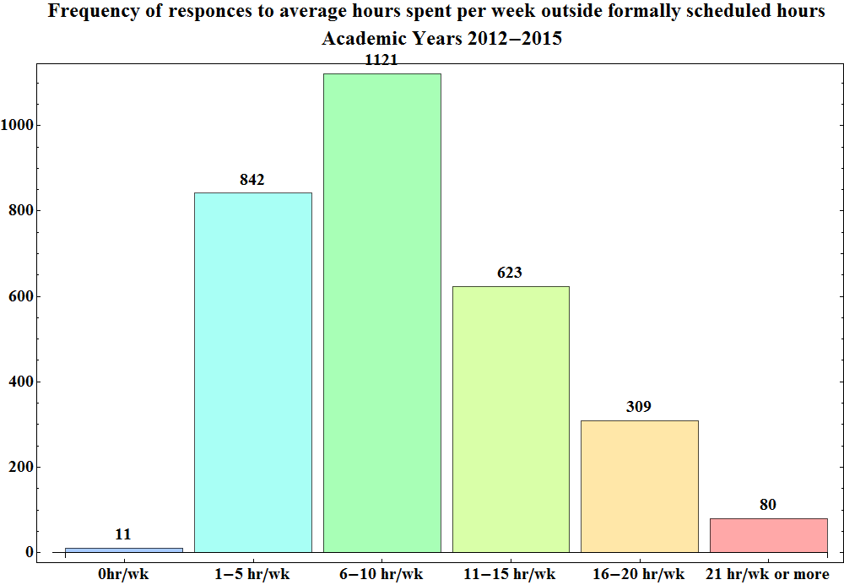
Figure 5 Showing the total ratings distribution of how hours outside of formally scheduled class time the students spent on their courses, for the physics department for Academic years 2012-13 to 2014-15

By comparing figure 5 with figure 2, one can see that physics courses at WPI tended to be a more demanding environment as compared to a general WPI course, where 71.5% of students who enrolled in physics courses did 6 or more hours of work outside of scheduled course hours in comparison to only 63.1% in general for students who enrolled in courses at WPI. Students who took physics courses at WPI put in more work outside of formally scheduled hours, with most students putting in 6-10 hours of work per week in physics for both fall and spring semesters in contrast most students at WPI only putting in 1-5 hours.

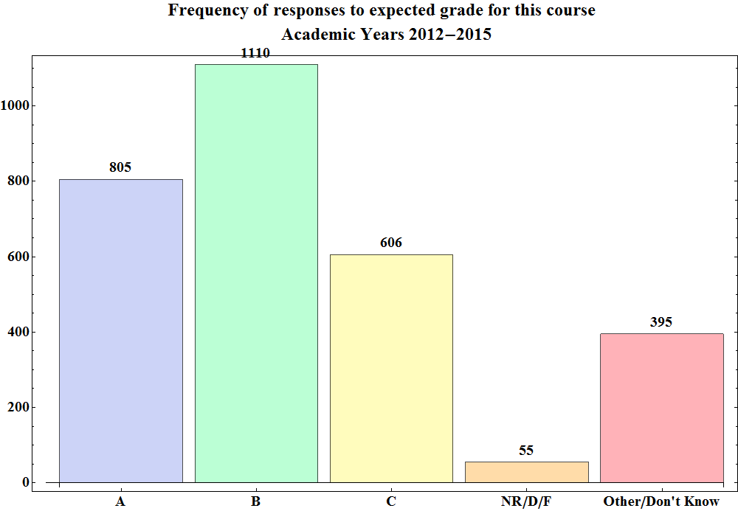
Figure 6 Showing the total ratings distribution of the grades that the students thought they would get in the course, for the physics department for Academic years 2012-13 to 2014-15

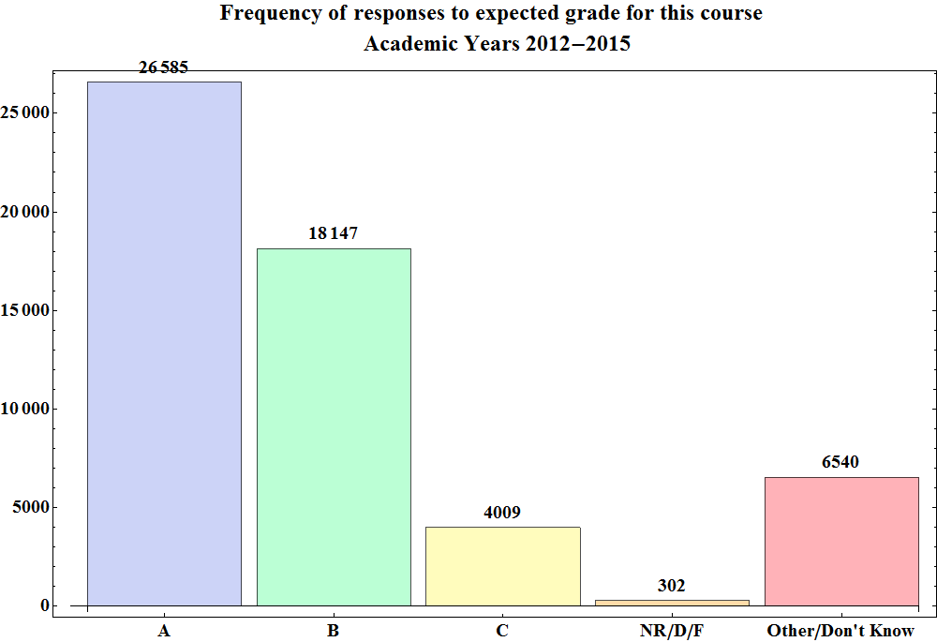
Figure 7 Showing the total ratings distribution of the grades that the students thought they would get in the course, for all departments for Academic years 2012-13 to 2014-15
Figures 6 and 7 are a student’s measurement of what they thought their performance was, since the distributions are not necessarily a measure of the grades that the student earned. Comparison between figures 6 and 7 shows that students who took courses from the physics department also generally considered their performance to be lower than that of students who took courses at WPI in general, where this conclusion was drawn since most students who enrolled in physics course expected to earn grade of B, while students who enrolled in courses at WPI expected to earn a grade of A. Both distributions however show that 80% of students expected to earn a grade of B or above in physics and in general for courses at WPI.

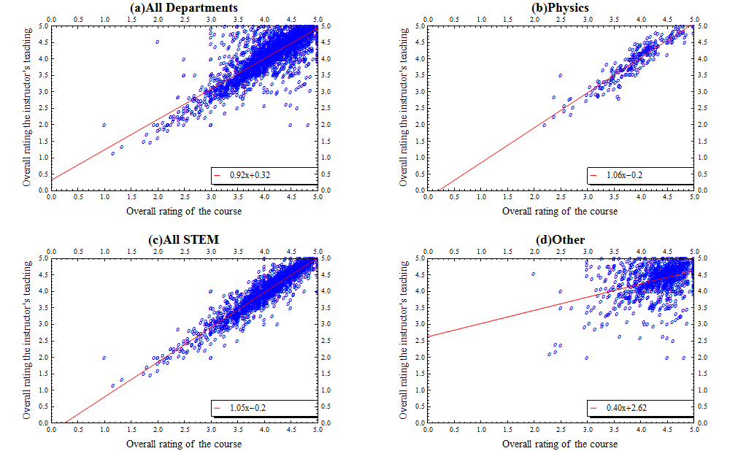
Figure 8 Showing the overall rating of the instructor’s teaching against the overall rating of the course for Academic years 2012-13 to 2014-15

From the table of correlation coefficients, and examination of figure 8, one can see that for physics, the greatest factor for determining course quality appeared to be the quality of the instructor’s teaching, with a correlation factor of 0.93, and a linear fit slope of almost 1.0, while the strongest factor in determining course quality in general was the amount learned in the course. The instructor’s teaching was also the greatest determining factor of STEM courses in general with a correlation factor of 0.94, while the amount learn was the greatest determining factor in general for all other courses, having a correlation factor of 0.75. Figure 8 highly suggests that in STEM(c) providing students with understandable explanations is the greatest determining factor of course quality, though not so much in other courses available at WPI (d).
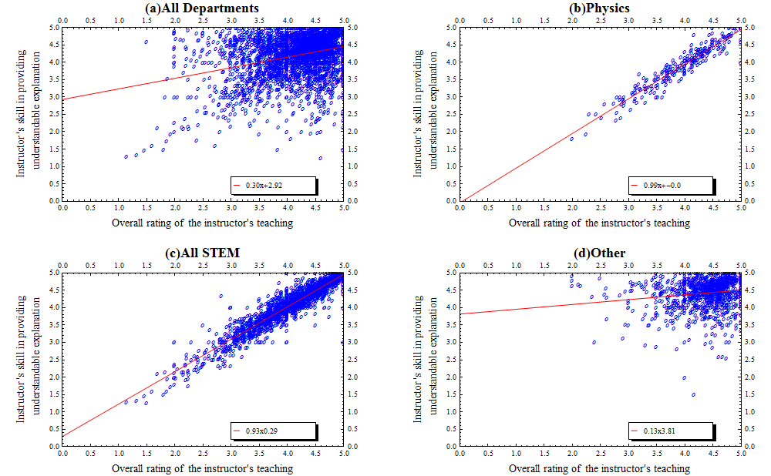
Figure 9 Showing the instructor’s skill in providing an understandable explanation against the overall rating of the instructor’s teaching for Academic years 2012-13 to 2014-15

Figure 9 shows that the quality of the instructor’s teaching and the instructor’s ability to provide an understandable explanation are almost perfectly correlated in STEM courses(c), which includes physics courses (b). Thus students who feel as though instructors are not able to deliver understandable explanations are more likely to rank instructor teaching quality, and necessarily course quality low, since teaching quality and course quality are so closely correlated. It was also noteworthy that the instructor’s teaching was somewhat moderately correlated with the educational value of the reading material in STEM and physics, with correlation factors of 0.6 and 0.62 respectively.

Further scatterplot data, along with the linear fits is given in the following scatter plots.
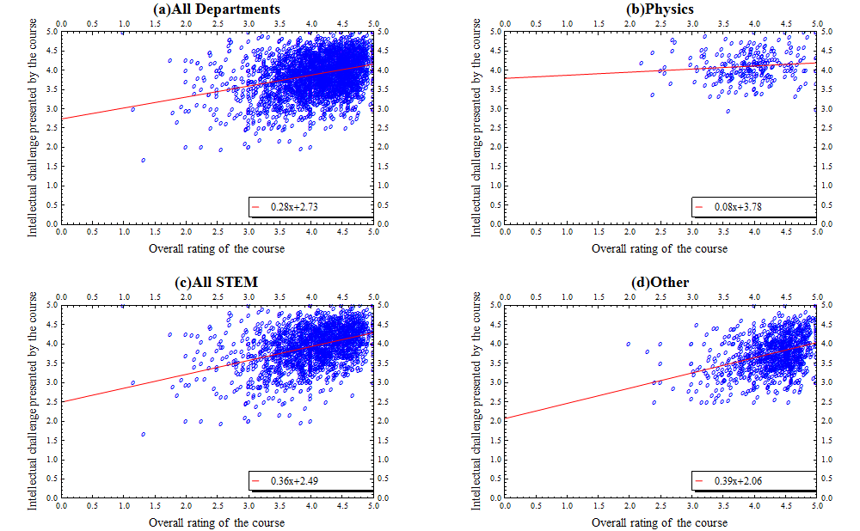
Figure10 Showing the Intellectual challenge presented by the course against the overall rating of the course for Academic years 2012-13 to 2014-15

There is a weak correlation between the intellectual challenge presented by the course and the overall rating of the course in general for all departments. STEM courses and courses within the ‘Other’ category show a weak correlation when viewed separately from all courses, with STEM featuring a slope of 0.36 and ‘Other’ a slope of 0.39. Physics however shows almost no correlation, with a slope of 0.08.

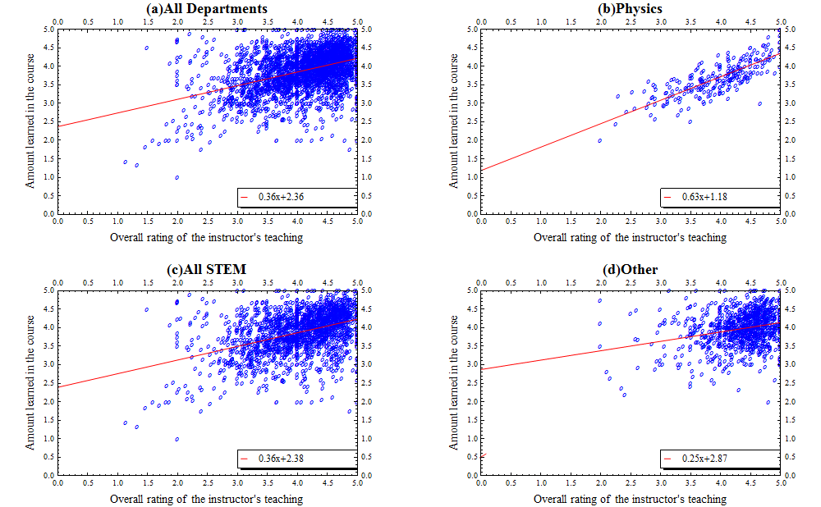
Figure 11 Showing the amount learned in the course against the overall rating of the instructor’s teaching for Academic years 2012-13 to 2014-15

There is a weak correlation between the amount learned in a course and the overall rating of the instructor’s teaching in general for all courses. Physics, however, shows a much stronger correlation, with physics featuring a slope of 0.63. STEM and ‘Other’ also have a weak correlation with STEM and ‘Other’ featuring slopes of 0.36 and 0.25 respectively.
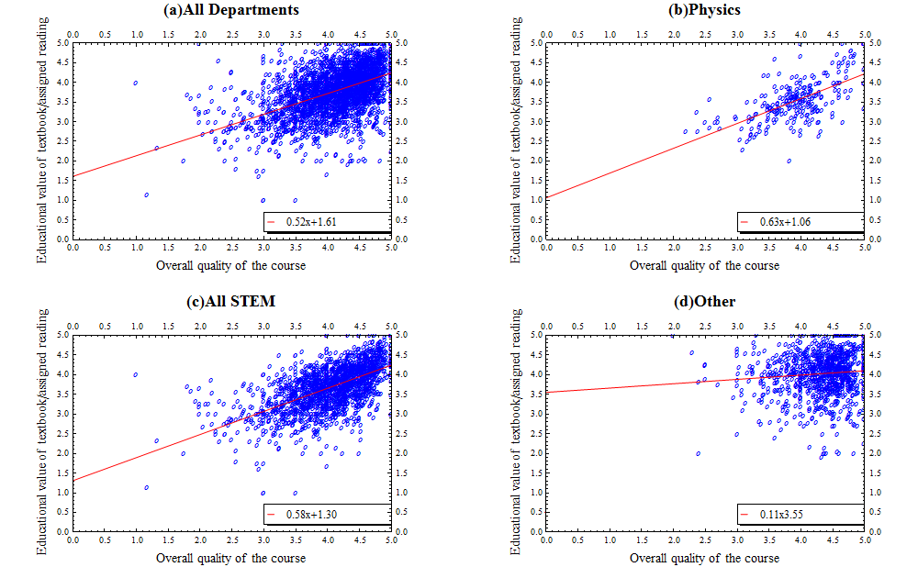
Figure 12 Showing the Educational value of the textbook or assigned readings against the overall rating of the course for Academic years 2012-13 to 2014-15

There is almost no correlation between the amount learned in a course and the overall rating of the instructor’s teaching in general for all courses. Physics and ‘Other’ also shows almost no correlation with STEM having a weak correlation. The linear fit of physics features a slope of 0.63, while STEM and Other feature a slope of 0.58 and 0.11 respectively. From the correlation of one could infer that a student’s opinion on the educational value of the readings in a course are not necessarily a good representation of their opinion on the quality of the course.

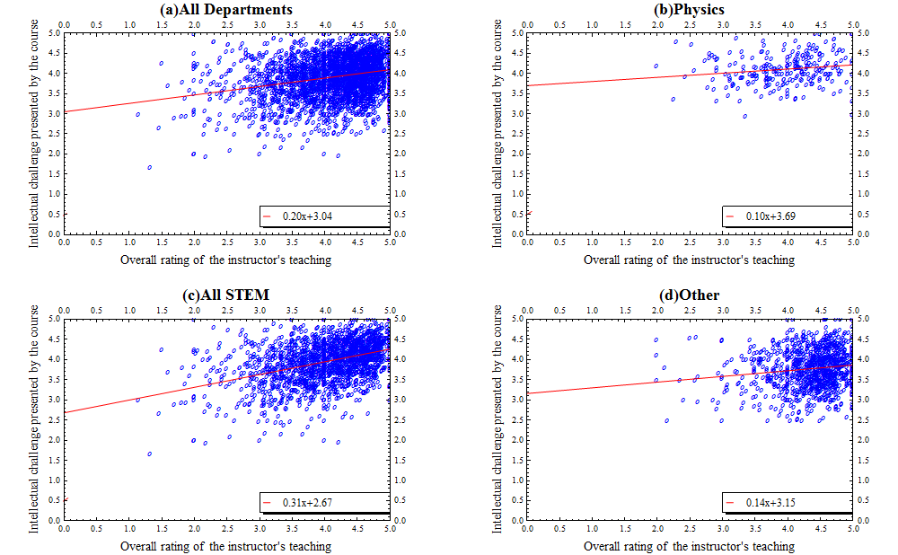
Figure 13 Showing the Intellectual challenge presented by the course against the overall rating of the instructor for Academic years 2012-13 to 2014-15

There is almost no correlation between the intellectual challenge presented by the course and the overall rating of the instructor’s teaching in general for all departments. STEM courses shows a weak correlation when viewed separately from all courses, with STEM featuring a slope of 0.31. Both physics and ‘Other’ show almost no correlation, with physics having a slope of 0.1 and ‘Other’ a slope of 0.14. This shows that difficulty in the intellectual challenge of a course plays almost no role in the student’s perception of the quality of the instructor, if only improving the instructor’s teaching quality only slightly.
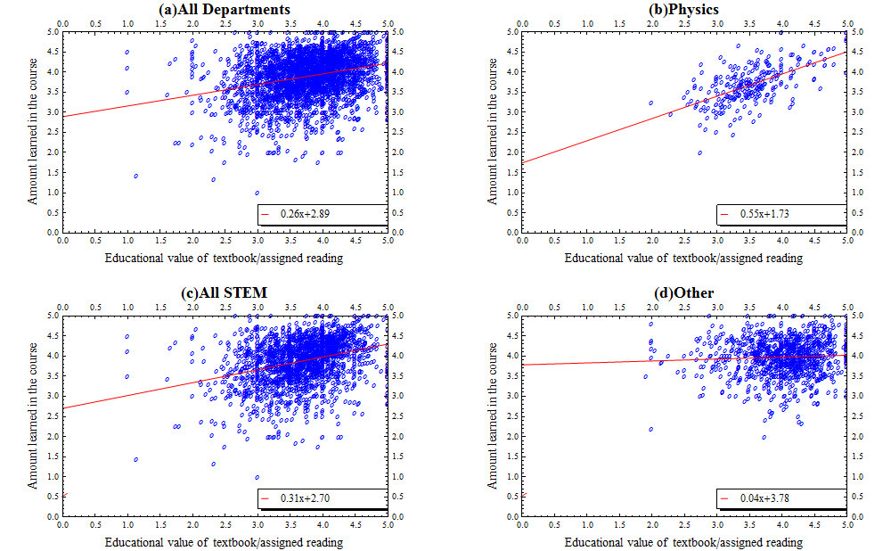
Figure 14 Showing the Amount learned in the course against the educational value of the textbook or assigned reading for Academic years 2012-13 to 2014-15

There is almost no correlation between the amount students said they learned, and the educational value of the textbook or assigned reading in general for all departments. STEM shows a weak correlation, while physics courses show a moderate correlation when viewed separately from all courses. The linear fit of STEM features a slope of 0.31, while the linear fit of physics features a slope of 0.55. ‘Other’ shows no correlation with a slope of 0.04. Thus reading assignments and textbooks prove to be a moderately useful source of knowledge for physics students, but less so for STEM and other courses in general.
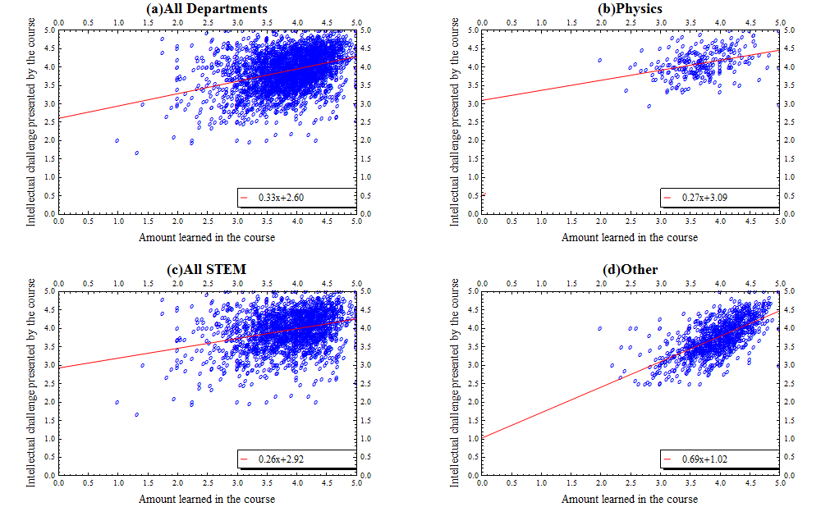
Figure 15 Showing the Intellectual challenge presented by the course against the amount learned in the course for Academic years 2012-13 to 2014-15

There is a weak correlation between the intellectual challenge presented by the course and the amount learned in the course in general for all departments. STEM and physics courses also show a weak correlation when viewed separately from all courses, with STEM featuring a slope of 0.26, and physics featuring a slope of 0.27. ‘Other’ shows a moderate correlation with a slope of 0.69. A student’s perception of the intellectual challenge of a course does not prove to be a good measure of the amount learned in the course.

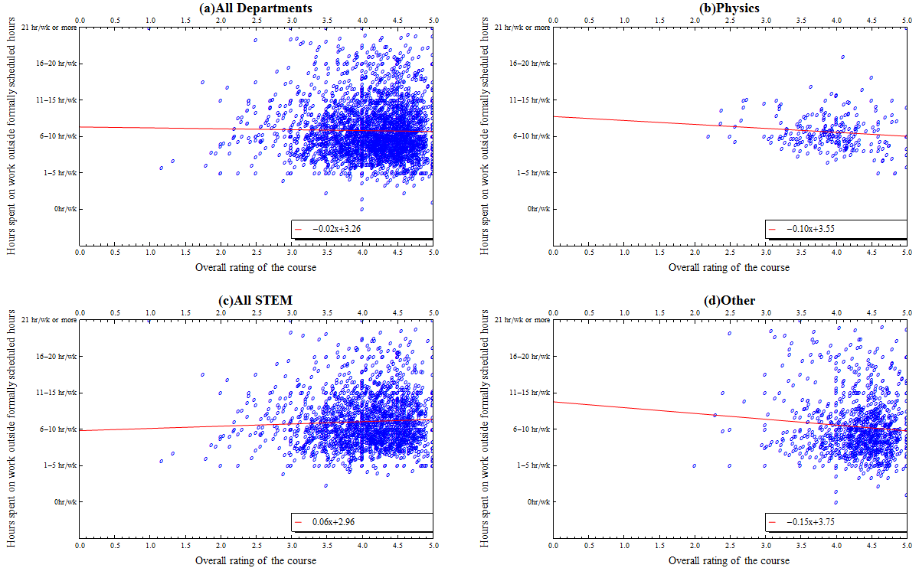
Figure 16 Hours spent outside formally scheduled hours against the Overall rating of the course for Academic years 2012-13 to 2014-15

There is almost no correlation between the hours spent working and the overall rating of the course in general for all departments. ‘Other’ and physics courses have a negative slope when viewed separately from all courses, with ‘Other’ featuring a slope of -0.15, and physics featuring a slope of -0.10. STEM shows almost no correlation a slope of 0.06. The hours spent working on a course does not affect a student’s opinion on the course quality.

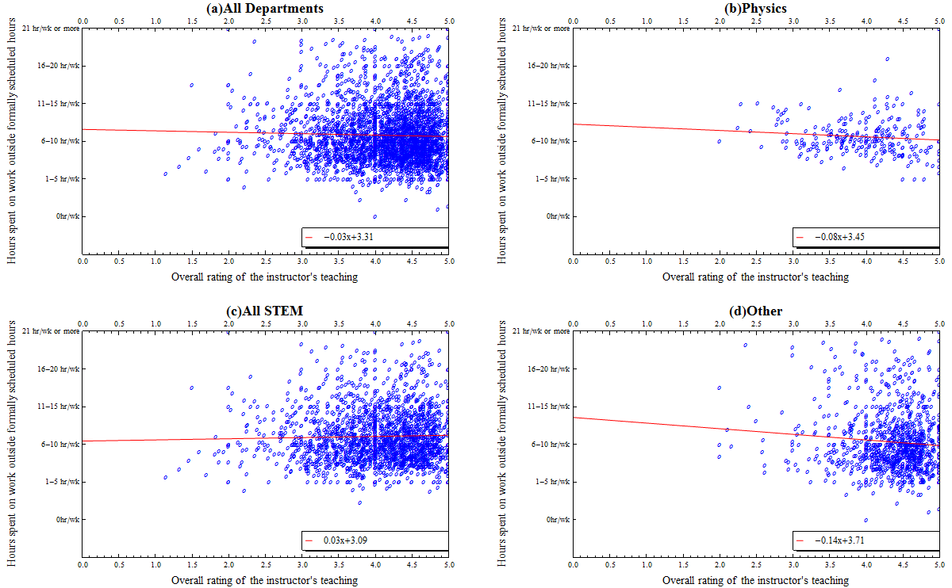
Figure 17 Hours spent outside formally scheduled hours against the Overall rating of the instructor for Academic years 2012-13 to 2014-15

There is almost no correlation between the hours spent working and the overall rating of the instructor’s teaching in general for all departments. ‘Other’ and physics courses have a negative slope when viewed separately from all courses, with ‘Other’ featuring a slope of -0.14, and physics featuring a slope of -0.08. STEM shows almost no correlation a slope of 0.03. The hours spent working on a course does not affect a student’s opinion on the instructor’s teaching quality.

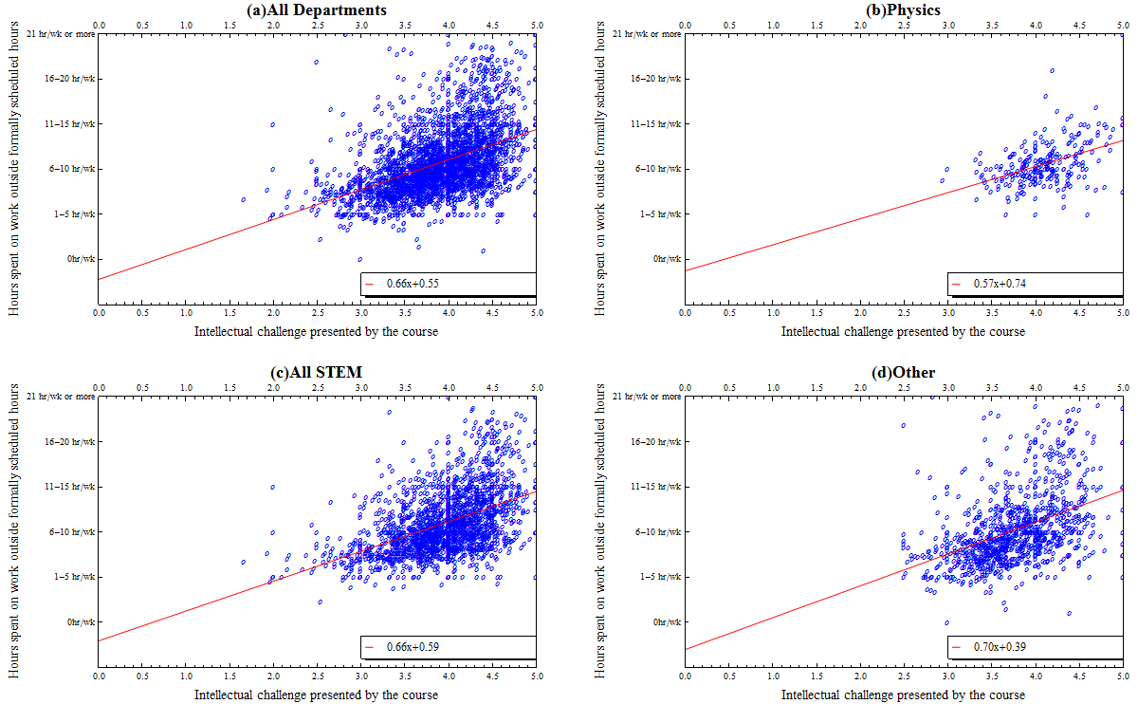
Figure18 Hours spent outside formally scheduled hours against the intellectual challenge presented by the course for Academic years 2012-13 to 2014-15

There is a weak correlation between the hours spent working and the intellectual challenge of the course in general for all departments. STEM and Physics, when viewed separately, have a weak correlation. ‘Other’ features no correlation with these questions. This shows that intellectual challenge is not a major contributing factor to the amount spent on work outside course hours.
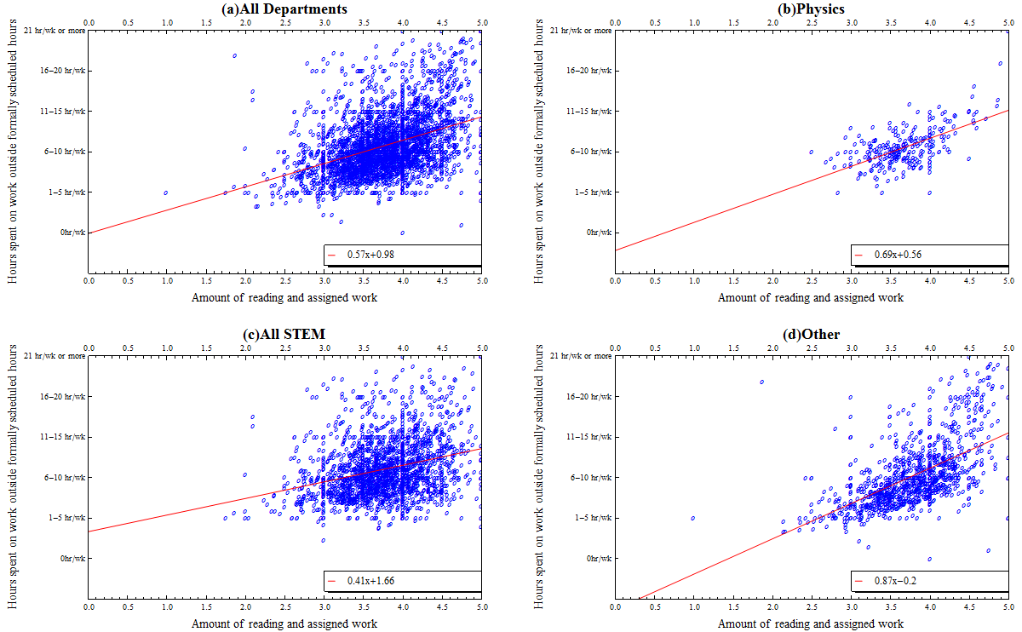
Figure 19 Hours spent outside formally scheduled hours against the amount of reading and assigned work for Academic years 2012-13 to 2014-15

There is no correlation between the hours spent working and the amount of reading and assigned work in general for all departments. ‘Other’ has the steepest slope of 0.87 and STEM has the gentlest slope of 0.41. The slope of the linear fit in Physics lies in STEM and ‘Other’ with a magnitude of 0.69. Physics however is the only of these three with a moderate correlation, with ‘Other’ having a weak correlation, and STEM having almost no correlation. Thus assigned work is clearly a large contributing factor for the amount spent on a course outside of formally scheduled course hours for Physics, but less so for STEM and other courses in general.

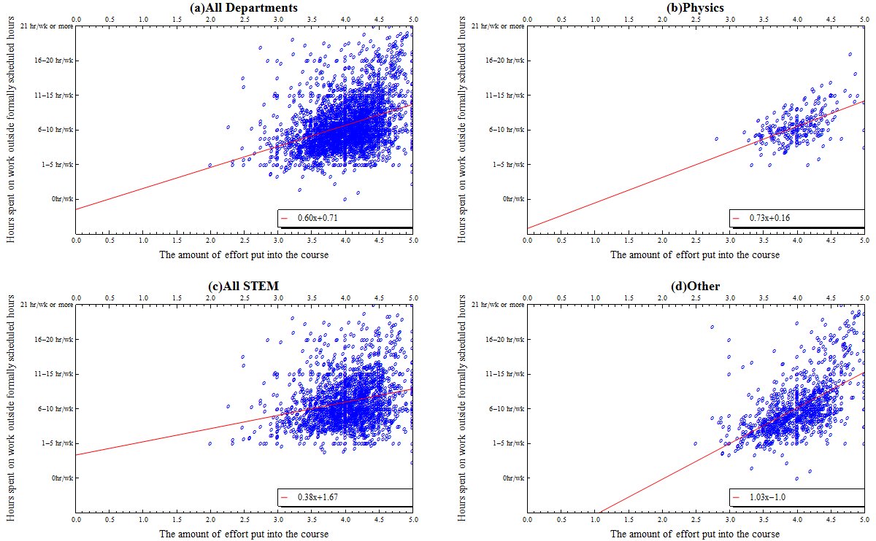
Figure 20 Hours spent outside formally scheduled hours against the effort put into the course for Academic years 2012-13 to 2014-15

There is a moderate correlation between the hours spent working and the amount of effort put into the course in general for all departments. The linear fit of ‘Other’ has a slope of magnitude which is close to 1, though very weak correlation between the two questions. Physics also shows a moderate correlation between the two questions with a slope of 0.73, while STEM has a more gradual slope in comparison to the other two, with a slope of 0.38, with almost no correlation. The time a student puts into a course is thus considered by students to be a good measure of effort put in for physics courses, though less so for other courses at WPI.

Improvements
There are a few ways in which WPI could improve the course evaluation process. The course evaluations could be made to be done digitally by students in order for students to have access to their transcript, which would allow for more available response choices for questions such as ‘total hours spent outside of formally scheduled hours’. In this way data can be automatically compiled, while on the same time offering more freedom for a greater possible range of answers that can be given by the students. It also allows for instructors to have a flexibility in designing and implementing custom questions. One may also recommend that students be asked to fill out a form that requests them to share their reason for dropping a class, if they chose to do so. Further explanation could also be given to question 25 to reduce ambiguity between the choices.
The amount of work done outside of scheduled course hours by students could be easily increase the amount of hours spent by students on courses outside of formally scheduled course hours, without affecting course quality, by increasing the course work load, since this was shown to be capable of having the desired effect in the scatterplot data.
With considerations to the physics department, assigned readings and choice of textbooks appeared to play an integral role in the amount learned by students. Thus careful considerations should be made by instructors for required textbooks when planning courses in order to maximise the amount of knowledge acquired by students who take physics courses. Though there was not a direct correlation between the reading material and the course quality, improving the reading material should have some influence on the amount that students learn, which would positively impact the course quality.
The stress due to the number of enrolments in fall semester could be reduced by decreasing the number of sections of 1000 level courses in the fall semesters, and increasing the number of sections in the spring semester. This will force some students to take physics courses in their spring semester rather than the fall semester, redistributing the student population more evenly across both semesters. In order to alleviate the effect of this on newly enrolled physics majors who would like to take the 1000 level course in the fall semester, priority could be given to physics majors for a short amount of time by reserving space for physics majors to fill during the first few days of course registration.

Appendix A

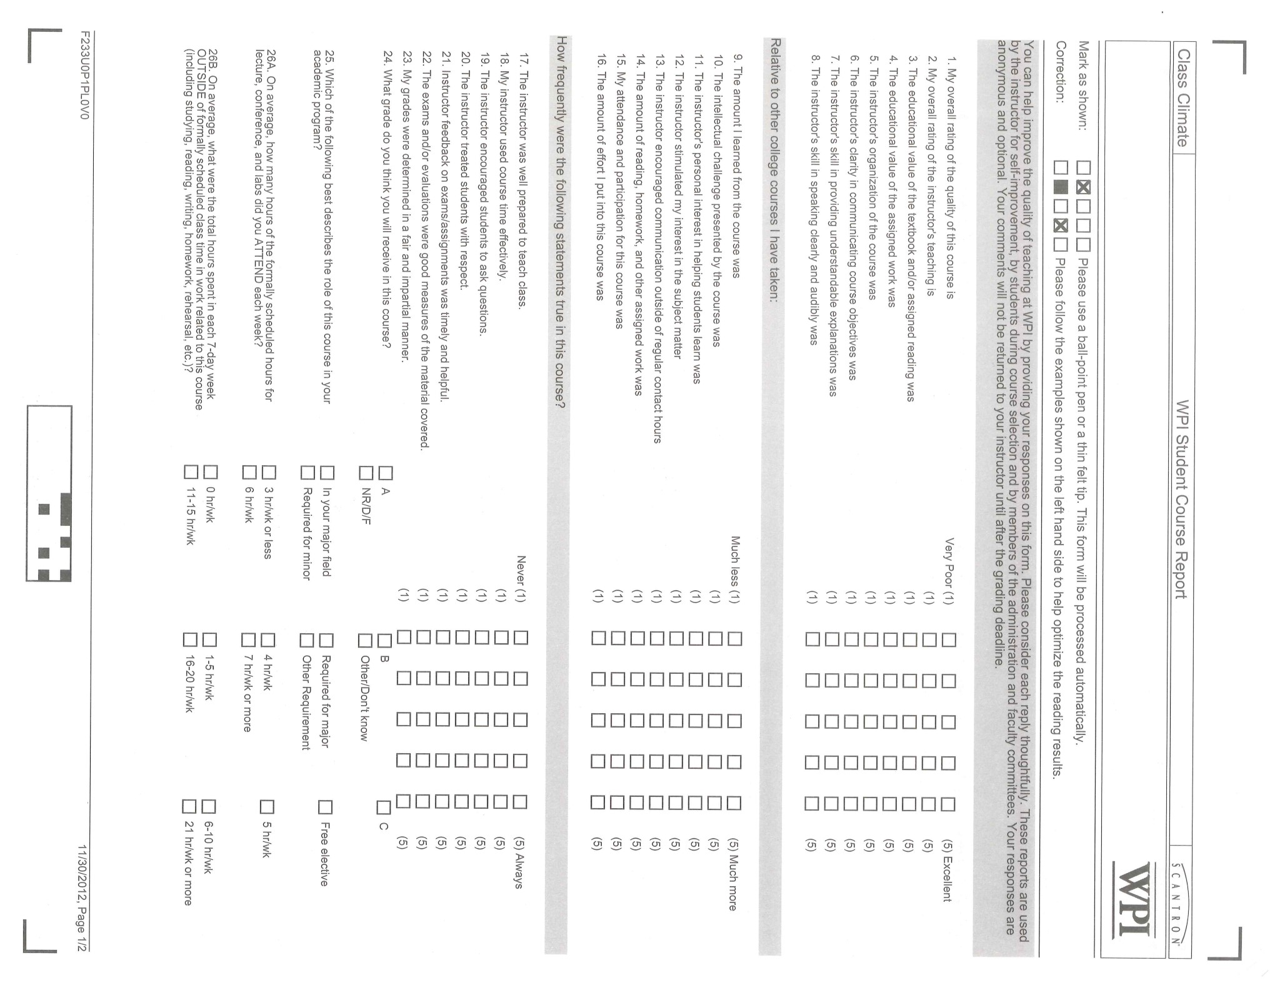
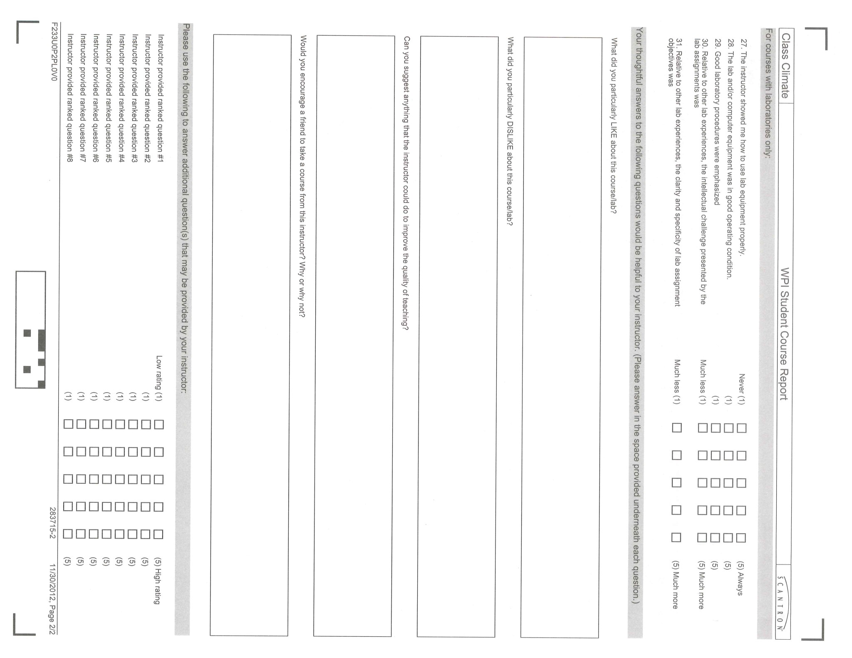

Appendix B
All Evaluations

Section 1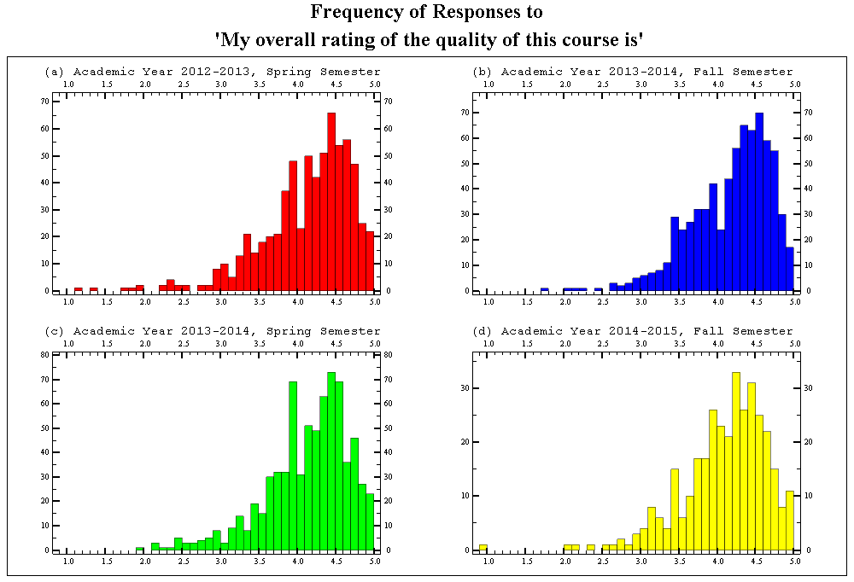
Figure 21.1 Showing the semester breakdown of the ratings distribution of the overall rating of the course quality, for all departments for Academic Years 2012-13 to 2014-15

The median score of each semester for this question had an average score of 4.26 with an average interquartile range of 0.69. Thus figure 21.1 suggests that students generally agree that there is a consistent good quality amongst courses at WPI over the time that the data was taken.
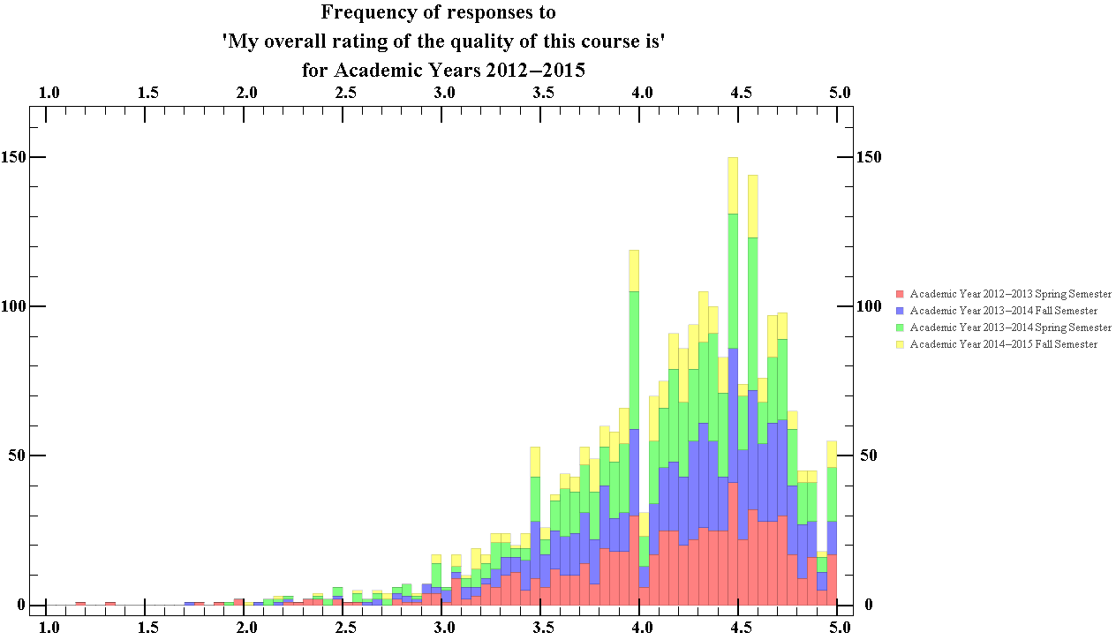
Figure 21.2 Showing the total ratings distribution of the total overall rating of the course quality, for all departments for Academic Years 2012-2015

The median score for this question was 4.27, with the peak occurring between the 4.45-4.5 bin, and an interquartile range size of 0.71. Thus figure 21.2 suggests that students generally consider the physics courses provided by WPI to be of good quality.

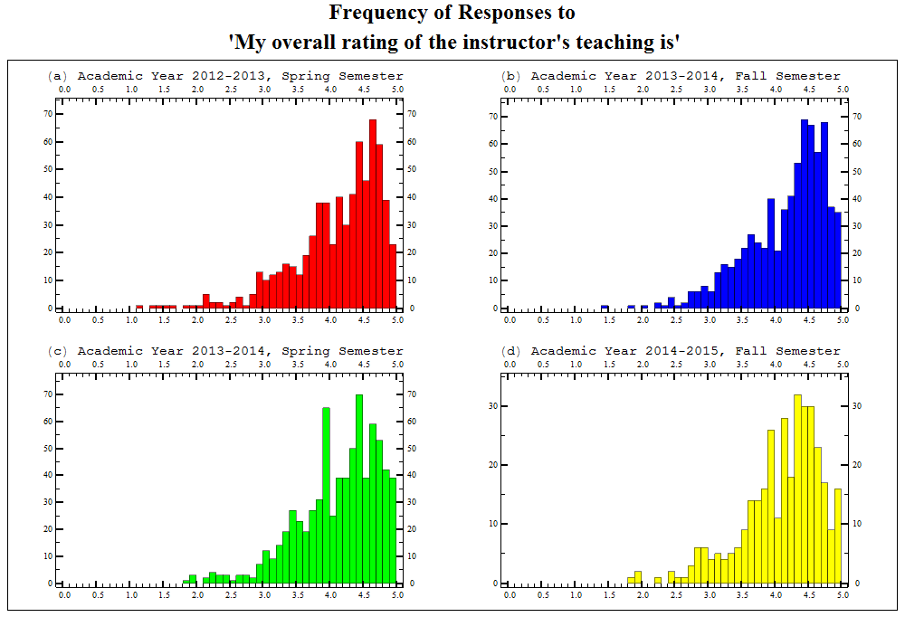
Figure 22.1 Showing the semester breakdown of the ratings distribution of the overall rating of the instructors teaching, for all departments for Academic Years 2012-13 to 2014-15

The average median score of each semester for this question was 4.29, with an average standard interquartile range of 0.79. Thus figure 22.1 suggests that the students thought that the quality of the manner in which all courses were taught at WPI was good over the time that the data was taken.

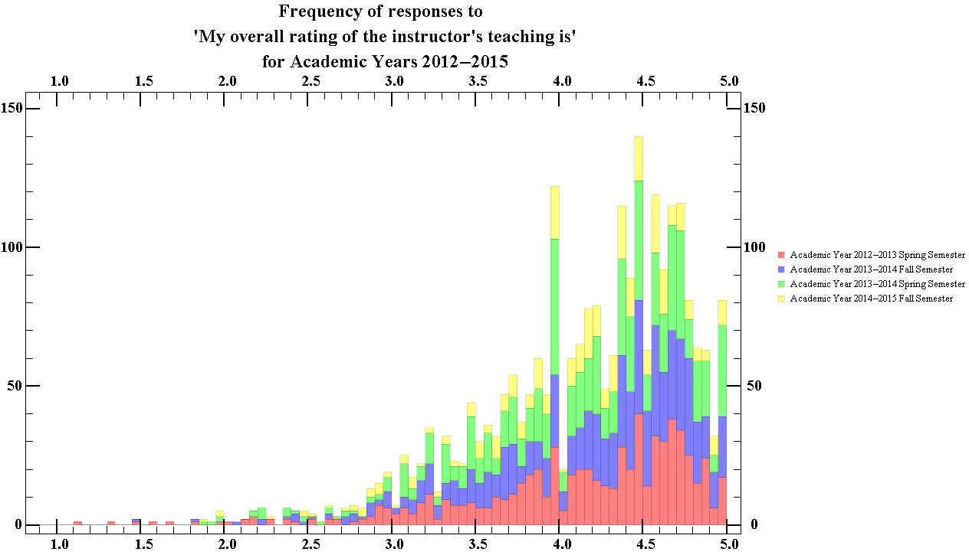
Figure 22.2 Showing the total ratings distribution of the total overall rating of the instructors teaching, for all departments for Academic Years 2012-2015

The median score given by students for the instructor’s teaching is 4.3, with an interquartile range of 0.8. Thus figure 22.2 suggests that students generally thought that courses at WPI were well taught.

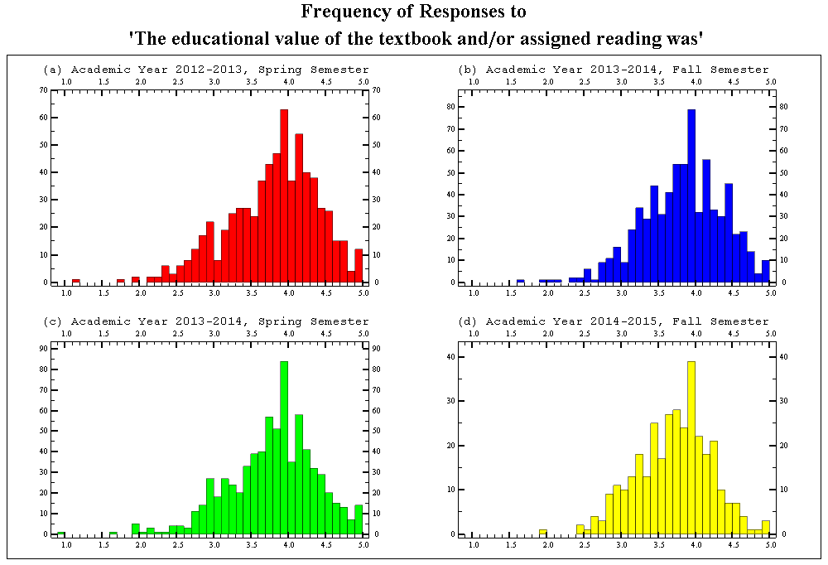
Figure 23.1 Showing the semester breakdown of the ratings distribution of the educational value of textbook and/or reading assignments, for all departments for Academic years 2012-13 to 2014-15

The average median score of each semester for this question was 3.86, with an average standard interquartile range of 0.71. Thus figure 23.1 suggests that students generally consider the textbook and assigned reading in courses at WPI to be good over the time that the data was taken.

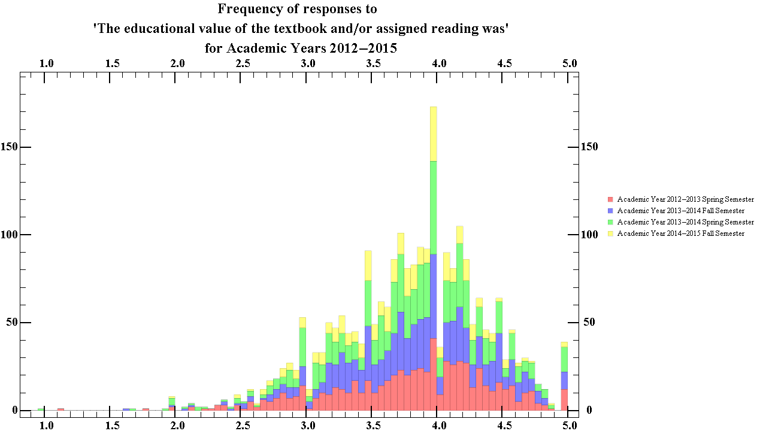
Figure 23.2 Showing the total ratings distribution of the educational value of textbook and/or reading assignments, for all departments for Academic years 2012-13 to 2014-15

The median score for this question was 3.87, with an interquartile range of 0.72. Thus figure 23.2 suggests that students generally consider the textbook and assigned reading in courses at WPI to be good.

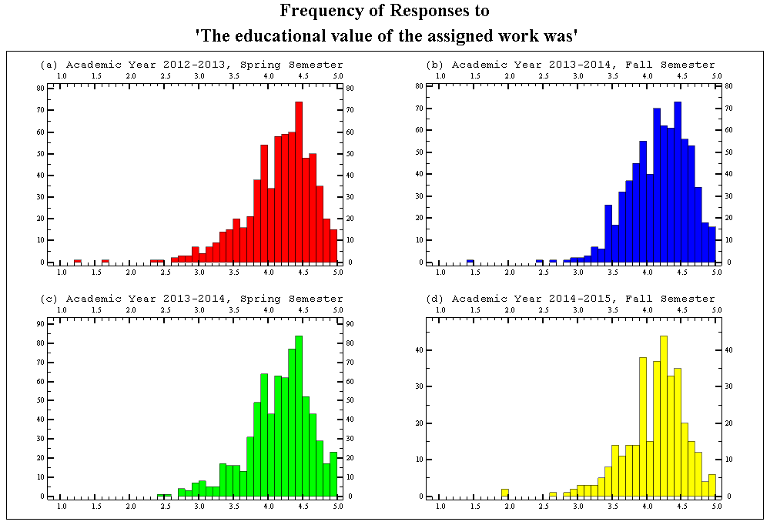
Figure 24.1 Showing the semester breakdown of the ratings distribution of the educational value of the assigned work, for all departments for Academic years 2012-13 to 2014-15

The average median score of each semester for this question was 4.23, with an average standard interquartile range of 0.56. Thus figure 24.1 suggests that students generally consider the educational value of the assigned work in courses at WPI to be good over the time that the data was taken.

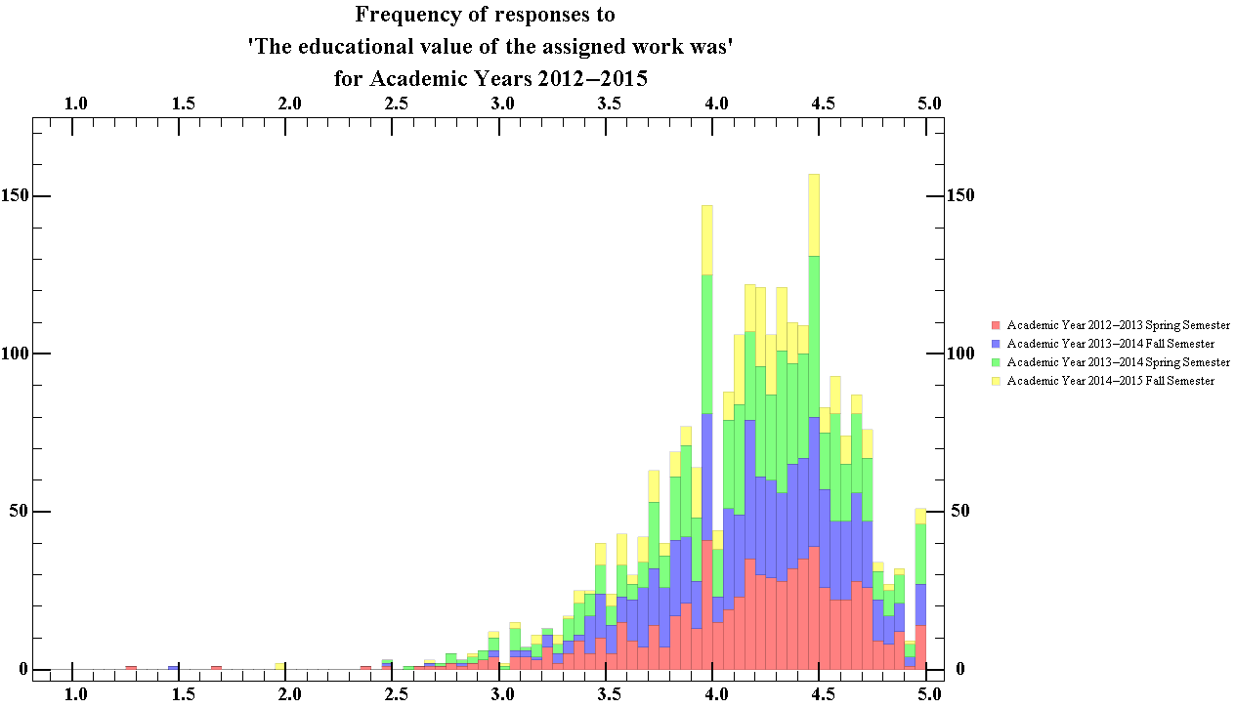
Figure 24.2 Showing total the ratings distribution of the educational value of the assigned work, for all departments for Academic years 2012-13 to 2014-15

The median score for this question was 4.23, with an interquartile range of 0.58. Thus figure 24.2 suggests that students generally consider the work given to be of a good educational value.

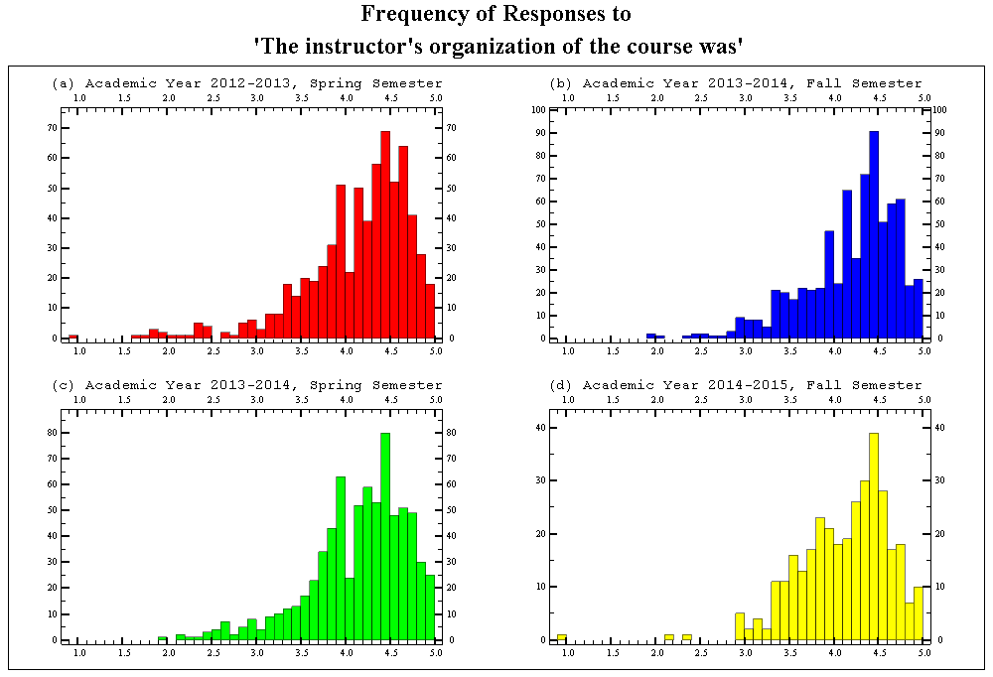
Figure 25.1 Showing the semester breakdown of the ratings distribution of the instructors course organisation, for all departments for Academic years 2012-13 to 2014-15

The average median score of each semester for this question was 4.27, with an average standard interquartile range of 0.68. Thus figure 25.1 suggests that students generally consider the organisation of courses at WPI to have been good over the time that the data was taken.

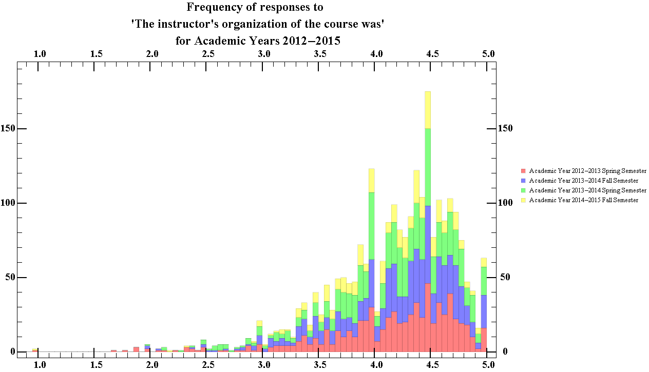
Figure 25.2 Showing the total ratings distribution of the instructors course organisation, for all departments for Academic years 2012-13 to 2014-15

The median score for this question was 4.29, with an interquartile range of 0.68. Thus figure 25.2 suggests that students generally consider the course organization at WPI to be good.

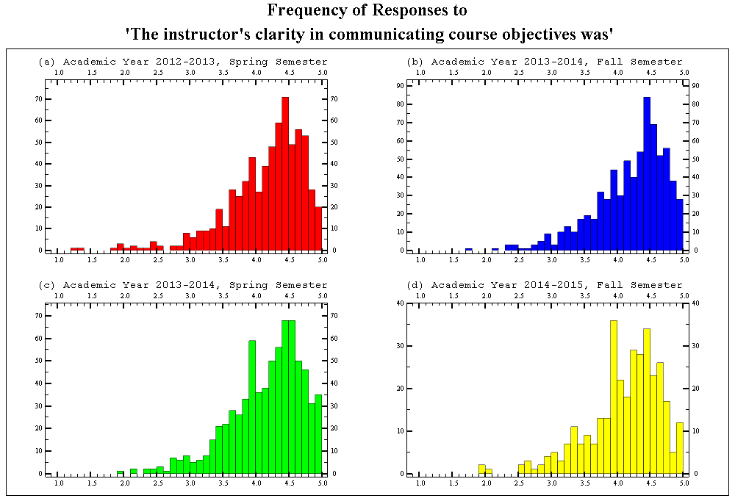
Figure 26.1 Showing the semester breakdown of the ratings distribution of the instructors clarity in communicating the objective, for all departments for Academic years 2012-13 to 2014-15

The average median score of each semester for this question was 4.28, with an average standard interquartile range of 0.68. Thus figure 26.1 suggests that students generally consider the communication skills of instructors of courses at WPI to have been good over the time that the data was taken.

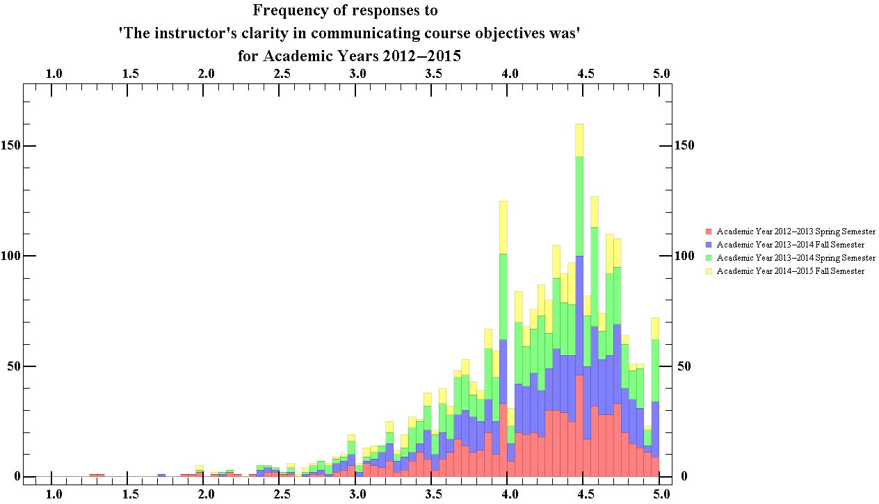
Figure 26.2 Showing the total ratings distribution of the instructors clarity in communicating the objective, for all departments for Academic years 2012-13 to 2014-15

The median score for this question was 4.29, with an interquartile range of 0.69. Thus figure 26.2 suggests that students generally consider the course organisation at WPI to be good.
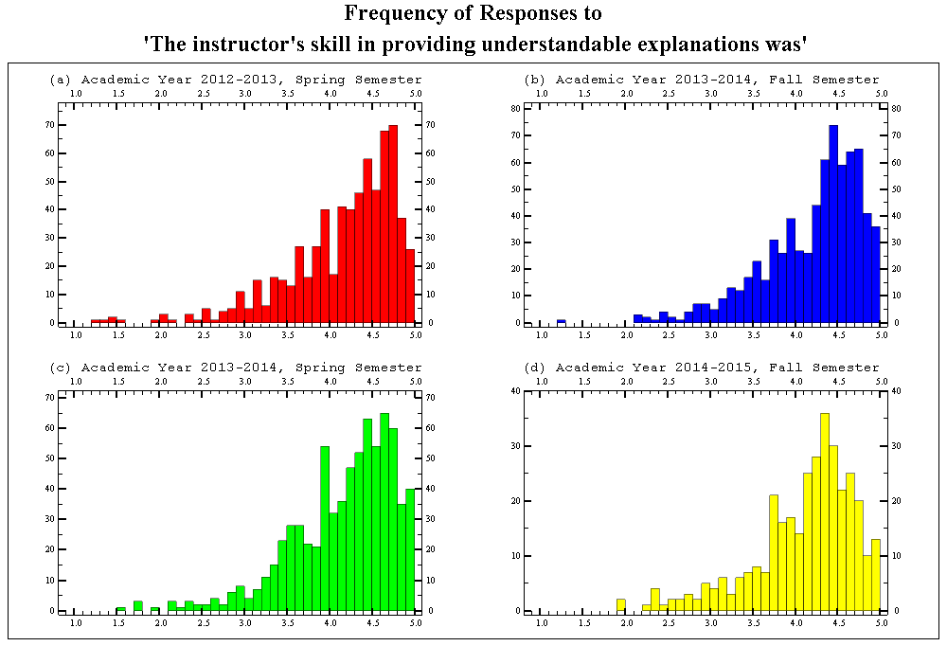
Figure 27.1 Showing the semester breakdown of the ratings distribution of the instructors skill in providing an understandable explanation, for all departments for Academic years 2012-13 to 2014-15

The average median score of each semester for this question was 4.32, with an average standard interquartile range of 0.76. Thus figure 27.1 suggests that over the time that the data was taken, students generally consider the instructors of courses at WPI to be well able to provide understandable explanations.

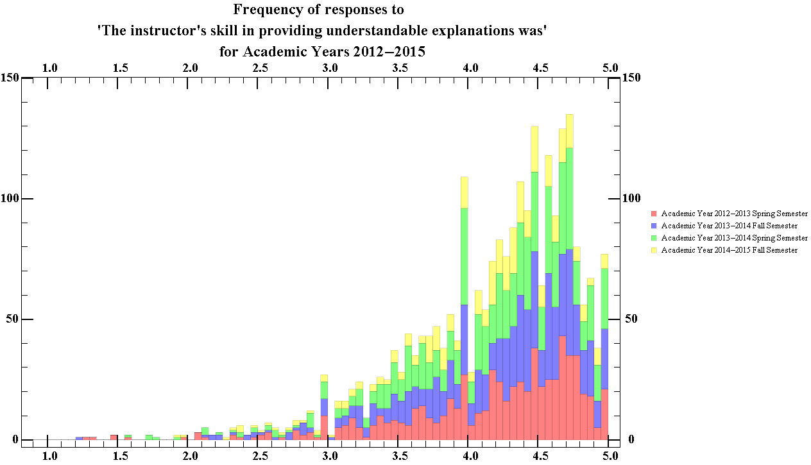
Figure 27.2 Showing the total ratings distribution of the instructors skill in providing an understandable explanation, for all departments for Academic years 2012-13 to 2014-15

The median score for this question was 4.33, with an interquartile range of 0.78. Thus figure 27.2 suggests that students generally considered the explanations provide by instructors at WPI to good. There is also a noticeably strange peak in the 3.95 - 4.0 bin.

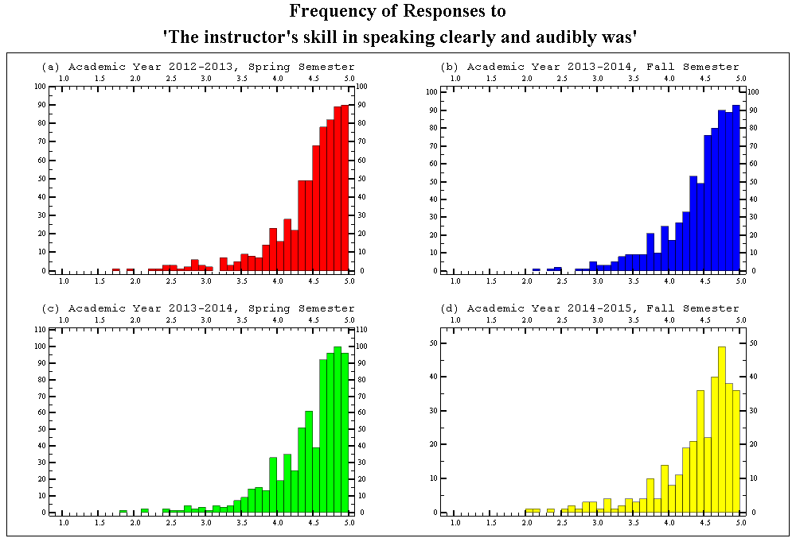
Figure 28.1 Showing the semester breakdown of the ratings distribution of the instructors skill in speaking clearly and audibly, for all departments for Academic years 2012-13 to 2014-15

The average median score of each semester for this question was 4.61, with an average standard interquartile range of 0.54. Thus figure 28.1 suggests that over the time that the data was taken, students generally consider the clarity of the speech of instructors of courses at WPI to be very good.

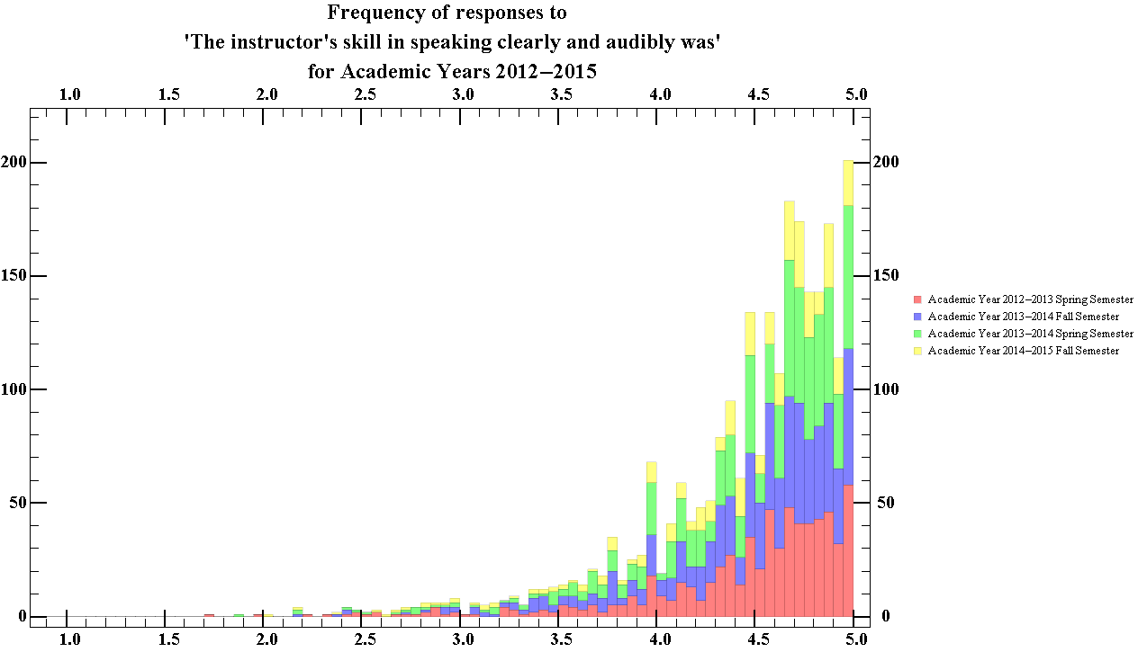
Figure 28.2 Showing the total ratings distribution of the instructors skill in speaking clearly and audibly, for all departments for Academic years 2012-13 to 2014-15
The median score for this question was 4.61, with an interquartile range of 0.54. Thus figure 28.2 suggests that students generally considered the clarity of the speech of instructors at WPI to be very good. From the graph, it is obvious that the highest peak occurs in the 4.95-5.0 bin.

Section 2
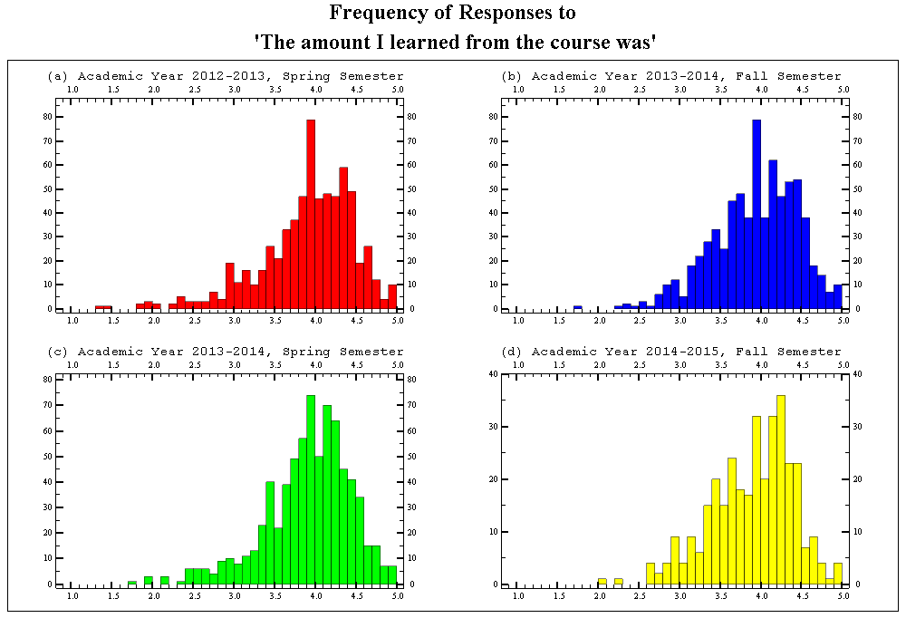
Figure 29.1 Showing the semester breakdown of the ratings distribution of the amount students learned for all departments, for Academic years 2012-13 to 2014-15

The average median score of each semester for this question was 4, with an average standard interquartile range of 0.67. Thus figure 29.1 suggests that over the time that the data was taken, students generally consider that they learned much more in WPI courses as compared to other courses they have taken. The highest peak occurs in the 3.9-4.0 bin in charts (a), (b) and (c).

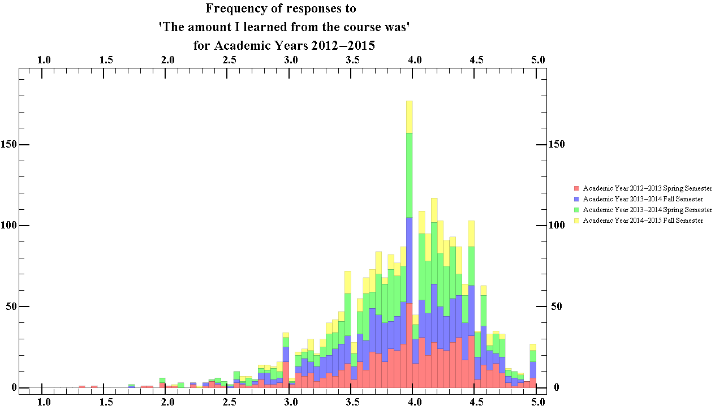
Figure 29.2 Showing the total ratings distribution of the amount students learned for all departments, for Academic years 2012-13 to 2014-15

The median score for this question was 4, with an interquartile range of 0.68. Thus figure 29.2 suggests that students generally considered that they learned more in courses at WPI in comparison to other courses they have taken. Like all previous charts of the total distribution, there is a noticeable dip in the 4.0-4.05 bin. From the graph, it is obvious that the highest peak occurs in the 3.95-4.0 bin.

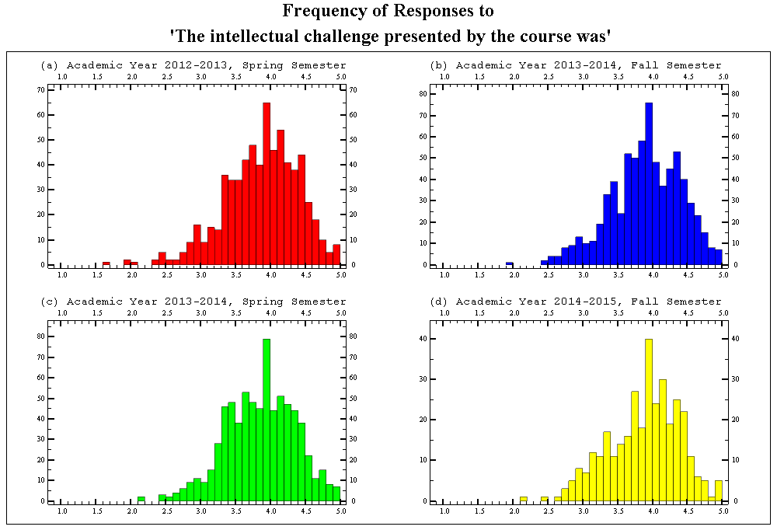
Figure 30.1 Showing the semester breakdown of the ratings distribution of the intellectual challenge presented by the course, for all departments for Academic years 2012-13 to 2014-15

The average median score of each semester for this question was 3.94, with an average standard interquartile range of 0.70. Thus figure 30.1 suggests that over the time that the data was taken, students generally consider that the intellectual challenge of courses at WPI was greater than other courses they have taken. The highest peak occurs in the 3.9-4.0 bin in all charts.

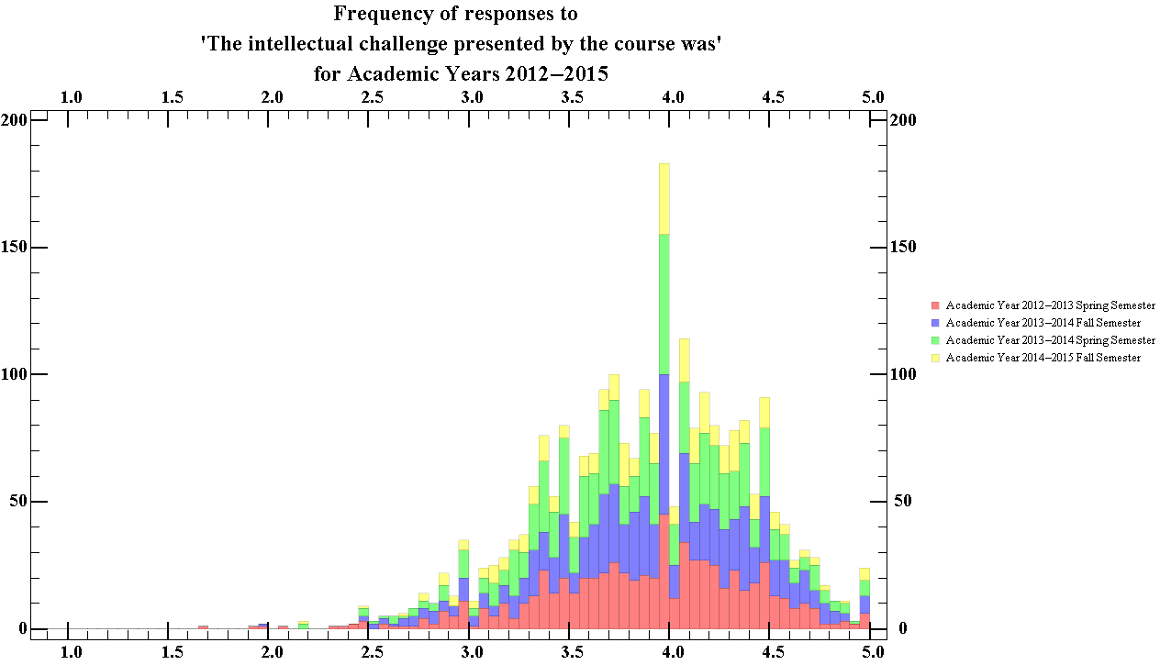
Figure 30.2 Showing the total ratings distribution of the intellectual challenge presented by the course, for all departments for Academic years 2012-13 to 2014-15

The median score for this question was 3.94, with an interquartile range of 0.69. Thus figure 30.2 suggests that students generally considered that the intellectual challenge of courses at WPI to be greater in comparison to other courses they have taken. From the graph, it is obvious that the highest peak occurs in the 3.95-4.0 bin.

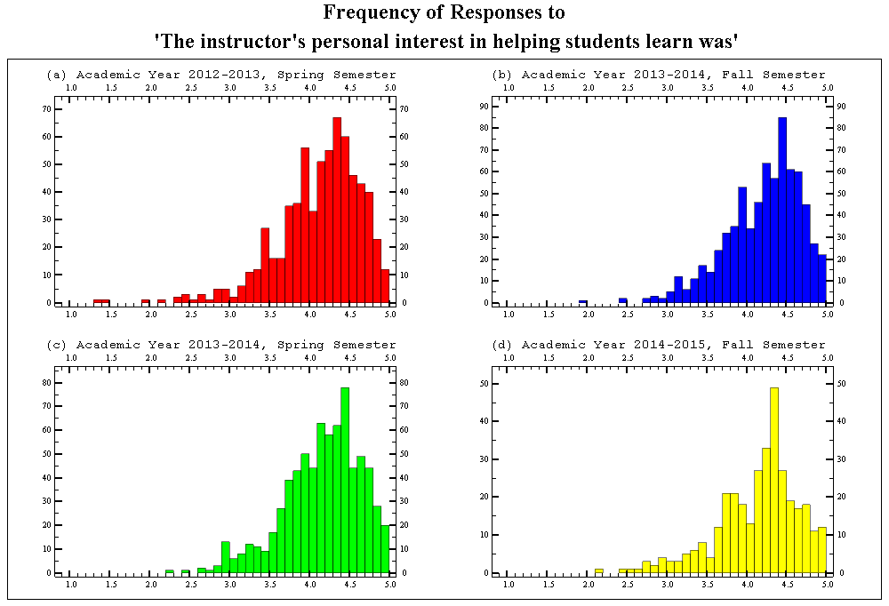
Figure 31.1 Showing the semester breakdown of the ratings distribution of the instructors interest in in helping students, for all departments for Academic years 2012-13 to 2014-15

The average median score of each semester for this question was 4.25, with an average standard interquartile range of 0.64. Thus figure 31.1 suggests that over the time that the data was taken, students generally considered their instructors to be more interested in helping students learn in comparison to instructors from other courses which the students have taken. It is notable that all charts have a dip in the 4.0-4.1 bin.

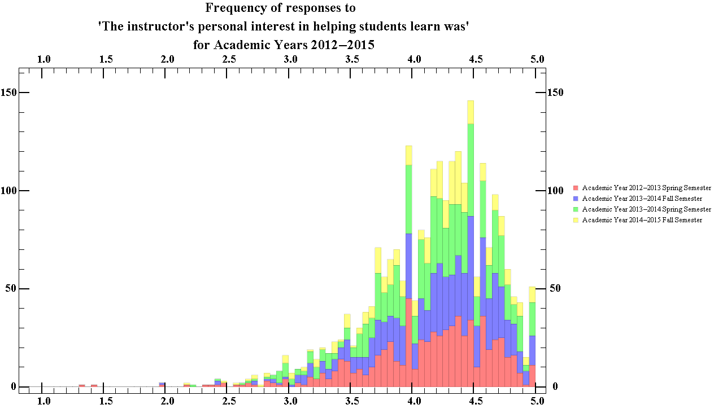
Figure 31.2 Showing the total ratings distribution of the instructors interest in helping students, for all departments for Academic years 2012-13 to 2014-15

The median score for this question was 4.25, with an interquartile range of 0.64. Thus figure 31.2 suggests that students generally considered the instructors at WPI to be more interested in helping students learn in comparison to instructors from other courses the students have taken. There is also a noticeable in the 4.45-4.5 bin.

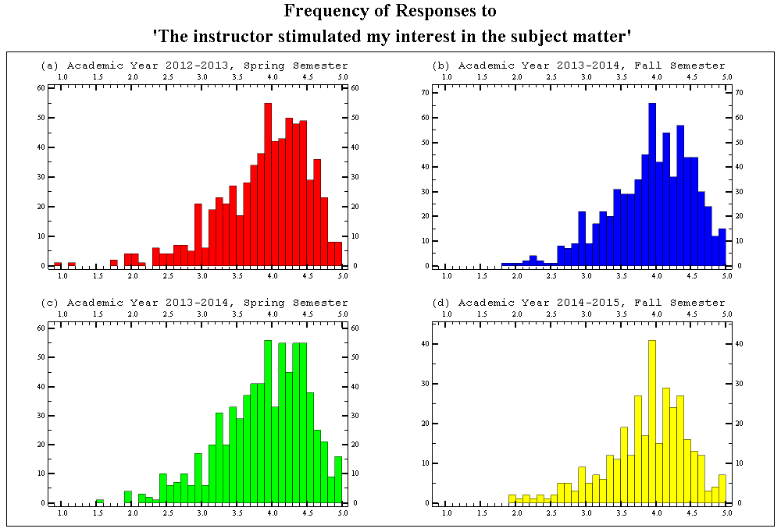
Figure 32.1 Showing the semester breakdown of the ratings distribution of the instructors ability to stimulate interest in the subject matter, for all departments for Academic years 2012-13 to 2014-15

The average median score of each semester for this question was 4.00, with an average standard interquartile range of 0.78. Thus figure 32.1 suggests that over the time that the data was taken, students generally considered their instructors to be better at stimulating their interest as compared to instructors from other courses the students have taken. It is notable that all charts have their highest peak in the 3.9-4.0 bin, with charts (b), (c) and (d) having a dip in the 4.0-4.1 bin.

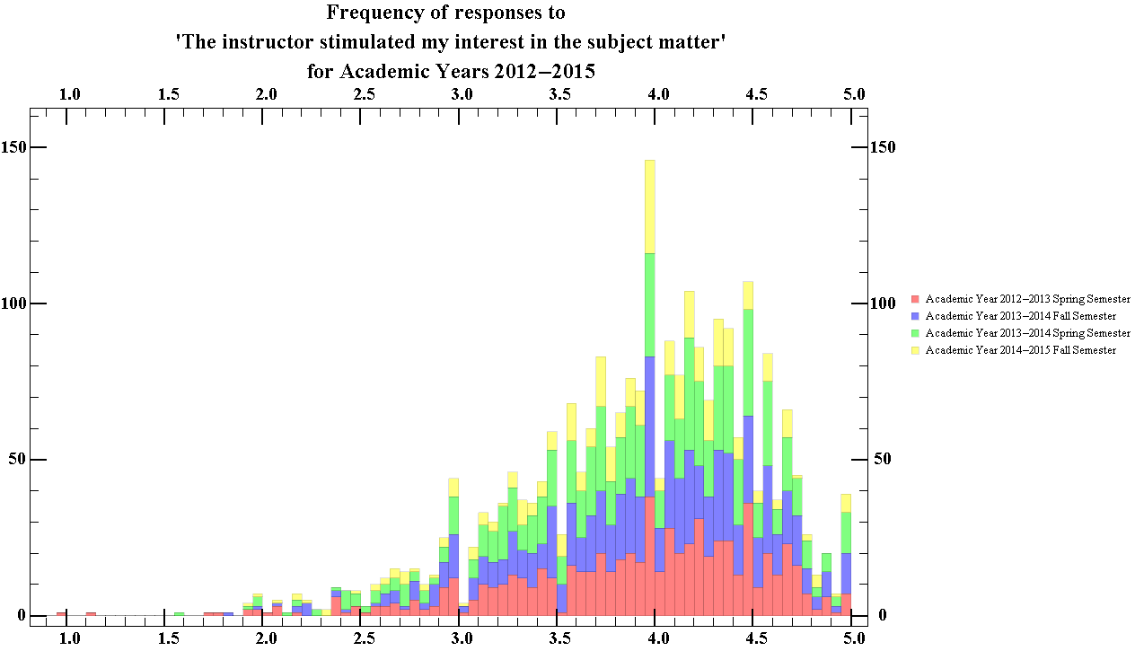
Figure 32.2 Showing the total ratings distribution of the instructors ability to stimulate interest in the subject matter, for all departments for Academic years 2012-13 to 2014-15

The median score for this question was 4.00, with an interquartile range of 0.80. Thus figure 32.2 suggests that students generally considered the instructors at WPI to be better able to stimulate interest when compared to instructors from other courses the students have taken. The highest peak occurs in the 3.95-4.0 bin.

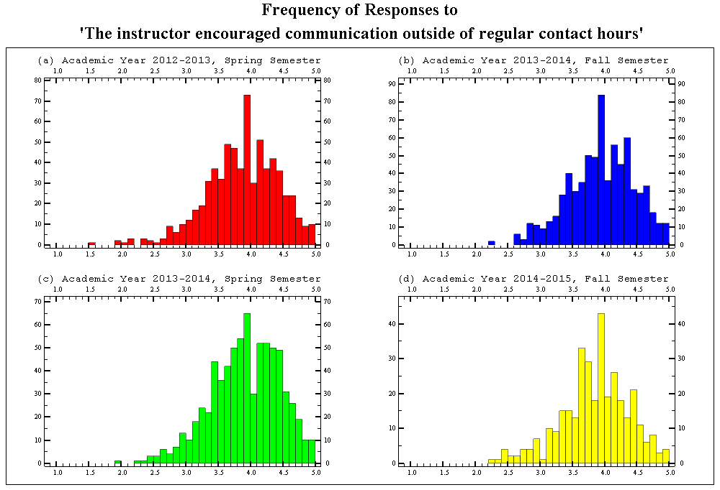
Figure 33.1 Showing the semester breakdown of the ratings distribution of the encouragement given by instructors for students to contact them outside of regular contact hours for all departments, for Academic years 2012-13 to 2014-15

The average median score of each semester for this question was 3.96, with an average standard interquartile range of 0.70. Thus figure 33.1 suggests that over the time that the data was taken, students generally considered their instructors to be more encouraging of students contacting them outside regular scheduled hours as compared to instructors from other courses the students have taken. It is notable that all charts have their highest peak in the 3.9-4.0 bin.

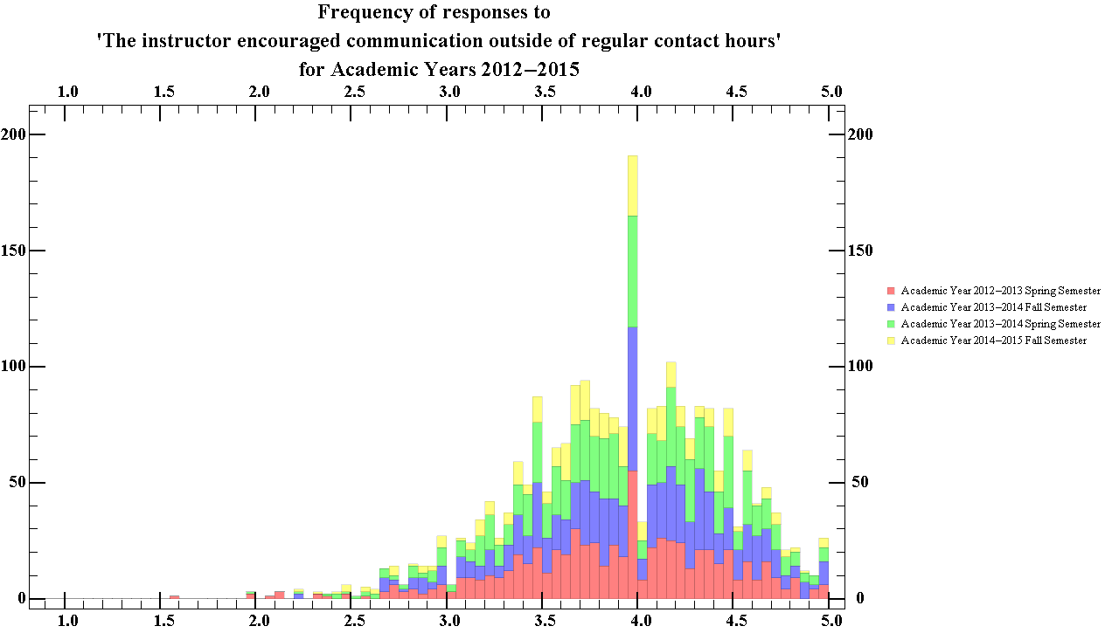
Figure 33.2 Showing the total ratings distribution of the encouragement given by instructors for students to contact them outside of regular contact hours, for all departments for Academic years 2012-13 to 2014-15

The median score for this question was 3.97, with an interquartile range of 0.72. Thus figure 33.2 suggests that students generally considered their instructors to be more encouraging of students contacting them outside regular scheduled hours as compared to instructors from other courses the students have taken. The 3.95-4.0 bin is the peak and easily stands out in comparison to the other bins.

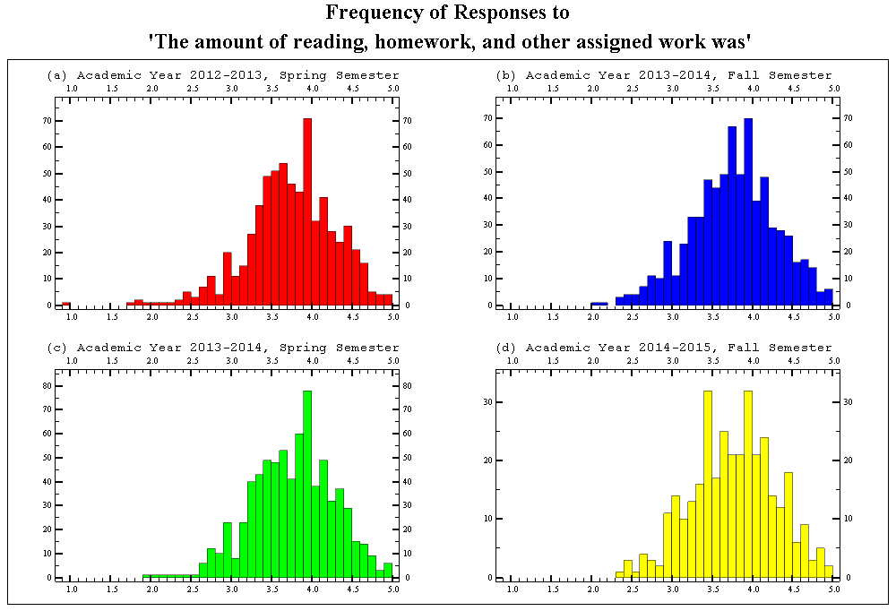
Figure 34.1 Showing the semester breakdown of the ratings distribution of the amount of reading and assigned work, for all departments for Academic years 2012-13 to 2014-15

The median score given by students was 3.79, with an interquartile range of 0.70. Thus figure 34.1 suggests that over the time the data was collected, students generally considered the amount of assigned work given in courses at WPI to be greater than that given in other courses the students have taken. The 3.95-4.0 bin is the highest peak in all these charts.

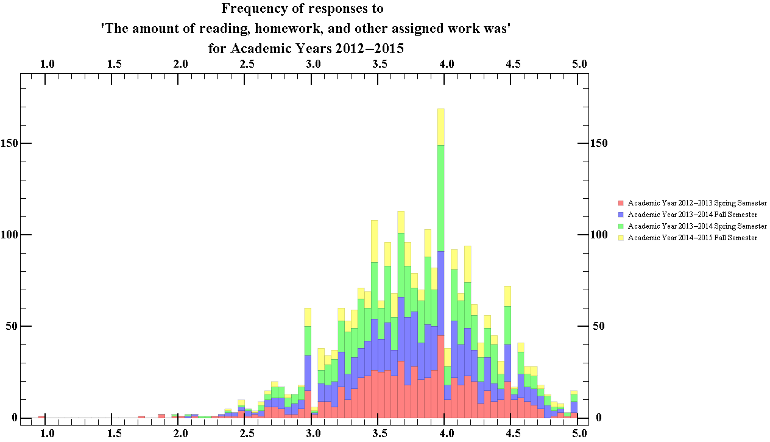
Figure 34.2 Showing the total ratings distribution of the amount of reading and assigned work, for all departments for Academic years 2012-13 to 2014-15

The median score for this question was 3.97, with an interquartile range of 0.69. Thus figure 34.2 suggests that students generally considered the amount of assigned work they were given in courses at WPI to be more than that of other courses they have taken. The 3.95-4.0 bin is the peak and easily stands out in comparison to the other bins.

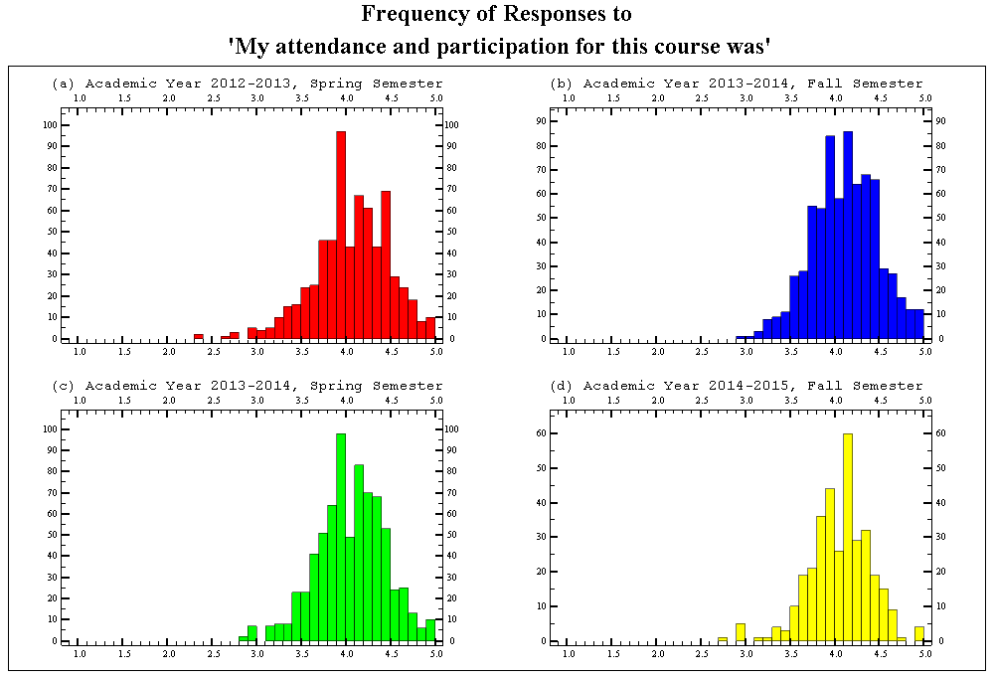
Figure 35.1 Showing the semester breakdown of the ratings distribution of the students attendance and participation in the course, for all departments for Academic years 2012-13 to 2014-15

The median score given by students was 4.10, with an interquartile range of 0.50. Thus figure 35.1 suggests that over the time the data was collected, students generally had increased participation in these courses in comparison to other courses they have taken. The 3.95-4.0 bin is the highest peak in (a) and (c) with dips in the 4.0-4.05 bin.

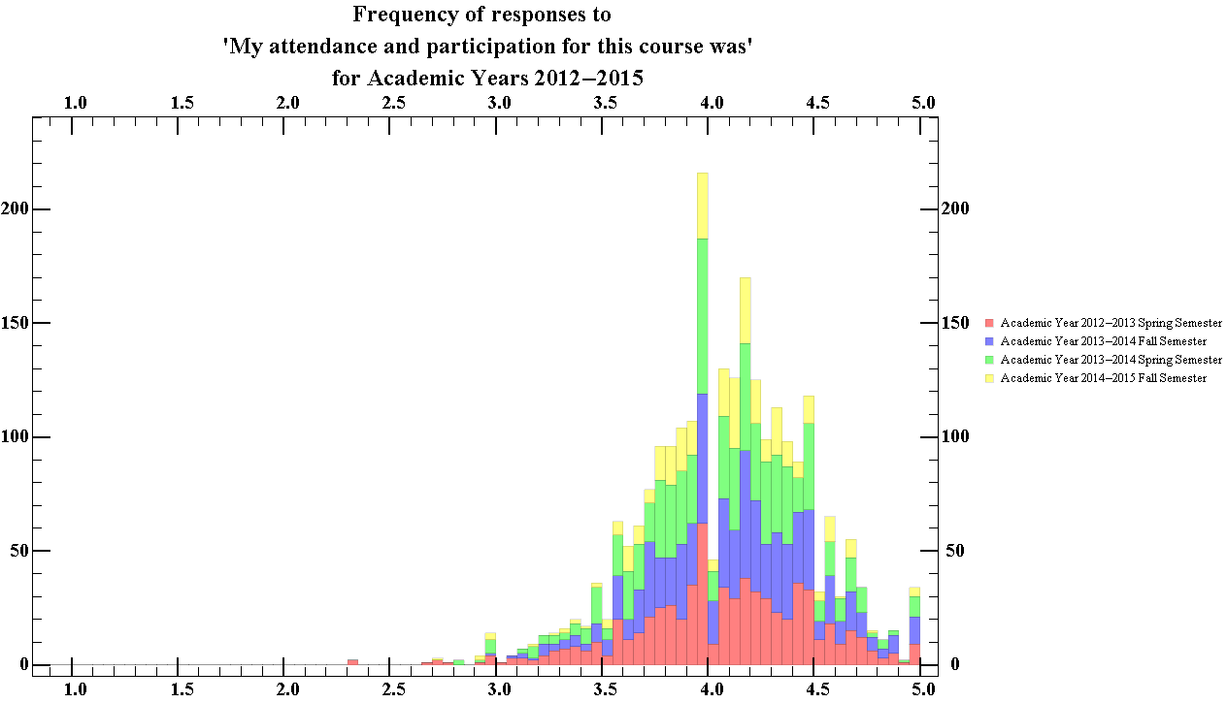
Figure 35.2 Showing the total ratings distribution of the students attendance and participation in the course, for all departments for Academic years 2012-13 to 2014-15

The median score given by students for this question was 4.1, with an interquartile range of 0.49. Thus figure 35.2 suggests that students generally considered their participation to be greater in courses at WPI when compared to that of other courses they have taken. The 3.95-4.0 bin is the peak and easily stands out in comparison to the other bins.

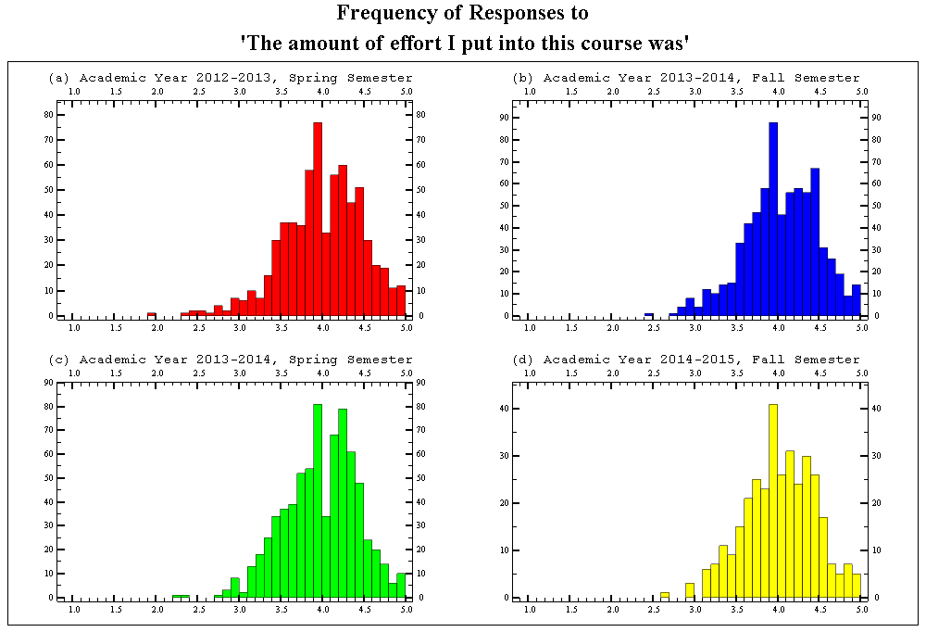
Figure 36.1 Showing the semester breakdown of the ratings distribution of the amount of effort the student put in the course, for all departments for Academic years 2012-13 to 2014-15

The median score given by students was 4.03, with an interquartile range of 0.60. Thus figure 36.1 suggests that over the time the data was collected, students generally tried to put in more effort in their courses in comparison to other courses they have taken. The 3.95-4.0 bin is the highest peak in all charts with dips in the 4.0-4.05 bin of charts (a), (b) and (c).

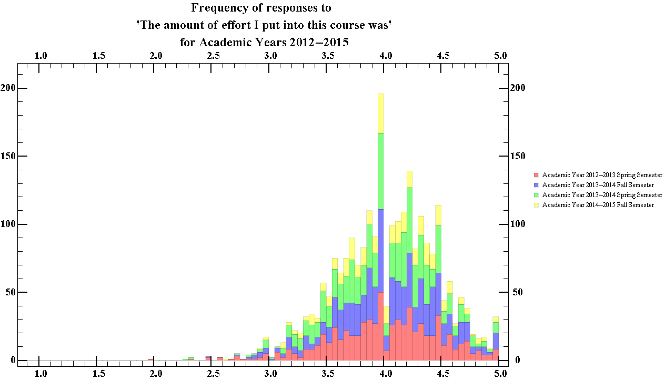
Figure 36.2 Showing the total ratings distribution of the amount of effort the student put in the course, for all departments for Academic years 2012-13 to 2014-15

The median score given by students for this question was 4.05, with an interquartile range of 0.60. Thus figure 36.2 suggests that students generally considered the effort they had put in to be greater in courses at WPI when compared to that of other courses they have taken. The 3.95-4.0 bin is the peak and easily stands out in comparison to the other bins.

Section 3
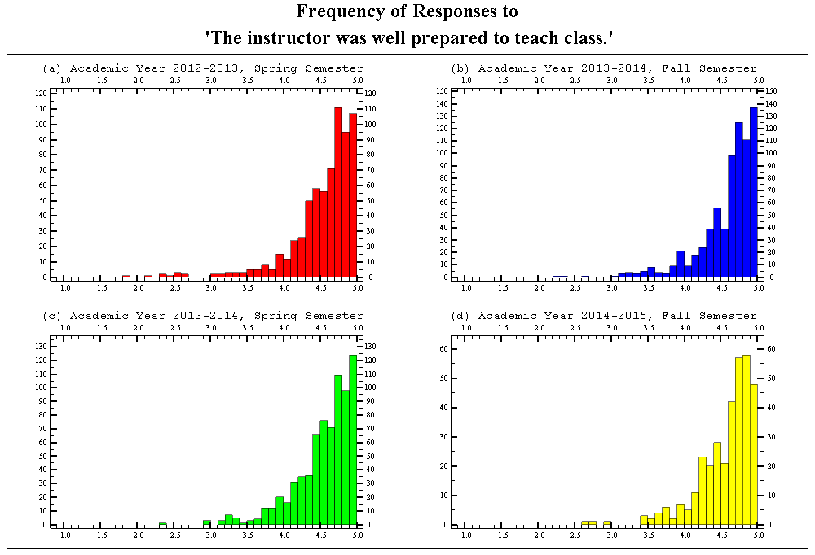
Figure 37.1 Showing the semester breakdown of the ratings distribution of the frequency that the instructors were prepared for class, for all departments for Academic years 2012-13 to 2014-15

The median score given by students was 4.68, with an interquartile range of 0.44. Thus figure 37.1 suggests that over the time the data was collected, students generally considered their instructors to be almost always prepared for teaching class.

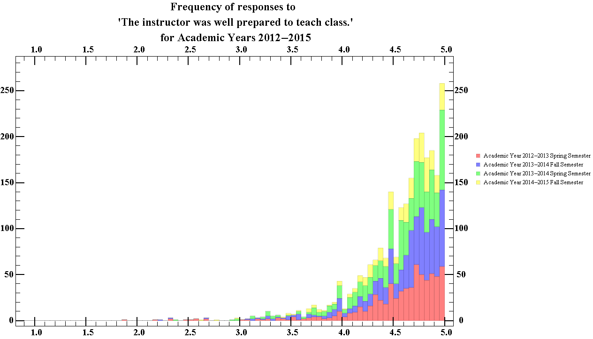
Figure 37.2 Showing the total ratings distribution of the frequency that the instructors were prepared for class, for all departments for Academic years 2012-13 to 2014-15

The median score given by students for this question was 4.68, with an interquartile range of 0.43. Thus figure 37.2 suggests that students generally considered their professors to be almost always prepared to teach the class.

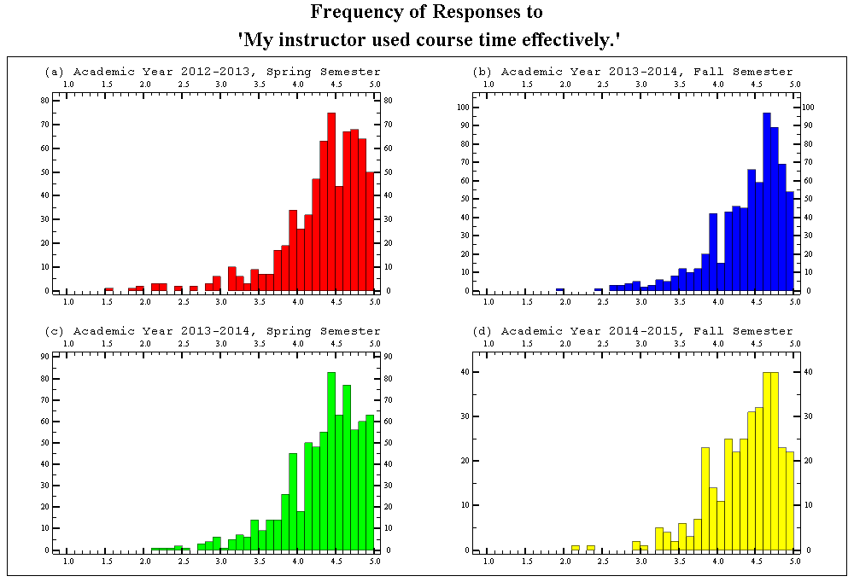
Figure 38.1 Showing the semester breakdown of the ratings distribution of the frequency in which the instructor was considered to be efficient with the course time, for all departments for Academic years 2012-13 to 2014-15

The median score given by students was 4.48, with an interquartile range of 0.58. Thus figure 38.1 suggests that over the time the data was collected, students generally considered their instructors to be almost always effective with the course time.
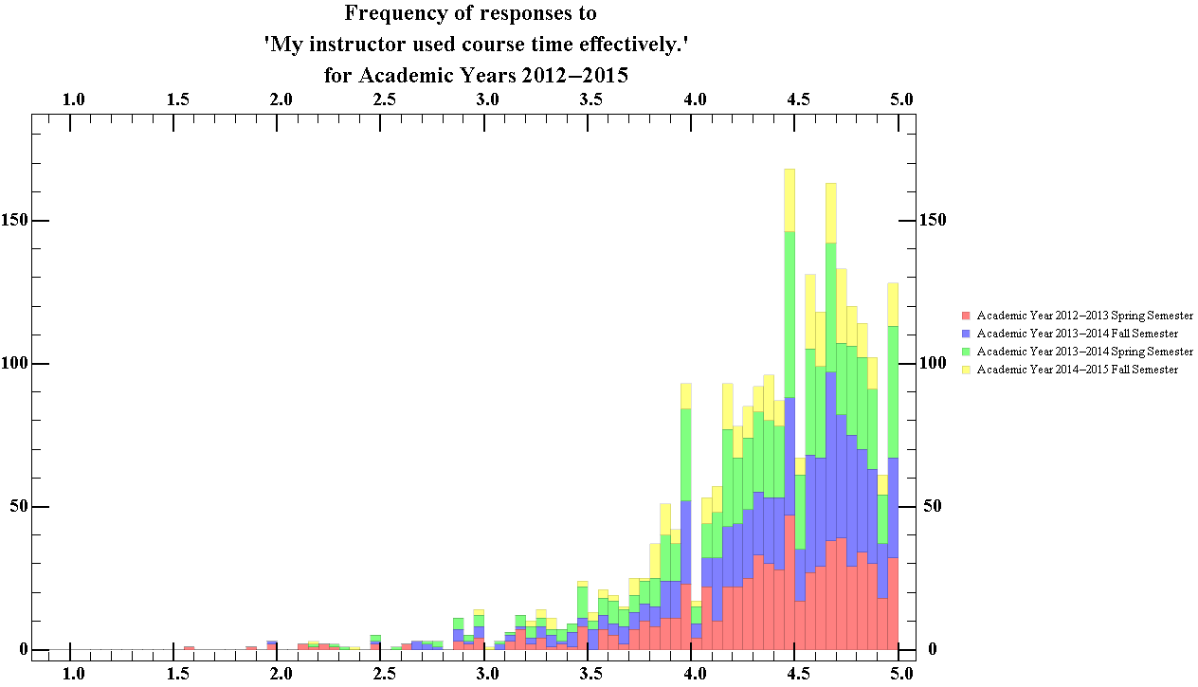
Figure 38.1 Showing the semester breakdown of the ratings distribution of the frequency in which the instructor was considered to be efficient with the course time, for all departments for Academic years 2012-13 to 2014-15

The median score given by students for this question was 4.5, with an interquartile range of 0.57. Thus figure 38.2 suggests that students generally considered their professors to be almost always efficient with the course time. Much like all previous charts of the total distribution, there is a dip in the 4.0-4.05 bin.

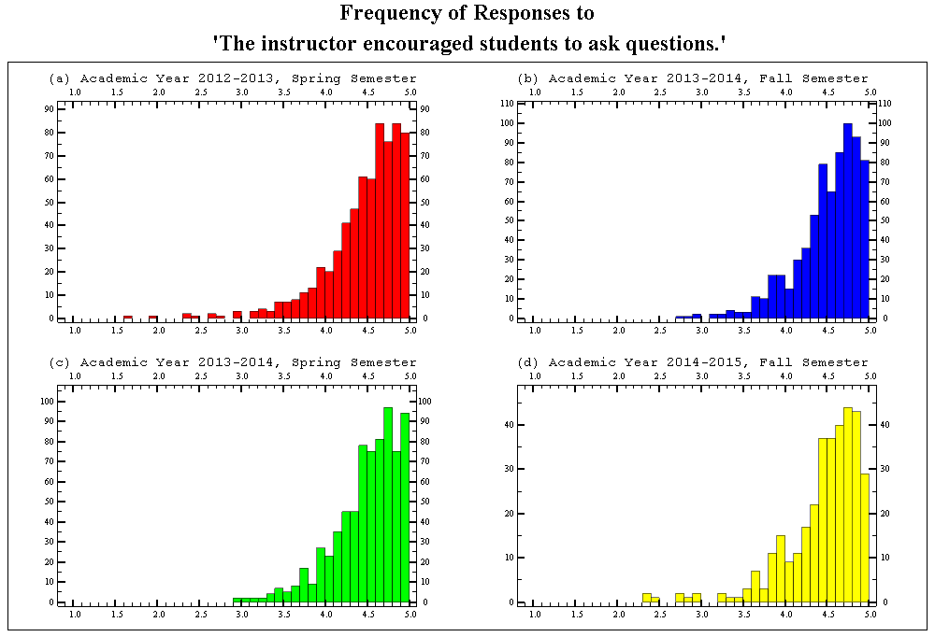
Figure 39.1 Showing the semester breakdown of the ratings distribution of the frequency in which instructors encouraged of students to ask questions for all departments for Academic years 2012-13 to 2014-15

The median score given by students was 4.59, with an interquartile range of 0.50. Thus figure 39.1 suggests that over the time the data was collected, students generally considered their instructors to almost always have been encouraging of students to ask questions.
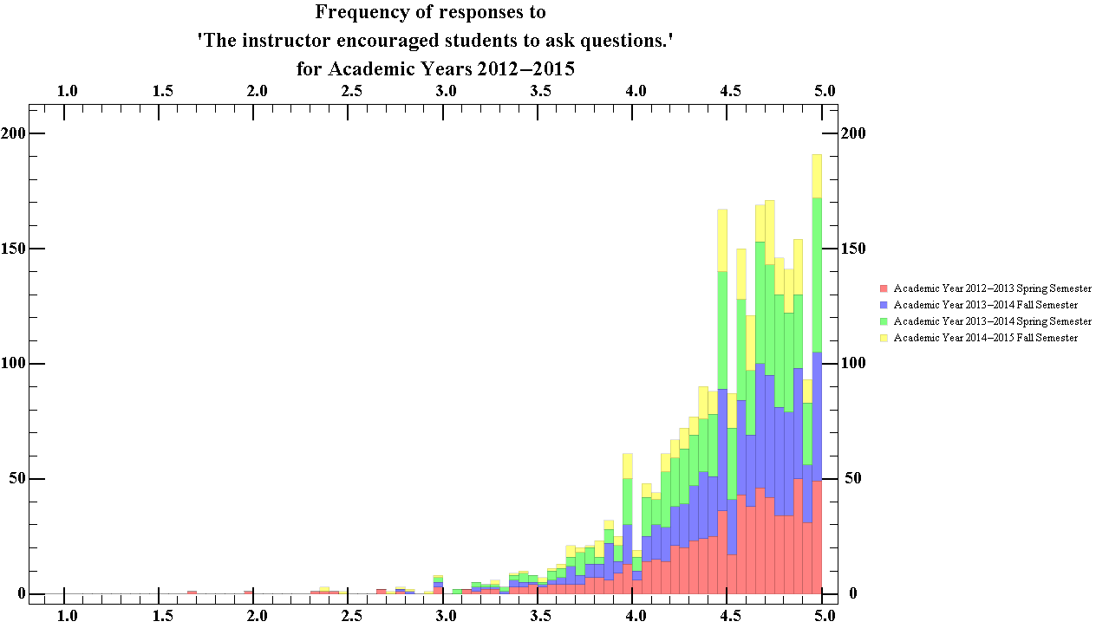
Figure 39.2 Showing the total ratings distribution of the frequency in which instructors encouraged of students to ask questions for all departments for Academic years 2012-13 to 2014-15

The median score given by students for this question was 4.59, with an interquartile range of 0.5. Thus figure 39.2 suggests that students generally considered their professors to almost always be encouraging of students asking questions.

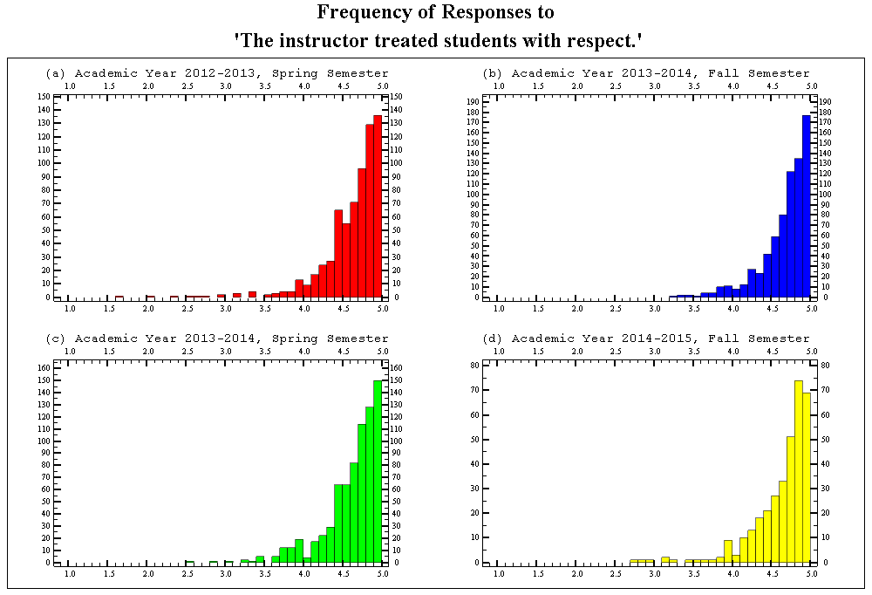
Figure 40.1 Showing the semester breakdown of the ratings distribution of the frequency in which the instructors treated students with respect, for all departments for Academic years 2012-13 to 2014-15

The median score given by students was 4.75, with an interquartile range of 0.38. Thus figure 40.1 suggests that over the time the data was collected, students generally considered that their instructors to almost always have treated them with respect.

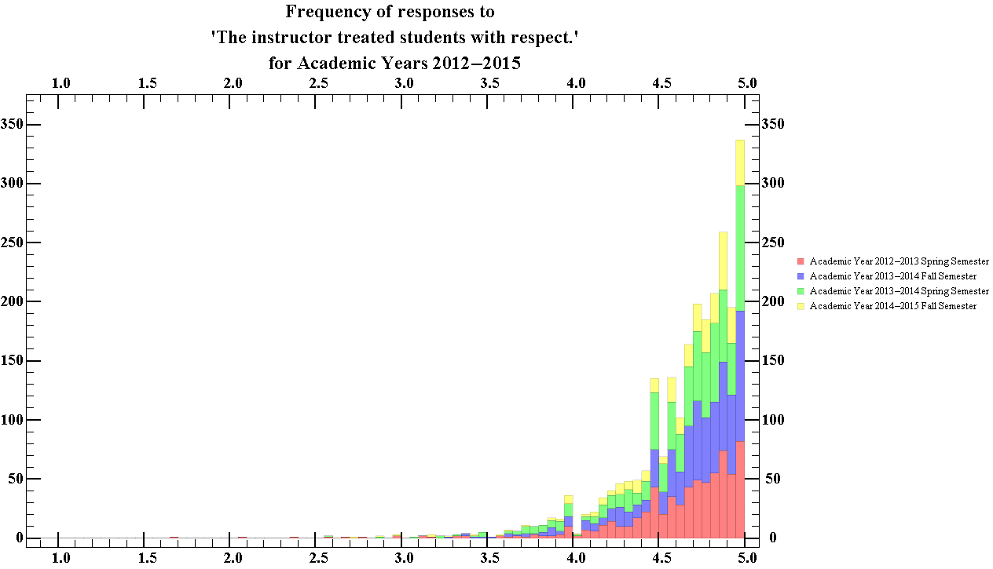
Figure 40.2 Showing the total ratings distribution of the frequency in which the instructors treated students with respect, for all departments for Academic years 2012-13 to 2014-15

The median score given by students for this question was 4.28, with an interquartile range of 0.71. Thus figure 40.2 that students generally considered their professors to have almost always been respectful.

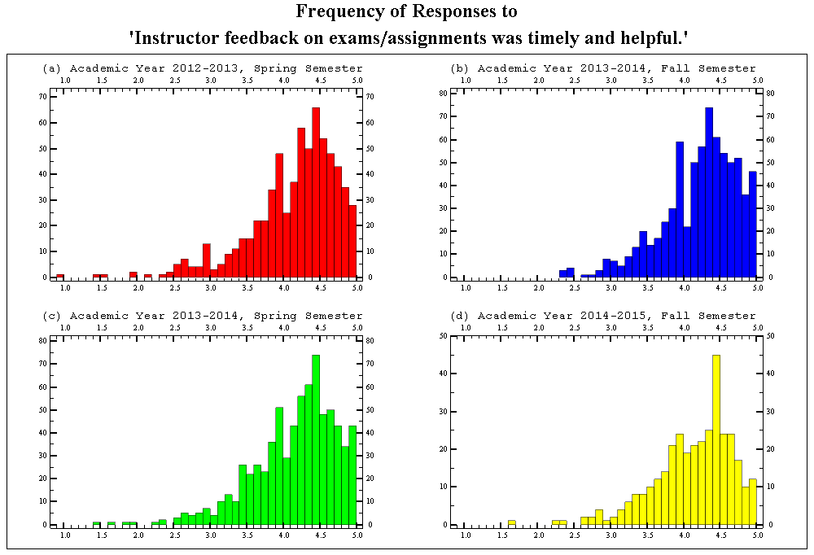
Figure 41.1 Showing the semester breakdown of the ratings distribution of the frequency in which the instructors feedback on assignments was timely and helpful, for all departments for Academic years 2012-13 to 2014-15

The median score given by students was 4.28, with an interquartile range of 0.71. Thus figure 41.1 that over the time the data was collected, students generally considered that their instructor’s feedback was almost always timely and helpful.
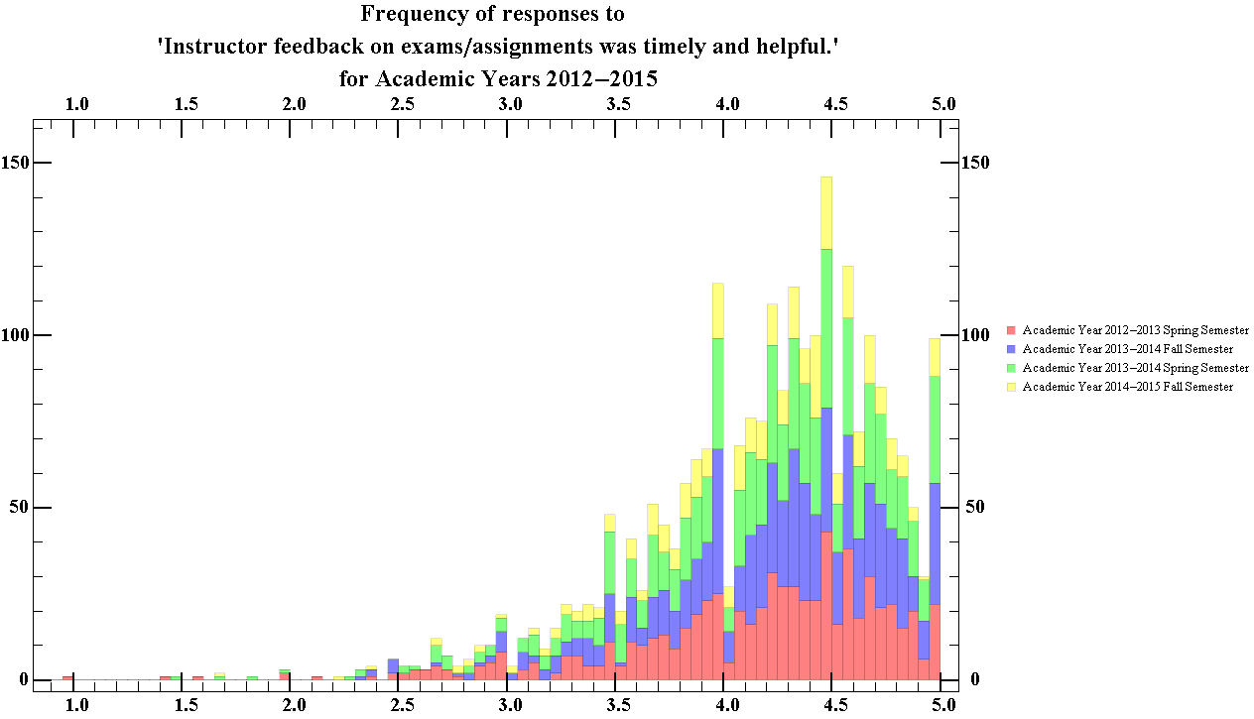
Figure 41.2 Showing the total ratings distribution of the frequency in which the instructors feedback on assignments was timely and helpful, for all departments for Academic years 2012-13 to 2014-15

The median score given by students for this question was 4.29, with an interquartile range of 0.69. Thus figure 41.2 that students generally considered their professor’s feedback to have almost always been timely and helpful.
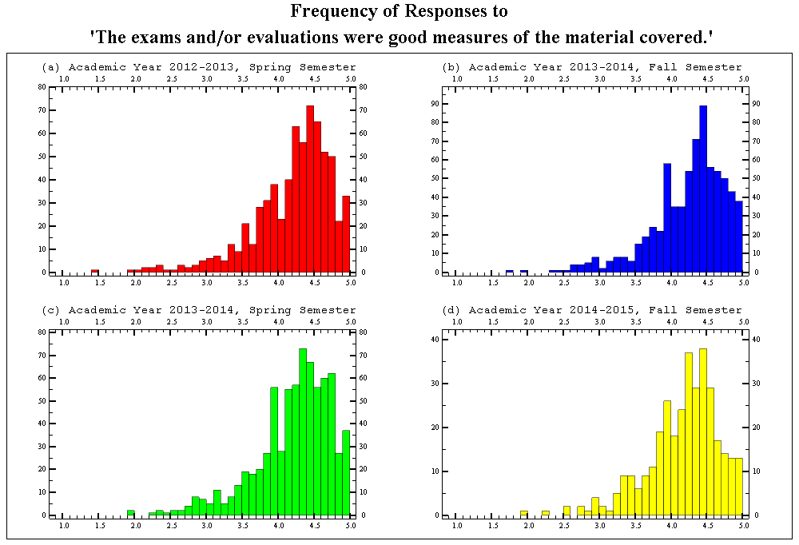
Figure 42.1 Showing the semester breakdown of the ratings distribution of the frequency in which the evaluations were a good representation of the material covered for all departments for Academic years 2012-13 to 2014-15

The median score given by students was 4.32, with an interquartile range of 0.61. Thus figure 42.1 that over the time the data was collected, students generally considered that the class evaluations were almost always a good representation of the material covered.
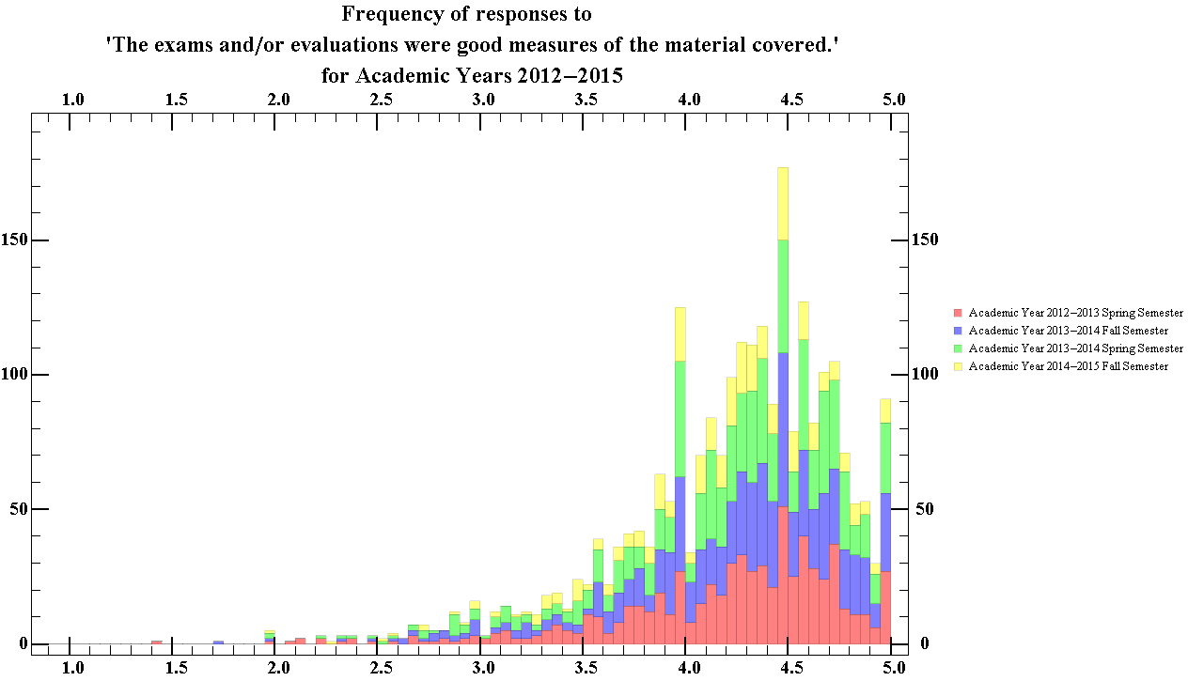
Figure 42.2 Showing the total ratings distribution of the frequency in which the evaluations were a good representation of the material covered for all departments for Academic years 2012-13 to 2014-15

The median score given by students for this question was 4.33, with an interquartile range of 0.59. Thus figure 42.2 that students generally considered the evaluations to almost always have been a good representation of the material covered.

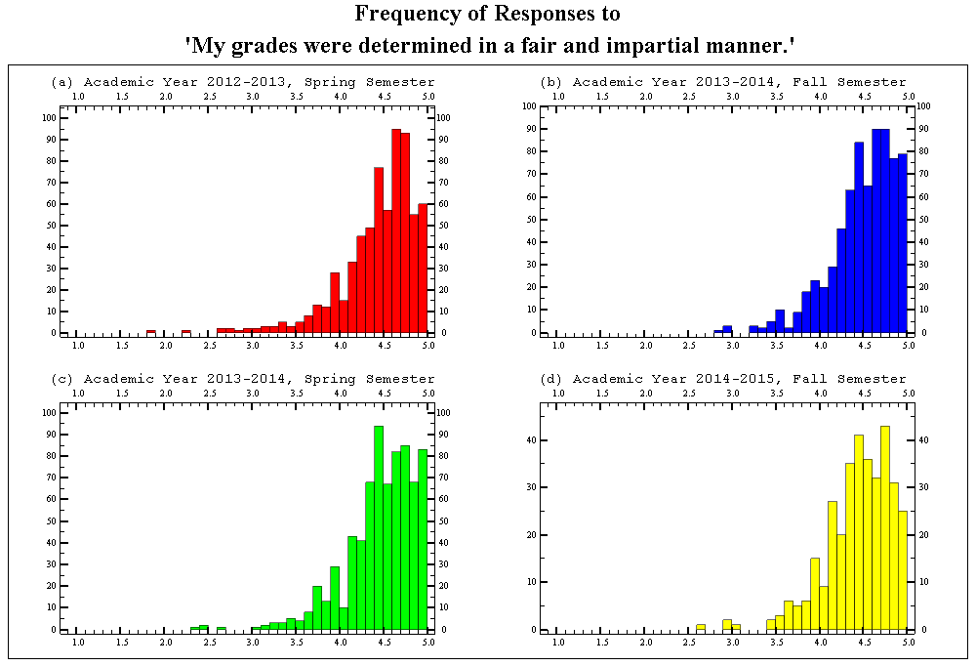
Figure 43.1 Showing the semester breakdown of the ratings distribution of the frequency in which the students thought their grads were determined in a fair and impartial manner, for all departments for Academic years 2012-13 to 2014-15

The median score given by students was 4.54, with an interquartile range of 0.47. Thus figure 43.1 that over the time the data was collected, students generally considered that their grades were determined in a fairer and impartial manner in comparison to other courses they have taken.
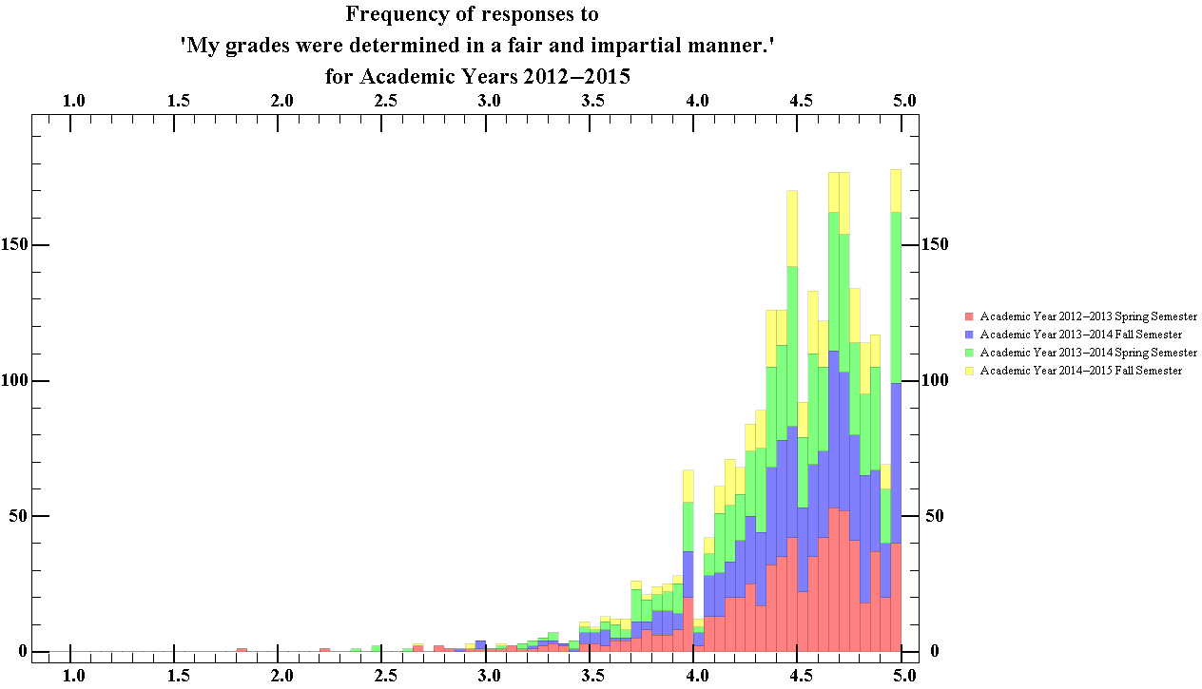
Figure 43.2 Showing the total ratings distribution of the frequency in which the students thought their grades were determined in a fair and impartial manner, for all departments for Academic years 2012-13 to 2014-15

The median score given by students for this question was 4.55, with an interquartile range of 0.46. Thus figure 43.2 that students generally considered their grades to have been determined in a fair and impartial manner in comparison to that of other courses they have taken.
Section 4
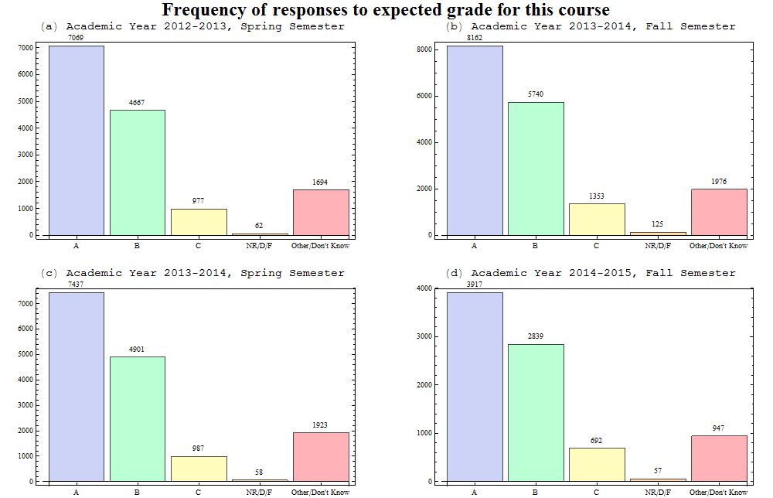
Figure 44.1 Showing the semester breakdown of the distribution of the grades that the students thought they would get in the course, for all departments for Academic years 2012-13 to 2014-15

From the data, it seems that students at WPI generally consider their performance good enough to achieve B’s and higher in courses they take, with most students expecting A’s. The student’s opinion of their performance appears to be very consistent over the period in which the data was collected. Here, we have nearly 50% of students responding that they expect to get an A in the courses they take, with the lowest percentage ate 46% in (d) and the highest 49% in (a). It should be noted that the expected grade is not necessarily a measurement of the grades that the student earn, but more of a measurement of a student’s own thoughts on their performance.

Figure 44.2 Showing the total ratings distribution of the grades that the students thought they would get in the course, for all departments for Academic years 2012-13 to 2014-15
The most frequent choice for this question was “A”, with 48% of students choosing this result. Nearly 80.5% Students expect to achieve grades of B or above.

Figure 45.1 Showing the semester breakdown of the distribution of how the course was related to their academic program, for all departments for Academic years 2012-13 to 2014-15

Analysis of figure 45.1 shows that the distribution between fall and spring semesters differ with larger proportion of students taking courses in the fall semester as major requirements rather than courses in their major field. The difference between enrolments as a major requirement between fall semesters and spring semesters was 38.8% and 34.4% respectively.

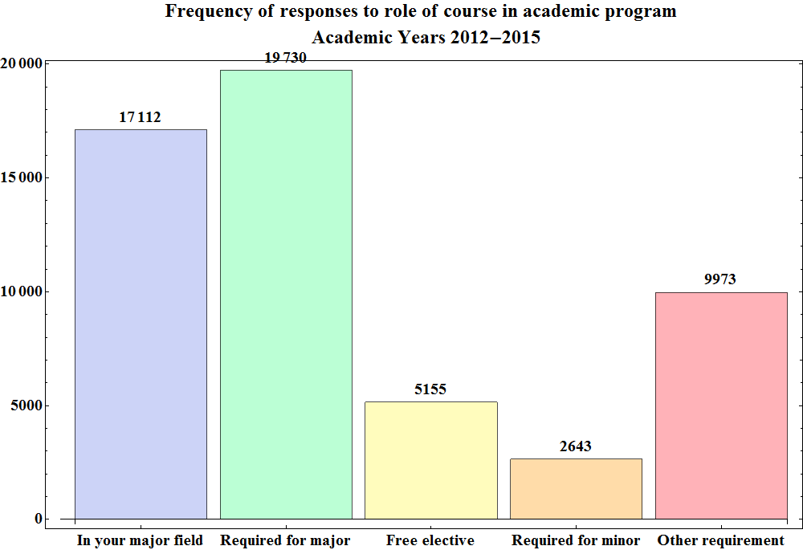
Figure 45.2 Showing the total ratings distribution of how the course was related to their academic program, for all departments for Academic years 2012-13 to 2014-15
There is almost a one to one relation between students who take courses as a major requirement versus those who take it as a course within their majors during the period in which the data was collected, with 31.3% of students taking the course as a subject in their major field, and 36% of students taking courses as a major requirement. One would suspect that majority of students would be taking courses in their major fields, rather than courses that were simply required for their major. The most likely reason for this disparity could be the ambiguity between the responses, since some course could be counted in either for many students, since many majors have required courses within their major.

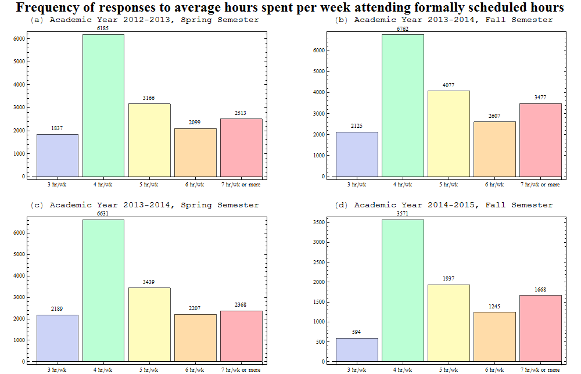
Figure 46.1 Showing the semester breakdown of the distribution of how many formally scheduled hours of course time the students attended, for all departments for Academic years 2012-13 to 2014-15
From figure 46.1, it is clear that the most frequent choice for the number of hours of scheduled class time attended per week was that 4 hours. 4hr/wk contained 39-40% of responses for all semesters except in (b) where 35.5% of students responded this way. Here there is a small difference between the percentage of students who attended 7 hours or more per week of scheduled course hours with 18.4% of students attending 7 hours or more in fall semesters, ad 15% in spring semesters.

Figure 46.2 Showing the total ratings distribution of how many formally scheduled hours of course time the students attended, for all departments for Academic years 2012-13 to 2014-15

In general most students seem to attend about 4 hr/wk of course hours, with 38% of students general responding this way. Examination of figure 46.2 also shows that only 16.5% of students attend 7 or more hours a week of formally scheduled course hours.

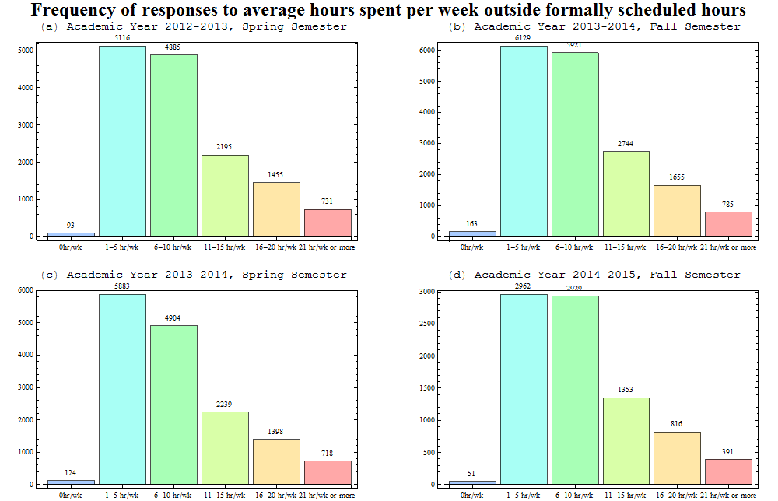
Figure 47.2 Showing the semester breakdown of the distribution of how hours outside of formally scheduled class time the students spent on their courses, for all departments for Academic years 2012-13 to 2014-15
The most frequent choice for all semesters for this question was 1-5 hours of work, with only about 30% of students putting in 11 hours or more per week. A high frequency concentrated about 1-5 hours and 6-10 hours suggests most students probably put in somewhere within the low end of 6-10 hours and the high end of 1-5 hours.
Figure 47.2 Showing the total ratings distribution of how hours outside of formally scheduled class time the students spent on their courses, for all departments for Academic years 2012-13 to 2014-15
Most students appeared to put in somewhere between 1-5 hours of work outside formally scheduled course hours per week on a course. Most students most likely had put in somewhere between 3 and 8 hours since there is also large frequency of students who chose the 6-10 hour category. It is clear that over the period for which the data was taken, only 30% of students put in 11 or more hours into their course work outside of formally scheduled hours.

Physics
Section 1
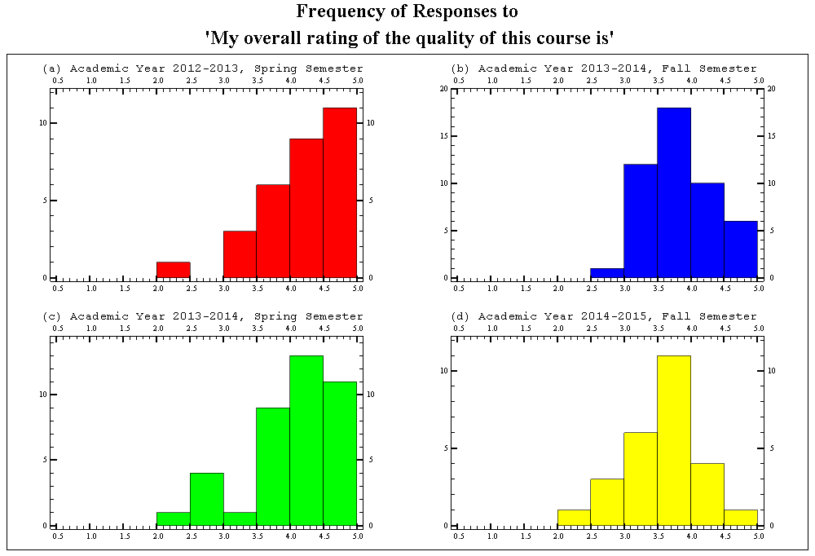
Figure 48.1 Showing the semester breakdown of the ratings distribution of the overall rating of the course quality, for the Physics department for Academic Years 2012-13 to 2014-15

The median score of each semester for this question had an average score of 4.02, with an average interquartile range of 0.68. This data suggests that the consensus amongst students is that the physics courses available at WPI are of a generally of good quality. The courses provided in the spring semesters,(a) and (c), had an average median score of 4.25 and courses in the fall semesters, (b) and (d), had an average median score of 3.78.
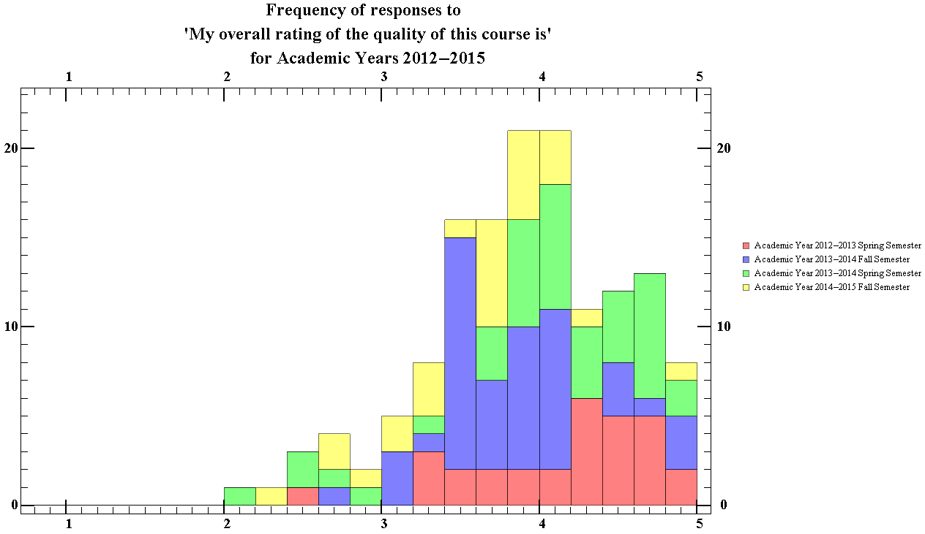
Figure 48.2 Showing the total ratings distribution of the total overall rating of the course quality, for the physics department for Academic Years 2012-2015

The median score given by students for the overall quality of physics courses at WPI is 4.0 with the highest peak occurring between the 3.8-4.0 bin and the 4.0-4.2 bin. The interquartile range for this question has a size of 0.79. This data suggests that students generally consider the physics courses provided by WPI to be of good quality.

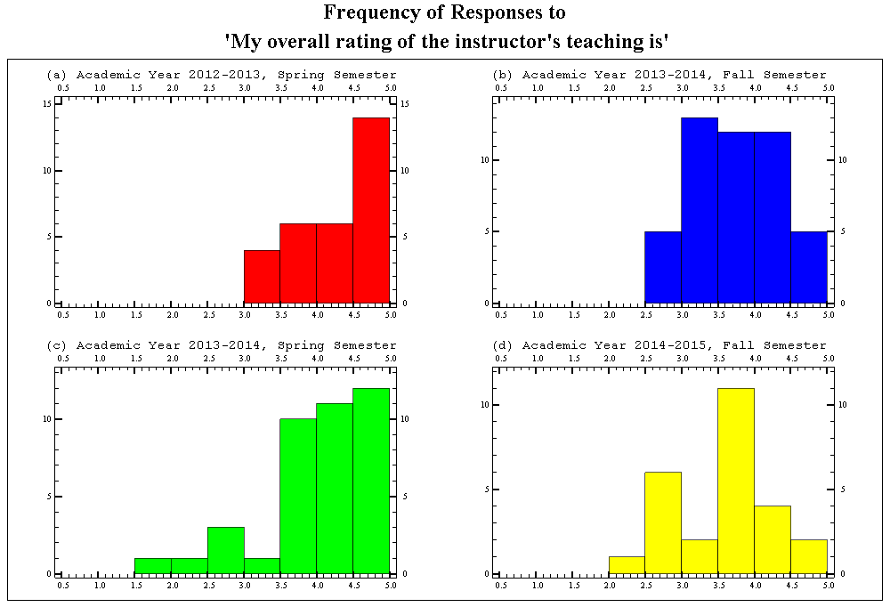
Figure 49.1 Showing the semester breakdown of the ratings distribution of the overall rating of the instructors teaching, for the physics department for Academic Years 2012-13 to 2014-15

The average median score of each semester for this question was 4.02, with an average standard interquartile range of 0.84. This data suggests that students generally consider physics courses at WPI to be well taught. The courses provided in the spring semester had average median score of 4.33 and courses in the fall semester had an average median score of 3.68. This question has the largest average interquartile range of any question.

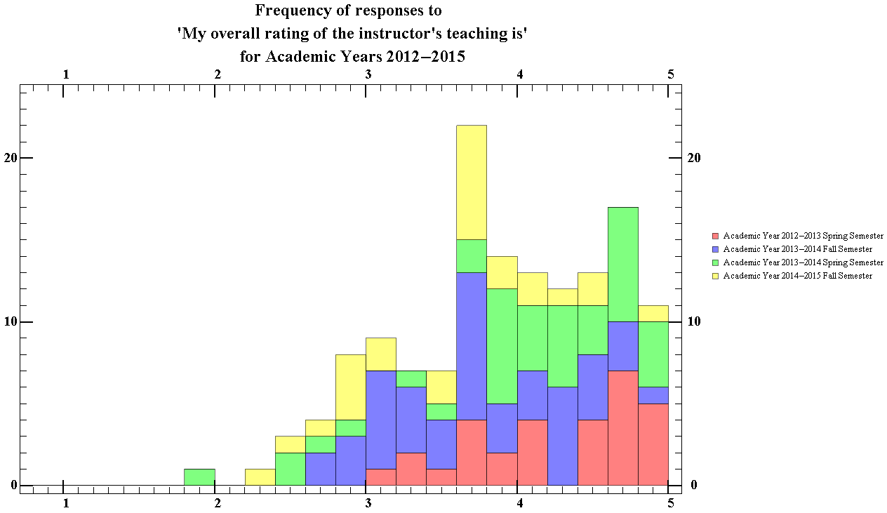
Figure 49.2 Showing the total ratings distribution of the total overall rating of the instructors teaching, for the physics department for Academic Years 2012-2015

The median score given by students for the instructor’s teaching is 4, with an interquartile range of 1. This indicates that students generally thought that physics courses at WPI were well taught. This question has the largest interquartile range amongst all the questions.

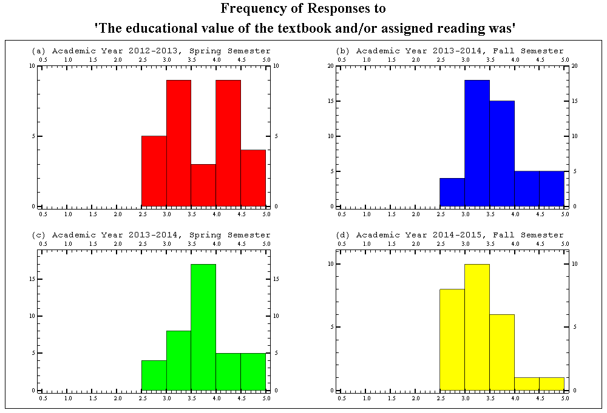
Figure 50.1 Showing the semester breakdown of the ratings distribution of the educational value of textbook and/or reading assignments, for the physics department for Academic years 2012-13 to 2014-15

The average median score of each semester for this question was 3.58, with an average standard interquartile range of 0.81. This data suggests that students generally consider the textbook and assigned readings in physics courses at WPI to be above average. The courses provided in the spring semester had average median score of 3.67 and courses in the fall semester had an average median score of 3.49.

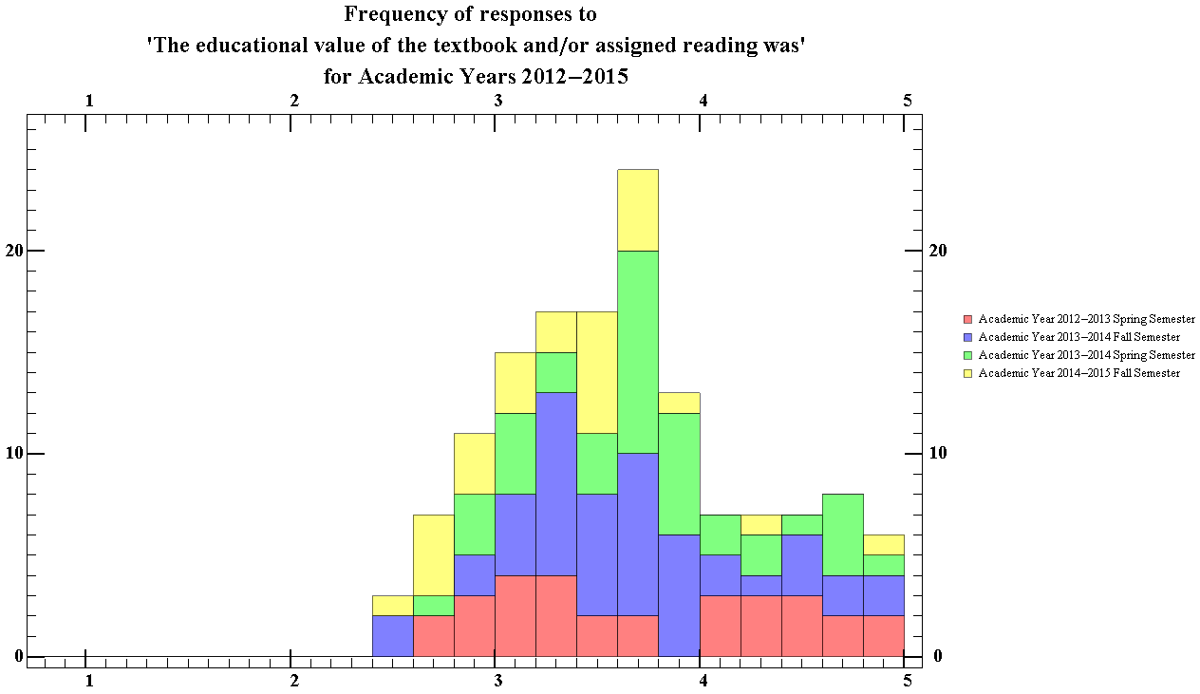
Figure 50.2 Showing the total ratings distribution of the educational value of textbook and/or reading assignments, for the physics department for Academic years 2012-13 to 2014-15

The median score given by students for the instructor’s teaching is 3.62, with an interquartile range of 0.8. This data suggests that students generally considered the textbook and assigned readings in physics courses at WPI were above average.

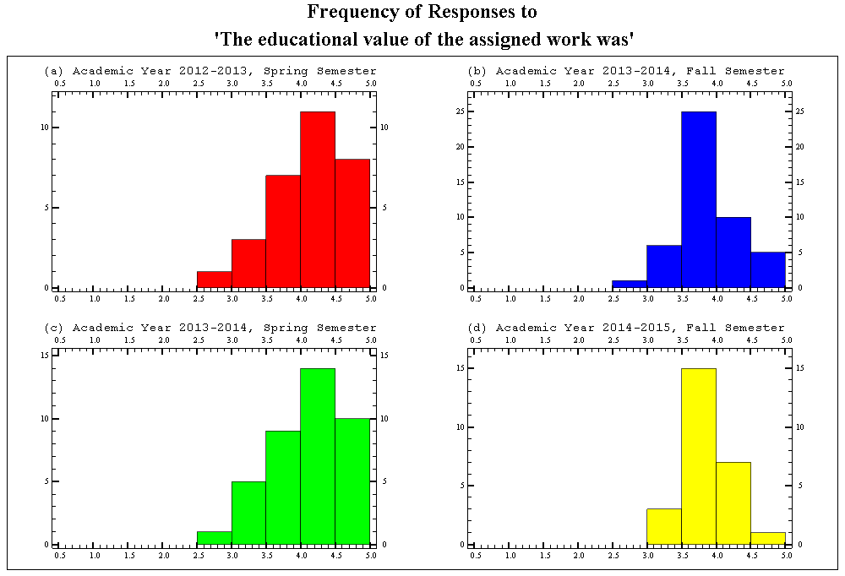
Figure 51.1 Showing the semester breakdown of the ratings distribution of the educational value of the assigned work, for the physics department for Academic years 2012-13 to 2014-15

The average median score of each semester for this question was 4.03, with an average standard interquartile range of 0.60. This data suggests that students generally consider the educational value of the work assigned in physics courses at WPI to be of good value. The courses provided in the spring semester had average median score of 4.21 and courses in the fall semester having an average median score of 3.84.

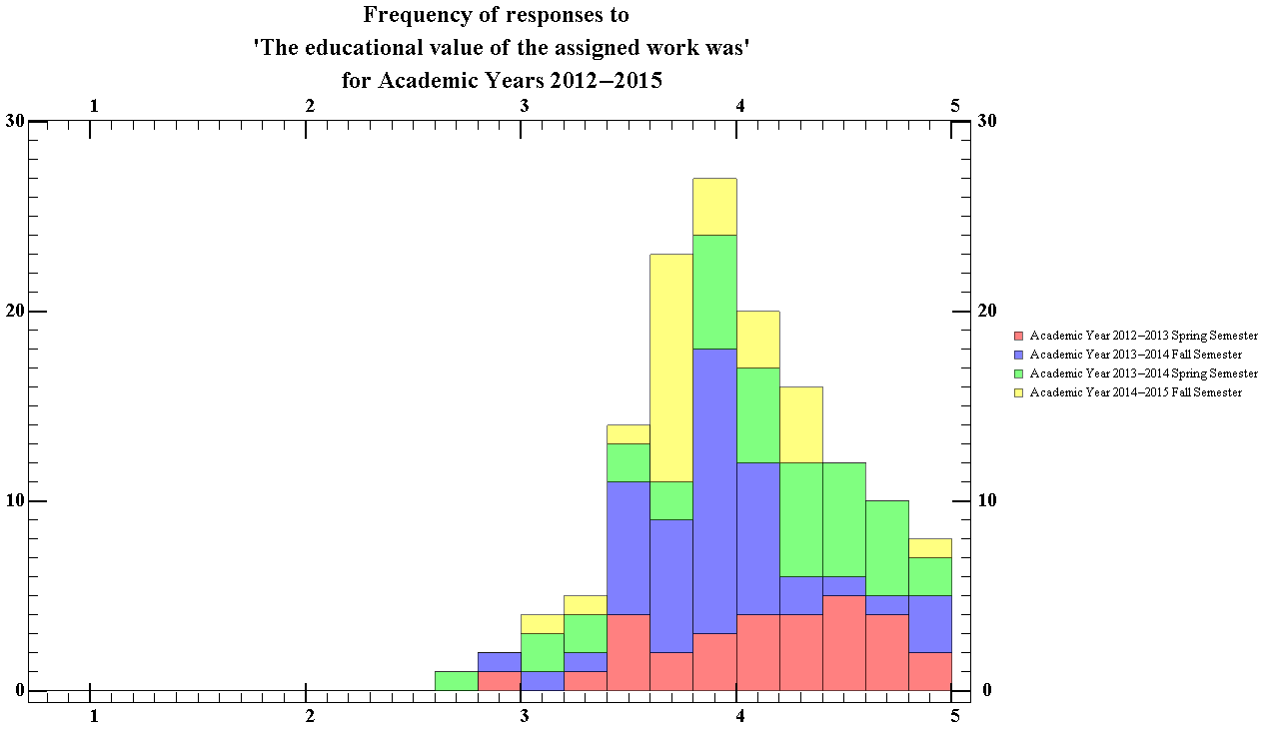
Figure 51.2 Showing total the ratings distribution of the educational value of the assigned work, for the physics department for Academic years 2012-13 to 2014-15

The median score given by students for the instructor’s teaching is 4.0, with an interquartile range of 0.64. This data suggests that students generally considered the assigned work in Physics courses at WPI were of good quality.

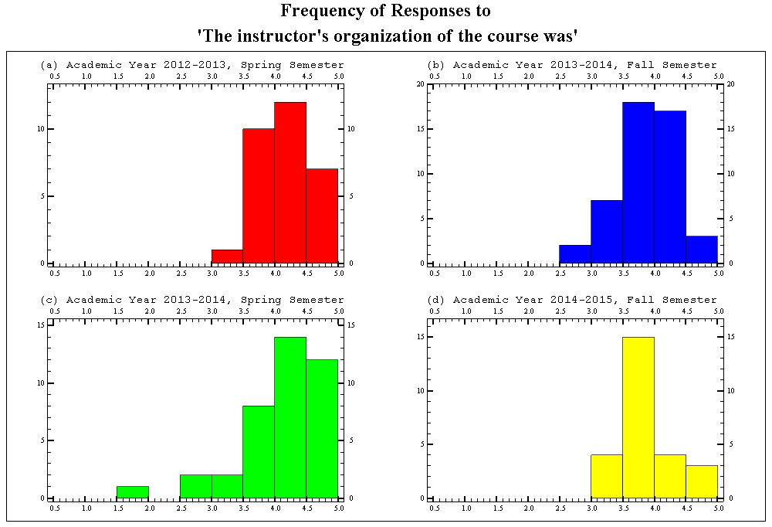
Figure 52.1 Showing the semester breakdown of the ratings distribution of the instructors course organization, for the physics department for Academic years 2012-13 to 2014-15

The average median score of each semester for this question was 4.08, with an average standard interquartile range of 0.56. This indicates that students generally consider the organization of physics courses at WPI to be good. The courses provided in the spring semester had average median score of 4.28 and courses in the fall semester having an average median score of 3.88.

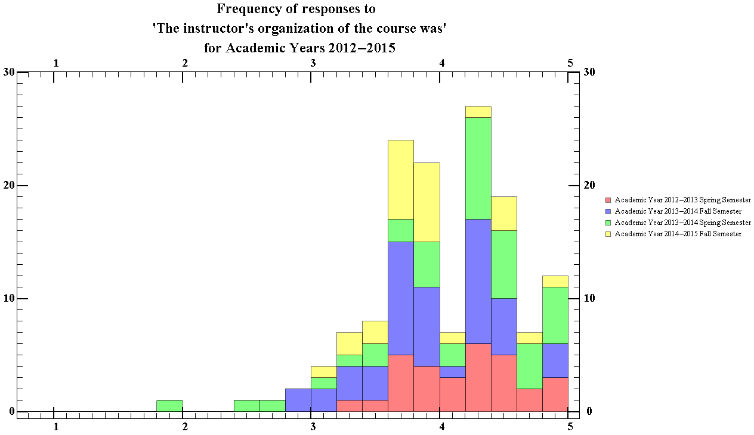
Figure 52.2 Showing the total ratings distribution of the instructors course organisation, for the physics department for Academic years 2012-13 to 2014-15

The median score given by students for the course organization was 4.11, with an interquartile range of 0.77. This data suggests that students generally considered the course organization of Physics courses at WPI to be good. There is a noticeable dip in the 4.0-4.2 bin.

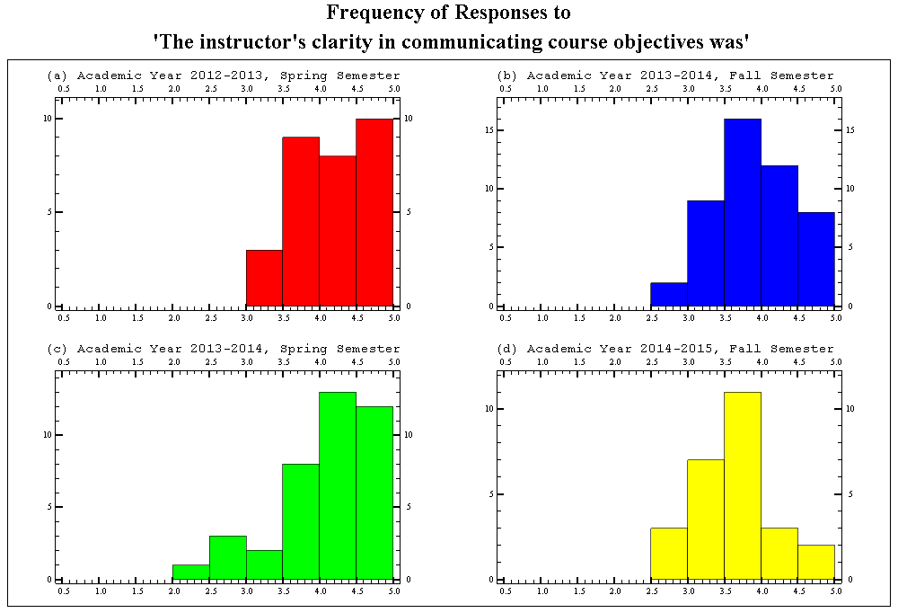
Figure 53.1 Showing the semester breakdown of the ratings distribution of the instructors clarity in communicating the objective, for the physics department for Academic years 2012-13 to 2014-15

The average median score of each semester for this question was 4.02, with an average standard interquartile range of 0.66. This data suggests that students generally consider the communication skills of physics courses instructors at WPI to be good. The courses provided in the spring semester had average median score of 4.26 and courses in the fall semester having an average median score of 3.78.

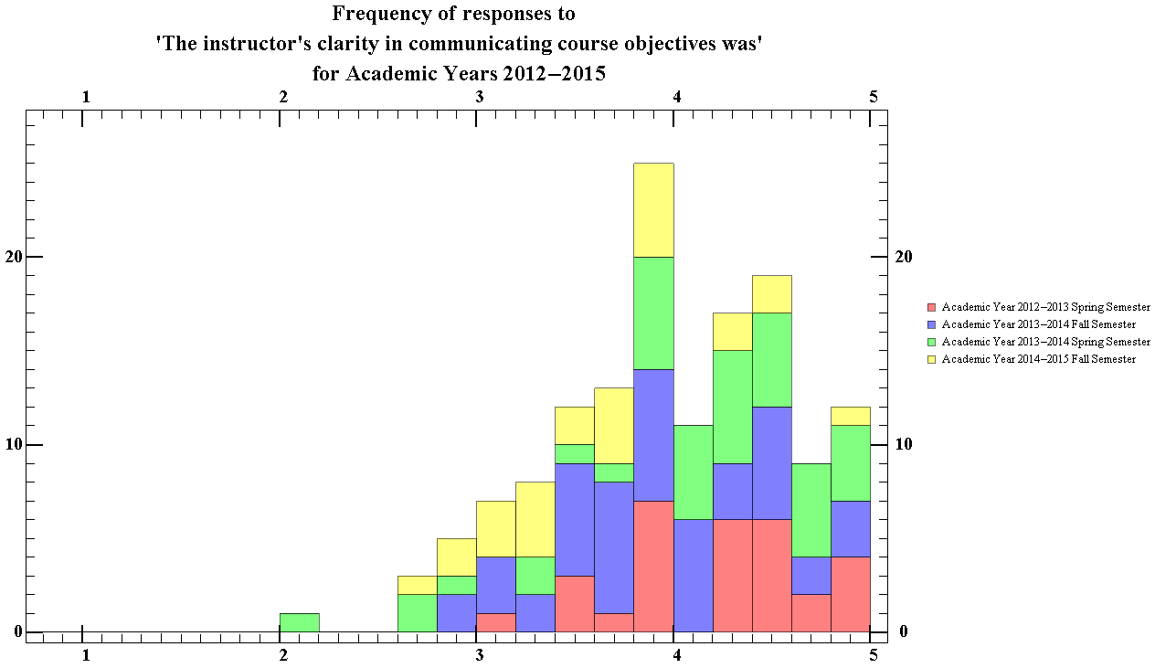
Figure 53.2 Showing the total ratings distribution of the instructors clarity in communicating the objective, for the physics department for Academic years 2012-13 to 2014-15

The median score given by students for the course organization was 4, with an interquartile range of 0.90. This data suggests that students generally considered the communication skills of the instructors of physics courses at WPI to be good. There is a noticeable dip in the 4.0-4.2 bin.

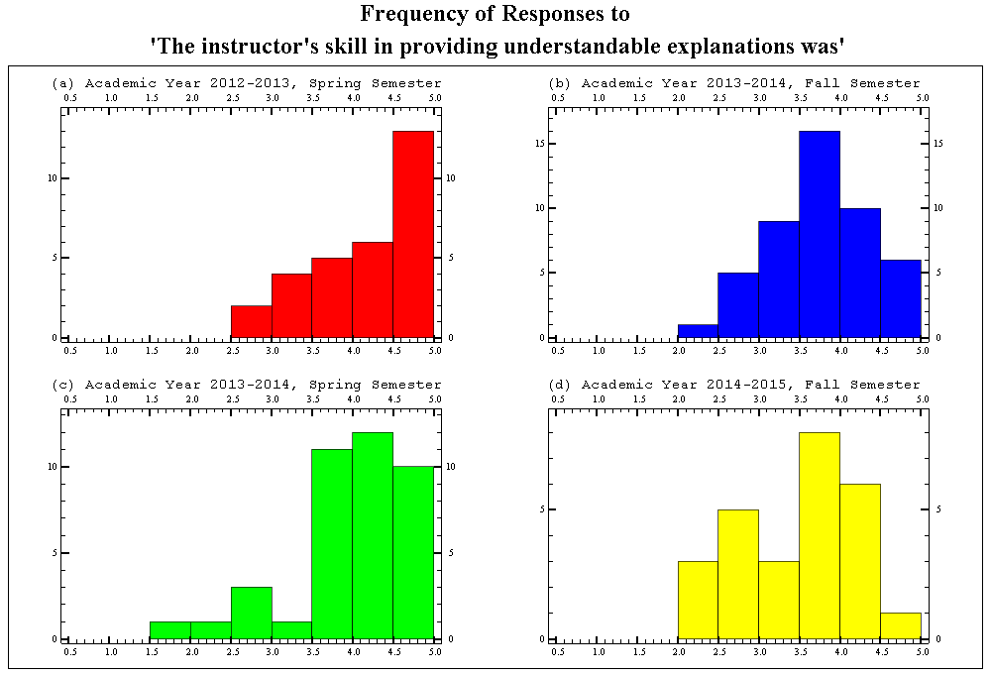
Figure 54.1 Showing the semester breakdown of the ratings distribution of the instructors skill in providing an understandable explanation, for the physics department for Academic years 2012-13 to 2014-15

The average median score of each semester for this question was 3.96, with an average standard interquartile range of 0.85. This data suggests that students generally consider the ability for physics professors at WPI to give an understandable explanation to be good. The courses provided in the spring semester had average median score of 4.23 and courses in the fall semester having an average median score of 3.7. This question had the third largest average interquartile range average. There was also a noticeable amount of variance in the interquartile range of each semester for this value, ranging from 0.5 to 1.08.

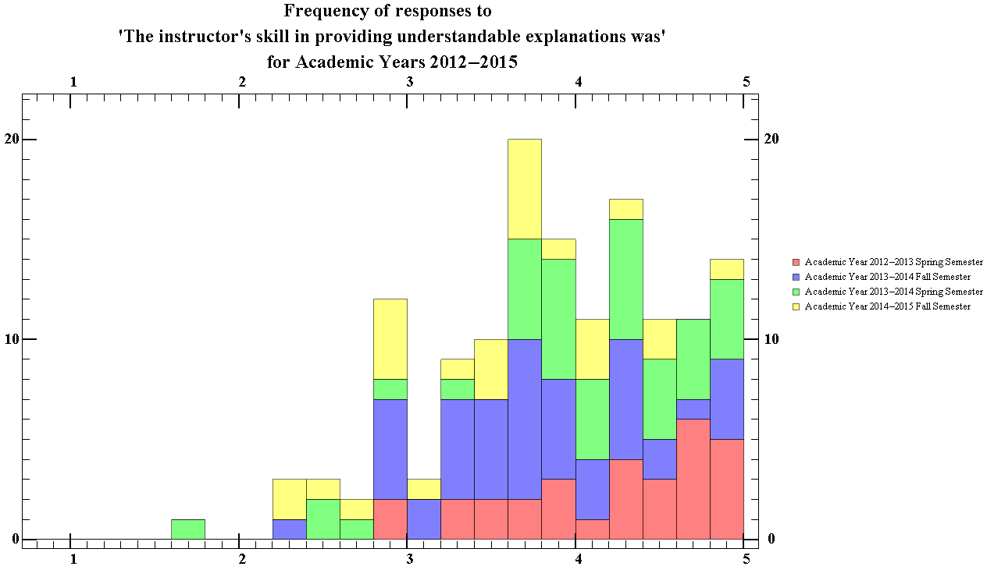
Figure 54.2 Showing the total ratings distribution of the instructors skill in providing an understandable explanation, for the physics department for Academic years 2012-13 to 2014-15

The median score given by students for the course organization was 3.90, with an interquartile range of 0.95. This data suggests that students generally considered the ability for physics instructors to provide understandable explanations to be good. There is a noticeable dip that occurs in the 3.0-32 bin, along with a dip in the 4.0-4.2 bin.

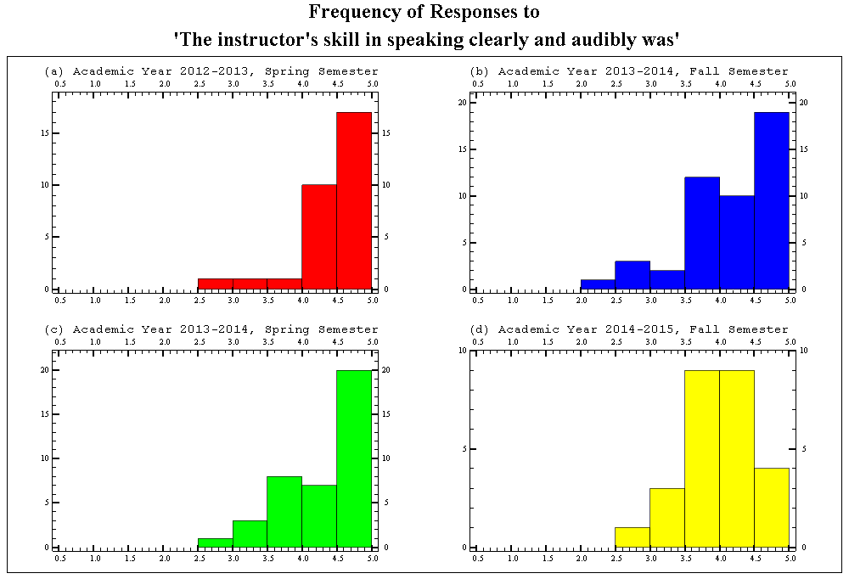
Figure 55.1 Showing the semester breakdown of the ratings distribution of the instructors skill in speaking clearly and audibly, for the physics department for Academic years 2012-13 to 2014-15

The average median score of each semester for this question was 4.36, with an average standard interquartile range of 0.64. This data suggests that students generally consider their physics instructors to be skilled in speaking clearly and audibly. The courses provided in the spring semester had average median score of 4.56 and courses in the fall semester having an average median score of 4.16. This question had the third largest average interquartile range average.

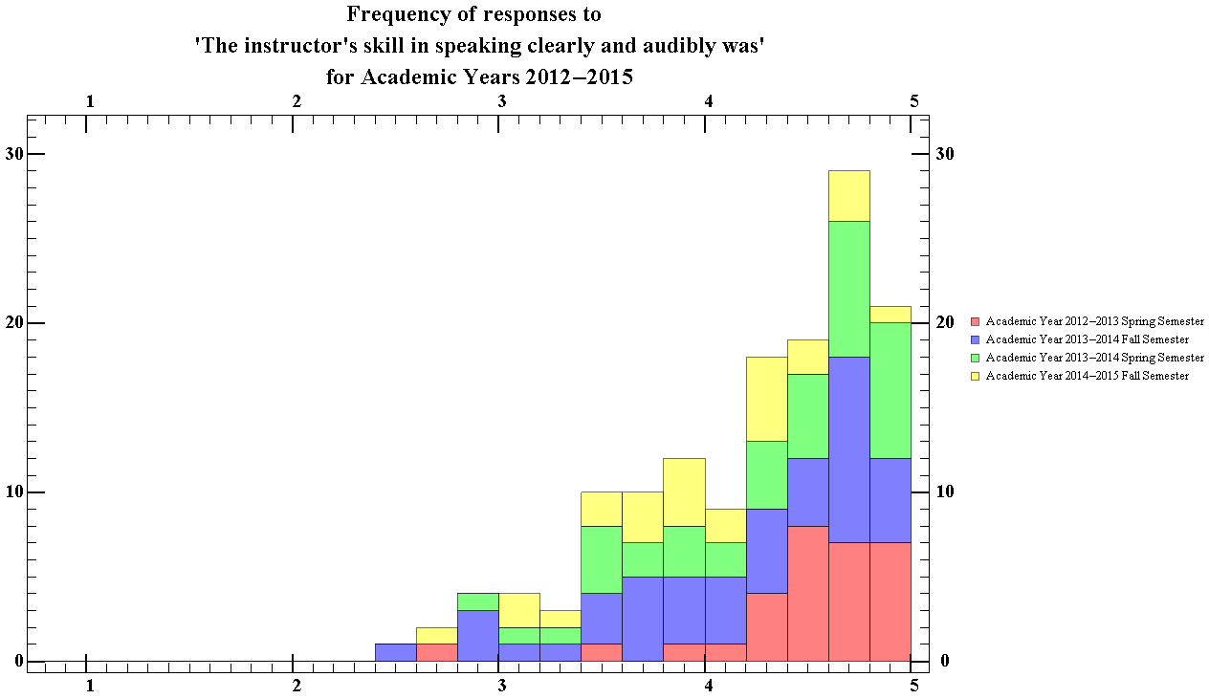
Figure 55.2 Showing the total ratings distribution of the instructors skill in speaking clearly and audibly, for the physics department for Academic years 2012-13 to 2014-15

The median score given by students for the course organization was 4.39, with an interquartile range of 0.86. This data suggests that students generally considered the clarity physics instructor’s speech to be good.

Section 2

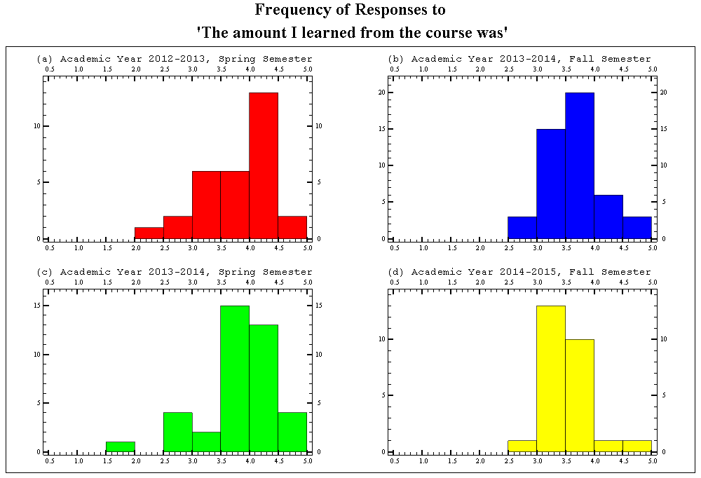
Figure 56.1 Showing the semester breakdown of the ratings distribution of the amount students learned for the physics department, for Academic years 2012-13 to 2014-15

The average median score of each semester for this question was 3.76, with an average standard interquartile range of 0.58. The courses provided in the spring semester had average median score of 3.97 and courses in the fall semester having an average median score of 3.55. The median for physics courses of this question is less than the school’s median.
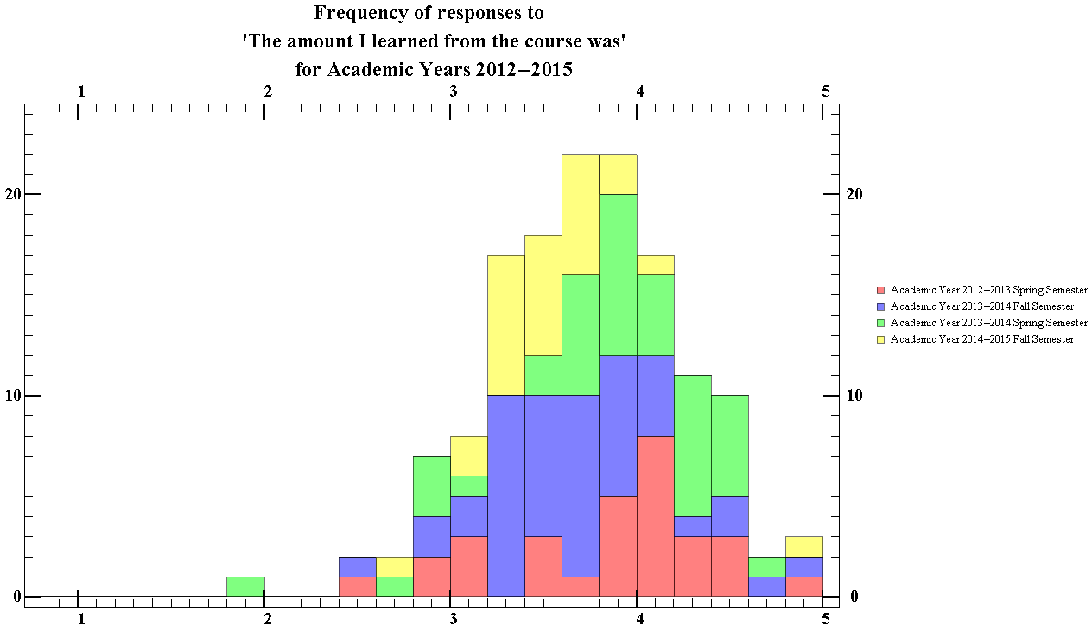
Figure 56.2 Showing the total ratings distribution of the amount students learned for the physics department, for Academic years 2012-13 to 2014-15

The median score given by students for the amount the students learnt in the course was 3.72, with an interquartile range of 0.78. The median for physics courses of this question is less than the school’s median.

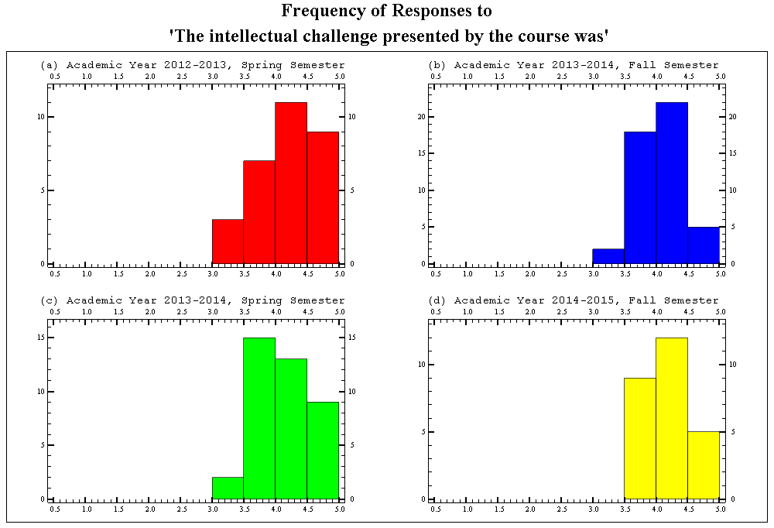
Figure 57.1 Showing the semester breakdown of the ratings distribution of the intellectual challenge presented by the course, for the physics department for Academic years 2012-13 to 2014-15

The average median score of each semester for this question was 4.14, with an average standard interquartile range of 0.51. The median for physics courses of this question is slightly larger than the school’s median.

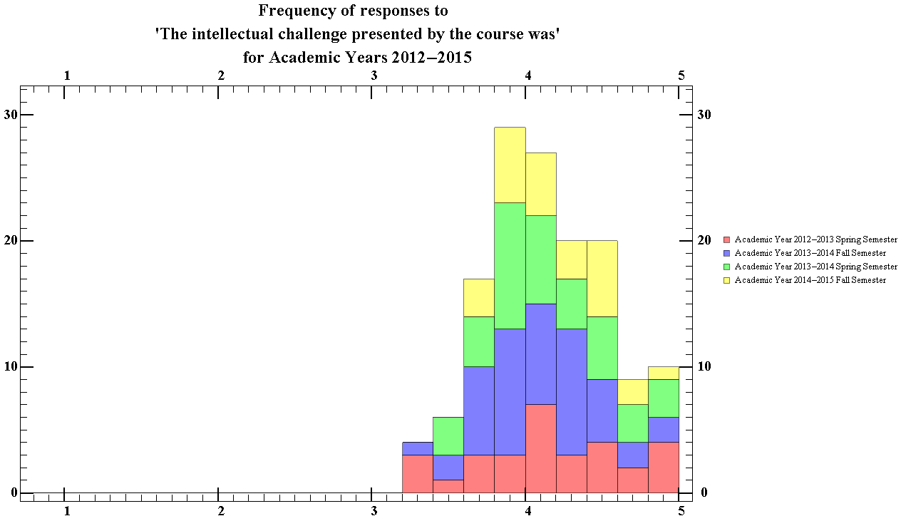
Figure 57.2 Showing the total ratings distribution of the intellectual challenge presented by the course, for the physics department for Academic years 2012-13 to 2014-15

The median score given by students for the intellectual challenge presented by the course was 4.14, with an interquartile range of 0.51. The median for physics courses was slightly greater than the median for other courses at WPI.

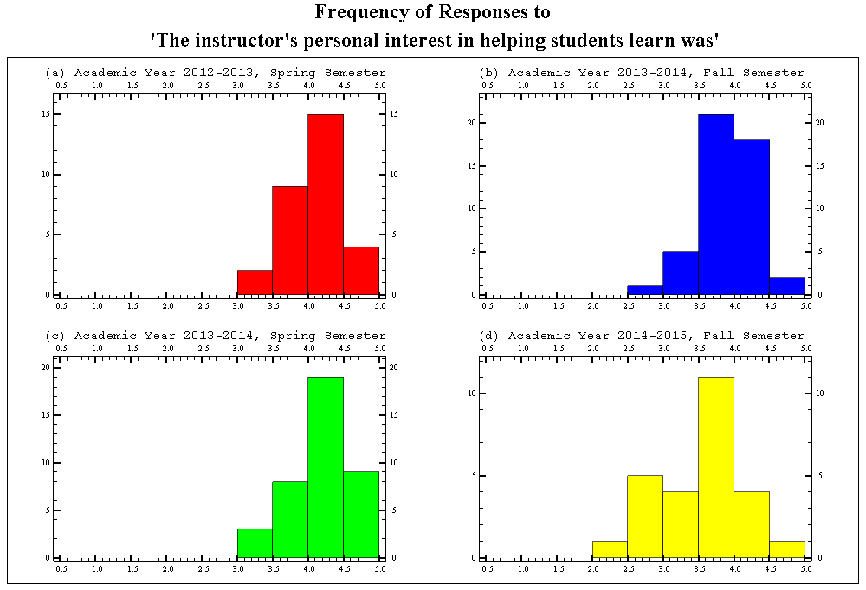
Figure 58.1 Showing the semester breakdown of the ratings distribution of the instructors interest in in helping students, for the physics department for Academic years 2012-13 to 2014-15

The average median score of each semester for this question was 4.03, with an average standard interquartile range of 0.58. The courses provided in the spring semester had average median score of 4.26 and courses in the fall semester having an average median score of 3.81. The median for physics courses of this question is slightly lower than that of the entire school.

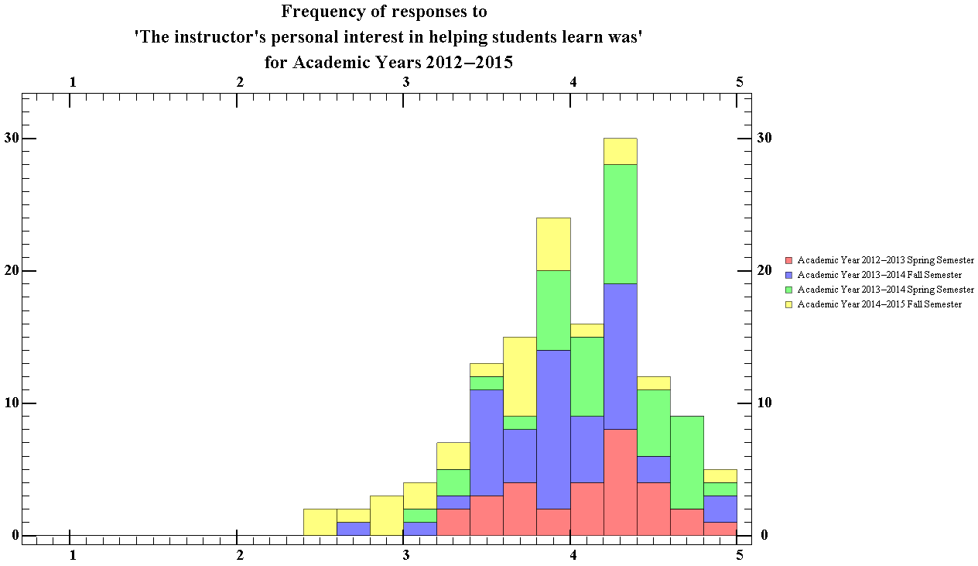
Figure 58.2 Showing the total ratings distribution of the instructors interest in helping students, for the physics department for Academic years 2012-13 to 2014-15

The median score given by students for the instructor’s personal interest in helping students was 4.03, with an interquartile range of 0.64. The median for physics courses was slightly lower than the median for other courses at WPI.

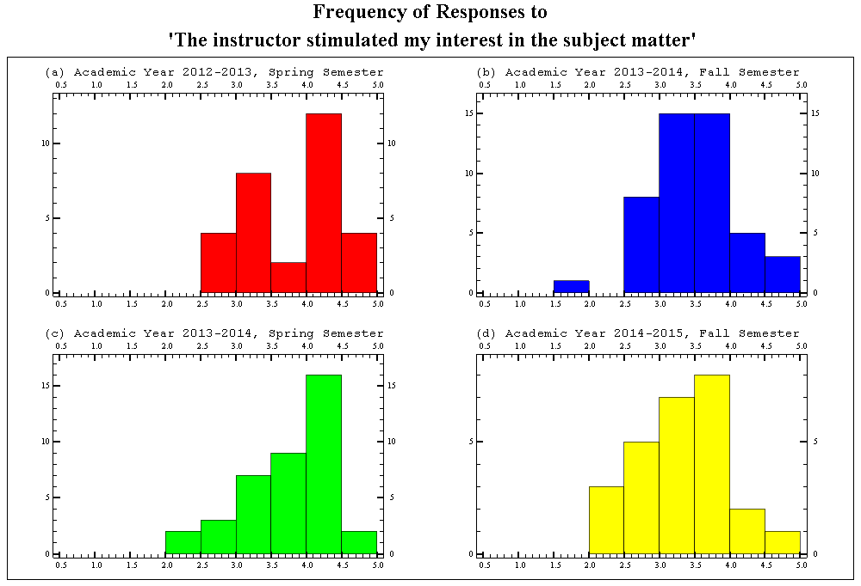
Figure 59.1 Showing the semester breakdown of the ratings distribution of the instructors ability to stimulate interest in the subject matter, for the physics department for Academic years 2012-13 to 2014-15

The average median score of each semester for this question was 3.7, with an average standard interquartile range of 0.85. The courses provided in the spring semester had average median score of 3.43 and courses in the fall semester having an average median score of 3.98. This is the second largest average interquartile range of all the questions. The median for physics courses of this question is slightly lower than that of the entire school.

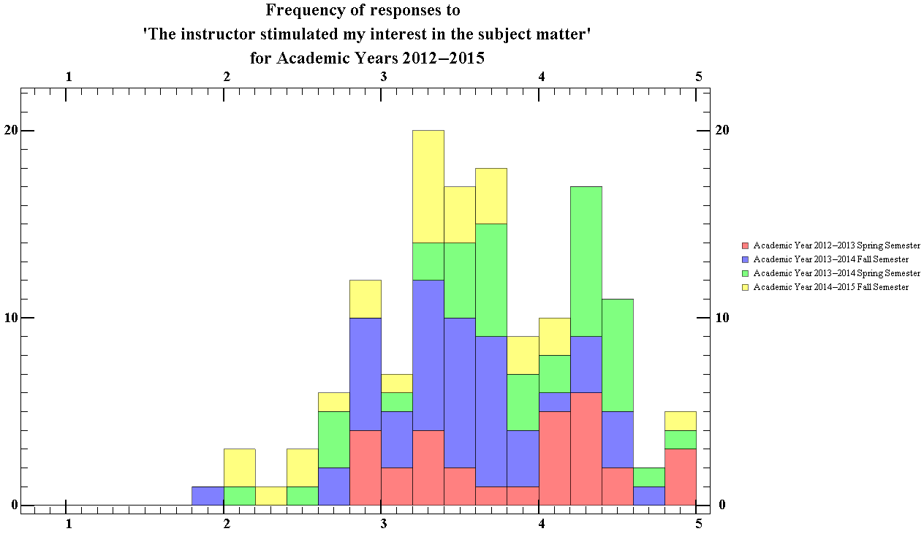
Figure 59.2 Showing the total ratings distribution of the instructors ability to stimulate interest in the subject matter, for the physics department for Academic years 2012-13 to 2014-15

The median score given by students for this question was 3.62, with an interquartile range of 0.93. The median for physics courses was lower than the median for other courses at WPI.

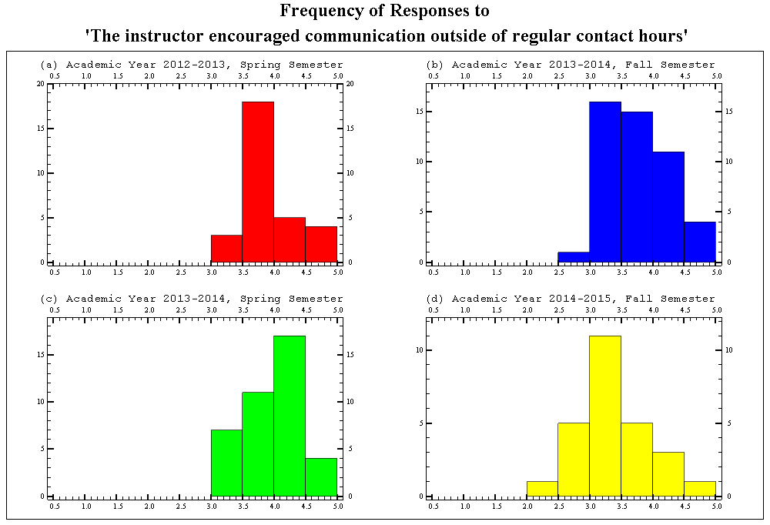
Figure 60.1 Showing the semester breakdown of the ratings distribution of the encouragement given by instructors for students to contact them outside of regular contact hours the physics department, for Academic years 2012-13 to 2014-15

The average median score of each semester for this question was 3.81, with an average standard interquartile range of 0.52. The courses provided in the fall semesters had average median score of 3.58 and courses in the spring semesters having an average median score of 4.05. The median for physics courses of this question is slightly lower than that of the entire school.

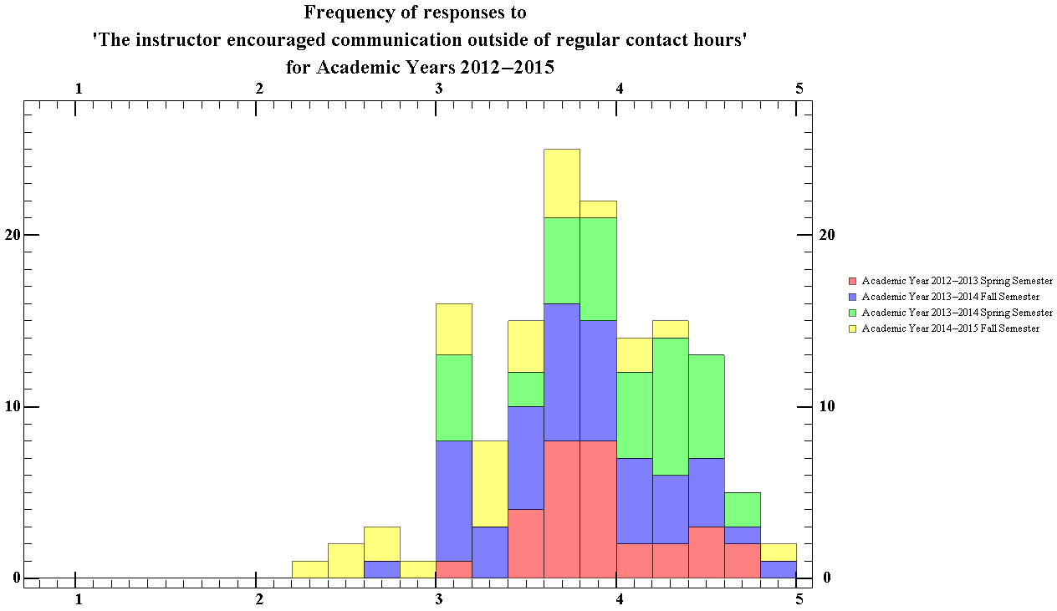
Figure 60.2 Showing the total ratings distribution of the encouragement given by instructors for students to contact them outside of regular contact hours, for the physics department for Academic years 2012-13 to 2014-15

The median score given by students for the instructor’s ability to encourage communication outside contact hours was 3.62, with an interquartile range of 0.93. The median for physics courses was slightly lower than the median for other courses at WPI.

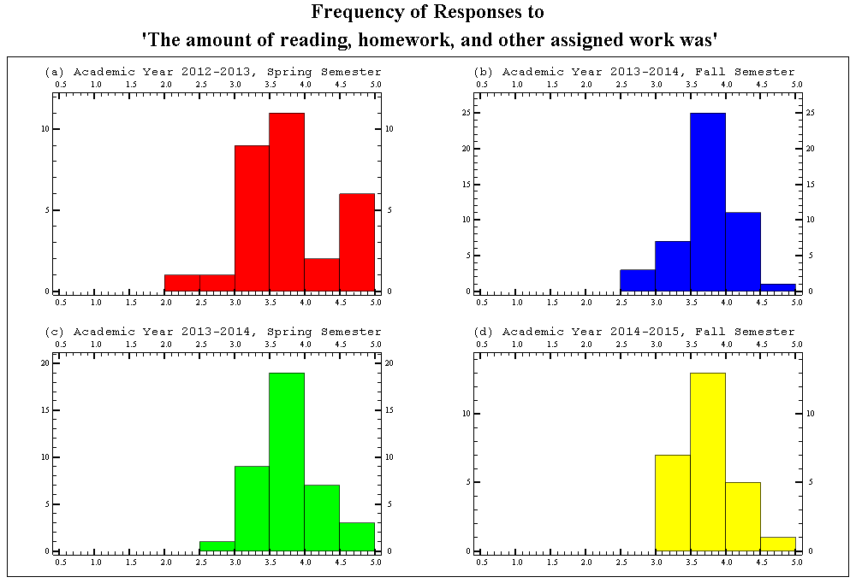
Figure 61.1 Showing the semester breakdown of the ratings distribution of the amount of reading and assigned work, for the physics department for Academic years 2012-13 to 2014-15

The average median score of each semester for this question was 3.78, with an average standard interquartile range of 0.55. The median for physics courses was approximately the same as the median for other courses at WPI.

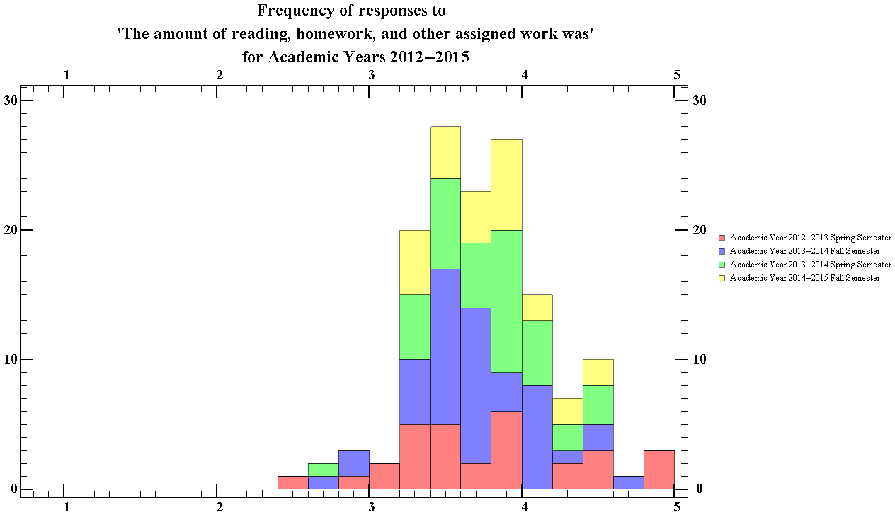
Figure 61.2 Showing the total ratings distribution of the amount of reading and assigned work, for the physics department for Academic years 2012-13 to 2014-15

The median score given by students for the amount of assigned work given was 3.77, with an interquartile range of 0.51. The median for physics courses was approximately the same as the median for other courses at WPI.

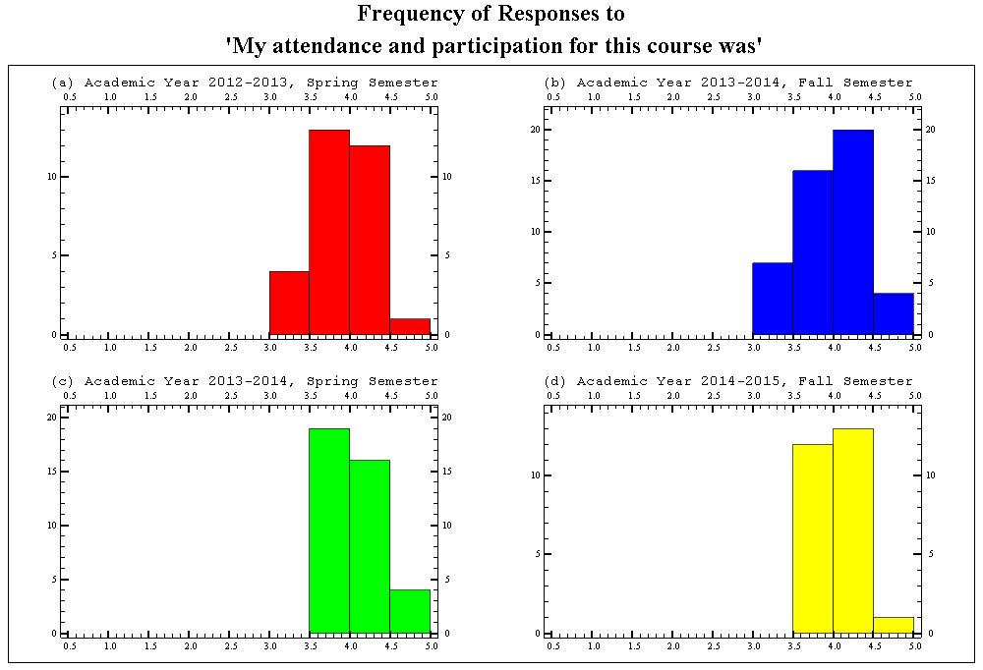
Figure 62.1 Showing the semester breakdown of the ratings distribution of the students attendance and participation in the course, for the physics department for Academic years 2012-13 to 2014-15

The average median score of each semester for this question was 4.04 with an average standard interquartile range of 0.41. The median for physics courses was approximately the same as the median for other courses at WPI.

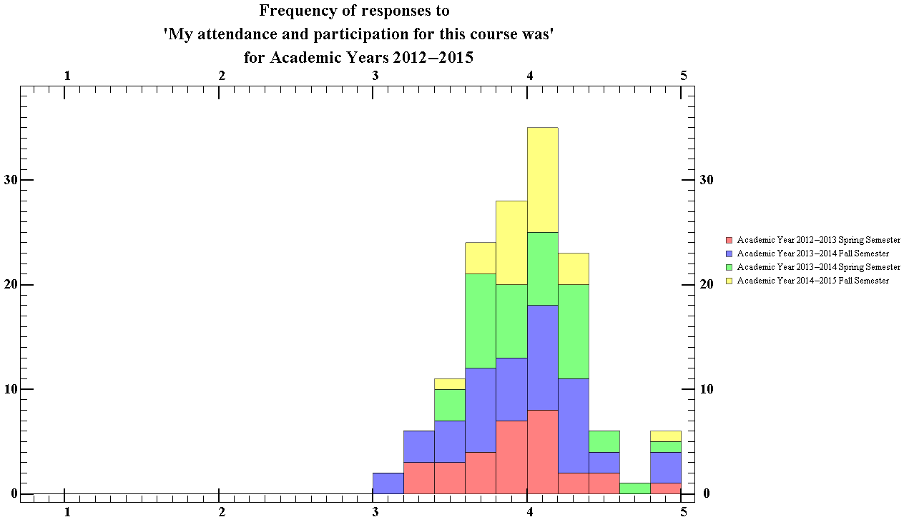
Figure 62.2 Showing the total ratings distribution of the students attendance and participation in the course, for the physics department for Academic years 2012-13 to 2014-15

The median score given by students for the amount of assigned work given was 4.01, with an interquartile range of 0.45. The median for physics courses was approximately the same as the median for other courses at WPI.

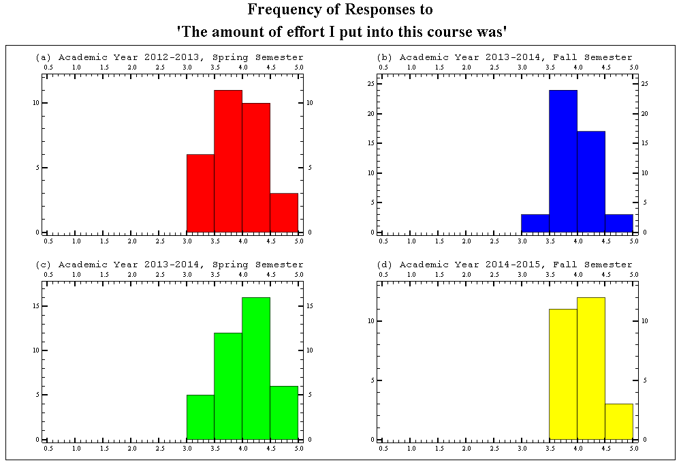
Figure 63.1 Showing the semester breakdown of the ratings distribution of the amount of effort the student put in the course, for the physics department for Academic years 2012-13 to 2014-15

The median score of each semester for this question has an average of 4.05, with an average interquartile range 0.49. The courses provided in the spring semester had average median score of 4.06 and courses in the fall semester having an average median score of 4.04. The median score for the physics department was around the same value as that of for all departments. The interquartile range for The Spring semesters however did have a larger spread than the range from the fall semesters, which can be seen from close analysis of the figures (See Appendix B).

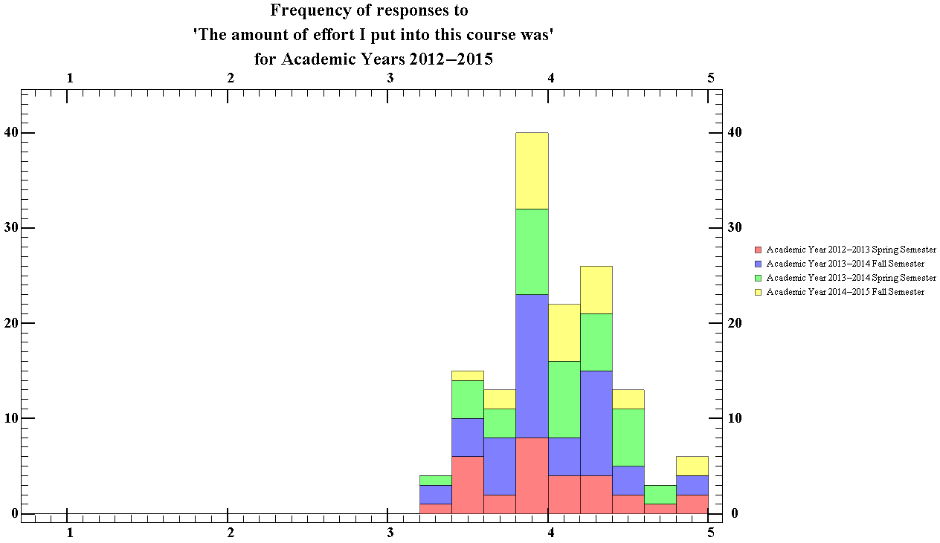
Figure 63.2 Showing the total ratings distribution of the amount of effort the student put in the course, for the physics department for Academic years 2012-13 to 2014-15

The median score of the total was 4, with an interquartile range of 0.48. The median score for the physics department was around the same value as that of for all departments.

Section 3
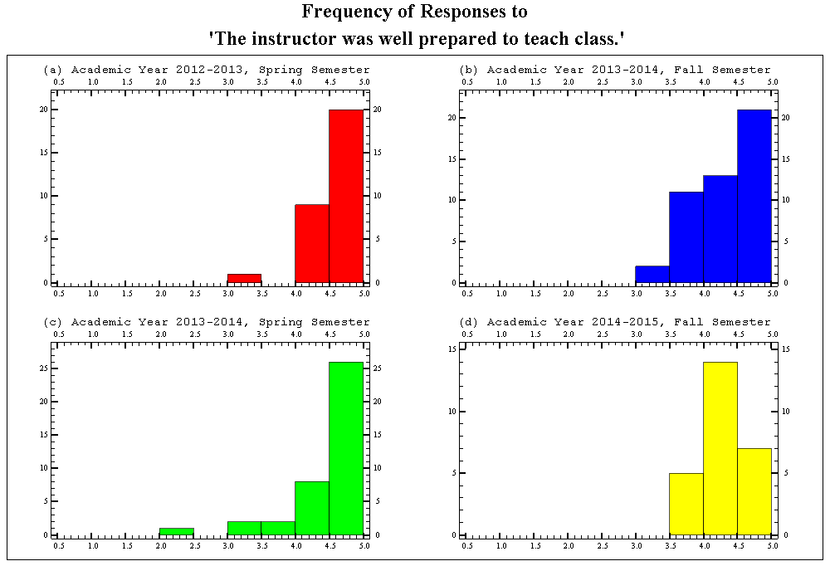
Figure 64.1 Showing the semester breakdown of the ratings distribution of the frequency that the instructors were prepared for class, for the physics department for Academic years 2012-13 to 2014-15

The median score of each semester for this question has an average of 4.57, with an average interquartile range of 0.51. This data suggests that students considered physics to instructors to almost always be well prepared. The courses provided in the spring semester had average median score of 4.74 and courses in the fall semester having an average median score of 4.40. The median score of this category was slightly less than that of all departments.

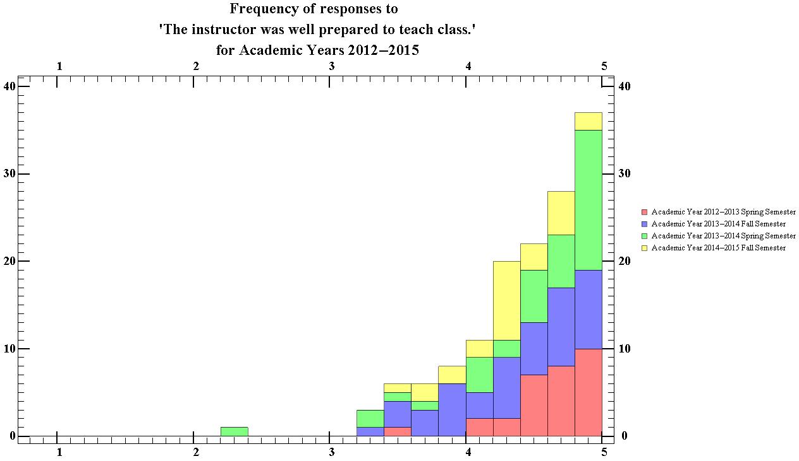
Figure 44.2 Showing the total ratings distribution of the frequency that the instructors were prepared for class, for the physics department for Academic years 2012-13 to 2014-15

The median score of the total was 4.56, with an interquartile range of 0.60. This data suggests that students generally consider physics instructors to almost always have been well prepared for class. The median score of this category was slightly less than that of all departments.

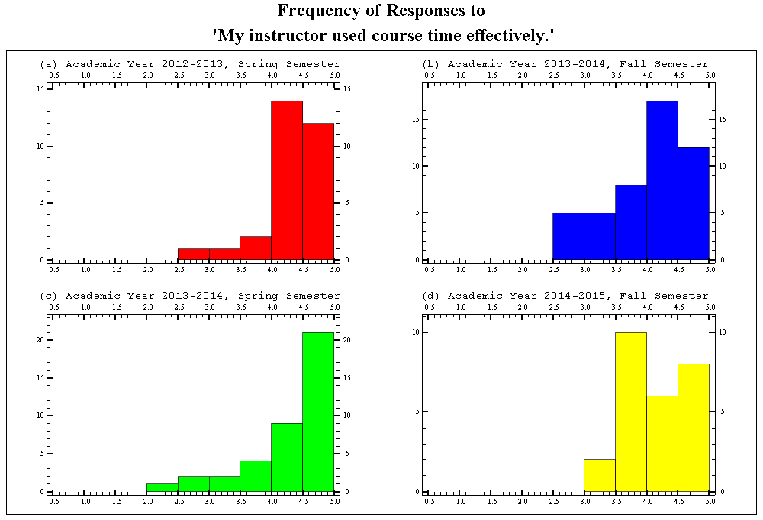
Figure 65.1 Showing the semester breakdown of the ratings distribution of the frequency in which the instructor was considered to be effective with the course time, for the physics department for Academic years 2012-13 to 2014-15

The median score of each semester for this question has an average of 4.31, with an average interquartile range of 0.67. This data suggests that students considered physics instructors to frequently be very effective with the course time. The courses provided in the spring semester had average median score of 4.47 and courses in the fall semester having an average median score of 4.15. The median score of this category was slightly less than that of all departments.

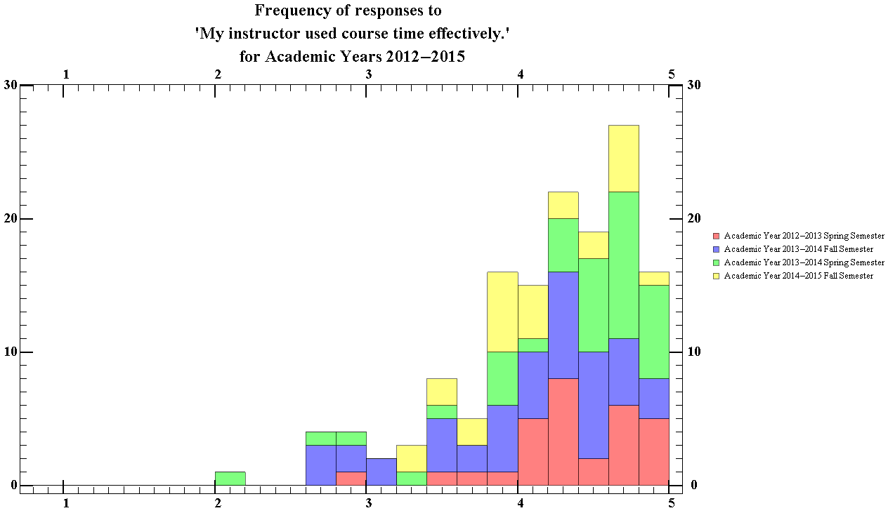
Figure 65.2 Showing the semester breakdown of the ratings distribution of the frequency in which the instructor was considered to be effective with the course time, for the physics department for Academic years 2012-13 to 2014-15

The median score of the total was 4.34, with an interquartile range of 0.73. This data suggests that students generally consider physics course instructors to be very time effective in comparison to other instructors in other courses that students have taken. The median score of this category was slightly less than that of all departments.

.
.

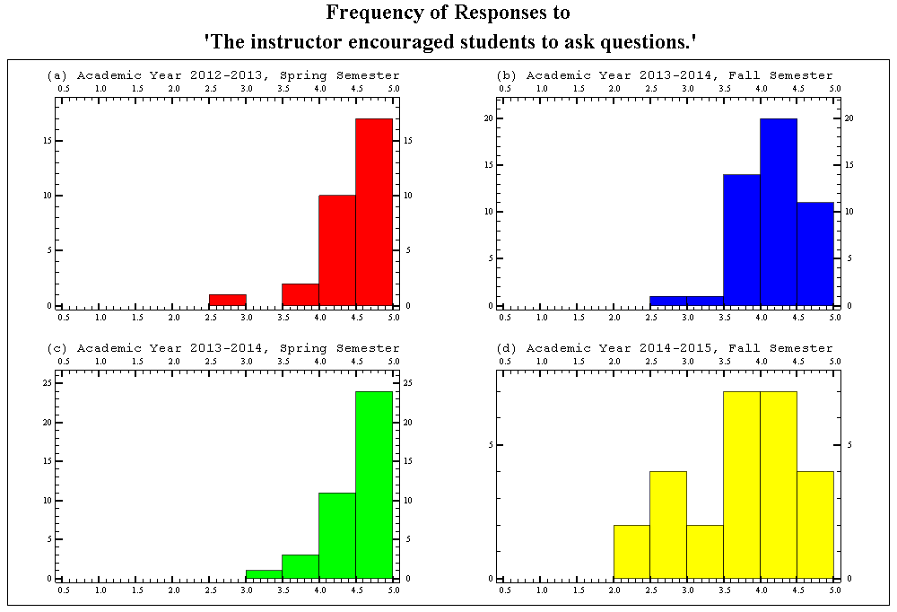
Figure 66.1 Showing the semester breakdown of the ratings distribution of the frequency in which instructors encouraged of students to ask questions for the physics department for Academic years 2012-13 to 2014-15

The median score of each semester for this question has an average of 4.38 with an average interquartile range of 0.58. This data suggests that students considered physics instructors to have be almost always have been encouraging of students asking questions. The courses provided in the spring semester had average median score of 4.47 and courses in the fall semester having an average median score of 4.15. The median score of this category was slightly less than that of all departments. The median score for the semester separated of this category was slightly less than that of all departments.

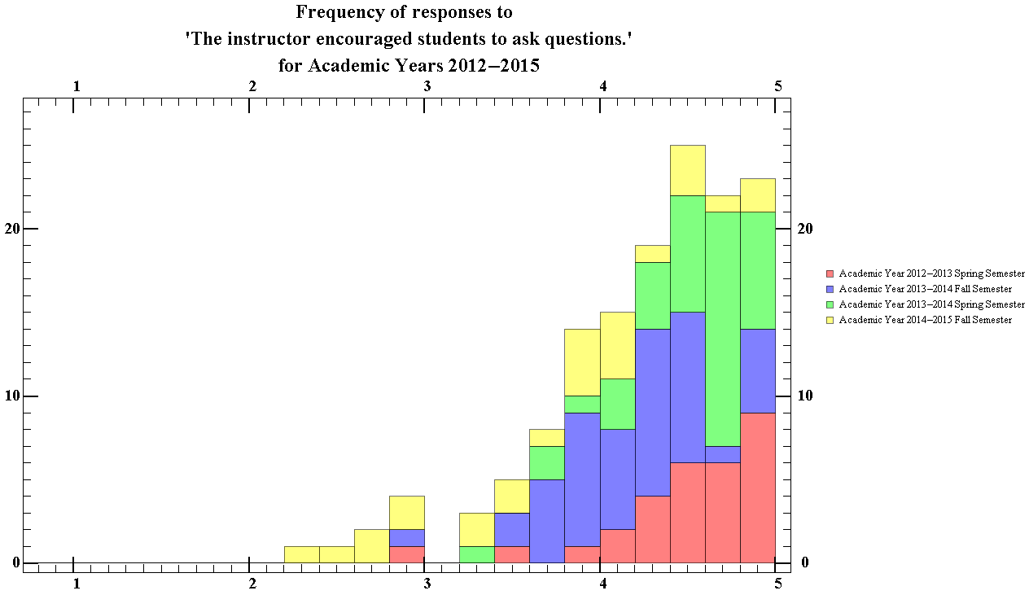
Figure 66.2 Showing the total ratings distribution of the frequency in which instructors encouraged of students to ask questions for the physics department for Academic years 2012-13 to 2014-15

The median score of the total was 4.4, with an interquartile range of 0.67. This data suggests that students considered physics instructors to have be almost always have been encouraging of students asking questions. The median score of total for this category was slightly less than that of all departments.

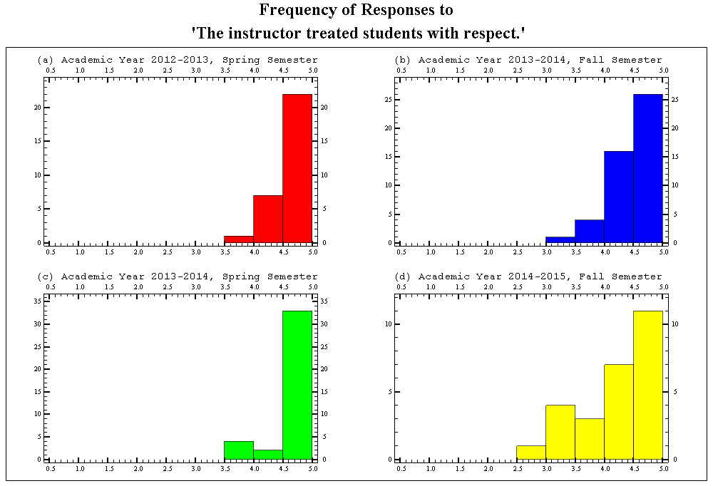
Figure 67.1 Showing the semester breakdown of the ratings distribution of the frequency in which the instructors treated students with respect, for the physics department for Academic years 2012-13 to 2014-15

The median score of each semester for this question has an average of 4.65 with an average interquartile range of standard deviations of 0.51. This data suggests that students considered physics instructors to be have almost always been respectful of students. The courses provided in the spring semester had average median score of 4.78 and courses in the fall semester having an average median score of 4.53. The median score of this category was slightly less than that of all departments.

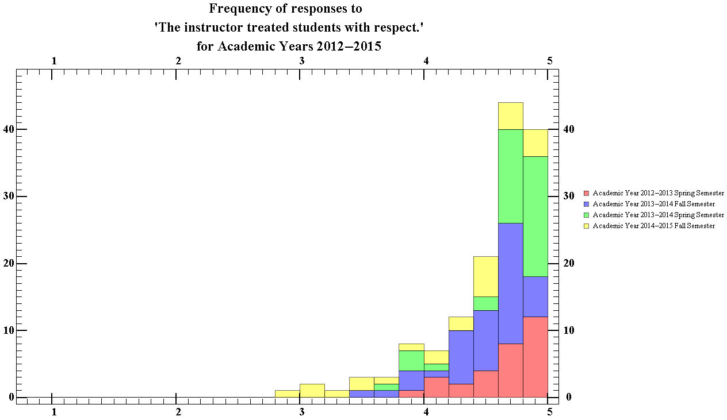
Figure 67.2 Showing the total ratings distribution of the frequency in which the instructors treated students with respect, for the physics department for Academic years 2012-13 to 2014-15

The median score of the total was 4.66, with an interquartile range of 0.68. This data suggests that students generally consider physics course instructors to be very respectful of students in comparison to instructors of other courses. Though the median score for the semester separated was slightly less than that of all departments, the median score of the total was however more than that of all departments.

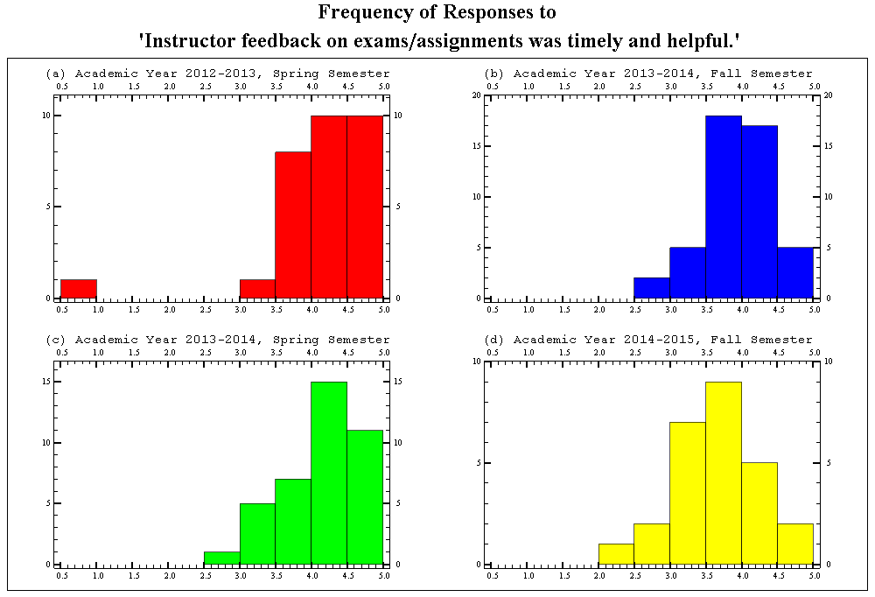
Figure 68.1 Showing the semester breakdown of the ratings distribution of the frequency in which the instructors feedback on assignments was timely and helpful, for the physics department for Academic years 2012-13 to 2014-15

The median score of each semester for this question has an average of 4.65 with an average interquartile range of standard deviations of 0.68. This data suggests that students considered physics instructor’s feedback to almost always have been timely and helpful. The courses provided in the spring semester had average median score of 4.36 and courses in the fall semester having an average median score of 3.91. The average median of the semester separated for this question was greater than that of all departments.

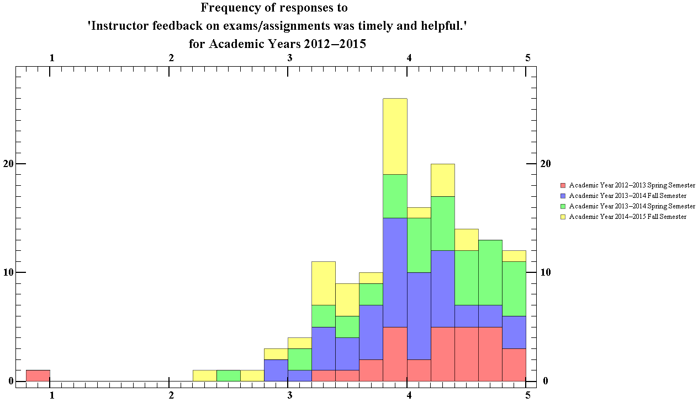
Figure 68.2 Showing the total ratings distribution of the frequency in which the instructors feedback on assignments was timely and helpful, for the physics department for Academic years 2012-13 to 2014-15

The median score of the total was 4.06, with an interquartile range of 0.73. This indicates that students generally considered the feedback that physics course instructors gave to have almost always have been timely and helpful. The median of the total distribution for the physics department was less than that of all that of all departments.

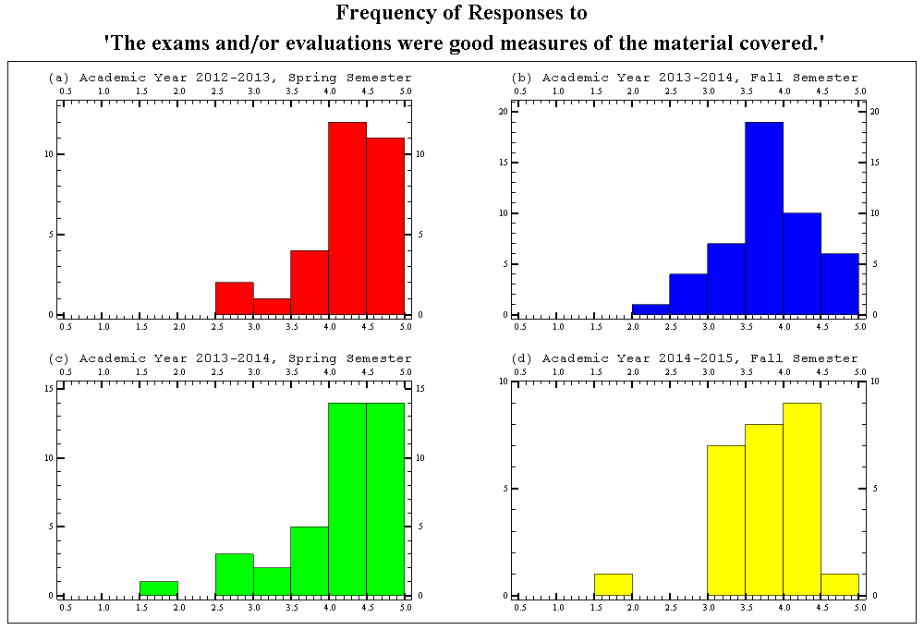
Figure 69.1 Showing the semester breakdown of the ratings distribution of the frequency in which the evaluations were a good representation of the material covered for the physics department for Academic years 2012-13 to 2014-15

The median score of each semester for this question has an average of 4.10 with an average interquartile range of 0.68. This data suggests that students considered physics instructors evaluations to almost always have been a good representation of the material covered. The courses provided in the spring semester had average median score of 4.36 and courses in the fall semester having an average median score of 3.91. The average median of the semester separated for this question was less than that of all the departments.

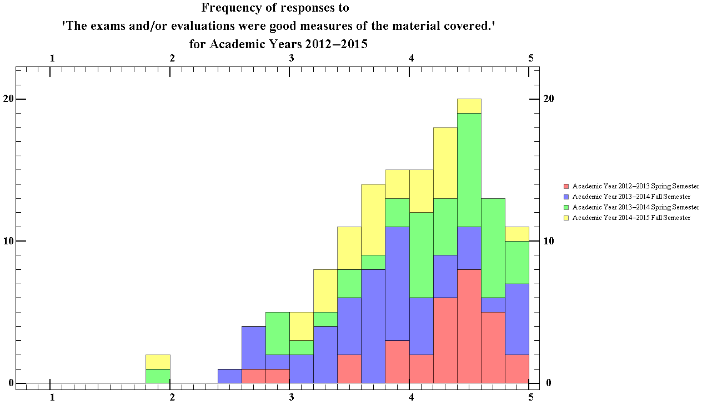
Figure 69.2 Showing the total ratings distribution of the frequency in which the evaluations were a good representation of the material covered for the physics department for Academic years 2012-13 to 2014-15

The median score of the total was 4.11, with an interquartile range of 0.90. This indicates that students generally considered the evaluations that physics course instructors gave to almost always have been a good representation of the material covered. The median of the total distribution for the physics department was less than that of all that of all departments.

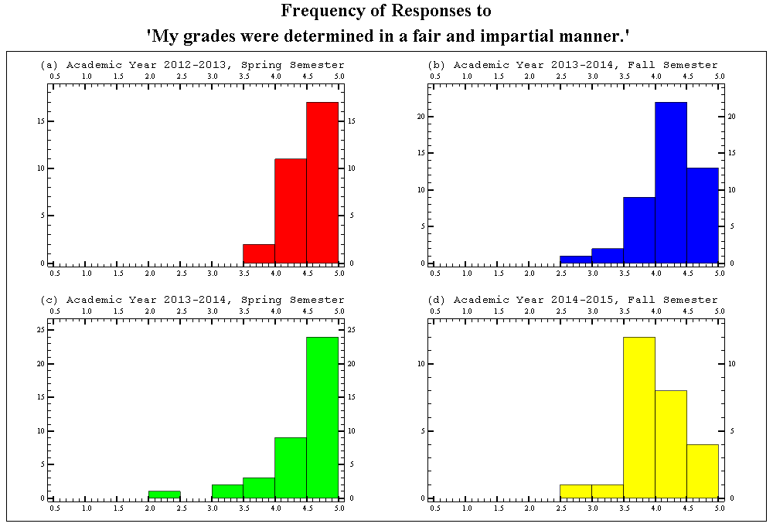
Figure 70.1 Showing the semester breakdown of the ratings distribution of the frequency in which the students thought their grads were determined in a fair and impartial manner, for the physics department for Academic years 2012-13 to 2014-15

The median score of each semester for this question has an average of 4.41 with an average interquartile range of 0.57. This indicates that students considered that their grades in physics courses were almost always determined in a fair and impartial manner. The courses provided in the spring semester had average median score of 4.66 and courses in the fall semester having an average median score of 4.15. The average median of the semester separated for this question was less than that of all departments.

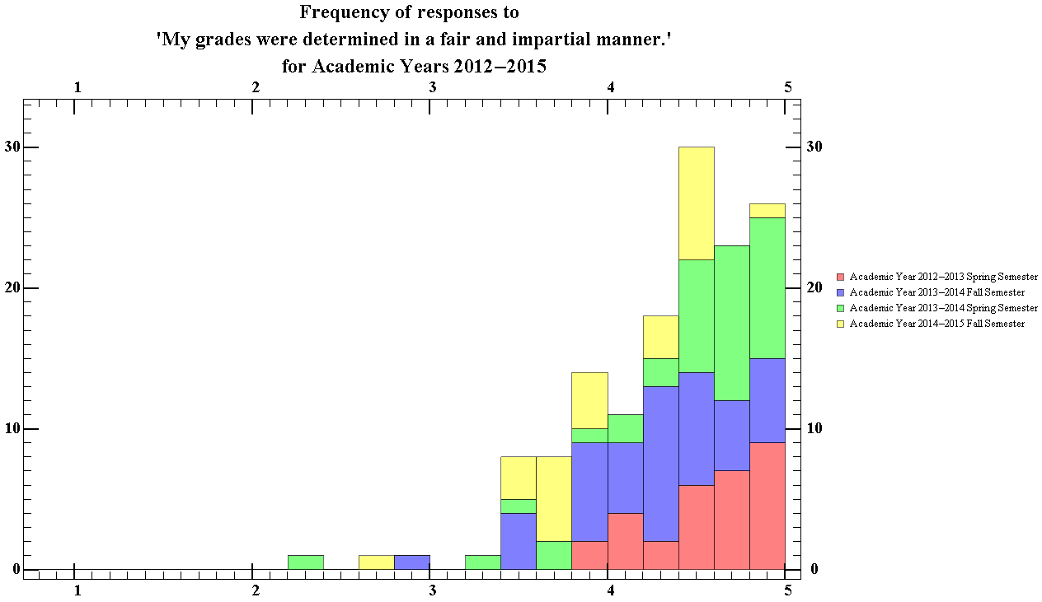
Figure 70.2 Showing the total ratings distribution of the frequency in which the students thought their grades were determined in a fair and impartial manner, for the physics department for Academic years 2012-13 to 2014-15

The median score of the total was 4.44, with an interquartile range of standard deviation of 0.67. This indicates that students generally considered that their grades were almost always determined in a fair and impartial manner. The median of the total distribution for the physics department was less than that of all that of all departments.

Section 4
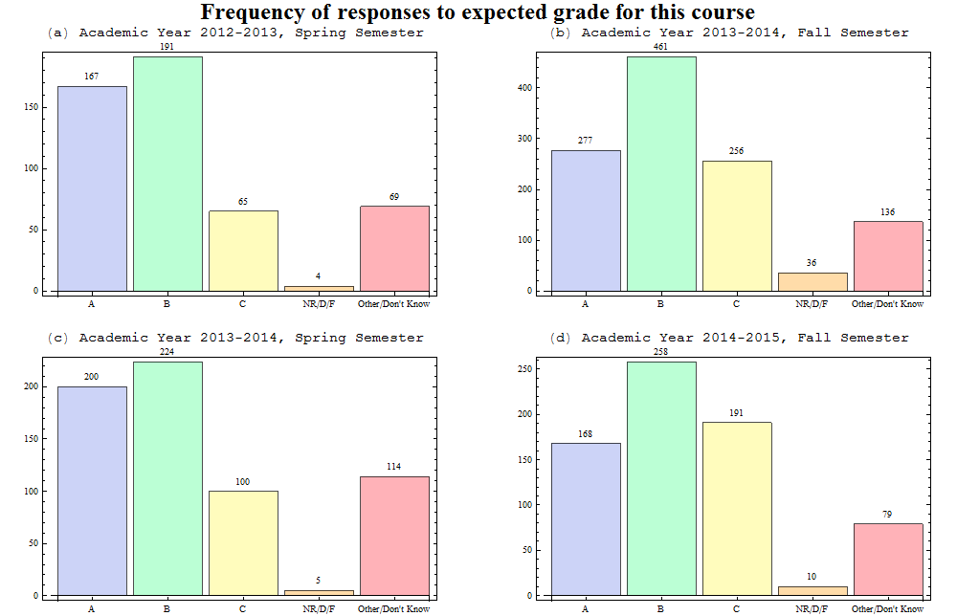
Figure 71.1 Showing the semester breakdown of the distribution of the grades that the students thought they would get in the course, for the physics department for Academic years 2012-13 to 2014-15

Majority of students who take courses in the physics department expect to get a B, with about 70% expecting a B or above in spring semesters, (a) and (c), and 63% in the fall semesters, (b) and (d). Thus we can conclude that students who took physics courses in the fall semesters considered their performance to be lower than did students who took courses in the spring semesters.

Figure 71.2 Showing the total ratings distribution of the grades that the students thought they would get in the course, for the physics department for Academic years 2012-13 to 2014-15

Here, much like that of all course evaluations, over the time the data was collected, 80% of students expected to achieve grades of B or above. The physics distribution however differs from that of the entire university with a peak in the B range rather than the A range.

Figure 72.1 Showing the semester breakdown of the distribution of how the course was related to their academic program, for the physics department for Academic years 2012-13 to 2014-15
The data shows that majority of students who take physics courses take them as a major requirement, and not as a course within their major field. As is clear from the figure 72.1 above, there is also greater percentage of students taking physics courses to satisfy requirements in fall semesters than in spring semester. Unlike that of the ‘All Department’s’ distribution, there is a 2:1 ratio in spring semesters, and a 5:1 ratio in the fall semester between students who take physics courses as a major requirement and students who take physics courses as a course in their major.

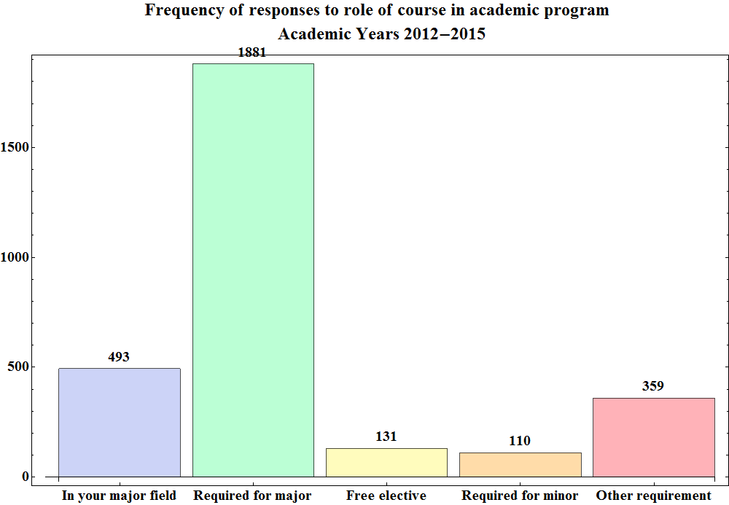
Figure 72.2 Showing the total ratings distribution of how the course was related to their academic program, for the physics department for Academic years 2012-13 to 2014-15

The median score of the total was 2.2, with an interquartile range of standard deviation of 0.53. From the data it seems as though most students who take physics courses take it as a major requirement, or as a class within their major.

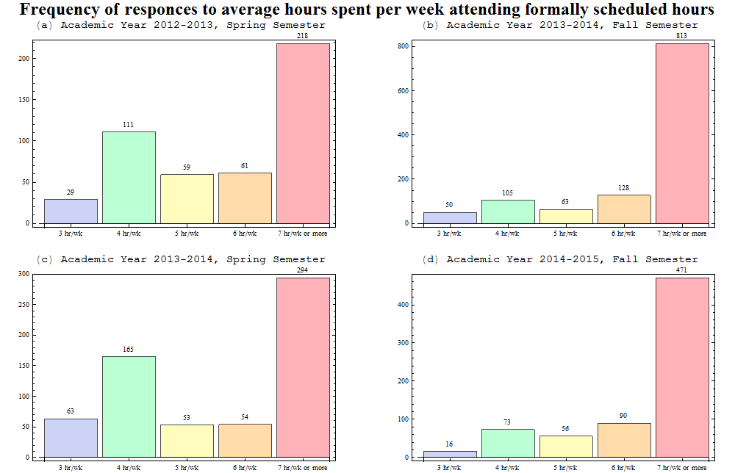
Figure 73.1 Showing the semester breakdown of the distribution of how many formally scheduled hours of course time the students attended, for the physics department for Academic years 2012-13 to 2014-15

The charts that showed the spring semester distribution appear to have 2 peaks, one at 4hr/wk and another at 7hr/wk or more, while the courses in the fall semester only have one obvious peak. This could possibly due to a higher frequency in the enrolment of 1000 level courses during the fall semesters in comparison to spring semesters. It is clear from the distribution that most students attend 7 hours or more of scheduled course hours, indicating the highest enrolment in the physics department are in 1000 level courses. Figure 73.1 shows that there is an average enrolment percentage of 68.4% during fall semesters, and 46.2% during spring semesters.

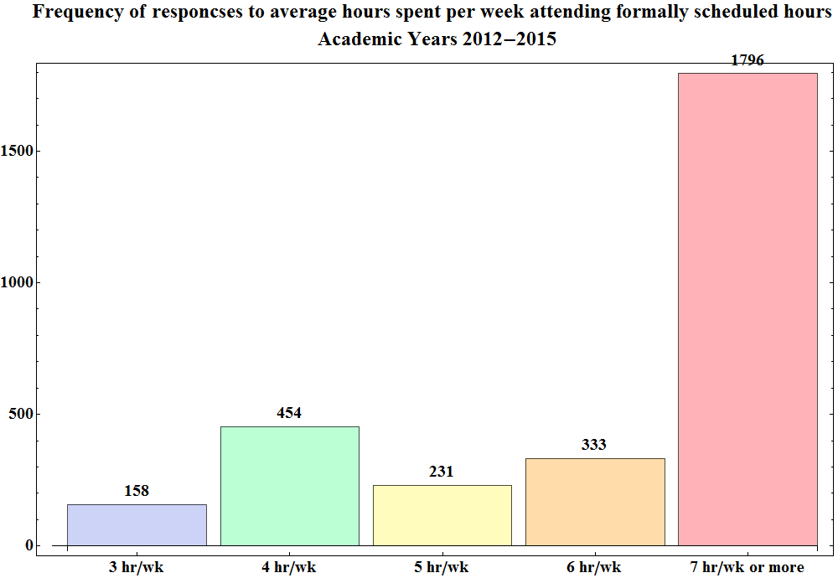
Figure 73.2 Showing the total ratings distribution of how many formally scheduled hours of course time the students attended, for the physics department for Academic years 2012-13 to 2014-15

Figure 73.2 shows that most students attend around 7hr/wk or more of formally scheduled course hours. This is probably a result of the large frequency of 1000 level courses in the physics department that meet up to seven hours per week. During the period in which the data was gathered, 60.4% of students enrolled in courses which met for 7 hours or more per week.

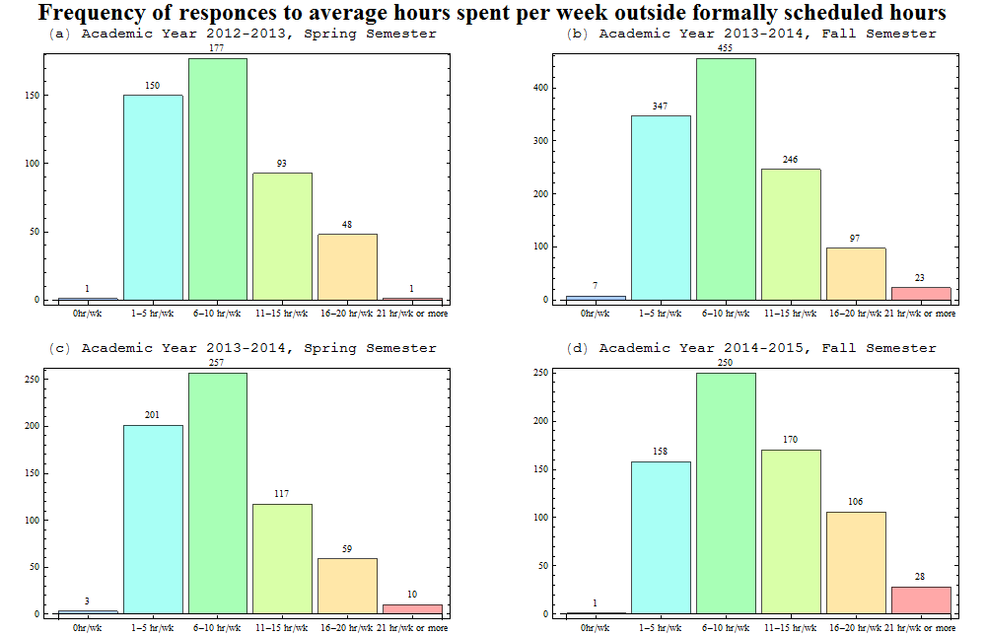
Figure 74.1 Showing the semester breakdown of the distribution of how hours outside of formally scheduled class time the students spent on their courses, for the physics department for Academic years 2012-13 to 2014-15

Majority of students who take courses in the physics department spend about 6-10 hours a week outside of course hours working, with about 37% putting in 11 or more hours of work on average in fall semesters, (a) and (c), and 29% in the fall semesters, (b) and (d). Plots (a), (b), and (c) however all show that 30% of students spent 11 hours or more on work outside formally scheduled course hours during those periods, with only (d) differing from this, with 42.6% of students putting in more than 11 hours. This may be a result of the fact that (d) contains only data from the A term of academic year of 2014-15, suggesting that the 1000 level courses offered in the first term of a semester may be harder than those offered in the second semester. This conclusion can be drawn since most of the enrolments seem to be in 1000 level course, which tend to have the largest class populations amongst all physics courses offered in the department.

Figure 74.2 Showing the total ratings distribution of how hours outside of formally scheduled class time the students spent on their courses, for the physics department for Academic years 2012-13 to 2014-15

From the graph, it is clear that majority of students put in 6-10 hours of work on courses in the Physics department. Here, only, 34% of students put in 11 hours or more of work outside scheduled course hours.

References
Abet.org,. 2015. 'Criteria For Accrediting Engineering Programs'. http://www.abet.org/uploadedFiles/Accreditation/Accreditation_Step_by_Step/Accreditation_Documents/Current/2013_-_2014/eac-criteria-2013-2014.pdf.
Andrews.edu,. 2015. 'Correlation Coefficients'. http://www.andrews.edu/~calkins/math/edrm611/edrm05.htm.
Aps.org,. 2015. 'Engineering Accreditation And The First Year Physics Course'. http://www.aps.org/programs/education/undergrad/faculty/challenge.cfm.
Bannerweb.wpi.edu,. 2015. 'WPI Course And Student Information'. https://bannerweb.wpi.edu/.
Wpi.edu,. 2015. 'WPI: Difference Between High School And College'. http://www.wpi.edu/offices/disabilities/differences.html.
Wpi.edu,. 2015. 'Morgan: Interpreting Student Course Reports - WPI'. http://www.wpi.edu/academics/morgan/interpreting.html.
Wpi.edu,. 2015. 'WPI Undergraduate Catalog 2015-2016'. http://www.wpi.edu/academics/catalogs/ugrad/flip/?page=1.
Wpi.edu,. 2015. 'The Story Of The WPI Plan'. http://www.wpi.edu/academics/library/history/plan/.
Wpi.edu,. 2015. 'Office Of Academic Advising - Course Advice By Major'. http://www.wpi.edu/Admin/OAA/Designs2/design103.html#me.
Wpi.edu,. 2015. 'Facts & Figures - WPI'. http://www.wpi.edu/about/facts.html.

Andrews.edu,. 'Correlation Coefficients'. N.p., 2015. Web. 10 Mar. 2015.
Abet.org,. 'Criteria For Accrediting Engineering Programs'. N.p., 2015. Web. 6 Mar. 2015.
Wpi.edu,. 'WPI Undergraduate Catalog 2015-2016'. N.p., 2015. Web. 3 Mar. 2015.
Wpi.edu,. 'The Story Of The WPI Plan'. N.p., 2015. Web. 3 Mar. 2015.
Wpi.edu,. 'WPI: Difference Between High School And College'. N.p., 2015. Web. 3 Mar. 2015.
Bannerweb.wpi.edu,. 'WPI Course And Student Information'. N.p., 2015. Web. 10 Mar. 2015.
Wpi.edu,. 2015. 'Office Of Academic Advising - Course Advice By Major'. http://www.wpi.edu/Admin/OAA/Designs2/design103.html#me.
Wpi.edu,. 'Office Of Academic Advising - Course Advice By Major'. N.p., 2015. Web. 3 Mar. 2015.
http://www.wpi.edu/academics/catalogs/ugrad/flip/?page=1

