An Interactive Qualifying Project Report:

A New Digital Presence for the Worcester Mural Archive
Submitted by:
Kyle Stack kjstack@wpi.edu

Submitted to:
Prof. Joseph Cullon, Project Advisor
Sponsoring Organization:
Worcester Mural Archive, as represented by Sarah Valente
November 5, 2017

ABSTRACT
The Worcester Mural Archive, a digital archive for murals in the city of Worcester is looking to redesign their digital presence in order to reflect their sponsors’ vision for the website. The goal of this project, sponsored by the Worcester Mural Archive and represented by Sarah Valente, was to create a foundation for the future redesign of the Worcester Mural Archive, and achieved through literature research and the analysis of similar existing platforms. The results of this project demonstrate a design that is both community friendly and interactive, and creates the base design framework for the future of the Worcester Mural Archive.

AUTHORSHIP
Kyle Stack contributed to the research and writing of this report. As he was the only member of the project team, he is responsible for writing and editing all of the content contained within this report.
ACKNOWLEDGEMENTS
The team would like to thank our sponsor Sarah Valente from the Worcester Mural Archive for sponsoring the project and giving insight on their vision for the redesigned archive.
We would also like to thank Laura Robinson from the Worcester Polytechnic Institute’s Gordon Library for her assistance in locating and obtaining various research materials on murals and public art. Her assistance was vital for finding an initial foothold for the project.
Next, we would like to thank our project advisor Professor Joseph Cullon for his generous assistance throughout the course of the project. The direction and insight he gave throughout the project’s duration made everything possible, without the time he spent meeting and conversing with the team we would not have made it to where we are today.

EXECUTIVE SUMMARY
Online art archives and databases work to catalogue and preserve digital records of existing art in a way that remains easily accessible to the public. Among these online resources is the Worcester Mural Archive, which preserves and collects information and images for the various murals throughout the city of Worcester, Massachusetts. As their collection continues to expand, the Worcester Mural Archive is looking to rebuild their website in a way that is more user friendly and interactive, while preserving the essence of the original archive. The new archive will also need to be able to expand with new content, without becoming difficult to navigate and obtain the desired information.
The team worked to research, identify, and analyze existing archives and databases that displayed elements similar to those desired for the redesigned Worcester Mural Archive, and came up with a new design incorporating all of the requested elements. In addition to making the content contained in the archive easy to search and sort, we came up with ways to integrate social media, plan tours directly from a map, and support user submitted content for new murals and information.
Redesigning the Worcester Mural Archive:
The first step in creating a new face for the archive was figuring out what the sponsor wanted to change about the existing archive. After an exchange of information, our team began researching the history of murals as well as identifying how different archives handled the various aspects we wanted to incorporate into the new design of the archive. From here, we researched which online platform would best meet the requirements for the new archive, and worked to design the new layout and plan the functions for the future website. The new plan incorporates a new layout and appearance for many of the webpages on the original archive, while still preserving much of the identity of the original. Some of the added functions include supporting community submissions, an interactive mural map, the integration of social media and visitor commenting, and a more efficient way to search and sort through the content in the archive.
Beyond the Redesign:
With a new design in hand for the future of the Worcester Mural Archive; there are additional opportunities to expand upon the current design in the form of additional interactive projects. Among these potential projects are an interactive app utilizing augmented reality, an interactive tour building off Google Maps, or a time-lapse showing the creation of public art by organizing user submitted images. With the research results and a new design, the next step to take is to build the new website.

TABLE OF CONTENTS
ABSTRACT ii
AUTHORSHIP iii
ACKNOWLEDGEMENTS iv
EXECUTIVE SUMMARY v
Redesigning the Worcester Mural Archive: v
Beyond the Redesign: vi
TABLE OF CONTENTS vii
TABLE OF FIGURES ix
BACKGROUND AND LITERATURE REVIEW 1
The Problem 1
IQP Objective 3
Engaging design that draws upon the diverse traditions of muralists: 4
Consistent metadata categories for each mural: 4
Geolocation: 5
Social media integration: 5
Ability to expand and edit as additional content is developed: 6
Community submission and/or feedback: 6
Ideas for Future Interactive Mural Projects: 7
Murals as Public Art 8
Strategies for Preserving and Documenting Public Art: 10
Photographing Works of Public Art: 11
Digital Archives and Databases: 11
METHODOLOGY 13
Redesigning the Worcester Mural Archive: 13
Images of the Current Archive: 15
The Worcester Mural Archive Design Plan: 17
Home Page: 18
Top and Bottom Bars: 19
About Us: 22
Artists: 23
The Murals: 24
Conservation: 28
Map: 29
News and Events Page 30
Community Submission: 31
Site Management: 32
FINDINGS: 34
Analysis Results: 34
Search and Sorting: 34
Overall Aesthetics: 35
User Submission and Comments: 35
Overall website size: 36
Development Platforms: 36
Omeka: 37
CONTENTdm: 37
CERES Exhibit Toolkit and WordPress: 38
DreamWeaver: 39
CONCLUSION AND RECOMMENDATIONS 40
Bibliography 41
Appendix A: Online Reference Analysis 49
Murals of Northern Ireland at Claremont Colleges Digital Libraries 49
Basque Murals 51
Clarion Alley Mural Project – San Francisco 53
CROW – Urban Archive in Seattle Washington 54
Denver Urban Art Directory 55
El Salvador Mural Archive 57
Mapping Watsonville Murals 59
Memphis Arts Project Digital Image Collection 61
Mural Durham 63
Mural Locator 65
Public Art Archive 67
Public Art Workshop Mural Archive – Chicago 70

TABLE OF FIGURES
Figure 1: Worcester Mural Archive Home Page 15
Figure 2: Worcester Mural Archive Collection Page 15
Figure 3: Worcester Mural Archive Content Page 16
Figure 4: Worcester Mural Archive Mapping Page 16
Figure 5: Worcester Mural Archive About Page 17
Figure 6: Worcester Mural Archive Home Page Design Layout 19
Figure 7: Suggested Top Page Bar Design 21
Figure 8: Suggested Bottom Page Bar Design 22
Figure 9: About the Archive/About Us Page Design 23
Figure 10: Artist Page Design 24
Figure 11: Collection Page Design 26
Figure 12: Individual Mural Page Design 27
Figure 13: Conservation Page Design 28
Figure 14: Mapping Page Design Featuring Google Maps 29
Figure 15: News and Events Page Design 30
Figure 16: User Contribution Page Design 32
Figure 17: Murals of Northern Ireland (Claremont Colleges Digital Library) 49
Figure 18: Basque Murals 51
Figure 19: Clarion Alley Mural Project 53
Figure 20: CROW Urban Archive 54
Figure 21: Denver Urban Art Directory 55
Figure 22: El Salvador Mural Archive 57
Figure 23: Mapping Watsonville Murals 59
Figure 24: Watson Ville Murals Sample Page 60
Figure 25: Memphis Arts Project Digital Image Collection 61
Figure 26: Sample Page from Memphis Arts 62
Figure 27: Mural Durham Home Page 63
Figure 28: Mural Durham Listing Page 64
Figure 29: Mural Locator About Us Page 65
Figure 30: Global View of Mural Locations 66
Figure 31: Mural Locator Content Page 66
Figure 32: Public Art Archive Home Page 67
Figure 33 (Top): Submission Process 68
Figure 34 (Bottom): Asset Uploading 68
Figure 35: Public Art Archive Search Page 69
Figure 36: Public Art Archive Submission Page 69
Figure 37: Public Art Workshop Home Page 70
Figure 38: Public Art Workshop Search and Listings Page Layout 71

BACKGROUND AND LITERATURE REVIEW
The Problem
As the city of Worcester has developed over time, so have various paintings on walls and other surfaces throughout it commonly referred to as murals. These murals sometimes present historical moments from the country’s history (Zander 25), and can be found both inside and outside various buildings, or even on roofs, such as the ‘Cool Roof’ painted by Molly Dilworth on a school in New York City. In addition to presenting historical events, murals can reflect elements of the local culture, serve as a creative outlet for talented artists, and help bring the community together through events and celebrations by collaborating with organizations. The Pow Wow Project and its local affiliate Pow Wow Worcester aim to create more murals across the world by collaborating with local artists by hosting events and celebrations. While these celebrations help bring together the local community, they can make things more difficult for art historians attempting to digitally catalogue and archive works of public art, especially if there is no record of the event at the time of their creation.
Many cities around the United States have murals at various locations, and finding detailed information on these works of art can be quite difficult for art historians and the public. Some cities have dedicated organizations for giving public presentations and tours for visitors to the city (Golden 2014). The information provided on those tours is presented in person, and those looking to learn the information without going on a tour will have to scour through history books hoping to find what they are looking for. In order to make information on murals more easily accessible, private art organizations sometimes take it into their own hands to create websites to catalog and preserve information on lesser-known murals. Often times they will take photos, information on the background and location, the name of the artist, and the name of the piece and treat them similarly to a digitized painting or entry in an online database. How easy it is to navigate and locate information on these sites varies from greatly, as some sites have the entire history of a mural such as those on Mural Durham, while others simply have an image and the date the image was uploaded online. Historians and the public also have to hunt for murals in cities that lack the organizations dedicated to giving tours or digital clearinghouses. As a result, it becomes a much greater task to locate, obtain, and catalog information on these murals.
Making matters even more difficult, cities often commission organizations to paint community murals, meaning that if a historian comes back a year or two later, there could be dozens more murals throughout the city than before. However, murals also are among the most vulnerable forms of public art due to environmental weathering, the demolition of the structure they were painted upon, or from vandalism. As a result, there are some murals that have been lost or defaced to a point where they are no longer identifiable, while others simply wore away from decades of exposure to the environment.
In addition, many murals tell a story or have a message behind them, though it is not always clear what the artist is trying to convey. In many cases, it would be extremely difficult to contact the artists who painted many of the older murals, or to locate an artist who did not leave some form of signature and ask them about the message behind their works of art. As such, interpretation of the mural’s message is up to the viewer, just like most art throughout history. It is entirely possible that a mural featuring a group of people could just a painting of the local community.
Murals also lack any real ability to interact with their audiences, especially in today’s technological age. Museums will have interactive tours or displays, while movies and video games have their alternate reality games, but what can you do to make a mural interactive? As an important part of a community’s history, murals deserve just as much attention for preservation as any painting in a museum, if not more due to how vulnerable they are to the weather and vandalism. Local preservation and painting events could be held in order to help make murals a larger part of the community, especially when many people take them for granted.
In order to properly catalogue and develop an online archive, simply gathering images is not enough. Information on the artwork’s location, title, the artist, when it was painted, or the message behind it can be obtained in some cases, but gathering this information takes a large amount of research and time. In addition, the information needs to be presented in a way that it is easy to understand, accessible, and accurate. Information from one source needs to be checked with information from additional sources to confirm that they agree on facts, and in the event that the information conflicts, even further research is required to gather the truth.

IQP Objective
Worcester Mural Archives (WMA) seeks to confront these challenges through a digital archive replete with photography, artist biographies, historical context and geolocation. WMA has asked this team to help develop their digital presence, design a website, and integrate interactive elements. The goal is to create a website that inspires Worcester residents, public art enthusiasts and tourists to visit and engage the city’s rich collection of murals. Thanks to Pow Wow Worcester, the city is gaining new murals that need to be archived and catalogued, further pushing the need for a site that is easy to maintain and update, but serves its function as an archive. Secondly, the website should provide crucial interpretative information and metadata, so its contents can be used in scholarly study and engagement about mural and public art more generally.

Elements of a successful redesign of the WMA’s currently Weebly page include the following elements:

Engaging design that draws upon the diverse traditions of muralists:
The overall aesthetics and message of the archive should be welcoming and not overwhelm visitors when they first enter the site. Choosing a soft color palette and font that is easy to read are a requirement. Any images on the pages should contribute to the overall design and not draw attention from the primary elements.
In addition, due to the various cultural influences behind murals, pages with multiple images on them should host murals from more than one culture and thus help showcase Worcester’s cultural diversity.
Consistent metadata categories for each mural:
As the Worcester Mural Archive seeks to preserve information and make the data easily accessible to the public, having a consistent format for the presentation of information is essential in maintaining an efficient database. The easiest method to maintain consistency is by creating a template for each page, and then filling in the information for each field.
Geolocation:
Using existing technology to integrate Google Maps into the new Worcester Mural Archive would serve to provide a real time map of murals featured in the archive, as well as allowing for links to each murals’ archive page on their respective markers.
Social media integration:
Twitter:
Twitter serves as a way to share an image and short message about one’s daily life in 140 characters or less. Users can favorite, forward the message to their followers by ‘re-tweeting”, and make comments about Twitter posts. As such, Twitter is an excellent way to share information about a new addition to the archive and promote the site to the masses.
Facebook:
An online social networking site for connecting with other individuals, Facebook allows users to write long posts, upload images, comment upon others posts, and plan trips and meetings. By integrating Facebook elements into the Worcester Mural Archive, and/or building a Facebook page for the archive, visitors will be able easily plan trips to visit the various murals throughout Worcester.
Instagram and/or Snapchat:
These two popular services allow users to take pictures and add comments to share online. Unlike writing a Facebook post or Tweet, Instagram and Snapchat are about sending images with one or two lines of text to share information. For individuals on the go, these two services may provide a favorable alternative.
Ability to expand and edit as additional content is developed:
Archives and historical collections are always expanding, but may eventually reach their capacity. Services that allow you to build a website easily may have a storage limit or not provide all of the tools necessary to continue expanding the site. As such, it is extremely important to choose the right platform to host the archive.
Community submission and/or feedback:
New Content:
Art historians, artists, and the public may have additional information on a mural currently featured in the archive, or wish to add in a new entry. By creating a submission system for new entries or adding additional information, archive moderators can approve these submissions in order to save time.
Community Feedback and Comments:
Implementing a system for contacting the web site manager and giving feedback on user experience is important for any service. In the event links to pages within the site stop functioning, incorrect information is present, or the website layout is confusing, users may wish to contact those running the site to report any such problems.
Ideas for Future Interactive Mural Projects:
In addition to a new website for the Worcester Mural Archive, further steps can be taken beyond the redesign to develop additional interactive elements.

Digital Murals App:
Using motion tracking technology, as well as considerable time and resources, a smart phone app could be developed that would allow one’s movements to be tracked by a digital camera. Creating murals on walls and surfaces, even if there is no physical mural present simply by moving around one’s body and limbs. Various users could then add onto the digital murals, creating a work of art from the combined efforts of numerous individuals.

Interactive Tour:
Similar to the Digital Murals App, visitors could go on a tour of the murals in Worcester using a randomly generated path from Google Maps.

Time Lapse Painting:
By taking pictures or recording footage of a mural during its creation, it is possible to create a time lapse showing the process from start to finish.

Murals as Public Art
Since the earliest civilizations, the paintings on the cave walls could have served as records of great feats, a tool for teaching using images, or just a way as a way to pass the time. The Greeks and Romans on the other hand, used their works of art to beautify their city, as a display of their nations’ wealth, and as tributes to their gods. There are entire museums dedicated to the art and history of past civilizations, and some historians spend decades attempting to discover something new. With so much appreciation for the past, why does it appear that the public art of our modern civilization is given little attention? While this may seem to be the case at a glance, there are in fact numerous organizations and websites dedicated to the preservation, appreciation, and sharing of modern society’s artwork.
Public murals can be found throughout various cities across the United States, especially in places where major historical events took place. City councils usually commission murals to record and display parts of America’s history. For example, in Philadelphia there are murals across the city depicting the war for independence, moments in the American Civil War, and iconic individuals and events from the Civil Rights Movement, or even the more recent wars in Iraq and Afghanistan (Golden). However, not all public art and murals depict historical events, such as many of those painted by artists during PowWow events to bring together the local community and help foster an appreciation for art. These works of public art can be anything from artistic self-expression to an image from a children’s cartoon. Depending on the dominant culture in the area, you may find works depicting a local sports team, cultural holidays, or a collage of ideas and images that each individual contributed.
Not every mural is commissioned by the city or an organization, as there are public artwork that is painted without permission from the property owner, such as various street art found throughout cities, on shipping containers, and at industrial sites. These pieces of street art are perceived negatively by the local community and are often categorized as ‘Graffiti’. Regardless of the art’s quality, some business owners do not want street art on the sides of their buildings, which could have an impact on how customers view their establishment (Schacter).
As graffiti and vandalism became more of a problem throughout the decades, various organizations appeared throughout the country, which commissioned artists and local individuals to paint murals and other works of art at pre-determined locations around cities. This gave members of low-income families an additional opportunity to earn money, as well as a way to show off their talents and express themselves, letting loose some of the stress and frustration that had been building up in their lives. As a result, instead of defacing property with graffiti and other vandalism, this gave individual a chance to use their talents in a way society viewed with a positive light (Sieber 263). In addition, people naturally have feelings of appreciation and wonder for art. Just like how gangs respect the territory of another gang, taggers and graffiti artists will not deface public works of art, especially if it was something created by their local community members. In addition, since murals are often outdoors and publicly visible, it becomes much easier to see and appreciate them than going to a museum to see a painting, which benefits the entire community rather than just a single person.
Seeing a mural on one’s way to work can serve to brighten up an otherwise bleak Monday, a gathering location for community events, as a conversation topic, or simply just make a wall more pleasant to look at (Opticos). Just as famous paintings are preserved and restored, so too should we preserve murals and other public art, not for monetary or material reasons, but for the same reasons we preserve artifacts recovered from ancient cultures around the world.
While digitally cataloguing images of murals serves a historic purpose, there is a distinct lack of presence when viewing an image online. Seeing a picture of the ocean and being there in person are two entirely different experiences, and art behaves very much the same. Part of what makes murals and other street are appealing is the span of time they encompase, while a mural may last a decade or two, chalk street art may last a week or not even a day if it rains. In order to properly archive and preserve murals and other artwork digitally you need several images of the work in different lighting and situations, otherwise you end may end up with a single image eventually that is the only image record of a work of art. There also is the issue of needing to maintain the hardware used to store the image, if the hard drive fails one day, all of the information and images stored inside will be lost. However, physical artwork is not immune to its own dangers. As such, both digital and physical preservation are not without their issues.

Strategies for Preserving and Documenting Public Art:
Public art is often painted on the walls of buildings and structures, creating a semi-permanent spectacle that is visible to those passing by. Due to being a part of the structure itself, it becomes difficult to transport these works of art to another location in the event the building is demolished, while outdoor works of public art are extremely vulnerable to the weather in addition to the condition of their surface.
Photographing Works of Public Art:
One way to preserve works of public art from the elements is to simply take a photograph of them with a camera, which can be done on the smartphone of a passing tourist or by the hands of a professional photographer. Doing so helps to preserve an image of the artwork, which will allow it to last beyond its lifespan and hopefully be shared with other people and historians.

Digital Archives and Databases:
Going a step beyond simple photography, taking the original photographs of the murals and other works of public art and placing them in an online digital archive or database. After researching and gathering additional information on their catalogued works, historians can then apply the additional information they have obtained to their corresponding works of art. At this point, information such as the location, artist, creation date, and other forms of information are added to create a more complete history for the works of art. As mentioned earlier in this report, online archives are not foolproof, and are vulnerable to data corruption and power consumption. In addition, any user with administrative privileges to manage and modify the archive can make changes to the information stored within, and not always with good intentions.

METHODOLOGY
Redesigning the Worcester Mural Archive:
Working from the original Worcester Mural Archive as a base, the first step was figuring out what needed to be added. The new design needed to look and feel similar to the original, yet also incorporate community submissions, elements of social media, a mapping system, and an easy to use metadata system.
Starting with the home page, I designed ribbon bars for both the top and bottom of the site. These two bars would feature links to a ‘News and Event’s page, the community submission page, and the social media integration. To avoid cluttering the screen, the new design has the two ribbon bars trigger and slide onto the users’ screen upon moving the mouse cursor over the circular icon at the top of all pages or sliding your mouse to the bottom of the window and holding it there for a second. Similarly, removing the mouse from the ribbon bars or icon for a second would cause them to slide back into their hidden positions. As such, this gives the ability to navigate to additional pages without cluttering one’s screen with additional information at all times.
Next, I worked on the design for the Collection page, which would host and sort all of the murals in the database. Adding a search bar to the top of the page and filter buttons on the left side creates different ways to search through the collection. The filters are vague, while the search bar allows for specific keyword searching. In addition, beneath the search bar is an additional button to take visitors to the contribution page. This way, if a visitor is unable to find what they are looking for, they can submit the information themselves later to aid future visitors.
From here, the design for the information page for each mural began. The information page includes sections for all of the important data, as well as a spot to integrate an image gallery and google maps onto the page. In addition, I added a search bar to the upper right corner of the page to allow users to quickly search for another mural, something many of the online database lacked.
Taking the categories and features on the mural information page, I laid out the format for the contribution page. In addition to the standard information and image upload section, there is also a section for information on the contributor in the event the archive staff need to contact them.
The page hosting information on the history and staff of the archive now has an additional section for listing the names of contributors and the contact information for the archive.
The mural map page will not be changing much, but it should have the markers on the map link to each mural’s page as well in order to serve as a quick method of gathering information on a mural one is currently at.
A new page has also been designed for any artists that are being featured in events or that work in collaboration with the Worcester Mural Archive. This page follows a simple design with photos and names arranged in an orderly fashion, and clicking on one will bring up additional information on the artists without leaving the page.
Finally, the brand new ‘News and Events’ page features an integrated google calendar for planning events and trips, twitter feed for the latest updates on new murals for the archive, and a section for any additional news or important information that the archive wishes to share.
Images of the Current Archive:
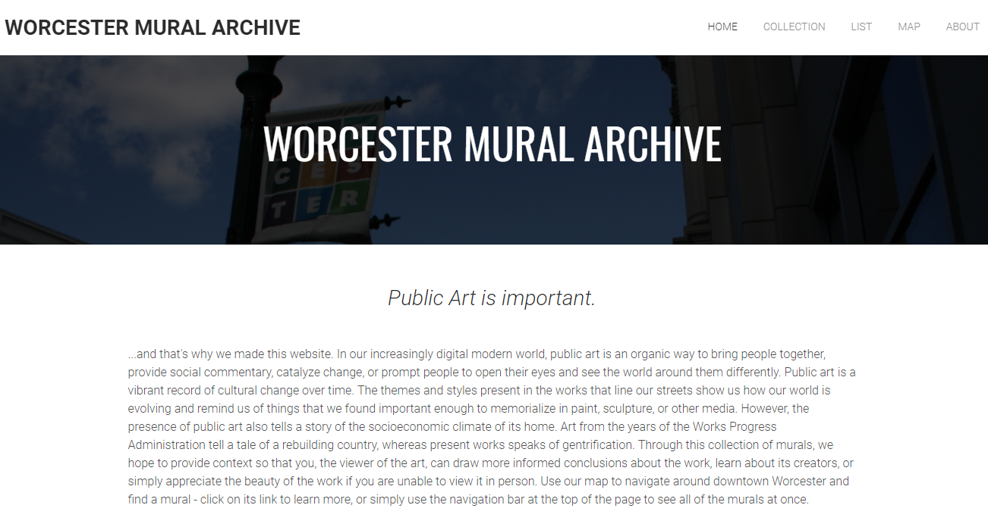
Figure 1: Worcester Mural Archive Home Page

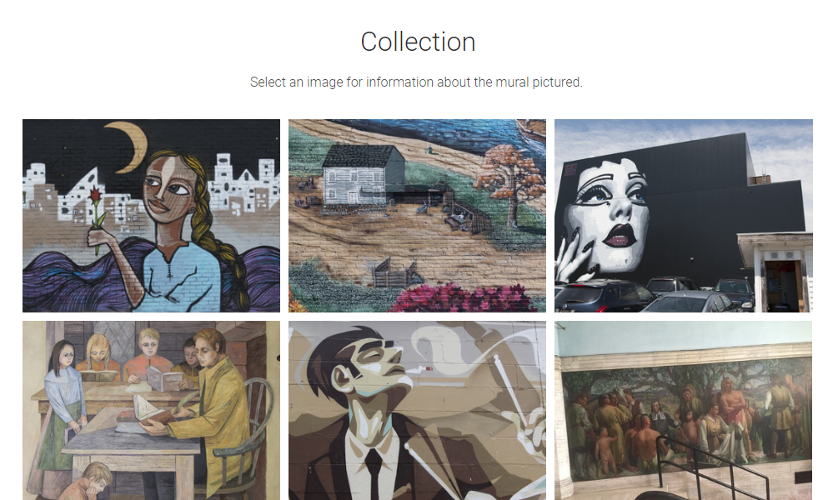
Figure 2: Worcester Mural Archive Collection Page
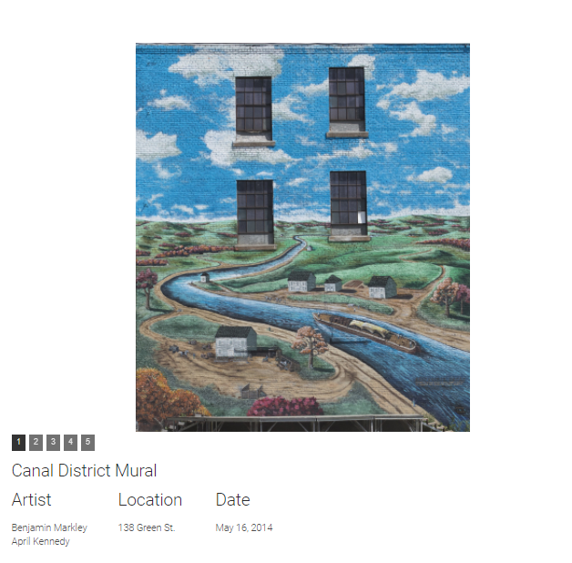
Figure 3: Worcester Mural Archive Content Page

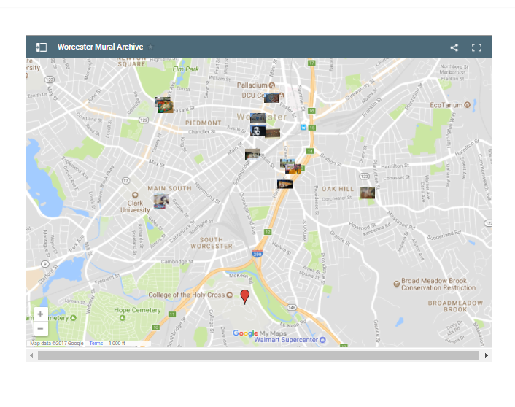
Figure 4: Worcester Mural Archive Mapping Page
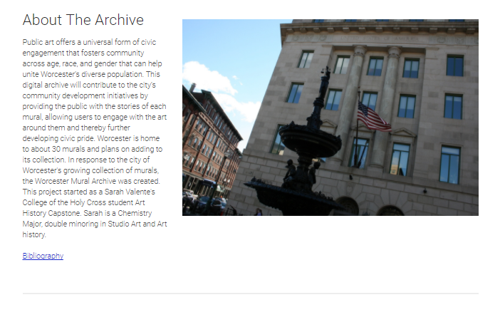
Figure 5: Worcester Mural Archive About Page

The Worcester Mural Archive Design Plan:
Presented below are important points on the content and function for each page on the redesigned Worcester Mural Archive. The archive itself is designed for use with a personal computer or laptop, but can easily be modified to support tablets and smartphones. When working with mobile devices, it is important to keep in mind that their screen proportions and size are different from regular computers. Having a separate mobile website that features webpages designed for use and viewing on those mobile devices is important, as it will allow users to submit content on new murals at their location instead of taking a picture and waiting until they are at their personal computer. In addition, users on a mobile device would primarily use the mapping and tour generators due to their integrated global positioning system (GPS).

Home Page:
- Purpose of the Archive
  - Should be taken directly from the original Worcester Mural Archive website.
  - Image selection, banner image, and the displayed text should be left to the website manager.
    - The Home Page should feature recent additions and serve as the website’s overall navigation hub.
    - The website can feature either a static color palette or change based on the season or ongoing events.
    - Static or neutral colors can be used that complement or contrast one another, but nothing that clashes. Possible suggestions follow:
      - Complementary primary or secondary colors
      - Greys with one or two primary colors
    - In the event of a seasonal change, use colors commonly associated with the season, and avoid choosing colors associated with specific religious holidays.
      - Winter: Lighter blues and whites
      - Spring: Pastel yellows, blues, and greens
      - Summer: Vibrant yellows and blues
      - Autumn: Oranges, reds, and yellows

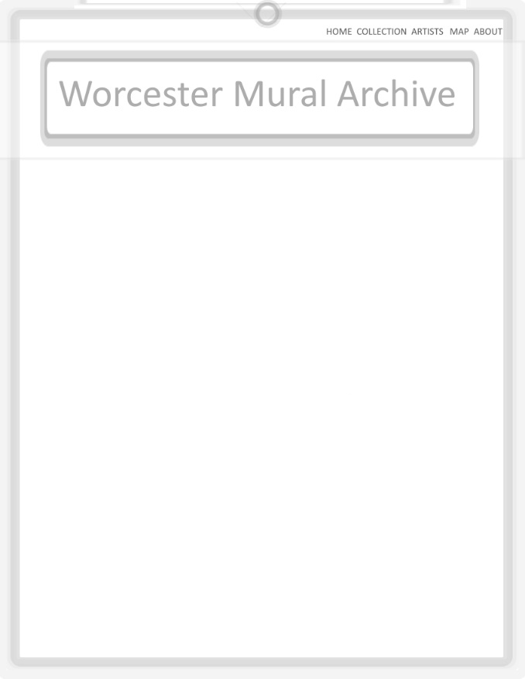
Figure 6: Worcester Mural Archive Home Page Design Layout
Top and Bottom Bars:
- These two site elements should only appear when:
  - The users’ mouse cursor hovers the circular button at the top, which brings down the top bar.
    - This keeps the screen from becoming cluttered, but still allows users to navigate to the pages on the top bar without scrolling all the way to the bottom.
  - The user’s cursor hovers at the bottom of the web page or over an indicator button similar to the circle at the top. This will cause the bottom bar to slide up.
    - Alternatively the bottom bar can always be present and maintain its position at the bottom of the screen even when scrolling. Doing so would make the top bar obsolete unless the information and buttons on the top bar are changed.

- These two elements will disappear if the user’s cursor stops hovering over their button or the bar itself for at least a second.

- The top bar features a button to take you to a News and Events Page, as well as to the Contribution page.

  - It could also have a button that takes users to the most recent additions to the archive.

- By having this bar present only when certain criteria are met it keeps pages from feeling cluttered while still having the information easily accessible.
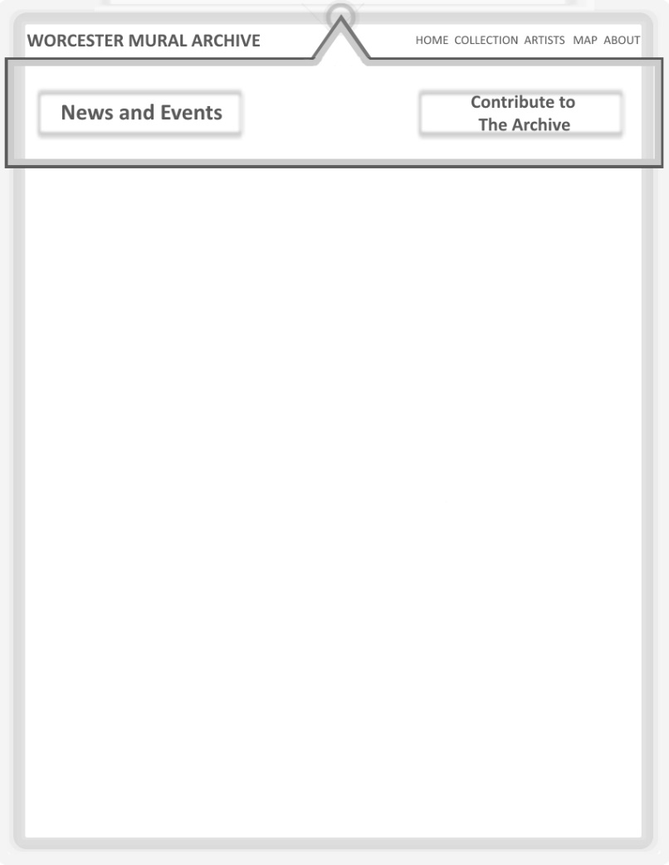
Figure 7: Suggested Top Page Bar Design
- Bottom bar features buttons for interacting and connecting using social media, another link to News and Events, and another link to the contribution page.
Figure 8: Suggested Bottom Page Bar Design

About Us:
- About the Organization
  - Background information on the archive and the group behind it.
- Organization Members
  - Members of the archive staff team and background information on them.
- Contributors
  - List of people from the community who have contributed to the archive
- Contact Information for the archive hub
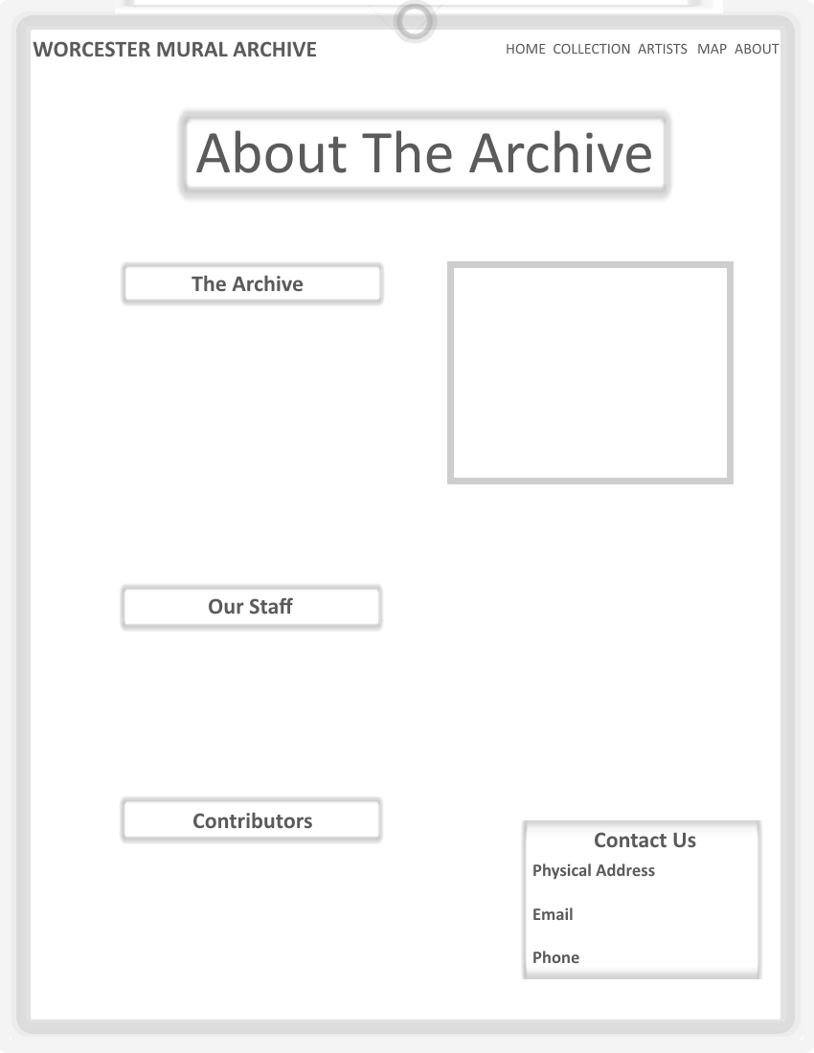
Figure 9: About the Archive/About Us Page Design

Artists:
- Information on mural artists who have contributed to works in Worcester
- Each box should feature a picture and the artist’s name.
- Hovering over an artist with the mouse cursor should bring up an interface element that has background information on the artist, and a close button for when the user finishes reading about each artist.
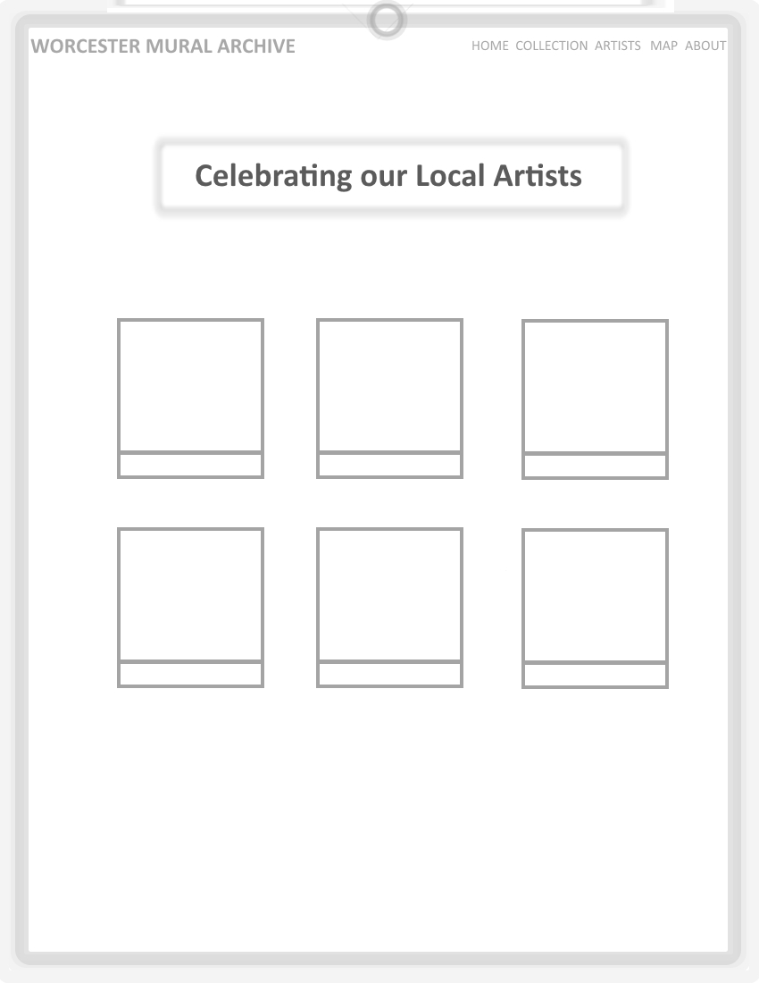
Figure 10: Artist Page Design
The Murals:
- Search Function:
  - Select criteria and enter keywords to quickly search for any murals matching those criteria.
- Sort Function:
  - Sort and filter murals by data categories
- Keywords:
  - The ‘Search’ and ‘Sort’ buttons can be made more efficient by assigning specific keywords to each mural.
  - These keywords or ‘tags’ would make it so any pages with the corresponding tags in your search would appear first.
  - An example would be if you searched ‘Italy’, then any page for artists or murals with the ‘Italy’ tag would come up first.

- Meta Data Categories:
  - Sponsor
  - Location
  - Artist
  - Creation Date
    - One for the mural and one for the page’s creation date
  - Image Depiction/Historical Event/other
  - Background and History
  - Style
  - Image or Content Uploader
    - Optional when submitting content
    - Useful when searching for a particular photographer or contributor.
    - Allows for posts made by a contributor to be located easily in the event their content is incorrect or not suitable for the public.
- Features an additional instance of the ‘Contribute’ button so visitors can easily add in something if it cannot be found in the archive already.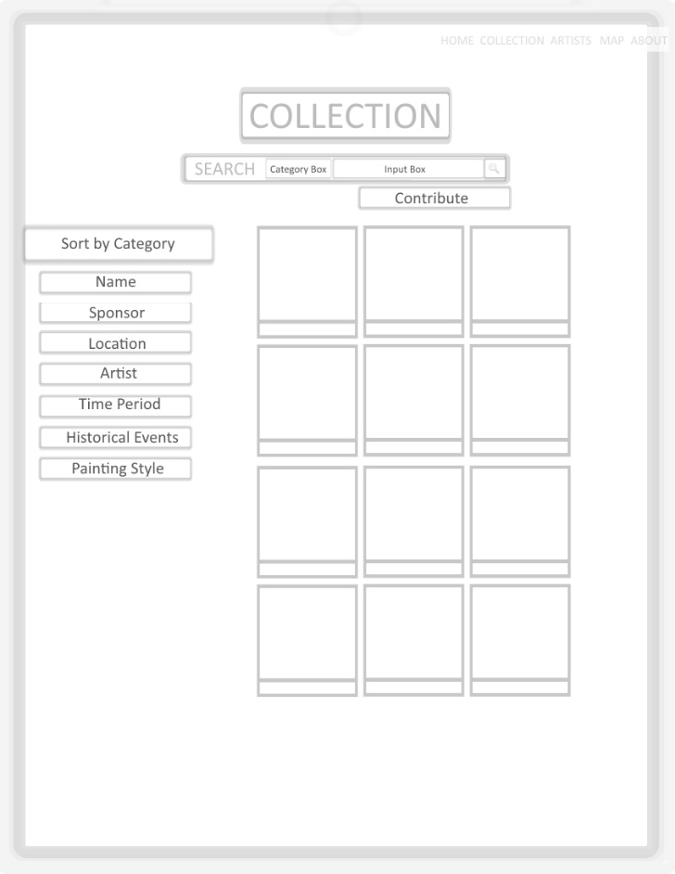
Figure 11: Collection Page Design
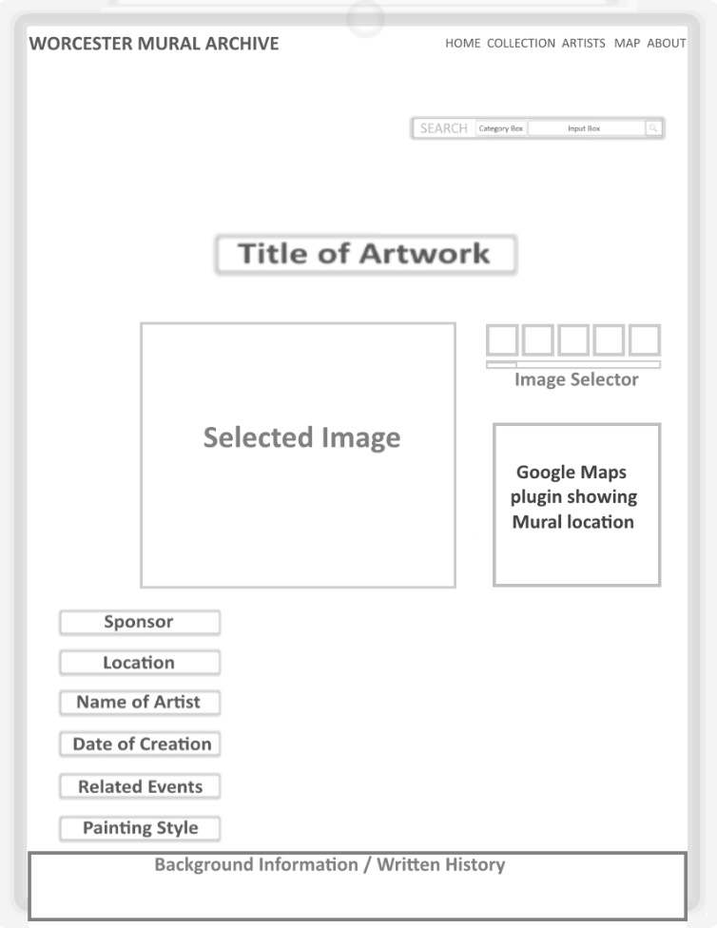
Figure 12: Individual Mural Page Design
- The mural page features all of the necessary information.
    - Each mural will have its own page
  - Image Selector:
    - The image selector allows visitors to browse through a gallery of images for each mural.
    - Some murals may have more images than others
  - Map Integration
  - Comment integration at the bottom of the page using Disquis or Facebook comment plugins.
    - Google maps should also be integrated on the mural page to help isolate the location of a single mural without needing to deal with all of the markers.
  - Search bar is also present on each mural’s page to allow for consecutive searching.
Conservation:
- The conservation page should be reachable from the ‘About’ and ‘Home’ pages.
  - Murals are vulnerable to the environment and vandalism
  - Due to being outside, murals may wear down more quickly than artwork stored indoors
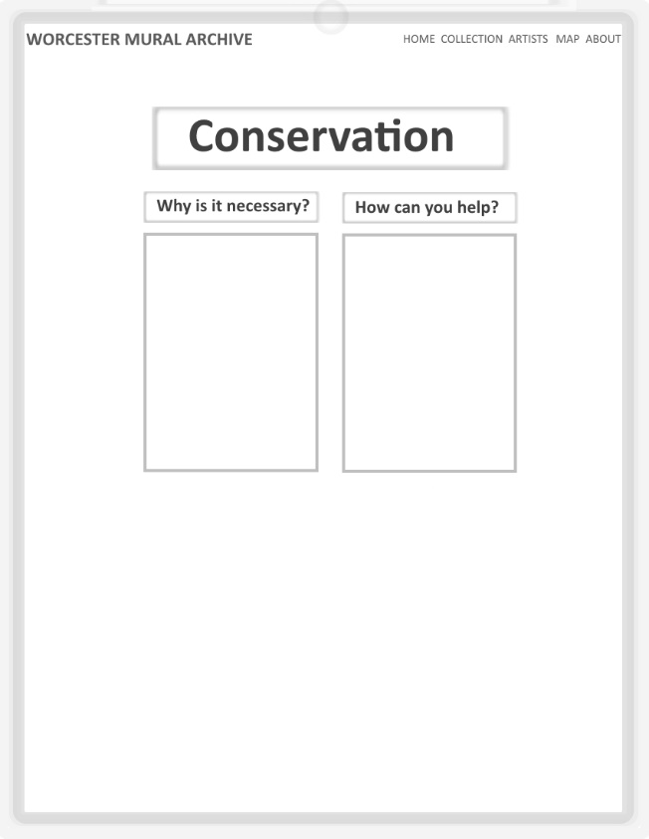
Figure 13: Conservation Page Design
Map:
- Page using the google maps plugin to display murals and their respective locations.
  - Each mural should have its own marker
  - Markers on the map should show the location and also have a link to the murals’ page on the archive.
  - Users can check off murals they would like to visit, and then have the map direct them to each mural.
    - This feature can use google map’s waypoint or stops when calculating routes between murals.

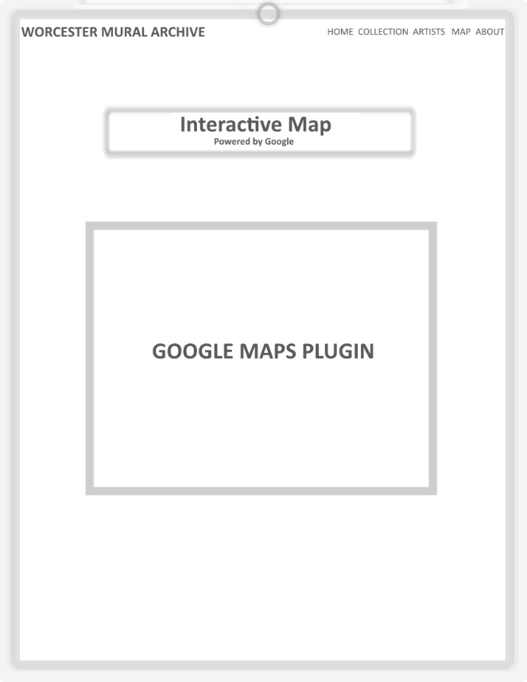
Figure 14: Mapping Page Design Featuring Google Maps

News and Events Page
- Features google calendar so visitors can easily see when events are and add them to their calendar.
- Twitter plugin allows any visitors to see update feed from a linked account so they know what is new on the site.
  - This plugin can also be placed on the home page with links in each tweet to the new pages for ease of access.
- Additional plugins for sharing pages among other social media platforms such as Facebook and Instagram can be added as well.
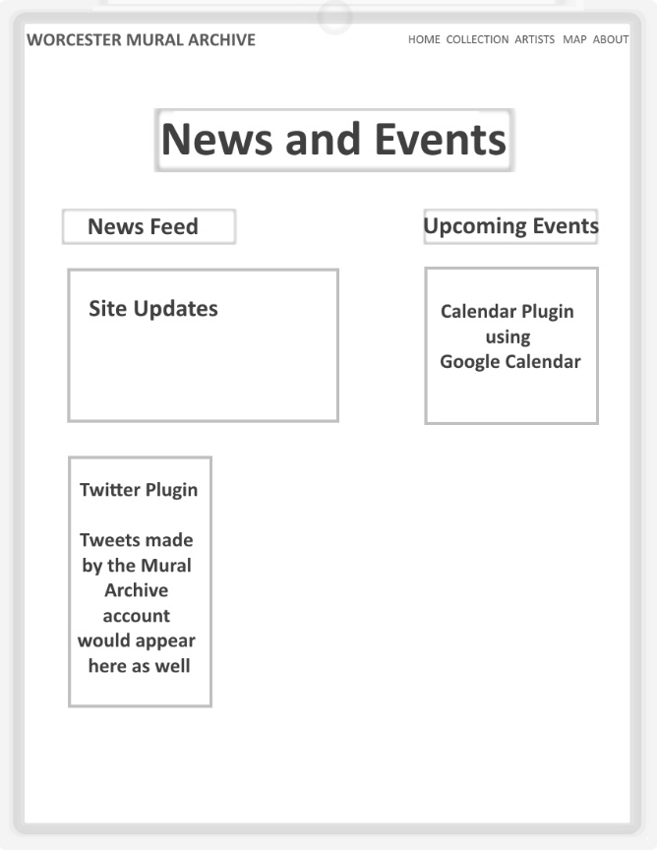
Figure 15: News and Events Page Design
Community Submission:
- Features a fill-in-the-blank format that makes it easier to know what information the archive is looking for.
  - Sections can be left blank, but would then need to be filled in with contributions from either the Worcester Mural Archive’s administrators or other community members later.
  - Image and file uploader for uploading pictures, audio recordings, and in some cases video footage.
    - ALL attachments should be previewed before accepting a community submission
      - While the vast majority of individuals will upload proper content, some will not. Making sure the content is safe for all to see is part of the job of a moderator.
  - Integrate a captcha with the submission page to prevent submission flooding from automated programs, ideally near the submission button.
  - Basic contact information for the content submitter in the event of needing future contact or sending update notifications.
    - They will not be required to enter contact information
  - The image upload section could also accept text input in the form of a hyperlink in the event the image is from the net and not an original photo taken by the contributor.
    - An additional section for attaching information and image sources should be added.
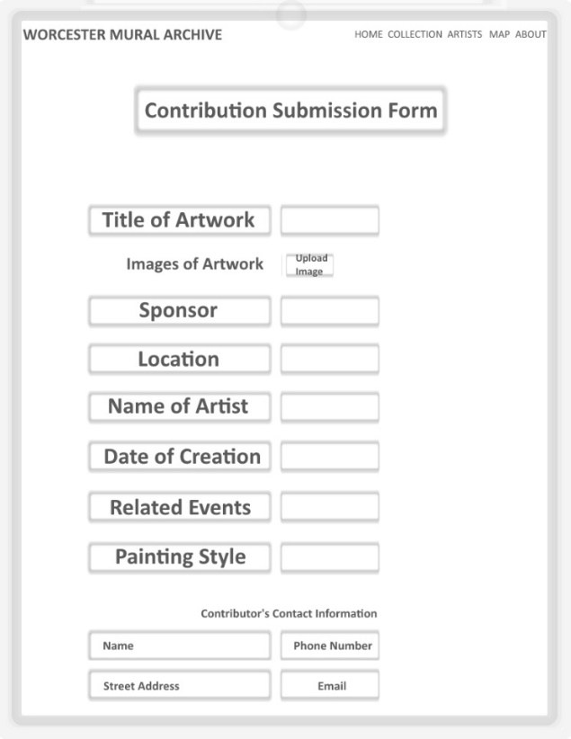
Figure 16: User Contribution Page Design
Site Management:
In addition to routine site maintenance and updates, the community submissions page will need to be checked on a regular basis in order to ensure that any community contributions are evaluated and published to the site.
The following may be necessary depending on how the site is prepared:
- An external storage unit for images and web pages.
  - Storage is only required if hosting the website locally and not through a service provider.
- The purchase and/or upkeep fee for a web domain.
- Active moderation by staff to ensure community submitted content adheres to decency and information accuracy standards.
- Additional action may be necessary to ensure that all content is sourced and does not infringe on copyright.

The new web design should be thoroughly tested before going live. Publishing a website without proper testing could result in broken links and down-time for maintenance while issues are resolved. Developers handle testing during the building process, so that when the site goes live there are no problems with the website.

FINDINGS:
Analysis Results:
From the various data each online resource provided, it was found that in every case images of the murals were provided for their corresponding page if the online resource was cataloguing the information. Sites with less complicated navigation tools often had the most concise data, whereas the larger databases like the Memphis project were difficult to navigate, and minimal information other than a title and image were provided for many of the murals.
Mural Durham and the Public Art Archive had overwhelming amounts of information, but the Public Art Archive suffered from poor search navigation. From this research, I have determined the following:
Search and Sorting:
How one locates information and how it is presented are extremely important. Therefore, assigning keywords to each page in the archive is important, these can go off of metadata or even simply words found in the history or background information for a mural or artist.
The search results should be organized by relevance, the more keywords and matching data points, the higher the page should be on the results. However, users should also be able to sort their results by date, location, or any other categories and tags of their choosing or through keywords entered into the search bar.

Overall Aesthetics:
The end appearance of the site is up to the sponsor, however all user interfaces should follow a common theme so that the site appears cohesive and easy to navigate. Links on the top, side, and bottom bars should all remain constant across the site. Additional buttons not located on the bordering bars can change based on the page, but their locations should follow a common theme in terms of placement and size.
In addition, the chosen colors should remain constant throughout the site, and should not clash with one another. Mural Durham handles their color and design selections in a way that fit together extremely well.

User Submission and Comments:
Of the analyzed resources, only a few allowed for actual user submissions, and they often required permissions not granted to the public. The Worcester Mural Archive wants users to be able to submit new information, and the best way to handle this would be through incorporating a submissions form that translates the information into an actual page that is then uploaded to the site itself after approval from a site moderator.
User comments could be handled by integrating Disquis or a similar commenting system into the various pages on the website, allowing users to share thoughts on the information without actually changing or submitting new content to the archive. Either a Facebook or Disquis plugin would be ideal for handling the commenting feature, as both are widely used and easy to integrate.
Overall website size:
Other than the pages dedicated to searching and browsing content on the digital archive, the rest of the website should ideally have as few additional pages as possible. This way the focus is on the content within the archive rather than on the organization or individuals behind its creation.

Development Platforms:
When redesigning a website, it is important to consider changing your development platform. Currently the Worcester Mural Archive is built on the Weebly web platform, a free browser-based system for creating and hosting websites that uses HTML / CSS coding. The advantages of such a platform are that it is easy to access and maintain using the site’s premade building templates or by uploading your own. It is incredibly easy to create and link new pages, build your own templates and elements, and upload files. In addition, Weebly allows unlimited files to be stored on the site as long as they do not exceed 10Megabytes (MB) each. Upgrading to a Pro account allows between 100 and 250 MB per file, depending on your plan. As long as the developers are experienced with HTML and CSS, Weebly is suitable for most sites, but it is important to consider alternative toolkits for building the new archive. Due to requiring extensive coding knowledge, file size limitations, and the monthly fees that come with an upgraded account, migrating to another platform is in the Worcester Mural Archives best interest.
Omeka:
Omeka is a free open-source software designed for building archives and databases with a focus on content. Using various plugins created by other users, developers can spend more time adding content to their site and spend less time on programming the backend for the system. These plugins range from a way for users to upload content to supporting Google Maps directly on your page. While the software itself is free, not all of the plugins are, as it depends entirely upon the plugin developer deciding whether to sell their work. In addition, since less programming knowledge is required to use the software, you no longer need to hire a highly skilled programmer to design and program your site, which can save on costs. Additional features include searching for specific images, configuring how pages can be searched and displayed, creating and building your own metadata templates, and it has no limit on the number of administrators that can access and modify the website.
Available free plugins include social media integration and geolocation, which are ideal for the desired website.

CONTENTdm:
CONTENTdm is software intended building, sharing, and preserving digital collections. Supporting both private and shared projects, it can be used for managing the archive regardless of the number of system administrators. In addition to allowing uploads directly from the web and creating metadata templates, CONTENTdm allows searches of specific images and configuring how pages are searched and viewed.
CONTENTdm is not a free service however, and requires collaborating with their staff in your area, receiving a quote, and has a subscription license fee in addition to any other costs incurred throughout the creation process. In the long term it is likely to be more expensive than the other alternatives presented here. ContentDM pricing starts at $4,300 annually, or a more expensive one-time fee with annual maintenance pricing.

CERES Exhibit Toolkit and WordPress:
Uses a digital repository to publish items and their metadata online using an Application Program Interface or API. The toolkit then lets you take the items you want using their toolkit interface to arrange and build them using a WordPress theme. The software toolkit itself is free, though it limits the developer to using WordPress as their host platform. As such, knowledge of the programming languages PHP, HTML, CSS, and Javascript are necessary for additional site management beyond the functions of the CERES Toolkit.
WordPress is at its core, a free platform for creating and publishing websites with some limitations. Those who create a free website are limited to a maximum of 3Gigabytes (GB) of storage space, which is far less than satisfactory for an online archive that will be hosting images, audio files, or even video footage. Your website would also have WordPress advertisements, a WordPress subdomain, and basic design customization. The upgraded domains start at $4.00 a month, and remove WordPress ads, increase storage space, and allow you to have you own domain name. However, the cheaper plans limit maximum space to 13GB, which is still not enough once you bring in more than image files. As such, the recommended path using the CERES Exhibit Toolkit and WordPress platform would be the $24.92 a month plan, which allows you to install plugins and upload themes, removes all WordPress branding, host ads to generate revenue for the website, as well as any other features likely needed to properly host and maintain the archive. In addition, the top end plan has unlimited storage space, which is necessary for a digital archive. This plan is also required to properly use the CERES Toolkit theme with WordPress. This plan comes in at $299.04 annually, before any tax or additional fees.

DreamWeaver:
Adobe Dreamweaver is a website development platform recommended for experienced website designers. Even using templates and other resources the program still requires knowledge of programming languages, and is not ideal for hosting an online archive that would be updated constantly, as the website goes offline when publishing new content. In addition to the monthly software contract of $19.99, you would need to purchase a storage cloud plan for the entire enterprise, or host all the files locally on dedicated storage drives, which require access to outlets, network adaptor ports, and may increase electricity costs. In addition, these drives take up space and if damaged the data stored on them can be lost. As such, using Dreamweaver to build the archive is not a recommended course of action.
CONCLUSION AND RECOMMENDATIONS
With this new design for the Worcester Mural Archive, not only will users be able to easily access information on various murals throughout Worcester, but they can also submit information on artwork that might otherwise be lost within a few days. Murals and street art do not last forever, as they are vulnerable to both weather and vandalism, and as such it is important to record and take pictures of them while we still can. These works of art are not just something to gaze at as you walk by, but reflect the efforts of communities to improve their image, grow closer, and record important parts of history. They reflect the struggles of daily life, the hard-fought battles for civil rights and independence, or as a creative outlet in a form that we find socially acceptable.
Through the use of the Omeka platform and its corresponding plugins to develop the core framework of the Worcester Mural Archive, the archive will be able to incorporate all of the necessary new features without requiring the use of a team of highly skilled programmers. Among the new archive features are an efficient search and sorting system, user and community submissions, and the integration of social media into the web site. These new features and changes will create the framework for the archive to continue expanding in the future and allow it to branch out into the community while still presenting all of its information in an organized and efficient manner.

Bibliography
Becker, Heather. Art for the people: the rediscovery and preservation of progressive- and WPA-era murals in the Chicago public schools, 1904-1943. San Francisco: Chronicle Books, 2002.

Bliss, Laurel, and Melissa Lamont. "Documenting WPA Murals in California." Art Documentation: Journal of the Art Libraries Society of North America 29, no. 1 (2010): 4-10.http://www.jstor.org.ezproxy.wpi.edu/stable/27949532.

Borda, Sylvia G. Digital image archives as public artwork and community engagement .Report. Photography and Digital Imaging , University of Salford. http://www.bcs.org/upload/pdf/ewic_ev10_s8paper4.pdf.

Braun-Reinitz, Janet. On the Wall: Four Decades of Community Murals in New York City. University of Mississippi Press, 2009.

Cockcroft, Eva Sperling. Signs from the Heart: California Chicano Murals. University of New Mexico Press, 1993.

Cockcroft, Eva Sperling. Toward a People’s Art: The Contemporary Mural Movement. University of New Mexico Press, 1998.

‘Cool Roof’ https://www.flickr.com/photos/350org/5204926883

Golden, Jane, et al., Philadelphia Murals and the Stories They Tell. Philadelphia: Temple University Press, 2012.

Golden, Jane, et al., More Philadelphia Murals and the Stories They Tell. Philadelphia: Temple University Press, 2006.

Golden, Jane. Philadelphia Mural Arts @ 30. Philadelphia: Temple University Press, 2014.

Golden, Jane. "Mural Arts Philadelphia." Mural Arts Philadelphia. Accessed June 18, 2017. https://www.muralarts.org/.

Gude, Olivia. Urban Art Chicago: A Guide to Community Murals, Mosaics, and Sculptures. Ivan R Dee, 2000.

Guisela Latorre. Walls of Empowerment: Chicana/o Indigenist Murals of California. Austin: University of Texas Press, 2008.
HENDERSON, ROSE. "MURAL PAINTINGS IN PUBLIC SCHOOLS." The American Magazine of Art 17, no. 5 (1926): 241-45. http://www.jstor.org.ezproxy.wpi.edu/stable/23929739.

Kieffer, Connie W. "New Deal Murals: A Legacy for Today's Public Art and Art Education." Art Education 53, no. 2 (2000): 40-45. doi:10.2307/3193849.

Lackritz Gray, Mary. A Guide to Chicago’s Murals. Chicago: University of Chicago Press, 2001.

Landres, Shawn. "PUBLIC ART AS SACRED SPACE: ASIAN AMERICAN COMMUNITY MURALS IN LOS ANGELES." In Practicing Religion in the Age of the Media: Explorations in Media, Religion, and Culture, edited by Hoover Stewart M. and Clark Lynn Schofield, 91-112. Columbia University Press, 2002. http://www.jstor.org.ezproxy.wpi.edu/stable/10.7312/hoov12088.10.

Marshall, John, and Pam Taylor. "Archives and Sources: The North-West Sound Archive." Oral History 7, no. 1 (1979): 57-58. http://www.jstor.org.ezproxy.wpi.edu/stable/40178550.

Palmer-Smith, Glenn. Murals of New York City: The Best of New York’s Public Paintings from Bemelmans to Parrish. Rizzoli 2013.

Prigoff, James. Walls of Heritage, Wall of Pride: African American Mural. Pomegranate Communications, 2000.

Robin J. Dunitz. "The Albina Mural Project." Oregon Historical Quarterly 111, no. 4 (2010): 486-508. doi:10.5403/oregonhistq.111.4.0486.

Schacter, Rafael. The World Atlas of Street Art and Graffiti. Kensington, NSW: New South Books, 2013.

Sieber, Tim, Graça Índias Cordeiro, and Lígia Ferro. "The Neighborhood Strikes Back: Community Murals by Youth in Boston's Communities of Color." City & Society 24, no. 3 (2012): 263-280.

Trumper, Camilo D. "Political Palimpsests: Posters, Murals, and the Ephemeral Practice of Urban Politics." In Ephemeral Histories: Public Art, Politics, and the Struggle for the Streets in Chile, 93-127. Oakland, California: University of California Press, 2016.http://www.jstor.org.ezproxy.wpi.edu/stable/10.1525/j.ctt1cg4nbc.8.

Valente, Sarah. "The Murals." Accessed June 18, 2017. http://www.magafanmuralproject.com/the-murals.html.

Valente, Sarah. "Worcester Mural Archive." Worcester Mural Archive. Accessed June 18, 2017. http://www.worcestermuralarchive.com.

"Public Art." Public Art | Worcester, Massachusetts. Accessed June 18, 2017. http://www.worcestermass.org/www/publicart.

"The Power of Public Art: How Murals Beautify Cities and Build Communities." Opticos Design, Inc. February 01, 2017. Accessed June 18, 2017. http://opticosdesign.com/the-power-of-public-art-murals/.

Zander, Mary Jane. "Instructional Resources: Murals as Documents of Social History." Art Education 57, no. 5 (2004): 25-31. http://www.jstor.org.ezproxy.wpi.edu/stable/3194101.

Public Mural Archives

Basque Murals
https://basquemurals.wordpress.com/2016/08/30/basque-online-mural-archive/

Clarion Alley Mural Project – San Francisco
http://clarionalleymuralproject.org/about/

CROW – Urban Archive in Seattle Washington
http://urbanarchives.org/mural.html

Denver Urban Art Directory
http://digital.auraria.edu/denverurbanart

El Salvador Mural Archive
http://www.rachelheidenry.com/murals.php

Mapping Watsonville Murals
http://www.watsonvillemuralarchive.com/

Memphis Arts Project Digital Image Collection
http://dlynx.rhodes.edu/jspui/handle/10267/25932

Mural Durham
http://www.muraldurham.com/#home

Mural Locator
http://murallocator.org/about/

Murals of Northern Ireland at Claremont Colleges Digital Libraries
http://ccdl.libraries.claremont.edu/cdm/landingpage/collection/mni

Public Art Archive
http://www.publicartarchive.org/content/about-public-art-archive

Public Art Workshop Mural Archive – Chicago
http://luna.lib.uchicago.edu/luna/servlet/uofclibmgr2~10~10

Appendix A: Online Reference Analysis

Murals of Northern Ireland at Claremont Colleges Digital Libraries
http://ccdl.libraries.claremont.edu/cdm/landingpage/collection/mni
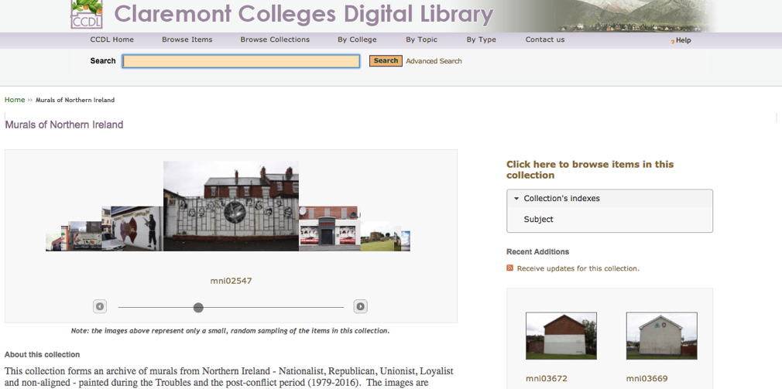
Figure 17: Murals of Northern Ireland (Claremont Colleges Digital Library)

Sponsor: Dr. Tony Crowley

Claremont Colleges Digital Library
Type: Academic Library with a scholarly interest in preserving Northern Ireland’s murals as historical artifacts
Audience: Students and scholars working together.
Description: The project describes itself as “an archive of murals from Northern Ireland - Nationalist, Republican, Unionist, Loyalist and non-aligned - painted during the Troubles and the post-conflict period (1979-2016). The images are records which include the representation of history, the expression of political standpoints, the articulation of community concerns, formations of memory and modes of ideological address. The murals range from overtly political declarations, to brutal depictions of the conflict, to comments on peace and the peace process, to humor and irony.”
Metadata:
- Name of the mural
- Photographer
- The subject or topic depicted in the murals
- Vague geographical location
- A description of the images depicted in the mural
- The original publisher of the image
- Date the mural was created
- The affiliated parties
- Images

Map/Geolocation:
- Written location, but no map.

Social Media Elements:
- None

Community Submissions:
- None
Website Analysis:
Information and Content:
The archive includes a basic description of each mural and several images.
Layout:
Set up as a database, information is present but non-invasive. Lacks a well-designed navigation bar, and instead requires use of the back button, going through the menus each time, or using the search bar.

Basque Murals
https://basquemurals.wordpress.com/2016/08/30/basque-online-mural-archive/
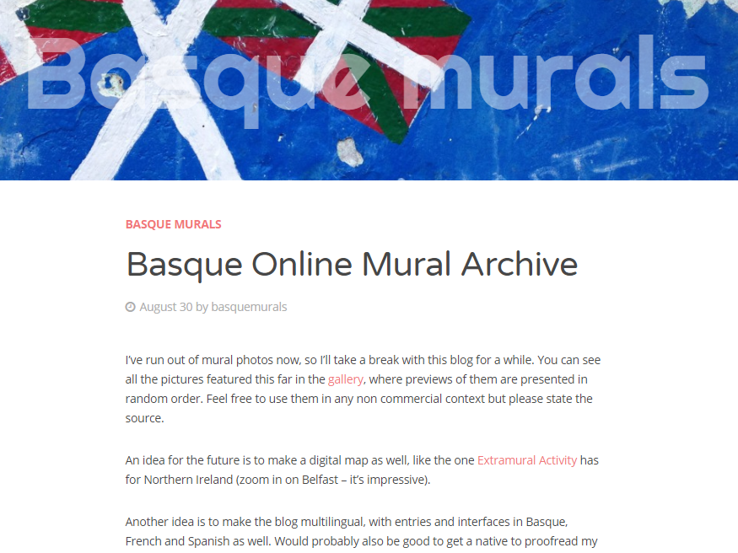
Figure 18: Basque Murals

Sponsor: Joakim Lilljegren
Type: Image Archive and Blog
Audience: Historians and interested individuals
Description: “This blog deals with the culture, society and history of the Basque Country seen through its murals. If you’re interested in mural art, the Basque Country is a goldmine – kind of like Northern Ireland but with slightly better weather and much better food.”
Metadata:
- Location
- Name
- Background information
- Dates
- Images

Map/Geolocation:
- None

Social Media Elements:
- None

Community Submission:
Allow user comments, but no community submissions. By clicking on any of the images in the gallery, you can comment on them or the posts themselves by scrolling to the bottom and leaving a comment/reply.
Website Analysis:
Information and Content:
The author includes some information about the murals, but not much more than a vague location and when they were made in many cases.
Layout:
Basque Murals is a blog run on a WordPress account. While the site has a gallery and you can easily find recent blog posts, the site lacks an efficient search function with categories you can use to filter through topics quickly. Due to this, unless you know what you are looking for, old topics end up buried beneath all of the newer posts.

Clarion Alley Mural Project – San Francisco
http://clarionalleymuralproject.org/about/
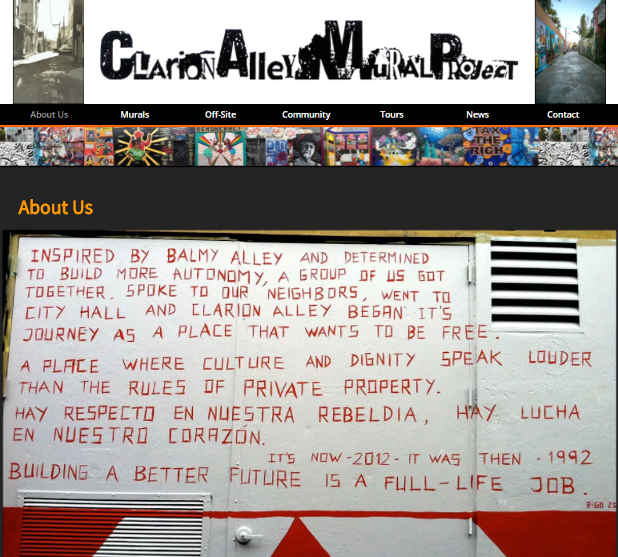
Figure 19: Clarion Alley Mural Project

Sponsor: Clarion Alley Mural Project
Type: Image Database and Tours
Audience: Tourists and Local Community Members
Description: The project describes itself as an organization created to promote socially diverse art for the community in San Francisco.
Metadata:
- Location
- Date of image upload
- Title
- Images

Map/Geolocation:
- No maps provided, but they do sponsor local tours.

Social Media Elements:
- Spread knowledge of the website through Twitter, Instagram, and Facebook.

Community Submission:
- None
Website Analysis:
Information and Content:
Provides a large amount of information on the organization and various projects, but nothing other than images and minimal information for the murals in the area.
Layout:
The website’s design is nice to look at, and is easy to navigate to each major category, but lacks an easy way to navigate between murals.

CROW – Urban Archive in Seattle Washington
http://urbanarchives.org/mural.html
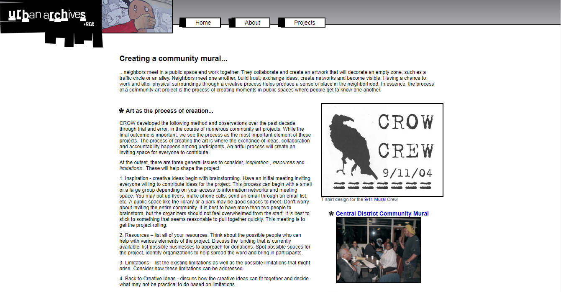
Figure 20: CROW Urban Archive

Sponsor: Urban Archives
Type: Project Information Site
Audience: Artists, tourists, historians
Description: A site created to bring communities together to create local works of public art.
Metadata:
- Unable to determine due to broken links.

Map/Geolocation
- No

Social Media Elements:
- None

Community Submission:
- None, though it does have information for ongoing events you can participate in.
Website Analysis:
Information and Content:
The site provides information on graduate and undergraduate projects at the University of Washington and St. Martins University. However, a large number of the links were broken or led to non-existent webpages.
Layout:
Several primary tabs on top for easy navigation. Home tab currently is not working.

Denver Urban Art Directory
http://digital.auraria.edu/denverurbanart
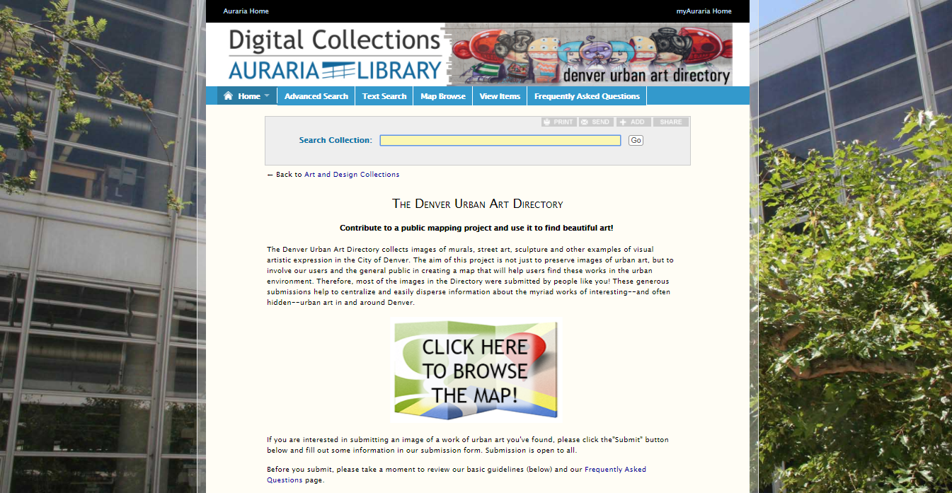
Figure 21: Denver Urban Art Directory

Sponsor: Auraria Higher Education Center
Type: Image Archive
Audience: Tourists
Description: “The Denver Urban Art Directory collects images of murals, street art, sculpture and other examples of visual artistic expression in the City of Denver. The aim of this project is not just to preserve images of urban art, but to involve our users and the general public in creating a map that will help users find these works in the urban environment. Therefore, most of the images in the Directory were submitted by people like you! These generous submissions help to centralize and easily disperse information about the myriad works of interesting--and often hidden--urban art in and around Denver.”
Metadata:
- Location
- Title
- Image

Map/Geolocation:
- Uses google maps to show murals on a map, which can then be clicked on to take you to that mural’s page on the site.

Social Media Elements:
- None

Community Submission:
- Accepts image submissions of ‘art’, but not graffiti or tagging.
- Also allows users to submit feedback comments.
Website Analysis:
Information and Content:
Using google maps to mark the location of murals, the site provides images at those markers, the date of submission, and the name of the image. As such, minimal information other than location and the name of the art piece is provided.
Layout:
Navigation is done primarily through the map. As such, other than the Frequently Asked Questions (FAQ), ‘Home’, and ‘Search’ pages, there isn’t much else on the site to distract the viewer.

El Salvador Mural Archive
http://www.rachelheidenry.com/murals.php
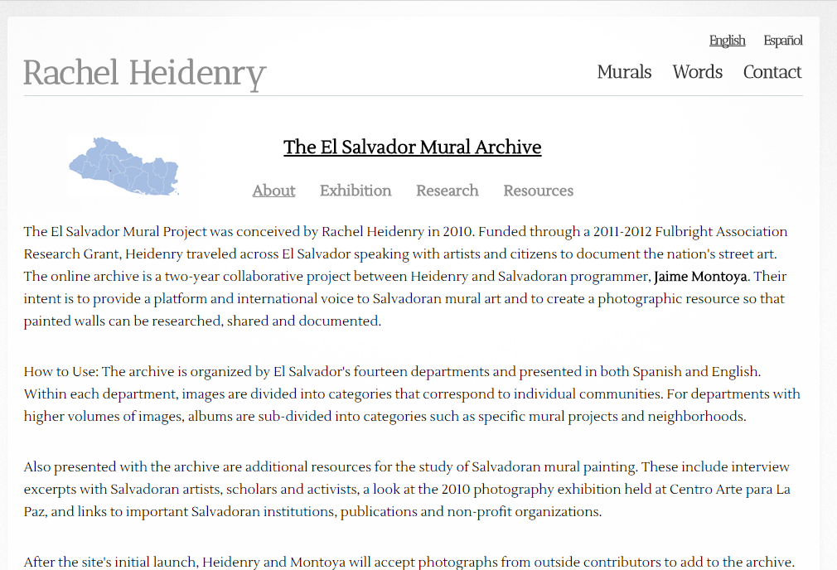
Figure 22: El Salvador Mural Archive

Sponsor: Rachel Heidenry & Jamie Montoya
Type: Archive
Audience: Tourists, historians
Description: An online archive documenting El Salvador’s street art through the combined efforts of Rachel Heidenry and Jaime Montoya.
Metadata:
- Location
- Name
- Images
- Interview excerpts and clips
- Some artists are named
- Some dates are given

Map/Geolocation:
- Some locations are provided and mapped

Social Media Elements:
- None

Community Submission:
- No way to submit new content.
Website Analysis:
Information and Content:
Information is provided through their flash application with images of murals, some background information on them, and their locations.
Layout:
The layout of the web site is handled in a simple and efficient manner, using three main pages on the navigation bar, and then several smaller pages linking out from some of the primary pages.

Mapping Watsonville Murals
http://www.watsonvillemuralarchive.com/
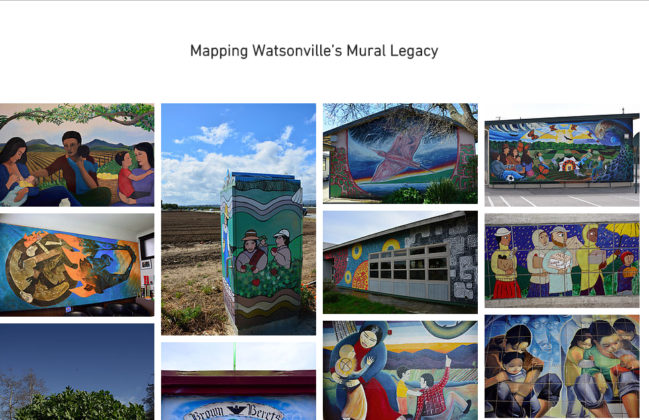
Figure 23: Mapping Watsonville Murals

Sponsor: Marisol Medina-Cadena
Type: Archive
Audience: Tourists, historians, general public
Description: The project describes itself as a way to memorialize events in the community by archiving murals in the local area.
Metadata:
- Location
- Name of artwork
- Images
- Audio clips from artists and historians
- Dates for some pieces
- Background information on depicted events
- Information on the history of the murals’ creation.

Map/Geolocation:
- Uses a google maps plugin to help locate murals.

Social Media Elements:
- Does not incorporate social media.

Community Submission:
- No method to add community contributions.
Website Analysis:
Information and Content:
Includes detailed information, images, and audio recordings discussing the murals, as well as background information from the artists themselves.

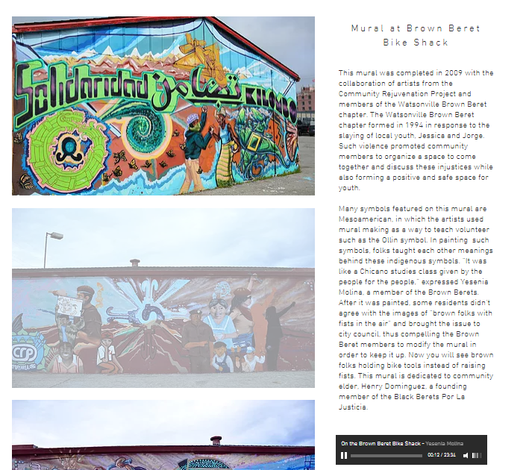
Figure 24: Watson Ville Murals Sample Page

Layout:
No search function requires returning to the home page every time and makes navigation difficult.
Memphis Arts Project Digital Image Collection
http://dlynx.rhodes.edu/jspui/handle/10267/25932
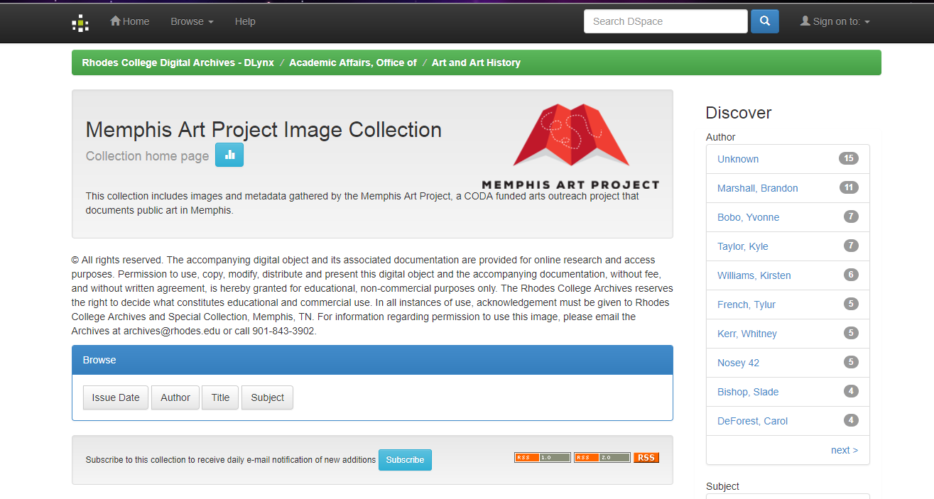
Figure 25: Memphis Arts Project Digital Image Collection

Sponsor: Rhodes College Archives and Special Collection
Type: Database
Audience: Historians and Students
Description: “This collection includes images and metadata gathered by the Memphis Art Project, a CODA funded arts outreach project that documents public art in Memphis”.
Metadata:
- Location (Vague)
- Images
- Name
- Background information

Map/Geolocation:
- Vague location

Social Media Elements:
- None

Community Submission:
Only for Rhodes College students who are curators or collaborative partners.

Website Analysis:
Information and Content:
Each page includes an image and minimal information on each mural. There is more information about the individual who took the image than the murals in many cases.
Layout:
Features a search system but no hierarchy tab for quick navigation.

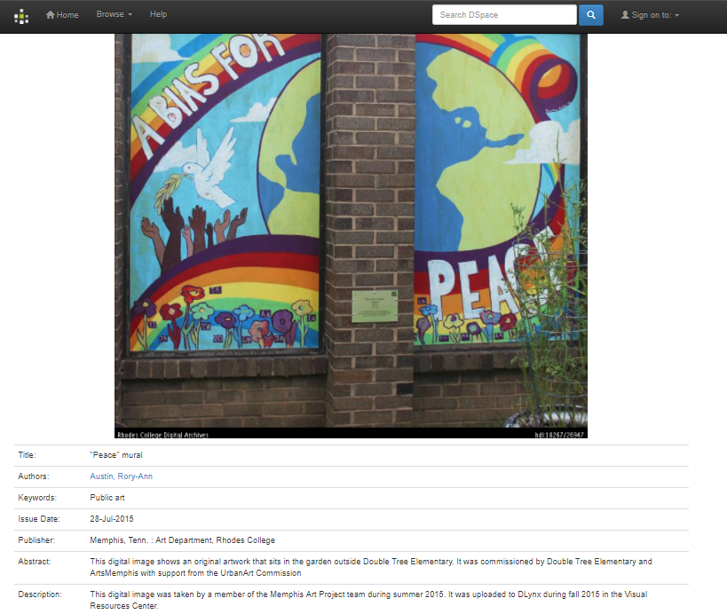
Figure 26: Sample Page from Memphis Arts

Mural Durham
http://www.muraldurham.com/#home
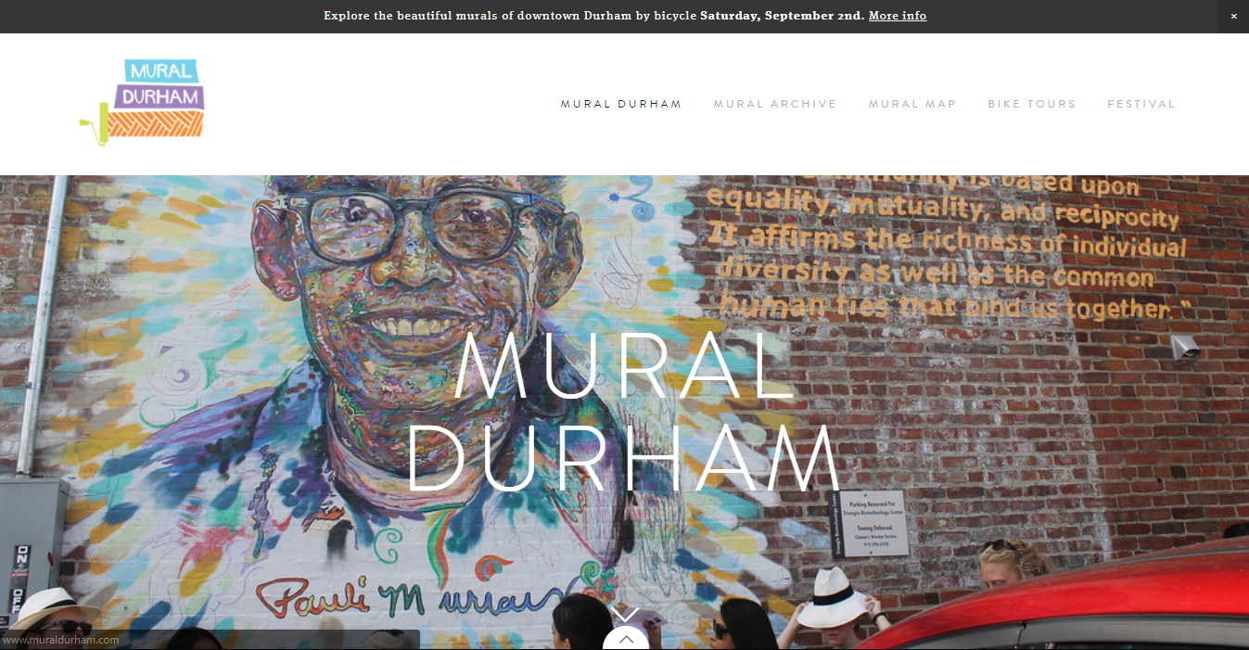
Figure 27: Mural Durham Home Page

Sponsor: Reneé Cagnina Haynes
Type: Mural Archive and Map
Audience: Tourists, historians, and the local community
Description: A mural archive created to archive the increasing number of murals in a community.
Metadata:
- Location
- Name
- Images
- Artist
- Extensive background information
- Depicted events and/or images
- Date

Map/Geolocation:
- Includes a written location for murals, but no actual map on the page for the corresponding mural. Instead, you have to visit the ‘mural map’ tab which has a map with markers for each mural, plugin uses Google Maps.

Social Media Elements:
- Incorporates the ability to share via Facebook, Instagram, or email.

Community Submission:
- Requires contacting the sponsor to have any new information added. No system for adding comments.
Website Analysis:
Information and content:
Each mural has location information and a written background on the mural itself.
Layout:
While the appearance of the site is pleasing to the eye, the site lacks a method to search through the archive, making it a time consuming process when browsing murals.

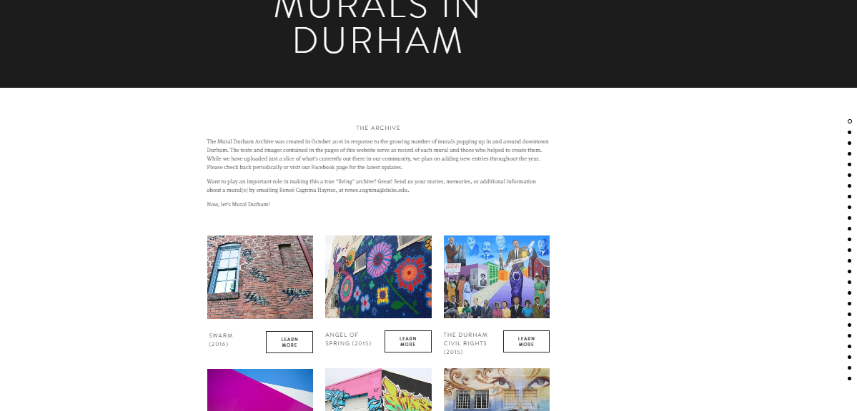
Figure 28: Mural Durham Listing Page

Mural Locator
http://murallocator.org/about/
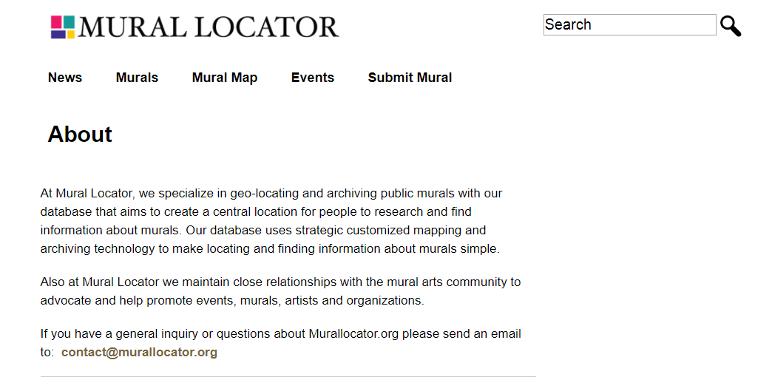
Figure 29: Mural Locator About Us Page

Sponsor: Los Angeles Times / LA Travel
Type: Map and Database
Audience: Tourists
Description: A database that serves as a way to map and archive images and information about murals worldwide, rather than just a specific city or country.
Metadata:
- Location
- Name
- Images

Map/Geolocation:
- Uses a plugin powered through google maps to mark on a map the locations of each mural.

Social Media Elements:
- Connect (Follow/share) on twitter and Facebook.

Community Submission:
- Yes, using the submit mural page which takes you to a form. But no comment section support.
Website Analysis:
Information/ content:
Serves as both an interactive map and a database for murals worldwide. Some pages have information on the murals themselves, others are just an image and a location on the map.
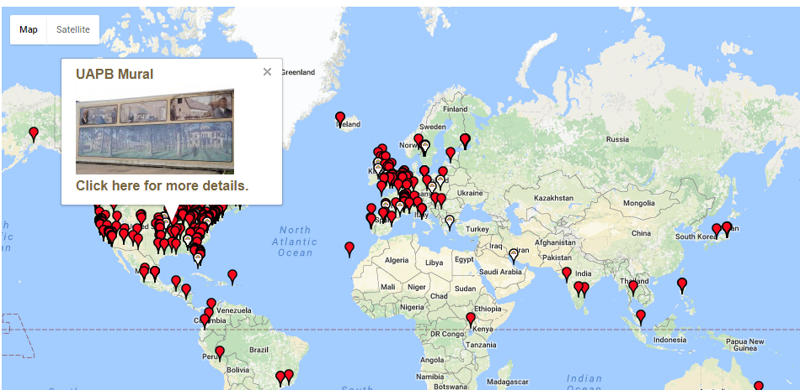
Figure 30: Global View of Mural Locations

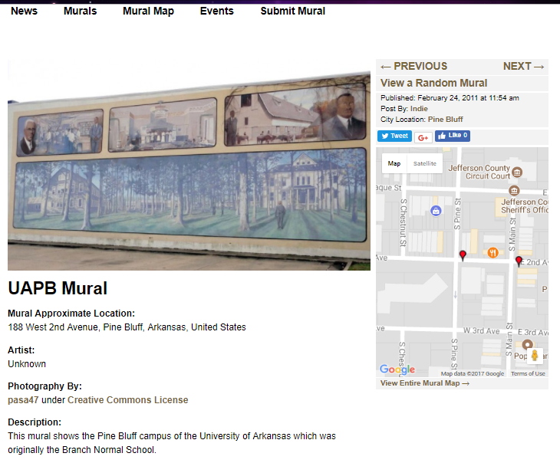
Figure 31: Mural Locator Content Page

Layout:
Home page is a google maps plugin showing the location of various murals.
Clicking on any mural allows you to go to a page with more information, just like a standard database.
Additional Notes:
Lacks an easy to use sidebar for quick navigation and hierarchy.

Public Art Archive
http://www.publicartarchive.org/content/about-public-art-archive
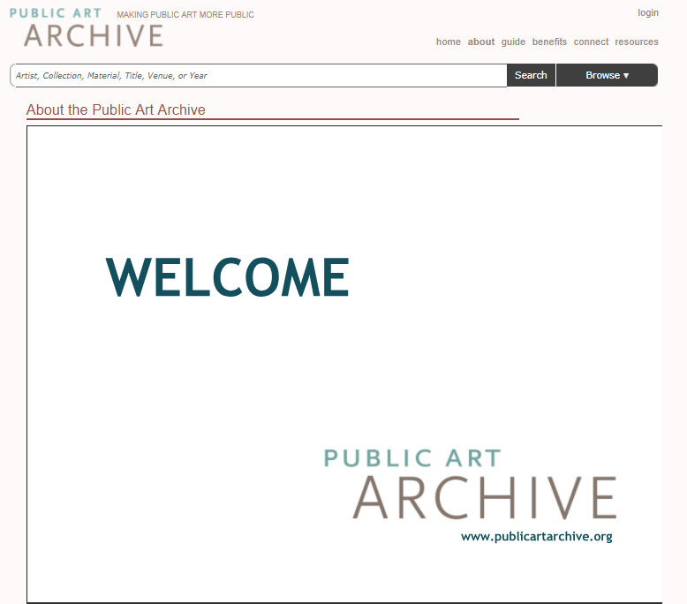
Figure 32: Public Art Archive Home Page

Sponsor: Western States Arts Federation WESTAF
Type: Database / Collection Hub
Audience: Artists, historians, and the general public
Description: The project describes itself as “a totally free, continually growing, online and mobile database of completed public artworks.”
Metadata:
- Location
- Name
- Images
- Artist
- Background information
- The data for each collection varies depending upon what the original creator for each collection chose to provide.

Map/Geolocation:
- Yes, provided that the community submissions provided that information, then the location is marked on Google Maps.

Social Media Elements:
- Ability to link and tweet pages, share them on Facebook, LinkedIn, Google+, Pinterest, etc.

Community Submissions:
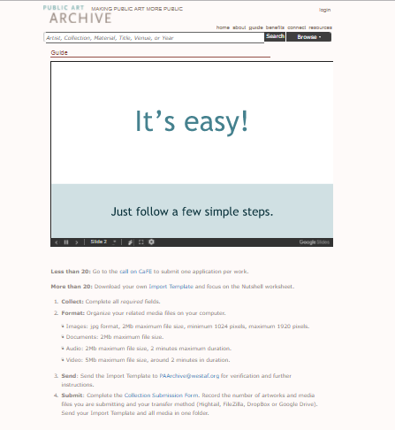
Figure 33 (Top): Submission Process

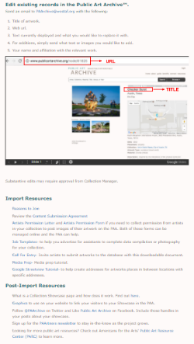
Figure 34 (Bottom): Asset Uploading

Website Analysis:
Information/Content:
The information for each collection or work of art is dependent upon what was provided at the time of submission. Some pages have all the background information on a collection or image, while others have a title and artist.
Layout:
Lacks a way to easily return to prior location or organize nagivation other than through the use of a top search bar, making navigation difficult.

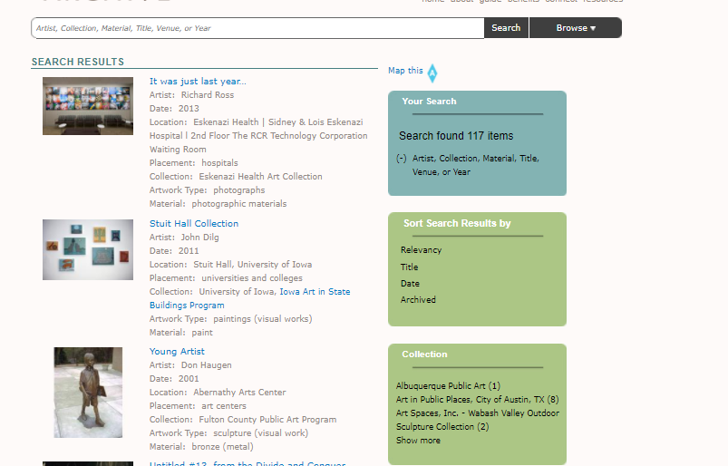
Figure 35: Public Art Archive Search Page

Additional Notes:
Incorporates a way to advertise your website through them as well as community submissions, which has both positive and negative aspects. It gives artists publicity, but also means the site is a for-profit organization rather than a free public collection. As a result, individuals who ‘subscribe’ may have their collections brought to the front page rather than having it stored as an actual database.
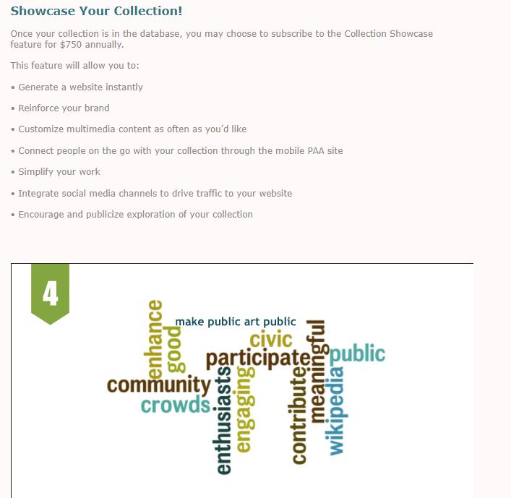
Figure 36: Public Art Archive Submission Page

Public Art Workshop Mural Archive – Chicago
http://luna.lib.uchicago.edu/luna/servle t/uofclibmgr2~10~10
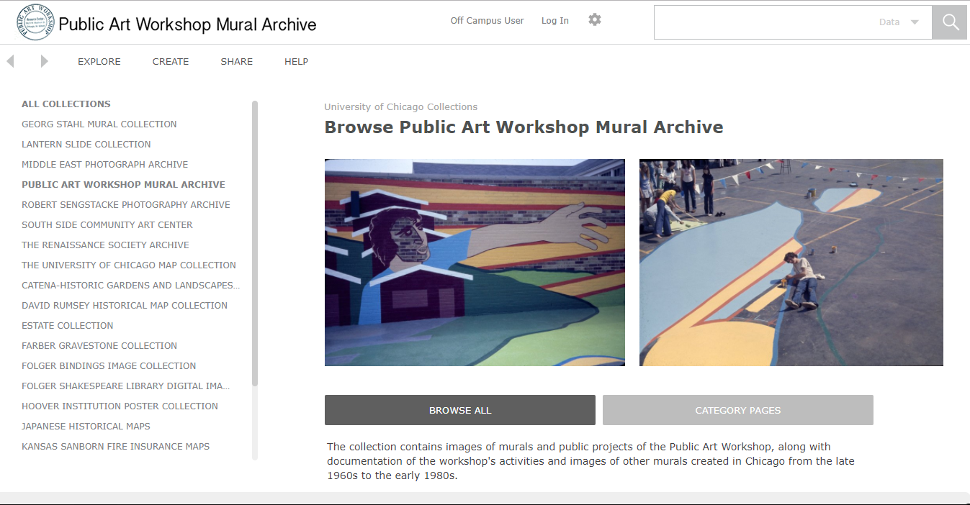
Figure 37: Public Art Workshop Home Page

Sponsor: University of Chicago
Type: Image Database
Audience: Historians and Students searching for images and basic information
Description: “The collection contains images of murals and public projects of the Public Art Workshop, along with documentation of the workshop's activities and images of other murals created in Chicago from the late 1960s to the early 1980s.”
Metadata:
Set up like a standard database:
- Creator, title, date, culture, location, Image ID, Style / time period, alternate titles, image source, and additional search tags.

Map/Geolocation:
- Address is given, but no actual map.

Social Media Elements:
- None

Community Submission:
- Restricted to students at University of Chicago (Requires Login)
Website Analysis:
Information/Content:
Other than the standard information in the database, there is a minimal amount of information for each image. The site lacks a section for an extended background on each image, instead showing the image and basic data on each work. As such, it is simply a collection of images rather than a tool for art historians.

Also includes embedded images of murals, some of which can be zoomed upon or feature several different shots from different angles.

Layout:

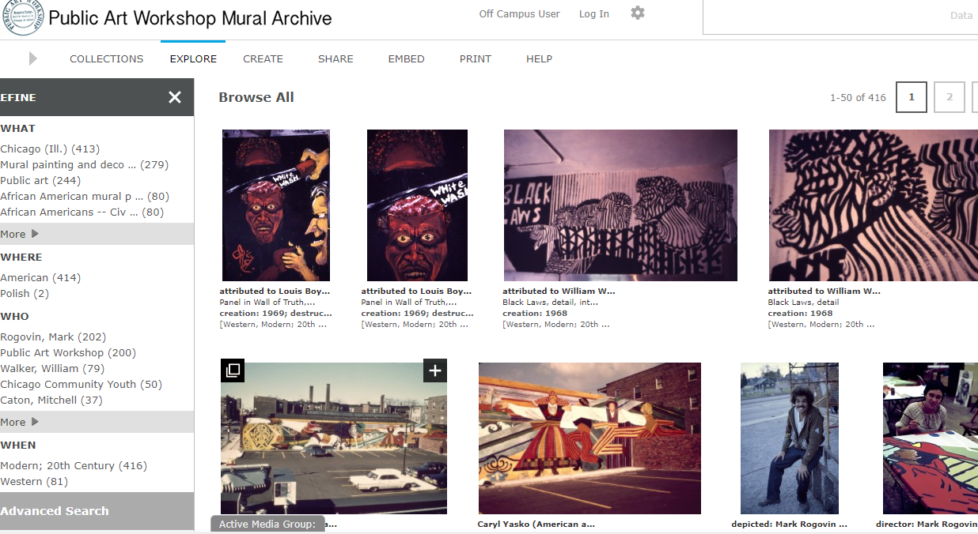
Figure 38: Public Art Workshop Search and Listings Page Layout

The site itself has a standard layout for any online database, but it is difficult to navigate, the information bar on the left side is always present.

