High Altitude Balloon
A Major Qualifying Project Report
Submitted to the faculty of
WORCESTER POLYTECHNIC INSTITUTE
In partial fulfillment of the requirements for the
Degree of Bachelor of Science
Submitted By:
Jiayi Jiang Jonney Lee Hanyang Ru
Date: 4/6/2020
Approved:
Prof. Maqsood Mughal

Acknowledgement
We would like to show our appreciation to Professor Maqsood Mughal from WPI for his passion and dedication towards our project and his support to us over the terms. Without him, we would not be able to gain such achievements. We also would like to thank staff from the Federal Aviation Agency and the Air Traffic Control in Boston, MA and Albany, NY for their assistance and guidance to our high altitude balloon launches. A special thank you to Mr. Boutin from Oakham for his generous help to retrieve the payload. Without his help we would not collect any data from the balloon flight. Thanks to Melissa Sullivan from Michael’s Party Rental for assisting us with helium gas supply, we were able to conduct several launches throughout the terms.

Abstract

In this project, we build a High Altitude Balloon to measure the high altitude air quality data. More specifically, we seek to investigate the data by using different air quality sensors to record measurement at a high altitude air. We solder wires to connect circuits, we cut the Styrofoam payload to arrange components, and we inflate air into the balloon to launch our payload. Included is a working prototype with results and advice for this high altitude project to facilitate future research on this project.

Table of Contents
Acknowledgement 1
Abstract 2
Table of Figures 5
Table of Tables 6
1 Introduction 7
1.1 Significance 7
1.1.1 Project Scope 7
2 Background 9
2.1 State of the Environment 9
2.1.1 History of Air Pollution Monitoring 10
2.1.2 Current Efforts to Monitor Air Quality 11
3 Methodology 17
3.1 Hardware 17
3.1.1 UV Sensor 18
3.1.2 Barometric Sensor 19
3.1.3 Temperature Sensor 20
3.1.4 Nitrogen Dioxide Sensor 21
3.1.5 Carbon Dioxide Sensor 22
3.1.6 Ozone Sensor 22
3.2 Connection 23
3.3 Embedded System/Software 30
3.3.1 Microcontroller Selection 30
3.3.2 Software Operation 32
3.4 Launch Process 33
3.4.1 Launch Site and Date Decision 33
3.4.2 Flight Simulation 35
3.4.3 FAA Clearance 37
3.4.4 Inflate Balloon 38
3.4.5 Track and Recover 39
4.1 Flight Data 41
4.2 Collected Data 43
5 Conclusion 49
5.1 Achievement of Initial Scope 49
5.2 Manufacturability Costs 50
5.3 Lesson Learned 51
References 53

Table of Figures
Figure 1: High Altitude Balloon 13
Figure 2: Functional Block Diagram of the HAB System 24
Figure 3: Arduino Uno 1 Schematic 25
Figure 4: Arduino Uno 2 Schematic 26
Figure 5: Inside Wiring Picture 28
Figure 6: External Sensors 29
Figure 7: Comparing Arduino and Raspberry Pi 31
Figure 8: Flight Simulation 36
Figure 9: Balloon Performance Calculator 36
Figure 10: Radar Reflector example 38
Figure 11: Gen Spot GPS Tracking 40
Figure 12: Flight Simulation 41
Figure 13: Payload Sealed 42
Figure 14: Real Flight Path 43
Figure 15: Altitude vs. Time vs. Inside Temperature vs. Outside Temperature 44
Figure 16: Altitude vs. Temperature/Pressure 45
Figure 17: Temperature vs. Altitude 46
Figure 18: Ascent Rate vs. Altitude 46
Figure 19: Descent Rate vs. Altitude 47
Figure 20: Altitude vs. Time 47
Figure 21: CO₂ vs. Time 48

Table of Tables
Table 1: Comparison between Known Methods 15
Table 2: Cost Analysis of UV Sensor 18
Table 3: Cost Analysis of Barometric Sensor 19
Table 4: Cost Analysis of Temperature Sensor 21

1 Introduction

1.1 Significance
The goal of this project is to measure the concentration of environmentally detrimental pollutants and greenhouse gases (GHG) at different atmospheric levels using high altitude ballooning (HAB). This project aims to offer a more accessible and economical affordable alternative to measuring air pollution in the atmosphere and capturing near-space imagery data.
Currently, methods for monitoring and measuring atmospheric pollution levels require both a large startup investment in addition to continuous maintenance of equipment [1]. For institutions that have large amounts of funding for monitoring environmental activity, the investment cost, as well as maintenance cost is not too detrimental [2]. However, for smaller institutions, this financial gateway to measuring GHG or other harmful pollutants in the atmosphere enforces alternate affordable measures and techniques. As a solution to this problem, the proposed project utilizes electronics capable of measuring air pollution at different atmospheric levels reaching heights close to 100,000 ft with high accuracy.

1.1.1 Project Scope
The scope of this project is to build a high-altitude balloon capable of measuring GHG emissions and other detrimental air pollutants in the atmosphere relative to specific regions of the atmosphere, as well as regional location. This project also offers a cost-affordable alternative to pre-existing methods of measuring and monitoring air quality in the environment. The results of this project will be the first of its kind for this specific application at Worcester Polytechnic Institute (WPI) and offer a framework for improvement and innovation for future students. Prof. Mughal aims to measure the pollutants in air over a longer period of time (10-25 yrs.), and this work will be a base to improve upon the design, electronics, and assembly, and add other features.

2 Background

2.1 State of the Environment
With the upward surge of technological innovation and globalization of the world, the state of the environment has become of critical importance to the balance of Earth’s ecosystem. Rising problems regarding increased global warming, climate change, and hazardous air quality have garnered more attention and visibility to their respective health ramifications. Among those issues, air quality has taken the majority of concerns due to its importance in both creating and maintaining life in all organisms.
One of the first documented cases of air pollution which resulted in tangible health problems for people in the modern age was in Donora, Pennsylvania in 1948. At the time, a weather inversion caused a nearby steel plant’s pollution to effectively be trapped within the lower atmospheric levels, causing 14,000 residents of the town to have severe respiratory illnesses [3].
In the past few decades, the landscape along the Yangtze River in China has experienced a dramatic destruction due to the worse air pollution. With rapid country development, the emission of harmful gases and noxious particles, such as carbon dioxide, is increasing year by year. The impact of the air pollution will not be obvious immediately, but it is gradually being expressed. With the burning of fossil fuel, for example, oil, gas and coal, small particles with diameters under 2.5 µm form and coalesce [4]. After long term processes, smog forms and the sky starts turning grey, sunshine can not go through the thick smog layer, and the trees along Yangtze River can not gather enough energy from sunshine and start withering. If people don’t take care about air pollution as soon as possible, the environment will finally punish ourselves.

2.1.1 History of Air Pollution Monitoring
With the increasing attention on air quality, the Office of Air Quality and Planning and Standards was founded by the Environmental Protection Agency(EPA) to monitor and preserve the nation’s air quality, who established the National Ambient Air Quality Standards for each pollutant. Each year, EPA examines six essential air pollutants in the country and releases a report including detailed analysis for the past ten years and a summary of current air pollution status. Every state is required to establish a monitoring network for air quality, for local and national. These are called the State and Local Air Monitoring Stations and the National Air Monitoring Stations. Local networks need to provide an annual summary of monitoring results while national networks need to meet more strict criteria and to provide quarterly and annual reports of results [5].
Under this initiative, institutions started to focus on air pollution treatment and the Clean Air Act was proposed in 1970 and then amended in 1977 and 1990 [6] in order to reduce air pollution, and to prevent hundreds of thousands of cases of serious health effects each year. It was defined in this law enforcement that it was “the Environmental Protection Agency’s responsibility to improve the air quality and the stratospheric ozone layer” [7]. To complete the Act more thoroughly, the federal Environmental Protection Agency established the National Ambient Air Quality Standards (NAAQS), which addressed six pollutants that threatened public health: sulfur dioxide, nitrogen dioxide, particulate matter, carbon monoxide, ozone, and lead. Not only NAAQS, EPA was also authorized to establish another standard which is New Source Performance Standards (NSPS). NSPS claimed the ceilings of amount for different pollutants emission, that set the level of emission to reduce the pollution[8]. The Clean Air Act was originally derived from the earlier Clean Air Control Act that was the first federal law including air pollution. Although there were so many standards to set the emission level of pollutants, in this act there was no regulation about how to regard the air pollution control.
In 1963, the extension of the Clean Air Control Act was enforced to authorize studies focusing on ambient air quality monitoring and air pollution control [9]. It was due to this act that the Air Quality Index (AQI) was developed, which was further adopted worldwide. Nowadays AQI is one of the factors people care about when checking weather during their daily lives, especially when nitrogen oxides, carbon oxides and particulates come to the public’s mind. AQI represents the overall rating for the air that we breath, however, it is until recently that people start to show their interest toward air quality at high altitude.

2.1.2 Current Efforts to Monitor Air Quality
High altitude air pollution may seem irrelative to people’s lives at first glance. However, through global atmospheric transport and precipitation, pollutants at high altitude have the potential to spread over continents and influence environments [10][11]. One of the main contributors to high altitude air pollution is civil aviation. In study [11], it reveals that scholars had assumed that aviation emission did not impact air quality at surface level for a long period. They only counted gas emission during flight landing and takeoff, thus considering it as regional and surface issues.
However, recent studies have discovered that the gas emission during flight impacts more on air quality. The primary pollutants from cruise emission are particulates, nitrogen oxides and sulfate oxides. Depending on the altitude and region where the cruise emission is placed, these pollutants can be brought to various regions, even various continents with atmospheric circulation [12]. That is, volcanic activities, wildfires, and other extreme environmental events that involve pollutants can spread intercontinentally; not to mention that the frequency of some of these events has been increasing during recent years [13], such as the wildfire in Australia. Study [10]-[12] emphasizes on modeling the spread of chemical substances at high altitude, however quantitative studies have not been carried out.
There are studies that measure air quality at high altitude with aircraft [14]. This study aimed to measure air quality over a wide range of altitude and localities for natural and artificial effects. However, the limitation of this study was that since sensors were placed on airlines, common laboratory sensors were not developed for such usage and thus could not perform best. In addition, using aircraft to complete measurement is too expensive as well. Another study investigated monitoring air quality at high altitude with a hexacopter [15]. In this study, people designed and developed a hexacopter platform to keep experiments at a certain altitude and compared collected data to more scientific one from EPA. However, the highest altitude this platform can reach is 5000 meters above sea level. Furthermore, the power efficiency was not ideal because high power was required to keep the hexacopter platform in hover condition. Another study used a drone to monitor PM2.5 and to report data back [16]. However, the limitation of this study is that the measured area is limited: it cannot cover a wide range of areas. A convenient and low-cost alternative to measure high altitude air quality is attracting more interest recently that is the HAB.
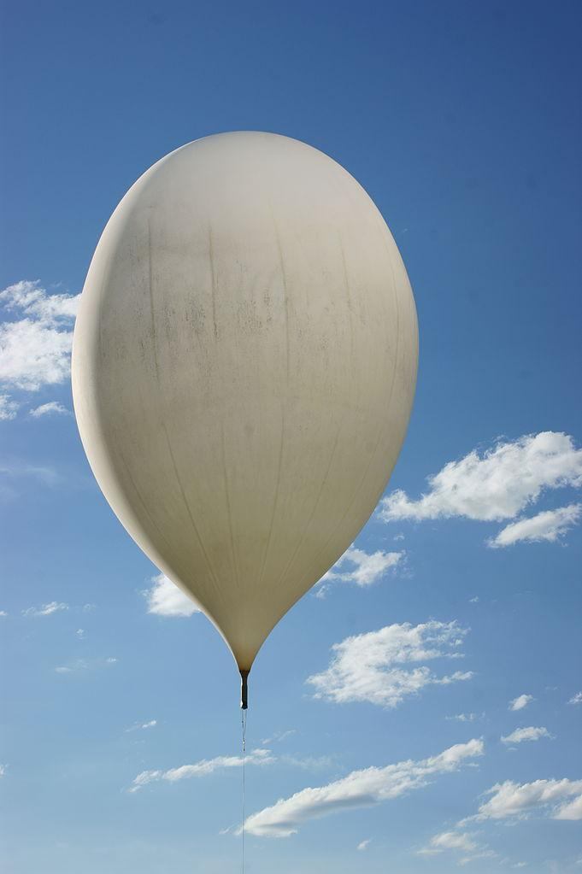
Figure 1: High Altitude Balloon [17]
HABs are derived from weather balloons that were invented in the 1800s by French meteorologist Leon Teisserenc de Bort who then discovered tropopause and stratosphere. The balloon that he used was called an instrumented balloon filled with hydrogen gas to observe the air quality around 8-17 kilometers of height. At that time, although Léon Teisserenc de Bort was suffering from biased experiment results, following with 200+ experiments, he derived several meaningful conclusions and named two layers of atmosphere as tropopause and stratosphere. Furthermore, Alfred Wegener, a meteorologist and geologist, discovered famous continental drift theory by research related to weather balloons [18]. With development of off-the-shelf electronic components, HAB now becomes a popular means to conduct near space experiments, including measuring air quality, or certain types of pollutants. With latex balloons, these balloons with payloads can easily reach near space with low cost -- which is one of the most economical ways for non-governmental organizations. However, contrasting with its economic advantage, HAB has disadvantages at the same time. One disadvantage of this method is that the weight of payload is restricted due to the limited balloon loading capacity.

Table 1: Comparison between Known Methods
Method | Aircraft | Hexacopter | High Altitude Drone | High Altitude Balloon
Maximum Height (km) | 20 | 5 | 10 | 40
Maximum Payload (kg) | N/A | 1.8* | 1.8* | 1.8*
Flight Time (min) | N/A | N/A | 25 | 90-120
Note *: According to FAA101, all unmanned aviation vehicles that reach high altitude can only bring payload less than 1.8kg.
Another disadvantage is the accuracy of the measurement result. The overall flying process is full of accidents and uncertainties. The payload that contains all electronics, including sensors, cameras, microcontrollers, and power supplies, is usually a styrofoam cube. Since there are different circuits to perform different operations, and wirings in the payload, it is hard to guarantee that there would be no accidents during the flight. Any wire pulled out or disconnected, can potentially cause malfunctioning of the device. Considering there is a reasonable cost associated with balloon launch such as gas tank, balloon, etc., it is important to take preventive measures and go through several rounds of testing before the launch. On the other hand, as people don’t usually install machines to control the flying direction, it’s hard to predict where the payload will land. Although now people have path prediction simulation software to estimate the landing place of the payload, people have to make sure the landing point is far away from the city or lakes or forest. Furthermore, weather is also a criterion for the launch. If the weather of the launch day is too windy or rainy, it’s not suitable to do the launch and people have to decide another day for the launch.
In our project, we propose to build a HAB as a way to measure air quality due to its higher flight altitude and predictable flight duration. The scope of our project is to measure certain pollutants with respect to altitude and location using various measuring sensors, thus we can have an overview of the high altitude air quality of the area. The pollutants that we decide to measure include carbon dioxide, nitrogen dioxide, and ozone; other specific data we would like to collect are UV index, temperature, pressure, and also high altitude real video captured by GoPro camera, which are essential to provide information for people when doing outside activities. As the first round of a long-term project, we also want to achieve a good payload recovery rate to guarantee the success of each launch. It will be meaningless if we cannot retrieve the payload back to read out data. In order to keep track of the high altitude air quality for a long term, we decided to launch HABs during a specific time of the year to take air quality data.

3 Methodology
Since our team is the first team to start this project, we may be facing so many unknown challenges during the process. The main goal for us is to convince others that this project is possible and is worthy to continue for a long term and to record all challenges that we faced to help the subsequent groups to avoid those difficulties. In order to do so, the expected result would be successfully launching the payload into the stratosphere reaching heights above 60,000 ft and gathering scientific data after the retrieval. Our scientific measurements will include but not limited to temperature (both inside and outside the payload), pressure, altitude, CO₂ concentration, NO₂ concentration, ozone measure, and UV index.

3.1 Hardware
In order to collect all the data, there are several sensors to be concerned. First, as a baseline of this long term project, we need to collect barometric information that includes altitude, pressure, and temperature. As for gas measurement, we need to collect concentrations of CO₂, NO₂ and ozone. We also decided to use a UV sensor as a sideway to detect concentration of ozone. At the same time, we need to measure the temperature inside the payload as well to make sure all components are working properly. At high altitude, the ambient temperature can drop to -55°C, which requires that all components selected should obtain a wide operation temperature range. In addition, we need a power system and GPS tracker inside the payload as well as a radar reflector, which consumes the weight budget. The rest of the components should be as light as possible. We need to keep these in mind when determining what component to use, in addition to their sensitivity.

3.1.1 UV Sensor
The wavelength of UV ranges from 10nm to 400nm. However we do not need to detect the whole spectrum. Among this range, the wavelength of UVA and UVB, which people concern most, is from 280nm to 400nm. In the market there are sensors specific to UVA and UVB detection, and we found several of them.
Table 2: Cost Analysis of UV Sensor
 | Detection Range (nm) | Operation Range (°C) | Power Supply (V) | Output
VEML6075 | 330, 365 | -40 - 85 | 1.7 - 3.6 | Digital
ML8511 | 365 | -20 - 70 | -0.3 - 4.6 | Digital
GUVA-S12SD | 240 - 370 | -30 - 85 | 2.7 - 5.5 | Analog

From our research, there were few sensors that can work properly at around -50°C, thus we decided to loosen the restriction on operating temperature range to - 20°C. Shown in Table 2 were the final components that we thought of. All the sensors corporate photodiodes and amplifiers since the light current is too low to be read. VEML6075 and ML8511 also contain the ADC to provide a measurement. The output of each sensor can be translated to UV index according to the datasheet. Both VEML6075 and ML8511 have a wider detection range and better operation temperature range. The main limitation of VEML6075 is its power supply. Due to the fact that all the sensors would be powered together, we used a 5V DC power supply for them. Therefore VEML6075 could not work properly with this power supply. GUVA-S12SD seems a better choice, which turns light intensity to analog voltage directly. Its output can be translated to UV index by dividing it by 0.1V. In addition, GUVA-S12SD only weighs 0.7g, which saves the total weight budget.

3.1.2 Barometric Sensor
In order to map the gas concentration with altitude, we decided to use a barometric sensor that gives us altitude, pressure and temperature simultaneously. These sensors first detect the baseline pressure and calculate the altitude based on difference between measured real-time pressure and baseline pressure. Therefore, the resolution is one critical factor to compare during cost analysis.
Table 3: Cost Analysis of Barometric Sensor
 | Accuracy (Pa) | Operation Range (°C) | Power Supply (V) | Output
MPL3115A2 | 1.5 | -40 - 85 | 1.95 - 3.6 | Digital
MIKROE-3328 | 0.01 | -40 - 85 | 3.3 | Digital
BMP180 | 0.03 | -40 - 85 | 1.8 - 3.3* | Digital

All the competitors satisfy our requirement of operational temperature range, the main difference is accuracy and power supply. Since the difference of measured pressure provides reading for altitude, we would like to achieve the accuracy as high as possible. In this case, MIKROE-3328 seems the best. Features of high resolution, low power consumption and water resistance made it suitable for our project. However, it cannot work with 5V power supply. Furthermore, it weighs 23g, which is too heavy due to the weight limitation. Therefore we turned to BMP180 that has similar resolution and same operation temperature range. Though its operation voltage originally marks as 1.8V to 3.3V, the breakout board is 5V compliant. There is a 3.3V regulator and an I2C shifter circuit to guarantee appropriate operation of the sensor.

3.1.3 Temperature Sensor
Though the barometric sensor can provide the temperature readings, we still want to measure the temperature inside the payload as a reference to check if all the sensors are working in the range. This sensor does not require a large operation temperature range due to insulation, however resolution is necessary. The results of this sensor can give us good feedback on insulation, which can be improved during the next experiment.

Table 4: Cost Analysis of Temperature Sensor
 | Accuracy (°C) | Operation Range (°C) | Power Supply (V) | Output
LM35 | 0.5 | -55 - 150 | 4 - 30 | Analog
MCP9700A | 2 | -40 - 125 | 2.3 - 5.5 | Analog
TMP275 | 0.5 | -40 - 125 | 2.7 - 5.5 | Digital

There were many excellent temperature sensors in the market to meet various requirements, and we made our final decision among the competitors shown in Table 3 due to their accuracy and power supply. LM35 and TMP275 share better accuracy over MCP9700A, and both of them are compatible with 5V power supply. We eventually chose LM35 over TMP275 due to its package. TMP275 provides two types of packages: TSSOP-8 and SOIC-8, while LM35 offers TO-92-3 package that is convenient to be soldered down on PCB.

3.1.4 Nitrogen Dioxide Sensor
Few NO₂ sensors are there in the market and we decided to use MiCS-2714 that works under 5V power supply and is suitable for air quality measurement. It requires an external heating resistor and a load resistor since the changing concentration of NO₂ will be reflected by variation of sensing resistance. The output sits between the load resistor and sensing resistor, which forms a voltage divider. Normally the sensing resistance of MiCS-2714 is around 2.2kΩ in the air, therefore it is easier for reading with a load resistor with the same value. The drawback of this sensor is that its operational temperature range is from -30°C to 85°C. However, other NO₂ sensors in the market that are able to operate below -40°C are not compliant with 5V power supply. Furthermore, the components inside the payload will heat up, thus it will not hurt much to use MiCS-2714.

3.1.5 Carbon Dioxide Sensor
MG811 was chosen due to its simplicity to use with the breakout board from DFRobot. It also has good sensitivity to CO₂and low dependence on humidity and temperature, which is ideal for our project. Though in the datasheet it is recommended to work with 6V power supply, however the board itself can work under 5V power supply. This module needs to be preheated for 48 hours to calibrate in the environment where air quality is relatively good. The analog output after calibration will be used in the code as reference to calculate measured CO₂ concentration. Similar to the NO₂ sensor, the disadvantage of this module is also the operational temperature range. Most CO₂ sensors in the market are aimed for room gas detection, MG811 is not an exception. However, due to the heat building up inside the payload from the electronics and low temperature dependence, we continued with MG811 as the CO₂ sensor.

3.1.6 Ozone Sensor
Few ozone sensors in the market satisfy our requirements of operation temperature range and power supply at the same time. Thus we loosened restrictions on operation temperature range and focused on power supply due to its importance, which led us to MQ131. MQ131 gives changing sensing resistance that reflects changing concentration of ozone. The conductivity becomes higher as gas concentration increases, which is shown as drop in output voltage. This sensor also needs to be preheated for 48 hours to operate properly.

3.2 Connection

The figure shown below displays the functional block diagram of the high altitude balloon system. Black lines represent the signal flow: all data are collected every 5 seconds and are written into micro SD cards to store. Red lines represent power flow: the Arduino is charged by the central power supply and charges other sensor modules for proper functionalities. Most sensor modules are supported from 3.3V to 5V; only the CO2 sensor module claims to use 6V power supply. However, when we looked into the datasheet we found out that this module actually can work properly with 5V supply. Thus we used a breadboard as a “power station” to power and ground all components.
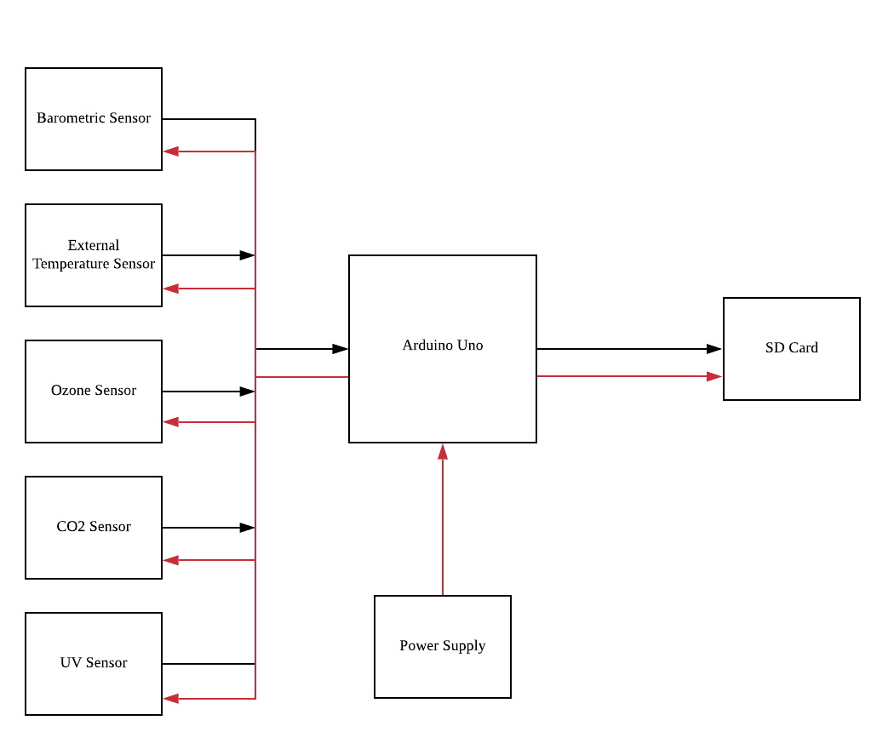

Figure 2: Functional Block Diagram of the HAB System
Since one Arduino Uno has limited analog pins, we used two Arduino’s to gather the data from sensors. The first Arduino was connected with a CO₂ sensor and a Ozone sensor. The other Arduino was connected with a biosensor, temperature sensor, UV sensor and a NO₂ sensor. The specific connection is shown below:
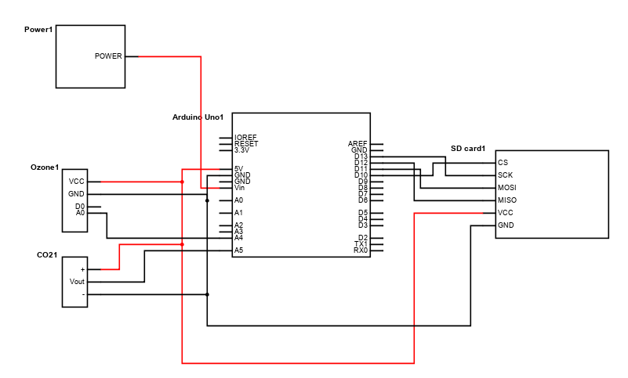
Figure 3: Arduino Uno 1 Schematic
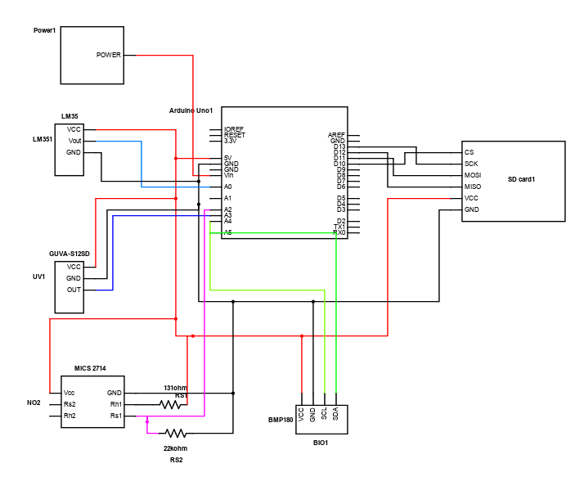
Figure 4: Arduino Uno 2 Schematic
Most of the sensors are connected simply to different pins on the Arduino except the NO₂ sensor, which needs resistors to adjust the voltage it reads. Except the LM35 sensor was set inside the payload, all other sensors were soldered and positioned such that the sensors were sticking out of the payload through a hole to measure the data accurately.
We also had a GoPro to record the flight process by cutting a hole on the payload and sticking the GoPro on the side of the Styrofoam. There are two ways to record the flight process: capturing video and taking pictures. In our first launch, we wanted to capture the whole flight process video using the GoPro. However, due to the battery life and memory limit( only 64GB), GoPro only captured part of the flight process. Thus, in the second launch, we used a power bank to charge the GoPro to resolve battery life limit, and we set the GoPro to take pictures every five minutes to overcome the memory limit problem.
The specific wiring layout picture is shown below:
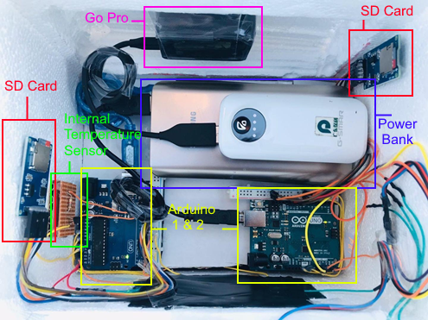
Figure 5: Inside Wiring Photo

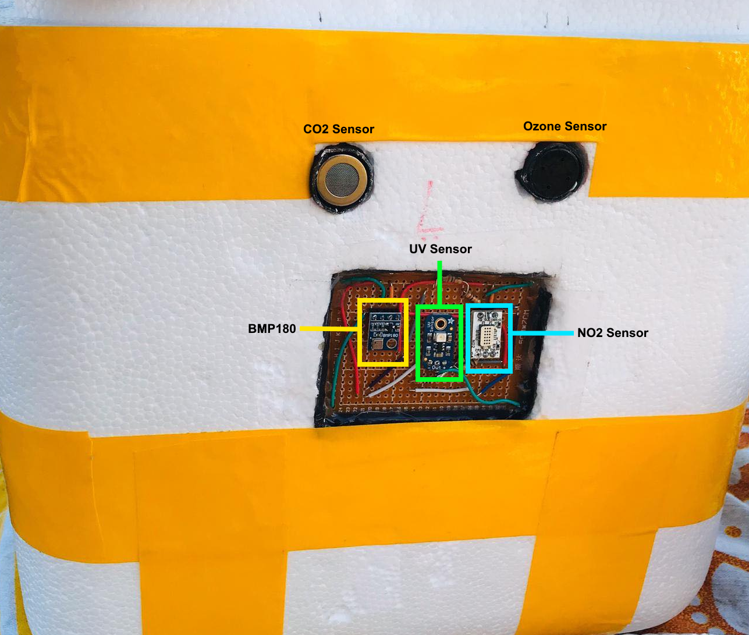
Figure 6: External Sensors
In our payload, we used three power banks to power Arduino and GoPro. All components were sticked on the sides of the payload, including our GPS tracker (sticked below the power bank), Arduinos, SD card modules, and all PCB boards. To power multiple components from the Arduino easily, we also used two breadboards as their ‘power station’ with one row 5 V input and one row ground.

3.3 Embedded System/Software

3.3.1 Microcontroller Selection
Given the scope of the project, as well as the purposes of the system being developed, a microcontroller that met specific requirements was necessary. These requirements can be classified into; Connectivity, Development, and Power. Each of the following requirements are necessary to be met such that the project can be completed in the most efficient developmental environment.
The connectivity requirement for this project corresponds to the number of analog and digital I/O pins available for the variety of sensors to interface to. Because certain sensors utilize more than one analog/digital I/O pin, it was necessary to select a board that would not be overpopulated.
The developmental requirements correlate to the microcontroller’s ability to execute a script effectively, with minimal risk of software and file corruption during launch that may arise due to temperature, humidity, or other weather complications. The development requirement for the microcontroller must also have extensive documentation and available community support in relation to the sensor selections.
The power specification for selecting a suitable microcontroller relates to the microcontroller’s on-board capabilities, such as stable power delivery to external components and memory availability.
Once all necessary requirements for the microcontroller were outlined, two popular microcontrollers were selected as suitable for the project, the Arduino Uno and the Raspberry Pi 3. Figure 6 displays a comparison between both microcontroller’s specifications.
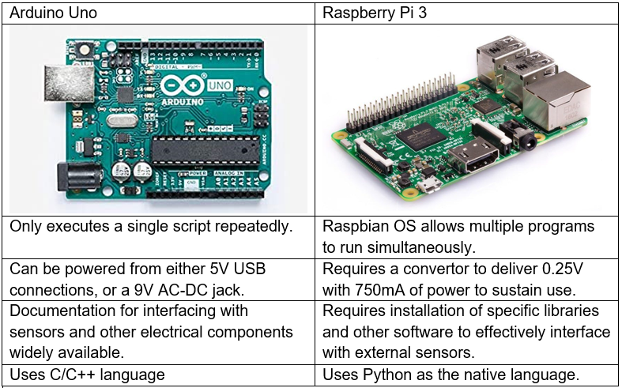
Figure 7: Comparing Arduino and Raspberry Pi
From the figure above, when comparing the two microcontrollers and their respective feature set, it was determined that the Arduino Uno was most effective in this specific project [19]. Due to the Arduino’s capability to be efficiently and compactly powered through an external supply was critical for maintaining weight and space limitation in the project’s internal designs. The Arduino also provides a more abundant source of documentation for connecting external sensors and obtaining measurements than the Raspberry Pi can offer. It is important to note that the Raspberry Pi, unlike the Arduino, supports a variety of wireless connections, including WiFi and Bluetooth for remote transmissions of data [19]. However, as such features were unnecessary in the scope of this project, the Arduino was ultimately chosen due to its simplicity and abundance of documentation.

3.3.2 Software Operation
The software embedded in the system is what allows the device to properly operate and take environmental measurements. As such, the software used for the embedded system is the Arduino IDE environment, using C/C++. Using the Arduino IDE allowed for fluid and seamless integration of the different sensors into one compiled script. This is possible due to the number of libraries supported by the Arduino IDE, as well as the ability to include multiple libraries that separate components require into the same script.
The Arduino IDE allowed for many troubleshooting and preliminary development steps to be done effectively and efficiently with its ability to easily configure analog/digital inputs and outputs and provide libraries that execute higher-level functions. The most critical feature of the Arduino library that provides with capability to write data captured from the serial monitor to a microSD card. The data read from the serial monitor was stored within a text file containing all sensor parameters at unique sampling intervals. The stored file can be later retrieved and read for analysis of the recorded data.

3.4 Launch Process
Launching a high altitude balloon sounds straightforward, however, there are so many potential risks we need to consider.

3.4.1 Launch Site and Date Decision
The first step to conduct a launch is to decide the place and date for a high altitude balloon launch. Though recently high altitude balloons have already become popular, it does not necessarily mean that a launch can be carried out anywhere at any time. Due to the time constraint of this project, we aimed for two launches: one in B term before winter comes and another in C term. The launch date was chosen keeping various weather conditions in mind: chances of precipitation, wind speed, and direction. Due to the fact that Worcester is close to the eastern coast line and the wind usually blows from west to east, the landing site will not be ideal because it is easy for payload to land in the ocean. In that case it is near to impossible that we can retrieve the payload back. Therefore, the launch site should be as inner as possible to avoid the consequence that payload may not be recovered. In our case, we chose Albany in New York State, 103 miles away from Worcester, to be the launch site. It is also preferable that the launch site contains an open area, because sometimes the ascent rate of the balloon may not be fast enough and there is possibility that it may be tangled onto trees or telephone holes. Athletic fields, playgrounds or large open parks are good places to choose for launch. For all the places mentioned above, we need to get permission to use the place to launch the balloon. We picked the Lincoln Park in Albany that has a large open field to conduct launch. When we made the decision, we contacted the officers of the Federal Aviation Agency (FAA) and Air Traffic Control (ATC) by the telephone number given on its official website to ask if we could conduct such an experiment. Usually large parks are open to these experiments and we got the permission successfully.
To decide when to conduct the launch, we checked the weather forecast to see weather conditions and wind information. The weather for launch needs to be sunny or at least cloudy and slightly windy, such that we can guarantee to record video in good quality and the whole process for the flight will not be unpredictable. If the wind is too strong, there is a chance that the payload may land in undesirable places and we will be unable to retrieve it. This step happened a month ahead of launch, so that we could pick a temporary date in the target week and conduct flight simulation. As the date approached, we then checked weather conditions again since the closer to the target date, the more accurate the weather forecast would be. Two weeks ahead, we finally decided the specific date for launch. For our first launch, we decided to do the launch on November 23, 2019, when the weather was mostly sunny and the wind was not too strong, therefore the payload was expected to land in southeastern Massachusetts. Our second launch was set to March 9, 2020, when the weather was sunny and cloudless.

3.4.2 Flight Simulation
We used ASTRA High Altitude Balloon Flight Planner as a simulator to estimate launches. With required information, it can predict the flight path that is similar to the actual launch. There are four sections of information to fill in: flight information, launch site, weather data and simulation settings. Under the flight information section, a specific time and date is required. This simulator can estimate as late as eight day after the current date. We need to specify what gas is used: helium or hydrogen. It is safer to use helium since there is flame risk when using hydrogen. Balloon type and parachute size need to be provided, as well as payload weight, nozzle lift and equivalent sphere diameter. The last one is usually between 0.1 and 0.3, and it does not affect simulation performance much. In the launch site section we need to decide the launch site. We can either input the location name or pick it on the map. In the other two sections, we need to choose what kind of weather data to use and how the simulator is set. In our case, we chose to use online forecast and select standard mode for simulation. The results serve as good reference in terms of tracking balloons. The yellow dots represent the places where the balloon bursts, and will display the altitude when clicking on it. The blue dots represent the landing places and will display overall flight time.
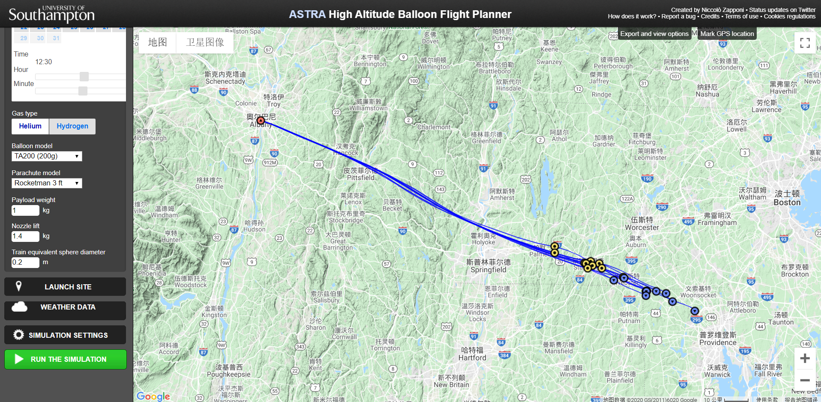
Figure 8: Flight Simulation
High Altitude Science also offers balloon performance calculator to estimate required gas volume. Balloon size, payload weight and desired lift is required for calculation. It also displays burst altitude, ascent time and rate as references. We can play around the payload weight and lift to reach ideal performance of the balloon.
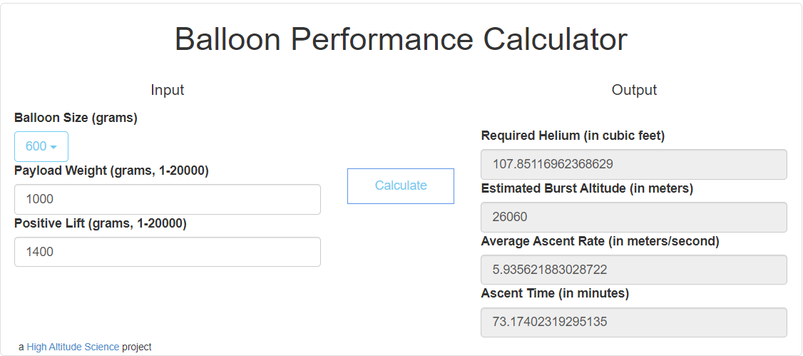
Figure 9: Balloon Performance Calculator

3.4.3 FAA Clearance
When the date and location is settled, we need to contact the Federal Aviation Administration to get permission for launching the high altitude balloon. Since the balloon can reach as high as flight cruise altitude, it is a must to notify people about the launch. According to Section 5 in Chapter 19 in Facility Operation and Administration (7210.3BB), the high altitude balloon is classified as unmanned free balloons, and launching it with waiver needs authorization from Air Traffic Control [20]. One thing to notice here is that only when payload’s weight is less than 4 pounds (1.8kg) the waiver applies. Otherwise the launch is not permitted at all. We called the number shown at its website and then was navigated to the officer who was in charge of it. We were told that we needed to email them about the launch, including everything in flight simulation and burst altitude, ascent rate, ascent time and whole flight time. After that, we could get clearance for launching the balloon. Before launching, we need to notify the officer 15 minutes in advance and report any changes during the flight.
Because the balloon will enter flight cruise altitude, it must be attached to a radar reflector. The radar reflector can reflect 200MHz to 250MHz, therefore the balloon can be monitored by Air Traffic Control. We chose to build our own radar reflector by cardboard and foil tape. The radar reflector is made by three complete plain boards so that it can reflect waves from any angle.
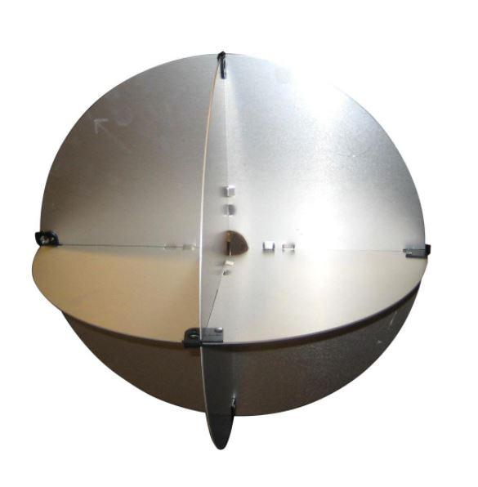
Figure 10: Radar Reflector example

3.4.4 Inflate Balloon
On the site, we tested all the devices to make sure they worked properly and then set everything in the payload and seal it. Bright color tapes are used for sealing and wrapping to make it more obvious, which is helpful when recovering it back. A note with contact information is also left on the payload for anyone who might pick it up accidentally.
When inflating the balloon, we used High Altitude Science Inflation System that can easily transfer gas to the balloon. It has a built-in gas regulator that is essential to inflation because we are working with high pressure that may cause serious injury [21]. It is safe to gradually inflate the balloon and hold it tight.
Once the balloon is inflated, it is time to check the lift. A lift meter can be used, which tells the lift in kilograms directly. Before reading out lift, it is important to seal the balloon. The first thing to do is to remove the nozzle and seal the neck. If the nozzle is still attached, the reading will be less than its actual value because the nozzle drags down the balloon. Therefore it is critical to remove the nozzle. Either elastic bands or strong ropes can be used. In our case, we used ropes. We tied rope at the top of the neck and then made several tight knots both at the front and back. Same procedure repeated several times to secure tightness. After this, we used tape to further seal the balloon by applying it at the top of the neck and moving downwards round by round. Finally secure the end of the neck by wrapping it up with tape. Now the meter can be tied to the balloon with another rope to read out lift. If the lift is smaller than expected value, then we need to uncover the neck and keep inflating. If the lift is greater, deflate the balloon carefully and slowly. It would be great if the lift is exactly what it is expected to be.

3.4.5 Track and Recover
Once the balloon is launched, all we need to do is to wait for its landing and to keep track of its location. Due to the launch simulation before the launch, we would drive toward the roughly direction of the landing location. To find the precise landing site, we used a GPS tracker to track the moving trail and landing location. The GPS tracker SPOT updates the location of payload every five minutes. The GPS operation interface will be shown below. After we found the locations are dense and don’t move, we could confirm that our payload landed and we could retrieve it back.
During our project, we have attempted three launches and among two of them, we have successfully retrieved the payload back and read the data from the SD cards. In these two attempts, the payload landed in the forest and was hanged on the tree. Although it’s difficult to find it, we can still successfully retrieve the payload and read the data. However, there’s always an accident that may happen in the project. In our last attempt, our payload landed in the ocean and we cannot retrieve it back. Although we simulated several times before the launch with all ideal results that it would land around our city, it still landed in the ocean after a few hours due to heavy winds.
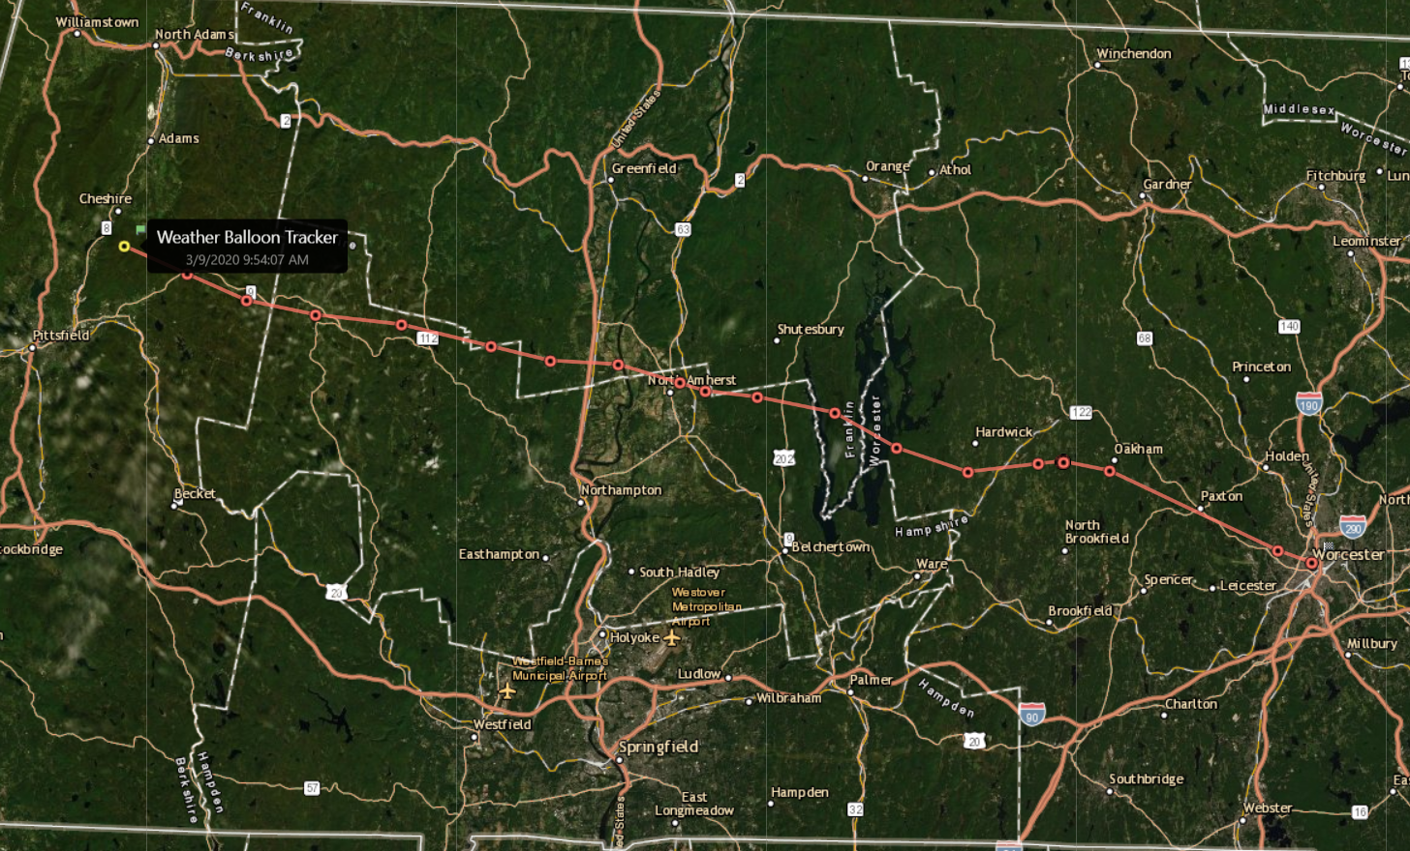
Figure 11: Gen Spot GPS Tracking
4 Results

4.1 Flight Data
Here we present the result that we collected during the second launch. Referring to the simulations in Figure 12, the high altitude balloon would land near Worcester area and the whole flight would last for about 2.5 hours with ascent time of 78 mins. The estimated burst altitude was around 98425.1969 foot(30000 meters). These would be the baseline when we compared the results with the simulation.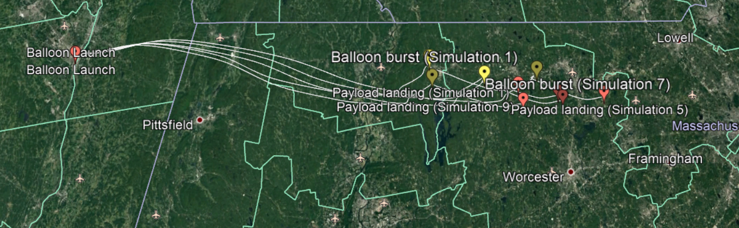
Figure 12: Flight Simulation
The final launch date and place was chosen to 9 March and Lincoln Park in Albany, NY. We departed from Worcester at 6 AM and arrived at the park at around 8:30 AM. On the site we first ran a final test for all the components and checked if they still operated properly. Simultaneously, the balloon was inflated since the whole inflation process would take a while before completion. Once everything was checked, the payload was then sealed with tapes. We also wrapped around the payload to secure its connectivity.
The payload without lid weighed around 1.2kg, however the lid contributed much weight to it. The final total weight for the payload reached around 1.4kg. We used up 115 ft³ helium gas to inflate the balloon, so that the balloon can be lifted up. The eventual launch time was 9:08 AM. After that we would track the balloon using the GPS tracker.
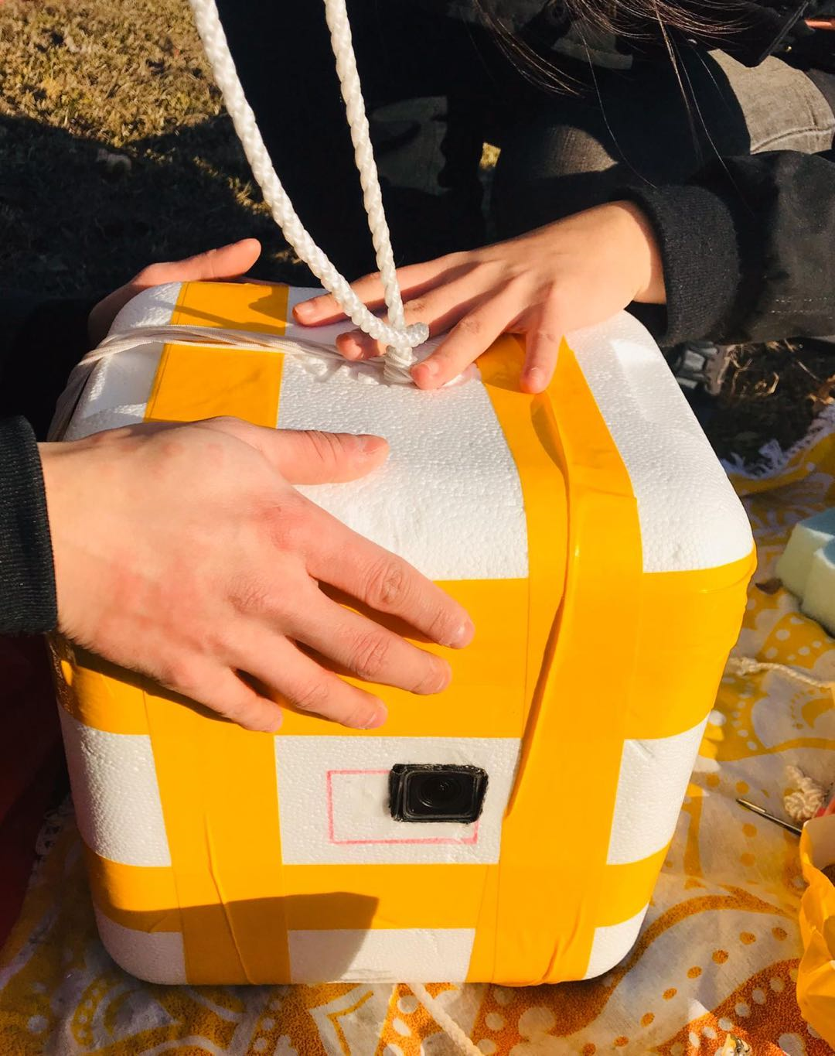
Figure 13: Payload Sealed
Figure 14 shows our real flight path. In Figure 14, each pin represents the recorded spot from the GPS tracker. To express the flight track more accurately and to observe easier, we added the altitude for each pin to show the position of the payload in the air.
Referring to Figure 14, as expected, our payload landed close to Worcester, which is the same as the simulation result. The flight process looks risky: the balloon kept increasing height in the beginning, and for some reasons, it decreased the height in the middle and then increased the height again. Finally, it landed around Worcester and hung on a tree -- we successfully retrieved it back.
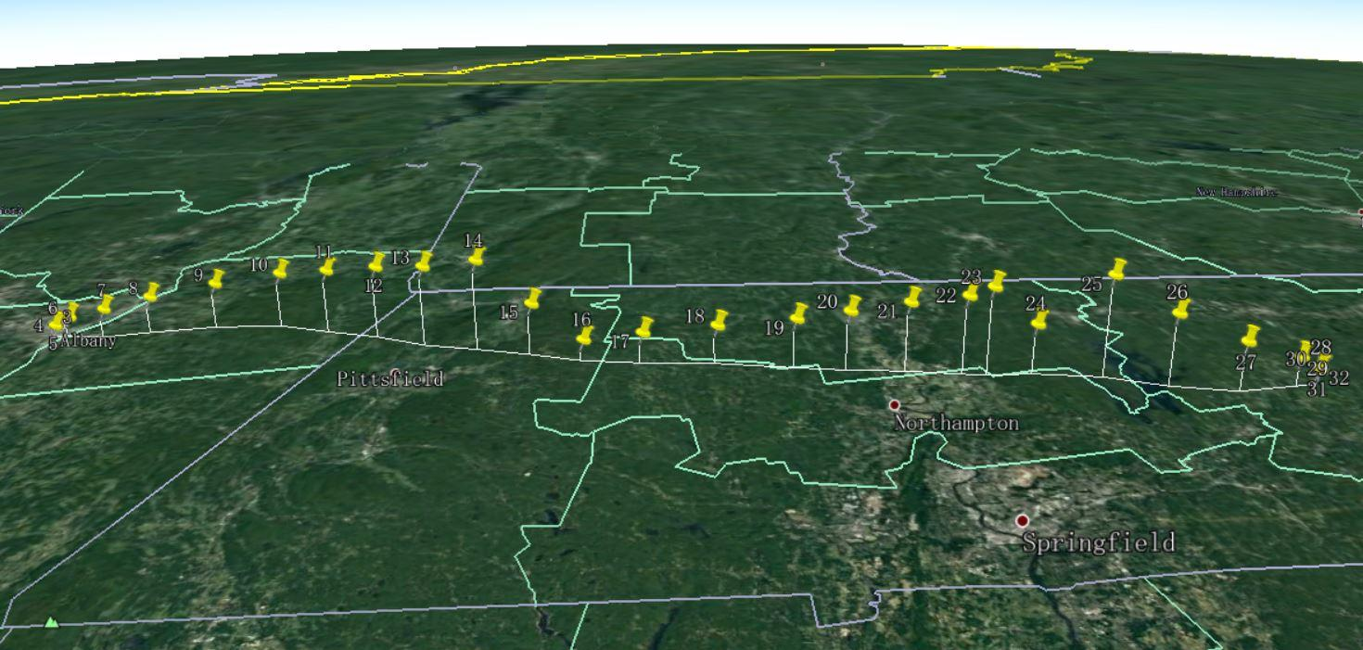
Figure 14: Real Flight Path

4.2 Collected Data
At around 1 PM the payload landed in Oakham, MA. Unfortunately the payload was hanging on the tree, which was too high for us to retrieve it. We found the owner of the property who helped us by cutting down the tree. The SD card with BMP180 worked well and recorded all the data, however, the SD card with gas sensors did not work properly. It turned out that the SCK cable dropped out from the SD card module, thus nothing was written to that card. Therefore, here we would present all the data with the BMP180 module.
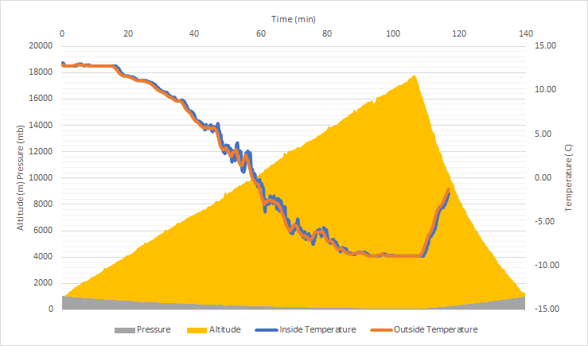
Figure 15: Altitude vs. Time vs. Inside Temperature vs. Outside Temperature
Figure 15 displays all the data collected from the BMP180 module with respect to time. The highest altitude that the balloon reached is 17700m, which is half of the estimation. The total flight time is roughly 2 hours. The ascent time is about 105 minutes, which is longer than the estimation. The inside temperature follows the pattern of the outside temperature, which drops to -10 °C. From this reading we know that all the electrical components inside the payload are still working properly since the lowest temperature does not drop out of the operating range. During climbing period, the inside temperature is slightly higher than its outside counterpart, which infers that the insulation with foam actually performs well. When both inside and outside temperature reaches the lowest point, inside temperature shows a trend of keeping that temperature, which reflects the insulation of the payload.
From Figure 16 and Figure 17, the average ascent rate is 3.3 m/s and the average descent rate is -10m/s. According to the high altitude balloon calculator, the ascent rate was estimated to be near 5 m/s.
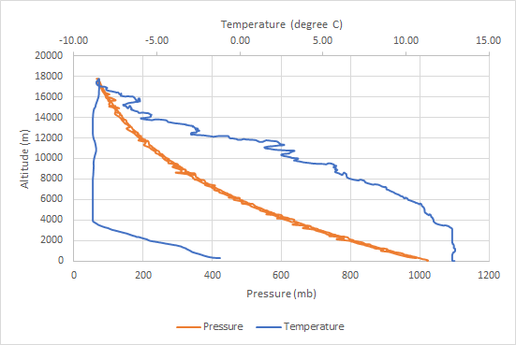
Figure 16: Altitude vs. Temperature/Pressure
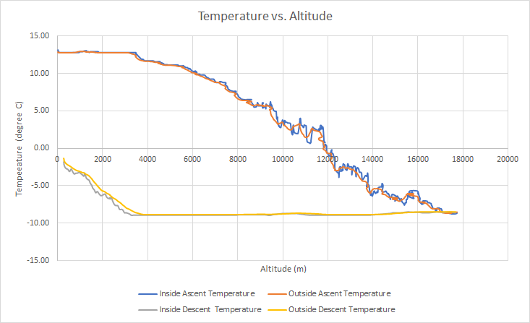
Figure 17: Temperature vs. Altitude

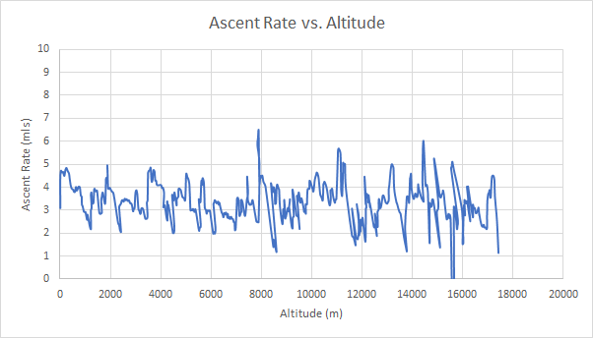
Figure 18: Ascent Rate vs. Altitude
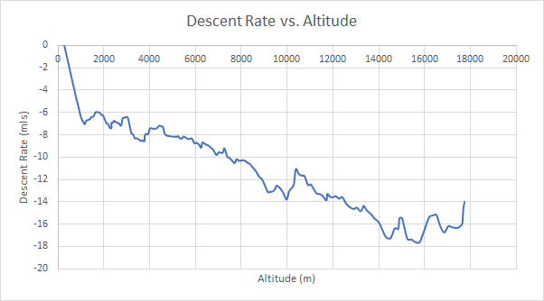
Figure 19: Descent Rate vs. Altitude

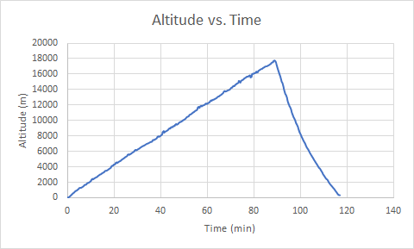
Figure 20: Altitude vs. Time
Due to the wire disconnection in the last launch, we didn’t gather the air quality data including CO₂ and NO₂ measurement. Thus, instead of measuring air quality data in the high altitude, we measured CO₂ data at ground level to prove our concept. The result is shown below in Figure 19. 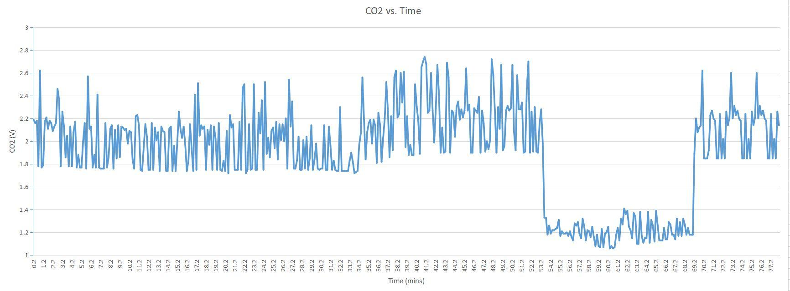
Figure 21: CO₂ vs. Time
Doing the ground level measurement, we connected the CO₂ sensor and Arduino uno together and put them outside the room to measure the CO₂ data. Referring to Figure 21, when the measured voltage is higher than 1.6V, it means the CO₂ concentration is low and doesn’t exceed the limit. When the measured voltage is lower than 1.6V, it means the CO₂ concentration is high and needs to be reduced. To prove our concept is working, we started to breathe on the sensor to make the curve fluctuate. Starting about fifty three minutes, the voltage reduced when we blew on the sensor. After about ten minutes, the voltage returned to normal. The whole process proves that our concept works and it’s available to be used for future groups.

5 Conclusion

5.1 Achievement of Initial Scope

From A term to C term, our team has finished three launches over seven months. During these months, we experienced everything from selecting the project to retrieving payload and writing the final report. The whole process is amazing and absorbing. Composed of all Electrical and Computer Engineering major students, our team not only used circuit knowledge in the project, but also learned how to design the payload, how to contact governmental organizations for launch permission, etc.
Being the start-up group of the High Altitude Balloon project, we have met several difficulties, but we overcome those difficulties one by one. As expected, from our launch, we gathered multiple data from launches and generated several plots to show the conditions in high altitude space. For future groups, we hope they can avoid difficulties we have met and add more features in payload to gather more data. The purpose of the High Altitude Balloon project is to collect air quality data in the high air and propose reasonable suggestions to improve the air quality. Unfortunately, we didn’t collect high air quality data, but data like CO₂ , NO₂ and other air data should be expected in the future.
Another thing to expect is landing equipment. At this time, we don’t have anything to control the flight trajectory. If there’s a feature that can control the balloon burst time or control the flight height and direction, the data collected in the high air will be more accurate and convincing. As a result, we can make reasonable suggestions from reliable data and improve air quality by ourselves to make the earth a better place.

5.2 Manufacturability Costs

For this project to become a widespread consumer product, several changes need to be met in order to increase reliability, and lower manufacturing costs.
The most important portions of the project that led to an increased manufacturing cost are the necessary GPS tracking software, as well as the price of Helium gas. The average balloon weight needed for a launch capable of reaching upwards of 50,000 ft is 400g. Given this, in addition to typical payload weight, the necessary volume of commercially available Helium tanks is 100 ft³. For the purpose of this project, when factoring in the limited availability of Helium in the current market, 100 ft³ of Helium costs $145.
Additionally, the tracking device utilized in this project required a monthly subscription in order to access the remote GPS tracking feature. This subscription’s cost included a sign-up fee of $64.95, and a monthly fee of $11.95.
In order to bring down manufacturing costs, the key points of interest to improve upon will be determining and finding a cheaper alternative supplier of Helium gas. Furthermore, creating a wireless long-range GPS can also be used in replace of a commercially available GPS. This can result in reducing costs in the long-term as a monthly subscription won’t be necessary.
In addition, in order to increase reliability and accuracy of data, sensors that do not utilize metal-oxides can be used, however, it is important to recognize that metal-oxides were used specifically in the scope of this project due to their versatility and cost effectiveness, at the cost of accuracy. If more accurate sensors want to be used, it is important to realize the cost-differential between different sensor materials.

5.3 Lesson Learned
Reviewing the whole project, the most important thing is wiring. During the launch and flight process, people have to make sure that the wiring is safe enough before successfully retrieved back. In our several launches, the most reason that we couldn’t gather data is the wiring is broken during the flight or even at the beginning of the flight. In our design, there are two fragile connections: from Arduino to sensors and from Arduino to SD cards. In the second launch, we used jumpers to connect components and used hot glue to fix the wires between Arduino, sensor, and SD cards. Unfortunately, there’s still one wire disconnected in that launch and there’s no reading in one SD card after retrieving it back. To improve, one thing needed to do is sticking everything fixed to make sure there’s nothing moving in the payload. During the flight, especially in the beginning of the flight, the payload would flip violently, which is highly risky that disconnection may happen.
From our view, one important thing in the project is the payload design. As long as we figure out a stable payload design, the vibration during the flight will reduce, and the risk of disconnection will reduce as well. All of the sensors work well at a high altitude place -- the cold temperature doesn’t interfere with those sensors working. Going through the whole project, circuit schematic is not a big issue, since we just need to connect everything correctly to the Arduino and get readings in the SD card. Next time, we’d like to ask people who are in physics major for suggestions about payload design.
Another lesson is about the launch site selection. To select the launch site, we need to make sure the launch site is far enough from cities and oceans. To do so, we need more comprehensive simulations under different weather conditions before selecting the launch site. Before selecting the site, we also need to contact the FAA and the local office for the launch permit.
Being the starting group of this project, it is good news that we successfully gathered the high altitude biosensor data and the flying process video and photos. As we recorded all struggles for the following groups, we believe the following groups will complement and avoid the struggles we met and complete the project perfectly.

References
[1] European Commission, Measuring air pollution with low cost sensors, https://ec.europa.eu/environment/air/pdf/Brochure%20lower-cost%20sensors.pdf Accessed on March 2020
[2] Environmental Protection Agency, Air Monitoring, Measuring and Emissions Research, https://www.epa.gov/air-research/air-monitoring-measuring-and-emissions-research Accessed on Marcn 2020
[3] Rossman, J., Rowell, E., “THE WEEK”, A brief history of air pollution, 15 Nov. 2015, https://theweek.com/articles/586863/brief-history-air-pollution Accessed on March 2020
[4] Z. Cheng, S. Wang, X. Fu1, J. G. Watson, J. Jiang1,, Q. Fu, C. Chen, B. Xu, J. Yu, J. C. Chow, and J. Hao, “Impact of biomass burning on haze pollution in the Yangtze River delta, China: a case study in summer 2011”, doi:10.5194/acp-14-4573-2014, Atmosphere Chemistry Physics, 14, 4573–4585, 2014
[5] Environmental Protection Agency, Air Pollution Monitoring, https://www3.epa.gov/airquality/montring.html Accessed on March 2020
[6] Union of Concerned Scientists. “The Clean Air Act”, 18 Nov 2010, https://www.ucsusa.org/resources/clean-air-act. Accessed 1 March, 2020.
[7] United States Environmental Protection Agency. “Clean Air Act Text”, https://www.epa.gov/clean-air-act-overview/clean-air-act-text. Accessed 1 March, 2020
[8] Holst, A, “Encyclopedia Britannica”, Clean Air Act, https://www.britannica.com/topic/Clean-Air-Act-United-States-1970 Accessed on 1 March 2020.
[9] United States Environmental Protection Agency, “Evolution of the Clean Air Act”. https://www.epa.gov/clean-air-act-overview/evolution-clean-air-act. Accessed 1 March, 2020
[10] Deka, J.P., Singh, S., Jha, P.K. et al. Imprints of long-range-transported pollution on high-altitude Eastern Himalayan lake water chemistry. Environ Earth Sci 75, 285 (2016). https://doi-org.ezpxy-web-p-u01.wpi.edu/10.1007/s12665-015-4813-9
[11] Koo, Jamin, et al. “Spatial Sensitivities of Human Health Risk to Intercontinental and High-Altitude Pollution.” Atmospheric Environment, vol. 71, no. C, Elsevier Ltd, June 2013, pp. 140–47, doi:10.1016/j.atmosenv.2013.01.025.
[12] Barrett, Steven, et al. “Global Mortality Attributable to Aircraft Cruise Emissions.” Environmental Science & Technology, vol. 44, no. 19, American Chemical Society, Oct. 2010, pp. 7736–42, doi:10.1021/es101325r.
[13] Shoen, J.W., Mcdonald, J. “Warming climate, population sprawl threaten California’s future with more destructive wildfires.” CNBC, 9 Nov 2019, https://www.cnbc.com/2019/11/09/why-californias-wildfires-are-going-to-get-worse.html. Accessed 3 Marh, 2020
[14] Rudey, R. A., and P. J. Perkins. “Measurement of High Altitude Air Quality Using Aircraft - NASA-TM-X-68221.” Intern. Conf. on the Environ. Impact of Aerospace Operations in the High Atmosphere, 13 June 1973, http://hdl.handle.net/2060/19730013857.
[15] Abarca, Monica, et al. “Design and Development of an Hexacopter for Air Quality Monitoring at High Altitudes.” 2017 13th IEEE Conference on Automation Science and Engineering (CASE), vol. 2017-, IEEE, 2017, pp. 1457–62, doi:10.1109/COASE.2017.8256309.
[16] S. N. Shah and X. Xiong, "Balluino: High Altitude Balloon/Drone Based Air Pollution and PM 2.5 Monitoring System," 2019 IEEE Long Island Systems, Applications and Technology Conference (LISAT), Farmingdale, NY, USA, 2019, pp. 1-5.
[17] Edge Of Space Science's high altitude hydrogen balloon ready for EOSS-187 launch with Colorado Space Grant's Student Hands On Training balloon satellites, Wikimedia Commons, 8 June 2013, https://commons.wikimedia.org/wiki/File:High_Altitude_Hydrogen_Balloon.JPG. Accessed on 1 March 2020.
[18] High Altitude Science. “Intro to Weather Balloons”, https://www.highaltitudescience.com/pages/intro-to-weather-balloons. Accessed Nov, 2019
[19] Mark, et al. “What Are the Differences between Raspberry Pi and Arduino?” Electronics Hub, 25 Dec. 2017, www.electronicshub.org/raspberry-pi-vs-arduino/
[20] Federal Aviation Administration, 7210.3 Facility Operation and Administration, 2019.
https://www.faa.gov/air_traffic/publications/atpubs/foa_html/chap19_section_5.html Accessed Nov, 2019
[21] High Altitude Science, Inflating a Weather Balloon, https://www.highaltitudescience.com/pages/how-to-inflate-a-weather-balloon Accessed Nov,2019

