Potential Uses of the Proposed Sports and Recreation Facility
An Interactive Qualifying Project Presented to the Faculty of the
Worcester Polytechnic Institute
April 18, 2006

A-Term B-Term C-Term

Authors:

John L. Bosch

Sean M. Colella

Joel R. Rousseau

Advisor:

William W. Farr

Authorship

Abstract John L. Bosch

Introduction John L. Bosch
Literature Review Sean M. Colella

Methodology Joel R. Rousseau

Part 1 John L. Bosch

Part 2 John L. Bosch

Part 3 John L. Bosch

Part 4 John L. Bosch

Part 5 John L. Bosch

Appendices Sean M. Colella
Joel R. Rousseau

Editing and Review John L. Bosch
Sean M. Colella
Joel R. Rousseau

Research and Analysis John L. Bosch
Sean M. Colella
Joel R. Rousseau

______________________
John L. Bosch
______________________
Sean M. Colella
______________________
Joel R. Rousseau
Abstract
This IQP aims to provide insight into the WPI community’s issues with the current athletic facilities and includes recommendations from the community and the authors regarding what types of programs, equipment, and technology to include in the proposed Sports and Recreation Facility.

We would like to dedicate this project to any one who has ever had to wait to lift weights or shoot hoops at WPI.

And here’s to swimmin’ with bow-legged women!!!

Table of Contents

Section Title Page Number

Authorship Authentication 2
Abstract 3
Dedication 4
Introduction 7
Literature Review 9
Methodology 12
Part 1: Description of the New Recreation and Sports Facility to be built on
WPI’s Main Campus………………………… 15

Part 2: Discussions with Dana Harmon, John Miller and Larry Noble……………. 19
Part 3: WPI Community Survey: Problems with the current facility and what
could be done with the new facility.……………….. 22

Part 4: The Effect of the New Sports and Recreation Complex on the
University and Incoming Students ………. 28

Part 5: Recommendations and Conclusion 32
Bibliography …… 36
Appendices ………….. 37

Introduction

Sports and recreation have been a central part of college life since the establishment of the first universities and schools of higher education. Students and the surrounding community congregate for athletic contests, intramural activities, and personal fitness on college campuses worldwide. In recent years Universities have seen that in order to stay competitive with other schools there is an increased need for larger, more state of the art sports and recreation facilities that will accommodate the students’ needs for an attractive and efficient place to work out and participate in recreational athletic events.
WPI is no different from the rest of the colleges in understanding that there is a need to stay competitive with other schools such as MIT and RPI who have similar academic standards and newer, larger athletic complexes and workout facilities. As the university continues to grow the number of students that use the current athletic facilities is also growing. The current facilities are no longer adequate for the amount of use they are getting. Scheduling and coordinating the use of the gyms, pool, and other areas has become an almost insurmountable task. In order to relieve the inefficiencies of the current buildings WPI and Sasaki, a Boston based consulting firm have drafted plans for a brand new athletic facility on campus that will be the largest and most state of the art building at WPI.
The new facility will include 4 basketball courts, a new pool, and a larger state of the art fitness center (Appendix A). Although the plans for the structure of the building already exist and are more or less set in stone at this point, there has been little insight into how the space is going to be used, what types of activities can take place, and what WPI can do to make the new facility state of the art from a technology standpoint.
This project aims to illustrate the plans for the new facility to the WPI community and to provide suggestions to the athletic director and facilities managers on how to create the most attractive, efficiently used, and technologically advanced sports and recreation facility possible. Input will be taken from WPI community members on what types of equipment and programs they would like to see in the new facility. Research into other schools’ use of their facilities and programs they offer will accompany a look into state of the art sports and recreation facilities equipment to support the recommendations made by the WPI community.
The new facility is crucial to the success of WPI as a competitive university and is something that will not only affect the current members of the WPI family but will impact students, faculty, and the community around the WPI campus for years to come.
Literature Review

This IQP has numerous aspects to it that really stretch the boundaries of previous projects before it. There will be many site visits and interviews with Athletic Directors, Engineers, and students. Another new aspect associated with this IQP is the fact that the Sports and Recreation Complex has already been designed and is ready to break ground. However, there has already been some quality material researched and archived that laid down a good foundation for us to pick up and begin our project. These “quality materials” consist of an IQP and an MQP from 2001. They are referenced in the bibliography.
Understanding that the focus of this project is the use of the new sports and recreation facility, we have looked for research concentrating around the topic of our IQP. Students before us have completed various IQPs in a similar area of study. The one report that serves as a great model for us to work from was a study done on how the “new” campus center was going to affect the WPI community entitled, “Campus Center And Community”. The project analyzed the effect of a campus center on the WPI community. The group looked into various parts of the campus center and provided extensive research into a history of “student unions”. When all was said and done, they concluded the campus center should be located near, residence halls and academic buildings, while being in an area with high foot traffic. The group also recommended an ATM as well as meeting rooms, lounges, and offices be available in the campus center.(i) As previously mentioned, the IQP provided history on “student unions”, and had detailed statistical analysis formed from surveys via the internet and paper copies.
The students working on this IQP had a slightly different approach to their project seeing as the final plans for the internal and external design of the building had not yet been finalized. We are concentrating specifically on opportunities that the building plans present us because the plans for the physical design of the Sports and Recreation Complex are more or less set in stone.
There have been some other projects dealing with other buildings on campus, but the previously mentioned IQP was the best report we found while researching in the library. The other project we found in relation to our report was an MQP entitled “Structural Design of the Proposed Campus Academic Building.”(vii) This MQP was advised by Professor Leonard D. Albano and obviously focused more on the structural layout of the campus center. The group analyzed the proposed steel and concrete framing system as well as testing the soil for stability and which foundation system would be best used for this project. As is with every real construction project in the world today, they evaluated each portion with cost in mind.(vii) In the MQP, the group has provided numerous site plans, structural analysis, code compliance, and fire safety protection evaluations. The appendices are overflowing with calculations drawn up by hand on each intricate detail concerning the structural integrity of the campus center.
WPI has hired a consulting Civil Engineering firm by the name of Sasaki, based in Boston, Massachusetts. Sasaki designed all of the facilities that will be built on campus as a part of this new complex and currently are in possession of the master plans and specifications on this project. As was previously mentioned already, the design phase has been completed to the full potential thanks to the great work from Sasaki. The build phase will commence or “break ground” as soon as WPI acquires the necessary funds to provide materials and labor. We are hoping that this IQP helps to speed up the process of acquiring the funds to begin building.
The IQP previously mentioned in this section about the “new” campus center on the WPI campus is the one report we found in the library that most closely relates with our project goals. Granted, their report came out before the final plans and specifications and our report will be completed afterwards, but besides that fact, the two are closely related. Both the old IQP and our new IQP are trying to examine the affects of the new building(s) on the WPI community. Both these projects will deal with the student population and the faculty in an effort to use statistics to measure the effectiveness of the programs and classes brought to campus due in part to the new Sports and Recreation Complex. The group who worked on the “new” campus center project compiled data and researched using similar tactics as we have this past term. We plan on using statistical analysis techniques similar to the ones that were used for the Campus Center project and we hope to achieve a solid quantitative understanding of how this new facility will affect campus life.
Procedure (Methodology)

To achieve the tasks and sub tasks established for this project we must first identify the main focus of our efforts on what it is we want to learn. This project as previously mentioned pertains to the new recreation center that Worcester Polytechnic Institute plans to build. We have narrowed our IQP focus down to the evaluation of the possible new programs that this recreation center could provide and how to best integrate technology and state of the art equipment into the center. The evaluation will cover what the potential programs are, how technology and equipment can be incorporated into the programs, and what effect this will have on the community of WPI.
The process in which this IQP will be executed can be organized into four major tasks. The first task will be to interview individuals who have both in depth insight and a high stake in this project. Such people include: the athletic director Dana Harmon, the head of plant services John Miller, and the head of intramural programs Larry Noble. A second task in the project will be to conduct surveys of the WPI students and faculty. The WPI community will be most affected by the new recreation center so it is vital that we obtain their input and see what they feel should be brought to WPI via the recreation center. Despite the fact that most of the current WPI students will not be here when the recreation center is completed it is likely that future WPI students will share the same expectations and interests. Research into related information will be the third task of this project. Such information consists of results from past MQPs and IQPs related to the subject of the effect of new buildings on campus. Other information that will be included will be the effects of new recreational facilities on other campuses and attempting to find other facilities that have been constructed by Sasaki. On-Site Visiting is a task which will be required in order to accomplish much of this research. The on-site visits will include interviews and research.
The IQP will require the utilization of certain materials. Computers will be a most useful resource in working on the project. The computers will provide us with useful programs such as Microsoft Excel to input and analyze the data we have obtained. Microsoft Word will also be used in the writing of the IQP. Email will be another resource used to establish a successful communication link between project members. The Site-Visits will require the use of a car as well. These comprise all the materials needed for the project.
The cost of the project will likely be minimal. Expenses will primarily consist of gas for the car and food while we are away on the site visits. Printing and making copies of the IQP is also a cost to consider.
The data needed for the project will be obtained by use of the individual surveying system. This will be a quite simple process. A desk will be set up in the campus center, where we will take advantage of the steady stream of WPI students who come through every day. We will attempt to stop members of the WPI community in the campus center and have them complete the survey provided in Appendix C. This method is likely to have a higher success rate and produce more quality information than other tactics such as mail box surveys that will most likely be ignored. Also, this will provide a random sample to be used for analysis. Once the data is obtained we will then load all of our results onto an excel spread sheet from which we will be able to manipulate the information provided and come to a conclusion. As mentioned before we will also conduct interviews. Individuals will be selected based on their involvement with either athletic programs at any number of selected schools primarily WPI, or the actual development of the recreational facility itself. The information that we must obtain will be found through interviewing these specified individuals. Information pertaining to past IQPs and MQPs can be accessed in the WPI library. The time frame in which all of these tasks should be obtained in is the seven weeks of B-term. The specified scope of the project has been established and tasks will be scheduled to provide further insight into how to use the facility in the most efficient and technologically advanced manner.

Part 1
Description of the New Recreation and Sports Facility to be Built on WPI’s Main Campus

WPI has contracted with Sasaki, a Boston based Civil Engineering firm to develop the plans for the new sports and recreation facility on WPI’s main campus. The cost of the project is estimated at $60 to $70 million dollars (iii) and involves a significant change in the landscape of the quad and field area on campus.
The master plan, which can be found in Appendix A, breaks the project down into 5 phases: the renovation of Alumni Field, the Parking Garage and Playing Fields, the Recreation Center, Renovation of Harrington Auditorium, and Salisbury Estates. A large diorama of the main campus after the construction has been standing in the campus center since late October. The photographs of the diorama appear in Appendix E.
Phase 1 encompasses changes that will be made to Alumni Field. As the field currently stands there is an antiquated press box and bleachers that are falling apart on the east side of the field. The plan for the renovation would replace those stands with seating for 500 spectators and make the east side the visitor’s side, as it is currently the home side. Additional stands and a new press box would be built on the Park Ave side of Alumni Field that would accommodate 1,500 spectators. The field surface is going to be replaced with new synthetic turf and the scoreboard, lights, and sound system will be taken down and also replaced with new state of the art systems.
Phase 2 involves the construction of a 500 car ground level parking garage on what is currently the baseball and softball fields. The garage will be accessed by a new road stemming from Salisbury St. On top of the garage will be new synthetic athletic fields that will facilitate soccer, lacrosse, field hockey, and football as well as intramural, club, and recreational activities. Accompanying the field will be a new sound and light setup, seating for 200 spectators, and field support facilities. Next to the synthetic turf field will be a new synthetic turf softball field. The softball field will have its own support facilities while another field support facilities building will be constructed to provide storage of equipment and other fields maintenance items. Lastly, pedestrian pathways connecting Alumni Field, Harrington Auditorium, and the Campus Center will be inserted and landscaped, thus providing easy transit between venues and the rest of campus.
Phase 3 calls for the construction of a new recreation center that will act as the replacement for Alumni Gymnasium, the fitness facilities, and athletic offices. The plans call for a natatorium with 25 yard by 37.5 meter pool and support facilities and a four 84-foot court gymnasium with a suspended three-lane running track. The building will house the weight room and fitness center, which will be in addition to group exercise classrooms, squash and racquetball courts, locker rooms, training rooms, and support facilities. The administrative offices currently located in Alumni will also be located inside the center.
Phase 4 involves the renovation of Harrington Auditorium. The basement level of Harrington will be redone and new Varsity locker rooms for home and visiting teams will be constructed. The wrestling practice room will remain at this level and the ROTC facilities will be relocated. The coaches’ offices will be moved to this level creating a situation in which the athletes and coaches are located on the same level and separated from the users of the new athletic facility. They will also have direct access to the fields.
The last phase of the project is the relocation of the baseball field to the grounds where Salisbury estates is currently located. The field will be synthetic turf and will be regulation size and include a fence all the way around the outfield. A new sound and light system will be installed and seating for 500 spectators. Also included will be living quarters for 200 students and 125-150 parking spots.
All in all, the renovations to campus will be an eyesore for a while but will solve many of the biggest issues that are holding the university back from their expansion plans. The need for more student-housing on campus and the need for centralized parking will be the biggest non-recreational issues alleviated by this project. Accompanied by the new sports and recreation building and all that is included in the structure, the new fields, and the renovation of Harrington Auditorium the undertaking of this project will provide the needed space and upgrade of facilities to put WPI in the top tier of school’s that provide great education and state of the art campus facilities including both recreational and educational. It will also eliminate the congestion that exists in the current facilities (Harrington Auditorium and the Alumni Gymnasium). The campus has become very interested in the development of this project and is anxious to see what exactly the outcome will be and how it will help to provide a solution for some of the challenges that face the campus today.

Part 2
Discussions with:

Dana Harmon, WPI Athletic Director
John Miller, Director of Plant Services
Larry Noble, Head Crew Coach and Director of Intramural Sports

The descriptions of the plans provided in Appendix A and detailed in Part 1 were the result of an interview conducted in early September, 2005 with Dana Harmon, Head Athletic Director of WPI. The interview was set up as an informational session to provide some guidance towards the direction and scope of this report. Prior to the meeting there was an assumption that plans did not exist for the building of the new Sports and Recreation Facility on WPI’s main campus. The interview began with Ms. Harmon handing out a booklet which contained the pages that are provided in Appendix A. She talked about each of the Phases and that Sasaki, a Boston based Civil Engineering Firm was contracted to manage the project. Estimates show, according to Ms. Harmon that the 5 phases will take a total of 2 years to complete after ground is broken. There is not yet sufficient evidence to predict the approximate date of ground breaking, but it will begin after the appropriate funding is acquired. The projected is estimated at $60-$70 million dollars.
Ms. Harmon stated that despite that the structural design of the building was more or less complete, there had been little research done into how to most effectively use the new facility and manage the new resources that will be available to the campus community after the project is complete. Thusly, the scope of this project was narrowed down to how to most efficiently use the proposed new sports and recreation facility located on WPI’s main campus.
In talking with John Miller, Head of plant services the information provided by the Athletic Director was confirmed. Mr. Miller had been in contact with Sasaki and had stated that in late 2005 there was going to be a presentation made to the Board of Trustees and that a design for the New Sports and Recreation Facility was going to be presented. As to the exact level of the design that was shown to the board, that is unknown, but shortly thereafter (late October 2005) the Diorama shown in Appendix E was placed in the main foyer of the Campus Center. No finalized plans have been complete as of the completion of this report.
Larry Noble, Head Men’s Crew Coach and Director of Intramural Sports was asked through email to comment on the difficulty he experienced in scheduling Intramural Sports and other activities in WPI’s current facilities. Some of the activities running at the time were:
Intramural Basketball
Intramural Bowling
Varsity Men’s and Women’s Basketball
Varsity Men’s Baseball
Varsity Women’s Softball
Club Men’s Lacrosse
Club Rugby
Club Men’s Volleyball
Wrestling
All of which needed gym time to practice and/or compete. Coach Noble responded in an email stating that there were significant scheduling difficulties and certain programs had to suffer (Appendix J).

Part 3:
WPI Community Survey: Problems with the current facility and what could be done with the new facility.

Members of the WPI community are going to be the primary and most numerous users of this new facility. The faculty, staff, and students on campus have a vested interest in the need for certain issues to be resolved regarding programs, equipment, and scheduling with the new sports and recreation facility. In light of this a survey was conducted asking several questions regarding the status of the current facilities, their use, and suggestions for improvements (Appendix C). The survey was conducted campus wide. The majority of participants were students, faculty, or staff members traveling through the campus center. This provided for a quality random sample of participants. A total of 200 community members took the questionnaire. The survey can be seen in Appendix C. 184 students, 10 staff members, 6 faculty members took the survey. There are 3,774 students (undergraduate and graduate) and 875 staff and faculty on campus (reference ii). Therefore 4.3% of the WPI community responded to this questionnaire. The surveys were handed out in person at the campus center and the completed surveys were then collected, analyzed and saved.
The surveys consisted of 6 questions which were made up of several that allowed for multiple answers to be chosen, and one-open ended question which provided the chance for personal suggestions to be recorded. The Questions and results are provided in Appendix D.
Using basic statistical analysis rules of simple random sampling and the sample population versus the actual population, it can be determined that approximately 99% of WPI students use the sports and recreational facilities. It can also be determined that approximately 64% of the WPI community uses the facilities on a regular basis of 3 to 5 time in a given week (Appendix D). The most used area of the facilities at WPI is by far the weight and exercise room. All members of the WPI community including both Varsity and non-varsity athletes, and individuals simply looking to maintain a quality level of physical fitness use the weight room. The overcrowding causes long lines for certain equipment and can affect individuals’ workouts because they do not have enough time to get their entire workout in because of the wait-time. The new facility and its new fitness center will provide more equipment and more space for what will be an increasing number of users in the years to come. This allows for the elimination of waiting time, higher quality exercises, and less stress and frustration for the WPI community members who use the facility.
One of the biggest points discovered with the survey is the need for a new pool. The new facility meets the general community requests exactly and even then some. Members of the swim team propose that a Jacuzzi be put on the deck for use during meets and after practice. This would also serve as a rehab device for other athletes. Due to health requirements and liability issues, it is highly unlikely that a Jacuzzi would be available to the general community but several members did request that in the survey. The biggest advantage of the new pool center would be directly related to the swim team and their ability to host meets, yet the WPI community will have the chance to view meets on campus and come out to support their student athletes. The current pool is built into the basement of Alumni Gym and is small and inadequate for the needs of the swim team and the general community. The new pool also allows for diving and for more work-study opportunities in the form of life-guarding and security.
99 % of the WPI community members that were surveyed have experienced difficulty in using the WPI facilities. The third and fourth most used facility at WPI are the Alumni Gym and Harrington auditorium respectively (Appendix D). The two gymnasiums serve as multi-purpose facilities providing for Varsity, Club, and Intramural competition and practice in Basketball, Volleyball, Softball, Baseball, Lacrosse, Indoor Track, Crew, Cheerleading, Dance Team, Fencing, Aerobics, Martial Arts. That is quite an extensive list for two gym floors, and handful of rooms, and antiquated indoor track made of cement and in the form of a bowl, and Harrington Auditorium, which is supposed to be the primary facility for Varsity sports practice and competition. Scheduling for these two facilities and between the numerous activities that need to be given time and space to practice and/or compete is a huge undertaking and an almost insurmountable task. One of the activities listed above must always sacrifice and continually gets moved the “bottom of the totem-pole”.
The most popular use of Harrington Gym and the Alumni Gym facilities is for basketball. Whether just shooting around, playing pickup, or trying to play intramural games, it has become increasingly more difficult to get on the court. Even the faculty members who play their daily noon-time pickup games have had difficulty finding a place to play. The addition of 4 new courts in the new facility should provide more than ample space for anything and should relieve the scheduling difficulties that currently exist with the two court format.
A new indoor track will allow for people to get their track workouts in inside during the cold winter months without having to run on the bowl shaped cement track in Alumni Gym or on the linoleum floor of the balcony inside Harrington Auditorium.
One of the most interesting requests received in the surveys was for one or two of the 4 new courts to be an artificial multi-purpose surface. This would allow for the outdoor-spring sports teams to use the artificial surface and not have to worry about damaging the wood floors. Also this would be ideal for Volleyball if they chose to no longer play on wood and creates the opportunity for indoor-tennis, and indoor track and field events such as shot put, hammer, and high jump to be performed in the new facility. Since Harrington will remain the primary facility for Varsity Basketball and Volleyball, they will no longer have to worry about others using the gym and lowering the quality of their practice and performance facility. It can almost be considered the “varsity exclusive area” and still create ample space and opportunity for intramurals, club, and general use in the new facility.
As for some of the other activities listed above such as fencing, dance, cheerleading, and others, the new facility will include multi-purpose rooms that are perfect for activities like dance, karate, fencing, etc. The number of the rooms is not specified in the plans but the survey results illustrated the interest in one of the rooms having wood floors, wooden-dance bars around the perimeter, and perimeter mirrors. An additional room with similar features but filled with spinning and aerobic equipment would be satisfactory to the survey requests for spinning classes and a separate aerobic area away from the fitness center and weight room. This room could also be used for potential programs such as yoga.
A similar situation arises when you look at the fall sports. Football, soccer and field hockey must all share alumni field for competitions and split the two fields for practices between the teams and club sports like Rugby. This congestion allows little time for intramural sports like football and softball that take place in the fall, never mind the people who just want to play catch or throw a Frisbee around in the nice weather. The new fields will allow for two competition facilities due to the seating and turf that will be on top of the parking garage. This creates an easier scheduling situation and opens up time for intramural and outdoor nice weather activities. The most significant request according to the surveys was that the turf surface be suitable for rugby, which means that it not be a carpet like surface such as the one that exists currently on Alumni Field but that it be similar to Nike Turf which is a combination of sod and gravel made of ground up old Nike shoes (appendix F).
A situation exists with the new baseball field on what is now the Salisbury Estates property that will provide the baseball team with an exclusive facility. This creates the opportunity to outsource the use of the field to the Worcester Community. The addition of stands allows for fans to comfortably view the baseball games as opposed to the current situation of sitting on the hill or standing during baseball games. The new surrounding student housing and parking also allows for students housed in that area to use the field to simply play catch or perform other general activities in the time it is not being used by the baseball team. Several requests for walls around the outfield of the baseball field were included in the survey and will be more than satisfied with the construction of the new baseball field and student housing at Salisbury Estates.
There were 198 community members that knew of the existing plans for the Sports and Recreation facility before taking the survey (Appendix C).
Part 4:
The Effect of the New Sports and Recreation Complex on the University and Incoming Students

WPI is looking to expand and further diversify the population of students and faculty on campus. One of the biggest factors in recruiting any potential student is the quality of campus life. WPI through this project aims to provide more opportunities for comfortable on campus-housing and more for the individual student to participate in on campus. The new sports and recreation facility enables any student to participate in any activity in the center without having to worry about availability and scheduling difficulties.
In reality the new sports and recreation facilities do more than that. They create an opportunity for the individual student to propose new activities and have a place to execute their goals. For example, recently several WPI students decided that is was time that a dance team was started on campus, seeing that other schools in the area had already established dance teams and that it was an advantageous activity that provided physical fitness and fun for the people involved. The girls did just that but, they do not have a suitable place to practice so they fight for time in Harrington Auditorium on the gym floor and on the balcony. (Appendix D). The dance team will benefit tremendously from the new athletic facility that should include a room designed specifically for dance related activities.
The example of the dance team shows that a student can have a say here at WPI and can take the initiative to bring new intramural and club sports to WPI. It is no secret that extracurricular activities such as these can make the difference in a student choosing between WPI and other schools of the same caliber such as RPI, and RIT.
Additionally, a prospective student will see that WPI is serious about the well-being of their students and their athletic teams. WPI has had many successful athletic programs in recent years and it has helped the image of the college in regards to attracting potential students. The average student is going to be a fan at one of the athletic competition and the better the programs, the more fun they are to watch. Directly paralleled with this is the notion that good programs and brand new or recently renovated facilities attracts fans. The fans are typically part of the campus community or parents and if the members of the community can not only watch the competitions in the great facilities but also have the knowledge that they have an opportunity to use the same facilities that these successful athletes do, brings an feeling of a true campus family and a real sense of community.
Along with the notion of the new facilities and what can be done with them is the continued mission of WPI to be one of the most technologically advanced colleges in the nation. The chance to integrate technology into this new facility presents an opportunity to get to the top of the list. WPI is currently ranked in the top 25 Universities in the Nations Most Wired Campuses (v).
The new sports and recreation facility enables the designers to have some imagination and include some really hi-tech and “cool” products in the new facilities. One technology that has been mentioned is the concept of virtual workout machines. These virtual workout machines consist of your typical treadmill and or bike surrounded by a large screen and surround sound so that it appears that you are running with Olympic athletes or riding the bike with lance Armstrong in the Tour de France (Appendix G). Also, one of the most popular virtual athletic technologies for fitness centers is the virtual golf machine. This golf machine allows for a person to feel and simulate playing at Pebble Beach or any other major golf course in the world (ix).
Taking a more mainstream approach, typical fitness centers have TV’s all over the place tuned to different channels and usually some type of stereo system, whether it is room-wide or have a connection on each machine.
WPI has committed itself to creating a community with campus wide access to wireless Internet. Creating both physical ports and wireless access points in the new sports and recreation center is an important step in that direction. Imagine a student being on the exercise bike and being able to dock their laptop, check their email or do homework while working out. WPI would have an efficient health center and educational center all in one.

Part 5:
Recommendations and Conclusion

After three terms of research into the construction and development of the new sports and recreation facility on WPI’s main campus the authors have established the following list of suggestions based on the campus-wide survey’s, visiting other schools and their own personal experience as avid participants in WPI intramural, club and varsity athletic programs.
- Keep the varsity sports in Harrington and the club and intramural sports in the new sports and recreation center.
The separation of the two creates a pleasant situation for all parties involved. The varsity sports teams are granted some exclusivity and truly have a place to call their own. Separate areas of the fitness center and weight room for varsity athletes and the general community is a very good idea in order to avoid over crowding during times when teams decide to participate in “team lifts”.
Refurbishing and reallocating the locker room space for each team involved raises team spirit and strengthens team unity when the have the opportunity to use a locker room area to its full potential as a team meeting room and a place to call their own. Some examples of such locker rooms are provided in Appendix K.
For the non-varsity athletes it provides confidence that they will be able to workout and use the facilities in the new center without having to work around the practice and competition times of the varsity sports teams. If a situation arises that a club or intramural team can practice in Harrington with ample time at a reasonable time of day (before 9 o’clock at night) then the chance should be granted, but otherwise the club and intramural sports should expect to practice and compete in the new center. Because of the size and availability of the features in the new center, it should also allow for multiple competitions to take place while providing space for individual workouts to continue without interruption.
Furthermore, the addition of multiple areas for different disciplines of recreation and sport eliminates the scheduling conflicts that currently arise on a daily basis. The possibility that scheduling issues will occur is highly likely but, the frequency and degree of agitation that accompanies the current difficulties will be drastically decreased.
- Put a Jacuzzi on the pool deck but keep it limited to the swim team and rehabilitating athletes
The Jacuzzi was one of the more popular answers given in question of the survey. In order to limit liability it should be exclusively used for the swim team and medicinal purposes.
- Have indoor intramural sports year round.
The new facility gives you enough space to have intramural Basketball, Volleyball, Floor Hockey, and Soccer year round. Take advantage of this situation. As shown in the survey analysis found in Appendix D, basketball is the number one use of the gym facilities (Appendix D). Students involved in intramural basketball will be more than willing to play 2 semester long seasons with a team playing 1-2 games a week until playoffs at the end of each semester shortly before finals. Unfortunately you cannot play outdoor sports year round but having both fall and spring intramural football and softball would be tremendously advantageous, especially with the baseball team moving to the new field at Salisbury Estates. This will open up more free time in the spring for softball and create the opportunity to have softball, football, and soccer going on at the same time.
- Make the new center web-accessible.
As mentioned previously, the ideal situation that needs to be available to students is the ability to get on the internet while in the new sports and recreation facility, and not just from the lobby or areas with tables and chairs, but from the weight room and while on the exercise bike, or on the elliptical machine, or in a dance classroom or yoga session. WPI needs to continue its reputation as a leader in network technology and campus accessibility and the new center provides just that opportunity to remain in the top 25 in the Forbes Ranking of the Most Wired Campuses.
- In the new sports and recreation complex make at least one of the basketball courts an artificial surface.
The artificial surface would allow for indoor tennis and indoor track and field events like high jump and shot-put. The ideal surface would be similar if not the exact same as the gym at the Reggie Lewis Center in Boston, MA. (Appendix H). The Reggie Lewis Center has all of the courts constructed in the artificial multi-purpose surface whereas the new sports and recreation facility would have one of four courts surfaced with the multi-purpose flooring.
- Create a truly multi-purpose gym area in the new sports and recreation center.
It would also be advantageous to consider moveable basketball standards such as the ones shown in Appendix I. They allow for flexibility in the use of the new gym in terms of providing for large events such as indoor track meets and floor hockey games. Also it creates a large space that could be used for school related non-athletic events such as an indoor backup for graduation in case of a rain, career fairs, and open houses.
- Allow for local baseball teams to use the field during the summer.
Worcester has a strong tradition of fielding nationally renowned little league baseball teams such as the team that won the Little-League World Series in 2002 (viii). WPI would benefit from allowing little league teams to use the new WPI baseball field and have concessions set up that will benefit both little league baseball and WPI athletics. Indirectly it also provides for more summer work opportunities in Plant Services seeing as someone will have to take care of the field. It also allows young children the opportunity to play at a college ball park and a state of the art one at that.
The new sports and recreation facility along with the plans that accompany it for the new fields, dorms and parking constructs will bring new life to the WPI community and create a truly unique campus. WPI is already attractive to students who are looking for a small college with great academics that will give you the best chance to obtain a well-paying job in competitive fields upon graduation. With the addition of the new facility it will also attract students that are looking to be involved on campus and take full advantage of the programs that a college has to offer, on top of just going to a school that cares about athletics and puts forth competitive teams and provides the very best sports and recreation opportunities to its community members. The suggestions above provide direct input from the current member of the WPI family and the authors regarding how WPI can make the most of their plans to expand and put this plan into action. All in all the undertaking of this project is a huge step in the process of making WPI the best institution of higher learning it could be and creating a truly unique college experience for everyone involved.

Bibliography
(i) Campus Center and Community, An Interactive Qualifying Project submitted to the faculty of the Worcester Polytechnic Institute in partial fulfillment of the requirements for the Degree of Bachelor of Science, Alexander J. Curry, Robert John Leonard III, Professor Miles D. Samson, Major Advisor, May 2001, Worcester, Massachusetts

(ii) Campus Facts and Figures, About the University, statistics for what WPI has to offer, http://www.wpi.edu/About/facts.html#1

(iii) Discussions with Dana Harmon, Director of Physical Education, Recreation, and Athletics

(iv) Discussions with John E. Miller, Director of Physical Plant, Plant Services

(v) Forbes Review, America’s Most Connected Campuses, Michael Noer and David M. Ewalt, January 2006, http://www.forbes.com/connected/

(vi) Recreational Facilities Master Plan, Worcester Polytechnic Institute, February 2005, Worcester, Massachusetts

(vii) Structural Design of the Proposed Campus Academic Building, A Major Qualifying Project submitted to the faculty of the Worcester Polytechnic Institute in partial fulfillment of the requirements for the Degree of Bachelor of Science, Eric Bregman, Laurel Gionet, Tzu Wen Wu, submitted and advised by Leonard D. Albano, 2001, Worcester, Massachusetts

(viii) Burkett All-Stars get heroes’ welcome, Worcester Telegram and Gazette Corp., Martin Luttrell, Telegram and Gazette Staff, August 28, 2002, http://www.telegram.com/static/burkett/082802.html

(ix) “Virtual Golf Training”. LastMinute.com http://www.lastminute.ie/lmn/pso/catalog/Product.jhtml?CATID=100081&PRODID=396232211

Appendices

Appendix A – Recreational Facilities Master Plan
Appendix B – Photographs from competing schools’ facilities
Appendix C – Copy of the survey
Appendix D – Statistical analysis from survey responses
Appendix E – Photograph of the diorama displayed in the campus center
Appendix F – Article concerning new-age Nike turf
Appendix G – Article concerning virtual workout equipment
Appendix H – Reggie Lewis Center, Boston, Massachusetts
Appendix I – Removable basketball hoops
Appendix J – Email from Larry Noble
Appendix K – Pictures of “Cool” Locker Rooms

Appendix A
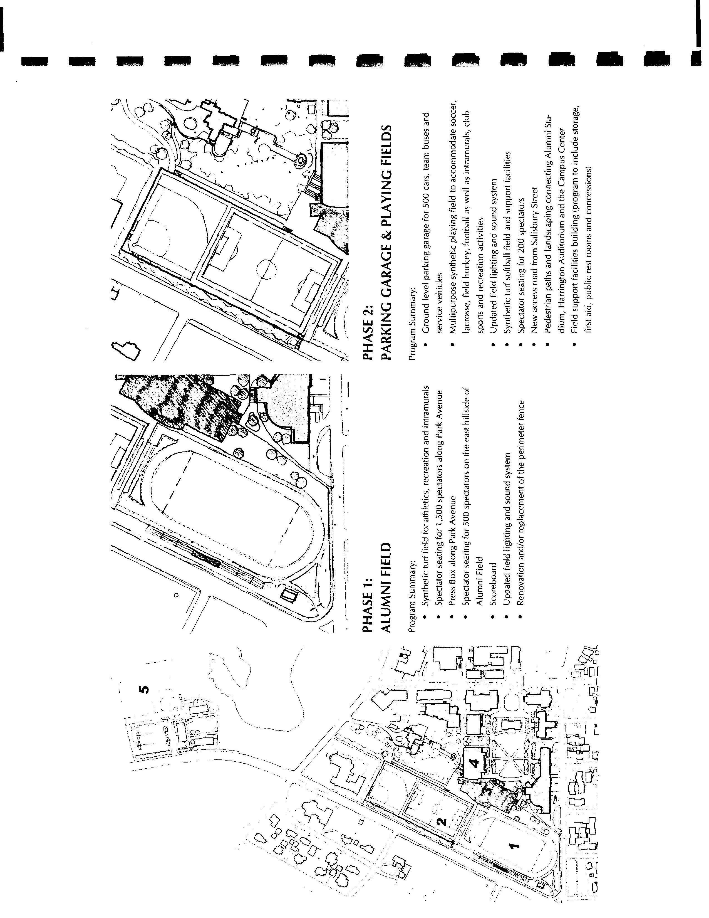

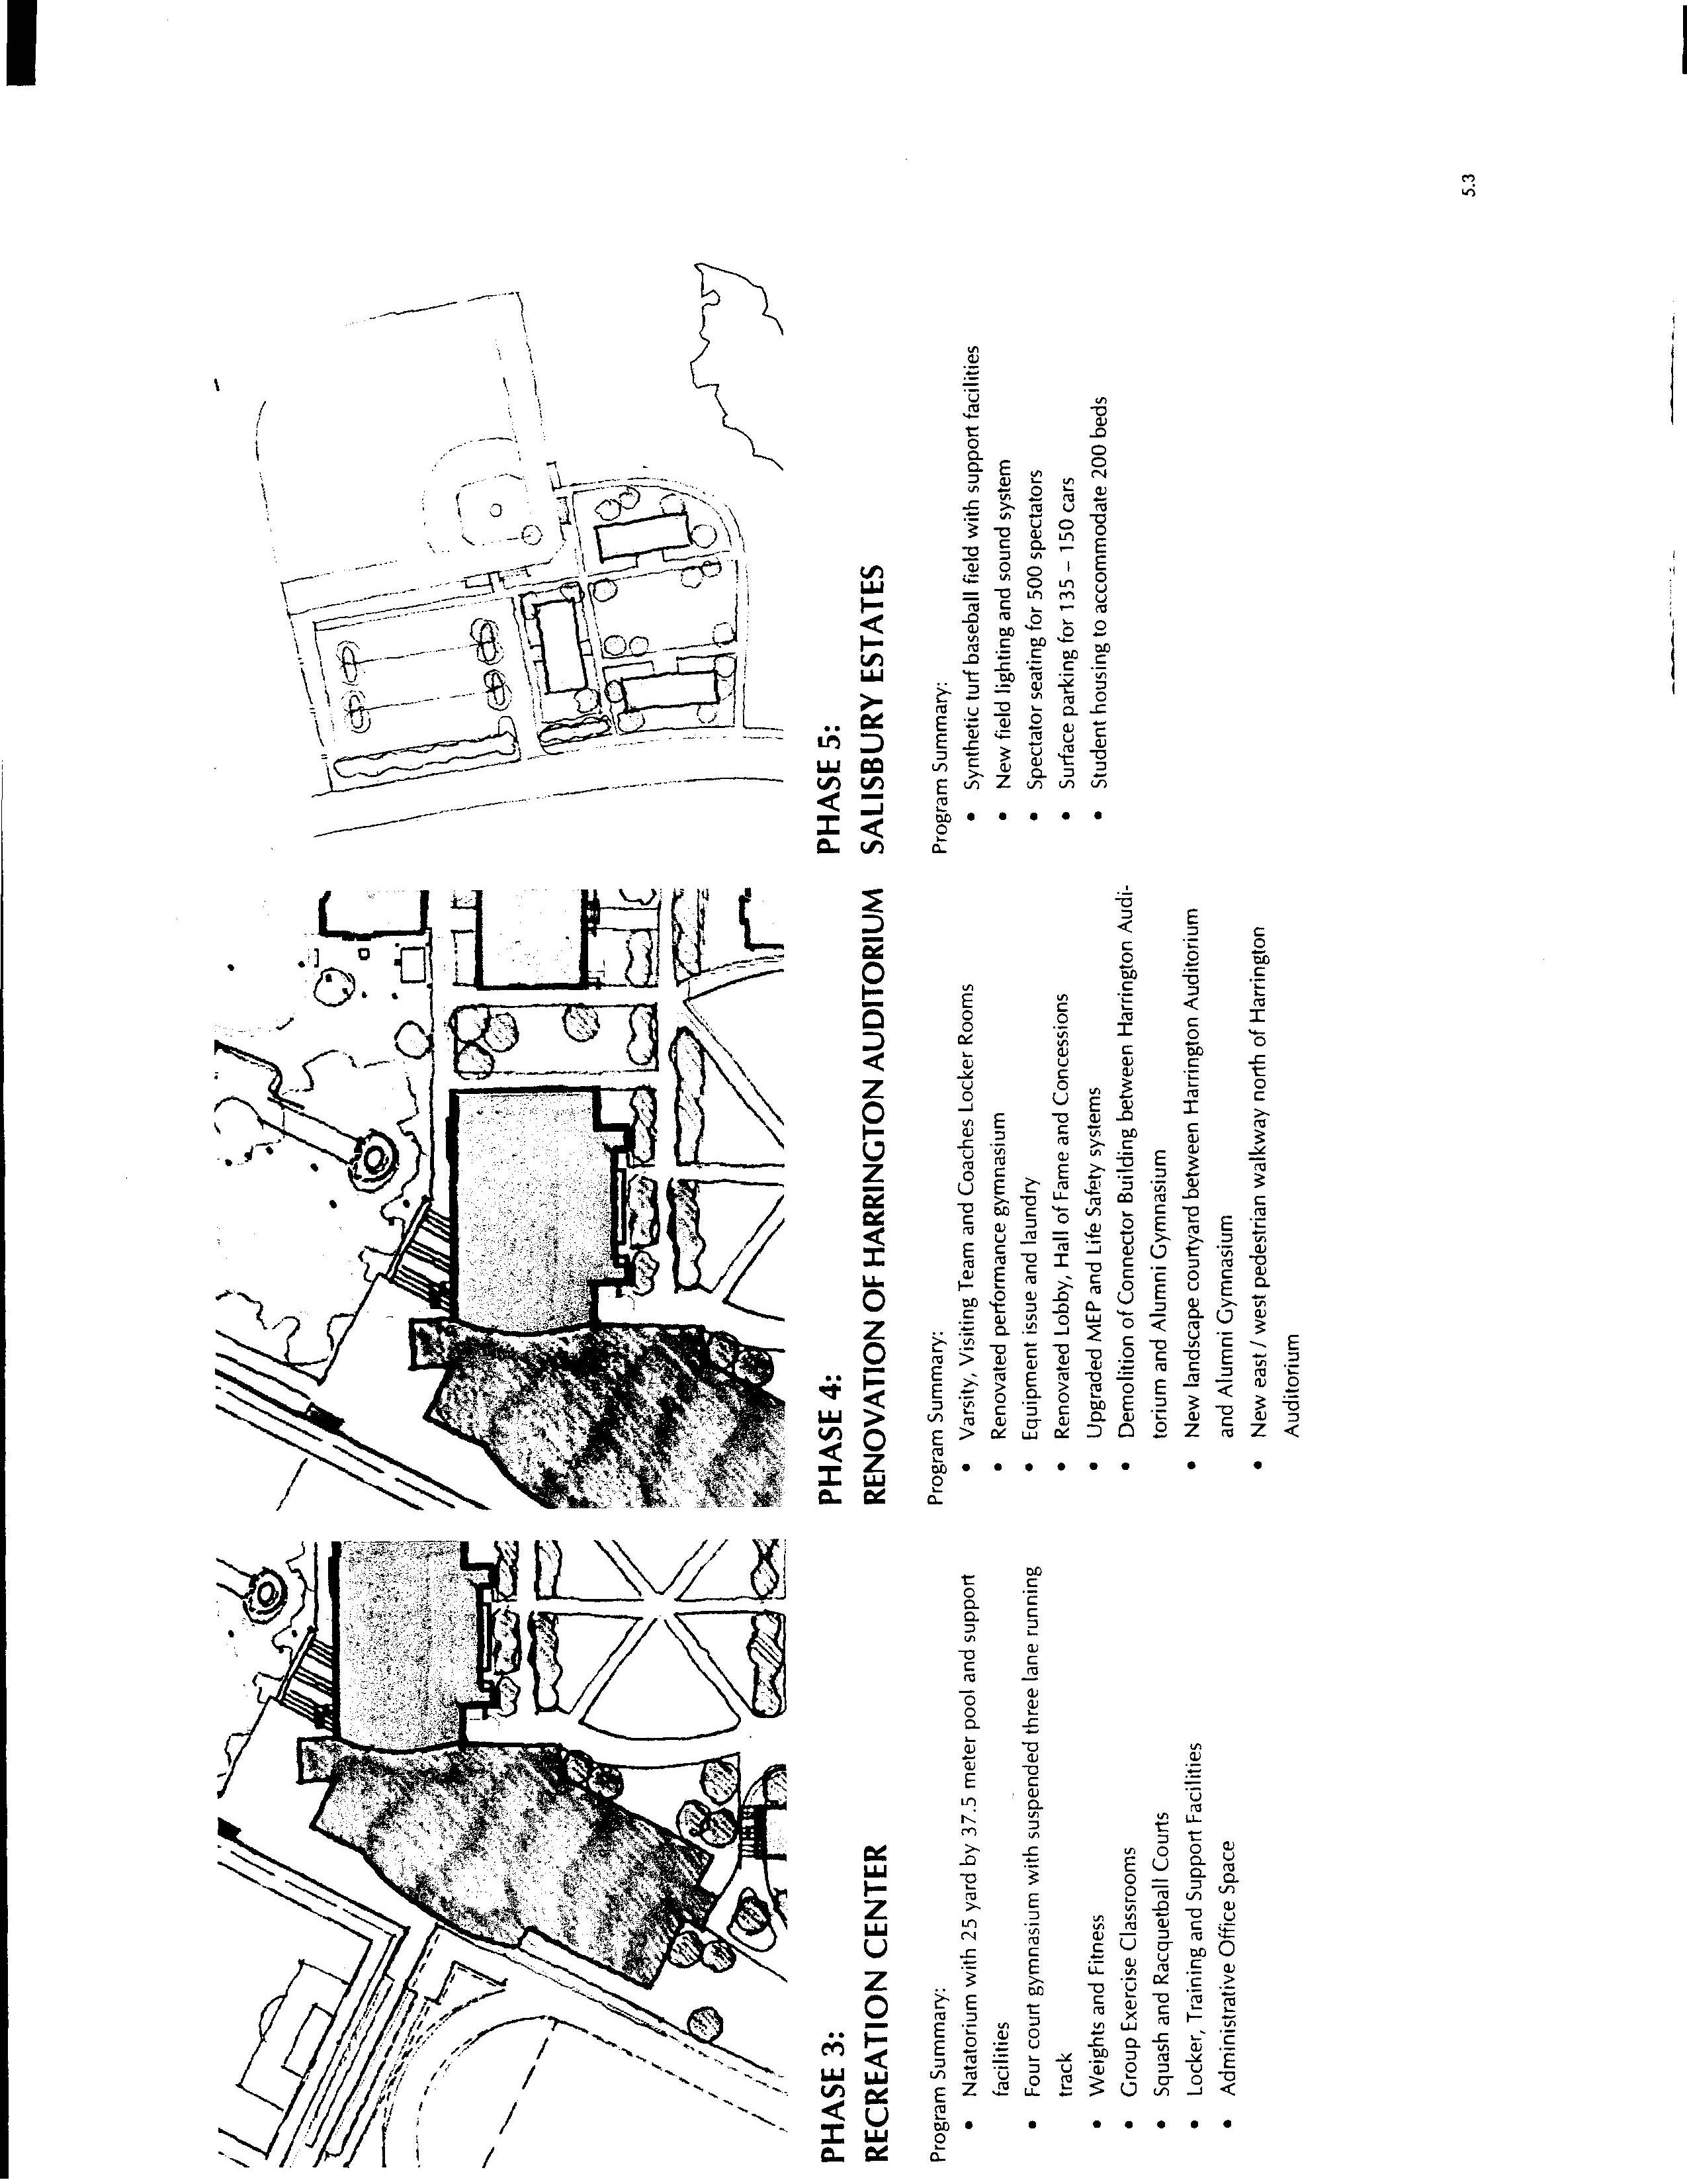

Appendix B
Massachusetts Institute of Technology
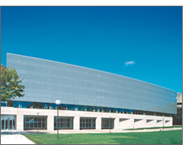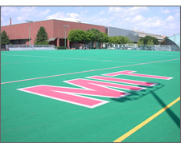
Zesiger Sports and Fitness Center Jack Barry Turf
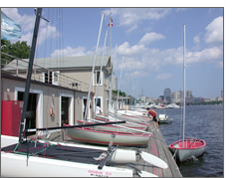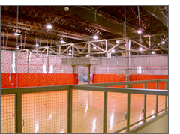
Pierce Boathouse Rockwell Cage
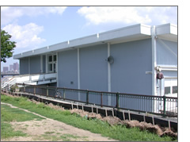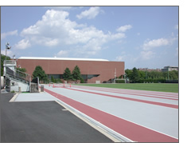
Pierce Boathouse Steinbrenner Stadium
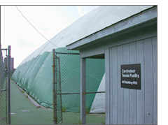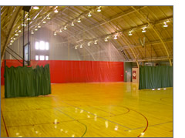
J. B. Carr Indoor Courts Dupont Courts
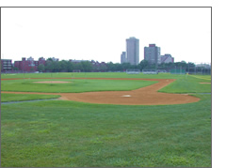
Briggs Field

Northeastern University
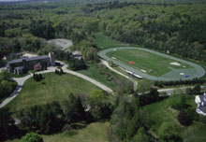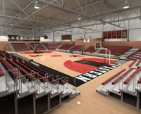
Solomon Track Solomon Court at Cabot Center
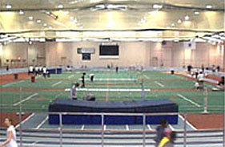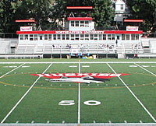
Reggie Lewis Track and Athletic Center Parsons Field and Friedman Diamond
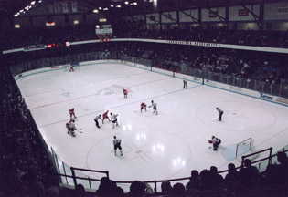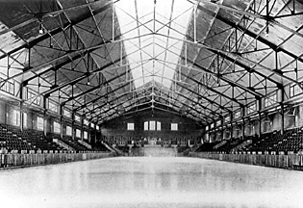
Matthews Arena Matthews Arena
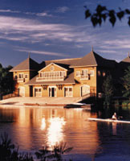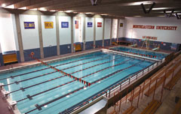
Henderson Boathouse Barletta Natatorium
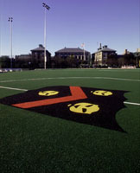
Sweeney Field

Rensselaer Polytechnic Institute
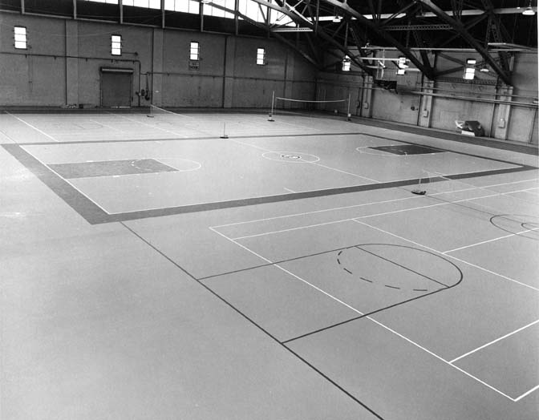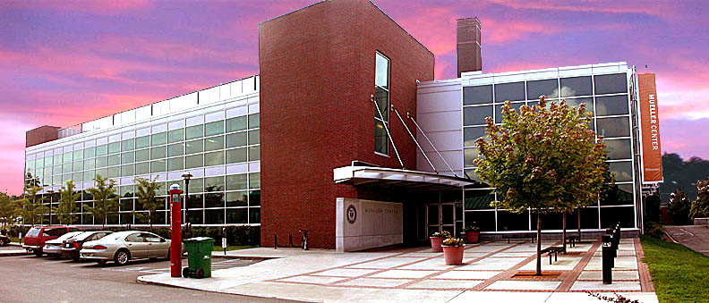
Robison Gym Mueller Fitness Center
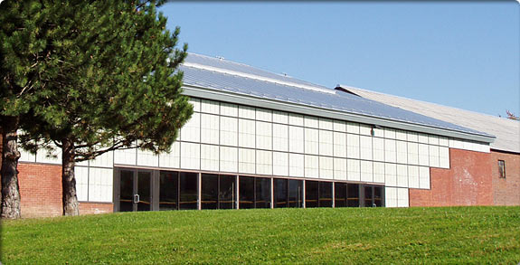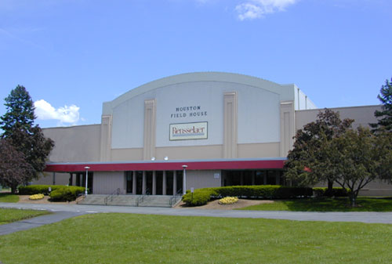
Robison Pool Houston Field House

Wentworth Institute of Technology
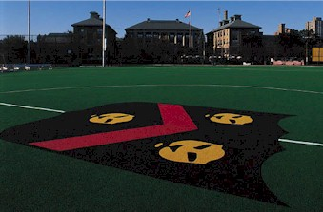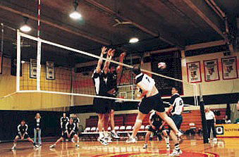
Sweeney Field Nelson Recreation Center
Matthews Arena
Appendix C
IQP SURVEY ___Student ___Faculty ___Staff

*Please Check All answers that apply*

- Are you aware of the existing plans to build a new sports and recreation facility on campus?

YES NO

- How often do you use the current athletic facilities in a given week?

___NEVER ___once or twice ___three to five times ___everyday

- Which facilities do you use when working out?

___Weight room ___Alumni ___Harrington
___Fields ___Tennis Courts ___Pool
___Squash Courts ___Track ___Bowling Alley
Other_________________

4. When using WPI’s facilities, which of the following do you find yourself using or
participating in?

___Weights ___Cardio Equip. ___Aerobic Equip. ___Basketball
___Volleyball ___Floor Hockey ___Martial Arts ___Cheerleading
___Dance Class ___Fencing ___Crew ___Badminton
___Ping Pong ___Soccer (Indoor) ___Football ___Bowling
___Tennis ___Frisbee ___Swimming ___Water Polo
___Squash ___Racquetball ___Dodge ball ___Rugby
___Running (Track) ___Softball/Baseball (Indoor) ___Softball/Baseball (outdoor)

- Have you ever run into a problem with availability/congestion when attempting to use WPI’s current sports and recreation Facilities?

___Yes ___No

Are there any programs, activities, clubs, or recreational equipment that you would like to see in the new athletic facility?

Appendix D
IQP Survey Results
Total Number of Surveys | 200
Number of Students | 184
Number of Faculty and Staff | 16
 |  | Undergrad | Grad | Faculty and Staff
Population of WPI Students (Undergrad and Graduate) | 3774 | 2825 |  | 511
Population of WPI Faculty and Staff | 875
TOTAL WPI COMMUNITY MEMBERS | 4649
Percent of WPI community members that took part in this survey | 4.30%
QUESTION 1 | Yes | % Yes | No | %No
Do you know about WPI's plans to build a new sports and recreation facility on campus? | 198 | 99% | 2 | 1%
QUESTION 2 | Never | Once or Twice | Three to Five | Everyday
How often do you use the current athletic facilities during a given week?
Percent of Total | 1% | 27% | 64% | 8%
QUESTION 3 | Total | %
Which facilities do you use when working out?
Weight room | 165 | 83%
Fields | 74 | 37%
Alumni | 131 | 66%
Harrington | 102 | 51%
Fields | 74 | 37%
Tennis Courts | 29 | 15%
Pool | 150 | 75%
Squash Courts | 37 | 19%
Track | 64 | 32%
Bowling Alley | 72 | 36%
Other | 33 | 17%
QUESTION 4 | TOTAL | % |  | TOTAL | %
When using WPI’s facilities, which of the following do you find yourself using or
participating in?
Weights | 115 | 58% | Football | 48 | 24%
Cardio Equip. | 148 | 74% | Racquetball | 77 | 39%
Aerobic Equip. | 137 | 69% | Swimming | 150 | 75%
Basketball | 98 | 49% | Dodge ball | 62 | 31%
Volleyball | 68 | 34% | Badminton | 26 | 13%
Dance Class | 17 | 9% | Bowling | 72 | 36%
Ping Pong | 14 | 7% | Water Polo | 8 | 4%
Tennis | 29 | 15% | Rugby | 27 | 14%
Squash | 37 | 19% | Crew | 32 | 16%
Running (Track) | 57 | 29% | Softball/Baseball (Indoor) | 63 | 32%
Fencing | 8 | 4% | Softball/Baseball (outdoor) | 91 | 46%
Floor Hockey | 110 | 55% | Frisbee | 22 | 11%
Soccer (Indoor) | 104 | 52% | Cheerleading | 4 | 2%
Martial Arts | 5 | 2.5%
QUESTION 5 | Yes | % Yes | No | %No
Have you ever run into a problem with availability/congestion when attempting to use WPI’s current sports and recreation Facilities? | 198 | 99% | 2 | 1%
QUESTION 6
Are there any programs, activities, clubs, or recreational equipment that you would like to see in the new athletic facility?

Results from Question 6:
Olympic Sized Swimming Pool with Diving Facilities
Pilates
Yoga
Student Health Services
Aerobics
Dance Room
More Pick-Up games of Basketball, Volleyball, etc…
Better Weight Room Equipment
Hammer Strength Machines in the Weight Room
More Dumbbells
Better Cardio Equipment
More Space
More Racquetball Courts
More Elliptical Machines
Dance Studio complete with mirrors and bars
More basketball courts
Indoor Tennis Courts
Personal Trainers in weight room
Fitness Program
Spa-Massage
Better soccer fields
Aerobic classes
Diet-and fitness counseling
Good sound system in gym
Indoor Soccer with goals
Better hours for grad students
Extended gym hours
Sauna and/or hot-tub
Better indoor track
Hiking club
Fencing
24-hour basketball court
Lawn darts
Grass field for Rugby Team
Varsity Only weight room
Slam-Ball Court
Hockey Team and Ice Rink
Virtual Golf Machine
Climbing wall

* Note: Most of the items listed above occurred several times throughout the Surveys. Specifically mention of improvements to be made regarding the weight room equipment, basketball courts, pool, indoor tennis courts, and Dance Room appeared most often throughout the questionnaire. *
Appendix E
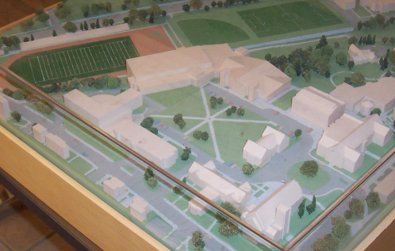

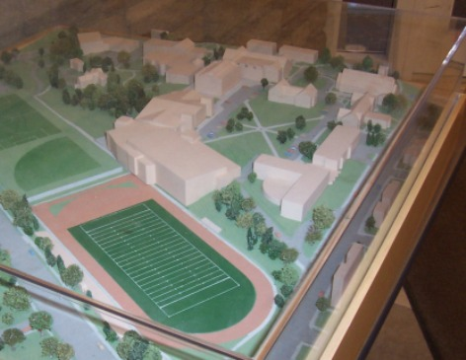
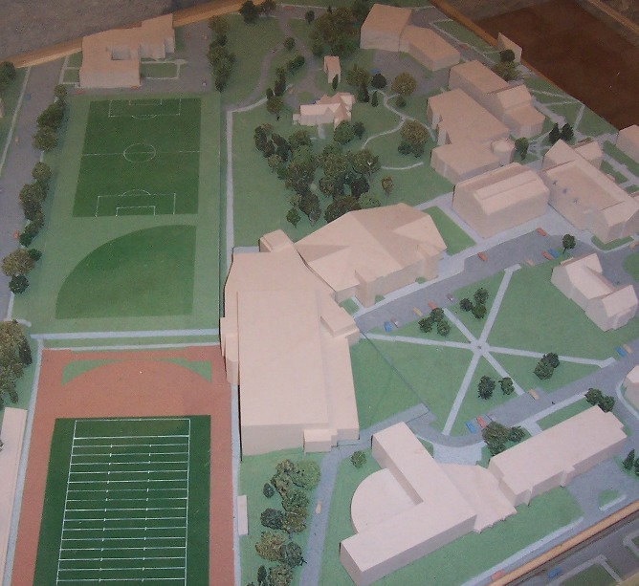

Appendix F

It’s a simple thing to slip on a pair of athletic shoes. But from the ground up, the making of an athletic shoe is a complex process involving a variety of raw materials that ultimately become footwear. More than 10 different materials might be used in even the simplest athletic shoe, more for higher performance shoes. While our overall goal is to simplify the number of materials used to make a shoe, our current recycling challenge with the Reuse-A-Shoe program is to process the shoes into as many pure materials as possible.
Slice and Grind
We get a lot of help from a growing number of retail and collection partners around the world. Nike collects worn-out athletic shoes of any brand, not just Nike. We then slice and grind up these post-consumer shoes along with Nike shoes that have been returned due to a material or workmanship flaw. The resulting products, collectively called Nike Grind material, are separated into three categories: outsole rubber, midsole foam and upper fabric.
From Shoes to NikeGO Places
While we’d ultimately like to make new shoes out of old shoes, our licensees currently use Nike Grind material to make innovative sports surfacing products that benefit the environment and local communities, and to help kids get active. Nike is taking old and defective shoes that no one wants and turning them into something that ultimately helps benefit youth around the world -- new soccer and football fields, tennis and basketball courts, running tracks and playground surfaces.
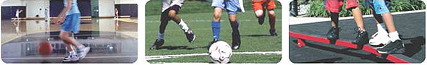
Using Other Kinds of Waste
In 1999, Nike began recycling an increasing amount of material from the manufacturing of footwear outsoles, which is added to the mix of Nike Grind material and used to make new soccer and football fields. Currently selected contract factories producing Nike-branded footwear in Vietnam, Indonesia and southern China all have programs to recycle materials from the manufacturing process. Local recycling centers collect these materials from the factories, sort it if needed, and grind it to FieldTurf's specifications. Nearly 6.5 million pounds (approximately 3,000 tonnes) of recycled rubber have been shipped for use in fields since 1999.
This Nike Grind material is used in FieldTurf fields that Nike helps donate around the world. For each field, we’re talking about the amount of rubber from approximately 75,000 pairs of shoes, unused manufacturing material that won’t end up in landfills.
Nike Grind Licensees

 |  | FieldTurf  For many years, Nike has worked closely with FieldTurf, a leading innovator of synthetic turf, to make some of the best athletic surfaces in the world. FieldTurf's high-performance synthetic turf incorporates Nike Grind material recycled from footwear manufacturing to help elite athletes and active kids to play their best game.  You have to play on it to believe it. FieldTurf emulates real grass using a smooth, coated fiber, an open-weave system that contains a combination of Nike Grind and other rubber material and sand infill. The infill surrounds and supports each grass fiber in the same way that natural earth holds each blade of grass. Compatible with many types of base surfaces, including asphalt, concrete or crushed rock, FieldTurf makes for an exceptional playing surface, indoors and out. The highly porous nature of the infill provides excellent drainage for consistent play in all types of weather.  Traditional grass fields require huge amounts of water and fertilizers for upkeep, making them expensive, hard to maintain and hard on the environment. FieldTurf, which requires neither water nor fertilizers, is not only more Earth-friendly, but allows for more play with far less maintenance.  For more information check out FieldTurf @ www.Fieldturf.com
 |  | Connor Sports Flooring  Nike partner Connor is the leading indoor sports surface company, producing many of the best athletic surfaces in the world. Connor's hardwood SmartSystems feature SmartPads that incorporate recycled materials, including Nike Grind material for gym floors from the highest competition to recreational levels. Additionally, Connor offers hardwood systems made with Smart Wood: wood from managed forests certified by the Rainforest Alliance to have come from harvested operations.  For more information check out the Connor website @ www.connorfloor.com
 |  | Rebound Ace  A leading innovator of cushioned tennis court systems and outdoor basketball courts, Rebound Ace Sports and Nike have teamed up to make superior multi-purpose courts known around the world. Rebound Ace's high-performance system incorporates Nike Grind material to help both elite athletes and active kids play a better game.  Rebound Ace courts are composed of multiple layers of cushioning material, including Nike Grind material plus durable sealers, adhesives and topcoats. The result is a resilient, strong, long-lasting, and low-maintenance tennis and outdoor basketball court. Moreover, Rebound Ace courts are heralded for their even ball bounce, high level of player comfort, and cushioning effect. No wonder Rebound Ace Sports systems can be found worldwide - USA, Europe, Asia and the Middle East.  For more information about Rebound Ace, visit www.reboundace.com.au
 |  | Atlas Track  It makes perfect sense that Nike would team up with Atlas, one of the leading track surfacing organizations, to make some of the best track surfaces around the planet. Atlas' innovative all-weather surfaces include Nike Grind material in its polymer-resin binder system, a technique perfected by a research, design and development team with more than 300 collective years of experience.  These surfaces are the world's finest, a proven product that performs in any climatic condition. So, when Nike went looking for someone to build its own world-class running surface, they looked to Atlas. The result? A track honored by the U.S. Tennis Court & Track Builders Association as the Track Facility of the Year in 2000. Atlas Track is also one of the preferred surfaces for the Bowerman Track Renovation program.  For more information check out Atlas @ www.atlastrack-tennis.com
Last updated October 2004
Appendix G
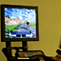
Members of San Francisco's Bay Club can pedal up barren mountains, past grass huts and through jungles without leaving the gym.
At Club One at San Jose's Santana Row, members build muscles by pushing and pulling a giant joystick to play video games including car racing and golf.
Virtual reality is becoming part of the exercise routine in gyms and homes across the country. Recently introduced technology transforms gyms into arcades.
The idea is to make fitness more compelling than just sweating on a treadmill. People are more likely to stick with their routines; the theory goes, if they are immersed in digital versions of bike rides, "American Gladiator"-style contests and dancing.
"After any of our members gets shown the new bikes, I haven't seen them go back to the old ones," said Brian Thomason, manager and physical trainer at the Bay Club.
So-called exer-tainment isn't new. Companies have offered gym equipment - - particularly stationary bikes -- with virtual-reality capability for years. With a few exceptions, the products failed to catch on because of the high cost and rudimentary imagery.
But these days, fitness equipment executives are more confident. Improved computer graphics and the increasing need to get Americans off the couch are paving the way for a greater number of sales, they said.
Dan Coleman, an insurance salesman who exercises at the Bay Club in San Francisco's Bank of America Center, is a fan of digital workouts. Twice a week he rides a stationary bike that has more than 20 virtual routes.
"If you can't ride outside, this is the next-best thing," Coleman said.
The bike, built by Expresso Fitness in Sunnyvale, has a video screen located beyond the handlebars. After pressing a few buttons, riders can call up an animated world to pedal and steer through.
Trees, houses and the seashore pass by the roadside. Squirrels scamper across the fields.
How fast riders go on-screen depends on how quickly they pedal. It gets tougher when climbing a mountain (though changing gears may help ease the pain).
Riders are joined on-screen by a pacer, who wears a yellow jersey. Or they can engage in a virtual race against the person on the next bike.
Expresso Fitness was founded in 2003 and introduced its first product, the Spark bike, earlier this year.
Nearly 30 of the bikes have been installed in gyms, mostly in the Bay Area. Mavericks Sports in Emeryville, ClubSport in Pleasanton and Club One in the Almaden neighborhood of San Jose are among the facilities.
Serious bikers may recognize some of the routes, which range from leisurely seaside rides to tortuous climbs rivaling the Tour de France. For example, a trail around Lexington Reservoir near Los Gatos is the inspiration for a ride called Oh Mama.
Brian Button, chief executive of Expresso Fitness, pointed to the proliferation of video-game consoles as an indicator of what may happen in gyms. The time is ripe, he believes, because practically nothing has been done over the past 20 years to make working out more interesting.
"Our view is that in five or six years, the sort of thing we are doing will be almost everything you see," Button said.
Not everyone is enamored of virtual workouts. Jon Salmon, a banker from Lafayette, said he prefers riding a traditional stationary bike at the gym.
Riding in virtual reality requires paying too much attention to a video screen, he explained. He said he'd rather be free to read the newspaper and occasionally glance at a more mundane LED screen that shows how fast his heart is beating.
Indeed, on a recent day, Salmon was doing just that while sweating on a stationary bike at the Bay Club. He also rides regularly on the streets near his home.
"I bike during the weekends," Salmon said. "So real reality is better than virtual reality."
Cost is a barrier to the spread of virtual fitness gear. The Spark's list price is $4,795; nearly double that of a traditional gym bike.
Button said he sometimes gives gyms free trials of his equipment. If they don't like it, they can give it back, he said.
Companies offering virtual fitness gear in a similar spirit include Powergrid Fitness, which introduced its Kilowatt exercise machine eight months ago. The equipment consists of a 4-foot-high pole that plugs into home video- game consoles such as Sony's Xbox.
Users push and tug the Kilowatt to move their characters on the screen in games like video soccer or Grand Theft Auto. Buttons on the machine control kicking, shooting and jumping.
Earlier this year, Powergrid began selling a system that allows users to participate in multiplayer games, often in gladiator-style contests.
"It gets your mind off of the fact that you're in intense pain while exercising," said Jason Grimm, vice president of marketing for Powergrid Fitness in Laurel, Md.
Companies are trying to appeal to home customers too, not just gyms. Several digital exercise products are designed for the home market, and more are on the way.
Powergrid sells about 40 percent of its Kilowatts for home use, Grimm said. Earlier this month, the company announced plans to create a scaled-down version that will cost less than $250 and require no assembly.
The dean of this new generation of home digital exercise is Konami Digital Entertainment's Dance Dance Revolution. It began as an arcade game in Japan in the late 1990s and quickly spread to the U.S. consumer market.
The home version consists of a touch-sensitive plastic mat that plugs into a video-game console. Users stomp out rhythms on the mat corresponding to the flashing arrows on screen.
An exercise mode is available that counts calories burned, among other things.
Physicians have studied the health benefits of the game, which is so popular that 3.5 million have been sold in the United States. Some schools are using it gym classes.
In the future, fitness may be even more like a video game. A handful of games provide a sense of what may be coming.
For example, EyeToy: AntiGrav uses motion-sensing technology. Players can make on-screen characters move by jumping and swinging.
But as the games are now, they don't appear to have much of a health benefit.
"I see this area as a big opportunity," said Jason Enos, product manager for Konami Digital Entertainment, which has offices in Redwood City. "Users can put themselves inside the game and punch out the bad guy or jump up on a ledge."

Digital workout
Video games are becoming part of the exercise routine in gyms and homes across the country. Some of the products available:
Expresso Fitness Spark
Powergrid Fitness Kilowatt
Cybex Trazer
Cateye Fitness GameBike
Konami Digital Entertainment Dance Dance Revolution
E-mail Verne Kopytoff at vkopytoff@sfchronicle.com.
Page E - 1
URL: http://sfgate.com/cgi-bin/article.cgi?file=/chronicle/archive/2005/07/25/BUGVRDRETD1.DTL
Appendix H
Reggie Lewis Center, Boston, Massachusetts
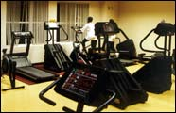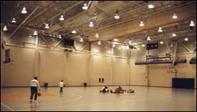
Cardiovascular Equipment Room Indoor Basketball Courts
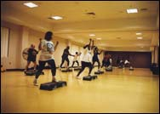
Aerobics Class and Dance Room Weight Room

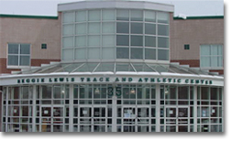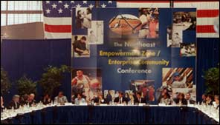
Reggie Lewis Center Entrance Conference at Reggie Lewis Center
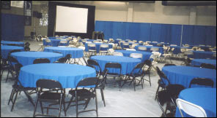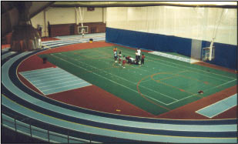
Meeting at Reggie Lewis Center Indoor Track and Field Complex
Appendix I
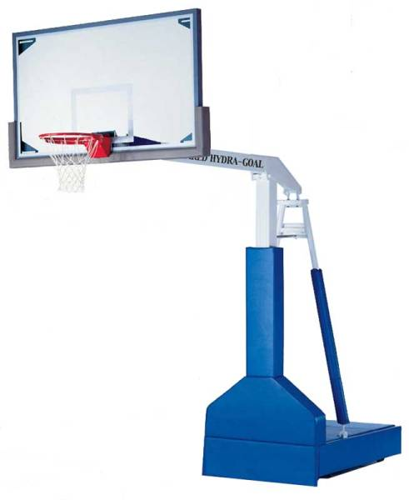

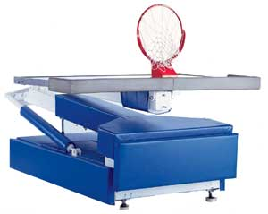
Appendix J
Email Response from Larry Noble, Director of Intramural Sports and Head Crew Coach
3/20/06

John,

The lack of facilities here at WPI is a real problem. I am lucky that I have Alumni, but even that is not enough for all the basketball teams that signed up last term. Teams only played 4 times each the whole term because there was only one court available. The turf and field are in even more demand. We can only play there on weekends and have to schedule around varsity/club games and practices.

--Coach Noble

Appendix K

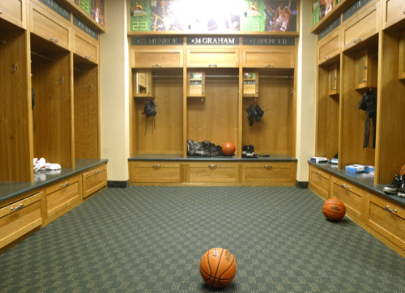
Wright State Men’s Basketball Locker Room
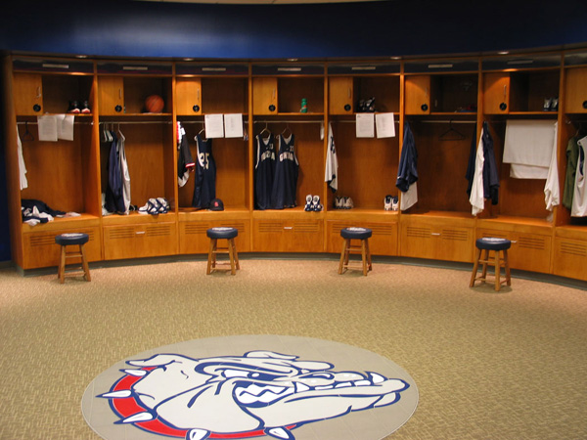
Gonzaga Women’s Basketball Locker Room

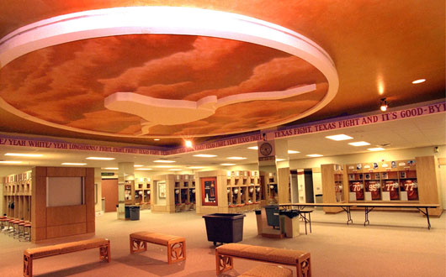
Texas Football Locker Room
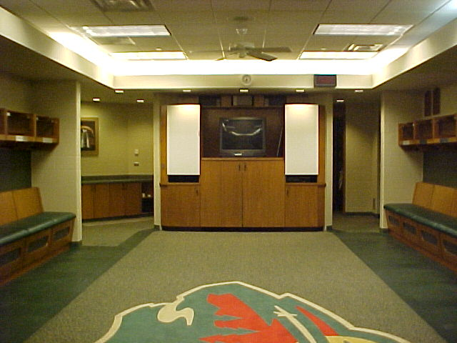
Sample Team Meeting Room within Locker Room

