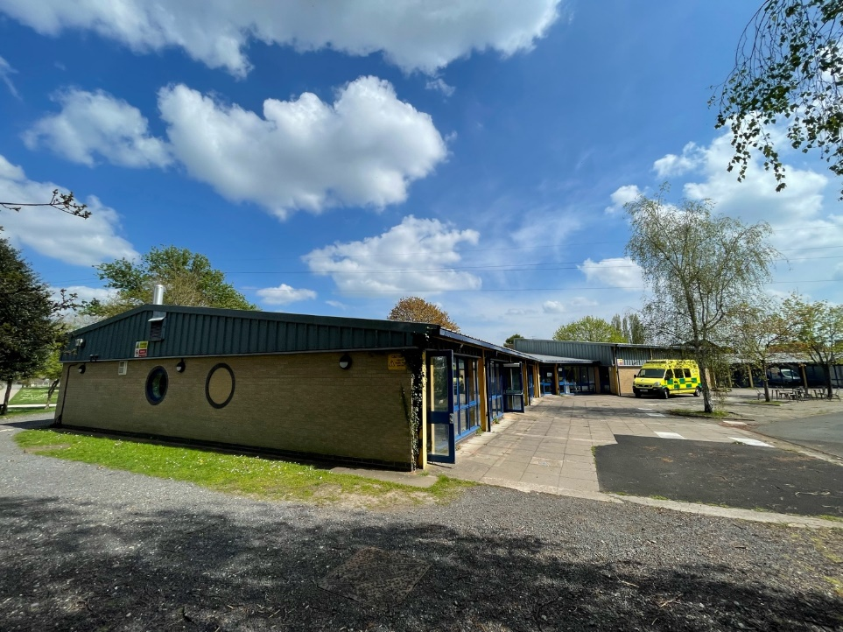
Human Factors Consideration for the
Sheila Scott Digital Twin Pilot
The Northwest Exterior Corner of The Sheila Scott Building

Yutai Han
Ryan Kievra
Emily Raynowska
Emma Smith

Worcester Polytechnic Institute
Worcester UK Project Centre

April 27th, 2022

Human Factors Consideration for the
Sheila Scott Digital Twin Pilot

An Interactive Qualifying Project submitted to the faculty of
WORCESTER POLYTECHNIC INSTITUTE
in partial fulfilment of the requirements for the
Degree of Bachelor of Science

Authors:
Yutai Han
Ryan Kievra
Emily Raynowska
Emma Smith

April 27th, 2022

Sponsors:
Katy Boom
Simon Dutton
Matt Smith
University of Worcester, UK
Abideen Grillo
Sean-Paul Tester
CPW LLP

Advisors:
Professor Fred Looft
Professor Linda Looft
Worcester Polytechnic Institute

This report represents the work of WPI undergraduate students submitted to the faculty as evidence of a degree requirement. WPI routinely publishes these reports on its web site
without editorial or peer review.

Acknowledgements
We would like to express our appreciation and gratitude to all the people who kindly offered their time and resources to make this innovative and educational project possible. Additionally, we would like to acknowledge:

- Professor Linda Looft & Professor Fred Looft of Worcester Polytechnic Institute for their continuous support of this project by reviewing our work and providing valuable feedback. Their guidance on this project helped us improve our researching, writing, and presentation skills. We are truly grateful for their presence on this journey with us.

- Mr. Simon Dutton - Service Development Manager & Mr. Matt Smith - Energy Officer & Ms. Katy Boom - Director of Sustainability of University of Worcester for hosting us at their beautiful campus estate and providing us with access to all the resources and contacts that exponentially expedited our research and learning. Finally, for helping facilitate our time-sensitive interview requests to other staff members at the University and fit us into their busy diaries to answer any questions we have.

- Mr. Sean-Paul Tester - Senior Design Engineer & Mr. Abideen Grillo - Senior Innovation Consultant of CPW, for volunteering their time and effort for this project, constantly providing information and knowledge for us to have a rudimentary understanding of the technical aspect of a digital twin. Finally, for inviting us to their office and giving us a brief experience of working as a professional engineer.

- All the faculty and staff at the University of Worcester for taking their time with us for all our questions, interviews, and their help with distributing our surveys.

- Shelby Green – Associate (BIM) of One Creative Environments, Gordon Mitchell – Chief Information Officer of Key FM, Paul Brodrick – Business Development Director, & Paul Beasley – Head of Research and Development UK of Siemens for taking their time to provide us with information on the status of digital twins in industry and feedback about our progress.

Abstract
As part of the University of Worcester’s decarbonisation effort to reach net-zero carbon emissions by 2030, the University has conducted a digital twin pilot at the Sheila Scott building. The goal of this project was to evaluate the human factor considerations when implementing a digital twin to maximise its benefits. With the support of background research, on-site interviews and evaluations, and stakeholder feedback analysis, we created a framework and rubric to evaluate human factor considerations during digital twin implementation. Final recommendations included enhanced communications between building users and administrators, the standardisation of operational and occupancy policies, and a simplified, yet informative, campus wide scheduling system, and a digital twin management team.

Executive Summary
The University of Worcester is implementing and testing new ways to decarbonise their campus, most recently testing the use of a digital twin for a campus building, as one aspect of their goal to reach Net-Zero Carbon by 2030. The University of Worcester (UW) has contracted with CPW, an engineering consultant firm, to aid their campus digital twin decarbonisation efforts with the UW Shelia Scott building.

Goal & Objectives
The goal of our project was to create a framework and rubric that defined the human factor considerations needed to maximise the benefits of implementing a digital twin. To accomplish this goal, we identified the following objectives:
- Identify and categorise building users and their building use needs.
- Identify building management teams and space utilisation procedures.
- Observe and document building user access to and use of building assets.
- Create a framework, rubric, and evaluation sheet of human factor considerations for implementing a digital twin.
To accomplish these objectives, we completed interviews, observation surveys, and formulated a framework and a rubric based on the information and data from Objectives 1 to 3.
Objectives 1 and 2 were accomplished by interviewing Sheila Scott building users and managers. The building users identified were the lecturers and students. The building managers identified were the estates, space and data management, clinical skills technicians, and registry services staff teams. These interviews gave us an understanding of how the building users used the building and its assets, as well as the different procedures for building management and space utilisation. Students were surveyed, in addition to these interviews.
Objective 3 was primarily accomplished through multiple observational surveys on the Sheila Scott building. As we surveyed the building, particularly the classrooms, we noted in each room its occupancy, what the occupants were wearing, whether windows and emergency doors were open, and the temperature outside. This data provided us with some concrete evidence about what a period of utilisation looks like at Sheila Scott, as well as recommendations for future work.
Finally, based on the data, interviews, and other findings, we created a framework checklist for what should be in place, both building and human factors, for digital twin implementation, as well as a rubric to evaluate the implementation status of any building on campus.

Interview and Observation Findings
To investigate the human factors of implementing a digital twin and gather stakeholder feedback, our team conducted a series of interviews and observations. We categorised our interviewees as building administrators and building users. In terms of building administrators, we interviewed the Estates department which oversees building maintenance and management. For building users, we interviewed multiple lecturers that frequently teach in the building. We also interviewed a group of Clinical Skill Technicians who are considered both users and administrators of the Sheila Scott building. Through our interviews, we learned that:
- There is a conflict between signage and operation policy.
- There appears to be a lack of understanding regarding heating retention strategies among building users.
- There appears to be a lack of communication about building management between the building users and managers.
- Building user feedback about heating is often misunderstood because of unclear communication between stakeholders.
- Instructors can book two rooms simultaneously to have sufficient class space and correct room set up, thus wasting energy heating (or cooling) a room that is ready to be used but empty.
- The posted occupancy number in each room is determined without proper surveying in the defined spaces and therefore appears to be inaccurate and inefficient to use.

As part of our data collection process, we observed classroom use and user behaviour in 10 out of 11 classrooms for three days. We recorded data on the occupancy, ambient temperature, windows, and glass exterior door usage. During our observation, we found that:
In the Sheila Scott Building, 62% of rooms were empty at the time of our observation, despite the timetable indicating that a class was in session. The other 38% of the rooms appear to be under-occupied. All the windows in the empty classrooms were closed during our observation, and only one window was observed open when a room was occupied.

Recommendations
Our recommendations are sourced from multiple points in the methodology. Recommendations have been made based on interviews, observation, and the framework, rubric, and evaluation sheet. From interviews and observation, we recommend:
- The University must review its heating, comfort, and Covid-19 policies and update them.
By reviewing and updating the different policies used on campus, the students, faculty and staff will be able to understand the shared concise goal of balancing health and sustainability.

- The University must establish a feedback system to gain insight into building users' issues with campus buildings.
By separating the maintenance job request system and creating new channels for feedback, the feedback about the campus buildings will be able to reach the correct personnel to be addressed.

- The scheduling of the Sheila Scott building needs to be examined and reconstructed to better accommodate student and lecturer needs.
By encouraging communication between the cohort leads for class to discuss their intended room usage prior to submitting semester timetable requests, the room utilisation efficiency could be improved.

- The University needs to determine a standard procedure for room capacity limits.
A standardised procedure with both space and legal consideration for room capacity will help the University improve space utilisation.

- The University needs to complete further studies of campus buildings to have the full picture of space utilisation and heat latency.
A comprehensive study should be done regarding building management based on the continuation of this project to maximise the building benefits.

- Students must be surveyed about their behaviour and feedback within the building.
Further surveying of students needs to occur to understand the full extent of building user behaviour and feedback within the building to make sustainable behavioural changes.

- The University needs to create a designated Digital Twin Management team to monitor and manage any existing DT and implement future DTs.
A team made up of one or more of each stakeholder group should be created to manage training, feedback, and overall operation of the digital twin.
From our findings in the Sheila Scott digital twin Pilot, we designed a generalised framework, rubric, and an evaluation sheet. The framework was envisioned to compile all necessary requirements in a building’s environment to implement a digital twin into a building. It was based on our findings during our time with the Sheila Scott Pilot. The rubric was then used to evaluate the status of the implementation of the digital twin in the Sheila Scott. This was developed through our methodology of the implementation of stakeholder considerations. The evaluation sheet was developed as a clear table to organise status of implementation and the target status of implementation. From the evaluation sheet, our team evaluated what stage the pilot is currently at, what its target stage is, and made recommendations for the Sheila Scott digital twin.

Authorship

Section Number / Name |  |  |  | Author(s) |  |  |  |  | Editing Author(s)
Acknowledgements |  |  |  | YH |  |  |  |  | YH, ES
Abstract |  |  |  | YH |  |  |  |  | ES, YH
Table of Figures and Tables |  |  |  | ES |  |  |  |  | ES
Executive Summary |  |  |  | ES, ER, YH |  |  |  |  | ES, ER, YH
1.0 Introduction |  |  |  | ER, ES |  |  |  |  | ER, ES, YH
2.0 Background
2.1 Climate Change |  |  |  | ES |  |  |  |  | ES
2.2 Decarbonisation |  |  |  | ES |  |  |  |  | ES
2.3 Building Decarbonisation |  |  |  | YH |  |  |  |  | YH
2.4 Digital Twins |  |  |  | YH |  |  |  |  | YH
2.5 The University of Worcester |  |  |  | ES, ER |  |  |  |  | ES
2.6 The Sheila Scott Building |  |  |  | ES |  |  |  |  | ES
3.0 Methods
3.1 Identify & Categorise Building Users & Needs |  |  |  | RK, ES |  |  |  |  | ER
3.2 Identify Building Management Teams and Space Utilisation Procedures |  |  |  | ES |  |  |  |  | ER, RK
3.3 Observe and Document Building User Access to Building Assets |  |  |  | ER |  |  |  |  | ER, RK
3.4 Create Framework, Rubric, and Evaluation Sheet of Considerations for Implementing a Digital Twin |  |  |  | YH, ER |  |  |  |  | ER
4.0 Results and Findings
4.1 Interview Results and Findings |  |  |  | ES, RK, YH |  |  |  |  | ES, YH
4.2 Observation Results and Findings |  |  |  | ES, YH |  |  |  |  | ES, YH
4.3 Framework & Rubric |  |  |  | ER |  |  |  |  | ES
5.0 Framework and Rubric
5.1 Digital Twin Preparation Checklists |  |  |  | ER |  |  |  |  | ER
5.2 Building Factor Checklist |  |  |  | ER |  |  |  |  | ER
5.3 Human Factor Checklist |  |  |  | ER |  |  |  |  | ER
5.4 Rubric for Building Factor and Human Factor Implementation of a Digital Twin |  |  |  | ER |  |  |  |  | ER
5.5 Evaluation Sheet for Assessing Status of Implementation |  |  |  | ER |  |  |  |  | ER
6.0 Recommendations
6.1 The University must review and update its heating, comfort, and Covid-19 policies |  |  |  | ES |  |  |  |  | YH, ES
6.2 The University must establish a feedback system to gain insight into what issues building users have with the management of campus buildings |  |  |  | ES |  |  |  |  | ES
6.3 The scheduling of the Sheila Scott building needs to be examined and reconstructed to better accommodate student and lecturer needs |  |  |  | ES |  |  |  |  | RK
6.4 The University needs to standardise a way of determining capacity limits for rooms on the campus |  |  |  | ES |  |  |  |  | YH, RK
6.5 The University needs to complete further studies of campus buildings to have the full picture of space utilisation, heat latency, and feedback |  |  |  | ES |  |  |  |  | RK
6.6 Students must be surveyed about their behaviour and building management feedback |  |  |  | ES |  |  |  |  | ES
6.7 The University must create a designated, trained Digital Twin Management team to monitor and manage any existing DT and implement future DT |  |  |  | ER |  |  |  |  | ER
Appendices
A Terminology & Definitions |  |  |  | ER, ES |  |  |  |  | ES
B Current State of the Sheila Scott Building |  |  |  | RK |  |  |  |  | RK
C Observation Data Sheet |  |  |  | ES |  |  |  |  | ES

Table of Contents
Acknowledgements i
Abstract ii
Executive Summary iii
Authorship vii
Table of Contents ix
List of Figures and Tables xi
1.0 Introduction 1
2.0 Background 3
2.1 Climate Change 3
2.2 Decarbonisation 4
2.3 Building Decarbonisation 4
2.4 Digital Twin 5
2.5 University of Worcester and Decarbonisation 7
2.6 The Sheila Scott Building 8
3.0 Methods 12
3.1 Identify and Categorise Building Users and Needs 12
3.2 Identify Building Management Teams and Space Utilisation Procedures 13
3.3 Observe and Document Building User Access to Building Assets 13
3.4 Create Framework, Rubric, and Evaluation Sheet of Considerations for Implementing a Digital Twin 14
4.0 Results and Findings 15
4.1 Interviews Results and Findings 15
4.2 Observation Results and Findings 19
4.3 Framework & Rubric 20
5.0 Framework and Rubric 21
5.1 Digital Twin Preparation Checklists 21
5.2 Building Factors Checklist 21
5.3 Human Factor Checklist 24
5.4 Rubric for Building Factor and Human Factor Implementation of a Digital Twin 28
6.0 Recommendations 33
6.1 The University must review and update its heating, comfort, and Covid-19 policies. 33
6.2 The University must establish a feedback system to gain insight into what issues building users have with campus buildings. 33
6.3 The scheduling of the Sheila Scott building needs to be examined and reconstructed to better accommodate student and lecturer needs. 33
6.4 The University needs to standardise a way of determining capacity limits for rooms on the campus. 34
6.5 The University needs to complete further studies of campus buildings to have the wholistic understanding of space utilisation and heat latency. 34
6.6 Students must be surveyed about their behaviour and feedback within the building. 35
6.7 The University must create a designated, trained Digital Twin Management team to monitor and manage any existing DT and implement future DT. 35
References 37
Appendices 40
Appendix A Terminology & Definitions 40
Appendix B: Current State of the Sheila Scott Building 41
Appendix C: Observation Data Sheet 45

List of Figures and Tables
Figure 1: Number of People in the UK Affected by Flooding With a 2.5°C and 5.4°C  Increase in Global Temperature................................................................................................... | 3
Figure 2: The Front Entrance to The Sheila Scott Building....................................................... | 8
Figure 3: Layout of the Sheila Scott Building............................................................................ | 9
Figure 4: Cropped View of Rooms SS 007 & SS 008 in the Sheila Scott Building.................. | 10
Figure 5: Summary of Objectives and Associated Methods...................................................... | 12
Table 1: Building Factors Checklist........................................................................................... | 22
Table 2: Stakeholder Checklist................................................................................................... | 25
Figure 6: Flow Chart for Use of Checklists, Rubrics, and Evaluation....................................... | 29
Table 3: Human Factors Rubric................................................................................................. | 30
Table 4: Evaluation Sheet........................................................................................................... | 32

1.0 Introduction
Climate change is a long-term natural or unnatural shift in temperatures and weather patterns (United Nations, 2022, paras. 1). Human activities, such as inefficient energy use, are one of the largest contributors to climate change in that they increase the amount of carbon dioxide (CO₂) being released into the atmosphere (Hertzberg & Schreuder, 2016; Solomon et al., 2008).
One way to address climate change is by reducing a building’s energy usage, and thus operational carbon emissions. In the UK, CO₂ emissions from buildings have decreased by 31% from 1990 to 2020, and this is due to their plan to reach net-zero carbon by 2050 (European Commission et al., 2021; Climate Change Committee, 2020). The digital twin pilot of the Sheila Scott building, on the University of Worcester’s St. John’s campus, is a part of the decarbonisation effort initiated by the University to address the climate change problem and, as a university, reach net-zero carbon emissions by 2030 (Green, 2021).
To decarbonise the Sheila Scott building, the University has worked jointly with engineering consulting firm, CPW. CPW developed a campus wide heat decarbonisation plan for the University and has been consulted by the University previously on campus construction. CPW has experience retrofitting older academic buildings and maximising post-retrofit energy savings. In this case, the Sheila Scott building is a use case of digital twin implementation to decarbonise a building. Communicating the benefits of this effort to the University’s major stakeholders and engaging the building users in the digital twin is imperative if maximum energy savings are to be achieved.
Digital twinning is an advanced building management technique that can be thought of as a digital representation of the physical object, which models characteristics of the object using real-time data streams from the object (Negri et al., 2017). In this digital twin pilot, real-time data of a building is being collected, ranging from sensor data of assets (e.g. temperature, air quality) to human factors (e.g., room occupancy, comfort). Central to this project, human factors are any building user behaviour that might not be anticipated and could influence the ambient environment and, ultimately, the decarbonisation of the building. The social aspect of a digital twin is an integral piece of the entirety digital twin. It is important to express that without iterative feedback of data from its human factors, a digital twin would only be a dashboard of data from sensors. It is the continuous improvement cycle of feedback that allows the technique of a digital twin to produce its benefits.
The goal of this project was to create a framework and rubric that defines the human factor considerations to maximise the decarbonisation benefits of implementing a digital twin. To achieve this goal, our project team first categorised stakeholders that engage with the building. Then, through surveys and interviews with building users and socio-technical digital twin consultants, the human factors that affect the building’s operation and environment were identified.
Ultimately, the Sheila Scott use case and its associated rubric will become a template for human factor considerations when implementing a digital twin in any building. It is hoped that this pilot will benefit and guide the community in their modern decarbonisation efforts. If the project demonstrates a successful way to decarbonise buildings, the framework and rubric could be communicated and applied across the University and the city of Worcester.

2.0 Background
To understand the background of this project, it is important to start by understanding the United Kingdom’s decarbonisation goals. Other pertinent topics include climate change, the role of buildings in carbon emissions, decarbonisation, digital twins, and the Sheila Scott building at the University of Worcester.

2.1 Climate Change
Climate change results, in part, from human activities that release greenhouse gases, such as carbon dioxide (CO₂). When CO₂ is released into the atmosphere, it traps heat, leading to global warming and climate change (Denchak, 2021). In addition to global warming, a range of other environmental impacts occur from the increase in atmospheric greenhouse gases, including sea level rise and flooding. As a result of warming oceans, melting ice caps, and melting land ice, sea levels are rising worldwide (Strauss et al., 2012) with the resulting threat of coastal (Cayan et al., 2008) and river flood events (Ciscar et al., 2011). As the temperature increases from 2.5 °C to 5.4 °C, the number of people affected by coastal and river flooding in the UK is predicted to increase by more than 60,000 individuals for river flooding and by more than 50,000 for coastal flooding, as seen in Figure 1.
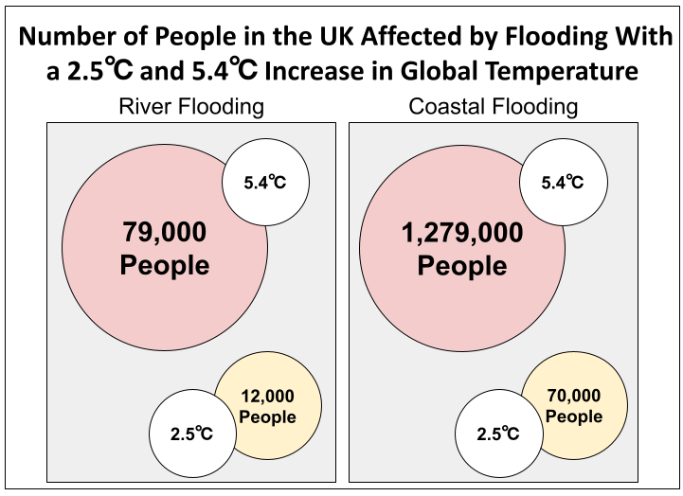
Figure 1: Number of People in the UK Affected by Flooding With a 2.5°C and 5.4°C
Increase in Global Temperature (Adapted from Ciscar et al., 2011).

2.2 Decarbonisation
Decarbonisation is one of the ways to limit the global and local impact of climate change. Decarbonisation is the reduction of carbon, particularly carbon emissions (Department of Business, Energy, and Industrial Strategy, 2021). To that end, the UK has outlined and followed several “carbon budgets” to decrease carbon emissions and reach net-zero carbon by 2050. Net-Zero Carbon, as defined by the United Nations, is reducing emissions as much as possible with any remaining uncontrolled emissions being absorbed by the atmosphere, oceans, and forests; it is a balance between the generation and consumption of greenhouse gases (United Nations, n.d.).
In addition to the broader goals of reducing greenhouse emissions by 78% by 2035, the UK has set reduced emissions and sustainability goals for the residential sector, principally with buildings (Department of Business, Energy, & Industrial Strategy, 2021). There are three pillars in the Net-Zero Pathway for buildings: behaviour change, energy efficiency, and implementation of low-carbon fuels and technology (Climate Change Committee, 2020). The broader methodology for building sustainability goals is known as decarbonisation.

2.3 Building Decarbonisation
Building emissions are carbon emissions generated by the processes of the normal operations within the building, both direct and indirect. Direct carbon emissions result from the exhaust gases emitted by equipment like water boilers or wood stoves in an older structure. Indirect carbon emissions are typically the result of the energy consumption within a building, putting additional loads on the grid power generation that, in turn, generates excess carbon emissions.
Water boilers, which supply hot water for domestic use and room heating, are often the primary source of carbon emissions for buildings. Traditional water boilers can be classified as natural gas-fired or heating oil-fired. Both methods generate carbon emissions, with oil-fired boilers generating more pollutants than gas-fired, as oil is a less efficient combustion accelerant (Rafique & Williams, 2021). The age of water boilers is also an issue since inefficient older boilers generate between 1.4 - 17.7 times more pollutants than newer, automatic control system boilers (Horak et al., 2017). Modern boiler control systems help an operator identify when equipment is operating inefficiently and can signal an operator to take corrective actions to improve heating efficiency.
Unnecessary energy consumption due to human behaviour can lead to additional carbon emissions. For example, opening a window and introducing cold air when a room is being heated leads to additional carbon emissions, since more energy is required to compensate for the potential heat loss from the open window(s). Unfortunately, additional carbon emissions are common in academic buildings since the variations in room occupancy during the day make efficiently controlling an academic building difficult (Kibert & Fard, 2012). In terms of the relationship between building emissions and its occupants, Harputlugil & De Wilde (2021) stated that “Occupants not only consume energy as a consequence of their presence but also with their operative control related to building type” (p.4).
Operative control is the control occupants have to change a room’s environment. For example, if a person thinks a room is too warm, they might turn off the heat and open a window, leaving the room comfortable at the time but too cold for later use. People tend to prefer the ambient environment that is more suitable for their comfort (Harputlugil & De Wilde, 2021). This unique challenge in decarbonisation is an example of human factor impact on a building’s decarbonisation efficiency.
The presence of occupants plays a significant role in building energy consumption; when a space is empty, assuming heating and cooling systems are operating normally, the systems will efficiently maintain a constant temperature in the room. When looking at equipment efficiency in an occupied space, additional factors need to be considered. For example, when the number of occupants in a room exceeds the designed occupancy for the ventilation capability of the equipment in a room. The occupants might open windows to reduce the humidity within the room. The opening of windows will resolve the issue of humidity but also introduce the outside environment where the temperature could be drastically different. As a result, the heating/cooling unit in the room will try to compensate and consume excessive energy to keep up with the over-crowded room and the open windows.
The series of actions leading to inefficient energy consumption in the example above cannot be anticipated and addressed without researching the cause and effect of the event. To study the event for best practice, occupancy (cause) and ambient environment (effect) data are needed. Occupancy data could be obtained through occupancy sensors that identify the exact number of occupants in the room. Ambient environment data could be collected through sensors that record the temperature, humidity, and carbon dioxide concentration. Once these data are available, they can be put into software to be further analysed and used to simulate the human behaviour that leads to inefficient energy consumption. Subsequently, changes can be made to the building’s control systems and temperature control actuators to provide the desired room environment without excess energy consumption.
However, like any other analysis process, advanced building and room control technologies require sensors to report the occupancy and ambient environment in defined spaces. Only then will the advanced building monitor system be able to make informed decisions to modify building equipment operation.

2.4 Digital Twin
For the purpose of this project, a digital twin (DT) is the digital model representation of a building. The DT receives real-time data from the building and can use that data to conduct simulations as well as control the building. The simulations can include multiple factors of the building and predict the outcome of any changes proposed for the building.
In the view of El Saddik (2018),

… digital twins will facilitate the means to monitor, understand, and optimise the functions of all physical entities, living as well as non-living, by enabling the seamless transmission of data between the physical and virtual world. (p. 87).

A digital twin is not just a simulation. Rather, a digital twin can be described as a simulation with the capacity and means to accept real-time data from whatever is being modelled (Khajavi et al., 2019). Because a digital twin receives real-time data from sensors, a user could use the digital twin to monitor the status of the environment and equipment to ensure normal operation.
When implementing a digital twin for a new or retrofitted building, one must start with the building’s existing information and with real-time data coming from existing building sensors. However, it is time-consuming to develop a comprehensive digital twin that represents a complete duplication of a physical building and intelligently and autonomously responds to the different needs of all building users. Specifically, to construct a complete and comprehensive digital twin model, the following four factors should be considered and included; i) the DT model contains all the new and existing information about the building; ii) the DT model is able to present real-time data that indicate the ambient environment and occupancy of the building; iii) there is a connectivity between the DT model to the estate-wide facility management system; and iv) there are considerations on the behavioural characteristics and human factors of the building users and operators in the DT model (Service Works Global, 2020).
As a representation of the physical building, the digital twin needs to integrate all the existing and new information about the building. Existing information includes the building layout drawing and the building material of the structure. New information is any data that is collected in the process of creating the digital twin. For example, a detailed survey of the plant room equipment and a 3-Dimension scan of the building to create the building model. This information is the backbone of the digital twin that later allows the user to relate the building information shown in the model with the correct space or equipment.
The ability of displaying real-time information in an easy-to-navigate model with real-time data to building users is what separate the digital twin from other building model or management systems. The real-time data streams from the building sensors are critical to the modelling accuracy of the digital twin. When first implementing a digital twin, the data could be collected from existing or other sensors that could give the user an idea of the environment and occupancy of the building. As the integration and development of the twin progresses, the data should represent the exact environment, occupancy, and operational status of the equipment. The coverage and precision of data collected are the keys to completing a digital twin.
To maximise the benefit of the digital twin, it should have the capability to communicate or transfer data with other interfaces or databases. The connection between the digital twin and a broader facilities management system, for example, is one way that building operators could benefit from the constant data of the digital twin. With such a connection, when a light bulb has failed and it is detected in the digital twin interface, the alert could be forwarded to the facilities management system to set up a work order to replace the bulb or fixture.
The human behaviour factor is a complicated DT input that also must be considered when using a digital twin. One of the benefits of a digital twin is its capability to incorporate and anticipate any trend in building environment change. For example, because each building user has their own standard for the definition of a comfortable environment, human factors should be considered when designing a digital twin. It is important for the digital twin interface to recognise that sometimes the change in the environment is due to human behaviour rather than defective equipment.
With all four factors included in the digital twin model, the twin will be a close representation of the physical building and environment. As a result, the digital twin could be used to conduct simulations on the existing building model and generate a potential outcome. For example, for decarbonisation purposes, a DT building manager or operator could propose changes to the building's operation and conduct simulations in the digital twin to verify the expected outcome.

2.5 University of Worcester and Decarbonisation
The University of Worcester is in Worcestershire County, England and contains multiple campuses: City Campus, St. John’s Campus, Severn Campus, and Lakeside Campus. The leading sustainability effort for the University of Worcester is its commitment to Net-Zero Carbon targets for 2030 (Green, 2021). The University of Worcester’s sustainability plans are currently led by the Director of Sustainability, Dir. Katy Boom. Dir. Boom works directly with students and staff to implement sustainability programs to help decarbonise the University.
Through the University’s sustainability programs, the University of Worcester is making progress towards their goal of Net-Zero Carbon by 2030. These programs target both the education and behaviour of students and staff. The University has developed and implemented training modules for education for sustainable development (ESD) for both staff and students (University of Worcester, 2019). Following this education comes the behavioural changes. For example, according to the Student Switch Off Initiative from 2017-2018, the University encourages students to reduce demands for energy during building usage by turning lights off when not in use, and to reduce water usage. It was estimated that the total energy savings from the Switch Off Initiative alone was approximately £5,209 (National Union of Students, 2018).
In addition to education and behavioural change, the University is working towards the mitigation, adaptation, and resource efficiencies through operational changes in campus buildings. For example, the University has installed Solar PV to Woodbury and the Arena, producing clean electricity, as well as looking toward other sources of energy for the campus, such as geo-thermal (University of Worcester, 2019). Recently, the University has undertaken the task of decarbonising their campus using a digital twin. This digital twin would be used to collect data about the building for the University to make informed decisions about the management and usage of that building. The pilot building for this effort is the Sheila Scott building, shown in Figure 2.

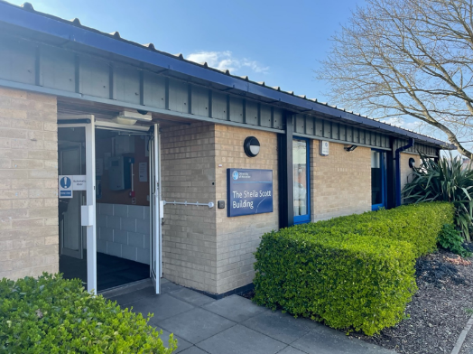
Figure 2: The Front Entrance to The Sheila Scott Building

2.6 The Sheila Scott Building
The Sheila Scott building is located at the University of Worcester’s St John’s campus and is used for simulation and instruction for the school’s Nursing, Midwifery, Paramedic Science, Physiotherapy, and Occupational Therapy programs (University of Worcester, n.d.). The building's structure consists of brick walls, large floor-to-ceiling windows, and a metal roof. A layout of the Sheila Scott building can be seen in Figure 3.
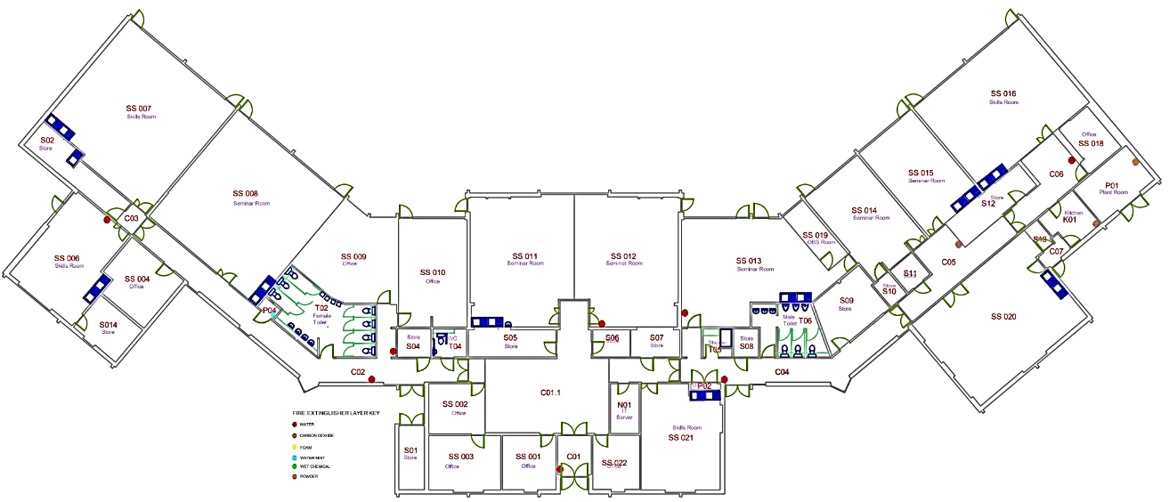
Figure 3: Layout of the Sheila Scott Building. Adapted from (University of Worcester Facilities & Estates Department, 2016).
Despite the simple layout of Sheila Scott, the building is complicated, yet contained, particularly with its use. The classrooms in Sheila Scott are split into two types: skill rooms and seminar rooms. The skill rooms are where most of the equipment for the hospital ward simulation is. Seminar rooms are typically used for theory and lectures. All the rooms can be rearranged to suit different needs requested by the lecturers. A range of factors need to be considered to establish capacities for these rooms, such as the human factors between both students and the teachers, the hardware factors, heating, and ventilating capacity, and finally, the safety factor to ensure the room is not overcrowded. A drawing of rooms SS 007 and SS 008 is shown in Figure 4; note that rooms SS 007 and SS 008 are identical in size but have different assigned specialties.
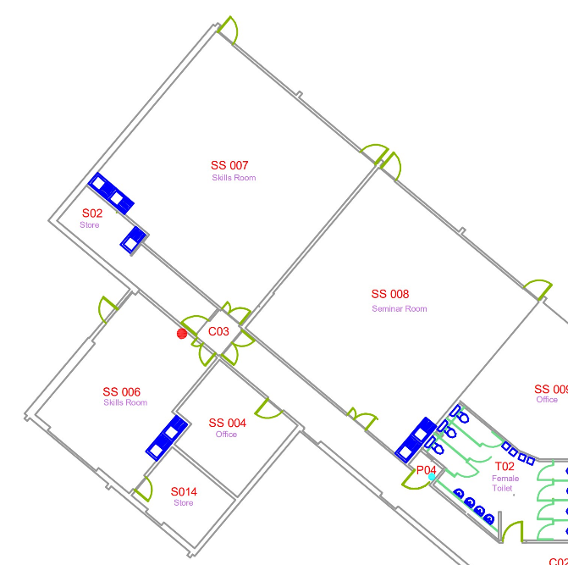
Figure 4: Cropped View of Rooms SS 007 & SS 008 in the Sheila Scott Building.
Adapted from (University of Worcester Facilities & Estates Department, 2016).
Building users are the students and lecturers in the Allied Health and Community programs. Students outside of these disciplines do not use this building, mostly due to no designated study space being available within the building and how small the building is.
One of the ways that the University is implementing heat decarbonisation is through the digital twin. The University of Worcester and CPW are working towards a pilot that involves the use of a digital twin on a building and is in the process of obtaining and integrating both human and building factors. The use of the digital twin is part of a decarbonisation effort being carried out by the University of Worcester and it is advised by CPW with their heat decarbonisation plan. Estates and registry services staff at the University of Worcester have completed space utilisation surveys across the campus, and Sheila Scott was found to have poor space utilisation. This, in combination with some of the technology installed in the building, detailed in Appendix B, made it a candidate for the digital twin. Sheila Scott is also not on the University’s Building Management System (BMS), which makes it even more unique. Provided that this pilot is successful, the digital twin could expand across the estate.
With what the University learns from the Sheila Scott Pilot, they hope to apply the valuable takeaways, such as the technology required, to other buildings on the campus. Eventually digital twinning the campus will enable the University to make informed decisions about the broader building management and will aid in their decarbonisation goal.

3.0 Methods
The goal of this project was to create a framework and rubric that defines the human factor considerations needed to maximise the benefits of implementing a digital twin. The focus of the framework was to formulate recommendations based on human factor considerations for implementing a digital twin. The focus of the rubric was to guide the DT implementation process with respect to human factors. The objectives and associated methods that were used to achieve the human factor framework and rubric goal are detailed below. An illustration of the objectives and methods is shown in Figure 5.
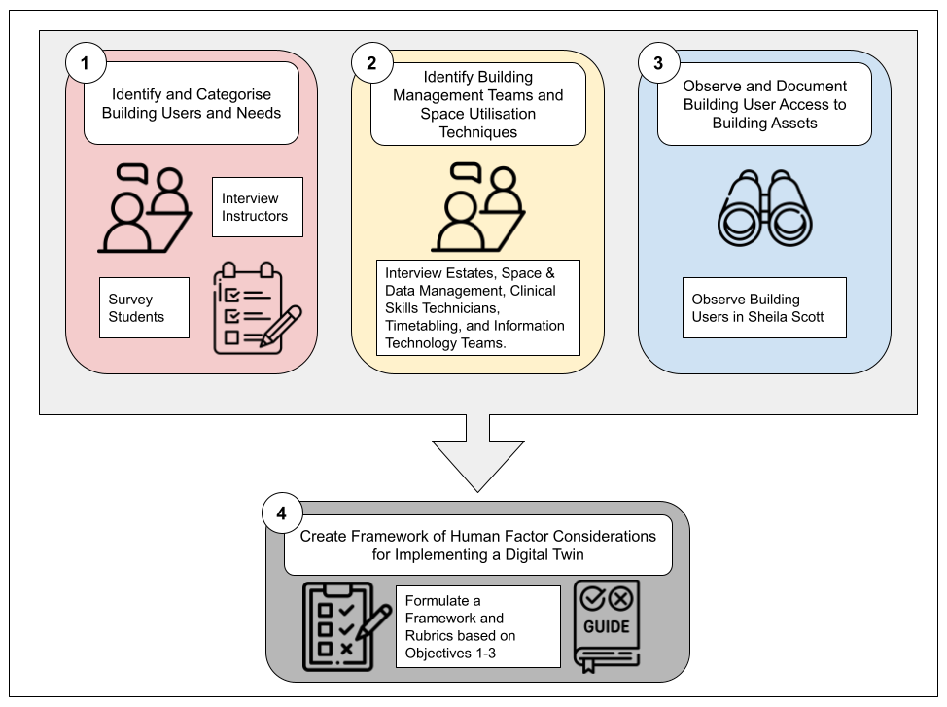
Figure 5: Summary of Objectives and Associated Methods

3.1 Identify and Categorise Building Users and Needs
The purpose of this objective was to identify the individuals and groups that engage with the Sheila Scott building and their interactions, needs, and expectations of the building. Any student, faculty member, staff member, estates staff member, or anyone else who steps inside the building is a building engager. Building user logs - the names and times of those building engagers - provided much of the data needed to categorise these groups.
To understand the human aspect of engagement with Sheila Scott, it was important to also know the how, when, and why. We proposed to have both one-on-one interviews with a select number of users, as well as surveying students that have classes in the building. The interviews were semi-structured, and generally revolved around these questions: Why do you go into the building, and what do you do there? A list of sample interview questions for the groups detailed above is provided in the Addendum to this report.
To reach the remaining building user group - students of the Sheila Scott building - our project team conducted a survey, provided in the Addendum to this report. The intention was to make this survey easy to fill out and take less than a few minutes to complete. This survey was accessed through QR code and contained general questions about the current conditions in the Sheila Scott building, a place to provide feedback on comfort conditions, and a box at the end to be filled with the participant’s email address if they wanted to be contacted about their participation in a focus group. Our project team dispersed this survey through multiple strategies, endorsements by clinical skills technicians and lecturers, education platforms, and approaching students leaving and entering the building.

3.2 Identify Building Management Teams and Space Utilisation Procedures
The University of Worcester has four staff teams that oversee building management: the estates team, space and data management team, registry services team, and clinical skills technicians. It is also important to acknowledge that in addition to stakeholder interviews, we met with professionals within the digital twin field. Our team gained insight on the use, implementation, and operation of a DT in a broad sense from at least one expert working in the field and building standards. These professionals are noted in acknowledgements at the beginning of this report.
To gain insight into the implementation, operation, and use of a digital twin for Sheila Scott, it was important to interview managers of the different staff teams about their roles. The managers identified trends in heat and energy usage, general building improvements, knowledge of digital twins, and potential benefits of a digital twin. The format of these interviews was semi-structured. We interviewed the Assistant Director of Estates Services, the Head of Maintenance, and an Energy Officer, the Service Development Manager from the Space and Data Management team, one Tabling Officer and Academic Registrar from the Registry Services team, and the Clinical Skills Technicians team. These individuals were contacted via email addresses obtained from our sponsors. A sample set of interview questions for each group and a general informed consent form provided in the Addendum to this paper.

3.3 Observe and Document Building User Access to Building Assets
Understanding the connection between human factors and the technology of the digital twin that CPW is creating as part of the DT project was crucial. To understand this connection, building users were observed and their interactive behaviours with the building assets were documented. Similarly, observations were used to identify the number of controls building users can access. For example, our team recorded whether building users could do things like change the thermostat or open windows in specific rooms.
In addition to assisting in documenting control usage, observation was utilised to track occupancy. It helped the team understand class sizes and occupancy status to formulate suggestions on space utilisation.

3.4 Create Framework, Rubric, and Evaluation Sheet of Considerations for Implementing a Digital Twin
The general knowledge of the technical aspects of the Sheila Scott digital twin needed to understand this pilot are discussed in Appendix B. However, the human factor considerations needed to implement a digital twin effectively was developed into a framework document based on previous observations, survey, and other data sources. Similarly, a rubric was developed to provide an implementation and integration progress guide of relevant building and human factor elements for implementing a digital twin of a building, and follows a format based on stages of the implementation. The stages follow a cycle from initial implementation of the digital twin to reaching an ideal steady state discussed in Section 5.0. Recommendations for optimising operational decarbonisation in the Sheila Scott and for use in other University and city buildings. An evaluation sheet was created to organise and formulate improvements from the rubric, discussed in more detail in Section 5.0.

4.0 Results and Findings

4.1 Interviews Results and Findings
Lecturer Interview
A total of three lecturers who teach in the Sheila Scott building were interviewed. The issue that was most often discussed in the interviews was that there is an influx of students that use the Sheila Scott building, but the building is not of the correct size to host them for their program needs. In short, the students are outgrowing the space. Other concerns that were raised were that the timetables weren’t always correct and that the roof leaks on occasion.
When lecturers are teaching sessions, it is common to use multiple rooms. This is typically because one room is used for one activity, while the other is used for a different one. Multiple rooms can be booked for the same class period.
Due to the impacts of Covid-19, lecturers open windows to help circulate air flow when a room is occupied. These impacts are year-round, with lecturers opening windows during colder temperatures in the winter. This results in students being instructed to wear layers of clothing. The lecturers have access to the heating and cooling systems; however, they aren’t trained on how to operate those systems.

Student Survey Data
Gathering data from the students that use the building proved to be difficult. We worked with a variety of personnel at the University to share the survey we created for the students, yet the response rate was low. We only received one response to the survey.

Estates Staff Interview
From these interviews, our team learned about the operational characteristics of the Sheila Scott building. For example, it was stated that the building is quite old and not energy efficient, as it is not well insulated. The inefficiency of space usage was also brought to our team’s attention.
When the estates team was asked about what improvements they would like to see implemented in the Sheila Scott building, answers ranged from the following:
- Updating the heating system
- Replacing the glazing on the windows
- Adding more sensors to detect things not currently accounted for, like harmful bacteria
A benefit of implementing the digital twin that was noted by the estates staff during interviews was that a digital twin could be used for preventative maintenance. It was also noted that the digital twin can help to improve the Sheila Scott building’s sustainability and reduce its carbon footprint. However, one estates interviewee was concerned about the digital twin being implemented in Sheila Scott and would have preferred the digital twin be implemented in a smarter building on the campus. Further issues discussed regarding the digital twin’s implementation is that it takes an entire team to manage, human factors within a digital twin are difficult to gauge, and that the physical assets digital twin is difficult to repair should issues arise because there was a contractor involved in the digital twin’s creation.

Registry Services Staff Interview
From our interview with personnel in the registry services team, our team was able to get a better understanding of how timetabling works, as well as potential applications of the digital twin in the timetabling process. Timetabling the classes at the University is a process that spans much of the academic year, starting in November and ending in August. Throughout November and December, the timetabling staff collects data about the modules, course leaders make sure that all the information is correct, and the timetabling staff creates virtual students to make sure there are no scheduling conflicts. In February, the new 2nd and 3rd year students select their courses. In April, the timetabling staff starts to draft the timetable, and in May, the first draft is created, module leaders and lecturers can still make changes, and the timetabling team works to implement those changes. Students can also request changes for their personal timetables. Finally, in August, the new 2nd and 3rd year students are given their timetables, and the new 1st years select their courses and get their timetable. The timetabling staff’s priority is the class schedule, it being the most complex task of the year.
Following the course timetable, corporate and University events are timetabled, staff can book rooms through their own booking system, and the student union can book rooms. Students do not have their own booking system and can only book through emailing the timetabling staff.
In addition to timetabling, the timetabling staff has a vested interest in room utilisation at the University. The timetabling staff used to undertake room surveys once a semester by employing students to observe rooms and see if they were being used, and if being used, to what capacity. Much of their data was anecdotal, and they are now looking to move towards data-driven ways to determine room utilisation.

Clinical Skills Technicians Interview
From the interview with the Clinical Skills Technicians (CSTs), our team was able to develop an understanding of how the Sheila Scott building is used and managed. The CSTs manage and set up the equipment and classrooms for each class; one of the responsibilities they have taken on this year is the timetable of Sheila Scott. During a normal year, the CSTs liaise between the lecturers and timetabling if there are any issues or questions about what rooms are available at what times. Through our interviews we learned that while timetabling Sheila Scott for this academic year (2021-22), classes were being changed on the timetable more than previous years, and the timetabling staff was unable to keep up with the changes being made. As a result, timetabling was assigned to the CSTs for the Sheila Scott building. The CSTs have a spreadsheet that they break down into weekly timetables to keep track of the classes being held in the building.
The CSTs identified one of the main issues with their timetabling is that Sheila Scott is not being scheduled efficiently, in part because of the different timelines of classes for the different courses and because of the lack of space for the increasing student population. For example, the year one nursing students have mandatory classes that they need to take before going on placement, working in a hospital. These mandatory classes can conflict with other classes year two nurses take. An example of how these might conflict is as follows, lecturers for the year two nurses want to block out a time to complete a requirement, but the requirement does not need to be completed until later in the year. Lecturers for the year one nurses want to block out a time to complete one of their requirements, and this requirement needs to be completed early in the academic year. Both lecturers decided to book rooms on the same day and time despite these requirements being due at different times.
The CSTs also mentioned that heat is not even throughout the building. For example, in rooms SS015 and SS016, which are in the right wing of the building from the foyer, it gets uncomfortably hot. On the contrary, rooms SS007 and SS008, located in the left wing, are often freezing. There are space heaters and thermostats in the rooms for lecturers and the CSTs do adjust the temperature when necessary. These heat disparities cause those that use the building to dress for the temperature inside the building, rather than outside. They also noted that the heat escapes through the windows, and all the rooms have openable windows.

Interview Findings
Interviewing each of the four groups provided us with an overview of the current state of building usage and management. It also helped our team understand the relationship between the concept of the digital twin and the reality of the estates staff and building users who represent the building management and users’ structure. Benefits and limitations of the maintenance, preparation, comfort, and other human factors of the digital twin were determined through these interviews. Interviews with these management teams allowed us to educate the stakeholders about digital twins for buildings and its specific benefits for each team. The information collected from these interviews allowed us to understand the managers’ and users’ usage of the building.
Through these interviews, we have found that:
- There is a conflict in the set standards in some of the building operations, particularly the conflict between signage and operation policy. For example, during the Covid-19 pandemic, the opening of windows was authorised and encouraged to maintain air flow within a room. There is still signage on the windows with this policy, even though the University has modified their Covid-19 policies to follow current government guidelines. In the University's Heating and Comfort Policy, it states that windows should remain shut, unless the heating has been turned down prior to the opening of the window.
- The user of the space is also encouraged to change the setting of the thermostat to adjust room temperature rather than opening windows. Although this is in place, there appears to be a lack of understanding and no clear instruction on thermostat adjustment. There are rooms with overhead heating units have signage that have a set limit for the heater and temperature setting that seems rather arbitrary with no indication of ambient temperature. There are also signs on the window that indicate keeping the window open even though signs on the room doors suggest all windows to be closed when the room is vacant. The conflict in posted signage contributes to the heating difficulties in the building, particularly with heating retention.
- There appears to be a lack of communication about building management between the building users and managers. During these interviews, it was mentioned that the radiator heats the room up too much, leading users to open all the windows and available exits for ventilation and cooling. As a result, the area of the room closest to the window became too cold for comfort while the area closer to the radiator remained too warm.
- There appears to be a lack of communication about building issues between the building users and managers. In all our interviews with the building users, they express an unsatisfactory opinion towards the heating provided in the Sheila Scott building. However, the building managers, who maintain the building, pointed out that all the equipment in the Sheila Scott building has been low-maintenance and operates normally.
- Building issue feedback about heating is often misunderstood because of unclear communication between stakeholders. Because the Sheila Scott building boiler control can only modify the whole building, there is often not much the estates staff can adjust to remedy this. Still, the building users could report the issue more precisely when they experience an uncomfortable environment. For example, which wing of the building is this heating issue more common, as well as whether the windows are kept open, is information pertinent to determining what exactly the issue is. When the estates staff are on-site, it is often found that the equipment is not faulty but rather put on the wrong setting. With better communication and education, the heating issue could be better identified and resolved.
- Instructors can book two rooms simultaneously to have sufficient class space and the correct room set up to ensure room readiness in terms of equipment but thus wasting energy heating (or cooling) a room that may not be used. Subsequently, a class would spend half of the time in one room studying theory and spend the second half of the class time in a different room practising exercises. With common practises that use multiple rooms for one class, the room scheduling at Sheila Scott is quite complicated, resulting in heating and lighting to be constantly running to ensure the room's readiness. This leads to increasing energy consumption and carbon emissions.
- Moreover, in terms of occupancy issues within the Sheila Scott building, it has been noted that the posted occupancy number in each room is determined without proper surveying in the defined spaces and therefore proven to be inaccurate and inefficient to use. The occupancy in each room depends on the activities that are carried out in the room at the time, often leading to what appears to be inefficient space utilisation. Because of the large number of students in a single class, a single cohort can consist of multiple classes utilising different rooms at the same time for the same large group of students. As a result, multiple rooms are booked for up to five hours of the day for the same class. When all the lecturers use their rooms as they are scheduled, the building appears to be well occupied, but it is common practice for lecturers to not use a room or cancel class without updating the person in charge of scheduling.

4.2 Observation Results and Findings
Our team observed various classrooms in the Sheila Scott building for three days, 4-6th April 2022. The observations occurred at the beginning and end of classes, which typically started around 9:00 and ended around 16:15. The data collected in and around the building were occupancy, open windows and emergency exits, what attire people were wearing in the building, and any other observations relevant to the use of the building. Of the 32 data points, 24 of those data points were usable; this is due to the observer not being able to accurately record the data needed. Using the data gathered from the Google form (can be found in Appendix K in the Addendum to this paper), we sorted the data into a spreadsheet, shown in Appendix C. Of the 11 rooms in Sheila Scott, 10 rooms were observed at least once.
During this observation period, 62% of the rooms were empty and 38% of the rooms were under occupied. For example, room SS013 was scheduled to be used from 9:15 to 16:15. When we arrived to observe at the beginning of the class, the room was empty. At the end of the class, the room was underoccupied. These occupancies were determined at the discretion of each observer, and the current capacity limits were used as a guideline. This data indicates that the rooms were not being used, and if they were being used, they were not being used efficiently. None of our team members observed a room over occupied or at the correct capacity. Throughout the three-day observation period, the windows and emergency doors were closed. A window was open once in our observation period. Emergency doors were open three times during the observation period, with each time happening at the time of the observation. The duration of the doors being opened was unable to be determined given the limitations of the study.

Findings
Because the Sheila Scott building does not have a listed room occupancy number on each of the rooms, the occupancy percentage recorded in the observation is based on the observer’s opinion about the number of observed occupants compared to the room size.
- Even with a schedule that is updated weekly by the Clinical Skills Technicians, it still does not accurately reflect the actual room usage in the building. During our observation period, more than half of the rooms that were scheduled to be used were empty. Even though some rooms were used, they appeared to be under-occupied. It is important to note that students were taking a written exam and certification process at the time in many of the classrooms observed. Therefore, the occupancy observation might be particular to an exam environment and does not represent room usage in the normal (teaching) environment.
- All the windows in the empty classrooms were closed during our observation, and only one window was observed open when a room was occupied. This indicates that even with the confusing and conflicting signage in the room, the room users did close the window prior to vacating the room. However, this might not be true during the days that the room usage is high and there is an increase in the number of people entering and exiting the room.
- Finally, it was observed multiple times that the emergency exit door on the back glass wall was ajar. This could be potentially due to the complexity of jamming the door open; once the door was successfully jammed open, it was kept open for the whole day. With the outside ambient temperature averaging 10 °C on the day of the observation, the ajar emergency exit could significantly affect heat retention within the rooms.

4.3 Framework & Rubric
For the Sheila Scott digital twin to be operated in a manner that optimally reduces carbon emissions, we determined that the conditions and characteristics of a building must meet a baseline. In the next section, a framework is described that was developed from the human factor considerations and building elements our team has identified that are needed prior to the implementation of a digital twin for decarbonisation. The framework checklist does not, however, address building or digital twin stakeholders since stakeholders and identification methodology are discussed in Methods sections 3.1 and 3.2. Generalising these checklists allows the framework to be applied to other buildings at the University or in the local area.
In addition to the framework, a rubric has been constructed to help building users, and primarily estates and contracted staff, understand the stages of implementation of a digital twin to a building environment. We created a rubric with two elements, one focused on building factors and one focused on human factors, both of which are presented in further detail in Section 5.0. After the rubric, the next step is to use the evaluation sheet to assess the status of implementation, which is again, described in detail in Section 5.0 below.
This framework, rubric, and evaluation sheet will serve to guide the University on the preparation of a building for a digital twin and the implementation strategies for its stakeholders.

5.0 Framework and Rubric

5.1 Digital Twin Preparation Checklists
Two checklists were developed to establish a baseline for factors that should be considered prior to the implementation of a digital twin for any building. One checklist was specifically for baseline building factors and one was for determining baseline human factors.

5.2 Building Factors Checklist
The building factors checklist is focused on factors such as its heating system, space utilisation, timetabling, building administration interfaces, and building user interfaces (definitions provided in Appendix A). Shown in the Framework Checklist in Table 1, is Stage 0, defined as the preliminary work that must be completed prior to implementing a DT.
The sub-elements included in the building factors checklist include HVAC, Space Utilisation, Baseline Building Data Requirements in Quantitative metrics, Building Admin Interface, and Building User Interface. Building fabrication pieces of the checklist include HVAC, Space Utilisation, and interfaces.
The baseline historical data requirements include resource use data (gas, electricity, water, etc.) for measuring continuous improvement. The critical pieces of this checklist include the historical data and benchmark costs of the building’s energy usage. It is critical because that data is a factor of a cost benefit analysis of energy usage, but also for the cost benefit analysis of implementing a digital twin to achieve decarbonisation goals.

Building Factors Checklist
Project Title: |  | Project Manager: |  | Location:
Element | Sub-Element | Stage 0: Preliminary Work Done | Included | N/A | Notes
Building Factors | HVAC | All HVAC system assets are documented with specifications and serial number for future inquiries. |  |  | Some buildings may not have HVAC. In that circumstance, use the heating and cooling systems as the sub-element.
 |  | All HVAC assets are currently managed to their maximum energy efficiency.
 | Space Utilisation | Weekly room schedules are made available to be accessed by all building users.
 |  | Rooms that are scheduled to be in use are being used at least 75% of the time.
 |  | Room usage is in accordance with listed capacity limits.
 |  | There is a verification process in place regarding when, how, and who is using rooms within the building.
 | Baseline Building Data Requirements: Quantitative Metrics | Water usage and costs from previous 6-12 months is tracked and quantified through metering to be used as a baseline. |  |  | A baseline of historical energy usage and costs are needed to complete a cost benefit analysis after the digital twin is implemented.
 |  | Electricity usage and costs from previous 6-12 months is tracked and quantified through metering to be used as a baseline.
 |  | Heating usage and costs from previous 6-12 months is tracked and quantified through metering to be used as a baseline.
 |  | Building use data from previous 6-12 months is tracked and quantified through metering to be used as a baseline.
 |  | A strategy to track space and energy intensities throughout all rooms and spaces of the building should be in place. This will identify the largest energy wastes. |  |  | Energy usage per room must be tracked to know where and when to make improvements to energy usage throughout the building.
 | Building Admin Interface | Existing building admin interface is fully understood by building management. |  |  | Building management refers to the team that manages the building assets and operations. An existing building management system can include a range of systems from manual control of building assets to SMART building technology.
 |  | Building management has physical control of all building assets through the existing building management system.
 |  | Building management has a reactive maintenance system in place.
 | Building User Interface | Building users are able to control the opening of windows in individual rooms.
 |  | Building users can adjust HVAC settings in individual rooms when deemed applicable.
 |  | There are limitations in the form of policies to ensure minimum energy waste.

Table 1: Building Factors Checklist

5.3 Human Factor Checklist
The human factor considerations elements are focused on the role of the stakeholder groups. The stakeholder checklist identifies the critical stakeholder groups defined by our findings and results from the Sheila Scott Pilot. The critical stakeholder groups included in this checklist are Estates staff, Building Users, IT, Data and Space Management, and Registry Services. Stage 0 for these groups includes the baseline specific to each group. The checklist includes statements regarding requirements and education of benefits specific to each group.
Utilising a digital twin in a building environment can provide many benefits specific to the listed stakeholder groups. For example, the Estates staff stakeholder group will manage the digital twin of the building regarding building assets, while the building users' group will focus on the behaviour and interaction within the building. Another example of specific needs and benefits for a specific stakeholder group is IT staff. Through the project team’s conversations with professionals in the field, they have expressed the importance of IT policies and protocols. The baseline checklist regarding the IT stakeholder group must reach a specific benchmark of preliminary security and maintenance protocols for adapting DT technology.
The last element in Stage 0 of the human factor checklist is forming a DT management team. This management team must be comprised of one or more representatives from each stakeholder group. This team will manage and monitor the digital twin in all aspects throughout the checklist and rubric phases. It is expected that this leadership team be created before the evaluation of the implementation of the DT with the rubric.
Throughout the creation of the human factor checklist, the focus was on the interaction and controlling of assets to maximise decarbonisation. The digital twin management team will be put in leadership roles throughout the following rubric and evaluation processes discussed in Sections 5.4 and 5.5.

Stakeholder Checklist
Project Title: |  | Project Manager: |  | Location:
Element | Sub-Element | Stage 0: Preliminary Work Done | Included | N/A | Notes
Human Factor Considerations | Building User Considerations | Building Users have been educated on what a Digital Twin is, how it functions, and their role in the Digital Twin.
 |  | Building users have received sustainability education and understand their effect on building energy usage.
 |  | Building users use energy in a sustainable way to the best of their ability following the education.
 |  | Building users are aware of the comfort policies in place.
 |  | Building users are aware of their current energy usage.
 |  | Building users are aware of their current space utilisation.
 |  | Building users have a feedback system in place for maintenance and comfort requests.
 |  | Building users are compliant to working towards sustainability targets for the building.
 | Estates Staff Considerations | The Estates staff have been educated on what a Digital Twin is, how it functions, and their role in the Digital Twin.
 |  | The Estates staff currently manage building assets to regulation standards (comfort policies, energy policies, etc.).
 | Data and Space Management Considerations | Data and Space Management staff have been educated on what a Digital Twin is, how it functions, and their role in the Digital Twin.
 |  | Data and Space Management understand current state of management and operations in the building.
 | IT Considerations | IT and Data and Space Management staff have been educated on what a Digital Twin is, how it functions, and their role in the Digital Twin.
 |  | IT Staff will create policies and standards for adopting DT technology. Specifics regarding security and protocols for implementation should be considered.
 |  | IT and Data and Space Management understand current state of management systems in the building.
 | Timetabling and Scheduling Staff Considerations | Timetabling and Scheduling Staff have been educated on what a Digital Twin is, how it functions, and their role in the Digital Twin.
 |  | A strategy to track space and energy intensities throughout all rooms and spaces of the building should be in place. This will identify the largest energy wastes.
 |  | Timetabling and scheduling staff understand how to schedule space at maximum efficiency without the Digital Twin.
 | Management and Monitoring of the Digital Twin | A DT management team made up of at least 1 of each stakeholder group is formed. |  |  | It is assumed that this group has completed their respective Stage 0 and preliminary work.
 |  | This group is educated on how to access, manage, and monitor the Digital Twin sensor dashboard.
 |  | This group has a line of communication to their stakeholder groups to gather feedback from users.
Table 2: Human Factors Checklist

5.4 Rubric for Building Factor and Human Factor Implementation of a Digital Twin
A rubric was created to evaluate the implementation status of a digital twin’s operational state. The rubric has been created with the end goal of maximum energy-saving potential, shown in Table 3. The stages are described below, and a cycle diagram is shown and described along with the stages in Figure 6. The rubric includes Stages 1 through 4 for both the building factor and the human factor elements.
The rubric includes the following stages: Stage 1: Iterative Education, Stage 2: Dashboard, Stage 3: Manual Feedback Integration, and Stage 4: Continuous Integration.
Stage 1 is defined as iterative education because it is assumed that the checklists of Stage 0 are completed. Education and training are integral pieces of a DT, and the education will expand as the DT grows. From conversations with professionals in the industry, it was determined that this is a stage that all building stakeholders must take part in. The education could be delivered through methods such as an online format and can be catered to different groups and include different depths of information.
Stage 2 is named the dashboard stage, where stakeholders can access and understand the sensor data of the twin. This stage is critical that each group can access the data applicable to their specific needs. This is a stage where stakeholder groups can start to formulate feedback for building management based on the information from the digital twin dashboard.
Stage 3 is manual feedback integration; this is where the stakeholder groups have lines of communication in place to provide feedback. This feedback was established previously in Stage 2, to be reported to the DT management team. The feedback can then be reviewed along with the sensor data provided by the DT dashboard.
In Stage 4, the management team, or those who have control over assets, policies, or strategies regarding specific feedback, can forward issues to the correct department. They will conduct the necessary improvements based on the feedback. For example, user feedback regarding heating can be designated to estates who manage heating assets. Alternatively, another example of feedback about space utilisation can be delegated to scheduling and timetabling to make improvements manually.
A cycle is displayed in Figure 6 that illustrates the continuous improvement within a digital twin. It presents how a digital twin is a continuous cycle of feedback integration between the technical and social aspects of a building. This cycle can aid in explaining where the checklist, rubrics, and evaluation stages fit.
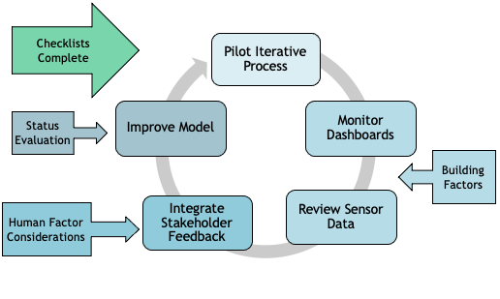
Figure 6: Flow Chart for Use of Checklists, Rubrics, and Evaluation
Human Factors Rubric
Project Title: |  | Project Manager: |  | Location:
Element | Sub-Element | Stage 1: Iterative Education | Stage 2: Dashboard | Stage 3: Manual Feedback Integration | Stage 4: Continuous Improvement
Stakeholder Groups | Building Users | Newcomers of each stakeholder group are educated on what a Digital Twin is, how it currently operates in their building and its respective benefits to the group. Returning building users are educated on the current operations and utilisation of the Digital twin, and any changes to feedback strategies. Iterative education and training should be scheduled to be completed every 12 months. This education can be treated as a recertification and suggested to be offered in an online format. | Building Users can understand the connection between their behaviours and building management. Building users are able to view the data applicable to them from the digital twin. | Building Users have a line of communication to provide feedback, on all topics, to be reviewed manually by the DT management team. | Building Users feedback is being fully integrated with sensor data for continuous improvement through an iterative cycle.
 | IT Staff |  | IT staff can access, view, and understand Digital Twin sensor data dashboard. | IT staff can monitor and use data to make space utilisation more efficient. They will be able to provide feedback to the Digital Twin management team. | IT staff feedback is being fully integrated with sensor data for continuous improvement through an iterative cycle. IT will lead and facilitate sensor data integration.
 | Data and Space Management |  | Data and Space Management can access, view, and understand Digital Twin sensor data dashboard. | Data and Space Management can monitor and use data to make space utilisation more efficient. They will be able to provide feedback to the Digital Twin management team. | Data and Space Management feedback is being fully integrated with sensor data for continuous improvement of the digital twin and space utilisation in the building.
 | Timetabling and Scheduling Staff |  | Timetabling staff can access, view, and understand Digital Twin sensor data dashboard. Ideally, Timetabling can correlate their scheduling with occupancy sensor data. | Timetabling staff can monitor and use data from the Digital Twin to allocate space to classes, events, and meetings. They can provide feedback to management team. | Timetabling and Scheduling staff feedback is being fully integrated with sensor data for continuous improvement of the digital twin and scheduling of the building. Timetabling will facilitate major scheduling changes.
 | Estates |  | Estates Staff can access, view, and understand Digital Twin sensor data dashboard. Ideally, estates staff can correlate the baseline energy consumption with respective sensor data of each asset they manage. | Estates staff are able to correlate the Digital Twin's dashboard data with user feedback to manually control building assets to their maximum energy efficiency. This is done without sacrificing building users needs. | Estates staff feedback is fully integrated with sensor data for continuous improvement of the digital twin and estate management. Additions and improvements to the digital twin in regard to energy management are approved by the estates team.
Building Factors | Basic Technical Understanding | Sensors are placed in the building. More sensors can be added as the system matures for added benefits, however those sensors require more education and training. | Sensor Dashboard is in an accessible state for all dashboard users. | Sensor dashboard displays historical data that can be correlated with other data and/or feedback. | The Digital Twin, as a whole, is running in a fashion that accounts for data and feedback to be analysed for a continuous improvement cycle.
Table 3: Human Factors Rubric
5.5 Evaluation Sheet for Assessing Status of Implementation
The purpose of this evaluation sheet is to track the status of implementation for a digital twin.
Within the evaluation sheet, the user evaluates their implementation by recording their target, their current levels, and how to improve to reach the target level, as well as the priority for the specific element. The evaluation sheet was created as part of a recommendation for the Sheila Scott digital twin use case. However, the evaluation was not created for the sole purpose of the use case, but to be generalised to be applied to other University and city buildings. This evaluation sheet could serve as a guide for any current or future digital twin implementations at the University.

Evaluation Sheet
Element | Sub-element | Target Level | Current Level | Ways to Improve | Priority Level
Stakeholder Groups | Building Users
 | IT Staff
 | Data and Space Management
 | Timetabling and Scheduling Staff
 | Estates
Building Factors | Basic Technical Understanding
Table 4: Evaluation Sheet

6.0 Recommendations
Our research results and findings have led us to the following recommendations.

6.1 The University must review and update its heating, comfort, and Covid-19 policies.
By reviewing the heating, comfort, and Covid-19 policies, a set of coherent building use policies should be created and disseminated to students, staff, and faculty. This will allow the University to combine and balance health and sustainability goals. The following steps should be taken to implement this:
- Review current building use and operational policies to ensure that they are up to date and consistent with the standards set forth by the UK government and University.
- Once all individual policies are updated, establish a committee to work on creating a singular, coherent policy for building use.
  - This committee will be made up of stakeholders from each department involved in building use.
  - Other campus groups, such as students, should be able to make comments about the policy.
- Disseminate the formulated policy to those in the community for feedback.
- Communicate the standard policies, as appropriate, through building signage to all building users.
Following this change, the building will be able to be used to its safest and most efficient by every person that enters and uses the space.

6.2 The University must establish a feedback system to gain insight into what issues building users have with campus buildings.
Despite having the Archibus system to report maintenance issues, such as a broken light, feedback about building and space management is difficult to report.
The University needs to create a system for building users to give feedback about the building, particularly with heating and space utilisation. This feedback system could take form through a process that uses:
- An email alias, such as estates-building-feedback@worc.ac.uk,
- A form for building users to fill out through a QR code or a physical form,
- Or an annual survey for building users to fill out about the building.
The feedback system can be advertised so that staff and students can reach out with questions, concerns, and suggestions. These can then be addressed by those on the estates team.

6.3 The scheduling of the Sheila Scott building needs to be examined and reconstructed to better accommodate student and lecturer needs.
Timetabling and scheduling of the classes that occur in the Sheila Scott building need to be modified. The reason for this modification is what surfaced in the interview with the Clinical Skills Technicians. It was evident through our interviews that rooms were booked, but not used. These rooms would be heated even though they were empty.
To address this, we recommend that those that lead the modules meet, discuss, and determine a timeline for when classes need to be done for each year of nursing. This will allow fewer scheduling conflicts between the different years of nursing, leading to a less complex timetable, resulting in an easily modified schedule. With this in place, lecturers will be able to plan their classes more easily, making it easier to know when and which rooms they will need. This in turn, would decrease the number of rooms that are booked but not used and allow for more efficient heating of all rooms, booked or otherwise.

6.4 The University needs to standardise a way of determining capacity limits for rooms on the campus.
The University needs to determine a standard way of determining capacity limits for all rooms. The room capacities across campus were determined in such a way that two rooms that are equal in size have two different capacities. Those from the University also do not know when or how those capacities were determined.
There is a standard for determining capacity based on floor space alone. This standard has been defined by the UK government and defines the floor space factor of specific rooms and buildings. However, this capacity standard is specifically for fire safety purposes, and it is unclear whether the University has taken these standards into account.
Quantifying a standard capacity calculation would allow for rooms across campus to be used safely and efficiently. These capacities would be very helpful when scheduling rooms for students. For example, a group of ten students may need a classroom to practice presentations together. The timetabling staff would assign them a room that is as close to the capacity as possible. Having these updated capacity limits would allow rooms to be utilised efficiently since the timetabling team will have the standard capacity rather than a capacity that somebody assigned to the room through means that nobody has knowledge of. Another thing to note when suggesting this is the increasing student population at the University of Worcester.
The increasing student population is causing lecturers and the timetabling staff to schedule classes based on the need for space rather than the limiting capacity. Updating the capacity limits of these rooms may not necessarily change this way of scheduling, but ad hoc scheduling, such as the example above, will be able to be more accurate, thus making the rooms being used more efficiently. It will also help the University in the long run through this piece of decarbonisation.

6.5 The University needs to complete further studies of campus buildings to have the wholistic understanding of space utilisation and heat latency.
In addition to the changes suggested above, the University needs to complete more studies on the campus about space utilisation, heating, and building users to get a wholistic understanding of the way buildings are used and managed.
The University needs to start with a comprehensive space utilisation survey. An example of a space that needs more surveying done is Sheila Scott. Looking into periods of both high and low utilisation in the Sheila Scott building will allow the University to get a better understanding of how the building is used.
Another important piece of analysis are the heating trends, particularly heat latency. When building users turn on the heat in a room or in the building, there is an amount of time between the control being changed and when that space heats up or cools down to the desired temperature. Knowing this latency will allow the managers to better advise users on how to use the heating system in the building without wasting energy.
The University should also consider modernising the Sheila Scott’s heating system. As mentioned above, it takes time for the current heating system to heat a room. More effective heating and cooling systems would help with that issue and would inevitably be more efficient in the long term.

6.6 Students must be surveyed about their behaviour and feedback within the building.
Due to the limitations of the data gathered by our team, particularly with the student survey data, the University needs to survey students to get more information about their behaviour and feedback within the building. To accomplish this, the University should follow these steps:
- Create and refine a survey about building use and feedback for students.
- Compile lecturer contacts for those that use Sheila Scott.
- Contact the lecturers about the survey and ask them to send the survey out to their students.
  - Preferably with an incentive of some sort, such as an extra credit point or gift card
The work that our team has done is a good start to looking at user experience, but it is important to gather more information about building user behaviour and feedback.

6.7 The University must create a designated, trained Digital Twin Management team to monitor and manage any existing DT and implement future DT.
Based on the experience of working with the Sheila Scott digital twin Pilot, we recommend that for further implementation of stakeholder considerations, the University must create a DT management team. This team would be useful to delegate any issues, maintenance, and enforce training and policies regarding the digital twin. The team acknowledges that this will take resources outside of current allocations. The following steps outline a preliminary track to begin a full digital twin cycle to implement this team:
- Deliver general education to university staff, students, and employees about this decarbonisation technique to gather interest.
- Engage in outreach for motivated individuals that would like to lead and manage the digital twin.
- Select and form a team from specific building users and stakeholders to manage respective DT.
  - This team must include at least one member of each of the building’s stakeholder groups.
- Provide the team with education and training, such as a digital twin conference or internal courses.
In addition to the formation of a management team, the project team also recommends that a further investigation into digital twin education for stakeholders is necessary.
From this, a future project can be suggested to implement DT training. This training could be delivered to university stakeholders, or whomever implements a DT. Following the path of our checklists and rubric, a future project team’s focus could be to create training modules for building engagers. This training, ideally, would educate stakeholders on what a digital twin is, how it works, and the benefits to their group. Our project team believes that this would be a logical next step in the Sheila Scott digital twin and for use in any further digital twins.

References
Cayan, D. R., Bromirski, P. D., Hayhoe, K., Tyree, M., Dettinger, M. D., & Flick, R. E. (2008). Climate change projections of sea level extremes along the California coast. Climatic Change, 87, 57-73. https://doi.org/10.1007/s10584-007-9376-7
Ciscar, J. C., Iglesias, A., Feyen, L., Szabo, L., Van Regemorter, D., Amelung, B., Nicholls, R., Watkiss, P., Christensen, O. B., Dankers, R., Garrote, L., Goodess, C. M., Hunt, A., Moreno, A., Richards, J., & Soria, A. (2011). Physical and economic consequences of climate change in Europe. PNAS, 108(7), 2678-2683. https://doi.org/10.1073/pnas.1011612108
Climate Change Committee. (2020). The Sixth Carbon Budget: The UK’s path to Net Zero. https://www.theccc.org.uk/wp-content/uploads/2020/12/The-Sixth-Carbon-Budget-The-UKs-path-to-Net-Zero.pdf
Denchak, M. (2019, July 16). Greenhouse Effect 101. National Resource Defense Council. https://www.nrdc.org/stories/greenhouse-effect-101#:~:text=Earth's%20greenhouse%20gases%20trap%20heat,gases%20(which%20are%20synthetic)
Department of Business, Energy, and Industrial Strategy. (2021). Net Zero Strategy: Build Back Greener. https://assets.publishing.service.gov.uk/government/uploads/system/uploads/attachment_data/file/1033990/net-zero-strategy-beis.pdf
Department of Business, Energy, & Industrial Strategy. (2021, April 20). UK enshrines new target in law to slash emissions by 78% by 2035 [Press release]. https://www.gov.uk/government/news/uk-enshrines-new-target-in-law-to-slash-emissions-by-78-by-2035
El Saddik, A. (2018). Digital Twins: The Convergence of Multimedia Technologies. IEEE MultiMedia, 25(2), 87–92. https://doi.org/10.1109/mmul.2018.023121167
European Commission, Joint Research Centre, Olivier, J., Guizzardi, D., Schaaf, E. (2021). GHG emissions of all world: 2021 report. Publications Office. https://data.europa.eu/doi/10.2760/074804
Green, D. (2021). Phase 2 Public Sector Low Carbon Skills Fund Submission (Report No. 21097) Salix Finance Ltd [PDF].
Harputlugil, T., & de Wilde, P. (2021). The interaction between humans and buildings for energy efficiency: A critical review. Energy Research & Social Science, 71, (101828). https://doi.org/10.1016/j.erss.2020.101828
Hertzberg, M. & Schreuder, H. (2016). Role of atmospheric carbon dioxide in climate change. Energy & Environment, 27(6-7), 785-797. https://doi.org/10.1177/0958305X16674637
Horak, J., Kubonova, L., Krpec, K., Hopan, F., Kubesa, P., Motyka, O., Laciok, V., Dej, M., Ochodek, T., & Placha, D. (2017). PAH emissions from old and new types of domestic hot water boilers. Environmental Pollution, 225, 31–39. https://doi.org/10.1016/j.envpol.2017.03.034
Khajavi, S. H., Motlagh, N. H., Jaribion, A., Werner, L. C., & Holmstrom, J. (2019). Digital Twin: Vision, Benefits, Boundaries, and Creation for Buildings. IEEE Access, 7, 147406–147419. https://doi.org/10.1109/access.2019.2946515
Kibert, C. J., & Fard, M. M. (2012). Differentiating among low-energy, low-carbon and net-zero-energy building strategies for policy formulation. Building Research & Information, 40(5), 625–637. https://doi.org/10.1080/09613218.2012.703489
National Union of Students. (2018). Student switch off campaign report - worcester.ac.uk. Retrieved March 28, 2022, from https://www.worcester.ac.uk/documents/student-switch-off-campaign-report.pdf
Negri E., Fumagalli L., & Macchi M. A review of the roles of digital twin in CPS-based production systems. Procedia Manuf., 11(2017), 939-948. 10.1016/j.promfg.2017.07.198.
Rafique, A., & Williams, A. P. (2021). Reducing household greenhouse gas emissions from space and water heating through low-carbon technology: Identifying cost-effective approaches. Energy and Buildings, 248(2021), 1-11. https://doi.org/10.1016/j.enbuild.2021.111162
Service Works Global. (2020, August 12). Why a Digital Twin is the Next Big Thing. SWG UK. https://www.swg.com/blog/digital-twin-the-next-big-thing/#:%7E:text=A%20digital%20twin%20replicates%20all,People%20layer%20(delivering%20behavioural%20data)
Solomon, S., Plattner, G.-K., Knutti, R., & Friedlingstein, P. (2009). Irreversible climate change due to carbon dioxide emissions. Proceedings of the National Academy of Sciences, 106(6), 1704–1709. https://doi.org/10.1073/pnas.0812721106
Strauss, B. H., Ziemlinski, R., Weiss, J. L., & Overpeck, J. T. (2012). Tidally adjusted estimates of topographic vulnerability to sea level rise and flooding for the contiguous United States. Environmental Research Letters, 7(1), 1-12. https://doi.org/10.1088/1748-9326/7/1/014033
The United Nations. (Accessed 2022, April 22). For a livable climate: Net-zero commitments must be backed by credible action. The United Nations. https://www.un.org/en/climatechange/net-zero-coalition#:~:text=Put%20simply%2C%20net%20zero%20means,oceans%20and%20forests%20for%20instance
The United Nations. (Accessed 2022, April 22). What is Climate Change?. The United Nations. https://www.un.org/en/climatechange/what-is-climate-change
University of Worcester Facilities & Estates Department (2016). Sheila Scott: General Layout Plan: Ground Floor Plan. University of Worcester [PDF]
University of Worcester. (2020). Change Today: Protect Tomorrow: Creating Critical Thinkers and Agents of Change to Protect Our Common Future: Annual Sustainability Report. https://www.worcester.ac.uk/documents/Sustainability-Annual-Report-2019-20.pdf
University of Worcester (n.d.) Clinical Skills & Simulation Centre: Sheila Scott Building: University of Worcester. https://www.worcester.ac.uk/documents/Clinical-Skills-and-Simulation-Centre-Booklet.pdf

Appendices

Appendix A
Terminology & Definitions
Building Administration Interface: | user interface of building management that only building administration has access to
Building Decarbonisation: | the reduction of carbon emissions and energy costs of a building
Building Management System: | a system used to manage building assets, space, and energy
Building User: | a person who enters and utilises any aspect of a building
Building User Interface: | an easy-to-understand dashboard
Course: | a series of lectures or lessons in a particular subject
Decarbonisation: | the removal of carbon emission or the reduction of energy consumption
Estates: | facilities staff on the University of Worcester campus
Heating System: | group of assets used to provide a building with heat and hot water
Module: | specific area of study at university or college
Technician: | the manager of a particular space on campus
Timetabling: | scheduling rooms within a building
Space Utilisation: | the usage of space within a certain time period
User Interface: | where the user and digital twin can interact

Appendix B: Current State of the Sheila Scott Building
Introduction
This appendix presents information on the current state of the Sheila Scott building, along with the current state of its digital twin.
Shelia Scott Background
Constructed in the 1980s, the Sheila Scott building was originally built as a primary school. In 2008 the building was purchased by the University of Worcester and after a few modifications to its layout, it became the University’s building for its Allied Health and Community programs.
Because of its initial usage as a primary school, the Sheila Scott building’s layout is relatively simple. It consists of a small reception area at the entrance to the building, and two hallways on the left and right sides of the reception area. There are several classrooms located on both sides of each hallway.
The Sheila Scott building houses the University of Worcester’s Nursing, Midwifery, Paramedic Science, Physiotherapy, and Occupational Therapy programs. Each of these programs use the building for very specific needs and most of the program needs met by the building cannot be replicated in other buildings, both because there is no available room to move to, and because much of the specialized program equipment are too integrated into the rooms to move them. An example of one of the classrooms in Sheila Scott set up for the Occupational Therapy program is shown in Figure A.B.1 below.
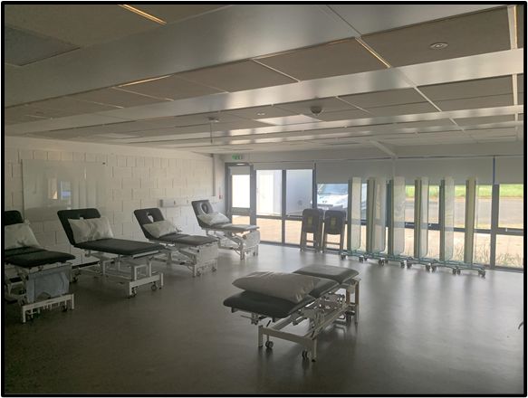
Figure A.B.1: An example of a classroom in the Sheila Scott building
Due to an influx of students into the University’s nursing program, issues have arisen. The Sheila Scott building isn’t capable of handling the number of students that need to use it, and because of how specialised the building is, these students cannot take classes anywhere else.
Energy-wise, the building also has issues. One side of the building is perennially warmer than the other. This can be seen in Figure A.B.2, which is a picture of the current digital twin dashboard. Note the temperature disparity between the left and right sides of the building.
Figure A.B.2: An image of the current Sheila Scott digital twin’s dashboard
Adapted from (CPW, 2022)
The current guidelines in the building permit the opening of windows to decrease the spread of COVID-19, but opening windows can be energy inefficient. An example of one of many openable windows in the building is shown in Figure A.B.3.
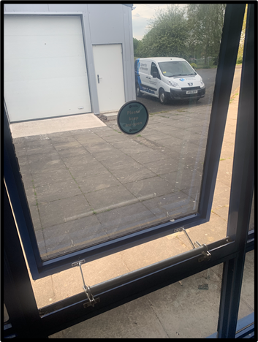
Figure A.B.3: An image of one of many openable windows
Shelia Scott Building Management System
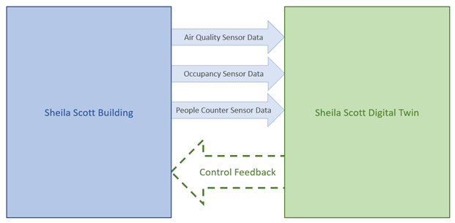
Figure A.B.4: A block diagram showing the information exchange between the Sheila Scott building and its digital twin
Figure A.B.4 shows the current state of the information exchange between the Sheila Scott building and its digital twin. A digital twin is defined as a simulation with the capacity and means to accept real-time data from whatever is being modelled (Khajavi et al., 2019). Without real-time data input, a digital twin does not qualify to be called as such. While digital twins can be complex - a 3-Dimensional model with lights and sounds that can be accessed with a virtual reality headset - it doesn’t have to be. It can be something as simple as a spreadsheet.
The information a digital twin uses comes from sensors in the real building. These sensors communicate with the digital twin, and using the data that the sensors send, the digital twin updates itself accordingly. This is the threshold that makes it a digital twin and not simply a simulation.
Building Sensors
There are three types of sensors in the building: air quality sensors, occupancy detectors, and people counters.
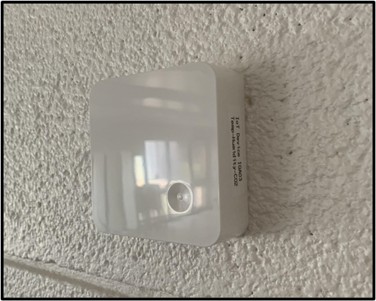
Figure A.B.5: An air quality sensor in the Sheila Scott building
The ten air quality sensors, such as the one shown in Figure A.B.5, that are installed in the building are mounted to the walls of specific rooms. These rooms are SS 002, 006, 007, 008, 011, 013, 016, 020, 021, and the main lobby. The sensors monitor temperature, humidity, and carbon dioxide levels, and each of these three data points are fed into the digital twin.
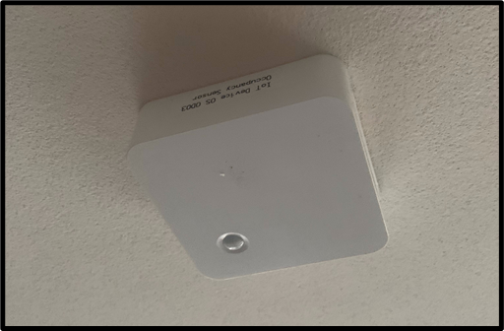
Figure A.B.6: An occupancy sensor in the Sheila Scott building
The fifteen occupancy sensors are attached to the ceilings of individual rooms. These rooms are SS 004, 006-016, 020, 021, and the lobby. These sensors monitor occupancy in the rooms they are in. The sensors are not counting the number of people in the room, but rather whether the room is occupied. The occupancy sensor in room SS ____ is shown in Figure A.B.6
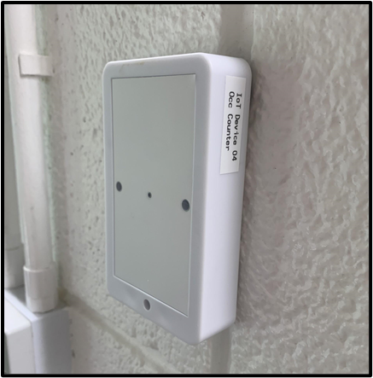
Figure A.B.7: A people counter transmitter in the Sheila Scott building
There are two sets of people counters on each hallway, making four sets in total. A transmitter in the left hallway is shown in figure A.B.7. The sensors consist of two lasers that, when interrupted, can calculate where people are moving, depending on which laser was interrupted first and second. This results in a somewhat accurate sense of where people are in the building. However, due to COVID-19 regulations, many if not all students leave the building through the fire exits in the back, none of which have people counters attached to them.
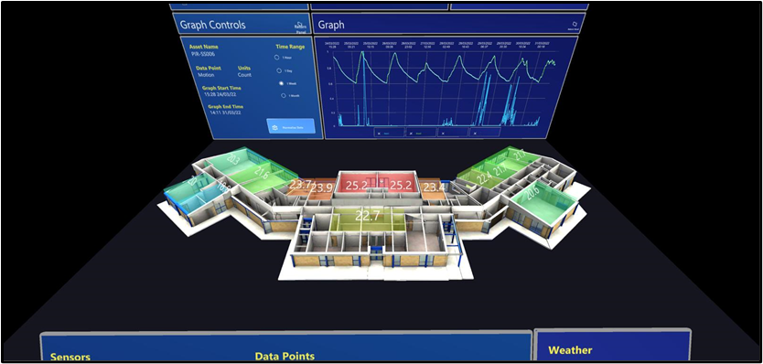
Figure A.B.8: The Sheila Scott digital twin interface
Adapted from (CPW, 2022)
The Sheila Scott digital twin is functioning. It can be accessed through a Microsoft HoloLens 2 AR headset. The interface, shown in Figure A.B.8, on the AR headset shows the data coming from the sensors in a more cohesive, understandable way. It can be interacted with the user’s right hand. Doing so allows the user to swap between modes, showing different data sets in the building. The dashboard also contains historical data that can be inspected.

Appendix C: Observation Data Sheet
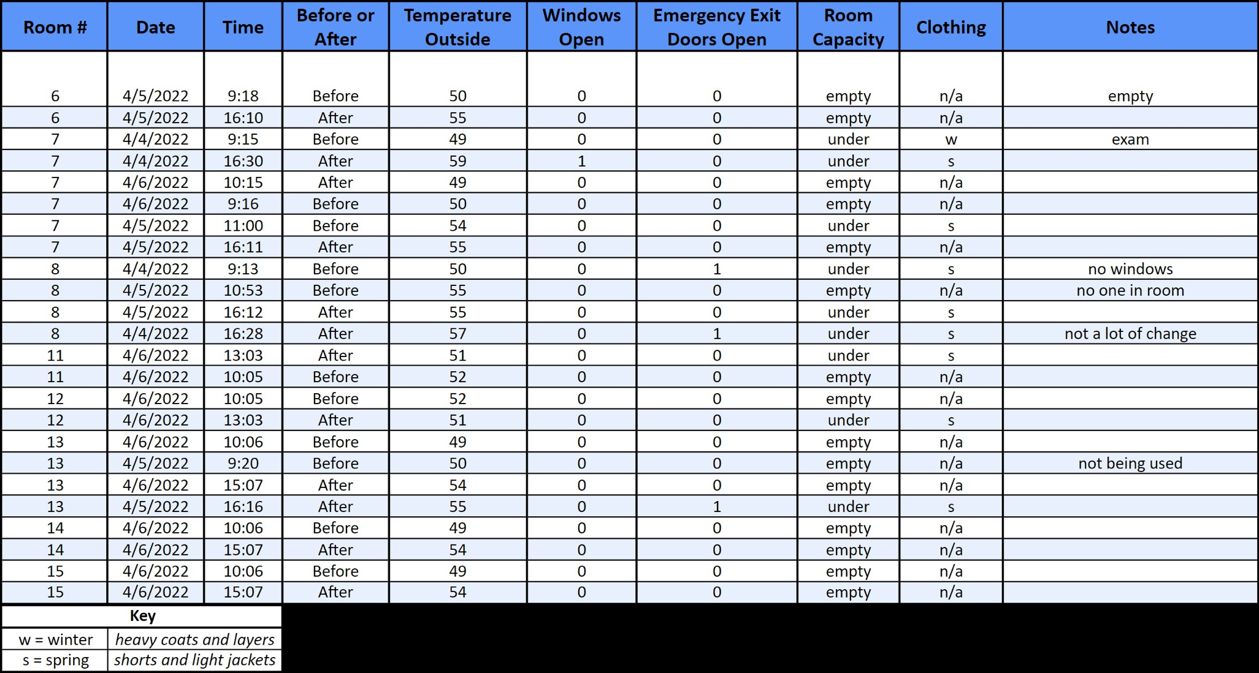

The addendum to this paper can be obtained through this link.

