Calcium Signals in A10 Cells

A Major Qualifying Project Report
Submitted to the faculty of
WORCESTER POLYTECHNIC INSTITUTE
in partial fulfillments for the requirements for the
Degree of Bachelor of Science
in Biochemistry
by

________________
Androniqi Qifti

03/24/2017

Approved by:

______________
Prof. Suzanne F. Scarlata, Advisor

Abstract

Muscle cells undergo constant deformation to stay healthy. Muscle cells contain protein structures on their plasma membranes called caveoale which act like little springs that flatten and recoil when the cell is stretched. The Scarlata lab previously found that caveolae stabilizes the activation of the protein, Gaq, which mediates Ca2+ signals. In my project, I have tested the idea that stretching cells will reduce Ca2+ signals in muscle cells which may be important for normal muscle health. Specifically, I found that when smooth muscle cells (A10) undergo mechanical bi-directional stretch, there is a structural change of caveolae that leads to a significant reduction in Ca2+ signaling when Gaq is activated. The response of calcium under mechanical pressure in A10 cells was also recorded in the form of cell density. When the cells were dense and had a large amount of cell-cell contacts, such as in muscle tissue, the number of caveolae were much greater and the effect on calcium is more pronounced. Taken together, these results indicate that the deformation of caveolae with mechanical stress may allow cells to regulate normal Ca2+ signals.

Table of Contents
Signature Page ………………………………………………………………………. 1
Abstract ……………………………………………………………………………… 2
Table of Contents ……………………………………………………………….…… 3
Acknowledgements ………………………………………………………………….. 4
Introduction…………………………………………………………………………….5
Background ……………………………………………….…………………………..6
Methods …………..…………..………………………………………………………9
Results………………………………………………………………………………...14
Discussion …………………………………………………………………………….26
Conclusion ………………………………………………………………………………..28 Bibliography …………………………………………………………………………..29
Appendix…………………………………………………………………………………..31

Acknowledgments

I would sincerely like to thank Worcester Polytechnic Institute for giving me the opportunity to work on a project like this that helped me explore different aspects of my major, improve my laboratory and intellectual skills and gain valuable experience for my future as a scientist in the field of Biochemistry.
I would like to thank my advisor Dr. Suzanne F. Scarlata, for all her expertise, insight, guidance, advice and support throughout each part of this project. Working in her lab was one of the most remarkable opportunities I was ever given and I would like to thank her for that.
I would also like to thank the Prof. Kristen Billiar and his graduate student Zachary Goldblatt for allowing me to use their device throughout my project and being willing to help with every obstacle that occurred.
I would like to thank Osama Garwain and Ashima Singla, for welcoming me in the lab, providing me with all the necessary information, guidance and feedback and working tirelessly alongside me in all experimental aspects of the project.
Lastly, I would like to thank my family and friends for all their psychological support and encouragement during the last year. This project would not have been nearly as successful without your presence and love.

Introduction
The goal of this project is to better understand how cells, and specifically muscle cells, regulate calcium in their normal function. In addition to regulating electrical signals, many enzymes and proteins are sensitive to changes in the cellular level of calcium. Calcium levels will dictate whether a cell is quiescent, whether it moves to a stimulus, whether it divides, whether it grows or whether it undergoes programmed cell death (apoptosis). The basis of this project stems from research from the Scarlata lab showing that the increase in cellular calcium that occurs in response to changes in environment, such as light, heat, changes in the levels of hormones and neurotransmitters or pharmaceutical agents, is modified by the interaction between a protein that triggers the calcium response (Gq) and a protein domains whose cellular function is unclear (caveolae).

Background
Caveolae are flask-shaped protein domains in the plasma membrane that are structurally composed of caveolin-1 (Cav1), or caveolin-3 (Cav-3) where Cav-3 is muscle specific. The “U” shape of these proteins results in them only occupying the inner leaflet of the plasma membrane. The proteins contain multiple palmitoylation sites, which together with cholesterol and other lipids promote the formation of tightly packed domains that can phase separate from other membrane lipids. This separation causes ~144 Cav1 or Cav3 molecules to aggregate, and because of their “U” shape, the aggregate induces an inward curvature of the membrane resulting in an invagination in the plasm membrane, called caveolae (fig 1).
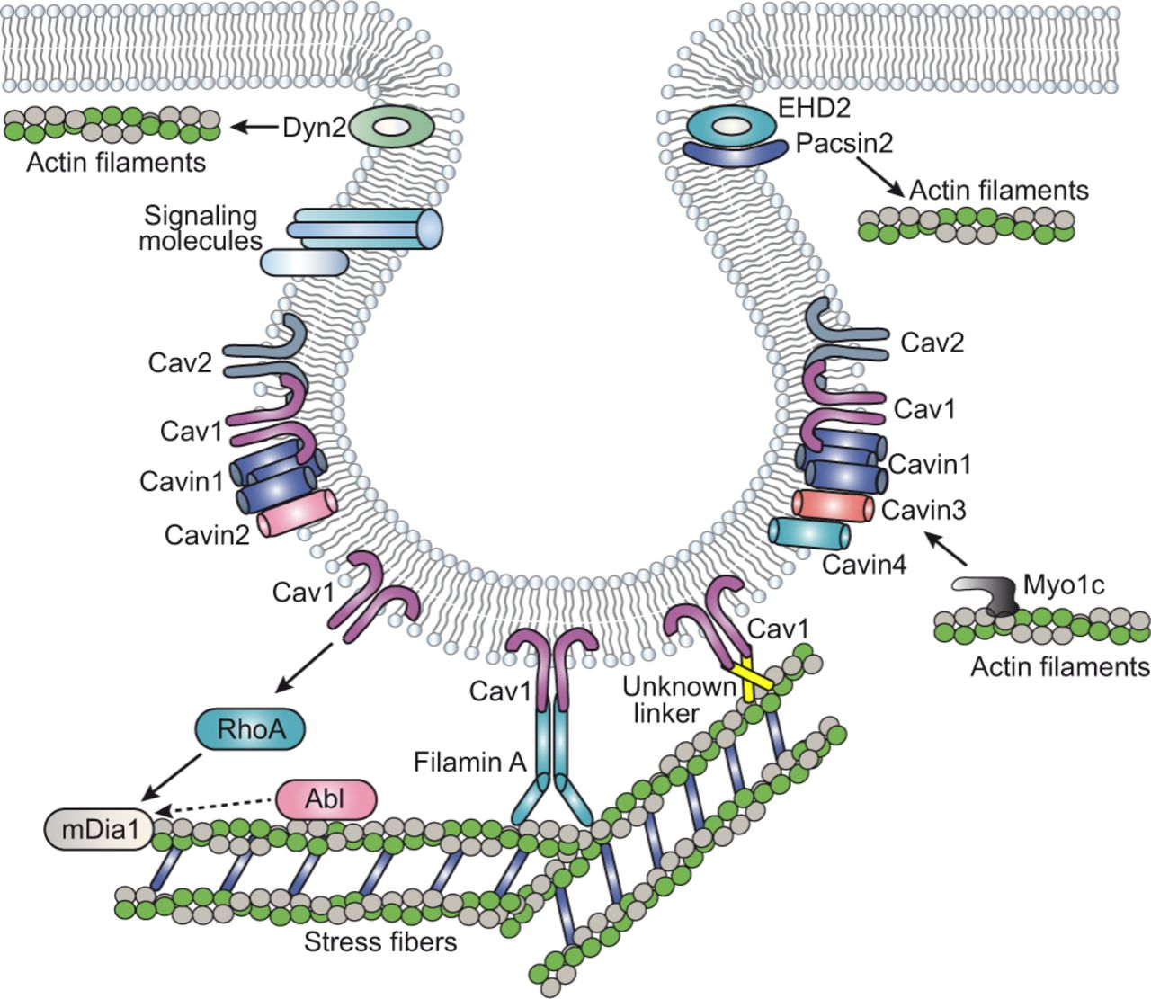
Figure 1: Cartoon of caveola composed of Cav1 along with other proteins that are often found in the domains. The cartoon depicts the link of caveolae to stress fibers and the actin cytoskeleton.

The main molecules that shape caveolae (caveolins, cavins and pacsin2) and the proteins that regulate their dynamics (Dyn2, EHD2 and filamin A) are depicted. The caveolar molecules that have functional or physical association with the actin cytoskeleton, and therefore potentially mediate the physical and functional interaction between caveolae and actin fibers, are also indicated. Filamin A is the main protein mediating a linkage with stress fibers, but other yet unidentified linkers might exist (indicated as unknown linker). Regulators of stress fibers (Abl kinases and mDia1) that impinge on caveolae organization and trafficking are shown next to RhoA, the main regulator of stress fibers, which is regulated by Cav1. (Echarri, 2015)
More than five decades ago, caveolae were found in most differentiated mammalian cells and many proteins involved in cell signaling where thought to be associated with these domains. Therefore, caveolae have been proposed to be responsible for the organization of signaling domains through specific interactions with its scaffold proteins (Marx, 2011). This idea is supported by the fact that several G-protein-coupled receptors (GPCRs) as well as their Gα subunits were found in caveolae domains (Yung,2017). Thus, caveolae domains might play a necessary and vital role in GPCR signaling by interfering GPCRs and their interactions with G-proteins.
In previous years, the functions of caveolae have been thoroughly studied. Caveolae has been proven to be involved in some muscular dystrophy cases while specifically Cav3 is strongly associated with cardiac hypertrophy in mice (Woodman, 2002). On the cellular level it has been proposed and proven that caveolae has a role in mechanical stress. When increased osmotic stress is applied to cells, the volume of the cell increases significantly resulting in the flattening of caveolae invaginations to accommodate the increase in cell volume. This flattening leads to the reduction in the interactions between Cav1 and another protein that stabilizes caveolae domains, cavin, and the release of the isolated molecules in the plasma membrane. (Sinha et al, 2011).
In order to understand the role played by caveolae in calcium signaling, the Gαq-PLCβ pathway must be analyzed. Gq is activated by receptors that are sensitive to acetylcholine, dopamine, bradykinin, angiotensin II, endothelin I and many hormones that play an important role in cardiac and smooth muscle function. Previous work in the Scarlata lab showed that Gaq binds to the scaffold domain of Cav1 and Cav3 and the association between Gaq and Cav1/3 enhances the activation of PLCβ. PLCb is the main effector of the G-protein subunit Gαq and activation of PLCβ catalyzes the hydrolysis of phosphatidylinositol 4, 5-biphospate in order to produce diacylglycerol and 1,4,5-triphosphate (Exton, 1996). When the triphosphate is diffused in the endoplasmic reticulum, the levels of intracellular Ca²⁺ are increased. In addition to that, the activation of Gαq strengthens the binding of Gαq to Cav1 and Cav3. Due to this interaction, and after taking into consideration that Gαq can continue to signal through PLCβ when bound to caveolae since they do not share the same association site, the localization of Gαq to caveolae can stabilize its activated state and enhance Ca²⁺ signals (Calizo, 2012). However, hypo-osmotic conditions, which can be characterized as a form of mechanical stress, reduced Ca2+ signals in cells by disrupting the Gαq/Cav1 interactions.
In this study, it was found that when rat aortic smooth muscle cells (A10), which are smooth muscle cells, undergo mechanical bi-directional stretch, there is a structural change of caveolae that leads to a significant reduction in Ca²⁺ signaling when Gaq is activated. The response of calcium under mechanical pressure in A10 cells was also recorded in the form of cell density. When the cells were dense and had a large amount of cell-cell contacts, such as in muscle tissue, the numbers of caveolae were much greater and the effect on calcium was more pronounced. Taken together, these results indicate that the deformation of caveolae with mechanical stress may allow cells to regulate normal Ca2+ signals.

Methods
Throughout the experiments that were conducted, there were specific methods followed in the cell culture, labelling, and stretching of the A10 cells.
Cell type. Cav3 is muscle specific and prominent component of most skeletal and smooth muscle cells. This cell line was established from the thoracic aorta of a DB1X embryonic rat in 1976 and was widely used for cardiovascular research. Their main characteristic is that A10 cells are nondifferentiated vascular smooth muscle cells that differ from neonatal but bear significant resemblance to neointimal cells. (Calizo, 2013).
Cell culture. A10 cells were maintained in Dulbecco’s modified Eagle’s medium which contained DMEM (Dulbecco’s Modified Eagle Medium), GIBCO, 320-355mosM supplemented with 50 mL Fobium Fetal Bovine Serum (FBS), 5mL P/S and 5mL of 100mm Sodium Pyruvate. When the cells were split, 2ml of trypsin were added (in a 100mm dish) and the plate was incubated at room temperature for 2 minutes in order for the cells to detach from the plate.
Sample preparation. In order to prepare the cells for bi-directional stretch, it was necessary for the cells to attach to special PDMS plates. These plates were first sterilized by cleaning with 70% ethanol. After, they were coated with Fibronectin for 30 minutes and washed with HBSS before being recoated again with Fibronectin for the same time period. This double coating was essential and necessary for the cells to attach and grow.
Calcium studies. After the cells were successfully attached to plates and before conducting the bi-directional stretch, cells were labeled with a fluorescent calcium indicator (Calcium Green, Invitrogen) to make them visible through the microscope. The cells were washed with HBSS (Hanks’ Balanced Salt Solution) and then 5 μM of calcium green were diluted in 2ml of HBSS. After adding the solution to the silicon plates, the plates were incubated at 37°C for 45 minutes and then washed with HBSS twice in order to remove the excess calcium green prepare the plates for experiments.
Stretch experiments. In order to conduct the bi-directional stretch, a special device that fitted the silicon plates was borrowed from Dr. Kristen Billiard’s lab. This device operated on software called Processing by Ben Fry and Casey Reas that allowed the stretch of the plate in the x or y axes or both (Appendix). For these experiments, the plates were stretched only on the x-axis by 1%, 2%, 5% and 10%. This stretch was continuously applied to the cells for different time periods including 1, 2, 5, 10 and 30 minutes before the cells were stimulated with 5μM of bradykinin. Intracellular calcium release was measured under normal (control) and stretched conditions with the control plates showing significantly more calcium signaling after stimulation and the stretched ones presenting a dramatic drop of the calcium that was intracellularly released. Consecutive images were taken right before stimulation and then after stimulation for more than 5 minutes in order to clearly observe and record the changes in calcium signaling. There were also pictures taken after stretching the cells by 1%,2% or 5% for 1, 2 or 5 minutes, letting them recover for 5, 10 or 20 minutes and then stimulating them with the same concentration of bradykinin. These observations and recordings were conducted on the Zeiss microscope which is an inverted confocal microscope LSM 510 meta. At this point, it should be underlined that this is was the only microscope that perfectly fitted the stretching device since the cells needed to be observed while they were directionally stretched.
Immunofluorescence studies. We determined whether stretch changed the distribution of caveolae in the plasma membrane with directional stress, and whether this distribution depends the number of neighboring cells (i.e. confluency). After splitting A10 cells to Lab TEK imaging dishes, there were 4 dishes with high density cells (1.5/2ml) and 4 dishes with low density cells (0.25/2ml).
When cells were attached and confluent, they were fixed with warm 2ml 3.7% formaldehyde solution in PBS (1:10 dilute 37% stock with PBS) and incubated for 1 hour. After the incubation, the dishes were washed 3 times with 2ml PBS each time and kept for 1 min per wash. The last wash was removed and replaced with 2ml of 0.2% NP 40 in PBS and then incubated for no more than 5 minutes. Then, the detergent was aspirated and replaced with 1ml of 4% BSA in 1X TBS which was incubated for 30 minutes. The blocking solution was then aspirated an replaced with 1ml of primary antibody from mouse diluted in 1% BSA in 1X TBS (1:500) and all dishes were incubated at room temperature for 2 hours. The primary antibody was removed and the dishes were washed 3 times with 2ml of 1X TBS for 3 minutes per wash. The last wash was replaced with appropriate fluorescent antibody diluted in 1%BSA in 1X TBS (1:1000) and incubated for 1.5 hours at room temperature. The secondary antibody was removed from all the dishes and the dishes were washed 3 times with 2ml of 1X TBS for 3 minutes per wash. The plates were covered again in aluminum foil and kept at 4ºC. Cells were viewed in TBS buffer, on the Zeiss microscope as well where single pictures and Z-stack pictures were taken. The colocalization analysis was performed using ImageJ.

We viewed more than twenty images of cells at varying density but only the best quality ones were chosen to be displayed (Fig 9.). Through these experiments, it was proven that when the cells had a large amount of cell-cell contacts, the number of caveolae were much greater and the effect on calcium was more pronounced (Fig 9, Fig 10). In order to prove this result, we quantified the amount of caveolin by western blotting. Since the molecular weight of the caveolin is very small (21.24), separating gels with 15% concentration were prepared.

The same colocalization procedure was also used in order to label A10 cells for caveolin and Gαq and compare them under stretched (2% stretch for 5 minutes) and non-stretched conditions. All cells, stretched and non-stretched, were stained for Gαq whereas the stretched ones were not stained for caveolin. This observation leads to the conclusion that caveolin is very mechanosensitive and therefore gets disrupted when the stretching takes place.

Western blotting. In order to prepare these separating gels, 2.3mL of dH₂O, 5.0mL of 30% acrylamide, 2.5mL of 1.5M tris (pH=8.8), 100μL of 10% SDS, 100 μL of 10% APS and 6μL TEMED were added together. The stacking gel was made by mixing together 2.2mL of dH₂O, 680μL of 30% acrylamide, 1mL of 0.5M Tris (pH=6.8), 40μL of 10% SDS, 40 μL of 10% APS and 4μL of TEMED. After splitting cells into wells, 8 wells of cells with low density (0.25/2 ml) and 4 wells of cells with high density (1.5/2 ml) were prepared. The four high density wells were trypsonized with 0.5ml trypsin in each, incubated for 5 min and then added to tubes after adding 0.5ml media. The low density wells were trypsonized with 0.25ml trypsin and after incubating for more than 5 min, transferred to tubes with 0.25ml media as well. In the end there were 4 tubes with high density and 4 tubes with low density after combining the low density tubes together. After counting the cells for each tube, all 8 tubes were centrifuged for 5 min at 4000rpm.

Media was removed after the centrifugation and 20 microliters of the Lysis buffer (100 microliters 10X lysis buffer + 900 microliters of water) were added on each tube. All tubes were placed in ice for 30 min. After that 5 microliters of sample buffer/ loading buffer were added I each tube and all tubes were placed in the heater for 8 minutes at T= 90-100 degrees C. Special lids were placed on the tubes in order to prevent the popping of the cups. In the meantime the gel setting was prepared. The glass slides were placed so that the thin slide stays inside and the thick outside. Running buffer was added inside then outside with the level outside being lower than the level inside. 8 microliters of the ladder were added on the big well side as well as 8 microliters of each tube. On the small well side there were 5 microliters added of the ladder and of each tube. The gels ran for 2 hours.

In the meantime the transferring buffer was prepared by adding 100ml 10X transferring buffer, 700ml water and 200ml methanol. Two pieces of nitrocellulose membrane were cut into two pieces based on the inside boundaries. The “gel boundaries” were made with the membrane facing the transparent side and the gel facing the black side. The device was put in the walk in cold room and run overnight at 0.6 A and 100 voltage.

The membranes but not the gels were removed into the boxes and some washer buffer was added in order to rinse them. Then, the milk solution/blocking was added and the membranes were kept in the walk in cold room, in the shaker for 1 hour. In the meantime the primary antibody solution was prepared in a concentration 1/1000 with milk solution. 24ml of that primary antibody solution were prepared and after adding 12ml of the solution on each box, the boxes kept shaking outside for 2 more hours.

After that, the two membranes were washed 3 times with washed buffer and kept on the shaker for 5 minutes each time. In the meantime we prepared the secondary antibody solution by adding 24ml milk solution and 20 microliters of the anti-mouse secondary. 12 ml were added on each membrane and then both boxes were kept at the shaker for 2 hours. After that the membranes were washed 3 ties with washing buffer for 5 minutes per wash. Then they were ready to be imaged after preparing the ECL solution with 2 ml of each bottle. During the imaging of the gels, there was a big difference between the high density and the low density plates.

After imaging the gels for caveolin, the gels were reblotted for beta actin to assess differences in protein loading. First, the membranes were stripped by adding 2-3ml to each membrane for 3-5 minutes. After the primary beta actin was applied after diluting it 1/10000 for 2 hours. The membranes were washed 3 times with washing buffer, 5 minutes per time. Then the secondary (anti-mouse) antibody was applied for 2 hours. The membranes were washed again with the same procedure and then they were ready to be imaged. The images obtained from the gels confirmed the fact that caveolin and therefore caveolae appears in greater numbers when cells are dense rather than when they are isolated. However, this result was not observed in the case of bet actin since the levels of beta actin remained almost the same in both cases which suggests that caveolae is being affected by the confluency of the cells (see Results).

Results
It has been previously found that that caveolae stabilizes the activation of the protein Gαq, which mediates Ca²⁺ signals. Ca²⁺ signals decrease significantly due to bi-directional mechanical stretch that was applied for different time periods. We propose that this bi-directional mechanical stretch leads to a structural change of caveolae when Gαq is activated. For these studies, rat aortic smooth muscle cells were used that have a robust Gα_{q} / PLCβ signaling system and are rich in caveolae. First, the cells were cultured on PDMS silicon plates and labelled with the fluorescence calcium indicator, Calcium Green (Invitrogen). Then, the cells were stretched for 1, 2, 5 and 10 minutes by 1%, 2%, 5% and 10% of bidirectional stretch only on the x-axis. When the arranged time was up, the cells were stimulated by bradykinin. In FIGURE 2 you can see the plot of the calcium signal mean vs the time for non-stretched cells with and without stimulation and in FIGURE 3 you can see the difference after the cells were stretched and recovered without being stimulated.
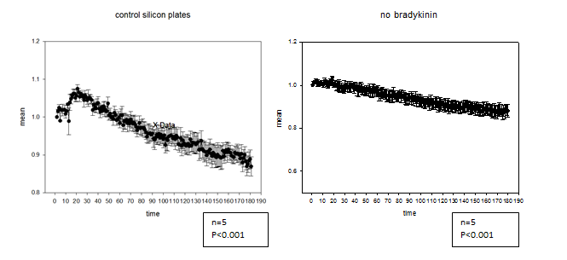
FIGURE 2. The calcium signal increases after stimulation in non-stretched cells whereas the calcium signals slowly decrease throughout time when there is no bradykinin applied.
FIGURE 3: The effect of bi-directional mechanical stretching in calcium signal intensity without stimulation.
As you can see in the figure above the bi-directional stretch has a great effect on signal intensity especially overtime. However, in the presence of bradykinin and stimulating of the cells after being stretched, the effect of mechanical stress is even greater as it can be seen in Fig 4.
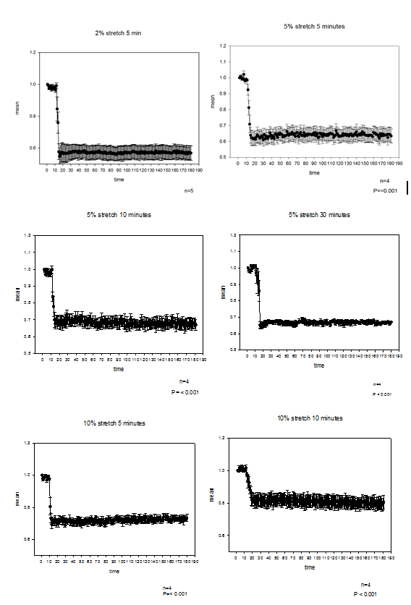
FIGURE 4. The calcium signal decreases after stimulation in stretched cells. After applying bi-direction stress of 2%, 5% and 10% for different time frames, the calcium signal significantly drops after stimulating with bradykinin.
As it can be seen, the Ca²⁺ signal intensity after stimulating the non-stretched cells increases significantly. However, the Ca²⁺ signals drop dramatically right after the bradykinin is applied and the cells are stimulated. In addition to that, cells were also examined after recovering from the bi-directional stretch and before being stimulated. The recovery time frames varied from 2 minutes to 20 minutes. In FIGURE 5 sample images of recovered cells that were stretched are displayed.
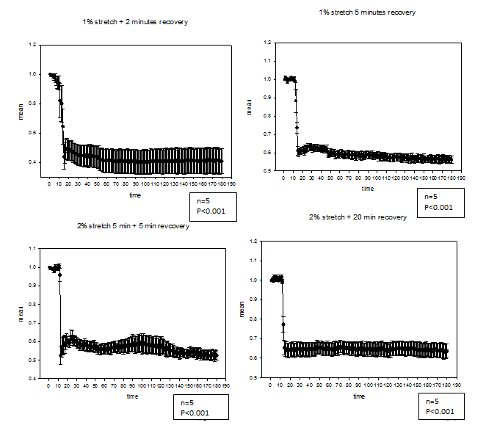
FIGURE 5. Calcium signals of A10 cells after stretch and recovery.
As it can be easily observed in the figure above, even though there is a slight recovery of the Ca²⁺ Green intensity, the Ca²⁺ signals continue to be decreased after stimulating the stretched cells.
In order to verify the difference between the data sets, a comparison test of all experimental sets of data was conducted. The results of the experimental test can be seen in Fig 6.
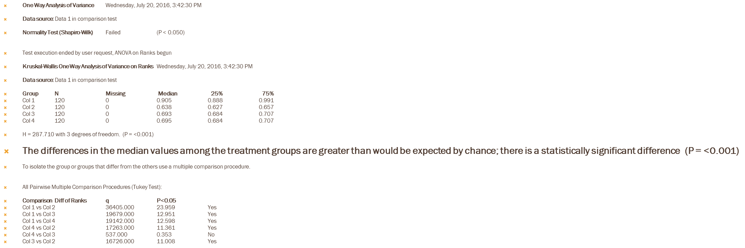
FIGURE 6. Comparison test of data sets
In addition to that, 1% and 5% stretching experiments were also conducted in the presence of EDTA. After staining the cells with calcium green and before the bi-directional mechanical stretch took place, A10 cells were kept in a solution that contained 50% HBSS and 50% of 1.26mM filtered EDTA. After the cells were kept in this solution for no more than one minute, the stretching occurred for 5 minutes before the cells were stimulated with Bradykinin. Due to the presence of EDTA, there was a different outcome observed from these experiments which is displayed in FIGURE 7 and FIGURE 8.
FIGURE 7: 1% stretch with and without the presence of EDTA
FIGURE 8: 5% stretch with and without the presence of EDTA
As it can be clearly distinguished in the figures above, once EDTA is present, the signal intensity decreases gradually after stimulation whereas in the absence of EDTA, the Ca²⁺ signals drop dramatically as soon as the stimulation with Bradykinin occurs.
After determining that bi-directional stretch changed the distribution of caveolae in the plasma membrane, there were experiments conducted in order to examine whether this distribution of caveolae depended on the number of neighboring cells. For these experiments, plates with very low and very high confluency of A10 cells were cultured, fixed and fluorescent labelled for caveolae. Through these experiments, it was proven that when the cells had a large amount of cell-cell contacts, the number of caveolae were much greater and the effect on calcium was more pronounced (FIGURE 9). Sample images of high and low cell-cell contact are displayed below.
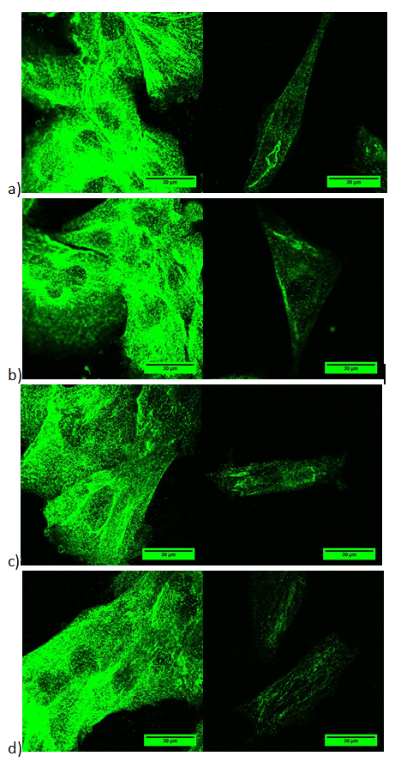

FIGURE 9. The distribution of caveolea in the plasma membrane depends on the confluency of the cells. Sample pictures of high density of cells (left) vs low density of cells (right) are displayed above.
In addition to the images that are displayed above, Z-stack images were also captured (data is not displayed). In order to verify that the two data sets are different from each other, there was a t-test conducted (FIGURE 10). In FIGURE 11 the box plots for the ratio of high cell-cell contact and low cell-cell contact are being displayed.
t-test
Data source: Data 1 in high density vs low density
Normality Test (Shapiro-Wilk)
Passed (P = 0.655)
Equal Variance Test: Passed (P = 0.626)
Group Name N
Missing Mean
Std Dev SEM
low density 13
0 523.101
258.977 71.827
high density 13
0 1893.361
284.850 79.003
Difference -1370.260
t = -12.833 with 24 degrees of freedom. (P = <0.001)
95 percent confidence interval for difference of means: -1590.631 to -1149.890
The difference in the mean values of the two groups is greater than would be expected by chance; there is a statistically significant difference between the input groups (P = <0.001).
Power of performed test with alpha = 0.050: 1.000

FIGURE 10. T-test for the cells that were immunostained for caveolae.
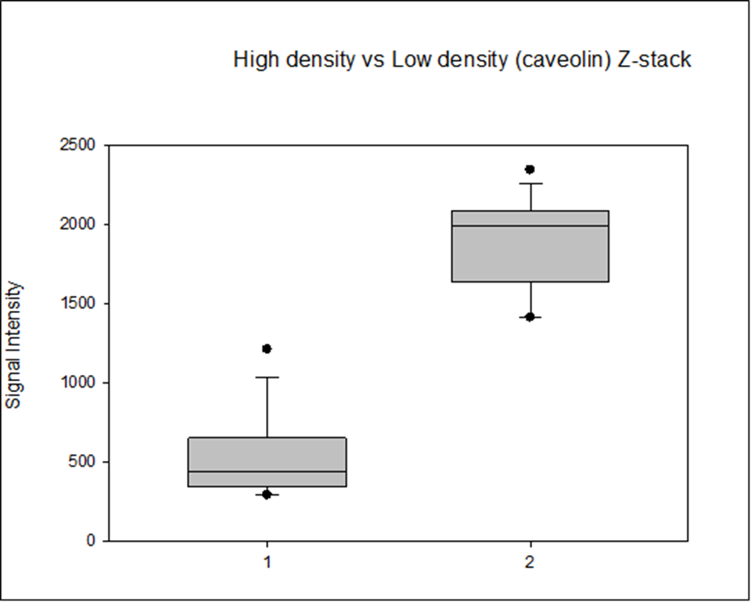
Low density
High Density

FIGURE 11. The number of caveolae is greater when the density of cells is higher.

In order to prove this result, the amount of caveolin was quantified by western blotting. In addition to that, the amount of beta actin was also quantified. As it can be observed in FIGURE 12 the concentration of beta actin remained almost the same despite the confluency of the cells. However, the amount of caveolin was significantly lower in the case of low cell-cell contacts.
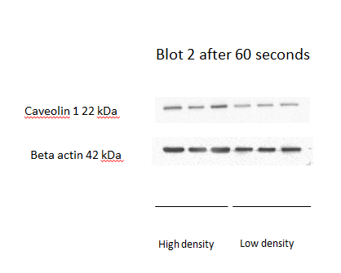
FIGURE 12. The amount of caveolin 1 is less when there is a decreased number of cell-cell contact. Beta actin appears to be the same despite the confluency of the cells.
Mechanical bi-directional stretch also disrupts Cav/ Gα_{q} interactions. It has been previously found that a significant population of Gα_{q} resides in caveolae domains. Specifically, Gα_{q} interacts with Cav1 and Cav 3. Therefore, it is possible that Gα_{q} molecules are released from caveolae under mechanical stretch. This possibility was examined by monitoring changes in colocalization between Cav 1 and Gα_{q} under bidirectional stretch (FIGURE 13). Samples images of cells that were colocalized are not displayed in this report. However, as it can be seen it the figure below, the differences between Gαq and Caveolin after bidirectional stretch are well pronounced.
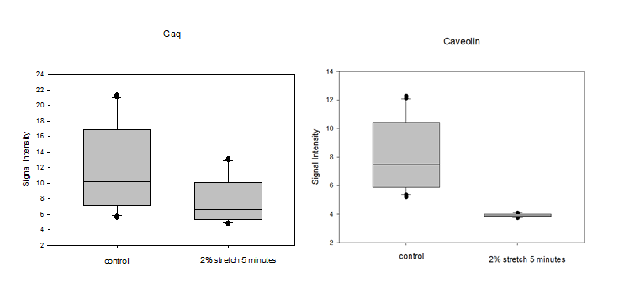
FIGURE 13. Differences between Gα_{q} and Caveolin after bidirectional stretch. A10 cells were stretched by 2% for 5 minutes before being fixed and labelled for both Gα_{q} and Caveolin (colocalization). It is observed that the bidirectional stretch appears to affect caveolin more than Gα_{q.} Gα_{q} is still present after the stretch is completed whereas caveolin has almost completely disappeared.

Discussion
In this study, we show that bi-directional stretch of cells directly affects the Ca2+ signals mediated through Gα_{q} and we provide evidence that this effect on calcium is due to disruption of Cav/ Gαq interactions. The distribution of caveolea in the plasma membrane was affected due to the bi-directional stress that was applied. This distribution was also determined to be dependent on whether or not there was a large number of neighboring cells. The confluency of the cells can be described as a high or low amount of cell-cell contacts. These results correlate the mechanical and signaling properties of caveolae supporting the idea that they may play a crucial role in cell communication by organizing proteins such as connexins. At this point it is important to mention that in muscle tissues such as cardiomyocytes where the cells are arranged in arrays, there is a high density of caveolea uniformly distributed among the actin lines of the membrane. In contrast, in fluid cells, transformed cells or immortalized cells, caveolae appears in low density or does not appear at all.
Caveolae is been mainly known for mechanically strengthen the membranes and organizing signal domains. This ability of caveolae to connect mechanosensing with cell signaling was first indicated by studies in the Scarlata lab. In those studies, A10 rat aortic smooth muscle cells were subjected to low osmotic conditions which were shown to deform caveolae. Because caveolae is so prevalent in muscle cells, which must undergo repeated stretch and contraction to remain healthy, we postulated that caveolae deformation may serve to regulate calcium signals in these cells. The goal of this work was to understand whether normal mechanical stretch could regulate calcium signals through deformation of caveolae.
In our studies, we measured calcium release in A10 cells when Gaq is stimulated. We find that when cells are in a stretched condition, a small increase in calcium is observed followed by a very large drop in calcium. These studies show that A10 cells are extremely mechanosensitive to bidirectional stress. We tested whether the large drop in cellular calcium is due to the opening of calcium-sensitive calcium channels that open after the initial calcium increase due to Gaq stimulation. This idea was tested by adding 50% EDTA in the imaging media to chelate external calcium. We find that removing extracellular calcium results in a typical calcium release curve. Our data that 1% stretch did not greatly affect the calcium release, 5% produced a notable reduction. We postulate that this mechanical stress deform caveolae making it unable to stabilize activation of Gaq.
The deformation of caveolae was assessed by antibody staining. We find a large reduction in antibody labeling of caveolae after mechanical stress suggesting the caveolin epitope is no longer available for antibody binding after stretch, and in turn suggesting caveolae deformation. This proposed deformation is seen by a loss in colocalization between caveolin-1 and Gaq. This loss in colocalization will result in a loss in calcium signals as show in previous work.
There are many previous studies of this lab showing that a significant amount of the Gα_{i}-coupled receptor of β2AR is localized to caveola domains. It is believed that the main reason that satisfies this observation is its association with β2AR along with ion channels or other proteins. However, the factors that are responsible for this localization are unclear. Unlike Gα_{q}-mediated signals, we find that changes in cAMP levels are not sensitive to caveolae and so the functional basis for the localization of β2AR/Gα_{i} is unclear. This result argues against the idea that aggregation of receptors in caveola domains enhances signaling. As mentioned, when A10 cells are subjected to osmotic bi-directional mechanical stretch, the enhancement of Ca²⁺ signals due to Gα_{q}-Cav1 interactions occurs. Additionally, our results suggest that mechanical stretch can be also measured by the density of neighboring cells. High density of neighboring cells leads to significantly increased signals whereas low confluency of cells has the opposite affects. Therefore, hypo-osmotic conditions, which can be characterized as a form of mechanical stress, reduced Ca2+ signals in cells by disrupting the Gαq/Cav1 interactions. These observations suggest that cells have varying caveolae that may be involved in different functions. More experiments needs to be conducted in order to satisfy this observation.

Conclusion
A10 cells are extremely sensitive in various forms of mechanical stress. This sensitivity causes the deformation of caveolae which further affects the level of Ca²⁺ intensity levels when Gαq is activated. This affect in caveolae has applications not only in rat smooth muscle cells but in normal muscle cells as well, where caveolae deforms due to muscle movement and therefore differences in signal intensity may appear. These applications can produce innovative ideas and revolution in current and future drug research. However, there is more research on this area to be conducted in order to reach that point.

Bibiography
- Marx, J. (2001) Caveolae: a once-elusive structure gets some respect. Science
294, 1862–1865
- Woodman, S. E., Park, D. S., Cohen, A. W., Cheung, M. W., Chandra, M.,
Shirani, J., Tang, B., Jelicks, L. A., Kitsis, R. N., Christ, G. J., Factor, S. M.,
Tanowitz, H. B., and Lisanti, M. P. (2002) Caveolin-3 knock-out mice
develop a progressive cardiomyopathy and show hyperactivation of the
p42/44 MAPK cascade. J. Biol. Chem. 277, 38988–38997

- Sinha, B., Köster, D., Ruez, R., Gonnord, P., Bastiani, M., Abankwa, D.,
Stan, R. V., Butler-Browne, G., Vedie, B., Johannes, L., Morone, N., Parton,
R. G., Raposo, G., Sens, P., Lamaze, C., and Nassoy, P. (2011) Cells respond
to mechanical stress by rapid disassembly of caveolae. Cell 144, 402–413

- Exton, J. H. (1996) Regulation of phosphoinositide phospholipases by hormones,
neurotransmitters, and other agonists linked to G proteins. Annu.
Rev. Pharmacol. Toxicol. 36, 481–509

- Calizo, R. C., and Scarlata, S. (2012) A role for G-proteins in directing
G-protein-coupled receptor– caveolae localization. Biochemistry 51,
9513–9523

- Calizo, R. C., and Scarlata, S. (2013) Discrepancy between fluorescence
correlation spectroscopy and fluorescence recovery after photobleaching
diffusion measurements of G-protein-coupled receptors. Anal. Biochem.
440, 40–48

- Yang, Lu, and Suzanne Scarlata. "Super-resolution Visualization of Caveola Deformation in Response to Osmotic Stress." Journal of Biological Chemistry 292.9 (2017): 3779-3788.

- Echarri, A., & Pozo, M. A. (2015, August 01). Caveolae – mechanosensitive membrane invaginations linked to actin filaments. Retrieved March 24, 2017, from http://jcs.biologists.org/content/128/15/2747

Appendix
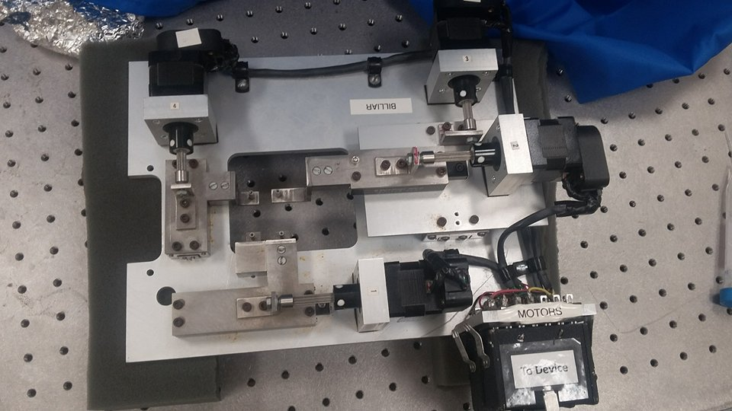
- Panoramic view of the device used for stretching experiments.
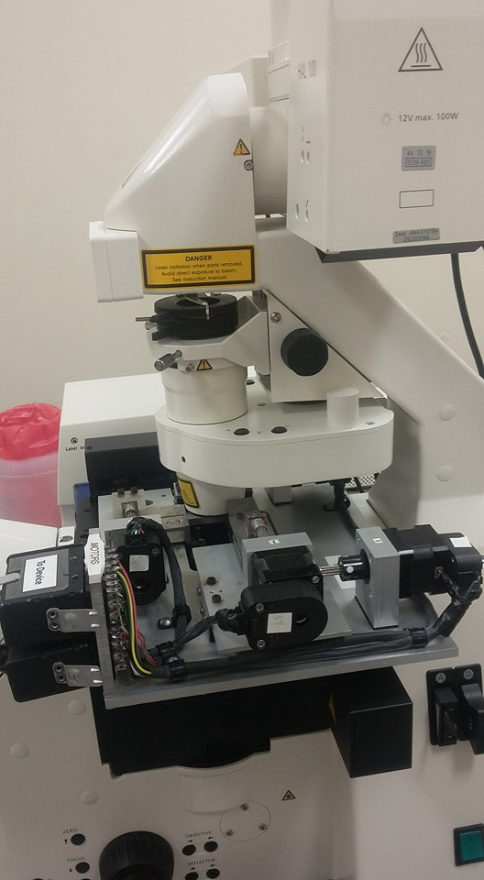
- View of the stretching device fitting the microscope while the imaging of stretched cells was taking place.

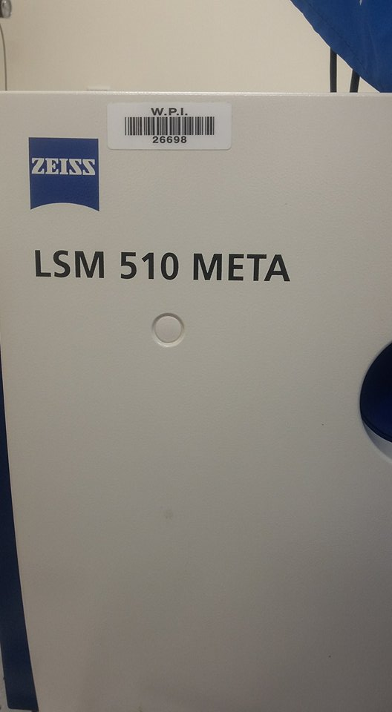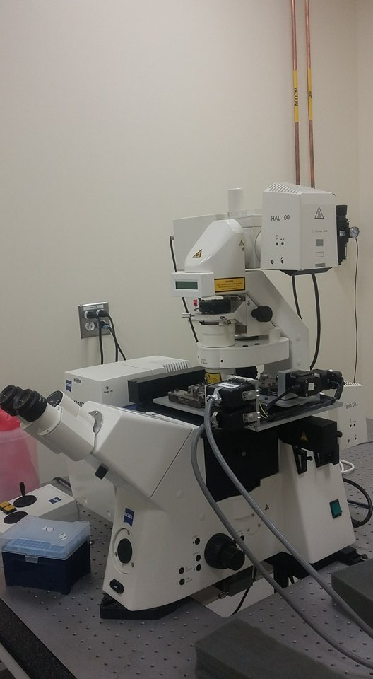

- The Zeiss microscope used for imaging.
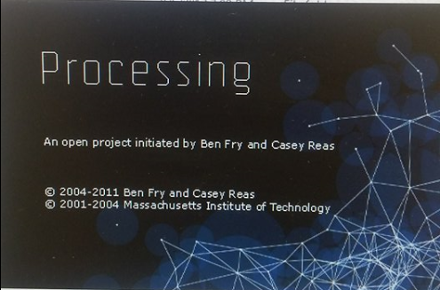
- Software controlling the stretching device.
- After running the software, this is the first tab that appears. In order for the device to run, COM3 needs to be selected. When the “Home” button is selected, the barriers that hold the PDMS plate, rearrange to their original position.

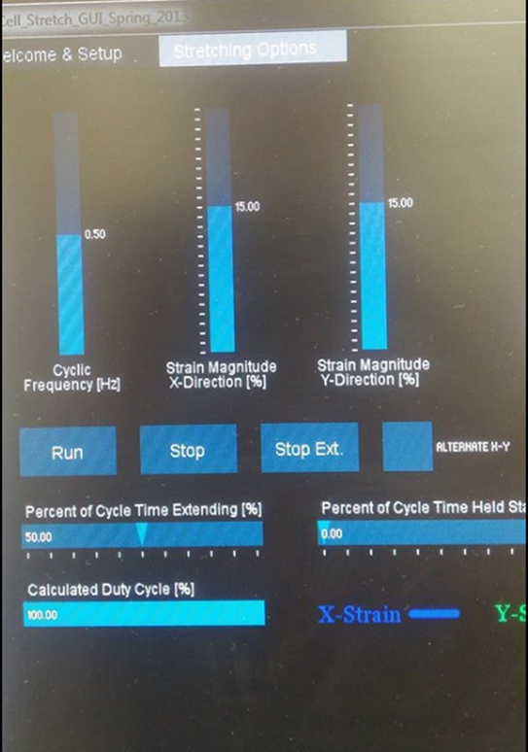
- The percentage of stress applied to either the x or the y axis (or both) can be selected on this tab. For the purposes of my experiments, the y-direction percentage was set to zero and only the x-direction percentage was being adjusted. The Cyclic Frequency was always 0.50 Hz.

