Washburn Project Portal

Submitted by:
Daniel Lemire
Howard Vance

Project Advisor:
Toby Bergstrom

This report represents the work of WPI undergraduate students submitted to the faculty as evidence of completion of a degree requirement. WPI routinely publishes these reports on its website without editorial or peer review. For more information about the projects program at WPI, please see

http://www.wpi.edu/academics/ugradstudies/project-learning.html

Acknowledgments__________________________________________

We would like to thank the following people/groups for their help completing this project:
- The student workers who signed up to help us provide this service to students.
- Washburn shop staff for their help maintaining the shops and facilitating the provision of this service.
- Torbjorn Bergstrom for advising us throughout this project.
- The POD and Campus Center digital advertising staff for allowing us to advertise this program through the digital ad boards.
- Katherine Crighton, Donna Hughes, and Colleen Sweeny for allowing us to send an advertising email to targeted majors who we believed would benefit from this program.
- The ME Department for providing funding to pay student workers for the duration of this service.

Abstract___________________________________________________
The purpose of this project is to create and evaluate the effectiveness of a program designed to provide project help to WPI students in a manner in line with WPI’s motto “Lehr und Kunst” or “Theory and Practice”. This system was created to provide assistance during shop hours that were not normally reserved but students were often not allowed to work. A system was created to have two sets of two student workers working two hour shifts during the weekdays to provide help in the WPI Manufacturing Labs to students who needed help with a project. This service was then advertised to students, specifically those working on Interactive or Major Qualifying Projects. The service’s goal was to provide project help to those who needed it without doing work for them. Every student who requested help would be taught how to complete the task or solve the problem they were asking about so they could better approach it in the future. This focus on teaching through practical means allows students to solve issues impeding their work while also learning along the way. A survey was conducted during the duration of this program to collect student feedback. This survey collected data on the effectiveness of shop staff, the number of hours the student had worked on their project that day, the students rating of the service, and any comments or ideas that could improve the service. Through the collected data we have been able to conclude that a service like this was appreciated and valued by students and should be continued in the future.

Introduction_______________________________________________

Objective:
The objective of this work is to determine the effectiveness and need for dedicated project help hours for the WPI Manufacturing Labs.

Rationale:
The goal of the WPI Manufacturing Labs has always been that of education. The facility was created as a teaching factory. Students would enter the WPI manufacturing labs with an idea and by the time that idea came to fruition those students would leave with a basic knowledge of manufacturing and the ability to operate CNC machinery. The mission of the CNC labs is to support the mission of WPI, by creating, discovering, and conveying knowledge at the frontiers of inquiry in CNC machining and education, as well as linking that new knowledge to applications and helping students achieve self-sufficiency in the use of CNC tools and technologies, so they can conceive, design, and create their own CNC machined parts for their projects.
To accomplish this goal the WPI Manufacturing labs does not make parts for students. Instead we empower them to make their own parts. The WPI Manufacturing labs have always been willing to help a student learn the basics of manufacturing so that the next time they worked on a project, whether it be as a student of WPI or an employed engineer, they could apply those teachings in real life.
According to a study conducted by Deloitte Consulting LLP and The Manufacturing Institute, with every passing year there is an increasing demand for experienced manufacturers, however a lot of the time those manufacturing jobs go unfilled due to a lack of experience. This creates a large skills gap. Deloitte Consulting LLP and the Manufacturing Institute came to the conclusion in their 2015 and Beyond Skills Gap Assessment that “Over the next decade, nearly three and a half million manufacturing jobs likely need to be filled. The skills gap is expected to result in 2 million of those jobs going unfilled. There are two major contributing factors to the widening gap - baby boomer retirements and economic expansion. An estimated 2.7 million jobs are likely to be needed as a result of retirements of the existing workforce, while 700,000 jobs are likely to be created due to natural business growth. In addition to retirements and economic expansion, other factors contribute to the shortage of skilled workforce, including loss of embedded knowledge due to movement of experienced workers, a negative image of the manufacturing industry among younger generations, lack of STEM skills among workers, and a gradual decline of technical education programs in public high schools.^{[1]}”
Manufacturing companies aren’t interested in what skills graduates could eventually possess but rather with the skills they already have. The project work that an undergraduate will receive will possibly bring them to the manufacturing labs. By completing their manufacturing needs through the manufacturing facilities, undergraduates can benefit and learn the skills that manufacturing companies desire. Our students will be able to fill these roles easier because students who utilize the WPI Manufacturing Labs are taught how to make their parts instead of having parts made for them by a machinist which is common at other universities, like the Massachusetts Institute of Technology machine shop which has a stated goal of “[providing] convenient, flexible and cost effective machine shop services to the MIT research community and acts as a clearinghouse for sending appropriate jobs to external shops.^{[2]}”
The education undergraduate students receive when they complete projects in the WPI Manufacturing Labs is exceptional, and more students should be able to leave WPI with basic knowledge of manufacturing and CNC machinery operation, but that is not the case. WPI Manufacturing Labs educates roughly 1600 students, 25% of the student body, in an academic year. This number is a dramatic increase from the number of students educated by WPI Manufacturing Labs in the past. According to Professor Torbjorn Bergstrom, who is also the Operations Manager for WPI Manufacturing Labs, the number of students educated in manufacturing in 2006 was only 300 students. Since 2006 the number of students receiving manufacturing education has increased without any additional resources being provided by WPI. In fact the WPI Manufacturing Labs doesn’t receive funding from the WPI Mechanical Engineering department. Instead, funding for is brought in by Professor and Operations Manager Torbjorn Bergstrom from outside sources. Over the past 7 years almost $1 million has been brought in to fund the WPI Manufacturing Labs.
The WPI Manufacturing facilities are operated by an operations manager, and two lab machinists who are assisted by up to 20 undergraduate peer learning assistants (PLAs). It is believed the over 1000 WPI students use the facilities each year completing hundreds of individual and group projects. The WPI manufacturing facility states that in a typical 7-week term they record over 4000 instances of use in the facilities which are available for student use 24 hours per day 365 days per year. However, the availability of the facilities is limited. The facility functions at the standard hours of a normal business from 9 am to 5 pm. Students that want to use machines must schedule a machine to use, and, if they have no previous training on a machine, often schedule time with one of the two lab assistants.
Over the years the WPI Manufacturing Labs have made continuous improvements to provide students with education on the basics of manufacturing. As of B term 2016, during normal shop operating hours, the CNC machines are in use by a number of different machining courses, including ME 1800, ME 4815, and Mass MEP. The facility has a limited number of machines as well so even when the machines are not booked for a course the lack of CNC machinery and available time means that students often will not have an opportunity to use a machine. Even when the machines are available students often do not have the knowledge or available help to utilize the machines for their needs. Because of this, most students are not able to use the machines until after the shops are officially closed at 5:00 PM. However, because of the system we have only students that are Authorized Users or Lab Monitors can access the shops after hours.
When a Lab Monitor opens the shops after these hours, students who come to work have no designated person to come to with questions. Students that are able to stay after normal hours will try to ask the student(s) that is the designated lab monitor for help. This can be a hindrance for those students that are Lab monitors or authorized users. If that student is inclined they make take time out of their schedule to help another student, but this is not a reliable system. Also, this can prevent the completion of project work WPI students have 7 weeks in a term to complete group work and all of their other coursework. It can be difficult scheduling time to work on a project let alone find time in the manufacturing lab’s machine schedule that lines up with a student's schedule. Because of this, we saw a need for additional open shop hours with hired PLAs; to provide these students with the help they need to operate the machinery within Washburn shops and complete any projects they may need to complete. Many MQP groups register and store their projects within Washburn shops and need to access the machine after normal shop hours.
It’s important to understand what the needs of the undergraduate and graduate students coming in the WPI Manufacturing labs are. As it stands the facility cannot accommodate every student that walks through the facility doors. By implementing the dedicated project help hours, the WPI Manufacturing Labs can continue with the mission of providing a learning environment for students and a facility that can help students fulfill their manufacturing needs. As well as, give students an opportunity to grow as an engineering student.

State-of-the-art:
There are many different methods to provide assistance to students, with no one service being definitively better than the other. Exploring other methods of providing help to students will help us better understand and develop our own.
The most common method of providing help to students for WPI courses is Professor and TA office hours. Office hours are designated times during the week that the Professor and TA are available for students to come and seek help. These hours are often limited due to the schedules of the Professor and TA. Because of this typical office hours may not work for every student. Office hours can often be only one or two hours a week depending on the Professor, which can leave students in a situation where they are incapable of receiving the help they need. Office hours also are often during the typical 8:00 AM to 5:00 PM window where courses are scheduled, so it is very common for students to have classes during the office hours of a Professor they need help from. In addition, office hours are often in the Professor or TA’s office which will have limited space and no additional computers besides the Professor's own. This means that if a course requires a student to do work on a computer or use a specific program then a student may not have the necessary resources available when they do attend office hours. Office hours do not work for all students and are primarily effective for courses with simple material or material that can be done entirely remembered and worked out on paper.
A less common method of providing help to students for WPI courses is lab help hours. Lab help hours are commonly done for courses that require certain equipment, programs, or access to a specific environment. ECE 2010 (Introduction to Electrical and Computer Engineering), ES 1310 (Introduction to Computer Aided Design), and ME 1800 (Manufacturing Science, Prototyping, and Computer-Controlled Machining) are a few courses that run lab help hours to provide students with access to the necessary resources to complete their assignments. These help hours also have Peer Learning Assistants or Teaching Assistants on hand to answer questions regarding the lab material. These lab help hours are scheduled around the use of their specific labs. The hours are primarily between the normal course times of 8:00 AM and 5:00 PM, though many lab help hours, since they are entirely student run, have been scheduled outside of these times or extended beyond these times. These hours, however, do not always guarantee full lab use for their duration. Often these lab help hours provide only part of the equipment relevant to the lab due to booking availability or booking limitation. For example, ME 1800 does not have all CNC machines typically used in the course booked during help hours since other students may have booked them before ME 1800 PLAs were able to. In addition, ECE 2010 lab help hours do not guarantee a lab bench area will be available, as the labs are open for free use after class time for the day has ended. These lab help hours are useful for these types of courses, but still have limitations since they are scheduled during scheduled course time.
A course that takes place in WPI Manufacturing Labs that has an effective method of helping its students is the Mass MEP machining course. Mass MEP is a course that is run in the WPI Manufacturing Labs as an advanced operation training course. This course is run from 5:30 AM to 10:30 AM on Mondays, Wednesdays, and Fridays and 5:30 AM to 9:00 AM on Tuesdays and Thursdays. These hours effectively avoid the WPI scheduled course time and avoid conflicts with other courses that would need to use the lab. This allows the course to be run at a pace that allows students to learn without feeling rushed. The amount of time the course runs each day also allows students to progress through multiple exercises in a day. The pace for the average student is set in such a way that there is time at the end of the duration of the course if students take longer than expected. This overflow room allows students to ask questions and receive help as they need it without the risk of falling behind. This model is effective for a full-fledged course, and could possibly be adapted to the manufacturing courses at WPI.
The goal of WPI Manufacturing Labs has always been to teach and foster an interest in learning. This goal differs greatly from the goal of machine shops in other universities. Other universities that have machine shops focus the use of their machine shops to create products and machine pieces for people who request them. In many of these shops there is absolutely no teaching going on. For example, Massachusetts Institute of Technology's machine shop has the stated goal of “[providing] convenient, flexible and cost-effective machine shop services to the MIT research community and acts as a clearinghouse for sending appropriate jobs to external shops.” With the ultimate goal of WPI Manufacturing Labs being to teach people, it is important for us to keep focus on our goal of teaching instead of resorting to completing projects or operations for students who request them.

Approach:
Ultimately, we wanted students who used these Washburn help hours to get the work they needed done while also learning useful manufacturing skills or techniques that they could continue to apply to projects in the future. In order to accomplish this we needed to create and develop a program with teaching as the primary goal. The program would utilize student workers to allow the program to be done outside of a typical professor's work day. Having a program student run also allows for more flexibility in scheduling and can also make the help given to other students more effective, as it is often easier for a student to teach something they had to learn to another student since the student doing the teaching is not necessarily comfortable enough with the topic to take it for granted. The program would also need to be run during a time that the WPI Manufacturing Labs are available for students to use the machines. This rules out any time during the day where a course or help session is being run, as it could interfere with the goal of this program. To avoid conflicts the program should run after the WPI Manufacturing Labs would normally be closed, as the machines should be available a large amount of the time at that point. This also would extend the WPI Manufacturing Labs open hours, allowing students to come in and work even if they don’t need the program to provide additional assistance. During the pilot of this program it is important for us to collect data and feedback regarding the program to assess the need for such a program and the effectiveness of such a program. In order to do that a student survey should be conducted for students who use the program to collect their thoughts after they have received help. Questions should address the short-term aspects of the program, such as the effectiveness of the current student workers and the hours the program is running, and the long-term aspects of the program, such as whether or not it should continue to be offered or anything that could be done to improve it moving forward. Keeping with the “continuous improvement” objective of lean manufacturing, the program itself should be fluid as it is important for it to be adapted as feedback is collected.

Methods___________________________________________________
The first step to this project was creating and staffing the program we would be observing to help students. We first chose the hours we would have the program run by looking at the use of WPI Manufacturing Labs during a typical week. Based on this schedule we chose the hours of 5:00 PM to 9:00 PM every weekday to run the program. These hours were often unused by other groups or courses on campus and the WPI Manufacturing Labs would usually be closed at these hours. Picking these times allowed us to avoid conflicts and provide additional working hours for students.
We then chose to address how we would collect data on the program. It is important for any pilot program to collect feedback on the program in order to improve. Any feedback that was collected during the duration of the program would be used to adjust the program in the moment or better refine the program in the future depending on the claim, its urgency, and its impact on the program at the time. We created a Google Form to collect student feedback. Every student who received help through the service was requiredm to fill out the feedback form before they are free to go to provide us with data. Students would be made aware that they were required to fill out the survey after receiving help, and students were receptive and cooperative in adhering to his request. The survey we conducted asked students asked students the following questions:

- What project did you receive help with?
- Which staff members assisted you?
- Was there anything the staff members were unable to help you with?
- How many hours did you work on this project today?
- Are there other times you’d like this service to be available?
- Was there any information you would have liked to know before starting your project?
- How would you rate the help you received (from 1, not at all helpful, to 5, very helpful)?
- Do you have any comments or suggestions to help improve this service in the future?

These questions allowed us to collect short-term information about our workers and aspects of the program that could be immediately improved, long term information to improve the program if it were continued, and relevant background data about the projects being done in the shop with help from this program. A copy of the conducted survey can be found in Appendix A
The next aspect of the program we addressed was hiring student workers and blocking out shifts. To hire student workers we looked to the staff and lab monitors of WPI Manufacturing Labs. Both the staff and lab monitors of WPI Manufacturing Labs have been vetted by senior members of the staff and have completed training or collected knowledge that would make them qualified to help students for this program. Once we found the group of students we would be providing applications to, we decided to create the shifts for the program so the workers could apply for the times they could work. We decided on two, two-hour shifts per day with two students working each shift. These shifts would go from 5:00 PM to 7:00 PM and 7:00 PM to 9:00 PM. Once these shifts were settled we sent an application with the specified shifts to the applicant pool we created. Based on the responses we received we staffed the programs hours as needed.
After hiring student workers we had a brief training with them to go over expectations of the program and cover any information that was missed or unclear from previous communications. The expectations we set were for the student workers to help students without doing the work for them. Student workers were also expected to have students who received help fill out the feedback survey for us to collect data. In addition, we set guidelines for acceptable workplace behavior and attitude, discussed how the workers should seek students who need help, and reiterated the fluidness of the program, which could change if needed based on feedback.
Once the program had been established we decided to advertise the program so that students would be aware of the program. We approached this in two ways: email advertising and digital advertising. The most targeted of our advertising was email advertising. We wanted to send emails specifically to students we believed would predominantly benefit from this program. We decided that we would send emails to all juniors and seniors in the Mechanical Engineering, Robotics Engineering, Aerospace Engineering, and Electrical and Computer Engineering majors. From previous observations and assumptions we believed that these majors were most likely to use the machine shop for projects at any given point. We therefore believed they would benefit the most from this program and would appreciate being notified of its running. For digital advertising we designed a graphic with a brief description of the program as well as the times it would be running. After communicating with the media directors for the Rueben Campus Center and the Pulse on Dining the graphic was displayed on the televisions throughout both buildings. The hope with this advertisement was to spread additional awareness of the program and draw more students in.
After these steps the program was able to run smoothly. Students were aware of the service and utilized it if they so desired. Workers were given the support and resources they needed to provide help and also have the flexibility to trade shifts if needed. Though we were not always on one of the shifts we checked in when our schedules allowed to observe the program and discuss the program with students who were receiving help. Overall students were appreciative of the program as receiving help with some of the more intensive projects here at WPI can be very sparse when it comes to manufacturing or machining. The general sentiment was that a program like this should continue but also have hours offered on the weekends when more students might be free to come and receive help. At the end of the pilot program's duration the collected data was observed and reviewed to better understand the impact and results of the program.

Below is each of the survey questions listed with a short description explaining the intent of each question

What project did you receive help with:
The intent of this question was to help us keep track of what projects the program we initiated had a part in. As well as, let us compare how many projects the program aided in during the designated help hours and how many of those projects were registered under the WPI Manufacturing labs. This question was also used to differentiate which projects were MQPs, class assignments, or personal. Through the findings we hoped to find evidence that there existed a group of WPI students that were in need of the designated help hours.

Which Staff Member did you receive help from:
Although it was not as helpful in determining the effectiveness of our program; the second question we had on our survey helped us keep track of which hired shop staff, or manufacturing assistants (MA) as we refer to them in previous sections of our report, were making a contribution to the program through the assistance they offered while they were on duty.

Was there anything the Staff Members were unable to help you with:
It’s important to the WPI Manufacturing Labs that we are able to help students satisfy their manufacturing needs. If we can identify problems with our ability to educate students on how to take their concepts and create a full working model, then we want to be aware of this so we can be better prepared to assist future students that may have the same needs that we were once unable to assist with.

How many hours did you work on this project today:
Identifying how many hours a student spends working on a project is vital to proving the need of longer operation hours for the WPI manufacturing facilities. By determining the amount of hours a student spends on average setting up, receiving instruction from a shop employee and creating their part we can compare these findings to the available hours during the WPI manufacturing facilities operation periods. We should be able to see two things: are the WPI Manufacturing Labs able to accommodate students with manufacturing needs and are there currently enough operating hours so that all students who have manufacturing needs are able to satisfy them.

Are there other times you’d like this service to available:
With this question we wanted to see if the times slots we had scheduled were convenient enough for the students that would potentially take advantage of them. As well as seeing if there was a large enough consensus indicating the dedicated help hours should be offered at later times or on different days.

Was there any information you would have liked to know before starting your project:
We wanted to scope if there was lack of information provided by us to the students about the dedicated help hours. Basically, we wanted to know if we had done enough advertising of the program to students. Were the expectations of the students when they came in for assistance clear. Were the expectations of the manufacturing students clear, and what areas of the program do we need to work on to better prepare the workers and students for the student/ worker interaction.

How would you rate the help you received (from 1, not at all helpful, to 5, very helpful):
The intent of this question was to be the evidence supporting the effectiveness of the program. Since the program is intended to be student run it is important to us to figure how students will respond to being instructed by a peer instead of by a professor or graduate student. With this is should become clear whether the program will be able to continue as it is or if the approach of the program should change.

Do you have any comments or suggestion to help improve this service in the future:
This is a point in the survey that the students who partook in the program can give us any extra feedback or suggestions that could help us to improve the program later down the road if it were to continue on. Also, if there were any problems with how the program ran we could fix them in the moment.

Results____________________________________________________
The survey filled out by students who utilized this service was designed to quantify 4 specific aspects of both the service and the machine shop as a whole: What kind of projects do students need help with, what times are convenient for students to receive help, how do students receive the help being given, and how many hours are students working on their projects in Washburn Shops per day. These 4 questions would allow us to make the necessary conclusions regarding the program to further develop and improve it. A total of 35 responses were collected during the duration of this service.

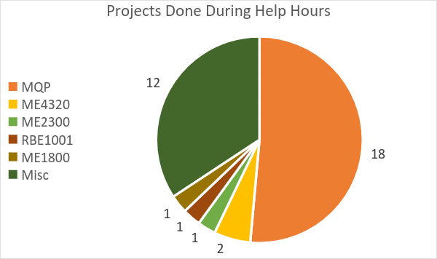
Projects done during help hours:
Figure A - What project did you receive help with?
During the term of this service, students worked on a wide set of projects ranging from MQP, which was what this service was created for, personal projects, which were also encouraged through this program for students who may be less experienced in the shops, to introductory class work like ME1800 and RBE1001. Pictured in Figure A (shown above) is a representation of the responses to the question “What project did you receive help with?” Of the 35 collected responses, 18 students received help with their Major Qualifying Project, 12 received help with miscellaneous personal projects, and 5 students received help with classwork from Advanced Engineering Design (ME 4320), Introduction to Engineering Design (ME 2300), Introduction to Robotics (RBE 1001), and Manufacturing Science Prototyping and Computer Controlled Machining (ME 1800). This program was designed with the initial intent to help students who may not be experienced with manufacturing get work done for their MQP. As debatably the most important part of a student’s graduation requirement, MQP is often one of the most complicated and intensive projects for students and help can sometimes be needed. With the short duration of this service paired with the difficulty in ensure students were aware of the service it is reasonable to think that even more students could need help through a service similar to the one provided in this project.

Number of times staff members assisted students:
Figure B - "Which staff member assisted you?"
This survey question was not found to be pertinent to our results. A table of data correlating to Figure B (shown above) can be found in Appendix B.

Problems the staff members couldn’t solve:
Figure C - "Was there anything the staff members were unable to help you with?"

This survey question was not found to be pertinent to our results. A table of data correlating to Figure C (shown above) can be found in Appendix C.
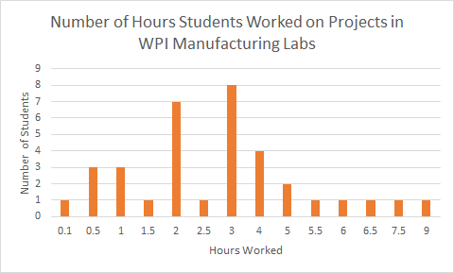
Figure D - "How many hours did you work on this project today?"
Number of hours students worked on projects in the WPI Manufacturing Labs:
In order to further understand the need of the students who use this service, our survey included a field for students to input how many hours they had been working on their project in Washburn Shops that day. It is important as a student at WPI to work hard and efficiently in order to meet all requirements and manage all responsibilities adequately. This becomes difficult when certain projects or assignments require large chunks of a student’s available time to complete them as it leaves little time for the student to complete other assignments or simply relax. Often times a student takes more time than they would like completing an assignment because they are not entirely familiar or comfortable with what they need to complete. This causes a task that should take 4 hours to instead take six hours as the student slowly relearns the necessary skills or techniques to complete the task to the level they need to. To collect data in regard to this point, we asked those surveyed “How many hours did you work on this project today?” This data, shown in Figure D (shown above), demonstrates both the value of this program and the need students have for this program. The help hours provided only ran for 4 hours each weekday, meaning that a student working for any hours more than 4 was working on their project outside of help hours, and any student working on their project for 4 hours or less could have finished their task within the duration of help hours. If a student finished their task during the help hours, it is encouraging to know that they got all the help they required during that time to complete their task quickly. If the task was started and finished during the help hours then the student was able to get all questions answered. This supports the idea that a program like this is needed, as students are able to get the necessary help to finish their tasks in a timely manner. For students who worked for longer than 4 hours, a different conclusion can be drawn. From 8:00 AM to 5:00 PM Washburn Shops are primarily occupied by machining courses, making them unusable for students who need to work on projects. The shops are not always open on the weekends, and if they are they are opened by a lab monitor without any way to notify students who may have work they need to get done. That means most students are forced to wait until 5:00 PM on a weekday to be able to use the machines they need to complete work. For students who worked for more than 4 hours in a day, they either started working before the machines were open on parts of their project that could be done without machining, which is a reasonable way to use their time, or they stayed in the shops well beyond reasonable hours in order to use the machines to complete their task. Without designated free time some students stay up extremely late to use the machines, which is neither ideal nor safe.

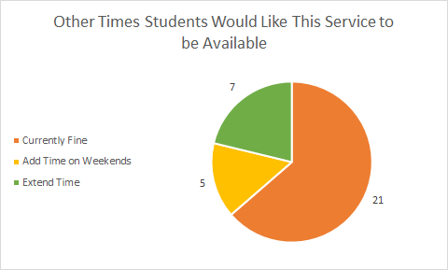
Other times students would like this service to be available:
Figure E - "Are there other times you'd like this service to be available?"
In addition to judging the effectiveness of the service in its current state, the survey was also used to decide if any changes could be made to improve the program moving forward. One of the main concerns in regards to improving the program was changing the times that it was provided. The service ran every weekday from 5:00 PM to 9:00 PM. The concern with this timeframe was that students wouldn’t be free to work during the weekdays and would need time provided on the weekends or that 4 hours was simply not enough time for students to get as much help as they needed. To gauge students’ feelings about the timeframe the service was provided we collected responses to the question “Are there other times you’d like this service to be available?” The responses to this question, pictured in Figure E (shown above), give us a decent idea of what works for students who would use this kind of service. Though most students said that these times are currently fine, enough students requested weekend times that it would be reasonable to allocate some hours of this service to the weekend. When reading this graph it must also be known that it is entirely possible that students who are free to work on the weekends may not have been able to make the weekday hours to request weekend hours. Because of this it makes sense to interpret the few recorded requests for weekend hours as more of a priority than the data may indicate. With these responses in mind, hours should be allocated to the weekend in one of two ways depending on the number of total hours allocated for the week. If the hours per week stays at the current number of 20 per week, then hours from less popular days should be moved to the weekend. For example, Mondays were a day with little help hour traffic since students would either finish their work on the weekend or receive other work that wasn’t going to be done in the machine shop. Ideally, the hours allocated per week would be increased to allow for weekend sessions in addition to the current weekday sessions.

Information students wanted to know before coming to WPI Manufacturing Labs:
Figure F - "Was there any information you would have like to know before starting your project?"
This survey question was not found to be pertinent to our results. A table of data correlating to Figure F (shown above) can be found in Appendix D.

How the help hours were rated by students:
Figure G - "How would you rate the help you received?"
Part of collecting survey responses was for us to evaluate at the end of the program how effective it was for students. From the data we collected we would make improvements to the service in regards to available times, procedure, or personnel. Most questions provided in the survey provided information regarding available times and procedure. Because of this we also wanted to include a survey question to gauge the effectiveness of the personnel we hired for this service. Shown in Figure G (shown above) are the results to the survey question “How would you rate the help you received?” Those surveyed overwhelmingly thought that the help provided by the chosen personnel was exactly what they needed, with 97% of respondents giving a 5 out of 5 rating. In collecting data it was important to us to know whether or not students were responsive to other students guiding them. Oftentimes students would prefer a professor or staff member helping them instead of another student because of the expectations that each position perceptually conveys. A professor or staff member is seen to be very proficient and knowledgeable on the topic at hand since they are being paid to teach/research the topic at hand or something similar. A student however is still learning, and other students would often prefer that the person helping them is proven in the topic they need help with. With an outstanding rating provided by students using this service, it seems apparent that students who need help are not only content with receiving help from other students, but they are also approving of the kind of help other students can provide them.

Suggestions to improve the program moving forward:
Figure H - "Do you have any comments or suggestions to help improve this service in the future?"
This survey question was not found to be pertinent to our results. A table of data correlating to Figure H (shown above) can be found in Appendix E.

Discussion_________________________________________________
Through the survey results and discussions with students who used the service, a service like this should continue to be provided by Washburn Shops. Survey results show that this program had an impact on project groups, allowing them to get help completing one of the most important projects in their college career. Comments left by students in their survey response request that this service continues to be provided, advertised, and improved for classes to come. Students expressed interest in this service as a long-term solution to the lack of additional resources in regards to learning manufacturing. There are two primary undergraduate manufacturing courses that students will take, but oftentimes students do not utilize their manufacturing knowledge after the courses end until a project comes up. This gap between learning and application causes many students to lose the knowledge they had when the course ends, making it much more difficult to complete projects without outside help. With this in mind, through the information collected during the duration of this project, it would be beneficial to continue this service of providing help hours for students to complete manufacturing projects.
Though many students who utilized the service during the period of this project expressed that there was no need to extend the time of each session or add time on the weekends, talking with students who did not use the service along with the few responses asking for weekend hours lead us to believe that allocating hours for the weekend would prove beneficial in delivering help to as many students as possible. The best way to do this would be to add extra hours to the weekly total for the program and allocate these on the weekend. Adding 8 hours per day for the weekend and running the program 9:00 AM to 5:00 PM would bring the total hours per week for the program to 36 and provide a near equal amount of time for students to get help on the weekend as there are hours to get help during the week. This number of course could be adjusted based on traffic to the machine shop during weekend hours and reallocation of these hours may be necessary depending on how the students use them.
Overall the program achieved what it was created to do: provide effective and available assistance to any student who needs it using only student workers to run the program. Students rated the help they received extremely highly, and many students we spoke to would recommend the service to other students who may need it. This program also managed to succeed without the need for excessive additional training of personnel or staff involvement. Moving forward, changes could be made to better optimize how the program runs, but no major changes need to be made in order for the program to be functional and effective.

Conclusions________________________________________________
- This service to provide project help in Washburn machine shops for WPI students should be continued.
- The hours covered by this service should be extended to cover weekends in addition to the current scheduled hours.
- The service provided to students for the duration of this project was effective and satisfactory enough to continue in the same manner.

Appendix__________________________________________________

Appendix A:

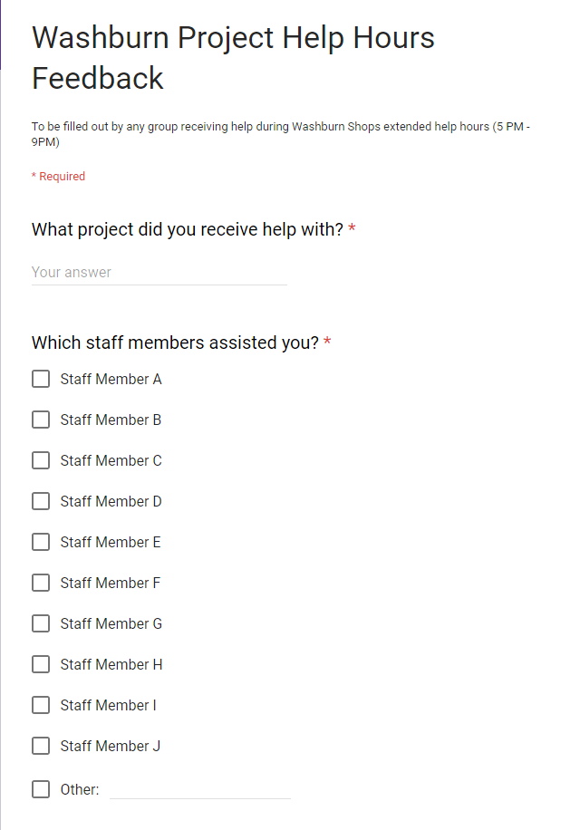

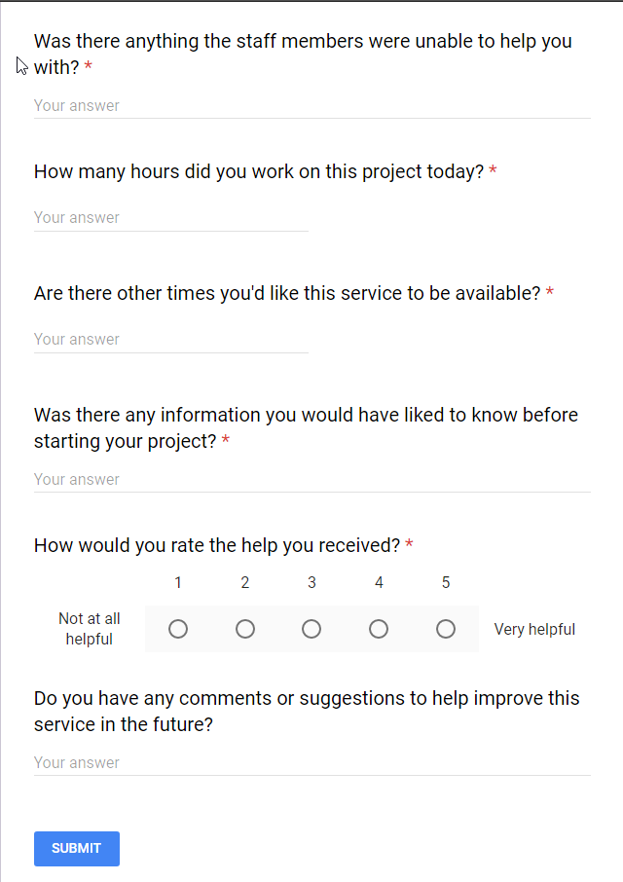

Appendix B:

Which Staff member assisted you | Count
Staff Member A | 4
Staff Member B | 3
Staff Member C | 3
Staff Member D | 8
Staff Member E | 8
Staff Member F | 3
Staff Member G | 4
Staff Member H | 1
Staff Member I | 5
Staff Member J | 3
Other Staff Member | 8

Appendix C:

Response | Count
No | 34
Yes (Missing Tool) | 1

Appendix D:

Response | Count
No | 25
Additional Manufacturing Education | 4
Material Information | 2
Strengths of each staff member | 1
More information about the Washburn Project Portal program | 3

Appendix E:

Response | Count
No | 15
Additional educational opportunities | 2
Advertise more or to specific depaRtments | 3

References_________________________________________________

[1] Giffi, Craig. “The Skills Gap in U.S. Manufacturing | Deloitte US | Manufacturing Industrial Products and Services.” Deloitte United States, The Manufacturing Institute, 18 May 2017, www2.deloitte.com/us/en/pages/manufacturing/articles/boiling-point-the-skills-gap-in-us-manufacturing.html.

[2] “ABOUT.” MIT Central Machine Shop - About, Massachusetts Institute of Technology, web.mit.edu/cmshop/about.html.

