Microbes to Molecules

MQP: Small World Initiative

Professor Mike Buckholt

Liam Goodale

4/26/18

# Abstract

Two bacterial samples, referred to as 14-29 & 15-6, were chosen from among several putative antibiotic-producing isolates originally discovered in a WPI laboratory course titled “Microbes to Molecules: Crowdsourcing Novel Antibiotic Discovery” from 2014 to present. Potential antibiotics were extracted from the samples and assayed for efficacy against *E. coli* and *B. subtilis* and characterized by HPLC. Antibiotic activity was visible to varying degrees on assay plates for each sample. Colony inhibition was demonstrated by each sample, but only 15-6 demonstrated inhibition from extraction. Identification of these antibiotics will determine their novelty and potential application for treatment of infection.

Table of Contents

Abstract 2

Introduction 5

Methodology 9

Gel Electrophoresis 9

Polymerase Chain Reaction 9

Table 1: Primer Sequences 10

Sequencing 10

Figure 1: Good Sequencing Result in 4Peaks® 11

Figure 2: Poor Sequence Result in 4Peaks® 12

Extraction 13

Picked Colony Assay 13

Disk Diffusion Assay 14

High Pressure Liquid Chromatography 14

Results and Discussion 16

Gel Electrophoresis 16

Figure 3: Gel Electrophoresis of Both Samples 16

Polymerase Chain Reaction 16

Sequencing 17

Figure 4: Abridged BLAST Hits for 14-29 with 27F 17

Extraction 20

Picked Colony Assay 20

Figure 5: *Bacillus* *subtilis* Picked Colony Zone of Inhibition Assay 20

Disk Diffusion Assay 21

Figure 6: Initial Disk Diffusion Assay 21

Figure 7: Secondary Attempt of Disk Diffusion Assay 22

23

Figure 8: Part Two of Final Disk Diffusion Assay 23

Figure 9: Part Four of Final Disk Diffusion Assay 24

Figure 10: Close-up of E1 Zone of Inhibition (from Figure 6) 24

Table 2: Extract Inhibition Summary 25

High Pressure Liquid Chromatography 25

Figure 11: E1 (15-6) High Pressure Liquid Chromatography 26

Figure 12: MH (Methanol) High Pressure Liquid Chromatography 26

Figure 13: E1;NE High Pressure Liquid Chromatography 27

References 28

Protocols 29

Gel electrophoresis 29

Polymerase Chain Reaction 29

Sequencing 29

Extraction 29

Disk Diffusion Assay 30

Picked Colony Assay 30

High Pressure Liquid Chromatography 30

Supplementary Data 31

Figure 14: 14-29 27F Original Sequence 31

Figure 15: 14-29 27F Conservative Sequence Trimming (as seen, in part, in Figure 4) 32

Figure 16: Part 1 of 14-29 92R Original Sequence 32

Figure 17: Part 2 of 14-29 92R Original Sequence 33

Figure 18: 14-29 92R Trimmed Sequence 33

Figure 19: 15-6 27F Trimmed Sequence 34

Figure 20: 15-6 92R Trimmed Sequence 34

Figure 21: Part One of Final Disk Diffusion Assay 35

Figure 22: Part Three of Final Disk Diffusion Assay 35

Figure 23: A1 Graph 35

Figure 24: A1;NE Graph 36

Figure 25: A2 Graph 36

Figure 26: A2;NE Graph 36

Figure 27: E2;NE Graph 36

Figure 28: Ma1 Graph 37

Figure 29: Ma2 Graph 37

Figure 30: M12 Graph 37

Figure 31: Repeat MH (Methanol) Graph 37

# Introduction

This project is designed around the mission of the Small World Initiative (SWI, 2018). SWI aims to isolate and study novel antibiotics produced by bacteria. Said bacteria are typically isolated from environmental samples, which SWI encourages students to collect (by providing protocols to educational institutions). This group describes its mission as applying the somewhat new concept of crowdsourcing to the one of the lesser-known areas of science, antibiotic discovery (“Mission,” 2015). In the age of antibiotic resistance in pathogens, the application of this research is certain.

Antibiotics are molecules that are produced by microbes in response to various stress stimuli. The production of these molecules is believed to have arisen by natural selection -- it is easy to imagine the advantage of prokaryotes with the capacity to inhibit or kill competing microbes (Drlica & Perlin, 2011). On the other hand, some antibiotics are synthetic – scientists can improve upon a natural antibiotic substance by purifying the agent and modifying its structure. In fact, drugs are overwhelmingly produced in racemic mixtures in which the enantiomer of the therapeutic agent is responsible for many of its side effects. Although, it is extraordinarily difficult, stereospecific manufacturing of these compounds would ameliorate this issue (Heilman, 2017).

Antibiotics can be divided into two distinct categories: lethal or static. Lethal compounds destroy microbes whereas static compounds prevent their growth. However, this distinction is complicated with the knowledge that an antibiotic’s function as a lethal or static compound is dependent on its target (i.e. frame of reference). In other words, many lethal antibiotics are only effective against particular microbes, and may even behave as a static compound against others. This complication is exemplified with the compound rifampicin: it is lethal against *M. tuberculosis*, and static against *E. coli* (Drlica & Perlin, 2011).

The design is to follow through with research by students in the self-driven laboratory course called “Microbes to Molecules.” Students in this course begin by collecting a soil sample, and carefully isolate bacteria from this. It is no messy task, requiring patience and repeated attempts. All the while, there is risk of contamination of any given sample, because of the sheer microbial biodiversity in the earth. Ultimately, students end up with one or two cultures of bacteria that demonstrate inhibition against the gram positive and negative bacterial standards (i.e. *E coli* and *B. subtilis*). This inhibition is regarded as a potential production of antibiotics, and these are noted and preserved for future observation. Thus, the students prepare and freeze samples of these potential antibiotic producers, noting their defining observations throughout this course. This is the point at which this Major Qualifying Project had begun. Last year’s group revisited ideal samples from this course – in other words, those that produced strong zones of inhibition against the bacterial standards – in order to first replicate inhibition that the students observed, and next begin independent research.

It was hypothesized that zones of inhibition against these standards were indicative of antibiotic production; with strength of inhibition being proportional to this indication. One argument that was provided in defense of this hypothesis was that out-competing bacterial standards (which is one possible scenario that would lead to a false positive in a previous colony inhibition assay) would kill them just the same as would secondary metabolites but may not create the characteristic ring of antibiotic producers. In summary, the goal of revisiting and observing these ideal samples was twofold: to reproduce the zones of inhibition against bacterial standards, and to ultimately identify the antibiotic agent (if there is one).

Identifying the antibiotic agent is a difficult task. First, it must be extracted from the culture and purified. Next, it must be in a sufficient amount to be analyzed. However, the final step of analyzing the compound can be made relatively easy with the use of a mass spectrometer. Herein, this instrument is used as the primary resource for antibiotic agent examination and identification.

Last year’s iteration of this project neatly catalogued Microbes to Molecules samples from 2014 to 2016 with a unique identification tag and strength of inhibition against *E. coli* and *B. subtilis* (Googins et al., 2017). E. coli and B. subtilis are used in this application for a few reasons: they are Gram negative and positive respectively and are essentially harmless to use in a laboratory environment. In other words, *E. coli* and *B. subtilis* are used in numerous studies as representatives of broad classes of bacteria (Gram negative and positive), such that inhibition of either one may suggest the application of the antibiotic compound to inhibit multiple members of a broad class of bacteria.

Armed with the hypothesis that colony inhibition is indicative of antibiotic production (and therefore potential extract inhibition), the samples that demonstrated strong colony inhibition of both *E. coli* and *B. subtilis* were chosen from among approximately 70 that were screened by last year’s group. There were only two samples that met these criteria, catalogued as 14-29 and 15-6. Sample 15-6 was later determined to produce antibiotic compounds by demonstrating inhibition of both test bacteria with its ethyl acetate extract (“E1”). Sample 14-29, on the other hand, was unable to inhibit either test bacteria with its extracts but nonetheless may warrant further study.

# Methodology

## Gel Electrophoresis

Each PCR product was run on a 1% agarose gel with 1X TAE buffer. Marker was HyperLadder I from Bioline Company and stained with SYBR Green in order to visualize the DNA. Gel was consistently supplied with 150 volts for 30 minutes oriented so that samples move along the gradient from negative to positive. Afterwards, the gels were imaged in order to estimate sample size and viability for sequencing.

## Polymerase Chain Reaction

Colony PCR was used exclusively throughout this project. First, colonies were boiled at 100 degrees Celsius for 10 minutes in 9 uL of distilled water using a thermocycler. PCR reactions were run at a total volume of 30 uL (9 uL boiled colony mixed with 15 uL of 2X New England Biolabs Inc. OneTaq® Master Mix, as well as 3 uL of both the forward and reverse primer each at 10 uM stock concentration). For UP1/UP2 primers, the stock concentrations deviated from this benchmark of 10 uM. In order to preserve the consistency of this procedure, they were diluted or added in a slightly greater volume in order to effectively become 10 uM primers in this reaction. Finally, PCR was performed on the thermocycler under the following conditions: 95 degrees for 2 minutes, and then a cycle that is repeated 30 times. The repeated cycle is as follows: 95 degrees for 30 seconds, 49 degrees for 45 seconds, and 72 degrees for 2 minutes. Afterwards, it remains at 72 degrees for 10 minutes, and then is held at 10 degrees until the samples are removed from the instrument.

Samples were consistently made in volumes of 10 uL for boiling, and 30 uL for PCR.

Two pairs of primers were used herein: 27F/1492R, and UP1F/UP2R from Integrated DNA Technologies Inc. These primers amplify the signature 16S rRNA hypervariable region of bacteria and produce PCR products approximately 1,500 base pairs in length.

Primer sequences are listed below, see Table 1 (Govenstein et al., 2013) (Macrogen, “Universal primer list,” 2018).

### Table 1: Primer Sequences

|  |  |
| --- | --- |
| Primer | Sequence |
| 27F | 5’ -AGA GTT TGA TCM TGG CTC AG- 3’ |
| 1492R | 5’ -TAC GGY TAC CTT GTT ACG ACT T- 3’ |
| UP1F | 5´ -AAA GAC TGA TCA GCA CGA AAC GGG-3´ |
| UP2R | 5’ -CTC AAG TGC TGA AGC GGT AGC TTA-3´ |

## Sequencing

DNA sequencing of PCR products was conducted by Eton Bioscience Incorporated in Boston, Massachusetts, with forward and reverse primers for each sample.

These results were received in the form of text and .ab1 files, i.e. sequence readout and chromatograms.

After receiving each sequence from Eton Bioscience Inc., it was refined using 4Peaks® sequence viewing software, which was able to display the strength each nucleotide determination (Nucleobytes, 2018). In other words, the chromatogram displayed by this software shows the signal strength for each possible nucleotide at any given position. In this software, strength of determinations is color-coded, so weak determinations are readily visible. Typically, the start and end of a sequence has low quality determinations, and so trimming a sequence (i.e. deleting a string of weak determinations at the start and/or end of a sequence) can improve the accuracy of its report from the National Center for Biotechnology Information (NCBI) nucleotide Basic Local Alignment Search Tool (BLAST). In other words, it can help to better identify the bacteria from the sample that was sequenced. For example, Figure 1 shows clean signals from the middle of a 15-6 PCR product sequenced with 92R primer.

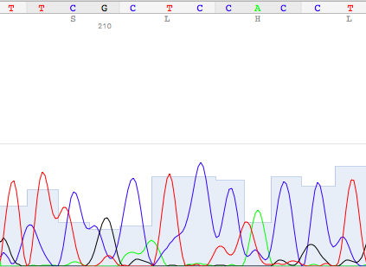

### Figure 1: Good Sequencing Result in 4Peaks®

Good sequencing results are distinguishable in this software by well-defined peaks with minimal background noise at any given peak (Nucleobytes, 2018). Figure 2, however, shows messy competing signals. This is from the same sequence seen in the preceding figure, that had to be trimmed. 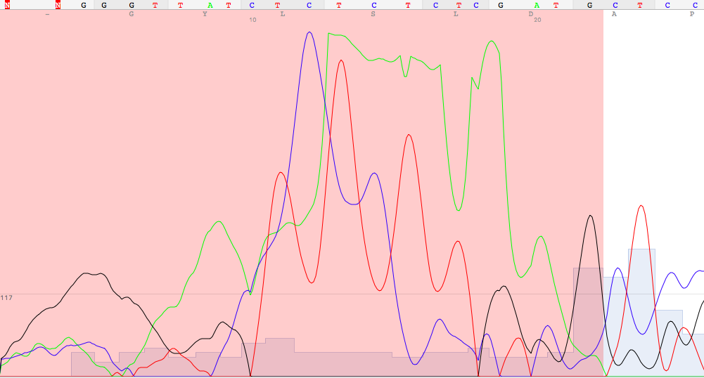

### Figure 2: Poor Sequence Result in 4Peaks®

Unlike inherently poor sequence – in which the beginning, middle, and end of the sequence are messy – Figure 2 shows the messy signals that can be expected at the beginning and end of most good sequences due to the primer. Examples of poor signal can be found at any point corresponding to uncalled bases (listed as N, rather than G, C, T, or A) in the text of a sequence result, such as in the first few base determinations of Figure 2. This trimming technique was employed only to provide a slight edge in the BLAST search of a sample; no further modifications were made to sequences herein.

BLAST was used with parameters for identifying any DNA sequences (default search) as well as ribosomal subunits (bacteria specific, as used by last year’s group).

There was no systematic differentiation in the case of NCBI BLAST yielding identical scores for two or more bacteria for a given sequence. As such, sequencing was ultimately inconclusive beyond narrowing down the identity of each bacterium to a small number of possible species. As per manufacturer instruction, products yielded from PCR conducted with UP1/UP2R primers were sequenced with UP1S/UP2SR.

## Extraction

Extraction protocols were similar to those of the previous MQP group and the Small World Initiative (Barter & McCarron, 2017) (SWI, 2018).

Acetone, ethyl acetate, and methanol extractions of antibiotics were conducted with overgrown samples on LB plates incubated at 37 degrees Celsius. Samples were suspended with 1 mL of solvent and then left for 1 hour on a shaker at 200 RPM. If after the 90-minute duration in the shaker, that extract did not appear to be suspended due to disproportionate volumes of extract and suspension, another mL of solvent was added, and the sample was left on the shaker for another 30 minutes. If the solution still did not appear to be suspended, however, the extract was left shaking overnight. Afterwards, the supernatant was transferred to a new container, leaving behind what was largely expected to be undissolved agar. Thereafter, suspended extracts were left to evaporate in a fume hood for 2-4 days, with the exception of methanol samples that were lyophilized. This was performed to expedite the otherwise slow process of drying methanol extracts.

## Picked Colony Assay

Bacterial standards were plated, and shortly afterwards, freezer stock of 14-29 and 15-6 were plated in their respective quadrants onto the already inoculated agar. Although, a very accurate method of plating the two species of bacteria was not employed, the mass was more or less consistent with a fairly precise method of picking the visual approximation of an equal glob. These plates were incubated overnight at 37 degrees Celsius.

## Disk Diffusion Assay

Finally, all extracts were re-suspended in methanol and then plated on bacterial standards using disk diffusion, i.e. gram positive and negative species, *E. coli* and *B. subtilis* using the disk diffusion method. *E. coli* and *B. subtilis* were plated from freezer stock at quantities of 20 uL per plate, spread using glass beads. The negative control in the disk diffusion experiment is a filter disk impregnated with methanol, and a positive control was deemed unnecessary. In the following trial, however, 10 ug of ampicillin from freezer stock was used as a positive control. This protocol revision is explained in the Results and Discussion section. As with each zone of inhibition assay herein, the plates were incubated overnight at 37 degrees Celsius.

## High Pressure Liquid Chromatography

Reference wavelengths set so as to be approximately 400 nm apart. 100 uL injection, in approximately 100% acetonitrile, 0.1% formic acid.

Extracts of some samples from previous year as well as this year observed in 200 uL methanol. Specifically, several extractions of 15-6 on various media (PDA, LB, THA, and TSA) were run. Similarly, all extracts from this were re-suspended in methanol for HPLC. Reports from the instrument were examined for absorbance patterns between corresponding recent and year-old samples. One would expect that would be identical, and if they were, further conclusions about these extracts would be validated.

In addition, methanol was run as a negative control for HPLC observation of suspended extracts. In other words, the characteristic peak from methanol was observed to demonstrate background noise so that this peak could be ignored in the observation of the antibiotic compound suspensions. Fractions were not collected during this experiment.

# Results and Discussion

## Gel Electrophoresis

Gel imaging was performed after each PCR trial and prior to each sequencing attempt. Imaging consistently demonstrated that the samples were both approximately 1.5 kilo-base pairs in length. A partially representative gel is shown below in Figure 3, containing 14-29 and 15-6 products of PCR with UP1/UP2.

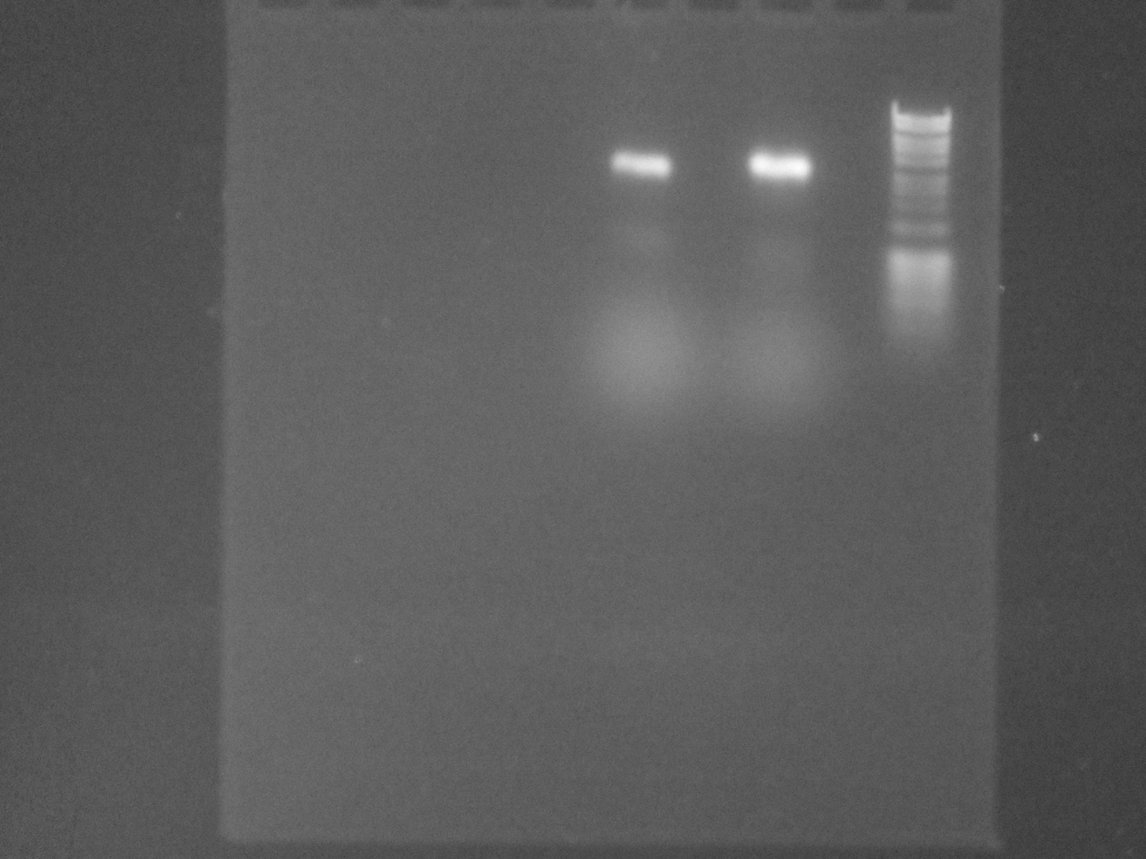  **15-6 14-29 Marker**

Size (bp)

8000

6000

4000

3000

2000

1000

800

600

400

200

### Figure 3: Gel Electrophoresis of Both Samples

Note that Figure 3 serves to demonstrate consistency of PCR product size between the two samples and is not representative of the typical bands as measured by the marker. Expected PCR products were between 1200-1500 kb, and products of sizes within this range were observed in multiple previous gel images (Yamamoto & Harayama, 1995).

## Polymerase Chain Reaction

There was no evidence to suggest that colony PCR was insufficient for sample

Identification, and it was noted that other student groups did not observe superior sequencing from isolated DNA PCR.

## Sequencing

Interestingly, in the first attempt, there was likely an error regarding primer 1492R in that the chromatogram was nonexistent with only this primer on sample 14-29 and its sequence readout with this primer read “NNNN,” whereas the other primer provided a nearly complete sequence with minimal noise in the corresponding chromatogram.

Although, the previous MQP team did perform PCR on these two bacteria samples, the primers were universal rather than deliberately selected in order to distinguish between a few specific species. As such, the samples could not be identified to the species level: instead, the team concluded that 14-29 was likely one of three species of Brevibacteria, and 15-6 was likely one of four species of Streptomyces. However, repeated sequencing attempts suggest that 14-29 was, in reality, a *Bacillus* rather than a *Brevibacterium*.

There were some notable differences between BLAST hits done herein on February 14th and those done by last year’s group with the same parameters for 14-29 sequences with 27F as well as 1492R primers. Abridged listing of BLAST hits for 14-29 with 27F sequencing is shown in Figure 4. Unabridged BLAST reports are available in Supplementary Data.

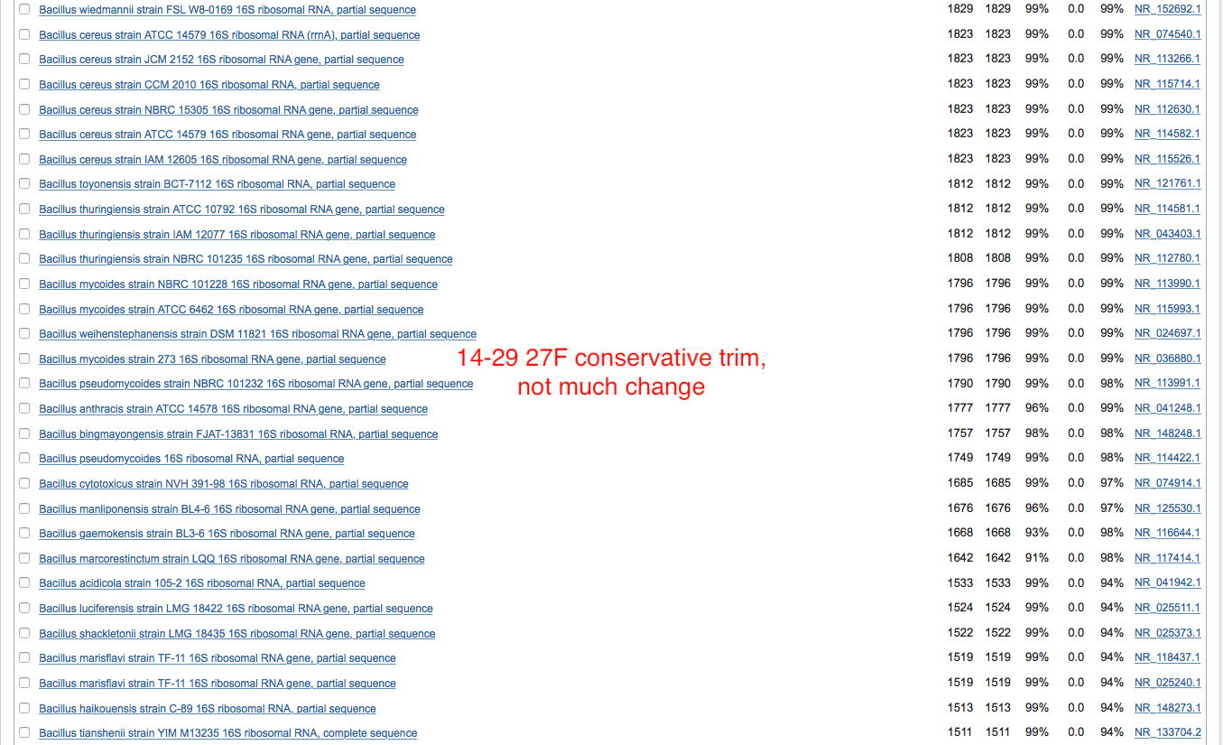

### Figure 4: Abridged BLAST Hits for 14-29 with 27F

Additional notice was taken to potentially hazardous BLAST hits of 14-29, such as *B. cereus* (seen on both 27F and 1492R sequences) and *B. anthracis* (seen on 1492R sequence). It was unsurprising that BLAST with default parameters was consistently less informative than it was with ribosomal subunit search restrictions. It is recommended to continue to search with this restriction throughout the continuation of this project in following years. However, one unexpected benefit from performing nucleotide BLAST with default search parameters in this case was perhaps uncovering an erroneous statement made in the report by the previous MQP group. By comparing this BLAST search with 15-6 27F and 92R sequences collected on February 11th to corresponding BLAST hits done by last year’s group, there was a striking similarity. The peculiarity comes from the expectation of greater similarity if they were to be searched using BLAST with the same parameters; however, they are divergent in this case. Instead, the BLAST hits of last year’s group are similar when the recent sequences are searched for using default parameters. In fact, for 15-6 92R, the results shown in their report were identical to those produced with its recent counterpart and default search parameters. This suggests the BLAST hits shown in their report may have been mislabeled as having come from ribosomal subunit search, and were in fact, from standard BLAST search parameters.

There is evidence to suggest that additional specific primers may be useful, specifically for 14-29 in order to distinguish between several *Bacilli*. As implied earlier, 27F and 1492R may not best amplify the genetic material of the bacteria (so as to yield more certain BLAST hits). Primers 27F and 1492R amplify the 16S ribosomal RNA of the bacteria and are named with respect to gene locations in *E. coli,* therefore they are suitable for prokaryotes such as the two samples of interest but were not necessarily the best choice for distinguishing between *Bacilli* as was needed in this case. For this reason, a different approach was necessary. Universal Primers 1 and 2, which happened to be in the laboratory during this project, presented a different approach; unlike 27F/1492R, UP1F/UP2R target the gyrase gene of the bacteria, and the hope was that they would provide a sequence that would allow BLAST to differentiate between the several *Bacilli* hits that were >99% alike (Weisburg et al., 1997).

This was the greatest motivator for the implementation of Universal Primers 1 and 2 (UP1F/UP2R), however, these primers failed to work as expected. In other words, they did not yield more accurate or specific sequences so as to clarify the identity of 14-29 with BLAST. Instead, 15-6 UP1F/UP2R PCR products (sequenced with UP1S and UP2SR) were of similar quality as 15-6 27F/1492R PCR products sequenced with 27F/1492R. Likewise, the BLAST hits were almost identical. On the other hand, 14-29 UP1F/UP2R PCR products (sequenced with UP1S and UP2SR) had far worse sequence quality than that of 14-29 27F/1492R PCR products (sequenced with 27F/1492R). There is unconfirmed suspicion at the time of publication that Eton Bioscience Inc. may have been experiencing instrument failure (with respect to primer compatibility) due to the volume of complaints from other Major Qualifying Project teams in the Biology/Biotechnology department; these concerns are noted for the benefit of the group that will continue this project. In the future, it may be worthwhile to send PCR products to another facility as well as Eton Bioscience Inc.

## Extraction

Extracts were re-suspended in methanol slowly, with only 1 mL being added every several minutes until the mixture appeared homogenous, at which point, one of the two inhibition assays were begun.

## Picked Colony Assay

Picked colony assays were moderately successful, although, they were inconsistent. Assay plates were divided into four sections. The quadrants (I, II, III, and IV) on each plate distinguish its treatment groups (see Figure 3). In quadrant I, there is a colony of 14-29. In quadrants II and III, there was no treatment, and therefore no expected inhibition. Lastly, in quadrant IV, there is a colony of 15-6. Note that there are zones of inhibition by both 15-6 (quadrant IV) and 14-29 (quadrant I).

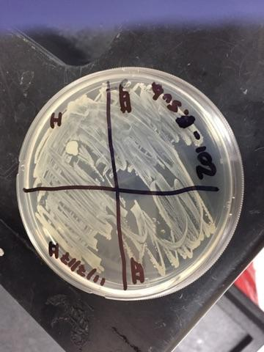

### Figure 5: *Bacillus* *subtilis* Picked Colony Zone of Inhibition Assay

A picked colony assay on much like that seen in Figure 5 was performed on *E. coli* and demonstrated a similar pattern of inhibition.

## Disk Diffusion Assay

All extracts were filtered with a 3mL syringe and 0.22 um sterile filter prior to HPLC and the first round of disk diffusion. However, some samples were retested in disk diffusion assays without filtration, and were demarcated with the subscript “NE.”

The initial trial had consisted of A1, A2, E1, E2, M11, M12, MA1, MA2, and negative controls (empty disks). Each sample had been filtered and each disk impregnated in 20 uL increments. This trial yielded no zones of inhibition. Figure 6 displays one of the several assay plates involved in this experiment and is representative of the outcome of this assay.

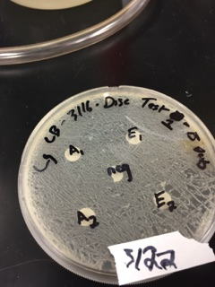

### Figure 6: Initial Disk Diffusion Assay

This result was inconclusive, because there are many reasons why this may have occurred. For example, the extraction may have failed in one way or another, or the bacteria only produce antibiotics as a response to particular environmental triggers, and so on. For this reason, future studies should further explore antibiotic production of this sample on other. However, such conclusions could not be made in confidence without additional trials and more evidence. Therefore, troubleshooting had begun, and it was considered that the disks may have been flooded too quickly, preventing the suspended antibiotic compound from being absorbed sufficiently to inhibit the bacteria.

A repeated experiment (excluding methanol samples, i.e. MA1;NE, MA2;NE, M11;NE, and M12;NE) was conducted in which the suspended extracts were dripped onto the disks much more slowly (10 uL every few minutes). Unfortunately, there were still was no visible zones of inhibition (see Figure 7). Figure 7 displays half of the plates used within this trial, and the lack of resultant zones of inhibition. Note that methanol extraction samples were not included in this quick repetition of the experiment due to time constraints; recall that these samples had been freeze-dried, and for this reason they were more difficult to re-suspend because lyophilizing tubes were unable to fit into the shaker. Afterwards, more possibilities for the negative results were considered.

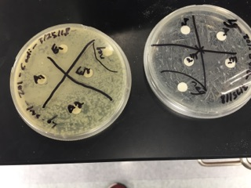

### Figure 7: Secondary Attempt of Disk Diffusion Assay

At last, a final attempt was made in which the procedure had been improved in three distinct ways: the disks were impregnated on an empty petri dish (rather than on fresh LB agar), a positive control was used, and a negative control (containing methanol) was also plated alongside the samples. Visible zones of inhibition were seen once again from this experimental trial (see Figures 8 and 9). Remaining disk diffusion trials are available in the Supplementary Data.

### 

### Figure 8: Part Two of Final Disk Diffusion Assay

Note in Figure 8 the E1 disk actually does exhibit a zone of inhibition, although difficult to see in this image. Refer to Figure 10 for clearer view of this zone of inhibition.

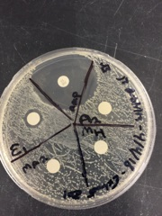

### Figure 9: Part Four of Final Disk Diffusion Assay

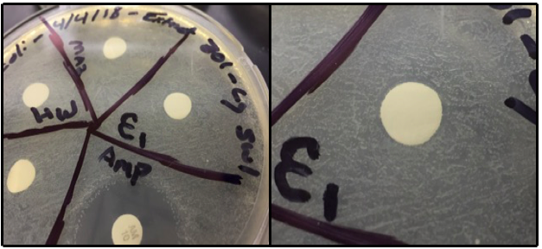

### Figure 10: Close-up of E1 Zone of Inhibition (from Figure 6)

The red arrows in Figure 10 point to a zone of inhibition produced by E1 on *E. coli*. The first panel of this figure shows E1 adjacent to the positive control (ampicillin, “Amp”). Relative to the zone of inhibition produced by the positive control, that of E1 is unimpressive.

The results of this comprehensive extraction are easily summarized: only the extract of E1 demonstrated antibiotic activity against the two bacteria (see Table 2).

### Table 2: Extract Inhibition Summary

|  |  |  |
| --- | --- | --- |
|  | *B. subtilis* | *E. coli* |
| A1 | No | No |
| A2 | No | No |
| E1 | Yes | Yes |
| E2 | No | No |
| M11 | No | No |
| M12 | No | No |
| Ma1 | No | No |
| Ma2 | No | No |

Where “yes” and “no” refer to observed inhibition.

## High Pressure Liquid Chromatography

Recovered extracts from last year’s group were re-suspended in methanol and compared among one another with HPLC in an attempt to replicate previous results and become familiar with the instrument. Slight differences were observed in otherwise identical samples that were extracted from different media, however, no strong conclusions could be made between these HPLC trials and those done last year for two reasons: a) the original volume of suspension was not recorded and therefore could not be replicated with certainty, b) extract may have degraded after several months of neglect in the HPLC apparatus.

Although it was considered, extractions herein were not performed from different media as they were by the previous group; instead, all extractions were performed on LB media.

Future studies should include mass spectrometry of isolated and filtered antibiotic samples. Although this measurement was planned to be incorporated into this project, it became impossible to include within the limited amount of time.

Graphs of both the sole extract able to produce a zone of inhibition, and then the solvent in which the extract was resuspended for HPLC are seen below in Figures 11 and 12 respectively.

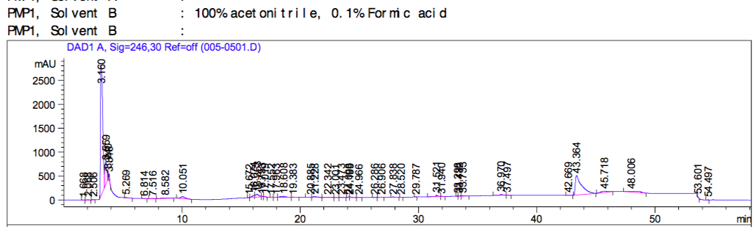

### Figure 11: E1 (15-6) High Pressure Liquid Chromatography

Where the above arrow refers to the peak that is expected to be characteristic of E1.

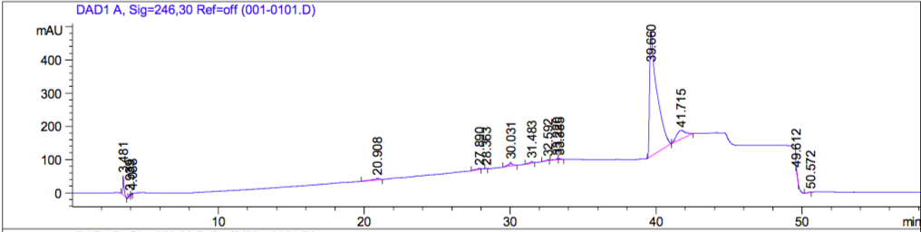

### Figure 12: MH (Methanol) High Pressure Liquid Chromatography

HPLC with methanol failed to produce the expected graph, as seen in Figure 12. It is important to note that this run was done at the same time as the other HPLC graphs shown herein.

The arrow above refers to the expected location of the appropriate methanol peak, based upon the what is likely the methanol peak in Figure 11.

Arrows seen in the above figures refer to the particular peaks on these graphs. In particular, the arrow in Figure 11 refers to what is believed to be the characteristic peak of the antibiotic compound. In Figure 12, the arrow points to where the characteristic peak of methanol would be expected, which reflected by this the counterpart of this graph. Methanol was run again after this experiment was concluded in an attempt to provide a more accurate HPLC graph without success (see Figure 31 in the Supplementary Data). These combined results – as well as parallel anecdotes from other MQP groups in the Biology/Biotechnology department regarding this machine and methanol samples – suggests possible instrument failure.

E1 was also observed without undergoing filtration of the solution, see Figure 13.

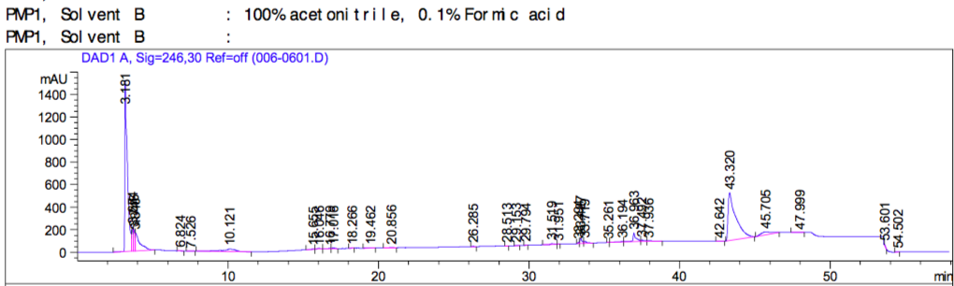

### Figure 13: E1;NE High Pressure Liquid Chromatography

In summary, 15-6 shows certain promise for further study by virtue of both its colonies’ and extract (E1) demonstrating inhibition of the two test bacteria. It is recommended that 14-29 undergo another extraction, nonetheless, because in this case, a lack of a positive result does not equate to a negative one (with respect to antibiotic production). There are multiple possible explanations for the lack of visible inhibition by this sample that were already discussed in brevity herein. Next, extracts from 15-6 and 14-29 (should its extract later demonstrate antibiotic activity) should be isolated in sufficient quantity for identification by mass spectrometry. At this point, it will become clear whether the antibiotic compound(s) isolated from the sample(s) is/are unique, and thereby important for the mission of the Small World Initiative.

# References

Barter & McCarron. 2017. “New Treatment for an Old Disease.” WPI. Major Qualifying Project.

CDC. 2018. “Antibiotic resistance questions and answers.” Government website: [www.CDC.gov](http://www.CDC.gov)

Drlica & Perlin. 2011. “Antibiotics: An Overview.” Financial Times Press. Pearson Education, Incorporated.

Googins, et al. 2017. “Isolation and Analysis of Antibiotic Compounds from Soil Microbes.” WPI. Major Qualifying Project.

Grovenstein, et al. 2013. “Identification and molecular characterization of a novel *Chlamydomonas* *reinhardtii* mutant defective in chlorophyll biosynthesis.” F1000Research, 2, 138.

Heilman. 2017. “CH4110: Protein Structure and Function.” WPI. Lecture.

“Mission.” 2015. Small World Initiative. Available from SWI website: <http://www.smallworldinitiative.org/mission/>

Nucleobytes. 2018. “4Peaks.” Nucleobytes website: [www.Nucleobytes.com](http://www.Nucleobytes.com)

Small World Initiative (SWI). 2018. SWI website: [www.smallworldinitiative.org](http://www.smallworldinitiative.org)

“Universal primer list.” 2018. Macrogen Corporation. Company website: <https://www.macrogenusa.com/support/seq/primer.jsp>

Weisburg, et al. 1991. “16S ribosomal DNA amplification for phylogenetic study.” J Bacteriology. 173(2), pp 697–703.

Yamamoto & Harayama. 1995. “PCR amplification and direct sequencing of gyrB genes with universal primers and their application to the detection and taxonomic analysis of *Pseudomonas* *putida* strains.” Applied and Environmental Microbiology, 61(3), 1104–9.

# Protocols

## Gel electrophoresis

Mix 50 mL of 1X TAE buffer with 0.5g of agarose. Microwave in 30 second intervals and stop when mixture begins to boil. Let cool for up to a minute. Repeat twice, and then pour into sealed casting tray. Add comb for appropriate number of lanes. Cover apparatus until it is solidified. Uncover, and orient gel so that the lanes begin at the negative end of the apparatus. Fill apparatus with 1X TAE buffer so that the gel is barely submerged. Load samples and marker into appropriate lanes. Connect to power source and run at 150 volts for 30 minutes.

## Polymerase Chain Reaction

Protocol for PCR was exactly as stated in the Methodology.

## Sequencing

Sequencing services were provided by Eton Bioscience Inc., and after PCR is begun, all necessary instruction can be found on their webpage while preparing to submit an order online.

## Extraction

Instruction for preparing and conducting extraction of bacterial samples was provided by the Small World Initiative’s research protocols. Specifically, those titled “Analyzing Organic Extracts for Antibiotic Production,” “Methanol Extraction,” and “Organic Extraction” were referenced herein. Ultimately, though, “Methanol Extraction” was found to be redundant and was discarded because “Organic Extraction” includes specific alternative steps for methanol use.

## Disk Diffusion Assay

Approximately 10 uL of freezer stock of each bacterial standard (*B. subtilis* and *E. coli*)were spread onto fresh LB plates with glass beads. Each disk was prepared in duplicate: impregnated slowly with a total of 80 uL of a suspended extract, and then placed equidistant from other disks onto a plate coated with one of the two bacterial standards. Ultimately, each extract would be tested on both cultures. Negative and positive controls are optional but recommended. The negative control should be the solvent in which the extracts were suspended. The positive control is flexible but should be an antibiotic standard that is expected to inhibit both bacteria so that it can be held constant throughout the experiment.

## Picked Colony Assay

Sterile LB plate inoculated with approximately 10 uL of bacterial standard (i.e. *B.* *subtilis* or *E. coli*). Afterward, a colony of sample of interest plated from an LB stock onto the inoculated plate into quadrant I. The same is done for the remaining sample of interest into quadrant IV. Controls may be used in remaining quadrants II and III.

## High Pressure Liquid Chromatography

Guidelines were set such that the reference wavelengths that are measured are within 300-400 nm apart.

# Supplementary Data

BLAST hits ribosomal subunit searches are shown below. Underlined BLAST hits and arrows indicate potentially hazardous identities of these samples. BLAST searches (Figures 14-20) were performed between February 14th and 23rd using sequences obtained using primers 27F and 92R. UP1/UP2 sequences were not included due to consistently poor quality (determined by chromatogram data and visualization software).

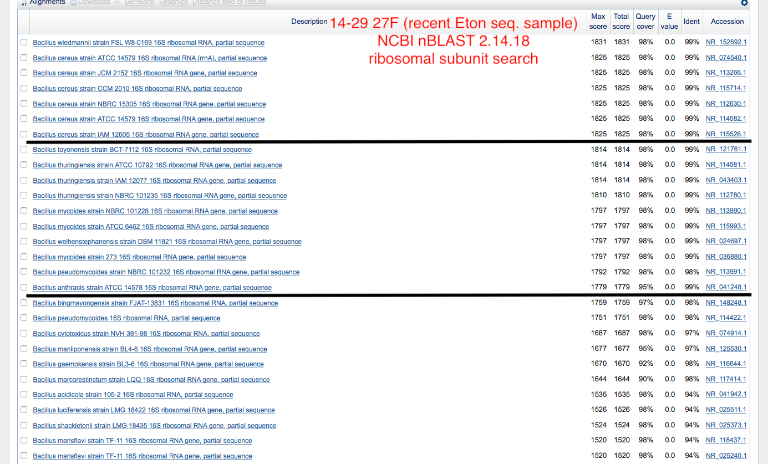

### Figure 14: 14-29 27F Original Sequence



### Figure 15: 14-29 27F Conservative Sequence Trimming (as seen, in part, in Figure 4)

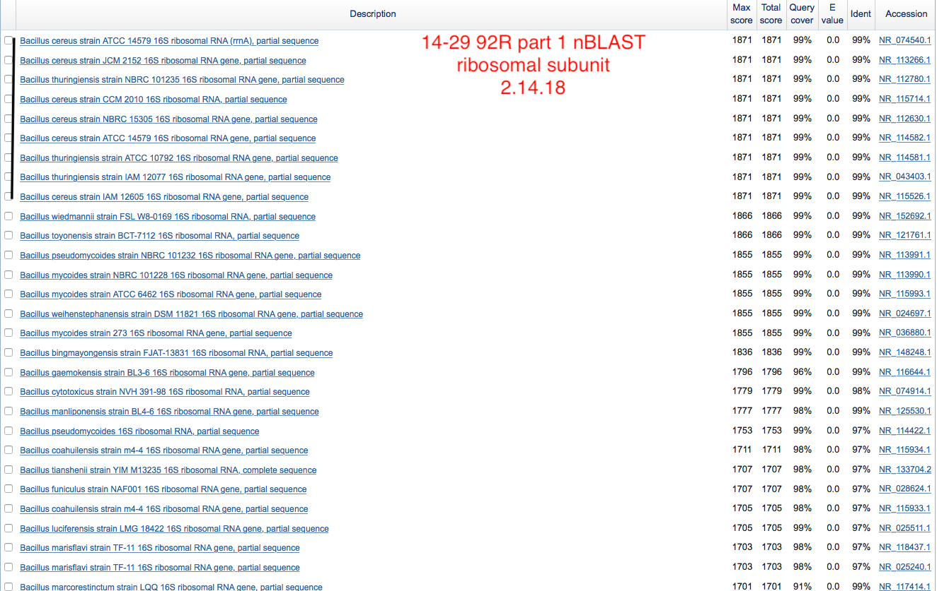

### Figure 16: Part 1 of 14-29 92R Original Sequence

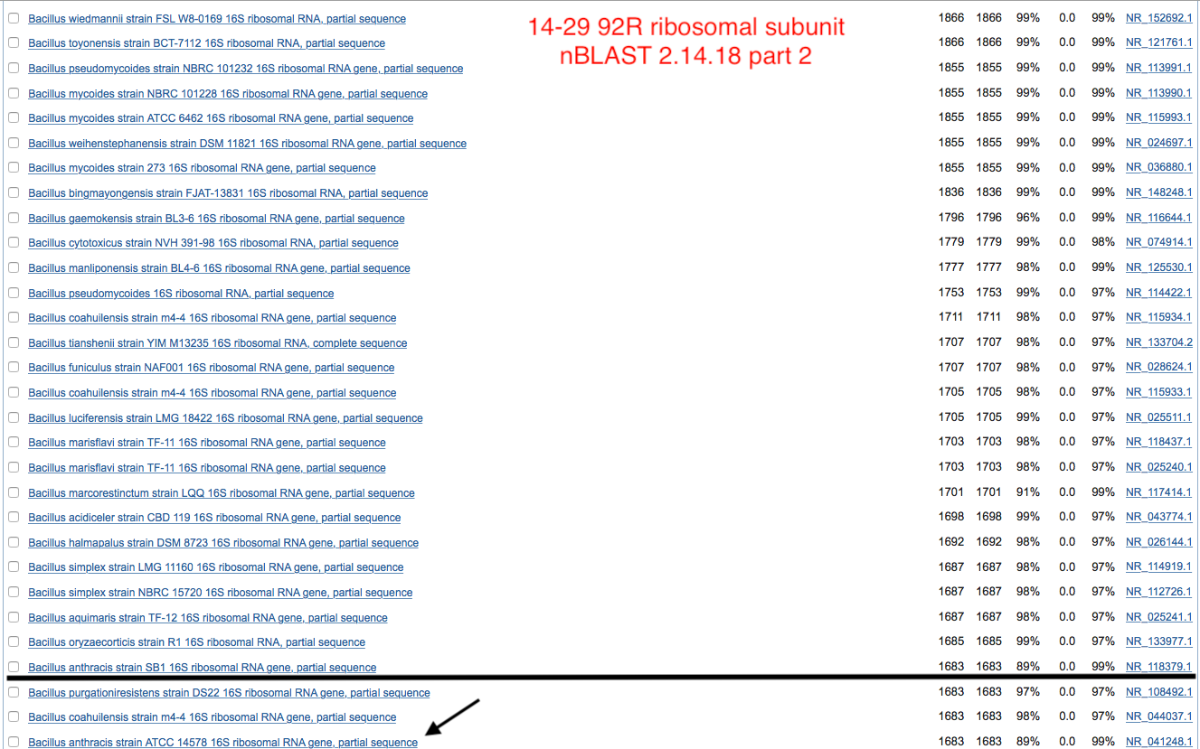

### Figure 17: Part 2 of 14-29 92R Original Sequence

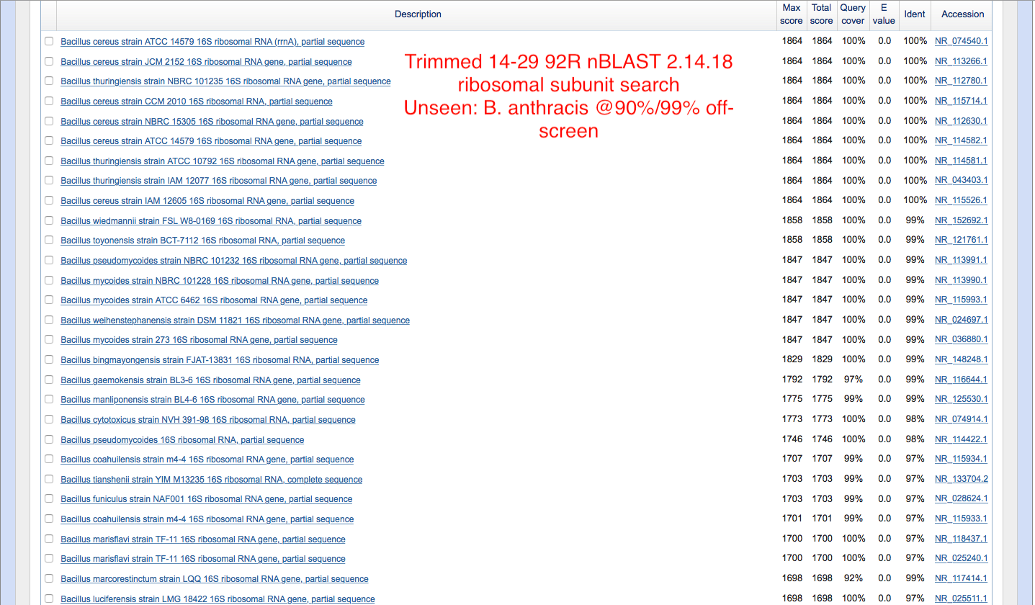

### Figure 18: 14-29 92R Trimmed Sequence

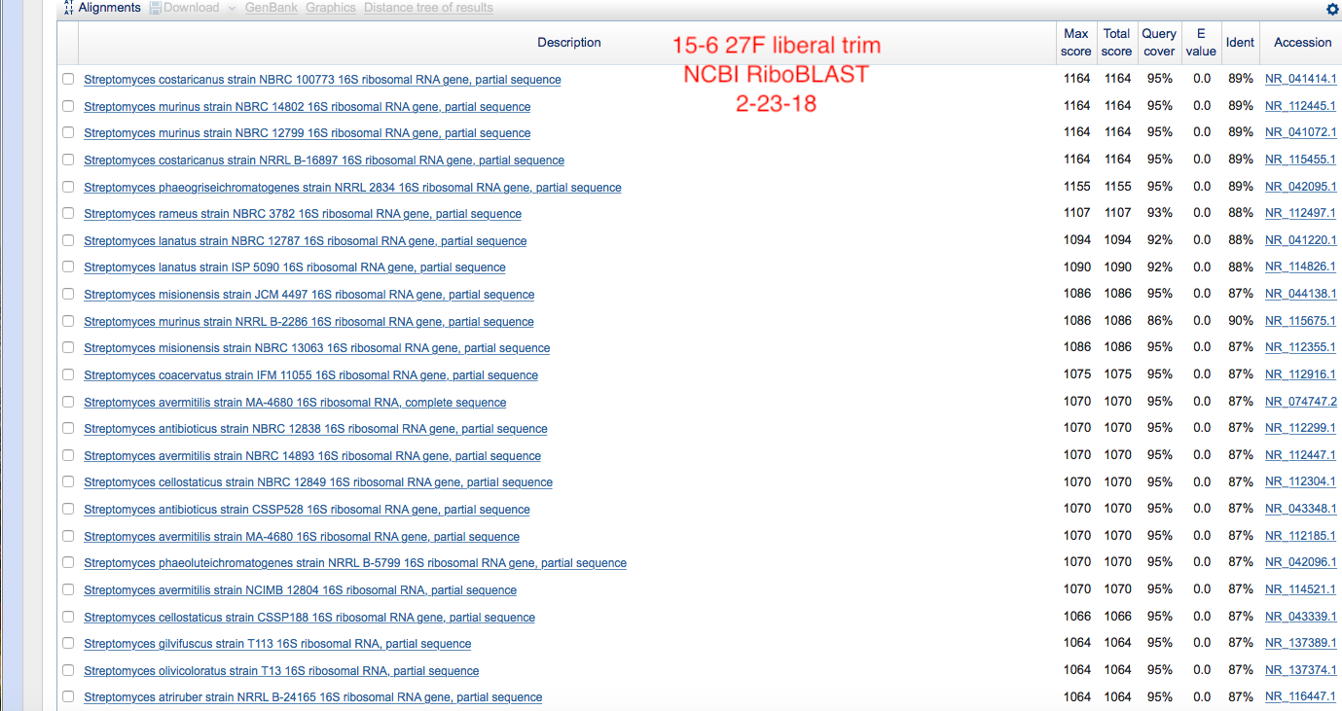

### Figure 19: 15-6 27F Trimmed Sequence

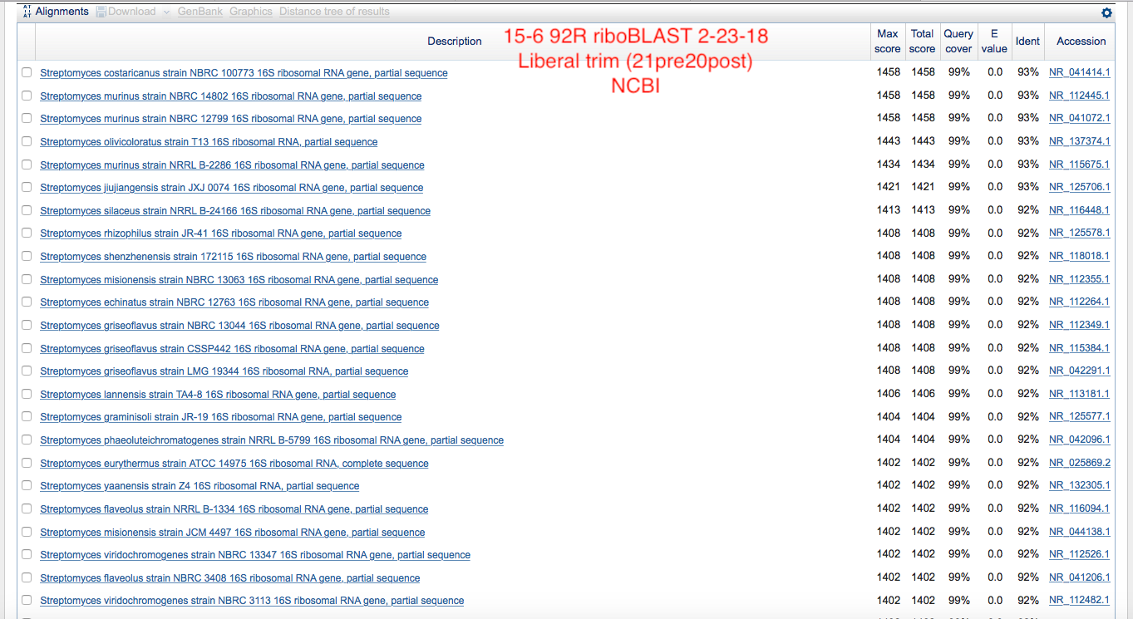

### Figure 20: 15-6 92R Trimmed Sequence

Additional disk diffusion images (“Parts One and Three”) are seen below:

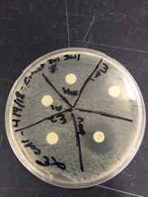

### Figure 21: Part One of Final Disk Diffusion Assay

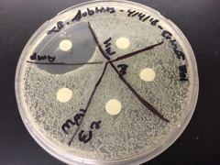

### Figure 22: Part Three of Final Disk Diffusion Assay

Additional HPLC sample peaks are provided below (full reports available upon request). Graphs of E2 and M11 were unavailable at the time of publication.

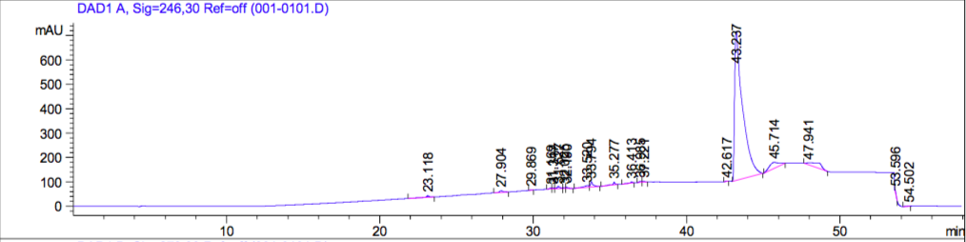

### Figure 23: A1 Graph

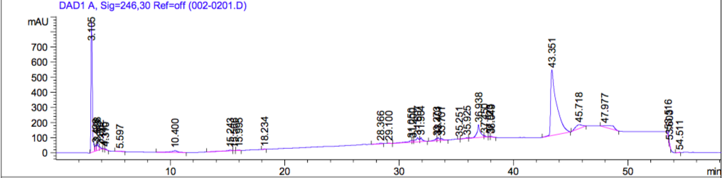

### Figure 24: A1;NE Graph

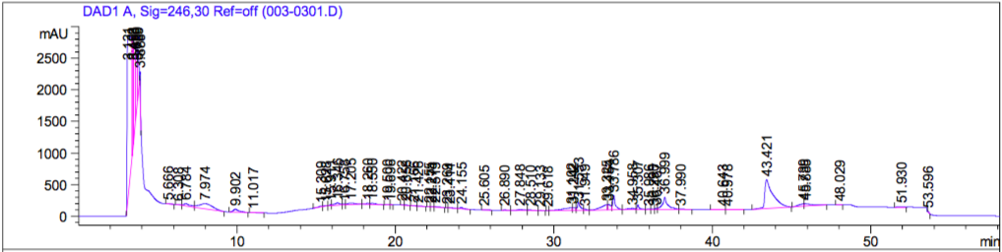

### Figure 25: A2 Graph

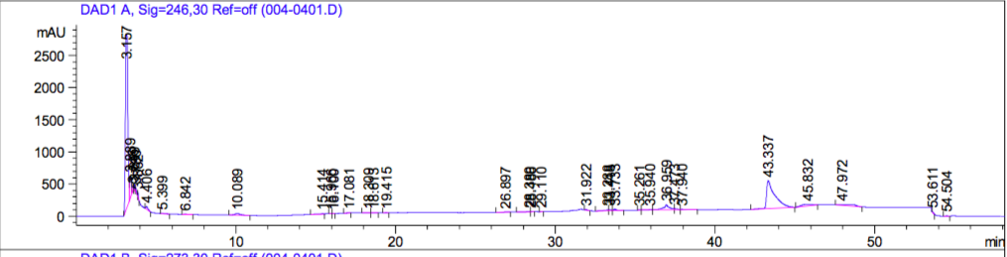

### Figure 26: A2;NE Graph

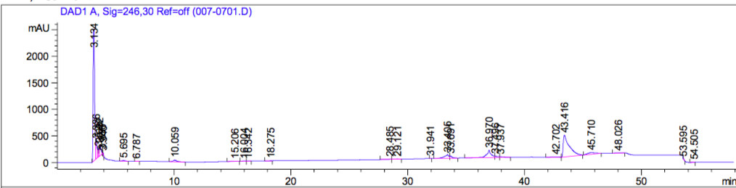

### Figure 27: E2;NE Graph

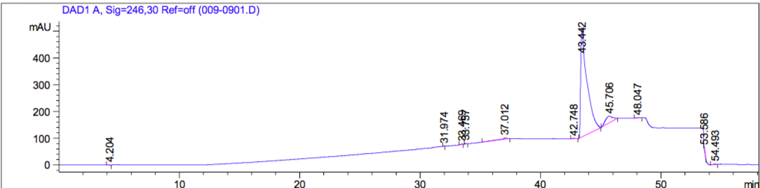

### Figure 28: Ma1 Graph

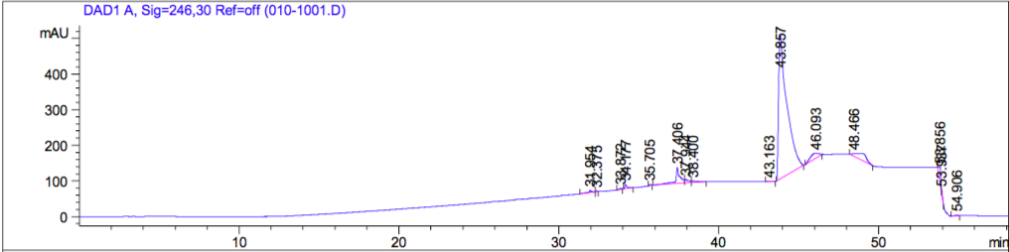

### Figure 29: Ma2 Graph

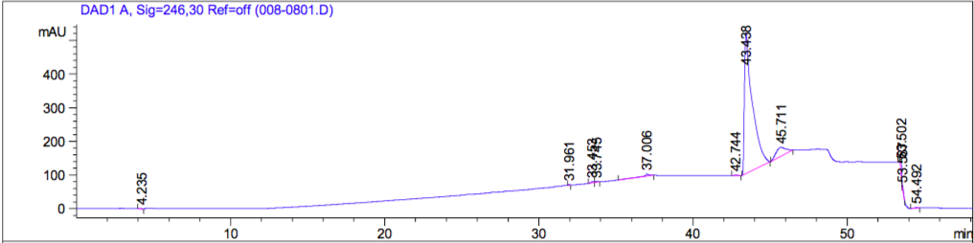

### Figure 30: M12 Graph

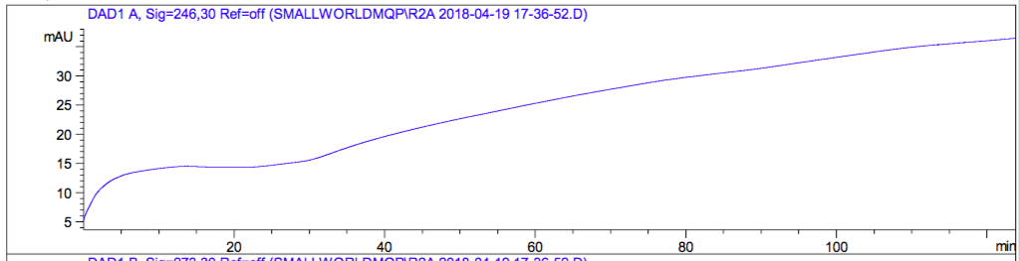

### Figure 31: Repeat MH (Methanol) Graph