Project Number: DZT0508

Stock Market Simulation
An Interactive Qualifying Project Report:
Submitted to the faculty
of the
Worcester Polytechnic Institute
in partial fulfillment of the requirements for
the Degree of Bachelor of Science
by

__________________________ ____________________________
Von Tourgee Michael Miller

___________________________
Daniel Butay

Date:
July 16, 2006

Approved:

__________________________
Professor Dalin Tang
Project Advisor

Table of Contents

Acknowledgements 3 Abstract 4
Chapter: 1 Introduction
1.1 Goals of the Group 5
1.2: General Plan for IQP 6
1.3 NYSE vs. NASDAQ 7 1.4 Stock Market History 8
Chapter: 2 Technical Analysis Trading
2.1 Introduction 15 2.2 Stock Selection 16 2.3 Weekly Trading Activities 19 2.4 Conclusion 34
Chapter: 3 Short Trading
3.1Introduction 39
3.2 Stock Selection 39
3.3 Weekly Trading Activities 43
3.4 Conclusion 57
Chapter: 4 Momentum Trading
4.1 Introduction 59 4.2 How to Momentum Trade 60 4.3 Stock Selection 61 4.4 Weekly Trading Activities 64 4.5 Conclusion 82
Chapter: 5 Trend Following
5.1 Introduction 85 5.2 Stock Selection 86 5.3 Weekly Trading Results 88 5.4 Conclusion 102
Chapter: 6 Fundamental Analysis Trading
6.1 Introduction 104 6.2 Stock Selection 105 6.3 Weekly Trading Results 107 6.4 Conclusion 122
Chapter: 7 Conclusions
7.1 Project Summary 126 7.2 Analysis of Trading Methods 126 7.3 Final Thoughts 129

Bibliography 130
Acknowledgments
We would like to thank Dr. Dalin Tang, Professor, Mathematical Science Department, Worcester Polytechnic Institute and our family members and friends for their support on the project as well.

Abstract
A stock simulation was conducted over a six-week period of time. During this time, we engaged in real time stock market simulations utilizing several different trading techniques. Stock performance data and company information were acquired through resources which are highly available to us. All of us gained active trading knowledge in the stock market, stock market history, and its trends in the near future. The knowledge and experience learned will give us an advantage for our real investment in the future.

Chapter 1: Introduction

1.1 Goals of the Group

The main goal of this project is for each member of our IQP group to gain knowledge of the stock market in several different ways. One of the ways in which we shall gain knowledge of the stock market is in the field of strategies. Another goal is to gain a better understanding of the stock market in general. There are countless ways to approach trading in the stock market. Many of these strategies are unique to the person who is investing, factors such as age, income, family situation, and company benefits come into play when creating a personal strategy. This is beyond the scope of our IQP we will not have the time, nor the ability to compare our results if we create different strategies for each of us, because of the variability. Our group is going to take the variables out of the equation. Each member of our group will start with 100,000 dollars in which they may invest based on their “standard” trading strategy. The strategies, which will be implemented are, Short Trading, The Big Dipper Method, Trend Trading, and Momentum Trading. To obtain our Goals, there will be a six, week trading period in which each member of the group may make as many trades as they wish as long as it follows the strategy, which they have chosen. At the end of the six, week period all of the strategies and choices of the group members will be analyzed, and compared. Through this comparison we will be able to come to a conclusion.

1.2 IQP General Plan

The general plan for the stock market simulation is brought together to obtain the goals, which we have set for ourselves for this project. The main goals are to investigate how different methods of strategy work in the stock market, given the same presets for each method. The second goal of learning about the stock market will be achieved through the actual simulation of stock market buying, and selling, as well as the research which goes on behind that buying and selling as well as the history of the stock market in general. The project will be run as such. Each member will use a different technique to approach investing in the stock market. They will be given “100,000 dollars” with which to invest. They are allowed to make as many or as few trades as they wish in the six, week trading period, as long as they give a reason for the trade which goes inline with their selected method. Each member will submit a 1-3 page weekly update, as to their situation in the stock market, and why or why not they made the moves they made. At the end of the six, week trading period each member will submit a final report on how much money was made or lost, and what influenced the stocks prices during that time period if there was any thing significant that happened. Also every one will critique their trading moves, as well as other members. Then as a group we will all analyze who made the most money, or who lost the least, and why their technique was more successful during that time period.

1.3 NYSE vs. NASDAQ
The NYSE, and NASDAQ are two mediums in which investors can use to invest in companies they are interested in. “Both of these mediums account for the majority of trading in North America, and the world as a whole.” [5] The NYSE, and NASDAQ; however, are run very differently from one another.
The NYSE is a physical place where stocks are bought, and sold by people. The NYSE is an auction market. The NYSE has a trading floor where people physically by and sell stocks from the person who is willing to pay the most to the person who is willing to sell for the least this is what is meant by an auction market. “For this system to work properly there needs to be a person who matches the buyer, and the seller to one another so that the transaction can take place. This person is know as a specialist, and matching the buyer, and the seller together is exactly what they do.” [5] The NYSE is a well, established market. They feature many of the older companies, which are also well established, that are known as a blue chip stock. A blue chip stock is a stock that is considered to be very stable.
“NASDAQ is not a physical place at all it is actually located on a telecommunications network.” [5] By not being a physical place, this allows buyers, sellers, as well as investors all to be directly connected to one another through the network. Using this system basically cuts out the “floor” where buying, and selling takes place physically. “In the NASDAQ buyers, and sellers are not buying, and selling from one another but to a “market maker”. [5] The market makers main job is to keep the flow of buying, and selling moving smoothly. The NASDAQ is more of a volatile market then the NYSE which is known for it’s stability. The reason for this is because NASDAQ is known more as a technologies market, and technology stocks are very volatile making the NASDAQ volatile. Also because the NASDAQ is cheaper for start up companies, which do not have the capital of a large company, many smaller companies are listed on the NASDAQ who cannot afford the NYSE.
These are the principal differences between the NYSE, and NASDAQ. Each have there benefits, and faults. Both markets add to the world of investing, and it is up to the individual investors to decided which one they would like to partake in if not both, and if they do decided to invest in both to what level do they want to invest in each of these.

1.4 Stock Market History
It is hard to imagine in this day of age that there was a time before the stock market as we know it today. The stock market in America has been around for a long time all of us have grown up with it, our parents have grown up with it, and our grandparents have grown with it, as well. But there was a time in the United States of America when there was no stock market. Before the United States created stock exchanges in America, there were stock markets, in other regions of the world. Some, “Other countries had such "exchanges" for many years. Belgium established the world's first in 1531.” [6] Stock exchanges where not a new thing, they had been around for quite some time, as we now know. Before the stock market was established, people used to sell stocks to people individually, to friends family, or those who they knew had the money to back there in devour. “Early in our country's history, Boston was the financial center of America. Bonds for projects such as roads, canals and bridges, and contracts for commodities such as hides and molasses, were bought and sold mostly by Boston dealers. However, there was not yet an official place to conduct such business.” [6] During this time period there was no place for the general population to invest in different opportunities. This is why the stock exchange was created to give the investors, and companies looking for investors to come together. One of the most historically important aspects of having a stock exchange in America was that there was now a need to have organized trading. Once this had happened it was an economic achievement for America. It shows us looking into the past, and the rest of the world at that time, that America had reached an economic point where there was a need for such an exchange.
Many people today believe that the first stock market exchange was founded in New York on Wall Street where it resides today. This is not the case, “The first stock exchange in America was actually founded in Philadelphia in 1790.” [7] We will focus on Wall Street because that is the exchange, which is the most important today. Wall Street gets its name because of the fact that originally there had been a wall along this particular street. “Dutch settlers had built a wall to protect themselves from Indians, pirates, and other dangers.” [7] This wall was eventually torn down, and a road was put in its place. This road became the economic center for Manhattan. “The path had become a bustling commercial thoroughfare because it joined the banks of the East River with those of the Hudson River on the west. The path was named Wall Street. Early merchants built their warehouses and shops on this path, along with a city hall and a church.” [7]
Originally the first stock market exchange was created by 24 men who where looking for an advantage when it can to dealing with securities. They believed that this advantage would come through organization, and exclusiveness. “The first organized stock exchange was created in 1792, when under a buttonwood tree in Castle Garden (now called Battery Park), John Sutton, Benjamin Jay, and 22 other financial leaders signed an agreement of rules, regulations and fees.” [7] Because they met under a buttonwood tree the agreement was called the Buttonwood Agreement. This exchange was not open to the public at first. To become part of the exchange members had to be voted in, and also pay an annual fee to become part of the exchange. “In 1817 a seat on the exchange cost $25, in 1827 it increased to $100, and in 1848 the price was $400. Members wore top hats and swallowtail coats.” [7] The top hats, and special clothing added to the exclusiveness of the exchange people knew who was in the exchange by what they wore.
Although Wall Street had humble beginnings, over the years it would grow into an economic powerhouse. This is blatantly obvious when the stock market crashed on a Tuesday in 1929. This day became known as black Tuesday. The United States economy came to a screeching halt. This would lead to the great depression. It took a world war to undo to the American economy what the stock market gave people the power to do to the American economy. We cannot blame the stock market exchange for Black Tuesday. It is only a medium to allow people to invest where they want to, and how they want to. It was the faith that the stock market would always go up, and that people where willing to invest in companies at extremely over valued prices, just because everyone believed that they would continue to go up. It is easy now to look back and see this as foolish investing which it was but, when one considers that, “From 1921 to 1929, the Dow Jones rocketed from 60 to 400! And that, millionaires were created instantly.” [8] With people making a killing all around them it would be very hard for a person not to get wrapped up in the whole stock market craze. Everyone was investing in the stock market. Poor, and wealthy alike went to the same place to invest their money. People where buying on the margin meaning that a person could buy a stock for only 10% of its actual value, and then pay the rest of the money back latter once it reached a higher value. These people where hit the hardest by the collapse. When this bubble burst, and the stock market collapsed, the market was “correcting’ this grouse miss value of stocks.

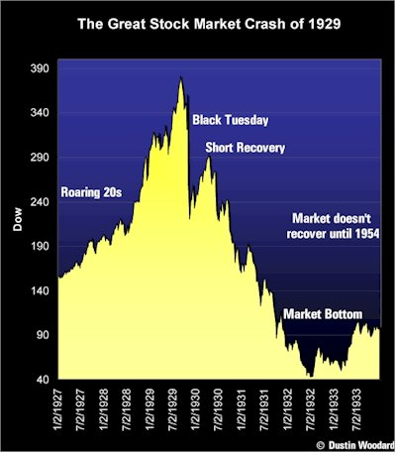
Fig. 1.1 Graph of Stock Market Crash leading up to, and after Back Tuesday [8].Just how bad the crash was is obvious by looking at figure 1.1 above, and by the fact that the market does not recover until 1954.
The crash that occurred in 1929 was due to a correction in the stock market. A correction is when stocks are overvalued, eventually the stock market will lower the value of these stocks to where they should be, usually people who are invested in a single stock that does this, or the entire market goes through a correction will lose money in the stock market, because their stocks are not worth what they once where. These corrections happen more often that people think. There was a correction in 1997, as well as on a Monday in 1987, which is known as Black Monday.
Since the stock market can be very volatile, and it does have the potential to make or break the U.S. economy rule have been put in place to help prevent another Black Tuesday from occurring, the most important of these new rules and regulations is the Circuit Breaker regulation. Basically it stops trading if the stock market begins to crash as it did in 1929, 1987, 1997. “The securities and futures markets have circuit breakers that provide for brief, coordinated, cross-market trading halts during a severe market decline as measured by a single day decrease in the Dow Jones Industrial Average (DJIA). There are three circuit breaker thresholds—10%, 20%, and 30%—set by the markets at point levels that are calculated at the beginning of each quarter. The formulas for these thresholds are set forth in the New York Stock Exchange (NYSE)” [9] The reasoning behind this rule is that if investors are given time to rethink there strategy, then they will not panic, and try to liquidate their entire portfolio. This is most easily visualized by figure 1.2
In the event of a 1,100-POINT decline in the DJIA (10 percent):
  Before 2 p.m.  1-HOUR HALT |   2-2:30 p.m.  30-MIN. HALT |   After 2:30 p.m.  NO HALT
In the event of a 2,250-POINT decline in the DJIA (20 percent):
  Before 1 p.m.  2-HOUR HALT |   1-2 p.m.  1-HOUR HALT | After 2 p.m.  MARKET CLOSES

Fig.1.2 Execution of Circuit Breaker Rule [8].
There is another rule called the collar rule which, when in the instance the Dow Jones goes down more then 2% from the previous days closing price, then this rule will go into effect, and in effect stabilize the stock market. When, and “if the DJIA moves up or down two percent (2%) from the previous closing value, program trading orders to buy or sell the Standard & Poor’s 500 stocks as part of index arbitrage strategies must be entered with directions to have the order executions effected in a manner that stabilizes share prices.” [9] This is a way to counter too much selling, and the lowering of stocks values by buying through this rule.
The most important questions facing the NYSE today are whether or not it will continue to be a physical place or not. With the advent of online trading has the NYSE become outdated, is there still a need for the physical transaction of stocks, or can the computer world do it better, and faster? These are some of the questions that are facing the stock market today. Investors are turning more, and more to the internet for trading stocks. There are several advantages to online trading. One, an investor does not have to go through a broker anymore. Another is that any stock at which they want to buy or sell they can do faster, and the stock prices are up to date. Basically it is giving the individual investor all of the advantages that a full time trader has. Will the NYSE continue to be a physical place in the future? It is hard to tell but one can be reassured that as long as people want to invest there will be a stock market, either physically, or digitally.
Chapter 2: Technical Analysis

2.1 Introduction
The trading and stock valuation method that I will cover is the method of Technical Analysis. Technical Analysis, also known as Chartism [3], involves the use of numerical series that is produced by market activity. Some numerical quantifiers used in this method involve price or volume of the stocks. Traders use these to predict future price trends. This strategy can be applied to any market, provided it has a comprehensive price history.

Rather than relying on financial data of a company, Technical Analysis mainly involves the studying of charts of past price movement. Technical Analysis relies mainly on the assumption that price patterns and trends exist in the stock market. These trends are then identified and exploited by the traders. Technical Analysis is an interesting method of trading because it is not necessarily the most accurate of methods, but overall, provides the outcome that is most likely to occur when investing [3].

Technical Analysis can be very simple. This is because it does not focus on the reason why stock prices are moving, but rather whether it is moving in a particular direction or in a particular chart pattern. This rules out concern about a company’s difficult business environment, poor management, poor earnings, or general unpopularity. Technical analysts follow the trends of the stock. If a stock price is continually rising, for example, then the analyst will look for opportunities to by the stock. They will continue in this manner until they are convinced that the upward trend either ends or reverses. The trader will then form patterns based on price activity in anticipation of the expected action of the prices. The most important concept of Technical Analysis is the assumption that prices must trend either upwards, downwards, or sideways (flat, or no change).

2.2 Stock Selection
Cisco Systems Inc.
The first company I chose is Cisco Systems Inc. The company provides products for transporting data, voice, and video within buildings and across campuses. It’s main service is in routers, used to interconnect computer networks by moving data, voice, and video from one network to another. Cisco’s technology products consist of home networking products, Internet protocol telephony products, optical networking products, and security products. It also offers wireless networking opportunities [3].
Cisco is making very progressive movements towards telecommunications and interconnectivity for people all over the country, both in businesses and at home. I found this appealing, but the main reason why I chose this company was its upward trend of prices. With the Technical Analyst method, because prices are going up, then it would be a good idea to start buying these shares.
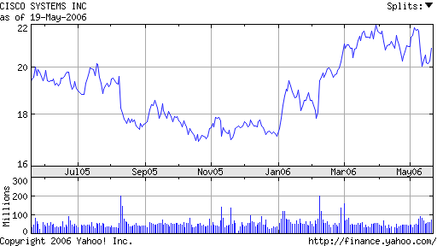
Figure 2.1: Recent upward trend of stock prices
After a dip in prices in November of 2005, the prices have continued in an upward trend. Putting all factors aside, this company will be a favorable one in which to invest.

Yamana Gold Inc.
Yamana Gold, Inc. is a company that revolves around the acquisition, exploration, development, and operation of precious metal mining properties in Brazil and Central America. As evinced in its name, the company mainly produces gold. The company owns several mining properties throughout the area including the Fazenda Brasileiro Mine, the Sao Francisco Mine, and the Sao Vicente and Fazenda Nova/Lavrinha properties. It also involves the Chapada copper-gold project in Brazil, the San Andres Mine in Honduras and the La Libertad Mine in Nicaragua [3].
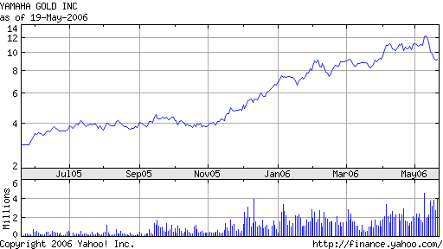
Figure 2.2 Recent upward trends of stock price for Yamana Gold Inc.

The Yamana Gold Inc. is an intriguing company to invest in because it is out of the nation, and is very productive in gold mining throughout Brazil and Central America. Gold has always been coveted, and even today, its value cannot be denied. Putting everything aside, the company has experienced a continuous and steady upward trend of prices. As a Technical Analyst, this is all I need to know in order to invest in it.

Titanium Metals Corporation
The third and final company that I will trade with is Titanium Metals Corporation. This company produces titanium melted and mill products. It offers titanium sponge, melted products, mill products, and industrial fabrications. Titanium sponge is the basic form of titanium metal used in processed titanium products. The mill products include billets, bars, plates, sheets, strips, and pipes. It sells products through its sales force in the United States and Europe; through independent agents and distributors worldwide; and through service centers [3].
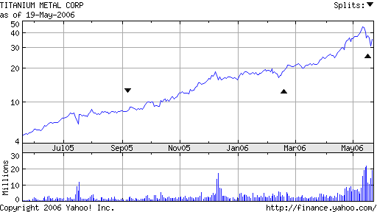
Figure 2.3: Upward trend of stock prices for Titanium Metal Corp.

Once again, I simply looked at the chart to choose this as a company to invest in. Clearly titanium is a new and popular tool used for metal in all sorts of construction today. I chose this company because it has experienced a tremendous, yet steady growth in the past year and has increased over 13% in recent short activity.

2.3 Weekly Trading Activities

Week 2
Technical Analysis
My week two progress proved to be somewhat successful. Two out of the three stocks that I had chosen because I thought they would continue an upward trend actually did have an upward trend. Yamana Gold Inc. began the week of May 22 at a price per stock of about $9.0. At the close of the week, the price had risen to $9.82, a 9.1% increase. Titanium Metals Corp. began the week at $33.5, and rose to $38.25, yielding an impressive 14.2% increase. Cisco Systems Inc. took on a flat trend, with an overall slight decrease starting the week at $20.65, and ending at $20.31, yielding an overall decrease of 1.6%. I do not foresee an overall decrease in Cisco Systems Inc. in the future, but I will have to hold off before making any major moves in this stock. I will also have to wait on the other two stocks, hoping that they both continue the impressive upward trend that I have seen in them.

I have decided to split the invested money among the three in favor of Cisco Systems Inc. It is the largest company of the three and is more likely to yield a profitable income. I have come to this decision viewing the volume of each of the companies, but I will make trading decisions solely based on Chartism, and studying trends that may occur. Of the $100,000 dollars I initially have to invest, I invested $40,000 in Cisco Systems Inc. buying roughly 1,937 stocks. $30,000 is invested in Yamana Gold Inc. which bought me roughly 3333 stocks. The remaining $30,000 is invested in the Titanium Metals Corp. buying roughly 896 stocks. If the prices continue to rise, I may decide to sell some stocks with the falling Cisco stock, and buy some in the other two. However, if these prices fall as well, I will look to sell them.

Week 3
Technical Analysis
My week 3 progress was much like last week’s results. Last week, Cisco Systems Inc. (CSCO) had a slight decrease, while my other two companies, Yamana Gold Inc. (AUY) and Titanium Metals Corp (TIE) had productive increases. This week, CSCO had an overall flat trend, while AUY and TIE both had a price increase once again.
CSCO began the week at $20.20 and ended the week at $20.44. This is an overall decrease of 1.19%. On Wednesday, the price of each stock fell almost a dollar to $19.50, but then when I checked on Thursday, the price had already began an upward trend back to over $20. The week had an overall flat trend, with a change of only 24 cents, but CSCO has not yet increased overall since I decided to invest in it. This could mean that I will have to sell what I have invested it soon.
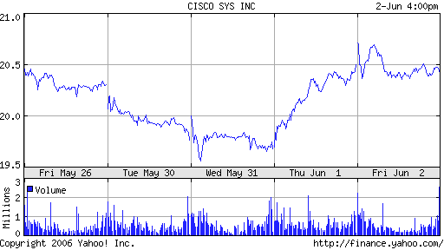
Figure 2.4: CSCO Week 3 progress
AUY began the week at an unusually high $10.20 after closing last week at $9.82. The closing price of this week was $10.14, a 0.589% decrease from the opening price, but an overall 3.26% increase over last Friday’s closing price. This means that AUY is keeping its upward trend. If the trend continues, I will strongly consider buying more shares from this company, and sell CSCO, which has been struggling to stay even.
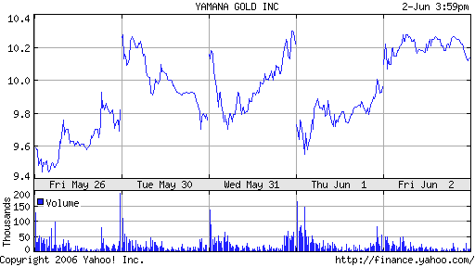
Figure 2.5: AUY’s Week 3 progress
Unlike the steady price openings and closing of my other companies, AUY usually begins the day at a price that is noticeably higher or lower than the closing price the day before. For example, the May 31st closing price of $10.22 was substantially greater than the opening price the next day, of $9.81. AUY closed June 1st at $9.96, but opened the next day at a greater place $10.20. Because my technique relies on looking only at the charts, we still can see an overall trend, however, I can infer that the oscillations in the price have something to do with the changing value of the product, gold. This company is showing an upward trend, but the unsteady prices could mean an unsteady future. I will have to wait a little bit longer to observe the trend.
TIE started the week at $37.90 and ended the week at $39.96, yielding an impressive increase of 5.43%. TIE has had a continuous upward trend, that has been pretty impressive. It does not have the up and down oscillations in its price that can be found in AUY. It also has been developing the most out of the three companies. Right now, TIE is the best company so far in which I have invested. It is has constantly been increasing and seems to be very stable. If the company continues this upward trend, and continuous stability, I will have no hesitation in making moves to take advantage of the company’s growth. I am very happy with this week’s progress, and I look forward to making some trades very soon.
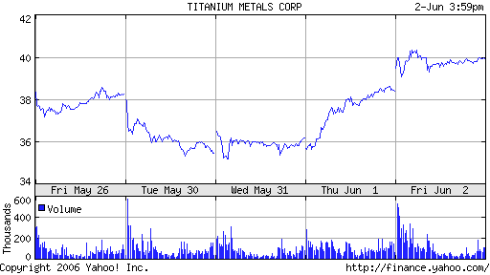
Figure 2.6 TIE’s Week 3 Progress

Week 4
My stocks did not do very well this week. Overall, it seems like almost every company’s stocks fell in value this week. The stock market is a complex system and I find it hard to explain the rise and fall of prices most of the time. This week, specifically Tuesday and Wednesday the market was very volatile and there were great fluctations in many stocks. The overall trend was downward however, and all of my companies’ stocks decreased in value.
AUY closed the week at $8.99, a 13.1% decrease from its weekly opening price of $10.35, and 8.45% less than the price of when I first bought shares.

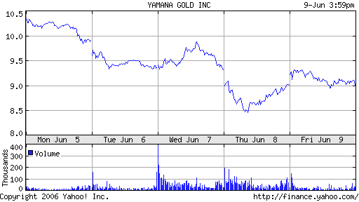

Figure 2.7: Downard trend for AUY this week

TIE closed the week at $34.33, a 12.8% decrease from its weekly opening price of $39.35, and 10.2% less than the starting price when I first bought the shares.
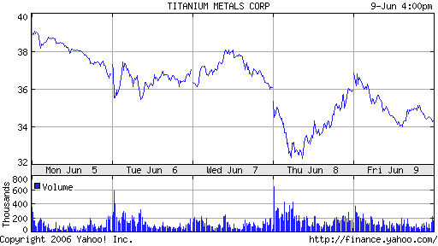

Figure 2.8: Downward trend for TIE this week

CSCO also had a downward trend this week. It closed the week off at $19.97, a decrease of 1.9% from the opening weekly price of $20.35. This is less than a two percent decrease from the price at which I bought the shares.

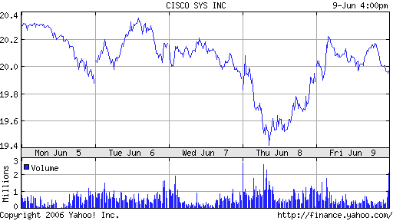

Figure 2.9: Cisco’s downward trend for this week

When I looked up why these downward trends occurred, the reports (yahoo.com finance) had reported that there were “no real news” that could explain the downward trend. This means that there was no specific reason why the prices of most of the stocks fell, but the falling prices were due to sentiment, poor sentiment and sentiments of fear [3]. The poor sentiments were brought about the concern that the Fed would raise rates so much that it would lead to slow economic growth [3]. The feelings of fear were brought about uncertainties in the market, including even the affect of the avian flu on the market [3]. The report basically explained how erradic the market was acting during the week.
Following the Techinical Analysis method, I decided to sell some of my stocks this week. This is what you are supposed to do when a downward trend is observed. I believe that AUY and TIE are in a downward trend that will continue, so I opted to sell 1000 AUY shares and 200 TIE shares. This is about a third each of my total shares for the company, so I did not choose to sell all of the shares. Overall, I lost money because I bought these shares for more money than the rate at which I sold them. I am going to keep the money that I got back from selling the shares, and wait to buy or sell shares in CSCO. This is because CSCO does not seem too harmed from the week, and may go on an upward trend. If CSCO goes on an upward trend, I will buy more stocks in it, and sell when that starts to go down.
I had a tough loss this week, but I learned a great deal. I waited all week to observe the trends, and waited till the close to act on anything. I did not realize the market would change so much in just a few days. I now know to follow it more closely, and I sense a downward trend, then I will sell right away. I believe the stocks will go back up, and I still see a profit in the next few weeks, although this was a tough week for my stocks, and the market in general.
Date | symbol | buy/ | Price | shares | netcost/ | Profit/ | total cash | total assets
Date | symbol | Sell | Price | shares | proceeds | Loss | total cash | total assets
26-May | CSCO | Buy | $20.31 | 1969 | $39990.39 - | $0.00 | $60,009.61 | $100,000
26-May | AUY | Buy | $9.82 | 3055 | $30000.10 - | $0.00 | $30,009.10 | $100,000
26-May | TIE | Buy | $38.25 | 784 | $29972.32 - | $0.00 | $36.78 | $100,000
11-Jun | AUY | Sell | $8.99 | 1000 | $8990 + | $830 loss | $9,026.78 | $99,170
11-Jun | TIE | Sell | $34.33 | 200 | $6866 + | $784 loss | $15,892.78 | $98,386

Table 2.1: Trades
Week 5
This past week’s progress was overall similar to last week’s. Some of the prices even had noticeable and volatile changes like those of last week. The prices are still much lower than the original buying price that I began with five weeks ago. The prices have been worse before, and seem to go on a trend back to their previous price, but others faltered.
CSCO had a basically flat trend for the week, the price going up just 3 cents from $19.95 to $19.98, a raise of only 0.15%. At last week’s close, the price was at $19.97. My most important stock has become one of my least productive in the past couple of weeks. Thankfully, it has not gone down at all, but it certainly has not improved, and has made basically no progress.
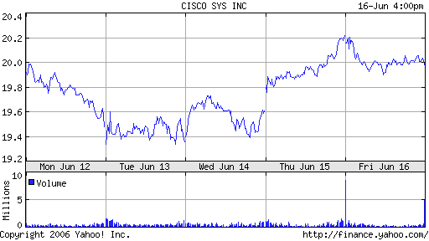

Figure 2.10: CSCO’s Week 5 progress

After falling and rising, AUY’s price settled to an overall loss for the week. It opened the week at a price of $9.10, and ended at $9.05, an overall 0.55% decrease. AUY has had a very bland week, and is slowly climbing back to its original price. Although it was at a loss at the end of the week, its price had increased in one day more than many other companies. Their price went up 30 cents, an overall increase of 3.43%. This could hopefully lead to a promising week. I can only hope the price skyrockets soon.

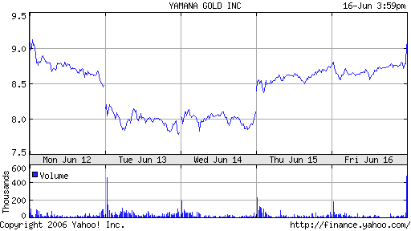
Figure 2.11: AUY’s Week 5 progress
TIE has been my hardest hit stock in this group of companies. It is still over Five dollars less than the original buying price of $38.25, and does not seem to be climbing at all. The price had spiked up at the end of Thursday, but fell once again. It began the week at a solid $34.49, but fell to $32.52 at the close of the week, a crushing decrease of 5.71%.
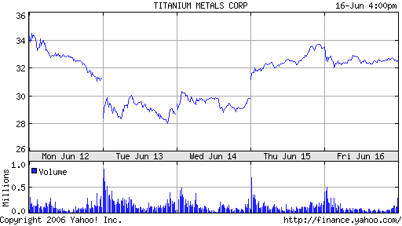
Figure 2.12: TIE’s Week 5 progress
Again, this past week proved to be rather frustrating. It has been very frustrating to see my stocks make negative progress, over multiple weeks. This past week, I had an overall flat trend for two of the companies, and an overall decrease for the third. AUY does look promising because of its recent strong upward movement, but I’ll have to wait until this week’s activity to be sure.
I do have some money that I am sitting on that I will look to use this week, in hopes of making some last minute moves and an extra bit of profit. I am looking at Hewlett Packard Co. to put some of my money into. It’s price has skyrocketed over this past week, with an overall increase from open to close of 10.35%. It has seen some very steady increase, and stands out very much compared to other companies because it is actually experiencing a good upward trend, rather than a flat or downward trend. I may even sell more stocks and decide to invest more into HPQ in my last couple weeks.
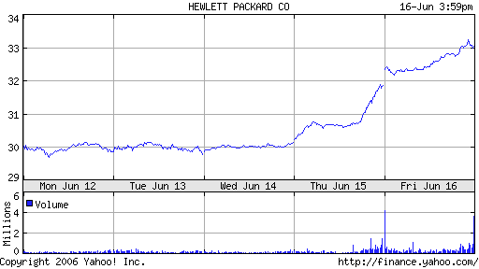
Figure 2.13: HPQ’s impressive upward trend

Week 6
With the market still struggling, week six turned out to be a disappointment once again. I was hoping that the upward trend that I had seen in my companies would continue, and to an extent it did. The market fell shortly around Tuesday, but surged into Wednesday and Thursday.
AUY had an overall excellent week. It’s opening price was $8.91. It ended the week at $9.41, yielding an overall increase of 5.6%. This increase is substantial and impressive because if you look at the way the market has performed in the past three weeks, the overall trend for most companies has been downward, and if there was an increase in any, they would increase rather slowly. AUY at this point is just 41 cents lower than the original price. Next week there will be some news that will hopefully have a positive effect on the market and let this company continue its upward trend.
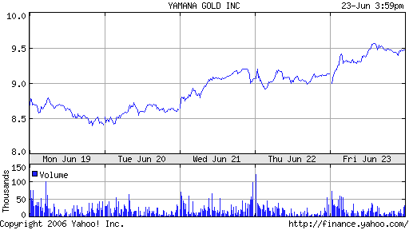
Figure 2.14: AUY’s impressive week
TIE has been one of my most frustrating companies to follow. It has closed the day over my original buying price only twice over the trading period. I thought that it was a promising company because of its strong upward trend at the very start, but it turns out I was just very unlucky. The upward trend ended pretty much as soon as I had bought all the stocks, and has dropped sharply ever since. At the moment it sits over five dollars below the original price, a 15.3% difference. I see no hope for TIE, it has raised somewhat, but the only reason why I would hang on to the stocks is because I would fear them to fall any further, because they do not seem to be increasing at all. This week it had an overall downward trend, starting the week at $32.94, and ending at $32.40, a decrease of 1.6%. I do not think that the company will progress anymore next week, but I will wait to see what it opens at to dump it all because the price at the moment is far below the opening price.
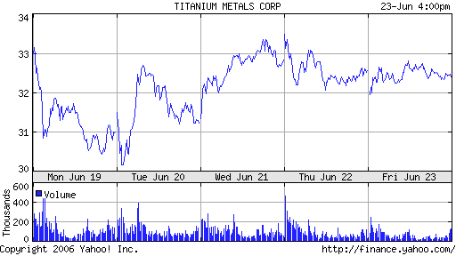
Figure 2.15: TIE’s erratic week
CSCO had progress this week that was similar to most other companies, it decreased a bit at the open of the week, had a peak towards the middle of the week, then finally ended the work lower than the open price. It opened the week at $19.67 and ended at $19.61, a decrease of just 0.3%. I had invested the most in CSCO, and it showed some promise before, but I at this point, I could not have just waited to see what would happen and wait until the price rose again, so I decided to make use of the money that would have just devalued. I sold all the shares in CSCO that I had at the peak of this week, which luckily was higher than the original buying price, so I made a small profit.
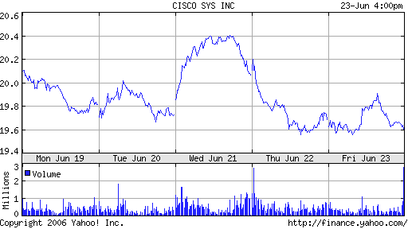
Figure 2.16: CSCO’s week 6 progress
Before, I had explained that I had become interested in Hewlett-Packard Company because of their upward trend, and I decided to actually buy some shares in it for the last part of this trading period. The progress of the company in the past three months has not exactly been spectacular, but in this short period of time in which stocks have been falling sharply, or continuing on flatly, it seemed like a great investment. Basically, Hewlett-Packard is known for its technology and advancements in computer technology. Their personal computers have been in the market now for several decades, and they are a growingly popular company [3], in fact, the computer I am using right now is a Hewlett-Packard brand. I decided that in order to make any progress, I would have to act quickly, because I learned that if you wait until the end of the week all the time, the proper price could slip away. After buying 498 just last Friday at $31.90, I decided to sell on Wednesday, just after the market started to settle back down at the peak price of $34.04. This was a good move because it ended the week at just $32.66. I made a small profit from this. There is not much time left, so I simply plan on hoping the market does well, and that I use the last of my assets properly. Right now, I’m sitting on over $57,000 from the CSCO shares I held, I will try to use the trends that occur in the next week to make a profit, using my now very active approach.
Date | symbol | buy/ | price | shares | netcost/ | Profit/ | total cash | total assets
Date | symbol | sell | price | shares | proceeds | Loss | total cash | total assets
26-May | CSCO | buy | $20.31 | 1969 | $39,990.39 - | $0.00 | $60,009.61 | $100,000
26-May | AUY | buy | $9.82 | 3055 | $30,000.10 - | $0.00 | $30,009.10 | $100,000
26-May | TIE | buy | $38.25 | 784 | $29,972.32 - | $0.00 | $36.78 | $100,000
11-Jun | AUY | sell | $8.99 | 1000 | $8,990 + | $830 loss | $9,026.78 | $99,170
11-Jun | TIE | sell | $34.33 | 200 | $6,866 + | $784 loss | $15,892.78 | $98,386
16-Jun | HPQ | buy | $31.90 | 498 | $15,886.20 | $0.00 | $6.58 | $98,386
21-Jun | CSCO | sell | $20.41 | 1969 | $40,187.29 | $196 profit | $40,193.87 | $98,582
21-Jun | HPQ | sell | $34.04 | 498 | $16951.92 + | $1,065 profit | $57,146 | $99,647

Table 2.2: Trades as of week 6

2.4 Conclusion
The final weeks of progress had been good. The serious troubles that I was facing in the past few weeks were no longer an issue, and some of my companies’ stocks took a surprisingly good turn. I thought that my trading period would end on a horrible note, fortunately, the market prospered in this last week of trading.
It turned out a good call to sell of my CSCO stocks at the peak that I had done because the closing price of the week was $19.53, and the peak price was only $20.03 on Friday. If I had waited until this week to sell, then I would not have made a profit at all. The same could be said for my shares with HPQ. In one week, I had bought and sold shares with the company, because I needed to make a quick profit. HPQ was doing well for a short period of time, but its fortunes fell after I had sold the shares. This week, its closing price was $31.68, with a peak of only $33.20 on Monday. When I decided to sell the shares I had, I had sold at a peak of $34.04, so again, if I had waited until this week, I would have made a profit, but smaller than that which I had actually made.
As for TIE, I decided to wait a week to see if the price would go up at all. I was able to sell the shares at a higher price than last week, but only by a few cents. Unfortunately, when I had bought the stocks, it was just at the peak of an upward run, after a week after I had originally bought the stocks, the price was nowhere near the peak any longer. I now regret hanging on to the shares for so long. I sold the remaining shares at a price of $34.38. This is $3.87 less than the original buying price. As a result of stubbornly hanging on to the TIE shares instead of selling them long ago, I had an overall loss $3,044, going to show how ineffective inactive Technical Analysis trading can be.
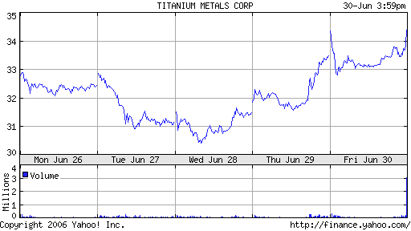
Figure 2.17: TIE’s final week progress
AUY took a good turn this week, and finally overcame the original buying price. It began the week at $9.58, 2.44% less than the original buying price. It had a rocky, but progressive week, ending at $9.86, 2.9% greater than the week opening price. I sold the shares at the peak price on Friday’s peak price of $9.92, slightly higher than the original buying price, yielding a small profit of $205.50, not much, but certainly better than nothing.
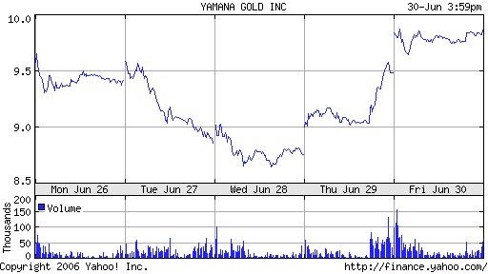
Figure 2.18: AUY’s final week progress
If there is anything that I have learned in the past trading period, I learned that an active approach is much more effective. Buying and selling in one week with a new company could be very effective for example. Just like HPQ, I was looking for a company that was in a good upward trend. I needed a company that I could make some sort of profit, to make up for the loss that I had acquired from TIE, and I had almost $60,000 to work with. General Motors has been nothing but successful for the past six months. As this method relies heavily on observing charts, I looked at GM’s 6 month, and 3 month progress charts. They both looked similar in that they both had good upward trends. I made the decision to buy GM shares at the beginning of the week, hope that it has an upward trend during the week, and sell at the end to make a profit. I had nothing to lose with this company, and since it had not have a downward trend within the past 6 months, I had no reason to believe the company would not succeed.
General Motors Company is a company that deals with the design, manufacture, and marketing of automotive products worldwide. These products are mostly, but not limited to automobiles, and automobile parts. GM sells automobiles in the North American region through such subsidiary branches as Chevrolet, Pontiac, GMC, Buick, Cadillac, Saturn, and HUMMER. These different companies specialize in a wide range of different types of automobiles, from heavy duty trucks (GMC), to luxury passenger vehicles (Cadillac), to sports cars (Pontiac). Many of these sub-companies have been manufacturing cars for many years now, and GM is a fast growing enterprise in the automotive world, an ongoing and ever growing market.
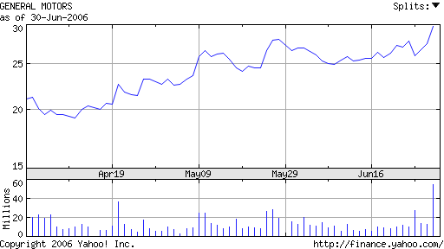
Figure 2.19: GM’s six month progress
With the $57,000 dollars that I had from selling the shares I had last week, I bought 2,112 shares. I closely followed the progress of GM this week, and was happy to see that it was upward everyday, ending everyday no lower than the opening price. It seemed like I had chosen the perfect company. At the beginning of the week, I had purchased at the original buying price of $27.05. The company closed the week at $29.79, an impressive 10.1% increase on the opening price of that week alone. GM was a great company to choose for the active Technical Analysis trading method. Selling all of the shares I had bought on Monday at Friday’s peak price of $30.56, I managed to make a profit of $7,396.72, overshadowing the loss I incurred from TIE. GM was just the right company to make a quick profit, and I was glad I took the risk in investing in it.
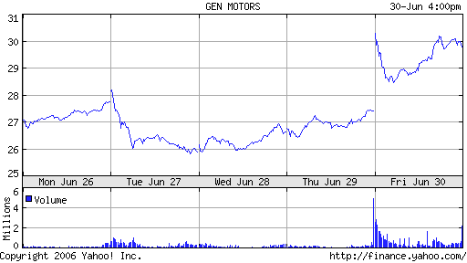
Figure 2.20: GM’s progress for the week of June 26, 2006

Date | symbol | buy/ | price | shares | netcost/ | Profit/ | total cash | total assets
Date | symbol | sell | price | shares | proceeds | Loss | total cash | total assets
26-May | CSCO | buy | $20.31 | 1969 | $39,990.39 - | $0.00 | $60,009.61 | $100,000
26-May | AUY | buy | $9.82 | 3055 | $30,000.10 - | $0.00 | $30,009.10 | $100,000
26-May | TIE | buy | $38.25 | 784 | $29,972.32 - | $0.00 | $36.78 | $100,000
11-Jun | AUY | sell | $8.99 | 1000 | $8,990 + | $830 loss | $9,026.78 | $99,170
11-Jun | TIE | sell | $34.33 | 200 | $6,866 + | $784 loss | $15,892.78 | $98,386
16-Jun | HPQ | buy | $31.90 | 498 | $15,886.20 | $0.00 | $6.58 | $98,386
21-Jun | CSCO | sell | $20.41 | 1969 | $40,187.29 | $196 profit | $40,193.87 | $98,582
21-Jun | HPQ | sell | $34.04 | 498 | $16951.92 + | $1,065 profit | $57,146 | $99,647
26-Jun | GM | buy | $27.05 | 2112 | $57,129.60 | $0.00 | $16.40 | $99,647
2-Jul | TIE | sell | $34.38 | 584 | $20,077.92 | $2260 loss | $20,094.32 | $97,387
2-Jul | AUY | sell | $9.92 | 2055 | $20,385.60 | $205 profit | $40,479.92 | $97,592
2-Jul | GM | sell | $30.56 | 2112 | $64,542.72 | $7,396.72 profit | $105,022.64 | 105,022.64

Table 2.3: Final trading actions
Chapter 3: Short Trading
3.1 Introduction
I decided to use the short trading technique. I found this method to be very interesting because it is trading in reverse. The main strategy of short trading is to determine when the price of a stock is going to fall. Then the buyer (in this case me) will actually sell shares of a stock before they buy them. Then when they think the stock price can’t get any lower they buy the stocks that they had already sold. In order to do this they must set up a special account with their broker. “Short trading has been condemned by many and there have been efforts to get rid of this strategy because it sets up a false market and allows one to sell what they do not have. However, it is right along the same lines as when a tailor measures someone for a suit, charges them some amount of money and delivers the garment in 10 days. This is also an example of selling something that does not exist [1].

3.2 Stock Selection
For the stocks that I am going to be using for short trading I will be looking for a trend over a couple of days where it looks like the price of the stock is on a downward swing. Based on the following graphs I feel these will be good choices.
As somebody who likes to go to concerts and movies I realized that tickets are now being purchased online more and more. I figured I would check out stock in a company Interactivcorp (IACI) who sells these tickets online. I found however they are on a serious down slope. This is perfect for my first short trade.
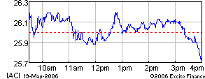
Fig. 3.1 Downward Trend over one day
Pfizer, Inc. engages in the discovery, development, manufacture, and marketing of prescription medicines for humans and animals, as well as consumer healthcare products worldwide. Its principal products include Listerine mouthwash, Listerine PocketPaks oral care strips, Nicorette for tobacco dependence, Benadryl antihistamine for allergies, Sudafed for sinus congestion, Rogaine for hair growth, Zantac for prevention and relief of heartburn, Rolaids antacid tablets, Neosporin antibiotic ointment, Visine eye drops, Lubriderm moisturizing lotions, and Purell instant hand sanitizer [3].

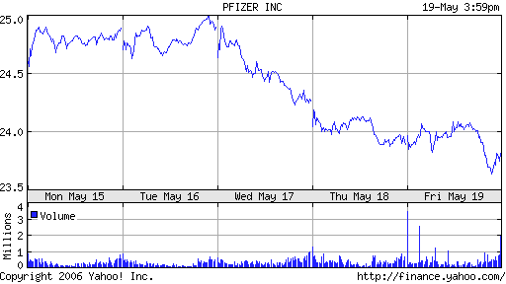
Fig 3.2 Downward Trend over one week
Motorola, Inc. engages in the design, manufacture, marketing, and sale of mobility products worldwide. It operates in four segments: Mobile Devices, Government and Enterprise Mobility Solutions, Networks, and Connected Home Solutions [3].
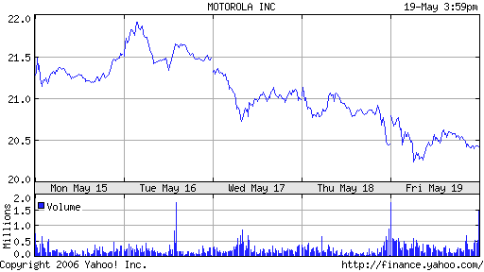
Fig 3.3 Downward Trend over 5 days

3.3 Weekly Trading Activities
Short Trading
Date | symbol | buy/  Sell | price | Shares | netcost/  proceeds | Profit/  Loss | total cash | total assets
22-May | IACI | Sell | $25.99 | 1283 | $33,338.76 | $0.00 | $33,338.76 | $99,999
23-May | MOT | Sell | $21.10 | 1579 | $33,316.90 | $0.00 | $66,655.55 | $99,999
22-May | PFE | Sell | $24.04 | 1387 | $33,343.48 | $0.00 | $99,999.14 | $99,999
24-May | MOT | Buy | $20.50 | 1579 | $32,369.50 | $947.40 | $67,629.64 | $100,964.14
26-May | PFE | Buy | $24.00 | 1387 | $33,288 | $55.48 | $34,341.64 | $101,019.62
25-May | IACI | Buy | $23.34 | 1283 | $29,945.22 | $3,393.54 | $4,396.42 | $105,416.04

Table 3.1 Short trading record

Week 2
Short Trading
The first week my plan was to just jump right in and start trading. Since I have $100,000 for each method I decided to divide that up equally between each stock in each method. That means I can spend $33,333.33 on each stock. My goal for the short trading was to sell as soon as the stocks started losing money. I found out soon enough though that the stock market can be unpredictable and the stocks started gaining money instead of losing it. Luckily the total values ended up coming down and overall I had a pretty good week. Keep in mind that with Short Trading you actually sell the stocks before you buy them at a lower price.
Interactive Corp (IACI) shot up right away after I sold it initially on Monday, but ended up coming down to under what I originally sold it for by $2.65. Overall I made a profit of $3,393.54
With Motorola (MOT) stock I noticed it was on the rise when I was buying the others so I decided to wait a day to see how high it would go. On Tuesday it turned and started a downward trend so I decided to sell at that point hoping it would start losing money. My intuition was right and it turned out well for me. After I sold the stock it dropped from $21.10 to $20.50. Overall I made a total profit of $947.40.
The last stock I traded using short trading was Pfizer (PFE). Pfizer’s stock had a lot of hills and valleys but never really made any major jumps up or down. I was hoping for a drop all week but it never really came. In the end I stayed very even buying a little under what I sold it for and making a profit of $55.48.
I learned this week that for this strategy it’s going to be a lot better to watch very closely for where the stock is dropping and make sure that I don’t let it go back up. It’s going to be tough, like most other methods, but I hope to increase my profit by 7% for next week. This week I increased my profit by 5.4%. I feel my picks are working out well for me and hopefully will keep making me money.

Week 3
Date | Symbol | buy/ | Price | shares | netcost/ | Profit/ | total cash | total assets
Date | Symbol | Sell | Price | shares | proceeds | Loss | total cash | total assets
22-May | IACI | Sell | $25.99 | 1283 | $33,338.76 | $0.00 | $33,338.76 | $99,999
23-May | MOT | Sell | $21.10 | 1579 | $33,316.90 | $0.00 | $66,655.55 | $99,999
22-May | PFE | Sell | $24.04 | 1387 | $33,343.48 | $0.00 | $99,999.14 | $99,999
24-May | MOT | Buy | $20.50 | 1579 | $32,369.50 | $947.40 | $67,629.64 | $100,964.14
26-May | PFE | Buy | $24.00 | 1387 | $33,288 | $55.48 | $34,341.64 | $101,019.62
25-May | IACI | Buy | $23.34 | 1283 | $29,945.22 | $3,393.54 | $4,396.42 | $105,416.04
30-May | IACI | Sell | $26.26 | 1269 | $33,323.94 | $3,378.72 | $37,720.36 | $108,794.76
2-Jun | MOT | Sell | $21.86 | 1524 | $33,314.64 | $945.14 | $71,035 | $109,739.90

Table 3.2 Short Trading Summary

This week I observed InteractiveCorp’s (IACI) stock very closely. Since I already owned the stock from the previous week I was looking for the perfect time to sell it again. The time came on Thursday the 30th when it jumped up to $26.26. This gave me a very nice profit of $3,378.72. I missed my chance to sell the next day, but I was having mixed feelings about it. I have been looking at long term charts lately and noticed that IACI seemed to hit a plateau in 2003 and was coming down. Because of this it leads me to believe that stock prices are on the downfall and there is a lot more to make by waiting for it to drop so I can buy at a lower price.
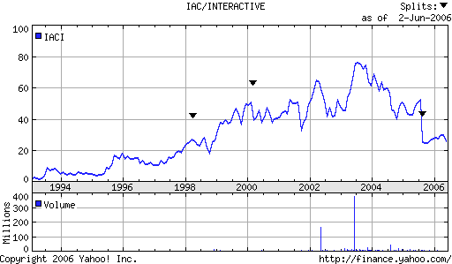
Fig. 3.4 15 year linear graph of IAC stock prices showing plateau

Pfizer this week was a disappointment to me. I said last week that I would watch closely to each stock that I had. Well after a week of watching I saw nothing but losses for me. On Tuesday it started its downward trend, and then somewhere through the week started to make its way back up.
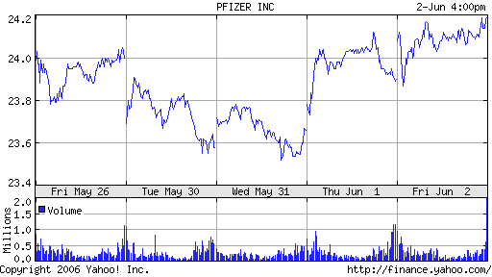
Fig 3.5 PFE stock dropping down and slowly making its way back up
I knew that if I had tried selling on Friday I would have made very little, and with the recent upward trend still going I am hoping that next week I will begin to see more profits with this stock in particular.
The last stock I traded using this method did fairly well for the week. It made small gains which is better than no gains at all. This was a slow stock all week then on Friday it made some jumps up about 1.5 higher than last week where I sold at $21.86. The total profit I made of it for the week was only $945.14. I am not expecting to see much profit out of Motorola and I might consider finding another stock to remain trading with for the rest of the weeks that we are still trading.
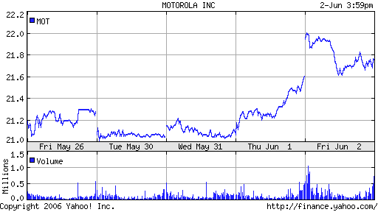
Fig 3.6 Motorola Jumps in the end of the week.

Week 4

Date | symbol | buy/ | Price | shares | Netcost/ | Profit/ | total cash | total assets
Date | symbol | sell | Price | shares | Proceeds | Loss | total cash | total assets
22-May | IACI | sell | $25.99 | 1283 | $33,338.76 | $0.00 | $33,338.76 | $99,999
23-May | MOT | sell | $21.10 | 1579 | $33,316.90 | $0.00 | $66,655.55 | $99,999
22-May | PFE | sell | $24.04 | 1387 | $33,343.48 | $0.00 | $99,999.14 | $99,999
24-May | MOT | buy | $20.50 | 1579 | $32,369.50 | $947.40 | $67,629.64 | $100,964.14
26-May | PFE | buy | $24.00 | 1387 | $33,288 | $55.48 | $34,341.64 | $101,019.62
25-May | IACI | buy | $23.34 | 1283 | $29,945.22 | $3,393.54 | $4,396.42 | $105,416.04
30-May | IACI | sell | $26.26 | 1269 | $33,323.94 | $3,378.72 | $37,720.36 | $108,794.76
2-Jun | MOT | sell | $21.86 | 1524 | $33,314.64 | $945.14 | $71,035 | $109,739.90
9-Jun | IACI | buy | $24.69 | 1269 | $31,331.61 | $1,992.33 | $39,703.39 | $111,732.23
8-Jun | MOT | buy | $20.61 | 1524 | $31,409.64 | $1,905 | $8,293.75 | $113,637.23

Table 3.3 Short Trading Summary

It seems as though this week every stock fell. It wasn’t a good week for regular long trading, but it was a great week for short trading. Two of my three stocks that I am trading using short trading fell below what I had originally sold them for by close to two points. At the end of the week I made a 3.5% profit of $3,897.33 and I probably could have made even more. I am enjoying using this strategy in this time because it seems at though most stocks prices are falling.
This week IACI prices fell 6% from $26.26 to $24.69.
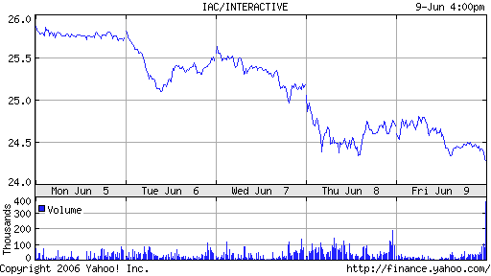
Figure 3.7 IACI week stock report
According to the graph the stock actually fell lower than $24.69, however I felt at the time that the stock prices would start to rise so I sold hoping that they would rise after I sold it so that I could keep making healthy gains on my investments. After the trade I ended up making a profit of $1,992 dollars which is less than my usual gains with this company, but is still a gain nonetheless.

With my next stock Pfizer (PFE) I felt that it hadn’t made significant changes for me to buy it back. I was hoping it would go lower and I’m hoping for next weeks case that it will continue its downward trend
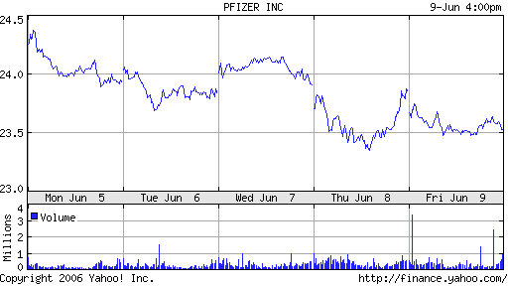
Fig 3.8 Pfizer weekly stock report
As you can see from Figure 2.8 it has a downward trend, but I felt that it hadn’t made the gains I wanted. If I were to buy PFE I would make a 2.1% gain. With the way that my stocks have been performing lately I would like to see at least a 5% percent gain before I trade the stock. So I will be holding this one until next week and hope to see a 3% increase.
The last stock Motorola (MOT) dropped in price 5.71% or 1.25 points this week.
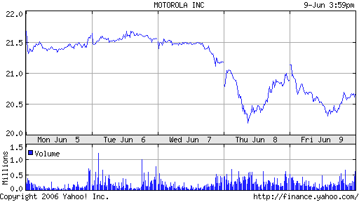
Fig 3.9 Weekly MOT stock report

This stock took a mid week dive which suited me nicely. After selling this at the end of the week I ended up making a profit of $1,905. I am hoping the price will rise again so that I can sell again at a higher price before it continues to drop.
In this summer of the stock market I enjoy this technique a lot. It seems as though most of the stock prices are dropping and with this strategy one can definitely take full advantage of it. I feel a smart way to do it is to get in and get out quickly and take the small gains. Its low risk and it allows for the analysis of many stocks over a short period of time. I am excited to see what will happen next week.

Week 5

Date | symbol | buy/ | price | shares | netcost/ | Profit/ | total cash | total assets
Date | symbol | Sell | price | shares | proceeds | Loss | total cash | total assets
22-May | IACI | Sell | $25.99 | 1283 | $33,338.76 | $0.00 | $33,338.76 | $99,999
23-May | MOT | Sell | $21.10 | 1579 | $33,316.90 | $0.00 | $66,655.55 | $99,999
22-May | PFE | Sell | $24.04 | 1387 | $33,343.48 | $0.00 | $99,999.14 | $99,999
24-May | MOT | Buy | $20.50 | 1579 | $32,369.50 | $947.40 | $67,629.64 | $100,964.14
26-May | PFE | Buy | $24.00 | 1387 | $33,288 | $55.48 | $34,341.64 | $101,019.62
25-May | IACI | Buy | $23.34 | 1283 | $29,945.22 | $3,393.54 | $4,396.42 | $105,416.04
30-May | IACI | Sell | $26.26 | 1269 | $33,323.94 | $3,378.72 | $37,720.36 | $108,794.76
2-Jun | MOT | Sell | $21.86 | 1524 | $33,314.64 | $945.14 | $71,035 | $109,739.90
9-Jun | IACI | Buy | $24.69 | 1269 | $31,331.61 | $1,992.33 | $39,703.39 | $111,732.23
8-Jun | MOT | Buy | $20.61 | 1524 | $31,409.64 | $1,905 | $8,293.75 | $113,637.23

Table 3.4 Trading summary
This week was not as good as the last for short trading my stocks. For some reason the prices of the three stocks that I picked have actually continued to fall past what I bought them at. I don’t know if I’ll even see any more profit made from these stocks. I have already made a good amount of profit, but I feel I could have been smarter about the process.
The story of the week was Motorola stock. It ended the week right about where it started but on Friday 6/16 there was a spike in the prices where it almost came to what I had originally bought it at. If I had been keeping a closer eye on the stocks that day I could have sold on the spike.
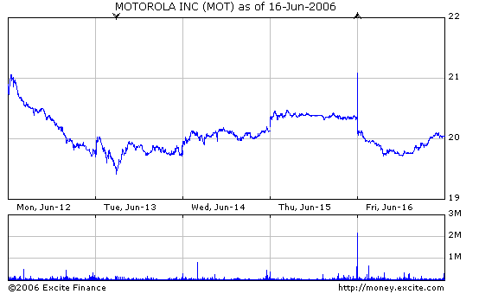
Fig 3.10 Motorola Weekly stock report with spike
Unfortunately I wasn’t paying enough attention and the whole potential profit went down the tubes. I am holding off trading this one until it comes back to a reasonable price. Pretty much anywhere above where I bought it.
Next is IACI. This has been a pretty strong stock for me. It rises when I want it to rise and falls when I need it to fall. This week it has risen above my buying price. However, it is still on an upward trend so I am going to hold off on the sales and wait for next week where hopefully on Monday it will be even higher and I will be able to sell it before it dips again. I am also counting on no dips on Monday, which is risky, but so is the stock market itself.
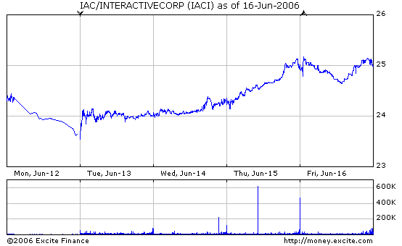
Fig 5.11 IACI weekly stock report

Last stock is Pfizer. I bought Pfizer at $24 over a week ago and since then all it has done is lose and lose and lose. I am waiting for the rise just barely enough so that I can sell and then it can lose some more. I can kind of see it struggling to get back up, but it hasn’t really shown any real signs of coming back. Over the week it has been nothing but losses for this stock.
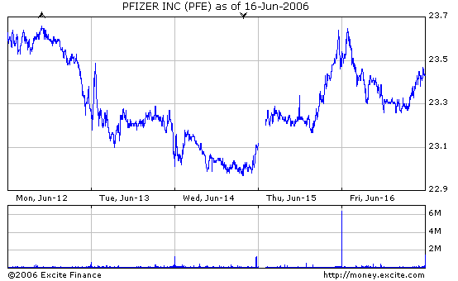
Fig 3.12 PFE weekly stock report
Week 6
Date | symbol | buy/ | price | shares | netcost/ | Profit/ | total cash | total assets
Date | symbol | sell | price | shares | Proceeds | Loss | total cash | total assets
22-May | IACI | sell | $25.99 | 1283 | $33,338.76 | $0.00 | $33,338.76 | $99,999
23-May | MOT | sell | $21.10 | 1579 | $33,316.90 | $0.00 | $66,655.55 | $99,999
22-May | PFE | sell | $24.04 | 1387 | $33,343.48 | $0.00 | $99,999.14 | $99,999
24-May | MOT | buy | $20.50 | 1579 | $32,369.50 | $947.40 | $67,629.64 | $100,964.14
26-May | PFE | buy | $24.00 | 1387 | $33,288 | $55.48 | $34,341.64 | $101,019.62
25-May | IACI | buy | $23.34 | 1283 | $29,945.22 | $3,393.54 | $4,396.42 | $105,416.04
30-May | IACI | sell | $26.26 | 1269 | $33,323.94 | $3,378.72 | $37,720.36 | $108,794.76
2-Jun | MOT | sell | $21.86 | 1524 | $33,314.64 | $945.14 | $71,035 | $109,739.90
9-Jun | IACI | buy | $24.69 | 1269 | $31,331.61 | $1,992.33 | $39,703.39 | $111,732.23
8-Jun | MOT | buy | $20.61 | 1524 | $31,409.64 | $1,905 | $8,293.75 | $113,637.23
23-Jun | IACI | sell | $26.00 | 1269 | $32,994 | $1,662.39 | $41,287.75 | $112,524.71
23-Jun | MOT | sell | $19.88 | 1524 | $30,297.12 | ($1,112.52) | $71,584.87 | $111,412.19
23-Jun | PFE | sell | $22.64 | 1387 | $31,401.68 | ($1,886.32) | $102,986.55 | $109,525.87

Table 3.4 Total trading summary for Short Trading

This has been my worst week so far. Overall the whole stock market including the Dow Jones and the Nasdaq have both gone down this week [3]. Even my short trading strategy didn’t work this week because those stocks happened to make money this week instead of losing it.
The first Stock using the short trading method that I traded was IACI. This is the only stock that I had made money off of this week. The price rose from $24.69 to $26 from Monday to Friday. I ended up making a 5% profit of $1,662.39. If I could continue to trade I would hope that the price would continue to increase to make even more money from this particular stock.
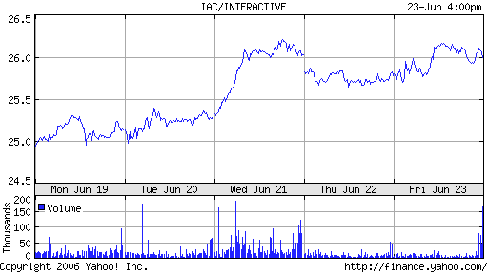
Fig 3.13 IACI Weekly Stock Summary

This stock didn’t perform very well this week. It had a couple ups and downs, but in the end of the week the selling price lowered just a little bit so that I had a little bit of a loss. I bought at the beginning of the week and at the end of the week I ended up taking a loss of $1,112.52.
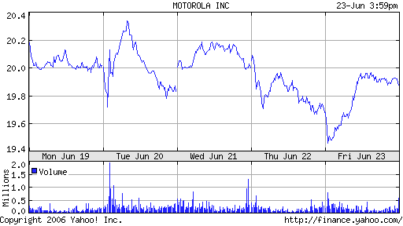
Fig. 3.14 Weekly Report of MOT stock
The last stock that I traded was Pfizer (PFE). This stock also performed poorly this week. Just like Motorola the price lowered as the week went on. My strategy if I sell at the end of the week is to buy at the beginning of the week. This is a risky strategy, and if I were to trade real money I don’t think I would be so quick to act. You can see the downward trend. It would have been better to sell on Monday and buy back later of Friday.

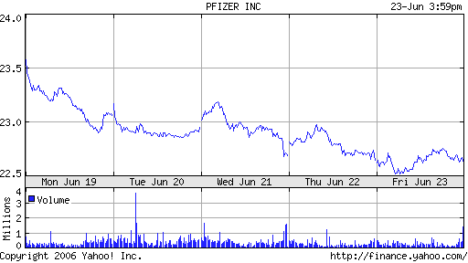
Fig. 3.15 Weekly stock report of PFE stock
3.4 Conclusion
Overall I had a great time trading with this method. It just so happened everything worked out in my favor because over this six week period the prices of stocks overall decreased more than they increased. Because of this fact I was able to fully utilize this method of Short Trading and turn a profit from it.
I started out trading with $100,000 for three stocks and split the money up as equally as I could so that I could invest the same amount of money into each stock. After a couple weeks I noticed that the prices in the stocks that I chose were beginning to decrease in price. Now most people would be upset over this, but because of my method it was the opposite. Because I was able to sell the stock before actually buying it I was happy that the prices fell because I could then buy at a lower price than what I had sold for and therefore turn a profit from it. Throughout the six weeks I was steadily making gains and turning out a profit weekly. It wasn’t until the last week when I had to get rid of my stocks that I saw any losses. Overall my total profit was $9,525.87.
For this six week period this method worked out great for me. Even though it worked I believe that it should be limited to the number of people who invest this way. If everybody in the stock market was hoping for companies prices to go down then I feel that I would take away from the overall goal of the stock market which would be to invest capital into companies so that they may use it to increase their business and in return increase the prices of the stock. Not decrease it. Overall though it was fun and I learned a lot about using this method.
Chapter 4: Momentum Trading Technique

4.1 Introduction

Momentum trading is a traditional way to trade in the stock market. To momentum trade, the trader finds a stock with a high volume of trade, which appears to be a continuing trend. Then the investor predicts at what prices the stock will start to decline. The investor will hold on to the stock until the stock hits that price mark, or it is obvious that it will not hit that price mark in the time the investor has allotted for his stock. [1] It is important to know that momentum trading is a high risk, high return style of investing. The demographic which, will use this form of trading the most is usually younger investors because they have time to make up for a loss if they should suffer one. Where as older investors closer to retirement do not want to take the risk because they do not have the luxury of time to make more money if they take a substantial hit in the stock market. The momentum of a stock is affected by a host of variables, which will affect the momentum of the stock. One of these variables is the “buzz” of the stock. How much publicity does the stock have? This publicity comes from several different areas, television, newspapers, and also word of mouth. All of these effect how a trader perceives how an investment in the stock will turn out. Traders often are more willing to invest in a stock, which they have heard about or which people are talking about then one, which they have never heard of. Another factor of a stock’s momentum is the stocks data. Is the company doing well? Are they poised to make a significant gain in profit? These factors are the reason that momentum trading is high risk. The price of the stock is effected by how the traders feel about the stock, and by the real numbers of how the company is doing. It is this fact that it is based on human nature, which makes this trading so unpredictable.

4.2 How to Momentum Trade

Momentum trading begins with a list of possible investments. To get on to this list the trader must believe, and the data must indicate that the stock is poised to make substantial gains. A key indicator of this is the volume of stocks being bought. When the volume of buying goes up so does the stock, and this is where the upward momentum will begin. Any of the stocks with low volume, should be cut from the list at this point. Next the investor will look at the history of the stock. The gaining trend must be definitive for this style of investing to work. The investor must be sure that it is a trend, and not a short, term spike in the stocks price, which will return to the normal price, in a short period of time. After this the momentum trader will look at the momentum indicator. The momentum indicator is the net change of the stocks closing price divided by time intervals. “The momentum indicator, the accumulated net change of a stock's closing/ending price over a series of defined time periods. The momentum line is plotted as a tandem line to the price chart, and it displays an axis of zero, with positive values indicating a sustained upward movement and negative values indicating a potentially sustained downward movement.” [1] After this final step another cut from the list should be made based on the momentum indicator, then with the ones which remain the investor should think about investing in them, if he or she is still weary of a stock then give they should give it some time until they have a better understand of what the stock might do, and then invest.

4.3 Stock Selection
I chose four stocks to invest in. I focused on energy companies at first because, as the price of oil continues to climb people will be looking more, and more into alternative fuel resources, and these are the companies which will be providing it. I invested in Energy South INC Company ENSI with $50,000. I invested half of my allotted money into them because I believe that they are less of a risk then my other companies. There momentum has been high for a long period of time, and I believe it is a permanent price increase. I do not believe that once the momentum is finished, that the price will crash back to its original value before the momentum gains. I will hold the stock until it reaches a price of $31.65, “it started at $31.56.” [4]
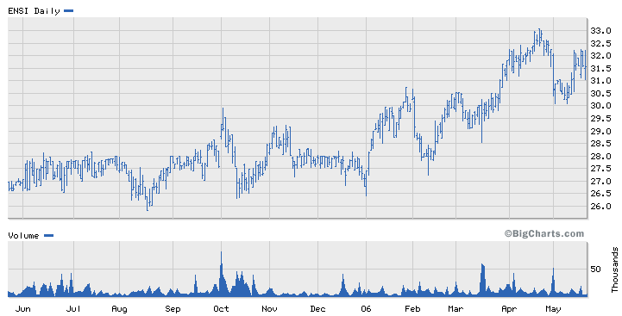
Fig. 4.1 ENSI upward trend of price over 1 year [4]
The next company, which I will invest $10,000 into, is more of a risk the Energy South was. This company has been showing an increase in price for long period of time with no signs of slowing down at this point. I do believe that this is at the tail end of the momentum, however being as it is that we are not in the stock market for more the 6 weeks I do not think it will take the price drop that soon. I will hold onto the stock until it reaches a price of $26.85, “it started at $26.80.” [4]
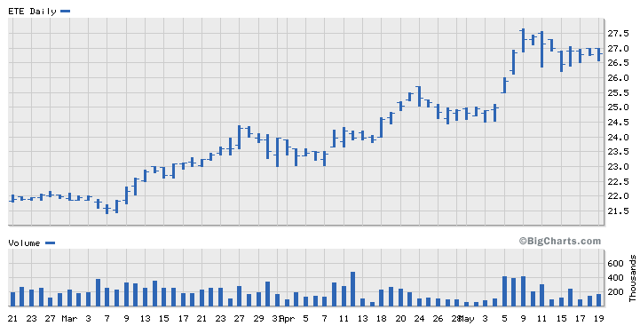
Fig. 4.2 ETE upward trend over 3 months [4]

The next company I invested in is Limited Brands Inc. This company has been riding the momentum wave for a while now after first quarter results showed a huge gain, in their revenue. Again I believe this to be a high risk investment so $10,000 will be invested.
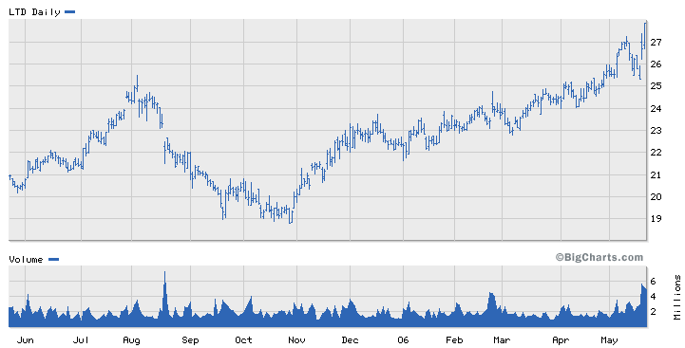
Fig. 4.3 LTD upward trend over 1 year [4]
The forth, and final company in which I invested in was FRNS. FRNS had a merger with another company, which has lead to the explosion of the stocks value. The stock has continued to gain momentum after the merger and has no signs of stopping.
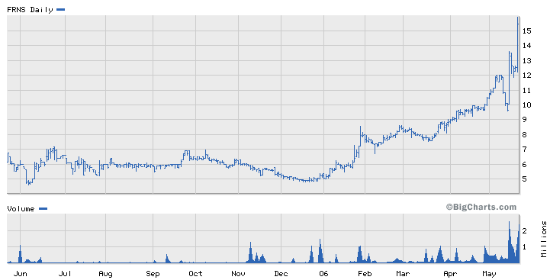
Fig. 4.4 FRNS upward trend over past year [4]

4.4 Weekly Trading Activities
Week 2

My first stock from last week was ENSI, which is Energy South Inc com. They have met, and beat my sell point of $31.65 and have reached $31.86 per share. [4] I originally said that I would sell the stock once it met 31.65 dollars a share, I have decided to continue with the investment, and ride out the momentum surge as the price rise. Once there is a significant drop in price which I do not believe there will be, I will sell the stock. As long as the stock continues to rise, I will hold onto my shares, and allow them to make money. I originally invested $50,000 into ENSI, which at the current price is valued at, 50,331.75. [4] This is a gain of 331.75 dollars from my initial investment in this company. Here are the recent graphs of the stocks price, in the last 6 months.
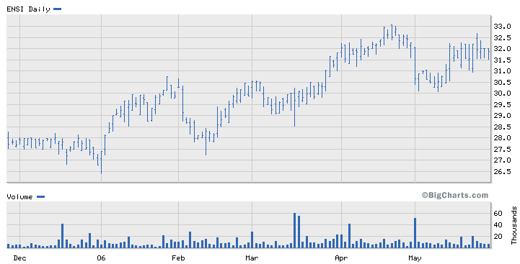
Fig. 4.5 ENSI gains over past 6 months [4]
The second company, which I invested in, was Energy Transfer Equality. Last week each stock was valued at 26.80 dollars. This week each stock is valued at 26.70 dollars. [4] From the graph it is easy to tell that this week has been up and down for this company. I have decided to hold on to this stock, and not sell at this point because it has only gone down 10 cents in the last week. I believe this is acceptable movement for this stock, and does not indicate any concrete problems with the company, which should lead me to stop my investment in the company. This is more easily understandable after seeing the 3, month graph of the stock price, which clearly shows a continual growth in price.
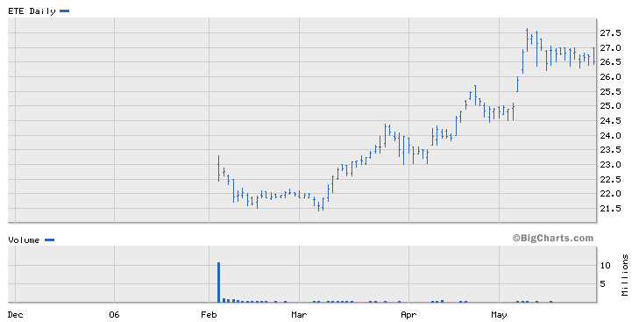
Fig. 4.6 ETE price over past 6 months [4]

I originally bought the stock for 26.80 dollars per share, and the current price is 26.70 dollars per share. [4] My initial investment was $10,000. At this moment my stock in this company is worth, $9962.69 this equates to a loss of $37.31 for the past week.
The third company, which I invested in, was LTD or Limited Brands Inc Com. The stock went down fairly significantly this week. From $27.87 to $26.83 more then a dollar loss per share, however; I believe it is way too early to count this company out. From looking at the graphs it is easy to tell that this has been a long time momentum performer.
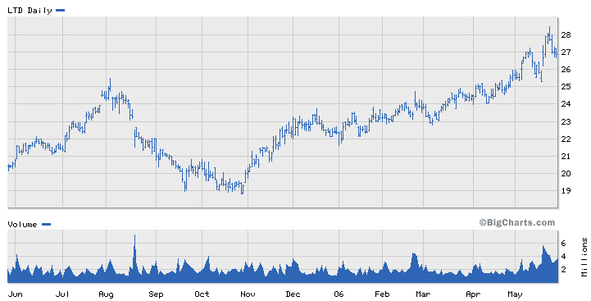
Fig. 4.7 trends after 1 year [4]
This graph of the past year clearly states that the company is continuing to rise, and that selling the stock after one week is premature. The following two graphs of the past 6 months, and the past month also make it obvious that this hypothesis is correct.
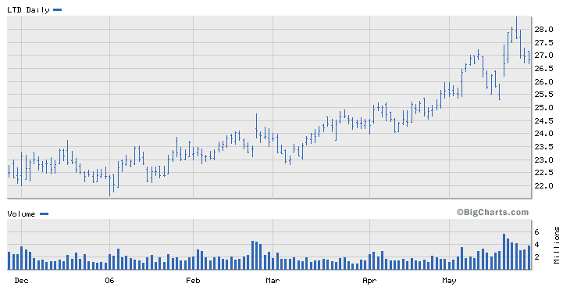
Fig. 4.8 LTD trend after 6 months [4]
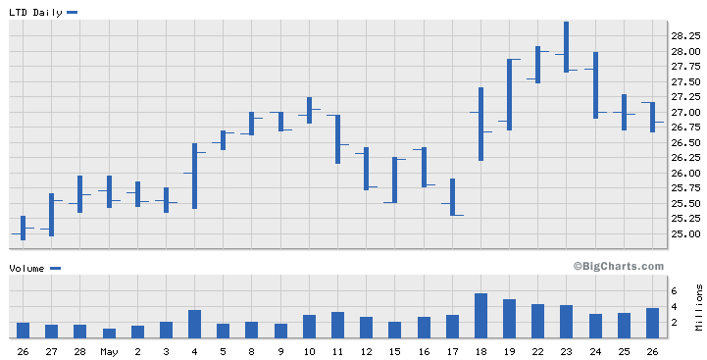
Fig. 4.9 Trends after 1 month [4]
I originally invest $10,000 at 27.87, which is at the current price of 26.83. [4] This brings the value of the initial investment for this stock down to $9626.84. This is a loss of $373.16 from the initial investment.
The fourth company, which I invested in, was FRNS, or First Ave networks INC COM. Last week the company was worth $15.44 per share when I invested. They have dropped to $14.08 per share more then a dollar drop per share. [4] I will also continue my investment in this company despite the hit it has taken this week. I believe that this is a strong performing company, which is obvious by the graphs, however I will be monitoring this stock closely this up coming week because I bought the stock at almost it’s highest value ever, and now it has come back down a little bit.
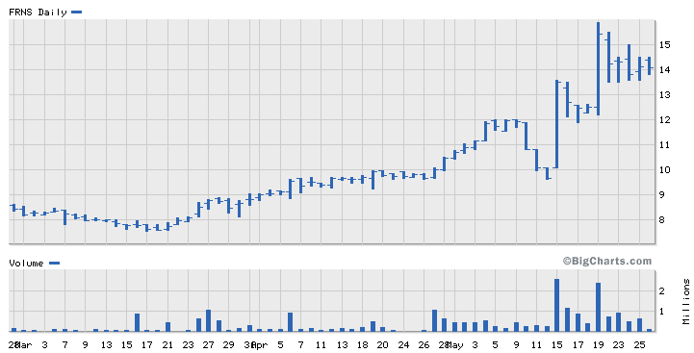
Fig. 4.10 Price of FRNS over 3 months [4]
If the stock continues to drop severely into this upcoming week I will discontinue my investment in the company. I believe that the value of the stock will fall slightly, or not rise or fall in value for a slight time, and then will regain its momentum, and rise in value again. I originally invested $10,000 into FRNS, and at its current value is worth $ 9119.17 which is a loss of $880.83. [4]
I originally only invested $80,000 of my $100,000 because I was unsure where to invest the remaining $20,000. I have decided to invest this $20,000 into Micron Technology Inc com. They create the computer chips, which are used for digital cameras. [4]
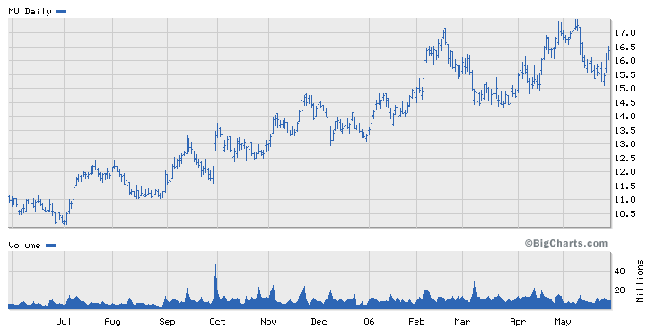
Fig. 4.11 Price of Micron Technology Inc com over 1 year[4]
The stock price varies a lot in a short amount of time, however; the overall trend has continuously risen. I am going to invest my remaining $20,000 in this company, which will buy me 1221 shares, at a price of $16.37 a share. [4]

Week 3
This was an interesting week for the stocks which I have invested in. One of my stocks is continuing to perform well, some others are starting to rebound, and one will be sold to invest in one of my well performing stocks.
I begin with ENSI this was the stock which I placed the most amount of confidence, and money into in week one. My initial investment was the amount of $50,000. I bought the stock when it was priced at $31.56, the stock is now valued at $31.98. [4] When I first bought the stock I said I would sell if it reached $31.65, which it did in the first week, but I changed my initial, approach to this stock when I realized the great potential for gain. The $50,000 that I started with is now worth, $50,665.39, which is a gain of $665.39. From figures 4.1, and 4.5 it is obvious that this stock is a very developed upward momentum performer, which has no obvious signs of slowing down. I will continue with my investment in the company into week 4.
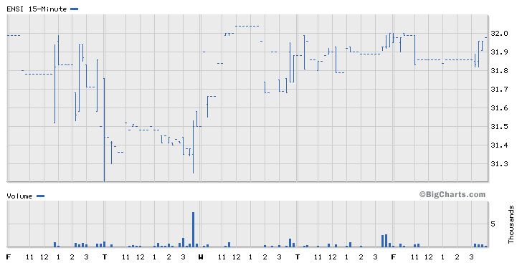
Fig 4.12 2nd weeks price, and volume [4]
This past weeks graph continues to impress upon me the upward momentum gain, which this stock processes.
The next stock, which will be addressed, is ETE. I originally invested $10,000 into ETE because I believed it to be a risky investment. In the first week the price of the stock slipped by ten cents a share, continuing with that trend this past week the stock slipped another twenty cents a share. The stock was originally worth $26.80, and currently is valued at $26.50. [4] If I were to sell now I would get back $9888.06 of my initial $10,000 investment, which would correlate to a loss of $111.94. I have decided not to sell this stock, and to ride out the slow drop in price by looking at the longer, term performance of the stock, it should begin to regain value before this project is over.
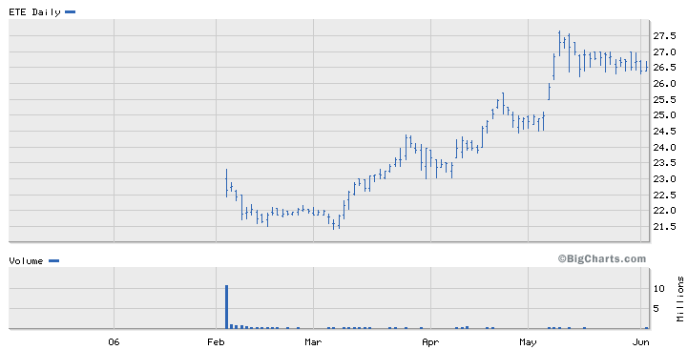
Fig 4.13 ETE over past 6 months [4]
Looking at figure 4.13 one will notice that the stock will gain value, quickly over a short period of time, and then decline, a small amount, and then again surge upward in price. I believe that this pattern will continue, and that this stock is poised to gain momentum again.
LTD recovered slightly from its first week drop of over more than a dollar a share, however; this is recovery is still not enough to get the stock back to the value which it was priced at when I bought into the company. I bought the stock at $27.87, then in week one it plummeted to $26.83, and now it is valued at $27.31. [4]
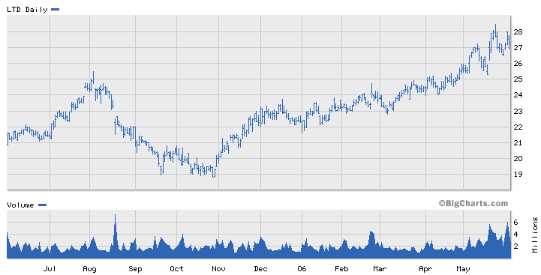
Fig 4.14 LTD price over past year. [4]
This is still a net loss of $.56 a share. I originally invested $10,000 into the company, which is now worth, $9799.07. Because of the upward swing of the stocks price in the past week, I will continue my investment in the company hoping that I will met, and beat the original price at which I bought the stock. I believe that in time this stock will recover fully, and possibly gain value from my buy in price.
MU the company which, I invested $20,000 into last week, and that I am going to add another 9393.07 to this week, has gone up 9 cents a share. I originally bought the stock at $16.37, and it is now worth 16.46. [4] From the $20,000 invested it is now worth $20,109.96. I am very happy with this quick gain, but the high for the week was $16.88, and the price dropped significantly one Friday. I do not see this as a bad thing I believe that with in the following two weeks the price will be valued at $16.88 again.
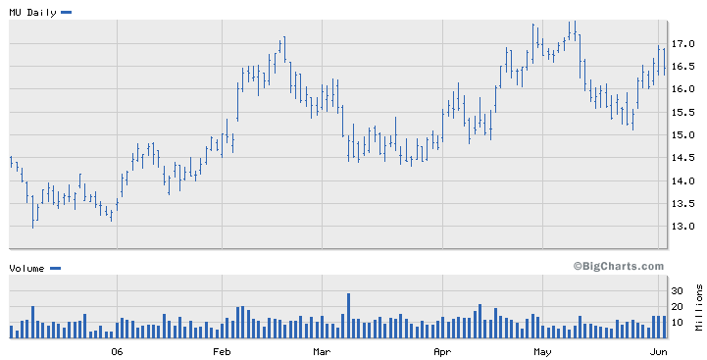
Fig. 4.15 MU price for past 6 months [4]
This stock has been worth over $17, at the peak of it’s past major surge. [4] I believe that the surge being experienced now is another one of these strong surges, and that the price will be driven up to, and higher then $17.10, a share before the price comes back down again. I now have 29397.67 invested into MU.
FRNS has risen in value over the past week to $14.51 I originally bought into the company at $15.44 this is almost a dollar loss per share. [4] At this point in time I have decided to sell the stock, and with the money which remains from the initial stock investment, place that money into MU. To date I have lost $602.33 because of FRNS decline in prices. Even though in the last week the stock has risen slightly from the week previous, it was not the major momentum surge, which I hoped that it would be. That is why at this point in time I have decided to cut my losses, and with the remaining $9397.67 invest else, where.

Week4

Week three has been hard on the four companies, which I am invested in. Each of my stocks dropped in value. ENSI, which I initially invested $50,000 into rose last week in value, and was worth $50,665.39. This week the stock dropped below my initial investment value, to put it in the red. The stock is now worth $49,572.23 of my initial $50,000 investment. I have decided to hold onto this stock, and to give it a chance to rise again in value. I believe that this was just a small hiccup, and that is will correct itself in the following weeks.
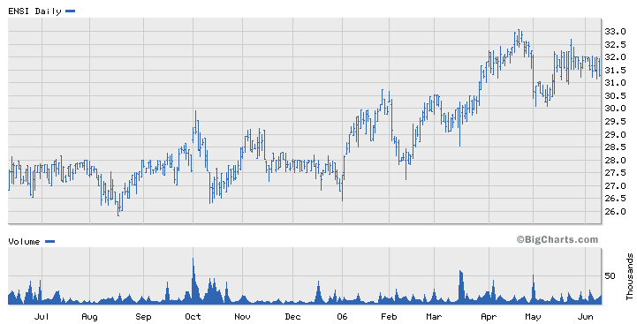
Fig 4.16 Updated ENSI graph [4]
ETE, which I initial invested $10,000 into, did not take a hit this week, however; it also did not make any money. The stock is worth the same value at the end of this week as it was at the end of week two. My game plan at this point is the same as last week due to the fact that it is at the same point as it was last week. I will hold onto this stock, and give it some time to redeem itself. The stock is valued at $26.50, and started at $26.80. [4] I bought $10,000 worth of this stock, which is now worth $9888.06.
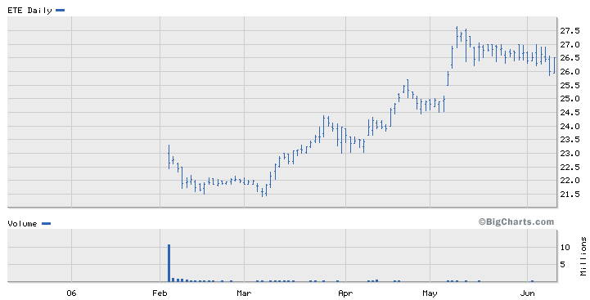
Fig. 4.17 ETE Updated Graph [4]
LTD took a nose, dive, this week going from being worth $27.31 last week to $26.72 as of this Friday. [4] This is down from when I made my initial investment, when it was worth $27.87 this is a drop of over a dollar a share. [4] The momentum of this stock has slowed, but by looking at figure 4.18 one can tell that the stock is going through a periodic drop in price, where if it follows its previous momentum spikes, will do so shortly, and the value should come back up. From the initial $10,000 investment, that money is now valued at $9799.07
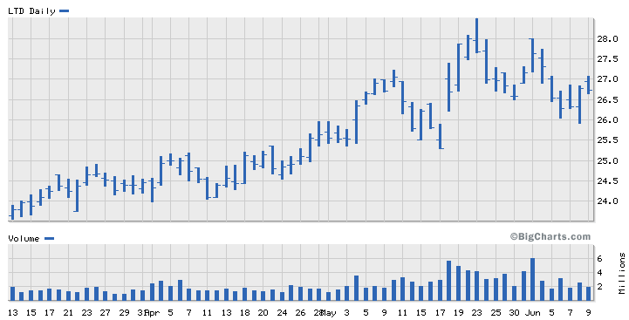
Fig. 4.18 Updated Graph of LTD [4]

MU has gone down quite a bit in the past week where it started at $16.46 to $15.53 as of Friday. [4] I had $20,000 initially invested into the company. That money was worth, $20,109.9, as of last week, and is now worth $18,973.74. I have decided to hold onto this stock as well. There are only two more weeks in this simulation. I believe that this stock is also going to come out of this slump, and rise in value past the value I bought it at originally. The real question in my mind is if that is going to happen with in the next two weeks or not, I have decided to take the risk that it well, based on the fact that the stock does fluctuate quite a bit, however the momentum upswing is quite apparent from the graph of the one year price value of this stock.
At the end of this week my investments all summed up are worth $97608.46. This is a loss of $2391.54 from my initial investment of $100,000.

Week 5

This week saw ups and downs for my stocks. Two of my stocks ENSI, and MU have made a come back. MU has not quite come back to my original investments worth, but ENSI has come back to and surpassed my original investments worth. On the other had ETE, and especially LTD have continued to decline, LTD will be sold and the money will be put into MU hoping that going into the last week of trading the lost money on LTD will be made up by investing the remaining amount into MU which really made progress this week. ETE on the other hand had a rally earlier in the project. I have decided to ride this stock out through the end of the project hoping that it will finally come around in this last week of trading.
ENSI started out last week at 31.29 dollars per share. It has risen to 32.18, which have put this stock into the positive. [4] I originally bought the stock at 31.56 dollars a share, and invested 50,000 into this stock believing that it would be a strong performer. I had my doubts in that past five weeks as this stock slowly slipped, but I believed that this was only a pause in the momentum of this stock, and that it would once again regain it’s former upward momentum swing, and in the end would make me money. I believe that this new revitalization of this stocks momentum has not fizzled out yet, and will continue to gain momentum driving the worth of this stock up. I will continue my investment in this stock, which is now valued at $50,982.24 which is a gain of $982.24 from my initial investment.
ETE has continued to decline in the past week slipping to a worth of $26.38 from the initial value that I invested into it at $26.80. [4] I continue to have faith in this stock. I believe it is like ENSI, and that this slow slippage is the calm before the storm just like with ENSI. My biggest point of controversy over this stock is if the stock will regain its former momentum in the week that is remaining in this project. After a lot of thought I have decided to stick with this stock through the final week of trading. I believe that this stock will rally in this last week of trading. It may not be able to regain all the value that it has lost since I initially invested in the stock, but I believe that I will get some of it back. The value of the stock I hold in ETE is now valued at $9843.28. This is a loss from my initial investment of $10,000.
LTD has also been a poor performing stock for me, and I have decided to sell this stock primarily because unlike ETE it has not shown any signs of life. It continues to drop week, after, week with out any real signs of momentum gain, or the hint that there might be momentum gains in the future. I originally bout the stock for $10,000 but now it is valued at $9257.27, and each stock is worth 25.80 a share. [4] This is almost a dollar drop per share when compared with last week’s price of $26.72. [4] I will invest the remaining money of this stock into MU which had a stellar performance in the past week, which I believe will continue into next week, and through the completion of this project.
MU has had an unbelievable week. I believe that this stock would come around, and it finally has. The stock last week was valued at $15.53 per share, and is now valued at $16.35 per share. [4] In terms of money it has not yet returned to the value at which I bought this stock, but I believe that it will in the upcoming week. The value at which this stock is valued is 19975.57, which are up from last week when it was valued at $18,973.74. I hold so much faith in this stock that I have decided to put an additional $9257.27 into this stock, which is from the LTD stock, which I have sold. This bring the amount of money with I have invested into this stock to a value of $29,232.84.
Week 6

Once again my stocks have taken a pounding, all but one have slipped again to lower values. ENSI which last week I believed was making a comeback after having gained, a good amount, and come back and past my original investment value, slowly slipped to a value of $31.70 per share where as last week the stock was valued at $32.18. [4] Even though the stock has slipped in the past week over all it is still at a higher value then when I originally invested 50,000 into this stock in week 1. When I originally invested into ENSI the stock was worth $31.56 per share, and just as I had predicted then the stock did gain value although I knew it would take some time because the stock is a long time performer, which needed time to fully develop. [4] The value of my initial $50,000 investment is now $50,221.78, which is a $221.78 net gain over all.
The next stock, which I invested, in was ETE, which also went down in value over the past week. I originally believed that this stock would recover in the time that was left with this project. Obviously I was wrong in this respect, however; if this project continued past the six week limit I would continue to invest in this stock believing that it would make a recovery after the stock market was finished with it’s correction. I originally bought the stock at $26.80 when I bought the stock during the first week of trading. [4] The stock has declined in value from then to be worth 25.65 now. [4] This brings my initial $10,000 investment in the company to a value of $9,570.89, which is a loss of $429.11.
The third stock, which I was invested in, was MU, which went up in value this week as I predicted last week. It continued to ride the momentum wave to a value of $16.42, which is up from last week being valued at $16.35. [4] Even though this is the last week of this project, I would have sold the stock this week because it has shown signs of losing momentum, and I believe next week will depreciate in value, and get stuck in the stock market correction which has been going on for a few months now. It shows obvious signs of slowing down in figure 4.19 you can see that during the past week it initially dipped, rallied, dipped again, and then went back up at the end of the week. This shows us that people are starting to wonder if the stock is really worth the value at which it is selling right now. Once investors become nervous two things can happen. One they get out of the stock completely. The other is to keep the stock they have, and not further invest into the company. I believe that this stock has reached this point, and will not continue to make gains. The value of the stock, which I have invested into MU at this point, is $29,358.
This was the Last week of Trading my net loss was 10,849.33.
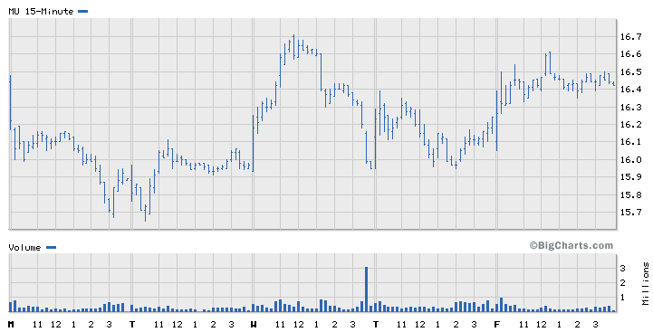
Fig. 4.19 MU Graph for week 6 trading [4]

4.5 Conclusion
In conclusion for this six, week simulation of the stock market, I believe that we have accomplished all of the goals we had set out to accomplish, even though we may have learned about it in an unorthodox way. When we set out on this simulation, our goals where to gain a general knowledge of how the stock market works, understand different trading techniques, and what advantages they have, and to understand the history of the stock market, so that we can understand the present. What I have learned about the Momentum Method for training is as follows. One, this is one of the most basic of stock market techniques. It deals only with buying low selling high, and finding the correct timing to get in on a stock, which has momentum in its favor. These principles are simple however implementing them is not. One of the most difficult things, which I learned quickly through this trading technique, is that it is very hard to be able to get in on a stock early in its momentum upswing. It is hard for several reasons one being, how long does a stock have to be going up before you see it as a developed upward swing and buy in. Another reason that this technique is hard is because how do you know if that the stock is maxed out at its highest price, or if it is going to continue upwards. Another reason I had problems implementing this technique during the past 6 weeks is because, of the stock market during this time. For the past few months the stock market has been going through a “correction” where before the stocks where valued too high, and once the correction is over they will be valued at a price that reflects there true value. Because of this it was very hard to find stocks that had upward momentum, let alone stocks that had upward momentum for enough time to be developed enough to buy in on those stocks. I lost money over the past six weeks of the stock market simulation. Even though I was trying to make money, and it seems like a good thing I think it is important for people to realize that yes they can in fact lose a great deal of money in the stock market. I believe that some investors, especially the ones in my generation, are starting to have the ideology that lead to the stock market crash during the 1920’s. People believe that buying stock is a good investment for returns, and it can be, but I think it was good for me to realize that it is not as easy as everyone says it is. My final thoughts about the Momentum Trading technique are that it is a good strategy. I would consider this technique once I begin my investing in the stock market. I believe that this technique is more effective for stock which have had momentum for a long period of time, even if the stock is not going to sky rocket, I believe it is this slow but gradual gain in momentum which will make this strategy the most effective. This can be seen in my section through ENSI which in the beginning I invested the most amount of money into because I believed if would be a stable upward momentum stock. In conclusion this technique is a very important tool for investors, and should be considered by new investors.

Chapter: 5 Trend Following

5.1 Introduction
I am planning to us the Trend following technique. Trend following is similar to momentum trading in the way people go about picking the stocks, but the difference between the two is how the buyer decides when to sell the stocks. Trend followers will literally follow the trends so when the price of a stock is going down the buyer sees the trend is that the stock is going down. They are much less concerned about the long run of the stock. Trend Following demands that you have strong self-discipline to follow precise rules. It involves a risk management system that uses current market price, equity level in an account and current market volatility [2].
Changes in price may lead to a gradual reduction or increase of your initial trade. On the other hand, adverse price movements may lead to an exit for your entire trade. Historically, Trend Following trader's average profit per trade is significantly higher than the average loss per trade [2].
Trend following stocks need to be on an upward swing, I feel that these will continue their upward pattern and after a very short time will show promising results.

5.2 Stock Selection
My first stock for trend following will be The9 Limited. The9 Limited engages in the development and operation of online games in China, this company operates ‘MU’, a three-dimensional massively multiplayer online role playing game (MMORPG) that allows players to log on to network servers to ‘role-play’ characters in a virtual world [3]. This company is on a definite up swing so I will start with them.
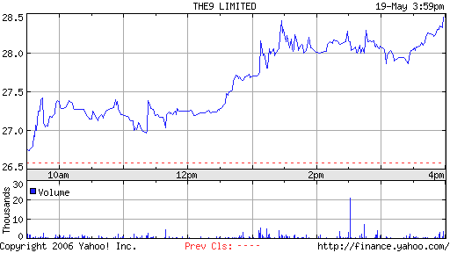
Fig 5.1 Upward Trend of NCTY over one day
Tyson Foods, Inc. engages in the production, distribution, and marketing of chicken, beef, pork, prepared foods, and related allied products [3]. They are a major distributor of frozen and packaged foods to companies such as Subway. I feel that from figure 5.2 that they would be a good candidate.

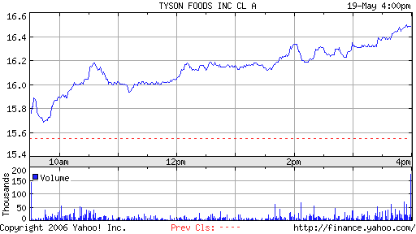
Fig 5.2 Upward Trend over one day
Microtune, Inc. engages in the design and marketing of radio frequency integrated circuits and subsystem module solutions to original equipment manufactures in the United States and internationally. Its products include microtuner single-chip broadband tuners; silicon amplifiers, including upstream amplifiers, intermediate frequency amplifiers, and broadband antenna amplifiers; and VideoCaster chipset and module for cable video-on-demand applications [3].
Now that I have all of my stocks picked out I can start trading. This will be done on Monday the 22nd of May. That will start the process of trading using these strategies. The stocks that I have picked are not necessarily the ones that I will keep. Over the course of these 6 weeks I will be looking out for other stocks that look promising using these techniques and hopefully through careful studying and paying attention I will be able to make some money.

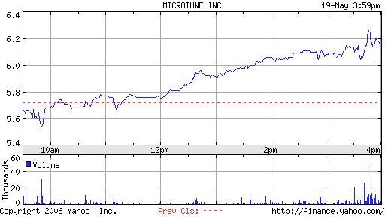
5.3 Upward trend over one day

5.3 Weekly Trading Activities
Week 2
Trend Following
Date | symbol |  | buy/ | Price | shares | netcost/ | Profit/ | Total cash | total
Date |  |  | Sell | Price | shares | proceeds | Loss | Total cash | Assets
22-May | NCTY |  | buy-long | $24.26 | 1374 | $33,333.24 | 0 | $66,666.76 | $100,000
22-May | TSN |  | buy-long | $16.40 | 2032 | $33,324.80 | 0 | $33,341.96 | $100,000
22-May | TUNE |  | buy-long | $6.07 | 5491 | $33,330.37 | 0 | $11.59 | $100,000
26-May | NCTY |  | Sell | $22.75 | 1374 | $31,258.50 | $2,074.74 | $31,270.09 | $97,925.26
26-May | TSN |  | Sell | $15.85 | 2032 | $32,207.20 | $1,117.60 | $63,477.29 | $96,807.66
26-May | TUNE |  | Sell | $6.28 | 5491 | $34,483.48 | $1,153.11 | $97,960.77 | $97,960.77
30-May |  | NCTY | Buy | $27.76 | 1200 | $33,312 |  | $64,648.77 | $97,960.77
30-May |  | TSN | Buy | $16.05 | 2076 | $33,320.80 |  | $31,328.97 | $97,960.77
30-May |  | TUNE | Buy | $6.11 | 5127 | $31,325.97 |  | $3 | $97,960.77

Table 5.1 Track of buying and selling

The stocks that I picked for my trend following were poorly picked this week because I ended up losing money on two of the three stocks that I picked. The only company that I made any money on was Microtune Inc (TUNE). I bought TUNE at $6.07 on Monday and on Friday I ended up selling it at $6.28 making a total profit of $1,153.11.
The next stock Tyson Foods (TSN) had some points in the week where it was rising, but at the beginning of the week it took a major drop, which ended up hurting my total assets. I bought TSN at $16.40 on Monday and on Friday sold it for $15.85. The overall loss on this was $1,117.60. This is still less than what I gained from TUNE so at this point I am still doing alright.
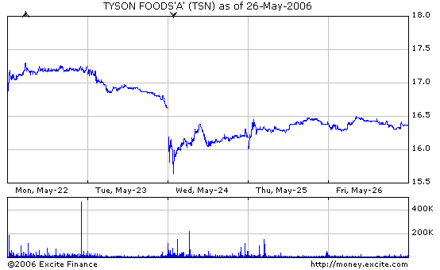
Figure 5.4 Weekly Stock Report
The last stock The9 Limited company (NCTY) was doing decently until midweek when it dropped $4 in one day. I bought this at $24.26 and it ended up coming back at $22.75. My overall loss with this was $2,074.74. My overall loss was about 2% of what I started with. I feel I made poor choices for this type of trading. My goal for next week is to research ways to determine whether a stock will rise or not and determine if I should pick new stocks or stay with the ones I have. I also plan to gain back the money that I lost by using the methods I find. I hope to be back in the positive range within 2 weeks.

Week 3
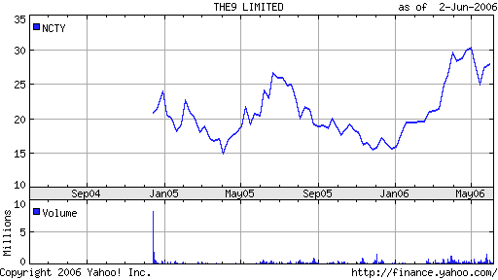
Fig. 5.5 Two year chart of NCTY

This week in sales The9 Limited (NCTY) stayed fairly even. At the end of the week I would say the price hadn’t fallen nor risen since Tuesday when the market opened up. I have noticed, however, from the 2-year chart that the peaks are getting higher (see figure 5.5 above). Since this is a fairly new company (less than 2 years old) I am hoping for the trend of increasing peaks and in a week or two large gains for the stock. For this week I have only bought the stock so I am waiting for the next peak to come.
I decided to give Tyson (TSN) one more chance this week. It created a loss last week so I was already not too interested in the stock anymore. I bought back 2076 shares at $16.05 a piece. After watching the stock for the week, I wasn’t able to sell because the price went down. Luckily it only went down by fractions of a point so it wouldn’t be a huge loss if I were to sell. However, there is the chance that it could shoot back up again. Next week will be interesting for this stock. I am hoping for at least a small jump up in price, and if it doesn’t come I think I will look for a new stock to trade.
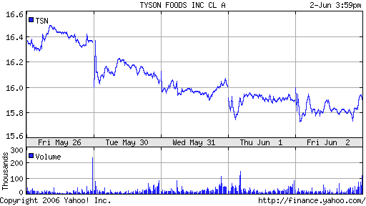
Fig 5.6 Week two showing price falling by fraction of a point
MicroTune is my hopeful stock. It is the only one showing promise out of all of the three. It peaked in late 2001 and is growing a base. According to Ted Warren it is important to notice when a stock is growing a sturdy base because once it has a base it can then begin to make some real big earnings[3]. I am not selling this stock this week because I am hoping for better things to come.
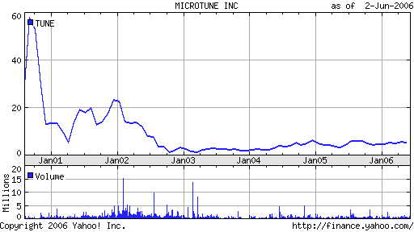
Fig 5.7 MICROTUNE prices for 5 years

Overall if I were to sell my stocks I would have lost a lot of money. I also still stand to lose that money if two of the three stocks don’t start showing an upswing in their prices. I am wary of NCTY and TSN because they have been showing losses and their long-term charts don’t show much promise. Also I don’t think what I would make selling TUNE stocks would make up for what I would lose selling the other two. Next week I will see whether or not to pick new stocks.
Week 4
Date | Symbol | buy | Price | Shares | netcost/ | Profit/ | total cash | Total
Date | Symbol | sell | Price | Shares | proceeds | Loss | total cash | Assets
22-May | NCTY | Buy | $24.26 | 1374 | $33,333.24 | 0 | $66,666.76 | $100,000
22-May | TSN | Buy | $16.40 | 2032 | $33,324.80 | 0 | $33,341.96 | $100,000
22-May | TUNE | buy | $6.07 | 5491 | $33,330.37 | 0 | $11.59 | $100,000
26-May | NCTY | sell | $22.75 | 1374 | $31,258.50 | $2,074.74 | $31,270.09 | $97,925.26
26-May | TSN | sell | $15.85 | 2032 | $32,207.20 | $1,117.60 | $63,477.29 | $96,807.66
26-May | TUNE | sell | $6.28 | 5491 | $34,483.48 | $1,153.11 | $97,960.77 | $97,960.77
30-May | NCTY | buy | $27.76 | 1200 | $33,312 |  | $64,648.77 | $97,960.77
30-May | TSN | buy | $16.05 | 2076 | $33,320.80 |  | $31,328.97 | $97,960.77
30-May | TUNE | buy | $6.11 | 5127 | $31,325.97 |  | $3 | $97,960.77
9-Jun | NCTY | sell | $24.11 | 1200 | $28,932 | $4,380 | $28,935 | $93,580.77
9-Jun | TSN | sell | $15.41 | 2076 | $31,991 | $1,329.64 | $60,926.16 | $92,251.13
Table 5.2 Trend following trade summary
With my last trading strategy, short trading, I was making a nice profit by taking advantage of the falling stock prices, but I wasn’t so lucky with this strategy. I believe that I made poor stock choices and now I am paying the price for it. This week alone I lost a total of $5,709.64. Only one of my three choices have any hope of turning a profit, and that one is Microtune.
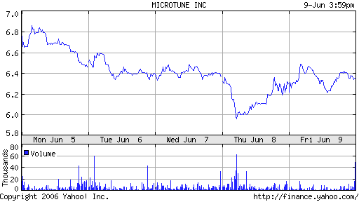
Fig 5.8 Week report for TUNE
Although it is down, it isn’t down by very much and I feel that based on its trend on a longer chart that it has the potential to start making some money for me. I will continue to ride this stock into next week and hope for good things to happen.
For my other two stocks its been nothing but bad things. Both are down by much more than I really want to believe.
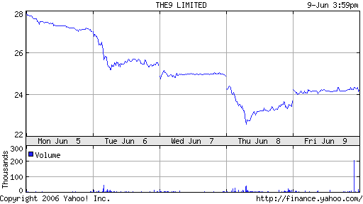
Fig. 5.9 NCTY weekly stock report
As you can see from the chart in the week NCTY was able to lose almost 4 points off the price. I sold this on Friday for a loss of $4,380. I have also decided that this stock will be nothing but disappointing for me in the future so I am planning on picking a new stock to replace it Monday. I am hoping that by doing a better job researching the stock with what I know now about the strategy that maybe I will be able to turn a profit from the hole that this stock left in my total assets.
The last stock, Tyson foods (TSN), was also a disappointment this week. Usually I can rely on Tyson, but lately its been nothing but disappointing. I was hoping that maybe this week it would make a little turn into the positive, but I wasn’t so lucky.
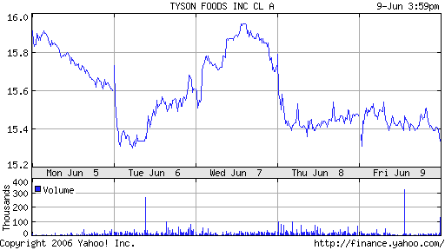
Fig 5.9 TSN weekly stock report.
The most I could have hoped for is for this to break even this week. Stupidly I didn’t sell when the price rose to what I had bought it for. I was hoping for it to keep rising. I wasn’t right about this prediction and I ended up selling lower than what I had bought it for. I ended up with a 1.42% loss of $1,329.64. I have also given up hope on this stock and plan to research another one to pick in its place because I don’t believe in the weeks coming up that it will make any profit for me. At least not more of a profit than what I have already lost from it.
This strategy has its ups and downs. Right now with the stock market in a downward trend it is a terrible strategy because it closely follows trends and when the trend is downward it should not be traded because it will most likely lose money.

Week 5
Date | symbol | buy/ | Price | shares | netcost/ | Profit/ | total cash | total
Date | symbol | Sell | Price | shares | proceeds | Loss | total cash | Assets
22-May | NCTY | buy-long | $24.26 | 1374 | $33,333.24 | 0 | $66,666.76 | $100,000
22-May | TSN | buy-long | $16.40 | 2032 | $33,324.80 | 0 | $33,341.96 | $100,000
22-May | TUNE | buy-long | $6.07 | 5491 | $33,330.37 | 0 | $11.59 | $100,000
26-May | NCTY | Sell | $22.75 | 1374 | $31,258.50 | $2,074.74 | $31,270.09 | $97,925.26
26-May | TSN | Sell | $15.85 | 2032 | $32,207.20 | $1,117.60 | $63,477.29 | $96,807.66
26-May | TUNE | Sell | $6.28 | 5491 | $34,483.48 | $1,153.11 | $97,960.77 | $97,960.77
30-May | NCTY | Buy | $27.76 | 1200 | $33,312 |  | $64,648.77 | $97,960.77
30-May | TSN | Buy | $16.05 | 2076 | $33,320.80 |  | $31,328.97 | $97,960.77
30-May | TUNE | Buy | $6.11 | 5127 | $31,325.97 |  | $3 | $97,960.77
9-Jun | NCTY | Sell | $24.11 | 1200 | $28,932 | $4,380 | $28,935 | $93,580.77
9-Jun | TSN | Sell | $15.41 | 2076 | $31,991 | $1,329.64 | $60,926.16 | $92,251.13
12-Jun | BBY | Buy | $50.48 | 660 | $33,316.80 | 0 | $27,609.36 | $92,251.13
12-Jun | DF | Buy | $35.46 | 778 | $27,587.88 | 0 | $21.48 | $92,251.13
16-Jun | DF | Sell | $36 | 778 | $28,008 | $420.12 | $28,029.48 | $92,671.25
16-Jun | BBY | Sell | $52.70 | 660 | $34,782 | $1,465 | $62,811.48 | $94,136.25
15-Jun | TUNE | Sell | $6.70 | 5127 | $34,350.90 | $3,024.93 | $97,161.18 | $97,161.18

Table 5.3 Summary of trading

This has been my best week so far. If you remember last week I sold two of my stocks for a loss so that I could buy up new stocks. After doing a little research I have found two of the highest performing stocks for two weeks ago, and this week they have also been doing well. In addition to them both doing well my other third stock has also made me a profit this week.
The stock I kept, Microtune (TUNE), finally made the leaps and bounds I was hoping for. Since the price of this stock is so low I can buy up a lot of so every little gain it makes will make me even more money. This week the price raised almost 10% from what I had bought it for. My total profit for this stock was around $3,000 dollars. This was great news to me because I had lost so much selling the other two stocks.
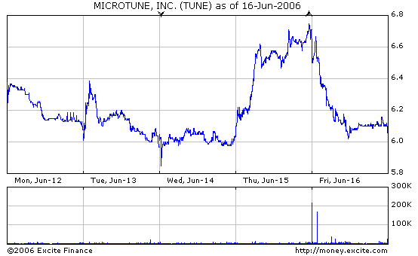
Fig 5.10 Weekly report of TUNE stock with high for end of Thursday
The first new stock that I bought up was Best Buy (BBY) It was the highest performing stock last week so I took that as an obvious sign that this could really be a potential money maker [3]. Once I looked at its past performance charts I was convinced that I needed to buy. I bought 660 shares of BBY at $50.48 on Monday and on Friday I sold 660 shares of BBY at $52.70 making a total profit of $1,465. I have the highest standards for this stock and I hope it will keep performing as well as it did this week.
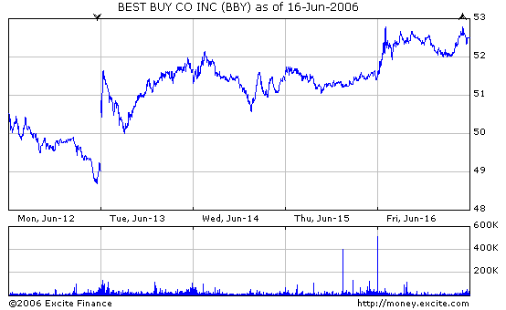
Fig 5.11 Best Buy weekly stock report

The last stock and second stock that I bought new was Dean Foods (DF). Now I didn’t go with another food company to replace Tyson, I looked at the highest performing stocks and then I looked at their performance charts for the previous years to get a good idea if the stock was on the rise or the fall. Well I could tell that this stock was on the rise so I got the same instinct that I got with the BBY to go ahead and buy. On Monday I bought 778 shares of DF at $35.46 and on Friday I sold it at $36. Now this didn’t make me much profit, but after losing a lot of money selling the other two stocks I wanted to make any profit that I could. I ended up making $420.12 for the week. I am hoping for a small drop before it rises again.

Week 6
Date | symbol | buy/ | price | shares | netcost/ | Profit/ | total cash | total
Date | symbol | Sell | price | shares | proceeds | Loss | total cash | assets
22-May | NCTY | buy-long | $24.26 | 1374 | $33,333.24 | 0 | $66,666.76 | $100,000
22-May | TSN | buy-long | $16.40 | 2032 | $33,324.80 | 0 | $33,341.96 | $100,000
22-May | TUNE | buy-long | $6.07 | 5491 | $33,330.37 | 0 | $11.59 | $100,000
26-May | NCTY | Sell | $22.75 | 1374 | $31,258.50 | $2,074.74 | $31,270.09 | $97,925.26
26-May | TSN | Sell | $15.85 | 2032 | $32,207.20 | $1,117.60 | $63,477.29 | $96,807.66
26-May | TUNE | Sell | $6.28 | 5491 | $34,483.48 | $1,153.11 | $97,960.77 | $97,960.77
30-May | NCTY | buy | $27.76 | 1200 | $33,312 |  | $64,648.77 | $97,960.77
30-May | TSN | buy | $16.05 | 2076 | $33,320.80 |  | $31,328.97 | $97,960.77
30-May | TUNE | buy | $6.11 | 5127 | $31,325.97 |  | $3 | $97,960.77
9-Jun | NCTY | sell | $24.11 | 1200 | $28,932 | $4,380 | $28,935 | $93,580.77
9-Jun | TSN | sell | $15.41 | 2076 | $31,991 | $1,329.64 | $60,926.16 | $92,251.13
12-Jun | BBY | buy | $50.48 | 660 | $33,316.80 | 0 | $27,609.36 | $92,251.13
12-Jun | DF | buy | $35.46 | 778 | $27,587.88 | 0 | $21.48 | $92,251.13
16-Jun | DF | sell | $36 | 778 | $28,008 | $420.12 | $28,029.48 | $92,671.25
16-Jun | BBY | sell | $52.70 | 660 | $34,782 | $1,465 | $62,811.48 | $94,136.25
15-Jun | TUNE | sell | $6.70 | 5127 | $34,350.90 | $3,024.93 | $97,161.18 | $97,161.18
19-Jun | DF | buy | $36.11 | 923 | $33,329.53 | ($5,321.53) | $63,831.65 | $91,839.65
19-Jun | BBY | buy | $52.86 | 630 | $33,301.80 | ($1,480.20) | $30,529.85 | $90,359.45
19-Jun | TUNE | buy | $5.80 | 5263 | $30,525.40 | $3,825.50 | $4.45 | $94,184.95
Jun-06 | DF | sell | $36.32 | 923 | $33,523.36 | $193.83 | $33,527.81 | $94,378.78
23-Jun | BBY | sell | $52.67 | 630 | $33,182.10 | ($119.70) | $66,709.91 | $94,259.08
23-Jun | TUNE | sell | $5.91 | 5263 | $31,104.33 | $578.93 | $97,814.24 | $94,838.01

Table 5.4 Total trading summary for Trend following

Overall this week didn’t do much. There wasn’t much of a profit or loss made or any of the stocks. Overall I made a total profit of $653.06. Unfortunately it did not bring my total asset category above from what I started at.
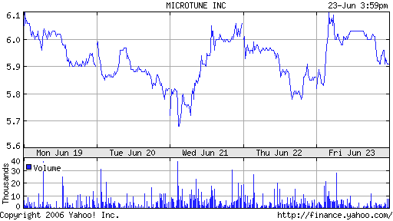
Fig 5.12 Weekly stock report of TUNE stock

I bought microtune stock at the beginning of the week and I sold it at 11 cents higher for a profit of around $500. It wasn’t the profit I was hoping for from this stock, however, any profit is better than a loss.
Next was best buy’s stock. Last week best buy made me a huge profit, however this week I wasn’t so lucky. In fact Best Buy was the only stock that made me lose money. Of course it was a small loss, but all in all it was still a loss.
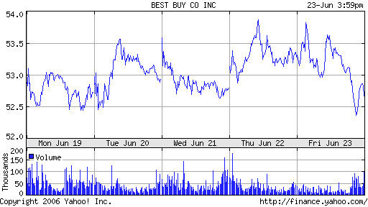
Fig 5.13 Weekly stock report for BBY
The last stock was Dean foods. This stock actually had an upward trend, unfortunately the trend had a very flat slope so not much profit could be made.
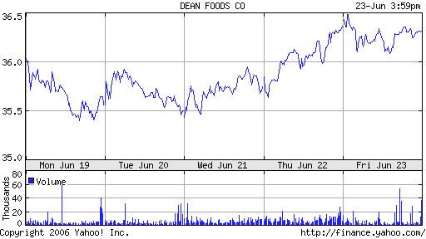
Fig 5.14 Weekly stock of DF.

Overall this week was pretty tame as far as profits and losses went.

5.4 Conclusion
This method didn’t seem to work too well for me for most of the six week period. Again I will blame some of that on the falling prices of the stock market this summer, but I also have to blame myself for the losses that I took. In the beginning I was looking at stocks trends for a daily basis, and the trend that a stock follows on a daily basis can change from day to day. So for the first couple of weeks I was making very little profit if any. I realized about halfway through the project that my picks for stocks weren’t working out for me so I decided to sell those and buy up new stocks. Once I did that I made pretty much all profit. When I decided to re-buy stocks I picked ones that were on an upward trend for at least a year. That way I was sure to make some sort of profit off of them. Overall after six weeks I took my losses at $5,161.99.
I feel that this method could be profitable if the investor did one of two things. Either they could pick a stock that was slowly climbing and hang on to it, or they could find a stock that they think is about to jump up and invest a lot of money in it. Then when it increases in price they get out before the price comes back down. Both methods would take a lot of research and patience. The first method would take a lot of research to find the right stock that it definitely making gains on a monthly basis. Then they would have to wait to see how high the stock actually gets. The second method would take more research to find that once stock that’s about to jump up, then invest lots of money into it and get out almost as soon as they got in which would probably turn a huge profit for them. Either way I believe I could have done a better job picked my stocks initially which would have increased my overall profit. Still it was fun using this strategy and I might consider using it in the future if I were to invest my own money.
Chapter 6: Fundamental Analysis
6.1 Introduction
Fundamental Analysis is a type of stock market valuation that utilizes financial and economic analysis in order to predict the movement of stock prices [3]. Unlike Technical Analysis that mainly relies on charts, trend following, and common sense, Fundamental Analysis is concerned with a important company information, including financial reports, as well as non-financial information that include estimates of growth of demands for similar products, company comparisons, or changes that effect the whole economy [3].
Rather than simple chart analysis that is involved in Technical Analysis, Fundamental Analysis focuses on company factors such out of company price trend estimation, the manner with which a company manages their money, the amount of debt the company has, or the growth of the company’s earnings [3]. Thus, Fundamental Analysis relies more on factual and tangible company development and less on assumption.
Fundamental Analysis first examines the company’s situation on a large economic scale. This involves both international and national activities of the company. Such factors analyzed include interest and exchange rates, inflation, and a company’s overall productivity [3]. The analyst then studies industry analysis of the company, this involves competing company comparisons, foreign competition, and analysis of total sales [3]. Finally, the Fundamental Analyst studies further studies the specific unit sales, earnings, and possibilities of future earnings or debt that the company may encounter [3]. A much more in-depth analysis, Fundamental Analysis can better guarantee accurate results.

6.2 Stock Selection
General Electric Company
Being an electrical engineer, I believe that in the future I hope that I would at least be considering trading with, if not working for a big electric company such as General Electric. I have decided to follow and trade with General Electric for this reason. General Electric is involved with the development, manufacture, and marketing of various products for the generation, transmission, distribution, control, and utilization of electricity [3]. The company produces a wide variety of products, from household lighting products to medical diagnostic imaging systems.
After more in depth research, the General Electric company is clearly a fast growing company that also has remained in the industrial world for quite some time. It offers an interesting impact on the consumer and business worlds is constantly developing new and innovative products. In fact, GE is affiliated with NBC Universal Inc. and produces and delivers network television services and motion pictures. GE also operates television stations, cable and satellite networks, and theme parks [3]. General Electric will surely prove to be an exciting as well as profitable investment company.

Exxon Mobil Corporation
I will also apply Fundamental Analysis trading in investing in the Exxon Mobil Corporation. The Exxon Mobil Corporation engages in the exploration, production, transportation, and sale of crude oil and natural gas. It also engages in the manufacture, transportation, and sale of petroleum products and petrochemicals, as well as participates in electric power generation [3]. The company operates in the United States, Canada, Europe, Africa, Asia-Pacific, the Middle East, Russia, and South America [3].
The Exxon Mobil Corporation will be an interesting company to trade with because of its global span of service and importance in the industrial world. The oil industry is one of the most important, and highly debated and scrutinized businesses today. In the United States, with gas prices on the rise, people are starting to question why gas is so expensive. Gas prices per gallon, do not reflect the general cost per barrel, and seem to outweigh the cost that would be involved in the refinery and taxation that is involved in gas production [3]. The public is beginning to question why the industry invests so much money instead of focusing on helping the consumer. Another issue is that Oil Industry CEO’s are making ludicrous amounts of money. There is also the issue with the oil in Iraq.
There are many factors that impact investing in this company, including political, social, and business issues. I believe that I will be able to learn much about the stock market as well as about the oil industry through Fundamental Analysis Trading with the Exxon Mobil Corporation. The many factors that I need to account for in trading with this company makes it perfect for the Fundamental Analysis Method.

6.3 Trading Summary
Week 2
I have decided to split evenly the amount of money I will invest in both the General Electric Co. and the Exxon Mobil Corp. This is because at this moment there are no indications that one company is necessarily more valuable and profitable than the other. This will probably change as the weeks go on and I learn about each company. Both have very widespread impact on society in different ways, one providing many household and helpful appliances and tools, the other providing a way to fuel the cars that are so crucial for the nation’s commuting world. I used $50,000 (of the original $100,000) to purchase roughly 1,466 shares with General Electric Co. and the remaining $50,000 to purchase 833 shares with the Exxon Mobil Corp.
The week was rather uneventful for General Electric Co. It began the week with a closing price of $34.07, and ended with the price at $34.33, yielding an increase of only 0.76%. During the week, Exxon Mobil Corp. experienced a slight increase, substantial compared to the movement in price for the GE. It began the week at $59.56 and ended at $61.58, an overall increase of 3.23%.
This week, I examined several aspect of the two companies that are pertinent to the fundamental analysis method of trading. These include statistics of profitability, management effectiveness, income statements and amount of debt. In terms of profitability, the two companies are interestingly very similar. GE’s profit margin is 10.98% and has an operating margin of 15.65%, compared to XOM’s profit margin of 10.83%, and operating margin of 16.43%. The two companies differ greatly in their management effectiveness. GE’s return on assets is only 2.11%, compared to XOM’s substantial 19.02%. GE’s return on equity is much less as well, 17.02% compared to XOM’s 33.93%. These two statistics mean that XOM’s management is much more effective than GE’s. XOM’s gross profit of $157.68B nearly doubles GE’s gross profit of $82.89B. XOM’s total debt is $7.99B. Meanwhile, GE’s debt is a staggering $376.16B. These statistics, other than profitability greatly favor Exxon Mobil Corp. XOM’s management effectiveness and profit are much greater than GE’s. XOM’s debt is surprisingly much less than GE’s [3]. These numbers are very alarming, but I will wait some time before I decide to buy or sell stocks in either of the two. After all, one of the most important stats, profitability is relatively the same. It does however, change my outlook when approaching both companies. I now feel that XOM is the more reliable of the two companies and may be lead to more profit in time.

Week 3
This past week’s progress was rather weak for the General Electric Co (GE). It has been inconsistent since the opening day of trading, last week it closed off dropping 9 cents from opening, this week it closed at $34.66, 32 cents greater than the opening price of $34.34, with an overall gain of 0.931%. It has increased more than the decrease of last week, but I would not go so far as to say that it is an excellent movement, although it has been an overall upward trend this week, as we can see from this chart.
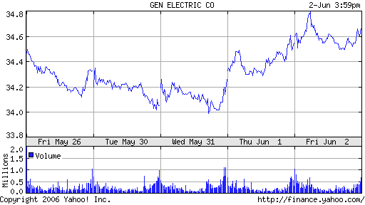
Figure 6.1: Week 3 progress for GE
Exxon Mobil Corp. (XOM) had a shaky week that lead to an overall decrease. It began the week at $61.70, and ended at $61.65, a decrease of just 0.08%. With the week’s decrease, its closing price was actually higher than last week’s $61.58 by 0.11%. The overall increase is not that substantial, and the trend that it is following is pretty much flat, especially because it had an overall decrease during the week. The price dipped in the middle of the week, falling to less than $60, but managed to lift itself up back to relatively where it was at the beginning of the week by the end of the week.
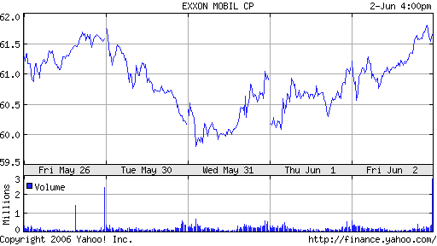
Figure 6.2: XOM’s Week 3 Progress
Although fundamental analysis does not rely mainly on Chartism and observing trends, it does not hurt to observe the price movements of both companies. This week, in the in-depth analysis, I will compare the price trend of the two companies across a period of five years.
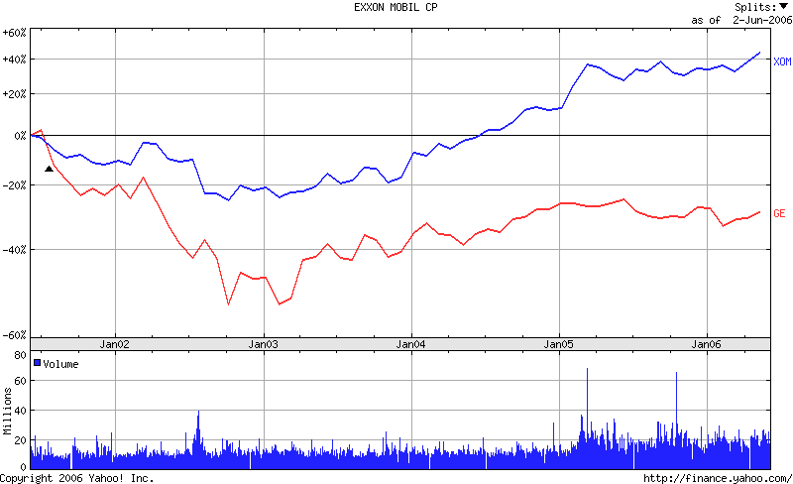
Figure 6.3: Price movement of GE vs. XOM
This very important chart actually says a great deal about both of the companies that I have chosen to invest in. It has reaffirmed greatly which of the two companies is doing better at the moment, and in the recent past. It does not necessarily which company is the best, but my confidence in GE is now faltering. This chart indicates that ever since in the past five years, XOM has experienced an increase of over 40% from its original value, at this point five years ago. GE on the other hand, has experienced an overall decrease of around 30% [3]. Both companies fell around January, 2003, indicating what probably was a stock market crash, but they began to increase immediately afterwards at about the same rate, the difference was that GE had experienced a much greater decrease. Also, by around June, 2004, two years ago, XOM had finally began to increase on its price in 2001. At this point, GE had not yet experienced an increase, but its price rose somewhat, mitigating the companies decrease [3].
Overall, GE has not been doing well at all. It can not seem to improve its price back up and provide an overall increase. It has made profit still, but the low, unmoving price could indicate unsuccessful business dealings, and in fact, it explains why GE has debt that is over $350B. If GE does not increase substantially soon, I will very likely change to a different company. For a more numerical example, GE’s price in January, 2000, opened at $153. Compare that to today’s price of $34.66. Between the five and a half years, the company has seen a staggering decrease of 77.34% [3]. This cannot bode well for the company.
On the brighter side, I have read several articles that show how GE has made great progress and company movements in many of its diverse areas recently, and has seemed to be very successful. For example, GE could benefit from its partnership with NBC and Universal studios with the success of recent movies from Universal, such as “Break Up,” which earned over $38.1 million just this past week [3]. Also, GE Healthcare is making tremendous bounds in the medical technology fields. GE has used its expertise in life science, IT and engineering to provide technology to help doctors detect diseases earlier so that patients can be treated early and have longer lives. GE also has made movements to formulate energy saving solutions for ecological problems. Recently, GE honored Unilever Canada with the 2006 Global Ecomagination Leadership Award, an award that recognizes Unilever's outstanding environmental leadership for providing significant reductions in water use and emissions [3]. GE is a very progressive company, I will have to study more about it to make my final decision of dropping the company. In the long run, GE has not done as well as other companies, but we are trading on a very short period, and I am hoping that over these next weeks, GE will be successful.
I am pleased with XOM’s progress, and I look forward in making some movements in the company soon. GE still has a little of my confidence, but I will have to look around and see if there is a different company that I could invest in soon and produce more of a benefit.
Week 4
Week four of trading was a tough week for the whole market. Last week attested to the market’s inconsistency, and this week showed how the market could change very quickly. The market was very volatile; some stocks rose and fell greatly. GE, like the S&P experienced an erratic increase in the middle of the week, before continuing to decrease for the rest of the week. XOM felt an overall decrease and downward trend. The whole market was rattled, and it seemed that no stock did well, but rather all felt a decrease. The decrease cannot be blamed on one specific bit of news or event, but was due to poor sentiments and feelings of fear for uncertainties [3].
GE closed the week at $34.07, 1.4% less than its opening price of $34.55, and less than 1% less than the overall beginning price that I bought the stock at of $34.33
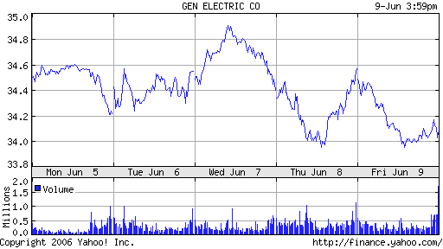
Figure 6.4: GE’s erratic weekly performance

XOM closed the week at $58.80, 5.3% less than the opening price this week of $62.10. This is an overall decrease of 4.5% since my original buying price.
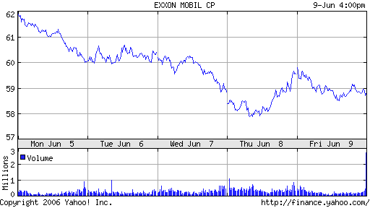
Figure 6.5: XOM’s overall downward trend this week

The market had a tough week, and it has truly been frustrating to watch all of my shares go down in value. But it this week has yielded a pretty good learning experience. I did not what to do this week, I felt like panicking because everything seemed to be going horribly wrong, but I with some reading, I realized that the whole market had an overall inexplicable downward trend. Rather than buy or sell any of my shares, I’m going to make the move to hold all of my shares in both GE and XOM. I have faith in both of my companies, and I expect them to shake off the downward trend. I have noticed however, that despite the decrease, both companies opened up at prices that were higher than even the original buying prices, which is a good sign. After all, the decrease happened in the whole market, therefore it could be related to actually an overall flat trend.
At this point, I have read articles, studied graphs, and looked over statistics for both of the companies. I have seen that XOM is the more prosperous company between the two, that it has less debt, has experienced a better trend of prices, and operates more efficiently. Next week, I will focus on society’s general opinion of both of the companies. This will be an interesting point to study because it would give me a better idea of the average trader’s opinion in stock selection. Although XOM has shown to be the better company, I believe that my research will lead me to find that GE is more popular. GE has made a great deal of helpful advances in the medical field and other fields, and has done a great deal for the environment. This is much more favorable movements than the oil companies movements in gas prices and profit along with its place in politics. XOM, being an oil company, therefore will be less popular than GE. This of course does not necessarily mean that less people invest in it, but it does speak for the reason why people do. The company’s characteristics could outweigh poor outlook in investment choices.
Week 5
Five weeks ago, I decided to invest in stocks using the Fundamental Analysis method in order to complement the Technical Analysis method that I am also using to manage my stocks. The other method is much more simple, but allows me to be much more dynamic and involved in the trading process. This is because it depends on the changes that occur in the market, and adapting to the changes. Fundamental Analysis was, I believe, much more focused on the selection process of investing, perhaps actually the most important aspect of trading. Over the past five weeks, I have stuck with my two companies that I chose based on their positive characteristics. I have also maintained the investment proportions within the two companies. I have not done much buying or selling, and truly, it does not seem like I have been very active. But there were times in the past five weeks that I was considering selling stocks in one company completely and buying into another, or changing my proportions at least. I have good faith in both of my companies at the moment.
GE had a dramatic week, but overall experienced a decrease. It opened the week at $34.17, and ended at $33.93, an overall decrease of just 0.7%. GE has recovered the best among all of my companies, and is almost back to the original price. As a matter of fact, GE is only 40 cents away from being back in the green, which I hope to see within this next week alone. I was considering changing companies and getting rid of GE because its issues with productivity and management, but I am glad that I have stuck with the company because I believed that it would do well in the short term period of time.
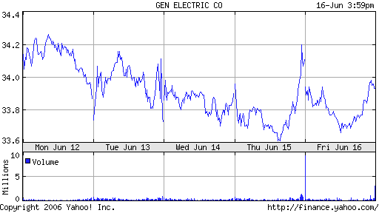
Figure 6.6: GE’s interesting week progress

I had projected before that XOM would be my better company compared to GE in terms of positive progress. This assumption is far from what actually has come to pass in the past five weeks. XOM is almost a full three dollars less than the original buying price (4.5% less). The most alarming aspect of the recent progress is that it has made none at all. It closed this week at the same exact price as the close of last week. There was much promise in XOM before, and it seemed to be a profitable company with good management, and effective productivity skills. However, now it seems doubtful that XOM will have a price increase that will surpass the original buying price. However, there are two full weeks of trading left at least, and all of this negative change has happened in more or less the same amount of time. So there is still some promise.
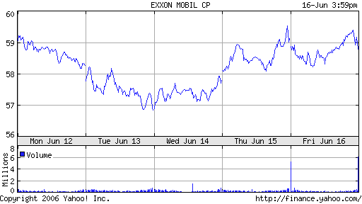
Figure 6.7: XOM’s unproductive week
It is clear that the public’s opinion of the companies differ greatly. GE has done much for progressive movements in the health and environmental fields [3]. XOM has the impression of being run by greedy, money loving executives who enjoy hiking up the gas prices, and also involves the issue of the Iraq war. XOM does not have a very good reputation in this sense, but it makes for good trading. Investors can expect a dynamic and interesting stock to follow when investing with XOM. Thus GE is progressive and has great public opinion and would be an excellent company if it could fix some internal issues. XOM on the other hand is not really highly regarded in terms of the general public, but turns out to be a very good company in which to invest.
At the moment, prices are still at a downward swing, or lower than in weeks before. This is due to poor sentiments and fear once again at inflation brought about by the Feds. Fed Chairman Bardanke has been very vocal to investors and the public about inflation. There has been much fear about inflation because it would essentially make money “cheaper” and each dollar would actually be worth less [3]. Investors will soon get a grip over the possibility of inflation, and prices and trading could and hopefully will go up in this next week. My success in investing depends on this and the activity that will occur in the next couple weeks.
Week 6
GE had a disappointing week in light of recent activity. It yielded a decrease, but it was not by much. It opened the week at $33.95 and closed the week at $33.16, a decrease of 2.3%.
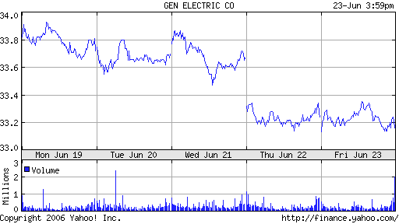
Figure 6.8: GE’s downward leading week
XOM had a very erratic week, with ups and downs in every day of the week. Sometimes it began the day at a high price, and end at a lower price, and sometimes it was the exact opposite. Wednesday was the most erratic day. To put it in perspective, the low for the day was $57.25, while the high was over a dollar more at $58.75. Both of these, I should point out, are both nearly $3 less than the original price, a notable difference of 4.6%. This week led to a disappointing decrease, starting the week at $58.77 and ended at $58.10, a decrease of 1.1%. It is not a very substantial decrease, but a frustrating one to say the least. In the trading period that we have used, the company has only closed off the week with a price higher than the original buying price only once—June 2nd, at $61.65 [3]. I seem to have caught the company at a peak, because there has been nominal progress ever since.
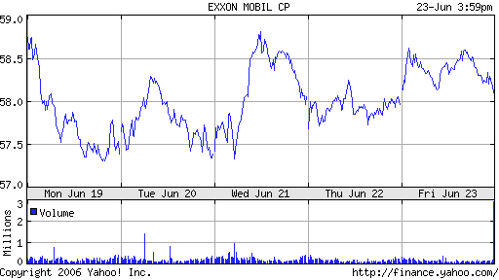
Figure 6.9: XOM’s up and down week
This week, I watched a television special on advancements in alternative energy. It pointed out that in the 80’s during an oil crisis, when prices of oil rose to unpractical prices, society responded by decreasing the use of oil by almost 85%. This crippled oil companies abroad and locally the same amount, so they decided to dump oil prices and put the money into investments, decreasing the money. They’ve done the same exact same thing each year. During every oil crisis, there has been a surge for alternative methods of fuel. In recent times, this surge to increase alternative fuel consumption is very serious, with the introduction and increasing popularity of hybrid cars. Democrats, Republicans, conservationists and religious leaders all have come together to promote the development of alternative energy sources. The fundamental problem is that a big motive for the war in Iraq and surrounding countries is that they control oil. However the more we spend on their oil, the more money we provide for them to spend in the war. It is a vicious cycle, in which they provide something the country needs, and we provide them with money that allows them to continue an ongoing war that in turn costs the country an ever growing mount of money. To analogize the situation, we are providing the enemy, for lack of a better word, with the noose to hang us, and we are even paying for that noose.
This is why so many people are promoting alternative fuels so that we are not as dependant on the oil companies overseas, so that we stop providing them with the means to potentially harm people in the country, at war, or through terrorist attacks. There are many opinions and theories. It is clear that as ironic as it may seem, this issue affects and relates both of my companies. XOM is an oil company, and GE is a company that is working on alternative fueling methods. Before, these two companies seemed to stand alone, but after I learned about the situation with the war and overseas oil companies, these companies could even be against each other. GE is providing ways to become less dependant on oil, and companies like XOM. This means that XOM along with companies overseas could make less money in the future because of companies like GE. It is interesting to see how these companies are actually related now, and it reaffirms the theory that GE has a better outlook in society.
The market activity has been something of great interest to me. The market seems to be doing poorly as a whole, and it matters of course because it is affecting my own stocks negatively. Apparently, the market reacts directly to news. If there is good news, the market prospers, and it fails if the news is bad. This week the poor progress can be blamed on bad news and poor sentiment once again. So it continues the trend of last week and the week before. It is disappointing, but there appears to be some important news in store next week that could have a positive effect on the market. I will have to look forward to it because next week is the last official week of trading. There has not been much movement in the price of the companies upwards or downwards, so I have not been as active in this method of trading. This is because a good part of this method is in the selection of companies, and less in the trading. I will summarize all of my trades with these two companies in the final week, next week.

6.4 Conclusion
My progress in the Fundamental Analysis trading came down to the last week. The principal of Fundamental Analysis trading method relies heavily on proper selection of good companies that will prosper. When I began trading 7 weeks ago, I chose GE and XOM for being two progressive companies,that would profit over the trading period. Both of these companies are two of the biggest among the trading scene. They both had effective management and good profitability statistics, so I did not seem to have a reason to doubt the effectiveness of the two companies. At this point, 7 weeks later, they have both made very little progress. I bought the GE shares at an original price of $34.33, and it closed the week at $32.96, 4% less than the original value. I bought the XOM shares at an original price of $61.58, and it ended the week at $61.35, 0.3% less than the original price. The decrease overall across the 7 weeks indicate that the companies were not good for this trading period, but I believe that over time, the two companies would be very profitable. I chose two that had great statistics that fit the Fundamental Analysis qualifications.
This week, XOM made excellent progress, its progress over this past week alone was greater than several weeks in the past. The problem with the progress of both of the companies is that in the middle of the trading period, about 3 weeks in, there was a great dip in the market due to poor sentiments, and the companies recovered in the time afterwards, but did not progress much farther. XOM began the week at $58.15 and ended the week at $61.35, an overall increase of 5.5%, in just one week. For a time it did not seem that XOM could even make it past the $58 point because it would continue an overall flat trend at around that point. I perceived that overall, XOM would do well. Overall it did, it made a good recovery in the past two weeks by going up almost 10% to a close proximity of the original value. With the trading period coming to an end, I sold all of the shares at Friday morning’s peak price of $62.65, to make an overall profit from the original buying price of $867.77. It is not much, but it is a profit, and next week, the company could have prospered even more, after this week’s phenomenal progress.
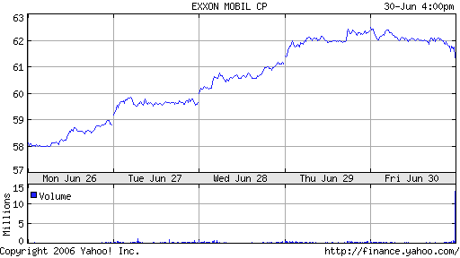
Figure 6.10: XOM’s successful final week progress
GE looked to have a promising week, but then fell towards the end, to have a worse week than I had hoped the final week would lead to. It ended the week at $32.96, after beginning at $33.18, an overall decrease of 066%. This being the final week of trading, I sold all the shares that I had with GE at Friday morning’s peak price of $33.37, and even at the peak it was still 2.8% less than the original buying price. This yields an overall loss of $1,397.76.
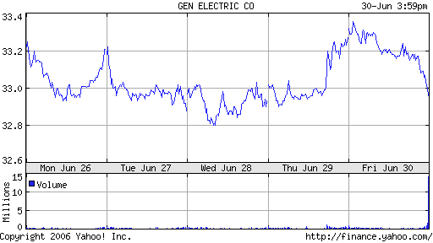
Figure 6.11: GE’s final week of progress
At the end of the trading period, I had made a small profit with XOM, but a loss with GE. Unfortunately the loss outweighed the profit, and so with the trading period coming to an end, I incurred a loss from the original assets of $100,000 of $529.99. Although it was a loss, the two companies still could do well, in the long run. They both have great statistics, and perhaps this short trading period was not long enough a time. I did not make many trades, only the buying at the beginning and the selling at the end, but the Fundamental Analysis method is not heavily reliant on active trading. Also, even though it was a loss, I believe that Fundamental Analysis could very well be a very effective method of trading.

Date | symbol | buy/ | price | shares | netcost/ | Profit/ | total cash | total assets
Date | symbol | sell | price | shares | proceeds | Loss | total cash | total assets
26-May | XOM | buy | $61.58 | 811 | $49,941.38 | $0.00 | $50,058.62 | $100,000
26-May | GE | buy | $34.33 | 1456 | $49,984.48 | $0.00 | $74.14 | $100,000
2-Jul | XOM | sell | $62.65 | 811 | 50,809.15 | $867.77 | $941.91 | $100,941.91
2-Jul | GE | sell | $33.37 | 1456 | $48,586.72 | $1,397.76 | $455.85 - | $99,544.15

Table 6.1: Trading period trades

Chapter 7: Conclusions

7.1 Project Summary

We have all learned important facts and procedures about trading on the Stock Market through this IQP. By simulating trading we got a first hand look at what actual trading is like so that we may use these methods in the future if we do decide to invest our own money. We also thought that the simulation itself was a fun learning experience. By simulating the trading we got to see where the strong points and weak points of our methods were and we were able to make changes based on what worked for us and what did not work. It really opened up our eyes to what Investing on the Stock Market is really like for people. It was exciting having to continuously check on stock prices to decide when to buy and sell. Unfortunately the period of time in which we began trading was not as beneficial to all investors, which made our experience a little tougher. Still the fact that we were in a poor investing time period makes us stronger believers that the Stock Market is very unpredictable and can be dangerous for some investors.

7.2 Analysis of Trading Methods

For the Past six weeks we have applied the following five techniques to the stock market, Momentum Trading, Technical Analysis, Short Trading, Trend Following, and Fundamental Analysis. At last we have come to the moment of truth which of these techniques has succeeded, and which have fallen short. We will start with the worst performing, and work to the best.
The momentum trading technique has done the worst in the past six week period. It achieved a net loss of $10,849.33. There are several reasons for the poor performance of this technique. Some credit must go to the investor who was implementing this technique, and some must also go to the stock market itself. This technique is highly dependent on the type of condition the stock market is in. For it to perform its best the stock market needs to be contusive to long term gains, in order for the “momentum” to be achieved. The stock market for the past 3 months has been very volatile, which is not a good environment for this technique to take root, and return a gain.
The next method which achieved a net loss of $5161.99 was the trend following technique. Once again some of the credit for this techniques poor performance needs to be taken by the operator of this technique. This technique is like the momentum method, in the fact that an investor will be looking for a stock that has been rising in value for a significant amount of time. They very in the fact that momentum traders also look at the amount of stock is being traded, to try and gauge the momentum that is behind its price. The volatile stock market also played a role in the poor performance of this stock, however; one should note that once the investor realized a fault in there approach to trading in this technique, and they made a correction this technique began to work very well.
The Next technique which was implemented was fundamental analysis, which ended the simulation, with a net loss of $1,397.76. Fundamental analysis was also struck hard with the condition of the stock market, for several reasons. One being that it is hard to buy a stock, even one in a good company as their prices are falling. Another reason this technique was hit hard was because even if an investor did invest in a sound company, which does not mean that the price will go up. With the stock market in the condition it was for the past six weeks, some investors are very instable, and will sell stock in a good company just because they do not have a strong stomach, which will hurt this techniques performance.
The fourth technique which was implemented was Technical Analysis which had a net gain of $5,022.64. This technique was doing mediocre up until the last week where it did much better. The reason that this technique did well was again credited to the investor, who realized that with this technique, long term investing is not necessary, one can easily turn a profit, in one week, and then sell that stock.
The fifth and best performing technique was short trading, which came in with a net gain of $9,525.87. This should come as no surprise when one looks at how the stock market has performed for the past six months.
In conclusion, it is important to note that all of these techniques are proven to work well when implemented properly, and timed accordingly. The real variables come down to the investor themselves. These techniques can be dependent upon the investor’s personality which will play into if they can apply the method appropriately or not. It is also important to understand that this was a simulation, If this where real money that all of us had earned, we would probably invest it differently, such as being more conservative, or being more long term. In the end all of these techniques are good techniques, if they are implemented correctly, and the stock market is in the correct condition for the specific method.

7.3 Final Thoughts
At the end of our trading period, the three of us can agree that this project has not only been interesting, but helpful and valuable. No doubt, we will use our skills that we have utilized in this project, not only in stock market trading, but as well in areas of business and others to help benefit our lives in one way or another.
The trading period was one that was fast-paced, with many changes, highs and lows. It allowed us to experience what it would have been like to have a large sum of money at our disposal, and to do whatever we please with it in terms of investments. It was not the best of markets with which to work, however this project was probably the closest experience to the real thing that we could have gone through. Whether yielding a profit or a loss, we now have valuable experience that we could use to start trading in the stock market immediately if we so chose. Going in with very little knowledge of how the market worked, we now feel that we are comfortable enough to make our own trades sometime in the future, and for that reason, we all value this IQP, and consider it one of our greatest learning experiences.

Bibliography

- Dice, Amos. The Stock Market. New York: A. W. Shaw Co., 1926
- Covel, Michael. “Commodity and Stock Trading with Tend Following and Turtle trading Systems.” 1996-2006 www.turtletrader.com/it.html
- http://finance.yahoo.com/
- www.ameritrade.com
- Investopedia, Staff. “The Tale Of Two Exchanges: NYSE and NASDAQ” October 31, 2003 www.Investopedia.com
- “Wall Street & Stock Market History” http://www.atozinvestments.com/history-of-wall-street.html
- “The History of the Stock Market”
http://www.hermes-press.com/wshist1.htm
- “Stock Market Crash of 1929”
http://www.stock-market-crash.net/1929.htm
- “Circuit Breakers and Trading Collars”
http://www.nyse.com/Frameset.html?nyseref=http%3A//www.google.com/search%3Fhl%3Den%26q%3Dcircuit+breaker+stock+market&displayPage=/press/circuit_breakers.html

