**Understanding the Interactions Between FXR1 and PLC𝛃1**



**A Major Qualifying Project Report**

**Submitted to the Faculty of**

**WORCESTER POLYTECHNIC INSTITUTE**

**In Partial Fulfillment for the**

**Degree of Bachelor of Science**

**in Biochemistry**

**On May 16th, 2020**

**Submitted By:**

Gabriella H. Fiorentino

**WPI Advisor:**

Prof. Suzanne F. Scarlata

**Table of Contents**

**Abstract** **3**

**Background** **4**

**Methods** **7**

**Results** **11**

**Discussion** **18**

**Conclusion** **21**

**Acknowledgements** **22**

**Bibliography** **23**

**Supplementary Materials** **25**

# Abstract

The aim of this project is to understand the interactions between the proteins FXR1 and PLCβ1. It is known that the protein PLCβ1 will bind to FXR1, as FXR1 is a stress granule protein, but not much more of that relationship is known. Using neuronal PC12 cells, different techniques of gene overexpression and fluorescent imaging were used to observe both protein's activity and localization. It was hypothesized that PLCβ1 may have specific interactions with FXR1 when subjected to a stressful environment. It was found through these experiments that FXR1 forms stress granules in response to specific stresses. Furthermore, PLCβ1 and FXR1 may not interact with one another directly, but possibly through other protein or RNA interactions.

# 

# Background

Fragile X syndrome (FXS) is a genetic condition that causes a range of learning and development issues. The gene responsible being Fragile X Mental Retardation (FMR1), makes the protein Fragile X Mental Retardation Protein (FMRP).1 FMRP is a key RNA binding protein that plays a role in mRNA trafficking and the regulation of other proteins that play a role in the development of synapses.2,3 If this gene is silenced, however, the loss of the protein leads to a disruption of the nervous system and causes the genetic condition FXS. This disruption is caused by the loss of FMRP binding to mRNA to halt translation. This leads to an increased number of overworked synapses that do not grow and mature properly. All due to the disrupted nervous system, some affected individuals with FXS may show a narrow face, larger ears, prominent forehead and jaw, flat feet, delayed development of speech and language. It is also known to increase the chances of getting another disorder such as anxiety, ADD, and Autism spectrum disorder.3

Fragile X Related 1 (FXR1) and 2 (FXR2) are homologous genes of FMR1, all having similar functions to one another. However, the functions of FXR1 and FXR2 are not fully known. Studies have determined the interactions between FXR1 and FXR2 with FMR1 and suggest that FXR1 and FXR2 both play an important role in the function of FMR1 and the progression of FXS. Similar to FMR1, FXR1 and FXR2 are also mRNA binding proteins. In addition, FXR1 and FXR2 can interact with each other as well as self-associate.4 Finding out exactly how fragile X related proteins work along with FMRP can allow a better understanding of the pathways that cause FXS as defects in RNA-binding activity is strongly suggested to be connected with this condition.

In previous studies, it was found that FMR1 and other fragile X related proteins are stress granule proteins5. Stress granules are membraneless organelles of clusters of proteins and stalled, untranslated mRNAs that appear in the cytosol when a cell is under stress.6 When cells experience adverse environmental conditions, cells put energy toward survival and do not migrate, grow or divide the way they normally should. Stress granules form to protect mRNA, stop unnecessary protein synthesis, and move resources from translation to fight stress by bringing other cellular functions to a momentary stop. Such a function then allows cells to go into a survival tactic that is similar to that of a “fight or flight” response. When this happens, cells stop functioning the way they are supposed to because transcription is halted and the protein production is changed.7.8.9

In order to understand more about Fragile X related proteins and their relationship with PLCβ1, this project focused solely on studying the interactions of these two proteins. FXR1 is a protein that is involved in many pathways with different functions. For example, FXR1 is involved with the regulation of pro-inflammatory transcripts10, regulating the structure of the nuclear envelope11 , as well as inhibiting FXR1 can be a therapeutic approach for targeting cancer12. Yet our primary focus of FXR1 would be its involvement with stress granule assembly, and its binding with PLCβ1. Even though many studies highlight FMR1 as a component for stress granule proteins,13-17 FXR1 is also found in stress granule aggergets. One study stated FXR1 interacts with Plakophilin (PKP) 3 which is a component of stress granules, suggesting that FXR1 is also found in stress granules.18,19

In another signaling pathway, the main role of phospholipase Cβ1 (PLCβ1) is on the plasma membrane. Here, PLCβ1 hydrolyzes phosphatidylinositol 4,5-bisphosphate (PIP2) into messenger proteins (IP3 and DAG) which then lead to the release of calcium (Fig.3)6. However, PLCβ1 also plays a critical role in the cytosol. Recent studies suggest that PLCβ1 binds to the Component 3 Promoter of RNA induced silencing complex (C3PO). C3PO catalyzes post-transcriptional gene silencing by using micro-RNA (miR) populations to degrade mRNA. However, if the binding between a miR target and the mRNA is imperfect, the mRNA strand is no longer able to degrade, which leads to the formation of stress granules.7,8

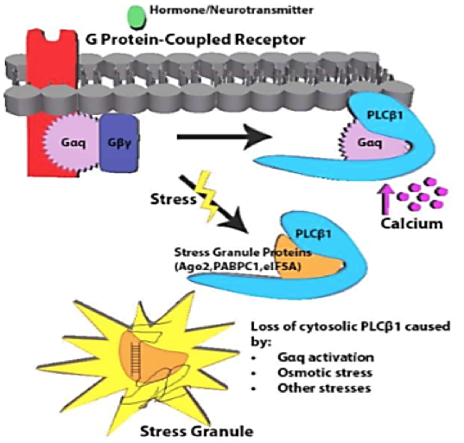

**Figure 3:** Molecular pathway showing PLCβ1 regulating calcium and stress granule formation

Previous findings support the idea that neuronal PLCβ1 binds to stress granule proteins. It was found that some of the proteins that PLCβ1 binds to are not only traditional stress granule proteins such as Ago2, PABPC1, G3BP and eIF5A, but also Fragile X related proteins: FXR1 and FXR2 (Fig.4)6. However, the interactions of FXR1 and PLCβ1 are not well known other than that PLCβ1 binds to FXR1. Understanding how these proteins are involved in the assembly and disassembly of stress granules would allow a better understanding of the pathway and therefore signifies the aim of this experiment.

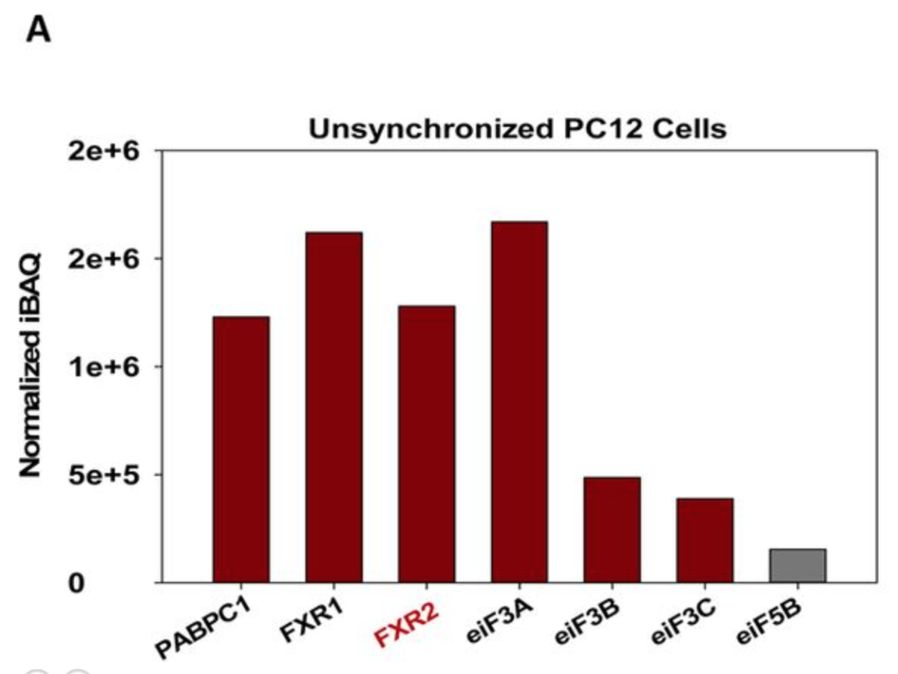

**Figure 4:** Mass spectrometry data showing selected cytosolic PLCβ1 binding partners

In order to research FXR1 and PLCβ1 protein-protein interactions, various experimental methods will be used. Different methods of fluorescent microscopy were conducted along with Dynamic Light Scattering to allow us to study protein interactions and quantify the number, size and location of stress granules forming under various conditions. Other methods such as MTT assays were conducted to accompany the microscopy experiments. It is hypothesized that through these experiments, there might be a possibility that we would see similar behaviors of FXR1 to those of stress granule proteins.

The objective of this project is to understand the interactions of FXR1 and PLCβ1. Moreover, understanding how FXR1 reacts to different types of stress can give more details on how this stress granule protein acts. From this, it allows for the possibility to learn more about PLCβ1-protein interactions resulting in the formation of stress granules. It will also allow for a better understanding of neurological diseases that arise when proteins are not broken down correctly. This is a similar way stress granules clump if not broken down. Understanding stress granules will also allow for a better understanding of these diseases such as ALS, Alzheimer’s, Parkinson’s disease, Bipolar Disorder, etc.

# Methods

**PC12 Cell Culture.** DMEM media supplemented with 10% Horse Serum, 5% FBS and 1% antibiotics (Invitrogen) were used to feed the cells. Complete PC12 media in the dish was changed every 2-3 days. If the cells were crowded in the dish, they were split to a lower confluencey to allow for further growth. For differentiated cells, differentiation media was added to fill the dish along with 1μM of NGF (nerve growth factor).

**Transfection.** PC12 cells were washed with PSB and antibiotic-free media was added. Then a solution of Opti-mem, P-3000, lipofectamine (Invitrogen) and DNA plasmid (Addgene) was added to the dishes and incubated overnight. The media was changed after 24 hours.

**Plasmids.** The two main plasmids that were used were eGFP-FXR1 and eGFP-PLCβ1 (Addgene). These plasmids were grown up in competent *E. coli* and purified using NucleoBond Xtra Midi EF Prep kit (Macherey Nagel). The concentration of plasmid was measured by nanodrop before cell transfection.

**Live Cell Fluorescent Lifetime Imaging Microscopy (FLIM).** PC12 cells were split into 35 mm glass bottom dishes (Mattek) before being transfected one of four ways: overexpression of only eGFP-FXR1, overexpression of only eGFP-PLCβ1, overexpression of eGFP-FXR1 and eGFP-PLCβ1, overexpression of eGFP-FXR1 and downregulation of PLCβ1 (Dharmacon smartpool siRNA). All four conditions were either then stressed with hypo-osmotic stress, or not stressed at all. Cells were then imaged using a confocal microscope (Alba version 5, ISS Inc.) equipped with photomultipliers and a Nikon Eclipse Ti-U inverted microscope to examine different light intensities and lifetimes with a 60x water immersion objective. The lifetime of the laser was calibrated before each dish was measured by measuring the lifetime of Atto 435 in water with a lifetime of 3.6 ns at ω=80MHz, 160MHz and 240MHz. All dishes were excited at 800/850nm and emission spectra were collected through a 525/550 bandpass filter. For each cell, a Phasor plot was generated after the smoothed rank was set to two. Then the fluorescence lifetimes was calculated using the following:

**Fixed PC12 Cell Immunofluorescent Staining.** Four different conditions were set up for these experiments. The first dish was stained for FXR1 (Alexa 488) and PLCβ1 (Alexa 647). The second dish was stained for the same proteins just with the cells under hypo-osmotic stress for 5 minutes. The third dish was first transfected with PLCβ1 siRNA to downregulate the protein then stained for FXR1 (Alexa 488) and PLCβ1 (Alexa 647). Finally the last dish was stained for FXR1 (Alexa 488) and a known stress granule protein TRAX (Alexa 647). The cells were then incubated with PBS, fixed with 3.7% paraformaldehyde, and then blocked in PBS with 5% goat serum, 1% BSA, 50 mM glycine for one hour. The primary antibody (1:200 dilution) was prepared and added to cover cells and was incubated for one hour at 37 C. After removing the antibody, it was washed with TBS three times for ten minutes each. The secondary antibody (fluorescent) was added and incubated for one hour at 37 C. Due to light sensitivity, this was wrapped in foil and continuously protected from light until imaging. Lastly, the cells were washed three times with PBS for 10 minutes each and stored at 4 C. A fresh wash of PBS was done before being viewed on an ISS Nikon confocal microscope. 20 Z-stacks were taken for each cell. The secondary antibodies that were used were Anti-mouse Alexa 647 (Santa Cruz) for FXR1, and Anti-mouse Alexa 647 (Santa Cruz) for PLCβ1, and TRAX. These dishes were used to analyze stress granule particles as well as colocalization.

**Analysis of Stress Granule Particles.** The immunostained dishes described above were then analyzed using two different techniques. First, through particle analysis, Hank’s Balanced Salt Solution (HBSS) was added to the dishes after transfection and stress, then viewed on an ISS Nikon confocal microscope (same as above) using a 100x oil immersion objective. A total of 20 1 um slice Z-stacks were taken for each cell. Particle analysis was performed using ImageJ where each measurement was thresholded before analyzing the particle count and total area of particles for every frame per measurement.

**Colocalization studies.** The second technique used with the immunostained dishes was colocalization. Hank’s Balanced Salt Solution (HBSS) was added to the dishes after transfection and stress, then viewed on an inverted confocal ZEIS microscope LSM 510 meta. One single image was taken of a group of 3-5 cells, which was then analyzed using ImageJ. Each measurement was taken with the function Coloc2 and averaged the Pearson's R value (above threshold).

**Western Blot.**  Cell pellets were lysed using a lysis buffer with NP-40 and protease inhibitors. After incubating on Ice for 30 minutes, Sample buffer was added at 20% of the total volume and boiled at 65 C for 10 minutes. An 8% SDS-PAGE gel electrophoresis was conducted. Afterwards, protein bands were transferred to a nitrocellulose membrane (Bio-Rad, California USA). Blocking was done in 5% milk with shaking for 1 hour at room temperature. Primary antibodies include anti-FXR1 (Santa Cruz), anti-PLCβ1 (Santa Cruz sc-5291), and anti-actin (abcam ab8226). Membranes were treated with antibodies diluted 1:1000 in 5% milk for 1 hour at room temperature, or overnight at 4 C. After primary incubation, membranes were washed 3 times for 10 minutes in TBST before applying a secondary antibody (anti-mouse or anti-rabbit from Santa Cruz) at a concentration of 1:2000. Membranes were washed 3 times for 10 minutes before imaging on a Azure c600 imager to determine the band intensities. Bands were measured at several sensitivities and exposure times to ensure the intensities were in a linear range. Data were analyzed using Image-J.

**RNA Extraction and Dynamic Light Scattering (DLS).** PC12 cells were transfected in four different ways: overexpression of only eGFP-FXR1, overexpression of eGFP-FXR1 and eGFP-PLCβ1, overexpression of eGFP-FXR1 and downregulation of PLCβ1 (Dharmacon siRNA), or no transfection at all. After growing to 85% confluency, RNA extraction was then performed after the removal of nuclear fractions. The RNeasy Mini Kit (50) by QIAGEN was used to obtain the total RNA. The concentration of the end solution was then measured using a spectrophotometer nanodrop. The absorbance was then calculated for each sample with an equation shown below:

The samples were run through the DLS and the diameter of particles were analyzed using SigmaPlot. This experiment was then repeated with all four different conditions now stressed with hypo-osmotic stress. After 24 hours of transfection, media at 150 mOsm (half media half water) was used to stress the cells for 5 minutes before lysis.

**Calcium Staining.** PC12 cells were transfected in four different ways: overexpression of only eGFP-FXR1, overexpression of eGFP-FXR1 and eGFP-PLCβ1, overexpression of eGFP-FXR1 and downregulation of PLCβ1 (Dharmacon siRNA), or no transfection at all. All cells were then labeled with a fluorescent calcium indicator (Calcium Crimson, Invitrogen) to make calcium proteins visible under the microscope. Cells were incubated for 45-60 minutes in 37°C at a concentration of 2 μg of calcium crimson per 1 mL HBSS. Cells were then washed 3 times with HBSS to get rid of any excess calcium crimson then viewed on an inverted confocal ZEIS microscope LSM 510 meta. Calcium was stimulated by adding 2 μM of Carbachol and calcium concentrations were then calculated with ROI in Image-J. This was then repeated on differentiated cells.

**MTT Assay.** PC12 cells were transfected in twenty-four and ninety-six well plates in three different ways: overexpression of only eGFP-FXR1, overexpression of eGFP-FXR1 and eGFP-PLCβ1, or no transfection at all. Wells with no cells were then used as controls. Cells were incubated in dark at 37°C for three hours with 5mg/mL of MTT solution in PBS. The plates were then placed on a shaker at room temperature with 4 mM HCl, 0.1% NP40 in isopropanol. Concentrations of solutions were then recorded using a well plate reader then analyzed in a graph.

**Number and Brightness (N&B).** PC12 cells were transfected with only eGFP-FXR1 and stressed in four different ways: heat shock (42°C for one hour), hypo-osmotic stress (150 mOsm for five minutes), carbachol (1μM for 10 minutes), or no stress at all. HBSS was added to the dishes after transfection and stress, then viewed on an ISS Nikon confocal microscope (same as above) using a 60x water immersion objective. Regions of interest (256×256 box) were analyzed from a 320×320 pixel image. Offset and noise were determined from the histograms of the dark counts performed every two measurements. Number and Brightness (N&B) data were analyzed using SimFC4 ([www.lfd.uci.edu](http://www.lfd.uci.edu/)).

# Results

**RNA Extraction and Dynamic Light Scattering (DLS).** In order to determine the size profile of total RNA in PC12 cells, the total RNA was extracted and purified. Figure 5 shows the size profile of the extracted RNA all four conditions with no stresses and hypo-osmotic stress. In both graphs, overexpression of only FXR1 has a larger size profile than all the other samples. Furthermore, when cells were subjected to hypo-osmotic stress (Fig.5B), there was an overall shift to the right, or larger size profile in the total RNA for all samples except for overexpression of eGFP-FXR1 and downregulation of PLCβ1.

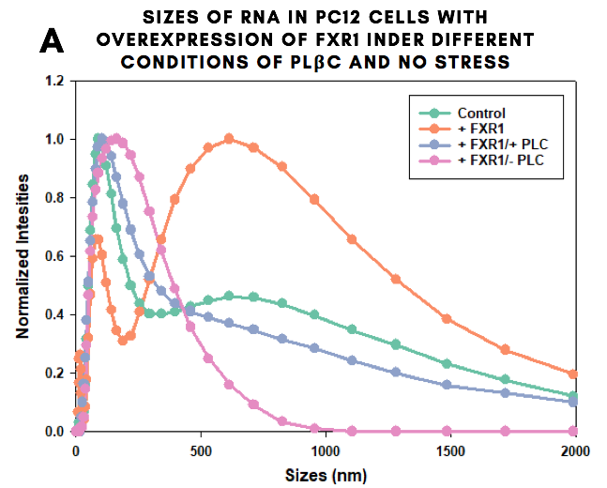

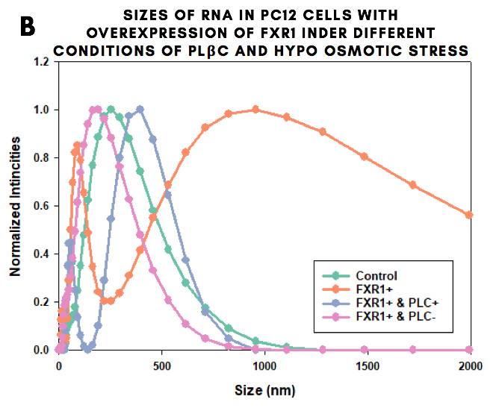

**Figure 5:** Dynamic light scattering**:** size of RNA in PC12 cells with or without stress

**Live Cell Fluorescence Lifetime Imaging Microscopy (FLIM).** The following experiment measured the lifetime of a fluorophore within a cell. Figure 6A-C shows the phasor plot of a cell overexpressing eGFP-FXR1 and eGFP-PLCβ1 and how the lifetime of the fluorophore is measured. After analysing all data, Figure 6D shows overexpression of eGFP-FXR1 had a longer lifetime than the cells with overexpression of eGFP-PLCβ1. With both overexpression of FXR1 and PLCβ1, the lifetime fell in between the previous two conditions. The fourth condition (overexpression of FXR1 and downregulation of PLCβ1) did not survive cell culture due to lack of adhering to new imaging dishes and therefore was not graphed.

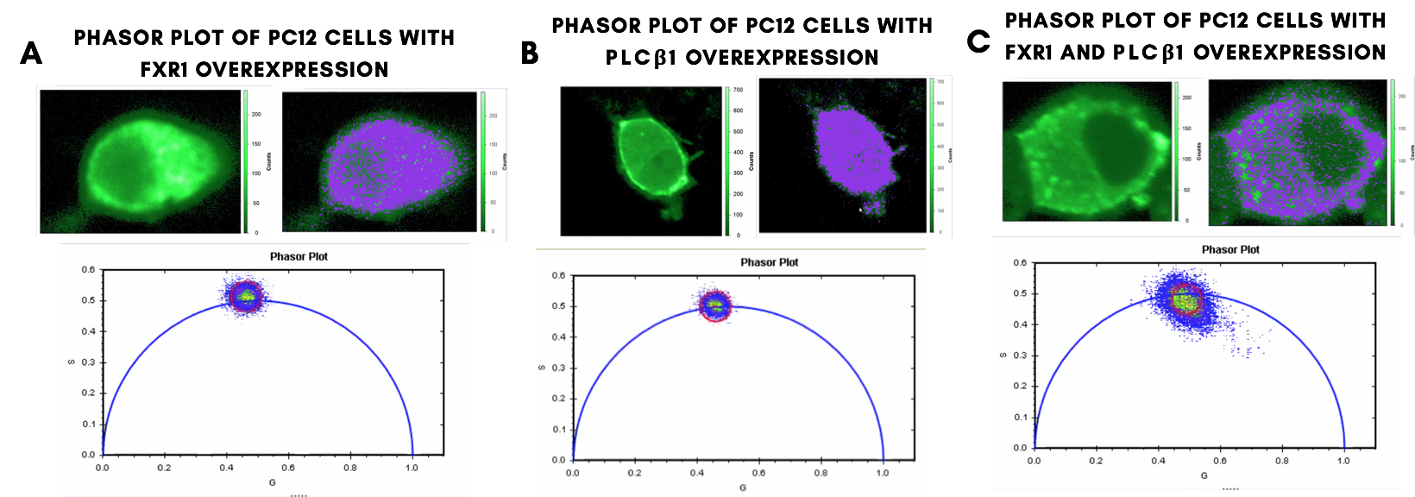

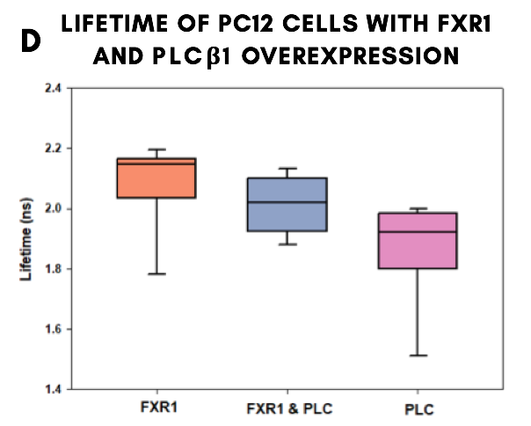

**Figure 6:** Lifetime of PC12 cells with FXR1 and PLCβ1 overexpression

**Immunostaining with Particle Analysis of Stress Granules.** Specific proteins were stained within the cell inorder to measure the formation, localization and size of FXR1, PLCβ1 and TRAX particles. There was a loss of one of the conditions (downregulation of PLCβ1 and stained for FXR1) due to lack of adhering to new imaging dishes. The graph in Fig.7 shows that for all conditions, the protein FXR1 (Red, Yellow, Pink) was a lot smaller in size when compared to PLCβ1 (black, green) or TRAX (blue), yet had mostly the same number of particles.

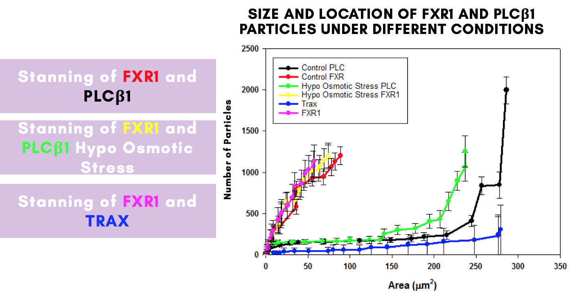

**Figure 7:** Size and Number of Particles Under Different Conditions

**Immunostaining with Colocalization.** With the same conditions as the previous experiment, correlations of the proteins FXR1 and PLCβ1 were measured by using colocalization. The cells stained for FXR1 had an averaged R-value around zero (Orange). The cells stained with FXR1 and PLCβ1 (Blue) had slightly higher R-values but still had correlations that were closer to zero. Yet for the dishes stained for FXR1 and TRAX (Pink), it had Pearson’s R-values below zero.

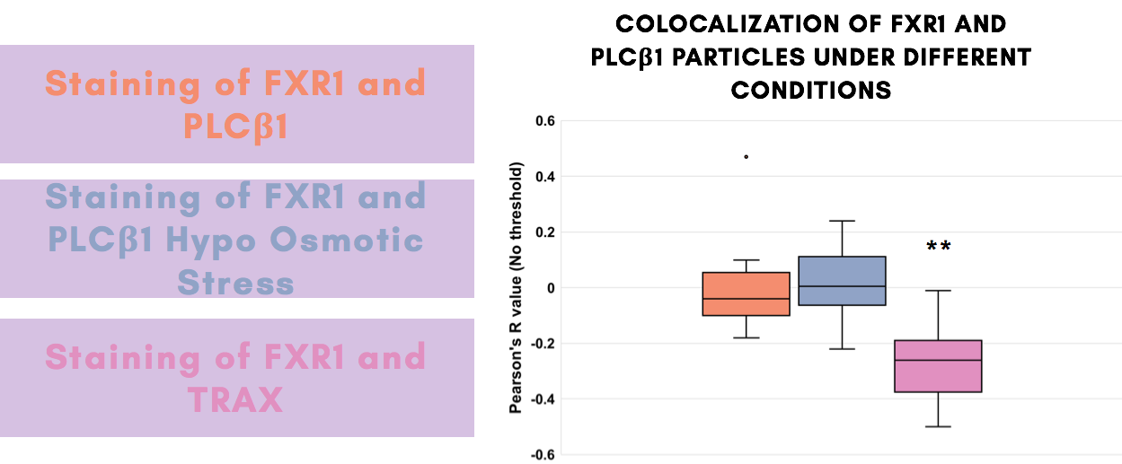

**Figure 8:** Colocalization of FXR1 and PLCβ1 Under Different Conditions

**Calcium Staining.** Calcium release under stimulation was explored in cells. After recording 10 frames on the microscope, 2 μM of carbachol was added to the dish in hopes of an immediate response. However, there was no calcium response after carbachol stimulation (Fig.9A). The same results were obtained with differentiated cells (Fig.9C). Calcium levels and plasmid levels both decreased over time and had no response to carbachol stimulation (Fig 9). Certain conditions were not recorded due to failure of cell adhesion to new dishes.

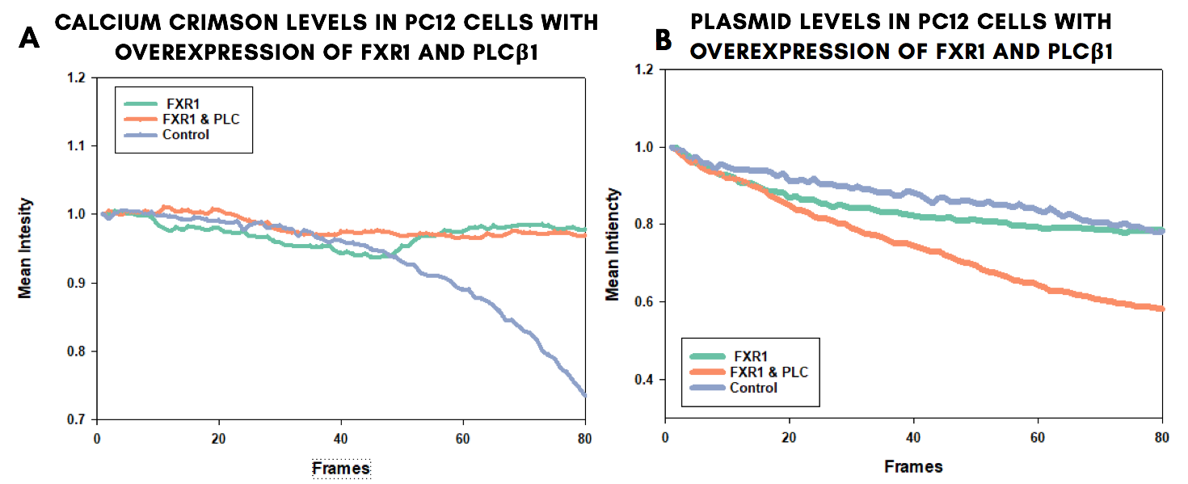

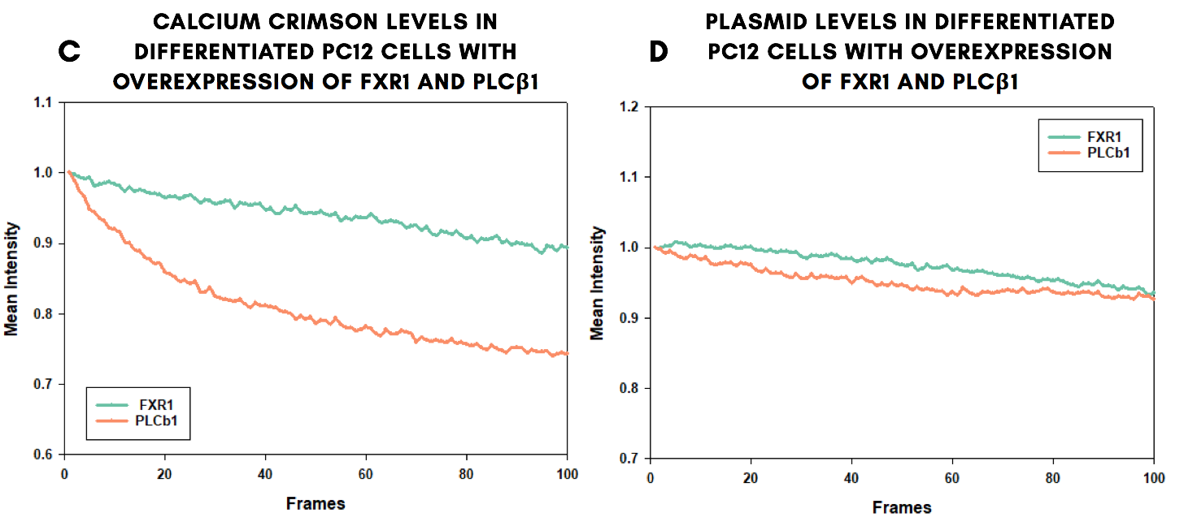

**Figure 9:** Calcium Crimson levels and plasmid levels in PC12 cells with overexpression of FXR1 and PLCβ1

**MTT Assay.** The metabolic activity of cells was recorded with an MTT assay first with a 24 well plate (Fig.10A), then a 96 well plates (Fig.10B). In the graphs below, both show a similar trend when compared to the control (Green) of a lower metabolic activity when overexpressed with FXR1 (Orange) and an even lower activity with an overexpression of FXR1 and PLCβ1 (Blue).

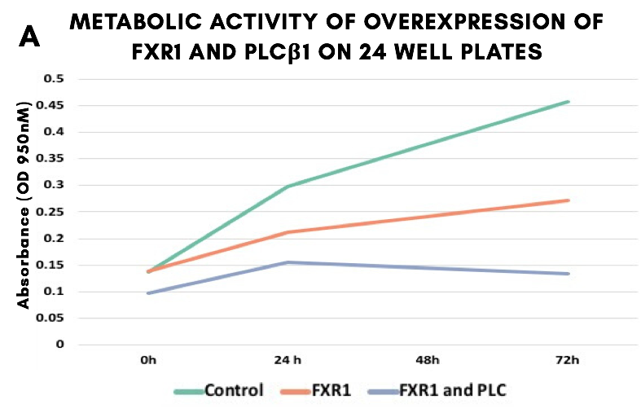

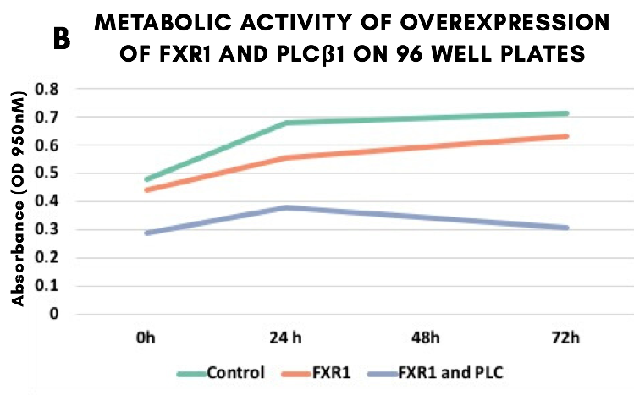

**Figure 10:** Metabolic Activity of PC12 cells with overexpression of FXR1 and PLCβ1

**Number and Brightness.** The number and brightness of aggregates of a FXR1 under different stress conditions was done in the very last study. All samples were overexpressed with FXR1 and subjected to a variety of stress conditions (Fig.11). Subjecting cells to heat shock resulted in a shift to a 26% increase of aggregates of FXR1 that were significantly larger than the monomer (Fig.11B). Cells undergoing hypo-osmotic stress resulted in a 28% increase of FXR1 aggregates(Fig.11C). Finally, cells subjected with carbachol stimulation resulted in only a 0.78% increase of aggregates of FXR1 that were significantly larger than the monomer (Fig.11D).

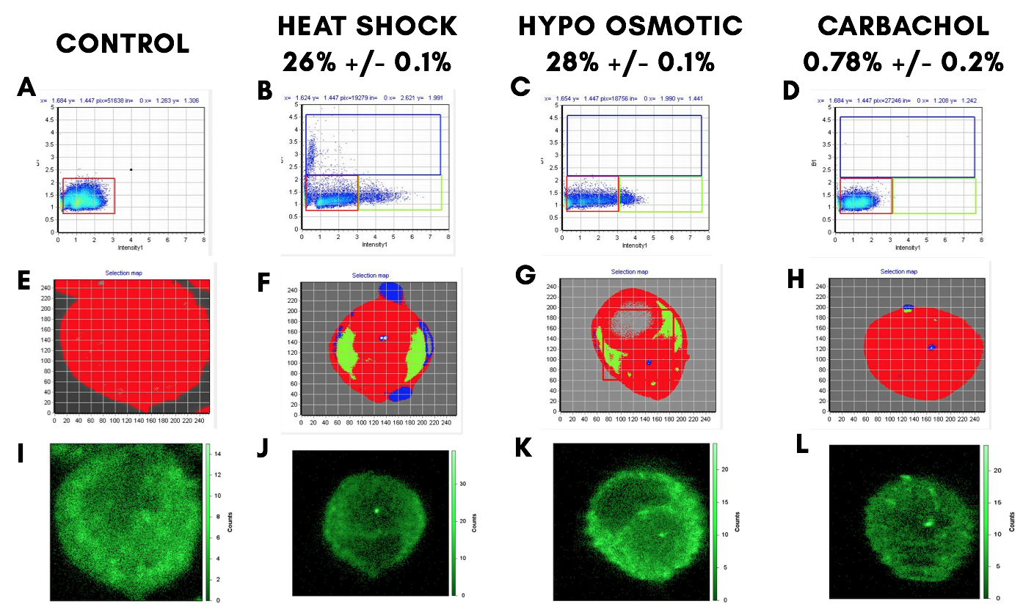

**Figure 11:** Number and Brightness of particles in PC12 cells with overexpression of FXR1 and PLCβ1

# 

# Discussion

The experiments presented here supported the overall goal to observe the interaction of two proteins in PC12 cells in order to obtain a better understanding of a specific pathway. Specifically, the proteins studied were FXR1 and PLCβ1. This interaction was visualized through many different experimental techniques such as Dynamic Light Scattering, live-cell fluorescent imaging, particle analysis, colocalization, calcium staining, MTT Assays and Number and Brightness studies. It was predicted that PLCβ1 will interact with FXR1 when cells are subjected to stressful conditions.

Dynamic Light Scattering displays the size distribution of extracted RNA under different conditions. The size of RNA was measured as RNA aggregation is a component in stress granules. We overexpressed the cells with FXR1 to see if stress granule formation would be higher given a higher concentration of this protein within the cell. Overexpression of FXR1 alone caused a large increase of RNA particles indicating stress granule formation. Since the FXR1 overexpression sample has the largest sized particles, FXR1 must mediate a stress response. It was then predicted that knockdown of PLCβ1 will allow more stress granule formation, showing an increase in the size of RNA particles. However, the opposite was observed and this sample had smaller sized RNA particles that were similar to the control. This can indicate that the formation of stress granules containing FXR1 may not be directly regulated by PLCβ1. Next, when all samples were subjected to hypo-osmotic stress, three out of four had an increase in the size of RNA particles. As expected, subjecting cells to stress caused larger aggregates of RNA, most likely due to increased stress granule formation. Extra trials for this experiment were completed for consistency in the data and can be found in the supplementary materials.

Further supporting the idea that FXR1 mediates a stress response, we used Number and Brightness studies: a technique to measure the average oligomeric state of proteins by calculating the percent increase of aggregates that are significantly larger than the monomer. This experiment was used because it is a great indicator for stress granules as they are intracellular aggregates. In these experiments, PC12 cells were subjected to different types of stress and the percentage of eGFP-FXR1 aggregates that were significantly larger than the monomer were measured. Two stress conditions showed a significant response through aggregation: heat shock and exposure to hypo-osmotic media. Carbachol stimulation did not show any notable response, having less than 1% increase of aggregates. From this, we can conclude that FXR1 forms stress granules under specific stress conditions, like heat shock and hypo-osmotic stress.

Next, to explore whether PLCβ1 and FXR1 interact directly, we measured the lifetimes of fluorophores in live cells by Förster resonance energy transfer (FRET) as monitored by fluorescence lifetime imaging microscopy (FLIM). FLIM/FRET measures the changes in energy transfer from a donor to acceptor fluorophore, resulting in changes in lifetimes which correspond to the intermolecular distance between proteins. Cells expressed with only eGFP-FXR1 had a longer lifetime than cells expressed with both eGFP-FXR1 and eGFP-PLCβ1. However, cells expressed with only eGFP-PLCβ1 had a shorter lifetime than cells expressed with both eGFP-FXR1 and eGFP-PLCβ1. These results are contradictory, because in order to unequivocally prove that FXR1 and PLCβ1 interact, the lifetimes of both homo-FRET experiments should be longer than the FRET experiments with both eGFP-FXR1 and eGFP-PLCβ1. These results indicate that FXR1 and PLCβ1 may engage in protein-protein interactions, but it is not certain.

In order to clarify this conclusion, we continued with other experiments to detect protein interactions within a cell, including Particle Analysis and colocalization. These techniques utilize immunostaining of fixed cells with fluorescent antibodies that can be visualized with confocal microscopy. Through these techniques, the size and location of particles were observed and quantified. We wanted to compare the presence of FXR1 against another known stress granule protein, translin-associated factor X (TRAX), as a negative control as previous literature has proven FXR1 does not interact with TRAX8. First, particle analysis of stress granules showed that PLCβ1 particles are slightly larger than FXR1 particles, but both conditions show roughly the same number of particles. It was expected to see more aggregates of FXR1 when the cells were subjected to hypo-osmotic stress. However, this was not observed and does not match previous data. This could be due to photophysical errors associated with the red channel on the microscope at this time, resulting in PLCβ1 or TRAX particles being measured incorrectly.

Along with Particle Analysis, we explored colocalization studies with the immunostained cells. These studies first allowed us to confirm that FXR1 and TRAX do not interact. FXR1 and TRAX have a negative Pearson’s R value showing a negative correlation, indicating the proteins do not show up in the same area and do not bind directly with one another. Next, we wanted to observe if the proteins FXR1 and PLCβ1 had any correlation with one another. The colocalization data showed there was little to no correlation between the proteins PLCβ1 and FXR1 as both conditions had a Pearson’s R value close to 0. This indicates that PLCβ1 may not bind directly to FXR1.

To explore how FXR1 affects cell health, we wanted to record the metabolic activity of the cells to accompany the fluorescent microscopy imaging. This was completed through a MTT assay which showed the metabolic activity was lowered when the cells were overexpressed with just FXR1. When compared to the control, however, there still was an overall increase in that condition. When cells are overexpressed with FXR1 and PLCβ1, the metabolic activity is lower than all other conditions and does not change that much over time. This trend was shown in both sized well plates to show consistency in the data.

We then wanted to also explore calcium levels in the cell as PLCβ1 is involved in the regulation of calcium through the G-protein coupled receptor signaling pathway. We wanted to see the effects on calcium release when a cell is overexpressed with eGFP-FXR1 and eGFP-PLCβ1. It was predicted that once cells were stimulated with carbachol, PLCβ1 would shift from the cytosol to the membrane, to cause an immediate efflux of calcium along with increased stress granule formation. However, no conclusive results were obtained from this experiment using the indicator Calcium Crimson. In the future, it is suggested to use Calcium Green instead of Crimson, since preliminary experiments showed an immediate response with Calcium Green (shown in supplementary files). Unfortunately, there was not enough time to do more experiments with this indicator and therefore, we cannot conclude any results from these data.

Other tests were completed including western blotting to confirm if our proteins were being overexpressed correctly or not. The two main proteins, FXR1 and PLCβ1, were blotted separately and analyzed with the main 4 conditions that were used throughout these experiments. Through this analysis, it was shown that overexpression as well as downregulation for the proteins were successful. These data can be found in the supplementary materials.

From all of these experiments, we can conclude that FXR1 aggregates form in stress granules under specific types of stress such as hypo-osmotic stress and heat shock. The stress response in cells mediated by FXR1 may vary under other stress conditions that we hope to test in the future. Furthermore, PLCβ1 may not bind directly with FXR1, but may have an association through other proteins as FXR1 is involved with many other pathways. However, that exact pathway can not be concluded from these data. For future experiments, it is recommended to test other stress conditions such as cold shock and arsenite stress to observe variations in cell response. Also, these experiments should be repeated with samples with overexpression of eGFP-FXR1 and downregulation of PLCβ1. As previous samples did not adhere to the imaging dishes, this condition was lost in many experiments. Furthermore, this project was expected to run for a full academic year; however, this project was abruptly shortened to three terms due to a worldwide pandemic outbreak.

# Conclusion

In order to figure out what relationship FXR1 has with PLCβ1 multiple fluorescent techniques were used. From these experiments, it was concluded that FXR1 is incorporated into stress granules in response to specific stresses. Furthermore, PLCβ1 and FXR1 may not interact with one another directly, but possibly through other protein or RNA interactions. However, the exact pathway is still unknown and further experiments still need to be conducted and due to certain circumstances, were cut short from this project.

# Acknowledgements

I would first like to sincerely thank Dr.Suzanne Scarlata for your teaching, guidance and comfort for the past two years, as well as providing such a welcoming lab community. I would also like to thank everyone in the Scarlata lab, especially Lela Jaskson for all your guidance and support throughout this project. Finally I want to thank Worcester Polytechnic Institute for providing an inspiring and supportive community and allowing me to take on incredible opportunities to work on amazing projects such as this one.

# 

# Bibliography

1. Ascano, M., Mukherjee, N., Bandaru, P., Miller, J. B., Nusbaum, J. D., Corcoran, D. L., . . . Tuschl, T. (2012). FMRP targets distinct mRNA sequence elements to regulate protein expression. *Nature, 492*(7429), 382-386. doi:10.1038/nature11737
2. Vita, D.J., Broadie, K. ESCRT-III Membrane Trafficking Misregulation Contributes To Fragile X Syndrome Synaptic Defects. *Sci Rep* 7, 8683 (2017). https://doi.org/10.1038/s41598-017-09103-6
3. Fragile X syndrome - Genetics Home Reference - NIH. (2020, April 15). Retrieved from https://ghr.nlm.nih.gov/condition/fragile-x-syndrome
4. Zhang, Y., O'Connor, J., Siomi, M., Srinivasan, S., Dutra, A., Nussbaum, R., & Dreyfuss, G. (1995). The Fragile X Mental Retardation Syndrome protein interacts with novel homologs FXR1 and FXR2. *The EMBO journal, 14*, 5358-5366. doi:10.1002/j.1460-2075.1995.tb00220.x
5. Say, E., Tay, H.-G., Zhao, Z.-s., Baskaran, Y., Li, R., Lim, L., & Manser, E. (2010). A Functional Requirement for PAK1 Binding to the KH(2) Domain of the Fragile X Protein-Related FXR1. *Molecular Cell, 38*(2), 236-249. doi:https://doi.org/10.1016/j.molcel.2010.04.004
6. Qifti, A., Jackson, L., Singla, A., Garwain, O., & Scarlata, S. (2019). Stimulation of Gαq Promotes Stress Granule Formation. *BioRxiv*, 521369
7. Jackson, L. (2019) The Importance of Stress Granules in Neuron Function. pp. 1–9, *Worcester Polytechnic Institute Qualifying Paper*
8. Protter, D. S. W., & Parker, R. (2016). Principles and Properties of Stress Granules. *Trends in Cell Biology, 26*(9), 668-679. doi:https://doi.org/10.1016/j.tcb.2016.05.004
9. Wolozin, B. (2012). Regulated protein aggregation: stress granules and neurodegeneration. *Molecular Neurodegeneration, 7*(1), 56. doi:10.1186/1750-1326-7-56
10. Herman, A. B., Vrakas, C. N., Ray, M., Kelemen, S. E., Sweredoski, M. J., Moradian, A., . . . Autieri, M. V. (2018). FXR1 Is an IL-19-Responsive RNA-Binding Protein that Destabilizes Pro-inflammatory Transcripts in Vascular Smooth Muscle Cells. *Cell Rep, 24*(5), 1176-1189. doi:10.1016/j.celrep.2018.07.002
11. Agote-Arán, A., Schmucker, S., Jerabkova, K., Boyer, I. J., Berto, A., Pacini, L., . . . Sumara, I. (2019). Spatial control of nucleoporin assembly by Fragile X-related proteins. *bioRxiv*, 767202. doi:10.1101/767202
12. Fan, Y., Yue, J., Xiao, M., Han-Zhang, H., Wang, Y. V., Ma, C., . . . Xiang, B. (2017). FXR1 regulates transcription and is required for growth of human cancer cells with TP53/FXR2 homozygous deletion. eLife, 6, e26129. doi:10.7554/eLife.26129
13. Mazroui, R., Huot, M. E., Tremblay, S., Filion, C., Labelle, Y., & Khandjian, E. W. (2002). Trapping of messenger RNA by Fragile X Mental Retardation protein into cytoplasmic granules induces translation repression. *Hum Mol Genet, 11*(24), 3007-3017. doi:10.1093/hmg/11.24.3007
14. Linder, B., Plöttner, O., Kroiss, M., Hartmann, E., Laggerbauer, B., Meister, G., . . . Fischer, U. (2008). Tdrd3 is a novel stress granule-associated protein interacting with the Fragile-X syndrome protein FMRP. *Human Molecular Genetics, 17*(20), 3236-3246. doi:10.1093/hmg/ddn219
15. Gareau, C., Houssin, E., Martel, D., Coudert, L., Mellaoui, S., Huot, M.-E., . . . Mazroui, R. (2013). Characterization of fragile X mental retardation protein recruitment and dynamics in Drosophila stress granules. *PLOS ONE, 8*(2), e55342-e55342. doi:10.1371/journal.pone.0055342
16. Didiot, M.-C., Subramanian, M., Flatter, E., Mandel, J.-L., & Moine, H. (2009). Cells Lacking the Fragile X Mental Retardation Protein (FMRP) have Normal RISC Activity but Exhibit Altered Stress Granule Assembly. *Molecular biology of the cell, 20*(1), 428-437. doi:10.1091/mbc.e08-07-0737
17. Kim, S. H., Dong, W. K., Weiler, I. J., & Greenough, W. T. (2006). Fragile X Mental Retardation Protein Shifts between Polyribosomes and Stress Granules after Neuronal Injury by Arsenite Stress or <em>In Vivo</em> Hippocampal Electrode Insertion. *The Journal of Neuroscience, 26*(9), 2413-2418. doi:10.1523/jneurosci.3680-05.2006
18. Hofmann, I., Casella, M., Schnölzer, M., Schlechter, T., Spring, H., & Franke, W. W. (2006). Identification of the junctional plaque protein plakophilin 3 in cytoplasmic particles containing RNA-binding proteins and the recruitment of plakophilins 1 and 3 to stress granules. *Molecular biology of the cell, 17*(3), 1388-1398. doi:10.1091/mbc.e05-08-0708
19. Bai, Y., Dong, Z., Shang, Q., Zhao, H., Wang, L., Guo, C., . . . Wang, Q. (2016). Pdcd4 Is Involved in the Formation of Stress Granule in Response to Oxidized Low-Density Lipoprotein or High-Fat Diet. *PLOS ONE, 11*(7), e0159568. doi:10.1371/journal.pone.0159568

# 

# Supplementary Materials

1. **Extra trials for DLS**

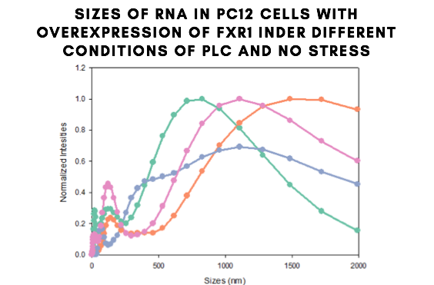

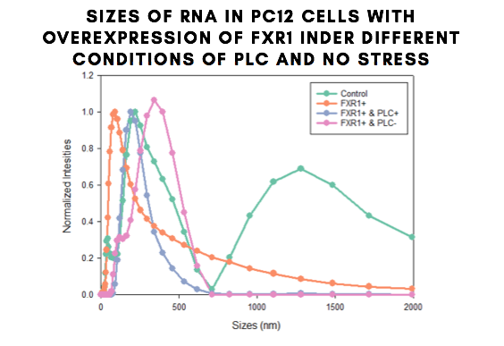

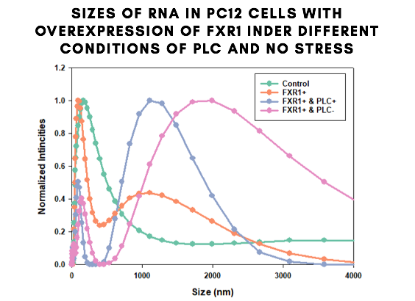

1. **Calcium Green for cells overexpressed with FXR1 and PLCβ1**

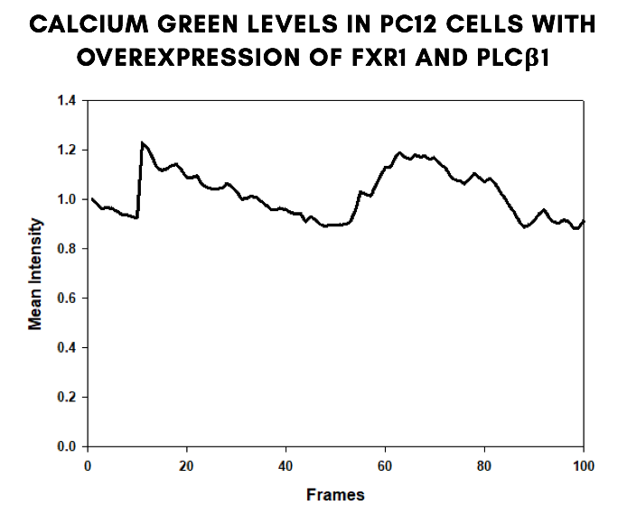

1. **Western Blots**

