Sprinkler System Assembly
*For specific notes, pictures, and links please go to: Final BOM > Build-Suggestions*
**This project was designed to be scaled (in reference to the pipe lengths) for different spaces; these instructions follow the design we initially made**
Tools:
- Drill (need 5/64 drill bit)
- PVC cement and primer
- Ruler/tape measure
- Teflon Tape
- PVC pipe cutters (optional)
Materials: *for PVC assume slip connector unless stated otherwise*
- (1) Pump and power source
- (1) 4-inch to 3-inch reducer coupling
- (1) 3-inch to 2-inch PVC bushing
- (2) 4-inch sections of 2-inch PVC pipe
- (1) 2-inch PVC union
- (1) mesh strainer for 2-inch PVC pipe
- (1) 3.5-inch by 3.5-inch square of 120 micron mesh sheet
- (1) 2-inch to 1.5-inch reducer
- (1) 1.5-inch to 1-inch bushing
- (2) threaded 1-inch PVC adapters
- (1) 4-foot section of 1-inch PVC pipe
- (1) 8-inch section of 1-inch PVC pipe
- (1) 1-inch to ½ inch 90 degree PVC connector
- (6) 4-foot sections of ½ inch PVC pipe
- (3) 3-foot sections of ½ inch PVC pipe
- (1) 2-foot section of ½ inch PVC pipe
- (2) 6-inch sections of ½ inch PVC pipe
- (1) 4-way ½ inch PVC connector
- (2) 90 degree ½ inch elbows
- (6) ½ inch ball valves
- (3) ½ inch end caps

Water Tank to the Pump
- Put together the filtration system
  - Trace the union onto the 120-micron mesh and cut out the circle
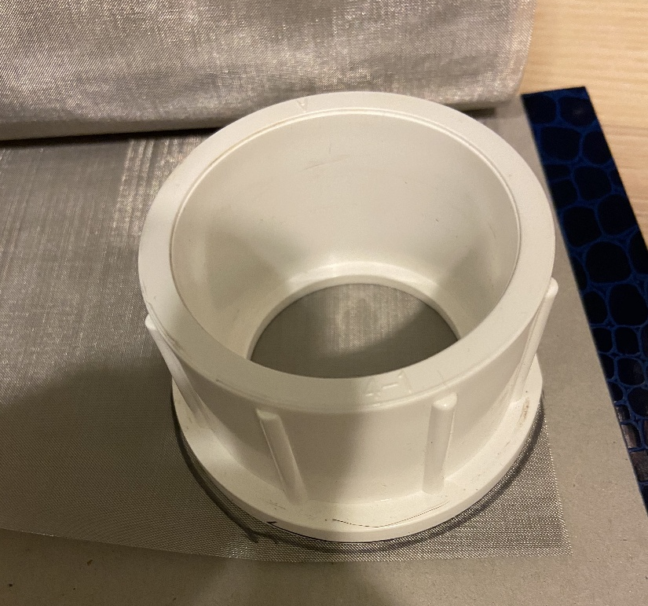
  - Assemble the filter in this order (remember that the water needs to flow through the filter with larger holes first). The strainer nests in the smooth part of the union, the micron is set inside the threaded part of the union
Filters should look like this (then put the union halves together)
- Setup the rest of the connectors
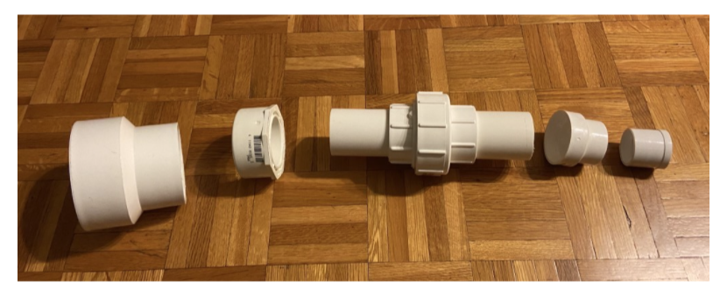
  - From left to right
    - 4” to 3” reducer
    - 3” to 2” bushing
    - 4” piece of 2” PVC
    - Filtration system from step 1 (larger filter would be on the left)
    - 4” piece of 2” PVC
    - 2” to 1.5” reducer
    - 1.5” to 1” bushing
  - Attach the 4” end to the water tank
  - Insert the 8” section of 1” PVC to the pump

Pump
- Screw the 1” threaded PVC adapters into the inlet and outlet valves for the pump (use thread tape for a secure connection)
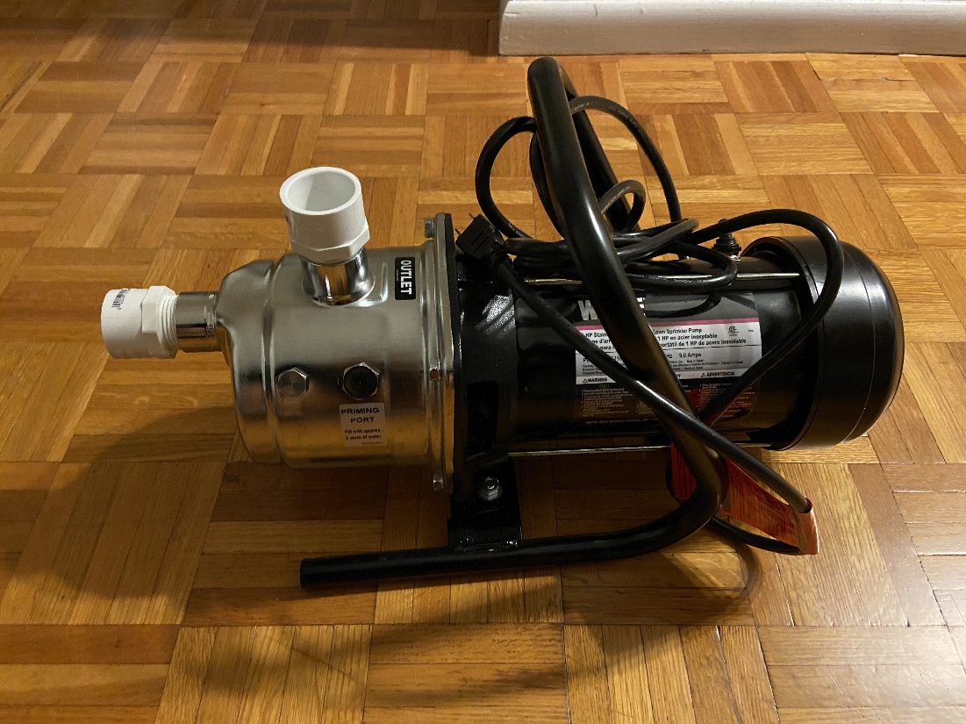
- Cement the 1” to ½" elbow to the 4’ section of 1” pipe then connect to the pump
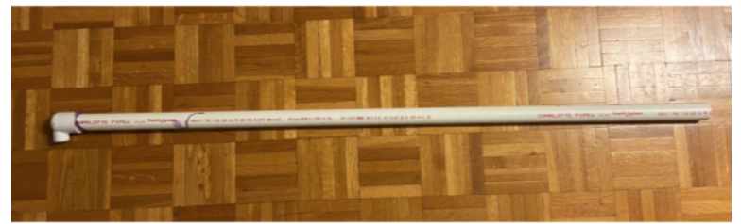

Sprinklers
*For this section we are working entirely with ½” PVC piping*
- Assemble the base of the pipelines
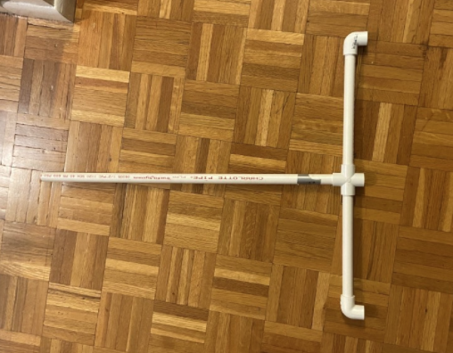
  - From left to right
    - Take the 2’ section of ½” PVC and cement it to the 4-way connector
    - Cement the 6” sections of ½" PVC to the 4-way connector as shown
    - Cement the 90-degree elbows to the ends of the 6” pipes (want this to be as straight as possible to avoid extra deflection or pipes popping out)
- Drill holes in the rest of the PVC
  - For the (6) 4’ sections and the (3) 3’ sections, mark a vertical line 1.5” from each end of the section. From these points, mark each inch along the pipes. Drill a hole at each line using the 5/64 drill bit
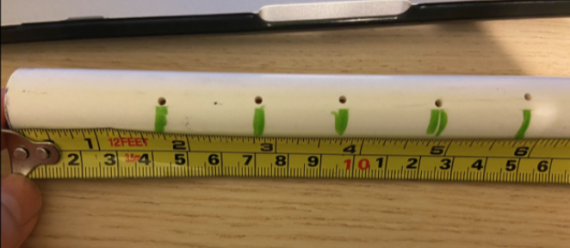
The markings do not have to be exact but try to have the holes be in a straight line (we found that using a piece of tape as a guide helped). Crooked holes cause the water to spray at an angle
- Cement valves and end caps
  - Take 3 of the 4’ sections and cement a ball valve to one end of each section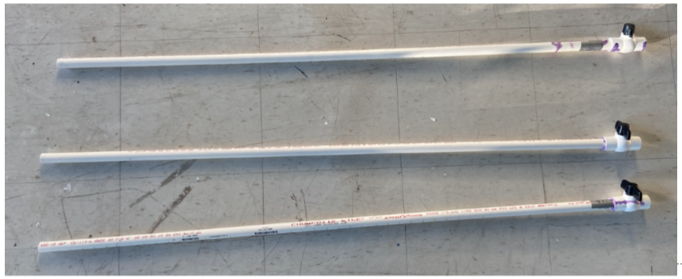
  - Cement a ball valve to the end of each 3’ section
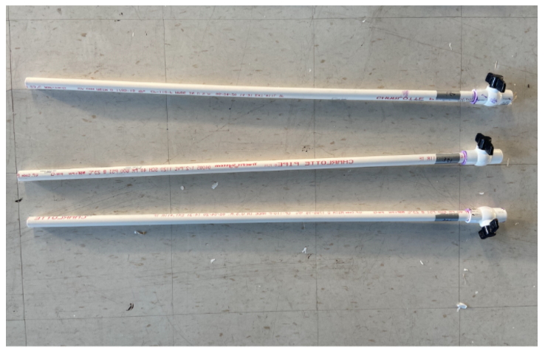
  - Cement an end cap to one end of each 4’ section remaining
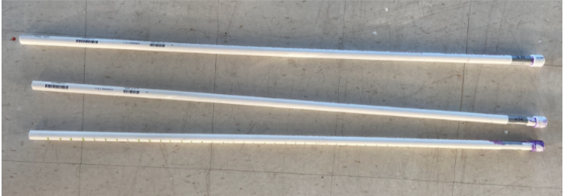
This makes it easier to disassemble and reassemble the system at the end of each season (less likely to lose parts, ensure things are in the correct order)
- Assemble the system
  - Each line of the pipe is a 4’ section, 3’ section, then another 4’ section. Because the endcaps are cemented, there is only one way to connect the system
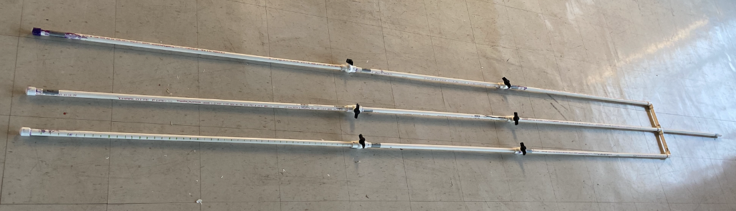
  - Attach the pipelines to the pump and add supports where needed

