Supplemental Materials for Advertising for Advocates: A Project to Bolster Volunteer Recruitment for CASA Worcester County

This material was submitted in partial fulfillment of the requirements for the degree of Bachelor of Science by
Tala Calvi
Jordan Counsel
Alaa Hassan
Vu Nguyen

Worcester Polytechnic Institute C’19

Advisor:
Professor Katherine Foo

Sponsor:
CASA Worcester County

Table of Contents
Appendix A - Authorship 3
Appendix B - Sponsor Description 5
Appendix C - Methodology 6
Appendix D - Raw Literature Review Data 12
Social Media Marketing Strategy 12
Video Production 19
Appendix E - Research Instruments 21
Focus Group Questions 21
Interview Questions 21
Survey Questions 21
Appendix F - Test Posts for Focus Groups 22
Appendix G - Survey Results 27
Appendix H - Focus Group Notes 27
Appendix I – Interview Transcriptions 29

Appendix A - Authorship
Alaa: Throughout the IQP term, I have kept in contact with Robb, Lynn, and Jordyn (CASA Crew) regarding scheduling focus groups and interviews as well as any updates regarding our project. I also have contacted former CASAs to schedule focus groups and interviews. I created test posts for the focus groups. I came up with a series of survey, interview, and focus group questions and conducted one interview and one focus group. In terms of the written deliverables, I have written and edited a majority of the Introduction, and further wrote for the methods, and results sections as well as the recommendations and conclusions.
Jordan: My primary contributions to the group were the creation of all the meeting agendas and minutes. I also contributed to the Prevalence, Impact and Methodology & Results sections of the report, using the notes taken from meeting minutes in order to accurately revise each section according to critiques left by Professor Foo, and our sponsor. I also contributed to the video production process by doing a literature review, and I conducted two interviews which was then used as footage in our video. For the social media marketing campaign, I conducted a literature review, and lead a focus group in order to find the most effective social media practices.
Vu: My contribution to this project was working on the booklet. I designed it to fit all our materials and provides extra materials that improve the overall appearance of the booklet. I also put all our references into Endnote, and put it in APA format. Next I created the storyboard, created the script, film the narrative, the children, and kept in contact with the ATC to get the video camera and film equipment to film 4 out of the 5 interview. I also hosted one of the focus group and took notes at another focus group as well as took an audio recording of that focus group. I learned how to use Adobe Photoshop and made some of the graphics on the presentation and booklet. I took 5 days (50+ hours) to edit the video and pull the content together.
Tala: I produced writing for the Background and Methodology & Results section of our final booklet. I also did many revisions on written drafts over the course of the term, both rewriting and editing spelling grammar, and flow. I did a lot of the major revisions on the Methodology & Results section specifically. I also wrote a section for our Recommendations and Conclusions. Specifically in regards to our video objective, I conducted two interviews, transcribed two interviews, and wrote the “Themes Prevalent in Interviews” section of our booklet. I also picked out clips for the final video. For the social media strategy, I did research, created test posts for the focus groups, conducted one focus group with Jordan, and finally created our calendar and hashtag table deliverable. Furthermore, I compiled our Supplemental Materials into one document.

Appendix B - Sponsor Description
Court Appointed Special Advocates for Children (CASA) is a public, nonprofit agency oriented around recruiting volunteers to be representatives for children in the foster care system. These volunteers, called CASAs by the organization, seek to best advocate for children in matters concerning their physical and mental wellbeing. CASA accepts donations and receives numerous grants for funding.
The National CASA Association consist of a board of directors that has 12 members, and
the organization is led by CEO Tara Perry. The National CASA Association has a network of nearly 950 local community programs support volunteers. The roles of these networks is to recruit, train and support these volunteers, while the National CASA Association role is to offer critical leadership and support, and lead the continuous growth of the CASA network. These activities include training and curriculum improvement, technical assistance and quality assurance of programs, volunteer recruitment and public awareness, resource development and grants.
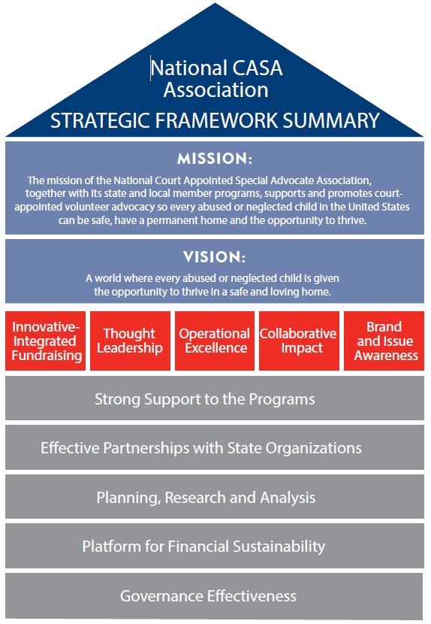

The CASA project consists of a board of directors that has 13 members, and a staff count of 14 people. This staff count consists of an Executive Director, an Assistant Director, advocate supervisors, a director of community resources, case manager/trainer, case assistant, finance and office manager, and a development associate. Their office is located at 100 Grove Street – 4th Floor, Worcester, MA 01605. The CASA project also has a total of over 170 CASA volunteers that commits 15-20 hours per month
As a national organization, CASA works in conjunction with organizations such as The Office of Juvenile Justice and Delinquency Prevention, the Kappa Alpha Theta fraternity, Jewelers for Children, Akerman LLP, and The Toy Foundation to help represent children across the country. These organizations contribute to CASA’s cause through both the services and funding they provide. Locally, the Worcester chapter of CASA is joined by the Ascentria Care Alliance as well as several other CASA agencies across New England.
The CASA project’s main resource to tackle this problem is through the generous individuals that donate their time to become CASA also known as Guardians ad Litem (GAL). There are more than 85,000 volunteers who represent the interests of more than 260,000 children. Along with the support of these volunteers, CASA is also endorsed by many high ranking officials including judges, senators, and other notable individuals. CASA has also experience significant financial growth over the years through investments, government loans, and individual contributions. Their total assets grew from $3,676,491 in 2016 to $4,219,961 in 2017. This growth is even more impressive when compared to their 2011 financial report which stated their total assets to be at $1,934,100.

Appendix C - Methodology
This project is intended to increase the amount of volunteer advocate applications for Court Appointed Special Advocates (CASA) Worcester County. We aim to accomplish this through a social media marketing campaign and the production of a video to educate our audience about CASA and push them to consider volunteering. Broadly, we hope that a boost in volunteers for CASA will result in a declining rate of child abuse cases.
CASA is a national, non-profit organization that works towards ending child abuse. There are numerous, local CASA agencies across the nation, and we will be working closely with CASA Worcester County. The institution works to prevent child abuse from occurring by appointing volunteers (known as CASAs) to children that are involved in the juvenile justice system. These advocates represent the best interests of the child in the court of law. Considering the increasing rate of child abuse in Massachusetts and the lack of legal representative children have overall, bolstering CASA’s volunteer recruitment is incredibly extremely important. Further information regarding the prevalence and effects of child abuse, as well as the role of the advocate can be found in the introduction and background chapters. As the rate of child abuse cases is increasing in Massachusetts, the need for CASAs also increases, and through the following methods, we hope to bolster the number of CASAs for CASA Worcester County.

Gantt Chart Detailing our Schedule for Completing the Methods:
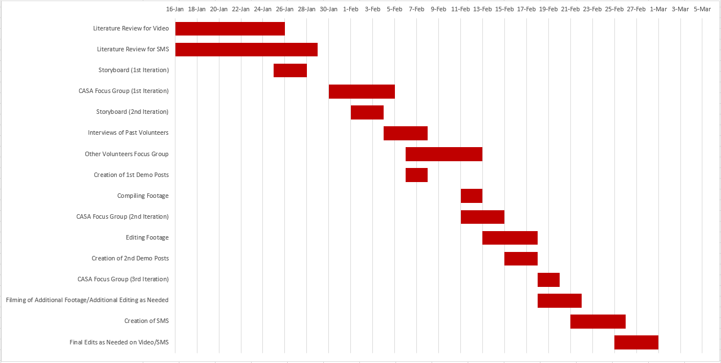

Create a yearlong social media marketing campaign for CASA
Social Media Marketing Campaign Literature Review
In order to understand how to create a social media marketing campaign for CASA, we will need to conduct research on what a social media marketing campaign is. To begin our research, we will learn how to start a marketing campaign, and we will look at the strategies that makes a campaign successful compared to unsuccessful ones. Specifically, it will be worthwhile for us to research what makes things go “viral” or popular online, since our marketing campaign will use social media as a vehicle, and we want to maximize CASA’s outreach online. We will also have to research how various social media platforms are using effectively. For example, on Instagram the only type of content one can post is pictures, but on Facebook one can post text, images, and videos. We will have to determine what type of posts and the content of said posts are most effective on each platform. Furthermore, Instagram utilizes a hashtag system of organizing content to its users, so we will have to research what hashtags have the most traffic. CASA specifies that their Facebook and Instagram pages are most important to the scope of our project, so those platforms will be the focus of our research. Though CASA as a much lesser presence on YouTube and no presence at all on Reddit, these are also platforms that we will research in this process. This research will begin before and during the first week of the project, which will help us finalize our questionnaire for the focus group while we recruit them.

Focus groups
In order to create a social media marketing campaign for CASA, we will conduct 4 separate focus groups to give us feedback on what volunteers want to see on these social media platforms, and furthermore, give us direction on where to go with the campaign. One focus group will be done with volunteers from other organizations, and there will be 3 iterations of focus groups done with CASA volunteers only. For the focus group iterations, we will be attaining a list of volunteers from CASA and from the organizations and then choosing volunteers from those lists. The staff at CASA and the other organizations will not know what is said about their organization, in order to ensure that the feedback will be kept confidential. For this method, we have baseline questions (refer to appendix B) that will help us understand how to approach this campaign and give insight into how volunteers utilize social media. A sample consisting of 6-8 people will be derived from the groups according to their respective organizations. By gathering data from volunteers at other agencies, we will be able to get information about how social media is used outside of CASA to reach out to potential volunteers and the public in general. We will be able to determine what volunteers like and dislike about their volunteering agency’s social media strategies, as well as what they want in the future for the organization's social media presence. Similarly to conducting the focus groups on outside volunteers, focus groups on CASA volunteers will allow us to gather the same kind of feedback, but on an internal level. Gaining both external and internal data from volunteers will allow our social media marketing campaign to be more all encompassing. These focus groups would take place at the respective organization’s office space, but if there is not space, then the WCPC will be a resource for us to utilize. We envision the focus group to consist of the volunteers in a circle with our team interspersed throughout. Since our focus groups will be decently sized, there will be two of us present for each one, with one group member leading the focus group and another taking notes. The direct data from the focus group sessions will consist of audio recordings of each iteration. This will allow the feedback from the focus groups to be easier to analyze. After gathering this feedback, we will create test posts for CASA based on our findings. After creating the test posts, we will gather specific feedback on the posts through the next iterations of the CASA volunteer-specific focus group. We hope that this feedback will allow us to fill in any gaps that might be missing in our social media campaign, and in doing so will help us recruit volunteers in the target demographic.

Surveys
Our social media marketing campaign will require a large amount of data regarding the types of advertising techniques that are most effective at engaging an audience. To accomplish this we will be sending out surveys to current CASA volunteers to get an understanding of how the most people are introduced to volunteering. We mainly want to know where they were first informed about CASA, what types of advertisements they tend to ignore, and what types of advertisements grab their attention. The surveys will be a valuable resource because we will be able to collect data from a very large sample size, so very accurate conclusions can be made about the best approach to marketing CASA. We will then use the data from the surveys to solidify our certain aspects of our social media marketing campaign such as the advertisement schedule and the type of content provided in the ads.

Design of social media strategy
Using the information gathered from the above-mentioned methods we will be able to successfully design our social media strategy. This strategy will provide details on the way in which CASA will advertise itself in the future. The strategy will be separated into categories such as upload schedules for advertisements, the main purpose for each social media platform, and the format that will be followed for the ads depending on their subject.
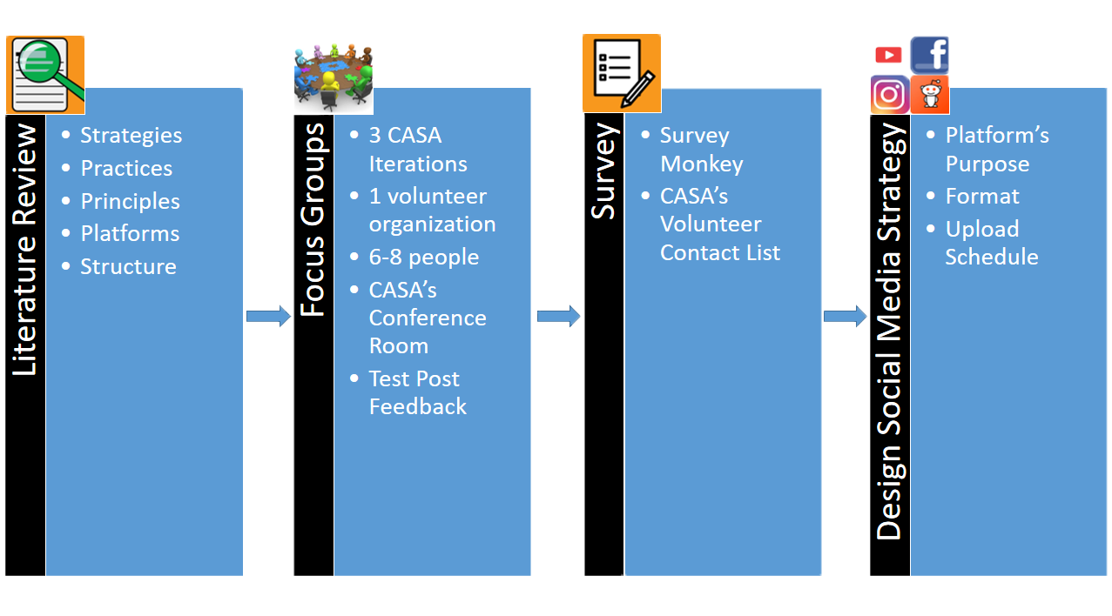
Produce a video to recruit volunteers and educate the public about CASA
Video Production Literature Review
In order to effectively create a video for CASA that imparts the audience with a strong desire to volunteer as a legal advocate, we first need to conduct an extensive literature review to learn about specific techniques and general philosophies behind creating an effective and impactful video. As our video will be promotional in nature, we will need to determine how to effectively market CASA to the audience, while also educating the viewers about what being a legal advocate entails. Balancing the promotional and educational aspects of our video will be a challenge, but researching how other nonprofits use videos to recruit volunteers, get donations, etc will be very useful to us. Even beyond nonprofits, reviewing the effectiveness of educational videos, or adverts for companies will help us further understand how our video should play out. Furthermore, we will also need to research the technical aspects of video production such as how to storyboard a video, how to frame a shot, how to use a microphone on a camera for filming professional grade footage, etc. We will also need to learn what video editing software will best suit our needs and how to specifically use the software to pare down our video to approximately five minutes in length. Through an extensive literature review, we will be able to successfully carry out the next steps in our video production process.

Video Production
Storyboarding
Before we begin gathering footage for the video, a storyboard will be created that describes the structure of video. Essentially, the storyboard will consist of illustrations to pre visualize our video. We will be drawing the panels of the storyboard with pencil and paper, with the drawings showing the frames of our video and written text underneath describing the motions and dialogue occurring in the scene. We anticipate that the storyboard will be edited heavily throughout this process. We want to show CASA our storyboard so that they can give feedback, then we will edit the storyboard accordingly. Our group will perform around 3 iterations of getting feedback from our sponsor and subsequently editing our storyboard. This will allow for the video to fluently transition between points, while also keeping the audience engaged and motivated. Storyboarding our video prior to filming will also us to meticulously organize the content of our video. As our video is relatively short at around 5 minutes in length, a well crafted storyboard will ensure that each moment in our video has purpose. It will begin with an introduction that grabs the viewers attention. This section will mainly be composed of statistics that describe the severity of the child abuse crisis on a national and state level. We will then move on to talk about the impact that abuse has on children, showing how it can have lifelong consequences. Then, we will describe the role that CASA’s, and show why their presence is needed in. This portion of the video will consist of footage from CASA events and testimonies from interviews. We will conclude the story board with a call to action for the viewers, in order to convince the audience that their contribution is needed in CASA.
Filming
In this video, we are planning on filming several scenes of CASA events. The most prominent part of the filming process will include interviews. Our methodology for interviewing is described in the next paragraph. Other than interviews, we would like to film parts of the swearing ceremony, if applicable. By doing this, we will familiarize potential advocates with the legal aspect of the CASA process. We are certainly going to film more events for this video, however, we are just waiting for scheduling from our sponsor. We are going to request Cloud storage from WPI and utilize the WCPC office computer to store our video footage and files. We are going to rent cameras from the ATC for principal filming. We will be using Adobe Premiere Pro to edit our video.
Interviews
We will include filmed interviews of CASA volunteers in our video. The interview process will give our video much needed credibility, and display to audiences that being a volunteer for CASA is rewarding and meaningful. For interviewees, we want to interview experienced, passionate legal advocates that speak positively of their time as a CASA. In order to ensure that we have no shortage of footage, we want to interview around eight volunteers, and we will be communicating with our sponsor to recruit interested volunteers. So that the interview is as comfortable as possible, we plan to conduct the interviews at the CASA office on a one on one basis. We believe that it would be too pressuring to have all four of us grilling one person. Though we have planned interview questions, we want the interviewee to speak as candidly about their experiences as possible, and will be asking many follow up questions or exchanging opinions if deemed necessary. The interviews will be filmed in such a way so that the interviewee is the main focus in the shot. In essence, the interviewer will not be featured in the footage of the interview. This framing of the interview will let the audience feel more personally connected to the interviewee and what they say. We will structure the footage in our video in a way that encourages potential volunteers through first hand experiences and recommendations.
Editing
We will be creating a five minute promotional video in order to motivate people to become volunteers for CASA, so the video must be edited meticulously. Generally, we will need to cut down our footage to fit within the time constraints of the video. Furthermore, we will need to make aesthetic changes to our footage during this stage if needed, such as color correction or fixing any strange audio. In this video, a sense of urgency surrounding the growing number of child abuse cases in Massachusetts and current gaps in support for child abuse victims will be imparted on the audience. Video editing techniques such as sad music and facts transitioning to hopeful music and footage of CASA volunteers will be utilized for effectiveness. Essentially, we will be turning our footage and research into a visual story during this stage, so our video must be thematically consistent and gripping. Our video will have to appeal to audience’s sense of logos and pathos to be successful, so we will find this balance in the video editing stage. Having edited down our video, we will then review the resultant film in its entirety, then finally edit more as deemed necessary.
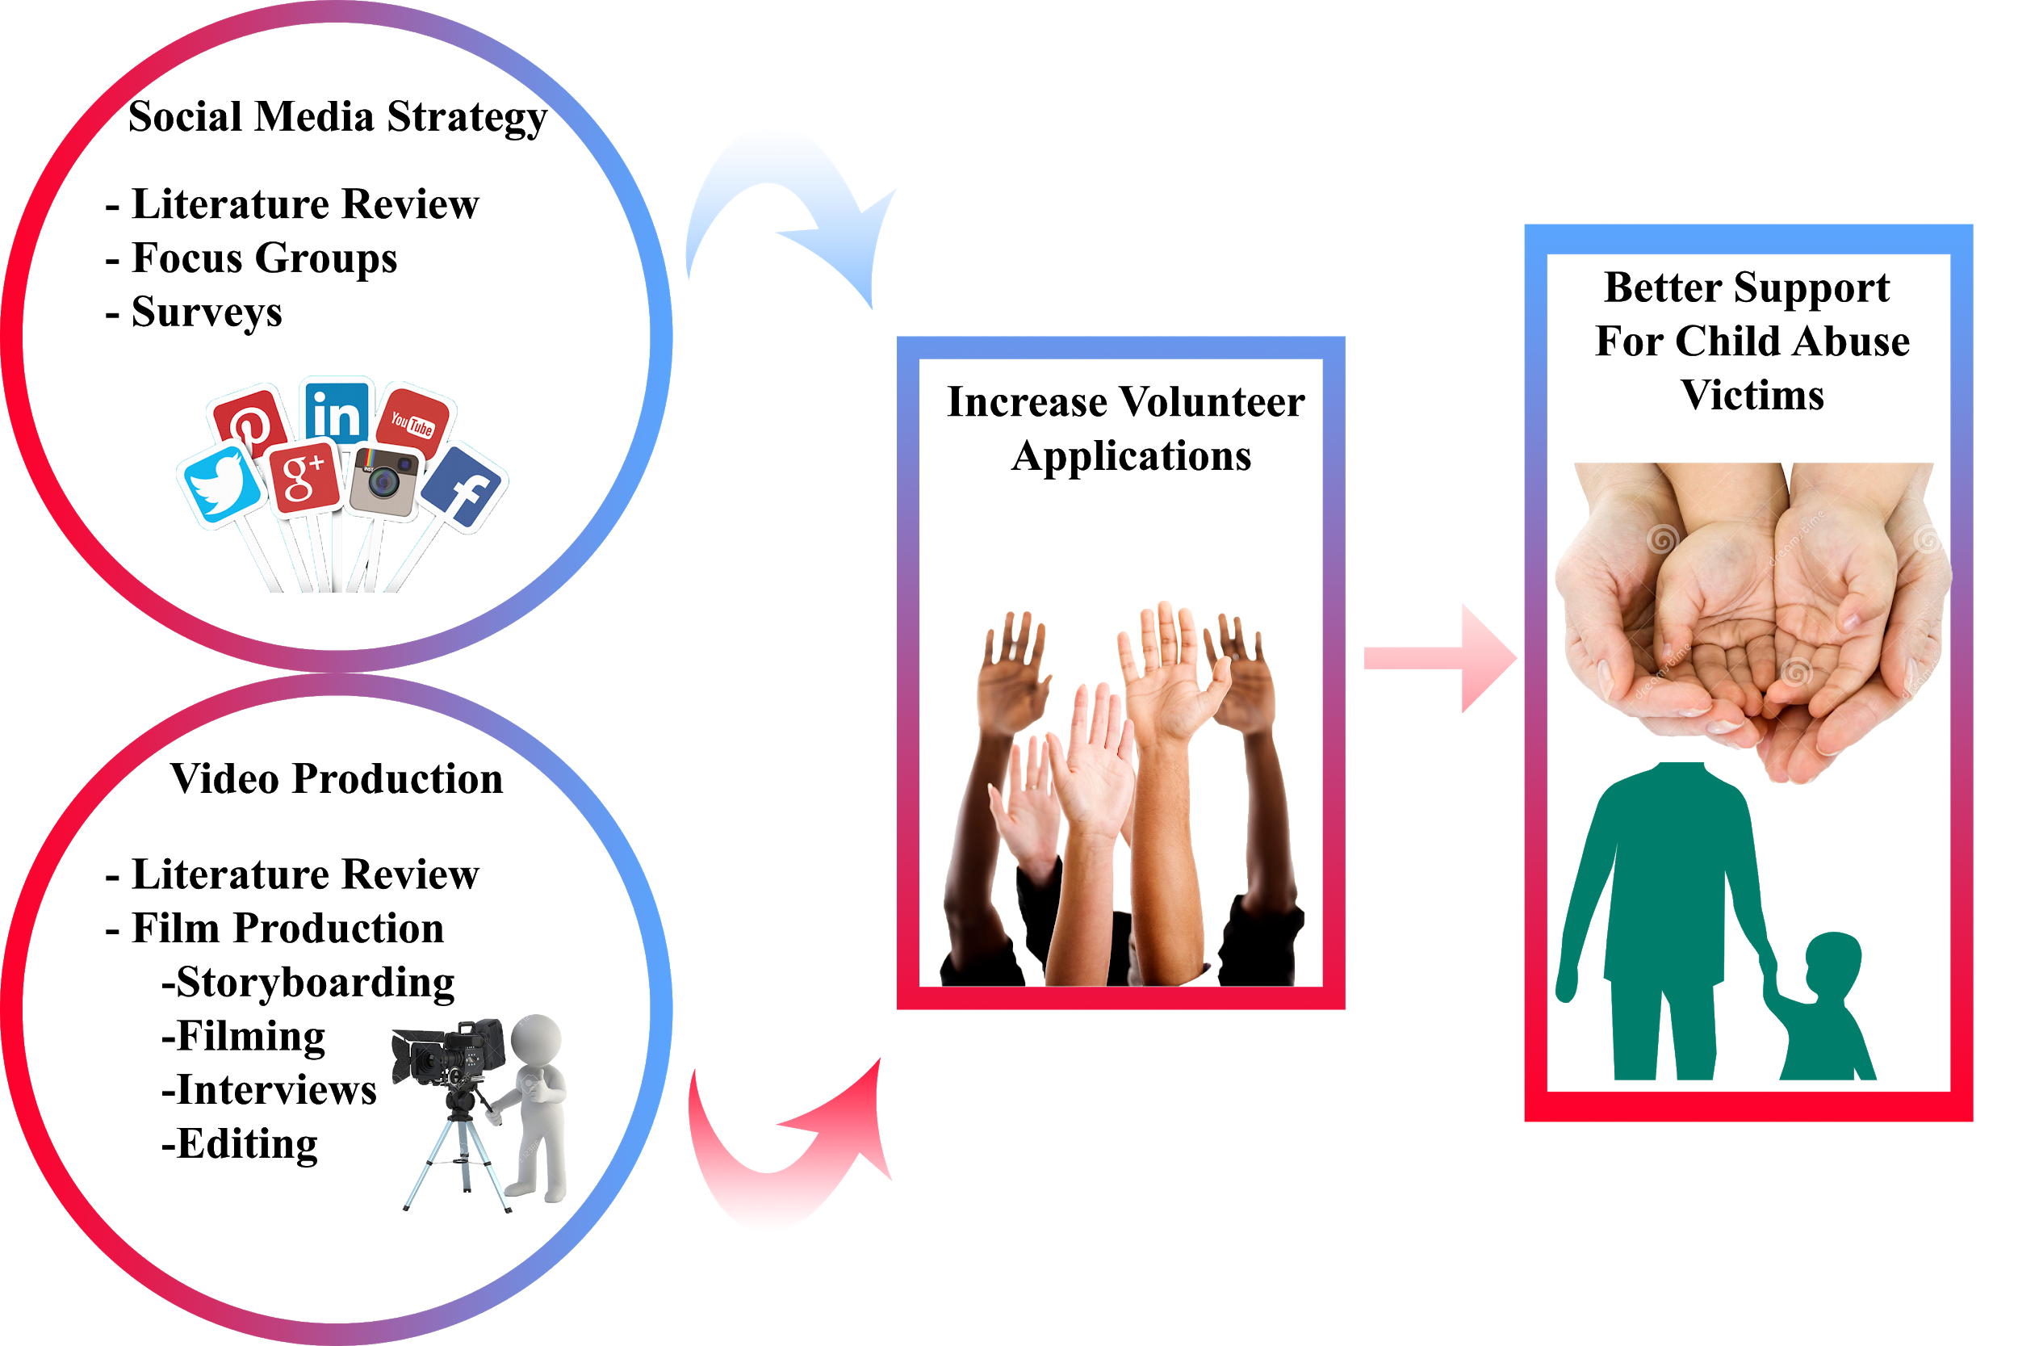

Appendix D - Raw Literature Review Data

Social Media Marketing Strategy
Links to sources:
http://www.journalofadvertisingresearch.com/content/52/1/40
https://www.sciencedirect.com/science/article/pii/S0007681309000329
https://books.google.com/books?hl=en&lr=&id=7l2OR6giC6AC&oi=fnd&pg=PT7&dq=social+media+marketing&ots=jNIauY2M9X&sig=WXDQS8c2QvSA233smJUO-RPVcUg#v=onepage&q=social%20media%20marketing&f=false
https://books.google.com/books?hl=en&lr=&id=F7BzCgAAQBAJ&oi=fnd&pg=PR7&dq=social+media+marketing&ots=prS_3a4wEp&sig=wGG8UTfRHVR1gburQ2iEDcm49AI#v=onepage&q=social%20media%20marketing&f=false
https://www.jstor.org/stable/1250756?seq=1#page_scan_tab_contents
https://elibrary.ru/item.asp?id=3357382
https://www.tandfonline.com/doi/abs/10.1080/02650487.1998.11104734
https://link.springer.com/article/10.1007/s12208-010-0049-2
https://www.sciencedirect.com/science/article/pii/S0007681311000152
https://www.theseus.fi/bitstream/handle/10024/148801/Tuomi_Ella.pdf?sequence=2&isAllowed=y
https://sproutsocial.com/insights/best-times-to-post-on-social-media/
^^ data that shows best times to post on facebook and insta for nonprofits
https://www.sciencedirect.com/science/article/pii/S0363811109000046
^^non profit orgs using social media
https://blogs.constantcontact.com/social-media-to-recruit-volunteers/
^^Enage, inform and recruit
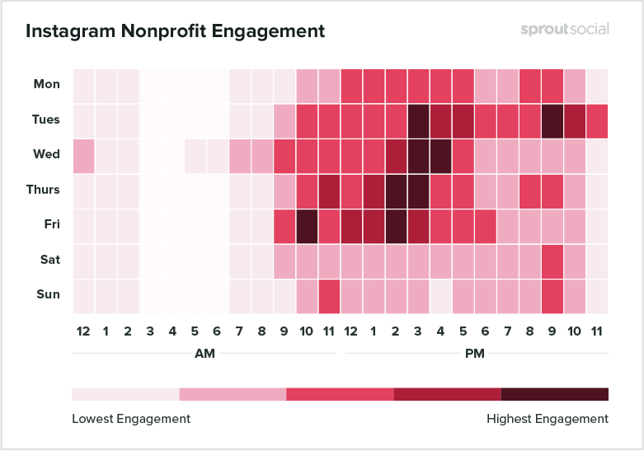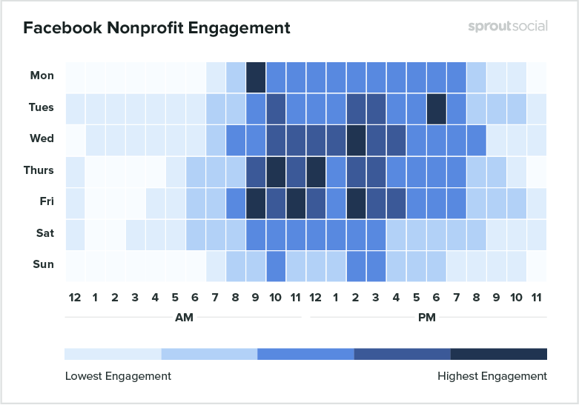

Things to address in lit review:
- what is an effective social media marketing strategy?
  - how should this strategy change as time goes on? (week by week, month by month, and eventually into next year)
- how are different platforms of social media used?
  - optimal times to post on each platforms
  - optimal content of each post
  - how to track successfulness of postings
- how are nonprofits advertised on social media? how is social work advertised?
- how to effectively use social media to advertise for something as “serious” as CASA
Stuff:
- creating a community for audience to engage with CASA in (posts asking questions and gathering opinions )
- mixing content of posts and post types frequently
- social media plan: summary of plans and achievements
- can make separate strategies for each social media platform
- cross promotion is vital
- “happy” content gets shared a lot more than “sad content”

Demographics of Social Media Platforms
- Younger americans (18 - 24) use a variety of social media platforms
  - 78% use snapchat and 71% visit it many times a day
  - 71% of americans in this age group use instagram
  - 45% use twitter
- 68% of adults are on Facebook
- 73% of adults use Youtube
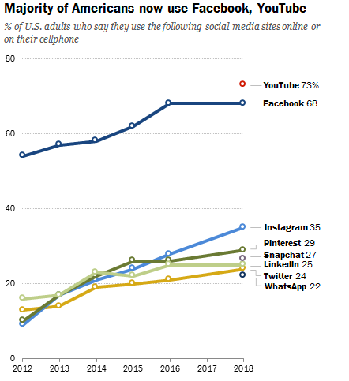

What are effective social media marketing strategies and how are they made?
- In order to make viral marketing work the right people need to get the right message under the right circumstances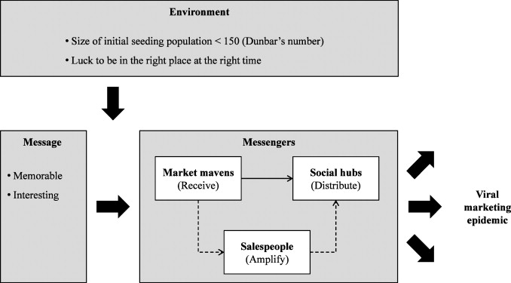
- The message must be memorable and interesting
  - This can be done by relying on true stories. Maybe creating a monthly post recognizing a CASA advocate who did something notable

The facebook algorithm favors posts that have a high amount of users interacting (Commenting, liking, Sharing)

Instagram does not have a chronological algorithm. Instead, the algorithm uses engagement to determine how many people see your post
- Posts that have a lot of likes in a short amount of time
- If you regularly comment and like a person's post you are more likely to see them\
- Timing: You are less likely to see post from a long time ago
- Sharing posts makes it more likely to see those posts again
https://blog.hubspot.com/marketing/how-does-the-instagram-algorithm-work
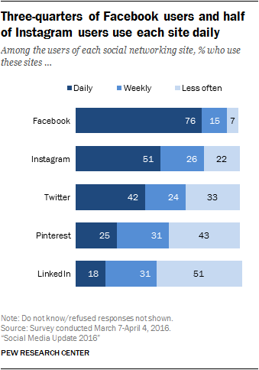

recommended hastags for insta:
#socialworker -- 274k posts
#courtappointedspecialadvocates -- 2.6k posts
#worcester 653k
#worcesterma 143k
#volunteer 3.9mil
#advocacy 358k
#socialwork 499k

→ hazard against posting in #casa since most pics are houses

“Facebook’s algorithm prioritizes posts that get lots of engagement early on”
https://www.socialmediaexaminer.com/facebook-algorithm-demystified-how-to-optimize-for-news-feed-exposure/
→ good strategy to reply to comments on posts
link posts to other platforms
https://www.classy.org/blog/11-ways-grow-nonprofit-social-media-followers/
Visuals are high-performers on social media, so be sure to include an eye-catching, colorful image or graphic with each post. Consider these visual marketing statistics, compiled by HubSpot:
- Content with relevant images rack up 94 percent more views than content without images.
- Compared to other types of content, visual content is more than 40 times more likely to get shared on social media.
- Instagram photos showing faces get 38 percent more likes than photos without faces.
Video is one of the most engaging content types that you can post on social media. Facebook reported that 50 percent of Americans who use the platform on a daily basis watch at least one video every day.

Forbes recommends posting content that influences audience interaction -- content that “asks”
https://www.forbes.com/sites/forbesnonprofitcouncil/2017/10/24/how-to-create-more-effective-nonprofit-social-media-content/#587e51237e57

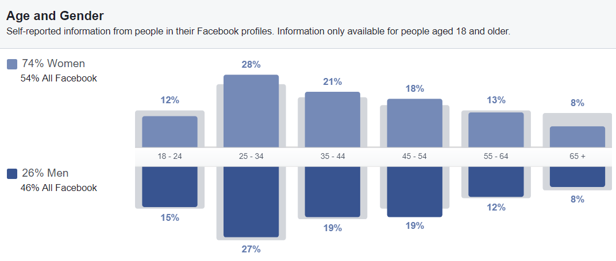
^^ using Facebook’s Audience Insight tool, we found that individuals of this age and gender are the main demographic in the Worcester MA area and have an interest in social work and volunteering
https://www.facebook.com/ads/audience-insights/people?act=566617140518565&age=18-&city=2466833&interests=6003108997093-6003137105590

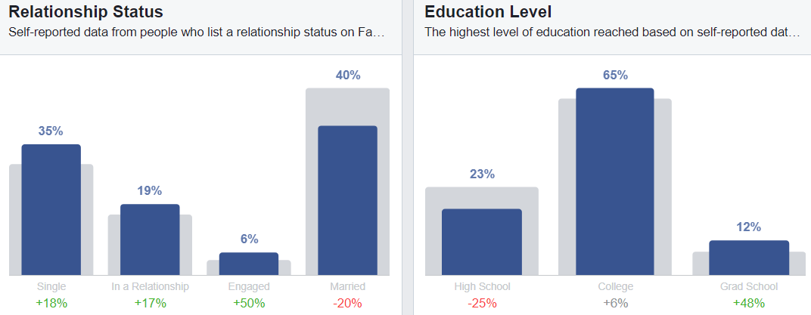

PLANS FOR SMS:
- guide for making posts
- hashtags to post in
- calendar for march, april, may
- key of what each post entails on calendar
Overall SMS:
- setting (measureable) goals and ways to achieve them
Facebook:
- times to best post
- keep posts mostly visual
- according to survey monkey volunteers want to see more inspirational CASA stories (Jordan suggests doing a “volunteer of the month” type of deal)
- more volunteer resources
- A post will be made at the first of every month that gives an overview of the month’s schedule
- more informative posts (educate on what a CASA does!)
- Informative posts will be made every Monday from 7 - 10 pm

Post Categories:
Create a template for each of the categories below
- Inform
  - Statistics on child abuse crisis and foster care system
  - Events and Schedules
- Engage
  - Cute posts :) (pics of kids)
  - These post can be for showing the accomplishments that kids with a CASA have made
  - Multimedia
  - It has been found that the algorithms for some social media platforms favor post with a lot of comments and likes. Try to encourage conversation with these posts. Example: “Comment your best CASA story”
- Recruit
  - Monthly posts recognizing noteworthy advocates
  - Talk about the organization and their impact
  - Give links to the CASA website

Instagram:
- times to best post
- suggest hashtags to post in that get lots of traffic
- use location stickers on instagram story
- The posts will be done on Wed from 3 - 5 pm and Thursday from 1 - 4 pm
  - These posts will be for recruitment, events, cute posts and advocates of the month

Post on other Stories and pages:
- Instagram: Post advertisments for events on the Worcester instagram story
- Reddit: Post on r/WorcesterMA
Hashtags to use:
Instagram: #nonprofitorganization #childadvocate #children #helpyourchild #humanity #hope #support #socialwork

Video Production
Sources Found Beneficial:
https://blog.markgrowth.com/how-to-create-engaging-videos-for-social-media-e3fdc1c26ee1

Things to mention:
Define end goal and and video statement: Identifying the main objective and customer/viewer personas
Different platforms, different strategies: different platforms need different strategies for engagement. However, we will not be making different videos for different platforms. Thus, our video has to incorporate several different strategies to account for facebook, instagram, etc.
Forget fancy gear: Don’t focus on getting the best, most-expensive equipment but rather the lighting, angles, lenses, etc.
Post Production: An intro and an outro, color correction, rearranging the clips and cutting/adding some in

Analysis of the “My Dad’s Story” advertisement:
https://medium.com/@shewitbmehari/the-impact-of-storytelling-my-dads-story-dream-for-my-child-metlife-abd88d659ea4

In what ways did it engage its audience?
- Emphasized the use of storytelling in order to have the issue be more relatable to parents
- Did not excessively promote their brand throughout the advertisement. They first told the story, and then they promoted Metlife at the end

How to make a Viral Video advertisement:
https://www.disruptiveadvertising.com/video-advertising/viral-video-ads/

There are key components that contribute to the making of a memorable video
1. Does the ad tell a story?
2. Are you entertained while watching the ad?
3. Does the ad make you feel anything?
4. Can you identify what the ad wants you to do?
5. Can you tell what demographic the ad is for?
6. Is there a central truth in the ad that you can identify with?

Telling a Story?
- The story should include interesting characters and an engaging setting
- Even informative commercials can have stories
Making it Entertaining
- The actors need to be entertaining
- If you are going to have actors, you should hold auditions to make sure the actors are right for the role
- Make sure the video isn’t dragging on. Make sure it is short and to the point
Does the ad make you feel anything?
- Try to make the audience feel certain emotions in order to make it memorable (humor, sadness, fear, discomfort, etc.)
- Make sure the emotion is right for the brand
- Try to think about what life would be like with or without your product
Can you identify what the Ad wants you to do?
- Make sure there is a call to action at the end of the ad
- You want your audience to know specifically what they should do and how they can do it
Can you tell what demographic is being aimed at?
- The ad needs to be selective. You cannot have everyone as your target
- The more specific an ad is the higher the chance of the audience being responsive
Is there a Central Truth?
- Incorporate a universal truth to your ad that does not contradict the ideals that your organization preaches

Current CASA promotional Videos:
https://www.youtube.com/watch?v=QGj-s_64TzM

What was done right? What can we use as a model?
- They included interview testimonies that reflected positively on CASA
- Good use of music to set the mood
- Accurately tells the need for CASA’s
What is it missing?
- The video is not engaging
- It lacks a story to give the audience a reason to be interested
- It would be more impactful if it showed scenes that could create an emotional response out of the audience
- Has scenes that repeats
- Not very entertaining
- Too long

Stand up For the Child
http://www.casaforchildren.org/site/c.mtJSJ7MPIsE/b.7650855/k.2EEF/Promotional_Videos_and_Radio_PSAs.htm
What was done right? What can we use as a model?
- Short and to the point
- Included a call to action at the end by directing the audience to become a CASA because “the Children need you”

Appendix E - Research Instruments

Focus Group Questions
- What social media platforms do you use?
- What social media platforms are you most active on?
- How often do you check those social media platforms?
- What drives you to use those social media platforms?
- What do you like most about the social media platforms that you use?
- Is there anything specific that these social media platforms post that catch your attention?
→ Show test posts here and ask questions
- What do you dislike about the social media platforms that you use? What would you change about these social media platforms?
- Do you research organizations you potentially want to volunteer with?
- What do you look for in an organization that you want to serve?
- Do you take into consideration an organization’s social media presence when considering to volunteer there?
- How do you use the social media of the organization(s) you volunteer at?
- Would you say CASA uses social media effectively? Why/why not?

Additional Questions (Showing test posts)
- What do you like about this post? What stood out the most to you from this post?
- What should be improved?
- If you didn’t know what CASA was would you still understand the post?

Interview Questions
- What motivated you to become a CASA?
- What part of being a CASA do you enjoy the most?
- Can you describe a day in the life of a CASA?
- Can you describe one event or case during your time as a CASA that stood out to you?
- If you could say one thing to potential volunteers, what would it be?

Survey Questions
1. What social media platform(s) do you mainly use?
- Instagram B. Facebook C. Twitter D. Reddit E. Others

2. What times of the day do you use social media most often? Circle all that apply.
- 10:00 am-1:00 pm B. 1:00 pm- 4:00 pm C. 4:00 pm- 7:00 pm D. 7:00 pm- 10:00 pm

3. What grabs your attention when looking at posts on social media?
- Hashtags B. Captions C. Post Content D. Likes E. Tags F. Other; Please specify

4. What do you mainly use social media for? Rank the following with 1 being the most frequent reason and 4 being the least frequent reason.
- Entertainment B. Business C. Socializing D. Staying Informed

5. Where did you first hear about CASA?
- Social Media B. Friend/Family Member C. Videos D. Television E. Billboard F. Other; Please specify

6. How do you use CASA’s social media?
- I do not follow CASA’s social media B. Updates C. Upcoming Events D. Socializing E. Other; Please specify

7. What do you want to see on CASA’s social media presences going forward?

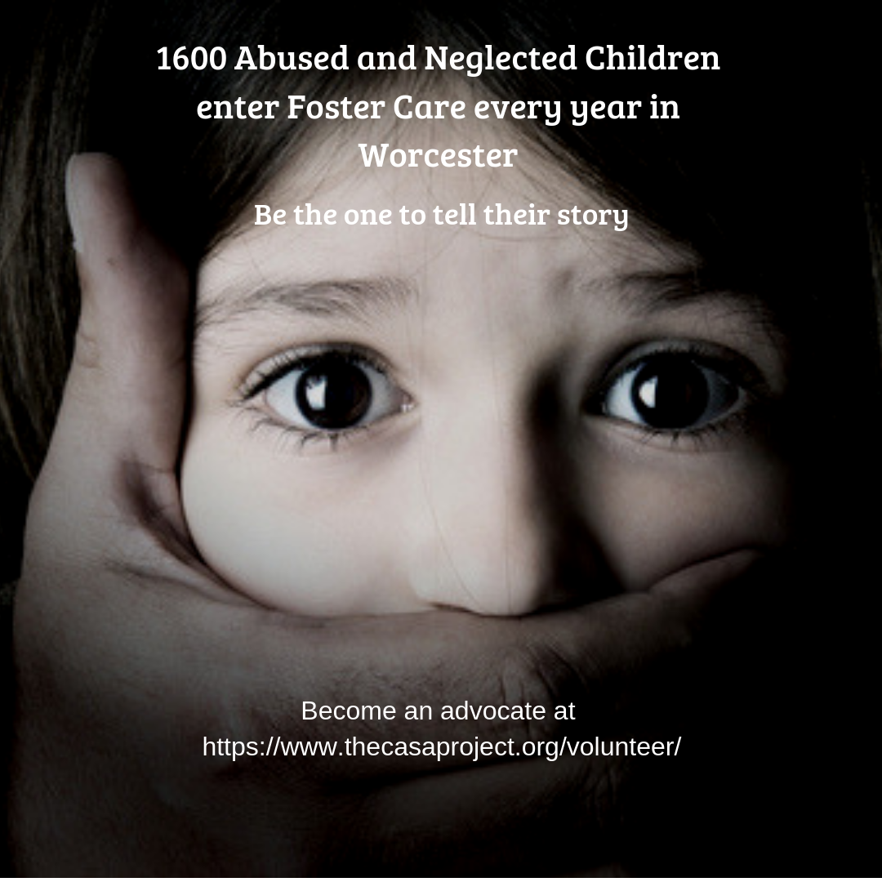
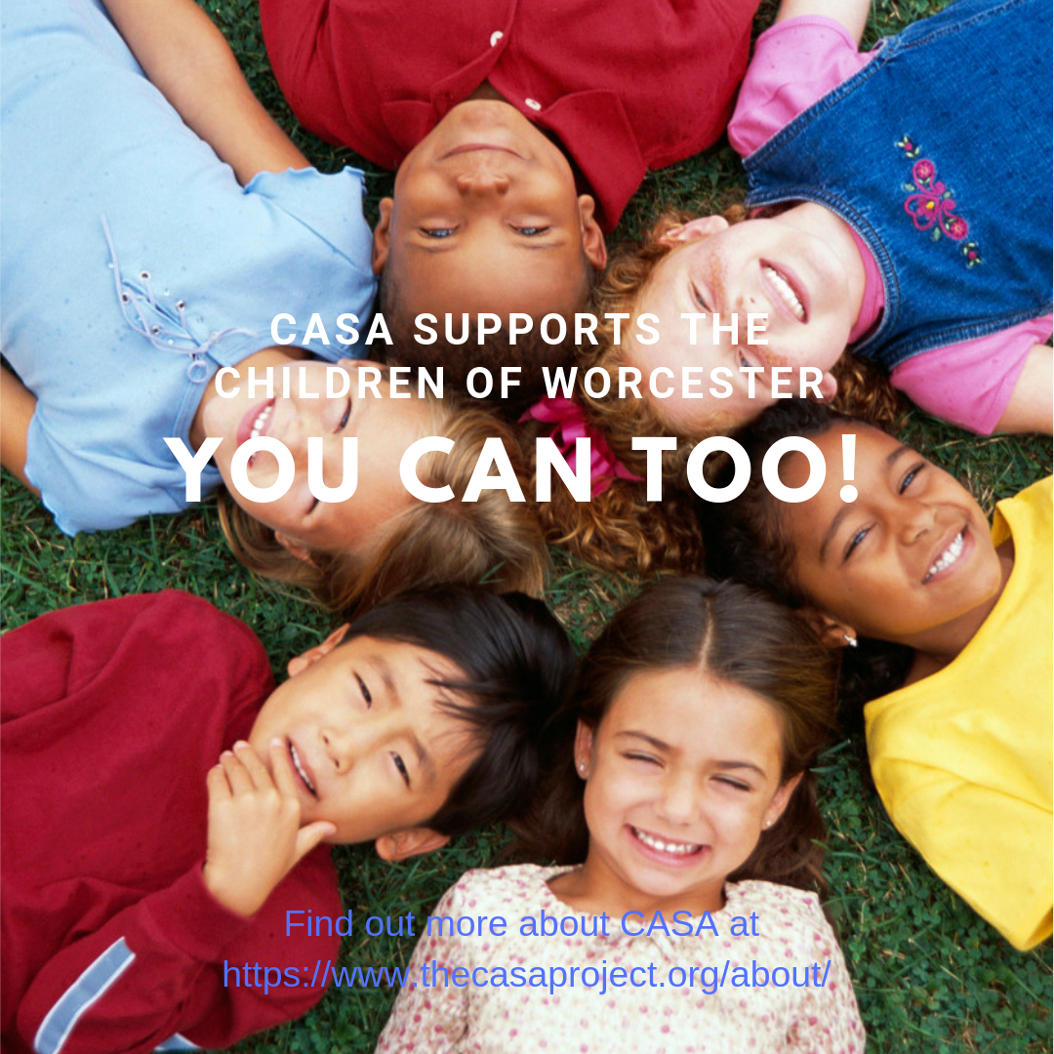
Appendix F - Test Posts for Focus Groups

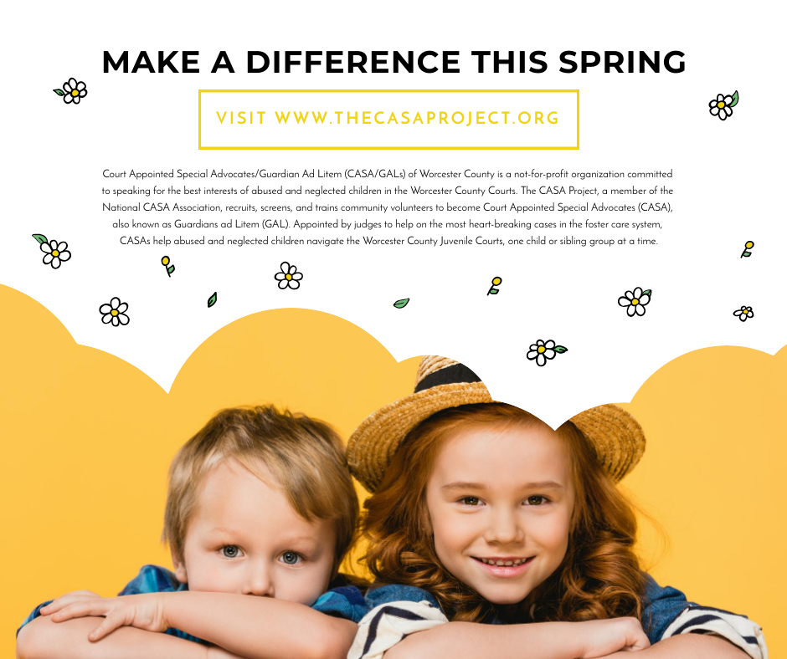
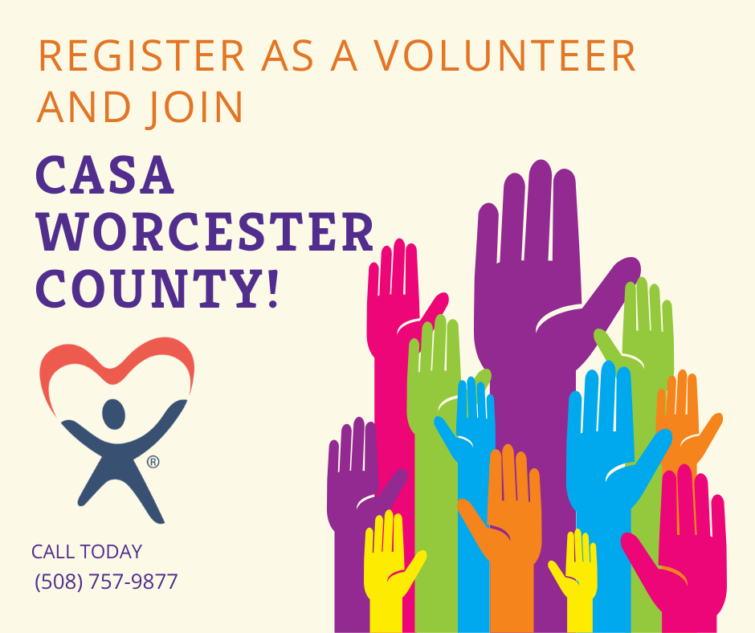
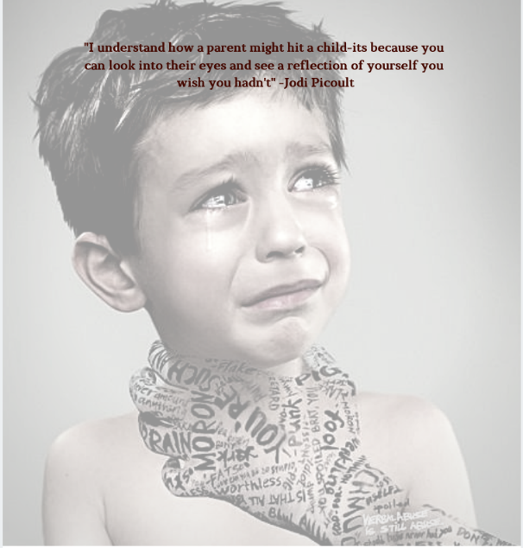

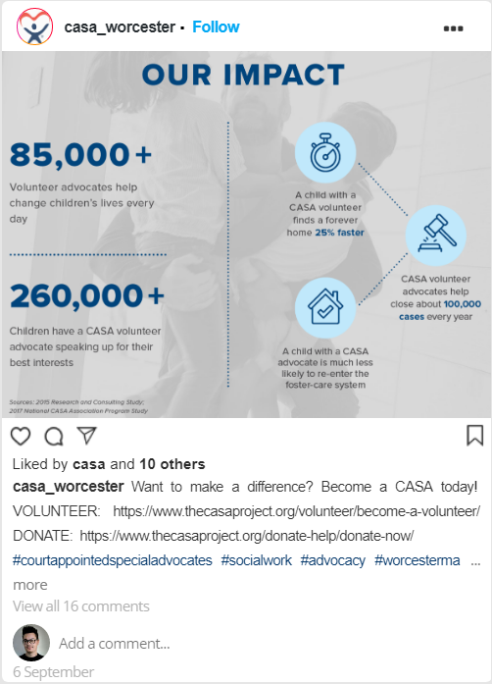

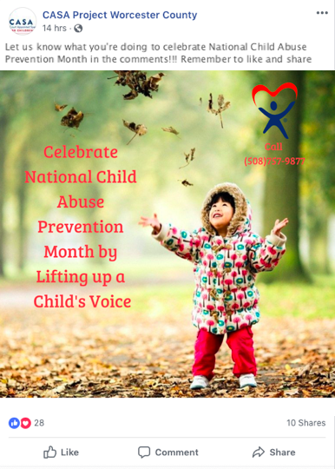
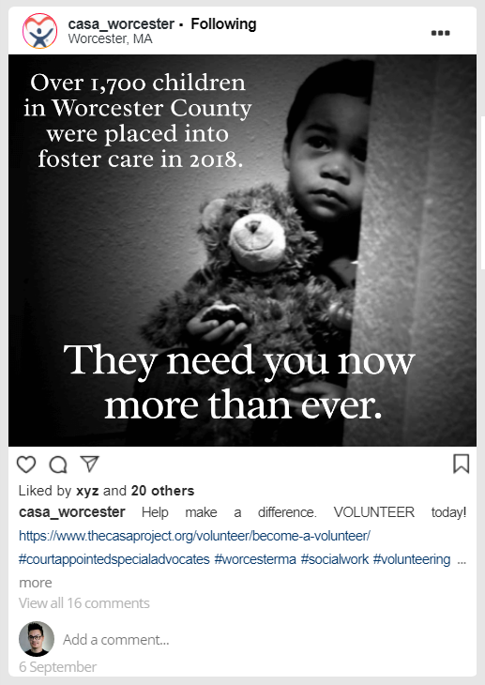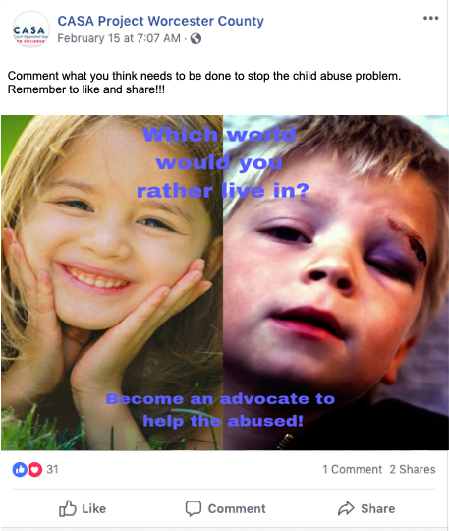

Appendix G - Survey Results

Appendix H - Focus Group Notes
2/14/2019 @ 2pm~3:20pm
  - What social media platforms do you use?
- Use it in order to get more information
- Likes to check to see what going on but they don’t actively go on it
- Helps to keep contact with friends or families
- What social media platforms are you most active on?
- Facebook
- How often do you check those social media platforms?
- Not very often
- What drives you to use those social media platforms?
- Keep in contact with friends and family
- What do you like most about the social media platforms that you use?

- Is there anything specific that these social media platforms post that catch your attention?

- What do you dislike about the social media platforms that you use? What would you change about these social media platforms?
- They dislike that they get spammed by posts on social media from people who aren’t like minded about things that don’t interest them
  - Reddit would be a good solution to this problem because you can subscribe to communities that are like-minded
- Don’t like ads
- If they
- Do you research organizations you potentially want to volunteer with?
- Yes, there are a lot of organizations and they need to be a fit for you
- What do you look for in an organization that you want to serve?
- Has to be pretty well established
- Good reason for the need of the volunteer
- Good support and resources
- Organized, some places take forever to communicate with volunteers
- Judge by how the volunteers are treated. Don't want to feel like it’s a job and be respectful of people's time

- Do you take into consideration an organization’s social media presence when considering to volunteer there?

- How do you use the social media of the organization(s) you volunteer at?

- Would you say CASA uses social media effectively? Why/why not?
- Some of the notices about events are put out very late
- It would be helpful if there was a way to access the posts

Questions about Test Posts:
- What do you like about this post? What stood out the most to you from this post?
- One was very happy and the other was very sad. This is why we do CASA.
  - The picture with the happy kids lined up together and the kid crying being choked by a tattooed hand communicated this effectively
  - Would post those post together; “Which world would you want to live in.” In isolation it doesn’t work, but together it tells a story
- They liked the black and white one more because the color was more distracting than the black and white. Also black and white evens out the playing field
- The one with the girl having her mouth being covered showed urgency and was scary.
- They like statistics and information
- What should be improved?
- Should be something more direct in the picture with the child's mouth being covered. “We need you” or “They need you”. Has to be a next step
- The one with the kids lying done had no message. They did not know what to do with it
- The one about celebrating child abuse month did not go with the message. It doesn’t show the reality of the CASA children
- The yellow picture was too wordy, and it did not include CASA kids
- Make sure to make the message clear. The one with the hands being raised
- If you didn’t know what CASA was would you still understand the post

How do you keep up with CASA events without social media
- They wait for an email
- They like being able to express themselves in a private manner
What kind of posts from CASA would you like to see
- Would like to see “feel good” posts
- Information about events and meetings are helpful
- Have something that is organized that wo
How did you hear about CASA
- Through a newspaper ad

“When asked about what's important about CASA, first of all, it would be the mission and then it would be the reward”
“The feeling that you do make a different is not for yourself is the piece that keeps you there”
“CASA is unique in the sense that it makes you feel thankful that they accepted you”
“It would be good to see how many CASA volunteers were assigned cases on a monthly basis. Just little milestones of the organizations”
“Social media is virtual but this is real”

Focus Group 2 Notes:
- One lady says technology is the “root of all evil”
- One older women uses Instagram and no Facebook which is kind of interesting
- Only one younger lady (college aged student), the other 3 are 40-60
- More receptive to black and white over color
- Liked posts that had a message
- Did not like posts that they thought were scary, i.e. too graphic

Appendix I – Interview Transcriptions
Interview 1
Tala: Just to start things off, what motivated you to become a CASA?
Helen: Well, at the time I was actually working here in Worcester. I was working in an extensive care unit so we had a lot of families that have a lot of extra needs and we certainly had some situations that were not the most supportive of families. I don’t mean in the hospital but rather in general in the community. I certainly over the years have seen people who maybe didn’t have the resources. I heard about CASA and honestly it has been so long. I can’t even remember how I found out about them. I made a call and came in for an interview and it just seemed to be what I was looking for. We certainly encourage people to get involved in community service but I think it needs to fit both the service and the individual to make it work for everyone. I was very excited and so I came to the classes and I’ve done the CASA classes twice only because in April of 1998 was when I was first sworn in as a CASA. And then I have done several cases and those were resolved and then in 2001 I lost my job. I can’t even remember if I had a case at that point or if it was just ending and I just really felt that I was under a lot of stress and I needed to take care of me and I think that was an important piece so I stepped away from CASA for a few years and came back in 2006 and redid the classes because I certainly knew things would have changed and I have been with them since then.
Tala: Wow.
Helen: Yes, Wow. Because I was looing up some of the information of my own history with CASA and I was like wow I can’t believe it has been that long.
Tala: Yeah. Absolutely. That is a really long dedicated time to be committed to this cause. It is really admirable. So, can you tell me a little bit about what a typical month is like for you as a CASA when you are on a case.
Helen: When I’m on a case. Well. Without giving too many details I am currently on a case that has been almost five years and this has been to me my toughest case. From the stand point from the families and the kids, but also from me as a CASA. I have really struggled with them not being able to get permanency for this length of time. In the past, I mean I have had cases that were like thirty days and it might have simply been that there was a particular incident that occurred and CASA comes in. Sometimes you find that maybe it wasn’t as it was perceived to be and so it is easy enough to be resolved. But, in the particular case I am thinking of we also were able to get some services for the parents that they didn’t even realize that they were; that they could have. It actually made a difference for them even though it didn’t go any further than thirty days. Within that time frame, they were able to get some help that they didn’t eve realize that they needed. And I have had some kids that have been removed from parents permanently and I have had others that have been reunited with families. Sometimes the kids are placed together but sometimes if there is several children, they may be in separate homes and it may be because of their ages or any number of factors.
Tala: Very interesting. So definitely in your cases it’s a wide spread of varying situations that you can deal with.
Helen: On the cases, I don’t necessarily make visits constantly but I always keep contact with them either through telephone calls, obviously home visits if that’s the case. That is particularly referring to the children and the foster families that they have been placed with. It might be making phone calls to their schools, to their therapists, to DCF, to my supervisor for moral support. It isn’t necessarily going to homes although that is a big piece of it because someone who isn’t with the day to day, you can pick up changes with them from one visit to another. Whether they have made progress or there is something that has changed a bit.
Tala: Absolutely. So having been a CASA for so long and having had x number of cases, are there any specific, I guess without going into too too much detail because of confidentiality, are there any specific cases or stories or events that you went through as a CASA that really stuck out to you and were like wow this is what it is all about?
Helen: Well, I can think back to a case that involved three children. The mother had addiction issues and when I was given the case I was told that they didn’t know where the mother was and hadn’t known for three months. My first thing was like why do you think I was going to find out where she is *laughs* if no one else has been able to find her. But sometimes you consider that a challenge and you go back to square one and start all over and it seemed as if everytime I finally located a mother from the program, she would have not been there any longer so then you went back to square one and started all over again. She was very difficult. I did find though that you’re still making reports for the courts and you’re hoping that the attorneys are looking at them and you can communicate with their clients and then what happened is one day, I’m not really quite sure whether she saw the report or how it was communicated but I received a call that she wanted to speak to me. She had been gone for months. Nobody knew where she was. So obviously something peaked her interest so we did meet. She and I met in person with another individual that was her support person and therapist. In the end, she actually did step up to the plate and she did actually finish a program and continued outside therapies. She did get her children back. Then, I got to visit her after she was reunited with the children and to see how they were going and how they were doing. We just sat and we had a chat about moving forward and being committed and doing what is best for the kids. Her name hasn’t come across the desks so I assume that she is doing well.
Tala: Wow, wow that is so nice.
Helen: It is because she was in a very bad place and it was just really good around all the way for her and for the children and also to see that she could make a difference. I think that really stands out simply because I really didn’t think she could do it.
Tala: It is the unexpected happenings that really stick out the most. Things that you just don’t see coming that are really impressive. So this video is essentially going to be spread across CASA’s social media and youtube in an effort to recruit more volunteers. If there are a few words of wisdom or some advice that you would like to say to people that are seeking to potentially volunteer, what would you say? How would you build CASA to people?
Helen: Well, it is a tough job. There were days that you would go to bed and cry yourself to sleep. *Begins to cry*
*Tala holds her hand*
Helen: But they have it so much worse

Interview 2:

Jordan: What motivated you to become a CASA?
Joe: Well, a CASA speaker came to our rotary club. It wasn’t too difficult for that speaker to hit my nerve as far as what the value of CASA was in the life of a child. I’ve done a lot of travelling in third world countries to do missionary type work particularly with rotary international. I have been to Haiti three times have met a lot of children in Haiti of different ages who have a lot of life in being in the poor country and whole western hemisphere. Yet they are always happy. You look at a CASA kid and a CASA kid isn’t always happy. They are challenged to think and act like an adult and they are really only a child with simple learning blocks in their brain. I think that all these kids need is to know that they are going to be safe and that is the legal role of being a CASA is to provide a feeling of safety. I think also that the big goal is to develop an element of trust. And trust is not only between the child and the CASA representative but to know when people come into their lives, to know that there are people that they can trust and that they will be trusted because they are challenged everyday in their own life by being accused and not treated like a decent human being. If we are not careful, they believe that’s the norm when in fact what we are trying to do is to tell them that life is heck a lot better than that. You deserve better than that.
Jordan: Right. Yeah I have always noticed that kids in other countries which you would think are more impoverish and experience unfortunate events are the kids that seem like they are happy. It is really good that you make sure that the child has a trustworthy and stable environment.
Joe: The first time I got off the plane in Kapatna, which is in the north west part of Haiti, the children were excited to see me and they immediately gave me a label. In their language, they called me blanco. Can you imagine why? When we were out in the fields installing solar panels and putting the deep wells in, in order to give them water for drinking and to be able to grow vegetables in an economy that was vegetable cooperative, they always called me blanco. Wherever I came, they called me blanco. They found a way to ingratiate themselves to me. They didn’t go hide behind a tree. They made the assumption that all people are good and I hope that I reinforced that with my behavior with them but you wouldn’t necessarily find a child to be thinking the same way. They look at you from their side of their eye to measure you up.to whether you are a friend or a foe. So that’s where that element of trust needs to come in and become a norm rather than an exception.
Jordan: That’s really interesting actually. So what do you think is most enjoyable about being a CASA?
Joe: Being a kid. It is kind of going into Disney World in a sort of way. You are there to do a job but in order to be able to develop that safety and trust, you got to act like a child. I am a grandfather of eight grandchildren. They go anywhere from your age, a bit older I may say, 24 down to 6 years old and they fill my life in a very normal and acceptable way. And I would like to think when I meet a little boys or girls, I can create, perhaps, a grandfather type image that will allow them to trust. I overuse the word but it is so important. But think of your own lives. You’ve got your siblings and your parents. You’ve got your grandparents and nowadays since people are living so much longer, you’ve got your great grandparents. So it truly takes a village to raise a child. I don’t think a CASA kid sees that because in a given family, a child can have a number of parents. That is just the way it is.
Jordan: Yeah. It is a really sad reality but atleast there is people like you can actually provide them with that trust.
Joe: I would like to think so. There are times that it can be very frustrating where you need to meet the role in the eyes and ears of the judge. You need to keep parental boundaries and you can see things happening. You can see, for instance, in my current case where the mother hasn’t gotten the concept that the kids need nutritious meals and not necessarily a bowl of fruit loops every single day. Heck the kids in Haiti eat one nutritious meal a day where they get chicken or goat in terms of the meat. There are some CASA kids that I believe don’t get nearly that nutrition. They get something to eat but that something to eat can be a candy bar with a bowl of fruit loops or whatever it is.
Jordan: Yeah, that is something that we really don’t think about. We like to think that the kids in our country are all above and have advantages, but there are some kids that really don’t get enough food. Can you describe a day in the life as a CASA?
Joe: Well it is in spurts. It is a monthly visit. I have never pulled a surprise visit; an unannounced visit sort of speak. I often wondered what it would look like if I did. But on the other hand is it fair for the parents and family for me to suddenly show up at the door. I get a better view of what their real life is doing that and if the kids are running around in paper diapers that were sagging that were not changed, then that would tell me a lot. They are upfront and center and the kids have nice clothes on and our on better behavior. It is calling ahead and scheduling an appointment. They are always great to see me and they are nervous if I see something or if I call them on something. I have a case now where I’m trying to get the parents to go to their elementary school where the oldest; they got three children, the oldest is the only one in school; to go in meet the teacher and guidance counselor and go over the progress of the child, not only educationally but socially as well. It hasn’t happened yet. I could simply pick up the phone and call the principal of the school and I could tell them who I am and they would require me to then fac over an appointment letter from the judge saying that I was the official representative of the judge through CASA and then come in and have an official meeting where I can talk about the children. But I am trying to voice a sense of responsibility on the parents in a more normal setting where the parents will be going to the parent-teacher conferences just like perhaps your parent has done in the past. They can deal with the good, the bad, and the ugly. You can have some dialogue on what to do to improve the situation. These parents that I am dealing with without going into names and confidentiality issues are probably just a year or two older than you and they have got three children, six, three-year old, and then a one-year-old. I believe without knowing for sure that the mother is now pregnant for number four.
Jordan: That seems like a lot of responsibility. I am a kid myself. Does it almost feel like you’re the parent?
Joe: You try not to be. You try to ask obtuse questions to get them to think but it is not registering what you’d like it to. You people are going to college and learning critical thinking and analyzing. Think of somebody who doesn’t have that skill set and has not been trained in any way to do that. So when the infant child now starts to scream and yell and cries and doesn’t sleep, the critical thinking would be gee lets take the temperature here and lets see what is going on and if necessary lets bring them to the hospital and have the baby looked at. I am not convinced that that’s what happens in these homes. It is sad that the home they are living in is a three decker and it has one bathroom, it has a very small kitchen, it has two bedrooms, and the third extra room could be a bedroom but it has got a fifty-five inch television. We’ve got our priorities right *laughs*. We are living in a challenged area and barely getting by and a fifty-inch television is considered a necessity in that case.
Jordan: That is very unfortunate. I know a lot of cases where people are like that. I used to grow up in a more of impoverished area and knew a lot of people with that same problem. Now that I am in college it is much easier to see that a lot of the problems could be solved if they just thought a bit more critically. That’s not to say for everyone but definitely there is a good amount of people in that situation.
Joe: I think if we had the time and money we should spend more time on focusing on the children as well as the parents going to school. This will teach the parent parenting and will teach them what are the right and wrong things to do, etc. But that does not happen.
Jordan: Can you describe maybe an event that really stood out to you throughout your entire CASA experience?
Joe: My first client took me for a ride and she is twenty-eight years old. She dropped out of school at the age of fourteen with her boyfriend and she is a drug addict. She has three children and she requested and was given a transfer to a home for mothers who are drug addicts. It is a working home where people have responsibilities. You are responsible for the breakfast every morning, you are responsible for the lunch, etc. So I visited her on a regular basis. She was out in western Massachusetts but her family origins are north central Massachusetts and she talked about separating herself. She was becoming strong of character for being able to separate herself from her boyfriend because he was a problem of hers supplying her with substance that she would use. We got to know eachother very well I thought. She finally asked me if I can petition for the courts for the next hearing for her to have a certain legal status that would allow her to have guardianship of the children. So I spoke to my CASA professional at length about what they thought. She said she has really worked hard and I would love to give her a leap of faith. Lets trust her. So CASA pationed to the judge and told them that it was time for this mother to take the next level of parental responsibility on the legal tree. Within three or four days when she got custody of the children, within three or four days, told the director of the home she was in that she was leaving. She went back to north central, she went back to the boyfriend, and she is back to her old ways.
Jordan: That is really sad.
Joe: It is disappointing to the point of devastation. And it is not so much that children got hurt by a decision that she made, but I felt so jaded by the decision. I am a sixty-something year old grandfather of eight kids and decided to do this not expecting any payback or anything special. I just want to see if I can help make a difference in a few peoples lives and then to have one of those people pull off right amongst you. It was very disappointing.
Jordan: Yeah it is very disappointing with all the work that you just put in.
Joe: Yeah and I waited about a month and asked what did I do wrong? I mean I am a pretty good reader of people and I felt as though I had a good read on this. I can look her in the eyes that I am looking right at you and ask her are you going to meet the responsibilities of what you are supposed to do and she looked right at me and said I can do this. She did do it. She did what she planned to do. To separate herself from the program and go back to her ways.
Jordan: That is really disappointing and that is hard to get over too.
Joe: There are a lit of successes too. When I was in Haiti, I am going to try something on you (referring back to Jordan). When the kids would come up to me I used to shake their hands and do this. Peace be with you. (handshake) Do it again. Do you see the smile on your face? Now you do that with a kid and say it is a secret handshake and it is only for you. Every time I saw those kids out on the fields, they would stand in a cued up line and do the handshake. That was a nonverbal communication that just happened. I would hope to think that the next tine I go down there they will not forget it. Something like that was kind of cool.
Jordan: Yeah, definitely. You would probably go down there and everyone is doing peace be with you. So if you had any advice or anything to say to potential volunteers, what would it be?
Joe: Be prepared to be grabbed. Right here. *points to heart* Any nervousness about going to someone else’s home quickly goes away once you are there. To be very practical, from the standpoint of role playing, I have a lanyard around my neck with a picture and my name and it says that I am in the eyes and ears of the judge in so many words. So when I walk in there in a respectful way, it is much like if a police officer walked up to you as you were having lunch. You would take pause and be very respectful because that is a position of authority and that happens more than not. There are some people that have attitudes. That is the way it goes I guess. You try to win them over but they have attitudes. Maybe that’s why I don’t do with the teenagers. *laughs* In general, “Yes sir” “No sir”. Wait time out. Just call me Joe. Call me Papa if you want to do that but lets get relaxed here. That sort of respect takes place automatically so you feel much more comfortable that you have a productive and fulfilling visit.
Jordan: Anything else you would like to say?
Joe: I think CASA is a great program. And I am very pleased to have the opportunity to do it.

Interview 3
Alaa: So, to start off what motivated you to become a CASA?
Jim: My wife. How’s that for a first answer. And then what was behind that? Really it’s the ability to make a difference in individual so that’s the motivation
Alaa: What do you enjoy the most about being a CASA?
Jim: Well it’s going to sound a little repetitive but there are two parts. One is the ability to make a difference to help children get what they need, and the other is building a relationship with them and its part of that process so that probably the two that matter the most.
Alaa: A difference in what way?
Jim: Well I think if somebodies in foster care they are in a situation where their lives have been uprooted and their needs may or may not are be met. So, I think its two things that happen where one is we get people have the view where we’re thinking of the child and it’s not always the view that everyone has so it’s nice to be that advocate and say hey I’m looking out. The other part is sometimes there’s the ability to reach out and facilitate different needs being met such as clothing medical care, or certain programs like after school care or some other part of their lives where you can help with little building blocks and sometimes the building blocks lead to very solid foundations. That’s really part of what I see as the two biggest things. The advocacy in terms of what we tell the judges and court system and the advocacy as far as forming building blocks.
Alaa: Can you describe a day in the life of a CASA?
Jim: Well, probably the biggest things is that, and its part of the reason I’m able to do it. I’m really busy with work and you don’t want to sign up for it if you don’t have time to do a good job. So what I might say is a month in the life because at a higher level you are really setting up to meet with the child you are an advocate for, checking with them talking with them getting to know them. And then you’re also checking in with all the checkpoints in their life; the teachers the medical people involved, the family, to come in and really see how they are involved. There’s a lot of involvement with people and sort of taking it out and writing it like a journalist. That’s the part that happens, and for someone like me who’s really busy I can get to work it into my schedule in a way that works for me. A lot of people might say, “Oh, I’m just way to busy”, but actually if you are busy this is probably the best fit because you get to work it into your schedule. It’s not like you have to do it at a certain day or certain time every day, every week, every month.
Alaa: Do you find it a bit overwhelming?
Jim: I don’t think that you would call it overwhelming. On the contrary I think it’s fairly simple in the fact that you’re really just out there trying to get a read on somebody in their life. Rather
than overwhelming I would say that its challenging and you’re getting exposed to situations or ways of getting to know people or ways of getting peoples trust to open up that I don’t see in my day to day life. So that part is something that you have to be ready for that effort.
Alaa: Can you explain and experience that stood out to you the most?
Jim: I would say its two-fold. The CASA that I served, he really likes band. So, his band teacher got him snare drums and he was showing that to me. Watching him light up, it was really nice just because he had so much excitement about it and I think those sorts of moments are the most rewarding.
Alaa: If you could give any advice to future volunteers what would it be?
Jim: There’s something called the five second rule. That is if you’re thinking of doing something, before you count to five just start doing this. No matter where you are in your life or how busy you can still work this in.
Alaa: Anything else you want to mention?
Jim: So, I think that a lot more women do this than men. What I would say is that a lot of times for men they think, “I want something with clear results” and this is sort of soft and messy but it can also get results. The other thing is if you are in a full time job it takes a little bit of effort to work in but it’s not every weekend or every month. You’ll just be doing few hours here or a few phone calls there. So, if you’re retired it’s a great choice to come into, and I would say that if youre younger it’s a good point to come into it. So, I really don’t see this big age correlation. I think its more about your willingness to step into a situation where you can take what you know and you can learn the little bit that CASA teaches you and you can make a big difference. But what I would say is that for me I wouldn’t have done it if my wife hadn’t pushed me, and I hope that more men would be willing to look and say “Gosh I think I should do that. I can make that happen.”
Alaa: If your wife didn’t push you where would you be today as a CASA advocate
Jim: There has to be a better way for busy people to engage more and more about it. I think that’s the challenge. If you’re busy there’s no great way of taking a step, like what’s your next step. Now if you go to your social network and you say, “Gosh I know these guys are doing it. If they can do it I can do it,” that’s where I think it would be an influencing factor. Or if your company is doing it then you’re probably going to do it. So I would say I probably would think about it, but it was definitely that. Which is an argue for that one of your best forms of influences is looking at people’s social networks. It’s had more influence on me than just about anybody. I wouldn’t go too generic with men and women. I think at its core I think that people have a desire to help or they don’t. Depending on what points in their life they are they have different amounts of time to give. Then you’re question becomes, so what do I do with my time? And you want you’re gift that you give can be valuable and effective. And I think that one
of the things you see here is that your gift can be valuable and effective, so I think that’s really the driving point particularly for busy people. I have a six-year-old and a three-year-old, so like things are really busy. That’s something that I think about a lot that’s important is where is that and how does that work? So, you could actually do some research on that and see where it’s effective. I think billboards are really effective because people drive around, and they see them. And then you think where guys watch or listen to and how do you correlate with sports. How do you correlate this with guys in that way? Anything you set up with social media you have to assume its going to be a 12 to 18 month process, and I think that for a lot of people it’s scary because you don’t know what you’ll get out of it. But I think what you’re really doing in a way is helping child mature
Alaa: Can it get emotionally challenging at times?
Jim: Oh definitely. I think there’s no doubt with that. Anytime you deal with situations that are sad, hard, unfair or painful it’s very hard to be closed to those because you expose yourself to that. But that’s what makes it deeper for the person, so it depends on your perspective. Do you want superficial things, or do you want depth?
Interview 4
Tala: hat initially moved to be the view to become a casa.

Suzanne: That's kind of a round about story.No, I volunteered in my kids classrooms for a long time and I was a teacher before I had them and I kinda was getting a little tired of that, but I like working with kids so I looked around and I actually found out about it through my spouse's colleague about the organization, so I just checked into it more and decided to take the training and Haim three-and-a-half years later. I Wow, yeah, that's a long time, yeah. Some people have been here a lot longer though.
Yes, I got more than what I bargained for though, because it's a lot more than just working with kids, the the main focus and talking about them and making sure they're okay, and doing things for them as the main focus. And I do see them most of my kids that I advocate for, I see one to two times a month, people have to see them at least once a month, but I feel like some kids need it more so I do get to work with them, but a lot of it is also about them.
I can't work about them unless I know them. Well, no, that makes sense, yeah, it's a really interesting difference between a big brother, big sister sort of program and also the legal side. of it or something that at least the sense I get is that a lot of people don't really know about... I feel, yes, that was actually a pleasant surprise for me because that was the part even though we were cordoned advocates that I was nervous about, and that I create frankly, before I started, wasn't very interested in so, but as I got to learn more about it and how it impacts the kids and the families, then went to court and wrote my court reports and saw the judges read them and ask questions. It's an essential part of the whole process. So in order to understand what's going on with the kids in turn, you need to understand what's happening basically in the court, especially with your cases. So I have learned a lot about the law in Chile child protective services and care protection cases and children Requiring Assistance cases, and even unlikely cases. So yeah, that was a little bit of a bonus that I actually find it interesting.

Tala: Yeah, absolutely, so I guess follow up question that What do you specifically enjoy most about being a casa?

Suzanne: The relationships that I formed with the kids, and some other people too. I would say that with other workers like social workers, attorneys, people that I know from case it's more of a professional rapport, and then sometimes I relationships just develop and we don't do things with the kids or anything like that. That's more like you said, the Big Brother, Big Sister, but just getting to know them, having the kids open up figuring out what they like to do it's kinda nice when they like it. When I walk in a... And when I look forward to seeing them, and seeing them grow and change, hopefully, or go, through really hard times, and then come out of it because a lot of these kids are incredibly resilient, so that's a pretty amazing thing to see.
Tala: Yeah, absolutely, someone else we interviewed actually was talking about how she's been on one case for five years now, and it's been really exciting, I guess to see the kids grow and change, especially over the course of five years.

Suzanne: Yes, yeah I know some I haven't had one that long but three years that two and a half, three years at... One case that's now going out to four. It will go on for at some point... Yeah, so you really do get to know... And also the foster families, and the pre-adoptive families and some of the bio-parents do lay in in case I had where the reunification was the goal and watching the mom go through the steps of being really dedicated and getting her act together, and I also thought she's pretty amazing. So it's just nice to see that there's a lot of strength out there, especially when we see all the struggles that go along with it yeah, absolutely, especially people too that are involved in the foster system. These might not necessarily be people you encounter in your day-to-day life. So it's like a different side of our community, I guess, yes, there's a lot of diversity. Well, in the city first of all, because I don't live in the city, so cities tend to be more like that anyway, so I've met a lot of different people from different cultures, different professions, different walks of life, different backgrounds, so they might not have come across. And so people are people to a... Right, so I... That's been a positive side of the experience also, I've met some really incredible people all across the board.

Tala: How much of your cases, been in the Worcester area?
Suzanne: Yeah, most of mine happened to be. Because when we become CASA, we can choose which part of the county we would like to work in. And since I live closer to the actual Central Massachusetts, I like to work as much in this area again, but sometimes kids move out of the area and then I stay with them. I don't just say, Bye. So we stay with the children, no matter what.

Yeah, I do read they go, "Yeah or at least I do, I... No, I think most people do, yeah, yeah, someone won't be interviewed actual is talking about how content itself, is really good about, I guess, assigning a child that matches that is a good match for you rather. So it's in the area, maybe in a specific age group or in a specific circumstance that you wanna be with. I guess that was interesting.

Tala: Yeah, that's true. So when you're hooked up with a supervisor they get to know the advocate? Suzanne: Obviously, and people have certain interests, they have certain ages that they like to work with certain types of families certain situations and they show us, the case before they give it to us, they don't just say, Oh here you go, this is your case. And so I, I mostly will work with anybody.

There's a bit of an exception to that, but some people want all they want. Were the teenage teenage girls or whatever and that's it. So, those are the cases that they get and they get have to wait a little bit, but the supervisors don't force cases, upon us that we are not interested in and everybody has their boundaries. And for instance, I have a lot of experience and special education, so I take a lot of cases where that is a particularly murky part of the case or problem at it, part of the case and then other people might have a medical background, and they are either asked to take those kind of cases are drawn toward them, so yeah, they do their best to make it successful for everybody, right? Because if you're wearing an to be, then you're more likely to be successful, I think, yeah, and dedicated and have some knowledge in it too.

Tala: Yeah, especially in the nature of the work to... It's vital that it's a good match. You said? So results are happening in... So what's like... What's the average month for you, as a case?

Suzanne: Well I take several cases at once so most cases take one at a time.

So at one time I had three, but one of them ended last summer, so I have to... And I what's my average month like?

I mean I definitely have several meetings, whether they be IEP meetings for Special Education foster care reviews, other types of meetings at schools utilization reviews or just meetings with social workers, that kind of thing, I see the kids, I usually start out seeing them twice a month, I've gone to the point where we sometimes see them once a week, if they're moving around a lot and stuff to be the only constant, a lot of phone calls to therapists, a social workers, psychiatrists, doctors different people that the kids work with. I occasionally talk to the biological parents. It depends on the situation. And we do report writings, so I... The most important thing that we do is visit the kids, but in my opinion the second most important thing we do our court reports well, because we are the eyes and the ears of the court where the judge can't be and we're taking all of our observations and putting them into a clear, concise report to clarify what's going on for a person who's not there. So I write in many reports from my supervisor, every time I have an interaction with somebody unless it's like What time is the meeting at or something like that? But if I have a substantive a substantial conversation with a... A person involved in the case, I give it to him. And then he gives me feedback on it, and then I go through an era a whole court report which are due on or before a record date, we have. So that takes time to do, I put that it's right, it's like writing a research paper.

You did all the research and then now I'm putting it all together in a way that other people can understand.

Tala: In your experience, have the core reports been utilized effective? I don't know if you see a lot of the implementation of them.

Suzanne: So sometimes I've gone to court and I see the judge sit there and read the report right on the stand and sometimes Asked questions about the report.

And sometimes, I bond the court and hand in a report and the entire hearing takes place on the side bar so it never goes on the record. So I don't know if it just went through my report or not.

I do know though, and I've talked to a judge about this, who's a child judge that they are definitely used during trials, and in the judges findings, because they're a permanent part of the court record. I think they're kind of like evidence, I don't know if that's the technical term for them but all the attorneys in the case get a copy of our reports. And I was also told by this judge is sometimes our reports are catalyst for open adoption agreements to get initiated and settled because a parent will see something in these reports and say, Yeah, it's really not going too well for me that whereas will say it's really not going to all for you so that it never goes to trial. I don't know... Often that happens, but we don't always see it, but I see the effects of it, a lot of the time.

Tala: Interesting, yeah, I was just curious 'cause I know you guys right reports and stuff, but he's curious to see how they're actually implemented.

Suzanne: And sometimes, we testify it in trials. It's not super common, but there are advocates because of what's in their report will testify at a trial.

Tala: More interesting, have you had any experience doing that?

I've been the two cases that I'm supposed to testify and got continued. So they got post-poems. I got prepared and everything, but their one got postponed by 14 months and the other one is just about to get postpone. Were 99% sure, by 10 months, so no, not yet.

Tala: Yeah, it's really crazy to see how slowly things move through the court system.

It's not something I realized that I started working on this project.

Suzanne: Yeah, so right now, Worcester County has the highest amount of case backlog in any county in the common... Well, so actually there is Senator More who's a senator of the Second District in the Wooster area, put in the budget last year I actually did change the statutes, so we could get a fifth judge in the county and that position and the given a ratified it, and there's money in the budget for it and it hasn't been filled yet, so that was ratified at the end of July, beginning of August, and that just is there, that we just had one retire, yesterday, so we're down to three judges and there was only one trial judge because not all judges do trials there, some do delinquency pre-trial stuff and Child Requiring Assistance cases, and then there are people who just do trials for when a case goes to the trial session. I know it's kind of confusing.

So right now we have one trial judge, and there'll be days they over-book them kind of like an airline, over books of flight, hoping that some people won't show up. And I've... You ever been in the airport and they say, "Oh my gosh, we were over-booked by three people who wants a free ticket. If you go tomorrow, no. So what they do instead is say, "Okay you're going in a year, they don't get us free tickets, but yours is postponed, by a year because we have eight trials on today.

How yeah, so... So kids are Massachusetts. General Law stipulates that care in protection cases end within 18 months. And I have a case that's going on three years. This other one that I'm on, we'll go for four years at least before the trial happens.

Sometimes there are extenuating circumstances, and the court has no choice but it's mostly due to the case back on there are just too many cases for the court to handle.
And we're talking Worcester County and it's a big county, so I guess it makes sense that the most care protection cases, but proportionally we don't have as many judges, so maybe one one county has a certain amount. I think more judges to take care of it or we have a lot and we have a few judges to take care of. It doesn't work out proportionately throughout the states.
So the Water Court is there, over a Main Street and then the judge is also here cases in Milford. Duly Fitchburg.

And you're gonna have to ask someone else to me on it 'cause I've never been... I've never been to those of an arson. Put that part in at a that... That I would, on it, so I... Yeah, but I've only been to the worker for a house in... Yeah, so they see them in five on the Worcester Court House, they're not even all there every day, and then if one of them gets sick, or goes on vacation and just too much work for them, to...

Tala: No, it's impossible for that many people to do that many cases or way overloaded.

Suzanne: Yeah, that's crazy. I'm not really from the area but that's something that I guess I haven't really thought of the interesting... And a lot of that is, I don't know how much factual statistical evidence or is about this, but a lot of it is a result of the opioid crisis, because when parents are addicted to opioids of... Not always, but often that leads to neglect and where kids aren't being taken care of given baths, giving food, noting picked up from school, that kind of thing. So according to I know one of the judges, they think that that's one of the reasons for the optic in cases 'cause it's been very drastic over the last... I wanna say the last time I saw the statistics were, or from 2014 to now, I...

I can't tell you the percentage, I don't wanna say that 'cause I probably won't be correct, but it's gone up way more epic. Do you know what I'm saying? Instead of going like this, it's when it's gone do I, I like that, yeah, yeah, so kids are staying in foster care longer. It's harder to find foster homes, because the more kids that are in foster care, the more homes are needed.

Tala: Oh yeah, wow. So, just in your experience, being a casa for these past three and a half years, are there any specific cases or events that really stick out to you and kind of make it worthwhile?

Suzanne: So, of course, they can't talk about specifics I guess. And some of mine are still going on, so I sort of focus on the small successes right because I think if people start doing this, and they think they're going to rescue a child that's a big responsibility to put on yourself, and it's not necessarily realistic, right?

So we do as much as we can and sort of let the system take over from there, right? So it's smaller things like getting a child, an appointment that they were going to have to wait six months for and other even next week. That's a little thing that I could do for a child that might in the long or make a difference, I'm not so sure. So I try to stick to those things, and if not, I can get a little overwhelmed with the negativity on this is going right, this is going wrong. Was part kid? But those type of things are... Wow, he's finally... I have a child who has been in 17 foster homes and he's finally in a pre-adoptive home and I think this is the one, I know. So to see that, and to see in there, and how different he is and how stable and he looks better and he's just a more joyful child, he's doing well in school. That's pretty incredible.

The other thing is, I think I mentioned this before, but having a case that I really thought I wasn't going to go well and the mom kinda out of nowhere, I really started doing everything she needed to and then some, and that child was able to go home with her and that's amazing, right?

Tala: Yeah, especially with all of the small victory, is I'm sure they eventually accumulated.

Suzanne: Hopefully, hopefully, sometimes things go sideways so it's a reality. Even if you did something a little here, a little here, sometimes, they go the case is grass and burn no matter what we did, it's just I don't wanna be negative, but it's a reality, it's not like we come in and fix every single thing, that's going on, we advocate and speak on behalf of the kids, and rider reports and do everything we can at meetings and what not, but sometimes just even if we're doing something right, and DCF is doing something great. And lawyers, you're doing something great. Sometimes it just still go sideways for a lot of different reasons.

So I guess it's just important to manage your expectations to be realistic. But yeah, that's kinda how I think. Let me do this one thing I think I can make some success and not worry about the big picture yet or worry about what's gonna happen in two years because you don't know how it's all gonna go. Sometimes you think a case is gonna go this like this and it goes move.

I often to some other the other direction, so I try to take it an incident or a couple of weeks at a time and not or at least court date, the court day at the time, let's put it that way. I try to, try to do that.

Tala: Yeah, absolutely, so to any potential volunteers that are watching, or future video, I guess. Do you have any words of advice any wisdom or just any... Any suggestions for them, I guess? And he is one.

Suzanne: So to... You gotta give me a minute on that.

I know I, because I do, but I wanna articulate it in a way that's going to make sense to other people.

Well, I think it's very important, just from a human to human level for people to understand when they undertake a role like this, that they need to have every intention of making a commitment to the child to see it through until the end because the kids have so many people in their lives that change all the time. If we can be one person, and that's there, we always show up when we're gonna say We are going to and do what we say we're going to do. Even if they never remember us when they get older, at least we were able to show them that it's somebody that didn't abandon them, right?

Because sometimes kids might sort of see it that way or what happened to this person. So I just encourage people to think about that and to when they go through the training to think about that too, and say This is for me. There's also a ton of support here, so we're never on our own.

If my supervisor isn't available, which she is a lot. There are other supervisors available, there are other staff members and it's not super common that there's an emergency. You might find something out that you really wanna tell somebody, or getting advice on, but it doesn't happen so often that it can't wait until tomorrow, it does that make any sense and sometimes it can feel that way because it becomes important to you.

And then also to maintain boundaries, with the people that you work with, and the kids, and you're not friends with any of these people.

I kind of, I guess how some people want parents and kids to operate with each other, right there, they respect each other, but their boundaries, they're not really friends friends.

So to keep a little bit of healthy distance I would say with the kids, the children I let my hair down a little bit more but still in an appropriate way that respects their boundaries and my... Oh yeah, absolutely, yeah. And I also wanna say that you'll need some of the most incredible people that you've ever met in ways that you didn't think you were going to meet them kind of like we were talking about before. incredible human beings in all areas, in DCF the loss, the judges support people, therapists other case workers, supervisors, just... There are a lot of amazing people out there looking out for the kids. Just the system is big and there are a lot of kids and there are some systemic issues, but the human beings in it a lot of them are pretty incredible.

Tala: Yeah, absolutely, just like with the interviews we've done thus far, I think we've all noticed that all of volunteers we've talked to, they're all so nice and be passionate about what they do.

Suzanne: I expect them to be mean or anything, but I know it seems like a, I don't know, the people that volunteer, I guess seemed very cut out for this. So take... Well, I also... And the way I think a lot of people look at it because the CASA volunteers actually don't work with each other a lot. We lost a... It's kind of a lone wolf sort of a job in a way. We're out, we know at the case except their support when we need it, from our supervisor and from the staff, we're kind of out doing the job, but the advocates that I have gotten to know they're all in it. They took on this responsibility and they were going to do everything in their power and expend as much energy as they can to within their power, make sure that this child is getting what they need and that their voice is heard, and that we're kind of speaking on their behalf, I kind of think of it like if it was my nephew or niece or... And you're taking out a human being a child who has no control over their life, a lot of them have gone through extreme trauma and being in foster here, even if they're in a wonderful foster home, and there are so wonderful foster homes, that's a trauma to them, that it has incredible effect on their lives, and other future unless it's sort of intervened in when they're younger, so they're relying on us on how, how could I give up on a child or a...

Tala: Yeah, yeah, absolutely, thank you so much for all you've said that's all I have for the questions today But I... And thank you very much. Yeah, so does everybody saying the exact same thing.

Interview 5
Jordan: So to start off, what kind of motivated you to become a casa?

Anne: Well, I always wanted to give back. I was a single mother for 20 years of three kids, so I was pretty busy working and doing all the things that you have to get done. But then, my children have grown up and I was looking for a way to get back.

My company is very supportive of giving back, so I kind of went out searching for things in the wider area at and believe not, I had to do a lot of social-going media to get here to find this, or the attrition thing, you doing this to.

And then I read about it in nationally it... So I kind of said, reading up and looked to see what the responsibilities would be and I probably took about three, four months to really kind of think about it, 'cause I didn't wanna give a commitment that I couldn't keep and then I basically hit the button and I always thought, and I thought this was a good fit for me.

I've always thought that much of the problems with children and these situations are basically because they are giving certain opportunities that other one given, right? So I wanted to kinda help leverage the Plainfield right? And I know you said that you were doing some setting around... So yes, I... We're kind of going to cassette other places that you came across a...

I didn't wanna do as so many things. You can volunteer for you, an event or the one have to, right, which kind of started, and I was looking for something much more permanent something much more fulfilling something I could really could sustain me and something I could continue to do long passed my working career and so I was looking for something a little bit more media than just showing up, which is important too, but showing up in, I don't know cleaning an area or whatever. Yeah, so I wanted something that I could really do kind of long-term and really make a difference right yeah, I can see that. With cast. 'cause you really make an impact on people's lives that that that's really a unique thing as compared to other organizations, where you may just be doing something to exactly, or you're doing something that's an extension of what they're doing, right?

Or who do not actually in the thick of it, you're not actually literally helping that person that needs the help or that child as case that needs to help you kind of more on the peripheral, right? So this is... So this is a way, if you really wanna if you really wanna get being really involved at a deeper level, this is definitely one way of doing it to... Yeah, and I know, 'cause when I came here for the training videos, I know not the video trainings. Rob said that Your job is to get both sides of the story from both perspectives. So I thought that was pretty unique. And that's actually really useful for the...

IT is very useful or so if you think about it, it's really about a... You probably relate to... This is really project managing, which is what I do at work is a way to... So it's really about project managing it, 'cause you're kind of trying to connect all the different links, you're trying to understand all the different angles and you're trying to come up with the, you know, we try to put trade the true or the thing that's actually going on, 'cause at the end of the day, the judge needs to hear all science, because when I see standing there, they're getting the side of the lawyers, but they're not an DCF, but they're not getting the holistic child view, they're not getting the view that is just about the child. We no other agenda that I think that's the important hot about being a cutouts that it is uniquely for the child. It is not with any agenda for anything else, not for the biological parent or parents not for DCF not for the lawyers not for anyone but the child.

And I think that makes it easy to makes it easy to focus, but there is a lot of work around making sure everybody's communicated the same thing. So there's a lot of that too. So you constantly connecting the dots.

Jordan: Yeah, it's fun sometimes.

Anne: So then, so we do do... And at it right the A, so that I... So out of all the things that are good about pass, what do you think is the most enjoyable part of the... So, I think seeing that what you do makes a difference, some way, somehow, and I... That's kind of cliche but it's really that what you have deserved and what you record is very much taken into account, and so it kind of... I think that in and of itself makes you feel good about what you do because like I said, there are careers of jobs and agendas involved in this, and as a volunteer, we have none of that, right? Yeah, it's just doing that for the job and that's that right.

Jordan: So can you describe maybe a day in life in Casa or what your month would look like?

Anne: Sure, yeah, sure. So I do a lot of reaching out via email, phone calls, I go to visit the children once a month on... Usually in a my particular case, I'm three children, three different foster homes, so I go to three in places.

I constantly reaching out GCs and back to the foster parents making sure the children have, they're all up in the medical and dental check-in with all the therapists, the schools, the day cares.

So there's a lot of... Emailing a lot of contacting me, I probably in all seriousness, the book a at least two to three hours out of my work week. Where I literally have in my schedule to contact or talk to or make a phone call to somewhat involved in the case. So it's a lot of, like I said, it's a lot of connecting the dots. Well, and you just have to do yeah, you have to try and quell your implicit bias which we ought to... And you have to just observe and write down what you're observing without necessarily a judgment.

Jordan: So does that amount work every day?

Anne: Not like my regular job it's so much more reporting.
Well, I a reward to me is a bigger definition. Then success to me is a big a definition, then things and salaries. That being said, we all have to make money. So there is some, you a truth to all of this at that level, but I think it's definitely given me a new perspective.

Jordan: Great right, a one, which everyone should maybe have the privilege of getting... Yeah, from these interviews, I'm definitely trying to... I want somewhere down the line in my future, I wanna try and to do something like that. I don't know if it will be Casa. You guys. Were there a very unique perspective?

Anne: Yeah, you know I... So, to me, it's really all about how I was lucky I was looking at... So you get up a band, I have a...

That's look so... Luck and luck is not something everyone has.

And opportunity is not equally distributed also, right?

And that's, I think, when my real passion comes from is that you don't... If you could have one Child make it and become happy with themselves, and have become a good... An upstanding citizen then that's it. You're doing right, I... And then have them pay that forward. That's the whole point of this. Everybody should be paying everything for... Yeah, it's like a side prepare.

Oh absolutely and that's like we can go the other way, which is oftentimes what happens. It's not because people are bad, or because some people are better, it's a mostly I think because... And this is dealing them in their art situations when people actually base... But I think for the most powers lack of up to in it, in a petition.

Jordan: So is there any, like an event that stood out to you the most, starter a casa experience a... So, in a good way or a bad way, a both or either on either I'm doing...

Anne: I would say my first visit was I didn't have any expectations 'cause I didn't know what to expect, so I tried to go in there without any but of course I had some... And I think when I heard the children just so nonchalant saying things that just broke my heart, I thought, "Wow this is serious. And it just sort of deepen my desire to continue I think so, yeah, I...

I think you can't be traced ultimately, even though they tried to prep as... And we went to training. I don't know that you can actually re-for that initial what you read and what you hear but... So I know you came on to the specific to how... So how severe was it? Really a I guess for me is I did not directly know of anyone in this situation, or been in contact with anyone who had gone through what was picked in in the case, so it was a little eye-opening. Like I said, for me, but I... Sadly, because there are so many cases and there aren't so many casinos, clearly I've been privileged.

So that's a good thing.

I say I... It is so long as you recognize that I... Right, okay, he is that you can be appreciative, and that's what makes you wanna get back if you don't never recognize it.

The right... Yeah, and that doesn't have a I guess a... So, is there any advice or the words that you would give to potential volunteers who are... Who might start with Jason, the words of advice. I think you need to be pre-prepared for the commitment and I think you have to understand that it is a real commitment. It's not one of those, you know, one day a week, kind of projects where you go and you do something for a day, which is fabulous and everyone should be doing that as well, but this is a bigger commitment and I think what I would advise is that, that you really have a passion for this before you step in, because I think it's something that really requires a level of giving back that isn't just your normal, volunteering in a tag.

And so I kind of curious to win.

Was there any point in time where you're like, "Okay this is my passion, or were you always just like that I... So yeah, so that's funny. I've always been like this, I was raised, but I particularly my father who was always also the India always going to help the kid who was a school teacher always going to help that child. In me, always coming home and saying So and so might need some help. They might have to come live with us for a while and they were five of us, so they were there was quite a number of us and so I was, I guess I was, I never thought this way until I kind of almost got here, but I think that was a major part.

Oh, I... Yeah, I think it was for that.

So I was sort of raised with the notion that I was lucky and that I shouldn't give better and that I was fortunate, but... And I think that kinda sealed the deal for me when I got my first case and stand. And we come in, 'cause that's exactly the truth.

Jordan: Yeah, I was very lucky to let interesting and... And if I don't know what I would have been if I didn't have that lucky, but probably went much different than many of the children in these cases, because to be truthful, that's the difference between a... Okay, that was pretty good. Thank you so much.

