Homework_11_18_11_19
Homework_11_18_11_19
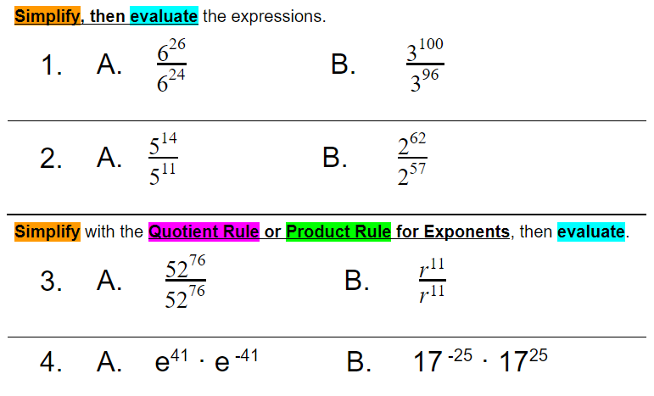
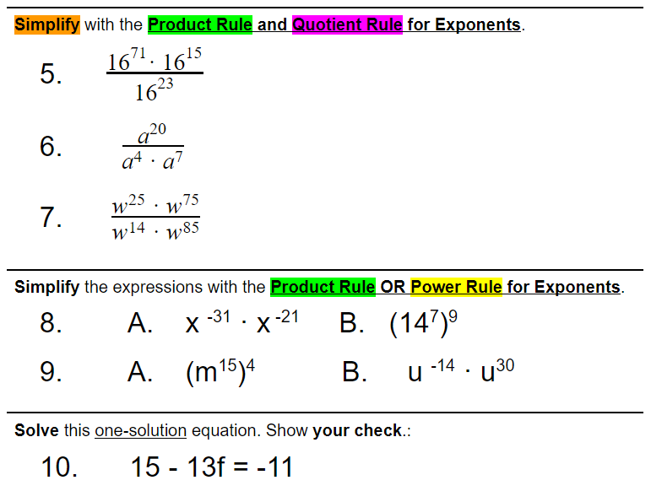
Take a picture and upload (insert) below:

