Project Number: DZT 1507

An Interactive Qualifying Project Report: submitted to the Faculty of
WORCESTER POLYTECHNIC INSTITUTE
in partial fulfillment of the requirements for the
Degree of Bachelor of Science
By

Teng Wang _____________________________

Submitted:
July 20, 2015

Approved by Professor Dalin Tang, Project Advisor

___________________________________________

Abstract
After researching basic knowledge of stock market and stock trading methods, the two-member group conducted two five-week stock trading simulations individually via Investopedia Stock Simulator with two different trading strategies, which were Day trading Strategy and Position Trading Strategy. The stock trading results were compared to determine the most profitable trading skills. The trading experiences learned from this Interactive Qualifying Project (IQP) will benefit team members for successful stock investment in the future.

Acknowledgements
We would like to thank Professor Dalin Tang for teaching and advising for the project, and Investopedia for its stock simulator tool. The simulation with day trading method was done by Jinqiang Ning. The simulation with position trading method was done by Teng Wang.

Table of Contents
Abstract 2
Acknowledgements 3
Table of Figures 6
Table of Tables 8
1. Introduction 10
1.1 Goals 10
1.2 History of the Stock Market 11
1.3 Stocks Types 11
1.4 Benefits of Stock Trading 12
1.5 Key term Definitions 13
2. Methodologies 17
2.1 Overview of Common Trading Methods 17
2.1.1 Day Trading Strategy 17
2.1.2 Position Trading Strategy 17
2.1.3 Swing Trading Strategy 18
2.1.4 Scalping Trading Strategy 18
2.2 Day Trading (Buy-and-Sell) Strategy 19
2.3 Position Trading (Buy-and-Hold) Strategy 21
3. Selection of Stocks 25
3.1 Apple Inc. 25
3.2 Microsoft Corp. 26
3.3 Amazon.com, Inc. 28
3.4 EBay Inc. 29
3.5 Google Inc. 30
3.6 Yahoo Inc. 32
3.7 McDonald’s Corp. 33
3.8 Starbucks Corp. 34
3.9 American Airline Group Inc. 35
3.10 Texas Instrument Inc. 36
4. Day Trading (Buy-and-Sell) Simulations 38
4.1 Week One Simulation Results 38
4.2 Week Two Simulation Results 44
4.3 Week Three Simulation Results 52
4.4 Week Four Simulation Results 57
4.5 Week Five Simulation Results 62
5. Position Trading (Buy-and-Hold) Simulations 68
5.1 Week One Simulation Results 68
5.2 Week Two Simulation Results 75
5.3 Week Three Simulation Results 82
5.4 Week Four Simulation Results 87
5.5 Week Five Simulation Results 94
6. Comparison 100
6.1 Final Stock Value Analysis 100
7. Conclusion 104
Reference 105
Appendix 107

Table of Figures
Figure 2.2.1. Intraday Candle Stick Charter 20
Figure 2.3.1. Channeling Trading Strategy 23
Figure 3.1.1. AAPL Stock Price Trend over Last Three Month 26
Figure 3.2.1. MSFT Stock Price Trend over Last Three Month 27
Figure 3.3.1. AMZN Stock Price Trend over the Last Three Month 29
Figure 3.4.1. EBAY Stock Price Trend over Last Three Month 30
Figure 3.5.1. GOOG Stock Price Trend over the Last Three Month 31
Figure 3.6.1. YHOO Stock Price Trend over the Last Three Month 32
Figure 3.7.1. MCD Stock Price Trend over the Last Three Month 34
Figure 3.8.1. SBUX Stock Price Trend over the Last Three Month 35
Figure 3.9.1. AAL Stock Price Trend over the Last Three Month 36
Figure 3.10.1. TXN Stock Price Trend over the Last Three Month 37
Figure 4.1.1. Week One Total Cash Change 39
Figure 4.1.2. GOOG Stock Price Trend in Week One 41
Figure 4.1.3. AMZN Stock Price Trend in Week One 42
Figure 4.1.4. AAPL Stock Price Trend in Week One 43
Figure 4.1.5. MCD Stock Price Trend in Week One 44
Figure 4.2.1. Week Two Total Cash Change 45
Figure 4.2.2. AAPL Stock Price Trend in Week Two 48
Figure 4.2.3. MSFT Stock Price Trend in Week Two 49
Figure 4.2.4. MCD Stock Price Trend in Week Two 50
Figure 4.2.5. AAL Stock Price Trend in Week Two 51
Figure 4.3.1. Week Three Total Cash Change 53
Figure 4.3.2. MSFT Stock Price Trend in Week Three 56
Figure 4.3.3. EBAY Stock Price Trend in Week Three 57
Figure 4.4.1. Week Four Total Cash Change 58
Figure 4.4.2. GOOG Stock Price Trend in Week Four 61
Figure 4.4.3. AMZN Stock Price Trend in Week Four 62
Figure 4.5.1. Week Five Total Cash Change 63
Figure 4.5.2. GOOG Stock Price Trend in Week Five 66
Figure 4.5.3. AMZN Stock Price Trend in Week Five 67
Figure 5.1.1.MCD Stock Price Trend Line 71
Figure 5.1.2.AMZN Week One Share Price Trend Line 72
Figure 5.1.3.EBAY Week One Share Price Trend Line 73
Figure 5.1.4.SBUX Week One Share Price Trend Line 74
Figure 5.2.1.MCD Week Two Share Price Trend Line 80
Figure 5.3.1.MCD Week Three Share Price Trend Line 87
Figure 5.4.1.MCD Week Four Share Price Trend Line 93
Figure 5.4.2.GOOG Share Price Trend Line in The Last Month 94
Figure 5.5.1.AMZN Price Trend Line in Week Five 99
Figure 5.5.2.AMZN Price Trend Line in June 99
Figure 6.1.1 Overall Day Trading Stock Simulation Total Asset Value Change 100
Figure 6.1.2. Overall Day Trading Stock Simulation Profit Results 101
Figure 6.1.3. Overall Position Trading Stock Simulation Total Asset Value Change 102
Figure 6.1.4. “U” and “N” Shape Price Trend 102
Figure 6.1.5. Increasing Price Trend 103
Figure 6.1.6. Decreasing Price Trend 103

Table of Tables
Table 4.1.1. Week One Day Trading Simulation Results Summary 38
Table 4.1.2. Week Two Day One Day Trading Simulation Results 39
Table 4.1.3. Week One Day Two Day Trading Simulation Results 40
Table 4.1.4. Week One Day Three Day Trading Simulation Results 40
Table 4.1.5. Week One Day Four Day Trading Simulation Results 41
Table 4.2.1. Week Two Day Trading Simulation Results Summary 45
Table 4.2.2. Week Two Day One Day Trading Simulation Results 46
Table 4.2.3. Week Two Day Two Day Trading Simulation Results 46
Table 4.2.4. Week Two Day Three Day Trading Simulation Results 46
Table 4.2.5. Week Two Day Four Day Trading Simulation Results 47
Table 4.2.6. Week Two Day Five Day Trading Simulation Results 47
Table 4.3.1. Week Three Day Trading Simulation Results Summary 52
Table 4.3.2. Week Three Day One Day Trading Simulation Results 53
Table 4.3.3. Week Three Day Two Day Trading Simulation Results 54
Table 4.3.4. Week Three Day Three Day Trading Simulation Results 54
Table 4.3.5. Week Three Day Four Day Trading Simulation Results 55
Table 4.3.6. Week Three Day Five Day Trading Simulation Results 55
Table 4.4.1. Week Four Day Trading Simulation Results Summary 58
Table 4.4.2. Week Four Day One Day Trading Simulation Results 59
Table 4.4.3. Week Four Day Two Day Trading Simulation Results 59
Table 4.4.4. Week Four Day Three Day Trading Simulation Results 60
Table 4.4.5. Week Four Day Four Day Trading Simulation Results 60
Table 4.4.6. Week Four Day Five Day Trading Simulation Results 61
Table 4.5.1. Week Five Day Trading Simulation Results Summary 63
Table 4.5.2. Week Five Day One Day Trading Simulation Results 64
Table 4.5.3. Week Five Day Two Day Trading Simulation Results 64
Table 4.5.4. Week Five Day Three Day Trading Simulation Results 65
Table 4.5.5. Week Five Day Four Day Trading Simulation Results 65
Table 4.5.6. Week Five Day Five Day Trading Simulation Results 65
Table 5.1.1.Positioning Trading Week One Simulation Results 68
Table 5.1.2.Positioning Trading Week One Day One Simulation Results 69
Table 5.1.3.Positioning Trading Week One Day Two Simulation Results 69
Table 5.1.4.Posotioning Trading Week One Day Three Simulation Results 70
Table 5.1.5.Positioning Trading Week One Day Four Simulation Results 70
Table 5.2.1.Positioning Trading Week Two Simulation Results 75
Table 5.2.2.Positioning Trading Week Two Day One Share Price Changes 76
Table 5.2.3.Positioning Trading Week Two Day Two Share Price Changes 76
Table 5.2.4.Positioning Trading Week Two Day Three Share Price Changes 77
Table 5.2.5.Positioning Trading Week Two Day Four Share Price Changes 78
Table 5.2.6.Positioning Trading Week Two Day Four Simulation Results 78
Table 5.2.7.Positioning Trading Week Two Day Five Share Price Changes 79
Table 5.2.8.Positioning Trading Week Two Day Five Simulation Results 79
Table 5.2.9.EBAY Week Two Share Price Changes 81
Table 5.2.10.AAPL Week Two Share Price Changes 81
Table 5.3.1.PositioningTrading Week Three Simulation Results 82
Table 5.3.2.Positioning Trading Week Three Day One Share Price 83
Table 5.3.3.Positioning Trading Week Three Day One Simulation Results 83
Table 5.3.4.Positioning Trading Week Three Day Two Share Price 84
Table 5.3.5.Positioning Trading Week Three Day Three Share Price 84
Table 5.3.6.Positioning Trading Week Three Day Three Simulation Results 85
Table 5.3.7.Positioning Trading Week Three Day Four Share Price 85
Table 5.3.8.Positioning Trading Week Three Day Five Share Price 86
Table 5.4.1.Positioning Trading Week Four Simulation Results 88
Table 5.4.2.Positioning Trading Week Four Day One Share Prices 88
Table 5.4.3.Positioning Trading Week Four Day Two Share Prices 89
Table 5.4.4.Positioning Trading Week Four Day Three Share Prices 90
Table 5.4.5.Positioning Trading Week Four Day Three Simulation Results 90
Table 5.4.6.Positioning Trading Week Four Day Four Simulation Results 91
Table 5.4.7.Positioning Trading Week Four Day Five Share Prices 91
Table 5.4.8.Positioning Trading Week One Day Five Simulation Results 92
Table 5.5.1.Positioning Trading Week Five Simulation Results 94
Table 5.5.2.Positioning Trading Week Five Day One Share Prices 95
Table 5.5.3.Positioning Trading Week Five Day Two Share Prices 96
Table 5.5.4.Positioning Trading Week Five Day Two Simulation Results 96
Table 5.5.5.Positioning Trading Week Five Day Three Share Prices 96
Table 5.5.6.Positioning Trading Week Five Day Four Share Prices 97
Table 5.5.7.Positioning Trading Week Five Day Four Simulation Results 97
Table 5.5.8.Positioning Trading Week Five Day Five Share Prices 98
Table 5.5.9.Positioning Trading Week Five Day Five Simulation Results 98

Introduction
Despite its popularity and presence in the news, the stock market is just one of many potential places to invest your money. Investing stock is often risky, which draws attention to the huge gains and losses of some investors. If you manage the risks, you can take advantage of the stock market to secure your finial position and earn money [1]. There are many advantages of investing in the stock market. By investing in stock market, investors can get investment gains, dividend income, and also diversify their wealth and obtain ownership.

Goals
At the beginning, group members will learn the basic knowledge about stock market and trading methods from their preferred sources such as related websites, newspapers and books. Then, based on online stock simulator, five-week stock market simulation will be conducted individually. In simulation procedure, the basic knowledge of stock market and trading methods will be applied and practiced. Meanwhile, group members will compare invested stocks’ values weekly and discuss their trading skills, to determine further operations. Finally, the total benefits of trading stocks will be compared, and the trading methods will be analyzed to help group members understand how the stock market works, and how investors maximize benefits and minimize risks. The experience obtained from this Interactive Qualifying Project (IQP) will help each group member to become a competent investor in the future.

History of the Stock Market
The market in which shares of publicly held companies are issued and traded either through exchanges or over-the-counter markets. Also known as the equity market, the stock market is one of the most vital components of a free-market economy, as it provides companies with access to capital in exchange for giving investors a slice of ownership in the company. The stock market makes it possible to grow small initial sums of money into large ones, and to become wealthy without taking the risk of starting a business or making the sacrifices that often accompany a high-paying career [2].
Stock change has a long history. The first stock exchange in London was officially formed in1773, which is 19 years before the New York Stock Exchange. Whereas the London Stock Exchange (LSE) was handcuffed by the law restricting shares, the New York Stock Exchange (NYSE) has dealt in the trading of stocks, for better or worse, since inception. The NYSE wasn’t the first stock exchange in United States, however, that honor goes to the Philadelphia Stock Exchange, but it quickly became the most powerful. Last for a few centuries, today’s stock market plays an unreplaceable role in global trades and affects global economies significantly. At the close of 2012, the size of the world stock market (total market capitalization) was about US$55 trillion. By country, the largest market was the United States (about 34%), followed by Japan (about 6%) and the United Kingdom (about 6%). This went up more in 2013 [3].

Stocks Types
There are two types of stock, common stock and preferred stock.
Common stock means having common rights in the management and distribution of the company’s operating and property. It is the basis of a company’s capital and a basic form of stock. And at the same time, it is also the most important stock and has the largest circulation.
Preferred stock has a fixed dividend and the dividend does not fluctuate with the company’s performance. Preferred shareholders usually do not participate in the company’s management. It has smaller risk than common stock. Also there are several main differences between them.
1) The shareholders of common stock have the right to participate in management of the company, while preferred shareholders usually do not have the right to participate in the company’s management.
2) The earning of common stock shareholders is dependent on the company’s profit situation, while the earning of preferred stock shareholders is fixed.
3) Common stock cannot be withdrawn and can only be realized in the secondary market. However, preference shares and preferred shareholders may redeem shares on the attached terms require the company to redeem their shares.
4) Preferred stock is the most important kind of special shares, have priority in the distribution of company profits and surplus property.

Benefits of Stock Trading
Stock Trading is one of the most effective ways of making money and building wealth. It brings huge wealth to investors even high risks exist especially for the investors who are lack of knowledge and experience. There are many advantages of stock trading such as investment gains, dividend income, diversification and ownership.
One of the primary benefits of trading stocks is the chance to earn money and build wealth. Over last a few decades, the stock market tends to rise in value, though the prices of individual stock rises and falls daily. Another benefit of trading stock is dividend income. Some stocks provide income in the form of a dividend, which is similar to bank interest but paid by stocks’ companies annually. Diversification is another benefit of trading stock. For investors who put money into different types of investment products, a stock market investment has the benefit of providing diversification. Stock market investments change value independently of other types of investments, such as bonds and real estate. Holding stock can help you weather losses to other investment products. Stock also adds risk to a portfolio, as well as the potential for large, rapid gains, helping investors avoid risk-averse or overly conservative investment strategies [1] In addition, investors can obtain ownership by buying shares of stock, which means that taking on an ownership stake in the company you purchase stock in. Shareholders have rights to vote depends on the percentage of their holding stocks to make certain business decision for the company. By allowing works to hold the company stocks where they are working for, the works will express loyalty and incentives to contribute more.

Key term Definitions
In order to be a technical investor in stock market, we search some technical stock trading skills and key term definitions, which will be practiced in selection of stocks and trading procedures.
After-hours Deal: The stock market usually closes at 4:00pm. After this scheduled time, deals can also be made but the transaction is dated the next day, known as an after-hours deal.
Balance Sheet: The financial statement which shows the liabilities and assets of a company.
Bargain: Regarding sale or purchase in the stock market, bargain is a common word.
Bearer Stocks: This is the stock that is unregistered with the owner’s name.
Bed and Breakfast Deal: This refers to the sale of share and repurchase on another day. It’s done to set up profit or loss for the purpose of tax.
Bid Price: This term indicates the sale price of stocks or shares.
Blue Button: Refers to the stockbroker’s clerk. Only a blue button is allowed on the trading floor.
Blue Chip: These are shares of big and reputed companies.
Book Value: The net worth of the company as listed on the balance sheet.
Bull: A person who considers the share price of the stock exchange to be on the rise.
Call: An extra installment due on shares.
Capital: The amount of money used for setting up a new business.
Cash Settlement: In the stock exchange, there are certain deals like Gilts which are rendered for cash and not for account settlement. They are settled the next day of the deal.
Contract Note: This is a printed confirmation letter from any broker indicating a bargain which is carried out.
Coupon: Refers to interest amount payable only for fixed interest stock.
Cum Dividend: These are shares that are sold, allowing the buyer to receive the following dividend.
Dawn Raid: Refers to the buying of a huge amount of shares in the morning at the opening of stock market.
Dealing: This means the purchase and sale of shares.
Debenture: The stock that a company issues which are backed by assets.
Depreciation: The amount of money set aside for replacement of the assets.
Dividend: The part of the company’s profits which is usually distributed to company’s shareholders, normally on regular basis.
Equities: These are the ordinary shares. They are different from debenture and also from loan stock.
Ex-dividend: The share which is bought without any right for receiving the next dividend. This is usually retained by sellers.
Final Dividend: This is the dividend which is declared according to the company’s annual results.
Futures: Contracts that allow any holder the legal right to buy or sell Indexes and Commodities in the future at a price set today.
Gross: The interest paid without deducting of tax.
Hedge: This means to insure the risk.
Initial Public Offering: The issue of new shares by a previously private company as it becomes a public company.
Limit Order: This is an order to any stockbroker specifying any fixed price limit.
Liquidation: Converting the prevailing assets to cash.
Loan Stock: The stock that bears a fixed interest rate. It’s different from debenture stock because it’s not required to be secured by any asset.
Nominee: The term refers to a person acting on the behalf of another in the stock market in documentary as well as financial affairs.
Offer Price: Refers to the specific price at which one can buy stocks and shares.
Options: The term means the right to purchase (call option) and sell (put option) a particular share at a particular price within a particular period.
Ordinary Share: This is a share where the dividends usually vary in the amount.
Over the Counter Market (OTC): Refers to a marketplace outside the main stock market.
PLC: This means Public Limited Company (formerly Ltd). In the stock market, some public limited companies are not always quoted.
Portfolio: A selection of shares usually held by a person or fund.
Proxy: Anybody who votes on another person’s behalf if the person is unable to attend a shareholders’ meeting.
Stock: Also referred to share or equity, stock is the basic ownership unit of a company.
Stock Warrants: An instrument that conveys the right to buy additional stock within a fixed time period at a set price. Warrants differ from stock options in the way they are exercised.
Yearlings: Bonds issued for twelve-month term, mainly by local authorities.
Yield: The gross dividend presented as the percentage of the share price [4].

Methodologies

Overview of Common Trading Methods
In stock market, there are four common trading methods such as Day Trading Strategy, Position Trading Strategy, Swing Trading Strategy and Scalping Trading Strategy.

2.1.1 Day Trading Strategy
Day Trading is the most well-known active trading strategy. Day trading is speculation in securities, specifically buying and selling financial instruments within the same trading day. Strictly, day trading is trading only within a day, such that all positions are closed before the market close for the trading day. Many traders may not be so strict or may have day trading as one component of an overall strategy. Traders who participate in day trading are called day traders. Traders who trade in this capacity with the motive of profit are therefore speculators [5]. Traditionally, day trading is done by professional traders, such as specialists or market makers. However, electronic trading has opened up this practice to novice traders. There are some common day-traded financial instruments, which are stocks, options, currencies, and a host of futures contracts such as equity index future, interest rate futures, and commodity futures.

2.1.2 Position Trading Strategy
Position Trading is not active trading strategy. It is also called buy-and-hold strategy. Position trading uses longer term charts, from daily to monthly, in combination with other methods to determine the trend of the current market direction. This type of trade may last for several days to several weeks and sometimes longer, depending on the trend. Trend traders look for successive higher highs or lower highs to determine the trend of a security [6].

2.1.3 Swing Trading Strategy
When a trend breaks, swing traders typically get in the game. At the end of a trend, there is usually some price volatility as the new trend tries to establish itself. Swing traders buy or sell as that price volatility sets in. Swing trades are usually held for more than a day but for a shorter time than trend trades. Swing traders often create a set of trading rules based on technical or fundamental analysis; these trading rules or algorithms are designed to identify when to buy and sell a security [6]. Swing traders hold a particular stock for a period of time, generally a few days or two or three weeks, which is between those extremes, and they will trade the stock on the basis of its intra-week or intra-month oscillations between optimism and pessimism.

2.1.4 Scalping Trading Strategy
Scalping is one of the quickest strategies employed by active traders. It includes exploiting various price gaps caused by bid/ask spreads and order flows. The strategy generally works by making the spread or buying at the bid price and selling at the ask price to receive the difference between the two price points. Scalpers attempt to hold their positions for a short period, thus decreasing the risk associated with the strategy. Additionally, a scalper does not try to exploit large moves or move high volumes; rather, they try to take advantage of small moves that occur frequently and move smaller volumes more often. Since the level of profits per trade is small, scalpers look for more liquid markets to increase the frequency of their trades. And unlike swing traders, scalpers like quiet markets that aren't prone to sudden price movements so they can potentially make the spread repeatedly on the same bid/ask prices.

Day Trading (Buy-and-Sell) Strategy
Day Trading Strategy is one of the primary trading methods. It means that investors will buy and sell financial instruments within the same trading day. However, for our IQP program, we are not very strict with the same day rule and may hold the stock overnight under special conditions.
To maximize profit and minimize risk, there are two things are important for day traders, which are liquidity and volatility in stocks. Market liquidity is a market's ability to facilitate the purchase or sale of an asset without causing drastic change in the asset's price. Equivalently, an asset's market liquidity (or simply "an asset's liquidity") is the asset's ability to sell quickly without having to reduce its price very much. Liquidity is about how big the trade-off is between the speed of the sale and the price it can be sold for. In a liquid market, the trade-off is mild: selling quickly will not reduce the price much. In a relatively illiquid market, selling it quickly will require cutting its price by some amount [7]. Volatility is a measure for variation of price of a financial instrument over time. Historic volatility is derived from time series of past market prices. An implied volatility is derived from the market price of a market traded derivative (in particular an option). The symbol σ is used for volatility, and corresponds to standard deviation, which should not be confused with the similarly named variance, which is instead the square, σ² [8].
In order to decide the entry points, we need to use some tools to get information to guide the buy and sell of stocks. There are three kinds of tools, which are Intraday Candle Stick Charts, Level II Quotes/ECN, and Real-Time News Service.
A candle stick chart that displays the high, low, opening and closing prices for a security for a single day (see Fig.2.2.1). The wide part of the candlestick is called the "real body" and tells investors whether the closing price was higher or lower than the opening price (black/red if the stock closed lower, white/green if the stock closed higher). The candlestick's shadows show the day's high and lows and how they compare to the open and close. A candlestick's shape varies based on the relationship between the day's high, low, opening and closing prices [9].
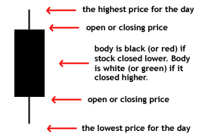
Figure 2.2.1. Intraday Candle Stick Charter
Level II is a trading service consisting of real-time access to the quotations of individual market makers registered in every Nasdaq listed security, as well as market makers' quotes in OTC Bulletin Board securities. Electronic Communication Network (ECN) is an automated system that matches buy and sell orders for securities. An ECN connects major brokerages and individual traders so that they can trade directly between themselves without going through a middleman. The ECN makes money by charging a fee for each transaction. ECNs make it possible for investors in different geographic locations to quickly and easily trade with each other. The Securities and Exchange Commission requires ECNs to register as broker-dealers [10].
Real-time news service is another important tool for stock investors. News moves stocks. Stock is one of the hottest topic for newspapers. There are thousands newspapers report stocks market over the world and some well-known newspapers such as Dow Jones, Wall Street Journal and New York Time have significant influences on world stock market. From 1797 to 1811 in the United States, the New York Price Current was first published. It was apparently the first newspaper to publish stock prices, and also showed prices of various commodities. In 1884 the Dow Jones company published the first stock market averages, and in 1889 the first issue of the Wall Street Journal appeared. As time passed, other newspapers added market pages. The New York Times was first published in 1851, and added stock market tables at a later date [11].

Position Trading (Buy-and-Hold) Strategy
Positioning trading method is one of the most popular trading method on the market. With positioning trading method, we but the stock and hold to see the how the price goes to decide either sell some shares of this stock or buy more shares. Also, there are several types of positioning trading:
Long position
- When a trader buys an option contract that he/she is not short, he/she is said to be opening a long position.
- When a trader sells an option contract that he/she is already long, he/she is said to be closing a long position.
- When a trader is 'long', he/she wins when the price increases, and loses when the price decreases.
Short position
- When a trader sells an option contract that he/she is not long, he/she is said to be opening a short position.
- When a trader buys an option contract that he/she is already short, he/she is said to be closing a short position.
- When a trader is 'short', he/she wins when the price decreases, and loses when the price increases.
Net position
- Net position is the difference between total open long (receivable) and open short (payable) positions in a given asset (security, foreign exchange currency, commodity, etc.) held by an individual. This also refers to the amount of assets held by a person, firm, or financial institution, as well as the ownership status of a person's or institution's investments [12].
For this project, we also chose to use short positioning trading, usually, we trading every one or two days depends on how the market performs.
Many position traders will take a look at weekly or monthly charts to get a sense of where the asset is in a given trend. Position trading is the polar opposite of day trading because the goal is to profit from the move in the primary trend rather than the short-term fluctuations that occur day to day. And there are four steps in positioning trading:
The first step is to use low leverage and using 10:1 or less leverage will allow a trader to stay in the position longer and withstand the day to day fluctuations.
The second step is to go hand in hand with step one and that is to use small position size. Risking 1% of your trading account on any one position trade. Using 250 to 400 pip stops with low leverage and low smaller position size opens the door for 1:10 and 1:20 risk to reward trades.
The third step is to use long time frames like weekly and monthly. By using these time frames, a trader gets the wider perspective and a more complete picture of where price was and where it could potentially go.
The fourth step is to be patient and let the market unfold for your trade setup [13].
And there is another method to help us doing positioning trading: channeling (see Fig.2.3.1). By looking at the channel, we can easily see the trend of a stock and help us to decide whether or not we should sell the stock.
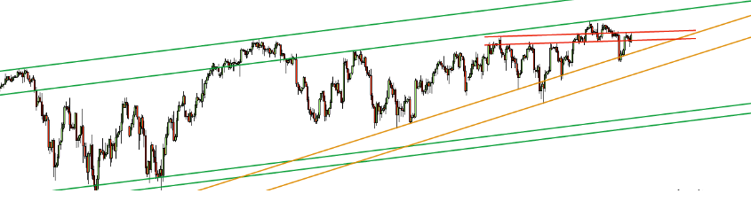
Figure 2.3.1. Channeling Trading Strategy
For example, as we can see in the channeling graph above, the green line show that during the past period of time, the price of this share of stock kept going up and as a positioning trader, buying more of this stock will be a good choice.

Selection of Stocks
The selected stocks are mainly chosen from famous companies in electronic and technology fields. By observing the stock price trend in last year, our group choose ten same stocks for each individuals to start the stock simulation. The chosen stock are Apple Inc., Microsoft Corp., Amazon.com Inc., EBay Inc., Google Inc. C Class, Yahoo! Inc., McDonald’s Corp., Starbucks Corp., American Airlines Group Inc., and Texas Instruments Inc.. The reasons to choose stocks from foods, beverages and airline companies is to reduce investment risks. Based on the researches for stock market, in electronic and technology fields, the market is more active and profitable but also more risky.

Apple Inc.
Apple Inc. is an American multinational technology company in California. It designs, develop and sell electronic products such as Mac line of computers, iPod media player, and iPhone smart phone and iPad tablets. Also, Apple has online storage service such as iCloud, and online stores such as iTunes store and App store where customers can music, video and applications to their Apple electronic devices. Apple was founded and led by previous CEO Steve Jobs and then became the first U.S. company and World’s second largest information technology company, and Apple was valued at over $700 billion in the end of 2014. Apple Inc. has 453 retail store in 16 countries. The stock symbol for Apple Inc. is AAPL. To better understand its stock price change and make proper investment, we need to review its stock price trend chart (see Fig.3.1.1).
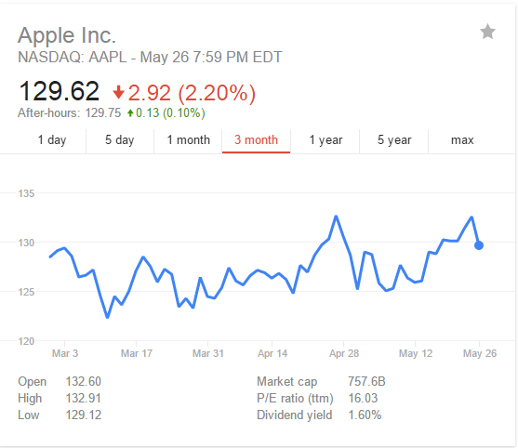
Figure 3.1.1. AAPL Stock Price Trend over Last Three Month

Microsoft Corp.
Microsoft Corp. is an American multinational technology company in Washington. It develops, manufactures, licenses and sell software and electronic hardware. Microsoft has Windows line of operating systems, which has largest amount of users around the world, and Microsoft Office suites includes Word, Excel, PowerPoint, and Outlook etc., and Internet Explorer Web browser. In hardware area, Microsoft has its flagship hardware products – Xbox game consoles, and Microsoft Surface series Tablets. It is the largest software maker measured by revenue around the world. Meanwhile, it is also one of the most valuable companies in the world. The stock symbol for Microsoft Corp. is MSFT. To better understand its stock price change and make proper investment, we need to review its stock price trend chart (see Fig.3.2.1).
The reason of choosing Microsoft Stock (MSFT) for investment is that Microsoft has announced some of new products such as Surface Pro 3 and Surface 3 that obtained huge commercial successes. In addition, Windows 10 system will come out later in this year. We believe that, as more new products coming to the market, more investors will buy MSFT stock and rise the stock price in the future.
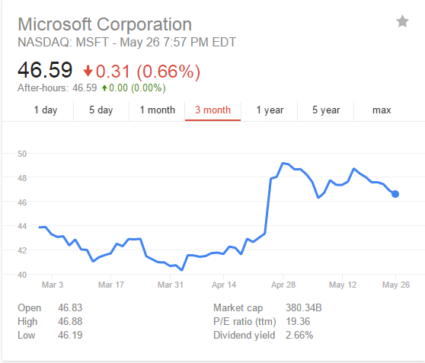
Figure 3.2.1. MSFT Stock Price Trend over Last Three Month

Amazon.com, Inc.
Amazon.com Inc. is an American multinational electronic commerce company in Seattle, Washington. It is the largest online retailer in the United States. Meanwhile, Amazon has separate retail websites for United Kingdom & Ireland, France, Canada, Germany, The Netherlands, Italy, Spain, Australia, Brazil, Japan, China, India and Mexico. It also has international shipping service for certain other countries. Amazon sells almost any products for people’s daily life such as DVDs, Blurays, CDs, vide downloads/streaming, MP3 downloads/streaming, software, video games, electronics, apparel, furniture, food, toys, and jewelry. In addition, Amazon.com produces its own electronics such as Amazon Kindle e-book, Fire tablets, Fire TV and Fire Phone. More important, Amazon’s revenue has reaches US$ 88.988 billion in 2014, and its stock symbol is AMZN. To better understand its stock price change and make proper investment, we need to review its stock price trend chart (see Fig.3.3.1).
The reason we chose trade stocks with Amazon is that Amazon is the largest online retailer in the United States and has continuously increase profit due to increasing number of online customers.
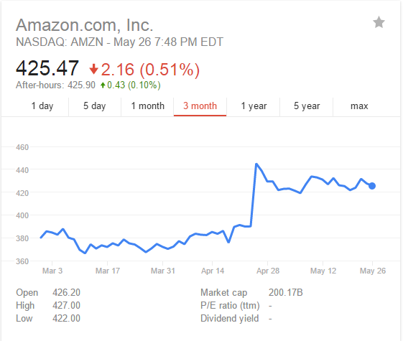
Figure 3.3.1. AMZN Stock Price Trend over the Last Three Month

EBay Inc.
EBay Inc. is American multinational corporation and e-commerce company in California, providing consumer to consumer &business to consumer sales services via Internet. EBay has the second largest online retailer in the United States – EBay.com. Unlike Amazon selling products to customer by themselves, EBay provides a platform for sellers and customers. In 2014, EBay obtained US$ 17.90 billion in revenue. The stock symbol of EBay is EBAY. To better understand its stock price change and make proper investment, we need to review its stock price trend chart (see Fig.3.4.1).
The stock price of EBAY in the last three month are relatively stable and now its price is in the middle range, which is $58.72 per share. The reason of choosing EBAY is that we want to EBAY Stock to reduce investment risks.
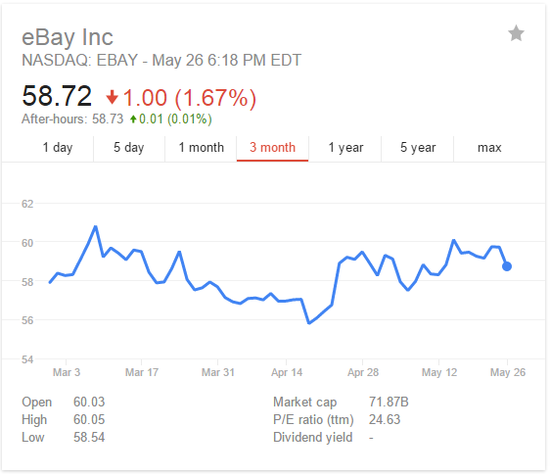
Figure 3.4.1. EBAY Stock Price Trend over Last Three Month

Google Inc.
Google Inc. is an American multinational technology company that mainly focus on Internet-related service and products. These products include online advertising technologies, search, cloud computing, and software. Its most famous product is Google search engine that has largest amount users all around the world. Google Chrome web browser and Google Gmail are also widely used in personal computers. In 2014, Google has obtained US$ 66.001 billion in revenue.
Google announced a 2-for-1 stock split back in January 2014. As a result, Google Stock was spitted into two parts, which were GOOG stock and GOOGL stock. GOOG Stock represents Class C shares, while GOOGL Stock represents Class A shares. The difference between Class C shares and Class A shares is that Class A shares have voting right based on one vote each share rule. The stock we choose to trade with is Google Class C shares, and its stock symbol is GOOG. To better understand its stock price change and make proper investment, we need to review its stock price trend chart (see Fig.3.5.1).

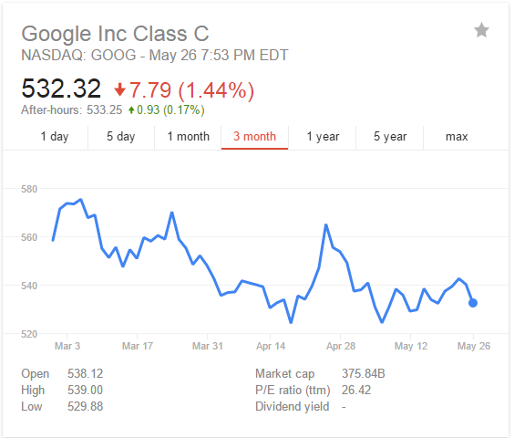
Figure 3.5.1. GOOG Stock Price Trend over the Last Three Month

Yahoo Inc.
Yahoo Inc. (Stock Symbol: YHOO) is a famous American Internet portal and is one of the most important Internet company in the late 20th century. It services include search engines, e-mail service, news, etc. Its services cover 24 countries and regions all over the world. This company also provide a wide range of network services worldwide over 500 million individual users. It is also a global Internet communications, commerce and media company.
Yahoo stock price is at the lower level according to its stock price trend over the last three month (see Fig.3.6.1). We believe that, by choosing Yahoo’s stock at lower price level, investors will obtain high profit in the future because Yahoo Inc. has huge business in many different areas not just a website searching company.
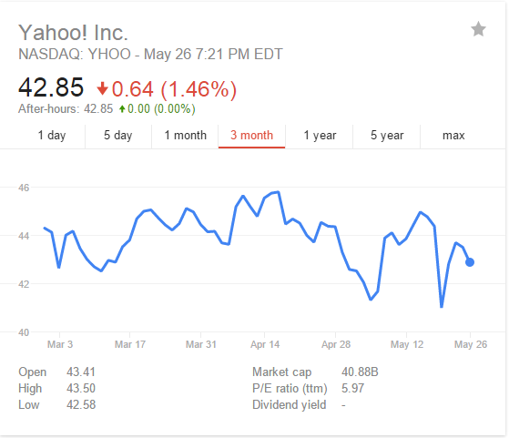
Figure 3.6.1. YHOO Stock Price Trend over the Last Three Month

McDonald’s Corp.
The McDonald's Corporation (Stock symbol: MCD) is the world's largest multinational chain of restaurants, founded in 1940 in the United States. This company has about 30,000 branches. The main selling hamburgers and French fries fried chicken, soft drinks, ice cream, salad, fruit and other snack foods. McDonald's around the world in 119 countries on six continents, with approximately 32,000 branches in many countries represents a kind of American way of life. Because is the first and largest multinational fast-food chain, McDonald's has been a public debate about food can lead to obesity, corporate ethics and consumer responsibility focus represents fast food culture.
Being one of the biggest fast food company in the world, McDonald’s Corporation has a great popularity. As our consideration, this stock will be in rising trend during the next few years because people always need cheap and fast food and there are few rival firms on the market. To better understand its stock price change and make proper investment, we need to review its stock price trend chart (see Fig.3.7.1).
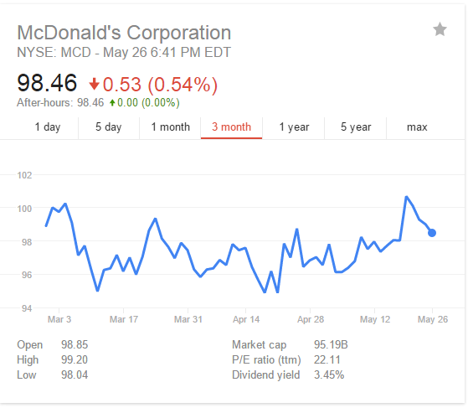
Figure 3.7.1. MCD Stock Price Trend over the Last Three Month

Starbucks Corp.
Starbucks Corporation, (Stock symbol SBUX) is an American chain of coffee company name, established in 1971, is the world's largest coffee chain. Its headquarters is located in Seattle, Washington, USA. Starbucks's retail products include 30 kinds of coffee beans, handmade espresso and a variety of hot and cold coffee drinks, fresh pastries tasty food and a variety of coffee machines, coffee mugs and other merchandise. Starbucks has nearly 21,300 stores throughout North America, South America, Europe, the Middle East and the Pacific on a global scale.
As we can see from the recent stock trend line below (see Fig. 3.8.1), Starbucks kept rising during the last few months. And in our everyday life, a lot of us are used to have a cup of coffee before go to class or work. So from this, we consider coffee has great demand over the market. Then we chose Starbucks, one of the most famous coffee seller in the world.
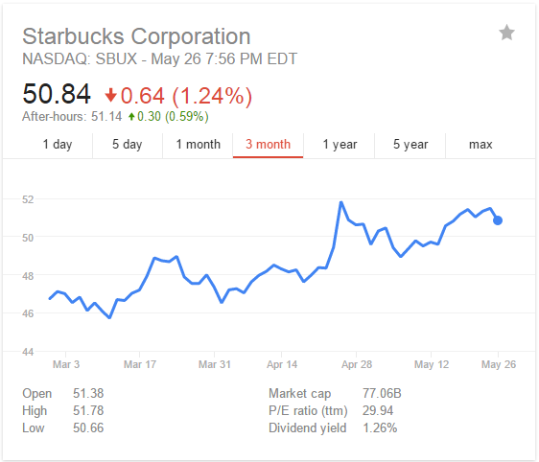
Figure 3.8.1. SBUX Stock Price Trend over the Last Three Month

American Airline Group Inc.
American Airlines, Inc. (Stock symbol AAL) is one of the major airlines in the United State. American Airlines’ history can be traced back to April 15, 1926 Robertson airlines to open e-mail from Chicago to St. Louis transport flights. The company is the second company in the US to contract airmail service. And it later developed into both air freight and air transport. American Airlines is originally a combination of about 82 small airlines and gradually developed into today’s size.
Although the trend line below (see Fig.3.9.1) shows that the American Airline stock kept dropping during the last 3 months, we still consider this stock as a choice. The reason why this stock was not good before is the time. Summer will be a busy season because students are having summer vocation and the stock price will rise during the busy season.
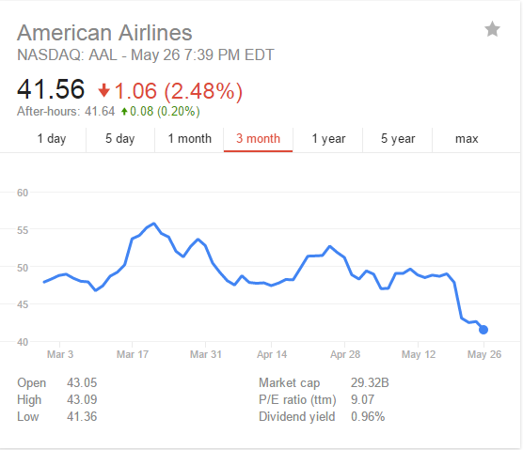
Figure 3.9.1. AAL Stock Price Trend over the Last Three Month

Texas Instrument Inc.
Texas Instruments Inc. (Stock symbol TXN) is one of the world's largest semiconductor companies. This company is committed to delivering innovative semiconductor Technologies to develop the world's most advanced electronic products for its customers. In TI's early stage of development, the company's goal is to use the company's unique technical capabilities fundamentally subvert the traditional market and create a new market.
The reason we chose this company is that almost every student use this company’s calculator. We do not know this company very well and the trend line (see Fig.3.10.1) show that this company was not in good condition over the last 3 months. But we still want to see how this stock will go during the summer.
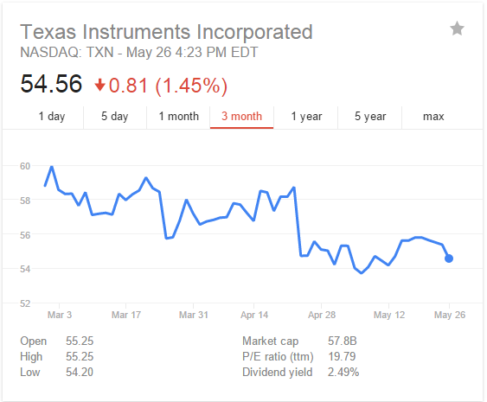
Figure 3.10.1. TXN Stock Price Trend over the Last Three Month

Day Trading (Buy-and-Sell) Simulations

Week One Simulation Results
In week one, as Monday is the Memorial Day, we conducted four days stock trade simulation with selected ten companies by applying day trading strategy, in which we will buy and sell stocks within same day. Here are some explanations for the key terms such as Net Cost, Sell Earning, Profit and Cash. Net Cost is calculated as buy price x shares + commission. Sell Earning is calculated as sell price x shares – commission. In our simulation, we use Investopedia Simulator which use the default commission as $19.99 per transaction. The start account has cash value $100,000. Profit is calculated as Sell Earning – Net Cost. Cash means total amount of cash available for trading stocks with. We record our data as two parts, weekly simulation results summary in one table and daily trading details in separate tables according to each single day.
The weekly stocks simulation results shows in the following Tables (see Table 4.1.1).
Date | Profit | Cash
26-May | -81.9 | 99918.1
27-May | 80.48 | 99998.58
28-May | 222.56 | 100221.1
29-May | 61.76 | 100282.9
Table 4.1.1. Week One Day Trading Simulation Results Summary

In order to understand total cash change weekly and guide our investment, we made the figure of total cash change weekly (see Fig.4.1.1).

Figure 4.1.1. Week One Total Cash Change

Week One Day one Tuesday, May 26 2015
On day one, we trade with five stocks, which are AAPL, MSFT, GOOG, AMAZON and MCD. The detailed trading results are shown in below (see Table 4.1.2). Since day trading investors buy and sell all stock shares within same day, stock shares are only recorded once in detailed trading results table.
Date | Symbol | Shares | Buy Price | Net Cost | Sell Price | Sell Earning | Profit | Cash
26-May | AAPL | 100 | 132.6 | 13279.99 | 132.9 | 13270.01 | -9.98
26-May | MSFT | 150 | 46.83 | 7044.49 | 46.79 | 6998.51 | -45.98
26-May | GOOG | 50 | 538.12 | 26925.99 | 538.79 | 26919.51 | -6.48
26-May | AMZN | 50 | 426.2 | 21329.99 | 426.89 | 21324.51 | -5.48
26-May | MCD | 100 | 98.85 | 9904.99 | 99.11 | 9891.01 | -13.98
Total |  |  |  | 78485.45 |  | 78403.55 | -81.9 | 99918.1
Table 4.1.2. Week Two Day One Day Trading Simulation Results
We do not record cash after sell/buy for each stock because these trades are happening within the same day, and we are able to purchase as long as total cost is smaller than total cash from previous day.

Week One Day two Wednesday, May 27 2015
On week one day two, we invested less to avoid potential loss which happened in day one. The detailed trading results are shown in below (see Table. 4.1.3).
Date | Symbol | Share | Buy Price | Net Cost | Sell Price | Sell Earning | Profit | Cash
27-May | AAPL | 100 | 130.16 | 13035.99 | 131.85 | 13165.01 | 129.02
27-May | MSFT | 100 | 46.82 | 4701.99 | 47.59 | 4739.01 | 37.02
27-May | MCD | 150 | 98.97 | 14865.49 | 98.56 | 14764.01 | -101.48
27-May | SBUX | 130 | 51.14 | 6668.19 | 51.57 | 6684.11 | 15.92
Total |  |  |  | 39271.66 |  | 39352.14 | 80.48 | 99998.58
Table 4.1.3. Week One Day Two Day Trading Simulation Results

Week One Day three Thursday, May 28 2015
On day three, we invested only three stocks after comparing with other stocks. The detailed trading results are shown in below (see Table. 4.1.4).
Date | Symbol | Shares | Buy Price | Net Cost | Sell Price | Sell Earning | Profit | Cash
28-May | AAPL | 150 | 131.86 | 19798.99 | 131.85 | 19757.51 | -41.48
28-May | EBAY | 200 | 62.49 | 12517.99 | 63.21 | 12622.01 | 104.02
28-May | GOOG | 100 | 538.11 | 53830.99 | 540.11 | 53991.01 | 160.02
Total |  |  |  | 86147.97 |  | 86370.53 | 222.56 | 100221.1
Table 4.1.4. Week One Day Three Day Trading Simulation Results

Week One Day four Wednesday, May 29 2015
On day four, we continued to trade with three stocks, which are AMZN, EBAY and YHOO. The detailed trading results are shown in below (see Table. 4.1.5).

Date | Symbol | Shares | Buy Price | Net Cost | Sell Price | Sell Earning | Profit | Cash
29-May | AMZN | 80 | 428.34 | 34287.19 | 431.23 | 34478.41 | 191.22
29-May | EBAY | 100 | 60.65 | 6084.99 | 60.35 | 6015.01 | -69.98
29-May | YHOO | 150 | 43.24 | 6505.99 | 43.11 | 6446.51 | -59.48
Total |  |  |  | 46878.17 |  | 46939.93 | 61.76 | 100282.9
Table 4.1.5. Week One Day Four Day Trading Simulation Results
In the previous week, the main benefit was coming from GOOG stock and AMZN stock, and the loss mainly was mainly due to MCD stock and AAPL stock, I would like to analyze the stocks’ prices trend in last week for these four stocks (see Fig. 4.1.2, 4.1.3, 4.1.4, 4.1.5).
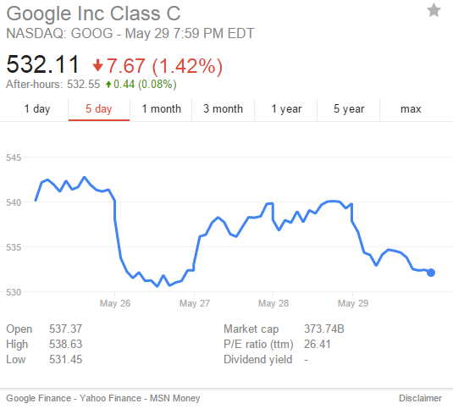
Figure 4.1.2. GOOG Stock Price Trend in Week One

As shown in Figure 4.2.2, there are two big fluctuations happened in last week. To get more profit, we should buy GOOG stock between May 26 and May 28, and then sell them before May 29. In addition, we should buy more GOOG stock in next week because its price is at almost lowest level.
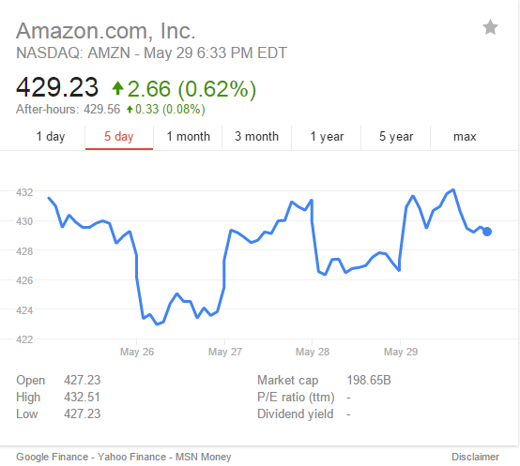
Figure 4.1.3. AMZN Stock Price Trend in Week One

From the Figure 4.1.3, we can see that the AMZN stock price trend is very similar to GOOG stock price trend, in which, there are three big fluctuations happened in last week. Therefore, the fluctuation is preferred for more profit but more risky. We need to buy and sell at proper times to make the difference as gains instead of losses.
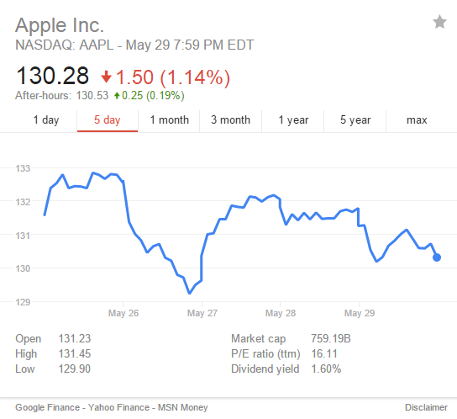
Figure 4.1.4. AAPL Stock Price Trend in Week One
From the Figure 4.1.4, we can see that there is big price drop happened on May 27. The stock price in the beginning of the week is little bit lower that the stock price at the beginning. Overall, one of the big loss from last week is from the price drop on May 27. In addition, the price drop have a sharp end and rose aback very quickly, which is not preferred by novice stock investors.
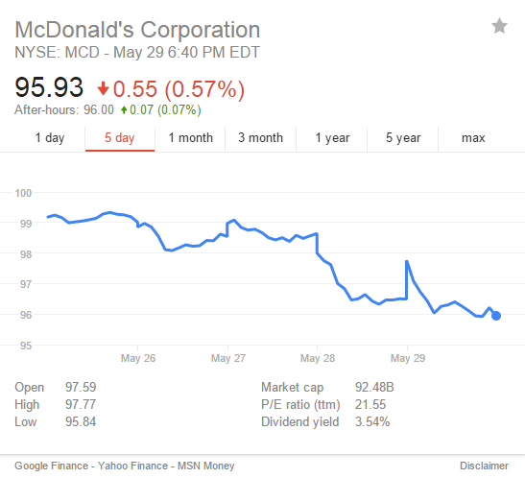
Figure 4.1.5. MCD Stock Price Trend in Week One
From the Fig. 4.1.5, we can see that the main price trend for MCD stocks is decreasing, which causes the loss of the investment. Also, we need to analyze the price trend to sell stocks that have continuously decreasing price trend.

Week Two Simulation Results
In week two, we conducted five days trading simulation and the results are shown in the following table (see Table 4.2.1). Similarly, we record our data as two parts, weekly simulation results summary and daily trading details. From the weekly simulation results table, we can easily see the profit for each single trading day and the amount change of cash in account. From daily detailed trading results, we can see the trading details such as buy/sell price, shares and profit for each stocks daily trading profit.
Date | Profit | Cash
1-Jun | 28.58 | 100311.48
2-Jun | 264.58 | 100576.06
3-Jun | -13.92 | 100562.14
4-Jun | -97.32 | 100464.82
5-Jun | -31.94 | 100279.54
Table 4.2.1. Week Two Day Trading Simulation Results Summary
In order to understand total cash change weekly and guide our investment, a figure of week two daily cash change is made (see Fig.4.2.1).

Figure 4.2.1. Week Two Total Cash Change

Week Two Day one Monday, June 1 2015
On day one, we chose four stocks to trade with, which EBAY, TXN, AAL are and YHOO. The detailed trading results are shown in below (see Table. 4.2.2)

Date | Symbol | Shares | Buy Price | Net Cost | Sell Price | Sell Earning | Profit | Cash
1-Jun | EBAY | 150 | 61.55 | 9252.49 | 62.43 | 9344.51 | 92.02
1-Jun | TXN | 100 | 56.13 | 5632.99 | 55.71 | 5551.01 | -81.98
1-Jun | AAL | 100 | 43.35 | 4354.99 | 44.23 | 4403.01 | 48.02
1-Jun | YHOO | 150 | 43.05 | 6477.49 | 43.12 | 6448.01 | -29.48
Total |  |  |  | 25717.96 |  | 25746.54 | 28.58 | 100311.48
Table 4.2.2. Week Two Day One Day Trading Simulation Results

Week Two Day two Tuesday, June 2 2015
On day two, we continue to trade with four stocks includes AMZN, AAL, EBAY and GOOG. The detailed trading results are shown in below (see Table 4.2.3).
Date | Symbol | Shares | Buy Price | Net Cost | Sell Price | Sell Earning | Profit | Cash
2-Jun | AMZN | 50 | 430.71 | 21555.49 | 432.21 | 21590.51 | 35.02
2-Jun | AAL | 100 | 43.55 | 4374.99 | 43.72 | 4352.01 | -22.98
2-Jun | EBAY | 150 | 62.1 | 9334.99 | 62 | 9280.01 | -54.98
2-Jun | GOOG | 50 | 532.23 | 26631.49 | 539.18 | 26939.01 | 307.52
Total |  |  |  | 61896.96 |  | 62161.54 | 264.58 | 100576.06
Table 4.2.3. Week Two Day Two Day Trading Simulation Results
Week Two Day three Wednesday, June 3 2015
On day three, we traded with AMZN and GOOG that earned benefits from previous day, and two other stocks, which are MSFT and YHOO. The detailed trading results are shown in below (see Table 4.2.4).
Date | Symbol | Shares | Buy Price | Net Cost | Sell Price | Sell Earning | Profit | Cash
3-Jun | AMZN | 100 | 435.26 | 43545.99 | 436.59 | 43639.01 | 93.02
3-Jun | GOOG | 50 | 539.91 | 27015.49 | 541.39 | 27049.51 | 34.02
3-Jun | MSFT | 100 | 47.37 | 4756.99 | 46.85 | 4665.01 | -91.98
3-Jun | YHOO | 100 | 43.3 | 4349.99 | 43.21 | 4301.01 | -48.98
Total |  |  |  | 79668.46 |  | 79654.54 | -13.92 | 100562.14
Table 4.2.4. Week Two Day Three Day Trading Simulation Results

Week Two Day four Thursday, June 4 2015
On day four, we chose stocks that have lower price per share to reduce the investment risk. The detailed trading results are shown in below (see Table 4.2.5).
Date | Symbol | Shares | Buy Price | Net Cost | Sell Price | Sell Earning | Profit | Cash
4-Jun | AAPL | 100 | 129.12 | 12931.99 | 129.36 | 12916.01 | -15.98
4-Jun | AAL | 100 | 42.99 | 4318.99 | 42.17 | 4197.01 | -121.98
4-Jun | AMZN | 80 | 434.4 | 34771.99 | 436.17 | 34873.61 | 101.62
4-Jun | YHOO | 100 | 43.09 | 4328.99 | 42.88 | 4268.01 | -60.98
Total |  |  |  | 56351.96 |  | 56254.64 | -97.32 | 100464.82
Table 4.2.5. Week Two Day Four Day Trading Simulation Results

Week Two Day five Friday, June 5 2015
On day five, we chose three stocks to trade with because, from last week experience, it is more possible to loss on last day of the week. The detailed trading results are show in below (see Table 4.2.6).
Date | Symbol | Shares | Buy Price | Net Cost | Sell Price | Sell Earning | Profit | Cash
5-Jun | MCD | 100 | 95.93 | 9612.99 | 95.62 | 9542.01 | -70.98
5-Jun | SBUX | 150 | 51.57 | 7755.49 | 52.19 | 7808.51 | 53.02
5-Jun | MSFT | 100 | 46.31 | 4650.99 | 46.57 | 4637.01 | -13.98
Total |  |  |  | 22019.47 |  | 21987.53 | -31.94 | 100279.54
Table 4.2.6. Week Two Day Five Day Trading Simulation Results

In the precious week, the main losses were from AAPL, MSFT, MCD and AAL stocks. Therefore, it is necessary to analyze the price trend for these stocks in week two to find the reasons (see Fig. 4.2.2, 4.2.3, 4.2.4, 4.2.5).
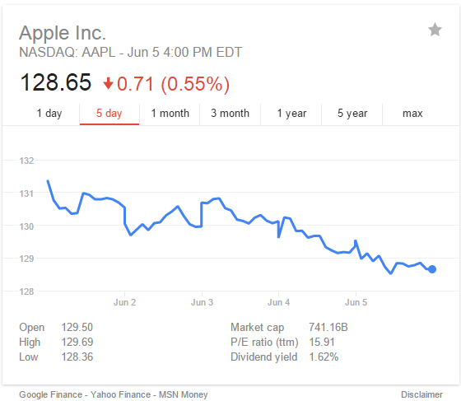
Figure 4.2.2. AAPL Stock Price Trend in Week Two
As shown in Figure 4.2.2, the price trend of AAPL stock was continuously drop over week two. We should avoid to invest on stocks that have this type price trend. Since Apple has announced any new products recently, there is no incentive to more investors to buy its stock. In addition, the price of AAPL Stock has reached a highest point at the end of week one. Therefore, to avoid stock that has continuously decreasing price trend, we should avoid to buy stocks which prices are at high level.
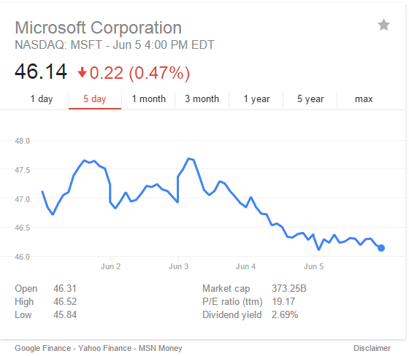
Figure 4.2.3. MSFT Stock Price Trend in Week Two
From the Figure 4.2.3, we can see that the price trend of MSFT stock is matched with the account value change. There is “U” shape between June 2 and June 3, and it is the only proper time in week two to make investment. After June 3, the stock price is continuously dropping, which is the reason for the total losses in week two.
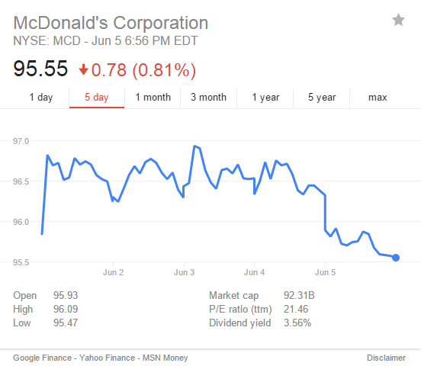
Figure 4.2.4. MCD Stock Price Trend in Week Two
From the Figure 4.2.4, we can see many fluctuations in price trend of MCD stock in week two. There is a sharp rise at the beginning of week two and gradual dropping in the end of week two. It is not preferred to invest stocks that has this type of price trend. However, the entire trend of MCD stock in this week is “N” shape and stock price is at lowest level, therefore, we are supposed to predict that another “U” shape will happen in next week. So, it is worth to buy more shares of MCD stock to earn benefits in week three.

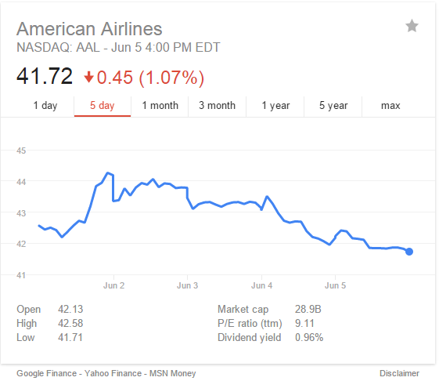
Figure 4.2.5. AAL Stock Price Trend in Week Two
From the Figure 4.2., we can see that the price trend of AAL stock is also matched with the account value change figure. There is increasing price trend at the first half of week two and decreasing price trend at the second half of week two.
Overall, in week two, the price trends of trading stocks are “U” shape, which means that investors should invest more at beginning of the week to earn more profit and invest less at the second half of the week to avoid potential losses. In addition, from the experience of two weeks trading simulation, the amount change of daily stock trading should be increased rather than small adjustments.

Week Three Simulation Results
In week three, we conducted five days simulation with day trading method. The simulation results were record in below table (see Table 4.3.1). In order to maximize our trading profit, we decided to hold stocks for more profit instead of selling all stocks at the end of each day.
From the simulation results, we can see that it is easier to obtain profit because we monitor price change all the time and seek for the price difference to buy/sell. We usually sell out our stock even with a small amount of loss to keep our profit as we are not sure about the next day’s price trend.
Date | Profit | Cash
8-Jun | 204.56 | 100637.44
9-Jun | 128.06 | 100765.5
10-Jun | -21.92 | 100743.58
11-Jun | 173.06 | 100916.64
12-Jun | 54.02 | 100970.66
Table 4.3.1. Week Three Day Trading Simulation Results Summary
In order to understand total cash change weekly and guide our investment, we made the figure of total cash change weekly (see Fig.4.3.1).

Figure 4.3.1. Week Three Total Cash Change

Week Three Day one Monday, June 8 2015
On day one, we traded with three stocks including AMZN, AAPL, and YHOO. The detailed trading results are show in below (see Table 4.3.2). We record buy/sell price, shares, total cost and earning, total profit and cash. The reason we only record total cash is that we are able to purchase stocks as long as the net cost is smaller than the cash form last week.
Date | Symbol | Shares | Buy Price | Net Cost | Sell Price | Sell Earning | Profit | Cash
8-Jun | AMZN | 100 | 422.42 | 42261.99 | 423.71 | 42351.01 | 89.02
8-Jun | AAPL | 150 | 127.35 | 19122.49 | 128.24 | 19216.01 | 93.52
8-Jun | YHOO | 200 | 42.04 | 8427.99 | 42.35 | 8450.01 | 22.02
Total |  |  |  | 69812.47 |  | 70017.03 | 204.56 | 100637.44
Table 4.3.2. Week Three Day One Day Trading Simulation Results

Week Three Day two Tuesday, June 9 2015
On day two, we were continuing to trade with three stocks, AAPL, MSFT and AMZN. The detailed trading results are show in below (see Table 4.3.3).
Date | Symbol | Shares | Buy Price | Net Cost | Sell Price | Sell Earning | Profit | Cash
9-Jun | AAPL | 100 | 126.34 | 12653.99 | 126.83 | 12663.01 | 9.02
9-Jun | MSFT | 150 | 45.94 | 6910.99 | 45.76 | 6844.01 | -66.98
9-Jun | AMZN | 100 | 422.96 | 42315.99 | 425.22 | 42502.01 | 186.02
Total |  |  |  | 61880.97 |  |  | 128.06 | 100765.5
Table 4.3.3. Week Three Day Two Day Trading Simulation Results

Week Three Day three Tuesday, June 10 2015
On day three, we decide to trade with more stocks with lower total cost to reduce investment risk. The detailed trading results are show in below (see Table 4.3.4).
Date | Symbol | Shares | Buy Price | Net Cost | Sell Price | Sell Earning | Profit | Cash
10-Jun | EBAY | 100 | 60.94 | 6113.99 | 60.47 | 6027.01 | -86.98
10-Jun | MCD | 100 | 95.01 | 9520.99 | 95.3 | 9510.01 | -10.98
10-Jun | SBUX | 100 | 51.66 | 5185.99 | 52.69 | 5249.01 | 63.02
10-Jun | GOOG | 50 | 536.35 | 26837.49 | 537.41 | 26850.51 | 13.02
Total |  |  |  | 47658.46 |  | 47636.54 | -21.92 | 100743.58
Table 4.3.4. Week Three Day Three Day Trading Simulation Results

Week Three Day four Tuesday, June 11 2015
On day four, we trade with less stocks and less shares since the previous experience telling us that it is easier to loss in the second half of each week. The detailed trading results are show in below (see Table 4.3.5).

Date | Symbol | Shares | Buy Price | Net Cost | Sell Price | Sell Earning | Profit | Cash
11-Jun | AAL | 100 | 40.12 | 4031.99 | 41.05 | 4085.01 | 53.02
11-Jun | AMZN | 50 | 432.39 | 21639.49 | 436.21 | 21790.51 | 151.02
11-Jun | MCD | 100 | 95.5 | 9569.99 | 95.59 | 9539.01 | -30.98
Total |  |  |  | 35241.47 |  | 35414.53 | 173.06 | 100916.64
Table 4.3.5. Week Three Day Four Day Trading Simulation Results

Week Three Day five Tuesday, June 12 2015
On day five, we were expecting that the stock market main trend was loss. Therefore, we only invest one stock with more shares so that we can pay more attention about the price change to earn profit. The detailed trading results are show in below (see Table 4.3.6).
Date | Symbol | Shares | Buy Price | Net Cost | Sell Price | Sell Earning | Profit | Cash
12-Jun | SBUX | 200 | 52.16 | 10451.99 | 52.63 | 10506.01 | 54.02
Total |  |  |  | 10451.99 |  | 10506.01 | 54.02 | 100970.66
Table 4.3.6. Week Three Day Five Day Trading Simulation Results
We were experiencing a minor loss mainly from the investment of stocks MSFT and EBAY. Therefore, we would like to analyze the price trend of these three stocks in last week (see Fig. 4.3.2, 4.3.3).
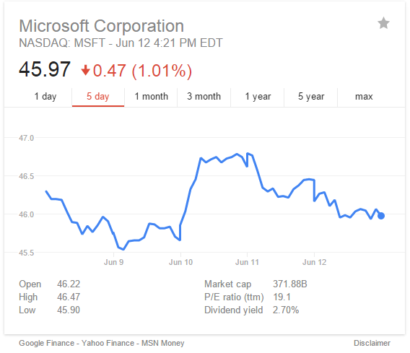
Figure 4.3.2. MSFT Stock Price Trend in Week Three
From the Figure 4.3.2, we can see the price change of MSFT stock has a big rise on June 10. However, the loss happened for our stock was on June 9 since there were relatively small price drop at the end of June 9, compared with price rise on June 10. Therefore, in the future, we should hold some stocks shortly to earn profits. In addition, small fluctuation can also cause a noticeable loss with trading lots of shares.
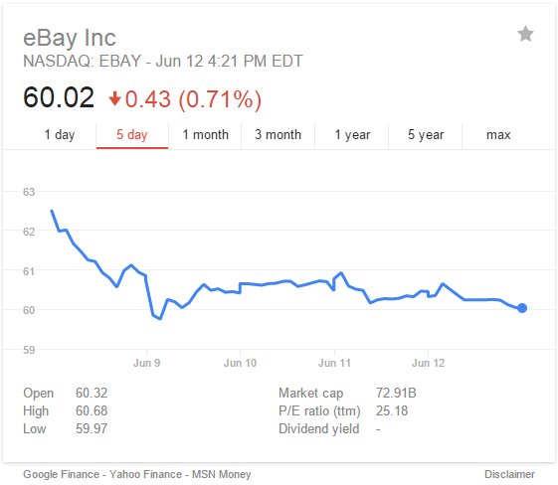
Figure 4.3.3. EBAY Stock Price Trend in Week Three
In Figure 4.3.3, we can see that the main price trend was dropping after first day of the week. For the stock with this type of price trend, it is harder to get profits as there are no big price rising curve. Usually, after price dropping, there should be a price rising period right after but this one is different from the usual case.

Week Four Simulation Results
In week four, we conducted a five-day day trading simulation via Investopedia simulator. Form the precious trading experience, we believed that the main price trend would rise on first half of the week and then drop on the second half. Therefore, we chose to trade more on first half of the week and then trade less. The week four simulation results are shown in below table (see Table 4.4.1). In the future, we decide to buy less stocks with more shares for each stock because commission fee ($19.99) will take high percentage if we buy more stocks with less shares per stock.
Date | Profit | Cash
15-Jun | 69.08 | 101039.74
16-Jun | 174.58 | 101214.32
17-Jun | 97.56 | 101311.88
18-Jun | 1131.06 | 102442.94
19-Jun | -306.46 | 102136.48
Table 4.4.1. Week Four Day Trading Simulation Results Summary
In order to understand total cash change weekly and guide our investment, we made the figure of total cash change weekly (see Fig.4.4.1).

Figure 4.4.1. Week Four Total Cash Change

Week Four Day one Monday, June 15 2015
On day one, we started to trade with four stocks, which were AAPL, AMZN, GOOG and YHOO stocks. The detailed trading results are shown in below table (see Table 4.4.2).
Date | Symbol | Shares | Buy Price | Net Cost | Sell Price | Sell Earning | Profit | Cash
15-Jun | AAPL | 100 | 126.12 | 12631.99 | 127.01 | 12681.01 | 49.02
15-Jun | AMZN | 50 | 425.65 | 21302.49 | 427.12 | 21336.01 | 33.52
15-Jun | GOOG | 50 | 528 | 26419.99 | 528.22 | 26391.01 | -28.98
15-Jun | YHOO | 150 | 94.55 | 14202.49 | 94.92 | 14218.01 | 15.52
Total |  |  |  | 74556.96 |  | 74626.04 | 69.08 | 101039.74
Table 4.4.2. Week Four Day One Day Trading Simulation Results

Week Four Day two Tuesday, June 16 2015
On day two, we continued to trade with four stocks, which were MSFT, YHOO, EBAY and SBUX stocks. The detailed trading results are shown in below table (see Table 4.4.3).
Date | Symbol | Shares | Buy Price | Net Cost | Sell Price | Sell Earning | Profit | Cash
16-Jun | MSFT | 150 | 45.38 | 6826.99 | 45.52 | 6808.01 | -18.98
16-Jun | YHOO | 200 | 40.35 | 8089.99 | 41.22 | 8224.01 | 134.02
16-Jun | EBAY | 100 | 60.01 | 6020.99 | 60.55 | 6035.01 | 14.02
16-Jun | SBUX | 150 | 52.55 | 7902.49 | 53.12 | 7948.01 | 45.52
Total |  |  |  | 28840.46 |  | 29015.04 | 174.58 | 101214.32
Table 4.4.3. Week Four Day Two Day Trading Simulation Results

Week Four Day three Wednesday, June 17 2015
On day three, we traded with three stocks to reduce potential risks based on our previous trading experience. We were continuous earning profits from our investment. However, there is no high profit (over hundred dollars for each single stock trade) because we buy/sell over a short period, in which, it is less possible to see high price change. The detailed trading results are shown in below (see Table 4.4.4).
Date | Symbol | Shares | Buy Price | Net Cost | Sell Price | Sell Earning | Profit | Cash
17-Jun | EBAY | 200 | 60.55 | 12129.99 | 60.92 | 12164.01 | 34.02
17-Jun | MCD | 200 | 94.6 | 18939.99 | 95.22 | 19024.01 | 84.02
17-Jun | TXN | 150 | 53.31 | 8016.49 | 53.44 | 7996.01 | -20.48
Total |  |  |  | 39086.47 |  | 39184.03 | 97.56 | 101311.88
Table 4.4.4. Week Four Day Three Day Trading Simulation Results

Week Four Day four Thursday, June 18 2015
On day four, we were continuing to choose three stocks to trade, which were MSFT, GOOG and AMZN stocks. The trade with GOOG and AMZN stocks brought us profits of $418.42 and $677.62 respectively. The detailed trading results are shown in below (see Table 4.4.5).
Date | Symbol | Shares | Buy Price | Net Cost | Sell Price | Sell Earning | Profit | Cash
18-Jun | MSFT | 150 | 46.22 | 6952.99 | 46.72 | 6988.01 | 35.02
18-Jun | GOOG | 80 | 531 | 42499.99 | 536.73 | 42918.41 | 418.42
18-Jun | AMZN | 80 | 430.42 | 34453.59 | 439.39 | 35131.21 | 677.62
Total |  |  |  | 83906.57 |  | 85037.63 | 1131.06 | 102442.94
Table 4.4.5. Week Four Day Four Day Trading Simulation Results

Week Four Day five Friday, June 19 2015
On day five, we decided to trade less to avoid loss because it has a high possibility to loss on Friday from previous trading experience. However, we still lost $306.46 on Friday. The reason that we sell stocks with losses is to avoid potential big losses. The detailed trading results are shown in below (see Table 4.4.6).

Date | Symbol | Shares | Buy Price | Net Cost | Sell Price | Sell Earning | Profit | Cash
19-Jun | MCD | 200 | 54.08 | 10835.99 | 53.93 | 10766.01 | -69.98
19-Jun | AMZN | 50 | 440.26 | 22032.99 | 436.33 | 21796.51 | -236.48
Total |  |  |  | 32868.98 |  | 32562.52 | -306.46 | 102136.48
Table 4.4.6. Week Four Day Five Day Trading Simulation Results
Since the most of profits we earned in this week were from trading with GOOG and AMZN stocks on day four. It is necessary to analyze the price trends for these two stocks in last week (see Fig.4.3.2 and Fig.4.3.3).
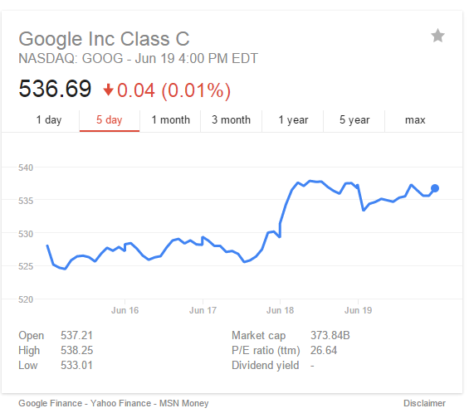
Figure 4.4.2. GOOG Stock Price Trend in Week Four
As shown in Figure 4.4.2, for GOOG stock in week four, there was a big price rising happened on June 18. In addition, the main price trend for GOOG stock in week four are rising. This type of price trend is preferred because we usually trade more in earlier time of each week and trade less in later of each week. On June 18, GOOG stock price rose from $530.79 to $538.15.
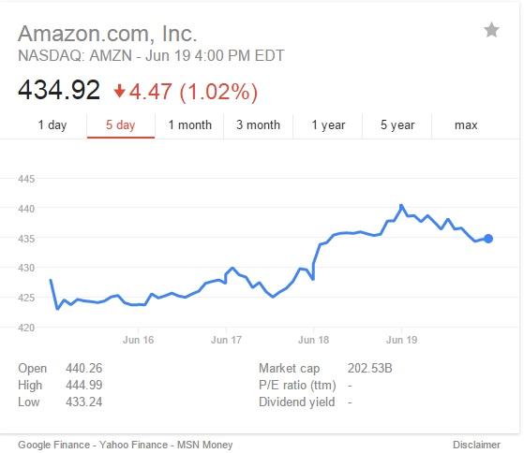
Figure 4.4.3. AMZN Stock Price Trend in Week Four
From the Figure 4.4.3, we can see that the price trend of AMZN stock in week four is very similar to GOOG stock price trend. The both main trends were rising and high price rising happened on June 18. For AMZN stock, its price on June 18 has lowest price $429.40 and highest price $439.73.

Week Five Simulation Results
In week five, we conducted a five-day stock trading simulation with Investopedia simulator. In this week, we decide to trade less stocks with more shares per stock. Therefore, we are able to pay more attention to the stock price change. Also, the commission fee will take less weight in total profit. From the previous trading experience, we realized that day trading method (trading very frequently) is relatively easier to earn profit but more time consuming because we need to monitor stocks price change all the time and trade much more frequently. The detailed week five trading summary is shown in below table (see Table 4.5.1).
Date | Profit | Cash
22-Jun | 286.46 | 102422.94
23-Jun | 737.86 | 103160.8
24-Jun | 115.04 | 103275.84
25-Jun | 94.04 | 103369.88
26-Jun | -28.96 | 103340.92
Table 4.5.1. Week Five Day Trading Simulation Results Summary
In order to understand the trend of total cash change in week five, we made the figure of total cash change weekly (see Fig.4.5.1).

Figure 4.5.1. Week Five Total Cash Change

Week Five Day one Monday, June 22 2015
On day one, we chose three stock to trade with, which were MCD, AMZN and GOOG. This time, we traded more shares per stock. We earned $236.02 from GOOG stock, and the buy/sell price difference was $2.95.The detailed trading results are shown in below (see Table.4.5.2).
Date | Symbol | Shares | Buy Price | Net Cost | Sell Price | Sell Earning | Profit | Cash
22-Jun | MCD | 100 | 96.31 | 9650.99 | 96.87 | 9667.01 | 16.02
22-Jun | AMZN | 80 | 436.32 | 34925.59 | 437.25 | 34960.01 | 34.42
22-Jun | GOOG | 80 | 538.65 | 43111.99 | 542.1 | 43348.01 | 236.02
Total |  |  |  | 87688.57 |  | 87975.03 | 286.46 | 102422.94
Table 4.5.2. Week Five Day One Day Trading Simulation Results

Week Five Day two Tuesday, June 23 2015
On day two, we continued to trade with three stocks, which were YHOO, AMZN and TXN stocks. We earned $736.82 from AMZN stock, and the buy/sell price difference was $9.21. The detailed trading results are shown in below (see Table. 4.5.3)
Date | Symbol | Shares | Buy Price | Net Cost | Sell Price | Sell Earning | Profit | Cash
23-Jun | YHOO | 150 | 40.62 | 6112.99 | 40.75 | 6092.51 | -20.48
23-Jun | AMZN | 80 | 436.11 | 34908.79 | 445.82 | 35645.61 | 736.82
23-Jun | TXN | 150 | 54.82 | 8242.99 | 55.23 | 8264.51 | 21.52
Total |  |  |  | 49264.77 |  | 50002.63 | 737.86 | 103160.8
Table 4.5.3. Week Five Day Two Day Trading Simulation Results

Week Five Day three Wednesday, June 24 2015
On day three, we chose only two stocks to trade with, which were AAPL and EBAY. Form the detailed trading results on day three and day four (see Table. 4.5.4 and Table 4.5.5), we can see that the lower price stock has less possibility to have a big buy/sell prices difference. Therefore, we need to buy more shares for the low price stock to earn more profits. Meantime, Trading with high price stocks is more risky due to the big buy/sell price difference.
Date | Symbol | Shares | Buy Price | Net Cost | Sell Price | Sell Earning | Profit | Cash
24-Jun | AAPL | 150 | 127.91 | 19206.49 | 128.85 | 19307.51 | 101.02
24-Jun | EBAY | 200 | 62.02 | 12423.99 | 62.29 | 12438.01 | 14.02
Total |  |  |  | 31630.48 |  | 31745.52 | 115.04 | 103275.84
Table 4.5.4. Week Five Day Three Day Trading Simulation Results

Week Five Day four Thursday, June 25 2015
Date | Symbol | Shares | Buy Price | Net Cost | Sell Price | Sell Earning | Profit | Cash
25-Jun | SBUX | 200 | 54.09 | 10837.99 | 54.4 | 10860.01 | 22.02
25-Jun | TXN | 200 | 53.83 | 10785.99 | 54.39 | 10858.01 | 72.02
Total |  |  |  | 21623.98 |  | 21718.02 | 94.04 | 103369.88
Table 4.5.5. Week Five Day Four Day Trading Simulation Results

Week Five Day five Friday, June 26 2015
On day five, we traded with two stocks, which were MCD and GOOG. We lost about a hundred dollars from the trading with GOOG stock. The detailed trading results are show in below (seeTable.4.5.6).
Date | Symbol | Shares | Buy Price | Net Cost | Sell Price | Sell Earning | Profit | Cash
26-Jun | MCD | 100 | 96.13 | 9632.99 | 97.22 | 9702.01 | 69.02
26-Jun | GOOG | 100 | 535.44 | 53563.99 | 534.86 | 53466.01 | -97.98
Total |  |  |  | 63196.98 |  | 63168.02 | -28.96 | 103340.92
Table 4.5.6. Week Five Day Five Day Trading Simulation Results
In week five, the main trading profits were coming from GOOG stock trading on day one, and AMZN stock trading on day two. The main loss was caused due to GOOG stock trading on day five. Therefore, it is necessary to analyze the price trend of GOOG stock (see Fig. 4.5.2) and AMZN stock (see Fig.4.5.3) in week five.
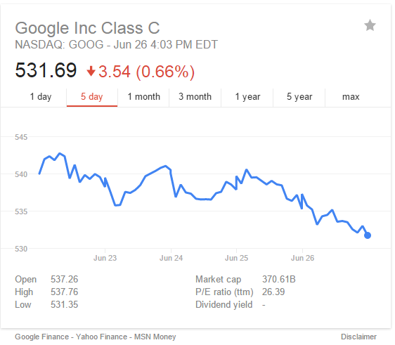
Figure 4.5.2. GOOG Stock Price Trend in Week Five
From the Figure 4.5.2, we can see that on June 22, the difference of high and low price is about three dollars. Since we bought 80 shares of GOOG stock in the day one morning and sold all in the noon, we earned $236.02 from the trading. Start from June 25, the main price trend of GOOG was dropping, which caused the loss.
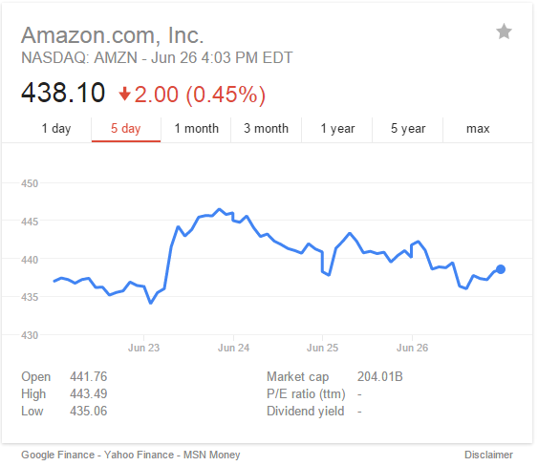
Figure 4.5.3. AMZN Stock Price Trend in Week Five
In above Figure 4.5.3, we can see that on June 23, the AMZN stock price difference at highest and lowest was more than $10. We traded 80 shares on day two and earned $736.82. This is the most profitable over the last five weeks simulation. The main price trend of AMZN stock in week five was “n” shape, which is preferred in stock investment.

Position Trading (Buy-and-Hold) Simulations

Week One Simulation Results
In the last week, we only simulated for 4 days because Monday was the Memorial Day. Since it was the first week of the simulation, the total earned was about 400 dollars, which was not so much. But this week’s experience of trading helped me to learn the trading system better and I think the profit will keep going up in the next few weeks. When I decide to buy a stock, the market will not respond immediately and only shows ‘buy market’. So it is also important to predict how the stock trend line goes.
Also from this week’s simulation, I found that the stock price was not steady at all. If one stock’s price increased 2 percent on the first day, the price could drop by 3 percent or more the very next day. And as a stock trader, what we want is definitely earn more money. So a good choice to decide whether we should buy or sell a share of stock is to look into the stock price trend line over the past several weeks or even months, so that we can predict the future price more precisely. And the stock simulating results are shown in the following table: (See Table 5.1.1)
Date | Profit ($) | Cash ($)
5/26/2015 | 0 | 6084.1
5/27/2015 | -11.89 | 7728.62
5/28/2015 | -16.28 | 6018.61
5/29/2015 | -4.77 | 1660.83
Table 5.1.1.Positioning Trading Week One Simulation Results

Week One Day one Tuesday, May 26 2015
This was the first day of the simulation. I bought stock from 10 companies: APPLE INC; MICROSOFT CORP; AMAZON.COM INC; EBAY INC; GOOGLE INC; YAHOO INC; MCDONALD'S CORP; STARBUCKS CORP; AMERICAN AIRLINES GROUP INC and TEXAS INSTRUMENTS INC. Since my trading method was positioning trading and it was the first day of the whole simulation, I did not make any changes of the stock. And the result of the first day is shown in below table (see Table 5.1.2).
Week One | Date | Symbol | Buy Price | Shares | Net Cost | cash
day1 | May-26 | AAPL | 130.59 | 50 | 6549.49
 | May-26 | MSFT | 46.43 | 100 | 4662.99
 | May-26 | GOOG | 530.97 | 50 | 26568.49
 | May-26 | AMZN | 425.44 | 50 | 21291.99
 | May-26 | MCD | 98.25 | 100 | 9844.99
 | May-26 | EBAY | 59.05 | 100 | 5924.99
 | May-26 | YHOO | 42.86 | 100 | 4305.99
 | May-26 | SBUX | 50.99 | 100 | 5118.99
 | May-26 | AAL | 41.69 | 100 | 4188.99
 | May-26 | TXN | 54.39 | 100 | 5458.99
sum |  |  |  |  | 93915.9 | 6084.1
Table 5.1.2.Positioning Trading Week One Day One Simulation Results

The Week One Day two Wednesday, May 27 2015
On the second day, all of the stock prices increased, which indicated that the choice of the company was successful. Most of the stock prices increase by about 1%, but the American Airline increase over 2% and McDonald’s Corp almost remained the same. And I think American Airline will perform well in the next few days. So I decided to buy 30 shares of American Airline and sell 30 shares of McDonald’s Corp. (See Table 5.1.3)

Date | Symbol | Buy/sell Price | Shares | Net Cost | Sell Earning | Profit | Total Profit | cash
May-27 | AAL | 42.37 | 30 | 1291.09
May-27 | MCD | 98.52 | 30 |  | 2935.61 | -11.89 | -11.89 | 7728.62
Table 5.1.3.Positioning Trading Week One Day Two Simulation Results

Week One Day three Thursday, May 28 2015
The third day of the simulation was definitely a bad day. All the stock prices except EBAY and STARBUCKS decreased. The stock price of McDonald’s Corp decreased about 2% and this showed that the selling action on the first day was correct. Although most of the stock prices dropped, only MCD’s total gain is negative. And for this day, I decided to sell 40 shares of YAHOO INC. (See Table 5.1.4)
Date | Symbol | Sell Price | Shares | Sell Earning | profit | Total Profit | cash
May-28 | YHOO | 43.25 | 40 | 1710.01 | -4.39 | -16.28 | 6018.61
Table 5.1.4.Posotioning Trading Week One Day Three Simulation Results

Week One Day four Friday, May 29 2015
On the fourth day of the simulation, MCD still goes down as it did in the last 2 days. During this day, four companies’ stock price went up and six went down. And after four days of simulation, the total account value was $100,379.35. The original value was $100,000. So for the first week, the total gain was 0.379%, which was acceptable. At the same time, the total profit was $55.2. And I decided to buy 15 shares of AMZN and sell 50 shares of AAL. (See Table 5.1.5)
Date | Symbol | Buy/sell Price | Shares | Net Cost | Sell Earning | Profit | Total Profit | cash
May-29 | AMZN | 428.92 | 15 | 6453.79
May-29 | AAL | 42.32 | 50 |  | 2096.01 | 11.51 | -4.77 | 1660.83
Table 5.1.5.Positioning Trading Week One Day Four Simulation Results

In the previous week of simulation, the MCD kept dropping for 3days and the gain is mostly from Starbucks, eBay and Amazon. I will analysis the stock price trend line and historical prices of those stocks and find out whether I should but more shares or sell some shares.
McDonald’s Corp.
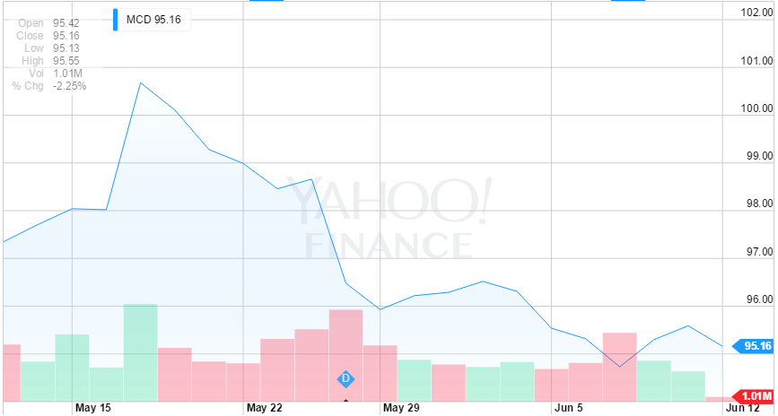
Figure 5.1.1.MCD Stock Price Trend Line
As we can see from the trend line (See Figure 5.1.1), the price of this stock increased a little bit on May 27 but kept deceasing during the next three days. It decreased about $2.5 per share in just 3 days and caused the profit loss in simulation. When we look into the historical price of this stock, we also found that the stock price did not fluctuate much during a day, which means this decreasing trend could continue in the next week. At the same time, the highest price throughout the four days was 99.20, which was just $0.35 higher than the purchase price.
Amazon.com INC.
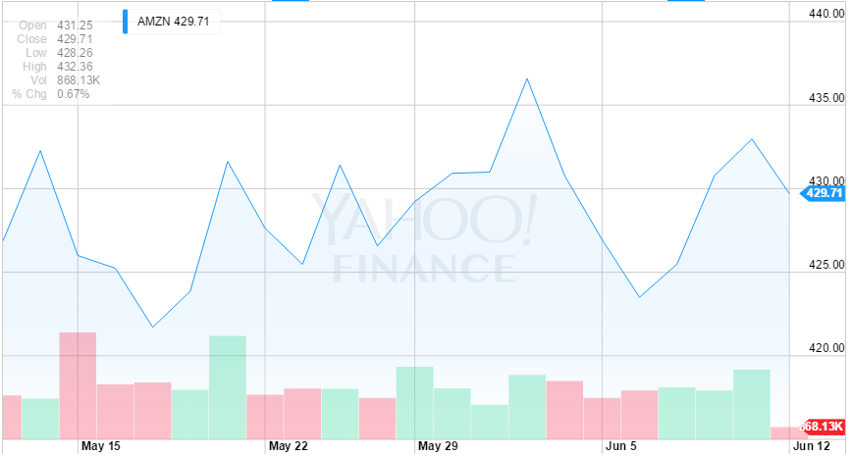
Figure 5.1.2.AMZN Week One Share Price Trend Line
For Amazon.com, I choose to analysis 1 month of the trend line (See Figure 5.1.2). The stock price of Amazon fluctuates quite a lot these days, but from the 1-month trend line, we can see that the stock shows an increase trend. And this trend is more obvious when it comes to 5 year. As online shopping becoming more and more popular, people are more likely to choose shopping on website because of the convenience it brings. Also from the historical price chart, we can see that both the highest price and the lowest price of the day kept increasing during the four days and this gives me a good expectation of this stock. But since this stock’s price fluctuates quite a lot, I chose to wait and see it performance in the next week to decide whether to buy or sell.
EBAY INC.
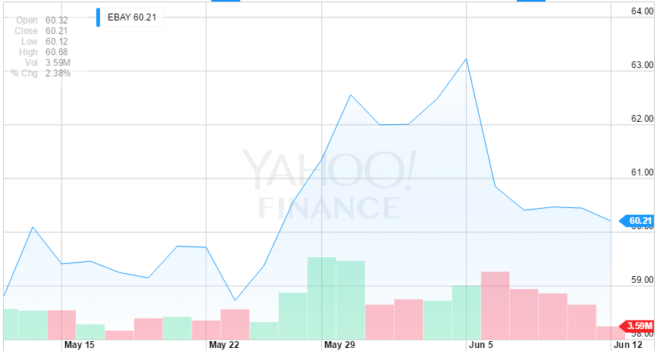
Figure 5.1.3.EBAY Week One Share Price Trend Line
It is pretty obvious from the 5-day trend line (See Figure 5.1.3) that EBAY’s stock price has an increasing trend, especially in the last three days. The trend line shows almost a linear shape, which indicates that this stock increased in every single day in the last week. And as an online shopping website, this company also has a bright future. Furthermore, as we can see in the historical price chart, the close price of this stock kept increasing during the last week. And it’s the same with the lowest price of day. So I will buy some shares if this company still performs well in the next week.

STARBUCKS CORP.
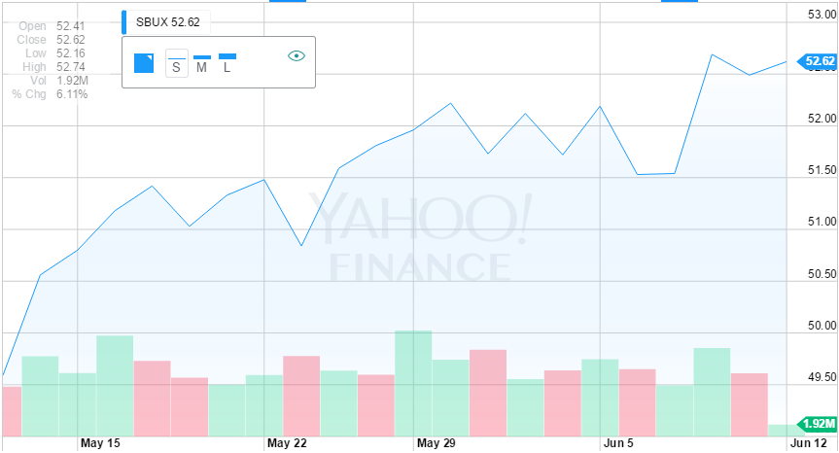
Figure 5.1.4.SBUX Week One Share Price Trend Line
From the 1-month trend line above (See Figure 5.1.4), we can easily see that the stock price increased about 3 dollars in the last 20 days. But the price trend line became smoother these days, so we do not know if this stock will decrease in the next week. A lot of people are used to drink a cup of coffee before they go to work. So Starbucks has a large amount of demand over the market. In the long term, the stock price will definitely goes up, but it is not for sure in the short run. Also from the historical price chart, we can find that almost every single column shows an increasing trend. Although this stock helped me to earn some profit, I will still sell some shares if it perform bad in the next week.

Week Two Simulation Results
In week two, we simulated for 5 days. And after analyzing each of the stock we chose, I made some significant decisions on some of them. Because of the bad performance of MCD, I chose to sell half the stock I have and wait to see if the price will go up again. At the same time, we also record the sell/ buy action we made as a reference. And the simulation results of the second week are shown in the following table. (See Table 5.2.1)
Date | Profit | Cash
2015/6/1 | -4.77 | 1660.83
2015/6/2 | -4.77 | 1660.83
2015/6/3 | -4.77 | 1660.83
2015/6/4 | -95.96 | 2366.65
2015/6/5 | -134.15 | 1722.27
Table 5.2.1.Positioning Trading Week Two Simulation Results

Week Two Day one Monday, June 1 2015
Since this is a new week, I do not know what will happen on the stock market. So I decided to make no change on the first day and to see if I need to sell or buy some of the stock. From the last week’s observation, I found that MCD has a decreasing trend over the past a few days. If this share of stock still keeps this trend, I think I need to sell. The price details are shown in the following table. (See Table 5.2.2)

Name | Open | High | Low | Close | Volume
AAPL | 130.28 | 131.39 | 130.05 | 130.54 | 32,112,797
MSFT | 47.06 | 47.77 | 46.62 | 47.23 | 28,837,332
GOOG | 536.79 | 536.79 | 529.76 | 533.99 | 1,904,332
YHOO | 43.05 | 43.63 | 42.91 | 43.35 | 11,152,854
AMZN | 430.4 | 433.16 | 426.2 | 430.92 | 2,253,264
EBAY | 61.55 | 63.03 | 61.55 | 62.56 | 14,098,761
AAL | 42.61 | 44.38 | 42.09 | 44.18 | 21,917,072
TXN | 55.7 | 56.34 | 55.42 | 55.71 | 4,576,011
MCD | 95.84 | 96.91 | 95.84 | 96.22 | 4,919,173
SBUX | 51.96 | 52.46 | 51.67 | 52.22 | 7,075,082
Table 5.2.2.Positioning Trading Week Two Day One Share Price Changes

Week Two Day two Tuesday, June 2 2015
On the second day of this week, I found that only two companies’ overall stock price dropped: Apple and McDonald’s Corp. The stock price of MCD was 2% lower than the original price and the AAL was just about 0.5% lower. Since most of the stock prices rose, the total account value has increased to $100896.15. And after comparing the price chart below (See Table 5.2.3), I chose to take no action on the stock.
Name | Open | High | Low | Close | Volume
AAPL | 129.86 | 130.66 | 129.32 | 129.96 | 33,667,627
MSFT | 46.93 | 47.35 | 46.62 | 46.92 | 21,498,326
GOOG | 532.93 | 543 | 531.33 | 539.18 | 1,938,989
YHOO | 43.18 | 43.62 | 42.92 | 43.15 | 8,866,474
AMZN | 430.07 | 433.23 | 426.25 | 430.99 | 1,669,845
EBAY | 62.1 | 63.03 | 61.91 | 62 | 7,093,853
AAL | 43.3 | 44.1 | 43.04 | 43.78 | 14,832,921
TXN | 55.42 | 55.6 | 54.88 | 55.25 | 4,630,112
MCD | 96.3 | 96.97 | 95.81 | 96.29 | 4,430,255
SBUX | 51.98 | 52.3 | 51.66 | 51.73 | 7,877,799
Table 5.2.3.Positioning Trading Week Two Day Two Share Price Changes

Week Two Day three Wednesday, June 3 2015
On the third day of this week, three of the stock I hold decreased. However, all of the total changes of these three stocks are positive. Although MCD increased a little bit today, it still caused the biggest loss over the 10 companies. I do not know if that would be the lowest point MCD reached. So I still did not make any changes on this stock. After the third day, the total account value increased to $101510.86. And the stock price changes are shown in the following table. (See Table 5.2.4)
Name | Open | High | Low | Close | Volume
AAPL | 130.66 | 130.94 | 129.9 | 130.12 | 30,983,542
MSFT | 47.37 | 47.74 | 46.82 | 46.85 | 28,002,154
GOOG | 539.91 | 543.5 | 537.11 | 540.31 | 1,717,036
YHOO | 43.3 | 43.78 | 42.98 | 43.21 | 11,893,374
AMZN | 434.4 | 438.39 | 432.75 | 436.59 | 2,727,914
EBAY | 62.37 | 62.5 | 61.51 | 62.01 | 7,914,080
AAL | 43.35 | 43.91 | 43.01 | 43.13 | 13,272,584
TXN | 55.46 | 55.58 | 54.82 | 54.88 | 3,658,970
MCD | 96.38 | 97.07 | 95.97 | 96.52 | 4,165,709
SBUX | 52 | 52.27 | 51.67 | 52.12 | 5,522,702
Table 5.2.4.Positioning Trading Week Two Day Three Share Price Changes

Week Two Day four Thursday, June 4 2015
On the fourth day of the week, I made the biggest decision of the first two weeks: sell half of the MCD I had to reduce more loss. From both the trend line on the internet and the performance over the past 8 days, I found that MCD is in a decreasing trend these days and this trend is supposed to keep going in the next a few days even weeks. On the other hand, EBAY seemed not so good on Thursday. But this stock had a perfect performance in the past 8 days. So I bought 50 shares of EBAY. And the total account value decreased to $100284.45 since most of the stock price decreased on Thursday. Since I sold half of the MCD I had, the total profit became negative. But this does not matter because EBAY has increased a lot and if I sell this stock, I will earn a big amount of profit. (See Table 5.2.6) The following table shows the stock price of Thursday and the trading results. (See Table 5.2.5)
Name | Open | High | Low | Close | Volume
AAPL | 129.58 | 130.58 | 128.91 | 129.36 | 38,450,118
MSFT | 46.79 | 47.16 | 46.2 | 46.36 | 27,745,512
GOOG | 537.76 | 540.59 | 534.32 | 536.7 | 1,348,337
YHOO | 43.09 | 43.44 | 42.76 | 42.88 | 10,033,370
AMZN | 434.4 | 436.76 | 429.26 | 430.78 | 2,510,761
EBAY | 61.77 | 62.55 | 61.73 | 62.49 | 7,723,297
AAL | 43.05 | 43.98 | 41.88 | 42.17 | 14,128,026
TXN | 54.66 | 54.88 | 53.83 | 53.98 | 6,640,652
MCD | 96.3 | 96.97 | 96.01 | 96.31 | 4,702,848
SBUX | 51.87 | 52.18 | 51.57 | 51.72 | 6,230,805
Table 5.2.5.Positioning Trading Week Two Day Four Share Price Changes

Date | Symbol | Buy/sell Price | Shares | Net Cost | Sell Earning | Profit | Total Profit | cash
Jun-4 | EBAY | 62.26 | 50 | 3132.99 |  | -91.19 | -95.96
Jun-4 | MCD | 96.47 | 40 |  | 3838.81 |  |  | 2366.65
Table 5.2.6.Positioning Trading Week Two Day Four Simulation Results

Week Two Day five Friday, June 5 2015
On the last day of the week, the situation was still not so good. Only three of the stocks increased. (See Table 5.2.7) It seemed that AAPL was not in god situation, so I sold 10 shares of this stock. EBAY, as expected, still in increasing trend and I bought 30 shares of this stock. The total account value was 100220.32, which was almost the same as the previous day. The following tables show the stock prices and trading results of Friday. After analyzing the stock price of AAPL, I found that this stock does not perform recently. To deduce the risk of losing more money on this stock, I sold 10 shares of AAPL. And because of selling AAPL, the total profit became -134.15. But at the same time, I bought 30 more shares of EBAY because I think this stock will bring me more profit. (See Table 5.2.8)
Name | Open | High | Low | Close | Volume
AAPL | 129.5 | 129.69 | 128.36 | 128.65 | 35,626,800
MSFT | 46.31 | 46.52 | 45.84 | 46.14 | 25,438,086
GOOG | 536.35 | 537.2 | 532.52 | 533.33 | 1,388,220
YHOO | 42.83 | 43.26 | 42.7 | 42.81 | 9,831,129
AMZN | 429.66 | 430.8 | 426.5 | 426.95 | 1,907,855
EBAY | 62.49 | 63.3 | 62.16 | 63.23 | 10,098,378
AAL | 42.13 | 42.58 | 41.71 | 41.72 | 9,951,149
TXN | 53.98 | 54.26 | 53.58 | 53.78 | 3,650,414
MCD | 95.93 | 96.09 | 95.47 | 95.54 | 3,959,308
SBUX | 51.57 | 52.44 | 51.27 | 52.19 | 7,123,248
Table 5.2.7.Positioning Trading Week Two Day Five Share Price Changes

Date | Symbol | Buy/sell Price | Shares | Net Cost | Sell Earning | Profit | Total Profit | cash
Jun-5 | EBAY | 63.07 | 30 | 1912.09
Jun-5 | AAPL | 128.77 | 10 |  | 1267.71 | -38.19 | -134.15 | 1722.27
Table 5.2.8.Positioning Trading Week Two Day Five Simulation Results
In the second week, I did some big actions such as sold half of the MCD stock and bought a lot of shares of EBAY. And I will analysis some of the stocks to show the precision of my decision and what move I should take in the third week.

McDonald’s Corp
Figure 5.2.1.MCD Week Two Share Price Trend Line
As we can see in the trend line (See Figure 2.2.1), although MCD increased in the first 2 days of the week, it decreased even worse in the next three days. This showed that the decision of selling half the MCD I had was definitely an excellent choice. Because in June 4th and June 5th this stock was in smash situation, but by that time, I have already sold the stock. However, this trend will not last forever and it will reach the bottom someday. The only thing I should do with this stick is just keep in track with the trend line and buy in when the stock price hit the lowest point.

EBAY INC
Date | Open | High | Low | Close | Volume
Jun 5, 2015 | 62.49 | 63.30 | 62.16 | 63.23 | 10,098,378
Jun 4, 2015 | 61.77 | 62.55 | 61.73 | 62.49 | 7,723,297
Jun 3, 2015 | 62.37 | 62.50 | 61.51 | 62.01 | 7,914,080
Jun 2, 2015 | 62.10 | 63.03 | 61.91 | 62.00 | 7,093,853
Jun 1, 2015 | 61.55 | 63.03 | 61.55 | 62.56 | 14,098,761
Table 5.2.9.EBAY Week Two Share Price Changes
From the table above (See Table 5.2.9), we can see that during the past five days EBAY’s stock price increased about $2. And this trend was relatively obvious in the last 3 days, which increased from about $61.5 to 63.5. This trend line tells me that buying EBAY is a good choice. And I bought this stock twice during the second week. Also from the 1 month trend line, the increasing trend can still be seen. However, after analyzing the whole table, we can find that the increasing speed was not as fast as last week. And at this point, I should be more careful because this may be the peak point of the stock price. So the best choice I should take is to wait and see the stock price next week instead of buying large amount EBAY without hesitating.
APPLE INC
Date | Open | High | Low | Close | Volume
Jun 5, 2015 | 129.50 | 129.69 | 128.36 | 128.65 | 35,626,800
Jun 4, 2015 | 129.58 | 130.58 | 128.91 | 129.36 | 38,450,118
Jun 3, 2015 | 130.66 | 130.94 | 129.90 | 130.12 | 30,983,542
Jun 2, 2015 | 129.86 | 130.66 | 129.32 | 129.96 | 33,667,627
Jun 1, 2015 | 130.28 | 131.39 | 130.05 | 130.54 | 32,112,797
Table 5.2.10.AAPL Week Two Share Price Changes
As we can see in the table above (See Table 5.2.10), the stock price of AAPL kept decreasing during last week, from $131 per share to about $129 per share. However, from the 1-month trend line I found that this decreasing trend only appeared these 10 days and before this period of time, AAPL’s stock price kept increasing. So I think it is still too early to sell more AAPL because if this stock increases in the next week, I will lose money.

Week Three Simulation Results
We did five days of simulation this week. And during this week, we only traded stock on Monday and Wednesday and the transactions made some profit. During the first 2 weeks, the overall profit was $-134.15. But after I sold the stock on Wednesday, the profit became $386.29. Although $386.29 is not big amount of money compared with the capital cost, this was still a significant progress in the simulation. And we record the daily stock price of each stock for further analysis. The overall result for the third week is shown in the following table. (See Table 5.3.1)
Date | Profit ($) | Cash ($)
2015/6/8 | 157.47 | 10866.39
2015/6/9 | 157.47 | 10866.39
2015/6/10 | 386.29 | 18573.43
2015/6/11 | 386.29 | 18573.43
2015/6/12 | 386.29 | 18573.43
Table 5.3.1.PositioningTrading Week Three Simulation Results

Week Three day one Monday, June 8 2015
Name | Open | High | Low | Close | Volume
AAPL | 128.9 | 129.21 | 126.83 | 127.8 | 52,538,200
MSFT | 46.3 | 46.43 | 45.67 | 45.73 | 21,822,300
GOOG | 533.31 | 534.12 | 526.24 | 526.83 | 1,520,600
YHOO | 42.72 | 42.89 | 42 | 42.01 | 7,596,300
AMZN | 425.62 | 426.8 | 421.43 | 423.5 | 2,166,900
EBAY | 62.52 | 62.52 | 60.45 | 60.85 | 12,112,700
AAL | 41.07 | 41.24 | 39.27 | 39.86 | 25,726,200
TXN | 53.67 | 53.72 | 52.71 | 52.82 | 4,571,700
MCD | 96 | 96.04 | 95.25 | 95.32 | 4,539,400
SBUX | 52 | 52.23 | 51.49 | 51.53 | 6,297,600
Table 5.3.2.Positioning Trading Week Three Day One Share Price
Date | Symbol | Sell Price | Shares | Sell Earning | Profit | Total Profit | cash
Jun-8 | MCD | 95.77 | 30 | 2853.11 | -94.39
 | EBAY | 63.11 | 100 | 6291.01 | 386.01 | 157.47 | 10866.39
Table 5.3.3.Positioning Trading Week Three Day One Simulation Results
Monday was definitely not a good opening for the week because every single stock decreased during the day (See Table 5.3.2). Since EBAY has increased a lot in the past two weeks, I decided to sell some of this stock because I do not know if this would be the peak point of it. And EBAY decreased in Monday. So I do not want to take the risk and sell 100 shares of EBAY to guarantee the profit. On the other hand, MCD kept its bad performance as usual. As a result, I made up my mind to sell all MCD I had although this action would cause me losing money because I cannot see any sign that MCD could increase these days. (See Table 5.3.3)

Week Three day two Tuesday, June 9 2015
Name | Open | High | Low | Close | Volume
AAPL | 126.7 | 128.08 | 125.62 | 127.42 | 55,771,500
MSFT | 45.76 | 45.94 | 45.46 | 45.65 | 24,124,700
GOOG | 527.56 | 529.2 | 523.01 | 526.69 | 1,441,600
YHOO | 41.92 | 41.95 | 41.02 | 41.63 | 11,943,500
AMZN | 422.96 | 427.49 | 419.14 | 425.48 | 2,274,600
EBAY | 60.73 | 60.84 | 59.74 | 60.41 | 9,463,900
AAL | 40.21 | 41.21 | 39.7 | 40.43 | 15,667,500
TXN | 53.14 | 54.39 | 52.92 | 54.19 | 6,563,000
MCD | 95.02 | 95.63 | 94.81 | 95.3 | 4,816,400
SBUX | 51.8 | 52.86 | 51.66 | 52.69 | 7,963,900
Table 5.3.4.Positioning Trading Week Three Day Two Share Price
As we can see from the table above, (See Table 5.3.4) almost stock’s price remained the same after the market was closed. Only AMZN increased from $422.96 to $425.48. Although it increased $3 per share, AMZN just increased very little in percentage. It was obvious that all the ten stocks were in a decreasing trend. So the choice I should take was to wait and see the share price tide to maximize the profit.

Week Three day three Wednesday, June 10 2015
Name | Open | High | Low | Close | Volume
AAPL | 127.92 | 129.34 | 127.85 | 128.88 | 38,915,900
MSFT | 45.79 | 46.83 | 45.69 | 46.61 | 27,952,300
GOOG | 529.36 | 538.36 | 529.35 | 536.69 | 1,811,400
YHOO | 41.7 | 42.31 | 41.69 | 42.06 | 7,930,000
AMZN | 426.46 | 432.2 | 425.66 | 430.77 | 2,166,500
EBAY | 60.56 | 60.94 | 60.21 | 60.47 | 8,852,500
AAL | 40.21 | 41.21 | 39.7 | 40.43 | 15,667,500
TXN | 53.14 | 54.39 | 52.92 | 54.19 | 6,563,000
MCD | 53.14 | 54.39 | 52.92 | 54.19 | 6,563,000
SBUX | 51.8 | 52.86 | 51.66 | 52.69 | 7,963,900
Table 5.3.5.Positioning Trading Week Three Day Three Share Price

Date | Symbol | Buy/sell Price | Shares | Sell Earning | Net Cost | Profit | Total Profit | Cash
Jun-10 | SBUX | 52.73 | 50 | 2616.51 |  | 67.01
Jun-10 | AMZN | 431.5 | 30 | 12925.01 |  | 161.81
Jun-10 | EBAY | 60.72 | 50 |  | 3055.99 |  | 224.48
Jun-10 | MCD | 95.17 | 50 |  | 4778.49 |  | 386.29 | 18573.4
Table 5.3.6.Positioning Trading Week Three Day Three Simulation Results
Since these 10 stocks kept decreasing during the past three days, (See Table 5.3.5) I chose to sell some shares whose prices were higher than the purchase price. So I sold 50 shares of SBUX and 30 shares of AMZN. After selling the stock, I found that my cash was $26407.91, which was much higher than expected. (See Table 5.3.6) So I also bought some EBAY and MCD. The reason I bought EBAY was the high expectation I gave to this stock. Although EBAY did not perform well this week, I strongly assist that it will go back to its position finally. However, buying MCD was a gamble. From the trend line, it is easy to see that MCD kept decreasing during the past several weeks. But there must be some point that MCD will come back. I suppose that was around the point because MCD has been decreasing for a long time.

Week Three day four Thursday, June 11 2015
Name | Open | High | Low | Close | Volume
AAPL | 129.18 | 130.18 | 128.48 | 128.59 | 35,260,400
MSFT | 46.66 | 46.92 | 46.13 | 46.44 | 27,186,700
GOOG | 538.42 | 538.98 | 533.02 | 534.61 | 1,205,000
YHOO | 42.09 | 42.21 | 40.55 | 40.94 | 23,654,400
AMZN | 432.29 | 438.89 | 431.47 | 432.97 | 2,917,100
EBAY | 60.7 | 60.99 | 60.15 | 60.45 | 7,077,100
AAL | 40.79 | 41.26 | 39.94 | 40.02 | 10,105,200
TXN | 54.17 | 54.26 | 53.57 | 53.64 | 4,698,100
MCD | 95.5 | 96.33 | 95.5 | 95.59 | 3,691,000
SBUX | 52.81 | 53 | 52.44 | 52.49 | 6,002,200
Table 5.3.7.Positioning Trading Week Three Day Four Share Price
As we can see in the table above (See Table 5.3.7), every single stock decreased during Thursday. It seems that the stock market is in bear market recently. And I think I should not buy or sell any stock today because any action with carelessness may cause loss on the very next day.

Week Three day five Friday, June 12 2015
Name | Open | High | Low | Close | Volume
AAPL | 128.19 | 128.33 | 127.11 | 127.17 | 36,754,200
MSFT | 46.22 | 46.47 | 45.9 | 45.97 | 23,416,200
GOOG | 531.6 | 533.12 | 530.16 | 532.33 | 952,400
YHOO | 40.77 | 41.11 | 40.46 | 40.53 | 9,220,600
AMZN | 431.25 | 432.36 | 428.26 | 429.92 | 2,050,200
EBAY | 60.32 | 60.68 | 59.97 | 60.02 | 6,907,800
AAL | 39.84 | 41 | 39.76 | 40.71 | 10,311,500
TXN | 53.35 | 53.51 | 52.99 | 53.01 | 3,756,000
MCD | 95.42 | 95.55 | 95 | 95.06 | 3,610,700
SBUX | 52.41 | 52.74 | 52.16 | 52.63 | 5,224,200
Table 5.3.8.Positioning Trading Week Three Day Five Share Price
During the last day of this week’s simulation, the situation was a little better than the previous day. Almost every single stock remained the same price except AMZN. AMZN increased about $8 during the day. (See Table 5.3.8) But it is still too early to say AMZN was a good choice to buy. I chose to take no action on Friday and see how the stocks will perform in the next week.
During the third week, the stock prices do not fluctuated so much and decreased almost every day. However, I still made some profit by selling EBAY, SBUX and AMZN. And I will analysis MCD to give myself a hint on the decision to make in the next week.

McDonald’s Corp
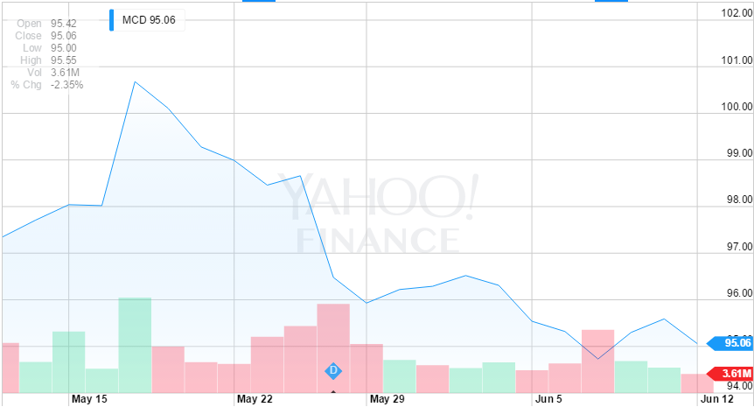
Figure 5.3.1.MCD Week Three Share Price Trend Line
As we can see both from the trend line (See Figure 5.3.1), the share price of MCD has been decreasing from May 19. However, this trend became smoother recently. There is no such stock that will decrease forever and I think MCD has reached its bottom. Maybe the price will fluctuate for some time, but it will increase very soon.

Week Four Simulation Results
During the fourth week, we simulated for five days and the overall results are shown in the table below. (See Table 5.4.1) During this week’s simulation, I found that my cash was way too much, which showed that I traded in a cautious way. Another reason that I had so much cash is that I sold all the GOOG and this action earned me more than $300, which is almost the sum of profit in the last three weeks.
At the same time, analyzing the trend line and historical price also helped me a lot. I can get a comprehensive overview of a stock by looking into the 1-week trend line and determine whether or not I should buy some shares of this stock.
Date | Profit ($) | Cash ($)
2015/6/15 | 386.29 | 18573.4
2015/6/16 | 386.29 | 18573.4
2015/6/17 | 381.34 | 32899.92
2015/6/18 | 381.34 | 32899.92
2015/6/19 | 708.85 | 40614.96
Table 5.4.1.Positioning Trading Week Four Simulation Results

Week Four day one Monday, June 15 2015
During the first day of this week, almost all of the shares prices remained the same except AMZN. (See Table 5.4.2) AMZN dropped about $4 in this day, but it still can be ignored compared with its high single share price. Also, from the trend line of the AMZN, this stock had a “W” shape of trend line, which means this stock fluctuated a lot during these days. So it was still too early to sell.
Name | Open | High | Low | Close | Volume
AAPL | 126.1 | 127.24 | 125.71 | 126.92 | 39,842,600
MSFT | 45.45 | 45.65 | 45.02 | 45.48 | 30,080,100
GOOG | 528 | 528.3 | 524 | 527.2 | 1,630,700
YHOO | 40.24 | 40.67 | 40.21 | 40.47 | 10,869,500
AMZN | 427.66 | 428.05 | 422.64 | 423.67 | 2,041,900
EBAY | 59.63 | 60.19 | 59.25 | 60 | 8,093,500
AAL | 40.35 | 41 | 40.01 | 40.07 | 8,819,400
TXN | 52.45 | 53.11 | 52.32 | 53.05 | 4,836,400
MCD | 94.74 | 95 | 94.02 | 94.3 | 4,715,600
SBUX | 52.23 | 52.46 | 52.01 | 52.27 | 5,550,700
Table 5.4.2.Positioning Trading Week Four Day One Share Prices

Week Four day two Tuesday, June 16 2015
In the second day of this week, almost all stocks’ prices increased. (See Table 5.4.3) Although the amount of growth was not much, it showed an increasing trend of the market. Most of the growth was in $1, so if this trend still continues in the next day, I will think about buying some shares of stock.
Name | Open | High | Low | Close | Volume
AAPL | 127.03 | 127.85 | 126.37 | 127.6 | 31,404,000
MSFT | 45.35 | 46.24 | 45.3 | 45.83 | 26,822,500
GOOG | 528.4 | 529.64 | 525.56 | 528.15 | 1,069,300
YHOO | 40.35 | 41.4 | 40.02 | 40.64 | 20,439,700
AMZN | 424.15 | 427.97 | 422.67 | 427.26 | 2,296,400
EBAY | 59.89 | 61.88 | 59.78 | 60.52 | 9,341,200
AAL | 40.13 | 40.32 | 39.32 | 39.48 | 9,193,400
TXN | 52.91 | 53.2 | 52.66 | 53.09 | 2,697,800
MCD | 94.25 | 94.67 | 94.1 | 94.63 | 3,082,500
SBUX | 52.27 | 53.14 | 52.2 | 52.97 | 6,099,200
Table 5.4.3.Positioning Trading Week Four Day Two Share Prices

Week Four day three Wednesday, June 17 2015
In the third day of this week, the increasing trend still continued. (See Table 5.4.4) Although the amount of growth was not so much, I still decided to buy in some shares of stock since the increasing trend would continue in the next few days. And I bought 50 shares of MCD and 50 shares of MSFT. At the same time, I sold 35 shares of AMZN and 50 shares of AAPL. (See Table 5.4.5) The reason I sold AAPL was that this stock kept decreasing for a long time and I cannot see any sign that it will come back again. So I sold AAPL to prevent further money loss.

Name | Open | High | Low | Close | Volume
AAPL | 127.72 | 127.88 | 126.74 | 127.3 | 32,768,500
MSFT | 45.73 | 46.07 | 45.36 | 45.97 | 28,566,300
GOOG | 529.37 | 530.98 | 525.1 | 529.26 | 1,268,600
YHOO | 40.8 | 41.52 | 40.78 | 40.96 | 11,936,400
AMZN | 428.36 | 431.35 | 424.75 | 427.81 | 2,184,100
EBAY | 60.5 | 61.09 | 60.24 | 60.55 | 4,557,000
AAL | 39.27 | 40.09 | 38.91 | 39.88 | 9,565,600
TXN | 53.31 | 53.53 | 52.87 | 53.29 | 3,259,900
MCD | 94.54 | 95.52 | 94.54 | 95.22 | 3,938,300
SBUX | 53.09 | 53.47 | 52.72 | 53.24 | 6,723,300
Table 5.4.4.Positioning Trading Week Four Day Three Share Prices

Date | Symbol | Buy/sell Price | Shares | Sell Earning | Net Cost | Profit | Total Profit | Cash
Jun-17 | MCD | 94.62 | 50 |  | 4750.99
Jun-17 | MSFT | 45.55 | 50 |  | 2297.49
Jun-17 | AMZN | 430.27 | 35 | 15039.46 |  | 149.06
Jun-17 | AAPL | 127.11 | 50 | 6335.51 |  | -154.01 | 381.34 | 32899.92
Table 5.4.5.Positioning Trading Week Four Day Three Simulation Results

Week Four day four Thursday, June 18 2015
As we can see in the table below, all the stock prices increased in the fourth day of the week. Especially, AMZN increased around $10 in a single day. (See Table 5.4.6) And this meant that the decision of buying stocks in Wednesday was a correct choice. And if the increasing trend of the market still exists in Friday, I will buy more stocks since I have a lot of cash.

Name | Open | High | Low | Close | Volume
AAPL | 127.23 | 128.31 | 127.22 | 127.88 | 35,241,100
MSFT | 46.22 | 46.8 | 46.17 | 46.72 | 32,184,500
GOOG | 531 | 538.15 | 530.79 | 536.73 | 1,828,100
YHOO | 41.04 | 41.27 | 40.79 | 40.91 | 10,003,000
AMZN | 430.3 | 439.73 | 429.41 | 439.39 | 3,369,700
EBAY | 60.65 | 61.12 | 60.63 | 60.69 | 6,966,100
AAL | 39.8 | 40.22 | 39.61 | 39.98 | 10,619,800
TXN | 53.48 | 54.37 | 53.34 | 54.22 | 5,678,200
MCD | 95.69 | 96.63 | 95.28 | 96.17 | 4,846,200
SBUX | 53.5 | 54.28 | 53.4 | 54.11 | 10,711,000
Table 5.4.6.Positioning Trading Week Four Day Four Simulation Results

Week Four day five Friday, June 19 2015
During the fifth day of this week, most of the stock prices decreased a little bit. (See Table 5.4.7) Although this was not as expected, I still think the stock prices will increase in the next week. So I bought 100 shares of MCD, AAL and SBUX. And compared with the original price, GOOG has increased about $7 per share. So I decided to sell all the 50 shares of GOOG to make some profit. (See Table 5.4.8)
Name | Open | High | Low | Close | Volume
AAPL | 127.71 | 127.82 | 126.4 | 126.6 | 54,181,300
MSFT | 46.79 | 46.83 | 45.99 | 46.1 | 57,500,600
GOOG | 537.21 | 538.25 | 533.01 | 536.69 | 1,885,700
YHOO | 40.9 | 40.93 | 40.37 | 40.51 | 11,586,600
AMZN | 440.26 | 444.99 | 433.24 | 434.92 | 4,481,100
EBAY | 60.79 | 61.46 | 60.66 | 61.17 | 10,458,200
AAL | 40.3 | 41.89 | 40.3 | 41.56 | 20,155,500
TXN | 54.25 | 54.59 | 53.54 | 54.51 | 9,925,100
MCD | 96.39 | 97.14 | 95.98 | 96.08 | 7,221,800
SBUX | 54.08 | 54.44 | 53.84 | 53.93 | 10,582,100
Table 5.4.7.Positioning Trading Week Four Day Five Share Prices

Date | Symbol | Buy/sell Price | Shares | Sell Earning | Net Cost | Profit | Total Profit | Cash
Jun-19 | MCD | 96.34 | 100 |  | 9653.99
Jun-19 | AAL | 40.76 | 100 |  | 4095.99
Jun-19 | SBUX | 53.91 | 100 |  | 5410.99
Jun-19 | GOOG | 537.92 | 50 | 26876.01 |  | 327.51 | 708.85 | 40614.96
Table 5.4.8.Positioning Trading Week One Day Five Simulation Results
During the last week, I bought MCD twice, which was way different from the decisions I made in the first three weeks. And at the same time, I sold all the GOOG I had. So I want to analysis these two stocks to explain the reason why I started to buy in MCD and sell GOOG in the fourth week.
McDonald’s Corp
As we can see in trend line of MCD (See Figure 5.4.1), during the last week, the share price of MCD was in a rapid growth. Also, in the 1-month trend line, this stock kept decreasing for almost the whole month. Definitely there is not such a stock that will decrease forever. And I think MCD was around its bottom point. So this was a perfect time to buy in some shares of MCD because this stock will increase again if it reaches its bottom.

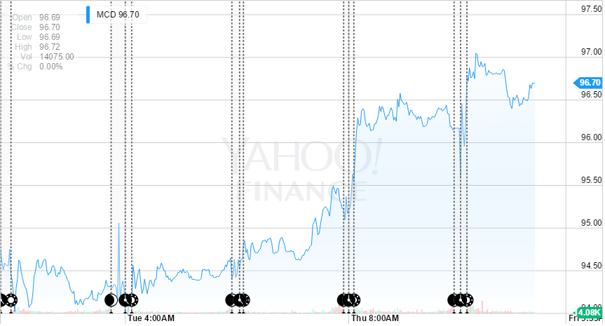
Figure 5.4.1.MCD Week Four Share Price Trend Line
Google Inc.
As we can see in the 1-month trend line below (See Figure 5.4.2), GOOG’s share price kept fluctuating in the last month. And on the Friday of the fourth week, the trend line was smooth. According to the trend line, the price has a high possibility of decrease in the next week. Furthermore, the share price of GOOG increased about $7 per share. So I decided to sell all the shares of GOOG to guarantee the profit.

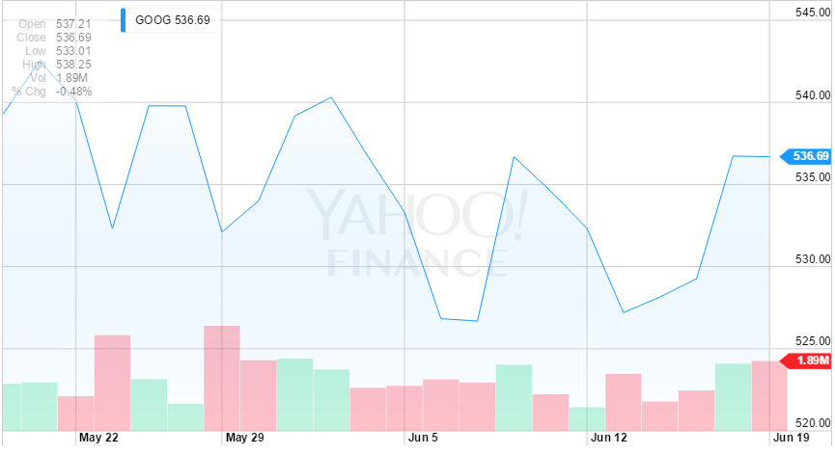
Figure 5.4.2.GOOG Share Price Trend Line in The Last Month

Week Five Simulation Results
We simulated for five days during the last week. And we traded on Tuesday, Thursday and Friday. But on Friday we just sold all the stocks we had. As a result of the five-week simulation, the total profit was $2095.75, which was not so bad since we are just beginners. The changes of profit and cash are shown in the table below. (See Table 5.5.1)
Date | Profit ($) | Cash ($)
2015/6/22 | 708.85 | 40614.96
2015/6/23 | 1280.58 | 55878.69
2015/6/24 | 1280.57 | 55878.69
2015/6/25 | 1280.57 | 2401.71
2015/6/26 | 2095.75 | 102095.75
Table 5.5.1.Positioning Trading Week Five Simulation Results

Week Five day one Monday, Jun 22 2015
As we can see in the table below, (See Table 5.5.2) when we look just the close prices and the open prices, the stocks were almost the same. But when we look into the highest price of the day, we can easily observe that GOOG and AMZN increased some bit and that thanks to the high share prices of the two stocks. At the same time, I did not make any transactions on Monday since some companies may put out some new polices that could affect the share prices.
Name | Open | High | Low | Close | Volume
AAPL | 127.49 | 128.06 | 127.08 | 127.61 | 33,833,500
MSFT | 46.33 | 46.72 | 46.16 | 46.23 | 20,278,600
GOOG | 539.59 | 543.74 | 537.53 | 538.19 | 1,242,500
YHOO | 40.66 | 40.89 | 40.54 | 40.73 | 6,127,200
AMZN | 437 | 439.24 | 434.18 | 436.29 | 1,765,500
EBAY | 61.59 | 61.9 | 61.28 | 61.75 | 5,094,300
AAL | 42.92 | 43.25 | 42.24 | 43.03 | 15,104,000
TXN | 54.62 | 55.52 | 54.62 | 55.5 | 9,275,900
MCD | 96.31 | 97.03 | 96.14 | 96.87 | 3,707,100
SBUX | 54.33 | 54.43 | 53.88 | 53.9 | 7,091,600
Table 5.5.2.Positioning Trading Week Five Day One Share Prices

Week Five day two Tuesday, Jun 23 2015
On the second day of the week, I sold all the AAPL I had although the sell price was lower than the original price because this stock kept a decreasing trend during the past few weeks. I decided to sell this stock to prevent further loss. At the same time, I sold 35 shares of AMZN, which earned a lot of profit. And I bought 100 shares of SBUX because from the recent share price trend line, this stock had an increasing trend. After the second day, the total profit was $1280.57 and the cash was $55878.69. (See Table 5.5.4) And the share price of Tuesday is shown in the table below. (See Table 5.5.3)

Name | Open | High | Low | Close | Volume
AAPL | 127.48 | 127.61 | 126.88 | 127.03 | 30,137,100
MSFT | 46.13 | 46.28 | 45.62 | 45.91 | 25,787,000
GOOG | 539.64 | 541.5 | 535.25 | 540.48 | 1,196,000
YHOO | 40.74 | 40.8 | 40.51 | 40.65 | 6,846,300
AMZN | 435.59 | 447.04 | 433.69 | 445.99 | 3,209,400
EBAY | 61.76 | 62 | 61.44 | 61.93 | 5,444,300
AAL | 42.98 | 43.42 | 42.35 | 42.73 | 10,698,400
TXN | 55.31 | 55.6 | 54.71 | 54.83 | 5,055,800
MCD | 97.59 | 97.96 | 97.12 | 97.18 | 4,486,900
SBUX | 54.04 | 54.18 | 53.72 | 54.12 | 5,679,000
Table 5.5.3.Positioning Trading Week Five Day Two Share Prices
Date | Symbol | Buy/sell Price | Shares | Sell Earning | Net Cost | Profit | Total Profit | Cash
Jun-23 | AMZN | 446.62 | 35 | 15611.71 |  | 721.31
Jun-23 | AAPL | 127.35 | 40 | 5074.01 |  | -149.59
Jun-23 | SBUX | 54.02 | 100 |  | 5421.99 |  | 1280.57 | 55878.69
Table 5.5.4.Positioning Trading Week Five Day Two Simulation Results
Week Five day three Wednesday, Jun 24 2015
We can easily see from the table that almost every single stock decreased during the day and AAPL was the only stock that increased. (See Table 5.5.5) Because of this situation, I did not trade during the third of the week.
Name | Open | High | Low | Close | Volume
AAPL | 127.21 | 129.8 | 127.12 | 128.11 | 54,964,900
MSFT | 45.67 | 46.25 | 45.55 | 45.64 | 34,784,600
GOOG | 540 | 540 | 535.66 | 537.84 | 1,283,400
YHOO | 40.68 | 41.23 | 40.58 | 40.94 | 11,444,300
AMZN | 444.97 | 446.47 | 440.23 | 440.84 | 2,614,400
EBAY | 62.11 | 62.39 | 61.51 | 61.61 | 8,388,000
AAL | 42.7 | 42.92 | 42.07 | 42.24 | 6,857,400
TXN | 54.65 | 54.81 | 53.93 | 53.99 | 4,196,500
MCD | 96.75 | 97.45 | 96.64 | 96.64 | 3,919,800
SBUX | 53.75 | 53.97 | 53.52 | 53.71 | 5,512,100
Table 5.5.5.Positioning Trading Week Five Day Three Share Prices
Week Five day four Thursday, Jun 25 2015
Although most of the stocks decreased during this day, (See Table 5.5.6) I still bought 100 shares of AMZN and 100 shares of MCD (See Table 5.5.7) because I thought these two stocks were around their lowest point. After the third day of week five, the cash became $2401.71.
Name | Open | High | Low | Close | Volume
AAPL | 128.86 | 129.2 | 127.5 | 127.5 | 31,816,700
MSFT | 46.03 | 46.06 | 45.5 | 45.65 | 20,569,500
GOOG | 538.87 | 540.9 | 535.23 | 535.23 | 1,331,500
YHOO | 41.1 | 41.39 | 40.9 | 41.07 | 10,764,100
AMZN | 438.07 | 443.47 | 436.39 | 440.1 | 2,235,600
EBAY | 61.68 | 62 | 61.48 | 61.6 | 6,000,600
AAL | 42.65 | 43.42 | 42.2 | 42.24 | 8,165,700
TXN | 54.23 | 54.42 | 53.74 | 53.8 | 3,755,800
MCD | 96.7 | 96.91 | 95.78 | 95.79 | 4,266,200
SBUX | 54.09 | 54.45 | 54 | 54.07 | 5,382,300
Table 5.5.6.Positioning Trading Week Five Day Four Share Prices
Date | Symbol | Buy/sell Price | Shares | Net Cost | Profit | Cash
Jun-25 | AMZN | 437.89 | 100 | 43808.99
Jun-25 | MCD | 96.48 | 100 | 9667.99 |  | 2401.71
Table 5.5.7.Positioning Trading Week Five Day Four Simulation Results

Week Five day five Friday, Jun 26 2015
Friday was the last day of the simulation and I sold all the stocks I had. The final simulation results were shown in the table below (See Table 5.5.9) and the final profit was $2095.75. Compared with the initial value, the profit rate was 2.1%, which was acceptable. And among the 10 stocks, AMZN brought me more than $1000 profit, which showed that this company was in great condition during the past few weeks. The share prices of the last day is shown below. (See Table 5.5.8)
Name | Open | High | Low | Close | Volume
AAPL | 127.67 | 127.99 | 126.51 | 126.75 | 42,111,000
MSFT | 45.65 | 46.28 | 45.03 | 45.26 | 45,610,900
GOOG | 537.26 | 537.76 | 531.35 | 531.69 | 2,011,500
YHOO | 40.83 | 40.87 | 39.93 | 40.06 | 16,011,600
AMZN | 441.76 | 443.49 | 435.06 | 438.1 | 2,529,500
EBAY | 61.6 | 61.71 | 60.7 | 61.04 | 6,289,000
AAL | 42.44 | 42.58 | 41.33 | 41.44 | 9,596,300
TXN | 53.39 | 53.75 | 52.43 | 52.9 | 7,566,600
MCD | 96.13 | 97.35 | 95.93 | 97.29 | 5,822,800
SBUX | 54.46 | 54.75 | 54.3 | 54.62 | 6,367,100
Table 5.5.8.Positioning Trading Week Five Day Five Share Prices
Date | Symbol | Buy/sell Price | Shares | Sell Earning | Profit | Total Profit | Cash
Jun-25 | MSFT | 45.94 | 150 | 6871.01 | -49.49
Jun-25 | AMZN | 442.24 | 100 | 44204.01 | 415.01
Jun-25 | EBAY | 61.51 | 30 | 1825.31 | -66.79
Jun-25 | YHOO | 40.65 | 60 | 2419.01 | -152.59
Jun-25 | MCD | 97.29 | 200 | 19438.01 | 314.51
Jun-25 | SBUX | 54.66 | 250 | 13645.01 | 302.51
Jun-25 | AAL | 42.49 | 180 | 7628.21 | 217.01
Jun-25 | TXN | 52.94 | 100 | 5274.01 | -164.99 | 2095.75 | 102095.8
Table 5.5.9.Positioning Trading Week Five Day Five Simulation Results
As we can see in the simulation results, the profit on AMZN was more than $1000 in this week. So I want to analysis this stock to see the recent price changes of it.
Amazon.com Inc.
From the share price trend line of the last week, (See Figure 5.5.1) it is hard to tell how this stock performed during the past five days because the share price first increased and reached its peak point on Tuesday and then decreased to its original level on Friday. However, when we look into the price trend line of the last month, the increasing trend is pretty obvious and this is the reason why this stock can give me so much profit in the last week.
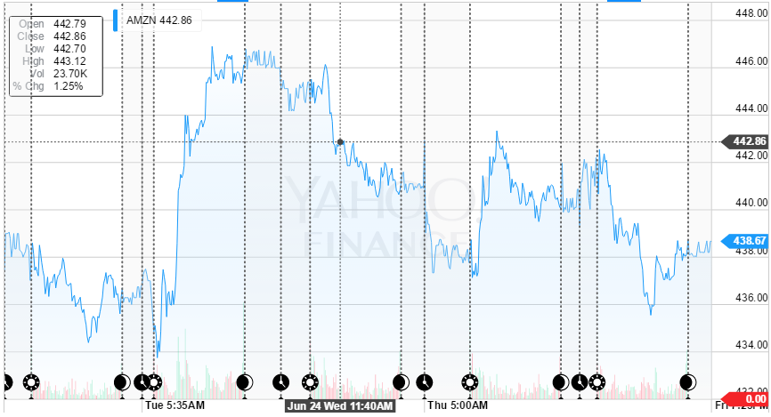
Figure 5.5.1.AMZN Price Trend Line in Week Five
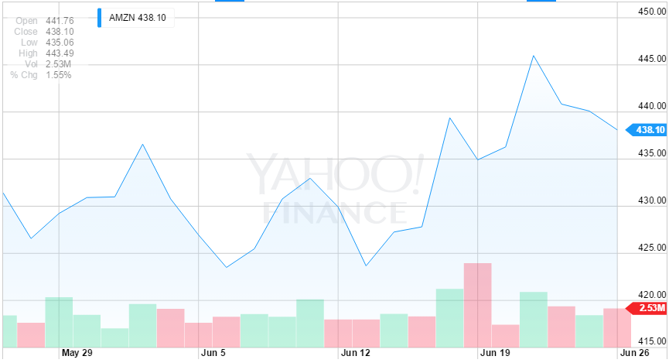
Figure 5.5.2.AMZN Price Trend Line in June

Comparison

Final Stock Value Analysis
After five weeks simulations, we summarized our day trading simulation results in follow figures (see Fig. 6.1.1 and Fig. 6.1.2). In addition, the detailed numerical data are included in appendix (see Table A1). The stock simulation starts with $100,000 and ends with $103,340.9. Therefore, the total profit of day trading stock simulations is $3,340.9.

Figure 6.1.1 Overall Day Trading Stock Simulation Total Asset Value Change
From the Figure 6.1.1, we can see that the main trend of overall cash change is rising. With the trading experience learned from first three week, we become more skillful in day trading method, which is shown in steep rising cash changes in last two weeks.

Figure 6.1.2. Overall Day Trading Stock Simulation Profit Results
From the Figure 6.1.2, we can see that the highest daily profit is about $1,100. Also, in most of trading days, we are earning profits, and the profits are higher than losses.
The position trading simulation results are shown in bellow (see Fig. 6.1.3). Position trading strategy is different day trading strategy. With position trading method, investors buy and hold their stocks to wait for higher price to sell. The hold period depends on stocks price trends. However, investors may also sell their holding stocks at lower price to avoid big losses. The position trading stock simulation starts with $100,000 and end with $102095.8. Therefore, the overall profit of position trading simulation is $2,095.8.

Figure 6.1.3. Overall Position Trading Stock Simulation Total Asset Value Change
From the Figure 6.1.3, we can see that, in most of the time, we are active investors since we keep to buy and hold stocks instead of keeping high amount of cash in our account. In this process, we also need to sell low profit stocks and high profit stocks.
More important, there are stocks with different type price trends need to be analyzed (see Fig. 6.1.4, Fig. 6.1.5 and Fig. 6.1.6).
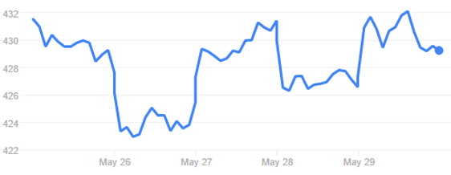
Figure 6.1.4. “U” and “N” Shape Price Trend
From the Figure 6.1.4, we can see that the price trend over a week has a few “U” and “N” shaped curves. The stocks with this type of price trend is preferred because it creates high price difference which means high profit, and within a day, the stock prices are relatively stable. However, high profits come with high risks.
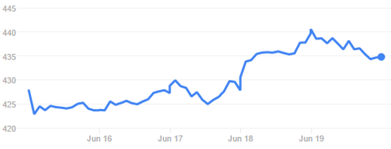
Figure 6.1.5. Increasing Price Trend
The Figure 6.1.5 shows an increasing price trend, investing on stocks with this type of price trend will promise profit but not high profit. It is preferred for beginning investors.
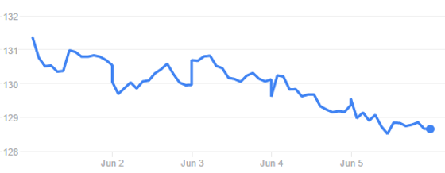
Figure 6.1.6. Decreasing Price Trend
The Figure 6.1.6 shows a decreasing price trend, investing on stocks with this type of price trend will definitely causes loss. Therefore, the stocks with decreasing price trend should be sold as earlier as possible to avoid continuous losses.
The last thing we learned from our simulation is that the first half of the week has high possibility to earn, and the second half of the week has high possibility to loss. Therefore, we trade more in beginning of each week and trade less in the end. Also, trading less stocks with more shares is another good practice to earn profits.

Conclusion
From the project stock market simulation, we learned the basic knowledge of stock market and stock trading techniques. Compared with position trading strategy, day trading strategy is easier to earn profit because investors who use day trading strategy trade more frequently to earn more profit or avoid bigger loss. There are three typical price trend such as “U” shape price trend, increasing price trend and decreasing price trend. In addition, trading more in earlier of each week and trading less in later of each week are also strategies to earn profit from stock trades. Trading less stocks with more shares will let investors concentrate on these a few stocks, which is also a good practice.
With the knowledge and techniques learned from this project, each team member will have more confidence to invest on stocks in the future.

Reference
- Finance - Zacks,. (2015). Advantages of Investing in the Stock Market. Retrieved 8 July 2015, from http://finance.zacks.com/advantages-investing-stock-market-2054.html

- Investopedia,. (2005). Stock Market Definition | Investopedia. Retrieved 8 July 2015, from http://www.investopedia.com/terms/s/stockmarket.asp

- Wikipedia,. (2015). Stock market. Retrieved 8 July 2015, from https://en.wikipedia.org/wiki/Stock_market

- Value Stock Guide,. (2015). Stock Market Terms for Beginners. Retrieved 8 July 2015, from http://valuestockguide.com/stock-market-terminology-for-beginners

- Wikipedia,. (2015). Day trading. Retrieved 8 July 2015, from https://en.wikipedia.org/wiki/Day_trading

- Kristina Zucchi, C. (2011). 4 Common Active Trading Strategies. Investopedia. Retrieved 8 July 2015, from http://www.investopedia.com/articles/active-trading/11/four-types-of-active-traders.asp

- Wikipedia,. (2015). Market liquidity. Retrieved 8 July 2015, from https://en.wikipedia.org/wiki/Market_liquidity

- Wikipedia,. (2015). Volatility (finance). Retrieved 8 July 2015, from https://en.wikipedia.org/wiki/Volatility_(finance)

- Investopedia,. (2003). Candlestick Definition | Investopedia. Retrieved 8 July 2015, from http://www.investopedia.com/terms/c/candlestick.asp

- Fontinelle, A. (2003). Electronic Communication Network (ECN) Definition | Investopedia. Investopedia. Retrieved 8 July 2015, from http://www.investopedia.com/terms/e/ecn.asp

- Wikipedia,. (2015). Stock market data systems. Retrieved 8 July 2015, from https://en.wikipedia.org/wiki/Stock_market_data_systems

- Wikipedia,. (2015). Position (finance). Retrieved 8 July 2015, from https://en.wikipedia.org/wiki/Position_(finance)

- DailyFX,. (2015). Forex Trading News & Analysis - DailyFX. Retrieved 5 July 2015, from http://www.dailyfx.com/

- Wikipedia,. (2015). Apple Inc.. Retrieved 5 July 2015, from https://en.wikipedia.org/wiki/Apple_Inc.

- Wikipedia,. (2015). Microsoft. Retrieved 5 July 2015, from https://en.wikipedia.org/wiki/Microsoft

- Wikipedia,. (2015). Amazon.com. Retrieved 5 July 2015, from https://en.wikipedia.org/wiki/Amazon.com

- Wikipedia,. (2015). EBay. Retrieved 5 July 2015, from https://en.wikipedia.org/wiki/EBay

- Wikipedia,. (2015). Google. Retrieved 5 July 2015, from https://en.wikipedia.org/wiki/Google

- Wikipedia,. (2015). Yahoo!. Retrieved 5 July 2015, from https://en.wikipedia.org/wiki/Yahoo!

- Wikipedia,. (2015). American Airlines. Retrieved 5 July 2015, from https://en.wikipedia.org/wiki/American_Airlines

- Wikipedia,. (2015). Texas Instruments. Retrieved 5 July 2015, from https://en.wikipedia.org/wiki/Texas_Instruments

- Wikipedia,. (2015). Starbucks. Retrieved 5 July 2015, from https://en.wikipedia.org/wiki/Starbucks

- Wikipedia,. (2015). McDonald's. Retrieved 5 July 2015, from https://en.wikipedia.org/wiki/McDonald%27s

Appendix
The day trading stock simulation numerical results are shown in below (see Table A1). The table below records daily profits and cash values (note: the negative number means trading loss). Also, the data are plotted into corresponding figures (see Fig. 6.1.1 and Fig. 6.1.2).
Date | Profit | Total Asset Value
26-May | -81.9 | 99918.1
27-May | 80.48 | 99998.58
28-May | 222.56 | 100221.1
29-May | 61.76 | 100282.9
1-Jun | 28.58 | 100311.5
2-Jun | 264.58 | 100576.1
3-Jun | -13.92 | 100562.1
4-Jun | -97.32 | 100464.8
5-Jun | -31.94 | 100279.5
8-Jun | 204.56 | 100637.4
9-Jun | 128.06 | 100765.5
10-Jun | -21.92 | 100743.6
11-Jun | 173.06 | 100916.6
12-Jun | 54.02 | 100970.7
15-Jun | 69.08 | 101039.7
16-Jun | 174.58 | 101214.3
17-Jun | 97.56 | 101311.9
18-Jun | 1131.06 | 102442.9
19-Jun | -306.46 | 102136.5
22-Jun | 286.46 | 102422.9
23-Jun | 737.86 | 103160.8
24-Jun | 115.04 | 103275.8
25-Jun | 94.04 | 103369.9
26-Jun | -28.96 | 103340.9
Table A1. Day Trading Stock Simulation Summary Results
The position trading stock simulation numerical results are shown in below (see Table A2 and Table A3). Table A2 records date, daily cash values and daily total asset value. Also, the daily asset values data are plotted into corresponding Fig. 6.1.3. Table A3 records weekly profits (note: the negative number means loss).
Date | Cash | Total Asset Value
May-26 | 6084.1 | 99813.6
May-27 | 7728.62 | 101081.52
May-28 | 6018.61 | 97301.01
May-29 | 1660.83 | 96960.74
Jun-1 | 1660.83 | 97539.93
Jun-2 | 1660.83 | 97553.88
Jun-3 | 1660.83 | 97947.08
Jun-4 | 2366.65 | 97080.75
Jun-5 | 1722.27 | 97938.82
Jun-8 | 10866.39 | 96710.79
Jun-9 | 10866.39 | 96796.09
Jun-10 | 18573.43 | 91980.48
Jun-11 | 18573.43 | 91770.88
Jun-12 | 18573.43 | 91367.33
Jun-15 | 18573.4 | 90723.15
Jun-16 | 18573.4 | 90999.4
Jun-17 | 32899.92 | 91235.92
Jun-18 | 32899.92 | 91962.62
Jun-19 | 40614.96 | 92032.96
Jun-22 | 40614.96 | 92600.16
Jun-23 | 55878.69 | 113202.49
Jun-24 | 55878.69 | 112787.09
Jun-25 | 2401.71 | 103230.11
Jun-26 | 102095.8 | 102095.75
Table A2. Position Trading Stock Simulation Summary Results
Week | Accumulated Profit ($)
One | -4.77
Two | -134.15
Three | 386.29
Four | 708.85
Five | 2095.75
Table A3. Position Trading Stock Simulation Weekly Accumulated Profits

