WPI Disclosure Number (OTC will assign) __________________

WORCESTER POLYTECHNIC INSTITUTE
INTELLECTUAL PROPERTY DISCLOSURE FORM
Forward this completed and signed form to the Office of Technology Commercialization

Title of invention: Smart Sport Backstop

Department: Mechanical Engineering and Industrial Engineering
Dean: John A. McNeill (Dean of Engineering, WPI) and Rev. Dr. Debora Jackson (Dean of Foisie Business School, WPI)
Is this an IQP or MQP? MQP

1. Big Picture: What is the ultimate “one sentence” possible product? What need does it address?

Smart backstop system that can measure and give feedback on speed, rotation, and position of a thrown or hit ball, like a softball or baseball pitch, European handball, American football, soccer, street or ice hockey, golf, lacrosse, tennis, or other racket sports.

2. Inventor(s) –Identify all individuals who have made significant intellectual contributions to this invention's advance over prior technology, but do not include anyone merely because s/he has carried out some of the experimental work.

Given Name: Bailey
Family Name: Berg
Faculty Title/Position: Student
If student:
Undergraduate/graduate: Undergraduate
Expected year of graduation: Spring 2021
WPI email: bcberg@wpi.edu
Non WPI Email: baileycberg@gmail.com

Given Name: Jordan
Family Name: DeDonato
Faculty Title/Position: Student
If student:
Undergraduate/graduate: Undergraduate
Expected year of graduation: Spring 2021
WPI email:
Non WPI Email:

Given Name: Michael
Family Name: Keable Jr
Faculty Title/Position: Student
If student:
Undergraduate/graduate: Undergraduate
Expected year of graduation: Spring 2021
WPI email: mwkeable@wpi.edu
Non WPI Email: mkeable19@yahoo.com

Given Name: Thien
Family Name: Nguyen
Faculty Title/Position: Student
If student:
Undergraduate/graduate: Undergraduate
Expected year of graduation: Spring 2021
WPI email: tqnguyen@wpi.edu
Non WPI Email: nqthien0408@gmail.com

Given Name: Griffin
Family Name: St. Onge
Faculty Title/Position: Student
If student:
Undergraduate/graduate: Undergraduate
Expected year of graduation: Spring 2021
WPI email: gmstonge@wpi.edu
Non WPI Email: gstonge99@yahoo.com

Given Name: David
Family Name: Leandres
Faculty Title/Position: Student
If student:
Undergraduate/graduate: Undergraduate
Expected year of graduation: Spring 2022
WPI email: dgleandres@wpi.edu
Non WPI Email:

Given Name: Christopher
Family Name: Brown
Faculty Title/Position: Professor
If student:
Undergraduate/graduate:
Expected year of graduation:
WPI email: brown@wpi.edu
Non WPI Email:

3. Specify any other inventor(s) who is/are an employee of an organization other than WPI and the institutional affiliation.

N/A

4. Describe the “Important Customer Need or Needs” that you are addressing. What is the specific market segment addressed and how big is it? Do you have a possible business model for your invention?

Customer Needs
- Measures speed of ball
- Measures position of ball going through middle of Homeplate, or other locations
- Easy to store
- Easy to transport
- Provide feedback on speed
- Provide feedback on position
- Provide feedback on rotation (option on vision system)
- Affordable
- Weather resistant
- Stops ball
- Minimizes potential injuries
- Can be used by anyone, children, or adults
The specific market segment addressed to sports and games markets. This product can be used for both training and for fun competitions with friends.
We do not have a specific business model, but this product is easy to replicate and cheap enough to reproduce when compared to other similar products, that there could easily be an adequate profit margin.
5. Describe your technical “Approach” for how you will address that need. Include the functions and the invention fulfills and the “physical” solution to the design problem posed by functions. Feel free to attach manuscripts, abstracts, drawings, or videos describing the technical aspects of the invention.

This invention uses a vision system with cameras mounted separately on tripods or integrated into the backstop frame and home plate or other low-to-the-ground component. Cameras capture ball flights to determine positions and speeds, and, optionally, seams or stiches to determine rotation. Computing is done on small volume processors, located separately or integrated with cameras in backstop and ground structures, communicating with the cameras, and with output devices, such as Bluetooth, which records or broadcasts statistics. In addition, there could be game simulations, which as calling balls, and strikes, and hits, walks, outs, innings, and games based on statistics at some level, such as in little league or legion ball.

6. Describe the quantitative “Benefits/costs” of your approach. Why is your idea of significant worth to somebody?

The benefit of our product is that it could be affordable (under $500, exact price TBD) and accurate (TBD). It can offer data and feedback on speed and position. Most similar products only offer data and feedback on speed. Additionally, most products are either expensive or inaccurate or both.

7. Who is the “Competition” and why are the benefits/costs of your approach significantly better? Quantify: is it 2-10 times better?

Product | Performance | Measurement Method | Accuracy | Reading Range | Power | Price | How much better is our design
SKLZ Bullet Ball | Inconsistent readings  Weight was not the same as regular baseball  Never shuts off | Speed sensor | Not accurate  ± 50 MPH | Up to 120 MPH | 1 LR-41 Battery | $18.49 | 5 - ours is more accurate but also more expensive
Radar Pitching Trainer 1000 | Good accuracy and display  Moves when speed is over 50 mph  Materials ware out | Radar | ± 1 MPH | 20-99 MPH | 4 D Batteries | $399.00 | 2 – similar but ours offer position data
Pocket Rader | Consistent readings  Immediate feedback  Easy to operate and transport | Radar | ± 1 MPH | 25-130 MPH | 2 AAA Batteries | $300-$400 | 2 - very similar but ours gives feedback on position
Speedtrack x | Poor quality and accuracy  Does not read high speeds | Radar | ± 2 MPH | 9-150 MPH | 4 C Batteries | $360.00 | 4 – better accuracy, similar price
Sports Sensor Swing Speed | Moderate accuracy  Easily portable | Doppler Radar | Within 1% | 20-200 MPH | 3 AA Batteries | $119.95 | 2 - better accuracy, similar price or more expensive
Stalker Sports 2 Radar Gun | High level accuracy  Able to read at multiple angles | Doppler Radar | ± 1 MPH | 5-150 MPH | 6 AA Batteries | $560 | 2 – little bit cheaper
Statcast (MLB) | High level accuracy  Reads all speeds and spin rates | Radar and camera | Extremely minimal  ± 0.5 MPH | All speeds if ball is picked up | Hardwired | $50,000+ | 2 – much cheaper but less accurate

8. Please provide key words that best identify with your idea:

Baseball (and other sports as listed above), measurement, speed, radar, position, backstop, camera vision, pitch trainer, sports sensor

9. Prior Art (Relevant recent “background” o successfully determine the patentability of this invention, it will be necessary to compare it to any existing technology, i.e., "prior art." Provide any references to assist in this evaluation.) You should go to http://www.searchrealfast.com/wpi and use your WPI email for a quick and efficient way to search for prior art. Use your key words to assist in the search. A quick tutorial can be found at: http://www.searchrealfast.com/faculty

For baseball only:
- System and method for predicting athletic ability US8308615B2
- Intelligent Sensor System US20170322054A1
- Ball rotation measurement system JP6350733B1
- Baseball pitch quality determination method and apparatus US10737167B2
- Method and apparatus for sport swing analysis system US20050202907A1
- Method, apparatus, and computer program product for measuring and interpreting metrics of an athletic action and an object associated therewith US20190258905A1
- Intelligent Sensor System US20170322054A1
- Pitcher training apparatus and method using a ball with an embedded inertial measurement unit US9032794B2
- Automated or assisted umpiring of baseball game using computer vision US10632359B2
- Systems and methods of analyzing moving objects US20180249135A1
- Ball sensing US9308426B2

10. What level of proof or evidence of viability do you have for the invention? Working prototype, proof of concept experiments, etc.?

Developing prototype and completed design decomposition (shown above in question 5).

11. Has this invention been disclosed to others, either verbally or in written form (date, place, to whom, method of disclosure)?

Disclosed general concepts of design to advisers and project sponsor through project meetings.

Cole Noreika has worked for the team on the computer programming since February 2021.
Weekly since December 2020 - Walter T. Towner – project advisor – verbally and in writing
Weekly since August 2020 - Christopher A. Brown – project advisor – verbally and in writing
November 10, 2020 - Gary Sowyrda – project sponsor - verbally and in writing

12. Indicate any pending disclosures (date, place, to whom, method of disclosure).

April 30, 2021 – oral presentation and Q&A to Worcester Polytechnic Institute professors and student

13. Indicate any potential commercial licensees that you think may be interested in this invention.

Sport Sensors, Inc.
Athlete Intelligence
Pocket Radar, Inc.
Blast Motion
Stalker Sport
Pro Sports Equip
Implus LLC

14. Identify any grants, sponsors or projects (provide grant/contract number) under which either conception or first reduction to practice occurred, including partial funding and Federal "formula" funding. Also list any related projects and/or inventions and any other potential claimants to rights in this invention.
NOTE: This is very important to have the correct grant number in the proper format as WPI needs to report any inventions developed under federal grant money.

Sponsor: Gary Sowyrda (WPI alumni)

15. Were any University funds or other resources used in making this invention (if yes, please explain).

No, just sponsor’s money.

16. If funded by an external sponsor, has the sponsor been notified of this invention, either, directly, in a progress or other report, or in an application for additional funds (date, sponsor, method of disclosure)?

Yes, he has been notified of this invention directly and through progress check ins.

This disclosure will become the first official University record of this invention.
Before signing, please ensure, to the best of your knowledge, that all information provided herein is complete and accurate. This disclosure must be complete with all invention information submitted and all signatures to be accepted.

Signed and submitted by:

Inventor's Signature (1) Date Citizenship

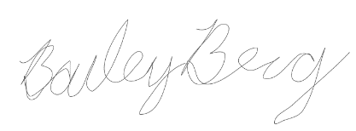 April 20, 2021 United States

Print name: Bailey Berg

Home Address, Including City, State and Zip
18 Jericho Drive
Kingston, New Hampshire
03848

Inventor's Signature (2) Date Citizenship

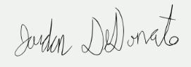 April 20, 2021 United States

Print name: Jordan DeDonato

Home Address, Including City, State and Zip
45 Longbow RD
Danvers, MA 01923

Inventor's Signature (3) Date Citizenship

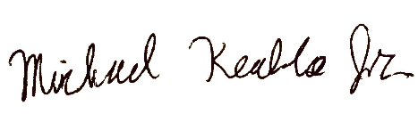 April 20, 2021 United States

Print name: Michael Keable Jr

Home Address, Including City, State and Zip
1357 Victory HWY
Oakland, Rhode Island
02858

Inventor's Signature (4) Date Citizenship

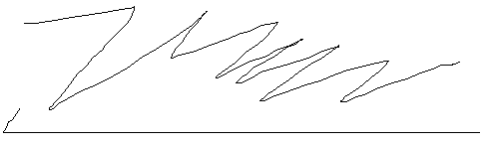 April 20, 2021 Viet Nam

Print name: Thien Nguyen

Home Address, Including City, State and Zip
45 Dover St
Worcester, Massachusetts
01609

Inventor's Signature (5) Date Citizenship

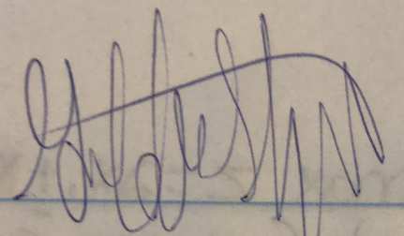 April 20, 2021 United States

Print name: Griffin St. Onge

Home Address, Including City, State and Zip
4 Newstead St.
Litchfield NH, 03052

Inventor's Signature (6) Date Citizenship

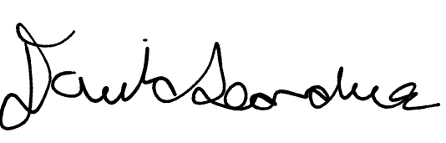 April 20, 2021 United States

Print name: David Leandres

Home Address, Including City, State and Zip
2 Belle Ln
Shelton, CT 06484

Inventor's Signature (7) Date Citizenship

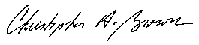 April 20, 2021 United States

Print name: Christopher Aldrich Brown

Home Address, Including City, State and Zip
77-2 Waterbury Center
Vermont 05677

NOTE: WPI will assume that any eventual revenue from this invention will be split equally, unless there is a different split as acknowledged below:

Inventor 1: Bailey Berg Percent of Inventor share: _12.5_________

Acknowledged: 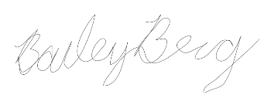

Inventor 2: Jordan DeDonato Percent of Inventor share: ___12.5_______

Acknowledged: 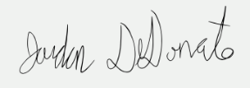

Inventor 3: Michael Keable Jr Percent of Inventor share: ___12.5_______

Acknowledged: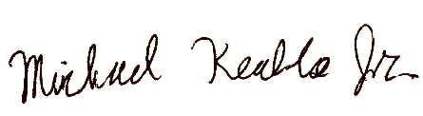

Inventor 4: Thien Nguyen Percent of Inventor share: _____12.5_____

Acknowledged:

Inventor 5: Griffin St. Onge Percent of Inventor share: _____12.5_____

Acknowledged: 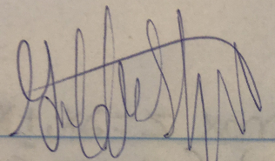

Inventor 6: David Leandres Percent of Inventor share: ___12.5_______

Acknowledged:

Inventor 7: Christopher Aldrich Brown Percent of Inventor share: ___12.5_______

Acknowledged:

Inventor 8: Gary Sowyrda Percent of Inventor share: ___12.5_______

Acknowledged: *please sign*

Advisor Endorsement for Inventions by WPI Students: To the best of my knowledge,
the above information is correct.

Christopher A. Brown
Student Advisor Signature Date 4-20-21

For Office of Technology Commercialization use:

Date Received

Acknowledged by

Sponsorship Rights Verified: Yes No

Copies Attached: Yes No

