Planta Láctea

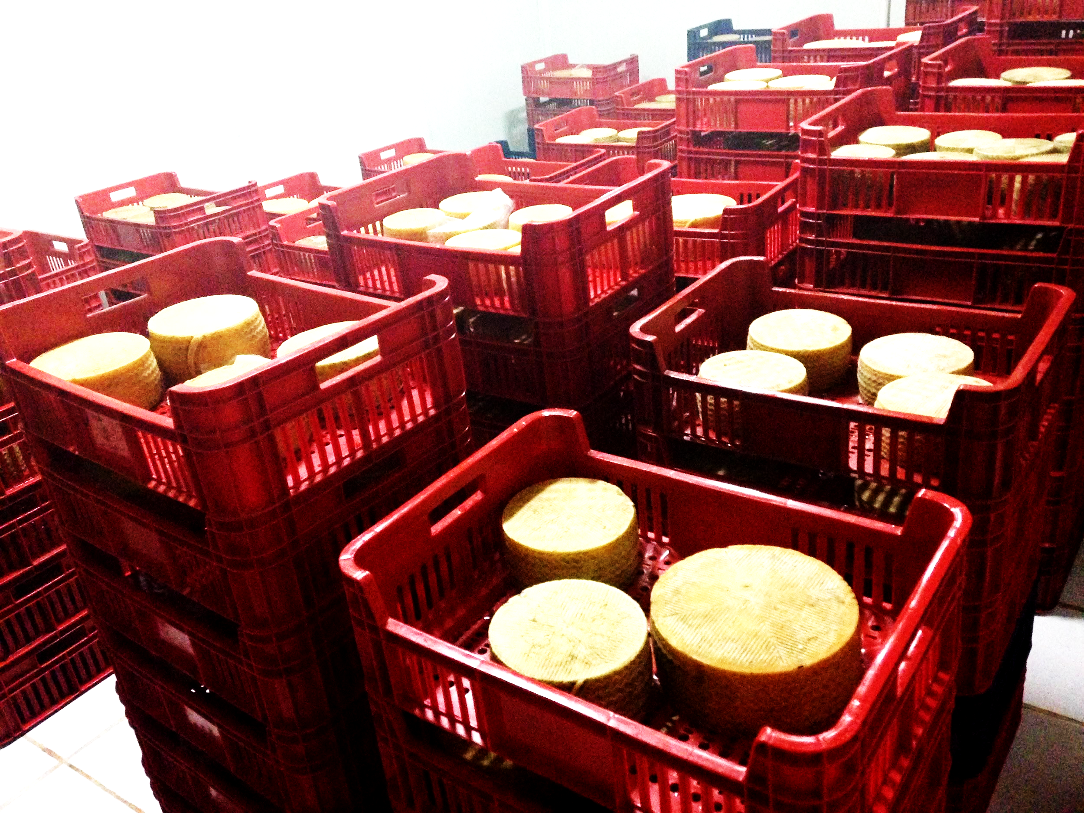

By:
Troy Hughes
Abdulrahman Jilani
Victoria Patterson

Date:
5/5/2015

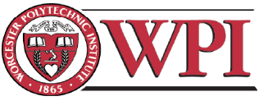
Cheese Factory

An Interactive Qualifying Project completed in partial fulfillment of the Bachelor of Science degree at
Worcester Polytechnic Institute, Worcester, MA

By
Troy Hughes
Abdulrahman Jilani
Victoria Patterson

Date:
5/5/2015

Professor Robert Traver
Worcester Polytechnic Institute

This report represents work of WPI undergraduate students submitted to the faculty as evidence of a degree requirement. WPI routinely publishes these reports on its web site without editorial or peer review. For more information about the projects program at WPI, see http://www.wpi.edu/Academics/Projects

Abstract
The San Francisco Agricultural School in Cerrito, Paraguay, is a school that provides self-sustaining education, home, and career support for all 150 of its students by way of a hands-on, vocational approach to education. Students here alternate throughout the week between classroom learning and working to provide an income for the school. Fundación Paraguaya manages the school. The foundation’s main goal is to help eliminate poverty in Paraguay. The project group’s main goal was to find a way to alleviate some of the school’s cost to maximize profits. Specifically, the group was concerned with making the school’s dairy factory more energy efficient and sustainable. Recommendations included a list of best-practice techniques as well as design modifications of some of the equipment used in the production of the school’s dairy products.

Acknowledgments
The group project would like to thank everyone listed below for helping us and providing us with any needed information during our research period for the Interactive Qualifying Project:
- Dorothy Wolf for advising our project and providing on-the-ground support as well as connecting us with the San Francisco Agricultural School.
- Martin Burt for connecting us with the San Francisco Agricultural School and his support during our research period.
- Robert Traver for advising us before and after we arrived to the project site and giving us feedback to achieve the best outcomes out of our research and studies.
- Fundación Paraguaya for inviting us to work at one of their facilities to complete a part of our degree requirements at Worcester Polytechnic Institute.
- San Francisco Agricultural School for hosting our group and allowing us to work side-by-side with the faculty and students.
- Jose Luis Salomon for advising our project and providing technical expertise.
- Ricardo Negrete for providing us with an in-depth look at all the different processes of the cheese factory.
- Luis Cateura for providing additional support to our project and our life on campus
- Virgilio Borges for helping us with the construction methods some of the recommendation we found would profit the cheese factory.
- The students of San Francisco Agricultural School for accepting us into their lives and making us comfortable on campus.
- Liina Nevalainen for being our all around resource for anything and everything paraguayan.
- Sarah Hooper for making our stay in Paraguay comfortable, and helping us with visas logistics.

Authorship Page
All members contributed equally to this project and paper.

Table of Contents
Abstract 3
Acknowledgments 4
Authorship Page 5
Table of Contents 6
List of Figures 8
List of Tables 9
1. Executive Summary 10
2. Introduction 11
3. Background 12
3.1. Paraguay 12
3.2. Fundación Paraguaya and the San Francisco Agricultural School 13
3.3. Planta Láctea (Cheese Factory) 13
3.4. Energy Sources 14
3.4.1. Heat Energy 14
3.4.2. Electrical Energy 15
3.5. Cooking Processes 16
3.5.1. Milk Pasteurizing 17
3.5.2. Cheese 18
3.5.3. Yogurt 20
3.5.4. Dulce de Leche 20
3.6. Selling the Products 20
4. Analysis of Everything 21
4.1. Energy Analysis 22
4.2. Time Analysis 22
4.3. Material Resource Analysis 23
4.4 Priorities and Implementation 23
5. Solutions and Recommendations 24
5.1 Firewood Management 24
5.1.1. Material Management 24
5.1.2. Boiler Feeding 25
5.2. Water Recycling System 25
5.2.1. Finding a Solution 25
5.2.2. Rearranging the Factory 25
5.2.3. Final Plans 26
5.3. Milk Pasteurizing and Cheese-making Tank 26
5.3.1 The Current Tank 26
5.3.2. Tank Solutions and Ideas 28
5.4. Yogurt Packaging 29
6. Results 29
6.1. Firewood Management 29
6.1.1 School Implementation 29
6.1.2. Expected Outcome 30
6.2. Water Recycling System 30
6.2.1. What was Implemented 30
6.2.2. Expected Outcome of What Was Implemented 30
6.2.3. Expected Outcome of Project Completion 30
6.3. Milk Pasteurization and Cheese-making Tank 30
7. Discussion of Results and Solutions 31
7.1. Firewood Management 31
7.1.1. Material Management 31
7.1.2. Boiler Feeding 33
7.2. Water Recycling System 33
7.2.1. Implemented Improvements 33
7.2.2. Future Improvements 34
7.3. Milk Pasteurization and Cheese-making Tank 34
7.3.1. Investing in a New Tank 34
7.3.2. Modifying the Current Tank 34
7.4. Yogurt Packaging 34
8. Conclusion and List Of Recommendations 35
8.1. Accomplishments and Recommendations 35
8.2. Future Endeavors 35
Bibliography 36
Appendices 37
Appendix i 37
Appendix ii 39
Appendix iii 40
Future Project: Yogurt Packaging 40
Appendix iv 41
Future Project: The Cost of Milk for The Planta Láctea 41
Appendix v 42
Future Project: Pump Utilization in The Planta Láctea 42

List of Figures
Figure 1: Map of Paraguay. 12
Figure 2: Front cross-sectional view of the boiler showing the main cylinder and the two chambers 15
Figure 3: Right cross-sectional view of the boiler showing the path of the heated air. 15
Figure 4: Front cross-sectional view of the pasteurizing/cheese making tank during the project groups time with the Planta Láctea. 18
Figure 5: First plan for rearrangement of the Planta Láctea 26
Figure 6: Final rearrangement of the Planta Lactea 26
Figure 7: Front cross-sectional view of the current tank 28
Figure 8: Front cross-sectional view of the proposed modifications for pasteurizing tank 29
Figure 9: Compare Wausau, USA to Cerrito, Paraguay: 2005-2014,Copyright 2015 by Wolfram Alpha. 32
Figure 10: Compare Wausau, USA to Cerrito, Paraguay: 2005-2014,Copyright 2015 by Wolfram Alpha. 33
Figure 11: a) Initial layer of wood. b) Alpha layer of wood 37
Figure 12: a) Correct Alpha layer on top of Beta layer. b) Incorrect Beta layer. 38
Figure 13: Figure 5: Real Life example of wood stack. 38
Figure 14: Planta Lactea before moving the machines. 39
Figure 15: Planta Láctea, Idea 1 39
Figure 16: Planta Láctea, Idea 2 39
Figure 17: Planta Láctea, Idea 3 39
Figure 18: Planta Láctea, Final Idea 39

List of Tables
Table 1: Price of milk for the school. 14
Table 2: Table of comparison of milk cost to produced cheese. 16
Table 3: The MPT and time spent at MPT. 17
Table 4: Cost of cheeses sold. 18
Table 5: Cost of all the products from the Planta Láctea 21
Table 6: Basic guide to feeding the boiler. 25

1. Executive Summary
Fundación Paraguaya is an organization that works to eliminate poverty by offering self-help services for families to proactively rise above the poverty line. Fundación Paraguaya utilizes a number of programs including self-sufficient agricultural schools to accomplish its goal of empowering families to overcome poverty. One such school, the San Francisco Agricultural School offers a free, self-sufficient, unique education for a select group of students who demonstrate both need and a drive to succeed. The school allows students to study basic principles of math, science, and language while also learning valuable trades such as horticulture, cattle raising, cooking, dairy manufacturing, and business. All departments of the school operate as small businesses and must monitor costs, profits, and production.
Sustainability is the single most important aspect of the school and as such, the school makes every effort they can to use renewable resources and cut costs. To this end, the school invited a group of WPI students to analyze their process and make recommendations. The project group’s main task was to analyze the cost, energy, and time efficiency of the school’s Planta Láctea (dairy factory) in order to increase the profit margin of the school.
The research required an initial examination of cheese production, small and large scale, and a review of heat sources. The fact that the project took place in rural Paraguay also required study of the host country's culture, Spanish as it is spoken in Paraguay, and the welcoming and friendship customs of school staff, students and faculty.
Initially while on site, each member of the group shadowed various members of the school in order to gain a better understanding of how the school operates, both in the Planta Láctea and as a whole. The group then observed the Planta Láctea more in depth, taking note of any areas of functionality that could improve efficiency, and ultimately, the profit margin of the Planta Láctea.
The group noticed many aspects of the production process, which could be improved. They performed a cost-benefit analysis of possible improvements and designs in order to narrow down to the most effective and sustainable solutions. The group chose to focus on a few aspects and possible improvements in the Planta Láctea.
The four main topics for consideration included the optimization of firewood storage and boiler feeding practices; the cheese-pasteurizing tank; a design to recycle water vapor back to the boiler; and a design to improve the yogurt bottling process. The project group felt all were important base improvements, which would allow future growth and sustainability of the Planta Láctea.

2. Introduction
Paraguay, with one of South America’s fastest growing economies, struggles with severe wealth inequality (Encyclopedia, 2015). While many people in the capital city, Asuncion, are beginning to prosper, others remain untouched by any boosts in the economy. In most any given town or city in Paraguay, one can see the effects of prosperity visible in a tall building or a new clothing store, yet can drive for only minutes before realizing the drastic disparity. ‘Asentamientos’, or informal settlements of people living on essentially unused land owned by the government, are often spotted in close proximity to cities and wealthy neighborhoods as well as other less prosperous areas (Romero, 2013).
A large portion, about 28%, of Paraguay’s Gross Domestic Product is agricultural based making its economy highly dependent upon agriculture to sustain its growth and take care of its people. However, only 6% of the land is utilized in production and products are exported at very low prices. This makes available only a very small number of low-paying jobs to the public and puts Paraguay in a tough situation; a large population of people struggle everyday to find meaningful employment (Encyclopedia, 2015).
By 2009, a little over a third of the population of Paraguay was below the poverty line with 20% being in extreme poverty (Encyclopedia, 2013). Since 2013, when President Horacio Cortes took office and vowed a war against poverty, the percent of people below the poverty line has decreased to only 23.8%. The poverty percentage is expected to decrease further as several organizations have made it their priority to defeat poverty nationwide (Paraguay, 2013).
Many poverty elimination efforts in Paraguay have centered on the concept of connecting families with self-help opportunities to lift themselves out of poverty. One such organization, Fundación Paraguaya, uses self-assessment surveys to determine the poverty level of each family and community as a whole and “address the household-specifics constraints that keep families below the poverty line” (Hendrix, 2014).
An important aspect to their efforts is that they do not offer handouts or temporary relief. Instead, they offer an educational relief. A primary example of this is Fundación Paraguaya’s education model in all of their 4 self-sufficient agricultural and trade schools. Students graduating from one of these schools, San Francisco Escuela Agricola, leave with two degrees: a “High School Diploma as an Agriculture/Livestock Technician and as a Hotel and Tourism Technician” (Self-sustainable, 2011). This education takes a systematic approach in helping the students and communities do better for themselves. During the students ‘four years in the school, they gain hands-on experience working different trades in each sector of the school’s’ business. This provides the students with valuable entrepreneurial skills to be successful on their own as well as an income that completely covers all of their educational expenses.
Although the students cut many costs for the school by providing a labor force, other expenses still exist. This pushes the school to strive for cost efficient and sustainable practices such as utilizing a bio digester to convert animal waste to usable fuel and growing 100% of food for the students. Because the San Francisco School constantly seeks ways to cut costs and increase its profit margins, it has sought university expertise. In response, Worcester Polytechnic Institute provided tea team of innovative engineering students to study the problem and make recommendations.
In particular, the San Francisco school wants to maximize their dairy product production and reduce associated costs. They asked the WPI students to analyze the process of the dairy factory for inefficiencies and to provide design feedback to improve each process. The WPI project team aims to increase the time, cost, and energy efficiency of the dairy factory as well as improve the overall work-environment significantly.

3. Background

3.1. Paraguay
Paraguay is a landlocked country in South America, measuring about 406,800 square kilometers with bordering neighbors Argentina, Brazil, and Bolivia (“Encyclopedia,” 2015). Its population, as of 2013, was over 6.8 million people. The country has a total of 211 square kilometers of land used for agricultural purposes (“Paraguay,” 2013).

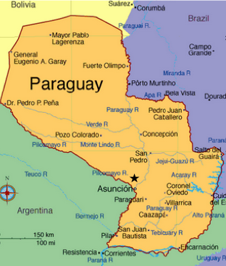

Figure 1: Map of Paraguay.
http://www.infoplease.com/atlas/country/paraguay.html
The San Francisco Agricultural School is located in Cerrito, Benjamin Aceval District (Star on the map in Figure 1), along the Rio Paraguay (Paraguay River). The local population is estimated at about 1,100 as of 2008. The district of Benjamin Aceval has a high concentration of agricultural land with a large portion of the land being used for sugarcane as well as chicken and dairy farms. Common commodities of the area include pasteurized milk, yogurt, and cheese.

3.2. Fundación Paraguaya and the San Francisco Agricultural School
Fundación Paraguaya, founded in 1985, is a not-for-profit organization that strives to eliminate poverty in Paraguay by providing a variety of self-help services to empower families to improve their socio economic status. The self-help services that the organization provides include a microcredit program which gives small loans for emerging micro-entrepreneurs, an entrepreneurial and financial education program for youth, and an agricultural boarding school for high-school aged youth of rural families.
Originally, the San Francisco Agricultural school was owned by the Brotherhood of Franciscan Missionaries, “purchased…with donations from German Benefactors” (Godfrey, 2010) in 1963. The first students began attending in 1964 and by 1978, the school was converted to an agricultural school “focusing on a more vocational and practical education than merely classroom instruction.” The transformation of the school resulted in government funding to help pay for a majority of the expenses such as teacher salaries. The school existed on government funding for a little over 20 years until political turmoil resulted in a freeze of the government infrastructure and funding for government-sponsored initiatives.
It was not until 2002 that the previous administrators of the school approached Martin Burt and Fundación Paraguaya with the idea of restarting the agriculture school--this time, without government funding (Godfrey, 2010).

3.3. Planta Láctea (Cheese Factory)
The cheese factory generates income for the school and teaches students both cheese making and entrepreneurship. The farm produces commercial amounts of milk daily, which the factory uses to produce consumable milk, cheeses, and other high-value dairy products. Each of these products are sold by the students and cheese master, Ricardo Negrete, weekly.
Each of the products from the Planta Láctea require different types of ingredients; with milk being the common thread among them all. In any given day, the Planta Láctea consumes between 300 and 600 liters of milk. Of which, 100 is produced and purchased on campus and the rest from external suppliers. The milk is the largest for each of the Planta Láctea’s products.
Below is a comparison of the prices of milk from each of the different suppliers. These prices were provided by Professor Cateura, the school director, and are inclusive of the approximate transportation costs (pers. comm. April 15, 2015).

Source | Price in Gs. and ($)
Farm | 1700 (.35)
Supplier 1 | 2300 (.47)
Supplier 2 | 2500 (.51)
Table 1: Price of milk for the school.

3.4. Energy Sources

3.4.1. Heat Energy
Production of each of the products in the Planta Láctea requires, at some point in the process, cooking temperatures of 65C or higher. To generate enough heat to reach this temperature goal, the Planta Láctea utilizes a wood-burning boiler. In the boiler, there is a main cylinder that is divided into upper and lower chambers, as shown in Figure 2.
The lower chamber burns the wood, heating the surrounding air and metal. The heated air rises to the upper chamber.
The upper chamber consists of a water tank containing pipes that run through the tank lengthwise. As the hot air travels through the pipes, the heat transfers to the water with a circuit of the following order:
- Convection: hot air to pipe.
- Conduction: pipe bulk.
- Convection: pipe to water.
Naturally, heat travels from higher gradient to lower gradient. When the water starts to produce vapor, the vapor travels from the boiler to the factory through a piping system. The pressure of the vapor ideally should be 2 kg/cm², and the theoretical temperature of the vapor should be 119C. The following two figures illustrate how the boiler works.

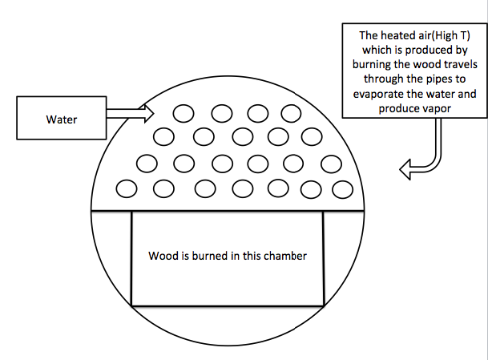
Figure 2: Front cross-sectional view of the boiler showing the main cylinder and the two chambers

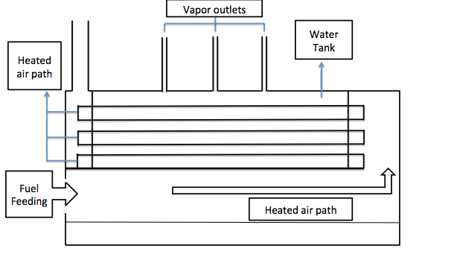
Figure 3: Right cross-sectional view of the boiler showing the path of the heated air.

3.4.2. Electrical Energy
The factory also consumes electrical energy during the cooking and aging periods of production. During the cooking period of production, electrical energy powers all stirring motors for pasteurization, mixing, and cheese forming. Sometimes, 3 motors may be run at once. Depending on which process is underway, a motor could be running anywhere from 30 minutes to 4 hours.
The other main electricity consumer for the cooking period of production is the compressor and cheese-drying machine. This machine squeezes cheese to remove the excess whey from the curdled cheese. The compressor alternates between on and off (cued when the pressure falls below a certain point value). Each time the compressor cycles back on, it requires additional electricity. The idling of the compressor uses nominally no electricity.
During the ageing period (or post production storage period) of the products, electricity powers refrigerators to maintain products at a safe temperature for later consumption. These systems run continuously all year long.

3.5. Cooking Processes
The Planta Láctea typically operates five days a week, producing three products: cheese, yogurt, and dulce de leche. On an average day, one type of cheese is created (Paraguaya or iberico), and one other product. Occasionally, only the cheese is produced, while on other days, three processes for three different products run at the same time. The decision of what to produce and when relies heavily on inventory and market demand.
The three main products, cheese; yogurt; and dulce de leche, require different ingredients, cooking methods and energy needs. The first difference is the yield of the three products based on their common need for pasteurized milk. Table 2 shows the yield difference.

Products | Liters of milk (L) | Produced amount
Queso Ibérico | 11 L | 1 kg
Queso Paraguay | 10 L | 1 kg
Queso Burgos | 10 L | 1 kg
Dulce de Leche | 2 L | 1 kg
Yogurt | 1 L | 1 L
Table 2: Table of comparison of milk cost to produced cheese.
A second difference is cooking temperatures. Specifically, there are different maximum processing temperatures (MPT) and time required to reach MPT. Table 3 shows the MPT and time at MPT.

Product | MPT | Time at MPT
Cheese | 65 C | 40-70 mins
Dulce de leche | 100 C | 4 hours
Yogurt | 90 C | 5 minutes
Table 3: The MPT and time spent at MPT.

3.5.1. Milk Pasteurizing
Pasteurizing milk is an essential part of cheese production because it kills harmful bacteria. Many different pasteurization techniques currently exist in industry. The implementation of these techniques by dairy factories mostly depend on the technology each factory can afford. The techniques differ in the time required and heating/cooling temperatures of the pasteurized liquid. There are three different types of pasteurization: Rapid pasteurization, continuous slow pasteurization, and momentary pasteurization. The Planta Láctea utilizes continuous slow pasteurization for its products.

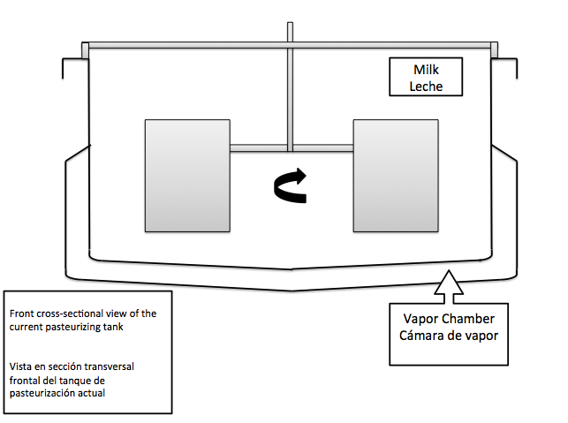
Figure 4: Front cross-sectional view of the pasteurizing/cheese making tank during the project groups time with the Planta Láctea.

3.5.2. Cheese
The Planta Láctea produces more cheese than the other two products on a monthly basis. Cheese also requires the largest amount of raw materials in a given month, especially milk. The factory produces two kinds of cheese: fresh cheese, such as Queso Paraguaya, Ricotta, and Burgos; and aged cheese, Queso Ibérico.
All of the cheeses are sold for profit, except for Ricotta. The ricotta is consumed at the school either as pig feed or in student meals. Table 4 shows the unit sale price for each of the products.

Product | Sales price in Gs. and ($)
Queso Ibérico (retail price) 3 months | 85,000/kg (17.4/kg)
Queso Ibérico (catering price) 3 months | 65,000/kg (13.28/kg)
Queso Ibérico: aged for 6 months | 100,000/kg (20.42/kg)
Queso Ibérico: Goat cheese | 120,000/kg (24/kg)
Queso Paraguay | 30,000/kg (6.31/kg)
Table 4: Cost of cheeses sold.

3.5.2.1. Queso Ibérico
The cheese master, Ricardo Negrete, brought the recipe for Queso Ibérico to the San Francisco Agricultural School. Queso Ibérico has the most return value of all cheeses produced at the Planta Láctea. The sale price for 1 kg of three-month old Queso Ibérico is 85,000 Gs. ($17.4) when made with cow milk, and 120,000 Gs when made with Goat milk. The price climbs even higher, to 100,000 Gs, when the cheese reaches the ripe age of 6 months (cow milk exclusively). The process of making Ibérico starts with pasteurized milk with added proteins and chemicals to form the colloids. When colloids are formed they produce a bulky gel that floats on the top, that bulk is then cut into very small cubes and stirred for 30 minutes. After that, the whey is removed from the tank and what is left in the tank is compressed into cheese molds and are then compressed further using a compressor and cheese-drying machine.
The dried cheese is placed in a saltwater bath where it stays completely submerged for an amount of time dependent upon the size of the wheel. From here, the cheese is refrigerated for 20 to 30 days. During this part of the process, the cheese is kept moist with olive oil. At the end of the period, a fresh coat of olive oil is applied and the cheese is moved to another refrigerator for the upcoming months until it is sold.
In the refrigerator, the cheese begins to age and dry on its own. The cheese is dated and left to dry and cool over time. The cheese chills for duration of time between two to five months to ages before it is sold.

3.5.2.2. Queso Paraguay
A fresh cheese, Queso Paraguay, can be consumed the same day it is produced. This cheese is very famous and native to Paraguay. In fact, most dairy companies and factories in Paraguay have it in their production lines. This cheese is produced daily and readily consumable, it has a lower price; 30,000 Gs. ($6.31) for 1 kg. This cheese initially follows a very similar process to that of Ibérico. The primary differences are the aging process, the size of the cheese bulk (grain of the cheese) and the added ingredients. Ibérico is a very fine cheese; this helps dry the cheese out more.
Queso Paraguay, on the other hand, is a moist cheese. The bulk is not cut as fine, thus the cheese retains more water. The whey is removed from this cheese identically to Ibérico and after the whey is removed, the cheese is molded and compressed. The last step for this cheese is the fridge to chill. While this cheese is consumable the same day, the Planta Láctea prefers to keep the cheese for seven to ten days to let it dry and settle before packaging and selling it.

3.5.2.3. Queso Burgos
Queso Burgos is a Spanish cheese that takes its name from the Burgos area in northern Spain. This cheese has a sweet taste, and is mostly used for making dessert and as a salad topping. The factory does not produce this cheese as often as the others because its demand is much lower. The process of making this cheese is very similar to the queso Paraguay; the principle difference being what happens after the whey is removed. Burgos is immediately molded and placed in a refrigerator for three to five days without a compression phase. From here, the cheese is then salted and packaged for sale.

3.5.2.4. Queso Ricotta
Ricotta is an Italian cheese produced from whey, which is left over from typical cheese production. The decision to make ricotta occurred two weeks into the project group’s time with the school. The school management board decided to make ricotta so the Planta Láctea could take advantage of the leftover whey that results from making the other kinds of cheese. In the past, the school produced ricotta, but at some point they stopped making it and began feeding the whey to the pigs. Recently, the school management board decided to take advantage of the project group’s presence and begin making ricotta cheese again.
The process for ricotta is not complicated. Whey is first heated to 98C, at which point vinegar is added and the heat source is removed. The whey is left for around 10-15 minutes to begin forming the cheese clusters. The cheese is skimmed off the top and molded.
This type of cheese can be consumed immediately, and as such, would have a lower sale price. However a price has not been established, because it is still so new to the Planta Láctea.

3.5.3. Yogurt
Yogurt, a popular drink in Paraguay, is produced about once a week in the Planta Láctea. As with all other products, its production starts with the pasteurization of milk. However, as soon as the pasteurization is over, several ingredients are added to give yogurt its unique characteristics and taste. After the ingredients, (sugar, gelatin, and fermentation bacteria) are added to the yogurt, the heat is removed and the yogurt sits to ferment until the temperature reaches 45C. The yogurt it then agitated for about 4-5 hours or until the acidity of the batch reaches between 4.4 and 4.7. The final step in the process is adding a flavoring agent for taste.
In terms of the energy requirement, yogurt ranks somewhere in the middle of all the products. It does not require as much heat energy as Dulce de Leche or the cheeses. Instead, its energy consumption is almost entirely due to mixing.

3.5.4. Dulce de Leche
Dulce de Leche is a very famous sweet spread in Latin America. It is very similar in nature to caramel, however, is made from milk with sugar added rather than from caramelized sugar with water or milk added. The English translation of Dulce de Leche is “sweets of milk”. Dulce de Leche is made from the Maillard reaction (desired browning reaction), by heating the milk to 100C and adding sugar and by continuous stirring until the mass ratio has 60% sugar. This process usually takes 4 hours at the factory. The heat requirement to keep the product at 100C is very large, yet is justified in the sale value and yield. The yield of Dulce de Leche is 2 kg to every 1 liter of milk. The finished product is bottled in “grande” or “pequeño” bottles. Dulce de Leche is popular in making ice cream, cakes, and many other desserts.

3.6. Selling the Products
The factory sells its products in farmers’ markets in Asuncion and other surrounding areas. However, the main customers are the school hotel, school visitors, local cheese vendors, restaurants, and the Spanish Embassy in Asuncion.
The cheese master, Ricardo Negrete, joined the school in March 2014. He completely remodeled the processes of the former cheese factory, choosing to halt production of cheddar and mozzarella and begin production of Queso Ibérico and Burgos, while Queso Paraguaya remained in production. Ricardo Negrete brought to the school an exceptional amount of experience, as he used to co-own a cheese factory in Spain that exported to five other countries. With the assistance of Ricardo Negrete, the Profits of the Planta Láctea 2014 were more than double what they were in 2013. The recent rise in profit has been mostly credited to the increase in production of Queso Ibérico. Below in Table 5 are the unit sale prices of each product.

Product | Sales price in Gs. and ($)
Queso Ibérico (retail price) 3 months | 85,000/kg (17.4/kg)
Queso Ibérico (catering price) 3 months | 65,000/kg (13.28/kg)
Queso Iberico: aged for 6 months | 100,000/kg (20.42/kg)
Queso Iberico: Goat milk | 120,000/kg (24/kg)
Queso Ricotta | Not available
Queso Burgos | 30,000/kg (6.31/kg)
Queso Paraguay | 30,000/kg (6.31/kg)
Yogurt 400ml | 4,000/bottle (0.82)
Yogurt 250ml | 2500/bottle (0.51)
Dulce de Leche (Grande) | 12,000/bottle (2.45)
Dulce de Leche (Pequeño) | 8,000/bottle (1.60)
Table 5: Cost of all the products from the Planta Láctea

4. Analysis of Everything
This section will describe the operations of the Planta Láctea as a whole and provide suggestions for improvement. The group examined aspects of time, energy, and material resource efficiencies of the Planta Láctea. Analysis of these subcategories led the team to identify which modifications would both benefit the school the most and could be made within the group’s allotted time at the school.

4.1. Energy Analysis
The main energy sources for the Planta Láctea are electricity and combustible energy from a boiler.
Electric energy is consumed by many different electrical components that are run throughout the day: a compressor to dry cheeses, multiple refrigerators/freezers, and three separate stirring machines.
A boiler fuels all heating processes in the Planta Láctea. Without the heat, the Planta Láctea could not produce any of its products. The Planta Láctea had a large number of wasteful components: waste of energy by surplus, waste of energy through inefficiency of use, and waste of energy through inefficiency of creation. The group was able to determine that these wastes could, unlike the electrical components, be reduced or avoided with little to no change in the production process.
Waste of energy by surplus occurred every time there was a significant amount of pressure in the boiler at the end of the day. It was determined that this was due to overload the boiler. The result was leftover boiler pressure at the end of the day.
Waste of energy through machine inefficiency is most evident in the pasteurization tank. This tank (rectangular) has heating elements only halfway up the sides of the walls. This introduces a large quantity of heat loss, thus requiring more time to heat the milk.
Waste of energy through inefficiency of creation regularly happened on the farm when wet wood was burnt in order to create energy. Burning the wet wood produce less energy delivered to the water used for heating, thus creates less hot vapor.

4.2. Time Analysis
Time management and efficiency is another aspect of production with cost-reduction potential. The cheese master, Ricardo Negrete, expressed interest in expanding production to grow the customer bas, but he is concerned that there is insufficient time in the day to complete all the tasks that are needed to meet the current schedule. Among these unfinished tasks are essentials like cleaning and inventory.
Yogurt packaging is another process that places huge constraints on time as it is performed by hand and is prone to spillage. The Planta Láctea’s method utilized a small pitcher to pour the yogurt into small drinkable bottles.
The transport of mild is a third time-sink for the Planta Láctea. The milk was transferred from one machine to the next via large buckets, carried by the staff. The process took much time because many buckets had to be used for a single batch. Everyday a significant amount of milk is spilled during the process. Cleaning the spill amounts to additional lost time.
Whey, a byproduct of cheese making, is also separated by hand. The separation is time extensive and highly prone to spillage.

4.3. Material Resource Analysis
The largest cost to production in the Planta Láctea is the raw ingredients; milk being the largest expense out of all of them. The Planta Láctea used between 300 and 400 Liters of milk each day. The 16 milkable cows on campus produce only 100 Liters. The rest of the milk is imported from local farms but at higher prices; see Table 1 (averaging to 2500 Gs per Liter).
Another material concern the Planta Láctea has is fuel for the boiler. Currently, the boiler uses wood as its fuel. The Planta Láctea did not purchase any of its firewood when the project group was on campus; all of it was collected around campus. With no formal firewood drying processes, relatively damp or wet wood will decrease boiler efficiency and increase boiler maintenance. This is an unsustainable process. The project group identified this process as unsustainable and as a long-term expense that could have serious negative impacts in the future.

4.4 Priorities and Implementation
In order to balance the needs of the school with the needs of the project, the group prioritized tasks that directly improved the profitability and sanitation of the Planta Láctea. The prioritization was driven by the project group’s assessment of the practicality of implementation, cost effectiveness, and time restraints, as well as the impact on profitability, sustainability, and sanitation.
The most cost-effective solution, increasing the number of cows on the farm, , the group chose to disregard. The school does not have the resources to implement a cattle increase and the project group did not have the time make suitable plans.
The project group chose to focus primarily on optimizing the firewood storing process on the farm. The wood collecting and storing practices were inefficient and unsustainable. Implementing wood-storing and boiler-feeding policies would reduce wood consumption by much as half. Although this solution does not directly improve profitability, it strengthens sustainability and reduces potential future costs to the farm when wood supplies become low.
A secondary goal of the project group was to address the daily waste of heat energy in the boiler. In the past, there existed a water-recycling system to return the condensed hot water from the cooking process back to the boiler; thus recycling the water and saving energy. This system broke at some point and was never fixed. The project group decided it would be beneficial to the Planta Láctea to rebuild and improve this system.
The tertiary goal was to improve the cheese pasteurization tank. Extending the cheese pasteurizers heating elements up the full wall would causes drastic decreases to the time and energy required to heat the milk when the tank is full.
The fourth goal was to improve the yogurt bottling process. By redesigning the old yogurt-bagging machine to work with the bottling process, time and human resources can be conserved.

5. Solutions and Recommendations
The nature of this project varied with the needs of the school. It was important to the school that the project group before their departure implement some suggested improvements. During the project, the group was able to create and implement a system for Firewood Management, design and partially implement a water return system for the Planta Láctea, and design solutions for the cheese pasteurization tank and yogurt packaging systems.

5.1 Firewood Management
Good firewood management depends on two key principles: material management and boiler feeding. Material management is the gathering of materials and the preparation of them. Boiler feeding refers to the techniques to determine the type and amount of material used in the boiler.

5.1.1. Material Management

5.1.1.1. Material Gathering
Wood should be collected on a continuous basis, everyday if possible. There are four types of useable materials that can be collected: very large pieces of wood, average wood pieces, small pieces of wood, and kindling.
Large to very large pieces of wood should be cut down to have an average width of 15 cm and 40 cm length; cutting them is important for drying. Wood should be collected, cut, and stored as normal.
Small pieces of firewood include anything smaller than an average piece of firewood, but bigger than kindling. Smaller firewood is important for burning for shorter periods of time. Small pieces can range from branches to smaller tree trunks (less than 5 cm in diameter).
Kindling includes any twigs, branches, or eucalyptus leaves that will be good for starting the fire. All small pieces of wood that chip off while cutting any other wood should be kept and stored with the kindling wood.

5.1.1.2. Wood Preparation
Wood must be cut and split to the acceptable dimensions for proper drying. The wood, at its longest length, should be cut no longer than 40 cm; this dimension should be along the ‘height’ of the wood (about the non circular face). The circular face should be split so that it’s no wider than 15 cm (this could result in the circular face not looking like a circle).
After splitting the wood it must be stacked in a covered area with good airflow to allow the water to evaporate. Either build the stacks in a covered area, or add a cover to protect the wood from rain.

5.1.2. Boiler Feeding
The time when wood is added to the boiler depends on what process is taking place in the Planta Láctea. The project group’s recommendation is to feed the boiler different amounts and types dependent upon the amount and duration of energy desired. The qualitative directions are outlined in Table 6.

Basic Guide to Feeding the Boiler | Higher heat required | Medium to low amount of heat
All day processes | Large, very dry pieces of wood. Occasionally feeding eucalyptus leaves | Large pieces of wood
Quick, end of day processes | Dry branches, eucalyptus leaves, very small pieces of wood | Dry Branches
Table 6: Basic guide to feeding the boiler.

5.2. Water Recycling System

5.2.1. Finding a Solution
The goal for this project was to return the condensed water back to the boiler tank to save energy. An initial constraint of this project was the inability to break the factory’s floor and redo it. The group’s alternative was to run the condensed water return pipes across on top of the ground. Precautions were taken to avoid laying piping in high-traffic areas as well to minimize the need for angles and bends in the pipes as they cause pressure loss.

5.2.2. Rearranging the Factory
Balancing the needs of the factory with safety and energy-safety precautions meant that machines were top priorities. The group wanted a rearrangement of the pipes that would minimally impact the day-to-day operations while taking full advantage of the available water for recycling.
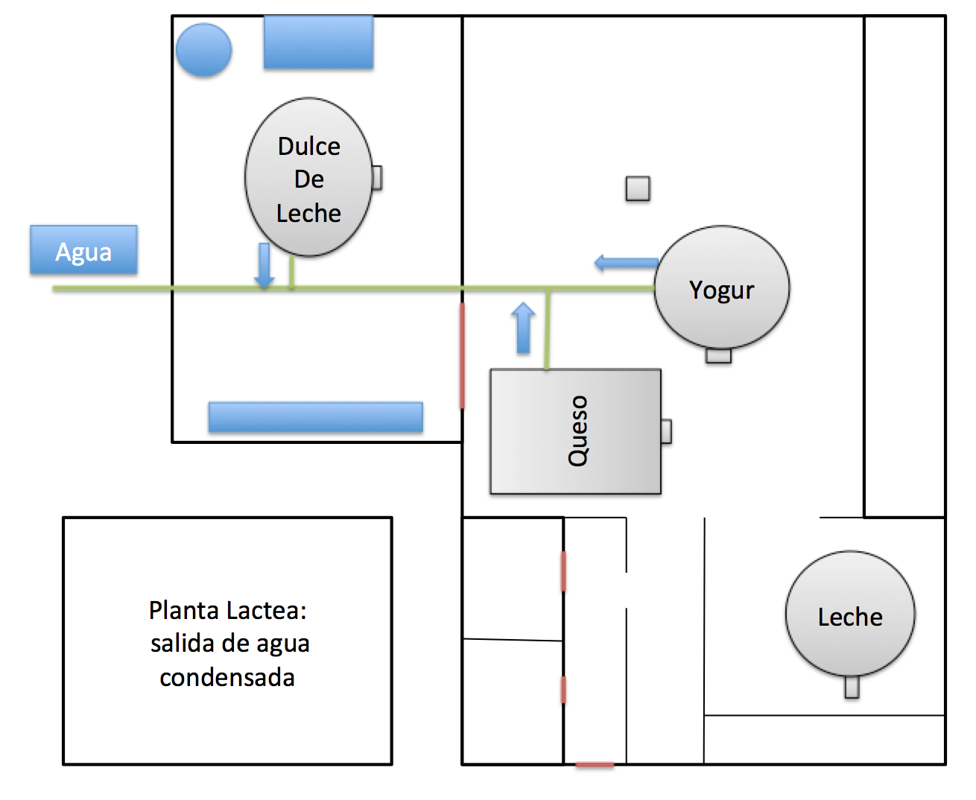
Figure 5: First plan for rearrangement of the Planta Láctea
Three possible designs of the new floor plan were created and presented to the school. The project group believed that each design was equally viable, though none of the possible arrangements perfectly addressed the walking hazard concern. Figure 5 is one of the figures that were presented in the meeting; the rest are in appendix ii.

5.2.3. Final Plans
The preferred rearrangement is shown in Figure 6. This design reflected the cheese-master’s experience with dairy production and the group’s knowledge of thermodynamics.
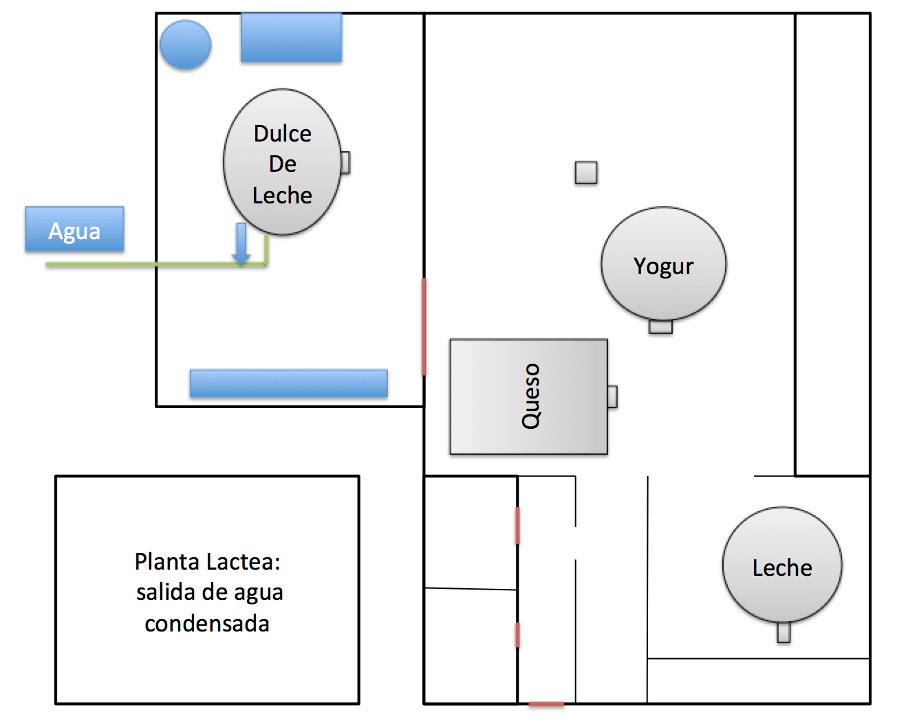
Figure 6: Final rearrangement of the Planta Lactea

The cheese master explained that the benefits of a rearrangement (reduced heating times for the majority of products) would outweigh any disadvantages and inconveniences in the factory. Ultimately, the project group’s primary goal was to improve the efficiency, sustainability, and profitability of the Planta Láctea. Potential hazards to the factory personnel working were insignificant. In the future, In the future, the school may elect to redo the plumbing to alleviate any hazards and inconveniences of the workers.

5.3. Milk Pasteurizing and Cheese-making Tank

5.3.1 The Current Tank
As discussed previously in the background, pasteurization is an important first step in production of all products. The tank used for pasteurization runs multiple times per day as it has two functions. The current design of the tank is flawed; the two main disadvantages of the tank include its shape and the heating efficiency.

5.3.1.1. The shape of the current tanks
The rectangular shape is inefficient for milk pasteurizing or cheese making. The cheese master advised that the best shapes for cheese making are oval or figure eight. The figure eight shaped tanks have two chambers, each with its own stirring machine. The oval shaped tanks have two stirring machines on each circular end; one on the top and one on the bottom. Two stirring machines stirring in opposite directions allows for more efficient mixing.
With only one stirring machine, all contents of the tank eventually begin to move at the same speed in the same direction. The result is that the contents do not sufficiently mix within the system without the assistance of the operator.
Another inefficiency of the tank shape is the introduction of cheese filled eddies during the cheese mixing process. After the cheese begins to solidify and the tank is filled with cheese and whey, it is cut and mixed up. During mixing, cheese forms in the corners and does not mix into the rest of the tank, ruining the integrity of the mixing motion and opening the possibility of burning.

5.3.1.2. Heating efficiency
Heating the milk in the tank is essential in the cheese making process. Pasteurizing the milk and forming the cheese occur in a single tank with heat emanating from the lower portion of the walls and the bed of the tank. The upper half of the tank is not exposed to any heat source. When the tank is filled to its maximum capacity, only half of the milk is heated at a given time. This causes delays in the overall cheese making process as well as heat loss through convection from the upper half of the tank walls. Figure 7 shows a schematic of the tank during the time that the project group was working.
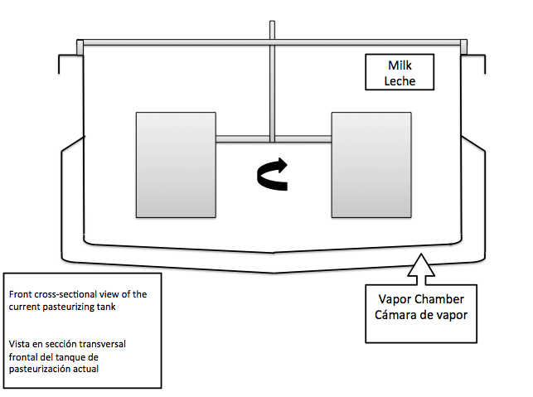
Figure 7: Front cross-sectional view of the current tank

5.3.2. Tank Solutions and Ideas
The group project proposed to the school board and the cheese master two solutions for rectifying the inefficiencies of the pasteurization tank --investing in a new tank or modifying the current tank.

5.3.2.1. Investing in a New Tank
A new tank with an optimal shape would provide better heating efficiency and stirring mechanism. A tank that meets these requirements is typically purchased for industrial purposes and can cost at least $25,000.

5.3.2.2. Modifying the Current Tank
A modification to the current tank could alleviate some of the inefficiencies present in the tank. There are not many improvements that can be made in the way of the tank’s shape, however, adding an additional heating chamber to the upper region of the tank walls is possible and relatively inexpensive.
The upper chamber would be isolated from the lower chamber, and have its own vapor inlet and condensed water outlet. Two chambers allow for the flexibility to produce either full or half tank of cheese with high heating efficiency.Isolating the top chamber from the lower will make the modifications cheaper to implement and easier to carry out. Figure 8 shows a sketch of the proposed design.
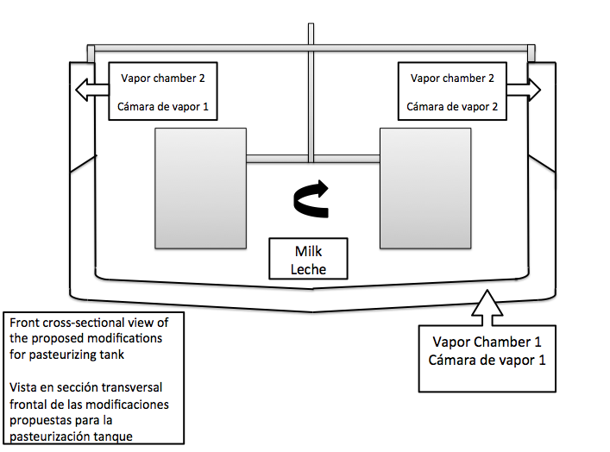
Figure 8: Front cross-sectional view of the proposed modifications for pasteurizing tank

5.4. Yogurt Packaging
The project group did not get beyond the brainstorming stage for its fourth goal. The problem with yogurt packaging is that it takes too much time and has high potential for waste. The students pour the yogurt by hand from a container into the yogurt bottles; they pour slowly to avoid wasting material and thus require a large amount of time to do so. Because this idea did not get out of the brainstorming stages, all information surrounding information will be presented in appendix iii for future endeavors of the school and other project groups to develop. As such, there is not a results or discussions sections for this topic.

6. Results

6.1. Firewood Management

6.1.1 School Implementation
Before the Project group departed the school, they worked with the Planta Láctea to implement their solution for Firewood Management. Professors Negrete and Virgilio acknowledged the importance of this implementation. However, it is important to note that the effectiveness of the solution depends on how closely the school staff and students follow the recommended guidelines.

6.1.2. Expected Outcome
In an experiment by Wood Fuel Wales, a United Kingdom group promoting efficient energy usage practices, showed the energy differences between using dry vs. wet wood. In the experiment, dry wood of 13% moisture was compared to 30% moisture wood to make a pot of tea (“Wood Fuel”, 2015). The dry wood required two minutes to bring the pot of water to a boil, while the wet wood required 7 minutes. The significance of this experiment was that a 50% energy difference existed between the two wood conditions.
When wood is freshly cut, its moisture is estimated at 30-40%. An implementation of proper drying techniques at the school would result in burning wood at an optimal water content of 20% or less and lessen the amount of wood required for the heating needs.

6.2. Water Recycling System

6.2.1. What was Implemented
The project group was unable to fully implement the water recycling system for the Planta Láctea before leaving. They were, however, able to rearrange the locations of many of the machines, as reflected in Figure 6.

6.2.2. Expected Outcome of What Was Implemented
The team expected the high ambient temperatures to decrease in the factory after the machine rearrangement. In addition, they expected that the water recycling would be more efficient as the Dulce de Leche machine became closer to the boiler, requiring less energy to transport the water.

6.2.3. Expected Outcome of Project Completion
When the hot condensed water-return system is added to the Planta Láctea, there will be an increase the temperature of the boilers water reservoir. This increase will decrease the amount of energy needed to bring the water to a boil, thus decreasing the amount of firewood needed to run the processes in the Planta Láctea.

6.3. Milk Pasteurization and Cheese-making Tank
Redesigning the pasteurization tank in the Planta Láctea will decrease the amount of heat required for production by decreasing the amount of heat loss and shortening the time necessary for production. The benefits of a new design would allow the factory staff to process more products and use less fuel.

7. Discussion of Results and Solutions

7.1. Firewood Management
Firewood management depends on two key principles; material management and boiler feeding. Material management outlines the importance of material gathering, and best practices of firewood storage and preparation. Boiler feeding outlines the importance of utilizing the right materials for the situation when feeding the boiler.

7.1.1. Material Management

7.1.1.1. Material Gathering
The Planta Láctea should maintain an equal balance of collecting wood and burning it. With the long time required to properly season firewood (up to a year), burning more than what is collected will cause the wood management system to falter.
It is important to collect a variety of types of firewood for efficient boiler use. By collecting and drying a variety of woods, the cheese master will be able better control the amount of heat produced for the Planta Láctea.

7.1.1.2. Wood Preparation
Wood preparation begins with proper splitting to size and stacking until dry. Splitting helps the wood dry faster. Dry wood burns cleaner and more efficiently than wet wood.
The water in the wood has a high heat capacity and will use much of the energy evaporating. The “‘practical maximum’ of the ‘heat value’ occurs at about “one-fifth water weight of the wood” (Kea, 2006).
To get the wood to a prime water composition, it must be cut to size and allowed to dry for a long period of time. The length of time that the stack is left to air dry depends on a number of factors. The climate is a very significant factor. A document published by two Natural Resource educators from the University of Wisconsin-Extension stated, “it is best to let your wood season for 18 months before burning, but many woodland owners get by with only 12 months of drying,” (Klase, 2015). This number can vary due to the large amounts of precipitation in a year, specific humidity, and the type of wood being use etc. In other locations in the United States, it’s been stated that the wood must be left out to dry for at least six months or longer (“How to Prepare,” 2014).
In order to estimate wood drying time for Cerrito, Paraguay, one can compare meteorological information between Cerrito, Paraguay and Wausau, Wisconsin easily by taking advantage of WolframAlpha.com’s weather comparison functionality. This starts with the temperature and the wind speed comparison - both of which are key factors to the wood drying process.

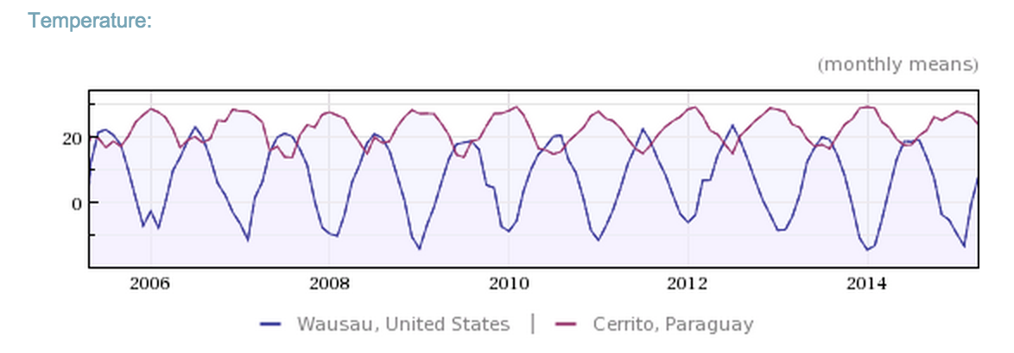
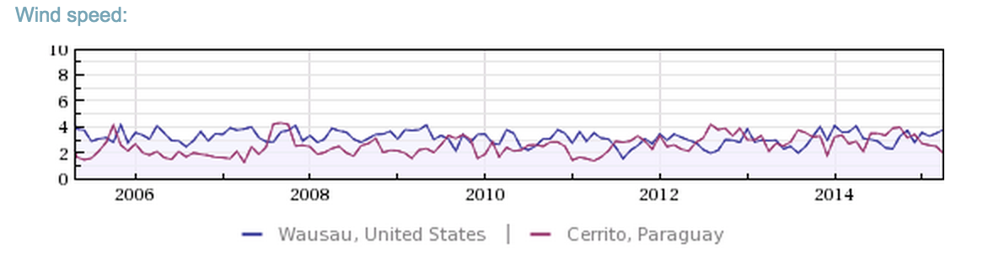
Figure 9: Compare Wausau, USA to Cerrito, Paraguay: 2005-2014,Copyright 2015 by Wolfram Alpha.
The temperature graph shows that, on average, the temperature in Cerrito is much higher than that of Madison. While the wind speed graph shows that, with the exception of 2006 and 2007, the wind speed averages out in the most recent portion of the past ten years. To further show similar drying conditions, it is important to look at the precipitation and the humidity of the areas. The humidity affects the rate of wood drying tremendously. However, precipitation does not affect the wood drying nearly as much.
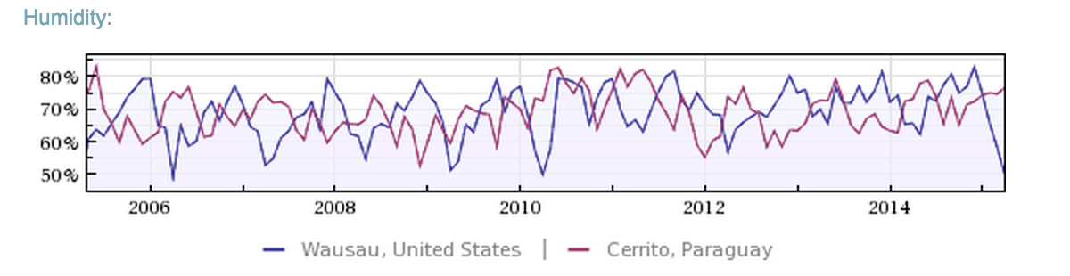
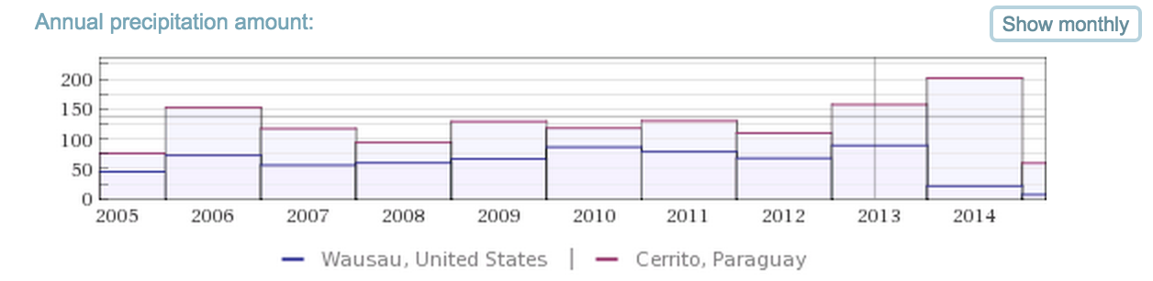
Figure 10: Compare Wausau, USA to Cerrito, Paraguay: 2005-2014,Copyright 2015 by Wolfram Alpha.
The graphs show that, again on average, the Humidity of Cerrito and Wausau are very similar, which yields the thought that they will experience similar drying conditions. While the precipitation will be pretty significantly different (just under double in most scenarios); with the average temperature of Cerrito being greater than Wausau, the precipitation could have been remedied.
The charts and data show a very similar climate in Cerrito as Wausau. This was the driving factor in the project group’s suggestion that the wood be dried no fewer than 6 to 7 months, and preferably more than 12 to 18 months if possible.

7.1.2. Boiler Feeding
Optimal boiler feeding requires the feeder to understand how to efficiently use firewood; primarily understanding the size of the firewood used should be dependent on the need of the Planta Láctea. For example, at the start of the Dulce De Leche process, adding large pieces of firewood is efficient; at the end of the cheese making process large pieces of firewood are inefficient. This is something that will need to be tracked by the school and adapted to fit their needs, but they should have a direct understanding that the woods they use will directly affect the amount of energy they get in the cheese factory.

7.2. Water Recycling System

7.2.1. Implemented Improvements
The project group was able to change the location of the Dulce de Leche and cheese pasteurizing tanks. There were three principal reasons for implementing this change in the Planta Láctea: the utility of the condensed water and how the return pipes would impact the work area; the temperature and humidity in the work area; and the ease for future improvements.
Professor Negrete’s concerns with a water-return system were those of machine accessibility. The project group was unable to design an above-ground condensed water return systems that would not hinder daily operations. Without that option, the simplest solution was to move the machines. While meeting with Professor Jose Luis, the group discovered the benefit of improved ventilation for steam. The rearrangement would reduce the temperature and humidity of the Planta Láctea, especially after the dulce de leche cooking process.
By moving the cheese pasteurization tank out into a more open area, future expansions and improvements become more manageable. Many of the cheese master’s desired improvements to the Planta Láctea can only be implemented after a rearrangement of the equipment.

7.2.2. Future Improvements
By implementing the water return pipes, the temperature in the tank boiler reservoir will drop. This means less firewood is needed.
In the future, the Planta Láctea will need to replace the floors once more. During this time, the Planta Láctea could re-run the return pipes from all of the machines (cheese and yogurt) underground. Doing this will maximize the benefits of returning the water from the cooking machines.

7.3. Milk Pasteurization and Cheese-making Tank

7.3.1. Investing in a New Tank
Investing in a new pasteurization tank is cost prohibitive. The estimated price is $25,000. This cost is high due to customization and expensive materials. The school indicated that it will reconsider this option when there are more financial resources.

7.3.2. Modifying the Current Tank

7.3.2.1. Picking a Solution
Of the two solutions presented to the school board, modification was the only viable option. Although modification will not solve all of the tank’s inefficiencies, it would still be a substantial improvement.

7.3.2.2. Why It Will Work
Heat naturally travels from high to low gradient. The heat transfer rate is dependent on many factors, surface area being one of the most critical. The Planta Láctea’s tank has only one heating chamber, located in the bottom half of the machine. By adding a second chamber extension, the surface area of contact between the heating elements in the tank and milk is increased and therefore will result in less heat time as well as an increased heating rate.

7.4. Yogurt Packaging
The project group observed that 80% of the components were worn down or broken and others were not suitable for the current method of bottle packaging. The main frame and the yogurt tank could be salvaged from the machine as they were in acceptable condition. The group proposed adding a circular tray which can hold a defined number of bottles to be filled one at a time. The tray would rotate to allow each bottle to be filled. Modifications to this machine will require a financial outlay that must be approved by the school board.

8. Conclusion and List Of Recommendations

8.1. Accomplishments and Recommendations
San Francisco agricultural school sought the help of the WPI project group to increase overall profitability of the Planta Láctea. With the short time available to make the largest contribution to the school, the group performed a cost-benefit analysis to determine the following recommendations
The project group was able to partially implement two solutions at the school with the help of the cheese master, manager of general services, and the school director. The group was able to implement a new firewood management system as well as factory machinery rearrangement. Both of the implantations will aid in the reduction of energy as well as time.

8.2. Future Endeavors
The project group’s recommendations to the school and future project groups are to find ways to reduce energy consumption and the cost of milk, and to improve time-management via the following:

- Install the pump and piping for condensed water return
- Implement the project group’s redesign to the pasteurization tank to improve energy efficiency.
- Redesign the old yogurt-packaging machine to be compatible with bottles.
- Acquire more cows so that the Planta Láctea can purchase less outside milk.
- Utilize a pump system to transfer milk between the machines, and
- Install plumbing under the floors to recycle water to and from the boiler.

The school should start these projects in the order presented, from most complete to least complete. The project group left points one and two started, for completion the school would need to follow through on what was started.
Points three through five were all, to some extent, examined by the project group. All the discovered information and recommended considerations are stored in appendix iii through iv. These points are important problems that could be solved by the school or revisited by future project groups.

Bibliography

- C. Godfrey, P. (2010). Fundación Paraguaya: The San Francisco School. Ballard Center. Retrieved April 23, 2015.
- Encyclopedia of the Nations. (2015, January 1). Retrieved April 24, 2015.
- Hendrix, S. (2014, September 16). Paraguay's Poverty Spotlight: Focusing on Women and Markets for Innovation, Tangible Success. Retrieved April 23, 2015.
- How to Prepare Your Fuel Supply. (2014, January 1). Retrieved April 24, 2015.
- Kea, J. (2006, February 16). Don’t Get Burned Cutting Firewood | North Carolina Cooperative Extension. Retrieved April 24, 2015.
- Klase, W., & Tiles, K. (2015). Harvesting Firewood from Your Woods. Clean Eater.
- Paraguay. (2013, January 1). Retrieved April 24, 2015.
- Romero, S. (2013, April 24). Boom Times in Paraguay Leave Many Behind. Retrieved April 24, 2015.
- Self-sustainable Schools - FUNDACIÓN PARAGUAYA. (2011, January 1). Retrieved April 23, 2015.
- Wood Fuel for a Sustainable Future. (2015, January 1). Retrieved April 24, 2015.

Appendices

Appendix i
The recommended method of wood stacking starts with two long strips of material (could be wood, metal or plastic, its makeup doesn’t affect the outcome) across the ground as a foundation for the stack. An optional, yet highly helpful, tall support can be planted adjacent to the start of the stack for the wood to gain initial structure and make it easier to stack the wood. This foundation can be represented by Figure 11a.
For the second layer, wood should be stacked perpendicular to the primary foundation. For simplicity, this type of layer will be referred to as an alpha layer. The alpha layer can be seen in Figure 11b. The wood should be packed tightly together to fit as much in one row as possible.

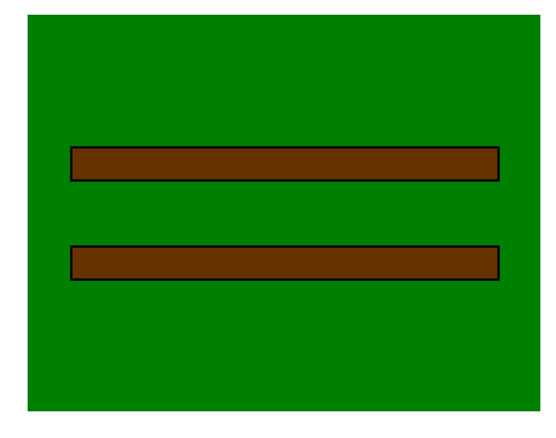  a | 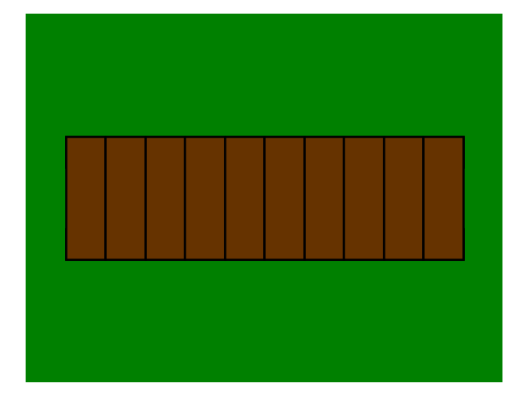  b
Figure 11: a) Initial layer of wood. b) Alpha layer of wood
The third layer of wood should be stacked perpendicular to the alpha layer. The difference for this layer is in the tightness of the packing. Pack this layer loosely to allow airflow for better drying. This layer will be referred to as a beta layer. The beta layer should resemble that of Figure 12a not that of Figure 12b.

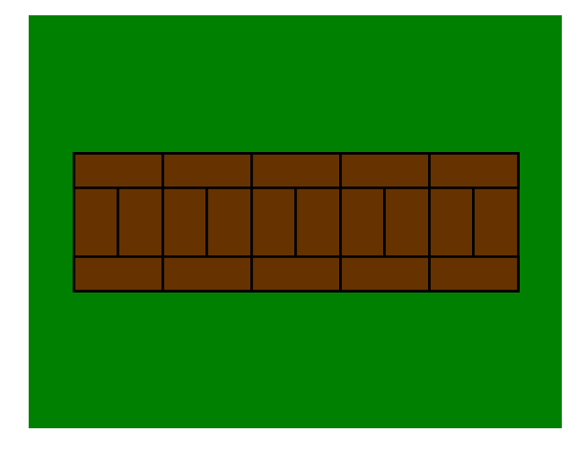  a | 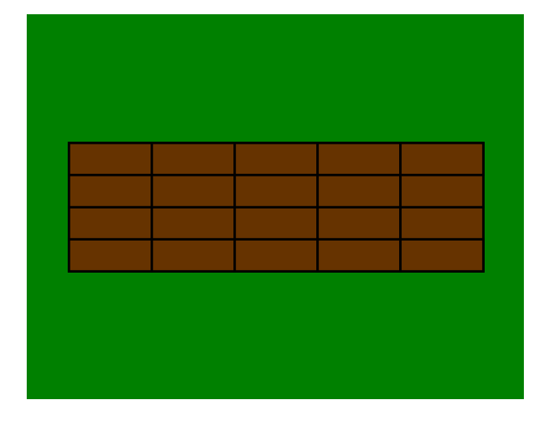  b
Figure 12: a) Correct Alpha layer on top of Beta layer. b) Incorrect Beta layer.
Following layers should be alternated between alpha and beta layers so that there are never two of the same layers on top of each other. This alternating can continue until the stack is about one meter high; it should resemble Figure 13. If nothing was set up adjacent to the foundation to help stack the wood, there should be supports extending out from the stack to ensure stack stability.
All wood collected should be cut and stacked like this. Each stack should be labeled upon completion with the date of completion. Dating the wood will allow the Planta Láctea to easily identify the time that the wood has been drying. Leave between a meter and a meter and a half of space between a completed stack, and the next stack to be started. After 6 months of drying, it is acceptable to use the wood, however, the longer the wood is left the better it will be for burning. Ideally, in Cerrito Paraguay, the wood should be left to dry for 12 to 18 months.

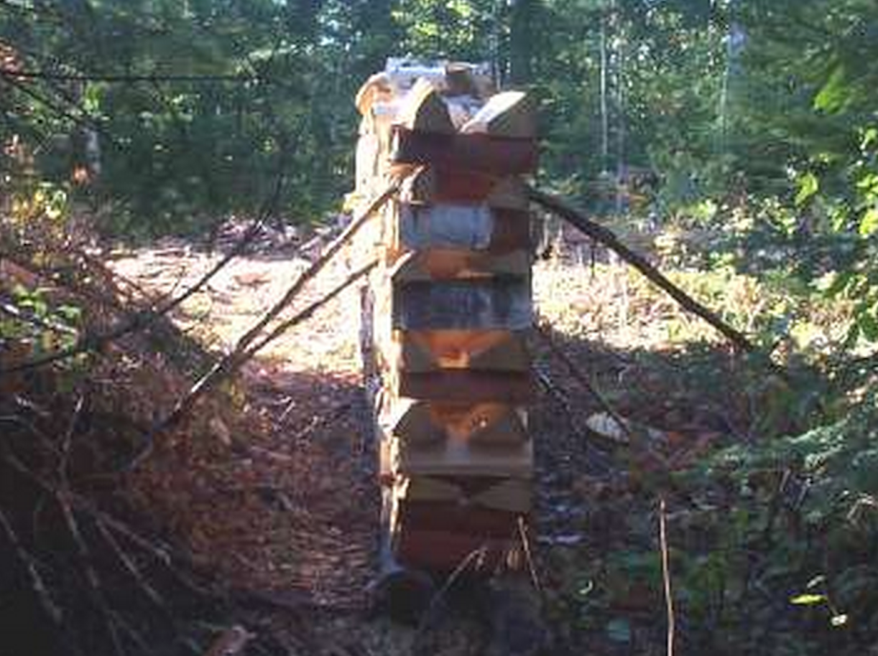

Figure 13: Figure 5: Real Life example of wood stack.

Appendix ii
This appendix contains the images proposed to the San Francisco Agriculture School on the changes to the Planta Láctea. The project group believed that each of the proposed designs resolved the problem, and wanted feedback from the school as well as help deciding on what worked best for them. Below are the Planta Láctea before, and the possible designs for after.
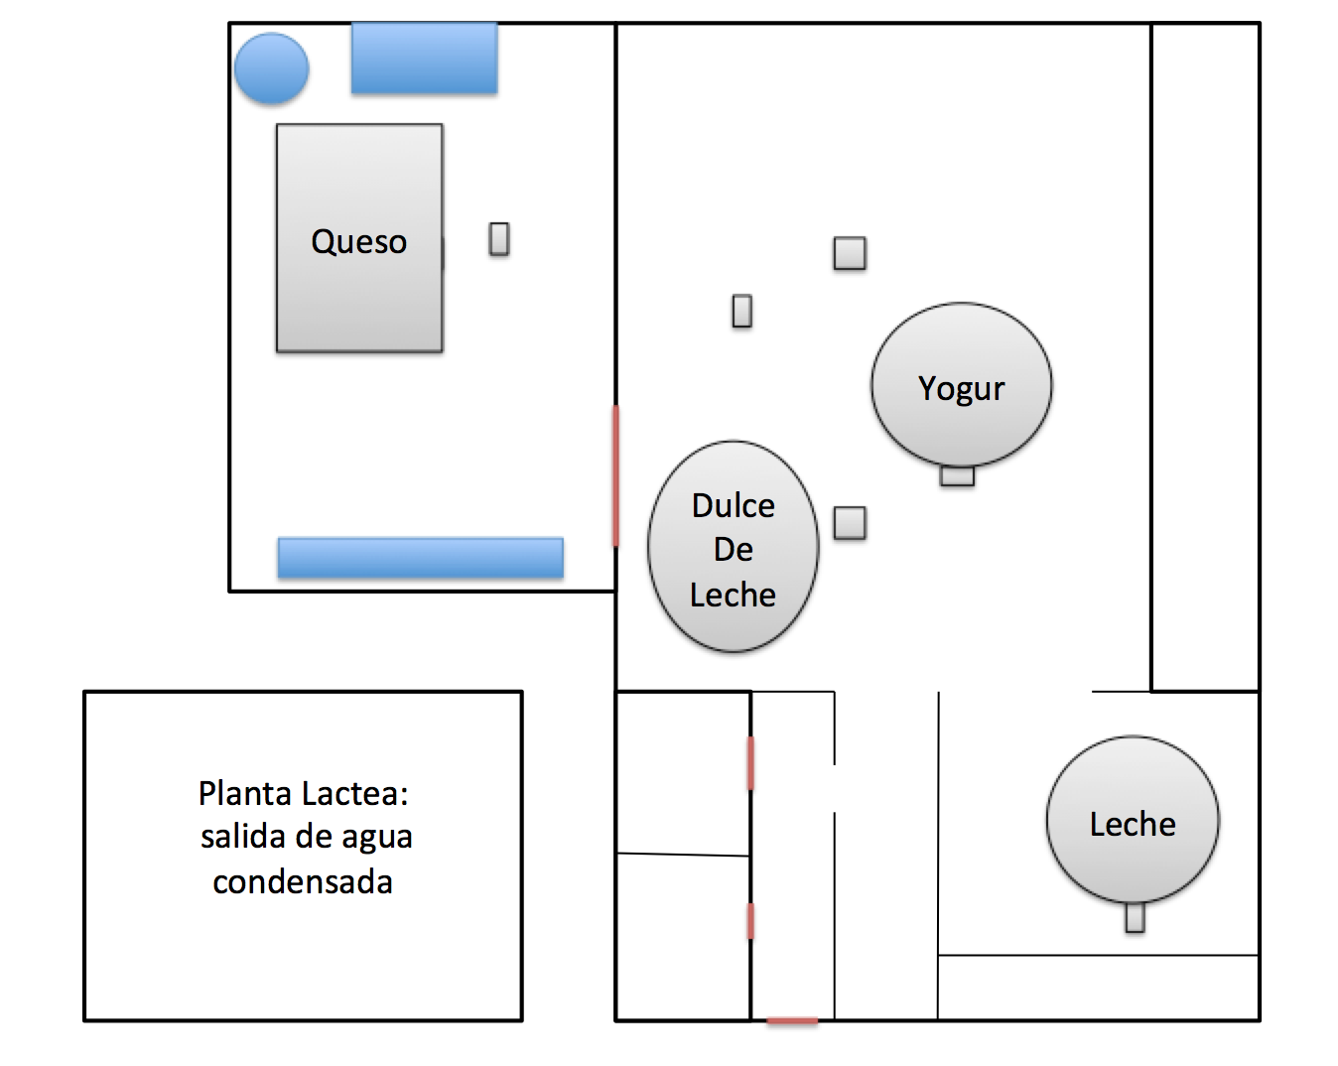
Figure 14: Planta Lactea before moving the machines.

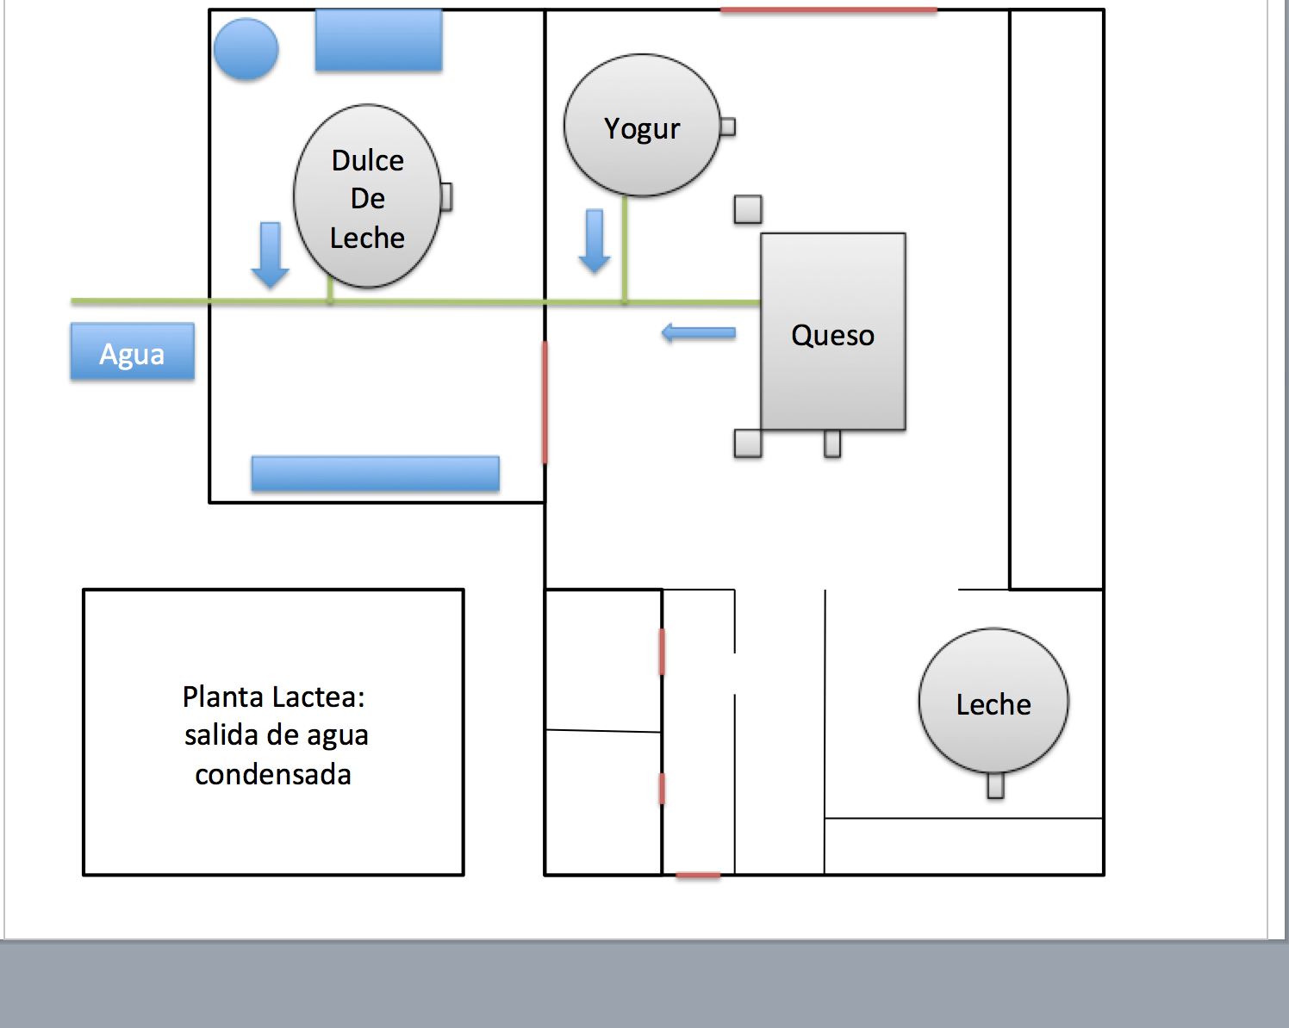  Figure 15: Planta Láctea, Idea 1 | 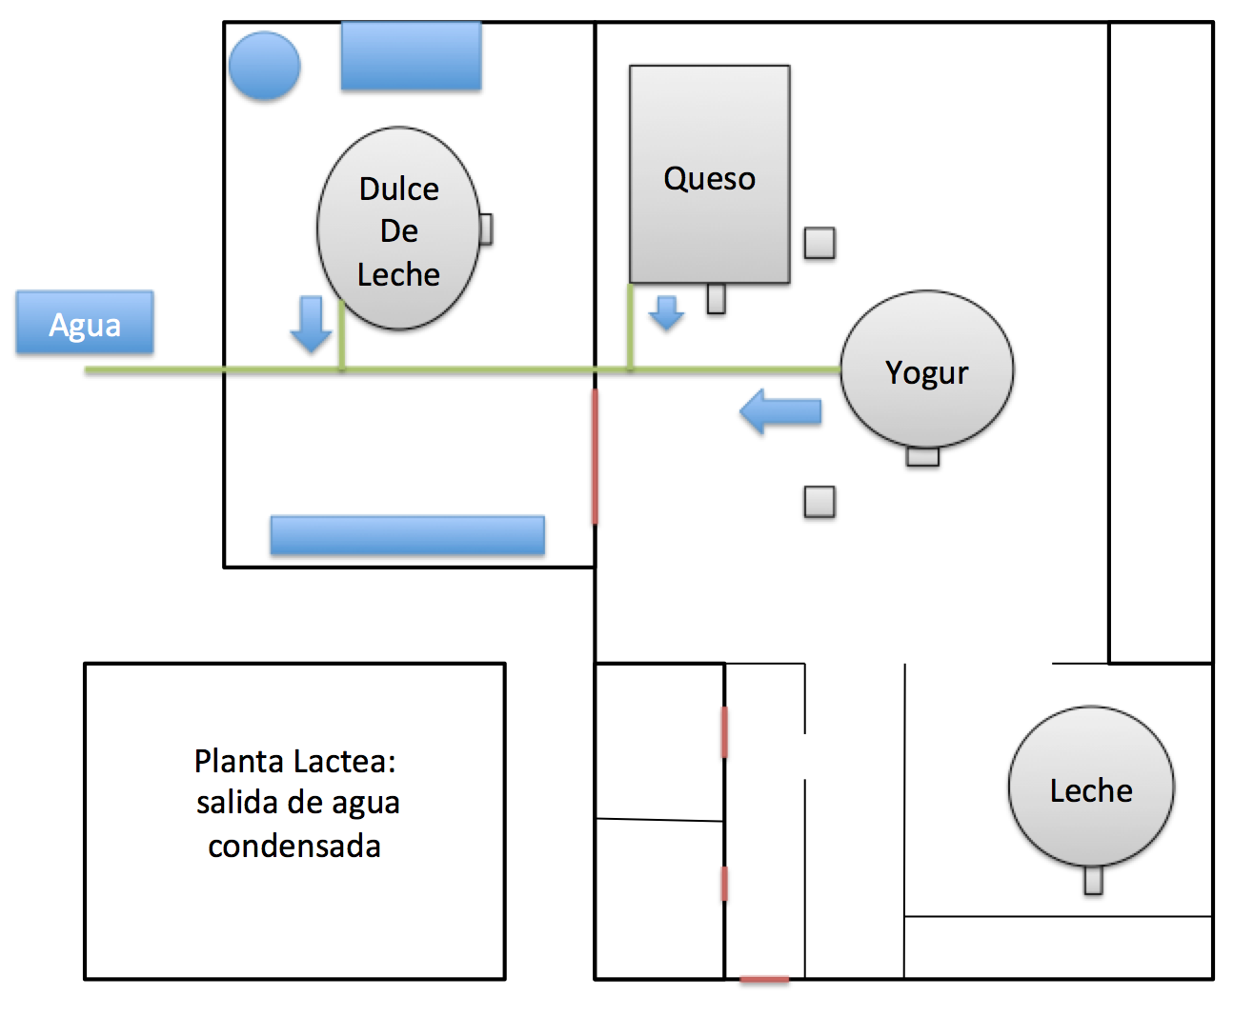  Figure 16: Planta Láctea, Idea 2
Figure 17: Planta Láctea, Idea 3 | 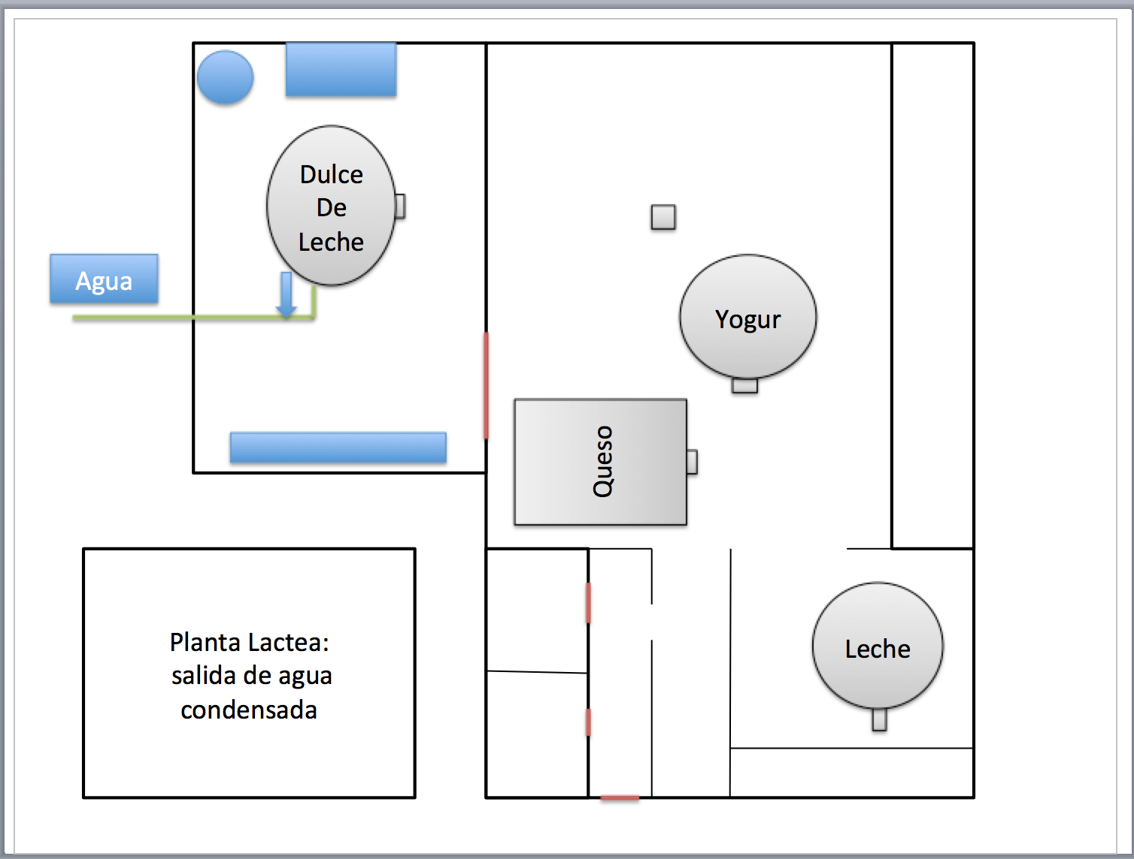  Figure 18: Planta Láctea, Final Idea

Appendix iii

Future Project: Yogurt Packaging

Problem:
Yogurt packaging in the Planta Láctea is a tediously long task that often results in spillage. The students individually pour the yogurt slowly from a container into the yogurt bottles. Pouring must be done slowly to avoid wasting material.

Associated Information:
There is an old yogurt-packaging machine from when the farm used to sell their yogurt in bags. This machine could be redesigned to be compatible for bottling the yogurt.
The project group looked into the reality of pouring multiple bottles at the same time but could not get an accurate list of resources available to begin such a project. Because the school runs on a very strict budget, only resources and tools presently available at the school are available for construction.

Functional Objectives
A replacement system would increase the efficiency of pouring yogurt. The project group started the design process by developing functional objectives for any new packaging system for future groups to consider.

- Fabrication must be possible within The San Francisco Agricultural Schools toolset and material set
- Assembly and repairs must be possible within the The San Francisco Agricultural Schools toolset and material set
- User Friendly Operation and Cleaning
- Manual Operation
- Affordable Production Costs.

Appendix iv

Future Project: The Cost of Milk for The Planta Láctea

Problem:
The most expensive cost to the Planta Láctea is milk. The school does not produce enough milk to entirely cover the needs of production.

Associated Information:
The project group hypothesized that a solution was to increase the number of cows on the farm. During the project group’s time, there were 16 milkable cows on campus producing around 100 Liters. The solution became more complicated when the group discovered that many of these cows were not at prime milking capacity. Expanding the number of cows would also introduce the need to expand/alter the school's use of the following:

- Amount of land that is grazeable by cows.
- Amount of food on reserve if the ground freezes during the winter.
- Amount of time between cow purchasing and cow milking.
- An understanding of the need for more males to keep the cows reproducing (and land etc. for them).
- A plan for cow replacement when optimal milking timespan has been passed.
- Introduction of more cow milking students/students to care for the cows.
- Examination of milking improvements to maximize milk produced per cow.

Appendix v

Future Project: Pump Utilization in The Planta Láctea

Problem:
Transportation of resources in the Planta Láctea is a time-consuming.

Associated Information:
The school administration has interest in installing a pump or a system of pumps for milk transfer between machinery as well as in whey removal. Making this change to milk manipulation will improve the production capacity as well as time efficiency of the Planta Láctea.
A constraint that has slowed the implementation of a pump is sanitation requirements. Because all of the milk would be streaming through the same system, the pipe and pumps all need to be easily disassembled for cleaning. Disassembly of the system might even be more time-consuming than the present setup.

Appendix vi

Rapid Pasteurizing
In this process, milk from 6 to 4C is heated to 90C and held at 20 seconds before it is suddenly cooled to 0C. This process saves a lot of time, but requires advanced and expensive pasteurization machinery.

Momentary Pasteurizing
In this process, milk from 6 to 4C is heated very rapidly to 90C and is kept at that temperature for 15 seconds. The very rapid heating kills all the unwanted bacteria. This process requires the most advanced technology in the milk pasteurizing machinery industry, and is very costly to be adapted by a dairy factory.

Continuous slow pasteurizing:
In this process, milk from 6 to 4C is heated to 65C and is stirred at that temperature for an average of 30 minutes. The time to raise the temperature depends on the efficiency of the available pasteurizing equipment. This process is the cheapest, but it needs longer times to pasteurize milk; while the project group was working with the Planta Láctea, this process was ideal for what needed to be accomplished. Figure 4 shows a front cross-sectional view of the tank the factory used to pasteurize milk.

Gs - Paraguayan currency, Guaranies.
The time depends on the amount of milk in the pasteurization tank; the number has been as low as 20-30 minutes. However, on average it’s between 40-70.
More information about each type is located in the appendix vi.
The Planta Lactea is testing Queso Ricotta and the results are not yet ready for market. The cheese, however, is tasty, and the school serves it to students and staff.
The availability is much lower than cow milk; only 5-10 liters per week.
We were asked by Professor Cateura to use this value for all our calculations. The actual average may be slightly smaller. The price varies with time, and the long term average is 2,500 Gs per Liter.
Before the project group finished, the School asked the team to implement some of its suggestions in addition to listing them as recommendations.
Without appropriate time for experimentation or software for simulation there is no way to know exactly how much this process will improve the efficiency. However, this is a typical thermodynamics and heat transfer problem, thus the answer is conceptually the same.
Wausau is the location of the college where the Natural Resource Educators are located.

