Triple Rinse Bucket Assembly
*For specific notes, pictures, and links please go to: Final BOM > Build-Suggestions*
**This project was designed to be modified for different spaces (the buckets/strainers do not need to be exactly what we bought, but many steps are dependent on the specific item purchased for sizing); these instructions follow the design we initially made**
Tools:
- Drill (variety of drill bit sizes)
- Bolt cutter/rotary cutting drill bit (to trim screws)
- Thin, strong string (we used dental floss)
- Spade drill bits to cut large circles (optional)
Materials:
- (1) large durable plastic bucket (recommended 20 gallon)
- (2) flexible plastic baskets (must fit inside the durable plastic bucket, preferably with holes but you can add holes)
- (1) drainage spout (kit we bought came with spout, silicone washers, and nut)
- (1) lazy Susan turntable hardware (bullets below are dependent on the size of the lazy Susan’s holes)
  - (8) long fully threaded bolts (at least 2” long)
  - (8) hex nuts
  - (16) flat washers

Outer Bucket
- Take the drainage spout and line it up with the bottom of the bucket (when the spout is attached it should be barely above the ground). Trace inside the silicone washer
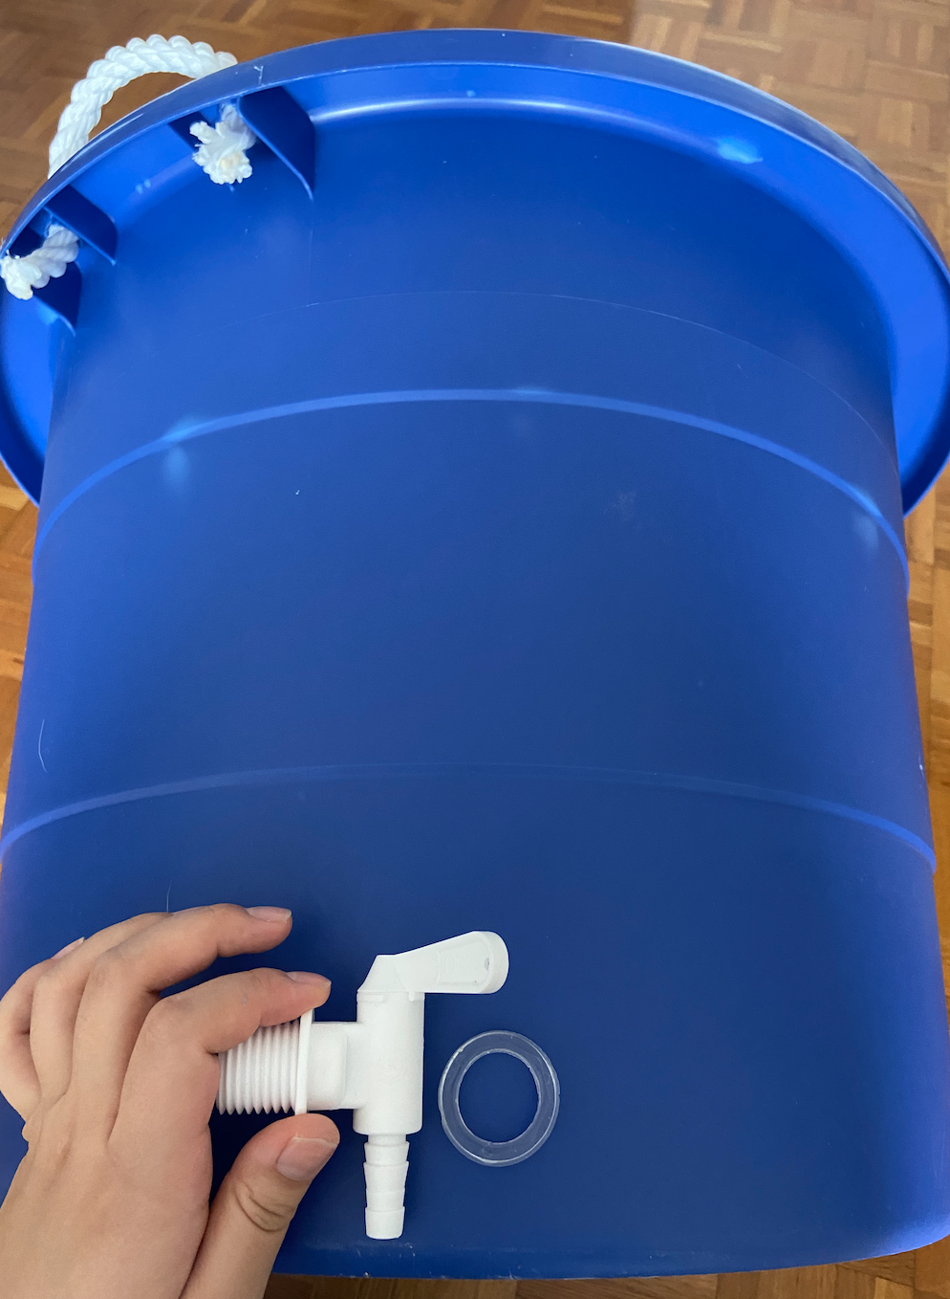
- Drill a hole the size of the washer opening and attach the spout. The order of assembling the spout should be as shown below where the bucket is sitting in between the silicone washers
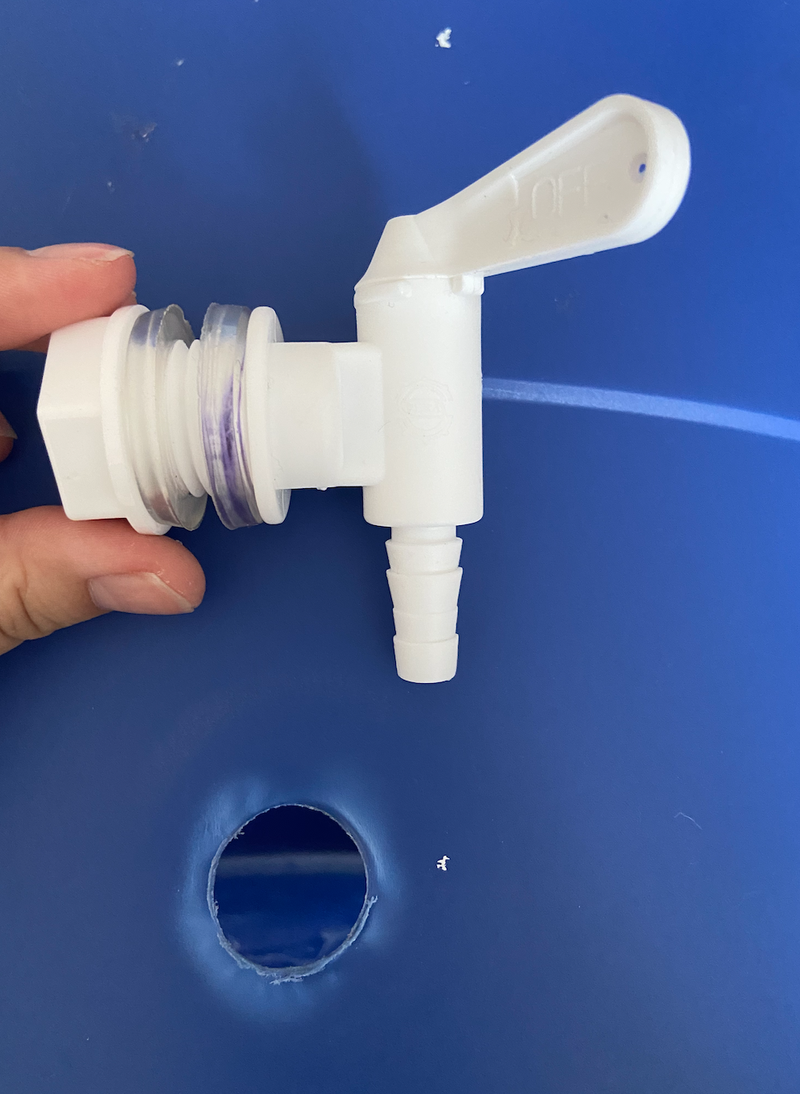
- Center the lazy Susan on the bottom of the bucket as shown. Mark and drill the 4 holes of the plate touching the bucket (Our lazy Susan recommended drilling 3/32 holes). Set aside until later
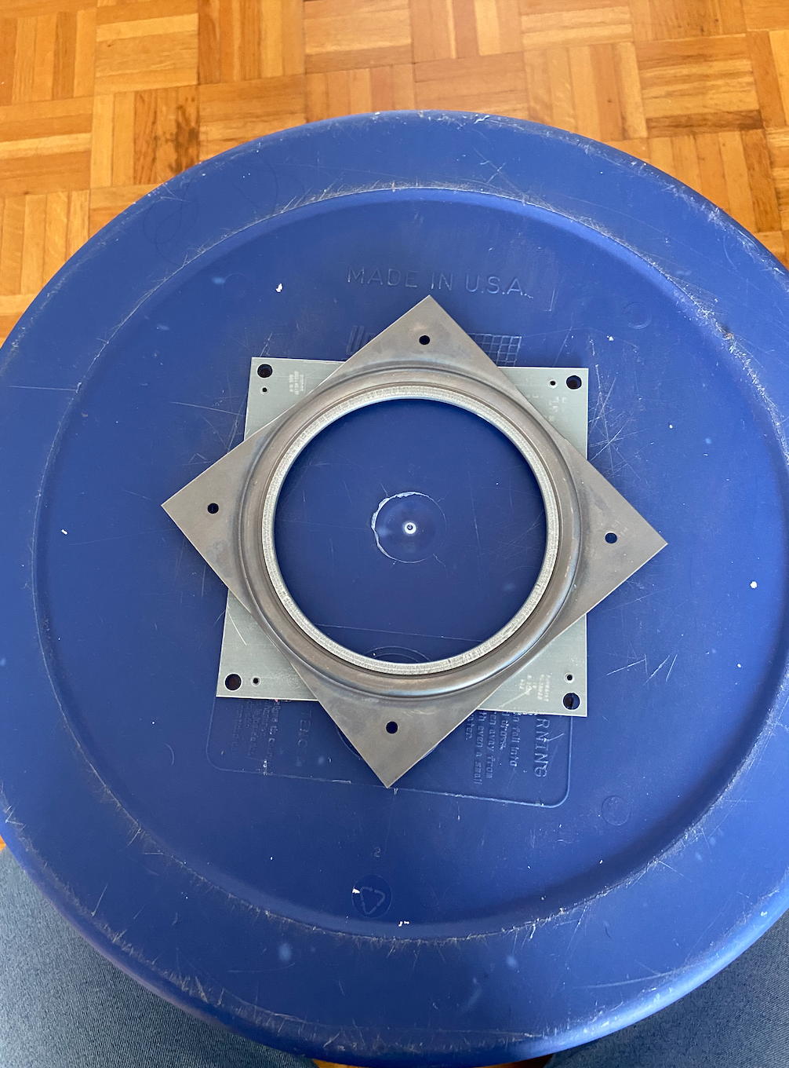

Strainers
- Take a flexible basket inside the outer bucket and mark a line slightly below the top of the outer bucket. Cut around the basket to this line (you shouldn’t see the basket inside the bucket). See progress picture below
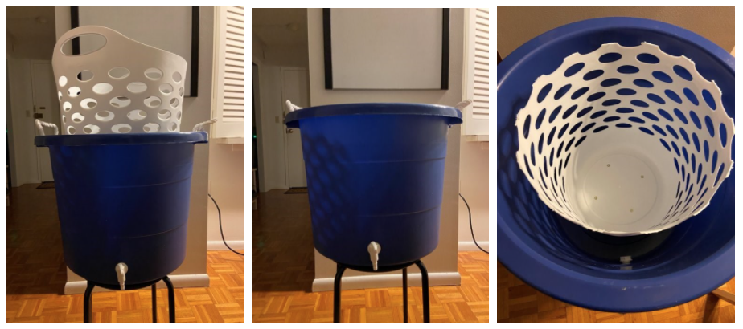
- Center the lazy Susan on the bottom of the basket you just cut (make sure you are working with the opposite side of the plate than the outer bucket). Mark and drill the 4 holes

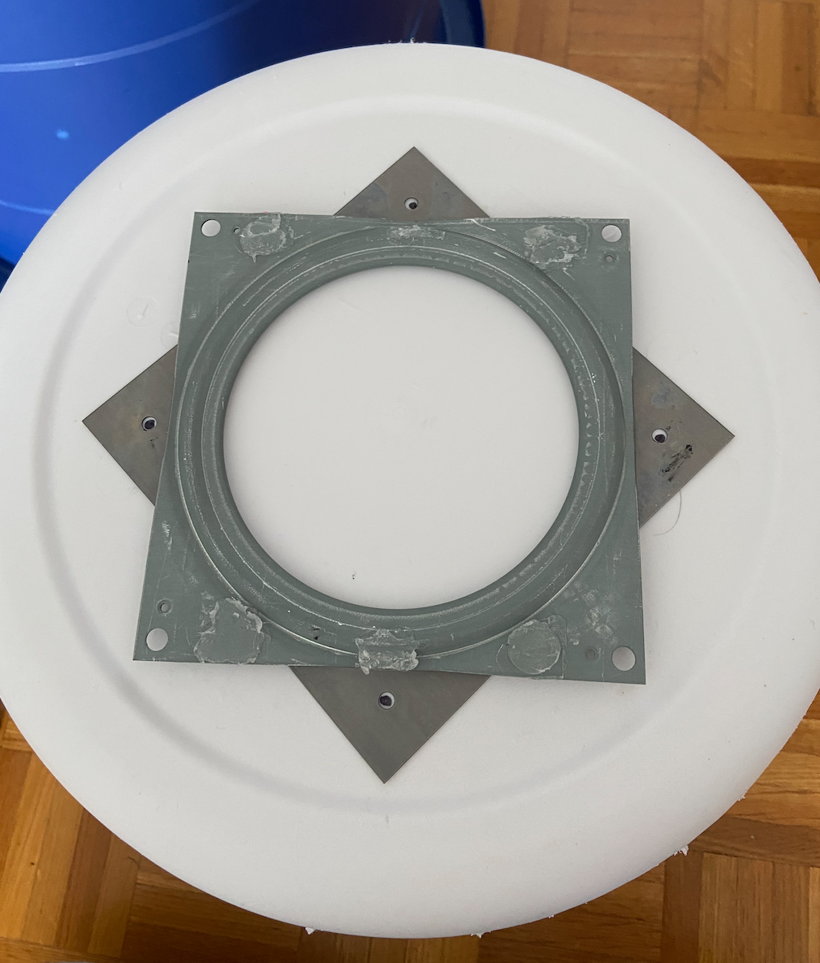
- If the flexible basket you got does not have holes it in, you will need to drill them. The ones we bought did have holes, but we needed to add extra so the baskets wouldn’t suction together. We loosely followed the original hole pattern. Only add the bottom holes for the shortened strainer
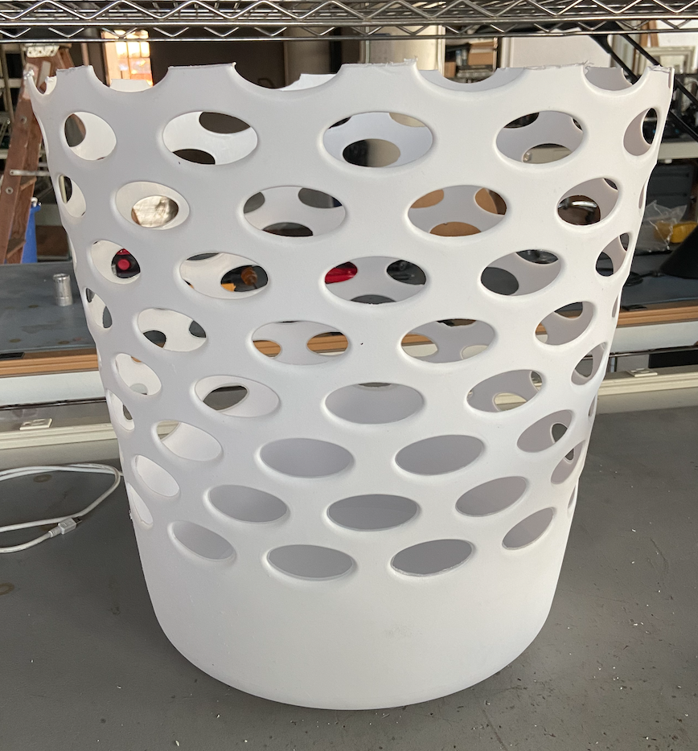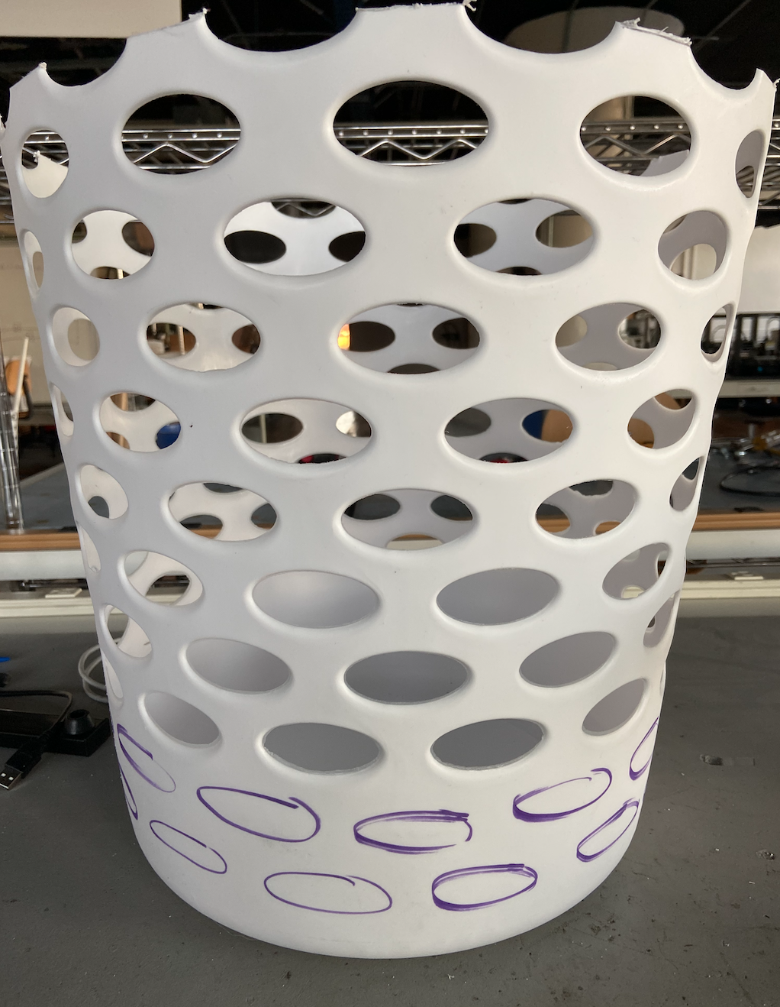
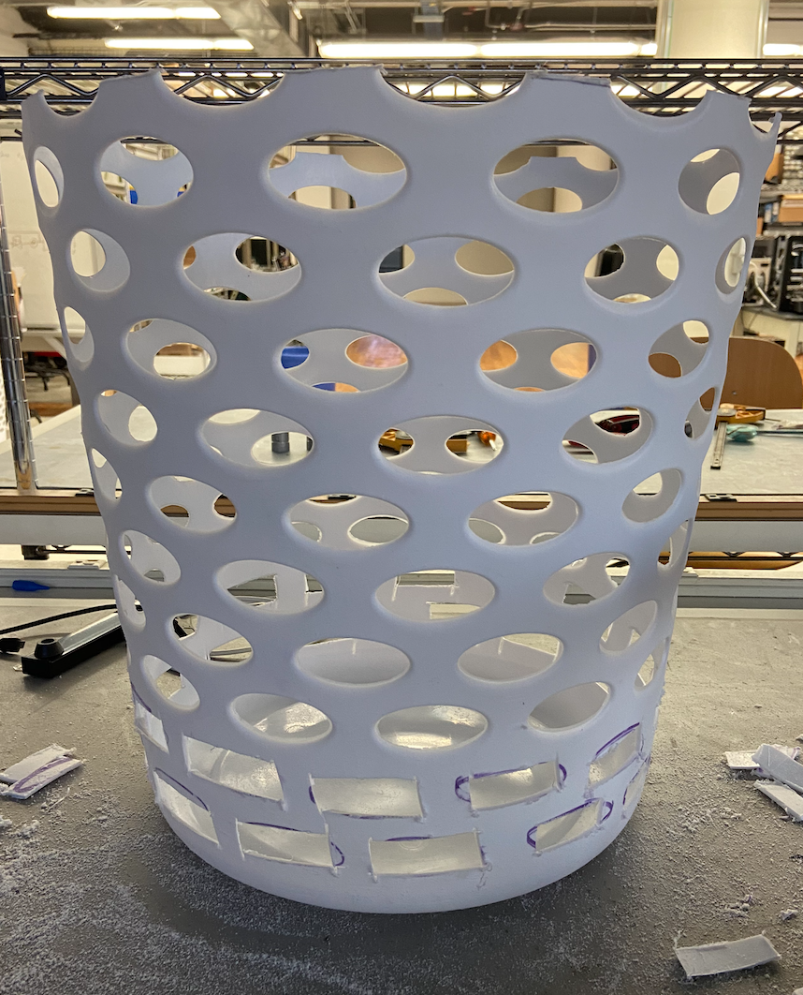

Assemble the Buckets
*highly recommend this be a 2-person job because of awkward positioning*
- Bolt the 4 holes of the lazy Susan to the short basket following the layout below. The plastic goes in between the washers (ours needed #6 size bolts, washers, and nuts. We are using 3” long bolts, but they will be trimmed later). The nut should be on tightly, but do NOT trim the bolt yet
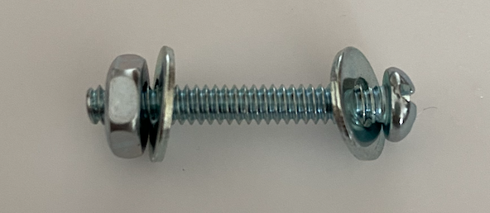
- Add ONLY the bolt and first washer to the 4 holes in the other half of the lazy Susan plate. The setup should look like below except the bolts will be attached to the white basket
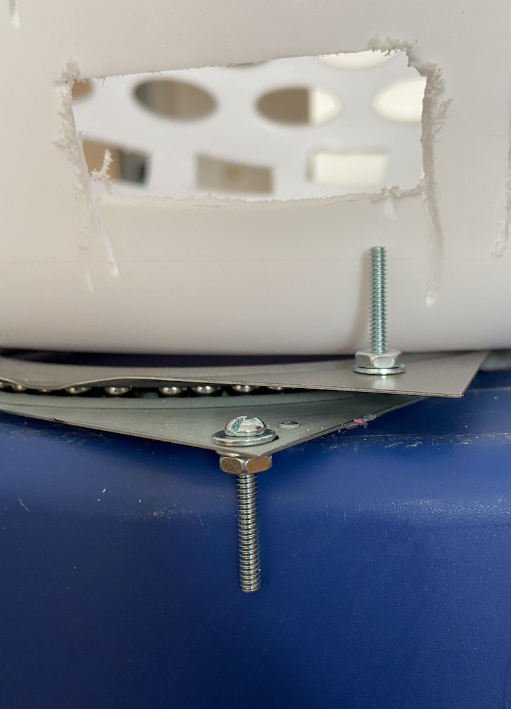
- Flip the white basket so the unfinished bolts are facing up (the reason you need long bolts is so they are less likely to fall out/apart during these steps)
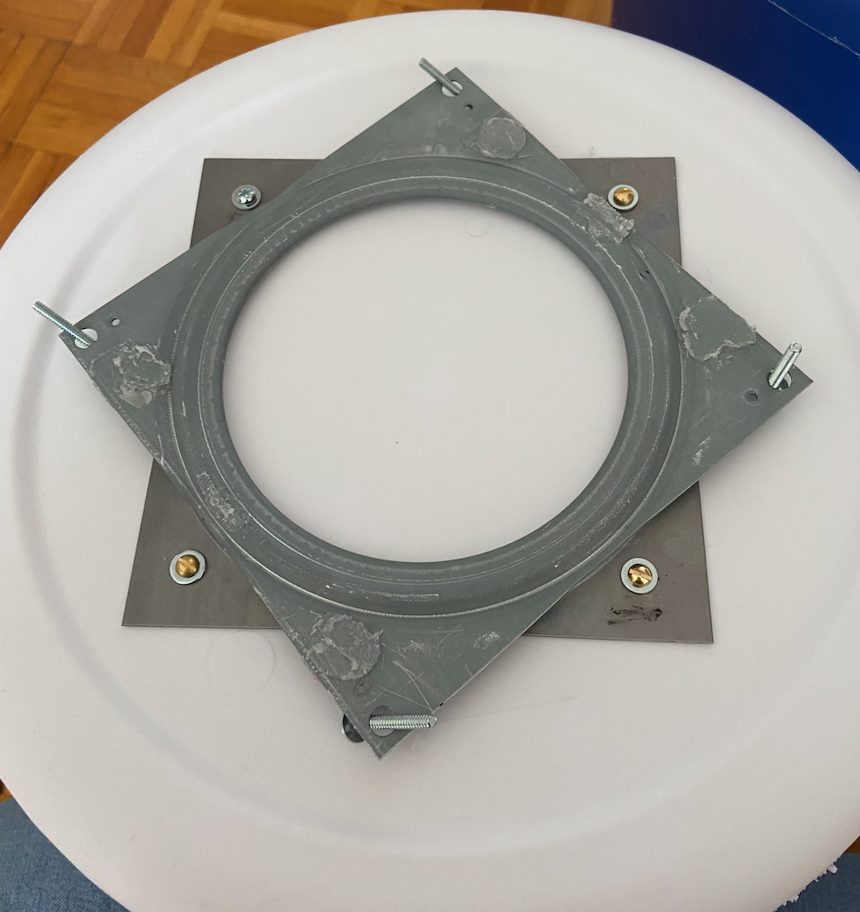
- Tie a string (about 18” long) securely to each bolt
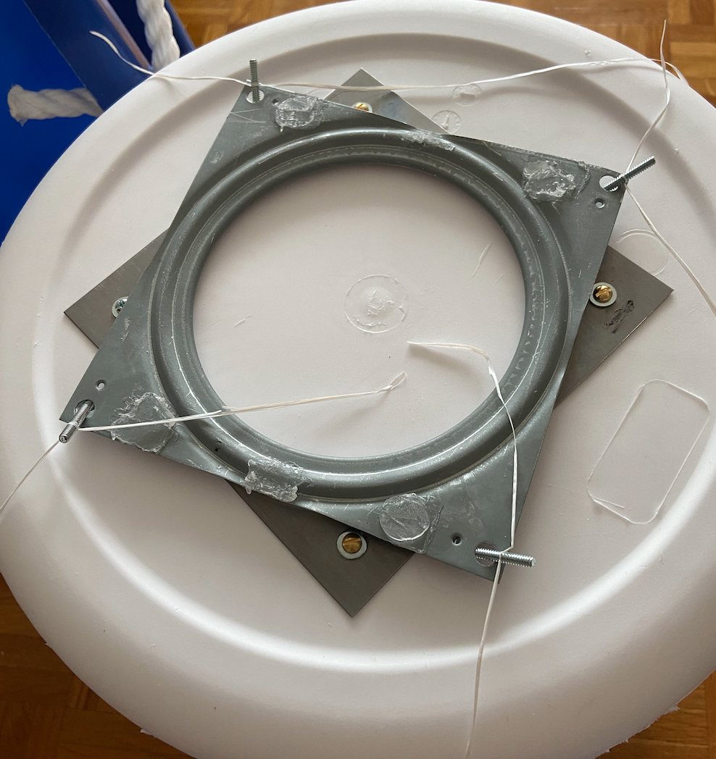
- Put both the outer bucket and the basket on their sides (good to have another person so they don’t roll). Feed each string through a hole and hold/tape it on the other side. DO NOT PULL. View inside on left, outside on right
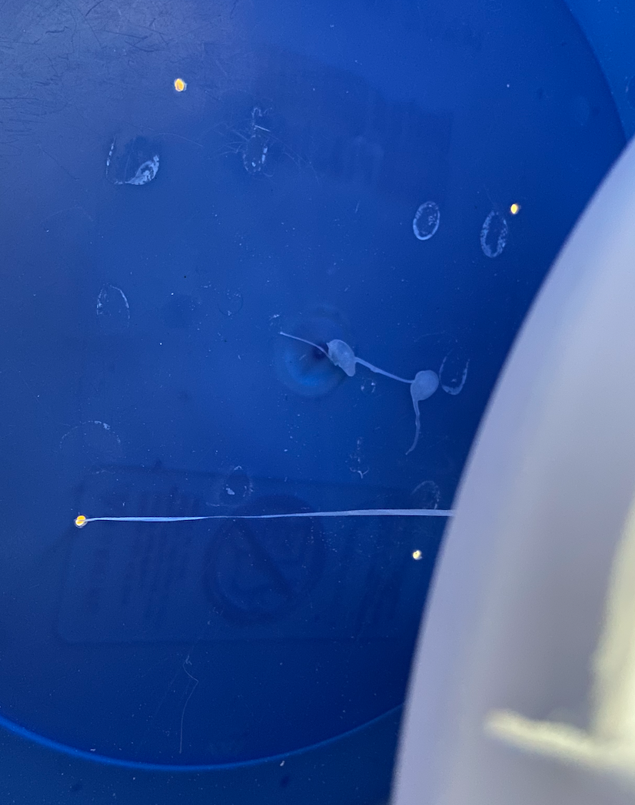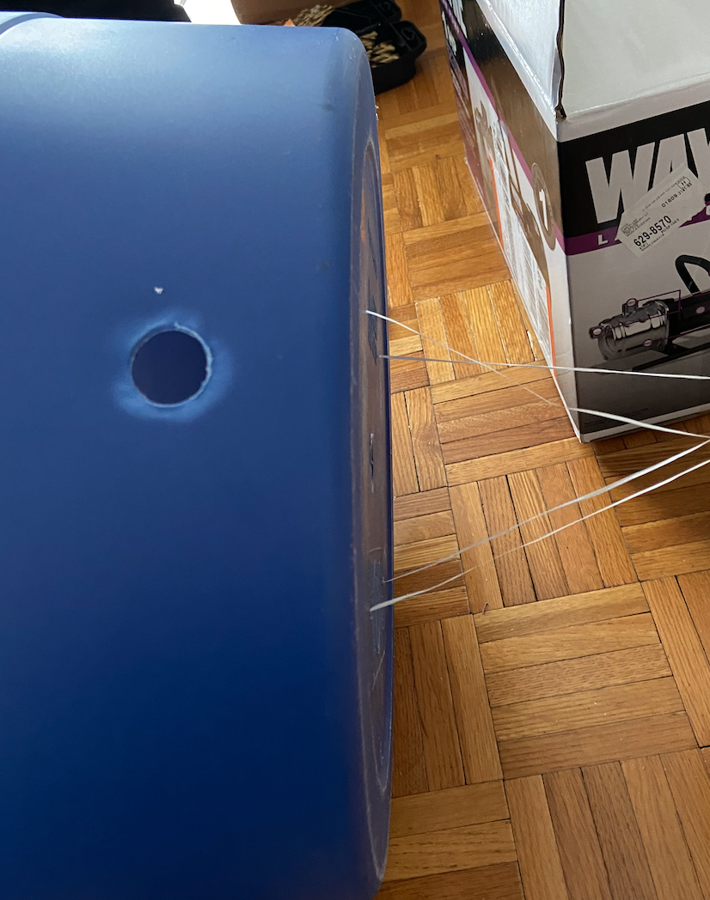
- Making sure not to pull on the strings, rotate the buckets so the bottoms are facing up. One person needs to hold/guide the outer bucket. Using the string, gently guide each bolt out of the hole. When a bolt comes out, loosely put the washer and nut on.
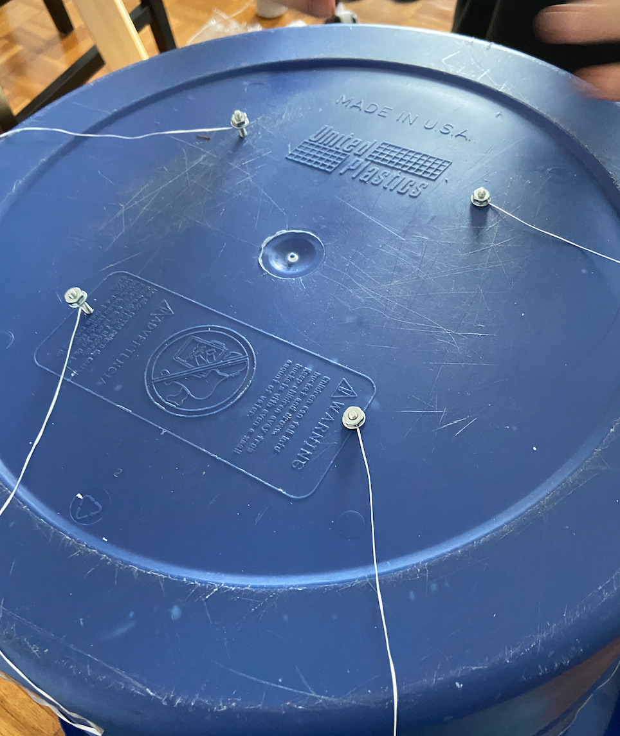
- Secure the bolts tightly and take off the strings. You may then trim the bolts on the inside and out (do not cut too close or else the nut may become loose)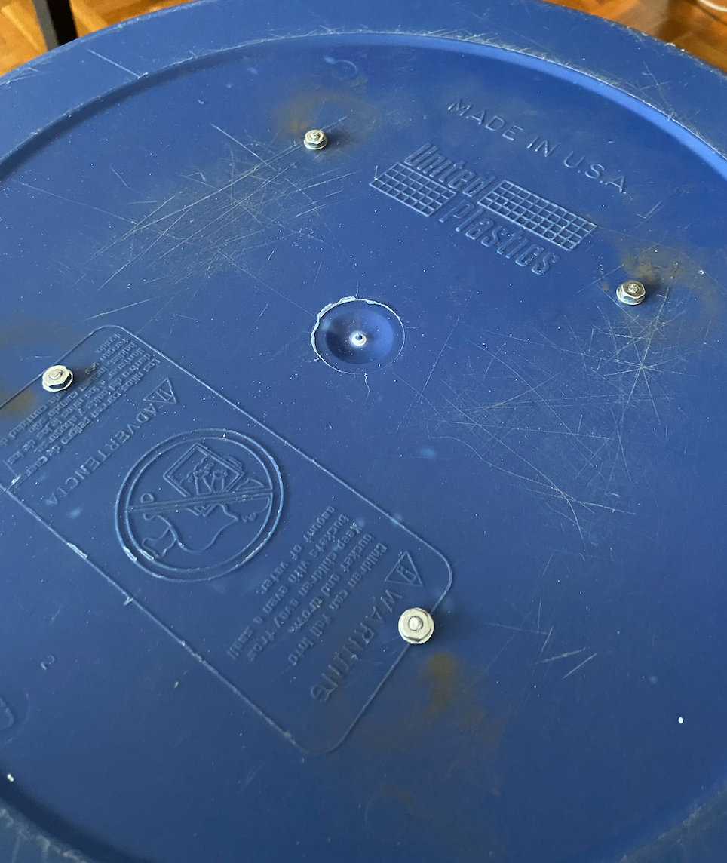
- The system is done, load crops to wash in the untouched plastic basket and then add to the bucket

