Brief History of Ethology: 1900s-Present
An Open Education Resource submitted to the faculty of
WORCESTER POLYTECHNIC INSTITUTE

Submitted to:
Professor Marja Bakermans
Worcester Polytechnic Institute

Submitted by:
Hannah Shell
Ashli Silvera
Vinh Tran
Catherine Williams

May 2nd, 2022
Licensed under CC-BY-SA

Table of Contents:
Abstract 2
1900s-1950s 2
1960s-1970s 4
Advances in Behavioral Genetics 4
Hypotheses and Theorems 5
Social Animal Behavior Studies 6
Other Historical Spotlights 6
Jane Goodall and Chimpanzees 7
Geoff Parker and Sperm Competition 7
Edward Wilson and Sociobiology 8
1980s-1990s 8
Semantic Communication 1980 8
The Hamilton-Zuk Hypothesis 1982 8
Reproductive Skew 1983 9
Brood Parasitism 1988 9
The Challenge Hypothesis 1990 10
Pain in Animals 1991 10
Ecosystem Engineers 1994 11
Multimodal Communication 1999 11
2000s-Present 11
Mapping the Brain - Emotions 11
Genomics of Game Theory, and Social Behavior 12
Social Networking 13
Personalities and Behavioral Syndromes 13
Maternal Epigenetics 14
Exploitation of Information Dissemination 15
Keystone Individuals 16
Current Research & Organizations 17
Popular Topics of Current Research 17
Further Reading 18
Current International Animal Behavior and Ethology Research Organizations[85] 18
Works Cited 20

Abstract
The following paper provides an overview of some of the most impactful animal behaviorists and their research from the early 1900s to present day(2022). This paper intends to provide an inclusive and overarching record of researchers throughout this time period with the following considerations. First, women and minority groups have been historically underrepresented in the scientific community. Second, records of research in the past may not have been recognized or recorded according to traditional academic standards. Finally, although there are many researchers that have been recognized as “major contributors” to the field, there are many other scientists who have explored other intriguing concepts within this complex field of study. Thus this article is a very simplified version of history.

1900s-1950s

Behaviors in Insects

Charles Turner, a zoologist, was one of the first behavioral scientists to study insects in the late 1800’s and early 1900’s. ^{[1]} His studies showed that insects could hear and could modify their behavior based on their experiences. ^{[1]} Uncommon at the time, he focused on the use of controls and variables and their effect on performance.^{[1]} For example, he used the “intertrial interval” to study the time between learning experiences.^{[1]} Turner was the first to study color vision and pattern vision in honey bees, discovering that they were capable of seeing color and recognizing patterns. ^{[2]} In 1910, he published the ground breaking “Experiments on color-vision of the honey bee” in the Biological Bulletin.^{[2]} Over the course of his career, Turner published more than 70 research papers.^{[2]} Victor Corntez named the circling of ants returning to their nests tournoiment de Turner after him.^{[2]} Dr. Turner’s accomplishments are particularly impressive as they occurred at a time of dominant institutional racism.

Insects and Plants

Gottfried Samuel Fraenkel, an entomologist, studied insect physiology, endocrinology and nutrition.^{[3,4]} He discovered the hormone that causes insect metamorphosis.^{[3,4]} In addition, he researched the co-evolution of insects and plants, discovering that plants emit chemical compounds that repel or attract insects.^{[3,4]} In 1940, Fraenkel co-wrote the “Orientation of Animals” with Donald L. Gunn.^{[3]} Their work developed a systematic method of animal classification and is considered fundamental for studying animal behavior.^{[3]} Dr. Fraenkel is from a Jewish family and grew up and studied in Germany until the rise of Nazism, when he moved to the United States.

Bat Behaviors

In 1940 Donald Griffin discovered bat echolocation. Bats' ability to navigate in dark environments had long puzzled scientists.^{[5]} In the late 18th century Lazzaro Spallanzani discovered that bats that were blind could fly and avoid obstacles the same way as bats that could see. He concluded that bats somehow saw with their ears.^{[6]} In the late 1930’s, Donald Griffin, an expert on bats, had tried unsuccessfully to learn if bats communicate using sounds and that explained their ability to navigate in the dark.^{[5]} Griffin found a graduate student that was using a psychological method to test animal hearing on guinea pigs and cats and asked if a bat could be tested using the same procedure.^{[5]} It turned out that the bat ear was highly sensitive, more so than the ears of humans, cats or guinea pigs.^{[7]} Subsequent research by zoologist Charles Jurine concluded that bats with clogged ears had difficulty navigating, further supporting the conclusion that bats use sound to navigate.^{[7]}

Bird Clutches

In 1947, British ornithologist David Lack promulgated the Lack Principle, which would ultimately lead to a better understanding of population biology in different species of animals.^{[8]} Lack studied the clutch sizes, or number of eggs released at one time, of birds. Clutch size varies greatly among different bird species.^{[9, 10]} Hummingbirds, for example, lay one or two eggs while ducks lay as many as 20.^{[9, 10]} Lack determined that different species of birds, by the process of natural selection, laid on average, the number of eggs they could provide food for so that the offspring could live to be independent.^{[9, 10]} This premise can be applied to different animal species to explain why they produce certain number of offspring during each cycle.^{[9, 10]}

Cognitive Maps

Cognitive maps are basically mental images of the layout of one’s physical environment in spatial representations.^{[11]} They can be specific or more generalized.^{[11]} When we interact with our surroundings we form mental maps of those surroundings which are then stored in our memory.^{[11]} During the 1940s, Edward Tolman, a psychologist, began studying the concept of cognitive maps.^{[12]} He would put a rat into cross shaped mazes, allowing the rat to explore.^{[12]} Later, the rat would be placed in one arm of the cross and food was placed in different locations within the maze.^{[12]} The rats showed familiarity with the layout of the maze and were able to navigate to the food wherever it was placed within the maze.^{[12]} By 1948, Tolman concluded that the rats had developed cognitive maps of the maze and were, therefore, able to navigate around the maze from their mental memory.^{[12]}

Hormones Affecting Behavior

Frank Beach was an ethologist who published the book Hormones and Behavior in 1948.^{[13]} As the title suggests, the book discussed the behavior of organisms and their endocrine systems on a variety of topics, including courting and mating.^{[13]} Beach gathered data from multiple academic disciplines such as psychology, physiology, biochemistry and neuro-anatomy.^{[13]} The book suggested that additional study of the biochemistry of the central nervous system as well as the metabolic actions of other hormones would be necessary to fully understand the effect hormones have on behavior.^{[13]}

Coolidge Effect

The Coolidge effect is “the progressive decline in a male's propensity to mate with the same female combined with a heightened sexual interest in new females.”^{[14]} (FN) Frank Beach claims to have originated the term in 1958/1959 based on a joke about President Calvin Coolidge and his wife visiting a government farm.^{[15]} The experiment to establish the Coolidge effect involved putting a male rat in an enclosure with 4 or 5 other female rats that were in heat.^{[15]} The male rat would mate with all of the female rats until he was exhausted.^{[15]} Although the female rats would continue to entice him to continue mating, he would resist.^{[15]} But when a new female rat that was in heat was introduced to the group, the male rat would muster up enough energy to mate with her.^{[15]} The Coolidge effect, as it was called, is caused by an increase in dopamine levels and the subsequent effect that has on an animals limbic system.^{[16]}

Stimulus Strength

Work on psychophysical laws commenced in the late 1800s.^{[17]} German physiologists Ernst Weber and his student Gustav Fechner discovered that human estimates of stimulus strength are nonlinear. Rather, the physical strength of stimulus doesn’t correspond along a straight line to the strength of our perception of the stimulus.^{[18]} Weber’s law essentially says that the size of the difference threshold, or the “just noticeable difference” is a constant proportion to the original stimulus value.^{[18]} Basically, if there is a mild change in tone, it is noticeable if the tone was soft to begin with but that same mild change is less noticeable if the initial tone was loud.^{[18]} Fechner’s law applied an algorithm to determine the nonlinear relationship.^{[18]} Likewise, Steven’s law modernized Weber and Fechner’s law in 1957 by creating a somewhat more sophisticated formula to define the nonlinear relationship.^{[18]}

1960s-1970s

Advances in Behavioral Genetics

The link between genetics and animal behavior has always been seen in practices involving human domestication of animals. Amidst the many researchers observing this phenomenon in the 1900s, one major collection of this knowledge can be seen in John Paul Scott and John L. Fuller's textbook “Genetics and the Social Behavior of the Dog” published in 1965. Further turning-point research in behavioral genetics also involved the study of model organisms such as D. melanogaster and C. elegans. Although understanding the molecular components of genetics was early in its development, these studies further established understandings within the relation of animal behavior with genetics.^{[19]}

- John Paul Scott and John L. Fuller’s “Genetics and the Social Behavior of the Dog”, 1965
- Ronald J. Konopka and Seymour Benzer study clock mutants in drosophila to understand behavioral genetics.^{[20]}
- Behavioral genetics research of C elegans as another ideal model organism.^{[21]}

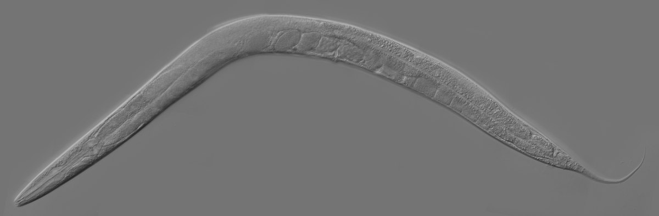
“Adult Caenorhabditis elegans” by Kbradnam, used under CC BY-SA

Hypotheses and Theorems

Ethologists have developed many approaches to understanding the complexity of animal behavior. Many appear as formalized scientific concepts, some of which have become fundamental to animal behavior include Niko Tinbergen’s four questions, Leigh Van Valen’s Red Queen Hypothesis, and John Maynard Smith and George R. Price’s use of Game Theory to model animal-to-animal interactions. Though there have been corrections or adaptations to some concepts, these original papers provided a foundation for the field of animal behavior.

- Niko Tinbergen's 4 questions as a important foundation of animal behavior study methods.^{[22, 23]}
- Animal Conflict based on game theory^{[24]}
- Many Eyes Hypothesis, examining how species groups energetically benefit by relying on others to look for predators while individuals rest.^{[25]}
- Understanding coevolution through the Red Queen Hypothesis by Leigh Van Valen “A New Evolutionary Law”, 1973. ^{[26]}
- The Handicap Principle shows how mates developing costly phenotypes is beneficial for selection^{[27]}
- Jeanne Altman reviewed standardized observation methods to improve objectiveness and reduce bias in recording animal behaviors. ^{[28]}
- Marginal Value Theorem examines how animals determine the value of foraging grounds, and act based on observations ^{[29]}

Social Animal Behavior Studies

Another major facet of animal behavior is the social interactions an organism has with its own species. One study that fascinated animal behaviorists was William D Hamilton’s research on altruism, and how genetic relatedness can influence an animals willingness to support another family member. Further research built off of past inquiries helped increase the knowledge of varying social activities within animal groups. Other studies around this time were fascinated by these social interactions, with interests stemming from parallels with human society as well.

- William D. Hamilton’s study of social behavior in groups, particularly altruism and its genetic relatedness. ^{[30]}
- Though the ethics of the study are questionable, Harry Harlow’s social isolation research in rhesus monkeys showed the importance of species group’s social presence and interaction. ^{[31]}
- Peter H. Klopfer’s “Habitats and Territories; A Study Of The Use Of Space By Animals”, 1969. ^{[32]}
- Stephen D. Fretwell, and Henry L. Lucas’ investigation of territoriality and how people in the 1960s were particularly interested in this due to war and human aggression.^{[33]}
- Altruism continued with Robert L. Trivers after Hamilton's work in 1964.^{[34]} Other contributions include (Lin and Michener 1972),(Alexander, 1974),(Wilson 1975), and (West-Eberhard 1975).^{[35, 36, 37, 38]}
- William D. Hamilton discusses selfishness activity in animal groups. ^{[39]}
- The Parent-Offspring Conflict studied how offspring and parents develop and respond to varying signals that influence where resources are provided^{[40]}
- Mating systems examined how certain animals select mates based on specific traits that prove them to be viable and produce fit offspring.^{[41]}

Other Historical Spotlights

Other studies or contributions of note that didn’t fall under any particular subject for the 60s and 70s are mentioned here.

Jane Goodall and Chimpanzees
Jane Goodall’s research with chimpanzees starting in the 60s has become well renowned in the scientific community. One instance of her work is seen through her observations of chimpanzees using tools in their day to day lives.^{[42]} Along with concurrent research from other primatologists, Goodall has provided intriguing insight in relating behaviors of primates and humans.
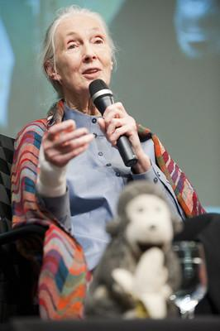
“Jane Goodall Visits the World Bank” by Kristoffer Tripplaar, used under CC BY-NC-ND

Geoff Parker and Sperm Competition
Another major conceptual establishment arose with Geoff A. Parker’s research into the yellow dung fly in the 1960s and 70s.^{[43]} Parker observed the insect’s interesting reproductive behaviors and physical reproductive adaptations, reaching the conclusion that male fly sperm competes with other males.^{[43]} From his early findings along with other concurrent researchers, it eventually became well known that the fitness of an organism doesn’t always end with finding a mate and copulating.

Edward Wilson and Sociobiology
In 1975, Edward O. Wilson’s publication of his book Sociobiology: The New Synthesis left a significant impact on the field of animal behavior. The majority of his book consisted of an overarching collection of his work and the works of George Willaims and William Hamilton, explaining animal behavior and natural selection for a general audience. However, his book created widespread controversy from his concluding discussion relating natural selection to human society and behavior. Despite major criticism from these sentiments without evidential support, this book still provided a significant synthesis of important topics in understanding animal behavior.^{[44]}

1980s-1990s

Semantic Communication 1980

Semantic communication is the use of signals to refer specifically to an object or stimulus in the environment. Humans achieve this method of communication using words.^{[18]} It was previously thought that humans were the only species who could employ semantic communication. However, through the research of Robert M. Seyfarth, Dorothy L. Cheney, and Peter Marler on vervet monkeys, it was proven that nonhuman species could also use semantic communication. The research on the topic of semantic communication is not limited to the work of Seyfarth et al. Throughout the years numerous scholars have researched semantic communication in regards to different species. Some examples include:
- Daniela Eugenia Lenti Boero who conducted a study on evidence of semantic communication in alarm calls in Alpine Marmot.^{[45]}
- Klaus Zuberbühler who conducted studies on the phylogenetic roots of language using evidence from primate communication and cognition^{[46]}
- Toshitaka N. Suzuki who conducted studies on semantic communication in birds^{[47]}

The Hamilton-Zuk Hypothesis 1982

In mating, many species rely on signals sent out by the opposite sex to choose the optimal mate. In 1982 William Donald Hamilton and Marlene Zuk proposed that these sex signals could be affected by parasites and diseases. This hypothesis therefore suggested that the ability to produce mating signals is a direct reflection of the immunological capacity of an animal.^{[18]}
Throughout the years, many researchers have conducted studies to test the validity of this hypothesis. Some of these researchers include:

- Andrew F. Read and Daniel M. Weary who conducted studies on the validity of the Hamilton-Zuk hypothesis by studying the correlation between parasitism and song duration, inter-song interval, song continuity, song rate, song versatility, and song and syllable repertoire size^{[48]}
- Joanna M. Setchell, Marie J. E. Charpentier, Kristin M. Abbott, E. Jean Wickings, and Leslie A.Knapp who conducted studies on the validity of the Hamilton-Zuk Hypothesis in Mandrills. ^{[49]}
- Rodrigo Megia-Palma, Rafael Barrientos, Manuela Gallardo, Javier Martinez, Santiago Merino who conducted studies on the validity of the Hamilton-Zuk Hypothesis in lizards.^{[50]}

Reproductive Skew 1983

Reproductive skew refers to the variation in the contribution of an individual within a group to reproduction. In 1983 Sandra L. Vehrencamp proposed that it would be more advantageous to skew reproduction of the group in such a manner that some individuals reproduce more than others.^{[51]} The study on reproductive skew is not limited to the work of Vehrencamp. Over the years numerous scholars have conducted studies on this area. Some of these scholars include:

- Hanna Kokko and Rufus A, Johnstone who delved into the dynamics of reproductive skew by analyzing social queuing as a facet of reproductive skew.^{[52]}
- Nobuyuki Kutsukake and Charles L Nunn who performed comparative tests of reproductive skew in male primates.^{[53]}
- Peter Nonacs and Reinmar Hager who analyzed reproductive skew through the lens of genetics.^{[54]}

Brood Parasitism 1988

Brood parasitism refers to species which rely on other species to raise their young. Brood parasitism is considered as a form of an evolutionary arms race, a theory which has long been common among scientists, However, in 1988 M. de L. Brooke and N. B. Davies shone a light on the coevolutionary arms race which took place between a parasite and host by examining the cuckoo bird.^{[18]}.

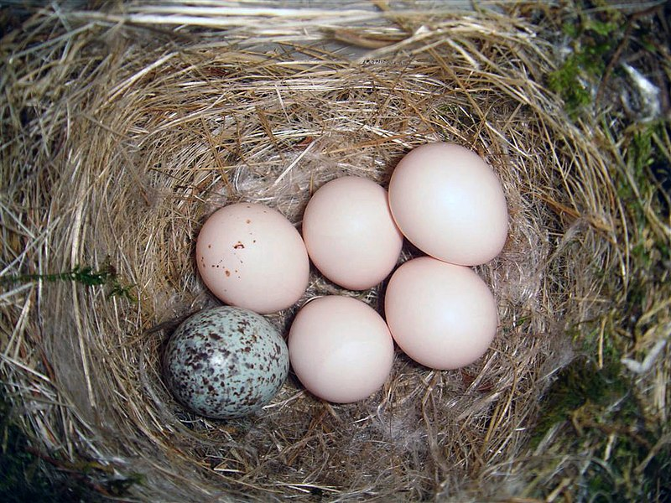
Eastern phoebe nest with one brown-headed cowbird egg (bottom left) by Galawebdesign - Own work, CC BY 3.0, https://commons.wikimedia.org/w/index.php?curid=4200741

The Challenge Hypothesis 1990

Testosterone is the primary sex hormone in males. However, the level of testosterone in a male is not fixed but rather shows large variations over time and among individuals. In 1990 J.C. Wingfield, R.E. Hegner, A.M. Dufty Jr, and G.F. Ball formulated the challenge hypothesis to explain the variation in testosterone levels seen in males.^{[18]} The applicability of the challenge hypothesis to different species has been explored by numerous researchers. Some researchers who have explored this area include:

- Elise D Ferree, Martin C Wikelski and David J Anderson who conducted studies on hormonal correlation of siblicide in Nazca boobies as a support for the Challenge Hypothesis.^{[55]}
- Katharina Hirschenhauser and Rui F Oliveira- who analyzed the application of the challenge hypothesis to vertebrates.^{[56]}
- EL Knight, A Sarkar , S Prasad , and PH Mehta who proposed dual-hormone hypothesis as an extension to the challenge hypothesis to account for inconsistencies presented by the challenge hypothesis.^{[57]}

Pain in Animals 1991

Throughout much of scientific history, it was thought that pain was a uniquely human emotion. As such many researchers resisted the notion that animals could experience pain. However, in 1991 Patrick Bateson published a paper integral in acknowledging that animals experience pain which led to much research on not only how animals experience pain but also the extent to which they experience pain as well.^{[18]}

Ecosystem Engineers 1994

Ecosystem Engineers is a term used to describe animals that physically modify their environments such as beavers. In 1994 Clive G. Jones, John H Lawton, and Moshe Shachak published a paper highlighting the importance of ecosystem engineers. The research on ecosystem engineers was not limited to these scholars. Over the years numerous researchers have also published works on the impacts that ecosystem engineers have on their environment. Some these researchers include:

- Jeffrey A Crooks who looked at the ramifications of introduction of ecosystem engineers into different ecosystems.^{[58]}
- Joe Roman,James A Estes, Lyne Morissette, Craig Smith, Daniel Costa, James McCarthy, JB Nation, Stephen Nicol, Andrew Pershing, and Victor Smetacek who looked at whales as ecosystem engineers.^{[59]}
- Holly E. Emery-Butcher, Stephen J. Beatty, Belinda J Robson who analyzed the impacts of invasive ecosystem engineers in freshwater.^{[60]}

Multimodal Communication 1999

The term multimodal communication refers to the use of more than one sensory means to communicate a message thereby reinforcing the message. In 1999 Sarah R Partan and Peter Marler published a paper that was important in the acceptance of multimodal communication. Other researchers such as Marlen Fröhlich & Carel P. van Schaik analyzed the function of multimodal communication in primates.^{[61]}

2000s-Present

Mapping the Brain - Emotions
Science took a major turn in the new century as the molecular mechanisms behind behavior and traits were discovered and further explored. Animal Behavior had a major pivotal point when [LeDoux, 2000] shifted the idea of emotions as a metaphorical and theoretical topic to a concept that can be objectively studied and measured on a molecular scale in his paper “Emotions circuits in the brain”^{[62, 18]}, merging psychological studies with more concrete biology. Specifically, he focused on the connection between emotions and neural firing in specific regions of the brain, finding that emotions would not result from/in limbic system neural activation (contrary to common belief at the time), but rather that of the neocortex, and finding that development of specific emotions in species could indicate evolutionary value and changes in fitness^{[62]}. LeDoux laid grounds for current research today for wider exploration of what might define emotion on a molecular basis and how this may differ or apply similarly to different species across a diverse animal world.^{[18]}

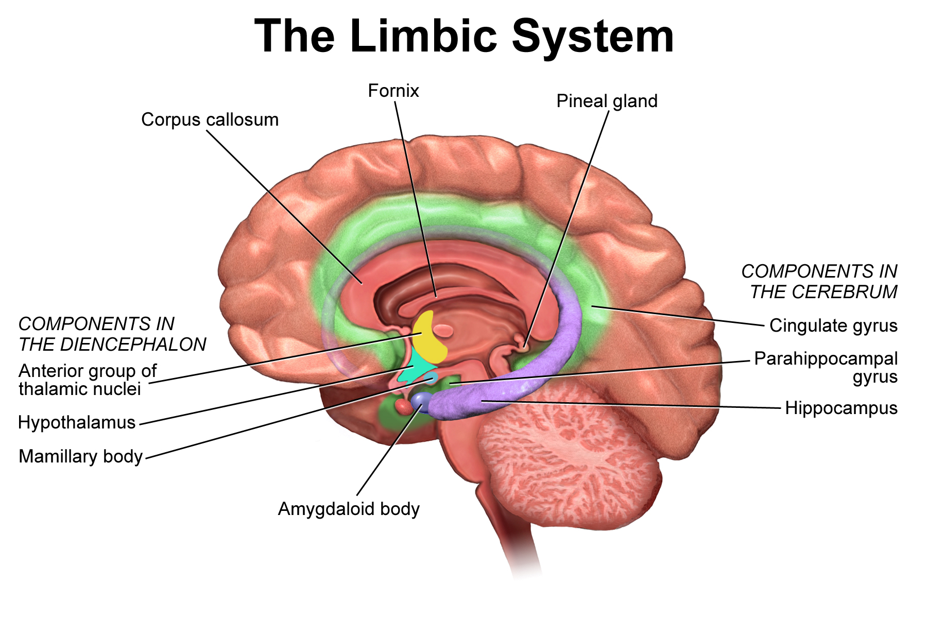
"Medical gallery of Blausen Medical 2014" by BruceBlausen, used under CC BY 3.0.

Further Reading
- LeDoux, J.E., 2000. Emotion circuits in the brain. Ann. Rev. Neurosci. 23, 155184.^{[62]}

Genomics of Game Theory, and Social Behavior
Two of the most commonly used organismal systems now used to study behavior influenced by and influencing genetics are social amoebas and microscopic worms, Caenorhabditis elegans (C. elegans). The first major publication exploring this was by [Strassmann et al.,2000] who analyzed social amoebas in a group, where certain individuals became self-sacrificial while others exploit that altruism.^{[63]} This is related to the concept of Evolutionary Game Theory, which examines the spatial and temporal spread of survival strategies employed by various individuals within a population and/or an ecosystem relative to other individuals during an interaction to maximize profits.^{[64, 65]} However, with newer, more powerful genome sequencing technology at their disposal, [Eichinger et al, 2005] was able to follow up this study by sequencing and analyzing the social amoeba genome, reinforcing the idea that genomics can be used to inform social behavior and opening the doors to a new field of study.^{[66]} As more and more species’ genomes were sequenced and analyzed for influence by and on behavior, more scientists discovered just how complex gene expression and regulation truly is, with the search for a single key gene directly changing one behavior or activity becoming a futile quest. Instead, the field has since shifted to understanding the general processes involved in major shifts of gene expression and regulation relative to social behavior across populations and species. Social amoebas have thus become a model organism to study the influence of genetics on social behavior, while C. elegans provided an ideal model to study behavior and the nervous system.^{[18]}

Further Reading
- J.E. Strassmann, Y. Zhu, D.C. Queller. Altruism and social cheating in the social amoeba Dictyostelium discoideum. Nature, 408 (2000), pp. 965-967. ^{[63]}
- L. Eichinger, J.A. Pachebat, G. Glockner, et al. The genome of the social amoeba Dictyostelium discoideum. Nature, 435 (2005), pp. 43-57.^{[66]}

Social Networking
Not long after the linking of genetics and social behavior, the concept of social networks and development of social or community processes based on behavioral interactions and information flow within a community began to gain track with the application of network analysis techniques to animal social structures. [Girvan & Newman, 2002] highlighted a number of properties found within community structures, including that in which biological social networks are composed of tightly knit groups that share looser connection to each other, creating a hierarchy of connectivity within populations.^{[67, 18, 68]} [Wey et al., 2008] continued this application of network metrics to analysis of social structures, aiming to examine individuals and groups relative to other group members by identifying and quantifying various characteristics of different social relationships present in populations using statistical network parameters.

Further Reading
- M. Girvan, M.E.J. Newman. Community structure in social and biological networks. Proc. Natl. Acad. Sci. USA, 99 (2002), pp. 7821-7826. ^{[67]}
- T. Wey, D.T. Blumstein, W. Shen, F. Jordán. Social network analysis of animal behaviour: a promising tool for the study of sociality. Anim. Behav., 75 (2008), pp. 333-344. ^{[68]}

Personalities and Behavioral Syndromes
Even though it has long been common knowledge that behavior, specifically personality, varies among individuals and is heritable, the study of variation (even contrasting variation) in animal personality across and within families, populations and species hadn’t been a popular topic of study until the early 2000s, with the publication of Sih et al.’s overview of behavioral syndromes in 2004.^{[69]} In fact, the subject was often frowned upon since it implied that a seemingly unique human characteristic could be applied to animals, and scientists (especially women) who did so (either through traditional or unconventional methodology) were often criticized and devalued for introducing the potential for personal bias that would interfere with the dispassionate observation of their experimental subjects.^{[18, 70]} For example, scientist Jane Goodall named her animals and regarded them as having emotional lives but faced heavy backlash from the scientific community for doing so. ^{[18, 70, 71]} Following Sih et al.’s publication, it has since been recognized by more and more of the scientific community that it is possible to study variation and behavioral responses without introducing significant bias^{[18]}, and although such methods can introduce occasional bias, by diversifying the researchers and the methods employed, many insights and various interpretations that provide a much fuller picture of animal behavior strategies that wouldn’t have otherwise been discovered are being brought to light.^{[70]}

Further Reading
- A. Sih, A.M. Bell, J.C. Johnson, R.E. Ziemba. Behavioral syndromes: An integrative overview. Quart. Rev. Biol., 79 (2004), pp. 241-277. ^{[69]}
- Z. Tang-Martínez. The history and impact of women in animal behaviour and the ABS: a North American perspective. Anim. Behav., 164(2020), pp. 251-260. ^{[70]}

Maternal Epigenetics
Epigenetics refers to the study of how the environment can influence and change gene expression (usually reversibly but sometimes permanently) without changing DNA sequences.^{[18, 72]} Since DNA must be packaged in the cell as a coil around groups of proteins called histones to allow it to fit, the distance between groups of histones with DNA wrapped around them changes whether other large proteins are able to access various DNA sequences to then transcribe those genes to make more proteins. Addition of other chemical groups like methyl groups (a CH₃ group) will also change the DNA structure to result in a similar prevention of transcription. These genes are said to be silenced.^{[18, 72]}
Maternal epigenetics refer to a mother’s influence on the extent to which her offsprings’ genes are expressed or not. This can be prior to birth/hatching, or after, and can occur from a large range of environmental influences or actions performed by the mother.^{[18]} One pivotal paper that examined this in mice was [Weaver et al., 2004] who found that female mice who licked their pups and arched their backs more during nursing changed the silencing and expression of the pups’ genes. In addition to informing the appearance of certain genetic diseases and behavior, and providing insight on parental affect on their offspring^{[73]}, maternal or paternal epigenetics can be combined with interspecies interaction studies to better understand how populations in an ecosystem can be affected by and can adapt to a continually changing environment.

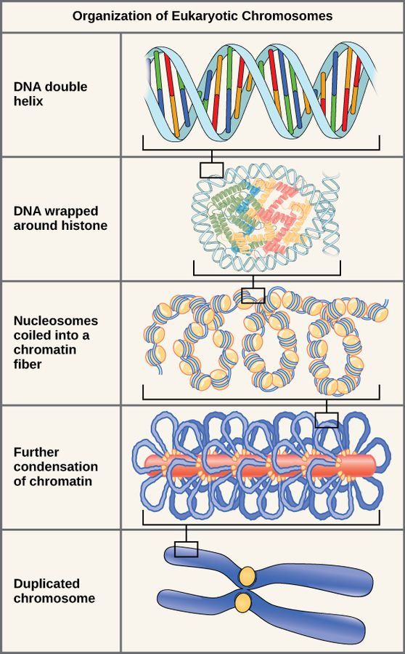
“Biology - Organization of Eukaryotic Chromosomes” by CNX OpenStax, used under CC BY 4.0
Further Reading
- I.C.G. Weaver, N. Cervoni, F.A. Champagne, et al. Epigenetic programming by maternal behavior
Nat. Neurosci., 7 (2004), pp. 847-854. ^{[73]}
- E.C. Braithwaite, M. Kundakovic, P.G. Ramchandani, S.E. Murphy, F.A. Champagne. Maternal prenatal depressive symptoms predict infant NR3C1 1F and BDNF IV DNA methylation. Epigenetics, 10 (2015), pp. 408-417. ^{[74]}
- E.B. Keverne, D.W. Pfaff, I. Tabansky. Epigenetic changes in the developing brain: effects on behavior. Proc. Natl. Acad. Sci. USA, 112 (2015), pp. 6789-6795. ^{[75]}

Exploitation of Information Dissemination
Everyone has things they’re comfortable sharing and other things they would rather keep secret. In 2004, [Danchin et al., 2004] synthesized the theory of how other animals do this as well, using the public and private information they learn to enhance their survival and reproduction.^{[18, 76]} [Danchin et al., 2004] created a framework comprising four categories for acquired (and not genetic) information:
- “Private information that has remained private.
- Private information that has been intercepted by unintended receivers.
- Public information that is not concealed because of its low value; cost of concealment exceeds the cost release.
- Public information that is purposefully release with either honest or dishonest intentions”^{[18, 76]}
In addition to drawing focus to mechanisms used to intercept private information or release misleading public information, [Danchin et al., 2014] also examined how evolution and cultural change control and are impacted by varying information dissemination, since animals often react differently based on the information they acquire from their environment, and this can change based on the individual, the population or generation.^{[18, 76]}.

Further reading
- E. Danchin, L.A. Giraldeau, T.J. Valone, R.H. Wagner. Public information: from nosy neighbors to cultural evolution. Science, 305 (2004), pp. 487-491. ^{[76]}
- S.R.X. Dall, L.A. Giraldeau, O. Olsson, J.M. McNamara, D.W. Stephens. Information and its use by animals in evolutionary ecology. Trends Ecol. Evol., 20 (2005), pp. 187-193. ^{[77]}
- J.-T. Seppanen, J.T. Forsman, M. Monkkonen, R.L. Thomson. Social information use is a process across time, space, and ecology, reaching heterospecifics. Ecology, 88 (2007), pp. 1622-1633. ^{[78]}
- T.J. Valone. From eavesdropping on performance to copying the behavior of others: a review of public information use. Behav. Ecol. Sociobiol., 62 (2007), pp. 1-14.^{[79]}
- J. Clobert, J.-F. Le Galliard, J. Cote, S. Meylan, M. Massot. Informed dispersal, heterogeneity in animal dispersal syndromes and the dynamics of spatially structured populations. Ecol. Lett., 12 (2009), pp. 197-209.^{[80]}

Keystone Individuals
In 2014, the concept of a keystone individual (an animal that stands out in a social group as central to its social network with a disproportionate effect on the animals of its group) was fully developed by [Modlmeier et al, 2014] as they examined of the various possible roles an animal can play in society.^{[18, 81]} Similar to the concept of a keystone species (a species that is disproportionately connected to more species in a food web, thus heavily affecting an ecosystem’s biodiversity^{[82]}), the implication of the existence of a keystone individual has been in literature for decades. However, there had been no specification of terminology, no specific outlined methodology to study these individuals or the mechanisms that explain their presence , no proposed methods to distinguish individuals that were permanent or temporary occupants of the role, and sparse literature review of the ecological implications of these individuals.^{[81]} Although [Modlmeier et al, 2014] compiles a list of general traits of keystone individuals, the two key characteristics that they identify and distinguish are related to the distribution of social information and the influence over group-level choices - the information center and the activator respectively. The information center is an animal tasked with gathering information from outside and/or inside of the social group and their environment to distribute to the rest of the group^{[18]} The example provided by [Breed, 2017] is a dancing honeybee informing others in the hive of the location of a potential food resource. The activator specifically instigates change in group behavior.^{[18]} As seen from controlled manipulation studies where keystone individuals were removed or replaced with others in manipulation experiments, both roles can be individualistic (based on an individual’s innate personality or characteristics) or circumstantial (based on external factors like the presence of other certain individuals, timing or intensity of signals, or changes in environment), based on the specific population and their environment . Individualistic based keystone individuals are defined as true keystone individuals, where their removal results in drastic change in social dynamic or behavior and it is difficult to re-establish the same dynamic with a replacement. Circumstantial based keystone individuals indicate the existence of a keystone role in a group, rather than an individual. When removing the specific individual from the group, the same or extremely similar group dynamic can be re-established when another member of the group fills in the role.^{[81]}

Further Reading
- A.P. Modlmeier, C.N. Keiser, J.V. Watters, A. Sih, J.N. Pruitt. The keystone individual concept: an ecological and evolutionary overview. Anim. Behav., 89 (2014), pp. 53-62. ^{[81]}
- J.N. Pruitt & C.N. Keiser. The personality types of key catalytic individuals shape colonies' collective behaviour and success. Animal Behav., 93(2014), pp. 87-95.^{[82]}

Current Research & Organizations

Popular Topics of Current Research
Although many major discoveries have been made since the early 1900s, every new finding only brings more questions. Below are some of the most popular topics found in Animal Behavior research today (spring of 2022).
- Mechanisms of Epigenetic Regulation ^{[18, 65, 83]}
- Informational Dissemination^{[18]}
- Behavioral physiology^{[65]}
  - Neuroethology^{[65, 83, 84]}
  - Etho Endocrinology^{[65]}
- Behavioral Genetics^{[65]}
- Cognitive Ethology^{[65]}
- Social Signals and Interaction^{[65, 18, 83]}
- Increasing equality, inclusion and diversity in the field and in general science^{[83]}

Further Reading
Below are the editor’s choice articles for the April 2022 edition of the Journal of Animal Behavior published by the Animal Behavior Society (ABS) and the Association for the Study of Animal Behavior (ASAB).^{[83]}
- Brian M. Myers, David T. Rankin, Kevin J. Burns, Alan Brelsford, Christopher J. Clark. k-mer analysis shows hybrid hummingbirds perform variable, transgressive courtship sequences. Animal Behaviour, Vol. 186, April 2022, Pages 67–84
- Claire M.V. Nelson, Terry J. Ord. Identifying potential cues of species identity in complex animal signals. Animal Behaviour, Vol. 186, April 2022, Pages 121–136
- Elizabeth S. Paul, William Browne, Michael T. Mendl, Gina Caplen, ... Christine J. Nicol. Assessing animal welfare: a triangulation of preference, judgement bias and other candidate welfare indicators. Animal Behaviour, Vol. 186, April 2022, Pages 151–177

Current International Animal Behavior and Ethology Research Organizations^{[85]}
- The Animal Behavior Society (ABS): A non-partisan, non-profit professional organization of scientists in primarily the North, Central and South American area dedicated to the promotion and advancement of scientific study of animal behavior across all levels of biological organization, research conditions, and approaches. They work with ASAB (below) to publish the scientific journal Animal Behavior, and individually sponsor a multitude of research conferences, educational and student research programs, outreach activities, and professional certification programs.^{[86]}
- The Association for the Study of Animal Behavior (ASAB): A community of scientists comprising primarily British and European professional biologists working to promote a diverse and inclusive community interested in the promotion and study of animal behavior with fair and equitable representation and participation in all activities of the association. They work with ABS (above) to publish the scientific journal Animal Behavior, and individually organize conferences, fund research and promote school animal behavior education.^{[87]}
- Australasian Society for the Study of Animal Behavior (ASSAB): A society of scientists primarily from Australia and New Zealand (although others from PNG and the Pacific Nations - including students - are also encouraged to join) working to promote scientific study of Animal Behavior and provide its community with opportunities for discussion and dissemination of information on conferences, fellowships, jobs and grants, as well as from members’ research in all aspects of Animal Behavior on a wide diversity of related fields and terrains, and with a large diversity of species.^{[88]} Members can post all of this on the community’s blog page and submit small video presentations to their youtube channel.^{[89, 90]}
- International Societies
  - International Society for Adaptive Behavior (ISAB): Part of the Union of International Associations (UIA) and publisher of the scientific journal Adaptive Behavior.^{[91, 92, 93]}
  - International Society for Behavioral Ecology (ISBE): Publisher of the scientific journal Behavioral Ecology and created to facilitate communication among scientists studying behavioral ecology and related fields to publish an affordable journal that covered a diverse range of subjects, taxonomic groups and geographical areas, as well as reflected the full range of interests among the society’s members.^{[94, 95]}
  - International Society for Neuroethology (ISN): A society dedicated to the promotion of the study of neural bases of behavior, committed to provision of and promotion of equal opportunities and non-discriminatory procedures and practices within members and within science in general.^{[84]} Resources they provide include career opportunities, a newsletter, educational support, and a library of member’s publications.^{[96]}

Works Cited
- Abraham, CI. Britannica [Internet]. Charles Henry Turner; c2022 [cited 2022 Apr 24]. Available from: https://www.britannica.com/biography/Charles-Henry-Turner
- Biography.com editors. Biography [Internet]. Charles Henry Turner Biography; c2020 [cited 2022 Apr 24]. Available from: https://www.biography.com/scientist/charles-henry-turner
- New York Times Archives. New York Times [Internet]. Gottfried S. Fraenkel; Studied Insect Biology; c1984 [cited 2022 Apr 24]. Available from: https://www.nytimes.com/1984/11/01/obituaries/gottfried-s-fraenkel-studied-insect-biology.html
- University of Illinois Archives. University of Illinois University Library [Internet]. Fraenkel, Gottfried Samuel (1901-1984); c2017 [cited 2022 Apr 24]. Available from: https://archon.library.illinois.edu/?p=creators/creator&id=1087
- Bat Conservation International [Internet]. Discover of Echoloaction; c2003 [cited Apr 24]. Available from: https://www.batcon.org/article/discoverer-of-echolocation/
- Gasking EB. Britannica [Internet]. Lazzaro Spallanzani; c2022 [cited Apr 24]. Available from: https://www.britannica.com/biography/Lazzaro-Spallanzani
- Scholarpedia [Internet]. Echolocation in Bats; c2022 [cited Apr 24]. Available from: http://www.scholarpedia.org/article/Echolocation_in_bats
- Wikipedia [Internet]. Lack’s Principle; c2019 [cited Apr 24]. Available from: https://en.wikipedia.org/wiki/Lack%27s_principle
- Lack D. The Significance of Clutch Size. International Journal of Avian Medicine [Internet]. 1947 [cited 2022 Apr 24]; 89(2): 302-352. Available from: https://onlinelibrary.wiley.com/doi/10.1111/j.1474-919X.1947.tb04155.x
- Wilson H. Colby University [Internet]. Clutch Size Variation; c2009 [cited Apr 24]. Available from: https://web.colby.edu/mainebirds/2009/07/11/85/
- Metivier, A. Gasking EB. Magnetic Memory Method [Internet]. What are Cognitive Maps & How do They Work with Memory Palaces?; c2022 [cited Apr 24]. Available from: https://www.magneticmemorymethod.com/cognitive-maps/#What%20are%20Cognitive%20Maps
- Tolman, EC. Cognitive maps in rats and men. Psychological Review [Internet]. 1948 [cited 2022 Apr 24]; 55(4), 189–208. Available from: https://psycnet.apa.org/record/1949-00103-001
- Beach, F. Cognitive maps in rats and men. Yale Journal of Biology and Medicine [Internet]. 1948 [cited 2022 Apr 24]; 516. Available from: https://www.ncbi.nlm.nih.gov/pmc/articles/PMC2602344/pdf/yjbm00475-0079b.pdf
- Wikipedia [Internet]. Coolidge Effect; c2022 [cited Apr 24]. Available from: https://en.wikipedia.org/wiki/Coolidge_effect
- Steiger S. The Coolidge Effect, Individual Recognition and Selection for Distinctive Cuticular Signatures in a Burying Beetle. Proceedings of the Royal Society B [Internet]. 2008 [cited 2022 Apr 24]; 275(16450), 1831–1838. Available from: https://royalsocietypublishing.org/doi/10.1098/rspb.2008.0375
- Fiorino DF. Dynamic changes in nucleus accumbens dopamine efflux during the Coolidge effect in male rats. Journal of Neuroscience [Internet]. 1997 [cited Apr 24 2022]; 17(12), 4849-4855. Available from: https://pubmed.ncbi.nlm.nih.gov/9169543/
- The Editors of Encyclopedia Britannica . Britannica [Internet]. Weber’s Law; c2020 [cited Apr 24]. Available from: https://www.britannica.com/science/Webers-law
- Breed, M. D. 2017. Conceptual Breakthroughs in Ethology and Animal Behavior, Colorado: Elsevier Science Academic Press. Available From: https://www.sciencedirect.com/science/article/pii/B9780128092651000800
- Scott JP, Fuller JL. 1965. Genetics and the social behavior of the dog. University of Chicago Press; [cited 2022 Apr 24]. Available from: https://books.google.com/books/about/Genetics_and_the_Social_Behaviour_of_the.html?id=ajPrMYi6a2kC
- Konopka RJ, Benzer S. 1971. Clock mutants of drosophila melanogaster. Proc Natl Acad Sci U [Internet][cited 2022 Apr 24]; 68(9):[2112-2116 p.]. Available from: [https://www.pnas.org/doi/full/10.1073/pnas.68.9.2112]
- Brenner S. 1974. The genetics of caenorhabditis elegans. Genetics [Internet][cited 2022 Apr 24]; 77(1):[71-92 p.]. Available from: [https://academic.oup.com/genetics/article/77/1/71/5991065]
- Tinbergen N. 1963. On aims and methods of ethology. Ethology [Internet][cited 2022 Apr 24]; 20(4):[410-433 p.]. Available from: [https://onlinelibrary.wiley.com/doi/10.1111/j.1439-0310.1963.tb01161.x]
- Tinbergen, N. Translated by Tierpvydhel, Z. F. 1963. On aims and methods of ethology - English Zeitschrift für Tierpsychologie 20:410-433. Available From: https://www.esf.edu/efb/faculty/documents/tinbergen1963onethology.pdf
- Maynard Smith J, Price GR. 1973. The logic of animal conflict. Nature [Internet][cited 2022 Apr 24]; 246:[15-18 p.]. Available from: [https://www.nature.com/articles/246015a0]
- Ronald Pulliam H. 1973. On the advantages of flocking. Journal of Theoretical Biology [Internet][cited 2022 Apr 24]; 38(2):[419-422 p.]. Available from: [https://www.sciencedirect.com/science/article/abs/pii/0022519373901847?via%3Dihub#!]
- Leigh VV. 1973. A new evolutionary law. University of Chicago [Internet][cited 2022 Apr 24]. Available from: [https://www.mn.uio.no/cees/english/services/van-valen/evolutionary-theory/volume-1/vol-1-no-1-pages-1-30-l-van-valen-a-new-evolutionary-law.pdf]
- Zahavi A. 1975. Mate selection-a selection for a handicap. Journal of Theoretical Biology [Internet][cited 2022 Apr 24]; 53(1):[205-214 p.]. Available from: [https://www.sciencedirect.com/science/article/abs/pii/0022519375901113?via%3Dihub]
- Altmann J. 1974. Observational study of behavior: sampling methods. Brill [Internet][cited 2022 Apr 24]; 49(3):[227-267 p.]. Available from: [https://www.jstor.org/stable/4533591?seq=1]
- Charnov EL. 1976. Optimal foraging, the marginal value theorem. Theoretical Population Biology [Internet][cited 2022 Apr 24]; 9(2):[129-136 p.] Available from: [https://www.sciencedirect.com/science/article/pii/004058097690040X?via%3Dihub]
- Hamilton WD. 1964. The genetical evolution of social behaviour. Journal of Theoretical Biology [Internet][cited 2022 Apr 24]; 7(1):[17-52 p.]. Available from: [https://www.sciencedirect.com/science/article/abs/pii/0022519364900396?via%3Dihub] doi:10.1016/0022-5193(64)90039-6
- Harlow HF, Dodsworth RO, Harlow, MK. 1965. Total Social Isolation in Monkeys. Proc Natl Acad Sci U S A [Internet][cited 2022 Apr 24]; 54(1):[90-7 p.]. Available from:[https://www.pnas.org/doi/abs/10.1073/pnas.54.1.90] doi: 10.1073/pnas.54.1.90
- Kopfer, PH. 1969. Habitats and territories; A study of the use of space by animals. Basic Books; [cited 2022 Apr 24]. Available from: [https://www.science.org/doi/10.1126/science.166.3909.1134.b]
- Fretwell SD, Lucas HL. 1969. On territorial behavior and other factors influencing habitat distribution in birds. Acta Biotheoretica [Internet][cited 2022 Apr 24]; 19:[16-36 p.]. Available from: [https://link.springer.com/article/10.1007/BF01601953 doi:10.1007/BF01601953
- Triviers RL. 1971. The evolution of reciprocal altruism. Quarterly Review of Biology [Internet][cited 2022 Apr 24]; 46(1). Available from: [https://www.journals.uchicago.edu/doi/10.1086/406755] doi:10.1086/406755
- Lin N, Michener CD. 1972. Evolution of sociality in insects. Quarterly Review of Biology[Internet][cited 2022 Apr 24]; 47(2). Available from: [https://www.journals.uchicago.edu/doi/10.1086/407216] doi: 10.1086/407216
- Alexander RD. 1974. The evolution of social behavior. Quarterly Review of Biology [Internet][cited 2022 Apr 24]; 5:[325-383 p.]. Available from: [https://www.annualreviews.org/doi/10.1146/annurev.es.05.110174.001545]
- Wilson DS. 1975. A theory of group selection. Quarterly Review of Biology [Internet][cited 2022 Apr 24]; 72(1):[143-146 p.] Available from: [https://www.pnas.org/doi/abs/10.1073/pnas.72.1.143] doi: 10.1073/pnas.72.1.143
- West-Eberhard MJ. 1975. The evolution of social behavior by kin selection. Quarterly Review of Biology [Internet][cited 2022 Apr 24]; 50(1). Available from: [https://www.journals.uchicago.edu/doi/10.1086/408298]
- Hamilton WD. 1971. Geometry for the selfish herd. Journal of Theoretical Biology [Internet][cited 2022 Apr 24]; 31(2). Available from: [https://www.sciencedirect.com/science/article/abs/pii/0022519371901895?via%3Dihub] doi:10.1016/0022-5193(71)90189-5
- Trivers RL. 1974. Parent-offspring conflict. American Zoologist [Internet][cited 2022 Apr 24]; 14(1). Available from: [https://academic.oup.com/icb/article/14/1/249/2066733] doi:10.1093/icb/14.1.249
- Emlen ST. & Oring, LW. 1977. Ecology, sexual selection, and the evolution of mating systems. Science [Internet][cited 2022 Apr 24]; 197(4300):[215-223 p.]. Available from: [https://www.science.org/doi/10.1126/science.327542] doi:10.1126/science.327542
- Goodall JV. 1964. Tool-Using and aimed throwing in a community of free-living Chimpanzees. Nature [Internet][cited 2022 Apr 24]; 201:[1264-1266 p.]. Available from: [https://www.nature.com/articles/2011264a0]doi:10.1016/S0066-1856(68)80003-2
- Simmons LW, Wedell N. 2020. Fifty years of sperm competition: the structure of a scientific revolution. Phil. Trans. R. Soc. B [Internet][cited 2022 Apr 27]; 375(1813). Available from: [https://royalsocietypublishing.org/doi/10.1098/rstb.2020.0060#d1e286]
- Lerdau, M. 2022. The complicated legacy of E. O. Wilson with respect to genetics and human behavior. Bioessays 44(5). Available from: [https://onlinelibrary.wiley.com/doi/full/10.1002/bies.202200034?saml_referrer]
- Boero DL. 1992. Alarm calling in Alpine marmot (Marmota marmota L.): evidence for semantic communication. Ethology Ecology & Evolution [Internet][cited April 24]; 4(2):[125–138].Available from: https://doi.org/10.1080/08927014.1992.9525334
- Zuberbühler K. 2005. The Phylogenetic Roots of Language. Current Directions in Psychological Science. [Internet] [cited April 24]; 14(3):[126–130]. Available from: https://doi.org/10.1111/j.0963-7214.2005.00357.x
- Suzuki TN. 2016. Semantic communication in birds: evidence from field research over the past two decades. Ecological Research. [Internet][cited April 24]; 31(3):[307–319]. Available from: https://doi.org/10.1007/s11284-016-1339-x
- Read AF, Weary DM. 1990. Sexual selection and the evolution of bird song: A test of the Hamilton-Zuk hypothesis. Behavioral Ecology and Sociobiology. [Internet][cited April 24]; 26(1):47–56. Available from: https://doi.org/10.1007/BF00174024
- ‌Setchell JM, Charpentier MJE, Abbott KM, Wickings EJ, Knapp LA. 2009. Is Brightest Best? Testing the Hamilton-Zuk Hypothesis in Mandrills. International Journal of Primatology.[Internet][cited April 24]; 30(6):[825–844].Available from:https://doi.org/10.1007/s10764-009-9371-0
- Megía-Palma R, Barrientos R, Gallardo M, Martínez J, Merino S. 2021. Brighter is darker: the Hamilton–Zuk hypothesis revisited in lizards. Biological Journal of the Linnean Society. [Internet][cited April 24]; 134(2):[461–473]. Available from: https://doi.org/10.1093/biolinnean/blab081
- Pamilo P, Crozier RH. 1996. Reproductive Skew Simplified. Oikos. [Internet][cited April 24]; 75(3):[533]. Available from: https://doi.org/10.2307/3545895
- Kokko H, Johnstone RA. 1999. Social queuing in animal societies: a dynamic model of reproductive skew. Proceedings of the Royal Society of London Series B: Biological Sciences. [Internet][cited April 24]; 266(1419):[571–578]. Available from: https://doi.org/10.1098/rspb.1999.0674
- Kutsukake N, Nunn CL. 2006. Comparative tests of reproductive skew in male primates: the roles of demographic factors and incomplete control. Behavioral Ecology and Sociobiology. [Internet][cited April 24]; 60(5):[695–706]. Available from: https://doi.org/10.1007/s00265-006-0213-1
- Nonacs P, Hager R. 2011. The past, present and future of reproductive skew theory and experiments. Biological Reviews. [Internet][cited April 24]; 86(2):[271–298]. Available from: https://doi.org/10.1111/j.1469-185X.2010.00144.x
- Ferree ED, Wikelski MC, Anderson DJ. 2004. Hormonal correlates of siblicide in Nazca boobies: support for the Challenge Hypothesis. Hormones and Behavior. [Internet][cited April 24]; 46(5):[655–662]. Available from: https://doi.org/10.1016/j.yhbeh.2004.06.009
- Hirschenhauser K, Oliveira RF. 2006. Social modulation of androgens in male vertebrates: meta-analyses of the challenge hypothesis. Animal Behaviour. [Internet][cited April 24]; 71(2):[265–277]. Available from: https://doi.org/10.1016/j.anbehav.2005.04.014
- Knight EL, Sarkar A, Prasad S, Mehta PH. 2020 Jan. Beyond the challenge hypothesis: The emergence of the dual-hormone hypothesis and recommendations for future research. Hormones and Behavior.[Internet][cited April 24]; :104657. Available from: https://doi.org/10.1016/j.yhbeh.2019.104657
- Crooks JA. 2002. Characterizing ecosystem-level consequences of biological invasions: the role of ecosystem engineers. Oikos. [Internet][cited April 24]; 97(2):[153–166]. Available from: https://doi.org/10.1034/j.1600-0706.2002.970201.x
- Roman J, Estes JA, Morissette L, Smith C, Costa D, McCarthy J, Nation J, Nicol S, Pershing A, Smetacek V. 2014. Whales as marine ecosystem engineers. Frontiers in Ecology and the Environment. [Internet][cited April 24]; 12(7):[377–385]. Available from: https://doi.org/10.1890/130220
- Emery‐Butcher HE, Beatty SJ, Robson BJ. 2020. The impacts of invasive ecosystem engineers in freshwaters: A review. Freshwater Biology. [Internet][cited April 24]; 65(5):[999–1015]. Available from: https://doi.org/10.1111/fwb.13479
- Fröhlich M, van Schaik CP. 2018. The function of primate multimodal communication. Animal Cognition. [Internet][cited April 24]; 21(5):[619–629]. Available from: https://doi.org/10.1007/s10071-018-1197-8
- LeDoux, J.E. 2000. Emotion circuits in the brain. Ann. Rev. Neurosci.[Internet] [accessed 2022 April 19];23(1):155-184. Available from: https://www.annualreviews.org/doi/10.1146/annurev.neuro.23.1.155 doi:10.1146/annurev.neuro.23.1.155
- Strassmann, J.E. Zhu, Y. Queller, D.C. 2000. Altruism and social cheating in the social amoeba Dictyostelium discoideum. Nature. [Internet] [accessed 2022 April 19]; 408(6815):965-967. Available from: https://www.scopus.com/record/display.uri?eid=2-s2.0-0034700501&origin=inward&featureToggles=FEATURE_NEW_DOC_DETAILS_EXPORT:1 doi:10.1038/35050087
- Evolutionary Game Theory - Wikipedia [Internet]. 2022.Wikimedia Foundation Inc. [accessed 2022 April 19] Available from: https://en.wikipedia.org/wiki/Evolutionary_game_theory
- Kappeler, P. M. 2020. Animal behavior - an evolutionary perspective. 5th edition. Chapter 1- Behavioral Biology: Content and History [Internet]. Springer Spektrum. Available from: https://link.springer.com/book/10.1007/978-3-030-82879-0 doi:10.1007/978-3-030-82879-0
- Eichinger, L. Pachebat, J.A. Glockner, G. et al. 2005. The genome of the social amoeba Dictyostelium discoideum. Nature [Internet] [accessed 2022 April 19];435(1): 43-57. Available from: https://www.nature.com/articles/nature03481
- Girvan, M. & Newman, M.E.J. 2002. Community structure in social and biological networks. Proc. Natl. Acad. Sci. USA [Internet] [accessed 2022 April 19]; 99(12):7821-7826. Available from: https://www.pnas.org/doi/abs/10.1073/pnas.122653799 doi:10.1073/pnas.122653799
- Wey, T. Blumstein, D.T. Shen, W. Jordán, F. 2008. Social network analysis of animal behaviour: a promising tool for the study of sociality. Anim. Behav.[accessed 2022 April 19]; 75(2):333-344. Available from: https://www.sciencedirect.com/science/article/pii/S0003347207004393 doi:10.1016/j.anbehav.2007.06.020
- Sih, A. Bell, A.M. Johnson, J.C. Ziemba, R.E. 2004. Behavioral syndromes: An integrative overview. Quart. Rev. Biol [Internet] [accessed 2022 April 19]; 79(3): 241-277. Available from: https://www.journals.uchicago.edu/doi/abs/10.1086/422893 doi:10.1086/422893
- Tang-Martinez, Z. 2020. The history and impact of women in animal behavior and the ABS: a North American perspective. SI: Animal Behavior [Internet] [accessed 2022 April 11]; 164(2020):252-260. Available from: https://doi.org/10.1016/j.anbehav.2019.12.011 doi:10.1016/j.anbehav.2019.12.011
- The Jane Goodall Institute Homepage[Internet]. 2022. The Jane Goodall Institute. [accessed 2022 April 19]. Available from https://www.janegoodall.org/
- What is Epigenetics? - Center for Disease Control and Prevention (CDC) [Internet] . 2020. U.S. Department of Health & Human Services. [accessed 2022 April 19]. Available from: https://www.cdc.gov/genomics/disease/epigenetics.htm#:~:text=Epigenetics%20is%20the%20study%20of,body%20reads%20a%20DNA%20sequence.
- Weaver, I. C., Cervoni, N., Champagne, F. A., D'Alessio, A. C., Sharma, S., Seckl, J. R., Dymov, S., Szyf, M., & Meaney, M. J. 2004. Epigenetic programming by maternal behavior. Nature neuroscience[Internet] [accessed 2022 April 19];7(8), 847–854. Available from: https://doi.org/10.1038/nn1276 doi:10.1038/nn1276
- Braithwaite, E. C., Kundakovic, M., Ramchandani, P. G., Murphy, S. E., & Champagne, F. A. 2015. Maternal prenatal depressive symptoms predict infant NR3C1 1F and BDNF IV DNA methylation. Epigenetics[Internet] [accessed 2022 April 19];10(5): 408–417. Available from: https://doi.org/10.1080/15592294.2015.1039221 doi: 10.1080/15592294.2015.1039221
- Keverne, E. B., Pfaff, D. W., & Tabansky, I. 2015. Epigenetic changes in the developing brain: Effects on behavior. Proc. Natl. Acad. Sci. USA [Internet] [accessed 2022 April 19]; 112(22), 6789–6795. Available from: https://doi.org/10.1073/pnas.1501482112, doi:https://doi.org/10.1073/pnas.1501482112
- Danchin, E., Giraldeau, L. A., Valone, T. J., & Wagner, R. H. 2004. Public information: from nosy neighbors to cultural evolution. Science (New York, N.Y.) [Internet] [accessed 2022 April 19]; 305(5683): 487–491.Available from: https://www.science.org/doi/10.1126/science.1098254 doi:10.1126/science.1098254
- Dall, S. R., Giraldeau, L. A., Olsson, O., McNamara, J. M., & Stephens, D. W. 2005. Information and its use by animals in evolutionary ecology. Trends Ecol. Evol [Internet] [accessed 2022 April 19]; 20(4): 187–193. Available from: https://www.sciencedirect.com/science/article/pii/S016953470500011X?via%3Dihub doi:10.1016/j.tree.2005.01.010
- Seppänen, J. T., Forsman, J. T., Mönkkönen, M., & Thomson, R. L. (2007). Social information use is a process across time, space, and ecology, reaching heterospecifics. Ecology [Internet] [accessed 2022 April 19]; 88(7): 1622–1633. Available from: https://esajournals.onlinelibrary.wiley.com/doi/full/10.1890/06-1757.1 doi:10.1890/06-1757.1
- Valone, T.J. 2007. From eavesdropping on performance to copying the behavior of others: a review of public information use. Behav. Ecol. Sociobiol [Internet] [accessed 2022 April 19];62(1): 1–14. Available from: https://doi.org/10.1007/s00265-007-0439-6
- Clobert, J., Le Galliard, J. F., Cote, J., Meylan, S., & Massot, M. (2009). Informed dispersal, heterogeneity in animal dispersal syndromes and the dynamics of spatially structured populations. Ecol. Lett [Internet] [accessed 2022 April 19];12(3): 197–209. Available from: https://link.springer.com/article/10.1007/s00265-007-0439-6 doi: 10.1111/j.1461-0248.2008.01267.x
- Modlmeier, A.P. Keiser, C.N. Watters, J. V. Sih, A. Pruitt, J.N.2014.The keystone individual concept: an ecological and evolutionary overview. Anim Behav [Internet] [accessed 2022 April 19]; 89(2014): 53-62. Available from: https://www.sciencedirect.com/science/article/pii/S0003347213005745 doi:10.1016/j.anbehav.2013.12.020
- Pruitt J.N. Keiser, C.N. 2014. The personality types of key catalytic individuals shape colonies' collective behaviour and success. Anim Behav [Internet] [accessed 2022 April 19]. 2014;93:87-95. Available from: https://www.sciencedirect.com/science/article/pii/S0003347214001882?via%3Dihub doi: 10.1016/j.anbehav.2014.04.017
- Animal Behavior - Journal. 2022. ASAB [Internet] [accessed 2 022 April 19] Available from: https://www.journals.elsevier.com/animal-behaviour
- ISN > Home [Internet]. 2022. ISN - International Society for Neuroethology (ISN) [accessed 2 022 April 19] Available from: https://www.neuroethology.org/default.aspx
- McIntosh, M. 2002 Nov 5. The University of Arizona Department of Ecology and Evolutionary Biology - Principles of Animal Behavior: links to societies. Arizona Board of Regents [Internet]. Available from: http://eebweb.arizona.edu/animal_behavior/links/links_societies.htm
- About the ABS [Internet]. 2022. Animal Behavior Society (ABS). [accessed 2022 April 19] Available from: https://www.animalbehaviorsociety.org/web/about-mission.php
- Welcome to ASAB [Internet]. 2022. Association for the Study of Animal Behavior (ASAB). [accessed 2022 April 19] Available from: https://www.asab.org/
- ASSAB Home [Internet]. 2022. Australiasian Society for the Study of Animal Behavior (ASSAB). [accessed 2022 April 19] Available from: https://www.assab.org/
- ASSAB Blog [Internet]. 2022. Australiasian Society for the Study of Animal Behavior (ASSAB-B). [accessed 2022 April 19] Available from: https://www.assab.org/blog/
- Official Youtube Channel of the Australasian Society for the Study of Animal Behavior (ASSAB-Y) [Internet]. 2022. Youtube.com. [accessed 2022 April 19] Available from: https://www.youtube.com/channel/UCDiNsdxd2rW92A8depKCuoA
- International Society for Adaptive Behavior Website [Internet]. 2018. International Society for Adaptive Behavior (ISAB). [accessed 2022 April 19] Available from: https://www.isab.org/
- International Society for Adaptive Behavior (ISAB) - UIA Yearbook Profile [Internet]. 2022. Union of International Associations/Union des Associations Internationales (UIA). [accessed 2022 April 19] Available from: https://uia.org/s/or/en/1100058943
- Adaptive Behavior: Sage Journals [Internet]. 2022. Sage Journals. (AdBJ). [accessed 2022 April 19] Available from: https://journals.sagepub.com/home/adb
- History - ISBE: The International Society for Behavioral Ecology [Internet]. 2022. International Society for Behavioral Ecology (ISBE). [accessed 2022 April 19] Available from: http://www.behavecol.com/history
- Our journal - ISBE: The International Society for Behavioral Ecology [Internet]. 2022. International Society for Behavioral Ecology (BEJ). [accessed 2022 April 19] Available from: http://www.behavecol.com/our-journal
- Resources [Internet]. 2022. International Society for Neuroethology (ISN-R). [accessed 2022 April 19] Available from: https://www.neuroethology.org/resources

