**How to Use the Deliverables**

# How to Analyze Hypotheses Data

| Strongly Disagree | Disagree | Neither Disagree Nor Agree | Agree | Strongly Agree |
| --- | --- | --- | --- | --- |
| -1 | -0.5 | 0 | 0.5 | 1 |

The data will automatically be transferred from Google Forms to Google Sheets, and the sheet will perform analyses on it. The data will be quantified on the above scale, in order to make qualitative analysis possible, as well as to combine English, French, and Arabic responses with the same meaning. “Strongly agree” was given a value of 1, “Agree” a value of 0.5, “Neither disagree nor agree” a value of 0, “Disagree” a value of -0.5, and “Strongly disagree” a value of -1. Graphs are then made in the Google Sheets file to clearly compare these values.

# Survey Interpretation

From the results of our pilot study, we were able to draw conclusions regarding the efficacy of our hypotheses. Below is listed the **Definition of the variables**, **Hypothesis**, and **Interpretation of Hypothesis** for each variable of TPB and DOI, as well as an interpretation of each individual statement.

## **H1: Attitudes Towards A Behavior**

**Definition of Attitude Towards a Behavior:** An individual’s personal evaluation of the behavior, such as if it is deemed a ‘good’ behavior or a ‘bad’ behavior.

**Hypothesis:** Attitude towards electric vehicle adoption positively influences the intention to adopt an electric vehicle.

**Interpretation of Hypothesis:**

A majority positive attitude has a positive influence on intent to purchase an electric vehicle. It demonstrates that people have a positive attitude towards electric vehicles.

A majority negative attitude has a negative influence on intent to purchase an electric vehicle. It demonstrates that people have a negative attitude towards electric vehicles.

**Interpretation of Statements:**

1. I think that electric vehicles are a good investment.
   1. Agreement = Positive attitude
   2. Disagreement **=** Negative attitude
2. I think that electric vehicles should be more popular than they are.
   1. Agreement = Positive attitude
   2. Disagreement **=** Negative attitude
3. I think that there is a need for electric vehicles.
   1. Agreement = Positive attitude
   2. Disagreement **=** Negative attitude
4. Using an electric vehicle is preferable to me.
   1. Agreement = Positive attitude
   2. Disagreement **=** Negative attitude

## **H2: Subjective Norm**

**Definition of Subjective Norm:** The perceived social pressure to perform or not to perform the behavior.

**Hypothesis:** Subjective norm positively influences the intention to purchase an electric vehicle.

**Interpretation of Hypothesis:**

A majority positive subjective norm has a positive influence on intent to purchase an electric vehicle. It demonstrates that people see a subjective norm in purchasing electric vehicles.

A majority negative subjective norm has a negative influence on intent to purchase an electric vehicle. It demonstrates that people do not see a subjective norm in purchasing electric vehicles.

**Interpretation of Statements:**

1. The people important to me would approve if I bought an electric vehicle.
   1. Agreement = Positive subjective norm
   2. Disagreement = Negative subjective norm
2. If I bought an electric vehicle, the people important to me would also buy an electric vehicle.
   1. Agreement = Positive subjective norm
   2. Disagreement = Negative subjective norm
3. People around me have electric vehicles, which makes me want to buy one.
   1. Agreement = Positive subjective norm
   2. Disagreement = Negative subjective norm
4. The people important to me prefer that I buy an electric vehicle over a petroleum one.
   1. Agreement = Positive subjective norm
   2. Disagreement = Negative subjective norm

## **H3: Perceived Behavioral Control (PBC)**

**Definition of PBC:** The perceived ease or difficulty of performing the behavior; includes a reflection of past experiences and anticipated obstacles.

**Hypothesis:** Perceived behavioral control positively influences the intention to purchase an electric vehicle.

**Interpretation of Hypothesis:**

A majority positive perceived behavioral control has a positive influence on intent to purchase an electric vehicle. It demonstrates that people feel in control of their purchase of EVs.

A majority negative perceived behavioral control has a negative influence on intent to purchase an electric vehicle. It demonstrates that people do not feel in control of their purchase of EVs.

**Interpretation of Statements:**

1. I could buy an electric vehicle if I wanted to.
   1. Agreement = Positive PBC
   2. Disagreement = Negative PBC
2. I think I know where I can buy an electric vehicle.
   1. Agreement = Positive PBC
   2. Disagreement = Negative PBC
3. I have the time, resources, and opportunity to buy an electric vehicle.
   1. Agreement = Positive PBC
   2. Disagreement = Negative PBC

## **H4: Relative Advantage**

**Definition of Relative Advantage:** The extent to which innovation is perceived to be superior to existing products or ideas.

**Hypothesis:** Relative advantage positively influences attitudes towards electric vehicles.

**Interpretation of Hypothesis:**

A majority positive relative advantage has a positive influence on attitudes towards electric vehicles. It demonstrates that people see relative advantage in using EVs.

A majority negative relative advantage has a positive influence on attitudes towards electric vehicles. It demonstrates that people do not see relative advantage in using EVs.

**Interpretation of Statements:**

1. I think I would save money long term by buying an electric vehicle.
   1. Agreement = Positive(apparent) relative advantage
   2. Disagreement = Negative relative advantage
2. I think an electric vehicle would be easier for me to maintain than a petroleum one.
   1. Agreement = Positive(apparent) relative advantage
   2. Disagreement = Negative relative advantage
3. Using an electric vehicle would be beneficial for the environment.
   1. Agreement = Positive(apparent) relative advantage
   2. Disagreement = Negative relative advantage
4. Fuel costs affect my desire for an electric vehicle.
   1. Agreement = Positive(apparent) relative advantage
   2. Disagreement = Negative relative advantage

## **Hypothesis 5: Compatibility**

**Definition of Compatibility:** The extent to which innovative products are perceived to be consistent with consumer needs.

**Hypothesis**: Compatibility positively influences attitudes toward electric vehicles

**Interpretation of Hypothesis:**

A majority positive compatibility has a positive influence on attitudes towards electric vehicles. It demonstrates that people view electric vehicles to be compatible with society.

A majority negative compatibility has a negative influence on attitudes towards electric vehicles. It demonstrates that people view electric vehicles to be incompatible with society.

**Interpretation of Statements:**

1. I can easily find an electric vehicle charging station in my area.
   1. Agreement = Positive (apparent) compatibility
   2. Disagreement = Negative compatibility
2. I would be able to do my daily activities with an electric vehicle as my transportation.
   1. Agreement = Positive (apparent) compatibility
   2. Disagreement = Negative compatibility
3. I would feel comfortable traveling long distances in an electric vehicle.
   1. Agreement = Positive (apparent) compatibility
   2. Disagreement = Negative compatibility
4. I know where to go to fix an electric vehicle in need of repair.
   1. Agreement = Positive (apparent) compatibility
   2. Disagreement = Negative compatibility

## **Hypothesis 6: Complexity**

**Definition of Complexity:** The extent to which innovative products are perceived as hard to understand and use.

**Hypothesis:** Complexity negatively influences attitudes towards electric vehicles.

**Interpretation of Hypothesis:**

A majority positive complexity has a positive influence on attitudes towards electric vehicles.

It demonstrates that people view electric vehicles as not complex.

A majority negative complexity has a negative influence on attitudes towards electric vehicles. It demonstrates that people view electric vehicles as a complex technology.

**Interpretation of Statements:**

1. I know how to charge an electric vehicle.
   1. Agreement = Positive (no) complexity
   2. Disagreement = Negative (apparent) complexity
2. I think it is hard to charge an electric vehicle.
   1. Agreement = **Negative** (apparent) complexity
   2. Disagreement = **Positive** complexity
3. I think operating an electric vehicle would be similar to operating a petroleum one.
   1. Agreement = Positive (no) complexity
   2. Disagreement = Negative (apparent) complexity
4. The concept behind electric vehicles is difficult for me to understand.
   1. Agreement = **Negative** (apparent) complexity
   2. Disagreement = **Positive** (no) complexity

## **Hypothesis 7: Observability**

**Definition of Observability:** The extent to which results of adopting innovative products are visible to others.

**Hypothesis:** Observability positively influences attitudes towards electric vehicles.

**Interpretation of Hypothesis:**

A majority positive observability has a positive influence on attitudes towards electric vehicles. It demonstrates that people feel that EVs are a common sight and are easily observable.

A majority negative observability has a negative influence on attitudes towards electric vehicles. It demonstrates that people feel that EVs are a not common sight and are not easily observable.

**Interpretation of Statements:**

1. People close to me would notice if I started using an electric car.
   1. Agreement = Positive (apparent) observability
   2. Disagreement = Negative observability
2. Electric vehicles stand out from other vehicles on the street.
   1. Agreement = Positive (apparent) observability
   2. Disagreement = Negative observability
3. I see electric vehicles often in my daily life.
   1. Agreement = Positive (apparent) observability
   2. Disagreement = Negative observability
4. I often see advertisements for electric vehicles.
   1. Agreement = Positive (apparent) observability
   2. Disagreement = Negative observability

## **Hypothesis 8: Trialability**

**Definition:** The ease with which potential consumers can try an innovative product.

**Hypothesis:** Trialability positively influences attitudes towards electric vehicles.

**Interpretation of Hypothesis:**

A majority positive trialability has a positive influence on attitudes towards electric vehicles.

It demonstrates that people feel that EVs are easy to trial before purchase.

A majority negative trialability has a negative influence on attitudes towards electric vehicles.

It demonstrates that people feel that EVs are not easy to trial before purchase.

**Interpretation of Statements:**

1. I have access to test drive an electric vehicle.
   1. Agreement = Positive (apparent) trialability
   2. Disagreement = Negative trialability
2. It would be difficult for me to test drive an electric vehicle.
   1. Agreement = **Negative** trialability
   2. Disagreement = **Positive** (apparent) trialability
3. Test-driving an electric vehicle would make me more comfortable buying one.
   1. Agreement = Positive (apparent) trialability
   2. Disagreement = Negative trialability

## **Intention**

These are direct methods of determining intent to purchase an electric vehicle, which predicts behavior. The above statements are indirect methods of measuring intent.

**Interpretation of Statements:**

1. I want to buy an electric vehicle in the near future.
   1. Agreement = Positive intention
   2. Disagreement = Negative intention
2. I am willing to buy an electric vehicle in the near future.
   1. Agreement = Positive intention
   2. Disagreement = Negative intention
3. I plan to buy an electric vehicle in the near future.
   1. Agreement = Positive intention
   2. Disagreement = Negative intention

# How to Use the Automated Document

The Google Sheet called “Automatic Document” is found in the Electric Vehicles Google Drive. It can be used to quickly recode data and to perform different analyses. Currently, the document is set up to take in the raw output from Google Forms automatically, recode responses to numbers, and perform Descriptive, Sentiment and Correlation analysis. Further analysis methods can be coded if need be.

1. On the Responses tab of the survey Google Form, click on the ‘View responses in Sheets’ button. This will open the current responses in the “Enter Data Here” sheet on the Google Sheets file called “Automated Document”. This will automatically fill in as more responses are received on the Google Form.

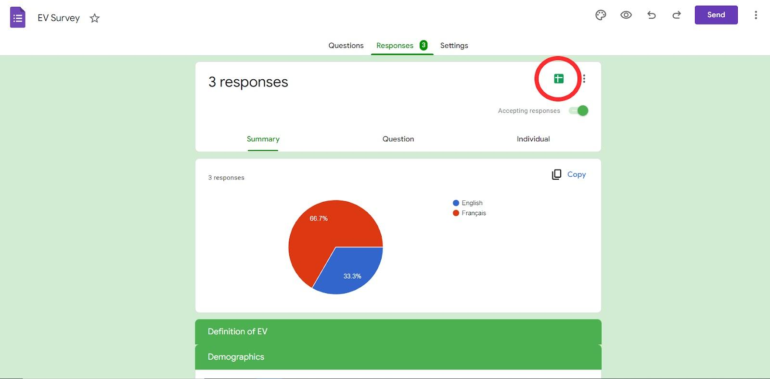

1. The sheet titled “Foundation Analysis” will show Descriptive Analysis for the demographic and foundation questions. These pie charts will update automatically to display the percentage distribution of each response.
2. The sheet titled “Survey Descriptive Analysis” will show Descriptive Analysis for the survey statements. The bar graphs here will display the distribution of Strongly Agree, Agree, Neutral, Disagree, and Strongly Disagree responses, also known as the Likert scale. Reminder, these bar graphs combine the French, English, and MSA responses with the same definition as one, and English labels are used for user convenience.
3. The sheet titled “Survey Sentiment Analysis” will show the combined sums of “Strongly Agree” and “Agree”, “Neutral”, and “Disagree” and “Strongly Disagree”. This creates three different categories: positive, neutral, and negative. The sums representing these categories vary depending on the statement, as not all statements are worded the same way. This sheet also includes sentiment graphs for each hypothesis.
4. The sheet titled “Survey Correlation Analysis” will show correlation matrices for questions within their respective hypotheses. This will illustrate the likelihood that users will answer similar questions in a similar way. From this, opinions towards certain barriers can be linked to each other.