Computational Fluid Dynamics Analysis on the Liquid Piston Gas Compression

A Thesis
Submitted to the Faculty
Of the

WORCESTER POLYTECHNIC INSTITUTE

In partial fulfillment of the requirements for the
Degree of Master of Science
In
Mechanical Engineering
By:

_______________________________________________
Lak Kin Wong
November 9th, 2011

Approved:

________________________________________________
Professor James D. Van de Ven, Advisor

________________________________________________
Professor David J. Olinger, Thesis Committee Member

________________________________________________
Professor Cosme Furlong, Thesis Committee Member

________________________________________________
Professor Simon W. Evans, Graduate Committee Representative
Abstract
Liquid piston gas compression utilizes a liquid to directly compress gas. The benefit of this approach is that liquid can conform to irregular compression chamber volume. The compression chamber is divided into many small little bores in order to increases the surface area to volume ratio. The heat transfer rate increases with increasing surface area to volume ratio. However, as the bore diameter becomes smaller, the viscous force increases. In order to maximize the heat transfer rate and to minimize the viscous force, computational fluid dynamics is used. ANSYS Fluent is used to simulate the liquid piston gas compression cycle. Having created the model in Fluent, different factors, including diameter, length, liquid temperature, and the acceleration are varied in order to understand how each factor affects the heat transfer and viscous energy loss. The results show that both viscous force and heat transfer rate increase as the diameter decreases. The viscous force increases and the heat transfer decreases as the length increases. Both the viscous force and heat transfer increase as the acceleration increases. The viscous force decreases as the liquid temperature increases. Results show that the highest compression efficiency of 86.4% is found with a 3mm bore radius and a short cylinder. The piston acceleration is advised to be below 0.5g in order to avoid surface instability problem.
Table of Contents
Chapter 1 Introduction-----------------------------------------------------------------------------1
1.1 Background ---------------------------------------------------------------------------1
1.2 Literature Review---------------------------------------------------------------------5
1.3 Overview -----------------------------------------------------------------------------15
Chapter 2 Preliminary Investigation -----------------------------------------------------------17
2.1 Introduction --------------------------------------------------------------------------17
2.2 Mesh Resolution Investigation-----------------------------------------------------18
2.3 Insulated Wall Gas Compression Model -----------------------------------------24
2.4 Single Fluid with Heat Transfer Model ------------------------------------------29
2.5 Liquid Piston Gas Compression Model ------------------------------------------36
2.6 Conclusion ---------------------------------------------------------------------------45
Chapter 3 Computational Experiments --------------------------------------------------------46
3.1 Introduction --------------------------------------------------------------------------46
3.2 Medium Baseline Experiment -----------------------------------------------------47
3.3 Liquid Temperature Variation Experiment --------------------------------------52
3.4 Radius Variation Experiment ------------------------------------------------------60
3.5 Length Variation Experiment ------------------------------------------------------68
3.6 Acceleration Variation Experiment -----------------------------------------------76
3.7 Discussion ----------------------------------------------------------------------------84
3.8 Conclusion ----------------------------------------------------------------------------86
Chapter 4 Post Possessing Work ----------------------------------------------------------------88
4.1 Introduction ---------------------------------------------------------------------------88
4.2 Methods -------------------------------------------------------------------------------88
4.3 Results and Discussion --------------------------------------------------------------94
4.4 Conclusion ---------------------------------------------------------------------------103
Chapter 5 Conclusion ----------------------------------------------------------------------------106
5.1 Review --------------------------------------------------------------------------------106
5.2 Conclusions --------------------------------------------------------------------------107
5.3 Recommendation for Future Work -----------------------------------------------111
References -----------------------------------------------------------------------------------------114
Appendix A MATLAB code to calculate the viscous, work, and the heat transfer -----115
List of Figures
Figure 1.1 The schematic design of the liquid piston gas compression----------------------2
Figure 1.2 Efficiency for One Adiabatic Cylinder and Both Isothermal Cylinder---------6
Figure 1.3 Basic operation of Fluidyne-----------------------------------------------------------8
Figure 1.4 Fingerlike behavior for surface instability-----------------------------------------11
Figure 2.1a Simulation model and mesh of a bore---------------------------------------------19
Figure 2.1b Actual mechanical configuration corresponds to figure 2.1a------------------19
Figure 2.2 Density result when the bore is fully compressed for the 10 grid point case--------------------------------------------------------------------------------------------------------------21
Figure 2.3 Temperature result when the bore is fully compressed for the 10 grid point case---------------------------------------------------------------------------------------------------22
Figure 2.4 Density result when the bore is fully compressed for the 20 grid point case--------------------------------------------------------------------------------------------------------------22
Figure 2.5 Temperature result when the bore is fully compressed for the 20 grid point case---------------------------------------------------------------------------------------------------23
Figure 2.6 Density result when the bore is fully compressed for the 100 grid point case-------------------------------------------------------------------------------------------------------------23
Figure 2.7 Temperature result when the bore is fully compressed for the 100 grid point case---------------------------------------------------------------------------------------------------24
Figure 2.8 Time vs volume averaged gas temperature for the insulated wall model------25
Figure 2.9 The progression of pressure for the insulated wall model------------------------26
Figure 2.10 The progression of temperature for the insulated wall model------------------27
Figure 2.11 The progression of density for the insulated wall model-----------------------28
Figure 2.12 Schematic of the heat transfer model----------------------------------------------31
Figure 2.13 Volume weighted temperature of the gas vs. time plot for the heat transfer case---------------------------------------------------------------------------------------------------32
Figure 2.14 The progression of pressure for the heat transfer model------------------------33
Figure 2.15 The progression of temperature for the heat transfer model--------------------34
Figure 2.16 The progression of density for the heat transfer model-------------------------35
Figure 2.17a Liquid piston model ----------------------------------------------------------------37
Figure 2.17b Actual mechanical configuration corresponds to figure 2.17a----------------38
Figure 2.18 Liquid piston model with boundary conditions----------------------------------39
Figure 2.19 Liquid piston model with initial conditions---------------------------------------39
Figure 2.20 Time vs volume averaged gas temperature for the liquid piston gas compression model---------------------------------------------------------------------------------41
Figure 2.21 The progression of pressure during compression and expansion--------------42
Figure 2.22 The progression of temperature during compression and expansion----------43
Figure 2.23 The progression of density during compression and expansion---------------44
Figure 3.1 The progression of pressure for the medium baseline experiment--------------50
Figure 3.2 The progression of temperature for the medium baseline experiment----------51
Figure 3.3 The progression of density for the medium baseline experiment---------------52
Figure 3.4 The progression of pressure for the high temperature experiment--------------54
Figure 3.5 The progression of density for the high temperature experiment---------------55
Figure 3.6 The progression of temperature for the high temperature experiment----------56
Figure 3.7 The progression of pressure for the low temperature experiment---------------57
Figure 3.8 The progression of density for the low temperature experiment----------------58
Figure 3.9 The progression of temperature for the low temperature experiment----------60
Figure 3.10a The progression of pressure in the first cycle for the low radius experiment-----------------------------------------------------------------------------------------------------------62
Figure 3.10b The progression of pressure in the second cycle for the low radius experiment-------------------------------------------------------------------------------------------62
Figure 3.11 The progression of density for the low radius experiment----------------------63
Figure 3.12 The progression of temperature for the low radius experiment----------------64
Figure 3.13 The progression of pressure for the high radius experiment-------------------66
Figure 3.14 The progression of density for high radius experiment-------------------------67
Figure 3.15 The progression of temperature for the high radius experiment---------------68
Figure 3.16 The progression of pressure for low length experiment-------------------------70
Figure 3.17 The progression of density for low length experiment--------------------------71
Figure 3.18 The progression of temperature for the low length experiment----------------72
Figure 3.19 The progression of pressure for the high length experiment-------------------74
Figure 3.20a The progression of density at the first cycle for the high length experiment-----------------------------------------------------------------------------------------------------------75
Figure 3.20b The progression of density at the second cycle in the high length experiment-------------------------------------------------------------------------------------------75
Figure 3.21 The progression of temperature for the high length experiment---------------76
Figure 3.22 The progression of pressure for low acceleration experiment------------------78
Figure 3.23 The progression of density for low acceleration experiment-------------------79
Figure 3.24 The progression of temperature for low acceleration experiment-------------80
Figure 3.25a The progression of pressure at the first cycle for the high acceleration experiment-------------------------------------------------------------------------------------------82
Figure 3.25b The progression of pressure at the second cycle for the high acceleration experiment ------------------------------------------------------------------------------------------82
Figure 3.26 The progression of density for the high acceleration experiment -------------83
Figure 3.27 The progression of temperature for the high acceleration experiment--------84
Figure 4.1 The viscous forces, the work and the heat transfer for each diameter experiments------------------------------------------------------------------------------------------95
Figure 4.2 The viscous forces, the work and the heat transfer for each length experiments----------------------------------------------------------------------------------------------------------97
Figure 4.3 The viscous forces, the work and the heat transfer for each acceleration experiments------------------------------------------------------------------------------------------99
Figure 4.4 The viscous forces, the work and the heat transfer for each temperature experiments----------------------------------------------------------------------------------------102
List of Tables
Table 3.1: The values for each computational experiment------------------------------------47
Table 4.1 Radius results for compression efficiency and the parameters of interest------96
Table 4.2 Length results for the compression efficiency and parameters of interest------98
Table 4.3 Accelereation results for the compression efficiency and parameters of interest--------------------------------------------------------------------------------------------------------100
Table 4.4 Liquid temperature results for the compression efficiency and parameters of interest----------------------------------------------------------------------------------------------103

Nomenclature
$ρ$ fluid density
$f$ frequency of liquid piston
$L_{t}$ length of tube
$V_{o}$ volume swept
$R_{t}$ radius of tube
${\text{Nu}}_{c}$ complex Nusselt number
Re Reynolds number
D diameter
$i$ imaginary number
${\text{Nu}}_{r}$ real part of Nusselt number
${\text{Nu}}_{i}$ imaginery part of Nusselt number
${\text{Pe}}_{ω}$ Peclet number
$V_{\text{AF}}$ air entrainment velocity
$μ$ dynamic viscosity
g gravity
$σ$ surface tension
E Mathieu equation
$ω$ angular velocity
$α_{m}$ zeroth order of Bessel function
l liquid level
Aa amplitude
R radius of cylinder
$a_{c}$ critical acceleration
a acceleration
b radius of the tube or half width for a rectangle
x piston location
A stroke
t time
$e$ internal energy
v, fluid velocity
$v_{r}$,$v_{θ}$,$v_{z}$ velocity components
n outward facing normal vector
q heat energy
Q heat generation
P pressure
$f_{i}$ body forces
$σ_{\text{ij}}$ normal stress in different direction and plane
k thermal conductivity
T temperature
$τ_{\text{ij}}$ shear stress in different direction and in different plane
$κ$ second coefficient of viscosity
$η$ compression efficiency
$W_{\text{ideal}}$ cooled actual work
$W_{\text{actual}}$ actual mechanical work
$P_{g}$ gas pressure
$V_{g}$ gas volume
$P_{i}$ cooled pressure
$V_{i}$ cooled volume.
n number of mole of gas
$R_{g}$ universal gas constant
Chapter 1 Introduction
1.1 Background
Conventional gas compression has some limitations due to poor heat transfer, resulting in near adiabatic compression, and the tradeoff between leakage and high sealing friction. The heat transfer is poor within the cylinder because it has a poor surface area to volume ratio. The poor surface area to volume ratio is caused by the geometric constraint of the mechanical piston. The mechanical piston is not flexible in the sense that cannot conform to any irregular volume. Therefore, the surface area to volume ratio is limited, reducing the heat transfer.
The second limitation is the tradeoff between leakage and high seal friction. The function of the seal is to prevent gas leakage from the chamber. However, high pressure seals typically result in high sealing friction between the wall and the piston. The higher the sealing friction, the higher the energy lost. The higher the energy lost, the more inefficient the compression is. On the other hand, if a regular seal is used instead of a high pressure seal, there will be a high gas leakage. Therefore, there is a tradeoff between gas leakage and high sealing friction. Gas leakage is a problem because of the pressure leakage, which causes energy loss as well.
A new design for gas compression is proposed in response to the limitations of the current gas compression. The new design is liquid piston gas compression. The schematic design is shown in figure 1.1. The liquid piston is operated by a mechanical piston that is driven by a cam. A liquid piston is used because liquid conforms to any irregular volume. In order to increase heat transfer and make the compression a near isothermal process, the surface area to volume ratio needs to be high. There are multiple ways to improve the surface area to volume ratio within the cylinder, such as wire mesh, porous media, or many small diameter cylinders. The small diameter cylinder case is used and is investigated in this thesis.
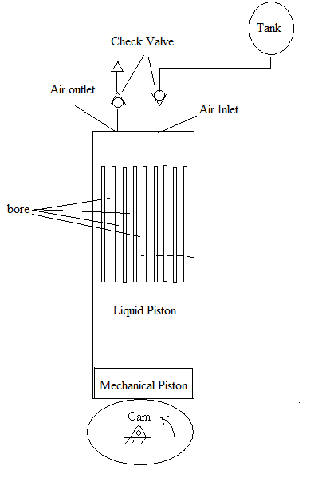
Figure 1.1 The schematic design of the liquid piston gas compression

Liquid can also enhance the heat transfer within the cylinder. It is maintained at a certain temperature, for example, cold liquid is used to cool the compression chamber. The heat is transferred from the gas to the chamber wall and then to the liquid in the compression chamber. When the liquid is pushed upward by the cam, it compresses the gas. Heat is removed from the wall of the bores by the liquid in the compression stage in the cylinder. During expansion stage in the cylinder, liquid is moved downward. Heat is transferred from the gas to the wall of the bore. The heat transfer from gas to the liquid through the bore wall provides another way to transfer heat from the liquid to the gas.
The liquid piston concept can be applied in compressors expanders and internal or external combustion engines. One of the applications is in the liquid piston Stirling engine. The ideal Stirling engine is quiet and has the ability to operate from different heat sources. However, the conventional Stirling engine is not widely used currently is due to high cost, low efficiency, and high dead volume. A major problem with the conventional Stirling engine is the heater, preheater, and cooler which are used to add and remove heat from the gas. However, these heaters and coolers increase dead space, which make the engine less efficient. Moreover, the design of the regenerator is very complicated, which increases the cost of manufacturing. Therefore, the Stirling engine is not popular nowadays. The liquid piston Stirling engine concept can eliminate the limitations of the practical Stirling engine. This liquid piston Stirling engine is not expensive, removes dead space, which includes the elimination of the heater, cooler, and pre-heater, and improves the efficiency of the engine. Therefore, the liquid piston Stirling engine has the potential to be a popular gas compression mechanism.
The liquid piston can improve the heat transfer by increasing the surface area to volume ratio. One of the ways to increase surface area is to use many small diameters. However, the viscous frictional forces increase as the bore diameter becomes smaller due to the zero velocity condition at the wall. Therefore, there is a tradeoff between heat transfer rate and viscous frictional forces. Computational fluid dynamics is used to determine the right geometry to maximize the heat transfer and minimize the viscous forces. In addition to the viscous forces, the liquid gas interface stability needs to be examined because it can adversely affect the engine. Moreover, there are several factors that affect viscous forces and the heat transfer rate. Those factors include diameter, length, acceleration of the piston, and the liquid temperature. Some computational experiments are conducted to understand how those factors affect the viscous and heat transfer within the bore. Low, medium, and high values for each factor are chosen and are simulated in Fluent, one of the commercial computational fluid dynamics software. The experiment with the least viscous forces and the most heat transfer is shown in the conclusion.
1.2 Literature Review
1.2.1 Introduction
Previous research related to liquid piston gas compression includes general compression and expansion processes, i.e. adiabatic and isothermal compression, gas compression computational programming, the history and application of liquid piston gas compression, and the viscous forces and heat transfer in small pipes. Surface stability is investigated at the end of this section.

1.2.2 Introduction to compression and expansion process
There are different ways to perform a compression and expansion stroke: adiabatic and isothermal. Adiabatic compression means there is no heat loss to the surrounding. Isothermal compression occurs when the compression is a constant temperature process [1]. Most high speed compression processes are near adiabatic compression. The adiabatic compression causes a reduction in efficiency when the gas is cooled before use [2]. West, who proposed a liquid piston Stirling engine concept, wrote a code to compare the efficiency of a near isothermal compression and a near adiabatic compression in a Stirling engine. Figure 1.2 shows that both isothermal cylinders as a system have higher efficiency than one isothermal and one adiabatic cylinder [2].
Figure 1.2 Efficiency for One Adiabatic Cylinder and Both Isothermal Cylinder [2]

There are multiple studies in computational gas compression programs which are validated with experimental results. Reitz and Rutland [3], for example, did computational analysis on Diesel engine. They used the KIVA code with submodels to analyze the Diesel engine cycle. The KIVA code can calculate three dimensional flows in the engine cylinder, including turbulence and wall heat transfer with any geometry. Results of the computational model were validated with the experimental results and found to be agreed. Another Diesel engine computational work, done by Payri et al. [4], shows the flow characteristics within the engine cylinder with different piston configurations. A finite volume flow program is used with the k-ε turbulent model and the PISO algorithm for pressure correction method. The first order upwind scheme is used for momentum, energy, and turbulence equations. The computational models were validated with experiments and found to be agreed.

1.2.3 History of liquid piston
The earliest liquid piston pump was the Humphrey pump [5], which was invented by Herbert Humphrey. This pump used the Atkinson cycle. The combustion mixture inside the cylinder is compressed and ignited by a spark. When the mixture ignites, the water level moves downward along the cylinder. When the pressure is dropped below the atmospheric pressure, a water valve is opened and water is entered in the cylinder. The return of water forces the exhaust gas out of the cylinder. Water moves up in the cylinder and combustible gas is compressed and ignited again. The ideal efficiency of the Atkinson cycle is 43%. The Humphrey pumping head was 6 meters and achieved 10% efficiency. The flow rate of this pump is 24 cubic meter per hour.
There are some studies which investigate the feasibility of installing low temperature liquid piston Stirling engines in developing countries to pump water for agricultural use. Colin West [2] called his liquid piston Stirling engine Fluidyne. Figure 1.3a shows the basic operation of the Fluidyne. The liquid in the displacer compresses and expands the working fluid. As the hot chamber gets hot, the pressure within the chamber increases. The displacer in the hot chamber expands. As the displacer in the hot chamber expands, the liquid displacer moves to the cold chamber and compresses the cold chamber. This compression in the cold chamber and the expansion in the hot chamber are due to the pressure difference, which forces the output tube to move from left to right. Half a period later, the gas moves from the hot chamber to the cold chamber. Figure 4b shows that working fluid is compressed in the hot side of the displacer. The gas pressure and temperature within the engine decrease. The liquid at cold side of the displacer is at the bottom dead center. The water at the output moves from right to left as the arrows show.
Figure 1.3 Basic operation of Fluidyne[2]

This idea of a liquid piston in a Stirling engine has been investigated by several authors. Gerstmann and Hill [6], for example, used the idea of a liquid piston to improve the efficiency of an engine. There is a temperature sink to reject heat before and after the regenerator. Syltherm 800 is used as liquid and helium is used as the working gas. Their numerical results showed that, for a heat output of 20kW, the temperatures in the expansion and compression chambers are between 0C to 400C. The heat rejection temperature is 156C. The Carnot efficiency is 36.1%, and the work output is 4.43kW. Three numerical experiments are conducted with different tube diameter: 100,300 and 1000 micrometer. The result shows that as diameter gets smaller, the pressure drop increases and the heat transfer coefficient also increases. This shows that the heat transfer increases as the diameter become smaller and smaller, but the losses also increase. At the end of this article, the authors suggested that liquid gas interface instability is a problem as the diameter decreases.

1.2.4 Viscous forces
Although the liquid piston provides higher efficiency as the tubes become smaller and smaller, the viscous effects cannot be ignored. Due to the small size of the tube, the Reynolds number is low and the flow is laminar. Laminar flow means the viscous effects dominate the flow [7]. Crandall [8] studied the viscous effect and suggested a way to predict the energy losses due to the viscous effect. He suggested that the energy loss due to the viscous effect for any flows can be calculated by the following equation.
$E_{\text{vis}}=π\sqrt{\text{πρ}fμ}L_{t}f^{2}{V_{o^{2}}}/{R_{t^{3}}}$ (1.1)
$L_{t}$is the length of the tube, $V_{o}$ is the volume swept. [8]. However, Chan and Baird [9] show that equation (1.1) underestimates the laminar flow effects by a factor of 3 or more.

1.2.5 Heat transfer
Heat transfer is an important factor in gas compression. When gas is compressed by a piston, the pressure and temperature increase. Heat transfer rate depends on the surface area and volume ratio, and temperature difference per unit time. There are a couple ways to increase the surface area. One way is to decrease the diameter in order to increase the surface area to volume ratio. The second way is to add fins to the hot object, which can increase the surface area to volume ratio [10].
A. A. Kornhauser [11] suggests that there is a phase shift between the bulk gas and wall temperature difference during compression and expansion. Newton’s law of convection cannot predict this out of phase behavior. Instead, Kornhauser uses the complex Nusselt number to predict this out of phase behavior. Base on the experimental results, the following equation can be used to calculate the complex Nusselt number.
${\text{Nu}}_{c}=0\text{.}3{\text{Re}}^{0\text{.}7}+0\text{.}\text{25}\frac{D}{L}{\text{Re}}^{0\text{.}7}i$ (1.2)
Re is the Reynolds number, D is the diameter, L is the length, i is the imaginary number. If the maximum volume to minimum volume ratio is between 1 and 2, and the oscillation Peclet number is higher than 100, the real part and the imaginary part of the complex Nusselt number is equal to the following.
${\text{Nu}}_{r}={\text{Nu}}_{i}=0\text{.}\text{56}{\text{Pe}}_{ω^{0\text{.}\text{69}}}$ (1.3)
${\text{Nu}}_{r}$is the real part of the complex Nusselt number, and ${\text{Nu}}_{i}$is the imaginary part of the Nusselt number. ${\text{Pe}}_{ω}$is the oscillation Peclet number. With this complex Nusselt number, the out of phase behavior is predicted during compression and expansion.

1.2.6 Surface stability
Interface stability is an important topic to liquid piston gas compression. Surface stability means when two fluids with different densities are present during free fall or oscillatory flow, the liquid gas interface will be either stable or unstable. Interface stability depends on the acceleration and the densities of the two fluids. If the interface is stable, the coherent structure of the interface does not change. A stable interface can be seen when the acceleration is low. As the acceleration increases, the interface becomes less coherent and more unstable. If the interface is not stable in the oscillatory flow, the denser fluid oscillates up and down along the cylinder. The interface stability has been analyzed by many researchers. The earliest investigations were conducted by Taylor and Lewis [12, 13]. After Taylor and Lewis initial investigations, other researchers defined criteria for interface stability.
Early investigation by Taylor suggested that when two fluids with different densities are accelerated in the direction perpendicular to the interface, the surface stability depends on the acceleration and the densities of those two fluids. Taylor did a mathematical analysis to show that if the acceleration of the denser liquid is greater than gravity, the interface between the denser liquid and the less dense liquid is unstable. Lewis conducted experiments that proved that there is a finger like behavior that occurs as the denser liquid moves to a less dense fluid, which makes the interface unstable. The finger like behavior is shown in figure 1.4. Taylor and Lewis’ contributions led to many other researchers investigating this interface stability issue.
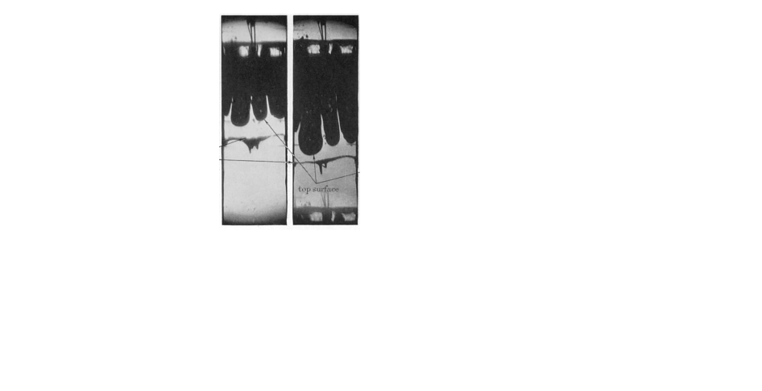
Figure 1.4 Fingerlike behavior

Burley and Kennedy [14] suggested a way to calculate air entrainment velocity. Air entrainment velocity is the velocity when air penetrates the liquid. If the viscosity of the fluid is less than 4.65 poise, air entrainment velocity depends on surface tension and viscosity. If the viscosity is greater than 4.65 poise, the air entrainment velocity is constant. Burley and Kennedy showed in an experimental study that when air is moving into the fluid, no gas entrainment is found when the viscosity of the fluid is less than 0.1 poise. When the viscosity is between 0.1 and 1 poise, a large rate of bubbles are formed deep under the surface. When the viscosity is between 1 and 1.5 poise, smaller bubbles can be seen. When viscosity is between 1.5 and 2 poise, bubbles are formed very close to the surface and travel downward to the bottom of the tube. Burley and Kennedy suggested that the air entrainment velocity for viscosity less than 4.65 poise can be calculated by the following equation.
$V_{\text{AF}}=\text{67}\text{.}\text{679}[μ(\frac{g}{\text{σρ}})^{1/2}]^{−0\text{.}\text{672}}$ (1.4)
$V_{\text{AF}}$is the air entrainment velocity, $μ$ is the dynamic viscosity of the liquid, g is the gravity, $σ$ is the surface tension, and $ρ$is the density of the liquid. According to the liquid piston gas compression simulation, water and air are used as the liquid and gas respectively. Applying equation 1.4 to the simulation, the air entrainment velocity is 7.19m/s assuming the liquid temperature is 303K.
Valha and Kubie [15] did an experimental study on the surface instability with respect to frequency or acceleration. The liquid gas interface is stable for low frequencies, which means that the coherent structure of the interface does not change. As the frequency or acceleration increases, the interface becomes unstable. The interface instability is caused by air bubbles penetrating into the liquid and by liquid drops ejected into the air. Valha and Kubie conducted experiments to find out the critical acceleration when the interface becomes unstable for different diameters and amplitudes. These experimental results are compared with the Mathieu equation. Equation 1.5 shows the Mathieu equation
$\frac{d^{2}E}{{\text{du}}^{2}}+[p−2q\text{cos}(2u)]E=0$ (1.5)
E is a time dependent function,$u={ωt}/2$, $ω$is the angular velocity,
$p=\frac{4}{ω^{2}}k_{m}\text{tanh}(k_{m}l)(\frac{σ}{ρ}k_{m^{2}}+g)$ (1.6)
$k_{m}$=${α_{m}}/R$, $α_{m}$is the zeroth order of the Bessel function,$J_{o}$, with $α_{1}=2\text{.}\text{405}$and $α_{2}=5\text{.}\text{52}$, l is the liquid level, $σ$is the surface tension, $ρ$ is the density, g is the gravity.
$q=2{\text{Aak}}_{m}\text{tanh}(k_{m}l)$ (1.7)
Aa is the amplitude. The Mathieu equation is a second order differential equation. The solution for this equation is assumed to be in the form of Fourier series. The solution is substituted back to the Mathieu equation, and infinite sets of linear equations are formed. Each set contains three coefficients of the series. The coefficients are calculated within each equation. From those coefficients, the interface stability can be determined. The experimental result and the Mathieu equation correlate well for liquid with low viscosity. Valha and Kubie showed that equation 1.8 is the critical acceleration to interface instability.
$\frac{a_{c}}{g}=1+α_{m^{2}}\frac{σ}{ρ{\text{gR}}^{2}}$ (1.8)
R is the radius of cylinder, $a_{c}$is the critical acceleration.
Epstein et al. [16] used the linear stability analysis to predict the critical velocity when the interface becomes unstable. The critical velocity is calculated by the following equation.
$v_{c}=\frac{(g+a)(ρ_{2}−ρ_{1})b^{2}}{3(μ_{1}−μ_{2})}$ (1.9)
g is gravity, a is acceleration, $ρ_{2}$is density of fluid 2, $ρ_{1}$ is density of fluid 1, $μ_{1}$ is the viscosity of fluid 1, $μ_{2}$ is the viscosity of fluid 2, b is the radius of the tube or half width for a rectangle. The surface is stable when $v_{c}$ is positive. This equation describes that when the denser, more viscous liquid move vertically upward to a less dense and less viscous fluid ($ρ_{1}$>$ρ_{2}$ and $μ_{1}$>$μ_{2}$), the interface is not stable.
Surface stability is a major issue in the liquid piston gas compression because the liquid piston includes two fluids with different densities and viscosities. As Taylor and Lewis suggested, the surface instability depends on acceleration and density of those two fluids. As Valha and Kubie suggested, the interface instability is caused by air bubbles penetrate into liquid and liquid drops are ejected to the air. The simulations in the following chapters show both air bubbles and liquid drops in air occur. According to the linear stability analysis by Epstein et al., the acceleration of the piston should not be greater than the gravity as the piston expands. As the piston expands, (g+a) term becomes (g-a) due to the downward motion. If the acceleration is greater than the gravity, (g-a) term becomes negative and the interface is unstable. Therefore, one of the design constraints is the acceleration cannot be higher than the gravity. The piston profile is a sinusoidal profile. The equation of this profile is shown in equation 1.10.
$x=\frac{S}{2}\text{sin}(ωt)$ (1.10)
x is the piston location, S is the stroke, t is time, $ω$is the frequency. The acceleration of this profile is the second derivative of the position profile, which is shown in equation 1.11.
$a=−\frac{S}{2}ω^{2}\text{sin}(ωt)$ (1.11)
This acceleration cannot be higher than gravity. From equation 1.11, small stroke allows higher frequency, and high stroke is limited by lower frequency.

1.2.7 Conclusion
The liquid instability issue occurs in high frequency, which means the coherent structure of the interface is destroyed. From the literature review, the interface instability depends on the acceleration, density, viscosity, and gravity. Therefore, one of the design criteria is that the piston acceleration cannot be higher than gravity. Since the acceleration is directly proportional to stroke and to angular velocity, high stroke has to be compensated with low angular velocity, and high angular velocity has to be with low stroke. Another criterion is that the temperature of the expansion chamber has to be lower than the liquid boiling point, and the temperature of the compression chamber has to be higher than the liquid melting point.

1.3 Overview
Chapter 2 shows a preliminary investigation using Fluent to simulate gas compression and expansion with a single fluid and the liquid piston. Chapter 3 presents the computational experiments using a more complex simulation. The factors varied in the experiments include the length, radius, acceleration, and liquid temperature, which allaffect the viscous and heat transfer of the bore. Results for different factors are simulated in Fluent and are shown in chapter 3. Chapter 4 shows the post possessing work for the liquid piston gas compression experiment. MATLAB is used to calculate the viscous forces, heat transfer, and the pressure of the bore when different factors are varied. The compression efficiencies for each experiment are also presented. Chapter 5 concludes the work and includes a discussion, which experiment can maximize the heat transfer and minimize the viscous losses.
Chapter 2: Preliminary Investigations
2.1 Introduction
In this chapter, the developmental progress of the liquid piston simulation model is presented through three levels of increased complexity. In the first simulation, the compression and expansion of only the gas is simulated within a bore. The bore wall is assumed to be insulated. The second simulation again only considers the compression and expansion of the gas, while including heat transfer from the wall. The wall boundary condition changes from an insulated wall boundary to the wall boundary that allow heat transfer. The third simulation is the liquid piston gas compression model, which means that the liquid and the gas are presented in a bore, and the heat transfer is allowed to and from the bore wall. ANSYS Fluent is used as a computational fluid dynamics code to simulate all models. A sinusoidal piston displacement profile for each compression and expansion cycle is created and used in the simulations. The primary output parameters are the pressure, density, and temperature.
A mesh resolution investigation is conducted before running the simulation. The purpose of the mesh resolution investigation is to understand which mesh resolution should be used in all three simulations. Three cases with different mesh resolution are used to determine which one is the best to run all three simulations.
Multiple simulation models were used because it shows how the changes in boundary condition change the result of the model and shows the progress of the research from the beginning. Only one bore out of many in the cylinder is selected because it is easier to analyzed and easier to single out problem if any. The compression ratio is 1:9, and the acceleration of the piston is 0.5g.
2.2 Mesh Resolution Investigation
2.2.1 Methods
Three cases with different mesh resolution are simulated in Fluent. The first case is the coarse grid case with 10 grid points in the radial direction and 100 grid points in the axial direction. The second case is a medium size grid case with 20 grid points in the radial direction and 390 grid points in the axial direction. The third case is a fine grid case with 100 grid points in the radial direction and 1000 grid points in the axial direction.
The model and the mesh are created in Gambit. Figure 2.1a shows the computational model with a single compression chamber that is 1mm in diameter and 5cm long. This geometry is chosen so as to understand how pressure, temperature, and density react within a small bore. The compression chamber is oriented with the piston moving horizontally, from left to right during compression. An axisymmetric assumption is made and the centerline is at the bottom of the figure. The mesh resolution of the chamber includes 20 grid points along the radial direction, and 390 grid points along the axial direction. This computational model is a beginning to develop the liquid piston computational model. Therefore, this model is different from the liquid piston model in figure 1.1. Figure 2.1b shows the actual mechanical configuration for figure 2.1a, which the piston moves from the bottom to the top to compress gas.

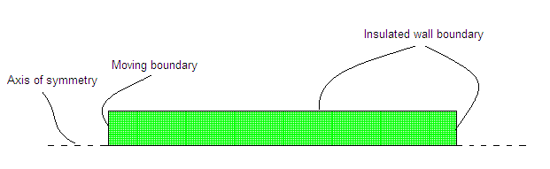
Figure 2.1a Simulation model and mesh of a bore

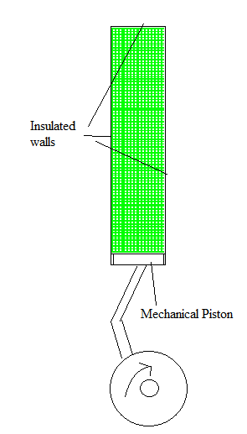
Figure 2.1b Actual mechanical configuration corresponds to figure 2.1a

The simulation of the geometry discussed above involves unsteady flow in two dimensions through the axisymmetric assumption. Air in the bore is assumed to be an ideal gas. The governing equation for this model is the conservation of mass, momentum and energy. The energy equation is applied in this case to calculate the temperature for each grid point since the energy equation depends on the gradient of the temperature of the fluid. The viscous heating option is turned on in this case because viscous forces at the boundary are an important factor in this simulation. The boundary conditions for the chamber are insulated walls everywhere except the piston face. The dynamic mesh model in Fluent is activated to produce the sinusoidal compression and expansion motion. The angular velocity is 130.9 rad/s. The compression ratio is 90%. First order upwind scheme is used to calculate the mass, momentum, and energy equation. First order upwind scheme is a method to change a differential equation into an algebraic equation by Taylor series. First order upwind is used because it reduces computational time, but results are less accurate than the second order upwind scheme.

2.2.2 Results and Discussion
Figure 2.2 and 2.3 shows the density and temperature results when the bore is fully compressed for the 10 grid point case. The maximum density is 11 kg/m³, and the maximum temperature is at 730K. The computational time for this case is approximately 1 day. Figure 2.4 and 2.5 shows the density and temperature results when the bore is fully compressed for the 20 grid point case. The maximum density is 10.8 kg/m³, and the maximum temperature is at 727K. The computational time for this case is approximately 2 days. Figure 2.6 and 2.7 shows the density and temperature results when the bore is fully compressed for the 100 grid point case. The maximum density is 9 kg/m³, and the maximum temperature is at 658K. The computational time for this case is approximately 5 days. Compare the 100 grid point case to 10 and 20 grid point case, there are some errors associated with the 10 and 20 grid point cases. The 20 grid point case is selected for the rest of this chapter due to the reduction in computational time, but there is error associated with this case.

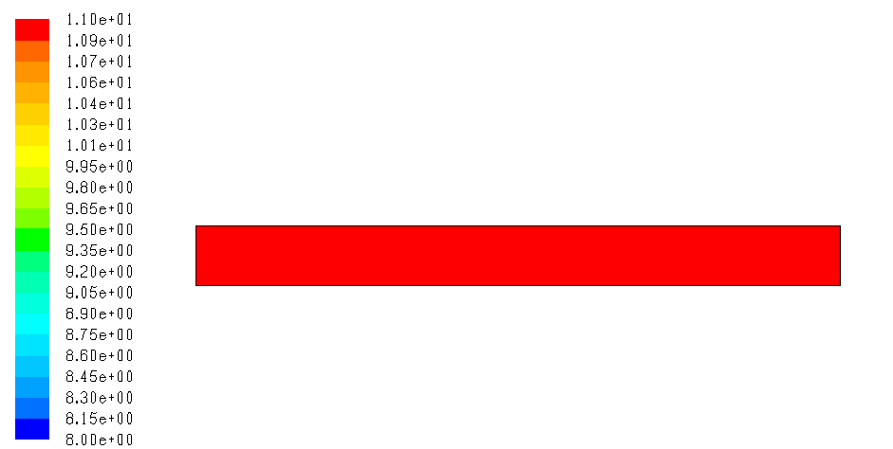
Unit (kg/m³)
Figure 2.2 Density result when the bore is fully compressed for the 10 grid point case

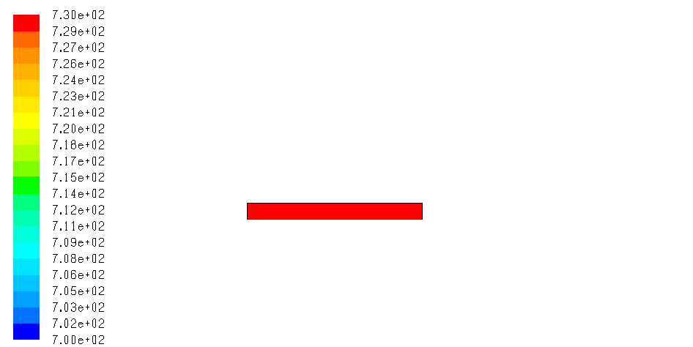
Unit (Kelvin)
Figure 2.3 Temperature result when the bore is fully compressed for the 10 grid point case

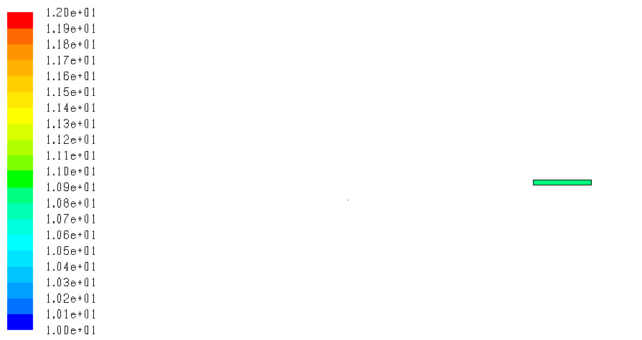
Unit (kg/m³)
Figure 2.4 Density result when the bore is fully compressed for the 20 grid point case

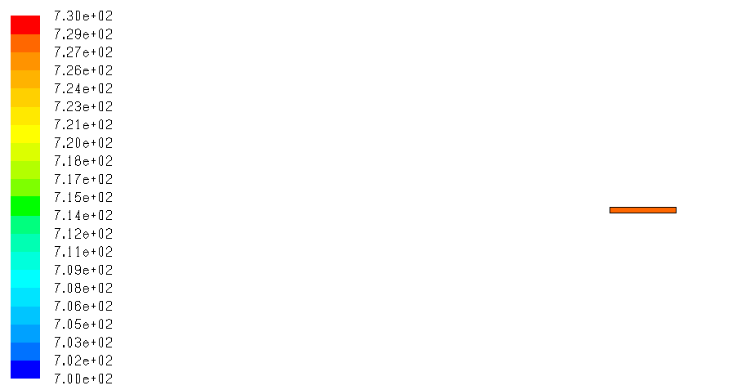
Unit (Kelvin)
Figure 2.5 Temperature result when the bore is fully compressed for the 20 grid point case

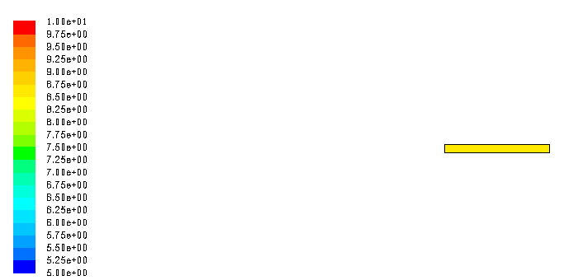
Unit (kg/m³)
Figure 2.6 Density result when the bore is fully compressed for the 100 grid point case

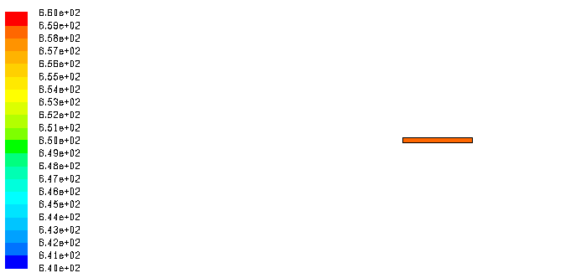
Unit (Kelvin)
Figure 2.7 Temperature result when the bore is fully compressed for the 100 grid point case

2.3 Insulated Wall Gas Compression Model
2.3.1 Methods: Insulated Wall Gas Compression Model
The first model of system considered the compression and expansion of the gas by a moving boundary, the mechanical piston, eliminating the complexity of the liquid gas interface. This model uses the same boundary conditions, geometry, and grid resolution to run. This computational model is a beginning to develop the liquid piston computational model. The results of this simulation are shown in the next section.

2.3.2 Results and Discussion: Insulated Wall Gas Compression
After running the simulation, the temperature, density, and pressure results are shown below. Two full cycles of compression and expansion were run in order to understand if the simulation reaches a steady state. In other words, a steady state is reached when the temperature rise in the second cycle is the same as the first cycle. Figure 2.8 shows the time and temperature plot for the insulated walls simulation. The maximum temperature of the tube is 725K. It also shows that the temperature increases as piston compresses, and the temperature decreases when the piston expands.

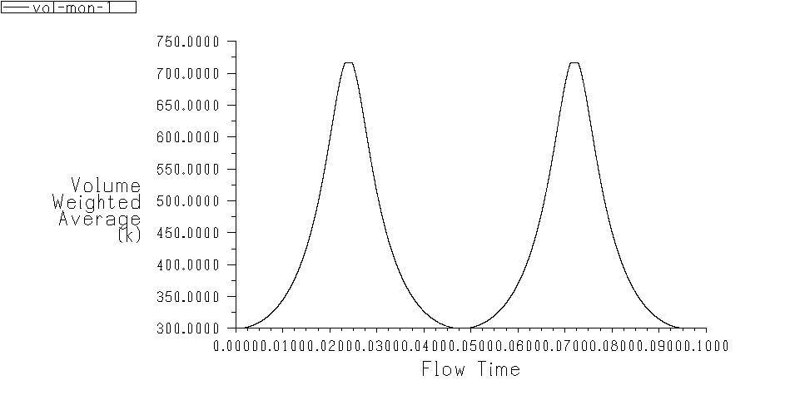
Temperature volume weighted average (Kelvin)
Figure 2.8 Time vs volume averaged gas temperature for the insulated wall model

Figure 2.9 shows the progression of pressure during compression and expansion. The bore is oriented horizontally because Fluent only accepts the axis of symmetry to be in the horizontal direction. The moving boundary is on the left boundary. The top plot, where the crank angle is 0 deg, shows the initial pressure distribution before the compression. The second plot, where the crank angle is 90 deg, shows the midstroke of the compression. The third plot, where the crank angle is 180 deg, shows the fully compressed bore. The fourth plot, where the crank angle is 270 deg, shows the midstroke of the expansion. The fifth plot, where the crank angle is 360 deg, shows the end of the first stroke. The initial pressure is the same as the atmospheric pressure. As the piston compresses, the pressure increases to approximately 2.3MPa. The pressure returns to atmospheric pressure as the piston moves back to its original position. The pressure distributions in the axial and radial directions are uniform because the viscous frictional force of air is not significant. The viscous force is not significant because the density of air is low.

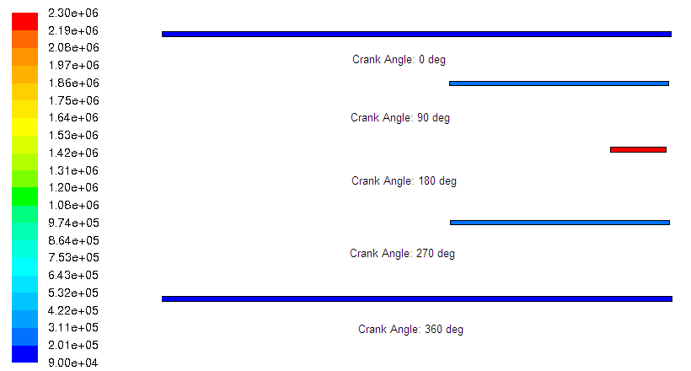
Unit (Pa)
Figure 2.9 The progression of pressure for the insulated wall model

Figure 2.10 shows the progression of the temperature during the compression and expansion. The initial temperature is at 300K, which is shown in the top plot of the figure. As the piston compresses, the temperature of the bore increases to 730K. The fully compressed bore is shown in the third plot of the figure. As the piston returns to the initial position, the temperature reduces to the initial temperature. The last plot shows the temperature distribution at the end of the first cycle. Since this is an insulated wall boundary condition, the compression is adiabatic. The temperature difference before and after compression is very high.
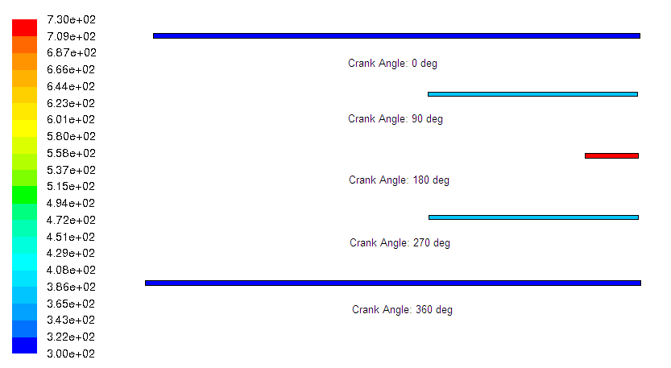
Unit (Kelvin)
Figure 2.10 The progression of temperature for the insulated wall model

Figure 2.11 shows the progression of density during compression and expansion. The initial density is about 1kg/m^3, which is the density of air at room temperature. The initial density is shown in the top plot of the figure. The mean density should be 9kg/m^3 due to a 9:1 compression ratio. As the piston compresses the bore, the maximum density increases up to approximately 11kg/m^3 due to error associated with the grid. The fully compressed bore is shown in the third plot of the figure. As the piston returns to the original position, the density returns to the initial density of the air. The last plot shows the density distribution at the end of the first stroke.
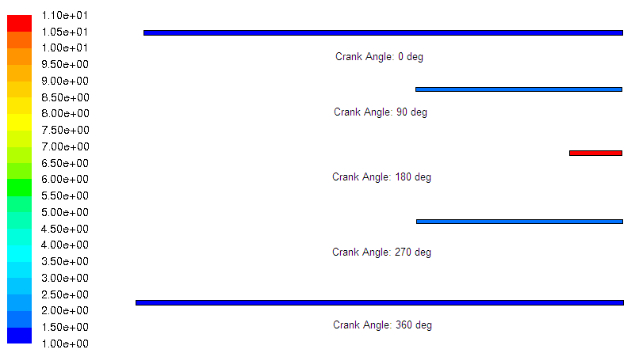
Unit (kg/m³)
Figure 2.11 The progression of density for the insulated wall model

2.3.3 Conclusion: Insulated Wall Gas Compression Model
The single fluid case is an initial investigation to use commercial computational code to study the compression and expansion cycle. The results from pressure distribution show that the density of air is so low that the pressure drop is not significant. This model is to simulate an adiabatic compression, where the wall boundary is insulated. The temperature difference before and after the compression is very high. The pressure increases up to 2.3MPa with a 9:1 compression ratio due to the increase in temperature.
An analytical solution can be used to test if this CFD code works. Equation 2.1 shows the analytical solution to this CFD code.
$P={ρR}_{g}T$ (2.1)
$R_{g}$ is the universal gas constant, which equals to 287 J/kg/K. $ρ$ and T are given in the model. For example, the maximum temperature and density of a fully compressed bore is 730K and 11kg/m3 in figure 2.4 and 2.5. The pressure of a fully compressed bore should be 2.3MPa according to equation 2.1, which is the same as the maximum pressure in figure 2.3.
The next simulation is a single fluid with heat transfer simulation, which demonstrates how the transfer of heat to and from the wall changes the temperature difference before and after compression.

2.4 Single Fluid with Heat Transfer Model
2.4.1 Introduction: Single Fluid with Heat Transfer Model
The single fluid with heat transfer case is a case where gas is compressed and expanded by a piston. Similar to the previous case, air is used as the gas. The only difference is that the walls are no longer insulated. In other words, heat transfer is allowed to and from the wall. The wall is expected to remove heat from the bore when temperature in the bore is higher than the wall temperature and transfer heat to the bore when the temperature in the bore is lower than the wall temperature. The temperature, density, and pressure are three major output parameters.

2.4.2 Methods: Single Fluid with Heat Transfer
This heat transfer model is similar to the model described above. The only change in this model is the thermal boundary condition. This heat transfer model can be done in a few ways. The first way is to specify the constant heat flux at the wall. The second way is to specify the constant temperature and the wall thickness. The third way is to specify the heat transfer coefficient at the wall, free stream temperature, and wall thickness. The fourth way is to specify the emissivity, ambient temperature, and wall thickness. The last way is to specify the heat transfer coefficient, emissivity, and the wall thickness. The constant wall temperature is the best approximation to our case because the wall heat flux and the heat transfer coefficient are an unknown in our case and the radiation is ignored in our case.
The wall temperature is assumed to be 290K, and the wall thickness is assumed to be 4cm. The wall temperature of 290K is used because it is very close to the room temperature. Figure 2.12 shows the schematic of the heat transfer model. This model is simulated without any other changes except the thermal boundary condition. The geometry is the same as the single fluid with insulated walls model, which is 1mm diameter with 5cm long tube. This geometry is used so as to understand how pressure, density, and temperature react within a small bore. The number of grid points is the same as the first simulation, which are 20 grid points along the radial direction and 390 along the axial direction. The temperature of the wall is constant at 290K, and the temperature of the air is 300K. The gas is at atmospheric pressure at the start of the simulation. The wall temperature cools the gas during the compression stage.
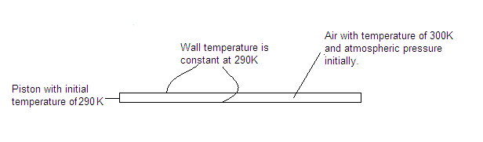
Figure 2.12 Schematic of the single fluid heat transfer model

2.4.3 Results and Discussion: Single Fluid with Heat Transfer
Having applied the boundary and initial condition of the bore, the simulation is run in Fluent and results are shown below. Figure 2.13 shows the time and temperature plot for this heat transfer model. The temperature decrease in the first section is due to the heat transfer between the gas and the wall. The temperature increase in the second section is due to the compression of the piston. The temperature decrease in the third section is due to the piston expansion and heat transfer from the wall. The increase in temperature of the fourth section is due to the heat transfer from the wall to the gas. The maximum average temperature is about 370K, which is a significant improvement over the insulated wall simulation.
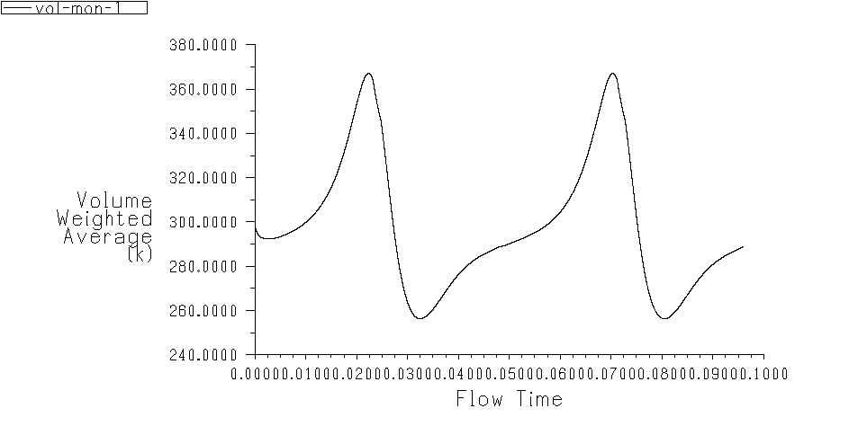
Temperature volume weight average (Kelvin)
Figure 2.13 Volume weighted temperature of the gas vs. time plot for the heat transfer case

Figure 2.14 shows the progression of pressure during the compression and expansion. The moving boundary is on the left boundary. The top plot, where the crank angle is 0 deg, shows the initial pressure distribution before the compression. The second plot, where the crank angle is 90 deg, shows the midstroke of the compression. The third plot, where the crank angle is 180 deg, shows the fully compressed bore. The fourth plot, where the crank angle is 270 deg, shows the midstroke of the expansion. The fifth plot, where the crank angle is 360 deg, shows the end of the first stroke. The initial pressure is the same as the atmospheric pressure, which is shown in the top plot of the figure. As the piston compresses, the pressure increases. When the pressure is in the top dead center, the pressure is approximately 1.1MPa. As the piston returns to the initial position, the pressure goes back to atmospheric pressure. The piston compresses and expands again for the second cycle, and the pressure distribution is the same as the first cycle. The pressure distribution is uniform because the density of air is low. Low density causes the pressure drop due to viscous force not to be significant.

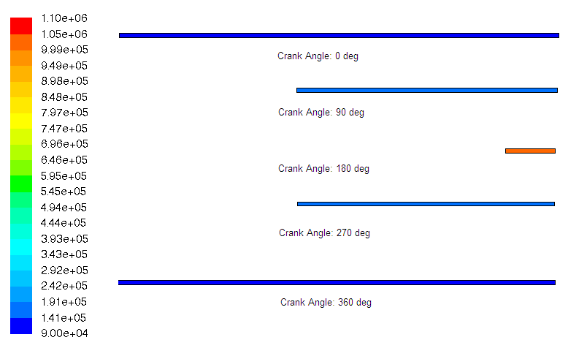
Unit (Pa)
Figure 2.14 The progression of pressure for the single fluid heat transfer model

Figure 2.15 shows the progression of temperature during compression and expansion. The initial temperature of the gas is 300K, which is shown in the top plot of the figure. As the piston compresses to the top dead center, the temperature increases to approximately 430K, which is shown in the third plot of the figure. When the piston is on the top dead center, there is a temperature gradient along the radial and axial direction. The heat flows from the gas to the wall when the piston is at the top dead center since the temperature of the gas is higher than the wall. As the piston retracts, the temperature of the gas is lower than the wall. Heat is transferred from the wall to the gas. As the piston returns to the initial position, the temperature of the gas is approximately the same as the initial condition.
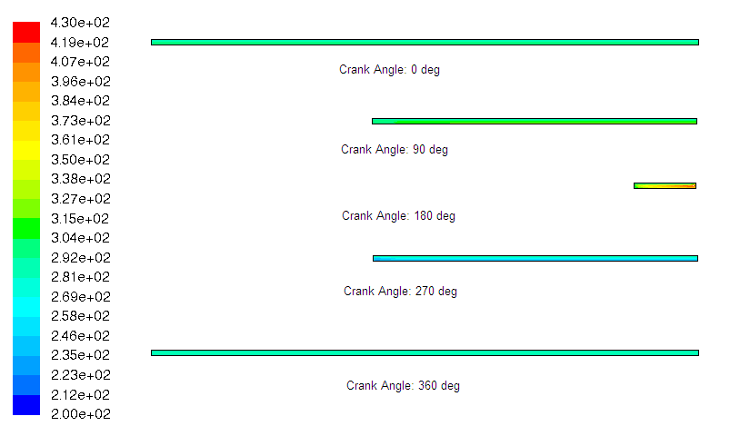
Unit (Kelvin)
Figure 2.15 The progression of temperature for the single fluid heat transfer model

Figure 2.16 shows the progression of density during compression and expansion. The initial density is the same as the air density in room temperature, which is shown in the top plot of the figure. The mean density should be 9kg/m^3 due to the 9:1 compression ratio. As the piston compresses the bore until it reaches the top dead center, the maximum density increases up to approximately 13kg/m^3 due to the mesh resolution error. As the piston retracts and returns to the initial position, the density of air returns to the initial condition. The piston extends and retracts again for the second cycle, which is the same as the first cycle. Since the variation of pressure is small, the density gradient is inversely proportional to the temperature gradient according to the ideal gas law.
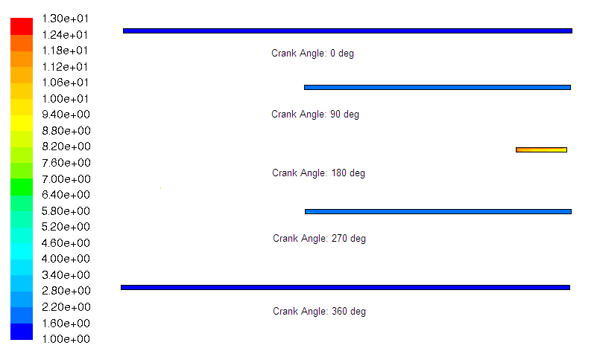
Unit (kg/m³)
Figure 2.16 The progression of density for the single fluid heat transfer model

2.4.4 Conclusion: Single Fluid with Heat Transfer
This single fluid with heat transfer case is very different from the insulated wall case. In the insulated wall case, all density, pressure, and temperature profiles are uniformly distributed. In the heat transfer case, the density and temperature profiles are not uniformly distributed due to the heat transfer from the wall. Ideal gas law in equation 2.1 can be applied in this case in order to show if the CFD code works. The maximum temperature and the density at maximum temperature in this case are approximately 425K and 9 kg/m³ according to figure 2.9 and 2.10. The corresponding pressure calculated from the ideal gas law is approximately 1.1MPa, which is the same as shown in figure 2.8.
The insulated wall simulation is an adiabatic compression, and the heat transfer simulation is a near isothermal compression, where the temperature difference is significantly improved compare to the insulated wall simulation.
In the next simulation, liquid piston gas compression simulation is presented, where liquid and gas are within the bore.

2.5 Liquid Piston Gas Compression Model
2.5.1 Introduction: Liquid Piston Gas Compression Model
The liquid piston gas compression simulation model includes is two fluids in the bore. The liquid gas interface is free to change shape as the piston moves up and down. The gas is compressed by the liquid. The liquid can transfer heat directly to the gas, or it can transfer heat to the wall during compression and transfer heat to the gas during expansion. In this simulation, water is used as the liquid and air as the gas. Air is assumed to be compressible, and the ideal gas law is applied. The temperature, pressure, and density are three major parameters in this simulation.

2.5.2 Methods: Liquid Piston Gas Compression Model
It is more challenging to set up the liquid piston model than the previous simulations because it involves two phase flow and setting up the liquid gas interface. The actual mechanical configuration for this computational model is in figure 1.1. The only difference between the actual model and the computational model is the computational model simulates one bore of the actual configuration. This saves a lot of computational time.
Figure 2.17a shows the liquid piston model in the bore. Liquid is located at the left of the cylinder, and is shown in red. The liquid is used to compress the bore. The gas is shown in green, and wall is shown in yellow. Figure 2.17b shows the mechanical configuration for the liquid piston model. The heat is transferred from the liquid to the bore wall and from the wall to the gas. Therefore, the wall is important and is included in the liquid piston simulation. The radius of this model is 3mm, and the length of this model is 5cm. About half of the tube is liquid, and the other half is gas. This geometry is chosen so as to understand how this particular geometry affects the pressure, density, and temperature within the bore. The maximum acceleration of the piston is 0.5g in order to avoid liquid gas interface instability. There are 20 grid points across the radial direction, and 1320 grid points along the axial direction. A total of 37384 grid points are in the model.
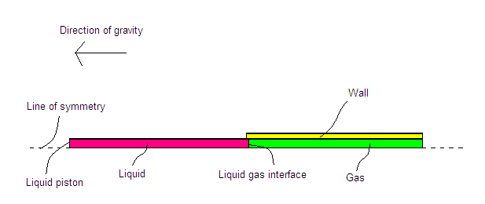
Figure 2.17a Liquid piston model

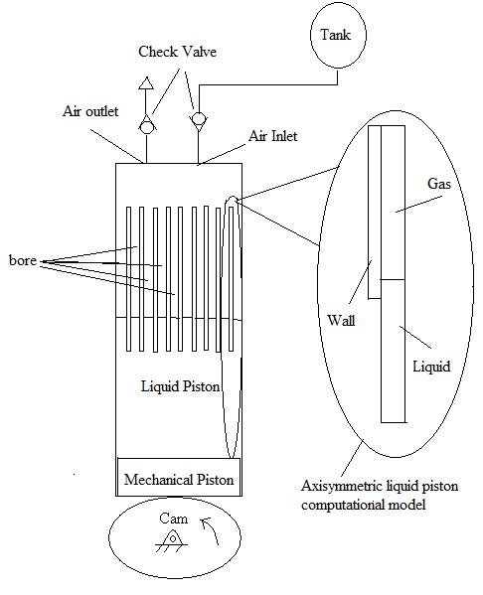
Figure 2.17b Actual mechanical configuration corresponds to figure 2.17a

Figure 2.18 shows the boundary conditions of this model. All the external walls are insulated, and the bottom boundaries are assumed to be axisymmetric. The boundary between the wall and the gas is coupled, which means heat transfer can be moved to and from the boundary. Liquid boundary condition is treated as a no slip boundary and the viscous option in Fluent is turned on, which means surface tension is calculated in this model. The wall does not extend down the length of the liquid because in the physical system of the whole cylinder, liquid is at the bottom of the cylinder, and the bore is located at the top half of the cylinder.

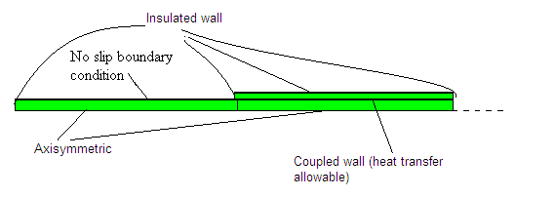
Figure 2.18 Liquid piston model with boundary conditions

Figure 2.19 shows the initial conditions for this model. The initial condition for the liquid is constant temperature at 300K. The gas and the wall are in 290K initially. The liquid and air interface is treated as interior boundary condition. It means that this interface is treated as ordinary nodes.
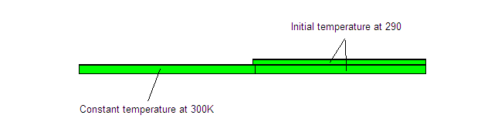
Figure 2.19 Liquid piston model with initial conditions

The governing equation is the conservation of mass, momentum, and energy. The first order upwind scheme is used for the continuity, momentum, and energy equation. PISO scheme is used for the pressure velocity coupling. PISO stands for pressure implicit solution by split operator method. The scheme guesses the pressure value and calculates the velocity components. The velocity components are used to correct the pressure. The values for pressure and velocity components are updated and repeated again until the updated pressure and velocity values is very close to the previous one. Volume of fluid model is used to calculate two phase flow. The volume of fluid model is basically used to track the interface within the grid. It calculates the proportion of one fluid within the grid, and the proportion of another fluid within the grid. Before running the simulation, the patch option turns the bottom half to be the liquid. Gravity is an important factor in this model. It is set in the horizontal direction with a magnitude of 9.81m/s^2.

2.5.3 Results and Discussion: Liquid Piston Gas Compression Model
Having applied the initial and boundary conditions for the liquid piston simulation, the simulation is run and results are shown below. Figure 2.20 shows the time and temperature plot for the liquid piston gas compression simulation. The gas temperature increases due to compression and the heat transfer from the liquid to the gas. The temperature then decreases due to the gas expansion. The temperature rises at the end due to the heat transfer from the wall to the gas.
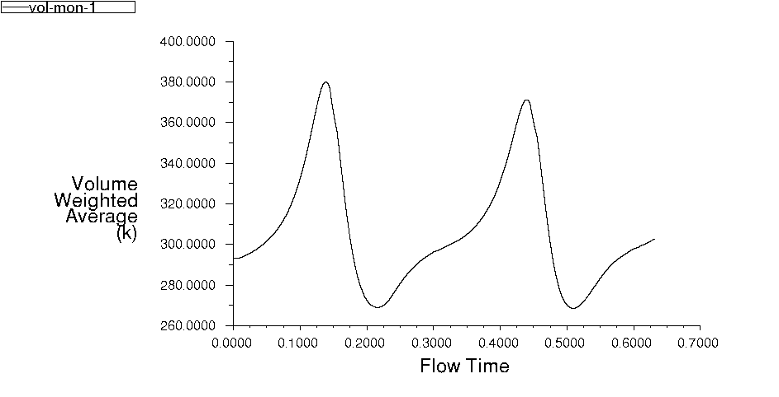
Temperature volume weighted average (Kelvin)
Figure 2.20 Time vs volume averaged gas temperature for liquid piston gas compression model

Figure 2.21 shows the progression of pressure during compression and expansion. The vertical lines in the figure represent the approximate location of the liquid gas interface. The initial pressure is the same as the atmospheric pressure, which is shown in the top plot of the figure. As the piston moves toward the top dead center, the pressure increases to approximately 1.1MPa. As the piston returns to the initial position, the pressure reduces to atmospheric pressure. The piston compresses and expands again for the second cycle, which is the same as the first cycle.
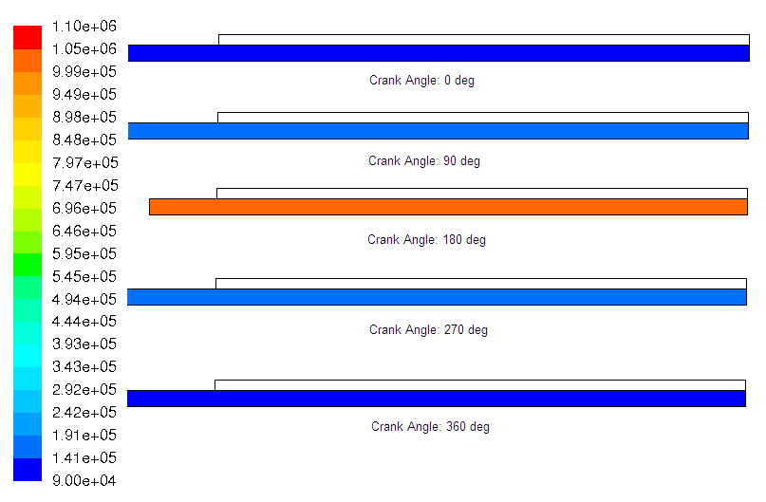
Unit (Pa)
Figure 2.21 The progression of pressure during compression and expansion

Figure 2.22 shows the progression of temperature during compression and expansion. The vertical lines in the figure represent the approximate location of the liquid gas interface. The initial liquid temperature is 300K, and the gas and wall temperatures are 290K. As the piston compresses to the top dead center, the maximum temperature of the gas increases to approximately 450K. The location of the maximum gas temperature is at the top corner of the bore. The reason that the maximum temperature is located at the top corner is that the gas velocity at the corner is so low that the heat energy slowly propagates to other places. As the piston returns to the original position, the gas temperature is lower than 290K, which means the gas temperature is lower than the wall and liquid temperature. The gas gains heat energy from the wall and the liquid, which increases to approximately 290K. The last plot of the figure shows the temperature distribution at the end of the first stroke. That plot shows the gas temperature close to the wall and the liquid has increased to approximately 300K. However, some of the location at the top of the bore still has not reached 300K.
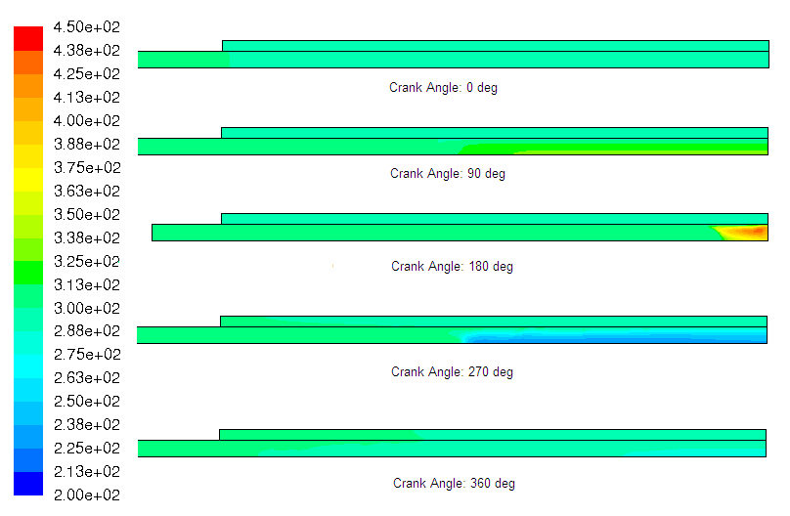
Unit (Kelvin)
Figure 2.22 The progression of temperature during compression and expansion

Figure 2.23 shows the progression of density during compression and expansion. The density of water is shown in red, and the density of air is shown in blue. Initially, the liquid gas interface is very clearly defined and coherent. As the piston compresses the bore, the interface begins to be less coherent. When the piston is at the top dead center, the gas is entrained in the side of the bore, and the interface becomes less stable. As the piston returns to the initial position, the liquid stays along the wall due to the viscous force, and bubbles are formed in the liquid column. The interface is no longer stable. The piston is compressed and expanded for the second cycle. The second cycle is worse than the first cycle because more bubbles are formed in the liquid column.
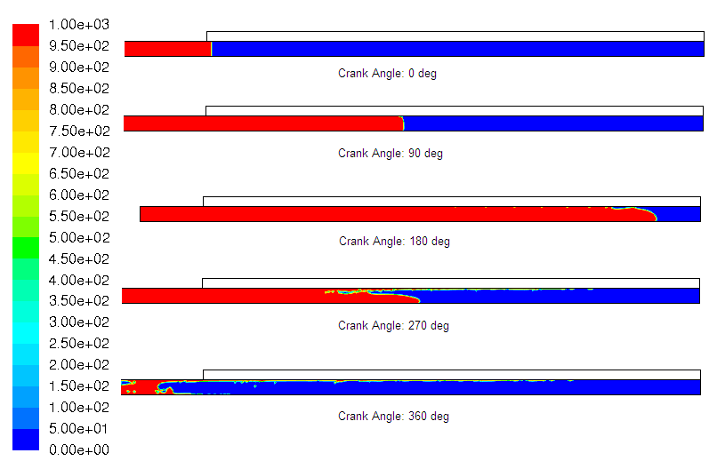
Unit (kg/m³)
Figure 2.23 The progression of density during compression and expansion

2.5.4 Conclusion: Liquid Piston Gas Compression Model
This liquid piston simulation is a challenging simulation due to the liquid gas interface and two phase flow problem. In the density plots, the liquid compresses the gas, but the interface is unstable as the piston returns to the initial position. This is a sign that the acceleration of piston is too high, and is needed to be reduced. Additionally, the liquid stays along the wall due to the viscous force. In the temperature plots, it is clear to see that the heat is transferred from the liquid to the wall during compression. The wall releases heat to the gas to cool the gas down during expansion. The range of gas temperature is from 200K to 450K due to the heat transfer to and from the wall, the liquid.

2.6 Conclusion
This chapter presented the mesh resolution study and three simulations, gas compression with insulated wall, gas compression with heat transfer from the wall, and the liquid piston simulation. In the mesh resolution investigation, the 20 grid point case is selected because of less computational time. However, there are some errors associated with this case.
The gas compression with insulated wall is an adiabatic compression simulation, where the temperature different before and after compression is very high. The second simulation is the gas compression with heat transfer simulation, which yields a smaller temperature difference than the insulated wall simulation. The third simulation is the liquid piston simulation, which is a more realistic liquid piston model than the previous two simulation. The preliminary investigation revealed multiple area for further study, which includes the interface stability, the acceleration of the piston, viscous force, and the heat transfer. In the next chapter, the computational experiments are conducted to investigate how changes in geometry, acceleration, and liquid temperature change the viscous force and heat transfer.
Chapter 3 Computational Experiments
3.1.1 Introduction: Computational Experiments
The third simulation involved the liquid and the gas interface, which will be initialized for the computational experiments. The computational experiments are parametric studies in order to understand how different factors affect the efficiency of liquid piston gas compression. The primary factors of interest include the radius, length, liquid temperature, and acceleration of piston. These experiments include low, medium, and high for each factor. A total of nine cases are simulated. One factor is varied while other factors remain at the medium value. The medium case is used as the baseline, which means that all the low and high experiments are compared with the medium case. In chapter 4, post possessing will be used to compare the results of the nine cases in order to determine which case has the least viscous forces and the most heat transfer.
Table 3.1 shows the value for different factors and for different low, medium, and high values. For the medium case, the piston acceleration is 0.5g, and the liquid temperature is 300K. The initial air temperature is 300K. The geometry of the medium baseline experiment is 3mm diameter and 5cm in length. These values are chosen because some preliminary investigations were conducted and those values seemed to offer a reasonable solution for the baseline experiment. The low and high values for the geometry are varied based on the medium baseline values. The low radius and high radius experiments are the same as the medium baseline experiment except the diameter is 1mm and 5mm for low and high radius respectively. The low and high length experiments have the length of 2 and 10 cm respectively and everything else is the same as the medium baseline experiment. The low and high acceleration vary from 0.3g and 0.7g. Those acceleration values are chosen because the liquid gas interface is unstable if the acceleration is greater than 1g. The acceleration values have to be less than 1g. The low and high liquid temperature varies from 290K and 320K keeping everything else the same as the medium baseline experiment. The liquid temperature values are chosen because liquid water temperature should be maintained between 273K and 373K to avoid evaporation and condensation. Liquid temperature can be constant within the gas compression system because it will pass through a heat exchanger, which keeps the liquid temperature constant. The governing equations, which are the conservation equations, are the same among all cases. The boundary conditions and mesh generation are shown in the method section.

Table 3.1: The values for each parametric investigation
 | Low | Medium | High
Diameter (mm) | 1 | 3 | 5
Length (cm) | 2 | 5 | 10
Acceleration (m/s^2) | 0.3g | 0.5g | 0.7g
liquid temperature (K) | 290 | 300 | 320

3.2 Medium Baseline Experiment
3.2.1 Methods: Medium Baseline Experiment
The dimensions of the medium baseline case are a 1.5mm radius, 5cm long bore in the gas region and 5cm long for the liquid region. There are 40 grid points in the radial direction and 1000 grid points in the axial direction. The boundary and initial conditions is the same as figure 2.11, 2.12, and 2.13. The piston profile is sinusoidal and the equation for the piston displacement is as follows.
$x(t)=\frac{S}{2}\text{sin}(ωt)$ (3.1)
Equation 3.1 shows the piston profile within the bore. S is the stroke, and $ω$is the angular velocity. The acceleration of the piston is the second derivative of the piston profile
$a(t)=−\frac{ω^{2}S}{2}\text{sin}(ωt)$ (3.2)
Equation 3.2 shows the acceleration of the piston. The absolute value of the maximum acceleration is as follows.
$\left|a(t)\right|=\frac{ω^{2}S}{2}$ (3.3)
Equation 3.3 shows the absolute value of the maximum acceleration. This equation is rearranged in order to calculate the angular velocity of this experiment.
$ω=\sqrt{\frac{2\left|a\right|}{S}}$ (3.4)
The acceleration of the piston is 0.5g. With the compression ratio of 9:1, the stroke of this experiment is 4.5cm. According to equation 3.4, it is equivalent to an angular velocity of 141rpm. The first order upwind scheme is used for the continuity, momentum, and the energy equation. PISO scheme is used for the pressure velocity coupling. Before running the simulation, the patch option turns the bottom half to be the liquid column. The patch option is to reset the values on the grid to be the initial values. Volume of fluid model is used to calculate two phase flow. The volume of fluid model is basically used to track the interface within the grid. It calculates the proportion of one fluid within the grid, and the proportion of another fluid within the grid. Water and air are the two fluids used in this model. Gravity is an important factor in this model. It is set in the horizontal direction with a magnitude of 9.81m/s^2.

3.2.2 Results: Medium Baseline Experiment
Having applied the boundary and initial conditions, the simulation is run and results are shown below. The computational run time is about 2 days on a regular computer. Figure 3.1 shows the progression of pressure during compression and expansion. The left end boundary is used as the moving boundary, which moves the liquid to compress the gas. The liquid column is truncated so as to focus on the behavior on the air region. At the beginning of the stroke, the liquid and gas pressure within the bore is the same as the atmospheric pressure, which is shown in the top plot of the figure. As the piston moves up to the top dead center, the liquid and gas pressure increases up to 1.2MPa. As the piston returns to the bottom dead center, the liquid and gas pressure decreases to the atmospheric pressure. The liquid and gas pressure remain constant within a bore for all plots because the pressure generated from compression is much greater than the pressure gradient created by the viscous force in the liquid column.
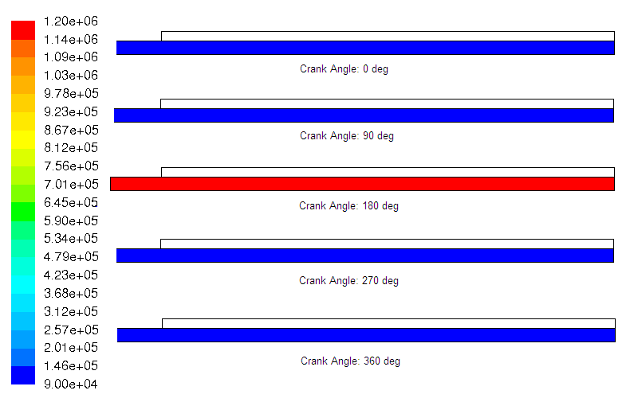
Unit (Pa)
Figure 3.1 The progression of pressure for the medium baseline experiment
Figure 3.2 shows the progression of temperature during compression and expansion. The initial liquid, air, and the wall temperature are at 300K, which is shown in the top plots of the figure. There is no heat transfer to and from the wall initially due to the same temperature among the fluid and the wall. As the piston moves upward to the top dead center, the gas temperature increases up to approximately 430K, which is shown in the third plot of the figure. The maximum temperature is located in the corner of the bore because of the low velocity at the corner. Due to the low velocity, the heat is slowly transferred to other location. As the piston retreats, the gas temperature decreases to below than 300K. At that time, the wall temperature, which is above 300K, transfers heat to the gas. When the piston is at the bottom dead center, the temperature of both fluids and the wall returns to 300K, which is shown in the last plot of the figure.

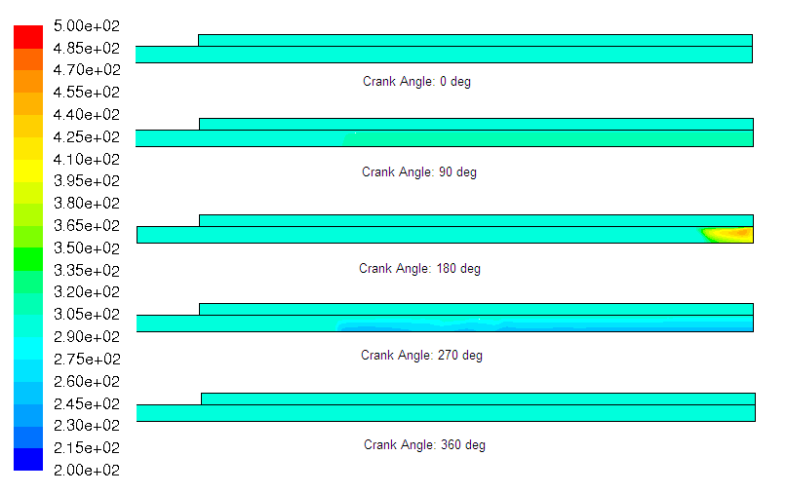
Unit (Kelvin)
Figure 3.2 The progression of temperature for the medium baseline experiment

Figure 3.3 shows the progression of density during compression and expansion. The red color represents water and the blue color represents air. At the beginning, the liquid gas interface is very clearly defined and coherent, which is shown in the top plot of the figure. As the liquid column moves up to the top dead center, the velocity profile is a parabolic profile since the no slip boundary condition is applied at the wall, which means the velocity of fluid at the wall is zero. As the piston retracts, some bubbles penetrate into the liquid column. When the piston returns to the initial position, air bubbles can be seen into the liquid column. Additionally, the liquid stays along the wall due to the viscous forces, and the liquid air interface is marginally stable.

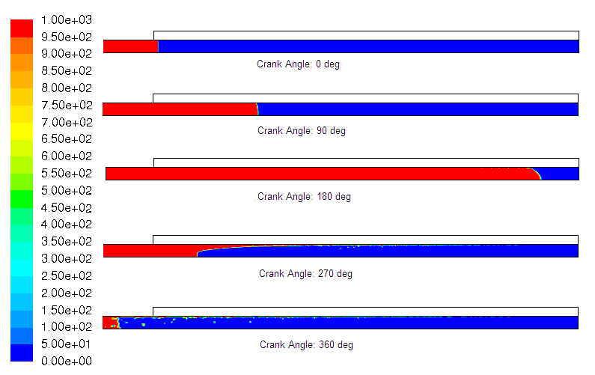
Unit (kg/m³)
Figure 3.3 The progression of density for the medium baseline experiment

3.3 Liquid Temperature Variation Experiment
3.3.1 Introduction: High Temperature Experiment
The high temperature experiment is an experiment where the liquid temperature is 320K instead of 300K. The geometry and the piston acceleration is the same as the medium experiment.

3.3.2 Methods: High Temperature Experiment
The method is very similar to the medium baseline experiment. The same mesh resolution and the same solution method are used. The only difference is to change the liquid temperature to be 320K.

3.3.3 Results: High temperature Experiment
Figure 3.4 shows the progression of pressure during compression and expansion. The initial pressure for both liquid and gas pressure is at the atmospheric pressure, which is shown in the top plot of the figure. As the piston compresses the bore, the pressure is uniformly distributed and the pressure of the bore is approximately 1.2MPa. As the piston returns to the initial position, the liquid and gas pressure reduces to approximately the atmospheric pressure, which is shown in the last plot of the figure. The piston compresses and expands again for the second cycle. The second cycle is the same as the first cycle. The maximum pressure of both cycles is the same.

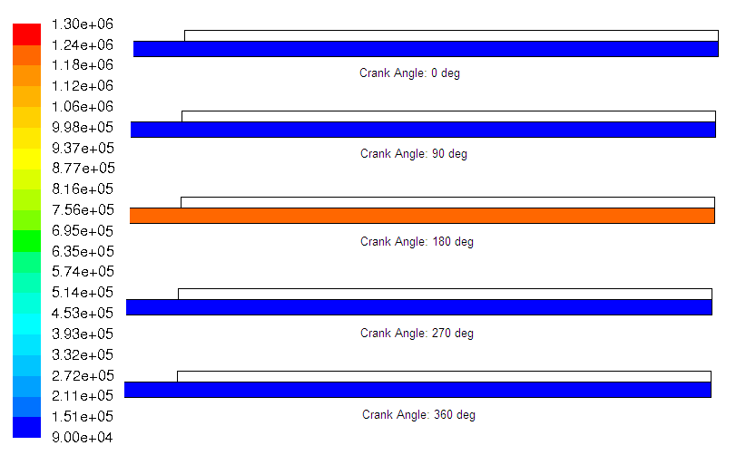
Unit (Pa)
Figure 3.4 The progression of pressure for the high temperature experiment

Figure 3.5 shows the progression of density during compression and expansion. In the beginning, the interface between the liquid and air is very stable. As the liquid moves up and compresses the air, a parabolic velocity profile is generated because the liquid velocity at the wall is zero due to the no slip condition, and the maximum liquid velocity is at the center of the bore. As the piston returns to the initial position, there are some bubbles penetrate into the liquid column, and liquid stays along the wall due to the viscous forces.
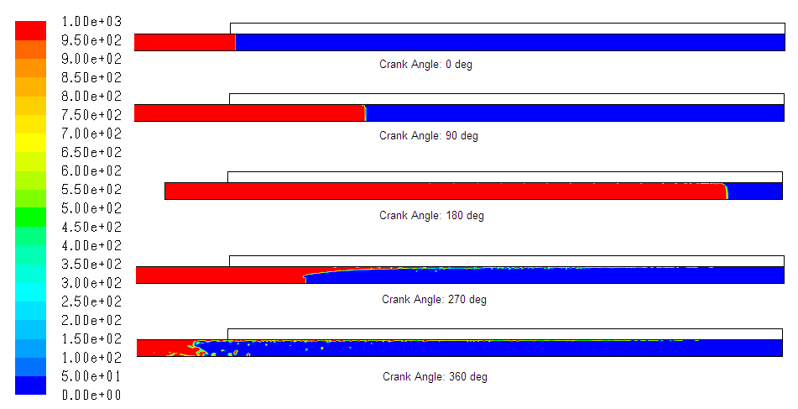
Unit (kg/m³)
Figure 3.5 The progression of density for the high temperature experiment

Figure 3.6 shows the progression of temperature during compression and expansion. The initial temperature of the liquid is 320K, the gas and wall temperatures are at 300K, which is shown in the top plot of the figure. Initially, the liquid temperature transfers heat to the wall and to the gas since the liquid temperature is higher than the gas and the wall. As the piston move to the top dead center, the maximum gas temperature is approximately 470K, and the maximum gas temperature is located at the corner of the bore because of low velocity at the corner. As the piston returns to the initial position, the gas temperature that is close to the liquid is approximately 320K due to the heat transfer between the liquid and the gas. The gas temperature at the top of the bore is still at approximately 300K. The last plot shows the end of the first cycle. Most of the bore has the temperature of 320K except the top of the bore because the heat energy from the liquid has not reached to the top yet.
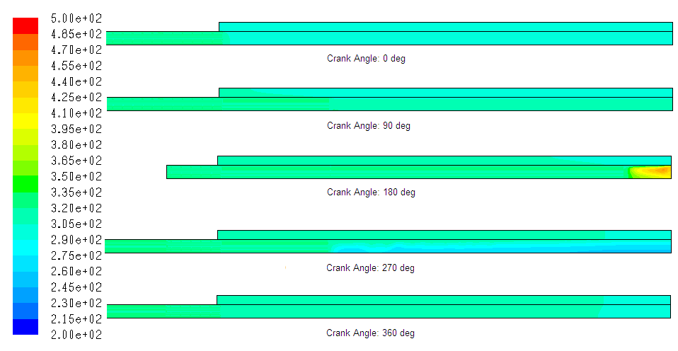
Unit (Kelvin)
Figure 3.6 The progression of temperature for the high temperature experiment

3.3.4 Introduction: Low Temperature Experiment
The temperature of the liquid in the low temperature experiment is 290K. The geometry of the bore is the same as the medium baseline experiment and the high temperature experiment. The only difference in this experiment is the liquid temperature is 290K instead of 300K in the medium baseline experiment or 320K in the high temperature experiment.

3.3.5 Methods: Low Temperature Experiment
The method is very similar to the medium baseline experiment and the high temperature experiment. The same mesh resolution and the same solution method are used. The only difference is to change the liquid temperature to be 290K.

3.3.6 Results: Low Temperature Experiment
Figure 3.7 shows the progression of pressure during compression and expansion. At the beginning, the pressure at the bore is the same as the medium baseline experiment, which is atmospheric pressure and is shown in the top plot of the figure. As the piston moves up to the top dead center, the pressure increases up to approximately 1.16MPa. The uniform pressure distribution is shown in the figure. As the piston returns to the initial position, the pressure within the bore decreases to approximately atmospheric pressure. The piston compresses the bore for the second cycle. The progression of pressure in the second cycle is the same as the first cycle. Compare this figure to figure 3.4, figure 3.4 shows the maximum pressure is approximately 1.2MPa. The low temperature experiment has a slightly lower pressure than the high temperature experiment because lower temperature yields lower pressure.
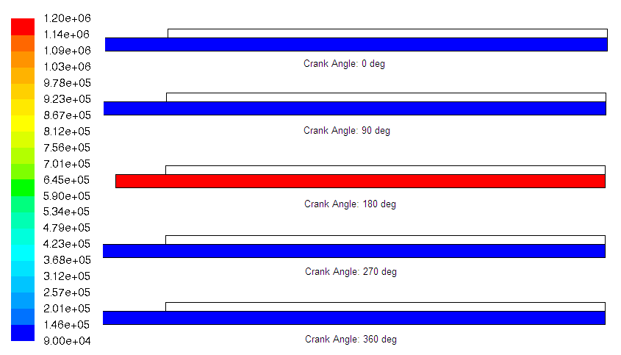
Unit (Pa)
Figure 3.7 The progression of pressure for the low temperature experiment
Figure 3.8 shows the progression of density during compression and expansion. Water initially is at 1000kg/m^3, which is shown in red in the figure. The air is at approximately 1kg/m^3, which is shown in blue in the figure. The liquid gas interface is very stable before any compression and expansion from the piston. As the piston moves up to the top dead center, the velocity profile is close to a parabolic profile and the some gas particles penetrate into the liquid along the wall. As the piston returns to the initial position, liquid stays along the wall and the interface becomes unstable. The liquid droplets stay along the wall and bubbles appear in the liquid column due to the viscous forces. The liquid droplets drip down towards the liquid column which makes a small wave at the surface of the liquid column.

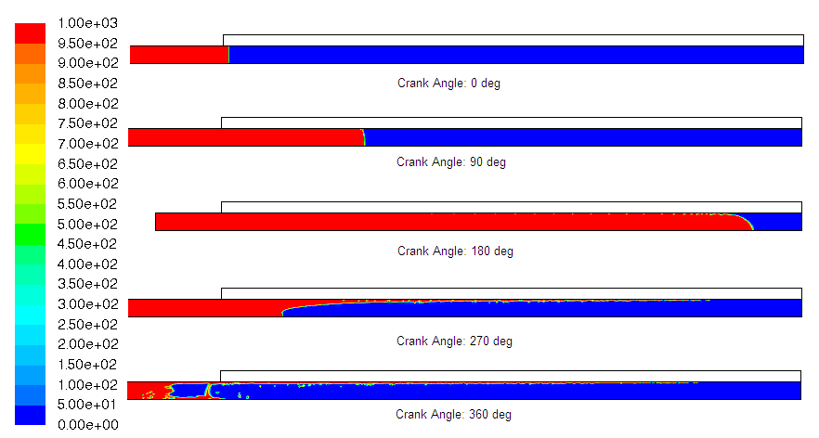
Unit (kg/m³)
Figure 3.8 The progression of density for the low temperature experiment

Figure 3.9 shows the progression of temperature during compression and expansion. The liquid temperature is 290K, the air and wall temperatures are 300K at the beginning. The heat is transferred from the air and wall to the liquid. As the piston compresses to the top dead center, the temperature within the tube increases to approximately 470K. As the piston returns to the initial position, the temperature of the gas falls below 290K. The wall and the liquid transfer heat to the gas. This heat transfer brings the temperature up to approximately 290K. The piston compresses and expands the bore for the second cycle. The second cycle is the same as the first cycle. Compare this figure to figure 3.6, gas is transferring heat to the liquid and the wall in both cases. However, this heat transfer does not occur fast enough. This is the reason why it looks very similar on the fully compressed (crank angle of 180 deg) plot on both figures. In contrasts, the temperature distribution on the next plot (crank angle 270 deg) is different between figure 3.9 and figure 3.6. It is because the gas transfers heat with the wall and liquid at that time due to the liquid temperature difference.

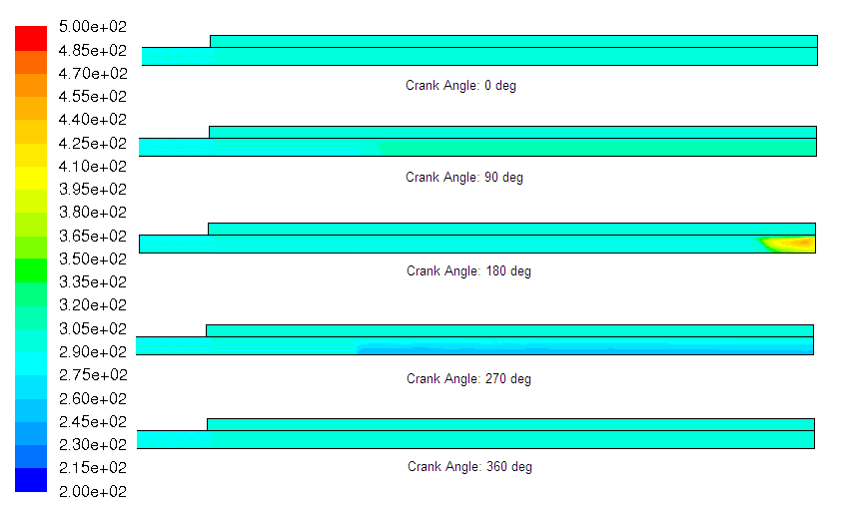
Unit (Kelvin)
Figure 3.9 The progression of temperature for the low temperature experiment

3.4 Radius Variation Experiment
3.4.1 Introduction: Low Radius Experiment
The low radius experiment shows how the change of radius influences the pressure, temperature, and the density within the bore. The bore diameter in this experiment is 1mm with 5cm in length. The acceleration is 0.5g and the liquid temperature is the same as the gas and wall temperatures, which is 300K.
3.4.2 Methods: Low Radius Experiment
The model of the low radius experiment is created and meshed in Gambit. A 0.5mm radius with the length of 10cm and the wall are drawn, half of the bore is the liquid column, and half of the bore is the gas. The mesh resolution is 40 grid points in the radial direction and 1000 grid points in the axial direction. The liquid, gas, and the wall are specified in Gambit. The model from Gambit is imported to Fluent software. The solution methods and the steps are the same as the medium baseline experiment in Fluent. Having set up all of those conditions, the simulation is run, and the results are discussed below.

3.4.3 Results: Low Radius Experiment
Having set up the methods properly, the simulation is run, and the results are shown below. Figure 3.10a shows the progression of the pressure during compression and expansion for the first cycle. The pressure at the beginning of compression is the same as the atmospheric pressure, which is shown in the top plot of the figure. As the piston moves to the top dead center, the pressure is uniformly distributed, and the maximum pressure is approximately 2.3MPa. As the piston returns to the initial position, the pressure reduces to the atmospheric pressure. Figure 3.10b shows the piston compresses and expands the bore for the second cycle. The maximum pressure in the second cycle is higher in the maximum pressure in the first cycle because there is more viscous force in the second cycle than the first.
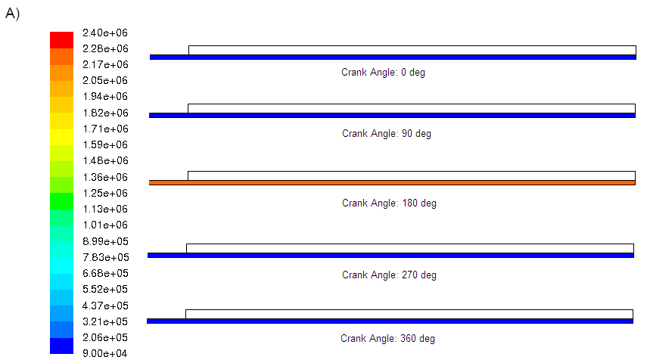
Unit (Pa)
Figure 3.10a The progression of pressure in the first cycle for the low radius experiment
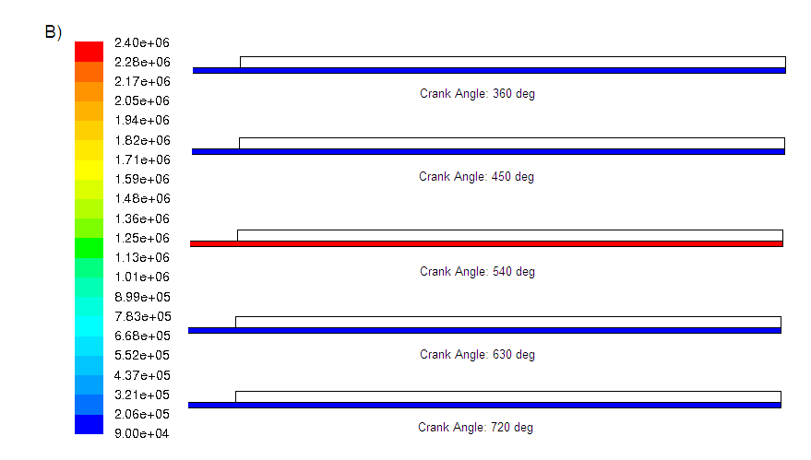
Unit (Pa)
Figure 3.10b The progression of pressure in the second cycle for the low radius experiment
Figure 3.11 shows the progression of density during compression and expansion. The density initially is the same as previous experiments. Water is shown in red, and air is shown in blue in the top plot of the figure. The liquid gas interface is very coherent at the beginning of the cycle. As the piston compresses the bore to the top dead center, the liquid gas interface is not coherent anymore. As the piston returns to its initial position, bubbles are formed in the liquid column, and some liquid droplets stay along the wall due to the viscous force. The piston compresses and expands the bore again for the second cycle.

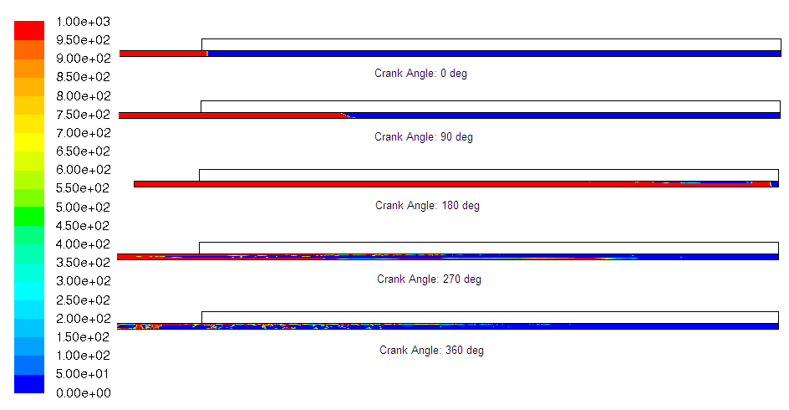
Unit (kg/m³)
Figure 3.11 The progression of density for the low radius experiment

Figure 3.12 shows the progression of temperature during compression and expansion. The initial gas, liquid, and wall temperatures are 300K, which is the same as the medium baseline case. As the piston moves to the top dead center, the maximum temperature of this experiment is approximately 400K. As the piston returns to the initial position, the temperature returns to 300K due to the expansion and the heat transfer from the wall and the liquid.

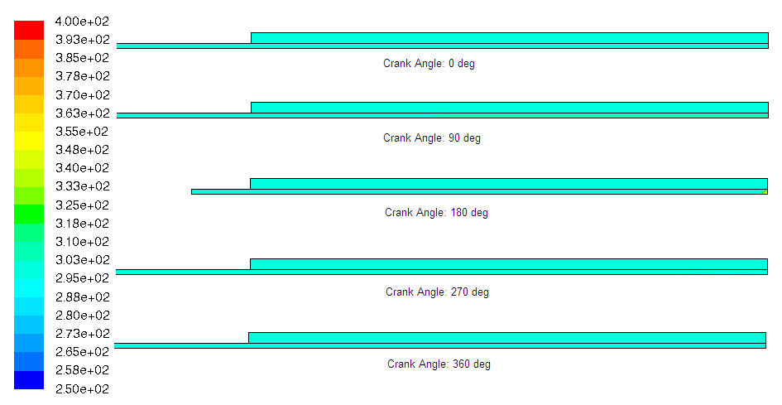
Unit (Kelvin)
Figure 3.12 The progression of temperature for the low radius experiment

3.4.4 Introduction: High Radius Experiment
The results of the low radius experiment were investigated. This section is to understand how high radius influences the pressure, temperature, and density. The high radius experiment has a diameter of 5mm, and the length is 5cm. The acceleration and the liquid temperature are the same as the medium experiment.

3.4.5 Methods: High Radius Experiment
The geometry of 2.5mm radius and 5cm long bore is modeled and meshed in Gambit. The wall is also modeled and meshed as well. The mesh resolution is 40 grid points in the radial direction and 1000 grid points in the axial direction. The model is imported to Fluent software. The solution methods and the boundary conditions are the same as the low radius experiment.

3.4.6 Results: High Radius Experiment
Figure 3.13 shows the progression of pressure during compression and expansion. The initial liquid and gas pressures are at atmospheric pressure, which is shown in the top plot of the figure. As the piston moves towards the top dead center, the maximum pressure is approximately 1.4MPa. As the piston returns to the initial position, the pressure is back to atmospheric pressure. The pressure distribution is uniform because less viscous force in the high radius case.
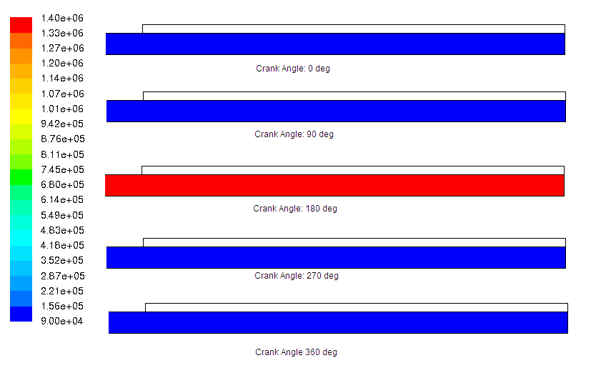
Unit (Pa)
Figure 3.13 The progression of pressure for the high radius experiment

Figure 3.14 shows the progression of density during compression and expansion. The liquid gas interface structure is very coherent and clear. As the piston moves towards the top dead center, no gas entrainment can be seen when the piston is at the top dead center. Additionally, the interface is still very clearly defined and coherent because the viscous force is low as the diameter increases. As the bore returns to the initial position, there is liquid droplets stay along the wall due to the viscous force. The liquid gas interface can still be defined when the piston returns to the initial position. The last plot also shows bubbles are formed in the liquid column.
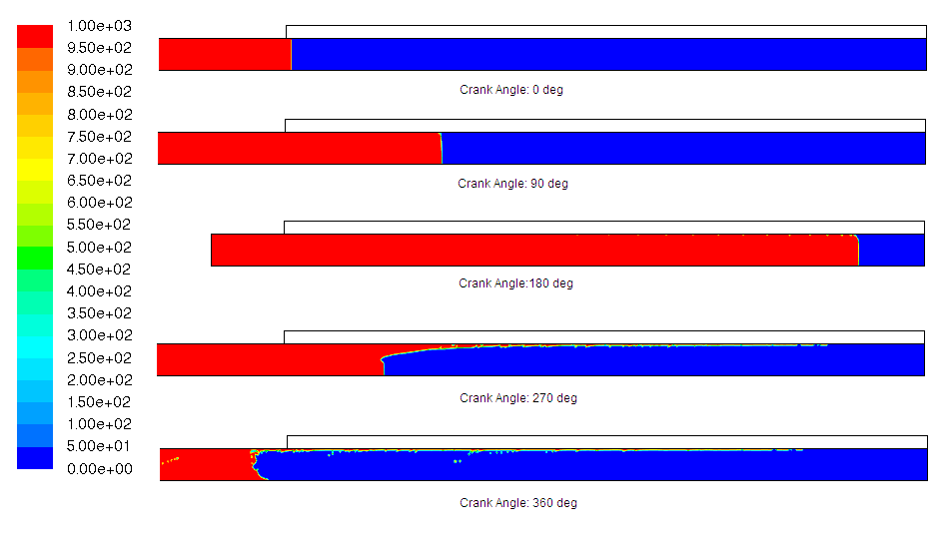
Unit (kg/m³)
Figure 3.14 The progression of density for high radius experiment

Figure 3.15 shows the progression of temperature during compression and expansion. The initial temperature of the gas, the liquid, and the walls are 300K. As the piston moves towards the top dead center, the temperature increases to approximately 560K. The maximum temperature is located at the top corner because of the low velocity at the corner. As the piston returns to the initial position, the temperature returns to 300K.
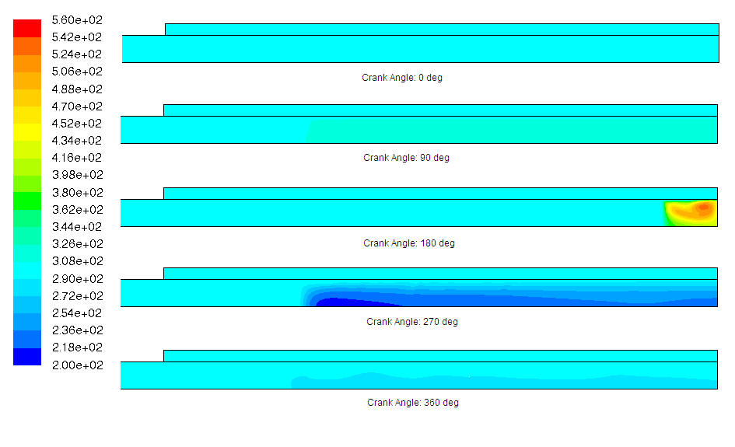
Unit (Kelvin)
Figure 3.15 The progression of temperature for the high radius experiment

3.5 Length Variation Experiment
3.5.1 Introduction: Low Length Experiment
The low length experiment is an experiment where the length is changed from 5cm to 2cm keeping everything else in the medium baseline category. In other words, the diameter is 3mm, the acceleration is 0.5g, and the liquid temperature is at 300K. The initial wall and gas temperature is at 300K as well.

3.5.2 Methods: Low Length Experiment
The model of the low length experiment is drawn and meshed in Gambit. A 4cm long bore, where half of the bore is liquid and half of the bore is liquid, with the radius of 1.5mm, and the wall are drawn. The mesh resolution is 40 grid points in the radial direction and 500 grid points in the axial direction. The liquid, gas, and the wall are specified in Gambit. The model from Gambit is imported to Fluent software. The solution methods and the steps are the similar to the medium baseline experiment in Fluent. The only difference is the sinusoidal piston profile is set with the stroke of 1.8cm and the angular velocity of 223rpm, which is equivalent to acceleration of 0.5g in equation 3.4. Having set up all of those conditions, the simulation is run, and the results are discussed below.

3.5.3 Results: Low Length Experiment
Figure 3.16 shows the progression of pressure during compression and expansion. The pressure is at the atmospheric pressure initially, which is shown in the top plot of the figure. As the piston moves to the top dead center, the pressure increases to approximately 1MPa. When the piston returns to its original position, the pressure is a little bit below the atmospheric pressure.
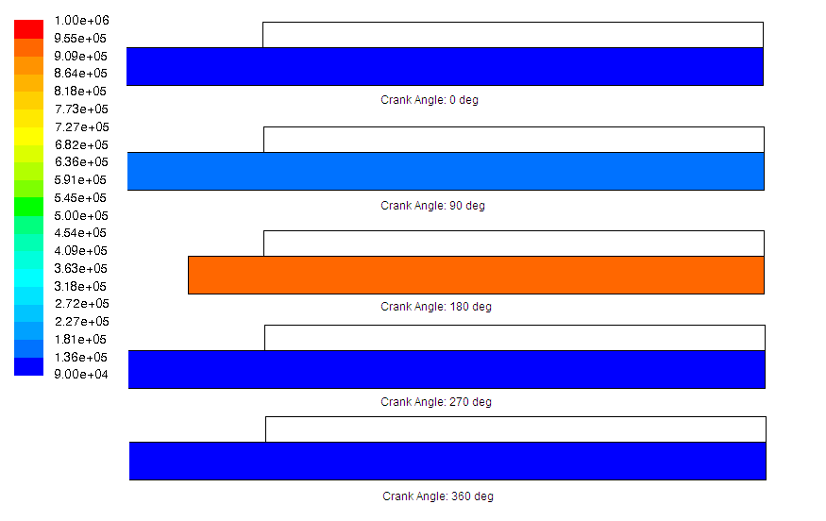
Unit (Pa)
Figure 3.16 The progression of pressure for low length experiment

Figure 3.17 shows the progression of density during compression and expansion. At the beginning, the liquid gas interface is clearly defined, which is shown in the top plot of the figure. As the piston moves up to the top dead center, the interface is also clearly defined and coherent. There is no bubble within the liquid column. As the piston returns to its initial position, the liquid stays along the wall due to the viscous forces. It shows that some bubbles are formed at the surface of the liquid column. The interface can still be defined, but it becomes less coherent. In other words, the liquid gas interface is not as stable as the initial interface.
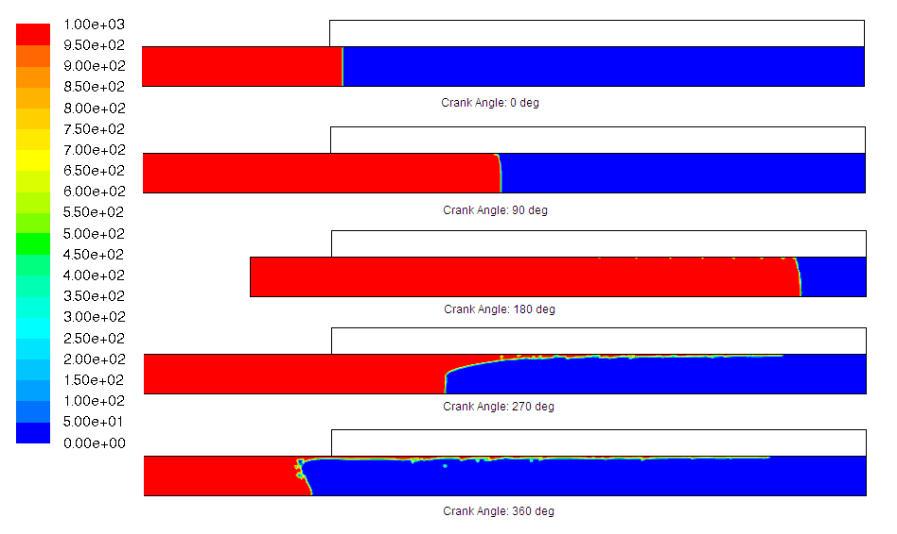
Unit (kg/m³)
Figure 3.17 The progression of density for low length experiment

Figure 3.18 shows the progression of temperature during compression and expansion. The initial temperatures of the liquid, gas, and the wall are 300K, which is shown in the top plot of the figure. As the piston moves towards the top dead center, the temperature increases to 460K, and the maximum temperature is located at the top corner of the bore due to the low velocity at the location. As the piston moves to the initial position, the temperature decreases to approximately 300K due to the heat transfer from the liquid and the wall.
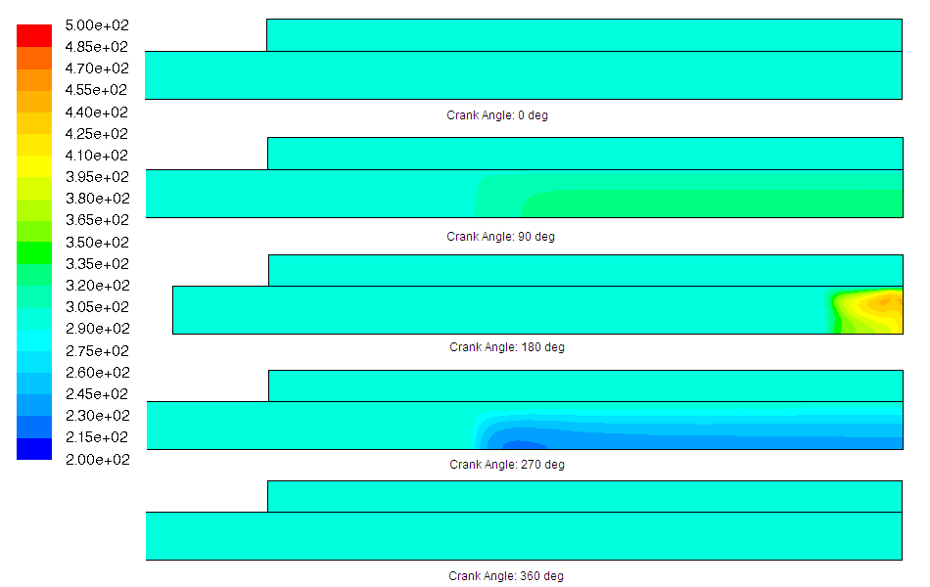
Unit (Kelvin)
Figure 3.18 The progression of temperature for the low length experiment

3.5.4 Introduction: High Length Experiment
Having seen the results from the low length experiment, it is important to understand how the high length experiment changes the density, the pressure, and the temperature. The high length experiment has a diameter of 3mm with 10cm long bore. The acceleration and the liquid temperature are the same as the medium experiment. The methods for this experiment are shown in the next section.

3.5.5 Methods: High Length Experiment
The model is drawn and meshed in the Gambit software. The geometry is 1.5mm in radius and 20cm long bore, which half of it is liquid and half of the bore is the air. The wall is also modeled in Gambit. The mesh resolution is 40 grid points in the radial direction and 2000 grid points in the axial direction. This model is imported to the Fluent software. Other than the geometry, there are some changes to make in the piston profile. The stroke of this experiment is 9cm, and the angular velocity of 100rpm, which is equivalent to an acceleration of 0.5g according to equation 3.4. The boundary conditions and solution method is the same as the low length experiment.

3.5.6 Results: High Length Experiment
Having set up the simulation, the experiment is run and results are shown below. Figure 3.19 shows the progression of pressure during compression and expansion. The initial condition for the pressure is it is the same as the atmospheric pressure, which is shown in the top plot of the figure. As the piston moves towards the top dead center, the maximum pressure is approximately 2.2MPa. As the piston returns to the initial position, the pressure within the bore reduces to atmospheric pressure.

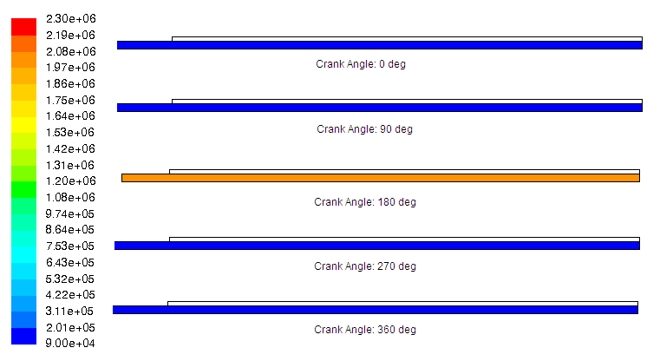
Unit (Pa)
Figure 3.19 The progression of pressure for the high length experiment

Figure 3.20a shows the progression of density at the first cycle during compression and expansion. Initially, the liquid gas interface is clearly defined and coherent. As the piston moves towards the top dead center, the interface becomes less coherent and less stable. The gas penetrates into the liquid along the wall. More liquid is concentrated at the center of the bore, and the gas is entrained along the wall. At this stage, no bubble is seen in the liquid column, but bubbles will form if gas particle enters to the liquid column. As the piston returns to the initial position, bubbles are formed in the liquid column. Liquid drips down to the liquid column from the wall, which causes the liquid gas interface to be less coherent and unstable. Figure 3.20b shows the piston compresses and expands the bore again for the second cycle. A more unstable interface is seen at the end of the second cycle since more bubbles are formed at the surface of the liquid column.
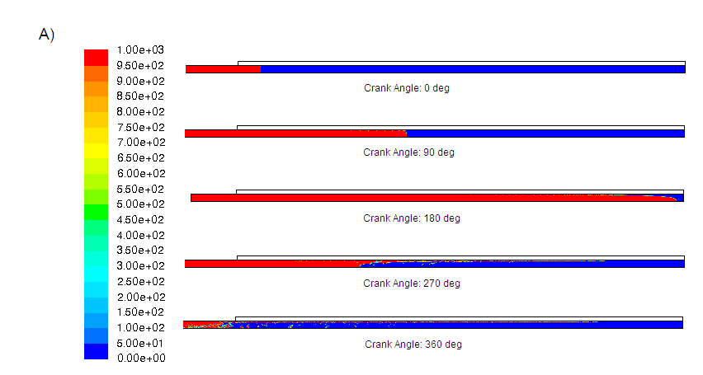
Unit (kg/m³)
Figure 3.20a The progression of density at the first cycle for the high length experiment
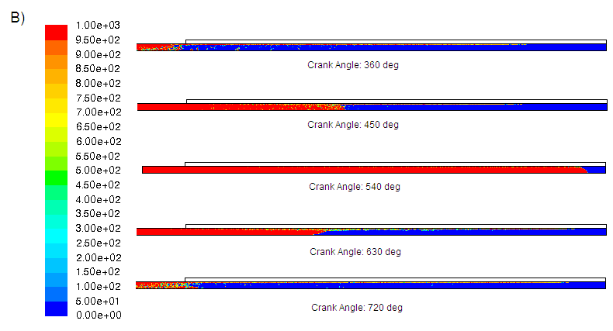
Unit (kg/m³)
Figure 3.20b The progression of density at the second cycle in the high length experiment

Figure 3.21 shows the progression of temperature during compression and expansion. The initial temperatures of the liquid, the gas, and the wall are 300K. As the piston moves towards the top dead center, the maximum temperature is approximately 500K. It is located at the corner of the bore because of low velocity at the corner. When the piston is at the top dead center, the gas temperature is higher than the wall and liquid temperatures. The heat is transferred from the air to the wall and the liquid. During expansion, the temperature of the gas falls below 300K. At this stage, the liquid and the wall transfer heat to the gas, and warm the gas up to 300K at the end of the cycle.
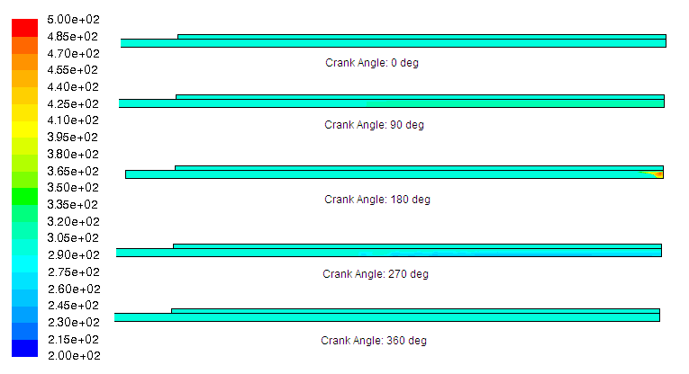
Unit (Kelvin)
Figure 3.21 The progression of temperature for the high length experiment

3.6 Acceleration Variation Experiment
3.6.1 Introduction: Low Acceleration Experiment
This low acceleration experiment shows low the piston acceleration affects the pressure, the density, and the temperature. The geometry is the same as the medium baseline experiment, which is 3mm diameter with 5cm long bore. The liquid temperature stays at 300K. The acceleration of this bore is 0.3g. The next section shows how the low acceleration experiment is set up in Fluent.

3.6.2 Methods: Low Acceleration Experiment
The geometry of the low acceleration experiment is the same as the geometry of the medium baseline experiment. This geometry is imported in Fluent software. The methods in Fluent are similar to the medium baseline experiment. The only difference is the sinusoidal piston profile is set with the stroke of 4.5cm and the angular velocity of 104rpm, which is equivalent to an acceleration of 0.3g according to equation 3.4. Having set up all of those conditions, the simulation is run, and the results are discussed below.

3.6.3 Results: Low Acceleration Experiment
Figure 3.22 shows the progression of pressure during compression and expansion. The pressure initially is the same as the atmospheric pressure, which is shown in the top plot of the figure. As the liquid compresses the air to the top dead center, the pressure increases to approximately 1.15MPa, which is approximately the same as the maximum pressure of the medium baseline experiment. As the piston returns to its initial position, the pressure reduces to atmospheric pressure.
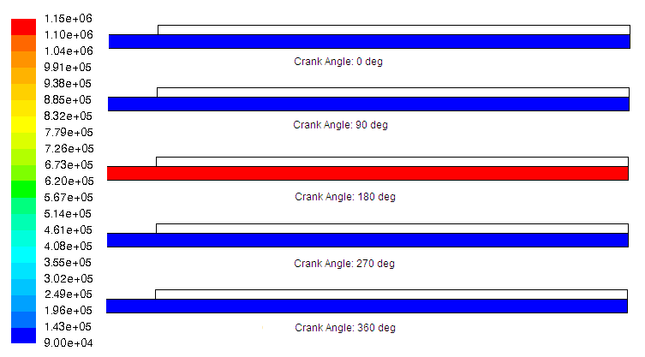
Unit (Pa)
Figure 3.22 The progression of pressure for low acceleration experiment

Figure 3.23 shows the progression of density during compression and expansion. The liquid gas interface is clearly defined at the beginning. Since this is a low acceleration experiment, the velocity of the piston is low. The viscous force should be low due to the low velocity. Therefore, as the piston reaches the top dead center, the liquid gas interface is coherent and still clearly defined, although it is not as stable as the initial interface. As the piston returns to the initial position, the interface is not clearly defined and less stable. Some bubbles are formed in the liquid column due to the gas entrainment. There are some liquid droplets stays along the wall due to the viscous force.
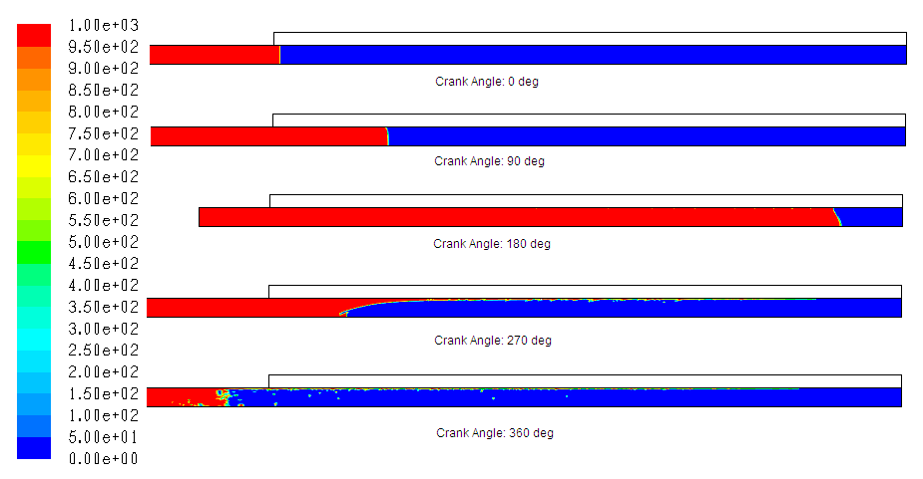
Unit (kg/m³)
Figure 3.23 The progression of density for low acceleration experiment

Figure 3.24 shows the progression of temperature during compression and expansion. The initial temperatures for the liquid, the gas, and the wall are 300K. As the piston moves towards the top dead center, the maximum temperature is approximately 500K. As the piston returns to the initial position, the temperature of the bore decreases very quickly because of the expansion and the heat transfer from the gas to the wall and to the liquid. Once the gas temperature are below 300K, the heat is transferred from the liquid and the wall to the gas since the liquid and the wall temperature are higher than the gas temperature. The temperature of the gas goes up to approximately 300K due to the transfer of heat from the liquid and the wall.
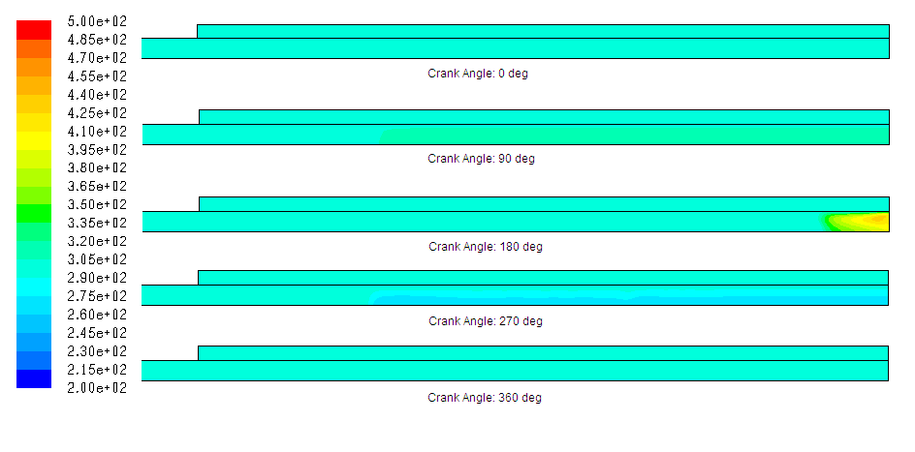
Unit (Kelvin)
Figure 3.24 The progression of temperature for low acceleration experiment

3.6.4 Introduction: High Acceleration Experiment
The high acceleration experiment is an experiment with a higher piston acceleration keeping everything else in the medium category. The piston acceleration is 0.7g. It is less than 1g because the liquid gas interface will become unstable when the piston acceleration reaches or over 1g.

3.6.5 Methods: High acceleration Experiment
The high acceleration experiment uses the same geometry as the medium baseline experiment, which is 10cm long bore, half of the bore is liquid and half of it is the air, with the radius of 1.5mm. The geometry is imported to Fluent. The same boundary conditions, material, and solution methods are used to simulate the bore. The sinusoidal piston profile is set with the stroke of 4.5cm and the angular velocity of 167rpm, which is equivalent to an acceleration of 0.7g.

3.6.6 Results: High Acceleration Experiment
Figure 3.25a shows the progression of pressure during compression and expansion. The initial pressure of the bore is the same as the atmospheric pressure, which is shown in the top plot of the figure. As the piston moves towards the top dead center, the maximum pressure is approximately 1.2MPa. The maximum pressure of this experiment is the same as the low acceleration and the medium baseline experiments. As the piston returns to the initial position, the pressure decreases to atmospheric pressure. Figure 3.25b shows the piston compresses and expands for the second cycle. The pressure of a fully compressed bore in the second cycle is slightly lower than the first cycle because there are some gases flows into the liquid column due to the gas entrainment. Some of the gas is dissolved in the liquid under high pressure. There is less gas in the gas region to compress. Therefore, the maximum pressure in the second cycle is less than the first. Compare this figure to figure 3.22, this figure shows a slightly higher pressure than the low acceleration experiment because the high acceleration experiment has a higher viscous force, which increases the pressure shown in figure 3.25.
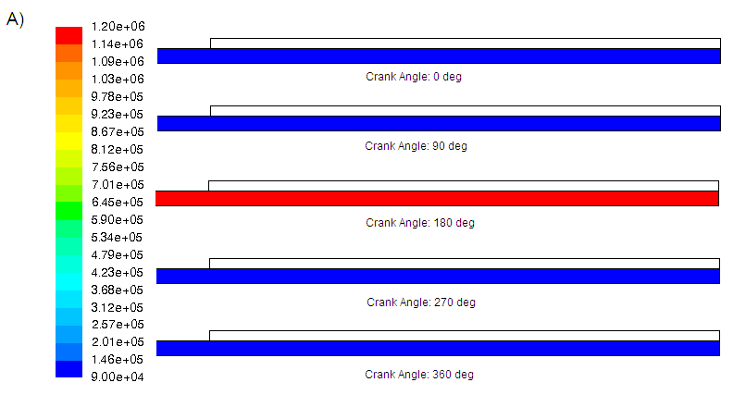
Unit (Pa)
Figure 3.25a The progression of pressure at the first cycle for the high acceleration experiment
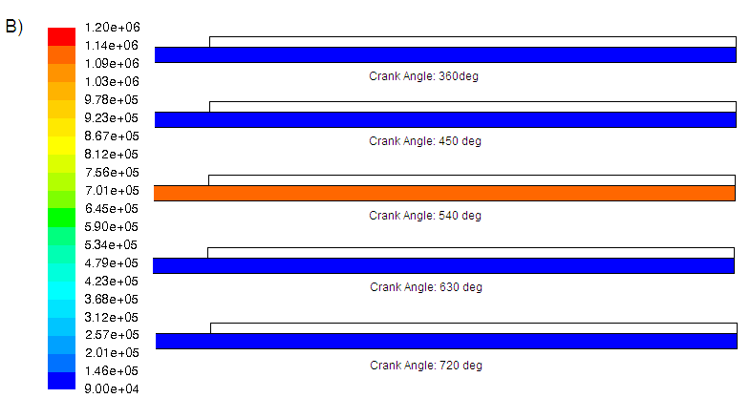
Unit (Pa)
Figure 3.25b The progression of pressure at the second cycle for the high acceleration experiment

Figure 3.26 shows the progression of density during compression and expansion. The liquid gas interface is clearly defined and coherent. High acceleration results in a high piston velocity, and thus high viscous forces. As the piston moves towards the top dead center, the gas entrainment issue can be clearly seen along the wall due to the high acceleration of the piston. Therefore, the liquid gas interface is not stable. As the piston returns to the initial position, the liquid gas interface is unstable and cannot be defined due to the acceleration of the piston. Additionally, bubbles are formed in the liquid column, and some liquid droplets stay along the wall due to the viscous forces.
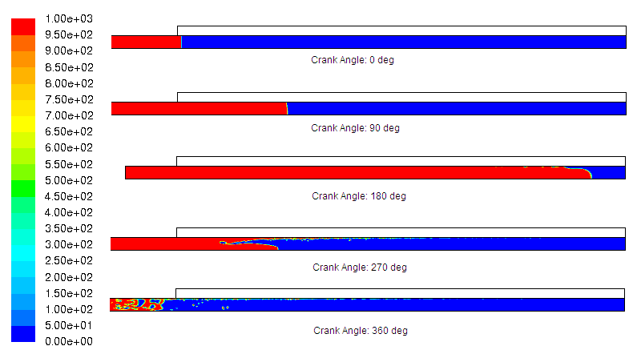
Unit (kg/m³)
Figure 3.26 The progression of density for the high acceleration experiment

Figure 3.27 shows the progression of temperature during compression and expansion. The initial temperatures of the liquid, the gas, and the wall are 300K. As the piston compresses to the top dead center, the gas temperature increases to approximately 500K. As the bore expands, gas temperature drops because of the expansion and the heat transfer from the air to the liquid and the wall. As the piston returns to the initial position, the temperature returns to 300K due to the heat transfer from the liquid and the wall to the gas.
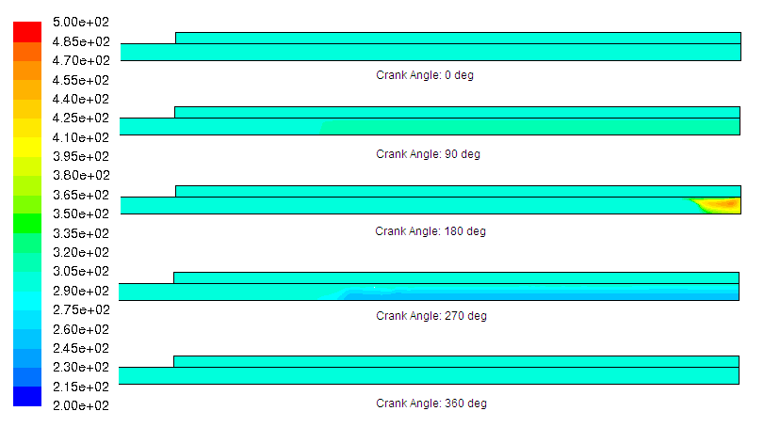
Unit (Kelvin)
Figure 3.27 The progression of temperature for the high acceleration experiment

3.7 Discussion
The radius variation experiment shows that pressure of the low radius experiment is greater than the medium baseline experiment because of the high viscous force. The viscous force also causes the liquid gas interface to be unstable when the piston returns to the initial position, as it is shown in figure 3.11. The interface becomes less coherent and difficult to define when the piston is fully compressed. The maximum temperature for this low radius experiment is approximately 400K, which is shown in figure 3.12. The maximum temperature of the medium baseline is 500K, which is shown in figure 3.2. The maximum temperature in the high radius experiment is higher than the medium experiment. This shows that as the radius decreases, heat transfer improves.
The liquid gas interface in the high radius experiment is clear defined and coherent at the end of the first cycle, which means that the viscous force is less than the medium baseline and the low radius experiment. The maximum temperature in the high radius experiment is approximately 560K, which is shown in figure 3.15. This maximum temperature is higher than the medium baseline and the low radius experiment because of the poor surface area to volume ratio, which yields a poor heat transfer.
The temperature variation experiment shows that as the temperature increases, the viscosity decreases. The lower the viscosity, less viscous force is in the bore. It can be shown in figure 3.5 that the liquid gas interface is still coherent and can be defined even when the piston returns to the initial position. On the other hand, the liquid gas interface in the low temperature experiment, which is shown in figure 3.8, is not stable when the piston returns to the initial position. The temperature figures show the gas is warmer if higher liquid temperature is used. It is important to control the water temperature to be under 373K so as not to turn liquid water become vapor.
The length variation experiment shows that the as the length increases, the liquid gas interface gets more and more unstable, as shown in figure 3.20. A long stroke means the liquid travels a longer distance. As the liquid travels a longer distance, more liquid droplets stay along the wall, and the interface is not coherent due to the viscous force. On the other hand, the low length experiment means a shorter stroke, which means less viscous force in the bore. The interface in the low length experiment, which is shown in figure 3.17, is still stable due to the low viscous force. The maximum pressure in the low length experiment, which is shown in figure 3.16, is approximately 1MPa. The maximum pressure in the high length experiment, which is shown in figure3.19, is approximately 2MPa. This difference in pressure between two experiments is because of the viscous force is higher in the high length experiment. An additional pressure is needed to overcome the high viscous force in the high length experiment.
The acceleration variation experiment shows that as acceleration increases, the liquid gas interface gets less stable. The interface in the low acceleration experiment, which is shown in figure 3.23, is more stable than the interface in the high acceleration experiment, which is shown in figure 3.26. The interface in the low acceleration experiment is more stable because the velocity of the piston is not high. Low piston velocity means the viscous force is low. Therefore, the interface in the low acceleration is more stable. On the other hand, the high acceleration experiment has a high piston velocity, which yields a high viscous force. Therefore, the interface in the high acceleration experiment is not as coherent as the medium and the low acceleration experiments. The heat transfer in the high acceleration experiment is higher than the medium and the low acceleration experiment because the heat transfer coefficient increases as velocity increases.

3.8 Conclusion
Nine computational experiments are presented in this chapter. Different inputs, including acceleration, temperature, length, and radius, are varied. Results show each individual input has an effect on the temperature, pressure, and density. For example, as radius of the bore decreases, the liquid gas interface becomes unstable due to the viscous forces, and the compression is a near isothermal. As the length of the bore increases, the pressure is greater and the interface is not as stable. As the acceleration increases, the interface becomes unstable. As the liquid temperature increases, there is more heat transfer to the gas, and there are lower viscous forces. In order to have a more stable interface, a low length, medium radius, low acceleration, and high liquid temperature should be selected. In the next chapter, post possessing works for all nine experiments are presented. Post possessing works include the calculation of viscous forces, pressure, and heat transfer.
Chapter 4 Post Possessing Work
4.1 Introduction
In the previous chapter, the results of all nine computational experiments are shown. In this chapter, the post possessing of the experimental results is presented. The post possessing includes the calculation of compression efficiency of each experiment, the calculation of the viscous forces, the mechanical work, and the heat transfer. The purpose of these calculations is to quantify the viscous force, heat transfer, and work in order to understand the similarities and differences between each case. The compression efficiency is also shown for each case to understand which case has the highest efficiency. These calculations are done by applying the conservation of energy principle, which is shown in the Methods section. The post possessing work is important because the work, heat transfer and the viscous force are evaluated with the influence of different factors. First, the viscous force, mechanical work, and heat transfer are calculated for each individual experiment. Those parameters are then compared with each other.

4.2 Methods
4.2.1 Methods: Calculating the Viscous Force, the Work, and the Heat Transfer
The conservation of energy principle is applied to calculate the viscous forces, heat transfer, and the mechanical work. These equations listed below are independent because those equations represent the viscous force, heat transfer, and work. These three terms are independent among each other. These equations are also consistent with the computational models, which also solve the energy equation. Equation 4.1 is the conservation of energy equation. The conservation of energy is applied to both liquid and gas in the bore.
$\frac{∂}{∂t}\int{{ρ\text{edV}+\int{ρ{\text{ev}}_{j}⋅n}}_{j}}\text{dA}=−\int{\text{qdA}+\int{{ρQ}_{j}\text{dV}−\int{{\text{Pv}}_{j}⋅n_{j}\text{dA}+\int{{ρf}_{i}⋅n_{i}\text{dV}+\int{v_{i}σ_{\text{ij}}⋅n_{j}\text{dA}}}}}}$ (4.1)
Equation 4.1 shows the conservation of energy equation. $ρ$is the density of the fluid, $e$is the internal energy, v is the velocity of the fluid, n is the outward facing normal vector, q is the heat energy, Q is the heat generation term, P is the pressure, f is the body forces, and $σ_{\text{ij}}$is the normal stress term. The body force is all the external forces that act on the objects. The first integral on the left hand side of equation 4.1 is the time rate of change of energy. The second integral on the left hand side is the convection of energy. The first integral on the right hand side is the heat transfer term. The second integral on the right hand side represents the heat generation term. The third integral on the right hand side represents the mechanical work term. The fourth integral on the right represents the body force term. The fifth integral represents the normal stress term. In the liquid piston gas compression case, the body force and the heat generation are assumed to be negligible. Equation 4.1 can be simplified to be the following:
$\frac{∂}{∂t}\int{{ρ\text{edV}+\int{ρ{\text{eu}}_{j}⋅n}}_{j}}\text{dA}=−\int{\text{qdA}−\int{{\text{Pu}}_{j}⋅n_{j}\text{dA}+\int{u_{i}σ_{\text{ij}}⋅n_{j}\text{dA}}}}$ (4.2)
Equation 4.2 can be discretized by the first order upwind scheme. The terms on the right hand side, the viscous forces, mechanical work, and the heat transfer are the parameters of interest. They are discretized as follows,
$\begin{aligned}−\sum_{j=1}^{m}{[(k\frac{\text{dT}}{\text{dr}}}2π\text{rdz})^{2}+(k\frac{\text{dT}}{\text{dz}}2π\text{rdr})^{2}]^{1/2}−\sum_{j=1}^{m}{[({\text{Pv}}_{r}2π\text{rdz})^{2}+({\text{Pv}}_{z}2π\text{rdr})^{2}]^{1/2}} \\ +\sum_{j=1}^{m}{\left[\begin{matrix}u_{r} \\ u_{θ} \\ u_{z}\end{matrix}\right]\left[\begin{matrix}σ_{\text{rr}} & σ_{rθ} & σ_{\text{rz}} \\ σ_{θr} & σ_{\text{θθ}} & σ_{θz} \\ σ_{\text{zr}} & σ_{zϑ} & σ_{\text{zz}}\end{matrix}\right]\left[\begin{matrix}2π\text{rdr} \\ 0 \\ 2π\text{rdz}\end{matrix}\right]}=0\end{aligned}$
(4.3)
q is the heat transfer term, which can be written as the multiplication of the thermal conductivity and the gradient of temperature. The area integrals can be replaced by the summation sign. The normal stress tensor is equal to the shear stress tensor because the liquid stays on the wall due to the shear stress. The square root of the sum of the square is used to find out the magnitude of the heat transfer and the work terms. The shear stress components are equal to the following:
$\begin{aligned}τ_{\text{rr}}=−μ[2\frac{∂v_{r}}{∂r}]+(\frac{2}{3}μ−κ)(∇⋅v) \\ τ_{\text{θθ}}=−μ[(2(\frac{1}{r}\frac{∂v_{θ}}{∂θ}+\frac{v_{r}}{r})]+(\frac{2}{3}μ−κ)(∇⋅v) \\ τ_{\text{zz}}=−μ[2\frac{∂v_{z}}{∂z}]+(\frac{2}{3}μ−κ)(∇⋅v) \\ τ_{rθ}=τ_{θr}=−μ[r\frac{∂}{∂r}(\frac{v_{θ}}{r})+\frac{1}{r}\frac{∂v_{r}}{∂θ}] \\ τ_{θz}=τ_{zθ}=−μ[\frac{1}{r}\frac{∂v_{z}}{∂θ}+\frac{∂v_{θ}}{∂z}] \\ τ_{\text{zr}}=τ_{\text{rz}}=−μ[\frac{∂v_{r}}{∂z}+\frac{∂v_{z}}{∂r}]\end{aligned}$
(4.4)
(4.5)
(4.6)
(4.7)
(4.8)
(4.9)
where $∇⋅v=\frac{1}{r}\frac{∂}{∂r}({\text{rv}}_{r})+\frac{1}{r}\frac{∂v_{θ}}{∂θ}+\frac{∂v_{z}}{∂z}$ (4.10)
$τ$with the subscript in equation 4.4 to 4.9 is the shear stress in different direction and in different plane; $∇⋅v$is zero for liquid, and non zero for gas; $κ$is the second coefficient of viscosity; $μ$is the dynamic viscosity. There are some terms that can be cancelled out, including $\frac{∂}{∂θ}$, which can be cancelled due to the axisymmetric assumption, and the term,$v_{θ}$, can be cancelled out because it is a 2 dimensional simulation. Equation 4.4 to 4.9 then becomes.
$τ_{\text{θθ}}=−2μ\frac{v_{r}}{r}+(\frac{2}{3}μ)(∇⋅v)$ (4.11)
$τ_{rθ}=τ_{θr}=τ_{zθ}=τ_{θz}=0$ (4.12) When all the components of the shear stress are substituted to equation 4.3, it becomes.
$m$ Equation 4.13 was programmed in MATLAB, which can be found in appendix A. Before the simulation, some information, including the temperature, velocity, density, viscosity etc, are extracted from the Fluent simulation code. Equation 4.13 integrates the liquid and gas over the space. After integrating over space, Integration is also required over time. The intermediate case files in Fluent serve as the intermediate time step. In order to integrate over all time steps, the heat transfer, the viscous, and the work terms for individual time step are added up from the beginning of the stroke to the top dead center. All three terms are only added up to the top dead center because as the piston reaches the top dead center, the gas leaves the cylinder in air compressor application. As the piston retracts to its original position, new gas enters cylinder, and another stroke occurs.
(4.13)

4.2.2 Methods: Calculating the Compression Efficiency
Having discussed the method to calculate the viscous, heat transfer, and the work, the method to calculate the compression efficiency is discussed. The compression efficiency is defined as the ratio of the work applied to the actual compression to the pressure and volume of the cooled actual work case. The actual compression work is the integral of pressure times the differential volume.
$η=\frac{W_{\text{ideal}}}{W_{\text{actual}}}$ (4.14)
$W_{\text{actual}}=\int{P_{g}{\text{dV}}_{g}}$ (4.15)
$W_{\text{ideal}}=\int{P_{i}{\text{dV}}_{i}}$ (4.16)
Where $η$is the compression efficiency, $W_{\text{ideal}}$ is the cooled actual work, $W_{\text{actual}}$ is the actual mechanical work, $P_{g}$is the pressure of the gas, $V_{g}$ is the volume of the gas,$P_{i}$ is the cooled pressure, and $V_{i}$ is the cooled volume. A numerical integral of the actual mechanical work results in the product of the pressure and the volume change.
$W_{\text{actual}}=\sum{P_{g}∗(V_{g2}−V_{g1})}$ (4.17)
Where $V_{g2}$is the new gas volume, and $V_{g1}$is the previous gas volume. The gas pressure and volume can be extracted from ANSYS Fluent. The summation goes from the first time step to the fully compressed cycle because the compressed gas leaves the cylinder when the piston reaches the top dead center.
The cooled actual work, which is equation 4.16, is the work from an isothermal compression. By making the assumption of ideal gas behavior, the state of the gas is described by the following.
$P_{1}V_{1}={\text{nR}}_{g}T_{1}$ (4.18)
Where n is the number of mole of gas in the cylinder, $R_{g}$is the universal gas constant, T is the temperature, and the subscript 1 refers to the initial state. Because n, R, T are constant due to the isothermal assumption, equation 4.18 becomes.
$\text{PV}=P_{1}V_{1}$ (4.19)
Rearrange equation 4.18, the equation becomes,
$P=\frac{P_{1}V_{1}}{V}$ (4.20)
Equation 4.20 is substituted into equation 4.16, the equation becomes.
$W_{\text{ideal}}=\int_{V_{1}}^{V_{2}}{\frac{P_{1}V_{1}}{V}\text{dV}}$,$W_{\text{ideal}}=P_{1}V_{1}\text{ln}\left(\frac{V_{2}}{V_{1}}\right)$ (4.21)
Since $\frac{V_{2}}{V_{1}}$is equal to $\frac{P_{1}}{P_{2}}$, equation 4.21 becomes.
$W_{\text{ideal}}=P_{1}V_{1}\text{ln}\left(\frac{P_{1}}{P_{2}}\right)$ (4.22)
The results for the viscous force, the mechanical work, the heat transfer, and the compression efficiency for the length, the radius, the acceleration, and the liquid temperature are compared based on a unit volume basis. Those results are presented in the next section.

4.3 Results and Discussion
4.3.1 Results and Discussion: The Low, the Medium, and the High Radius Experiments
Figure 4.1 shows the heat transfer energy, the compression work, and the work due to viscous forces for the three diameter experiments. The work due to viscous forces decreases as the radius increases, which is predicted and is shown in the previous chapter. The work term decreases from 1mm radius to 3mm radius and increases from 3mm radius to 5mm radius. The reason for the decrease is due to decreasing viscous forces as radius increases. As the viscous forces decrease, less work is required to push the piston upward or downward. The heat transfer term decreases as the radius increases, which is also predicted. The heat transfer term decreases because of the poor surface area to volume ratio.

Figure 4.1 The work due to viscous forces, the compression work and the heat transfer energy for each diameter experiments

Table 4.1 shows the compression efficiency for the low, medium baseline, and the high radius experiments. As it shows in table 4.1, the compression efficiency for the low radius experiment is 71%. The medium baseline experiment has a compression efficiency of 85%. The high radius experiment has a compression efficiency of 82.8%. The detailed calculation of those three experiments are shown in appendix E. The low radius experiment has a lower efficiency than the medium baseline experiment because of the viscous force. Additional mechanical work is needed to overcome the viscous force, which drives the efficiency down. The high radius experiment has a lower efficiency than the medium baseline experiment because additional mechancial work is needed to provide heat to the gas due to a poor surface area to volume ratio. The results of the viscous, the heat transfer, and the work for the length experiments are presented in the next section.

Table 4.1 Radius results for compression efficiency and the parameters of interest
Radius
 | Low | Medium | High
 | 1mm | 3mm | 5mm
Viscous energy per unit volume (W/m^3) | 3.64*10^5 | 3.36*10^4 | 1.11*10^4
Thermal energy per unit volume (W/m^3) | 2.55*10^8 | 1.45*10^8 | 8.73*10^7
Work per unit volume (W/m^3) | 3.12*10^10 | 1.48*10^10 | 2.02*10^10
Actual work (J) | -0.0171 | -0.10 | -0.311
Ideal work (J) | -0.0121 | -0.09 | -0.257
Efficiency | 0.71 | 0.85 | 0.828

4.3.2 Results and Discussion: Low, Medium, and High Length Experiments
Figure 4.2 shows the compression work, work due to viscous forces, and the heat transfer energy for the three length experiments. The viscous forces increases as the length increases because as the stroke gets longer, the liquid needs to travel a longer distance, which increases the viscous forces. The work term increases as the length increases because more mechancial work is needed to overcome the viscous force as the length increases. The heat transfer term decreases as the length increases because the angular velocity of the piston for the low length experiment is faster than the angular velocity for the high length experiment with the acceleration being constant. As shown in equation 3.4. With the piston acceleration being constant and a shorter stroke, the maximum angular velocity of the piston increases. Therefore, the piston of the low length experiment, which has a shorter stroke, moves faster than the medium and the high length experiments. A faster piston means that more heat transfer due to convection appears in the bore. Therefore, the low length experiment has a higher heat transfer within the bore.

Figure 4.2 The work due to viscous forces, the compression work and the heat transfer energy for each length experiments

Table 4.2 shows the compression efficiency for the low, medium, and the high length experiments. Appendix H shows the detailed calculation of the compression efficiency of the low and the high length experiments. The low length experiment has a compression efficiency of 86.4%. The medium baseline experiment has a compression effiency of 85%. The high length experiment has a compression efficiency of 79.3%. The low length experiment has a higher efficiency than the medium baseline experiment because the viscous force in the low length experiment is less than the medium and the high length experiments. Less mechanical work is used to overcome the viscous force, which increases the efficiency. The high length experiment has a lower compression efficiency than the medium experiment because of the increase in viscous force and the poor heat transfer due to a slower piston velocity in the high length experiment.

Table 4.2 Length results for the compression efficiency and parameters of interest
Length
 | Low | Medium | High
 | 0.02m | 0.05m | 0.1m
Viscous energy per unit volume (W/m^3) | 1.43*10^3 | 3.36*10^4 | 7.31*10^4
Thermal energy per unit volume (W/m^3) | 1.97*10^8 | 1.45*10^8 | 1.14*10^8
Work per unit volume (W/m^3) | 1.23*10^10 | 1.48*10^10 | 3.38*10^10
Actual work (J) | -0.036 | -0.102 | -0.255
Ideal work (J) | -0.031 | -0.087 | -0.203
Efficiency | 0.864 | 0.851 | 0.793

4.3.3 Results and Discussion: The Low, the Medium, and the High Acceleration Experiments
Figure 4.3 shows the work due to viscous force, the compression work, and the heat transfer energy with different acceleration experiments. The viscous forces increases as the acceleration increases because the viscous forces is directly proportional to the velocity, which correlates to the liquid gas interface for the high acceleration experiment is less stable than the interface for the low acceleration experiment in chapter 3. The work increases as the acceleration increases because the increase in viscous force. The heat transfer increases as the acceleration increases because the velocity for the high acceleration experiment is faster than the low acceleration experiment. The higher the velocity, the more the heat transfer is in the bore.

Figure 4.3 The work due to viscous forces, the compression work and the heat transfer energy for each acceleration experiments

Table 4.3 shows the compression efficiency for the low, medium, and high acceleration experiments. Appendix K shows the compression efficiency for the low and the high acceleration experiments. The compression efficiency for the low, the medium, and the high acceleration experiment are 85.6%, 85%, and 84.2% respectively. The low acceleration experiment has a higher efficiency than the medium baseline experiment and the low acceleration experiment because of the increase in viscous force as the acceleration increases. The next section discusses the effects of the low, the medium, and the high liquid temperature on the viscous, the heat transfer, and the work.

Table 4.3 Accelereation results for the compression efficiency and parameters of interest
Acceleration
 | Low | Medium | High
 | 0.3g | 0.5g | 0.7g
Viscous energy per unit volume (W/m^3) | 1.78*10^4 | 3.36*10^4 | 3.85*10^4
Thermal energy per unit volume (W/m^3) | 1.27*10^8 | 1.45*10^8 | 1.52*10^8
Work per unit volume (W/m^3) | 1.18*10^10 | 1.48*10^10 | 1.88*10^10
Actual work (J) | -0.100 | -0.102 | -0.103
Ideal work (J) | -0.086 | -0.087 | -0.087
Efficiency | 0.856 | 0.851 | 0.842

4.3.4 Results and Discussion: Low, Medium, and High Liquid Temperature Experiments
Figure 4.4 shows the work due to viscous force, the compression work, and the heat transfer energy with different liquid temperature experiments. The viscous force decreases as the liquid temperature increases because the viscosity of water decreases with increasing temperature. Therefore, the lower the fluid viscosity, the lower the viscous force. The heat transfer in the low liquid temperature experiment is higher than the heat transfer in the medium experiment because the liquid temperaure in the low temperature experiment is different from the air and the wall temperature. There are some initial heat transfer from the air and the wall to the liquid before compression. The high liquid temperature experiment has a higher heat transfer than the medium experiment because the liquid transfers heat to the gas and the wall initially. The mechanical work slightly decreases from the low liquid temperature to the medium experiment because the decrease in viscous force, which requires less work to overcome the viscous force. The work increases slightly from the medium experiment to the high temperature experiment because of the higher gas pressure as the gas temperature goes up. If the volume of the bore in the high liquid temperature experiment is the same as the medium experiment, the gas pressure increases when the gas temperature increases according to the ideal gas law. Increaasing gas pressure increases the mechanical work of the bore. Therefore, the work increases from the medium to high temperature experiment.The compression efficiency of the low, the medium, and the high liquid temperature are compared in the next section.
Figure 4.4 The work due to viscous forces, the compression work and the heat transfer energy for each temperature experiments

Table 4.4 shows the compression efficiency of the low, medium, and high liquid temperature experiments. Appendix N shows the detailed calculation of the compression efficiency for the low, the medium, and the high liquid temperature. The compression efficiency for the low, the medium, and the high liquid temperature are 85.03%, 85%, and 84.98% respectively. The compression efficiency are relatively the same because the change in viscous force and the mechanical work from the low liquid temperature to the high liquid temperature experiments are not very significant.
Table 4.4 Liquid temperature results for the compression efficiency and parameters of interest
Liquid Temperature
 | Low | Medium | High
 | 290K | 300K | 320K
Viscous energy per unit volume (W/m^3) | 3.77*10^4 | 3.36*10^4 | 1.78*10^4
Thermal energy per unit volume (W/m^3) | 1.99*10^8 | 1.45*10^8 | 8.37*10^8
Work per unit volume (W/m^3) | 1.53*10^10 | 1.48*10^10 | 1.63*10^10
Actual work (J) | -0.1019 | -0.102 | -0.1034
Ideal work (J) | -0.0866 | -0.087 | -0.0878
Efficiency | 0.8503 | 0.851 | 0.8498

4.4 Conclusion
The computational experiments calculate the viscous force, heat transfer, pressure, and the compression efficiency. The viscous force decreases as the radius increases because viscous force is lower as the radius increases. On the other hand, the heat transfer increases as the radius decreases due to the increase in surface area to volume ratio. Therefore, the mechanical work is high for the low radius experiment due to the increase in viscous forces. The mechanical work is high for the high radius experiment due to the decrease in heat transfer. The medium baseline experiment has the highest efficiency because the low radius experiment has a high viscous force, and the high radius experiment has poor heat transfer.
The viscous force increases as the length increases because of the long stroke and high swept volume. The heat transfer decreases as the length increases because of the slower angular velocity with increasing length. The work increases as length increases because the viscous force increases.
The acceleration experiments show that the higher the acceleration, the higher the viscous force due to the increase in piston velocity. The heat transfer also increases as acceleration increases because the higher piston velocity increases the convectivve heat transfer. The work increases as the length increases because more work is required to overcome the viscous force, despite the improved heat transfer.
The liquid temperature experiment shows the viscous force decreases as the liquid temperature increases. The viscous force decreases because the viscosity of water decreases as temperature increases. The heat transfer decreases from the low liquid temperature to medium baseline experiment because of the initial heat transfer before compression. The heat transfer increases from medium to high temperature experiment because of the initial heat transfer from the liquid to the gas.
If the design criteria is to maximize the heat transfer, a low length, high acceleration, low radius, and high or low liquid temperature is selected. The low length experiment is selected to increase heat transfer because the frequency of the cycle increases as the length decreases keeping the acceleration constant. As the frequency increases, the convective heat transfer increases. The high or low liquid temperature can be used because it depends on the application. If the heat is transferred to the gas, a high liquid temperature can be used. If the heat is removed from the gas, a low liquid temperature can be used.
The compression efficiencies correlate well with the viscous, the heat transfer, and the mechanical work plots. The increase in viscous force and the decrease in heat transfer reduces the compression efficiency. The highest compression efficiency for the radius category is the medium beaseline experiment, which is 85% efficient. The highest compression efficiency for the length category is the low length experiment. The highest compression efficiency for the acceleration experiment is the low acceleration experiment. The highest compression efficiency for the liquid temperature experiment is the low liquid temperature experiment. If only compression efficiency is considered,the bore is going to be with medium radius, low length, low acceleration, and low liquid temperature. However, there are other factors that affects the the bore. The liquid temperature, for example, may need to increase to a higher temperature in order to heat the gas up to a desired temperature.

Chapter 5 Conclusion
  - Review
The liquid piston gas compression concept is divided the compression chamber into many small bores. Those small bores can increase the surface area to volume ratio, which increases the heat transfer rate. Liquid is on top of the mechanical piston, which pushes the liquid up through the small bores and compresses the gas. Liquid is used because it can conform to any irregular volume. This is a gas compression system improves the heat transfer within the bore, which improves the compresison efficiency. Another advantage for the liquid piston is that it is portable due to its small size. One bore size is only 3mm. If 10 bores are inside the cylinder, the total volume of the cylinder is about 20cm³. Therefore, it can be used anywhere.
Most of the conventional gas compression systems are near adibatic. However, as the radius of the bore gets smaller, the compression approaches a near isothermal process due to the increase in surface area to volume ratio. However, as the radius decreases, the viscous force increases. Other than the radius, there are other factors that affect the viscous force, mechanical work, and heat transfer of the bore. Therefore, computational fluid dynamics is used to investigate the radius, length, piston acceleration, and the liquid temperature to maximize the heat transfer and minimize the viscous force in the bore.
The preliminary investigation chapter shows the evolution of the modeling of the liquid piston gas compression. There are three computational models in chapter 2. The first model is the compression and expansion model without heat transfer from the wall. The second model is the compression and expansion model with heat transfer from the wall. The third model is the liquid piston gas compression model. Air is the only fluid in the first and the second models. Liquid and gas are presented in the third model.
Having created the CFD models in the liquid piston gas compression, the computational experiments were presented in chapter 3 in order to see how different factors including the radius, length, liquid temperature, and the acceleration affect the pressure, temperature, and the density of the bore. There are a total of nine computational experiments, which include the medium baseline. All the other cases are varied between low and high values for each factor keeping the rest of the factors in medium case. The radius experiments vary between 1mm and 5mm. The length experiments vary between 2cm and 10cm. The piston acceleration experiments vary between 0.3g and 0.7g. The liquid temperature experiments vary between 290K and 320K.
Chapter 4 shows the post possessing work in order to calculate the viscous energy, heat transfer, the work, and the compression efficiencies of different experiments. Some of the values, which include the temperature, pressure, and the density, are extracted from the Fluent code. The conservation of energy is used to analyze the viscous, heat transfer and the work on both liquid and gas in the bore. The compression efficiency is calculated by the ideal work divided by the actual work. The actual work is the integral of pressure with the change in volume. The ideal work is from the equation of state with isothermal compression.

5.2 Conclusions
- The liquid piston model in chapter 2 shows that as the liquid returns to its original position, the liquid stays along the wall due to the viscous force.
- Liquid gas interface becomes unstable when the acceleration of piston is greater than the gravity. This put a limit in the frequency of compression cycle. This application of liquid piston is only limited to smaller, high frequency systems.
- Gas entrainment occurs in the liquid, which creates bubbles in the liquid column.
- In the radius variation experiment shown in chapter 3, the compression is a near isothermal compression as the radius decreases. However, the viscous force increases as the radius decreases. As the radius becomes large, poor surface area to volume ratio causes a poor heat transfer, which increases the gas temperature in the bore.
- In the radius variation experiment shown in chapter 4, the viscous force and the heat transfer increase as the radius decreases. The mechanical work increases in the low radius experiment because additional work is required to overcome the viscous force. The mechanical work increases in the high radius experiment because additional work is required to increase the internal energy of the gas through increasing the temperature.
- The highest compression efficiency of the radius variation experiment is medium baseline experiment. The low radius experiment has a high viscous force, which reduce the efficiency of the compression. The high radius experiment has a poor heat transfer, which also reduce the efficiency of the compression.
- The temperature variation experiments in chapter 3 show the viscous force decreases as the liquid temperature increases. If the high liquid temperature is used, the gas temperature also increases due to the heat transfer between the liquid and the gas. On the other hand, if low liquid temperature is used, the gas temperature decreases.
- The liquid temperature variation experiment in chapter 4 shows the viscous force decreases as the liquid temperature increases. The viscous force decreases because the viscosity decreases as the temperature increases. The heat transfer increases in the low liquid temperature and in the high liquid temperature experiments because of the initial heat transfer between the liquid and the gas. The mechanical work increases from the medium to low liquid temperature because of the increase in viscous force.
- The compression efficiencies of all three temperature variation experiment are very close because the change in viscous force and the mechanical work from the low liquid temperature to the high liquid temperature experiments are not very significant.
- The length variation experiment in chapter 3 shows the longer the stroke, the higher the viscous force. The liquid gas interface in the high length experiment is more unstable than the interface in the low length experiment. In the high length experiment, more bubbles are in the liquid column due to the gas entrainment. The viscous force increases the pressure of the bore because more pressure is required to overcome the viscous force as the length increases.
- The length variation experiment in chapter 4 shows the viscous force increases as the length increases. The viscous force increases as length increases because of the long stroke. The heat transfer decreases as the length increases because of the increase in the angular velocity. The work increases as the length increases because of the increase in viscous force and the poor heat transfer.
- The highest compression efficiency for the length variation experiment is the low length experiment. The low length experiment has the highest efficiency because it has a low viscous force and a high heat transfer. As the length gets longer, the high viscous force and poor heat transfer lead to a decrease in compression efficiency.
- The acceleration variation experiments in chapter 3 shows the viscous force increases as the acceleration increases because of increasing velocity. When the low and high acceleration are compared, the liquid gas interface in the high acceleration experiment is less stable than the low acceleration experiment.
- The acceleration variation experiment in chapter 4 shows the viscous force increases as acceleration increases because of the increase in velocity. The heat transfer increases as the acceleration increases because of the increase in the piston velocity. The work increases as the acceleration increases because the viscous force increases.
- The highest compression efficiency of the acceleration variation experiment is the low acceleration experiment. The low acceleration experiment has the highest compression efficiency because of the low viscous force. It is also recommend that the piston acceleration should not be higher than the 0.5g because the surface stability becomes an issue as the piston acceleration increases.
- The results from the above chapters shows that in order to maximize the heat transfer and minimize the viscous force, the medium radius and low length should be selected because the low radius experiment has a high viscous force, and the high radius experiment has poor heat transfer.
- The liquid temperature depends on the application of the gas compression.
- If the gas temperature is designed to be below certain temperature, the liquid temperature can be set at a lower temperature, but the liquid temperature should be above the melting point of the liquid.
- If the gas temperature is designed to be above certain temperature, the liquid temperature can be set at a higher temperature, but the liquid temperature should be below the boiling point of the liquid.
- The acceleration of the piston cannot be larger than 1g because the liquid gas interface is unstable if the piston acceleration is greater than 1g.

5.3 Recommendations for future work
The future work includes the need to simulate the whole cylinder with many bores instead of simulating one bore. Throughout this research, one bore is simulated and analyzed. In order to understand the viscous and heat transfer in the whole compression chamber, the whole chamber should be analyzed. The simulation of the whole compression chamber is a complicated process. It takes a long time to create the model and a long computational time. It may involve a number of steps before getting to the simulation of the whole compression cylinder. The steps include making an axisymmetric multi bore in a single compression cylinder with liquid compresses the gas. After simulating the axisymmetric model, the full 3D liquid piston gas compression can be created. It takes a longer computational time for the 3D model to simulate. The viscous force, work, and the heat transfer of the whole compression cylinder can be analyzed from the 3D liquid piston gas compression model.
The surface instability should be quantified. One of the issues with surface instability is the gas entrainment problem, where gas bubbles penetrate into the liquid column. Therefore, one way to quantify the surface instability is to determine the average density of the liquid before and after the stroke in the liquid column. This method calculates the liquid loss in the liquid column depends on the gas entrainment and the viscous force. Therefore, an analytical method for liquid loss due to gas entrainment should be determined.
More computational experiments can be conducted so that the influence of different factors on the liquid piston can be further understood. More experiment can be conducted on varying different factors without keeping other factors in the medium control case. For example, the low radius, high length, low piston acceleration, and low liquid temperature can be simulated. The medium radius, low length, medium piston acceleration, and high liquid temperature can be simulated. The high radius, medium length, low piston acceleration, and the low liquid temperature can be conducted. Those computational experiments can be conducted so that more information about the liquid piston can be understood. The information includes the viscous force, work, heat transfer, and the compression efficiency for the experiments. Also, the influence of different factors on the liquid piston can be understood.
The third recommendation is that different liquid other than water can be used. Liquid water temperature is between 0C to 100C. Some of the gas compression application may require the gas temperature to be higher than 500C or lower than 0C. In those situations, liquid water cannot be used as the liquid in the liquid piston. Some other liquid that has a higher boiling point and a lower melting point should be used. However, there are different fluid properties for different liquid at different temperature. The fluid viscosity is major concern for this liquid piston system because the viscosity of the fluid is one of the factors affect the viscous force within the bore. The viscous force causes the increase in mechanical work because more work is needed to overcome the viscous force.
The last recommendation is to conduct a physical experiment on this liquid piston gas compression in order to understand how the physical results correlate with the computational model. The physical model has a piston or a cam that drives the liquid up and down the cylinder. There are many small bores within the cylinder. The pressure, density, and the temperature of the gas are recorded as the piston compresses and expands the gas. A small heat exchanger is used and placed next to the cylinder in order to maintain a constant liquid temperature. After the liquid enters the cylinder, it is recommended to wait for a short amount of time so as to stabilize the liquid gas interface. The piston acceleration also needs to be carefully controlled.

References

[1] Moran, M. J., Shapiro, H.N., Fundamentals of Engineering Thermodynamics, 5th edition
[2] West, C. D., Liquid Piston Stirling Engine, Van Nostrand Reinhold Company Inc., New York
[3] Reitz R.D., Rutland, C.J., Development and Testing of Diesel Engine CFD Models, Progress in Energy and Combustion Science, Vol. 21, pp 173-196, 1995
[4] Payri, F., Benajes, J., Margot, X., Gil, A., CFD modeling of the in-cylinder flow in direct-injection Diesel engines, Computers and Fluids, Vol. 33, issue 8, pp 995-1021, 2004
[5] Joyce, N.G., Humphrey Pump - Internal Combustion Pump, Conference of Small Engines and Their Fuels In Developing Countries, p 31-44, Sept 1984
[6] Gerstmann J, Hill WS. Isothermalization of Stirling heat-actuated heat pumps using liquid pistons, Intersociety energy conversion engineering conference, 1, San Diego, CA; 1986. p. 377–82.
[7] Van de Ven, J.D. Mobile hydraulic power supply: Liquid piston Stirling engine pump. Renewable Energy, vol. 34, pp. 2317-2322. 2009
[8] Crandall, I.B. Theory of Vibrating Systems and Sounds. Van Nostrand, Princeton, N.J. 1927.
[9] Chan K.W. and Baird, M.H.I. Wall Friction in Oscillating Liquid Columns. Chem.Eng. Sci., vol.29, pp. 2091-2099. 1974
[10] Kays, W.M. and London, A.L., Compact Heat Exchangers, Third edition, Krieger Publishing Company, Florida, 1998
[11] Kornhauser, A.A., Smith, J.L., Application of a Complex Nusselt Number to Heat Transfer During Compression and Expansion, Journal OF Heat Transfer, vol. 116. 1994.
[12] Taylor, G, “The Instability of Liquid Surfaces when Accelerated in a Direction Perpendicular
to their Planes. I,” Proceedings of the Royal Society of London. Series A, Mathematical and Physical Sciences, Vol. 201, No. 1065, 1950, pp. 192-196.
[13] Lewis, D.J., “The Instability of Liquid Surfaces when Accelerated in a Direction Perpendicular
to their Planes. II,” Proceedings of the Royal Society of London. Series A, Mathematical and Physical Sciences, Vol. 202, No. 1068, 1950, pp. 81-96.
[14] Burley, R. and Kennedy, B. S., “An experimental study of air entrainment at a solid/liquid/gas interface,” Chemical Engineering Science, Vol. 31, issue 10, 1976, Pages 901-911
[15] Valha, J. and Kubie, J., “Stability of a gas-liquid interface in a periodic vertical motion,” Chemical Engineering Science, Volume 51, Issue 22, November 1996, Pages 4997-5006
[16] Epstein, M, Burelbach, J.P., Fauske, H.K., Kubo,S., Koyama, K., “Liquid–liquid interface stability in accelerating and constant-velocity tube flows,” Nuclear Engineering and Design, Volume 210, Issues 1-3, December 2001, Pages 37-51
Appendices
Appendix A MATLAB Programming Code to Calculate the Viscous, Heat Transfer, and Work
% Lak Kin Wong
% Post Possessing code

clc; clear all; close

ndata = dlmread('Intermediate case files-0360', ',', 1);
ndata= sortrows(ndata,[2 3]);
ndata(19772:19845,:) = [];
n = length(ndata);

for j = 1:n
nodenum(j) = ndata(j,1);
L(j) = ndata(j,2);
r(j) = ndata(j,3);
P(j) = ndata(j,4);
rho(j) = ndata(j,5);
V(j) = ndata(j,6);
Vz(j) = ndata(j,7);
Vr(j) = ndata(j,8);
T(j) = ndata(j,9);
e(j) = ndata(j,10);
mu(j) = ndata(j,11);
k(j) = ndata(j,12);
end

dr = zeros(1,n);
dVr = zeros(1,n);
dVrdr = zeros(1,n);
dVrdz = zeros(1,n);
drVr(1) = zeros(1,n);
dTdr(1) = zeros(1,n);

for j=2:n
dr(j) = (ndata(j,3)-ndata(j-1,3));
rVr(j) = ndata(j,3)*ndata(j,8);

if ndata(j,2)==ndata(j-1,2)
drVr(j) = rVr(j)-rVr(j-1);
dVr(j) = ndata(j,8)-ndata(j-1,8);
dVz(j) = ndata(j,7)-ndata(j-1,7);
dT(j) = T(j) - T(j-1);

else
dVr(j) = 0;
dVz(j) = 0;
drVr(j) = 0;
dT(j) = 0;
end

dTdr(j) = dT(j)/dr(j);
dVrdr(j) = dVr(j)/dr(j);
dVzdr(j) = dVz(j)/dr(j);
drVrdr(j) = drVr(j)/dr(j);
end

for j = 39:75
dz(j) = ndata(j,2)-ndata(j-38,2);
dVrdz(j) = (ndata(j,8)-ndata(j-38,8))/dz(j);
dVzdz(j) = (ndata(j,7)-ndata(j-38,7))/dz(j);
dTdz(j) = (dT(j)-dT(j-38))/dz(j);
end

dz(76) = 0;
dVrdz(76) = 0;
dVzdz(76) = 0;
dTdz(76) = 0;

for j = 77:39076
dz(j) = ndata(j,2)-ndata(j-39,2);
dVrdz(j) = (ndata(j,8)-ndata(j-39,8))/dz(j);
dVzdz(j) = (ndata(j,7)-ndata(j-39,7))/dz(j);
dTdz(j) = (dT(j)-dT(j-39))/dz(j);
end

for j = 39077:n
dz(j) = ndata(j,2)-ndata(j-38,2);
dVrdz(j) = (ndata(j,8)-ndata(j-38,8))/dz(j);
dVzdz(j) = (ndata(j,7)-ndata(j-38,7))/dz(j);
dTdz(j) = (dT(j)-dT(j-38))/dz(j);
end

for j = 1:n

if ndata(j,5) < 10 && r(j) > 0
shear_rr(j) = -2*ndata(j,11)*dVrdr(j)+(2/3*mu(j)*… ((1/r(j)*drVrdr(j))+dVzdz(j)));
shear_zz(j) = -2*ndata(j,11)*dVzdz(j)+(2/3*mu(j)*… ((1/r(j)*drVrdr(j))+dVzdz(j)));
shear_tt(j) = -2*ndata(j,11)*ndata(j,8)/ndata(j,3)+(2/3*mu(j)*… ((1/ndata(j,3)*drVrdr(j))+dVzdz(j)));
else
shear_rr(j) = -2*ndata(j,11)*dVrdr(j);
shear_tt(j) = -2*ndata(j,11)*ndata(j,8)/ndata(j,3);
shear_zz(j) = -2*ndata(j,11)*dVzdz(j);
end
shear_rz(j) = -ndata(j,11)*(dVrdz(j) + dVzdr(j));
shear_zr(j) = shear_rz(j);
shear_rt(j) = 0; shear_tr(j) = 0; shear_tz(j) = 0; shear_zt(j) = 0;

vis_rr(j) = 2*pi*ndata(j,8)*shear_rr(j)*dr(j)*ndata(j,3);
vis_rz(j) = 2*pi*ndata(j,7)*shear_rz(j)*ndata(j,3)*dz(j);
vis_zr(j) = 2*pi*ndata(j,8)*shear_zr(j)*dr(j)*ndata(j,3);
vis_zz(j) = 2*pi*ndata(j,7)*shear_zz(j)*ndata(j,3)*dz(j);
vis_r(j) = sqrt(vis_rr(j)^2 + vis_rz(j)^2);
vis_z(j) = sqrt(vis_zr(j)^2 + vis_zz(j)^2);
vis(j) = sqrt(vis_r(j)^2+vis_z(j)^2);
end

vis_total = sum(vis)

for j = 1:n
Pgage(j) = P(j)-101325;
PVrA(j) = Pgage(j)*Vr(j)*r(j)*2*pi*dz(j);
PVzA(j) = Pgage(j)*Vz(j)*2*pi*r(j)*dr(j);
PVA(j) = sqrt(PVrA(j)^2 + PVzA(j)^2);
if PVzA(j) < 0
PVA(j) = -PVA(j);
end
end
PVA_total = sum(PVA)

for j = 1:n
kTrA(j) = k(j)*dTdr(j)*2*pi*r(j)*dz(j);
kTzA(j) = k(j)*dTdz(j)*2*pi*r(j)*dr(j);
kTA(j) = sqrt(kTrA(j)^2 + kTzA(j)^2);
if kTrA(j) < 0
kTA(j) = -kTA(j);
end
end
kTA_total = sum(kTA)
kTrA_total = sum(kTrA)
kTzA_total = sum(kTzA)
rr = sum(vis_rr)
rz = sum(vis_rz)
zr = sum(vis_zr)
zz = sum(vis_zz)
PVr = sum(PVrA)
PVz = sum(PVzA)

