  - Day 3 Class Activity

Policy Brief Rubric & Guide
Final Project
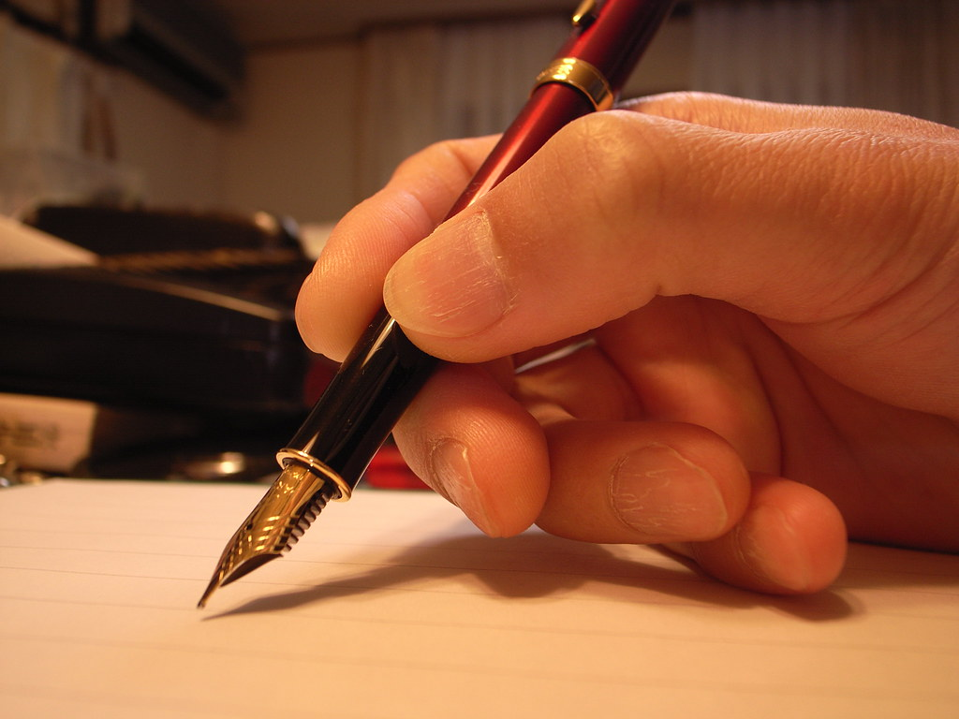
"In writing" by matsuyuki is marked with CC BY-SA 2.0.

Overview:
Now that you have a grasp on the basics of restoration and the story of the red wolf, it’s time to apply what you’ve learned as well as exercise your research and writing skills. Red wolf restoration has faltered in recent years due to politics and mismanagement. Your duty is to research into other species restoration cases and tactics in combination with more in-depth research on the red wolf to create a 2-3 page policy brief that addresses these modern challenges and offers suggestions on the best way to solve them.

Rubric:
 | Poor | Sufficient | Excellent
Title Page/Abstract
Title is descriptive and creative; it highlights the main topic and its relevance.
Abstract contains key points and overview of paper. It has a clear thesis and demonstrates the problem, solutions, and overall relevance.
Analysis
There exists a clear problem, with evidence-based claims and analysis that supports said claims.
Arguments made throughout the brief follow clear and persuasive logic that leaves no room for easy criticism
Brief reflects high-quality analytical research and avoids non-evidence-based claims and reasoning
Recommendations avoid generalizations and are backed by evidence/research
Recommendations are clear, make sense, and are appropriate in their objective
Writing/Formatting
Writing style is professional, specific, and avoids generalizations
Paragraphs are coherent and flow together in a way that makes sense; good transitioning is used
Descriptive headings separate each section and provide good overview of the respective paragraph.
Sentences are clear in their meaning and appropriate verb tense is used. Contractions are avoided
Minimal grammatical and spelling mistakes
Proper in-text citations are used as well as figure references
Bibliography/sources are in a consistent style (CSE, MLA, APA acceptable)
References are peer-reviewed or government websites and are appropriate for the topic
At least 10 sources are included

