project number: MQP-WAA-IN08

Global Capitalism: Defenders & Critics
A Major Qualifying Project Report:
submitted to the Faculty
of the
WORCESTER POLYTECHNIC INSTITUTE
in partial fulfillment of the requirements for the

Degree of Bachelor of Science

By

______________________
Drew Wilson

April 24, 2008

Approved:

______________________
W.A. Addison

Abstract
This paper provides a critique of the neoliberal arguments in defense of global capitalism. It deconstructs the arguments made by neoliberals like Norberg, Mandle and Bhagwati by drawing upon the writing of various altermunistas and critical theorists like David Schweikart. After deconstructing the neoliberals' defense capitalism, the paper criticizes its fundamental weaknesses concerning matters of global equity and the threat it poses to world ecology. It’s a moral and ecological imperative that humans start exploring an alternative socio-economic model.

Introduction
In this paper we will examine the writings of various supporters of global capitalism. Obviously, some of the more positive effects of economic globalization are readily apparent to us here in the United States. We have goods imported from all over the world. Go through the student store at WPI and read the tags on the sweatshirts and t-shirts. See where they were made. They are not all made in the same place, but you will come up with a list of less than a dozen foreign countries from which the garments are imported, mostly from East Asian and South American countries. In spite of our enjoyment of the labors of people all over the world, our abundant supplies of goods may hide a sad reality.
Make the same catalog of foreign fruits and vegetables at a grocery store. Although businesses that sell food are not required by law to include the country of origin for the food, many do nonetheless. Just like garments, much of our food in the United States is imported from less developed countries (LDCs). For the most part, these LDCs produce only a handful of exports, which are their “cash crops”. In fact, their economies often depend on exporting only one or two national products to the United States and other more developed countries (MDCs). Neoliberals like Norberg believe that these exports have brought more money into these developing economies, resulting in increases in standards of living. However, I will argue here that single commodity export economies make LDCs' vulnerable and dependent on richer countries. MDCs have such a tremendous amount of economic power over developing countries making the current neoliberal economic system into a form of neoimperialism, where rich countries use their economic power to control the economic as well as political development of LDCs. . Again, the abundance of our food supplies from other countries hides both the poverty and powerlessness these developing countries truly have.
On the other hand, supporters of neoliberalism like Johan Norberg believe by deregulating global markets, less developed countries can better compete with more developed countries. Norberg mounts a defense of global capitalism by claiming that global living standards have gone up as a result of the spread of global capitalism. Norberg argues also that every country on earth has a competitive advantage. His defense has a number of problems, which will be addressed in chapter 2.
Also in chapter 2, we look at scholars who point out significant problems created by trade liberalization, but who are supporters of it nonetheless. Jay R. Mandle is one such supporter. Unlike Norberg, he at least acknowledges some of the immediate social problems created by global capitalism. Mandle is interesting because he stops short of condemning economic globalization, but he does call for a number of reforms aimed at reducing the hardships the system produces. Mandle, along with his intellectual big brother Bhagwati, argue that the suffering created by globalization is short-term and ought to be mitigated by international social programs and welfare organizations. Although they both couple their criticisms with moralistic arguments for global capitalism. They believe that “economic growth” is necessary to improve the lives of people living in LDCs, but the reformers also have a number of problems with their argument, which is covered in chapter 2.
After addressing the defense of global capitalism mounted by both ideological supporters and reformists, chapter 3 provides a critique of global capitalism. The critique is based on principals of environmentalism, a respect for native culture, the value of national sovereignty and independence, and the reality of global inequality.
Lastly, chapter 4 provides a quick overview of existing pockets of alternatives and reflect on past failures in confronting global capitalism.

Background
As Thomas Friedman puts it, "globalization is driven by computerization, miniaturization, digitalization, satellite communication, fiber optics, and the Internet" because they "permit instantaneous communication among the far-flung operations of global enterprises." As technology has advanced, instant global communication has become possible. This global communication has paved the way for global markets. Businessmen and women discovered that if you can communicate, you can transfer money, you can invest and you can do business. Business now has the tools to operate across borders with relative ease. Capital and labor are now no longer confined to the locale where their resultant commodities are bought and sold.
The recent layoffs at US auto manufacturers is a perfect example of a US company taking advantage of this new opportunity by outsourcing labor to countries where labor is cheaper (i.e. countries with less strict labor laws and a more desperate population). This labor flow is not regulated by any international body, but is usually subject to the local laws.
I will steer clear of technological determinism--the reductionist idea that technology determines cultural and social values. Technology has made global communication possible and had a profound effect on culture and trade. These new economic opportunities have inspired a revival in laissez-faire economic thinking. As Mandle also points out, although technology has enabled it, global capitalism is not inevitable, other model are possible. Mandle is correct when he says that this new economic model is very different than the model we saw a hundred years ago. Of course there was global trade, but true economic globalization was not possible technologically.
The issue of global capitalism is a hot topic on both sides of the debate. There are a number of think-tanks that are pushing forward international free trade and deregulation, including the CATO institute, the publisher of the Norberg text cited above. On the alternative-globalization side (or the "altermundista" or "anti-globalization") there has been wide-spread protest of free trade. In fact, at every meeting of the World Trade Organization since its inception there has been opposition in the form of protests, marches, civil disobedience and symbolic property destruction. In 1999 in Seattle, Washington, USA the meetings were shut down early by non-violent civil disobedience, marches, and property destruction. As the recent Haitian food riots, the unrest in Egypt, and the economic problems in the housing market in the United States have shown, this issue is certainly relevant and crisis created by global capitalism will not go away on its own.

A Note on Vocabulary
There is significant confusion about the term "liberal", especially in the United States. In the US, "liberalism" is colloquially used to describe social liberals or leftists, whereas in Europe "liberalism" still retains its original meaning of classical liberalism. It is customary in the US to use "classical liberalism" in its entirety or even use the term "libertarian" when talking about Adam Smith liberals. With the recent resurgence of classical liberalism as applied to global markets, the term "neoliberalism" has become the popular word. It is in fact just an abbreviation of the term "neoclassical liberalism". For this paper, it is fair to assume anytime "liberal' or "neoliberal" are used, I am referring to classical liberalism or neoclassical liberalism, not social liberalism. Any mention of social liberals, in the US sense of the word, will be clarified.

What is Neoliberalism? A Brief History
Neoliberalism is characterized by a strong support for legal protections of property rights, deregulation of the market, individual freedom and privatization of state enterprises just like classical liberalism. Neoliberalism is the revival of classical liberal thinking, especially as it applies to global issues. Free market ideas started as early as 1776 with Adam Smith's Wealth of Nations. Smith's writing was a response to the mercantile system, the dominant trade system at the time. Smith's free market model is often contrasted with John Maynard Keynes'. Keynesian economics centers around the idea that governments ought to fine-tune the market with various tariffs, tax incentives, and regulations. During the early 19th century, Keynesian economics was the accepted economic model of global elites. It was the Keynesian model that was used to address the Great Depression and resulted in the New Deal. While the New Deal is often credited with alleviating much of the social unrest of the time, liberals are nonetheless critical of what they see to be interferences with market functions created by the welfare state that developed with Keynesianism.
Keynesian economics received heavy criticism from the Chicago School of economic thought, notably led by Milton Friedman. With Friedman as the head of the economics department at the University of Chicago, much of the work that came out of the University was aimed at refuting Keynesian economics and arguing for free trade. The Chicago School laid the intellectual groundwork for economic liberalization reforms made by Ronald Reagan and Margaret Thatcher.
The World Bank, International Monetary Fund (IMF) and US Treasury are some of the institutions that have been heavily influenced by the neoliberal work of the Chicago School. All of the economic policy directives that come out the White House, IMF, World Bank, and WTO are grouped together and referred to as "The Washington Consensus". The term was coined in the late 1980's to loosely describe a lot of the changes that the United States pushed upon less developed countries, particularly in South America. The changes were a result of the new economic direction of the United States under Ronald Reagan. Similarly Margaret Thatcher's economic directive in Great Britain directly confronted unions and dismantled government subsidies.
As Mandle points out, John Williamson is credited with providing us with this label for the package of policies endorsed by the United States. Williamson pointed out 10 elements that made up the Washington Consensus:
1. Fiscal discipline in government spending
2. A redirection of public expenditures away from subsidies and towards education, health and infrastructure.
3. A reduction of marginal tax rates.
4. Decontrol of interest rates.
5. Movement away from fixed exchanged rates to more market determined ones.
6. Trade liberalization.
7. Liberalization of foreign direct investment inflows.
8. Privatization of public enterprises.
9. Deregulation of output markets.
10. Securing of private property rights.
On an international level, the World Trade Organization (WTO) is one of the largest institutional embodiments of neoliberal ideas. The WTO was founded in 1995 as a replacement for the General Agreement on Tariffs and Trade (GATT). Established in 1948, GATT was a set of bilateral trade agreements geared at increasing trade between nations by reducing tariffs and other so-called "barriers to trade". The WTO took over the functions of GATT and expanded upon its mission.

Nowadays, neoliberalism is often seen as the only global economic model, but only 50 years ago even the US and other western countries had a much different outlook on global economics. As recently as the 1960's and 70's Keynesian economics was considered by world leaders to the best economic model. In terms of global history, the Washington Consensus is a relatively new directive. Governments of both MDCs and LDCs regulated international trade with tariffs and other protections. While I would argue that even Keynesian models cannot address fundamental global injustices and suffering, its widespread implementation shows that there are alternatives to classical free trade. With this background on neoliberalism we will now look to the defenders of global free trade and deconstruct their arguments.

Chapter 1. Deconstructing the Case for Global Capitalism

Introduction
There are primarily two categorizes for defenders of economic globalization. There are the hardcore ideological supporters and the supporters who are at least calling for some kind of reforms. There are the die-hard neoliberals and there are neoliberals who are still holding onto Keynesian protectionist thinking. The latter--the reformists--recognize some of the immediate social problems created by global capitalism, but believe that trade liberalization is a necessary move to help improve standards of living in LDCs.
On the side of the ideological supports we have Johan Norberg, a Swedish CATO Institute fellow. Norberg is a neoliberal/libertarian who argues that global capitalism ought to be deregulated almost entirely in order to allow the market to operate more freely. Johan Norberg is a free market capitalist to the core. But interestingly, he breaks with other economics literature that defends global capitalism by using the language of social welfare and statistics about social progress to construct his argument. It is a sign of the times that such a die-hard capitalist scholar, and proud member of the Western elite, is compelled to mount a defense of capitalism using UN data about human development. Unfortunately he distorts the data to fit his ideology. Early capitalists did not even pretend to have an interest in social welfare, as they professed that poverty was the result of the failures of individuals. Norberg, on the other hand, seems to indicate that he sees an inherit value in human rights and welfare, but disagrees with social reformers and anti-capitalists on how to best raise global living standards.
On the reformist side we have arguments from two prominent scholars, Jay R. Mandle and Jagdish Bhagwati. They are both supporters of global capitalism, but at the same time they find problems with the new economic model. They believe that economic globalization has a dirty underbelly, but they believe it can be reformed and regulated into something good. Even more so they believe that global capitalism is necessary for global progress. Mandle and Norberg have some similarities in their key arguments in defense of globalization, but Mandle offers a limited critique of an entirely free market.
While there are many capitalist ideologues to draw from, I will focus on Norberg as the symbol of hard-line neoliberal and Mandle as the more moderate reformist of economic globalization. They are particularly good examples to use because they use a significant amount of UN and World Bank data to support their arguments. Sometimes we're lucky and their data even overlaps. They both make good arguments, but they both ultimately fail in defending globalization. This chapter will critique the key arguments underlying the defenses mounted by both Mandle and Norberg.

Better Living Through Capitalism
"We eat bananas from Ecuador, drink wine from France, watch American movies, order books from Britain, work for export companies selling to Germany and Russia, vacation in Thailand, and save money for retirement in funds investing in South America and Asia." (p. 9) This is how Johan Norberg describes globalization and introduces his book, In Defense of Global Capitalism. I would certainly hope Norberg is not naïve enough to belief that a majority of the world lives as he describes, but he ultimately pays scarce attention to those who have been left out of capitalist prosperity. It may be an accurate description of how economic globalization has affected his life in Sweden or maybe the lives of the upper-/middle-class in the United States, but that is not the experience of the majority of world's population. In fact, only a very small fraction of the world's population lives with such luxuries. Currently, the richest 1% of people in the world receives income as much as the bottom 57%. The reality is that a small global elite accumulates a majority of the world's wealth. We'll look more at global inequity in chapter 2. For now, we will address one of Norberg's key arguments. It is a two part argument:

1. The world is getting better. In other words, global standards of living are on the rise.
2. The spread of global capitalism is the reason--the only reason--behind these improvements.

The ultimate failure of Norberg's argument is that he does not make the link between the rise of capitalism and the evidence he uses to show that the world is becoming a more humane place, this would be debatable under capitalism even with prosperity. Norberg provides good evidence that people live longer or eat more on average (ignoring of course the immense suffering of millions of people), but even with these positive signs, he falls short convincing us that these good developments are due to liberalism.
His argument is a major post hoc ergo propter hoc fallacy. Norberg finds evidences that supports his claim that global living standards have increased over a decade-long period. Then he retrospectively attributes those increases to the spread of free markets. He does not prove causality, nor does he even show a strong correlation between the spread of capitalism and increases in global living standards.
When Norberg uses data from the UN, he does make a good case that globally there has been an overall trend towards improved standards of living. He rightfully proclaims, “global misery has diminished and the greatest injustices have started to unravel.” He uses solid UN statistics to show that infant mortality rates are decreasing and literacy rates are increasing. However, he does not provide a strong link between the rise of liberalism and increased standards of living; he simply assumes that since globalization has been occurring over the past two decades, then such improvements must be attributed to its magic wand. This part of his argument is nothing but hand waving.
There are a number of possible reasons for an increase in global standards of living, only one of which is the spread of global capitalism. Direct aid charity programs virtually did not exist a hundred years ago. Now they move billions of dollars every year from wealthy countries to poorer countries (something that neo-liberals might decry as protectionist). In 2005 private remittances were over $167 Billion, much more than governmental aid. International aid from the US and other western countries has been increasing exponentially since 1970. Advances in medical technology are being used in poorer countries, despite temper tantrums thrown by big pharma companies engaging in free trade. Many environmental protections, labor laws, and safety laws have been enacted. Child labor has been virtually eliminated in the western world due to legal protections. There has been such a great amount of change that has occurred in recent years. Any combination of these could be the reason for improvements in global living standards. To simply say that all advances in living standards are due exclusively to free market capitalism is simplistic and is simply fundamentalist ideological thinking by capitalist fanatics. Norberg does not even mention any of these other possible factors.
Now that we have pointed a basic underlying causal problem with his analysis, let's look at some of Norberg's data:

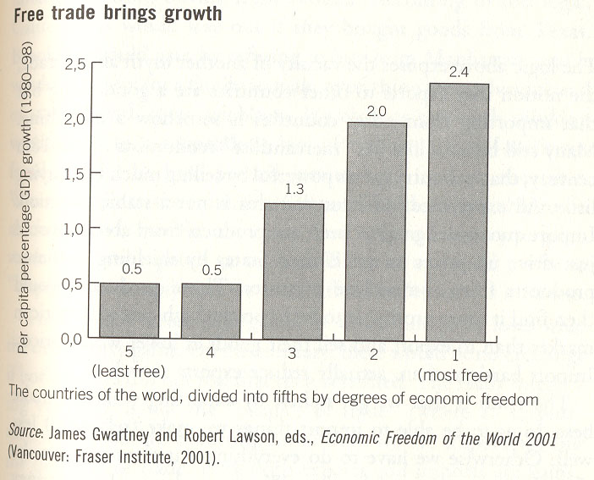

Figure #1: Free Trade Brings Growth.

In Figure #1 we see the world's countries divided into fifths, by degree of economic freedom. What criteria Norberg used to divide the countries, I do not know. However, let us assume that he accurately divided the world into these fifths. He then compared degrees of economic freedom to the growth of the economy between 1980 and 1998. The conclusion he draws is that economic freedom correlates to growth. In other words, the more free the economy, the more it will grow. There are a number of problems with this.
There is a simple refutation of Norberg's evidence. This is where the post hoc fallacy comes in. Norberg uses Figure #1 to attribute growth to free markets, but he does not isolate the growth variable. The top one-fifth of free economies were the most wealthy to begin with. The countries that benefit most from free trade are the countries that already have wealth. Perhaps it is because they are riding the post-colonial wealth, perhaps it is for other neoimperialist reasons arising from their inherited wealth, but that is beyond the scope of this paper. Regardless of the reason, Norberg does not show a connection between free trade and increases in global living standards.

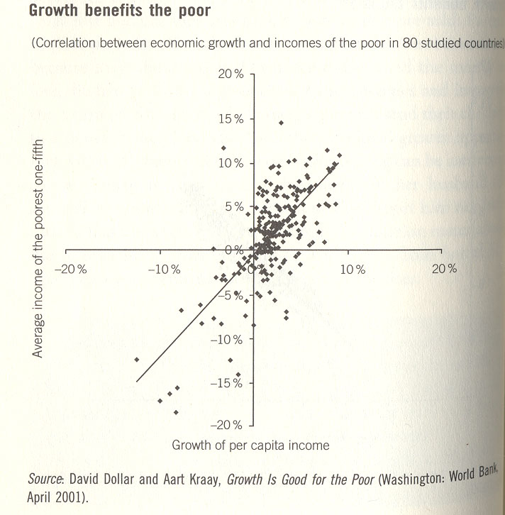

Figure #2: Correlation Between Growth and Income of the Poor in 80 Studied Countries.

Even if we were to accept a correlation between economic freedom and growth, it is important to ask: Was that growth equitably distributed? Or did that new-found wealth just line the pockets of the nation's elites? Norberg is not terribly concerned with equity, but he does address this question nonetheless. In Figure #2 he tries to uses Dollar and Kraay’s data to show that if you divide a nation's population into fifths by income, the poorest one-fifth benefits from economic growth proportionately as compared to the nation as a whole. He does not show, however, that the wealth is equitably distributed. This is unimportant to Norberg because he believes as long as everyone is doing better we not need be concerned with equity. When there are significant portions of the world’s population living on less than a dollar a day, whose children have little to eat and no schooling, I cannot accept his argument. I flat out disagree with Norberg’s nonchalance toward equity. We will later look at how vast the global inequities, as well as the inequities in the United States.
Another issue with the graph shown in Figure #2 is that is does not demonstrate that the relationship between a nation's poorest one-fifth and its national growth is exclusive to countries with free markets. In fact if we look to the source study, the first two lines of the abstract of the source study state that:

"When average incomes rise, the average incomes of the poorest fifth of society rise proportionately. This holds across regions, periods, income levels, and growth rates." [Emphasis added.]

Unless there was a comparison between the most free nations and least free nations, there is not link to free markets here. It is not stated that the countries selected for the study were exclusively from the most free nations. So if the incomes of the poorest fifth of nations rise and fall proportionately across regions and less free countries are included in this sample, then it cannot be proven from this data that free markets are the reason for this linear connection.
On a more basic level, the relationship depicted in Figure #2 does not imply that free markets are beneficial, Norberg's argument is nothing more than a post hoc thesis here. Regardless, it would be interesting to further explore which 80 countries were chosen and their respective political landscape. (In the study cited by Norberg 96 countries instead of 80 were studied and it would be of interest to determine why 16 are not included in his data.)
Interestingly, Mandle also draws on Dollar and Kraay in his writing. His interpretation is that growth is necessary to improve the conditions of the world's poor:

"It is true that growth alone does not secure justice. But it is certainly also true that the alleviation of poverty cannot be accomplished without growth."
This assumption--“that the alleviation of poverty cannot be accomplished without growth"--will be criticized later in this paper. We have not even tried alternative systems. When we look at the scale of global inequality (chapter 2), we will see that not even capitalist growth has been able to alleviate poverty. Why should we continue to believe it ever will.

The "Going Rate" Paradox & Other Justifications for Low Wages
There are a handful of arguments that are often used to justify low standards of living for foreign workers employed by western corporations. One of the most common is the going-rate paradox. "We cannot pay workers in less developed countries what we would pay American workers," say the managers and foreign factory owners. "That would throw off the balance of their economy," they say. "If our foreign garment workers," they go on, "were paid according to American standards, they may very well earn more than local doctors! What incentive would that give professionals? That would destroy the economy." So the multinationals pay the "going rate". In other words, they pay only the lowest wage that local workers rather than addressing the issue of how to raise the wages of doctors who would better serve local citizens.
However, if we follow the money trail back to where it is the commodity is sold, let's say the United States, the paradox becomes apparent. When the product is sold in US, there is a tremendous price increase. "If we sold sweatshirts in the US at Malaysian prices," the multinational companies proclaim, "it would destroy the American economy." So the corporations sell garments at the "going rate", in other words they charge the highest price that consumers are willing to pay. Where does all the profit go? It goes to the owners of the multinationals. How does that affect the economy? It keeps wealth in the hands of the already wealthy. You can see how the going rate argument is a self-serving paradox.
Additionally, any claims that the increase in jobs brings economic growth are unrealistic. Mandle especially stresses the importance of bringing jobs into less developed countries. He believes that it results in greater development, linking it to increases in literacy and other human development indexes. But Mandle fails to acknowledge that the vast majority of the wealth created by the labor of these foreign workers is not invested in the local economies. Rather it is exported to the richer counties along with the commodities. Furthermore, even if workers organize and demand better pay and working conditions from their foreign employers, under a laissez-faire economic system the multinational may decide to pack up shop and move. This has happened time and again. Two of the most notable examples are the economic collapse in Argentina and the abandoned free trade zones in Mexico. Under neoliberalism, the odds are stacked against the world poor and in favor of the multinationals. As Mandle properly points out, labor is not as liquid as capital. Workers cannot relocate as easily as factories. However, he does not take the next step that therefore multinationals have the ultimate trump card when offering jobs. They can leave and take their industry elsewhere as they do and have done for decades leaving behind misery and destitution.
While Mandle might agree that this dependency is not good as it leaves LDCs vulnerable to change, he may ask: What would the global poor do otherwise? However, framing the choice between working a sweatshop job or working no job at all and starving is a false dichotomy. A number of alternative systems have been--and are being--used, notably the fair trade model and worker-owned cooperative model. We will list some alternatives in chapter 3.
Mandle would likely acknowledge some of these problems, however he would not attribute them to globalization. Instead he would argue that we need to reshape economic globalization in order to address these problems. He has suggested the creation of an International Labor Organization, with a charter of working with multinational corporations and workers to help facilitate just employment. However, the interests of the two groups are so diametrically opposed that such an organization would be doomed to failure. Much like the Fair Labor Alliance that Mandle mentions in his section on the Student Anti-sweatshop Movement, such an organization would likely become a rubber stamp organization controlled by industry. Furthermore, creating another organization to address the problems created by the WTO and free trade is only tangentially addressing the problem. In many ways Mandle is much more like a Keynesian than a neoliberal.

Norberg is a market-fundamentalist. He ignores the many factors may could have influenced human development, claiming that free trade is the only possible reason for improvements in global standards of living. The criticism of his argument in this chapter is that it is largely a post hoc ergo propter hoc fallacy; Norberg does not correlate the spread of global capitalism to increases in human development and as a result does not mount a successful argument for global capitalism.

Mandle is somewhat more observant of the destructive reality of global capitalism. He recognizes that there are immediate problems with liberalization, although he does not think these problems are endemic to global capitalism. He calls for a reshaping of economic globalization and the use of international organizations to help alleviate the suffering created by economic liberalization. He still believes that in the long run economic development will increase standard of living in poor countries.
While neither has made a convincing argument in defense of global capitalism, we do not yet have reason to dismiss globalization as a possible force for positive change. In the next section we will lay out arguments against global capitalism.

Chapter 2. A Critique of Global Capitalism

Introduction
In the last chapter we looked at the arguments made in defense of economic globalization and raised objections to some of these arguments, but some criticisms have still not been addressed. This section looks briefly at an environmental critique of globalization, the implications for native culture, cash crop economies and the vulnerability of single commodity economies, and the criticism that vast inequalities persist under global capitalism. Hopefully this chapter will create a compelling for the reader to consider looking for an alternative system.

The Environment & Industrialization
The Earth simply does not have enough resources to support the sort of consumption that we see in the world's more developed countries. If the neoliberals are right and deregulation helps other countries industrialize to US standards, we will have an even more serious environmental problem. The one-fifth of the world’s people who live in the highest-income countries account for 86% of total private consumption expenditures, where as the poorest 20% only accounts for 1.3%. The Earth has a finite amount of resources, there are not enough resources to support a dozen more New York Cities. There is not enough fossil fuel for every adult in the world to drive a car for an hour a day, as is common in the United States. There is not even enough oil for every American to do so! Most estimates place the global peak somewhere in the next five or ten years.
Another example of how spreading the kind of industrialization and consumption-driven lifestyle that we see in more developed countries will result in dramatic environmental problems, can be found in the most basic way in which we consume products: what we eat. The richest 20% of the world's population consumes 45% of all meat produced in world, while the poorest fifth eats only 5%. The United States and European Union nations consume a huge amount of meat, which is a major cause of global warming. According the 2007 report from the Food and Agriculture Organization of the United Nations (FAO), "livestock are responsible for 18 percent of greenhouse-gas emissions as measured in carbon dioxide equivalent, reports the FAO. This includes 9 percent of all CO2 emissions, 37 percent of methane, and 65 percent of nitrous oxide. Altogether, that's more than the emissions caused by transportation." With our current global consumption rates, we already have a global warming crisis. The Arctic Ocean could be ice free in summer by 2050. We can only imagine how much worse off the global climate crisis would be if more of the world lived and ate like the people in the United States.
Meat consumption is just one example out of many ways in which consumption in more developed countries simply cannot be done on any larger of a scale. The same is true for paper: the richest one fifth uses 84% of all paper produced on the paper and the poorest fifth uses a mere 1.1%. In many cases consumption in just the richer countries is beyond sustainable right now, but it continues nonetheless. Our planet cannot support any more increases in consumption.

Hegemonic Culture
When it is addressed at all, some supporters of free trade say that globalization has connected people through trade and led everyone to be exposed to more cultures. But many critics outside the United States say that the US is exporting its culture along with its products. As American companies spread across the globe, native culture is slowly--sometimes quickly--being destroyed. It is somewhat difficult to quantify ways in which native culture and heritage is fading because of economic globalization because indigenous traditions and practices are annihilated by the fixation on “progress”. Culture is embodied in language, literature, music, art, local businesses, food, restaurants, fashion and many other artifacts. With the spread of global capitalism much of these manifestations of culture are becoming more and more homogeneous. Economies of scale remove the local culture from the commodities it creates.
Anecdotally, I have seen native culture start to lose the battle against multinational companies. I grew up in Vienna, Austria in the 1990's. The 90's were a decade in which Austria saw much deregulation and privatization. As a result of an European Union law requiring all member nations to dissolve all state monopolies by 1998, Austria's telephone company was privatized in 1994 and taken out of public control. Only a couple years later television and radio were privatized. The publicly owned Österreich Radio und Fernsehen (ORF) channels still exist, but many more popped up and challenged its dominance, including a new MTV channel that played almost exclusively American music. Thus began the onslaught of American music and television shows, like a cultural d-day. American companies started popping up. Burger Kings, Dairy Queens, and American-style mega-shopping centers opened up across the city. These multinational companies replaced corner stores, farmers markets and family businesses. Looking back, I regret going to the Grand Opening of the first Pizza Hut to set up shop in the historic city of Vienna.
Vienna is city well-known for its coffeehouses. Some coffeehouses in Vienna have been around for more than a hundred years, oftentimes owned by the same family. These coffeehouses are a celebrated part of Vienna's rich history. Many claim famous historical intellectuals—Mozart, Freud, Wittgenstein--as having been their regular patrons. During my high-school years, Starbucks moved into Vienna, opening coffeeshops throughout the city. When the first Starbucks opened, it did not go unnoticed. There was much protest. It was a hot topic. In addition to the coverage on television and print news, there were even student editorials in my small high-school newspaper urging us to avoid it and support local coffeehouses. But despite it all, more Starbucks opened. Many opened next door to, or across the street from, long established Viennese coffeehouses. Another important point is that Starbucks is a huge company, with 15,011 stores in 44 countries. Even if they sold their coffee in Vienna at a loss, the corporation could recoup the costs elsewhere. The spread of Starbucks throughout Vienna is a real threat to Austrian culture. When I moved to the United States in 2003, there were 12 locations in downtown Vienna.
Although I focused on Vienna, the hegemonic influence of capitalism is happening all over the world. The organization Cultural Survival (cs.org), based in Cambridge, MA, works with Indigenous Peoples to help protect their languages and cultures.

Neo-colonialism & Exploitation
Unregulated global capitalism à la Norberg and the international institutions that promote it, like The World Trade Organization, World Bank and IMF, grant an unfair advantage to richer countries. While the free trade scholars claim that economic globalization will improve the lives of the poor, their policies create "banana republics" and encourage cash crop economies in less developed countries. These single-commodity export economies are problematic. The export economies become entirely reliant on patronage from their importers, affording their patron a disproportional amount of power. In an economy, as in any ecosystem, diversity creates resiliency. With only one export and only a handful of buyers, a national economy is extremely vulnerable. Since the country cannot provide all of the goods required to run a country, they depend on the money they get from exports to spend on imports. This gives more developed countries considerably more power over the weaker countries.
Another problem with cash crop economies is the issue of ownership of the means of production, or to state the concept in non-Marxist terms, who is able to control their economic fortunes. When multinational companies come into a developing country to set up a single commodity export system, they own all of the capital. For this reason they hold the ultimate trump card. If at any point in time their profits are challenged by taxes, workers' rights laws, environmental regulations and so on, the company can pack up and move their capital to another, more favorable country. Employers often use threats of relocation to low wage countries in order to ratchet down wages and benefits. This exclusive control on the capacity for economic development does not lead to long term social progress or increases in standards of living.
"But trade liberalization bring jobs," the neoliberal would say. It is undeniable that it deregulation will draw in foreign companies and bring in jobs, but are the jobs worth it? When a foreign companies moves production to a less developed country their reasons are not altruistic. Companies outsource to save money by, for example, paying lower wages and avoiding costly environmental regulations. When a new factory is set up in, say, Mexico, the capital--the means of production--is all still owned by the foreign company. The vast majority of profits flows back out of the LDC to the corporate headquarters. This money is not invested in local infrastructure or industry, it leaves the country. The profits are not used to create more local jobs.
This economic dependency also has a political element to it. Similar to how profits flow out of the community where the commodities are manufactured, business decisions do not come from workers, but from the foreign corporate headquarters. These business choices can have a major impact on the day-to-day lives of workers. You can see how this takes political control of the economy outside of the community, even outside of the nation. Decisions that affect the local economy are made in a far away country without regard for local concerns or culture.

Global Inequality Persists
Perhaps the most compelling criticism of global capitalism is the fact that the inequalities that persist under capitalism are enormous, both within a nation and globally. These disparities are numerous and many believe that the gap is widening. Whether the gap is in spite of free trade policies or a direct result of them, is not terribly important. If they persist, we ought to try better alternatives. In the US, even a pro-free trade economist has determined that 39 percent of the increase in income inequality can be attributed to trade. There is ample evidence to suggest that free trade policies are the cause of the inequality, but I do not wish to make the same post hoc ergo propter hoc fallacy that Norberg made. Regardless of the cause, it is apparent that global capitalism is not addressing the problem of inequality adequately.

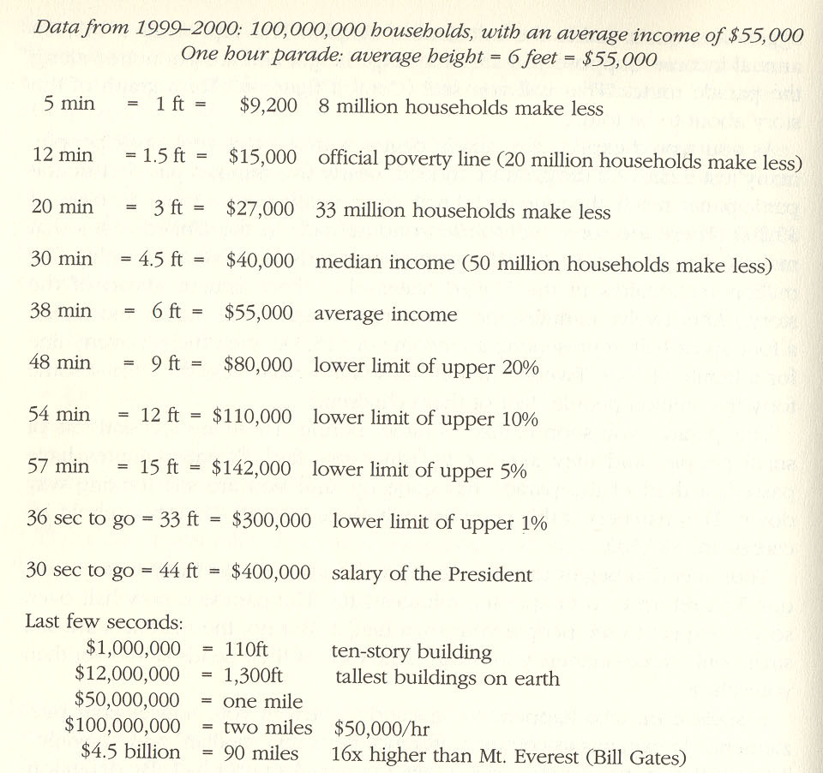

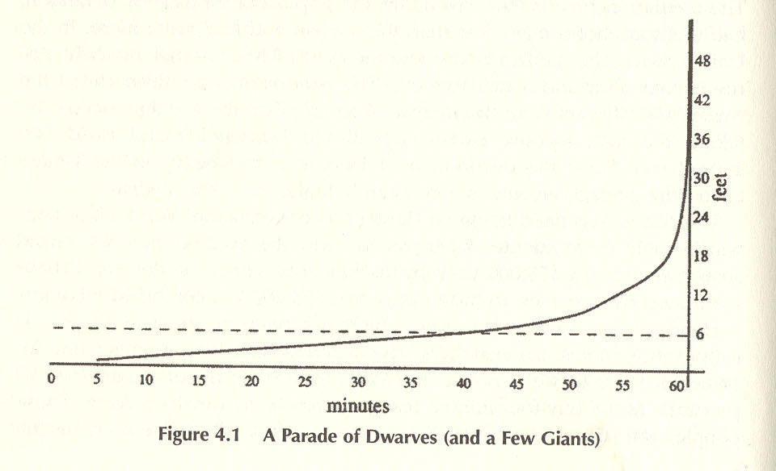

Figure #5: Schweikart's Parade of Dwarves (and a Few Giants)
First let's have a look at the inequality within the richest nation. David Schweikart looked at income data from 100,000 household in the United States with a mean income of $55,000. In order better visualize the income disparity, he describes the distribution of income in the US as an hour long parade of dwarves and a few giants. As the analogy goes, imagine we held an hour-long parade of all the households in the United States. Each household is represented by a single person, and by some sort of biotechnical alchemy the person's height is representative of their household's yearly income. For the first 5 minutes we would see the 1 foot tall people walk by, representing the households that make less than $9,200 per year. For the next seven minutes we would see 1.5 foot tall paraders, representing the families under the official poverty line: $15,000. At the 20 minute mark we will start to see 3 foot tall people, representing the 33 million American families who make less than $27,000 each year. Half-way through the parade we will see the 4.5 foot marchers, marking the median income $55,000. Now the heights start to increase rather quickly. When we reach 38 minutes we see the 6 footers. 10 minutes later the 9 foot tall people show up. 6 minutes later we're at 12 feet. 3 minutes later, at 57 minute into the parade, we see the 15 foot tall people. With 36 seconds left we see 33 foot tall people and 6 seconds later we see people 44 feet high. Finally in the last couple of seconds, a handful of giants run past. We see someone as tall as a ten-story building, another person 2 miles tall, then the last person runs by and is more than 16 times taller than Mount Everest. Keep in mind that this is the income inequality in one of the richest countries in the world. The global disparities are even larger. Imagine the disparities if we had included a country with a significantly lower mean income, like Chile or Namibia.
In the previous section on the environment and industrialization, we saw some of the unequal ways in which resources are consumed. To paint a better picture of this global inequality look at some more data from the UN about consumption and resource use. The richest fifth of the world's population uses 58% of the all energy produces, while the poorest 20% uses less than 4%. The richest 20% own 74% of telephone lines and 87% of the world's vehicle fleet, while the poorest one-fifth owned less than 1.6% of both (SOURCE: UN Human Development Report 1998 Overview). Statistics abstract reality and sometimes make it hard to truly understand the seriousness of the information they hold. Perhaps a more interesting way is to see how typical families live in different parts of the world.
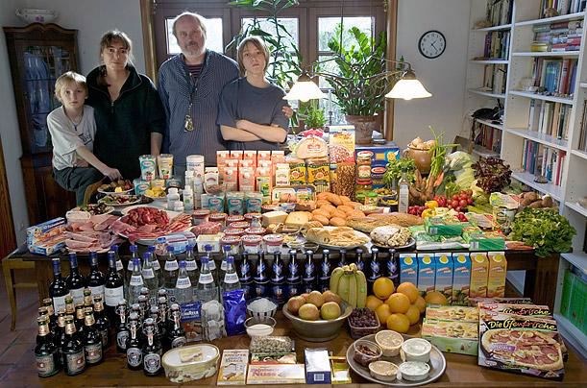

Figure #3: The Melander family of Bargteheide, Germany spends $500.07 on food weekly.

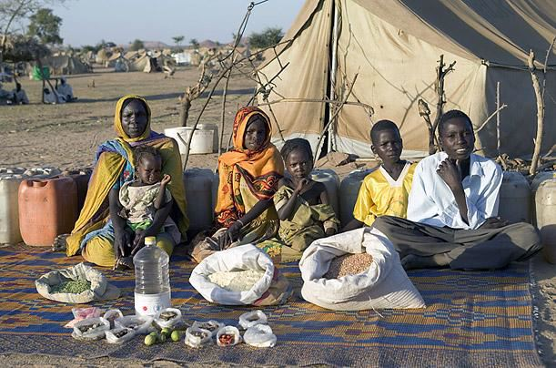

Figure #4: The Aboubakar family of Breidjing Camp in Chad spends $1.23 on food weekly
One stark example of these global inequalities is the global disparity in diet. Time Magazine recently published a photo-essay called "What the World Eats", which is an excerpt from the book, Hungry Planet. The photo-essay shows middle-of-the-road families from 16 countries sitting in their homes with all of the food they would typically eat in a week. The captions explain how much they would spend for that food. The contrast between the German family and the family in Chad is stark. The family from Chad's weekly food is primarily grains and some local fruits. They typically spend $1.23 per week on food. That is more than 0.3% than the German family who spends $500.07 per week and eats meats, packaged dairy products, some breads, fresh imported fruits and vegetables, and drinks beer, soda and juices. These two examples are not just extreme cases. The Bhutan family of the Shingkhey Village spend $5.03 on food each week and eats primarily local rooted vegetables and grains. That is 1% of the German family. The Ayme family from Ecuador spend $31.44 on food each week and primarily eats cabbages, grains, potatoes, carrots, and other rooted-vegetables. That is 6% of the Germans. None of the families in less developed countries come anywhere near the German or American weekly expenditures. These images help personalize the sometimes abstract statistics about global inequality.
It is apparent from a number of examples that there the world's resources are not fairly distributed. Deregulation and free trade have been the Washington Consensus since the 1970's and yet global inequalities persist. There is also evidence to suggest that global inequalities are becoming even greater.

Neoliberals argue that free markets lead to better standards of living and more equal distributions of wealth. However, after 30 years of dominance, neoliberalism has not not, in fact, solved the striking and unjust disparities presented above. We should look back on what elements of past economic systems have worked and what have not. With the housing market crashing and food crisis in Haiti, Egypt and Bangladesh we must take a critical look at the legacy of Milton Friedman and the Chicago School.
We have an environmental and global climate change crisis that is primarily an issue of over-consumption. Multinational corporations are stamping out native and indigenous culture. Globally and nationally, there is an enormous chasm between the incomes and consumption of rich and poor. Some believe the gap is even expanding. Global capitalism does not address these problems and may even perpetuate them. We need to find an another model, a successor system (Schweikart). In the final chapter we will look David Schweikart's discussion of alternatives to capitalism and the system that could follow.

Chapter 3. Alternatives to Global Capitalism

Introduction
There are some compelling arguments against global capitalism, but what is the alternative? Successor System Theory is what David Schweikart calls the study of such alternatives. In this section we will address one of the trickiest defenses of global capitalism--the TINA defense-- and briefly look at some alternatives to global capitalism.

TINA & TATA
The mantra of the neoliberal is TINA, TINA, TINA: There is no alternative to global capitalism. The slogan is attributed to Margaret Thatcher, but the idea has been expressed by many. Neoliberals like Thatcher, argue that modern societies can develop only through liberal economic policies, free markets, free trade and global capitalism are way. Supporters of global capitalism make wild claims that no other system is possible and that we cannot do any better. It can be difficult to envision a world structured very different than our own, but that's not to say it is impossible. It only serves the interests of the global elites to have the world believe that there is no better alternative.
We hear from the liberals that workers in third world countries would starve without the sweatshop job from Nike. Less developed countries would go into economic crisis if we try a different model, they say. There is no incentive to work without free markets, they say. There are certainly a number of a systems that were different than failed economically, including the non-democratic command economies of the former Soviet Union, but that does not imply that capitalism is the only system that works or can work. Furthermore there are plenty of alternatives that are already taken root.
The Soviet Union is an obvious example to use when looking for counter-capitalist systems that have failed. The Soviets tried to challenge capitalism, but just created another form of fascism. There were aspects of it that challenged capitalism, but there were many of the same elements present in today's capitalism. Import Substitution Industrialization (ISI), as practiced in South America was another example of a system that tried to address the issues of dependency on foreign economies, domestic employment and ecological critique of global capitalism. Import substitution was tried in Latin America in the 1930 and 1940 because of the Great Depression. There is debate among economists about whether ISI worked, some say it resulted in the so-called "Lost Decade" and other point out that in Mexico it is resulted in a 6% improvement in the economy. Simply because there have been failures in the past does not mean that finding an alternative is hopeless.
In response to TINA, Susan George, a prominent critic of neoliberalism coined her own term "TATA to Global Capitalism". TATA stands for: There are Thousands of Alternatives. Schweikart puts forward a model of workplace democracy and democratic control over the economy. Internationalism is another such alternative, one that was popular among the Old Left. It is the idea that nations ought to cooperate for the common good of all instead of compete against one another. Relocalization is another alternative taking root in the US and elsewhere . It is populist social movement that encourages local consumption and products and supporting locally-owned businesses. Collective and cooperative business model is yet another example. Worker's owned cooperatives like Red Star Publishing in Boston and volunteer cooperative businesses like the Artichoke food Coop in Worcester are good examples of this model in action. Permaculture is an example of an agricultural model that challenges the industrial agribusiness that we see in global capitalism. The fair trade model that we see growing in the coffee and chocolate industry values fair wages over the bottom-line of global capitalism. There truly is an endless list of alternatives. Determining which one or what combination of ones are best if far beyond the scope of this paper, but it is important to point out that global capitalism is not the only model that works. It only takes creativity and dedication to grow a new system. We already see the beginnings of many.

Conclusion
In terms of world history, neoliberalism is a relatively new economy model. It has come into existence because of great advancements in communication technology, but it is not inevitable. Despite claims to improve global standards of living, the neoliberal defense of global capitalism falls short. There is not a strong link between any increases in global standards of living and the spread of trade liberalization. Some critics of globalization even say that there is even evidence to say that global living standards have improved. In any case, there are major problems with global capitalism. Our planet cannot support more industrialization like that which the developed countries have used to ravage streams and woodlands. Native culture is being snuffed out by the spread American corporations; Viennese coffeehouses may soon be a only a memory. Global inequality is an enormous problem, with the vast majority of wealth held in the hands of a very small fraction of the world's population.
Neoliberals argue that there is no alternative--nothing better than capitalism. To them capitalism is the final iteration in humans' economic and social system. They are like the self-important starfish in Daniel Quinn's novel, Ishmael, who proclaims that evolution has reached its pinnacle and created its final product and masterpiece: the starfish. To neoliberals global capitalism is perfect and cannot be improved upon and need not be replaced, but to those most harmed by economic globalization the need is very apparent. Finding an alternative system that will succeed is far beyond the scope of this project, but is a moral and ecological imperative nonetheless. There are many people smarter than I am. I do not know what an alternative will look like, but there are numerous examples that are currently working in practice. We can draw on them to patch together a solution that is organized on the principals of democracy, equity, environmentalism and human rights. It will take a massive effort of cooperation and mutual aid and solidarity from the international community to create lasting, just solutions, but it is absolutely necessary because of the immense problems with our current economic system. There will be a time when we look back upon the injustice and global inequality of capitalism with disbelief for, as Martin Luther King said, “the arc of the universe is long but it bends toward justice.”
Bibliography
Bhagwati, Jagdish. 2004. In Defense of Globalization. New York: Oxford University Press
Black Gold (2006)
Cohen, Daniel. 2006. Globalization and Its Enemies. Cambridge, MA: The MIT Press
Commanding Heights: The Battle for the World Economy (2002)
Danaher, Kevin, and Roger Burbach. 2000. Globalize This! Maine: Common Courage Press
Friedman, Thomas. The Lexus and the Olive Tree. 1999. New York : Farrar, Straus, Giroux.
Friedman, Milton. DOS capital, Foreign Pol'y, Fall
Fischer, William F. and Thomas Ponniah. 2003. Another World is Possible. USA: Zed Books Ltd.
Global Capitalism and the Moral Imperative (1998)
Nicholls, Alex & Charlotte Opal. 2004 (Reprinted 2006). Fair Trade: Market Drive Ethical Consumption. Thousand Oaks, CA: SAGE Publications
Norberg, Johan. 2003. In Defense of Global Capitalism. USA: Cato Institute
Maquilapolis (2008)
Mandle, Jay R. 2003. Globalization and the Poor. New York: Cambridge University Press.
Schweickert, David. 2002. After Capitalism. USA: Lanham : Rowman & Littlefield Publisher

DOS capital, Foreign Pol'y, Fall 1999)
Stever and Muroyama, 1988
There are some cases where even local laws are suspended in the name of increasing trade. The free-trade zones in Mexico are a good example of this.
N30, Crimethinc
http://www.reuters.com/article/latestCrisis/idUSN4O352822
http://news.bbc.co.uk/2/hi/middle_east/7355217.stm
Milanovic, B. (1999). "True world income distribution, 1988 and 1993: First calculation based on household surveys alone", World Bank.
http://www.globalissues.org/TradeRelated/Debt/USAid.asp#ForeignAidNumbersinChartsandGraphs
Ibid
The Best "Anti-Sweatshop" Policy: Expanding U.S. Trade with Developing Countries, CATO institute
The Take (2004)
Maquilapolis (2006)
UN Human Development Report 1998 Overview
http://en.wikipedia.org/wiki/Peak_oil
UN Human Development Report 1998 Overview
Inconvenient Truth (2006), Commentary by Al Gore
UN Human Development Report 1998 Overview
Latzer, M. - Ohler, F. - Knoll, N., Neue Rahmenbedingungen in der Telekommunikation: Perspektiven für die Post , August 1994
Starbucks Company Fact Sheet. http://www.starbucks.com/aboutus/Company_Factsheet.pdf . URL last accessed March 17, 2007
Danaher, Kevin, and Roger Burbach. 2000. Globalize This! Maine: Common Courage Press
Ibid
“A Fresh Look at the Apostle of Free Markets”, New York Times, April 13 2008 - http://www.nytimes.com/2008/04/13/weekinreview/13goodman.html

