Electric Vehicle Barriers: What Stops the Switch?

An interactive qualifying report
submitted to the faculty of
Worcester Polytechnic Institute
in partial fulfillment of the requirements for
the degree of Bachelor of Science

26 April 2022
Worcester, UK Project Center

Submitted by
Aradhana Bissoondial, CE
Katy Hartmann, DS
Sage Ortega-Shue, ECE
Jolie Walts, RBE

Project Advisors
Prof. Fred Looft
Prof. Linda Looft
Worcester Polytechnic Institute

Sponsors
Dr. Heather Barrett, University of Worcester
Director of Sustainability Katy Boom, University of Worcester
Michael Hallett, Indra

This report represents the work of WPI undergraduate students submitted to the faculty as evidence of completion of a degree requirement. WPI routinely publishes these reports on its website without editorial or peer review.

Acknowledgements

We would like to thank all of those who assisted us throughout the project:
- Professors Fred and Linda Looft for their guidance and feedback throughout the project. They were very helpful and we could not have done it without them.
- Dr. Heather Barrett and Director of Sustainability Katy Boom for providing us with guidance and local contacts.
- Michael Hallett and everyone at Indra for guidance, information and local contact that assisted in our projects.
- Sally Jones for posting our survey in the University’s Daily News.
- The University of Worcester for providing housing during our stay.
- Worcestershire County Councilor Beverley Nielson for visiting the campus to learn about our project.
- Georgia Williams, Herefordshire & Worcestershire Chamber of Commerce Marketing and Communications Manager for posting our survey to the Chamber of Commerce website.
- All survey respondents and interviewees for taking the time to respond to our survey and participate in our interviews they provided essential input without which the project would not have been possible.

Abstract

The goal of this project was to create a framework (methodology and rubric) that can be used by local governments and organizations to improve the EV charging infrastructure in Worcestershire County. We implemented methods of mapping, surveys, and interviews to gather responses from residents to gain insight on current perceptions of barriers to EV adoption and charging infrastructure. After analyzing our data and findings, our recommendations included installing and maintaining new and current chargers, creating policies regarding smart charging, and continuing to incentivize EV purchases through subsidies.

Executive Summary

Introduction
The United Kingdom has set the goal of net-zero emissions by 2050 to reduce the effects of climate change. Currently, the transportation sector is the largest source of greenhouse gas emissions in the UK. When breaking down the sector by vehicle type, internal combustion engine (ICE) vehicles account for the majority of emissions from the sector.
Due to their lower life-cycle emissions, electric vehicles (EVs) have become a vital part of achieving the UK’s goals and an important alternative to ICE vehicles. Further, to incentivize and encourage citizens to purchase EVs, the government has established a ban on the sale of all new, non-commercial internal combustion engine vehicles for 2030.
Focusing on Worcestershire, England, the county has a two-tier local government: Worcester County Council and Worcestershire City Council. Both councils have created projects to implement changes in the EV support infrastructure and various policies to encourage greener transportation options. One main issue that appears to challenge potential EV buyers is the lack of EV charging locations that will meet current and future demand.

Goal and Objectives
The goal of this project was to create a framework (methodology and rubric) that can be used by local governments and organizations to improve the EV charging infrastructure in Worcestershire County, focusing on the City of Worcester. To achieve this goal, we identified the following objectives.
- Document the transportation options for residents in the Worcester area.
- Document transportation routes and methods used by residents in the Worcester area.
- Identify barriers and incentives for residents looking to purchase electric vehicles.

Methodology
Our methods for this project included mapping, surveys, interviews, and the development of a rubric. A map including public transportation (bus stops and rail stations) and public EV charger locations was created using GIS. Survey methods were piloted while assisting with the distribution of the University of Worcester’s Student Travel Survey. An additional EV knowledge survey was distributed through numerous Facebook groups and the University's Daily News. The purpose of the EV knowledge survey was to determine how people are traveling and to understand the perceived barriers to EV adoption. Results from the survey and interviews assisted in the creation of a rubric that can be used to assess the state of the EV charger infrastructure implementation.

Findings
The GIS map showed that there are only three charging locations in the city of Worcester, WR1. This was confirmed on ZapMap, a UK app to search for charge point locations and working status. When validating the working status of the chargers in WR1, it was found that only 7 of 12 chargers were available for use.
The EV knowledge survey received the most responses from the staff of the University of Worcester as well as from the 45-54 age group. Key findings included that those in the 45-54 age group are most likely to consider the purchase of an EV when compared to other age groups and that the main barrier to EV purchase was cost. These findings may be correlated through the fact that an older age group is more likely in a better financial position to purchase an EV than those who are younger. Data from the survey also indicated that those without dedicated off-street parking were less likely to purchase an EV. Our survey showed that the 18-25 age group had the least off-street parking and was also the least likely to purchase an EV.
Interviews were used to supplement information about barriers from the survey and supported the idea that EV and ICE vehicle owners both face barriers to EV adoption. Our main finding was that while both EV owners had their own chargers at home, they agreed it was difficult to find chargers that worked in public places.

Rubric Development
We created a rubric (Figure 23, main report) to help evaluate the implementation status of EV charging infrastructure in urban areas. This rubric has five assessment categories for consideration and review of the status of a charger infrastructure implementation plan and is meant to be used by those well versed in current EV technology and policy. Each category has a scale of one to four with four being the target for meeting stakeholder requirements and one being the level below the current implementation status in WR1. The charging infrastructure assessment rubric consists of the following categories:
- EV charging availability
- public charging speed
- smart charging policy
- public charging etiquette policy
- maintenance and upkeep
Charging availability is ranked on the time it takes to walk to/from a charger for a given percentage of people. EV charging speed is ranked on if charging speed is inversely proportional to time spent at a location. The smart charging policy category starts with no policy or incentives to encourage or mandate it and ends with policies requiring it in both new and old construction. The public charging etiquette category is ranked on the existence of policies to encourage respectful use of public chargers and effective enforcement methods. Finally, maintenance and upkeep refer to the percentage of total chargers that are working in the parking garage or lot, street location or other area being evaluated.
The rubric was designed to be used in any urban area, not just in Worcester. The rubric can be used in the future to assess different areas and reassess areas of Worcester’s EV charging infrastructure.

Rubric Application
Our application of the rubric to WR1 provides an example of how to apply it to other areas including reasoning for each category. The WR1 application allowed us to evaluate the current EV charging implementation status in one area of Worcester. The results of the rubric application were used in conjunction with our background research to assist in the creation of our recommendations.

Recommendations to Reduce Barriers to EV adoption
Reducing barriers to EV adoption has many components including broken chargers, charging speed, smart charging policies and EV purchase subsidies. Below are recommendations to address these components based on our background research and rubric application to WR1. Each of these recommendations is detailed and supported in the main report.

- Require charging network operators to maintain existing and future chargers.
- Install future public EV chargers with consideration to the time spent at the location and ease of access.
- Continue to create and implement smart charging policies that encourage the transition to EV over ICE vehicles.
- Increase Government level EV purchase subsidies.

University of Worcester Student Travel Survey Recommendations
There is no one answer to increasing the number of students that participate in the University of Worcester Student Travel Survey annually. We observed that the survey was lengthy, not mobile device friendly, no incentive was offered for participation, and students were generally unaware of the survey. The following 6 recommendations which should help increase survey participation in future years. Each of these recommendations are detailed in the full report.

- Reduce the length of the survey.
- Make the survey mobile friendly.
- Offer an incentive for survey participation.
- Research other survey distribution methods to better reach the student population.
- Do not use intercept surveys as a method of distribution during exam weeks.
- Do not use costumes when utilizing intercept survey methods.

Authorship Page
Worcester UK
Section Name | Author(s) | Editing Author(s)
Abstract | AB | All
Executive Summary | All
1.0 | All
2.1 | SOS
2.2 | KH
2.3 | SOS
2.4 | SOS
2.5 | AB
2.6 | KH
2.7 | JW
2.8 | AB
2.9 | JW, AB
3.1 | All
3.2 | All
3.3 | All
3.4 | All
4.1 | AB
4.2 | JW
4.3 | KH
4.4 | KH
4.5 | All
5.1 | All
5.2 | JW
5.3 | All
Appendix A | All
Appendix B | All
Appendix C | All
Appendix D | All
Appendix E | AB
Appendix F | JW
Appendix G | SOS
Appendix H | KH

Table of Contents

Acknowledgements ii
Abstract iii
Executive Summary iv
Introduction iv
Goal and Objectives iv
Methodology iv
Findings v
Rubric Development v
Rubric Application vi
Recommendations to Reduce Barriers to EV adoption vi
University of Worcester Student Travel Survey Recommendations vi
Authorship Page vii
Table of Figures xi
1.0 Introduction 1
2.0 Background 2
2.1 UK Carbon Emissions 2
2.2 What is an Electric Vehicle? 4
2.3 Electric Vehicles Have Lower Lifecycle Emissions 5
2.4 EVs Effect on the Power Grid 6
2.5 Current Sustainability Efforts by Local Government in Worcester 8
2.6 Electric Vehicle Ownership Incentives 9
2.7 Electric Vehicle Ownership Barriers 10
2.8 Public Transportation in the City of Worcester 12
2.9 Transportation and EVs at the University of Worcester 14
3.0 Methodology 16
3.1 Document the transportation options for residents in the Worcester area. 17
3.2 Document transportation routes and methods used by residents in the Worcester area. 17
3.3 Identify barriers and incentives for residents looking to purchase electric vehicles. 17

3.4 General Methods for All Objectives 17
3.4.1 Identifying Areas of Interest 17
3.4.2 Survey Distribution 18
3.4.3 Interviews 18
3.4.4 Rubric 18
4.0 Results and Findings 19
4.1 Public Transportation Availability 19
4.2 University of Worcester Student Travel Survey 22
4.3 Survey Discussion 24
4.4 Interview Findings 32
4.5 Rubric to Evaluate EV Charging Infrastructure Implementation Status in an Urban Area 33
4.5.1 Rubric Development 33
4.5.2 Rubric Applied to WR1 35
5.0 Recommendations 37
5.1 EV Recommendations to Reduce Barriers to EV adoption 37
5.2 University of Worcester Student Travel Survey Recommendations 38
5.3 Future Research 40
References 41
Appendix A - Preambles 47
Introduction 47
Sample Preambles 47
Survey Preamble 47
Interview Preamble 47
Appendix B - Non-Student Survey 48
Introduction 48
Non-Student Survey 48
Appendix C - Interview Questions 53
Introduction 53
Questions 53

Appendix D - Example Flyer 54
Introduction 54
Flyer 54
Appendix E - Oil Price Impact on EV Demand 55
Introduction 55
Summary 55
Appendix F – Rubric Topic Outline 57
Introduction 57
Rubric Topic Outline 57
Appendix G – Zap Map Charger Information 58
Introduction 58
Zap Map Data 58
Appendix H – Distances to/from Postcodes 60
Introduction 60
Average Distances Traveled by Postcode 60

Table of Figures
Figure 1: Emissions by sector. 2
Figure 2: Further Breakdown of 2020 Transportation sector emissions. 3
Figure 3: Yearly United Kingdom CO₂ emissions. 4
Figure 4: Structure of UK power grid from power generation to supply. 7
Figure 5: Bus network map of routes available in the Worcester city area. 13
Figure 6: University of Worcester electric fleet and chargers. 15
Figure 7: Mapped methods to achieve the stated objectives. 16
Figure 8: GIS Map created to display postal districts, postal areas, public transportation availability (bus and rail stops), and public EV chargers 20
Figure 9: Worcestershire GIS post code map to display the different postcodes. 21
Figure 10: Types of housing students live in. 22
Figure 11: Modes of transport students use to commute to campus. 23
Figure 12: Are students considering purchasing an EV or hybrid vehicle as their next vehicle? 23
Figure 13: Would students charge their EV on campus if they purchased an EV? 24
Figure 14: Percent responses by age group 25
Figure 15: Percent of each age group without off-street parking 25
Figure 16: Reasons People Consider When Thinking about EV Adoption 26
Figure 17: How Likely to Purchase an EV 27
Figure 18: How likely to purchase an EV for people without off-street parking 28
Figure 19: Average number of miles per Age Group 29
Figure 20: How far respondents would walk to park/charge their motor vehicle 30
Figure 21: Barriers identified from background research ranked by respondents 31
Figure 22: Incentives Barriers identified from background research ranked by respondents 32
Figure 23: EV Urban Charging Infrastructure 34
Figure 24: EV charging sign at the University of Worcester 36

1.0 Introduction

Climate change driven by greenhouse gas emissions is causing unprecedented environmental changes ranging from rising sea levels to extreme weather patterns (Met Office, n.d.). Rising sea levels in particular are a concern for the United Kingdom as an island nation. To address this the UK has set strict climate goals to achieve net-zero emissions by 2050 (IEA, 2021).
Currently, transportation is the sector with the highest emissions of greenhouse gases in the UK. Internal combustion engine (ICE) vehicles make up the majority of the UK’s greenhouse gas emissions within the transportation sector (Department for Transportation, 2021c). The International Council on Clean Transportation (ICCT) found that the lifecycle emissions of electric vehicles (EV) are significantly lower than ICE vehicles over their lifetimes (Hall, D., & Lutsey, N., 2018). This makes electric vehicles an important consideration to achieving the UK’s emissions goals. According to the Society of Motor Manufactures and Traders (SMMT) approximately a quarter of cars sold in the UK in 2021 were electric or hybrid (2021) but as of 2020, EV’s made up only 1% of total UK vehicles (Terry, 2020).
Efforts to increase EV adoption have been undertaken by all levels of the UK government. The Government has implemented tax credits and will ban the sale of new ICE vehicles in 2030 (HM Government, 2021). Worcestershire, England has a two-tier local government system, a county council, and a city council. Both councils have created a sustainability strategy to implement changes in infrastructure and policy to encourage greener transportation options. Universities in the area such as the University of Worcester have also dedicated themselves to efforts addressing the area’s sustainability goals. Part of these efforts are working with other organizations regarding electric vehicle adoption. Potential electric vehicle buyers are confronted with issues including lack of sufficient charging infrastructure (Office of National Statistics, 2021), high costs (Kwick-fit, 2020), and in the case of many students and young professionals, a lack of dedicated off street parking.
The purpose of this project was to develop a framework consisting of a methodology and rubric for assessing the perceived barriers to EV adoption faced by those without off-street parking in the Worcester, England area. It was envisioned that this framework could be used by local governments and others interested in understanding the barriers to EV adoption.

2.0 Background

This section will provide an overview of electric vehicles and the importance of their adoption to reduce carbon emissions by reviewing the literature of known barriers to and incentives for EV adoption. An additional topic covered below will be the current charging infrastructure and transportation services in Worcester, England.

2.1 UK Carbon Emissions
The United Kingdom (UK) is taking the threat of climate change driven by greenhouse gas emissions seriously. As outlined in the government's Net Zero Strategy: Build Back Greener (2021) policy, it has committed to reaching net zero carbon emissions by 2050. The policy defines net zero as a reduction in emissions to as close to zero as practically feasible with any remaining emissions removed using emerging carbon capture technologies and natural carbon sinks. In order to achieve these goals, the Climate Change Act of 2008 tasked the Secretary of State with setting legally binding carbon emissions targets for five-year periods. So far, the UK has met its carbon budgets. However, the Government’s Department for Business, Energy & Industrial Strategy (BEIS) predicted that that there will be a growing gap between emissions and emission reduction targets going forward (2021).
According to the Department for Transport, the transportation sector is the single largest contributor to CO₂ emissions in the UK, accounting for 31% as of 2020. Of this, 52% came from passenger vehicles, with other road vehicles making up 38%. A more detailed breakdown can be found in Figures 1 and 2 (Department for Transport, 2021c).
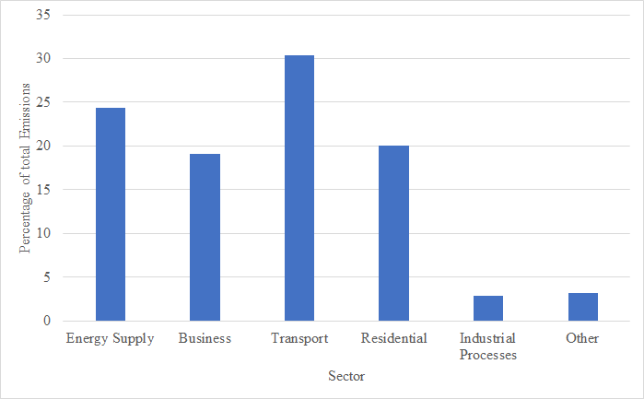
Figure 1: Emissions by sector.
(Adapted from Department for Business, Energy & Industrial Strategy, 2021)

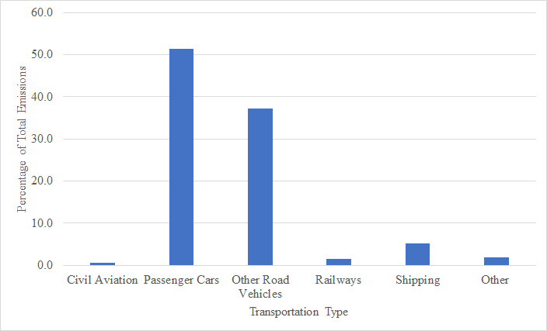
Figure 2: Further Breakdown of 2020 Transportation sector emissions.
(Adapted from Department for Business, Energy & Industrial Strategy, 2021)

Emissions numbers, as seen in Figure 3, were likely lower for post 2019 years due to the COVID-19 pandemic and the effects of government lockdowns. Data from the Department of Transportation supports this, showing an overall reduction in car usage of approximately 21% for 2020-2022 compared to the corresponding weeks in previous years. During the same period, all assessed methods of transportation experienced a 27.8% reduction in usage, resulting in lower carbon emissions (Department for Transport, 2022b). The recent (spring, 2022) lifting of COVID-19 restrictions is likely to result in a return to pre pandemic transportation sector emissions levels. The beginning of this return to pre COVID emissions levels can be seen in the Department for Transport dataset with January 2022 vehicle transportation down only 14% (compared to 43% for the previous year) for the equivalent months (Department for Transport, 2022c). Because vehicles make up a significant portion of total emissions, switching to greener electric vehicles is critical to emission reduction goals.

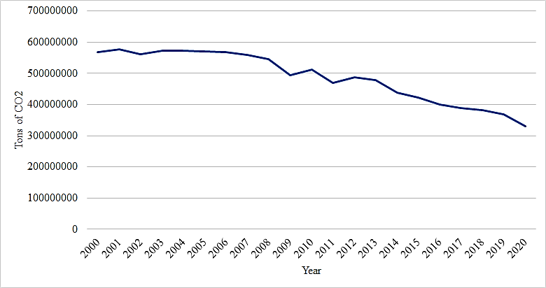
Figure 3: Yearly United Kingdom CO₂ emissions.
(Adapted from Our World in Data, 2020)

2.2 What is an Electric Vehicle?
Electric Vehicles (EVs) are vehicles that do not rely directly on fossil fuels, and so do not emit pollution directly from their exhaust. Instead, they use batteries, fuel cells, and other non-ICE energy sources for power. There are a few different types of electric vehicles: Hybrid Electric Vehicles (HEVs), All Electric Vehicles (AEV or often just EV), Battery Electric Vehicles (BEV), Fuel Cell Electric Vehicles (FCEV), and Plug-in Hybrid Electric Vehicles (PHEV) (Das, 2019). There are 2 general types of EVs. HEVs run on both petrol and electricity while AEVs only use electrical motors and batteries and/or fuel cells for motive power. AEVs also have a typical range of 160-250km (100-155 miles). The range of EVs is increasing with better batteries and more efficient EV designs with many modern EVs getting up to 500km (310 miles) per charge (Sanguesa, 2021). For the remainder of this report, the term EV will mean only those vehicles that are fully electric as well as plug-in hybrid electric vehicles.
In terms of charging, EVs have traditionally been charged from an AC source. More recently, both AC and DC charging are possible with DC charging being available on newer EVs for very high capacity, short duration charging (Sanguesa, 2021). Indra, a UK based EV charger company and one of the sponsors of this project, has developed an AC charging system compatible with any EV (Indra, 2022). Level 1 & 2 charging stations (private and residential options) are described here and are slower than level 3 charging stations (also known as DC fast charging). Level 3 chargers are the fastest and most power driven and require authorization from utility providers. Level 1 and 2 chargers are more commonly found in residential settings while higher capacity and charge rate level 2 charges can also be found in commercial/public locations but take longer to deliver a charge to a parked EV than a level 3 charger. Level 3 chargers are almost exclusively installed in public settings.
With a 7kW level 2 charger, 3+ and 5+ hours of charging can provide around 97+ and 160+ km (60+ and 100+ miles) of driving range respectively. These types of commercial chargers are typically found in parking lots and other public locations. “Low level” DC fast chargers and “high level” level 2 charges with 22 kW and 50 kW capability or more are usually found in car parks and with 2 hours of charging can add up to 225km (140 miles) of range. Finally, the most advanced DC fast chargers (including truly high-capacity future DC chargers) with 100Kw or more of charging capacity can add more than 100-200+ miles of range in only 5-15 minutes (Hallett, 2022). More DC fast charging details, standards, time to full charge and other information can be found here for the interested reader.

2.3 Electric Vehicles Have Lower Lifecycle Emissions
While the manufacture of a new electric vehicle has a higher carbon impact than manufacturing a new Internal Combustion Engine (ICE) vehicle, EVs have lower life cycle emissions. The higher initial carbon impact of an electric vehicle is due in large part to the manufacturing of the battery, which accounts for 31-46% of the EV’s manufacturing emissions (Ellingsen, L. A.-W., Singh, B., & Strømman, A. H., 2016). After manufacturing, EV’s begin to approach the carbon impact of a new ICE vehicle. The breakeven point for EV’s is between 44,000km (27,340 miles) to 70,000km (43,500 miles) depending on vehicle size, weight, and other factors (Ellingsen, L. A.-W., Singh, B., & Strømman, A. H., 2016). After this point, total life cycle emissions are lower for EVs than ICEs, and the gap continues to widen the longer an EV is driven.
As of 2020 the Department for Transport found that the average UK car was 8.6 years old (2021a) and was driven approximately 11,000km (6,800 miles) per year (2021b). This gives an average mileage of 94,600km (58,782 miles), well beyond the breakeven point for EV’s having lower life cycle emissions compared to an ICE vehicle. This indicates that the average EV will have lower lifecycle emissions than an ICE vehicle. The International Council on Clean Transportation (ICCT) found in a 2018 research review that the average UK EV has 40% lower life cycle emissions than the average UK ICE vehicle, assuming a 150,000km (93,205 mile) lifetime (Hall, D., & Lutsey, N., 2018). The report considered energy generation over this period and indicated that countries with a higher percentage of generation from renewable sources, such as France and Norway, can achieve 68% and 74% lower lifecycle emissions respectively.
Because lower lifecycle emissions are important to meeting upcoming emissions goals, the UK is taking steps to encourage EV ownership. The most impactful of these steps is a ban on the sale of new passenger ICE vehicles starting in 2030 (HM Government, 2021). However, according to a 2021 study by Ofgem, 38% of consumers are unlikely to buy an EV in the next five years (2021). Similarly, an Opinions and Lifestyle Survey found that in 2021 only 44% of drivers said they were likely to switch in the next ten years (Office for National Statistics, 2021). The same study found that of those who said they are likely to switch, 41% expect to do so in the next five years. The rate of projected EV adoption will have a profound effect on other infrastructure sectors.

2.4 EVs Effect on the Power Grid
An expanded EV charging infrastructure will have a noticeable impact on the power grid that will need to be addressed. A charging infrastructure expansion sufficient to meet the charging needs expected for 2030 and beyond will lead to greater electrical energy demand requiring, in turn, increased transmission and generation capacity (EV Policy Team 2021). Natonal Grid’s Future Energy Scenario (FES) model places EV energy demand at 81-87TWh in 2050, other models range from 41-111TWh (Carbon Trust 2021). This represents between 3.3% and 8.9% of total 2021 UK energy production which was slightly more than 1,243TWh (Department for Business, Energy & Industrial Strategy, 2022). As outlined in the Flexibility in Great Britain report this electricity demand will require significant network build-out with an emphasis on flexibility of supply including on-site power generation and smart charging infrastructure. The FES model assumes a 99% smart charging infrastructure with 27% vehicle to grid (V2G) chargers. This model also assumes high acceptance of smart charging (tariffs) which are used in conjunction with smart chargers to regulate load by encouraging charging during off peak hours.
As shown in Figure 4, the structure of the UK power grid is atypical with almost no vertical integration, it consists of Power Generators, Transmission System Operators (TSOs), Distribution Network Operators (DNOs), and Supply (Fowler 2022). Power Generators are responsible for generating power and providing it to TSOs who in turn are tasked with balancing supply and demand and passing power to DNOs. In the UK there is only one TSO, National Grid, who oversee the entire transmission network. DNOs provide the connection from TSOs to customers. Suppliers buy energy on the wholesale market and sell it to customers utilizing the TSO and DNO networks making the UK power grid at the DNO and supply level a highly competitive market (Energy UK, 2022).
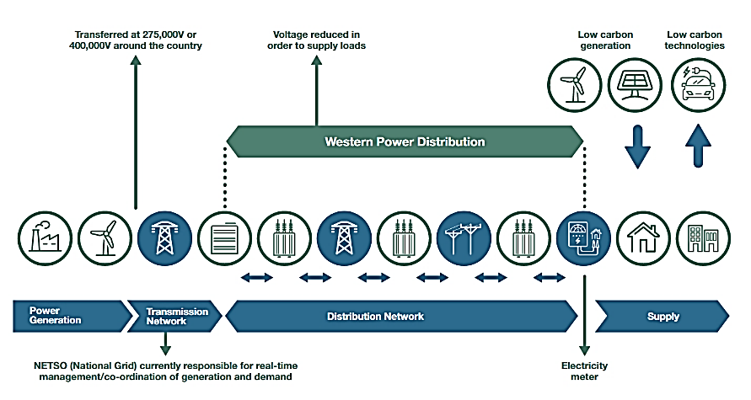
Figure 4: Structure of UK power grid from power generation to supply.
(Adapted from Western Power Distribution 2020)
In order to meet grid flexibility goals, which rely on smart charging, barriers to installing and utilizing smart EV chargers must be reduced. Ofgem in 2021 identified the cost of installing a smart charger as a significant barrier, with residential charges running between £500 and £1,000 before incentives (PriceYourJob, 2022). Another barrier identified by the 2021 Flexibility in Great Britain study was a lack of clear roles and responsibilities for the different segments of the UK power grid. The report outlines the efforts to mitigate these barriers including regulatory support and financial incentives to offset installation costs. The efforts to mitigate these barriers include regulatory support and financial incentives to offset installation costs.

2.5 Current Sustainability Efforts by Local Government in Worcester
Worcester operates under a two-tier local government, Worcestershire County Council and Worcester City Council. As part of a local enterprise partnership (LEP), Worcestershire County Council is responsible for local economic development. This includes playing a role in the energy sector, especially in low carbon transport and active travel, because changes in transportation usage will influence the energy needs of the transportation sector.
The Worcestershire LEP Energy Strategy published by the Worcestershire County Council lists the area’s short-term projects to help reduce the emissions of this sector and the main challenges in low carbon transport (2019). One of the challenges noted by the council was the lack of EV infrastructure and charging points, which will become a significant issue with the future ban in personal ICE vehicle purchase and subsequent increase of EV ownership. To address this issue, the county council has developed an EV strategy to:
- Encourage installation of charging points at public and private locations,
- Encourage new construction, housing, and other developments to incorporate facilities for charging plug-in and other ultra-low emission vehicles, and has
- Proposed solutions to address the challenges of home charging. (Encraft Ltd, 2019).
Short-term goals include installing more on-street charging stations for those who live in homes without a dedicated parking space. The county council will also investigate installing EV taxi charge points to facilitate the change from ICE taxis to EVs so that public transportation will also be a low emission option (ibid.).
To complete these projects and identify public charger locations, the county council needs data on the daily transportation needs and habits of specific groups in specific areas. To achieve its goals and collect the necessary data, the County council is teaming up with parishes and local councils in the area, such as Worcester City Council.
The city council has implemented several measures to curb its own carbon emissions, such as purchasing five electric vans for use by their environmental operations team and two electric bikes from the University of Worcester Woo Bikes program for Council staff to travel to meetings. Staff members are also able to purchase a bike by salary sacrifice, in turn reducing their income taxes. The council plans to procure additional zero emission vehicles to be used in place of their current fleet or in a shared car program. In addition, a salary sacrifice scheme will be adopted to enable city council employees to purchase an EV.
Measures have not only been implemented for the city council, but for city residents as well. Nine electric charging points, including one rapid charger, were made available in 2017 within St Martin’s Gate, a car park garage around an eight-minute drive and half-an-hour walk from the University of Worcester. A proposal has also been submitted to the Accelerated Towns Fund for a rapid charging hub. There are also plans to encourage EV adoption through local incentives and to accommodate residents without off-street parking through affordable and easily accessible charging provisions in council owned car parks (Worcester City Council, 2020).

2.6 Electric Vehicle Ownership Incentives
Local government is not the only entity working toward low carbon emissions. Since the UK has set a goal to become net zero-emission by 2050, the UK is taking steps to encourage the sale of EVs. In particular, the UK has created an incentive of a maximum of £4,500 for an EV purchase and if an EV cost less than £40,000 then it is tax exempt (Sanguesa, 2021). In the UK, the Scrapping Program is designed to help improve air quality by offering an incentive to recycle older ICE vehicles (Macioszek, 2021). People who want to dispose of their older diesel vehicle are given cash towards the purchase of a new lower emission vehicle (ibid.).
Another incentive program offers government grants to help cover the cost of a plug-in hybrid EV (PHEV) costing less than £35,000. The government grant is only available at the time of purchase and is only for EVs with an electric range of at least 113km (70 miles), and for PHEVs with emissions of less than 50g/km of CO₂ (RJP, 2021).
Tax incentives are another important tool that the UK has used to get people to switch to an EV. There is a tax relief incentive for businesses that want to install charging stations located on or near their facility before March 31, 2023 (ibid.). The businesses can claim 100% first year allowances on the investment cost providing them with a reduction in their taxes for the given year. Another tax incentive encouraging EV adoption is a £0 rate for charging fully electric vehicles which will apply until at least 2025 (RJP, 2021). In addition, hybrids also have reduced tax rates based on emissions. In the 2019-2020 tax year low emissions cars were taxed at 16% the listed price and diesel cars were at 20%. Fully electric cars were taxed at 0% for 2020 but rose to 1% in 2021/22 and rose another 1% in the 2022/23 year. There is also a reduction for hybrid cars which is based on the electric range of the vehicle (ibid.).
The price of oil acts as an effective incentive for EV ownership. When the price of oil increases the demand for EV’s also increases. Information on the relationship between oil price and EV demand can be found in appendix E.

2.7 Electric Vehicle Ownership Barriers
According to a 2021 Office of National Statistics survey of UK adults aged 16-49 and research carried out by Opinium with a sample size of 2,003 UK adults in July 2020, the top three reasons ICE car owners gave for not considering an EV purchase for their next vehicle were:
- Lack of charging infrastructure (Office of National Statistics, 2021),
- Inability to travel long distances on a single charge,
- High purchase cost in comparison to a similar sized petrol, diesel, or hybrid car (Kwick-fit, 2020).
Supporting these survey results, Volkswagen has warned that there will need to be a significant increase in the availability of chargers before consumers will be convinced to switch from ICE vehicles (Partridge, 2022). If the UK hopes to encourage the sale of EVs over ICE vehicles by 2030, charging infrastructure improvements will also be needed to meet the (in particular, fast DC) charging demand, as well as fast charging future EVs on national highways (ibid.). For example, currently in the West Midlands, there are only 31 public charging devices per 100,000 residents, and only 8.3 rapid chargers per 100,000 people (Department for Transport, 2022c). Compared to Norway, a country ranked second for EV adoption in Europe (Doll, 2022), this number is very low as there are 350 chargers per 100,000 people (Yamada, 2021). It is advised by The Society of Motor Manufacturers and Traders (SMMT) that the UK will need 2.3 million charging points by 2030 to meet the predicted public charging demand (EVC, 2021).
As battery technology improves, more people will be able to switch to EVs. According to the Society of Motor Manufacturers and Traders (SMMT), the current range of EVs in a single charge is between 201km (125 miles) and 560km (348 miles) (Rowlatt, 2020). The researchers concluded that 25% of car owners can already switch to electric vehicles because they generally drive less than 100km (62 miles) in single journey (Waterstaat, 2020). The same study also found that once electric vehicles with a range of 500km (310 miles) or more are common, that 70% of people will be able to make the switch because their driving needs will be met.
Comparing the cost of EVs and ICE vehicles is challenging because many factors affect overall purchase cost as well as operating costs. The Mobility House compared the electric Hyundai IONIQ Elektro Trend to an ICE car, the Hyundai i30 1.4 T-GDI Trend DCT (2021). As seen in Table 1, The IONIQ Elektro Trend has a higher purchase price of 33,300 €, while the i30 costs around 24,550 € to purchase. When all costs in Table 1 are considered and the EV government subsidy is accounted for, the cost of purchasing the IONIQ is about the same as the petrol powered i30.
Operating costs in Table 2 are estimated for both the cost of the electricity or petrol for one year. The Fuel/Energy consumption cost is the estimated cost of both vehicles to travel 15,000 km (9320 miles). The cost of electricity was calculated using 15 kWh per 100 km at the average electricity cost of 0.30 €. Fuel costs for the comparable petrol engine were calculated at 5.5 liters per 100km at an assumed average cost of petrol in Germany of around 1.30 €. When all estimated yearly operating costs are taken into account the cost of operating the IONIQ is cheaper than the comparable ICE vehicle mainly because of the savings in fuel/energy consumption costs.

Table 1: Purchase cost comparison of an EV and petrol vehicle.
(Adapted from The Mobility House, 2021)
Purchase Cost Factors | Hyundai IONIQ Elektro Trend | Hyundai i30 1.4 T-GDI Trend DCT
Purchase Price | 33,300 € | 24,550 €
Charging Infrastructure | 1,100 € | 0 €
Cost Before Subsidy | 34,400 € | 24,550 €
Subsidy/Purchase Premium | -9,000 € | 0 €
Total Purchase Costs | 25,400 € | 24,550 €

Table 2 : Yearly operating cost comparison of an EV and petrol vehicle.
(Adapted from The Mobility House, 2021)
Yearly Operating Costs | Hyundai IONIQ  Elektro Trend | Hyundai i30 1.4  T-GDI Trend DCT
Fuel/Energy Consumption | 675 € | 1,170 €
Car Tax | 0 € | 98 €
Insurance | 969 € | 1,260 €
Maintenance/Servicing | 552 € | 744 €
Total Yearly Costs | 2,196 € | 3,272 €

2.8 Public Transportation in the City of Worcester
As an alternative to the purchase of an EV, there are a variety of public transit options in the Worcester area. Shown in Figure 5, the Worcester First Bus line operates throughout Worcestershire and the surrounding area. Other options for transportation include car clubs, which offer an alternative model to vehicle ownership. Similar to Zipcar in the U.S., car clubs are short term car rentals that are locally parked in the area and paid for by the minute, hour, or day. This reduces the need for private parking or even private car ownership and allows for travel when convenient (Transport for London, 2022). Ride share services such as Woober, a taxi service similar to the U.S.’s Uber and Lyft, is also available. The abundance of public transportation raises questions about the first/last mile, or what is “the beginning or end of an individual journey to or from a transportation hub or service,” a problem which contributes to carbon emissions by excessive motor vehicle use (England’s Economic Heartland, 2019). Some people choose to drive because public transport, although greener, would not be as convenient and would make their commute longer.
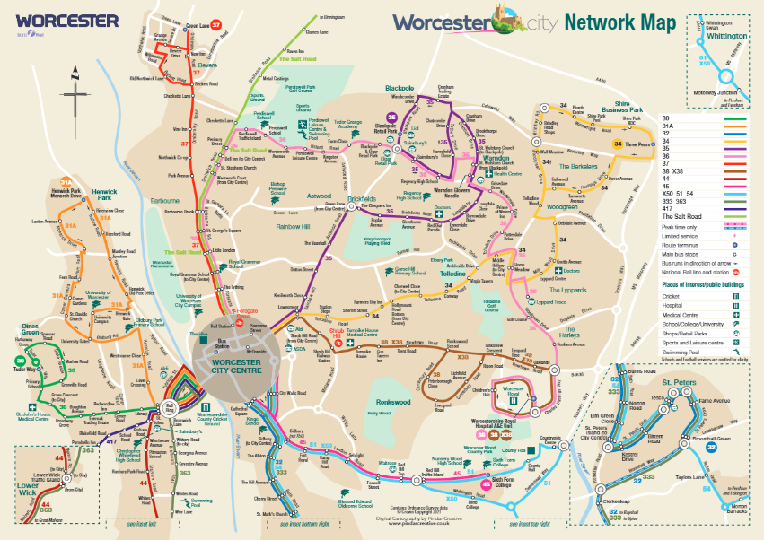
Figure 5: Bus network map of routes available in the Worcester city area.
(First Worcestershire, 2022)

2.9 Transportation and EVs at the University of Worcester
The University of Worcester is the only public university located in Worcestershire County, and has three locations: St John's Campus, City Campus, and Severn Campus. St John’s Campus is around a twenty-minute walk from City Campus, and Severn rests between the two (University of Worcester, 2022b). A key value of the University is to promote sustainability with its students, and the surrounding community to benefit both society and promote a greener future. Since transport-related carbon emissions are the second largest contributor to the University’s total carbon footprint, creating a set of transportation and travel targets has played a crucial role in the University’s plans to reduce emissions (University of Worcester, 2022g). By working with the European Network for Sustainable Mobility at University, a European Union funded campus sustainable mobility program (UMOB, 2022), the University has produced an action plan to decarbonize travel. The Mobility Plan 2019-2021, Strategic Line V outlines the steps that will be taken by the University to promote efficient car use:
- 100 EV charging stations will be installed around campus
- University carpooling will be expanded
- UW will add EV minibuses to the electric fleet of vehicles (Figure 6; Univ. Worcester, 2022d).
In addition, the Sustainable Environments Research Group (SERG) was launched to bring together members across the University to engage in research that will ultimately help people and the planet. While SERG has several areas of distinction, the Sustainable Places research area focuses on the link between green infrastructure and positive effects on people and the environment in rural and urban locations (University of Worcester, 2022e). One ongoing SERG project is Woo Bike Share, a program that promotes a healthier work commute and reduced environmental pollution through a low-cost bike sharing service (University of Worcester, 2022a). The Worcester County Council and Worcester City Council have worked alongside the University to help extend the program to the city of Worcester (Encraft Ltd, 2019). For those who take the bus, The University currently offers exclusive discounts through First Bus, which has over 30 stops in Worcestershire, shown in Figure 5 (First Worcestershire, 2022).
As a part of the University’s ongoing efforts to reduce their carbon footprint, yearly student travel surveys are conducted. These surveys report how students commute to campus, what type of vehicles they drive (ICE or EV), and their thoughts about electric vehicles. The results of the University of Worcester student surveys will provide a baseline for our non-student survey.
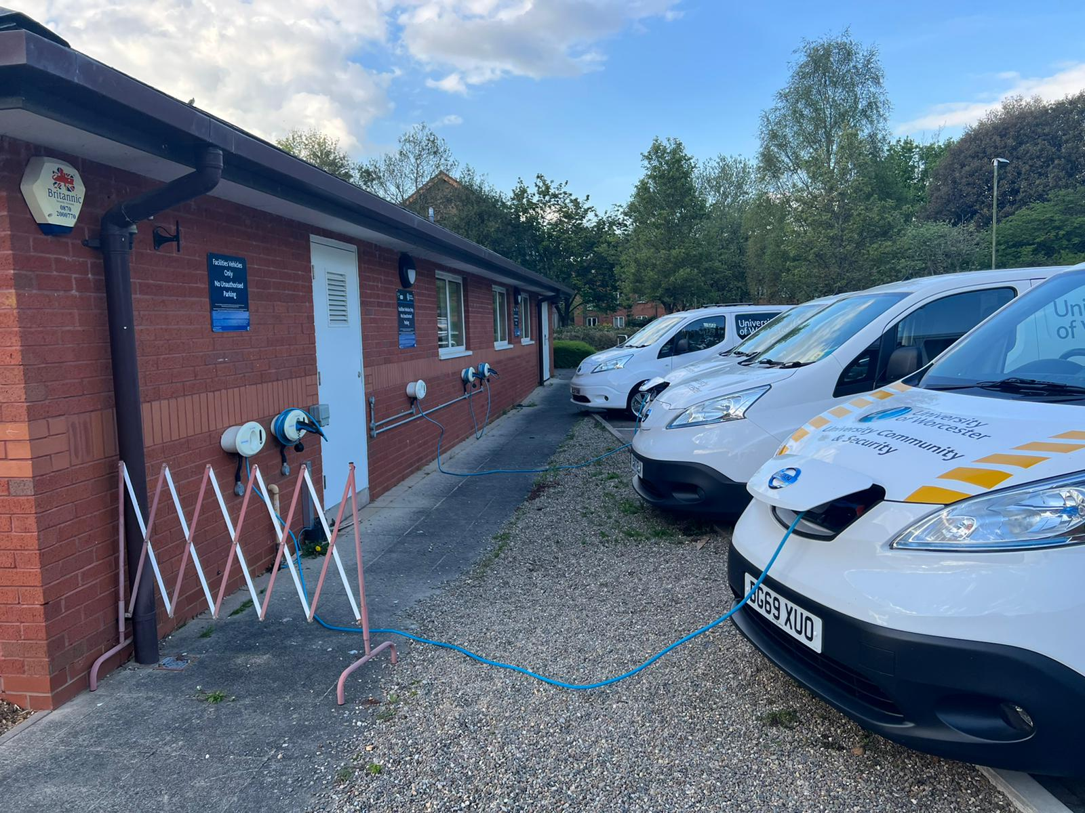
Figure 6: University of Worcester electric fleet and chargers.

3.0 Methodology

The goal of this project was to create a framework (methodology and rubric) that can be used by local governments and organizations to improve the EV charging infrastructure in Worcestershire County, focusing on the City of Worcester. To achieve this goal, we identified the following objectives.
- Document the transportation options for residents in the Worcester area.
- Document transportation routes and methods used by residents in the Worcester area.
- Identify barriers and incentives for residents looking to purchase electric vehicles.
In addition to the graphic for our objectives and methods shown in Figure 7, this section describes the methods in more detail we used to achieve each objective.

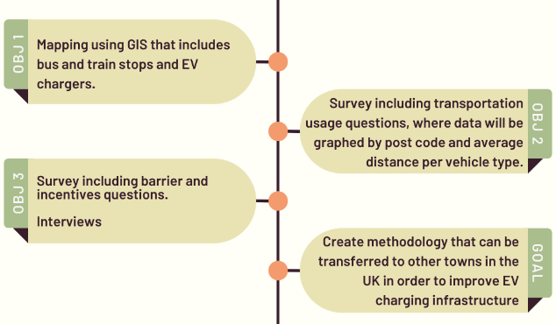
Figure 7: Mapped methods to achieve the stated objectives.

3.1 Document the transportation options for residents in the Worcester area.
To achieve this objective, publicly available information regarding common modes of transportation was analyzed and depicted on a map using geographic information system (GIS) mapping software. The data plotted includes the following:

- Bus routes, bus hubs, and bus stops from Government databases,
- Train routes and hubs based on West Midlands Railway routes,
- Postal area and district from the Office of National Statistics, and
- EV chargers from the national charge point registry and confirmed using Zap Map.

This map served as the basis for identifying the availability and possibilities of different modes of transportation in areas surrounding the University of Worcester.

3.2 Document transportation routes and methods used by residents in the Worcester area.
To achieve this objective, we surveyed students and young professionals, but primarily only in those neighborhoods surrounding the University of Worcester St. Johns and other campus locations. A survey for young professionals (appendix B) provided information about age, travel distance, mode of transportation, purpose of travel, and EV ownership. We used the travel data, postcode, and mode of transportation to create various graphs and information figures that illustrate the survey and travel data results. For each mode of transportation, the distances provided were analyzed to compare how far participants were travelling in relation to their residence. We also used age and other factors to identify and discern data differences (if any).

3.3 Identify barriers and incentives for residents looking to purchase electric vehicles.
Barriers and incentives to EV adoption were identified from survey and interview results. Our survey asked participants to identify obstacles to EV adoption which helped us identify barriers we missed in our research. Participants were also asked to rank barriers and incentives identified in our background research. This ranking provided us with data on both the perception of barriers and incentives, as well as the relative importance of different barriers and incentives. In addition to surveys, we conducted interviews to obtain more detail and, in general, gain a deeper understanding of EV purchase factors participants were considering.

3.4 General Methods for All Objectives

3.4.1 Identifying Areas of Interest
One particular group of interest is commuter students living in off campus housing with minimal off-street parking. The neighborhoods of St. Johns near the University of Worcester were recommended as an area of interest. For the non-student groups the selection criteria were age and limited off-street parking access. We were looking for young professionals, those who were working and between the ages of 18-35, however, our survey was designed to be distributed to all age groups. We then filtered the results based on age to separate different groups. The Arboretum area in Worcester City Centre was recommended as an area of interest because it has a mixed population and lots of foot traffic. More generally, we also targeted the postcodes surrounding the University of Worcester campuses.

3.4.2 Survey Distribution
We piloted our survey methods by assisting with the distribution of this year's University of Worcester Student Travel Survey. The survey methods used were intercept surveys, door to door surveys, social media, the University Daily Update, and incentives. We conducted intercept surveys at the University of Worcester St. Johns Campus and in the city center at Crown Gate Shopping Center. Other ways of conducting intercept surveys were going door to door with flyers and attending the University’s trivia night. Also, while any type of in-person survey was conducted, we wore attire that attracted attention including costumes, safety vests, WPI or University of Worcester attire. Another method of survey distribution was social media. We joined student and local social media groups and sent requests to the administrators to post the link and flyer (see Appendix D) to our survey. We mainly used Facebook but investigated others. We also worked with Georgia Williams, Marketing and Communications Manager at the Herefordshire & Worcestershire Chamber of Commerce to post our survey on the Chamber’s website. Another method of distribution was that our survey was sent out to University of Worcester staff using the University’s Daily Update. Lastly, we used the incentive of a raffle for a £50 Amazon gift card. Survey participants had the opportunity to enter their email at the end of the survey in order to be entered in the raffle. All of these efforts resulted in 180 responses to the survey and 74 additional responses to the University’s Student travel survey.

3.4.3 Interviews
Interviews were used to supplement the results of the survey. The survey featured a section where respondents could indicate interest in participating in a focus group, with the incentive of being entered in the raffle twice. Participants schedules did not align for focus groups, so we switched to 10-15 minute interviews. The interview data provided us with more information than the survey leading to a deeper understanding of perceptions surrounding EV adoption. This helped us gain more qualitative data regarding barriers and incentives than the survey could provide. The consent preamble for interviews can be found in Appendix A and interview questions can be found in Appendix C.

3.4.4 Rubric
A rubric was created to assess the status of current EV charging infrastructures in selected areas. Rubric categories were informed by our survey results and background map research. The purpose of the rubric was to guide and assess the long-term development of EV charging infrastructures in other cities and towns in the UK.

4.0 Results and Findings

This section will detail the results from each method and discuss the findings. The findings from this section were used to support the recommendations.

4.1 Public Transportation Availability
We created a GIS map of Worcester to analyze current public transportation infrastructure. Layers included in the map are as follows: Open Street Map, Postal Area, Postal District, Bus Stops, Rail Stations, and public EV chargers. A map of the postcodes WR1 and WR2 is shown below in Figure 8, however the map will display any of the previously mentioned layers for any postcode in Worcestershire which are shown in Figure 9.
The St. John’s area, located in WR2, and Worcester City Centre, located in WR1, were found to have limited public charging through GIS, which was confirmed with ZapMap. Based off the number and coverage of bus stops and close-by rail stations, public transportation would appear to be a convenient way to get around Worcester and the local area. This would later be expanded upon during interviews, which allowed for firsthand accounts of experiences with public transportation.
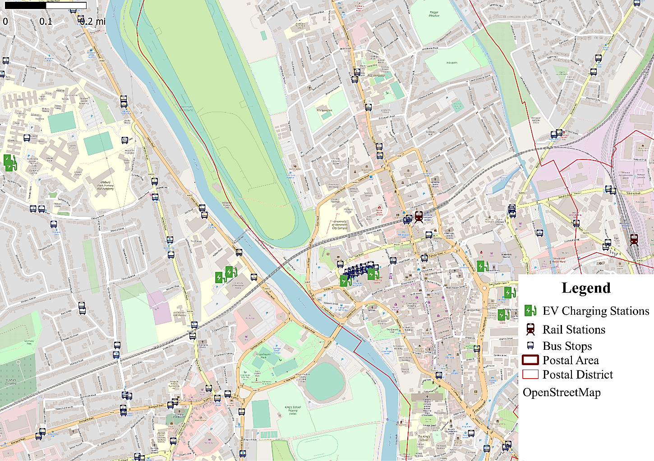
Figure 8: GIS Map created to display postal districts, postal areas, public
transportation availability (bus and rail stops), and public EV chargers

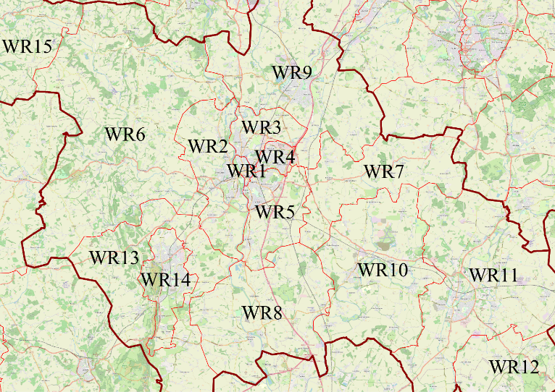
Figure 9: Worcestershire GIS post code map to display the different postcodes.

4.2 University of Worcester Student Travel Survey
University of Worcester student travel surveys in 2018 and 2020 revealed that most students reported living at home, and that the number of students living at home increased by almost 20% during COVID-19 (see Figure 10). The rest of the University’s students lived in student halls, shared student houses, private housing, or made other arrangements.

Figure 10: Types of housing students live in.
(Adapted from University of Worcester, 2018; University of Worcester, 2020b)

Most students surveyed had a 0–60-minute commute to campus (University of Worcester, 2018; University of Worcester, 2020b) and some said it was not feasible via public transportation. As seen in Figure 11, the most common modes of transport for students were by car and on foot. About 95% of students who commute to campus by vehicle drive ICE vehicles. The remaining 5% of students drive a combination of hybrids, EVs, Motorbikes and other vehicles (University of Worcester, 2018; University of Worcester, 2020b). The top reasons behind students using a vehicle to commute to the University included: distance from home, personal responsibilities, time saved vs public transit, and lack of public transport.

Figure 11: Modes of transport students use to commute to campus.
(Adapted from University of Worcester, 2018; University of Worcester, 2020b)

When asked if considering purchasing an EV for their next vehicle, it was found that consideration of purchasing a hybrid or fully electric vehicle is increasing among University of Worcester students (ibid.). There was approximately a 9% increase since the beginning of the COVID-19 pandemic (Figure 12). The survey showed that a significant minority (20-30%) of students are considering an EV for their next vehicle but most would want to charge on campus. The majority of students who said they were considering purchasing an EV as their next vehicle said they would charge their vehicle on campus (Figure 13) and would not plan on paying to charge as they expected it to be included in parking fees (University of Worcester, 2018; University of Worcester, 2020b).

Figure 12: Are students considering purchasing an EV or hybrid vehicle as their next vehicle?
(Adapted from University of Worcester, 2018; University of Worcester, 2020b)

Figure 13: Would students charge their EV on campus if they purchased an EV?
(Adapted from University of Worcester, 2018; University of Worcester, 2020b)

4.3 Survey Discussion
We received a total of 180 responses. There were many challenges with gathering responses. When the survey was first posted to various Facebook groups, many responses were received within the first 24 hours, but then the response rate tapered off. About 2 weeks later we reposted our flyer in the same Facebook groups, resulting in a few more responses. As a result of posting on these Facebook groups, we received 120 invalid responses with postcodes from the U.S.A.
Another distribution method we used was door knocking and flyer handouts in areas identified by our sponsor, neither of which was successful as we gained only one response. On two occasions the survey was sent to University of Worcester staff through the University’s Daily News which led to many more responses. Below we describe our findings and provide a critique for each of our survey questions.

Q: Please indicate which age group you are in.
The age group distribution of survey respondents is shown in Figure 14. As shown here, 81% of respondents were between the ages of 35-64. Many of these respondents were staff at the University of Worcester. The age groups were important to understanding different perspectives at different points of life and were used in later questions to assist in the comparison of data.

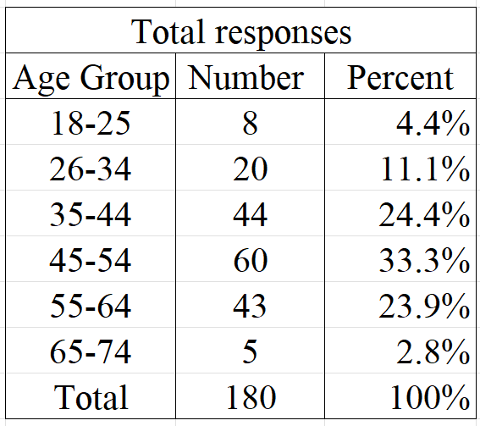
Figure 14: Percent responses by age group

Q: Does your residence have off-street parking?
Of our 180 respondents 34 (about 19%) do not have off-street parking (Figure 15). The age group with the least off-street parking is 18-25. The age groups with the most off-street parking were 65-74 and 35-44. Not having off-street parking was important to understanding how different parking situations will affect respondents' needs and answers to other questions. Further use of this data will be seen in some of the following question analysis.

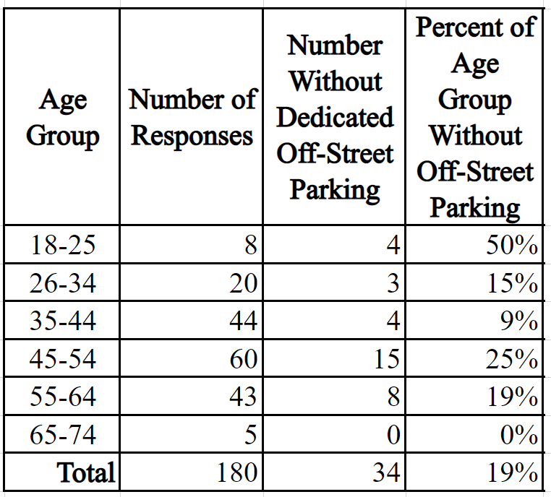
Figure 15: Percent of each age group without off-street parking

Q: When thinking of purchasing an electric vehicle what are three factors you would consider? Please list.
The survey, itemized in Appendix B, asked participants to list up to three factors they would consider with the purchase of an EV. Respondents provided 477 factors which were categorized into 7 categories shown in Figure 16. The cost category included cost of purchase, running the vehicle, charging, and installing a charger. Infrastructure included where participants would charge their car and how long charging would take. Range was another category including how far the vehicle can travel per charge. The car specific category is comprised of a variety of factors that relate directly to the car such as model, space, appearance, quality, and reliability. Barrier is considered anything that stops a respondent from wanting to switch. This mainly consists of worries about the impact on the environment. Battery is consistent of the battery life which is how long the battery will last. The incentive category consisted of tax saving. Overall cost was the most considered factor with over 165 responses. Understanding the perceived barriers is the first step to being able to address them. The fill in the blank question provided respondents to enter whatever came to their mind first so it did not have to be the ones we identified. The outcome of this question provided us with valuable insight into factors we had not considered. These turned out to be in line with the barriers our background research identified.

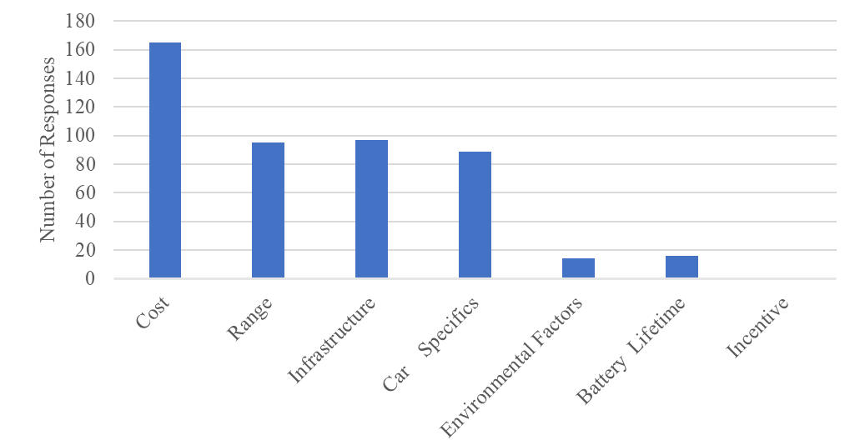
Figure 16: Reasons People Consider When Thinking about EV Adoption, N=180

Q: When purchasing your next vehicle how likely are you to consider a plug-in hybrid or fully electric vehicle?
Participants were asked to rate their likeliness of buying an EV as their next vehicle on a scale of 1 to 5, 1 being very unlikely and 5 being very likely. Overall, around 40% of respondents were very likely to consider an EV purchase as their next vehicle as shown in Figure 17. When looking at the various age groups of participants, 55% in the 45-54 age group responded with a 5 (very likely). In the 65-74 age group, which only had 5 participants, 80% of respondents responded with a 5 (very likely). Only 20% of the 26-35 age group responded with a 5 (very likely) response rate, making this age group the least likely to buy an EV as their next vehicle.
The data was sorted by those who did not have off-street parking to see if that could be a factor in EV adoption. As shown in Figure 18, respondents who did not have off-street were less likely to consider the purchase of an EV. Also seen in Figure 18, 63% of respondents without off-street parking responded with a 3 (neutral) while less than 20% responded with a 5 (very likely). Of the 34 respondents 15 of them didn’t know where they would charge their EV and 5 would charge at work if they were to purchase an EV. Respondents have concerns about where they would park their car without off street parking which leads them to be less likely for EV adoption.

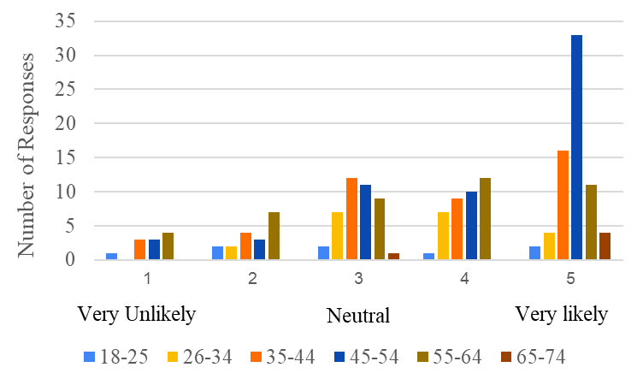
Figure 17: How Likely to Purchase an EV, N=180

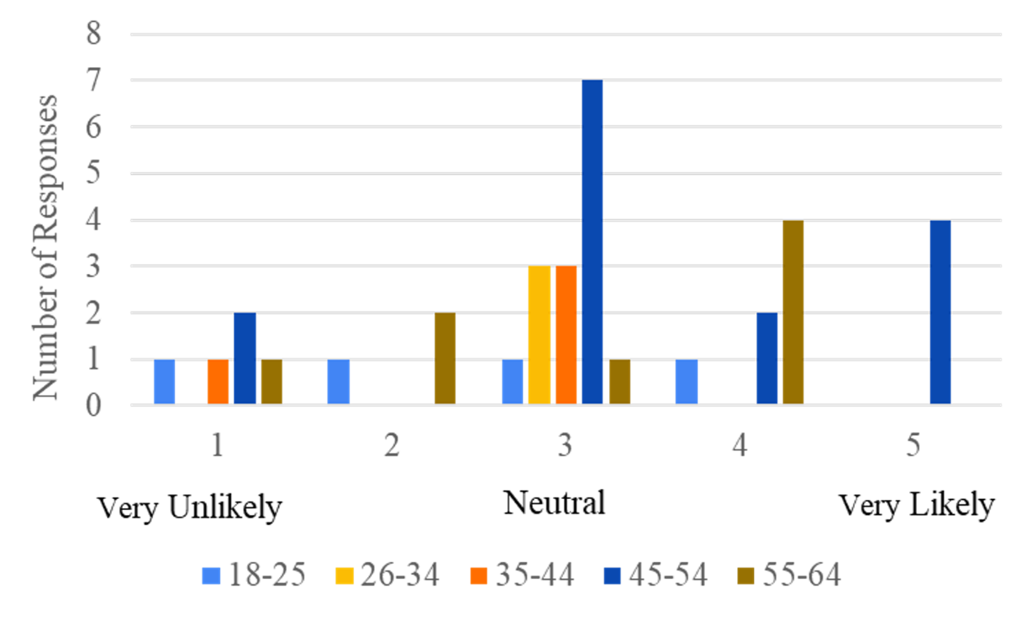
Figure 18: How likely to purchase an EV for people without off-street parking, N=34

Q: What is post code of your residence (home)? & What is the postcode of your most common destination?
The survey asked participants to provide their home postcode and the postcode of their most common destination. Some respondents included the complete postcode while others only input the main part of the postcode. Google maps was used to determine the distances between home postcodes and destination post codes. The average distances travelled were first organized by age group as shown in Figure 19. The 35-44 and 45-54 age groups traveled the farthest distance with averages of 13.7 and 13.8 miles respectively. Those aged 65-74 traveled the shortest distance of 2.96 average miles.
The average distances were also organized by post code to illustrate how far respondents traveled, both to and from a certain postcode (Appendix H). From the responses the distances travelled are generally less than the number of miles an EV can travel on a full charge.

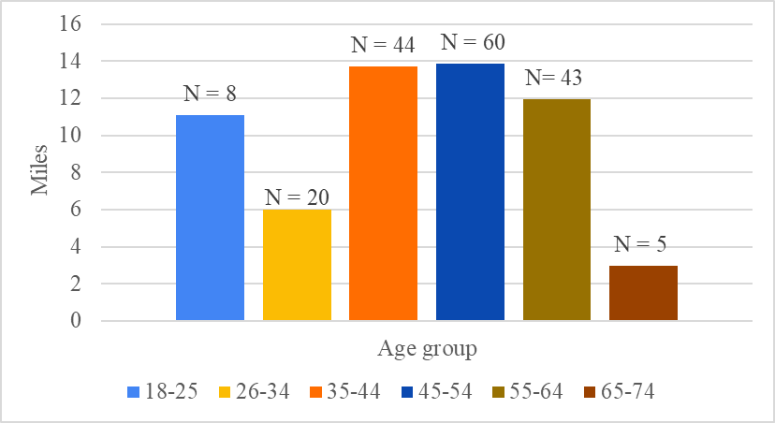
Figure 19: Average number of miles per Age Group, N=180

Q: How far would you be willing to walk from where you park/charge your motor vehicle to your residence?
As seen in Figure 20, around 71% of respondents said that they would be willing to walk 0-5 minutes and 17% were willing to walk 6-10 minutes. Combining these leads to 88% of respondents being unwilling to walk further than 10 minutes. This shows that respondents do not want to have to walk very far from where they park/charge to their residence, this is an important factor to consider when placing future chargers.
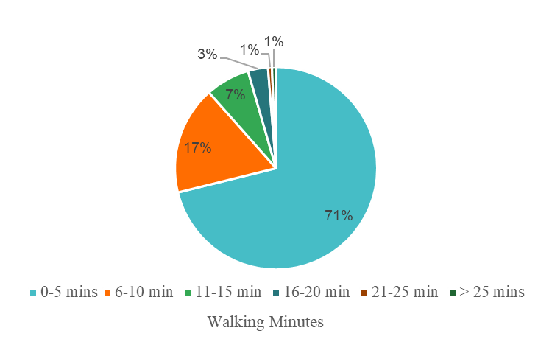
Figure 20: How far respondents would walk to park/charge their motor vehicle, N=180

Q: Please rank the following possible obstacles to electric vehicle adoption with 4 having the greatest impact and 1 having the lowest impact.
As shown in Figure 21, cost was the perceived barrier ranked as highest impact with 56% of respondents ranking it a 4. Environmental impact was the least impactful barrier in EV adoption with 64% of respondents ranking a 1. When the four barriers were sorted by age group there was very little variance between age group on the most impactful perceived barriers. This data demonstrates how the most impactful perceived barrier to EV adoption is cost while people are least worried about the environmental impact of EV manufacturing.

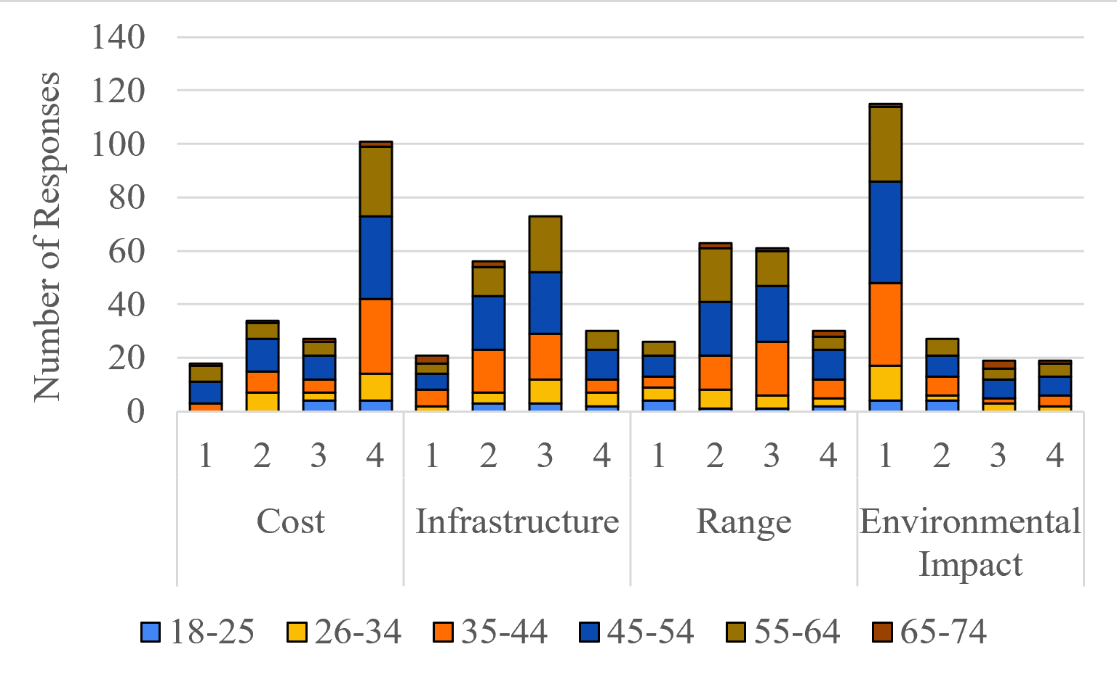
Figure 21: Barriers identified from background research ranked by respondents, N=180

Q: Please rank the following incentives for electric vehicle ownership with 3 having the greatest impact to 1 having the lowest impact.
The survey asked respondents to rank incentives from least impactful (1) to most impactful (3) with response distribution shown in Figure 22. Subsidies overall were the most impactful incentive to EV adoption with 58% ranking it at 3. Road tax was overall the least impactful with 48% of respondents answering with a 1. Government subsidies being ranked the most impactful by respondents correlates with the most impactful perceived barrier being cost. Subsidies are important to reduce the purchase cost of EVs to the price of a comparable ICE vehicle.
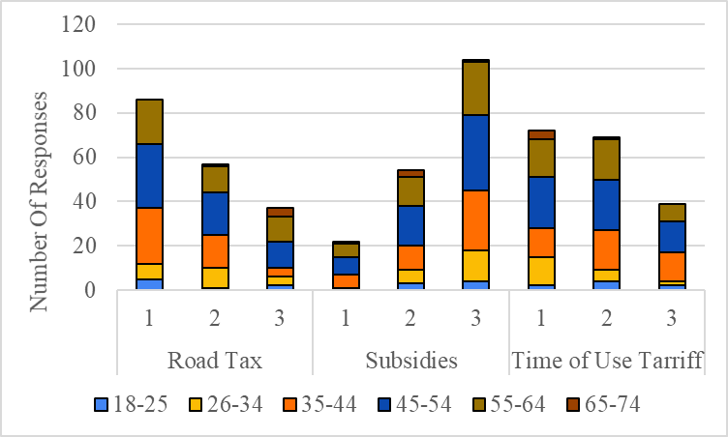
Figure 22: Incentives Barriers identified from background research ranked by respondents, N=180

4.4 Interview Findings
We interviewed a total of five people about their interest in EVs, categorized by interviewees 1, 2, 3, 4, and 5. Interviewees 1 and 2 owned EVs, while 3, 4, and 5 were ICE vehicle owners. Our sample size was small but had a few key findings. There were several similarities between the first four interviewees: designated off-street parking, ability to install a home charger, and interest in EVs. Interest in EVs stemmed from a variety of reasons, including research from owning one and working in a sustainability field.
The EV owners purchased their vehicles at different times. Interviewee 1 has owned for 4 years with Interviewee 2 owning for only 5 weeks. They both talked about different issues they ran into with their EV, with the main problem being that public chargers are not always reliable. Many of them would not be working and we were able to confirm this on Zap Map.
For the ICE vehicle owners, Interviewee 3 and Interviewee 4, are both considering the purchase of an EV. Interviewee 3, however, is very concerned with the environmental impact of scrapping an EV. They researched hydrogen powered EVs, however, it is not currently feasible to purchase one due to limited availability. They were also concerned with the range of an EV and how quickly it would charge. Interviewee 4 was very open to the idea of an EV and didn’t describe any concerns. We also learned from them that public transport is not widely available where they are located, so a personal vehicle is their only option. Interviewee 5 is not considering an EV because they are worried about the lack of infrastructure. Overall, from our interviews we were able to have an open discussion and learn more information about the barriers with EVs that we were not from our survey.

4.5 Rubric to Evaluate EV Charging Infrastructure Implementation Status in an Urban Area

4.5.1 Rubric Development
We created a rubric (Figure 23) to help evaluate the implementation status of EV charging infrastructure in urban areas. This rubric has five assessment categories for consideration and review of the status of a charger infrastructure implementation plan and is meant to be used by those well versed in current EV technology and policy. Each category has a scale of one to four with four being the target for meeting stakeholder requirements and one being the level below the current implementation status in WR1. The charging infrastructure assessment rubric consists of the following categories:
- EV charging availability
- public charging speed
- smart charging policy
- public charging etiquette policy
- maintenance and upkeep
Charging availability is ranked on the time it takes to walk to/from a charger for a given percentage of people. EV charging speed is ranked on if charging speed is inversely proportional to time spent at a location. The smart charging policy category starts with no policy or incentives to encourage or mandate it and ends with policies requiring it in both new and old construction. The public charging etiquette category is ranked on the existence of policies to encourage respectful use of public chargers and effective enforcement methods. Finally, maintenance and upkeep refer to the percentage of total chargers that are working in the parking garage or lot, street location or other area being evaluated.
The rubric was designed to be used in any urban area, not just in Worcester. The rubric can be used in the future to assess different areas and reassess areas of Worcester’s EV charging infrastructure.
EV Charging Infrastructure | Category | Level 1 | Level 2 | Level 3 | Level 4
 | EV charging availability¹ | EV chargers more than 30 walking minutes for at least 75% of people | EV chargers within 16-30 walking minutes for at least 75% of people | EV chargers within 6-15 walking minutes for at least 75% of people | EV chargers within 0-5 walking minutes for at least 75% of people
 | Public charging speed² | Nearly 100% of chargers are level 2 chargers | ~75% of chargers are level 2 with ~25% level 3 chargers | ~50% of chargers are level 2 chargers with the remaining chargers being level 3 or other types of fast chargers | At least 75% of chargers are level 3 chargers
 | Smart charging policy³ | No policy to encourage /mandate smart charging | Policies encouraging smart charging in new construction. | Policies in place requiring smart charging in new construction and encouraging retrofit. | Robust policies requiring smart charging in new construction and retrofits for existing sites.
 | Public charging etiquette policy⁴ | No policy to encourage /mandate only spending the required time at chargers | Policies encouraging only spending the required time at the chargers | A mix of policies encouraging and mandating only spending required time at chargers. | All policies are robust and mandate only spending required time at chargers.
 | Maintenance and Upkeep ⁵ | Less than 30% of EV chargers in a selected area are fully functional | 30%-59% of chargers in the area are fully functional | 61%-90% of chargers in the area are fully functional | 91% or more of chargers in the area are fully functional
Figure 23: EV Urban Charging Infrastructure Rubric
Rubric Notes
- Level four was determined using the results of the survey which found people did not want to walk more than minutes to charge their vehicle.
- Level 1 charging does not exist or is uncommon in the UK as the standard voltage is 240 volts. Level 3 chargers are not common yet but will be necessary in the future to make charging efficient.
- Current smart charging policy can be found here.
- Currently there are not any policies enforcing charging etiquette. An example of charging etiquette in EVgo can be found here.
- Number of fully functional chargers as a percentage of the total number of chargers.

4.5.2 Rubric Applied to WR1
We chose to apply the rubric to the post code WR1 where Worcester City Center is located because it is an urban area with shopping centers and public EV chargers. For the category of EV charging availability, it is rated at rubric level 2. We used the distance from the farthest charger to the farthest point in WR1 representing a worst-case scenario withing the same postcode. This distance was found to be about 1.2 miles so around 25 walking minutes, landing between 16-30 minutes which is rubric level 2.
Based off the public charging speed category criteria, WR1 was evaluated to be rubric level 2. There are three public charging stations in the area, located in Crown Gate Shopping Centre, ASDA, a British supermarket chain, and St. Martin’s Gate Car Park. Starting with Crown Gate, we found that the average shopper will typically spend 98 minutes shopping in town centers (Statista Research Department, 2014). Crown Gate offers two chargers with charging speeds of 43 Kw and 50 Kw. This is appropriate for the average time spent at the mall. When grocery shopping, the average shopper will typically spend 37 minutes per visit (Hains, 2022). There is one 3 Kw and one 7 Kw charger located by ASDA. Since customers are often spending shorter periods of time at the grocery store, there should be faster chargers rather than slow ones. Located right next to ASDA is St. Martin’s Car Park, where the amount of time spent can vary depending on the purpose of the visit to City Centre. Typically, people who are parking for work will spend 6 hours in the garage, while if someone is only going grocery shopping, they will spend around 37 minutes as previously noted (Gomm, 2021; ibid). The car park has 9 chargers, with speeds of 50 Kw and 22 Kw. The car park has appropriate chargers for the average time spent there. Since two of the three charging locations (66%) have appropriate charging speeds, public charging speed is rubric level 2.
We rated the category of smart charging at rubric level 2. Currently in the UK, The Electric Vehicles (Smart Charge Points) Regulations 2021, requires new chargers for private use to be smart chargers. While privately owned chargers are required to be smart chargers it is not yet required that they make use of smart charging features. Also, there are no policies encouraging the retrofit of previously owned non-smart chargers as needed for rubric level 3.
We rated the category public charging etiquette at a level 2. Currently there are not any policies in place to enforce public charging etiquette. There are signs at local chargers encourage people to move their cars when the charge is complete, an example can be seen in Figure 24.
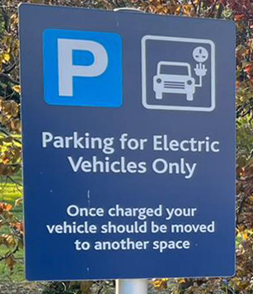
Figure 24: EV charging sign at the University of Worcester encouraging
users to move their vehicles once fully charged

We rated working chargers at rubric level 2 as according to our data obtained from Zap Map (Appendix G) 58% of chargers in WR1 are working. All three charging sites in WR1 have reported issues with two fully out of order. The sites range from one to nine chargers with the two smaller sites having zero out of one and zero out of two working chargers and the larger site having six out of nine working.

5.0 Recommendations

This section will detail a set of recommendations to local governments and organizations and the University of Worcester to improve EV charging infrastructure in Worcester.

5.1 EV Recommendations to Reduce Barriers to EV adoption

Reducing barriers to EV adoption has many components including broken chargers, charging speed, smart charging policies and EV purchase subsidies. Below are recommendations to address these components based on our background research and rubric application to WR1.

- Require charging network operators to maintain existing and future chargers.
Currently 42% of public EV chargers in WR1 are broken and 100% of sites have reported issues according to Zap Map (see Appendix G). The Secretary for State for Transport has acknowledged a significant number of EV charging stations are out of service in the UK at any one time, citing it as a problem stemming from lack of incentive for charge point operators (CPOs) to repair when charger utilization rates are low (Department for Transport, 2022a). The government has proposed a 99% availability standard regulation for CPOs across all owned chargers (ibid). For example, if a CPOs’ owned chargers operate 24 hours a day, 365 days a year, they would be allowed up to 4 days of downtime per charger for maintenance and repair. We propose passing this policy within the next two years to allow CPOs to prepare for the coming policy. An incentive or penalty should also be considered to ensure CPOs will follow policy, such as a bonus for exceeding requirements and/or a fine for non-compliance.

- Install future commercial public EV chargers with consideration to the time spent at the location and ease of access.
Based on our rubric application, we have determined that not all public chargers in Worcester City Centre have speeds that match the average length of stay by location. For example, since customers are spending around an hour at ASDA, there should be rapid chargers available rather than slow chargers. Installing chargers that match length of stay will likely decrease congestion at chargers and optimize how many miles can be added to an EV for a given charging time across the city or area being evaluated.

- Continue to create and implement smart charging policies that encourage the transition to EV over ICE vehicles.
The government needs to ensure that smart charging is eventually a requirement for both public and personal installations. Smart charging can reduce perceived barriers to EV adoption by providing customers with lower electricity rates for charging at different times determined by the power distributor. This is also important for allowing power generators to regulate load by encouraging charging at times when grid load is low. These times are typically when there is less electricity demand, which helps reduce the strain on the grid.

- Increase Government level EV purchase subsidies.
Current government grants do not reduce the cost of an EV to the price of a comparable ICE vehicle. From our survey results, the number one perceived barrier to EV adoption is the cost associated with EVs. In order to address this perceived barrier, the government needs to take action to reduce the purchase cost of an EV to at or below that of a comparable ICE vehicle through grants.

- Install street chargers in areas without dedicated off-street parking.
Our survey shows that 62% of all respondents would want to charge their EV at their residence, and 71% of all respondents would want their EV charger to be a 0–5-minute walk from their destination. Of those without dedicated off-street parking who expect to charge at home after the purchase of an electric vehicle, 80% would want their charger to only be a 0-5-minute walk away from their home. This is supported by deliberative research on public EV charging infrastructure by BritainThinks, which found that having convenient and sufficient near-home EV charging infrastructure was a priority for residents who were considering on-street charging as a potential charging option (BritainThinks, 2022). In urban areas, parking is already in short supply. Installing street chargers would ensure potential EV owners in areas without dedicated off-street parking would have a place to charge their vehicle as well as a parking spot close to home.

6. Implement policies to encourage only spending the required amount of time at public chargers.
Currently many public chargers have signs posted encouraging users to move their cars once they are charged, however, there is no enforcement for this policy. Providing backing either legally or with monetary penalties would motivate EV owners to remain at chargers only as long as necessary. Monetary penalties could be implemented using variable charging costs, for example, if a vehicle remains at a charger after it charges to a set percentage, the cost per KWH would increase.

5.2 University of Worcester Student Travel Survey Recommendations
There is no one answer to increasing the number of students that participate in the University of Worcester Student Travel Survey annually. We observed that the survey was lengthy, not mobile device friendly, no incentive was offered for participation, and students were generally unaware of the survey. The following 6 recommendations should help increase survey participation in future years.

- Reduce the length of the survey.
The reduction of the number of questions and options for the choose-all-that-apply questions would save time and space. The survey needs to be between 5-10 minutes so students would have time to take it between classes. The survey currently takes 10-15 minutes and has 35 questions and many questions have multiple parts. The number of questions should be reduced and tested by students until the 5-10 minute survey duration is reached.
Some of the choose-all-that-apply question have options that were similar and could be reduced to one option, saving time and space. For example, question 17 has 23 options which take up a lot of space. The questions’ similar choices are concerns about road safety, unsafe intersections, driver’s attitudes toward cyclists and poorly maintained road surfaces. All these options could fall under the concerns about road safety. This is only one example of a similar process that should be applied to all these choose-all-that-apply questions.

- Make the survey mobile device friendly.
Most students participate in the survey on their phones. The survey currently requires the participant to zoom all the way out on a mobile device to take the survey. The survey being mobile device friendly would decrease the amount of time it takes to participate in the survey. The survey should be made easily readable on any phone, tablet, or laptop. If it is not possible on the current survey distribution platform, a change in platform should be considered.

- Offer an incentive for survey participation.
The survey did not have an incentive this year which made encouraging students to take the survey much more difficult. Emails should be collected for a raffle for a gift card or food. Students are motivated by food supported by those who took the survey in exchange for chocolate. An incentive would be enticing, leading to a greater participation in the survey.

- Do not use costumes when utilizing intercept survey methods.
We were not taken seriously while wearing vegetable costumes. In the time we did not have vegetable costumes on, we received more survey responses.

- Do not use intercept surveys as a method of distribution during exam weeks.
Students did not like to be bothered during their break and did not have time to take the survey in the passing period between classes. When we conducted the survey, it was during an exam week prior to Easter Break. The beginning of an academic period would be a better time to distribute surveys and explore alternative survey distribution methods.

- Research other survey distribution methods to better reach the student population.
Prior to our efforts the only method of survey distribution used was email, which was not found to be effective as only 58 students participated. Most students ignored the email because none of the students we spoke to had heard about it. However, since it did gather some responses, it should still be used to supplement other methods. The University’s social media pages would be a better way to reach students because many students are on social media.

5.3 Future Research
Several projects could be done as an extension of the EV barriers project with the local data that has been collected. One idea is a survey sent out to those who use local public chargers, using the data to determine where new chargers should be installed. Potential and current EV owners should also be educated on EVs and why the switch from ICE vehicles is important to make the transition as smooth as possible. This education program could include information on subsidies and current infrastructure to change current perceptions of barriers facing EV adoption. Extensions of this project also include assisting people without dedicated off-street parking in the transition to EVs.

References

Amadeo, K. (2022, March 10). The Price of Gas: Why It Goes Up and Down. The Balance. https://www.thebalance.com/why-are-gas-prices-so-high-3305653
BBC News. (2018, September 14). Electric vehicle sales surge in UK as fuel prices rise. https://www.bbc.co.uk/news/business-45419705
BritainThinks. (2022). Public Electric Vehicle Charging Infrastructure. https://assets.publishing.service.gov.uk/government/uploads/system/uploads/attachment_data/file/1061865/public-ev-charging-infrastructure-research-report.pdf
Carbon Trust, & Imperial College London. (2021). Flexibility in Great Britain [Review of Flexibility in Great Britain]. https://www.carbontrust.com/resources/flexibility-in-great-britain
Climate Change Act 2008, c. 39. https://www.legislation.gov.uk/ukpga/2008/27/contents
Crider, J. (2022, March 17). Middle Eastern Oil Producers Worried More People Will Buy EVs As A Result Of High Oil Prices. CleanTechnica. https://cleantechnica.com/2022/03/17/middle-eastern-oil-producers-worried-more-people-will-buy-evs-as-a-result-of-high-oil-prices/
Das, H. S., Rahman, M. M., Li, S., & Tan, C. W. (2019, November 30). Electric vehicles standards, charging infrastructure, and impact on grid integration: A Technological Review. Renewable and Sustainable Energy Reviews. https://doi.org/10.1016/j.rser.2019.109618
Department for Business, Energy & Industrial Strategy. (2021). Energy and emissions projections. gov.uk. https://www.gov.uk/government/collections/energy-and-emissions-projections
Department for Business, Energy & Industrial Strategy. (2022). Energy Trends UK, October to December 2021 and 2021. Gov.uk. https://assets.publishing.service.gov.uk/government/uploads/system/uploads/attachment_data/file/1064782/Energy_Trends_March_2022.pdf
Department for Transport. (2021a). Vehicle Licensing Statistics. https://assets.publishing.service.gov.uk/government/uploads/system/uploads/attachment_data/file/985555/vehicle-licensing-statistics-2020.pdf
‌‌Department for Transport. (2021b). Vehicle mileage and occupancy. https://www.gov.uk/government/statistical-data-sets/nts09-vehicle-mileage-and-occupancy#table-nts0901
Department for Transport. (2021c). Transport and environment statistics: Autumn 2021. gov.uk. https://www.gov.uk/government/statistics/transport-and-environment-statistics-autumn-2021/transport-and-environment-statistics-autumn-2021
Department for Transport. (2022a). Consultation outcome: The consumer experience at public chargepoints. GOV.UK. https://www.gov.uk/government/consultations/the-consumer-experience-at-public-electric-vehicle-chargepoints/the-consumer-experience-at-public-chargepoints
Department for Transport. (2022b). Electric vehicle charging device statistics: January 2022. https://www.gov.uk/government/statistics/electric-vehicle-charging-device-statistics-january-2022/electric-vehicle-charging-device-statistics-january-2022
Department for Transport. (2022c). Transport use during the coronavirus (COVID-19) pandemic. gov.uk. https://www.gov.uk/government/statistics/transport-use-during-the-coronavirus-covid-19-pandemic
Doll, S. (2022). New study predicts which European countries will have the highest percentage of new EVs by 2035. Electrik. https://electrek.co/2022/01/24/new-study-predicts-which-european-countries-will-have-the-highest-percentage-of-new-evs-by-2035/
Eisenstein, P. (2022, March 3). Will high gas prices supercharge electric vehicle sales? NBC News. https://www.nbcnews.com/business/autos/will-high-gas-prices-supercharge-electric-vehicle-sales-rcna18444
Encraft Ltd. (2019). Worcestershire LEP Energy Strategy. https://www.wlep.co.uk/wp-content/uploads/P3695-Worcestershire-Energy-Strategy-Strategy-with-glossary.pdf
Energy UK. (2022). The energy market explained. https://www.energy-uk.org.uk/energy-industry/the-energy-market.html
England's Economic Heartland. (2019). First/Last mile international best practice review. https://eeh-prod media.s3.amazonaws.com/documents/First_Last_Mile_International_Best_Practice_Review.pdf
EVC. (2021). How many EV charge points does the UK need? https://www.ev-chargersuk.co.uk/about-us/news/62-how-many-ev-charge-points-uk
EV Policy Team. (2021). Enabling the transition to electric vehicles: the regulator’s priorities for a green fair future. Ofgem. https://www.ofgem.gov.uk/sites/default/files/2021-09/Enabling%20the%20transition%20to%20electric%20vehicles%20-%20the%20regulators%20priorities%20for%20a%20green%20fair%20future.pdf
Ellingsen, L. A.-W., Singh, B., & Strømman, A. H. (2016). The size and range effect: lifecycle greenhouse gas emissions of electric vehicles. Environmental Research Letters, 11(5), 054010. https://doi.org/10.1088/1748-9326/11/5/054010
First Worcestershire. (n.d.) Network Maps. https://www.firstbus.co.uk/worcestershire/routes-and-maps/network-maps
Fowler S (2022) Electrifying Transport WPD PowerPoint
Ganti, A. (2021, August 31). How OPEC (and Non-OPEC) Production Affects Oil Prices. Investopedia. https://www.investopedia.com/articles/investing/012216/how-opec-and-nonopec-production-affects-oil-prices.asp#:~:text=The%20Impact%20of%20Non%2DOPEC%20Production%20on%20Oil%20Prices,-Non%2DOPEC%20oil&text=Interestingly%2C%20some%20of%20the%20top,thus%2C%20limited%20capacity%20to%20export.
Gausden, G. (2022, March 11). Petrol prices: Record high fuel costs result in 37% surge in interest for electric cars in the UK. iNews. https://inews.co.uk/inews-lifestyle/money/petrol-prices-record-high-fuel-costs-electric-cars-interest-uk-surge-1511362
Gross, S. (2019, March 5). What Iran’s 1979 revolution meant for US and global oil markets. Brookings. https://www.brookings.edu/blog/order-from-chaos/2019/03/05/what-irans-1979-revolution-meant-for-us-and-global-oil-markets/.
Grundy, A. (2022, April). More battery electric vehicles sold in March than entirety of 2019 – SMMT. Current. https://www.current-news.co.uk/news/more-battery-electric-vehicles-sold-in-march-than-entirety-of-2019-smmt
Kwick-fit. (n.d.). Pandemic has caused almost 14 million UK drivers to change their car
buying plans. https://www.kwik-fit.com/press/pandemic-has-caused-almost-14-million-uk-drivers-to-change-their-car-buying-plans
Hall, D., & Lutsey, N. (2018). Effects of battery manufacturing on electric vehicle life-cycle greenhouse gas emissions. theicct.org. https://theicct.org/wp-content/uploads/2021/06/EV-life-cycle-GHG_ICCT-Briefing_09022018_vF.pdf
Hallett, M. (2022) Destination Charging PoC Payment System Indra PowerPoint
Hamilton, J. (2009) Causes and Consequences of the Oil Shock of 2007-08. The Brookings Institution. https://www.brookings.edu/wp-content/uploads/2016/07/2009a_bpea_hamilton-1.pdf
Hänni, A. (2014, April 9). The Great Recession Was an Oil Crisis. Medium. https://medium.com/@eselskind/the-great-recession-was-an-oil-crisis-aa94c17b1e7c
HM Government. (2021). Net Zero Strategy: Build Back Greener. https://assets.publishing.service.gov.uk/government/uploads/system/uploads/attachment_data/file/1033990/net-zero-strategy-beis.pdf
IEA. (2021). Net Zero By 2050: A Roadmap for the Global Energy Sector. https://iea.blob.core.windows.net/assets/beceb956-0dcf-4d73-89fe-1310e3046d68/NetZeroby2050-ARoadmapfortheGlobalEnergySector_CORR.pdf
Indra. (n.d.). About INDRA: Leading EV Charger Manufacturers & Installers. https://www.indra.co.uk/about
Indra. (2021). Indra leads the project that will bring new intelligent, automated and sustainable mobility to spanish roads. https://www.indracompany.com/en/noticia/indra-leads-project-will-bring-new-intelligent-automated-sustainable-mobility-spanish-roads
Macioszek, E. (2021). The role of incentive programs in promoting the Purchase of Electric Cars.... Springer Link. https://doi.org/10.1007/978-3-030-71708-7_4
Met Office. (n.d.). Effects of Climate Change. Met Office.
https://www.metoffice.gov.uk/weather/climate-change/effects-of-climate-change
The Mobility House. (2021). Cost comparison: Electric car vs. Petrol. https://www.mobilityhouse.com/int_en/knowledge-center/cost-comparison-electric-car-vs-petrol-which-car-costs-more-annually
National Travel Survey: 2020. (2021). gov.uk. https://www.gov.uk/government/statistics/national-travel-survey-2020/national-travel-survey-2020
Ofgem. (2021). One in four consumers plan to buy an electric car in next five years according to Ofgem Research. https://www.ofgem.gov.uk/publications/one-four-consumers-plan-buy-electric-car-next-five-years-according-ofgem-research
Office for National Statistics. (2021). Over half of younger drivers likely to switch to electric in next decade. https://www.ons.gov.uk/economy/environmentalaccounts/articles/overhalfofyoungerdriverslikelytoswitchtoelectricinnextdecade/2021-10-25
Office of The Historian. (n.d.) Oil Embargo, 1973–1974. https://history.state.gov/milestones/1969-1976/oil-embargo#:~:text=During%20the%201973%20Arab%2DIsraeli,the%20post%2Dwar%20peace%20negotiations.
Oil & Gas UK. (2015). Economic Report 2015. https://cld.bz/bookdata/TYrkA5w/basic-html/page-1.html
Partridge, J. (2022). UK electric vehicle charging network is lagging behind, says Volkswagen. The Guardian. https://www.theguardian.com/business/2022/jan/26/uk-electric-vehicle-charging-network-is-lagging-behind-says-volkswagen
PriceYourJob. (2022). Home EV Charger Installation Cost. https://www.priceyourjob.co.uk/ev-car-charging-station-cost/
Ritchie, H., & Roser, M. (2020). CO2 and Greenhouse Gas Emissions. Our World in Data. https://ourworldindata.org/co2/country/united-kingdom
Ritchie, H & Roser, M. (2020). Energy. Our World In Data. https://ourworldindata.org/energy
RJP LLC. (2021). Understanding the tax advantages of electric vehicles.
https://www.rjp.co.uk/tax-advantages-of-electric-vehicles/
Rowlatt, J. (2020). How electric cars are charged and how far they go: Your questions answered. BBC News. https://www.bbc.com/news/science-environment-54989167
Sanguesa, J. A., Torres-Sanz, V., Garrido, P., Martinez, F. J., & Marquez-Barja, J. M. (2021). A review on electric vehicles: Technologies and challenges. MDPI. https://doi.org/10.3390/smartcities4010022
SMMT. (2021). Car Registrations. http://www.smmt.co.uk/vehicle-data/car-registrations/
Synergen. (n.d.). Top 6 Events That Impacted Global Oil Prices. https://synergenog.com/2020/05/03/top-6-events-that-impacted-global-oil-prices/
Terry, W. (2020). The UK’s transition to electric vehicles. Climate Change Committee.
https://www.theccc.org.uk/wp-content/uploads/2020/12/The-UKs-transition-to-electric-vehicles.pdf
Transport for London. (n.d.). Car Clubs. https://tfl.gov.uk/modes/driving/car-clubs
Worcester City Council. (2020). Worcester City Council's environmental sustainability strategy 2020-2030. https://www.worcester.gov.uk/component/fileman/file/PDF%20Documents/Sustainability/Environmental%20Sustainability%20Strategy.pdf?routed=1&container=fileman-files
UK Transportation Services. (n.d.) Late Night Transportation. https://www.uky.edu/transportation/bus/latenighttransportation
UMOB. (n.d.). Project. http://u-mob.eu/project/
University of Worcester. (n.d.a). Bike share. https://www.worcester.ac.uk/about/sustainability/what-we-do/transport-and-travel/bike-share.aspx
University of Worcester. (n.d.b). Campus Locations. https://www.worcester.ac.uk/contact/campus/#:~:text=The%20University%20has%20three%20main,conveniently%20situated%20between%20the%20two.
University of Worcester. (n.d.c). Dr Heather Barrett. https://www.worcester.ac.uk/about/profiles/dr-heather-barrett.aspx
University of Worcester. (n.d.d). Mobility Plan for 2019-2021. https://www.worcester.ac.uk/documents/Mobility-Plan-University-of-Worcester-2020-2021.pdf
University of Worcester. (n.d.e). Private student housing. https://www.worcester.ac.uk/life/accommodation/private-accommodation.aspx
University of Worcester. (2018). Student travel survey 2018 [Online survey results].
University of Worcester. (2019). Staff travel survey 2019 [Online survey results].
University of Worcester. (2020a). Staff travel survey 2020 [Online survey results].
University of Worcester. (2020b). Student travel survey 2020 [Online survey results].
University of Worcester. (n.d.f). Sustainable Environments Research Group (SERG). https://www.worcester.ac.uk/about/academic-schools/school-of-science-and-the-environment/science-and-the-environment-research/sustainable-environments-research-group-serg.aspx
University of Worcester. (n.d.g). Transport and Travel. https://www.worcester.ac.uk/about/sustainability/what-we-do/transport-and-travel/
U.S. Energy Information Administration. (n.d.). What drives crude oil prices: Supply Non-OPEC. https://www.eia.gov/finance/markets/crudeoil/supply-nonopec.php
Vehicle Technologies Office. (2016). March 7, 2016 Average Historical Annual Gasoline Pump Price, 1929-2015. Office of Energy Efficiency & Renewable Energy. https://www.energy.gov/eere/vehicles/fact-915-march-7-2016-average-historical-annual-gasoline-pump-price-1929-2015
Waterstaat, M. van I. en. (2020). Going with the Flow: promoting electric driving
[Publicatie]. Knowledge Institute for Mobility Policy; Ministerie van Infrastructuur en Waterstaat. https://www.kimnet.nl/publicaties/rapporten/2020/07/01/met-de-stroom-mee-het-stimuleren-van-elektrisch-rijden
Western Power Distribution. (2020). DNO Transition to DSO. https://www.westernpower.co.uk/downloads/105967
Yamada, R., & Fukao, K. (2021). Japan trails Norway and France in EV charging stations per capita. NIKKEI Asia. https://asia.nikkei.com/Spotlight/Datawatch/Japan-trails-Norway-and-France-in-EV-charging-stations-per-capita

Appendix A - Preambles

Introduction
The purpose of this appendix is to present the preambles presented to survey participants to inform them of their participation choices.

Sample Preambles

Survey Preamble
You are invited to participate in a research survey about electric vehicles (EVs) and transportation services. The goal of this survey is to identify transportation usage and perceptions towards EV adoption. This survey will take 10-15 minutes. Your participation in this survey will help local governments understand the transportation choices of city residents and how the city can plan for better transportation infrastructures. This study is being conducted by Aradhana Bissoondial, Katy Hartmann, Sage Ortega-Shue, and Jolie Walts sponsored by the University of Worcester and Indra.
You must be 18 or older to be a part of this survey. Participation in this study is voluntary. If you choose to participate in this study, you will be asked questions about electric vehicles and travel preferences. You may choose not to answer the question or to drop out of the study all together. If you have any questions or would like to be made aware of the results of our survey, you can contact us at gr-uk22-ev@wpi.edu. Participating in this study may not help you directly, however it will help us learn valuable information about EVs. This information you share through this survey will be published, however your personal information will be kept confidential.

Interview Preamble
The goal of this interview is to identify transportation usage and perceptions towards EV adoption. It will take approximately 10 to 15 minutes. Your participation in this interview will help local governments understand the transportation choices of city residents and how the city can plan for better transportation infrastructures. This interview is being conducted by (the two people who are doing the interview) sponsored by the University of Worcester and Indra.
You must be 18 or older to be a part of this interview. Participation in this study is voluntary. If you choose to participate in this study, you will be asked questions about electric vehicles and travel preferences. You may choose not to answer the question or drop out of the study all together. If you have any questions or would like to be made aware of the results of our survey, you can contact us at gr-uk22-ev@wpi.edu. Participating in this study may not help you directly, however it will help us learn valuable information about EVs. This information you share through this interview will be published, however your personal information will be kept confidential.

Appendix B - Non-Student Survey

Introduction
The purpose of this appendix is to present the survey that was used for non-students to gather perceptions about EV adoption.

Non-Student Survey
Some questions in this survey have been adapted from staff and student travel surveys conducted by the University of Worcester in 2018-2020. These surveys were sent to us as PDFs by Katy Boom and Heather Barrett from the University of Worcester.

18 or Over
- Are you 18 or over?
  - Yes
  - No Go to Under 18 section
Demographics
- Please indicate which age group you are in.
  - 18-25
  - 26-34
  - 34-44
  - 45-54
  - 55-64
  - 65-74
  - 75 or over

- What Kind of housing do you reside in?
  - Apartment or Flat
  - House
  - Shared home
  - Other (fill in the blank)

- What is the postcode of your residence(home)?
  - Fill in the blank

- Do you own a motor vehicle
  - Yes
  - No Go to Residence section

Vehicle Owner Questions
If you own multiple vehicles, select the type you drive most.
- What kind of motor vehicle do you own?
  - Fully Electric Go to Electric Vehicle Owner Questions section
  - Plug-In Hybrid Go to Electric Vehicle Owner Questions section
  - Hybrid Go to Travel Habits section
  - Petrol Go to Travel Habits section
  - Diesel Go to Travel Habits section
  - Motorbike/Moped Go to Travel Habits section
  - Other (Fill in the blank)

Electric Vehicle Owner Questions
- Where do you charge your Electric Vehicle most often?
  - Residence (Home)
  - Work
  - Education
  - Shopping
  - Other (fill in the blank)

Travel Habits
- What is your most common destination from your residence regardless of your mode of transport?
  - Education
  - Work
  - Shopping
  - Other (Fill in the blank)

- How do you most commonly commute to the location you selected in the previous question?
  - Owned Car
  - Shared Car
  - Bus
  - Bicycle or eBike
  - On Foot
  - Train
  - Motorbike/Moped
  - Taxi
  - Car Club
  - Other (Fill in the blank)
- What is the postcode of your most common destination?
  - Fill in the blank

- How long is your journey from your residence to your most common destination? Answer in Miles.
  - Fill in the blank

Residence
- Does your residence have off-street parking?
  - Yes Go to Electric Vehicle Considerations section
  - No

Parking
- Where do you park your vehicle?
  - Street Parking
  - Car Park
  - Other (Fill in the blank)

Electric Vehicle Considerations
If you already own an electric vehicle, answer this section with what you considered when purchasing your EV.
- When thinking of purchasing an electric vehicle what are three factors you would consider? Please list
  - Long Answer

- When purchasing your next vehicle how likely are you to consider a plug-in hybrid or fully electric vehicle
  - Very Unlikely | 1 2 3 4 5 | Very likely

Charging and Parking
If you already own an electric vehicle, answer this section with what you thought before purchasing your EV.
- If you are considering purchasing an electric vehicle, where is the primary place you plan to charge your vehicle?
  - Work
  - Education
  - Your Residence
  - I Don’t Know
  - Other (Fill in the blank)

- When charging at your primary location would you expect to pay for charging?
  - Yes
  - Don’t Know
- How far would you be willing to walk from where you park/charge your motor vehicle to your residence?
  - 0-5 min
  - 6-10 min
  - 11-15 min
  - 16-20 min
  - 21-25 min
  - More than 25 min

Incentives and Barriers
- Please rank the following possible obstacles to electric vehicle adoption with 4 having the greatest impact and 1 having the lowest impact.
  - ___ Cost of purchasing an electric vehicle
  - ___ Not enough electric vehicle chargers
  - ___ Range
  - ___ Battery manufacturing and recycling environmental impact concerns
- Please rank the following incentives for electric vehicle ownership with 3 having the greatest impact to 1 having the lowest impact
  - ___ Reduced road tax
  - ___ Subsidies from the government to reduce purchase costs
  - ___ Time of Use Tariff for electricity – saving on electricity at certain times of day

End of Survey
Thank you for taking the time to complete our survey! Please remember to hit the submit button below. You must enter an email to be eligible for the gift card and to participate in the focus group. Entering your email will not automatically enter you in the focus group.

- If you would like to be included in our raffle for a £50 Amazon gift card please enter your email.
  - Fill in the blank

- Would you be willing to be contacted at the email above to participate in a focus group further discussing electric vehicle adoption considerations? You will be entered again into the raffle if you participate.
  - Yes
  - No
Under 18
Our survey is only available to those 18 or over, thank you for your time.

Appendix C - Interview Questions

Introduction
The purpose of this appendix is to present interview questions that were used when we conducted our zoom interviews.

Questions

1. Do you own or lease a vehicle?
2. What kind?
If they have a hybrid explore (is it truly hybrid? Ask about range, make and model)

If No EV:

3. Is this your most common mode of transportation? Why?
4. Have you considered purchasing an EV within the next 5 years? 10 years? Why or why not?
5. What incentives would encourage you to purchase an EV sooner rather than later? Why?
6. Where do you most commonly park your vehicle? Why? This may vary based on where you’re going, so feel free to include multiple locations.
7. If going to work, do they provide EV charging?
8. Is electric vehicle infrastructure important to you?
9. How would you rate your knowledge of EVs on a scale of 1-5, with 1 being nothing really and 5 being a lot.
10. Are you looking for other electric modes of transportation?

If Owned EV:

3. Where do you most commonly park?
4. Where do you most commonly charge?
5. What motivated you to purchase an EV?
6. What barriers did you face when owning an EV?
7. Is your EV your most common mode of transportation? If not, why?
8. What would you like to see improved in EV infrastructure?
9. How would you rate your knowledge of EVs on a scale of 1-5, with 1 being nothing really and 5 being a lot.
10. Are you looking for other electric modes of transportation?

If Extra Time:
1. If any, about how many days a week do you use public transportation?
2. What would motivate you to use public transportation more?

Appendix D - Example Flyer

Introduction
The purpose of this appendix is to present the flyer presented to potential participants to invite them to take the survey.

Flyer
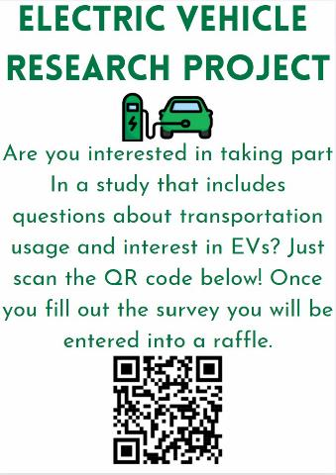

Appendix E - Oil Price Impact on EV Demand

Introduction
The purpose of this appendix is to highlight the correlation between oil price and EV demand and introduce conflict as a driver of oil price. It is important to consider global history’s effect on oil and gas and the impact this will have on EV purchases in the future.

Summary
The international source of energy is fossil fuels, more specifically crude oil (Ritchie, 2020). In the UK, oil serves the purpose of supplying the power industry, heating homes, and providing fuel for vehicles and airplanes. Breaking down the transportation sector, oil meets 97% of the sector’s demand (Oil & Gas UK, 2015).
Despite being such an important energy resource, oil is unstable in the sense that its price can be impacted by global turmoil. High oil prices lead to high gas prices since the cost of oil accounts for 43% of the price of regular gasoline. Typically, when oil barrel cost increases by $10, the cost per gallon of gas increases by $0.25.
There have been several instances throughout history where oil prices have hit new highs due to global conflict and many fluctuations are related to policy changes by the Organization of Oil Exporting Countries (OPEC). OPEC was founded by 5 countries, Iraq, Iran, Kuwait, Saudi Arabia and Venezuela, with the purpose of coordinating petroleum policies to achieve fair and stable prices for producers (Synergen, n.d.). The rise to prominence of OPEC came around 1970 when OPEC gained control of a major portion of crude oil due to their own successful domestic industries, and in turn gained control of its prices. By 1975, there were 13 countries involved as members of OPEC, with new members including Qatar, Indonesia, Libya, the United Arab Emirates, Algeria, Nigeria, Ecuador, Gabon.
One of the largest oil price fluctuations in history occurred during the 1979 Iran-Iraq War (ibid.). The U.S. economy had been strained by the 1973 Oil Embargo placed by the Arab members of OPEC as a response to the U.S. decision to resupply the Israeli military (Office of The Historian, n.d.). While this embargo was extended to other countries that supported Israel, the U.S. had become increasingly dependent on foreign oil and was significantly impacted, with oil prices rising from $13 per barrel to $34 per barrel and the corresponding price of gas rising from $0.63 to $0.86, which would be approximately the equivalent of $3.41 today (Gross, 2019; Vehicle Technologies Office, 2016). The economy had only begun to recover by 1976, and a movement was triggered towards a more oil-independent U.S. (Synergen, n.d.).
OPEC related conflicts are not the only cause of oil price fluctuations, as other global and local economic crises have caused issues in the past. A recent example of an economic crisis that has affected oil prices is The Great Recession of 2008. While the recession was more prominent in the U.S., it caused a lengthy economic depression across the entire world (Synergen, n.d.).
Following the 1979 Iran-Iraq War, the U.S. had made the move towards making itself an independent oil source. Many other countries made similar moves around this time, with other non-OPEC suppliers including Canada and China (Ganti, 2021).
Non-OPEC producers generally make independent decisions about oil production (U.S. Energy Information Administration, n.d.). These producers typically operate at full or near full capacity. When production by these non-OPEC suppliers declines, the total global supply decreases and demand increases on OPEC’s end, raising the price of oil. More price volatility occurs due to the uncertainty of when non-OPEC production will return to the market. This was evident from the steep increase in the price of oil between 2004 and 2008, which occurred in parallel with the first significant decrease in non-OPEC supply since 1973 and increased global demand. Oil prices had reached an all-time high by July 2008 of $145 a barrel (Hamilton, 2009). Although OPEC responded with increased production, it was not enough to meet the higher demand after years of only producing just enough oil (Ganti, 2021).
The effects of the recession on the U.S. and the world due to fundamental shifts in the oil market are here to stay. The International Energy Association (IEA) predicts a speedy decline from existing conventional oil fields by 40 million barrels a day until 2035, meaning a large producer like Saudi Arabia will need to double their supply every 4 to 5 years to keep up with demand (Hänni, 2014). Since this is not possible, oil prices will continue to rise as supply decreases and global conflicts continue, as we have seen with the War on Ukraine.
Moving towards more renewable and sustainable sources of energy will allow the world to shift away from its oil dependence as well as the political and economic effects that come along with it. A key technology in moving away from oil dependence is EVs. Electric vehicle sales have been steadily rising over the past decade, especially as the UK moves towards the ban of new ICE vehicles, with the pace of conversion to EVs increasing as gas prices rise (Eisenstein, 2022). While global conflicts are not directly attributed to increasing the sale of EVs, they increase oil prices which in turn increases EV demand. This can be seen as oil and gas prices have been rising due to the conflict in Ukraine. Middle Eastern oil producers and members of OPEC have expressed worry over the possibility higher oil prices may hasten the transition to EVs (Crider, 2022).
As a more recent example of the drive to move away from oil dependence, the Russo-Ukrainian War dates back to 2014 with the conflict reaching its peak when Russia invaded Ukraine in February 2022. Much like many other countries, the UK has faced record high petrol prices, with a petrol tank for a 55-liter car now costing an average of £88.58 (Gausden, 2022). In turn, there has been a 37% surge in interest for EVs (ibid.). This is reflected by the sale of EVs in the UK, where there were more EVs sold in March 2022 than during the entirety of 2019 (Grundy, 2022). This example illustrates the correlation between oil prices and EV demand, indicating that as oil prices continue to rise so will EV demand

Appendix F – Rubric Topic Outline

Introduction
This appendix presents an outline of elements and sub elements of the rubric for evaluating EV infrastructure.

Rubric Topic Outline

- EV Charging infrastructure
  - EV charging availability
    - Walking time to charger(s)
    - Percent of people it is available to
  - Public charging speed
    - Charger types available
    - Precent of each type of charger available
  - Smart charging policy
    - Are there laws in place to encourage smart charging?
    - Do the laws in place require smart charging?
    - Have the laws reached the point of retro fitting?
  - Charger etiquette
    - Are there policies in place to require or incentivize people to move their car once it is charged?
  - Working chargers
    - Percentage of total chargers that work

Appendix G – Zap Map Charger Information

Introduction
This appendix presents charger information gathered from WR1, WR2 and a few other postcodes. It includes the post code of the charging point, the name of the location, the charger operator, the speeds offered by the charger, the number of chargers at the location, the number that are working, if there is a use restriction on the charger, and the condition as reported by Zap Map.

Zap Map Data
post code | location | operator | charging speeds | number of points | number of points working | restriction | condition
WR2 6AJ | UW car park | BP Pulse | 7Kw | 1 | 0 | no | out of service
WR2 5HP | Motorline Hyundai Worcester | Hyundai | 7Kw | 1 | 1 | yes | working
WR2 5HW | Motorline Hyundai Worcester | Hyundai | 7Kw | 1 | 1 | yes | working
WR2 5JN | UW sports complex | BP Pulse | 7Kw | 1 | 1 | yes | working
WR1 3LE | Crowngate car park | BP Pulse | 43Kw, 50Kw | 2 | 0 | no | out of service
WR1 2BS | Saint Martins gate car park | Swarco E.connect | 50Kw, 22Kw | 9 | 6 | no | issues reported
WR1 2DA | ASDA Worcester | BP Pulse | 3Kw, 7Kw | 1 | 0 | no | out of service
WR3 8SE | Lidl Blackpole road | pod point | 3Kw | 1 | 0 | no | issues reported
WR3 8SQ | Blackpole inn pub & restaurant | Osprey | 50Kw, 22Kw | 2 | 1 | no | working
WR4 0SX | MFG nunnery park | MFG EV power | 7Kw, 50Kw, 120Kw | 1 | 1 | no | working
WR4 0SX | Bluebell Farm Restaurant | other | 7Kw | 1 | 0 | no | out of service
WR4 9NS | sharp drive | other | 22Kw | 2 | 2 | no | working
WR5 2NP | Worcestershire county council county hall | Worcestershire county council | 43Kw, 50Kw | 2 | 1 | yes | out of service
WR5 2NL | oak apple pub & restaurant | Osprey | 50Kw, 22Kw | 1 | 1 | no | working
WR5 2JG | Waitrose Worcester | BP Pulse | 7Kw | 2 | 2 | yes | working
WR5 2RL | The Swan at Whittington | other | 7Kw | 2 | 2 | yes | working
WR5 3SW | Tesco superstore Worcester | pod point | 7Kw | 2 | 1 | no | working
WR2 4TW | Stainbrook Abby reception venue | BP Pulse | 43Kw, 50Kw | 1 | 1 | no | working

Appendix H – Distances to/from Postcodes

Introduction
This appendix presents average distances traveled by postcode in miles (N=180).

Average Distances Traveled by Postcode
Distance Traveled from Home Postcode in Miles |  |  |  | Distance Traveled to Postcode in Miles
Home Postcode | N | Avg Distance Traveled |  | Going To Postcode | N | Avg Distance Traveled
B13 | 1 | 34.3 |  | B1 | 1 | 27.1
B48 | 1 | 26.9 |  | B45 | 1 | 19.8
B61 | 1 | 17.2 |  | B5 | 1 | 33.1
B76 | 1 | 42.4 |  | B74 | 1 | 35.3
BA3 | 1 | 32.9 |  | B90 | 1 | 24.4
BS20 | 1 | 66.9 |  | B91 | 1 | 33.2
DY8 | 2 | 23.1 |  | B98 | 2 | 28.7
DY9 | 1 | 22.1 |  | CF10 | 1 | 81.9
DY10 | 2 | 20.1 |  | CV34 | 1 | 42
DY11 | 3 | 11.1 |  | CV5 | 1 | 44
DY12 | 2 | 37.7 |  | dy10 | 3 | 9.4
DY13 | 2 | 12.3 |  | DY11 | 3 | 10.1
GL52 | 1 | 22.2 |  | DY5 | 1 | 25.2
GL51 | 1 | 15.8 |  | DY6 | 1 | 33.1
HR2 | 1 | 2.4 |  | DY8 | 1 | 22.3
HR6 | 1 | 25.1 |  | Dy9 | 1 | 29.4
HR8 | 1 | 12.4 |  | Gl20 | 1 | 16.6
LD8 | 1 | 45.5 |  | SA6 | 1 | 120
NG8 | 1 | 85.9 |  | Sn3 | 1 | 55.9
SO31 | 1 | 128 |  | Ta19 | 1 | 32.9
WR1 | 5 | 1.3 |  | WR1 | 23 | 6.9
WR2 | 39 | 11.7 |  | WR2 | 90 | 9.1
WR3 | 33 | 7.2 |  | WR3 | 6 | 2.9
WR4 | 8 | 3.5 |  | WR4 | 8 | 11.3
WR5 | 28 | 10.7 |  | WR5 | 10 | 3.6
WR6 | 9 | 8.4 |  | WR6 | 3 | 6.1
WR7 | 1 | 10.5 |  | WR9 | 3 | 4.8
WR8 | 2 | 3.4 |  | WR10 | 1 | 10.5
WR9 | 3 | 7.2 |  | WR13 | 1 | 8.8
WR10 | 2 | 13.5 |  | WR14 | 8 | 22.6
WR11 | 4 | 10.6
WR13 | 7 | 9.1
WR14 | 10 | 7.7

Vertical integration in this context refers to a single company having control over every or many segments of the power distribution system. For example, a power company exhibiting high levels of vertical integration would control all levels from power generation to supply.
a multi category assessment tool based on our background research and results from our previous methods
GIS, Geographic Information System, allows for spatial visualization and analysis through mapping.
The Happy Lands and Arboretum Area
The other 57% is taxes, transportation and delivery and other related costs.

